Original Research Article
Micropropagation of Bacopa monnieri (L.) Pennell

ABSTRACT
Bacopa monnieri (L.) Pennell, commonly known as “Brahmi,” is a medicinally important plant widely used in Ayurveda for its neuroprotective and memory-enhancing properties. The present study aimed to standardize an efficient in vitro micropropagation protocol by optimizing explant type, surface sterilization, hormone concentration, and sucrose level. Nodal and leaf segments were selected as explants. Effective surface sterilization was achieved using 0.1% Bavistin for 30 minutes followed by 0.05% HgCl₂ for 4 minutes, which eliminated contamination while preserving viability. Shoot initiation occurred within 5–8 days, with the highest frequency of multiple shoots observed on MS medium supplemented with 3 ppm BA or 2 ppm BA + 1 ppm NAA. Callus induction was most successful from leaf explants cultured on MS + 2 ppm 2,4-D + 1 ppm kinetin, forming friable and regenerative calli within 30–35 days. For rooting, IBA at 3 ppm promoted direct multiple shoot and root formation, while MS + BAP (5.5 ppm) + NAA (0.2 ppm) supported both elongation and rooting. Optimal growth was obtained at pH 5.8 and 3% sucrose, which enhanced shoot number and explant vigor. The developed protocol is fast, reliable, and reproducible, providing a basis for large-scale clonal propagation, conservation of germplasm, and potential metabolite enhancement in B. monnieri.
KEY WORDS: Bacopa monnieri, Micropropagation, MS medium, Explant, Surface sterilization

INTRODUCTION
Biotechnology stands as a pivotal technological intervention addressing challenges in agriculture and plant conservation. It encompasses methods that utilize living organisms or their components to enhance plants or animals and modify their products for specific purposes. Key branches of biotechnology include genetic engineering, tissue culture, bioprocessing, and protein engineering. Among these, micropropagation—also known as plant tissue culture—is a rapid and efficient technique for producing large numbers of commercially important crop species from small plant fragments. This method enables the generation of entire populations of superior plants with desirable traits under controlled, aseptic conditions (George et al., 2008; Murthy, 2022; Vinod et al., 2023).
Bacopa monnieri (Brahmi or water hyssop) is an important medicinal herb classified as a “Medhya Rasayana” in Ayurveda, traditionally used to enhance memory and intellect. Its ethnomedicinal use extends across South and Southeast Asia, where it has been applied for epilepsy, insomnia, and anxiety management. The therapeutic potential of Bacopa is primarily attributed to bioactive compounds, especially bacosides A and B, which improve synaptic transmission, reduce oxidative stress, and protect neuronal integrity (Bhattacharya et al., 2000; Sanyal et al., 2022). Pharmacologically, Bacopa modulates the GABAergic system, supporting anticonvulsive, sedative, and locomotor effects. Clinical studies have demonstrated that standardized Bacopa extracts improve memory retention in Alzheimer's patients and exhibit antioxidant and anxiolytic activities (Agular & Borowski, 2013; Stough et al., 2008). Furthermore, animal and clinical studies have explored its potential in managing ADHD and depression (Kumar et al., 2019; Singh et al., 2021; Valotto Neto et al., 2024).
Despite its high medicinal value, large-scale cultivation of B. monnieri using conventional methods is limited by low seed viability, seasonal growth constraints, and habitat degradation. Overharvesting for commercial purposes further threatens its natural populations (Patel et al., 2020). In this context, micropropagation offers a practical solution by enabling rapid production of disease-free, genetically uniform plantlets in a relatively short period. This study aims to develop a reproducible and efficient micropropagation protocol for Bacopa monnieri using nodal and leaf explants, to optimize sterilization methods and growth media for maximal shoot proliferation and rooting, and to evaluate the potential of in vitro-grown plantlets for large-scale conservation and commercial application. Additionally, in vitro culture provides an opportunity for enhancing the production of bioactive compounds, such as bacosides, under controlled conditions, which can further support pharmaceutical applications (Murthy, 2022; Sharma & Pandey, 2021).

MATERIALS AND METHODS
The study was conducted using explants, which include the leaves (1”- 5th from the apex), shoot segments (3rd to 5th from the apical node), and meristem portions, which were collected from the medicinal garden of ONATTUKARA REGIONAL AGRICULTURAL RESEARCH STATION, KAYAMKULAM. The explants were obtained from healthy specimens of Bacopa monnieri kept at the station. Murashige and Skoog media is used as the basal media in this work to culture the explant. From the stock solution desired volume of MS was prepared (Table 1). The appropriate amount of MS was generated using the stock solution and supplemented with various combinations of growth regulators such as BA, BAP, Kinetin, NAA, IBA, and 2,4-D, The nodal segments were inoculated in MS media supplemented with different amounts and combinations of cytokinin (BA, DAP, and Kn), such as MS ± 3BA, MS ± 2BA +1 NAA, and MS + BA 1ppm, NAA + BA 1 ppm + MS 1 ppm (Table 6). The solution's pH was then adjusted to 5.8 by adding 1N HCI or 1N NaOH solution drop by drop. Culture tubes were transferred for sterile inoculation.
Before the inoculation of the explant to the MS medium, it was surface sterilized with Bavistin (fungicide) and mercuric chloride. Six bottles containing 0.05% and 0.1% of mercuric chloride were taken; the explants previously treated with Bavistin were inoculated into the first three bottles containing 0.05% of mercuric chloride, with an increasing exposure time from 2 to 6 minutes, with a difference of 2 minutes.
Before inoculation, the explants were placed aseptically on the medium's surface. After inoculation, the culture tubes were transferred to the incubation room. The room was provided with artificial illumination with cool fluorescent lamps. The light intensity was maintained at around 3000 lux. The relative humidity was maintained at 60-70% and the temperature 25±2°C. For rooting, the culture was kept in the dark. The explants with bud proliferation cultures were transferred to culture bottles containing fresh MS medium. After 10-15 days of incubation, the initiated plants were taken out of the culture bottle and transferred into fresh semi-solid MS media. Then the bottles were kept in a culture room at 25±2°C. After experimental days, the fully mature culture was obtained, and they were further subcultured in MS medium supplemented with different plant growth hormones at different concentrations for the regeneration of shoots.

Stock | Compounds | Quantity (mg/l) | Stock concentration | Quantity required for 1L | Quantity required for mg | Volume of stock | Volume required for 1L media
A | Macronutrients  Ammonium nitrate  Potassium nitrate  Potassium phosphate dibasic anhydrous  Magnesium sulphate | 1650  1900  170  370 | 40X | 66000  76000  6800  14800 | 33000  38000  3400  7400 | 500ml | 25ml  For 11medium
B | Calcium chloride dihydrous | 440 | 100X | 44000 | 4400 | 100ml | 10ml
C | Iron source  Sodium EDTA  Ferrous sulphate heptahydrate | 37.3  27.8 | 200X | 5560  5560 | 556  746 | 100ml | 5ml
D | Micronutrients  Manganese sulphate monohydrate  Zinc sulphate heptahydrate  Boric acid  Potassium iodide  Sodium molybdate dihydrate  Cobalt chloride hexahydrate  Copper sulphate pentahydrate | 22.3  8.6  6.2  0.83  0.25  0.025  0.025 | 200X | 4460  1720  1240  166  50  5  5 | 2230  860  620  83  25  2.5  2.5 | 500ml | 5ml
E | Organic supplements  Glycine  Nicotinic acid  Pyridoxine HCl  Thiamine  Inositol | 2  0.5  0.5  0.1  100 | 1000X | 2000  500  500  100  100 | 200  50  50  10  10 | 100ml | 1ml

Table 1: stock for MS medium

Table 2: Preparation of plant growth hormones from the solutions.
Concentration | Duration | Recovery of culture % | Remarks
0.05% | 2  4  6 | 50  95  48 | Fungal contamination  Effective  Drying
0.1% | 2  4  6 | 90  45  5 | Effective  Drying  Drying

Compounds | Quantity (mg)  for 10 ml stock | Preparation | Concentration
NAA | 10 | Dissolve in 1N NaOH and made up to 10 ml | 1ml=1mg
BA | 10 | Dissolve in 1N NaOH and made up to 10 ml | 1ml=1mg
2,4-D | 10 | Dissolve in 1N NaOH and made up to 10 ml | 1ml=1mg
Table 3: Effect of mercuric chloride on the growth rate of Bacopa monnieri in the MS medium

Sl. No | Duration of Bavistin (0.2%) treatment (min) | Rate of growth | Rate of contamination
1 | 5 | - | +
2 | 10 | - | +
3 | 15 | + | -
4 | 20 | ++ | -
5 | 25 | +++ | -
Table 4: Effect of Bavistin on the growth rate of Bacopa monnieri in the MS medium

Sl. No | Concentration of sucrose | Rate of growth | Rate of contamination
1 | 20 g/l | - | -
2 | 25 g/l | - | -
3 | 30 g/l | ++ | +
4 | 35 g/l | + | ++
5 | 40 g/l | ++ | -
Table 5: Response of nodal explants on various concentrations of sucrose in MS Medium
*
- | No

+ | Low

++ | Medium

+++ | High

Sl. No | Hormone treatment in the medium | Observation after 5 days
1 | MS + BA 1ppm | -
2 | MS + BA 1ppm + NAA 1ppm | -
3 | MS + BA 3ppm | 1
4 | MS + NAA 1ppm | -
5 | MS + 2,4-D 2ppm | -
6 | MS + BA 2ppm | -
7 | MS +BA 2ppm +NAA 1ppm | 1

Table 6: Response of nodal segments of Bacopa monnieri in varying levels and combinations of hormones in shoot induction

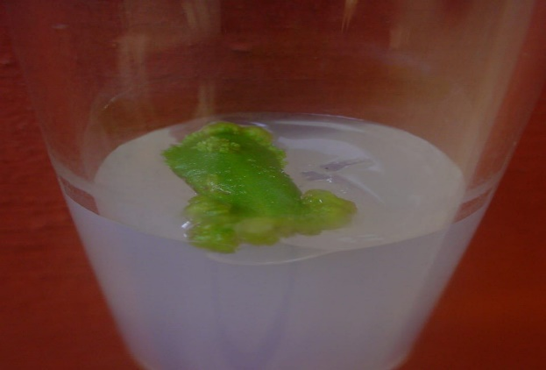
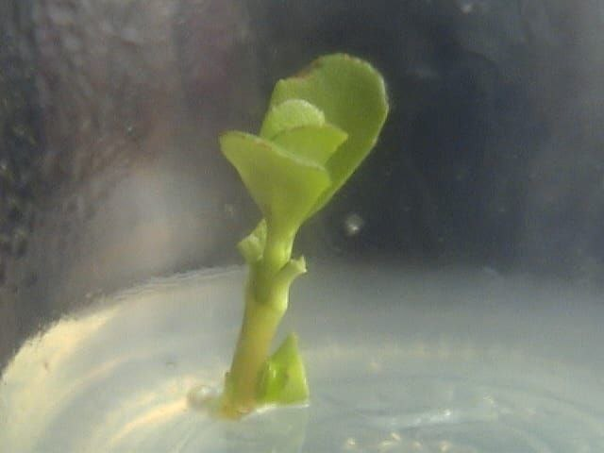

Figure 1: Explant inoculation in to the medium.
Figure 2: Induction of shoot bud from cut edge of the leaf after 8 days.

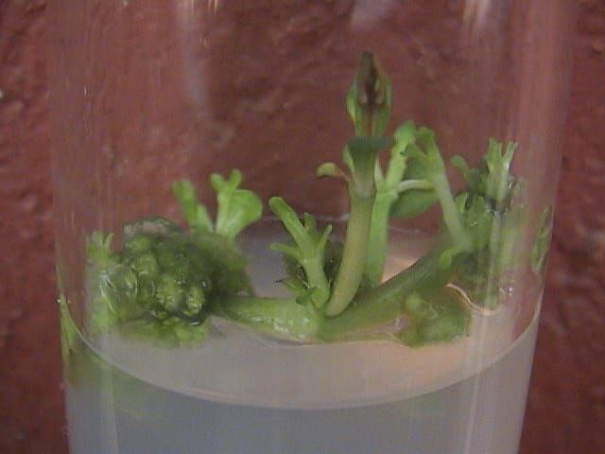
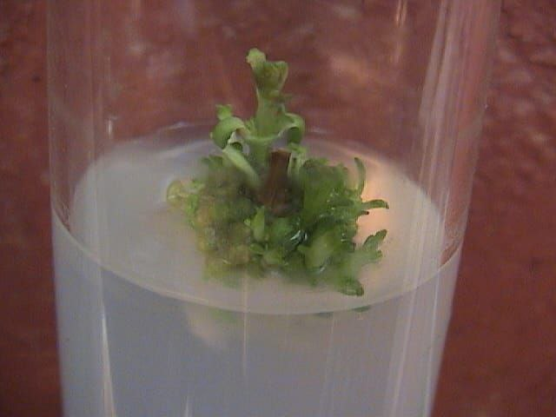

Figure 3: Shoot multiplication on MS medium supplemented with 3ppm BA after 5 days.
Figure 4: Shoot elongation on MS medium supplemented with 3ppm BA.

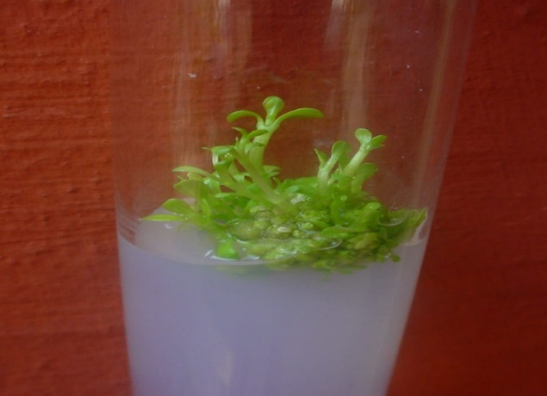

Figure 5: Elongated shoot in MS medium after 30-35 days.

RESULT AND DISCUSSION
Explant Selection and Surface Sterilization
Nodal and leaf segments were selected as explants owing to their rapid regeneration potential. Effective surface sterilization was achieved using 0.1% Bavistin (30 minutes) followed by 0.05% HgCl₂ (4 minutes), which minimized microbial contamination while maintaining tissue viability. Higher HgCl₂ concentrations or longer exposure caused necrosis due to toxic effects on cell membranes, while shorter treatments failed to prevent fungal contamination. Chaudhuri et al. (2002) reported efficient surface sterilization of leaf explants with HgCl₂, enabling direct shoot regeneration. Chaudhuri et al. (2004) further standardized the use of HgCl₂ and NaOCl for nodal explants and confirmed its effectiveness in establishing high-frequency regeneration systems. In addition, Tiwari et al. (2006) demonstrated that Bavistin, a systemic fungicide, effectively reduced fungal contamination when used before HgCl₂ treatment, without affecting explant viability.
Shoot Induction
Shoot initiation was observed within 5 days from nodal segments cultured on MS medium containing 3 ppm benzyl adenine (BA), while a combination of 2 ppm BA + 1 ppm NAA produced well-elongated shoots within 8 days. The highest shoot induction frequency was recorded with 3 ppm BA. At higher BA concentrations, shoot formation declined, possibly due to cytokinin-induced vitrification or disruption of apical meristem signaling. Cytokinins such as BA stimulate cell division in the apical meristem, explaining their effectiveness in inducing multiple shoots. BA is widely recognized for its effectiveness in shoot multiplication in medicinal plants (Murashige & Skoog, 1962). The addition of a low concentration of NAA may further enhance shoot elongation through auxin–cytokinin interactions, though specific data for Bacopa monnieri are limited.
Callus Induction and Proliferation
Callus initiation occurred 18–24 days post-inoculation, with friable, cream-colored calli developing from leaf explants cultured on MS medium supplemented with 2 ppm 2,4-D + 1 ppm kinetin. Nodal explants cultured on 3 ppm 2,4-D also produced callus but were less friable. Auxins such as 2,4-D promote dedifferentiation and cell proliferation, while kinetin enhances morphogenetic competence by maintaining cell totipotency. This auxin–cytokinin synergy explains the superior callus response in leaf explants. Comparable findings were reported by Pandey et al. (2010), who demonstrated that leaf explants were more responsive to callus formation than nodal explants, likely due to higher meristematic competence.
Rooting and Regeneration
Calli transferred to MS medium containing 5.5 ppm BAP + 0.2 ppm NAA produced both shoots and root primordia within 10–14 days. In parallel, nodal explants treated with 3 ppm IBA developed multiple shoots with strong rooting ability. The combination of BAP and NAA likely facilitated simultaneous shoot elongation and root differentiation by maintaining a balance between cytokinin-mediated shoot induction and auxin-induced root initiation. IBA is well known for its strong rhizogenic effect, explaining its efficiency in root development. Similar effects were reported by Pandey et al. (2010), who observed effective shoot and root regeneration in Bacopa monnieri using cytokinin–auxin combinations.
Optimization of pH and Sucrose Concentration
Growth and morphogenesis were influenced by medium pH and sucrose concentration. The best growth response was obtained at pH 5.8, where higher shoot elongation and leaf expansion were observed. At pH below 5.6 or above 6.0, growth was suppressed due to impaired nutrient absorption and enzyme activity. Similarly, 3% sucrose was found to be optimal for shoot number, callus weight, and explant vigor, whereas higher sucrose levels (3.5–4%) led to increased contamination and osmotic stress. Sucrose acts both as a carbon source and an osmotic regulator, so its concentration must be balanced to support optimal morphogenesis.
Effect of Hormone Combinations
Among the hormone combinations tested, BA + NAA proved most effective for shoot induction and elongation. NAA alone did not induce shoots, while 2,4-D alone promoted callus formation instead of organogenesis. This demonstrates that a balanced cytokinin–auxin interaction is crucial for directing the developmental pathway, where cytokinins promote shoot initiation and auxins regulate root and callus formation. The classic model of hormonal regulation proposed by Skoog and Miller (1957) explains this observation, in which cytokinin dominance favors shoot induction while auxin dominance promotes root or callus formation.

CONCLUSION
The commercial propagation and preservation of potentially endangered medicinal plant resources can be accomplished through the use of this protocol. When the growth patterns of different types of explants were studied, it was found that nodal segments had higher rates of off shoot branching and multiplication than shoot tips, which were mostly associated with low levels of shoot elongation and multiplication. Primordia were present in several shoot clusters, indicating the maximum growth rate. For every type of explant, rooting was essentially consistent. Comparisons of plant growth and survival in the field under various conditions also differ. The survival percentage of plants that were directly transplanted from in vitro settings was relatively low upon planting out. Even after a week, transplants cultured on MS media without cytokinins were unable to form shoots. BAP significantly improved the percentage of regeneration, the number of shoots, and the length of the shoots when combined with 2,4-D and NAA. Out of all the cytokinin-auxin combinations tested, IAA and BAP/2,4-D produced the highest percentage of regeneration, 90% of shoots, and 4.95±0.9 shoot length per explant produced the highest percentage of shoots, 95% of shoot length, and 4.90±00 shoot length per explant. Numerous occurrences have been reported regarding the impact auxin has in the medium when combined with cytokinins to promote shoot multiplication.

Disclaimer (Artificial intelligence)
The author(s) declare that generative AI tools were used only for language editing and improvement of readability. Specifically, ChatGPT (GPT-5, OpenAI, 2025) and Grammarly (2025 version) were employed for grammar correction, sentence rephrasing, and minor improvements in clarity.
No AI tools were used to generate or analyze scientific data, prepare results, or draw conclusions. All experimental design, data collection, analysis, and interpretations are the original contributions of the author(s).

1. ChatGPT (GPT-5, OpenAI, 2025 version, https://openai.com)
2. Grammarly (Premium, 2025 version, https://www.grammarly.com)

REFERENCE
- Aasim, M., Dogan, M., & Khawar, K. M. (2013). Adventitious shoot regeneration of the medicinal aquatic plant water hyssop (Bacopa monnieri L. Pennell) using different internodes. Archives of Biological Sciences 65: 297–303.
- Aguilar, F., & Borowski, T. (2013). Bacopa monnieri: Cognitive enhancer in traditional medicine and clinical research. Phytomedicine, 20(6), 583–589. https://doi.org/10.1016/j.phymed.2012.12.010
- Bhalerao, S., Jondhale, A., Chava, S., & Patil, R. (2025). A comprehensive review on micropropagation of Bacopa monnieri L. The Bioscan, 20(1), 499–505.
- Bhandari, A., & Bhandari, S. (2023). Abiotic stress-driven Bacoside-A biosynthesis in Bacopa monnieri (L.) Wettst. Biotechnology Advances, 61, 107994.
- Bhattacharya, S. K., Bhattacharya, A., Kumar, A., & Ghosal, S. (2000). Antioxidant activity of Bacopa monnieri in rat frontal cortex, striatum and hippocampus. Phytotherapy Research, 14(3), 174–179. https://doi.org/10.1002/(SICI)1099-1573(200005)14:3<174::AID-PTR573>3.0.CO;2-C
- Bhusari, W., Wanjari, R., & Khobragade, P. (2013). Cost effective in vitro clonal propagation of Bacopa monnieri L. Pennell. International Journal of Industrial Medicinal Plants, 46, 1239–1244.
- Ceasar, S. A., Maxwell, S. L., Prasad, K. B., Karthigan, M., & Ignacimuthu, S. (2010). Highly efficient shoot regeneration of Bacopa monnieri (L.) using a two-stage culture procedure and assessment of genetic integrity of micropropagated plants by RAPD. Acta Physiologiae Plantarum, 32, 443–452.
- Deepa, M., Sangli, G. K., Arun, P. C., & Amit, A. (2003). Quantitative determination of the major saponin mixture bacoside A in Bacopa monnieri by HPLC. Phytochemistry, 66(8), 665–667.
- DVV Kumar, R., Reddy, S., & Narasimha, P. (2024). Standardization of protocol for production of synthetic seeds of Brahmi (Bacopa monnieri) and assessment of their longevity. Plant Cell Biotechnology and Molecular Biology, 25(9–10), 39–48.
- George, E. F., Hall, M. A., & De Klerk, G. J. (2008). Plant propagation by tissue culture: Volume 1. The background. Springer. https://doi.org/10.1007/978-1-4020-5005-3
- George, F., Geetha, S. P., Balachandran, I., & Raveendran, P. N. (2004). In vitro medium term conservation of Bacopa monnieri (L.) Pennell – the memory plus plant under flow growth conditions. Plant Genetic Resources Newsletter, 151, 49–55.
- Inthima, P., & Supaibulwatana, K. (2024). Comparative growth and bacoside production in diploid and tetraploid Bacopa monnieri cultivated via hydroponic vs. soil systems. Horticulturae, 10(6), 574.
- Joshi, A. G., Pathak, A. R., Sharma, A. M., & Singh, S. (2010). High frequency of shoot regeneration on leaf explant of Bacopa monnieri. Environmental Experimental Biology, 8, 81–84.
- Kashyap, A. (2023). Effect of vermicompost extracts on in vitro micropropagation of Bacopa monnieri. International Journal of Green Pharmacy, 17(1), 57–64.
- Kumar, N., Singh, B., & Gupta, A. (2019). Neuropharmacological potential of Bacopa monnieri in attention deficit hyperactivity disorder (ADHD). Journal of Ethnopharmacology, 240, 111909. https://doi.org/10.1016/j.jep.2019.111909
- Mehta, J., Ansari, R., Syedy, M., Khan, S., Sharma, S., Gupta, N., Rathore, R., & Vaishnav, K. (2012). An effective method for high frequency multiple shoots regeneration and callus induction of Bacopa monnieri (L.) Pennell. Asian Journal of Plant Science and Research, 2, 620–626.
- Mohapatra, H. P., & Rath, S. P. (2005). In vitro studies of Bacopa monnieri: An important medicinal plant with reference to its biochemical variations. Indian Journal of Experimental Biology, 43(4), 373–376.
- Mullick, R., Samanta, D., & Roy, D. (2023). Bacosides neurotropic molecules production by tissue cultures of Bacopa monnieri. In Biotechnology of Medicinal Plants (pp. 123–135). Elsevier.
- Murthy, H. N. (2022). Biotechnological production of bacosides from cell and organ cultures of Bacopa monnieri. Applied Microbiology and Biotechnology, 106(5–6), 1799–1811.
- Murthy, H. N. (2022). Micropropagation of medicinal plants: Applications and prospects. Biotechnology Advances, 60, 108008. https://doi.org/10.1016/j.biotechadv.2022.108008
- Obta, T., Nakamura, S., Nakashima, S., Oda, Y., Matsumoto, T., Fukaya, M., Yono, M., Yoshikawa, M., & Matsuda, H. (2016). Chemical structure of constituents from the whole plant of Bacopa monnieri. Journal of Natural Medicines, 70, 404–411.
- Otari, S. S., Devkar, S. P., Patel, S. B., & Ghane, S. G. (2023). Micropropagation and elicited production of triterpenoid saponin glycosides and stigmasterol via precursor and elicitor feeding in Bacopa floribunda. Frontiers in Plant Science, 14, 1096842.
- Pandiyan, P., & Selvaraj, T. (2012). Multiplication of Bacopa monnieri (L.) Pennell from shoot tip and nodal explants. Journal of Agricultural Technology, 8, 1099–1108.
- Patel, M., Sharma, R., & Singh, A. (2020). Conservation challenges of Bacopa monnieri: Overexploitation and prospects of micropropagation. Indian Journal of Traditional Knowledge, 19(3), 548–555.
- Patra, K. N. (2003). In vitro studies of Bacopa monnieri with reference to its biochemical variation. Phytomedicine, 11(2), 333–345.
- Roy, D., Samanta, D., & Mullick, R. (2022). Phytochemical and molecular profiling of tissue culture derived Bacopa monnieri (L.) Wettst clones against field grown plants. International Journal of Botany Studies, 7(4), 103–111.
- Sanyal, R., Nandi, S., Pandey, S., & Bhattacharya, S. (2022). A comprehensive review on tissue culture studies and secondary metabolite production in Bacopa monnieri L. Pennell: a nootropic plant. Applied Microbiology and Biotechnology, 106(5–6), 1837–1854.
- Sanyal, S., Ghosh, S., & Bandyopadhyay, S. (2022). Bacopa monnieri and its bacosides: A review on pharmacological aspects. Journal of Herbal Medicine, 30, 100519. https://doi.org/10.1016/j.hermed.2022.100519
- Sharma, P., & Pandey, S. (2021). Tissue culture of Bacopa monnieri for bacoside enhancement: Recent trends and future perspectives. Plant Cell, Tissue and Organ Culture, 145(2), 281–295. https://doi.org/10.1007/s11240-021-02050-7
- Singh, H., Kumar, A., & Verma, S. (2021). Antidepressant and anxiolytic effects of Bacopa monnieri: A clinical perspective. Frontiers in Pharmacology, 12, 679569. https://doi.org/10.3389/fphar.2021.679569
- Skoog, F., & Miller, C. O. (1957). Chemical regulation of growth and organ formation in plant tissue cultures in vitro. Symposium of the Society for Experimental Biology, 11, 118–131.
- Stough, C., Lloyd, J., Clarke, J., Downey, L. A., Hutchison, C. W., Rodgers, T., & Nathan, P. J. (2008). The chronic effects of an extract of Bacopa monniera (Brahmi) on cognitive function in healthy human subjects. Psychopharmacology, 156(4), 481–484. https://doi.org/10.1007/s00213-001-0879-0
- Sudheer, W. N., Thiruvengadam, M., & Nagella, P. (2022). A comprehensive review on tissue culture studies and secondary metabolite production in Bacopa monnieri L. Pennell. Critical Reviews in Biotechnology, 42(6), 935–950.
- Tiwari, V., Tiwari, K. N., & Singh, B. D. (2006). Shoot bud regeneration from different explants of Bacopa monnieri (L.) Wettst by trimethoprim and Bavistin. Plant Cell Reports, 25, 629–635.
- Türkmen, S., Karadayı, M., & Çelik, A. (2023). Effective contamination agent for tissue culture applications of Bacopa monnieri. Bilge International Journal of Science and Technology Research, 7(3), 148–157.
- Valotto Neto, L. J., Rocha, M. S., de Souza, C. F., & Rodrigues, R. S. (2024). Investigating the neuroprotective and cognitive-enhancing effects of Bacopa monnieri: A systematic review focused on inflammation, oxidative stress, mitochondrial dysfunction, and apoptosis. Antioxidants, 13(4), 393.
- Vijayakumar, M., Vijayakumar, R., & Stephen. (2010). In vitro propagation of Bacopa monnieri L. – a multipurpose medicinal plant. Indian Journal of Science and Technology, 3(7).
- Vinod, A., Sharma, S., & Sharma, V. (2023). Advancement in plant tissue culture-based research for sustainable exploitation of well-known medicinal herb Bacopa monnieri. Jurnal Teknologi dan Bioteknologi Bumi Tropika, 11(1), 1–10.
- Vohora, B. S., Khanna, T., Athar, M., & Ahmad, B. (1997). Analgesic activity of bacosine, a new triterpene isolated from Bacopa monnieri. Fitoterapia, 68, 361–365.
- Zhang, Y., Li, Q., Wang, H., & Chen, J. (2023). Somaclonal variation and clonal fidelity in micropropagated medicinal plants: insights from molecular markers. Plants, 12(4), 411.
- Sivanandhan, G., Selvaraj, N., Manickavasagam, M., & Ganapathi, A. (2012). Enhanced biosynthesis of withanolides by elicitation and precursor feeding in adventitious root cultures of Withania somnifera. Industrial Crops and Products, 37(1), 124–129. https://doi.org/10.1016/j.indcrop.2011.11.032

