***Original Research article***

**Molecular Characterization of *Melia dubia* Cav.: Insights from Natural Populations in South Gujarat,India**

**ABSTRACT**

*Melia dubia*, a short rotational agroforestry tree species, has earned wide fame among farmers of India for its apparent monetary benefits. To gain firsthand knowledge about population structure and diversity, unexplored naturally occurring four populations of this species are being examined in India's northernmost Western Ghats region. Our approach used assessment based on molecular analysis using Random Amplified Polymorphic DNA (RAPD) technique. RAPD profiling suggested moderate gene diversity (PPL= 52.54-59.32 %, H= 0.16-0.21) and genetic differentiation (GST=0.11) but high gene flow (N*m*=4.22) among populations. Most genetic differentiation (96%) was ascribed within-population. The close range of Nei’s genetic identity coefficient (0.955-0.973) among populations confirmed a limited gene pool of this species. Divulgence of narrow genetic base warrants immediate measures for *in-situ* conservation of *M. dubia* in the northernmost Western Ghats region. Waghai and Nanapondhaappeared to be the most genetically diverse among the populations. Therefore, they should be prioritised as a seed source for artificial regeneration.

**Keywords**: Genetic diversity, Malabar neem, Population structure, RAPD markers

**1. INTRODUCTION**

Assessment of genetic diversity in natural plant populations is important in two ways. First, screening diversity distribution in available germplasm is the foremost foundation for developing new and productive tree lines. Second, it is helpful to understand the social structure for effective planning and development of conservational strategies. Several tools and techniques, *viz.* morphotyping, molecular and biochemical profiling, are available at biologists' disposal to characterise genetic diversity. Notwithstanding, each of them offers some advantages over others on one side and a few shortcomings on another side (Jiang, 2013). In this genomic era, molecular markers have proven to be an indispensable tool in diversity measurement within and among populations, genotype characterisation, population dynamics and gene flow, owing to their high and accurate output with no dependency on environmental variables (Govindraj *et al.* 2015). Since a combination of diversified marker types is recommended by Porth and El-Kassaby (2014) for precise detection of diversity, we employed RAPD markers, to assess the extent of intra and inter-population genetic diversity in populations of *Melia dubia Cav.* in south Gujarat region of India.

*M. dubia* is an industrially important, short rotational tree species belonging to the family Meliaceae. It is indigenous to South–East Asia and Australia and is popularly known as ‘Malabar Neem’ in the Indian subcontinent. It grows naturally in Northern Bengal, Assam, Khasi hills, Deccan plateau and the Western ghats region of India. This species has recently gained good recognition among Indian farmers and is widely adopted on farmlands for monetary benefits (Thakur *et al.* 2018; Prajapati *et al.* 2020). As an estimate, 75 tons of commercial wood fetching approximately 2.25 lacs (INR) from one hectare of plantation in a short span of three years (FAO, 2016). Wood is primarily used for making paper, plywood, packing boxes, match sticks, small furniture and agricultural implements (Parthiban *et al.* 2019; Sinha *et al.* 2019). Besides wood, leaf, bark and fruit extract were tested for their anti-oxidant, anti-cancerous, anti-microbial, anti-feedent and biopesticidal properties (Thangavel *et al.* 2019). The fruit pulp is recommended as an alternative livestock feed (Sukhadiya *et al.* 2021).

The demand for high-quality planting material has been rising in Gujarat, a western state of India (Khakhariya, 2018). In South Gujarat, this species has a sparse natural distribution with a regional 'Endangered category (Khanna and Singh, 2010). Assuming the commercial importance of *M. dubia*, few attempts have been made to study DNA-based genetic diversity and population structure studies*,* covering parts of Haryana and Punjab (Johar *et al.* 2017), Karnataka (Rawat *et al.* 2018), Uttarakhand, West Bengal and Tamil Nadu (Kumar *et al.* 2021). However, the genetic diversity and population structure of *M. dubia* from Gujarat state are still undisclosed. This study uniquely applies molecular approaches to assess diversity and relation among natural populations from this region. The findings of this study are assumed to be invaluable for developing superior and locally adaptive planting materials for wood-based industries and setting the conservation goal for this species.

**2. MATERIALS AND METHODS**

**2.1 Study area and sampling**

The present investigation was carried out at the College of Forestry, Navsari Agricultural University, Navsari, Gujarat, India. Four populations of *M. dubia viz. Kaprada (KP), Nanapondha (NP), Waghai (WG) and Sagai (SG)* were selected from the natural growing regions of the hilly tract in South Gujarat (Fig. 1). A total of 10 individuals per population, based on good phenotypic characteristics, abundant fruits and at least 100 m apart were marked for the study. The climate of the south Gujarat region is typically sub-humid with an averagely hot summer, moderately cold winter and humid and warm monsoon. Most precipitation received from the southwest monsoon condensed in July and August.

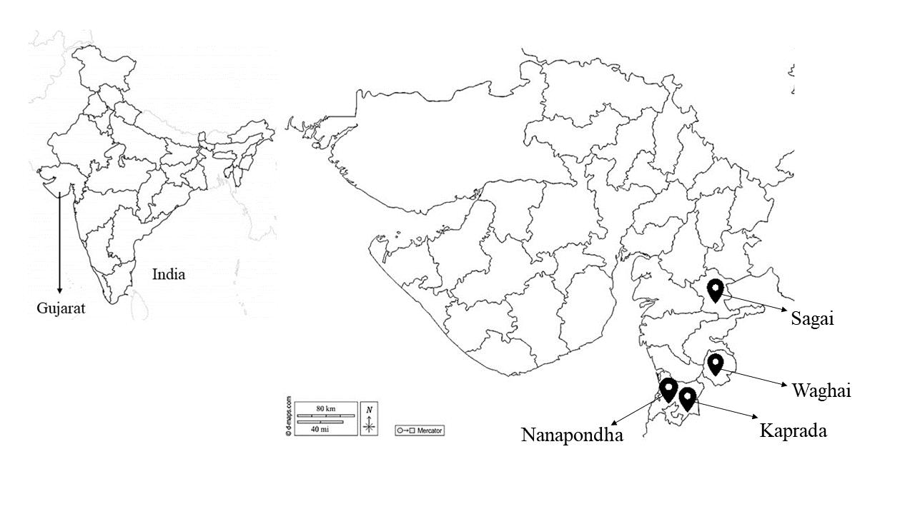

**Fig. 1.** Geographic location of *M. dubia* natural populations selected in the present study

**2.2 Assessment of molecular variability**

We used the Random amplified polymorphic DNA (RAPD) markers technique to reveal the genetic diversity among selected populations of *M. dubia*. Fresh leaves with no sign of disease were collected from the selected trees, brought to the laboratory in paper bags, and stored in an ice pack bucket. Samples were shifted to the laboratory on the same day and kept in a deep freezer (-20°C) for DNA extraction. The genomic DNA was extracted using the standard method (Doyle and Doyle, 1990) with modified buffer concentrations per 10 ml (1 M Tris-1 ml, 0.5 M EDTA-1 ml, 4 M NaCl-3.75 ml, 3% CTAB- 300 mg, 2% PVP-200 mg and de-ionised water-4.25 ml). According to Sambrook *et al.* (1989), DNA was quantified using Nanodrop (at 260 nm), and the quality of the DNA was determined using agarose micro gel electrophoresis. Genomic DNA was electrophoresed on a 0.8 per cent agarose gel using 1x TBE buffer and ethidium bromide (0.4μg/ml) staining at a voltage of 6V/cm. The gel was inspected under UV light and photographed using the GeNei UVITEC, Gel Documentation system Cambridge at the end of the run. Good quality DNA samples with a ratio of 1.8-2.0 at OD 260/280 were kept for DNA fingerprinting. Random decamer oligonucleotide primers from Qarta Bio Inc., USA, were used in the RAPD tests. The PCR amplification for each primer was carried out in a 25 µl reaction volume combination in a 96-well thermal cycler from Applied Biosystems (Thermo Fisher Scientific Inc.) as per Williams *et al.* (1990). The PCR amplification programme was run for 35 cycles with initial denaturation (95° C for 4 minutes), denaturation (95° C for 30 seconds), primer annealing (40° C for 1 minute), extension (72° C for 1 minute), final extension (72° C for 7 minutes) and hold at 4° C. The amplified product was removed from the thermal cycler and put onto a 1.8 per cent (w/v) agarose gel with ethidium bromide in 100 ml (0.4 µg/ml electrophoresis buffer) produced in 1x TBE (pH 8.0). The entire amplified PCR product was mixed with 6x gel loading dye, of which 10 µl was loaded in well. The ready-to-use DNA ladder of 100bp was also loaded with the samples for reference. A potential difference of 7-8V/cm was provided until the bands resolved properly.

**2.3 Statistical analysis**

Reproducible RAPD results were manually scored for band presence (1) or absence (0) for each individual in a population, and a binary qualitative data matrix was built. Primer banding characteristics, such as number of total bands (NB), number of the monomorphic band (NM), number of polymorphic bands (NP) and percentage of polymorphic bands (PPB), were assessed manually. PIC values of each marker were calculated as per the formula for dominant marker PIC= 1- [(1-*f* 2 +(1-*f*)2], where *f* is the frequency of the marker (Cheskonov and Artemyeva, 2015). We employed the genetic software package POPGENE version 1.31 (Yeh *et al.* 1997) by choosing the dominant marker data setting to generate genetic variations statistics, *viz*. Per cent polymorphism (PPL), Observed and effective number of alleles (Na and Ne), Nei's gene diversity (H), Shannon information index (I) and gene diversity parameters in subdivided populations *viz*.total genetic diversity (HT ), genetic diversity within the population (Hs), coefﬁcient of gene differentiation between populations (*GST)*  and gene flow (*Nm*) among populations, according to Nei (1987). Nei's original measures of genetic identity and distance (Nei, 1972) were also calculated in POPGENE 1.31, and the dendrogram was constructed using an unweighted pair group method with arithmetic average (UPGMA). Analysis of Molecular Variance (AMOVA) was done with software package GenAlEx6 (Peakall and Smouse, 2006).

**3. RESULTS AND DISCUSSION**

**3.1 Molecular variability among natural populations of *M. dubia* as revealed by RAPD markers**

Molecular profiling of 40 genotypes, comprising 4 natural populations was done in the present study using RAPD markers. Out of 18 RAPD primers tested, 10 primers (Table 1) produced clear and reproducible band. The number of loci amplified by these RAPD primers ranged between 4 (OPL 12) to 8 (OPD 02) (Fig. 2). A total of 59 locus amplified of which 44 (74.58%) loci were polymorphic and 15 (25.42%) loci were monomorphic. The highest diversity in DNA band pattern was evident from OPD 02 (6 polymorphic loci), followed by OPB 02, OPD 15, OPL 13 and OPL 14 with 5 polymorphic loci in each whereas, minimum diversity was resulted from OPB 11 and OPL 12 with 3 PL each. The percentage of polymorphism ranged from 60 % for OPB 11 to 83.33 % for OPB 02, OPL 13 and OPL 14. High PIC value of 0.5 (OPB 11) and low PIC value of 0.16 (OPL 13), with an average value of PIC per primer 0.32 were obtained. The differences in DNA band pattern was result of amplification of DNA sequence at certain base pairs due to differences in base pairs (Na'iem *et al.,* 2017). Similar variations in DNA band pattern was noted in *Melia azedarach* by Yulianti *et al.* (2011), *Melia volkeensii* by Runo *et al.* (2004) and in *A. indica* by Dhillon *et al.* (2007).

**Table 1. Primer-wise analysis of banding patterns generated by RAPD marker assays in natural populations of *M. dubia***

|  |  |  |  |  |  |  |
| --- | --- | --- | --- | --- | --- | --- |
| **Primer** | **TL** | **NML** | **NPL** | **PP (%)** | **PIC** | **BP** |
| **OPB 02** | 6 | 1 | 5 | 83.33 | 0.23 | 300-1300 |
| **OPB 11** | 5 | 2 | 3 | 60.00 | 0.50 | 300-2000 |
| **OPD 02** | 8 | 2 | 6 | 75.00 | 0.43 | 300-2500 |
| **OPD 15** | 7 | 2 | 5 | 71.42 | 0.32 | 275-2150 |
| **OPL 05** | 6 | 2 | 4 | 66.67 | 0.23 | 300-1750 |
| **OPL 11** | 5 | 1 | 4 | 80.00 | 0.38 | 250-1850 |
| **OPL 12** | 4 | 1 | 3 | 75.00 | 0.39 | 300-2250 |
| **OPL 13** | 6 | 1 | 5 | 83.33 | 0.16 | 300-2175 |
| **OPL 14** | 6 | 1 | 5 | 83.33 | 0.32 | 275-1650 |
| **OPL 15** | 6 | 2 | 4 | 66.67 | 0.22 | 250-2275 |
| **Overall** | **59** | **15** | **44** | **74.58** | **0.32** | **100-3000** |

**Note:** TL- Total loci; NML- Number of monomorphic loci; NPL- Number of polymorphic loci; PP- Percentage polymorphism (%); PIC- Polymorphism Information Content; BP- base pair

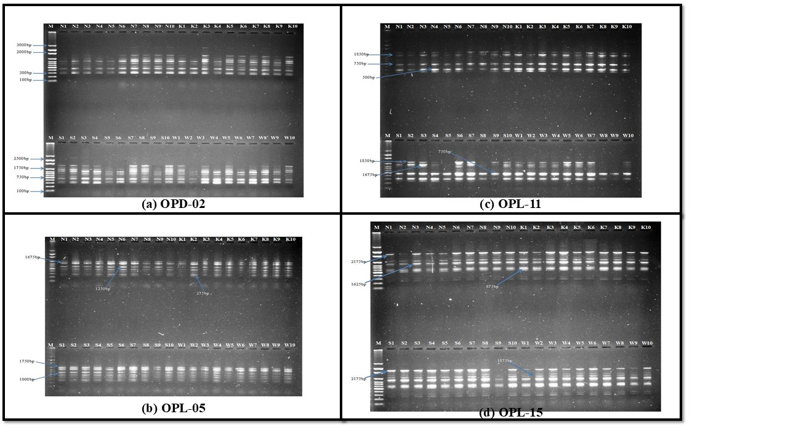

**Fig. 2. RAPD fingerprints (a-d) of natural populations of *M. dubia***

**3.2 Genetic diversity analysis in natural populations of *M. dubia* based on RAPD markers**

**3.2.1 Genetic diversity parameters and molecular variance**

The genetic diversity values for polymorphism, Nei’s diversity index (H), and Shannon’s information index (I) are given for each population in Table 2. For the *M. dubia* populations, RAPD analysis revealed a polymorphism range of 52.54–59.32 %, with a mean of 56.36 % at the level of populations and 74.58 % at the level of region. Highest numbers (35) and percentage (59.32) of polymorphic loci were recorded in Nanapondha and Waghai population and lowest in Sagai population (31 and 52.54 %). Similarly, highest numbers of allele (Na=1.59) observed in Nanapondha and Waghai population, and lowest (1.53) in Sagai population however, effective allele frequency (Ne) was highest (1.36) in Nanapondha followed by Waghai 1.35) and lowest in Kaprada population (1.26). Nei’s index (H) and Shannon’s information index (I) ranged from 0.16 to 0.21 and 0.25 to 0.3, respectively among populations. Highest H values were detected in Nanapondha and Waghai populations and lowest in Kaprada. Similarly, highest I index was attribute of Waghai population and lowest of Kaprada. The values for genetic structure of populations [Total gene variability (Ht), Gene variability within population (Hs), Inter-population differentiation (Gst) and Gene flow (Nm)] are presented in Table 3. The values of total gene variability and gene variability within population was obtained 0.21 and 0.19 respectively whereas, the coefficient of genetic differentiation (Gst) and gene flow among populations (Nm) were 0.11 and 0.42 respectively.

**Table 2. Genetic variability within populations of *M. dubia* as detected through RAPD markers**

|  |  |  |  |  |  |  |  |  |
| --- | --- | --- | --- | --- | --- | --- | --- | --- |
| **Populations** | **PL** | **PPL** | **Na** | **Ne** | **Ho** | **He** | **H** | **I** |
| **Nanapondha** | 35 | 59.32 | 1.59 (0.50) | 1.36 (0.39) | 0.37 | 0.26 | 0.21 (0.20) | 0.31 (0.29) |
| **Kaprada** | 32 | 54.24 | 1.54 (0.50) | 1.26 (0.32) | 0.35 | 0.21 | 0.16 (0.18) | 0.25 (0.26) |
| **Sagai** | 31 | 52.54 | 1.53 (0.50) | 1.31 (0.37) | 0.35 | 0.24 | 0.18 (0.20) | 0.27 (0.28) |
| **Waghai** | 35 | 59.32 | 1.59 (0.50) | 1.35 (0.34) | 0.37 | 0.26 | 0.21 (0.19) | 0.32 (0.28) |
| **Overall** | 59 | 74.58 | 1.75 (0.44) | 1.35 (0.36) | 0.43 | 0.26 | 0.21 (0.19) | 0.33 (0.29) |

*Standard deviations are given in brackets.

**PL- polymorphic loci; PPL- Percentage of polymorphic loci; Na- observed number of allele frequency; Ne- effective number of allele frequency; Ho- observed heterozygosity; He- expected heterozygosity**;** H- Nei’s diversity index; I- Shannon’s information index

**Table 3. Population genetics parameters and estimate of gene ﬂow in populations of *M. dubia***

|  |  |
| --- | --- |
| **Population genetics parameter** | **Values** |
| Total gene variability (Ht) | 0.21 |
| Gene variability within population (Hs) | 0.19 |
| Inter-population differentiation (Gst) | 0.11 |
| Gene flow (Nm) | 4.22 |

Further, Analysis of Molecular Variance (AMOVA) for four populations of *M. dubia* was carried out in the present study. Results indicated that out of total genetic variability, 4 % resides among populations and 96 % within populations (Fig. 3).

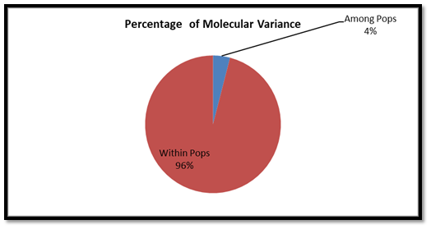

**Fig. 3. Percentage of Molecular Variance in natural populations of *M. dubia***

**3.2.2 Cluster and Principal co-ordinate analysis**

Nei’s measures of genetic similarity (above diagonal) and genetic distance (below diagonal) between four populations of *M. dubia* are presented in Table 4. The range of Nei’s genetic similarity coefficient and genetic distance ranged from 0.955 to 0.971 and 0.027 to 0.045 among the populations of *M. dubia* under this molecular investigation. Highest similarity coefficient (0.973) and shortest genetic distance (0.27) was detected between Sagai and Waghai population, conversely, lowest similarity coefficient (0.955) and longest genetic distance (0.045) obtained between Waghai and Nanapondha populations.

**Table 4. Nei’s measures of genetic similarity (above diagonal) and genetic distance (below diagonal) between natural populations of *M. dubia***

|  |  |  |  |  |
| --- | --- | --- | --- | --- |
| **Populations** | **Nanapondha** | **Kaprada** | **Sagai** | **Waghai** |
| **Nanapondha** | **** | 0.971 | 0.958 | 0.955 |
| **Kaprada** | 0.029 | **** | 0.965 | 0.956 |
| **Sagai** | 0.042 | 0.035 | **** | 0.973 |
| **Waghai** | 0.045 | 0.044 | 0.027 | **** |

Clustering pattern, based on Nei’s measures of genetic similarity, as evident from UPGMA Dendrogram resolved in two main clusters. Cluster I consisted of Nanapondha and Kaprada population whereas, cluster II possessed Sagai and Waghai populations. The results of PCoA corresponded well with the cluster analysis obtained through UPGMA (Fig. 4). The two coordinates accounted for 50.47 and 28.03 per cent of the total variance, respectively. Thus, the total cumulative variance accounted by these two coordinates was 78.50 percent.

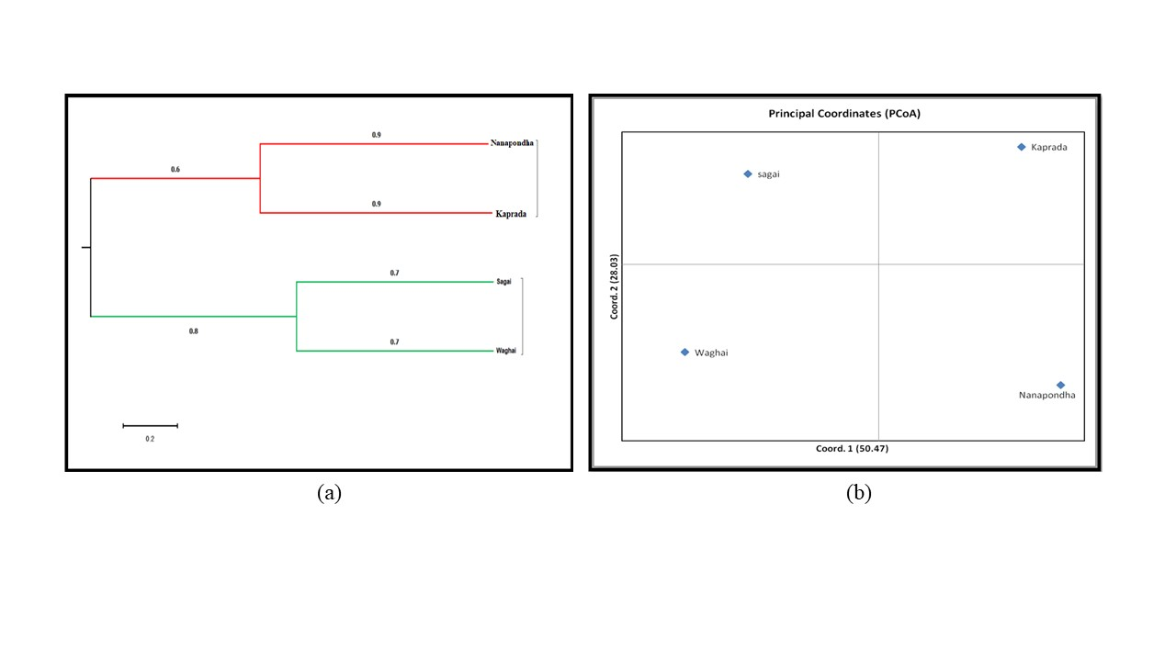

**Fig. 4. (a) UPGMA dendrogram and (b) Principal Coordinates (PCoA) plot for the natural populations of *M. dubia* generated from molecular data**

Molecular markers have proven to be valuable tools for determining genetic diversity within and among population, characterization of genotypes and studying population dynamics and gene flow (Porth and El-kasaby, 2014). Molecular profiling through RAPD technique is relatively quick and cheap method as compared to other marker techniques. Although, lower reproducibility is known but ease of working even with small DNA sample size make them suitable for population studies (Sasikala and Kamakshamma, 2015).

Incurrent genetic diversity analysis based on molecular data, within population range of genetic diversity parameters (PPL, Na, Ne, H and I) did not vary largely, showing similarity of individuals within population. although, higher gene diversity was recorded in Waghai and Nanapondha populations and lower in Kaprada and Sagai populations. In population genetics, gene differentiation based on Gst values is classified as low (< 0.05), medium (0.05–0.15), or high (>0.15) (Li *et al,* 2018). In present study, the Gst (0.11) and Nm of 0.422 indicated a moderate level of genetic differentiation between populations and a low level of gene flow. Further, out of the total gene variability (Ht), greater portion were attributed within population. Partitioning of genetic diversity (AMOVA) confirmed that maximum diversity was within population rather among population. molecular studies elsewhere on other tree species enforced present findings as in *A. indica* (Cruz da Silva *et al.,* 2013), Baobab tree (Assobadjo *et al.,* 2006) and in Teak (Chaudhari *et al.,* 2018) wherein, within population variability was noted higher than among population.

Further, survey of scientific literature revealed the relationship of genetic differentiation and population structure depends on several factors like geographic isolation, ecological habitat destruction, breeding system, seed dispersal mechanism, gene flow and human intervenes Ikbal *et al.,* (2010); Senapati *et al.,* (2012) and (Salem and Sallam, 2015). In present study, a mixed mode of pollination mechanism due to scattered population structure of *M. dubia*, and shorter seed dispersal by herbivores might have restricted gene flow among populations which finally led to low genetic diversity among individuals and consequently increased divergence among populations. This finding is in agreement of other findings in *M. dubia* by Rawat *et al.* (2018) and in Neem by Dhillon *et al.* (2007) populations. The close range of genetic similarity coefficient (0.955 to 0.971) and genetic distance (0.027 to 0.045), as revealed by Nei’s genetic similarity and distance matrix, also confirmed less degree of genetic differentiation among populations suggesting narrow genetic base of *M. dubia* in studied population. Similar conclusions were drawn by Johar *et al.* (2017) while analyzing *M. dubia* germplasm in Haryana, in *A. indica* (Farooqui *et al.,* 1998; Deshwal *et al.,* 2005) in *Jatropha curcas* by Singh *et al.* (2010).

Close similarities between Kaprada and Nanapondha populations might be a result of geo-climatic similarities in habitat and shorter geographic distance whereas, resemblance of Sagai and Waghai population, although geographic distant apart could have aroused as a consequence of human intervention like transportation of germplasm from one place to another. Visualization of genetic relationship among four populations by UPGMA dendrogram and PCoA (Fig. 4) were also shown enforcement of the conclusion. Use of diverse germplasm from most distant population like Waghai and Nanapondha is recommended in future tree breeding programmes.

**4. CONCLUSIONS**

Molecular analysis of variability through RAPD markers indicated within and among population genetic variations in a close range. It means there is limited gene flow within and among populations, showing narrower genetic base of *M. dubia* populations in South Gujarat. However, there were indications of higher within population variability as compared to among populations. Genetic relations between Kaprada and Nanapondha populations and between Sagai and Waghai populations were similar, as revealed by molecular data. Genetic similarity between Sagai and Waghai populations, although geographically distant apart directing towards the role of human intervention in transportation of germplasm. Therefore, hybridization of genotypes either between Kaprada and Waghai or between Sagai and Nanapondha populations are promising to deliver good results.

**DISCLAIMER (ARTIFICIAL INTELLIGENCE)**

Authors hereby declare that NO generative AI technologies such as Large Language Models (ChatGPT, COPILOT, etc) and text-to-image generators have been used during writing or editing of this manuscript.

**REFERENCES**

Assogbadjo, A. E., Kyndt, T., Sinsin, B., Gheysen, G., & Van Damme, P. (2006). Patterns of genetic and morphometric diversity in baobab (*Adansonia digitata*) populations across different climatic zones of Benin (West Africa). *Annals of botany*, *97*(5), 819-830.

Chaudhari, C., Kumar, R., Dhaka, R. K., Parekh, V., Sankanur, M. S., Prajapat, P., & Thakur, S. (2018). Genetic diversity analysis of teak in South Gujarat by RAPD marker. *International Journal of Chemical Studies*, *6*(6), 260-267.

Chesnokov, Y. V., & Artemyeva, A. M. (2015). Evaluation of the measure of polymorphism information of genetic diversity. Sel’skokhozyaistvennaya Biologiya (*Agricultural Biology)*, (5 (eng)), 571-578.

Cruz da Silva, A. V. C., Rabbani, A. R. C., Almeida, C. S., & Clivati, D. (2013). Genetic structure and diversity of the neem germplasm bank from Brazil Northeast. *African Journal of Biotechnology*, *12*(20).

Deshwal, R. S., Singh, R., Malik, K., & Randhawa, G. J. (2005). Assessment of genetic diversity and genetic relationships among 29 populations of *Azadirachta indica* A. Juss. using RAPD markers. *Genetic Resources and Crop Evolution*, *52*(3), 285-292.

Dhillon, R. S., Mohapatra, T., Singh, S., Boora, K. S., & Singh, K. (2007). Assessment of genetic diversity in *Azadirachta indica* based on DNA fingerprinting. *International Journal of Biotechnology,* *6*(1): 519-524.

FAO. (2016). Innovations for raising Malabar neem (*Melia dubia*) in Tamil Nadu, India, <http://www.fao.org/3/ca3719en/ca3719en.pdf>

Farooqui, N.; Ranade, S.A. & Sane, P.V. (1998). RAPD profile variation amongst provenances of neem. *IUBMB Life*., *45*(5): 931-939.

Govindaraj, M., Vetriventhan, M. & Srinivasan, M. (2015). Importance of genetic diversity assessment in crop plants and its recent advances: an overview of its analytical perspectives. *Genetics research international*, *2015*(1): 431487.

Ikbal, A.; Boora, K. S., & Dhillon, R. S. (2010). Evaluation of genetic diversity in *Jatropha curcas* L. using RAPD markers. *International Journal of Biotechnology,* *9*(1): 50-57.

Jiang, G. L. (2013). Molecular markers and marker-assisted breeding. *Jiang, G.-L. Plant Breeding from Laboratories to Fields*, 45-85.

Johar, V., Kajla, S., Dhillon, R. S. & Bhatia, P. (2017). Evaluation of genetic diversity using random amplified polymorphic DNA (RAPD) markers in *Melia dubia* Cav. *Indian Journal of Biotechnology,* *16*(1): 76-83.

Khakhariya, M. (2018). This tree could bring down ‘Made in Gujarat’ home furniture cost by 30%. Times of India May 16. https://timesofindia.indiatimes.com /city/rajkot/this-tree-could-bring-down-furniture-cost-by-30/articleshow/64181741.cms. (Accessed on 14.09.2024)

Khanna, P. & Singh, H. S. (2010). Tree wealth of non-forest areas of Gujarat. Gujarat Forest Department [https://forests.gujarat.gov.in/writereaddata/images/pdf/14_Books- Final- Tree-Wealth-in-Gujarat-ENGLISH.pdf](https://forests.gujarat.gov.in/writereaddata/images/pdf/14_Books-%09Final-%09Tree-Wealth-in-Gujarat-ENGLISH.pdf)

Kumar, A., Kumar, A., Joshi, G. & Warrier, R. R. (2021). Molecular techniques to analyse genetic diversity in *Melia dubia.* In: *Kumar A, Joshi G (eds) Recent advances in Melia dubia Cav.* ISBN 978-81-943323-50, ICFRE, Dehradun, pp. 75-86.

Li, S., Gan, X., Han, H., Zhang, X., & Tian, Z. (2018). Low within-population genetic diversity and high genetic differentiation among populations of the endangered plant Tetracentron sinense Oliver revealed by inter-simple sequence repeat analysis. *Annals of Forest Science*, *75*(3), 74.

Jayusman, J., Na’iem, M., Indrioko, S., Hardiyanto, E. B., & Nurcahyaningsih, I. L. G. (2017). Assessment of genetic diversity among surian *Toona sinensis* Roem in progenies test using random amplified polymorphic DNA markers. *Indonesian Journal of Biotechnology*, *22*(1), 22-30.

Nei, M. (1972). Genetic distance between populations. *The American Naturalist*, *106*(949), 283-292.

Nei, M. (1987). Molecular evolutionary genetics. *Columbia university press*, pp.176-187.

Parthiban, K. T., Chauhan, S. K. and Sudhagar, R. J. (2019). *Malabar Neem-Melia Dubia: Genetic Resources, Silviculture and Economics*. Agrobios (India).

Peakall, R. O. D. and Smouse, P. E. (2006). GENALEX 6: genetic analysis in Excel. Population genetic software for teaching and research. *Molecular ecology notes*, *6*(1): 288-295.

Porth, I. and El-Kassaby, Y. A. (2014). Assessment of the genetic diversity in forest tree populations using molecular markers. *Diversity*, *6*(2): 283-295.

Prajapati, D. R., Thakur, N. S., Singh, N., Gunaga, R. P. and Patel, V. R. (2020). Economic feasibility of *Melia dubia*-Sorgham Sudan grass based silvi-pasture systems. *Indian Journal of Ecology*, *47*(2): 502-506.

Rawat, S., Arunkumar, A. N., Annapurna, D., Karaba, N. N. and Joshi, G. (2018). Genetic diversity of *Melia dubia* using ISSR markers for natural populations and plantations. *International Journal of Genetics,* *10*(9): 490-494

Runo, M. S., Muluvi, G. M., & Odee, D. W. (2004). Analysis of genetic structure in *Melia volkensii* (Gurke.) populations using random amplified polymorphic DNA. *African Journal of Biotechnology*, *3*(8), 421-425.

Salem, K. F. & Sallam, A. (2015). Analysis of population structure and genetic diversity of Egyptian and exotic rice (*Oryza sativa* L.) genotypes. *C. R. Bio.,* *339*(1), 1-9.

Sasikala, T. P., & Kamakshamma, J. (2015). Genetic Diversity Assessed yhrough RAPD Markers in *Terminalia Pallida* Brandis. *Journal of Pharmaceutical Sciences and Research*, *7*(2), 58.

Senapati, S. K., Das, G. K., Aparajita, S., & Rout, G. R. (2012). Assessment of genetic variability in the Asoka tree of India. *Biodiversity*, *13*(1), 16-23.

Singh, P., Singh, S., Mishra, S. P., & Bhatia, S. K. (2010). Molecular characterization of genetic diversity in *Jatropha curcas* L. *Genes Genomes Genomics*, *4*, 1-8.

Sinha, S. K., Chaudhari, P. A., Thakur, N. S., Jha, S. K., Patel, D. P. and Dhaka, R. K. (2019). *Melia dubia* Cav. wood properties vary with age and influence the pulp and paper quality. *International Wood Products Journal*, *10*(4), 139-148.

Sukhadiya, M. L., Thakur, N. S., Patel, V. R., Gunaga, R. P., Kharadi, V. B., Tyagi, K. K., & Singh, S. (2021). Provenance variations in proximate principles, mineral matter, total phenols and phytochemicals of *Melia dubia* drupes: an unexplored alternate livestock feed stock. *Journal of Forestry Research*, *32*, 119-131.

Thakur, N. S., Jilariya, D. J., Gunaga, R. P. & Singh, S. (2018). Positive allelospoly of *Melia dubia* Cav. spatial geometry improve quantitative and qualitative attributes of Aloe vera L. *Industrial Crops and Products*, *119*, 162-171.

Thangavel, P., Pathak, P., Kuttalam, I. & Lonchin, S. (2019). Effect of ethanolic extract of *Melia dubia* leaves on full‐thickness cutaneous wounds in Wistar rats. *Dermatologic Therapy*, *32*(6), e13077.

Williams, J. G., Kubelik, A. R., Livak, K. J., Rafalski, J. A. & Tingey, S. V. (1990). DNA polymorphisms amplified by arbitrary primers are useful as genetic markers. *Nucleic acids research*, *18*(22): 6531-6535.

Yeh, F. C., Yang, R. C., Boyle, T. B., Ye, Z. & Mao, J. X. (1997). POPGENE, the user-friendly shareware for population genetic analysis. Molecular biology and biotechnology centre, University of Alberta, Canada.

Yulianti. Y.; Siregar I.Z.; Wijayanto. N.; Tapa Darma I.G.K. & Syamsuwida D. (2011). Genetic variation of *Melia azedarach* in community forests of West Java assessed by RAPD. *Biodiversitas Journal of Biological Diversity*, *12*(2)., 64-69.