Thymus Gland Development in White Leghorn Chickens: A Gross and Biometrical Evaluation from Hatching to 24 Weeks

ABSTRACT
The study was conducted from March to November, 2024 in the Department of Veterinary
Anatomy & Histology, College of Veterinary Science & Animal Husbandry, Central Agricultural University, Mizoram, India to investigate the thymus gland development in White Leghorn Chickens from hatching to 24 weeks of age. The twenty-one (21) numbers of experimental birds were divided into seven (7) age-groups, at 4 weeks interval, consisting of three (3) numbers of birds in each group. After collection, the birds were sacrificed by the cervical dislocation method at their respective age and the thymus glands were collected. Along with morphological parameters the biometrical parameters like weight, length, width and thickness were also recorded. The left thymus was deeply situated near the esophagus, trachea, blood vessels, and nerves, whereas the right thymus was positioned closer to the skin and away from cervical structures, extending from the third cervical vertebra to the upper thoracic region. The thymus of all White Leghorn Chickens appeared light pink to creamy white in colour, regardless of their age and bean or button-shaped, and soft in texture. The body weight of White Leghorn chickens increased steadily from hatching to 24 weeks, while thymus weight rose until 12 weeks before gradually declining. Thymus weight, width, and thickness peaked at 12 weeks, with the right thymus reaching maximum length at 12 weeks and the left at 20 weeks. The highest number of lobes was observed at 8 and 16 weeks, and by 24 weeks, thymic involution was complete, with lobes replaced by adipose tissue. It was also noted that the thymus thickness increased from 0 day to 12 weeks, reaching its maximum thickness on both sides.
Keywords: Thymus, Morphology, Biometry, White Leghorn Chicken, Mizoram.

- INTRODUCTION

White leghorn chickens are a well-liked breed for their versatility, productivity, and adaptability to various climates. They are ideal for commercial egg production as well as for small-scale farming or backyard flocks due to their high egg productivity and low maintenance needs. The primary benefits of White Leghorn chickens is their ability to adjust to any type of environmental conditions (Kostaman et al., 2016). It holds the title of the top egg-producing bird in the Mediterranean category worldwide. It was distinguished by its white coloured skin, fairly long neck, noticeable chest, and elongated leg (Sapcota et al., 2014). Average weight of cock and hen are 2.7 kg and 1.8 kg, respectively (Sapcota et al., 2014). They are excellent laying hens that produce an average of 280 eggs per year, occasionally reaching as high as 300 to 320 eggs. Poultry farming significantly contribute to the rapid economic growth in India. According to the 20th livestock census, India is ranked 3rd in egg production and 6th in poultry meat production. Despite these advancements, poultry farmers encounter various challenges such as diseases and abiotic stresses that impact the immune system, causing disarray in the histological structure of organs, immune suppression, reduced production, and increased mortality (Hussan et al., 2009).

Poultry farming has been a traditional practice in Mizoram for many years, with numerous women participating for generations (Rahman, 2017). Most of the rural population in Mizoram consists of small and marginal farmers as well as landless labourers (Census, 2011). The majority of farmers and landless labourers in Mizoram lack sufficient land for large-scale poultry production, so they raise poultry in small quantities in their own backyard. The significant population of rural farmers are depending on the egg production which make them economically viable for the day today life.
As per the statistics of Economic survey of Mizoram (2021-2022), Mizoram state was deficient of meat and egg production in relation to its population. It has to import meat and egg to fulfil its demand from other states of India and neighboring country like Myanmar. Thereby rearing White Leghorn chicken in Mizoram is an ideal choice of breed because of its high egg production quality which can fulfil the demand of egg as well as it can also improve the economy of rural people of Mizoram.
Lymphatic system of avian species plays a crucial role both in providing immunity against diseases (Ayman et al., 2020). The thymus gland has been immunologically classified as a primary lymphoid organ responsible for the lymphocytes production, involved in cell-mediated immune responses and also modulate B cells for the production of antibodies (Leena et al., 2009). From thymus lymphocytes migrate to peripheral lymphoid organs such as the spleen, the caecal tonsil and the lymph nodes as the thymus involutes at adult stage and the secondary lymphoid organs provide immunity for the rest of the life (Treesh et al., 2014).
Due to the limited literature available on the age-wise development of the thymus gland in White Leghorn chickens, and with the belief that this study will aid in proper management practices and vaccination in poultry farms, the present study aims to examine the gross anatomy and biometrical characteristics of the thymus gland.

- MATERIALS AND METHOD
The eggs of White Leghorn chicken were incubated in the hatchery for 21 days. The 21 numbers of day-old chicks were collected and were reared in proper hygienic conditions, food and ad libitum water. Airflow/ventilation of the poultry shed was sufficient and biosecurity of the poultry shed as well as the farm was maintained strictly.
The present research was conducted on 21 numbers of White Leghorn chicken, irrespective of sex at different stages of development. They were collected from Instructional Livestock Farm Complex (ILFC), College of Veterinary Sciences and A.H., CAU, Selesih, Aizawl, Mizoram, 796015, India. The experimental birds were divided into 7 age-groups from 0 day to 24 weeks of age, at 4 weeks interval, consisting of 3 numbers in each group (Table no. 1). Prior to starting the experiment, approval was secured from the Institutional Animal Ethical Committee (IAEC) at the College of Veterinary Sciences, Central Agricultural University, Selesih, Aizawl, Mizoram, under Approval Reference Number CVSC/CAU/IAEC/23-24/P-17dated 29.07.2024 and CPCSEA Registration No: 1476/GO/Re/SL/2011/CCSEA.
The birds were collected and their weight was recorded using a weighing scale. After that, the collected birds were sacrificed by cervical dislocation method as per the method described by Jaksch, 1981. The skin was incised by the ventral neck dissection method in order to expose the cervical and thoracic part of thymus. The collected thymus was washed in normal saline and mopped with blotting paper for the study of gross morphological features like size, shape, and colour, number of lobes and age-related changes of the same parameters. Different biometrical parameters of the organ were recorded with the help of weighing machine, graduated tape, scale and digital Vernier calliper.
Table 1: Experimental design of White Leghorn birds from hatching to 24 weeks of age (N=21)

Age group No. | Age | No. of Birds
I | 0 day | 3
II | 4 weeks | 3
III | 8 weeks | 3
IV | 12 weeks | 3
V | 16 weeks | 3
VI | 20 weeks | 3
VII | 24 weeks | 3

  - Statistical Analysis: All the collected data were analysed using Statistical Package for the Social Sciences (SPSS; version 20.0) software and the results were depicted in tabular forms.
- RESULTS AND DISCUSSION
  - Body weight of the birds
Throughout the current study, the body weight of the White Leghorn chicken increased progressively from day 0 to 24 weeks of age. A highly significant difference (p<0.01) was observed in relation to age progression (Table 2). The present results were similar with the findings of Mahanta in (2018) in local hill fowl of Uttarakhand and Rhode Island Red birds. He stated that the body weight of the bird increased gradually from day old to 6 months of age. Contrary to this finding Hashimoto and Sugimura (1976) recorded the highest body weight at 11 weeks of age in White Pekin Duck. The variance in the current results could be attributed to the differences in breed, environmental effect and dietary supplements.
  - Location of the thymus
In the present study, thymus was found to be located in ventral aspect on either side of the neck (Fig: 2, Fig: 4) in the form of a chain under the sub dermal adipose tissue extending from third cervical vertebra to upper thoracal segments. The similar findings were opined by Kendall (1980) and Mešťanová et al. (2016) in birds, Ali et al. (2016) in turkey, Nasser (2019) in geese and Davison et al. (2008) in avian species. The thymus stretched from the bottom of the heart to the third cervical vertebra. However, Haseeb et al. (2014) in Aseel chicken, Ali (2016) in turkey, Sultana et al. (2011) in ducklings, Khan et al. (2014) in chicken observed that the thymus was extended from anterior cervical region to the anterior thoracic regionIn current study, left thymus was found to be situated deeply and in close proximity to the esophagus, trachea, blood vessels, and nerves in the neck, whereas, the right thymus was positioned near the surface of the skin. The same observation was also reported by Dahariya et al. (2020) in Hansli chicks and Vencobb broiler chicks. In contrast, Pereira et al. (2017) documented that the chain of the thymic lobes shifted away from the midline as it moved towards the upper third of the neck, whereas, in middle and lower third of the neck it was located near the midline. However, Jayachitra et al. (2022) stated that the cervical region of the thymus started at the ninth cervical vertebra and was connected to the trachea, jugular vein, common carotid artery, and vagus nerve on both sides in turkey. The right thymus was nearer to the esophagus in the neck region and extended to the thoracic inlet at the level of the crop. The terminal part of the thoracic thymus was associated with the thyroid gland and brachiocephalic artery on both sides. In commercial broiler chicken, Islam et al. (2019) found that the thymus gland in day-old chicks extended from the base of the skull to the thoracic cavity, whereas, in adults it was absent in the upper one fifth of the neck. The dissimilarities observed in the present study might be due to the variations in breed.

3.3 Thymic weight
In the present study, the weight of both right (Fig: 5) and left thymus gradually increased from 0 day to 12 weeks of age. After that the weight gradually declined to 24 weeks of age. Between the age-groups, a highly significant difference (p<0.01) was noticed. The highest thymic weight was observed 1.21 ± 0.08 gm and 1.07 ± 0.12 gm for the left and right sides, respectively at 12 weeks of age (Table 3). The present finding was closely similar to the observations obtained by Dahariya et al. (2020) in Hansli chicks and Vencobb broiler chicks. The current observations were in contrary to the findings of Fadhilah et al. (2022) in ALPU chicken where he found the maximum weight of thymus at 15 weeks of age. In broiler chicken, maximum thymic weight was recorded on 28 days by Khan et al. (2014) and on 2 weeks by Tarek et al. (2012). Whereas in turkey, Muthukumaran et al. (2011) found that the thymus reached its maximum weight at the age of 6 month. Yamada et al. (1971) documented that the male Japanese quails reached their peak thymus weight at 5 weeks, while females reached it at 4 weeks of age. Hashimoto and Sugimura (1976) observed the maximum thymic weight at the age of 11 weeks in White Pekin Duck. Bellamy et al. (1982) observed the maximum thymic weight at 58 days old bird. The dissimilarities revealed in the present investigation might be due to the variations in breed.
  - Shape of the thymus
In all experimental birds, irrespective of age-groups, the thymus appeared in the shape of a bean or button like (Fig: 1, Fig:3). But McLelland (1990) in avian species, Kanasiya et al. (2017) in Kadaknath chicken, Ayman et al. (2020) in Sonali chicken, Haseeb et al. (2014) in Aseel chicken, Akter et al. (2006) in broiler chicken found flat, irregularly elongated shaped thymus. Muthukumaran et al. (2011) and Nnadozie et al. (2019) documented irregularly elliptical shaped thymus in turkey. These findings were in contrary to the reports of current study that might be due to the variations in breed.
  - Colour of the thymus
The thymus of all experimental birds appeared light pink to creamy white in colour, regardless of their age. Similar findings were also reported by Sawad (2019) in broiler chick embryo. Closely similar observations were also noted by Romanoff (1960) in bird and Ali (2016) in turkey that the colour of thymus was yellowish-pink; Haseeb et al. (2014) in Aseel chicken, Khan et al. (2014) in broiler chicken, Akter et al. (2006) and Sultana et al. (2011) in Indigenous ducklings where they found pale white to yellowish white thymus. Opposing the current results Kanasiya et al. (2017) reported gray to black coloured thymus in Kadaknath chicken. Mahanta et al. (2018) found reddish black coloured thymus in local hill fowl of Uttrakhand and RIR birds. Muthukumaran et al. (2011) and Nnadozie et al. (2019) documented pale red pink thymus in turkey. Variations in breeds could account for the differences in the current results.
  - Consistency of thymus
In the present research, thymus exhibited a soft consistency in birds of all age-groups. Sultana et al. (2011) also found comparable results in ducklings, while Ayman et al. (2020) discovered similar findings in Sonali chicken.
3.7 Thymic length
In the present study, length of thymus (Fig: 6) showed a variable pattern among the left and right thymus with the advancement of age. The length of the left thymus increased gradually from 0 day to 20 weeks of age. The highest length of left thymus was found at the age of 20 weeks. But the pattern was different in case of right thymus. At first the right thymic length increased from 0 day to 12 weeks of age. After that it declined as involution proceed. Throughout the study, the left thymic length was more than the right one. But only at 12 weeks of age the right thymic length was more than the left. A considerable difference was observed (p<0.01) in relation to age progression from birth to 20 weeks of age (Table 4). Similar type of findings was also obtained by Dahariya et al. (2020) in Hansli and Vencobb broiler chickens. Opposing the current results, Mahanta (2018) in RIR birds found the maximum length at 3 months of age and in local fowl of Uttarakhand at 6 months of age. Variations in breeds could account for the differences in the current results.
  - Thymic width
In current study, thymic width (Fig: 7) increased from 0 day to 12 weeks in both the right and left thymus, followed by a decrease after 12 weeks. The thymus reached its greatest width at 12 weeks old in both the left and right sides. A notable disparity (p<0.01) was observed in age progression from birth to 20 weeks old (Table 5). These results were similar with the reports of Mahanta (2018) in local fowl of Uttarakhand but differed from the finding of Mahanta (2018) in RIR birds where he reported the maximum thymic width at the age of 6-month-old birds in both right and left thymus. Variations in breeds could account for the differences in the current results.
  - Thymic thickness
In the current research, it was noted that the thymus thickness (Fig: 8) increased from 0 day to 12 weeks, reaching its maximum thickness on both sides. Beginning at 12 weeks, a considerable reduction with a highly significant fluctuation (p<0.01) was witnessed in both the right and left thymus. A notable disparity (p<0.05) was detected in the thymus of 12-week-old bird in between its right and left sides (Table 6). The outcomes were comparable to Mahanta's (2018) study on local hill fowl of Uttarakhand but contrasted with Mahanta's (2018) research on RIR birds, where the maximum thickness of thymus was observed in both right and left thymus of 6-month-old birds. Breed differences might be the cause of difference in the present findings.
3.10 Number of lobes in the thymus
In the present study, the numbers of lobes in both left and right thymus followed a fluctuating pattern. Highest number of lobes was found at the age of 8 weeks and 16 weeks old White Leghorn birds. In between the groups the biometrical values were highly significant. However, within the group only at the age of 12 weeks a significant difference (p<0.05) was observed in between the right and left thymus (Table 7). Closely related findings were also obtained by Kanasiya et al. (2017) in Kadaknath chicken, Muthukumaran et al. (2011) in turkey, Khan et al. (2014) in broiler chicken and Akter et al. (2006) in broiler chicken. In the present study, the involution of thymus was found to be completed at 24 weeks of age and the lobes were replaced by adipose tissue. This finding was in contrary with the findings of Ayman et al. (2020) in Sonali chicken where they reported the involution at day 56 or 8 weeks of the post-natal stage. However, in White Leghorn bird Aire et al. (1973) observed involution at 26 weeks of age. The variance in the current results could be attributed to the differences in breeds, environmental effect and dietary supplements.
Table 2: Weight of the White Leghorn chickens from 0 day to 24 weeks of age (gm)
Age of the birds/ groups | Weight of the White Leghorn chicken (gm)
0 day | 43.6667 ± 1.33^{f}
4 weeks | 265.0 ± 18.61e
8 weeks | 451.33 ± 10.03^{d}
12 weeks | 619.67 ± 17.03^{c}
16 weeks | 655.67 ± 20.12^{c}
20 weeks | 870 ± 35.50^{b}
24 weeks | 1106.0 ± 11.37ª
P- value | 0.00**

** Parameters with different subscript in a single row are significantly different (p<0.01)
* Parameters with different subscript in a single row are significantly different (p<0.05)
NS- Non significant
Table 3: Weight of the thymus in White Leghorn chickens from 0 day to 24 weeks of age (gm)
Age group | Weight of thymus (gm) |  | P value
 | Left thymus | Right thymus
0 day | 0.1466 ± 0.03^{d} | 0.1533 ± 0.02^{d} | 0.59^{NS}
4 weeks | 0.9581 ± 0.12^{ab} | 0.9389 ± 0.08^{ab} | 0.66^{NS}
8 weeks | 1.1244 ± 0.00ª | 0.9985 ± 0.01^{ab} | 0.06^{NS}
12 weeks | 1.2129 ± 0.08ª | 1.0720 ± 0.12ª | 0.53^{NS}
16 weeks | 0.7401 ± 0.16^{bc} | 0.7376 ± 0.07^{bc} | 0.11^{NS}
20 weeks | 0.6112 ± 0.13^{c} | 0.5531 ± 0.13^{c} | 0.99^{NS}
P value | 0.00** | 0.00**

** Parameters with different subscript in a single row are significantly different (p<0.01)
* Parameters with different subscript in a single row are significantly different (p<0.05)
NS- Non significant

Table 4: Length of the thymus (left and right) in White Leghorn chickens from 0 day to 24 weeks of age (mm)
Age group | Length of thymus (mm) |  | P value
 | Left thymus | Right thymus
0 day | 38.33 ± 2.03e | 34.00 ± 3.21^{d} | 0.45^{NS}
4 weeks | 52.21 ± 0.87^{d} | 51.81 ± 0.89^{c} | 0.79^{NS}
8 weeks | 63.52 ± 0.88^{c} | 59.63 ± 2.39^{b} | 0.15^{NS}
12 weeks | 64.57 ± 2.04^{c} | 67.95 ± 2.68ª | 0.48^{NS}
16 weeks | 70.39 ± 0.48^{b} | 62.81 ± 0.91^{ab} | 0.33^{NS}
20 weeks | 79.89 ± 0.85ª | 53.26 ± 0.39^{c} | 0.18^{NS}
P value | 0.00 | 0.00

** Parameters with different subscript in a single row are significantly different (p<0.01)
* Parameters with different subscript in a single row are significantly different (p<0.05)
NS- Non significant

Table 5: Width of the thymus (left and right) in White Leghorn chickens from 0 day to 24 weeks of age (mm)

Age group | Width of thymus (mm) |  | P value
 | Left thymus | Right thymus
0 day | 4.33 ± 0.67^{b} | 3.67 ± 0.67^{b} | 1.00^{NS}
4 weeks | 7.74 ± 0.18ª | 6.82 ± 0.36ª | 0.16^{NS}
8 weeks | 8.09 ± 0.71ª | 7.37 ± 0.63ª | 0.95^{NS}
12 weeks | 8.33 ± 0.69ª | 8.06 ± 0.29ª | 0.23^{NS}
16 weeks | 7.98 ± 0.33ª | 6.83 ± 0.17ª | 0.18^{NS}
20 weeks | 7.79 ± 0.46ª | 6.79 ± 0.95ª | 0.16^{NS}
P value | 0.00** | 0.00**

** Parameters with different subscript in a single row are significantly different (p<0.01)
* Parameters with different subscript in a single row are significantly different (p<0.05)
NS- Non significant
Table 6: Thickness of the thymus (left and right) in White Leghorn chickens from 0 day to 24 weeks of age (mm)

Age group | Thickness of thymus (mm) |  | P value
 | Left thymus | Right thymus
0 day | 7.33 ± 0.33^{f} | 6 ± 0.58^{c} | 0.56^{NS}
4 weeks | 10.91 ± 0.48^{d} | 10.10 ± 1.77^{b} | 0.10^{NS}
8 weeks | 12.20 ± 0.20^{bc} | 11.11 ± 0.48^{ab} | 0.11^{NS}
12 weeks | 14.28 ± 0.18ª | 13.34 ± 0.03ª | 0.03*
16 weeks | 12.78 ± 0.41^{b} | 11.92 ± 0.47^{ab} | 0.77^{NS}
20 weeks | 11.43 ± 0.09^{cd} | 11.54 ± 0.59^{ab} | 0.11^{NS}
P value | 0.00** | 0.00**

** Parameters with different subscript in a single row are significantly different (p<0.01)
* Parameters with different subscript in a single row are significantly different (p<0.05)
NS- Non significant

Table 7: Number of lobes of thymus (left and right) in White Leghorn chickens from 0 day to 24 weeks of age

Age group | No. of lobes of thymus |  | P value
 | Left thymus | Right thymus
0 day | 5.33 ± 0.33ª | 5.33 ± 0.33^{bc} | 1.00 ^{NS}
4 weeks | 4.67 ± 0.33ª | 4.67 ± 0.33^{c} | 1.00 ^{NS}
8 weeks | 6 ± 0.58ª | 6.33 ± 0.33ª | 0.64 ^{NS}
12 weeks | 5.67 ± 0.33ª | 4.33 ± 0.33^{c} | 0.04*
16 weeks | 6 ± 0.57ª | 6.67 ± 0.33ª | 0.37 ^{NS}
20 weeks | 5.67 ± 0.33ª | 6.67 ± 0.33^{ab} | 0.10 ^{NS}
P value | 0.306 ^{NS} | 0.00**

** Parameters with different subscript in a single row are significantly different (p<0.01)
* Parameters with different subscript in a single row are significantly different (p<0.05)
NS- Non significant

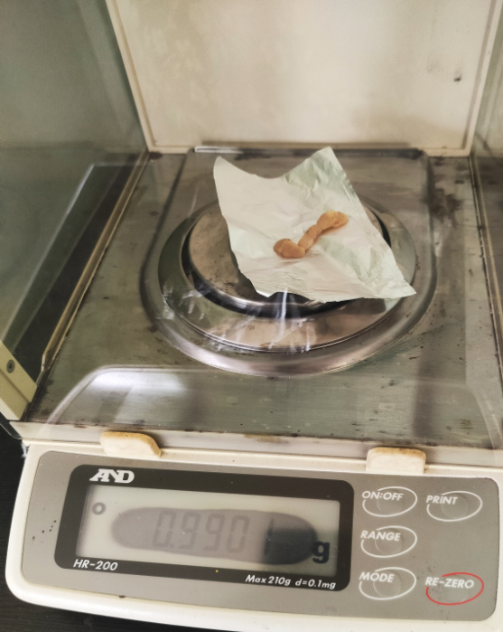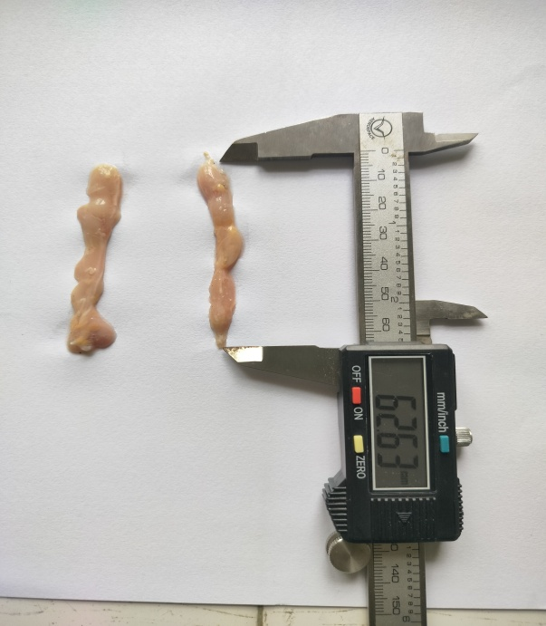
Fig 6: Photograph showing length of right thymus in 12 weeks old White Leghorn chicken

Fig 5: Photograph showing weight of right thymus in 8 weeks old White Leghorn chicken

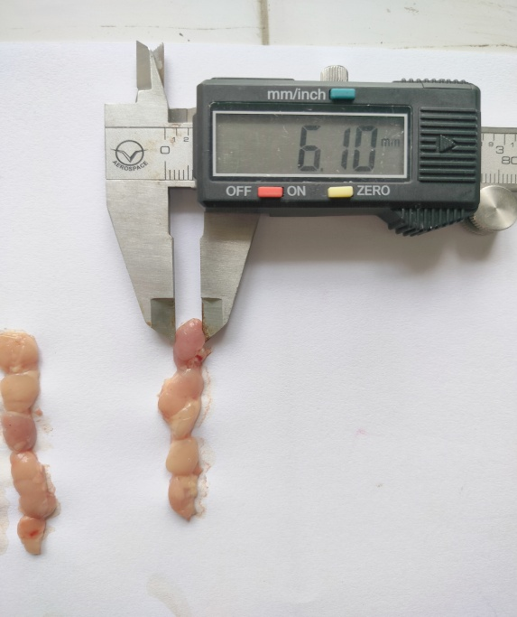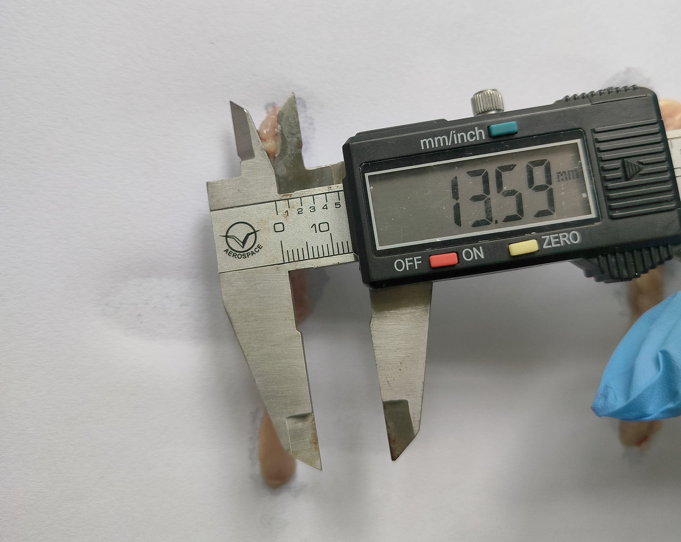
Fig 8: Photograph showing thickness of left thymus in 16 weeks old White Leghorn chicken

Fig 7: Photograph showing width of right thymus in 4 weeks old White Leghorn chicken

4. Conclusion
The weight of the White Leghorn chicken increased steadily from hatching to 24 weeks of age. Thymus weight rose until 12 weeks, then gradually declined. The left thymus was deeply located near the esophagus, trachea, blood vessels, and nerves, while the right thymus lay closer to the skin and farther from neck structures, extending from the third cervical vertebra to the upper thoracic region. Both thymuses were pink to creamy white, bean or button-shaped, and soft in texture. Thymus weight, width, and thickness peaked at 12 weeks, with the right thymus reaching maximum length at 12 weeks and the left at 20 weeks. The highest lobe count occurred at 8 and 16 weeks. By 24 weeks, thymic involution was complete, with lobes replaced by adipose tissue. This study provides insights into the development and involution of the thymus gland, which is crucial for evaluating the maturity of the immune system.
ETHICAL APPROVAL:
Prior to starting the experiment, approval was secured from the Institutional Animal Ethical Committee (IAEC) at the College of Veterinary Sciences, Central Agricultural University, Selesih, Aizawl, Mizoram, under Approval Reference Number CVSC/CAU/IAEC/23-24/P-17dated 29.07.2024.

Disclaimer (Artificial intelligence)
Option 1:
Author(s) hereby declare that NO generative AI technologies such as Large Language Models (ChatGPT, manuscript.
Option 2:
Author(s) hereby declare that generative AI technologies such as Large Language Models, etc. have been used during the writing or editing of manuscripts. This explanation will include the name, version, model, and source of the generative AI technology and as well as all input prompts provided to the generative AI technology
Details of the AI usage are given below:
1.
2.
3.

Reference

20th Livestock Census (2019). Department of Animal Husbandry, Dairying and Fisheries, Ministry of Agriculture, Govt. of India, Krishi Bhawan, New Delhi.

Aire, T.A. (1973). Growth of the bursa of Fabricius and thymus gland in the Nigerian and White Leghorn cockerel. Res. J.Vet. Sci., 15(3): 383-385.

Akter, S., Khan, M.Z.I., Jahan, M.R., Karim, M.R. and Islam, M.R. (2006). Histomorphological study of the lymphoid tissues of broiler chickens. BJVM., 4(2): 87-92.

Ali, H. K. (2016). Anatomical and histological study of thymus gland in the local breed of Turkey (Meleagris gallopavo) in Iraq. In 3rd scientific conference, College of Veterinary Medicine, University of Tikrit, pp: 93-97, 2nd and 3rd May 2016.

Ayman, U., Alam, M.R. and Das, S.K. (2020). Post-natal macro-and microscopic changes of the thymus of Sonali chicken in Bangladesh. JAVAR., 7(2): 324.

Bellamy, D. and Mohamed, K. (1982). A comparative study of age involution of the bursa of Fabricius and thymus in birds. Thymus, 4(2): 107-114.

Census Report, (2011). Census of India, Registrar General and Census Commissioner, India.Website:http://censusindia.gov.in/2011census/censussinfodashboard/stock/profiles/en/IND015 Mizoram pdf. Accessed on 16/06/2015.

Dahariya, N., Sathapathy, S., Mishra, U., Patra, R., Dehury, S., Joshi, S. and Jena, B. (2020) Gross morphological and biometrical studies on the thymus in various chicken genotypes. Haryana Vet., 60(1): 74-80.

Davison, F., Kaspers, B. and Schat, K.A. (2008). Avian Immunology. 1st edn., Acadmic Press Elsevier, London.

Economic Survey of Mizoram (2021-2022). Planning & Programme Implementation Department, Research & Development Branch, Govt. of Mizoram, pp. 60-63.

El-Zoghby, I.M.A and Attia H.F. (2007). Fine structure of the thymus gland in ostrich (Struthio camelus). The 31th Scientific Conference of the Egyptian Society of Histology and Cytology: 1-16.

Fadhilah, K., Erina, E. and Yaman, M.A. (2022). Observation of Thymus Regression Time of ALPU chicken. J. Med. Vet., 16 (2): 55-60.

Haseeb, A., Shah, M.G., Gandahi, J.A., Lochi, G.M., Khan, M.S., Faisal, M. and Oad, S.K. (2014). Histo-morphological Study on Thymus of Aseel chicken. J. Agric. Food Tech., 4(2): 1-5.

Hashimoto, Y. and Sugimura, M. (1976). Histological and quantitative studies on the postnatal growth of the thymus and the bursa of Fabricius of white Pekin ducks. JJVR., 24(3 4): 65-76.

Hussan, M.T., Khan, M.Z.I. and Lucky, N.S. (2009). Immunohistochemical study of the postnatal development of lymphoid tissues and mucosa of broilers. J. Vet. Med., 7(1): 253-258.

Islam, M.S., Kamruzzaman, M., Rahman, M. S., Ferdous, K. A., Juli, M.S.B. and Kabir, M.H. (2019). Effects of age on gross and microscopic changes of bursa of Fabricius and thymus of commercial broiler chicken. J. Entomol. Zool. Stud., 7(1): 184-189.

Jaksch, W. (1981). Euthanasia of day-old male chicks in the poultry industry. Int. J. Study Anim. Probl., 2(4): 203-213.

Jayachitra, S., Balasundaram, K., Sivagnanam, S., Jayachandran, S. and Arulmozhi, A. (2022). Age dependent gross morphological changes of thymus gland in Turkey (Meleagris gallopavo). J. Pharm. Innov., 11(7): 1520-1523.

Kanasiya, S.A., Kamore, S.K., Bahariya, R.K., Gupta, S.K. and Jatav, G.P. (2017). Gross anatomical studies on primary lymphoid organs (thymus and bursa of fabricius) of Kadaknath Birds. IJVSBT., 13(2): 73-76.

Kendall, M.D. (1980). Avian thymus glands: a review DCI, 4: 191-209.

Khan, M.Z.I., Masum, M., Khan, M.Z.I., Aziz, A.R., Nasrin, M., and Siddique, M.N.H. (2014). Histomorphology of the lymphoid tissues of broiler chickens in Kelantan, Malaysia (HistomorfologiTisuLimfaAyamPedaging di Kelantan, Malaysia). Sains Malays, 43(8): 1175-1179.

Kostaman, T. and Sopiyana, S. (2016). The differences in egg quality of white leghorn and naked neck chicken. In International Seminar on Livestock Production and Veterinary Technology.pp. 365-369, August 10th -12th, 2016. Indonesia, Bali, Denpasar.

Leena, C., Prasad, R.V., Kakade, K. and Jamuna, K.V. (2009). Age related histochemical changes of the bursa and thymus of domestic fowl. J. Vet. Anim. Sci., 40: 9-11.

Mahanta, D., Mrigesh, M., Sathapathy, S., Tamilselvan, S., Pandit, K. and Nath, S. (2018). Gross and morphometrical studies on the thymus, spleen and bursa of Fabricius of day old Kadaknath chick. J. Entomol. Zool. Stud., 6(3): 555-558.

Mclelland, J. (1990). A color atlas of avian anatomy. 1st ed. Wolfe Publishing Ltd. London. pp: 75-81.
Mešťanová, V. and Varga, I. (2016). Morphological view on the evolution of the immunity and lymphoid organs of vertebrates, focused on thymus. Biol., 71(10): 1080-1097.

Muthukumaran, C., Kumaravel, A., Balasundaram, K. and Paramasivan, S. (2011). Gross anatomical studies on the gallopavo). TNJVAS., 7(1): 6-11.

Nasser, R.A.A. (2019). Macroscopic and microscopic study of the thymus during mature and immature in local geese (Ansercygenoides). Biochem. Cell. Arch., 19(2): 3819-3824.

Nnadozie, O., Ikpegbu, E., Nlebedum, U.C. and Agbakwuru, I. (2019). Assessment of the morphological development of the caecal tonsil in turkey (Meleagris gallopavo). Anat. J. Afr., 8(1): 1431-1437.

Pereira, C.C.H., de Freitas, A.G., da Silva, M.C., Treichel, T.L.E., Calábria, K.C. and de Moraes, M. (2017). Morphology and biometry of the thymus in Gallus gallus domesticus (Linnaeus, 1758) from the isa brow lineage. Acta Vet. Bras., 11(4): 235-240.

Rahman, S. (2017). Status and constraints of backyard poultry farming in Mizoram. IJHF, 2017, Special Issue, pp: 76-82.

Romanoff, A.L. (1960). The avian Embryo: Structural and Functional development. The Macmillan Co., New York.

Sapcota D., Nahariya D. and Mahanta J.D (2014). Avian (Poultry) Production A Text Book. New India Publishing Agency, New Delhi.

Sawad, H.M.A.A. (2019). Anatomical and histological study of thymus glands in broiler chicks embryo (Gallus gallusdomesticus). Bas. J. Vet. Res., 18(1): 174-182.

Sultana, N., Khan, M.Z.I., Wares, M.A. and Masum, M.A. (2011). Histomorphological study of the major lymphoid tissues in indigenous ducklings of Bangladesh. BJVM, 9(1): 53-58.

Tarek, K., Mohamed, M., Omar, B. and Hassina, B. (2012). Morpho-Histological study of the thymus of broiler chickens during Post-Hashing Age. Int .J. Poult. Sci., 11(1): 78-80.

Treesh, S.A., Buker, A.O. and Khair, N.S. (2014). Histological, histochemical and immunohistochemical studies on thymus of chicken. Int. J. Histol. Cytol., 1(11): 103-11.

Yamada, J., Tanaka, H., Iwasa, K., Yamashita, T. and Misu, M. (1971). The growth of the lymphoid organs and the gonads in the Japanese quail (Coturnix coturnix japonica). Res. Bull. Obihiro. Univ., 7: 1-14.

