Original Research Article
Faunal diversity and abundance of syrphids in litchi and guava ecosystems, including a new record of Scaeva latimaculata (Brunetti, 1923) from the Shivalik Hills, Himachal Pradesh, India

Abstract
Aims: Himachal Pradesh is situated in the western Himalayas. Kangra district of the state, especially Shivalik hills are known to retain a rich treasure of climatic variability, favourable for diversified vegetation and insect fauna. This study assessed the abundance and diversity of syrphids (Diptera) in litchi and guava ecosystems.
Study design: Orchards were randomly divided into three replicates without a fixed design.
Place and Duration of Study:
Total six different locations in the Kangra district were surveyed from the year 2019 to 2020. Surveys on litchi were conducted during the year 2019 at Palampur, Nagrota Bagwan, Sulah, Saliana while on guava during 2020 at Palampur, Bharwar and Nurpur.
Methodology: Sweep net collections were preserved and identified. Species richness, relative abundance, diversity indices, and per cent contribution of syrphid fauna were calculated.
Results: Ten species across seven genera in two subfamilies (Eristalinae, Syrphinae) were recorded. In addition, Scaeva latimaculata (Brunetti, 1923) was reported for the first time from Kangra in litchi. Litchi exhibited greater diversity than guava, with higher species richness and diversity indices (Simpson, Shannon-Weiner: 1.98 vs 1.28; Pielou’s Evenness: 0.95 vs 0.92), indicating uniform species distribution and absence of dominance. Overall, Eristalini syrphids comprised 48.89% of specimens. Litchi attracted more Eristalini members, while guava attracted more Syrphini. Among locations, Nagrota Bagwan had the highest visitation (28.89%), while Saliana documented the lowest (5.56%). These records of syrphid flies from different sites will enrich the prevailing data on syrphid fauna and their spatial arrangement during their blooming periods within the two selected ecosystems i.e. litchi and guava.

Conclusion: Syrphids formed one of the major insect visitor groups and were anticipated to enhance pollination in the region. Litchi ecosystem was more diverse when compared to guava and indicated more uniform distribution of syrphid population. Eristalini outnumbered overall, though crop-specific trends emerged differently. Eristalini members dominated litchi, while Syrphini dominated guava. Spatial records from this study enhance baseline data on syrphid fauna and distribution patterns during bloom, though extended monitoring is recommended for validation.
Key words: Abundance, diversity, guava, litchi, species richness, syrphid
1. Introduction
Dipterans constitute an array of important flower visitors. The Syrphidae being one of Diptera's largest family approximately contain 6000 species in 180 genera worldwide (Pape and Thompson, 2017) and is considered to be very significant group of insects. They are distinguished from bees on the basis of having a single pair of wings. Like bees, many dipteran flies also forage for nectar and pollen and assist in pollination. Syrphidae members are known to be pollinators of many crops (Sutherland et al., 1999). A few species of syrphids eat pollen like bees but most of them only feed on nectar. About 199 genera of syrphid flies belonging to 3 subfamilies viz., Eristalinae, Microdontinae and Syrphinae are recognized worldwide (Mitra et al., 2004). Among them 355 species are currently recorded in India (Sengupta et al., 2016). The first extensive survey in Himachal Pradesh (HP) reflected 49 species of Syrphidae under 27 genera and 9 tribes (Sengupta et al., 2016).
Diversity studies are of paramount importance. Besides, morphological diversity, syrphids possess wider array of niches where they carry out different roles i.e. some larvae are saprophagous, some are mycetophagous, others are predatory on Hemipterans and Thysanopterans, and still others are plant-sucking. (Rotheray and Gilbert, 2011). Fly taxa are highly variable with respect to body size. Commonly hoverflies are characterized by a spurious vein, located parallel to the fourth longitudinal wing vein (Mukherjee et al., 2006). Owing to their dense body pilosity, syrphid flies effectively collect and transfer pollen across a broad range of floral species (Stavert et al., 2016). Flies, despite being present in various biomes, have been studied far less than bees (Larson et al., 2001). They can be as efficient as, or better than, bees for pollinating some crops (Orford et al., 2015), and are often responsible for transporting high pollen loads in both natural and modified systems.
Pollination is one of the most fascinating processes in the natural world and hoverflies are considered potential pollinating agents after honeybees (Rader et al., 2020). Increasing decline of pollinators around the world calls for abundance studies of various non-conventional and wild pollinators. Syrphid being one of the abundant insect visitors of many crop habitats sometimes also regarded as an ‘alternate pollinator’ hence, needs conservation. Studying syrphids in litchi and guava ecosystems of the Shivalik Hills is unique because it explores under documented, subtropical agro-ecosystems in the hill region, offering novel insights into syrphid diversity, pollination roles, and habitat-specific adaptations that have been largely overlooked in earlier studies (Doyle et al., 2020). The present proposal aimed at identifying diversity during the bloom periods of select crops in Shivalik hill range (350-650 m amsl).
Litchi and guava are highly cross-pollinated crops and need insects to assist with pollination. These are two important fruit crops of HP especially in Kangra district (Shivalik hills). Litchi is being grown in the state on an area of about 3.303 thousand ha with fruit production of 3.292 thousand MT while guava is being grown on 0.772 thousand ha and produces 0.521 thousand MT (Anonymous, 2018). Various syrphids visit their blooms along with prominent honeybee species. Present study, is therefore, intended to enhance the information on syrphid fauna from the state. This study is expected to offer an insight into the abundance of syrphid fauna as well as serve as an important tool to harness them as imperative pollinator in future.
2. Materials and methods
2.1 Study area
Studies were carried out at Bee Research Station, Nagrota Bagwan (Elevation: 870 m Coordinates: 32.1054° N, 76.3789° E) of Chaudhary Sarwan Kumar Himachal Pradesh Agriculture University, Palampur, District Kangra, Himachal Pradesh, India during 2019-20 to generate information on relative abundance of different syrphid fauna in guava and litchi.
2.2 Crops and sites surveyed
In the first year (2019), observations were taken on litchi crop while in the succeeding year, 2020, similar observations were taken on guava. Species richness and diversity indices were then assessed for both the ecosystems. The field studies for litchi (var. Culcuttia) were conducted at Palampur, Nagrota Bagwan, Sulah and Saliana while for guava (var. Allahabad Safeda) at Palampur, Bharwar and Nurpur of the Kangra district (Fig. 1).
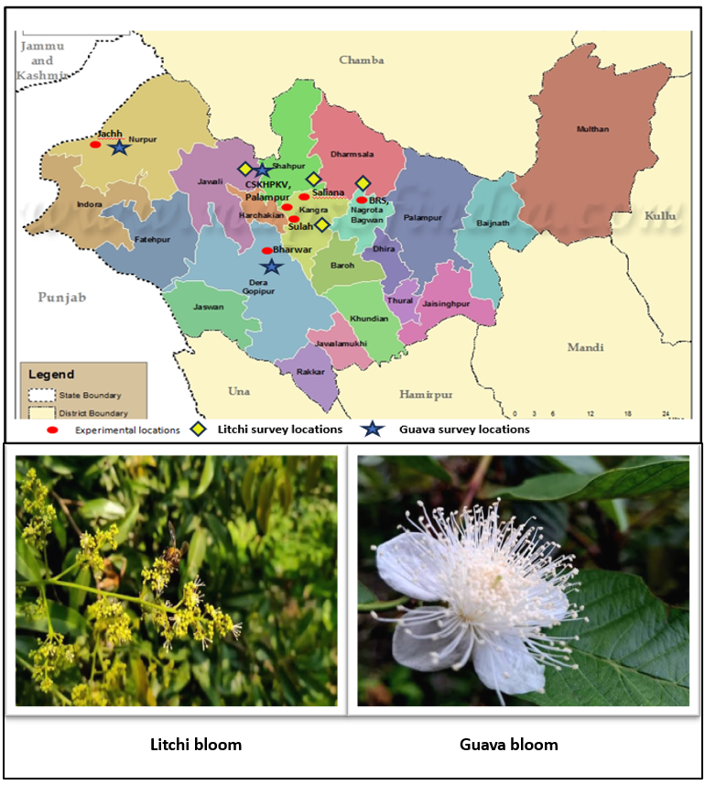
Fig. 1. Map of Kangra, Himachal Pradesh showing the experimental locations with litchi and guava ecosystems

2.2 Visual records and sweep net collection
Bloom periods for both the ecosystems were noted down. Visual observations were recorded as number of syrphids visiting blooms of litchi and guava trees. The data was recorded in three replications (chosen randomly in the orchard of each site without any fixed design) twice a week from early to full blooming periods (Thangjam et al., 2018).
A total number of visiting insects/m²/minute on the randomly selected canopy area of each tree during morning (1000-1100 hours) and evening hours (1400-1500 hours) were counted as per method by Amin et al., 2018 with slight modifications. The branches of these trees were chosen in such a manner (4 branches covering 1 m² area), that they had approximately the same dimensions with respect to their spread, phase of flowering, number of flowers and height above ground, covering all possible directions (Anita et al., 2012; Kaur and Sharma, 2020).
Sweep net method was used preferentially for their collection. Both dry and wet methods of collection (in 70 % Ethyl alcohol) were considered. All the specimens were first poisoned with Ethyl acetate in an air tight killing jar, and later carried back to the laboratory. Then, they were carefully mounted on insect pins, labelled and kept in the collection box for further preservation. For close up photographs of pinned insects NIKON COOLPIX L310 21X optical zoom camera and Canon SX740 HS camera were used alternatively. The collected specimens from each site were got identified with help of taxonomists at ICAR-IARI, New Delhi.
2.3 Species richness (S) and Relative abundance (%)
Species richness was quantified as the total number of distinct species present within the ecosystem under study while relative abundance of each species was calculated using the following formula by Das and Jha (2018):

$$Relative abundance \left(\%\right)=\frac{(Population of a specific species (ith) visiting flowers)}{(Total population of all species visiting flowers)}×100$$

2.4 Determination of diversity indices:
Three diversity measures were used in this study with the assumption that individuals are sampled randomly from an infinitely large population at different locations.

    - Shannon-Wiener diversity index (H´)
The Shannon-Wiener diversity index, as detailed by Shannon and Weaver 1949, is widely used since it considers both species richness and evenness and computed by using the following formula:
 |  | _{S}
H' | = - | ∑ | (p_{i}) | (log₂p_{i})
 |  | i=1

2.4.2 Simpson Index (D)
The Simpson Index which measures the diversity score of a community based on richness and evenness was used because; Shannon-Wiener diversity index alone cannot be used to compare habitats that differ greatly in species richness. Following formula was used:

 |  |  | S
D | = | 1- | ∑ | (p_{i})²
 |  |  | i=1

    - Pielou’s evenness index (J')
It describes the individual’s equipartition in the habitat. It is ranging from 0 (no evenness) to 1 (complete evenness). The value nearer to one demonstrates more uniform distribution of sampled population. It was estimated by employing succeeding formula:

J' = H'/ H_{max}
Where,
H'= Shannon-Wiener diversity index
p_{i}= Proportion of total sample belonging to the i^{th} species.
S= Total number of species present in an ecosystem i.e. Species richness.
∑= Sum from species 1 to species S
D= Simpson’s index of diversity.
n= Frequency of a species or number of organisms of a species
J'= Evenness of allotment of individuals among the species i.e. Pielou’s evenness index.
H_{max} = Maximum species diversity (H') = Log₂S
2.5 Statistical analysis
The data collected as Species richness, Relative abundance, Diversity and Evenness indices of hoverflies were studied under two different ecosystems and calculated with the help of Microsoft Excel 2019. Ecological network (Fig. 8) based upon syrphid species of two ecosystems was framed out using R studios version 2025. Diversity profile was worked out by PAST 4.03 (Hammer et al., 2001) software to check the variation in species distribution.
3. Results
3.1 Bloom duration
Bloom in Culcuttia variety of litchi was observed on 4th of April in 2019 with its peak bloom on 12th of April and termination of flowering period noticed on 28th April, 2019. During this year due to incessant rains and prevailing low temperature, the flower initiation was delayed as it usually appears in February-March.
In guava variety Allahabad Safeda, flower initiation was observed on 26th of April and blooming continued up to 3rd June during the year 2020 at Nurpur. Flower initiation in guava at Palampur site in the same variety was seen on 1st May and terminated on 8th of June, 2020.
3.2 Predominant species and richness
A total of ten species framework was recorded (with two of them are shared in both sampling ecosystems) in six different locations of Shivalik hill region in district Kangra. These ten species were identified as Eristalodes paria (Bigot, 1880); Eristalis tenax L., 1758; Eoseristalis arbustorum L., 1758; Eristalinus arvorum F., 1787; Scaeva latimaculata (Brunetti, 1923); Episyrphus balteatus (De Geer, 1776); Melanostoma sp.; Episyrphus viridaureus (Wiedemann, 1824); Eristalis sp. and Paragus sp. (Table 5 and Fig. 5, 6 and 7).
Among two different types of ecosystems i.e. litchi and guava, there had been an evident difference in species composition of syrphids. Litchi in the year 2019, attracted eight hoverfly species belonging to four tribes under two subfamilies (Table 1), on the contrary guava during the year 2020, attracted only four hoverfly species belonging to three tribes of the two subfamilies under family Syrphidae. For the first time Scaeva latimaculata species was recorded from Kangra district in litchi. During the field survey, all the six samples were recorded from litchi orchards of Sulah location, in the year 2019. In both the ecosystems, two species i.e. Eristalis tenax and Episyrphus viridaureus were common belonging to Eristalini and Syrphini tribes of the Eristalinae and Syrphinae subfamilies under family Syrphidae, respectively.
Table 1. Syrphid diversity of litchi and guava at different locations of Kangra district in 2019-2020
Litchi
Sr. No. | Location | Insect species
1. | Sulah | Eristalodes paria
 |  | Melanostoma sp.
 |  | Scaeva latimaculata
2. | Palampur | Eristalis tenax
3. | Saliana | Eristalinus arvorum
4. | Nagrota Bagwan | Eoseristalis arbustorum
 |  | Episyrphus balteatus
 |  | Episyrphus viridaureus
Guava
Sr. No. | Location | Insect species
1. | Palampur | Eristalis tenax
2. | Bharwar | Eristalis sp.
 |  | Paragus sp.
3. | Nurpur | Episyrphus viridaureus

Investigations revealed that, out of total (n=90), litchi had 57 while guava had 33 syrphids, consequently litchi ecosystem was more visitor-frequent. Species richness in litchi ecosystem was recorded more (S=8) as compared to guava ecosystem (S=4). On comparing all the collected species, Eristalis tenax and Episyrphus viridaureus were found to be the most predominant visitors while Eristalodes paria and Eristalis sp. were among the least abundant (Table 2). The per cent relative abundance (Fig. 3) shows distribution trends of syrphid fauna in both the ecosystems, together.

Fig. 3. Per cent relative abundance of Syrphid fauna in litchi and guava during 2019-2020
Table 2. Abundance and species richness of Syrphid fauna from Kangra district of Himachal Pradesh during 2019-20
Sr. No. | Syrphid species | Subfamily | Tribe | #Ecosystem |  | *Frequency | Relative Abundance %
 |  |  |  | Litchi | Guava
1. | Eristalodes paria | Eristalinae | Eristalini | 3 | 0 | 3 | 3.33
2. | Eristalis tenax | Eristalinae | Eristalini | 13 | 11 | 24 | 26.67
3. | Eoseristalis arbustorum | Eristalinae | Eristalini | 9 | 0 | 9 | 10.00
4. | Eristalinus arvorum | Eristalinae | Eristalini | 5 | 0 | 5 | 5.56
5. | Eristalis sp. | Eristalinae | Eristalini | 0 | 3 | 3 | 3.33
6. | Scaeva latimaculata | Syrphinae | Syrphini | 6 | 0 | 6 | 6.67
7. | Episyrphus balteatus | Syrphinae | Syrphini | 10 | 0 | 10 | 11.11
8. | Melanostoma sp. | Syrphinae | Bacchini | 4 | 0 | 4 | 4.44
9. | Episyrphus viridaureus | Syrphinae | Syrphini | 7 | 12 | 19 | 21.11
10. | Paragus sp. | Syrphinae | Paragini | 0 | 7 | 7 | 7.78
 | Total |  |  | 57 | 33 | 90

#Each value for particular crop ecosystem represents total no. of individuals of a species observed.
*Frequency represents total individuals in two ecosystems collectively.

3.3 Contribution subfamily-wise, tribe-wise and location wise
Both the subfamilies i.e. Eristalinae and Syrphinae had 50 per cent share in the recorded sampling. Among the four tribes, Eristalini had the maximum share of species (48.89 %) followed by Syrphini (38.89 %), followed by Paragini (7.78 %) while least number of species was represented by Bacchini (4.44 %). Fig. 2 highlight the tribe-wise distribution of syrphid fauna in litchi and guava ecosystems collectively. Species belonging to Eristalinae subfamily are more abundant in litchi ecosystem while those belonging to Syrphinae subfamily are more abundant in guava ecosystem. Results also highlighted Nagrota Bagwan (28.89 %) to be the most frequently visited location, followed by Palampur (26.67 %) and Sulah (14.45 %) while Sulah was documented richest, with syrphid fauna belonging to three different tribes in comparison to any other location (Table 4).
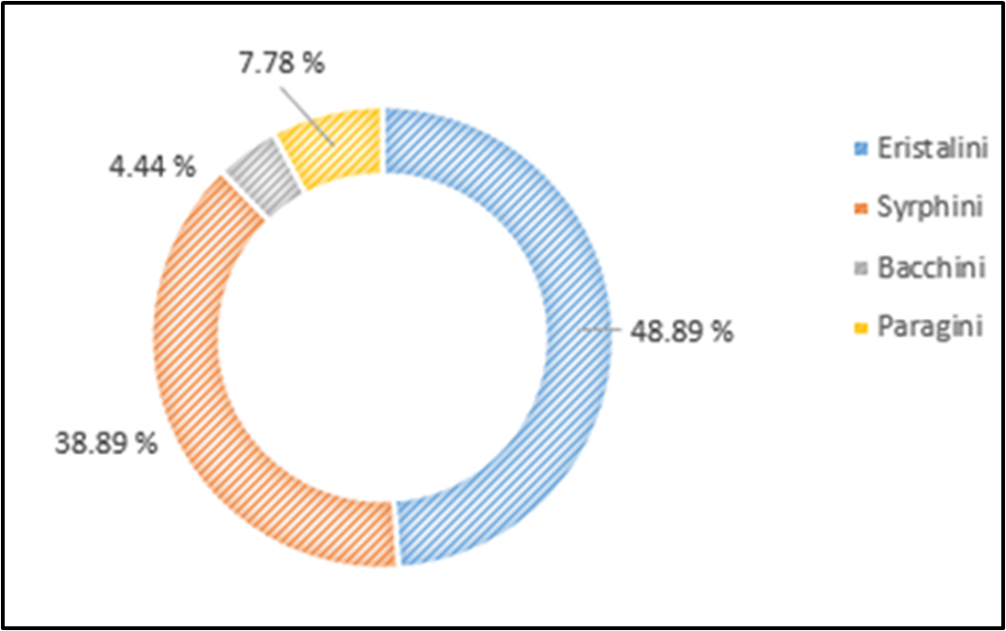

Fig. 2. Tribe-wise distribution of Syrphid fauna in litchi and guava during 2019-2020

3.4 Diversity indices

The data yielded on diversity and evenness indices (Table 3) depicted species diversity and their distribution at two chosen horticultural ecosystems. The dominance of species was observed by, Simpson Index which recorded higher value for litchi ecosystem (0.85) than guava ecosystem (0.71). The Shannon-Weiner diversity index (Fig. 4) also registered higher value for litchi ecosystem (1.98) when compared to guava ecosystem (1.28). These results indicated that litchi ecosystem was more diverse. Pielou’s Evenness value estimated for litchi ecosystem showed a value 0.95, which was found to be comparatively higher than guava (0.92). This straight away suggested that all species in litchi ecosystem have uniform distribution while large disparity between numbers of individuals within each species existed in guava ecosystem.
Table 3. Diversity indices of syrphids observed during survey at Kangra district of Himachal Pradesh during 2019-20
Ecological indices | Ecosystems
Ecological indices | Litchi | Guava
Shannon-Weiner diversity index (H´) | 1.98 | 1.28
Pielou’s Evenness index (J´) | 0.95 | 0.92
Simpson’s index (D) | 0.85 | 0.71

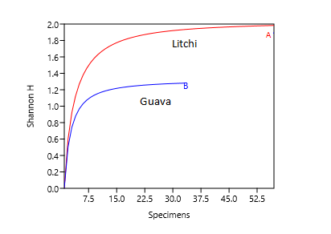
Fig. 4. Diversity profile of different species of syrphids in Kangra district (made using PAST 4.03 statistical software)

Table 4. Location wise distribution of syrphid fauna at Kangra district of Himachal Pradesh during 2019-20
Sr. No. | Location | Ecosystem |  | Frequency | Relative Abundance %
 |  | Litchi | Guava
1. | Palampur | 13 | 11 | 24 | 26.67
2. | Nagrota Bagwan | 26 | 0 | 26 | 28.89
3. | Sulah | 13 | 0 | 13 | 14.45
4. | Saliana | 5 | 0 | 5 | 5.56
5. | Bharwar | 0 | 10 | 10 | 11.12
6. | Nurpur | 0 | 12 | 12 | 13.34
 | Total | 57 | 33 | 90

Table 5. Checklist of syrphids (Tribe-wise) recorded from different locations at Kangra district of Himachal Pradesh during 2019-20
Sr. No. | Insect |  | Locations
 | Tribe | Species | Palampur | Nagrota Bagwan | Sulah | Saliana | Bharwar | Nurpur
1. | Eristalini | Eristalodes paria | − | − | + | − | − | −
 |  | Eristalis tenax | + | − | − | − | − | −
 |  | Eoseristalis arbustorum | − | + | − | − | − | −
 |  | Eristalinus arvorum | − | − | − | + | − | −
 |  | Eristalis sp. | − | − | − | − | + | −
2. | Syrphini | Scaeva latimaculata | − | − | + | − | − | −
 |  | Episyrphus balteatus | − | + | − | − | − | −
 |  | Episyrphus viridaureus | − | + | − | − | − | +
3. | Bacchini | Melanostoma sp. | − | − | + | − | − | −
4. | Paragini | Paragus sp. |  | − | − |  | + | −
+ = presence; − = absence.

Fig. 5. Hoverflies reported from Kangra district of Himachal Pradesh (India)
a. Eristalodes paria b. Eristalis tenax c. Eoseristalis arbustorum
d. Eristalinus arvorum

Fig. 6. Hoverflies reported from Kangra district of Himachal Pradesh (India)
a. Scaeva latimaculata b. Episyrphus balteatus c. Melanostoma sp.
d. Episyrphus viridaureus

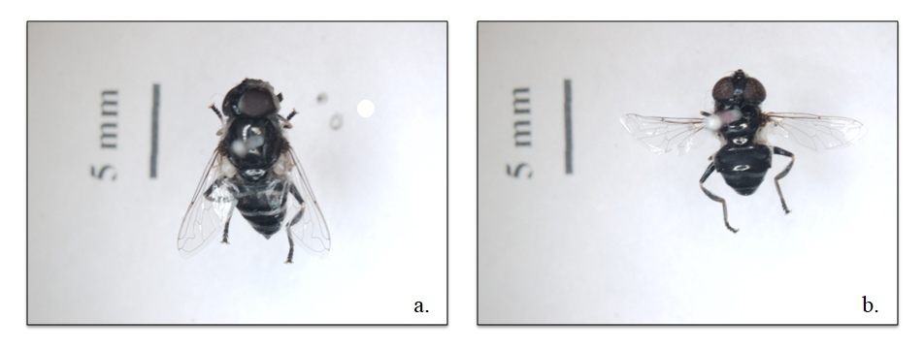
Fig. 7. Hoverflies reported from Kangra district of Himachal Pradesh (India)
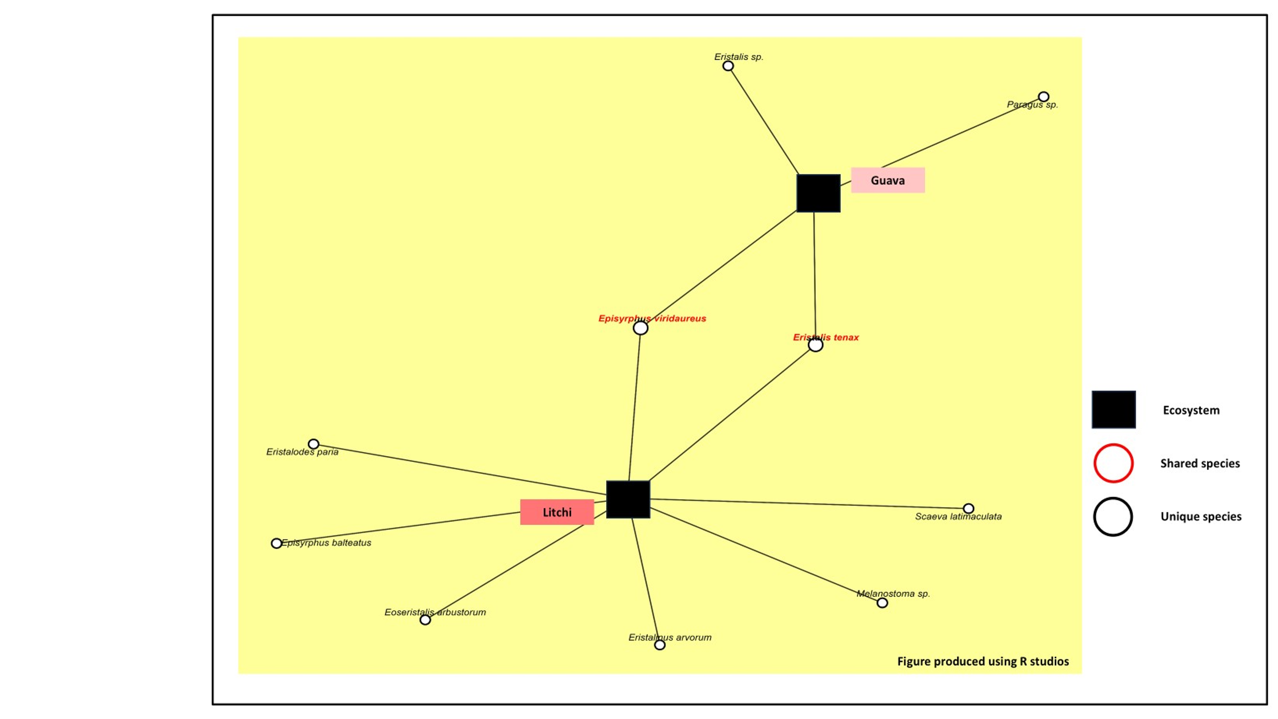
- Eristalis sp. b. Paragus sp.

Fig. 8. Ecological network of different hoverfly species in litchi (2019) and guava (2020) ecosystems in Kangra district of Himachal Pradesh (India)
4. Discussion
During the survey on syrphid flies in HP (India), in 2019-20, eight different species from litchi were collected as important bloom visitors. In a similar study by Wahid and Singh, 2024 in Bihar, total four different species (belonging to Syrphidae) were collected which constituted around 14.52 % of the total visitors in litchi. Kumari et al., 2023 documented 24 % Diptera visitors in litchi out of all the insect visitors in litchi blooms from Kangra, HP.
Similar studies on litchi were confirmed by Das et al., 2019 where they recorded five species i.e., Episyrphus balteatus, Eristalis sp., Syrphus sp., Sacrcophaga sp. and Lucilia sericata under Diptera. Furthermore, results on diversity of syrphid flies by Sajjad et al., 2010 and Khan and Hanif, 2016 were quite similar to our findings. These authors identified 16 and 14 species from Pakistan, respectively.
Among two different types of ecosystems i.e. litchi and guava, there had been an evident difference in species composition of syrphids. Litchi attracted eight hoverfly species belonging to four tribes under two subfamilies, on the contrary guava, attracted only four hoverfly species belonging to three tribes of the two subfamilies under family Syrphidae. This reflected the suitable composition of different food sources in the former ecosystem and healthiness of surrounding environment although the fluctuations in counts maybe accounted to several differences one of which maybe time frame for observing records. On comparing all the collected species, Eristalis tenax and Episyrphus viridaureus were more frequent visitors while Eristalodes paria and Eristalis sp. were declared least present. This again could be due to different reasons; out of them preferential aspects of species can be prominent ones. Weather conditions including, temperature, relative humidity and altitude differed as both the field records were taken in different years and different sites. As the current study did not correlate weather parameters to the documented estimates, it does not highlight the clear reason for different compositions. Khan, 2017 at Kashmir, established Eristalis tenax as the most distributed syrphid species in the floricultural ecosystem, which supports our results. But as per Srivastava et al., 2017, in litchi blooms at Muzaffarpur, Bihar, other than Apis genera important visitors were Episyrphus balteatus, Syrpus sp, Erisyrphus sp, etc.
Both the subfamilies of our study i.e. Eristalinae and Syrphinae had 50 per cent share in the recorded sampling. These results corroborated with Khan and Hanif, 2016. Among the four tribes, Eristalini had the maximum share of species (48.89 %) followed by Syrphini (38.89 %), followed by Paragini (7.78 %) while least number of species was represented by Bacchini (4.44 %). In a similar study by Karki et al., 2024, a total of eighteen insect species among the recorded insects in litchi, the order Diptera was the most abundant, accounting for 51.12% of the total, and was represented by five families: Syrphidae, Sarcophagidae, Calliphoridae, Muscidae, and Tachinidae.
Species belonging to Eristalinae subfamily are more abundant in litchi ecosystem while those belonging to Syrphinae subfamily are more abundant in guava ecosystem. A study on litchi pollinators conducted at Haripur (Pakistan) explicitly mentions three species from Eristalis genus (from Eristalini), as their regular bloom visitors by (Ali et al., 2013).
The diversity and evenness indices depicted species diversity and their distribution at two given horticultural ecosystems. The abundance of species in litchi when compared to guava was evident by, Simpson Index, Shannon-Weiner diversity index. While our study documented Shannon diversity index value of 1.98 in the litchi, Dubey et al., (2020) from Nepal and Kumari et al., (2023) from Kangra, HP found 1.07 and 1.15 values respectively. This showed that there is always variation from location to location depending upon crop, weather and time of sampling.
In our study, Pielou’s Evenness value estimated for litchi (0.95), which was found to be comparatively higher than guava (0.92). Often Evenness value closer to 1 shows uniform distribution of species. As, litchi ecosystem showed a higher value than guava it suggested that all species in litchi ecosystem had even distribution than the guava ecosystem. Thangjam et al., 2019, in a similar way conducted his trial for comparison of ecosystems, in which they professed horticultural ecosystem as more diversified, which supports our findings. These deviations may be attributed to so many factors, few out of them being the time, specific crop and weather factors. Provided the magnitude of study area and repetitions conducted, such a study needs more refinement. Although this study covers biodiversity aspect, exhaustive studies on syrphid utilization as important pollinating agents needs to be harnessed in future.
5. Conclusion
The present study assessed the abundance and diversity of syrphid flies in litchi and guava ecosystems across six locations in Kangra district from 2019 to 2020. In the study Syrphids were concluded as prominent floral visitors with total of ten species from seven genera, spanning two subfamilies Eristalinae and Syrphinae. Notably, Scaeva latimaculata was recorded for the first time in litchi from the Kangra region. The litchi ecosystem exhibited greater syrphid diversity with a species richness of 8, compared to 4 in guava. This was supported by higher values of Simpson’s Index (0.85 vs. 0.71), Shannon-Weiner Index (1.98 vs. 1.28), and Pielou’s evenness (0.95 vs. 0.92), indicating a more diverse and uniformly distributed syrphid community in litchi. Members of Eristalini syrphids dominated the overall fauna (48.89%), with crop-specific variation; Eristalini prevailing in litchi and Syrphini in guava. Among the surveyed sites, Nagrota Bagwan showed the highest visitation (28.89%), followed by Palampur (26.67%) and Sulah (14.45%). Sulah also recorded the highest tribe-level richness. These findings contribute valuable insights into the diversity and distribution of syrphid flies in relation to fruit crops, supporting their ecological importance in agroecosystems.
6. Future thrusts
Future studies may include aspects pertaining to monitoring of hoverflies in a continuous manner for underscoring hidden biases towards fluctuating counts. Comparing their pollination potential with bees and concluding points based on their quality of produce is a potential work to be followed up.
Acknowledgements

The authors are highly thankful to CSKHPKV, Bee Research Station, Nagrota Bagwan, HP for the required facilities and infrastructure. Invaluable reviewing by all the co-authors and support extended in the identification of insect samples by a team of taxonomists at IARI is gratefully acknowledged. Especially, Dr. Debjani Dey is acknowledged for timely species level identification.
Competing interests
No potential conflict of interest (financial or non-financial) was reported by the authors.
Authors’ contributions
‘Author AS = Akash Sharma’ conducted the study, managed the literature searches and wrote the initial draft. ‘Author SKS = Surender Kumar Sharma’ designed the study and supervised in the statistical analysis. ‘Author SP = Shivani Parmar’ proof read the manuscript. All authors read and approved the final manuscript.
Disclaimer (Artificial intelligence):
Author(s) hereby declare that NO generative AI technologies such as Large Language Models (ChatGPT, COPILOT, etc) and text-to-image generators have been used during writing or editing of this manuscript.
References
Ali S, Shehzad A, Rafi MA and Zia A. Insect pollinators of litchi (Litchi chinensis) from district Haripur, Pakistan. Pakistan J Agric Res. 2013;26(3):220-229.
Amin D, Ahmad M, Shifa, Ibrahim S. Insect pollinator diversity in major traditional leafy vegetables kale (Brassica oleracea var. acephala) and knol-khol (Brassica oleracea var. gongylodes) of Kashmir Himalayas. Int J Curr Microbiol Appl Sci. 2018;7(3):3082-9. doi:10.20546/ijcmas.2018.703.358
Anita M, Sivaram V, Jayaramappa KV. Influence of bee attractants on pollination and yield parameters in guava (Psidium guajava L.). Int J Plant Reprod Biol. 2012;4(1):13-6.
Anonymous. Horticulture Area Production Info System. Ministry of Agriculture and Farmers' Welfare. 2018. Accessed 21 Dec 2018. Available: https://agriwelfare.gov.in/Documents/Horticulture%20Statistics%20at%20a%20Glance-2018.pdf.
Das R, Jha S. Record of insect pollinators and their abundance on Indian mustard (Brassica juncea L.) in New Alluvial Zone of West Bengal. J Pure Appl Biosci. 2018;6(5):848-53.
Das R, Jha S, Halder A. Insect pollinators of litchi with special reference to foraging behavior of honeybees. Int J Pharmacogn Phytochem Res. 2019;8(4):396-401.
Hammer Ø, Harper DAT, Ryan PD. PAST: Paleontological statistics software package for education and data analysis. Palaeontol Electron. 2001;4(1):19-20.
Karki N, Kattel IP. Diversity and relative abundance of insect visitors of litchi (Litchi chinensis Sonn.) at Baisjagar, Tanahun, Nepal. Agro-Environ Sustain. 2024;2(3):133-8.
Kaur H, Sharma SK. Foraging fidelity of honeybees and abundance of insect visitors on some horticultural crops. Int J Chem Stud. 2020;8(3):1974-8. doi:10.22271/chemi.2020.v8.i3aa.9494.
Khan AA. Distribution, relative abundance, species diversity and richness of syrphid flies in floricultural ecosystem of Kashmir. J Curr Microbiol Appl Sci. 2017;6(9):1539-52.
Khan SA, Hanif H. Diversity and fauna of hoverflies (Syrphidae) in Chakwal, Pakistan. Int J Zool. 2016;1(1):22-3.
Kumari P, Rana S, Bhargava B, Reddy SE. Diversity, abundance and impact of insect visitors in Litchi chinensis production. Agronomy. 2023;13(2):298.
Larson BMH, Kevan PG, Inouye DW. Flies and flowers: Taxonomic diversity of anthophiles and pollinators. Can Entomol. 2001;133:439-65.
Mitra B, Parui P, Sharma RM. A preliminary study on the Dipteran flower visitors/pollinators of Himachal Pradesh. Ann For. 2004;12(1):119-24.
Mukherjee M, Parui P, Mitra B. Insecta, Diptera, Syrphidae. Fauna of Arunachal Pradesh. State fauna series. 2006;13(2):331-54.
Orford KA, Vaughan IP, Memmott J. The forgotten flies: The importance of non-syrphid Diptera as pollinators. Proc R Soc B Biol Sci. 2015;282:20142934. doi:10.1098/rspb.2014.2934.
Pape T, Thompson FC. Systema Dipterorum (version 2.0, Jan 2011). In: Roskov Y, Abucay L, Orrell T, Nicolson D, Kunze T, Culham A, et al., editors. Species 2000 and ITIS Catalogue of Life, 29 Oct 2014. Leiden (Netherlands): Species 2000: Naturalis. Available: http://www.catalogueoflife.org/col.
Rai VL, Srivastava P, Bisht K, Mishra VK. Diversity and relative abundance of pollinating insects visiting litchi (Litchi chinensis Sonn.) inflorescence under Tarai agro-climatic condition. J Exp Zool India. 2017;20(1):221-7.
Rotheray GE, Gilbert F. The natural history of hoverflies. Tresaith (UK): Forrest Text; 2011.
Sajjad A, Saeed S, Ashfaq M. Seasonal variation in abundance and composition of hoverfly (Diptera: Syrphidae) communities in Multan, Pakistan. Pak J Zool. 2010;42(2):105-15.
Sengupta J, Naskar A, Maity A, Hazra S, Banerjee D. New distributional records and annotated keys of hoverflies (Insecta: Diptera: Syrphidae) from Himachal Pradesh, India. J Adv Zool. 2016;37(1):31-54.
Sengupta J, Naskar A, Maity A, Hazra S, Mukhopadhyay E, Banerjee D, et al. An updated distributional account of Indian hoverflies (Insecta: Diptera: Syrphidae). J Entomol Zool Stud. 2016;4(6):381-96.
Shannon CE, Weaver W. The mathematical theory of communication. Urbana (IL): University of Illinois Press; 1949.
Srivastava K, Sharma D, Pandey SD, Anal AKD, Nath V. Dynamics of climate and pollinator species influencing litchi (Litchi chinensis) in India. Indian J Agric Sci. 2017;87(2):266-9.
Stavert JR, Liñán-Cembrano G, Beggs JR, Howlett BG, Pattemore DE, Bartomeus I. Hairiness: The missing link between pollinators and pollination. PeerJ. 2014;4:e2779.
Sutherland JP, Sullivan MS, Poppy GM. The influence of floral characters on the foraging behavior of the hoverfly, Episyrphus balteatus. Entomol Exp Appl. 1999;93:157-64.
Thangjam R, Kadam V, Ningthoujam K, Sorokhaibam M. Hoverflies of Assam (Diptera: Syrphidae): New records and their diversity. J Entomol Zool Stud. 2019;7(4):965-9.
Wahid F, Singh BKP. Diversity and relative abundance of insect visitors to litchi inflorescence with special reference to the foraging behaviour of honeybee (Apis mellifera L.). Entomon. 2024;49(1):135-40.

