Review Article

Artificial intelligence and Internet of things in sericulture: Transforming sustainability, efficiency, and rural livelihoods

.
ABSTRACT

Sericulture remains a vital source of livelihood and a custodian of traditional knowledge in rural economies, particularly in Asia. However, the sector continues to grapple with persistent challenges such as climate variability, pest outbreaks, labour dependency, and inconsistent cocoon quality—factors that undermine its global competitiveness and sustainability. Recent advancements in Artificial Intelligence (AI), Machine Learning (ML), Internet of Things (IoT), and drone technologies offer promising avenues to modernise and future-proof sericulture. These tools facilitate early disease detection, predictive yield forecasting, automated cocoon grading, and real-time environmental monitoring, thereby enhancing operational efficiency across the value chain. Integration of smart technologies not only improves cocoon quality and productivity but also enables precision pest management and optimised resource utilisation, contributing to reduced chemical input and water use. Nonetheless, the sector faces barriers including high initial costs, limited digital literacy, and infrastructural constraints, which must be systematically addressed to ensure inclusive and scalable adoption. Strategic investments in policy support, research and development, and farmer capacity building are essential to unlock the full potential of these innovations. Embracing digital transformation will enable sericulture to align with global sustainability targets, meet the rising demand for eco-friendly and traceable silk products, and evolve into a resilient, technology-enabled industry that empowers rural communities and reinforces its role in the global textile economy.

Keywords: Artificial Intelligence, IoT, Drone technology, Smart sericulture, Disease detection

1. INTRODUCTION

Sericulture, encompassing mulberry cultivation and silkworm rearing, plays a crucial role in rural livelihoods across Asia, particularly in India, which is the second-largest silk producer globally [1,2]. This agro-based, labour-intensive activity not only sustains rural economies but also contributes to preserving traditional knowledge and practices associated with silk production [2]. However, despite its socioeconomic significance, the sector faces persistent challenges including climate variability, pest outbreaks, labour dependence, and inconsistent cocoon quality, all of which limit its global competitiveness and reduce the ability of farmers to realise stable incomes [3,4].
The impacts of climate change, such as irregular rainfall patterns, temperature fluctuations, and increased incidence of pest infestations, further exacerbate the vulnerabilities faced by sericulture farmers, affecting mulberry leaf quality and silkworm health, which are critical for high-quality cocoon production [1,3]. With the increasing global demand for sustainable, traceable silk products aligned with eco-conscious consumer preferences, there is an urgent need to transform the sericulture sector through modernisation and technology integration to enhance its resilience and competitiveness [5,6].
Advanced technologies, including Artificial Intelligence (AI) and Machine Learning (ML), have demonstrated significant promise in predictive analytics, disease detection, and automated grading within broader agricultural systems, offering avenues for improved operational efficiency and decision support in sericulture as well [4,7,8,9]. By applying AI and ML models to sericulture, it becomes possible to detect foliar diseases in mulberry crops, predict silkworm disease outbreaks, and support data-driven decisions for timely interventions, thereby reducing crop losses and ensuring consistent cocoon yield [4,8,9].
The Internet of Things (IoT) offers additional potential by enabling real-time monitoring of rearing environments, such as maintaining optimal temperature, humidity, and carbon dioxide levels within silkworm rearing houses, which is essential for silkworm health and for mitigating climate-related risks [10,11]. This technology allows for continuous data collection and analysis, empowering farmers to adjust management practices promptly to prevent disease outbreaks or environmental stresses [5,11].
Drone technology is another critical enabler for precision sericulture, facilitating targeted pesticide application, mulberry crop monitoring, and field surveillance, thereby reducing manual labour requirements while improving pest management practices [12,13,14]. The integration of drones with IoT systems enables comprehensive monitoring of mulberry crop health and canopy coverage, supporting timely interventions to enhance leaf quality and availability for silkworm rearing [12,14].
However, the ethical deployment of AI within agriculture, including sericulture, requires careful consideration of privacy, inclusivity, and transparency to ensure that technological advancements do not widen socioeconomic disparities within rural communities [8,15]. The goal should be to utilise AI, ML, IoT, and drone technologies in a manner that promotes environmental sustainability while equitably benefiting smallholder sericulture farmers and empowering them through accessible technology adoption pathways [5,8,16].
With these evolving opportunities, it becomes imperative to evaluate the potential of integrating advanced technologies within the sericulture sector, addressing the challenges associated with traditional practices while aligning production with the global demand for sustainable and high-quality silk products [5,6]. This review thus critically examines the prospects of AI, IoT, and drone technologies in transforming sericulture towards enhanced productivity, quality consistency, and climate resilience, contributing to sustainable rural livelihoods and the global silk economy.

- AI AND ML APPLICATIONS IN SERICULTURE

  - Disease Detection and Pest Management
AI and ML models enable rapid disease detection in mulberry and silkworm rearing, which is critical for preventing yield losses and ensuring the economic viability of sericulture [4,7]. By leveraging advanced image processing and convolutional neural network (CNN) techniques, early detection of foliar diseases such as leaf spot, powdery mildew, and other fungal infections in mulberry plantations is now feasible, enabling timely and targeted interventions that significantly reduce chemical pesticide use and associated costs [5,17,18]. AI-powered foliar disease identification has been shown to reduce crop loss by up to 20% and minimise pesticide use by 18%, thereby lowering production costs and environmental impact [4].
For silkworms, the application of AI in visually analysing larval conditions and cocoon quality has shown effectiveness in detecting diseases such as grasserie and pebrine, reducing mortality rates while enhancing productivity [4,9]. Advanced pest prediction models using ML algorithms can also forecast pest outbreaks, including the uzi fly, by analysing climatic parameters, thus supporting integrated pest management (IPM) frameworks in sericulture for proactive, data-driven interventions [1,5]. In one study, predictive models integrated with pest traps and weather data reduced uzi fly infestations by 30%, leading to improved cocoon survival and reduced dependency on chemical sprays [5].

  - Predictive Analytics and Yield Forecasting
AI-driven models predict cocoon yields using climatic data, rearing parameters, and historical datasets, aiding farmers in scheduling and planning resource allocation with greater accuracy and efficiency [19,20]. These models can incorporate factors such as temperature, humidity, mulberry leaf availability, and silkworm health indicators, allowing for dynamic forecasting that supports timely decision-making in resource management and labour allocation [19]. Such predictive analytics not only help in anticipating yield fluctuations due to seasonal variations but also in identifying optimal rearing windows to maximise cocoon quality and quantity [20].
Predictive systems are increasingly being integrated with IoT sensors for real-time data collection, which improves model accuracy and responsiveness by providing continuous environmental and physiological data [10,11]. This integration enables the models to adjust predictions dynamically as new data is captured, enhancing their reliability under varying climatic conditions [10]. Additionally, IoT-based monitoring facilitates early detection of anomalies, allowing corrective actions that help in reducing losses and improving overall productivity within sericulture operations [11]. By leveraging AI-driven predictive analytics combined with IoT systems, sericulture can transition towards a more data-driven, resilient, and profitable enterprise.

- IoT IN SMART SERICULTURE

  - Environmental Monitoring
IoT-based systems allow continuous monitoring of temperature, humidity, and CO₂ levels within rearing houses, supporting optimal environmental conditions essential for healthy silkworm development and consistent cocoon production [10,11,21,22,23,24]. Maintaining stable environmental parameters through real-time monitoring reduces climate-related risks, supports silkworm health, and enhances cocoon quality and yield, thereby addressing challenges posed by fluctuating weather conditions (Figure 1) [21,25]. Studies have shown that IoT-enabled rearing environments can reduce silkworm mortality by up to 17% due to better thermal and humidity regulation [11,22). Furthermore, optimized conditions have resulted in a 12–15% increase in average cocoon weight and an improvement in silk filament length consistency [10].
Additionally, these IoT-based monitoring frameworks facilitate early warning systems for environmental anomalies, allowing immediate corrective actions and minimising production losses [10,23]. Integration of 6LoWPAN protocols and image processing further advances environmental and disease monitoring, automating the detection of anomalies in rearing conditions and reducing the reliance on manual monitoring [11,18]. These technologies collectively enhance operational efficiency while ensuring the sustainability and scalability of sericulture practices under varying climatic scenarios [10,24].

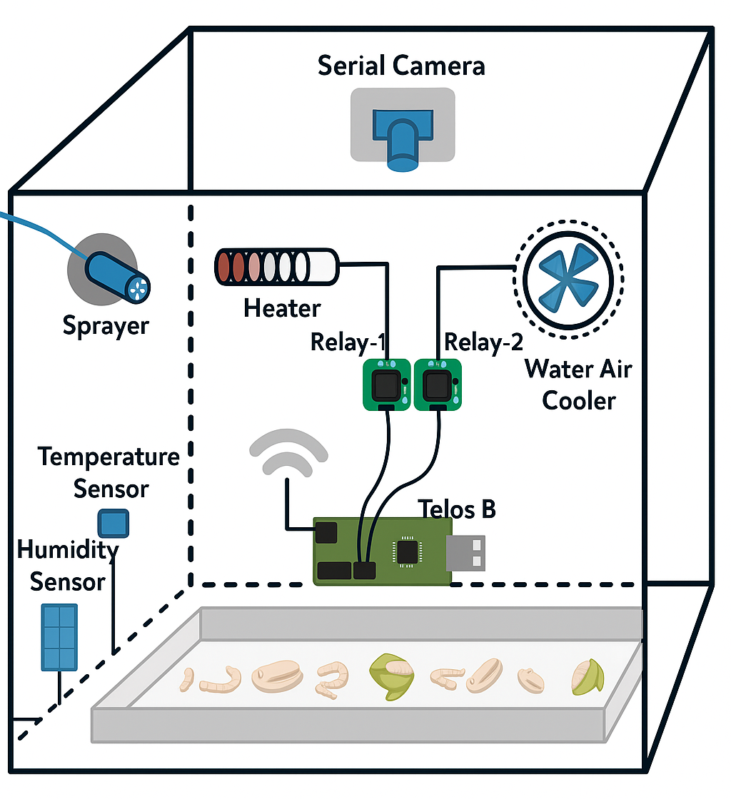
Figure 1. Smart sericulture system prototype showing integrated environmental monitoring and alert mechanisms for optimized silkworm rearing conditions [22].

  - GIS and Remote Sensing Applications
Geospatial technologies support site selection, mulberry crop health monitoring, and pest hotspot mapping, providing valuable spatial and temporal data to optimise sericulture practices [2,9,26]. These technologies assist in identifying suitable areas for mulberry cultivation by analysing soil type, moisture content, and climate conditions, ensuring better crop performance and resource utilisation [9,26].
Additionally, GIS and remote sensing facilitate continuous monitoring of mulberry crop health, enabling the detection of stress factors such as pest infestations, water deficiencies, and disease outbreaks at an early stage [2,26]. The SILKS system employs GIS and remote sensing to provide site-specific advisories, supporting sericulturists in making informed decisions regarding pest management, irrigation scheduling, and fertiliser application [2]. By incorporating these spatial tools, sericulture can enhance productivity, minimise risks associated with climate variability, and contribute towards sustainable sericulture practices aligned with precision farming initiatives [2,9]. The overall workflow of GIS and remote sensing applications in sericulture, from data acquisition to spatial decision-making, is illustrated in Figure 2.

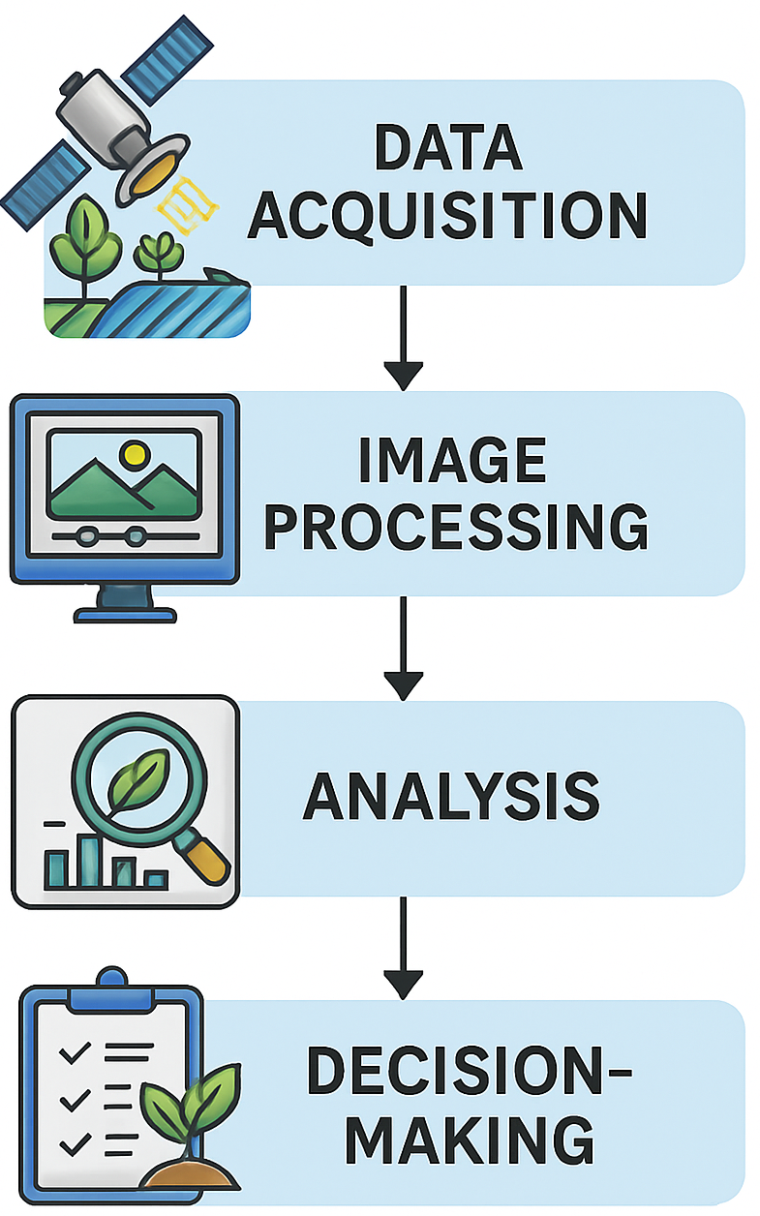

Figure 2. Workflow of GIS and remote sensing applications in sericulture, showing the sequence from spatial data acquisition to image processing, analysis, and decision-making for site selection, crop health monitoring, and precision management (Source: Author’s own illustration).

- DRONE APPLICATIONS IN SERICULTURE
Drone technologies facilitate mulberry plantation monitoring, pest detection, and precision pesticide application, reducing labour while enhancing effectiveness in sericulture [12,13,14]. The use of drones enables rapid assessment of large mulberry fields, detecting variations in plant health and soil moisture levels, which is crucial for timely irrigation management and pest control interventions [27]. Drones equipped with high-resolution cameras assist in monitoring canopy health, leaf density, and pest outbreaks, facilitating data-driven decisions for integrated pest management (IPM) and ensuring effective pesticide usage while minimising environmental impacts [14,27]. The drone monitoring process, from aerial image capture to targeted field action, is illustrated in Figure 3, highlighting its role in delivering timely and precise interventions in sericulture.

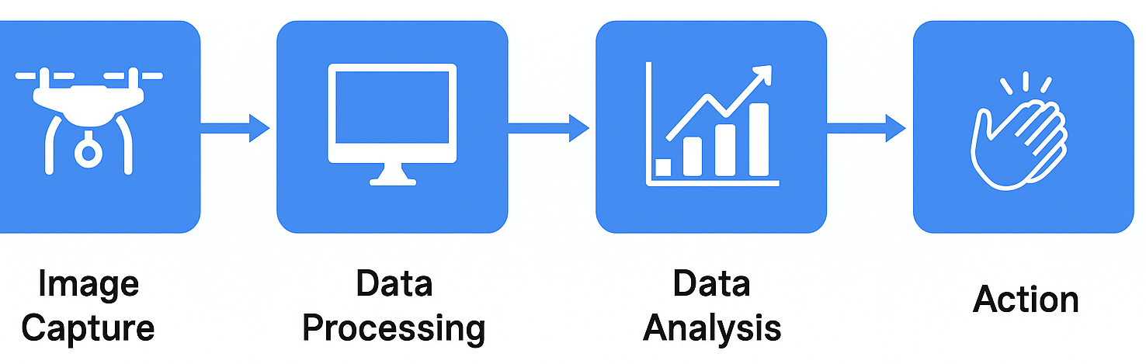

Figure 3. Flowchart illustrating the drone monitoring process in smart sericulture, from aerial image capture to data processing, analysis, and targeted field action. This workflow supports rapid pest detection, crop health assessment, and precision management strategies (Source: Author’s own illustration).

The integration of drones with IoT frameworks further strengthens real-time monitoring and targeted interventions in sericulture, aligning with precision agriculture practices adopted in other sectors [28]. Additionally, drones can be utilised for mapping disease hotspots within plantations, enabling focused rearing and crop management strategies to reduce disease spread and increase operational efficiency [12,13,14]. Table 1 provides a comparative overview of AI, IoT, and drone applications in sericulture, highlighting their distinct strengths, use-cases, and constraints across the value chain.

Table 1: Comparison of AI, IoT, and Drone Applications in Sericulture

Technology | Application Area | Benefits | Limitations | References
AI | Disease detection, Yield forecasting, Grading | Early detection, better planning, automation | Requires high computing power, data expertise | [4,8,9]
IoT | Environmental monitoring, Yield optimisation | Real-time data, early warnings | Connectivity, cost | [10,11]
Drones | Pest monitoring, Leaf health monitoring | Precision spraying, labor-saving | Regulatory barriers, training needed | [12,14]

- CASE STUDIES AND INDUSTRY APPLICATIONS
Reshamandi’s establishment of Asia’s second-largest silk cocoon mandi demonstrates the potential of technology-driven market systems in sericulture, integrating digital platforms to enhance transparency, price realisation, and stakeholder participation across the value chain [29,30]. This initiative showcases how digital interventions can bridge gaps between farmers and buyers, creating a seamless supply chain that ensures fair pricing, quality traceability, and real-time inventory management, significantly empowering sericulture farmers while aligning with market demands [29].
Automated cocoon grading systems using vibration impact acoustic emission analysis have further transformed post-harvest operations in sericulture, improving grading accuracy while reducing manual drudgery and variability in cocoon sorting processes [31,32]. By enabling objective, standardised quality assessments, these technologies assist farmers in receiving fair prices for their produce while enhancing the quality of raw silk extracted by reeling units [32]. The deployment of such systems also addresses inefficiencies in manual sorting, reduces the workload on labourers, and minimises human errors in grading [31].
Image processing-based systems have similarly advanced cocoon sorting and disease detection practices, enabled rapid and consistent assessment of cocoon quality while facilitated early detection of infections (Figure 4) [33]. By integrating these systems, sericulture operations can maintain high-quality standards and reduce disease-related losses, thus enhancing the economic sustainability of silk production while ensuring product consistency for downstream processes [33].

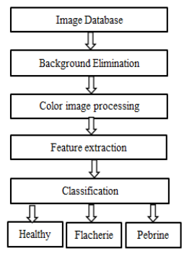
Figure 4. Diagram illustrating the image processing workflow for sericulture [22].

In parallel, automated silkworm egg counting systems using image processing techniques have been developed to improve accuracy and reduce manual errors in grainages and seed production centres, facilitating efficiency in the early stages of sericulture operations [34]. These systems assist in handling large volumes of silkworm eggs with precision, reducing the labour-intensive nature of traditional egg counting and mitigating inconsistencies caused by manual counting methods [34]. Further advancements in this area have incorporated enhanced image processing algorithms and automated workflows to improve counting accuracy, operational efficiency, and handling speed in silkworm egg management, building upon earlier systems to reduce manual dependency and enhance productivity in grainages [35].
Collectively, these case studies highlight the transformative impact of technology integration across the sericulture value chain—from seed production to cocoon grading and market integration—demonstrating practical pathways towards achieving smart, efficient, and quality-focused sericulture systems [29,30,31,32,33,34,35].

- CHALLENGES AND CONSTRAINTS

  - Economic and Infrastructure Constraints
High initial investments in AI, IoT, and drone systems remain a significant barrier for smallholder sericulture farmers who often operate with limited financial resources and risk-bearing capacities [5,6,16]. The cost of acquiring and maintaining advanced technological tools, coupled with the need for supporting infrastructure such as sensors, connectivity modules, and data management systems, can be prohibitive for individual farmers and small cooperatives, especially in developing regions where sericulture is a primary livelihood [5].
Additionally, inadequate rural connectivity and irregular power supply further hinder the effective utilisation of these technologies, limiting the scalability of smart sericulture initiatives across diverse geographies [5,22,36,37]. Even in regions where pilot projects have demonstrated the potential of AI and IoT integration, the lack of a robust supply chain for maintenance and servicing of devices often leads to operational discontinuities and underutilisation of the deployed systems [6]. Addressing these economic and infrastructural barriers requires systematic policy support, the establishment of shared technology hubs, and financing models that reduce the financial burden on smallholders while encouraging adoption.

  - Technical Literacy
Limited technical skills and digital literacy among farmers present another critical constraint in the widespread adoption of AI, IoT, and drone technologies in sericulture [15,38]. Effective utilisation of these advanced tools necessitates a fundamental understanding of data interpretation, sensor handling, and device maintenance, which many sericulture practitioners currently lack, especially in rural contexts where education levels may be lower [15]. This gap in technical literacy can result in underutilisation or misuse of devices, reducing their intended benefits and discouraging further adoption [38].
Moreover, the complexity of interpreting AI-driven analytics for disease detection, environmental monitoring, and yield forecasting can be daunting for farmers unfamiliar with digital platforms, leading to a reliance on intermediaries and reducing the independence of smallholder operations [38]. To overcome these challenges, it is essential to implement targeted training programs and capacity-building initiatives tailored to local contexts, fostering digital confidence among farmers and ensuring they can leverage technological advancements effectively to improve productivity and sustainability in sericulture [15,38].
These challenges, although significant, are not insurmountable. Strategic solutions tailored to the needs of smallholder sericulture farmers can address the barriers to technology adoption and unlock the full potential of AI, IoT, and drone integration. Table 2 summarises the key challenges and corresponding mitigation strategies. Addressing these challenges through targeted interventions can foster inclusive adoption of smart technologies, ensuring that innovation in sericulture benefits even the most resource-constrained farming communities.

Table 2: Challenges vs Proposed Solutions in Smart Sericulture

Challenges | Description | Proposed Solution
High Initial Cost | Expensive hardware and infrastructure inaccessible to small farmers | Shared tech hubs, government subsidies, public–private financing schemes
Infrastructure Gaps | Poor internet, unreliable power in rural areas | Use of solar-powered systems, low-power devices, offline-capable tech
Low Digital Literacy | Limited skills to operate or interpret data from AI/IoT systems | Farmer training programs, multilingual mobile apps, visual-based alert systems
Maintenance & Support | Lack of repair and support services in remote areas | Local servicing units, training rural youth in tech maintenance
Data Privacy Concerns | Farmers wary of how data is collected and used | Transparent data policies, farmer consent models, community data ownership frameworks

  - Cross-Sectoral Insights from AI and IoT Adoption in Agriculture
The successful integration of AI and IoT in other agricultural sectors—such as cotton, tea, and horticulture—provides strong validation for their applicability in sericulture [39,40]. In cotton farming, AI-supported IoT systems have been shown to detect and classify insect pests with high accuracy (70–98%), helping farmers deliver targeted interventions against pests like whitefly, pink bollworm, and American bollworm, thereby enhancing yield stability and reducing unnecessary pesticide use [41]. Dalmia et al. (2020) demonstrated the deployment of an AI-driven pest monitoring system in Indian cotton farms, where deep learning models were used to interpret trap images, improving spraying accuracy and reducing excessive pesticide application. Such systems have achieved pest identification accuracies ranging from 90% to 98%, confirming the suitability of AI for integrated pest management (IPM) strategies in cotton cultivation [42].
In horticulture, IoT-based irrigation and decision-support systems have demonstrated substantial water savings. For example, sensor-driven irrigation using soil moisture, temperature, and humidity data yielded up to 34% water reduction in field trials in Rajasthan, India [43]. Other implementations of machine-learning enabled irrigation scheduling systems in agricultural settings have reported water savings of up to 50–60%, along with improved resource efficiency and crop management [44]. In tea plantations, drone-assisted multispectral imaging combined with AI-based classification models has been successfully used to map disease incidence and crop stress in real-time. Such systems offer high-resolution insights into leaf health and infestation zones, enabling precision management and harvest planning (e.g. over 80% accuracy in identifying disease-affected zones) [45].
These advancements underscore how climate-sensitive and labour-intensive crops—like those in sericulture—can benefit significantly from digital transformation.
A recent comprehensive review found that deep learning and IoT–enabled pest detection systems across multiple cropping systems routinely achieve over 90% classification accuracy, reducing labour and enabling more targeted interventions—both factors essential for increasing resilience under climatic stress and pest pressure [46]. By drawing on these proven examples, the sericulture sector can avoid common implementation barriers (such as low detection accuracy or infrastructure gaps) and adapt best practices for precision farming, data-driven decision support, and resource optimisation—tailored to small holder farmer contexts. Reviews in precision agriculture emphasize the necessity of designing AI/IoT systems that are low-power, farmer-centric, and context-specific—highlighting that deployment success hinges on combining technological accuracy with inclusive usability and local infrastructure compatibility [41,47,48].

- FUTURE PROSPECTS AND STRATEGIC ROADMAP
The integration of blockchain for silk supply chain transparency, coupled with AI for pest prediction and quality grading, can transform sericulture towards precision and sustainability [5,49]. Automated cocoon sex identification using fluorescence [50,51] and advanced image-based disease detection [52,53] can enhance productivity and breeding efficiency, supporting consistent supply of high-quality silk. The broader application of AI in agriculture demonstrates challenges such as data privacy, technical literacy, and high initial investment, which are also relevant for its effective integration into sericulture systems and require systematic addressing for successful deployment [5,54].
Additionally, the Central Silk Board’s policy frameworks and annual strategies support the adoption of advanced technology in sericulture, aligning with national goals for sustainable rural development while empowering farmer communities [2,55]. Collaboration between government, research institutions, and private sectors will accelerate the transition towards smart sericulture, ensuring inclusive growth and positioning India to meet rising global demands for sustainable and traceable silk products [5,37,56].

- Conclusion

AI, IoT, and drone technologies have the potential to transform sericulture by enhancing disease detection, environmental monitoring, cocoon grading, and operational efficiency, supporting consistent quality and higher productivity. However, addressing challenges related to cost, infrastructure, and technical literacy is essential to ensure inclusive adoption and meaningful impact across smallholder farmers and sericulture clusters. Leveraging technological innovations alongside targeted policy support will enable sericulture to align with global sustainability goals while strengthening rural livelihoods and competitiveness in the silk sector. As global markets shift toward eco-friendly and traceable textile products, integrating these advanced technologies can position sericulture to meet evolving consumer demands. Strategic investments in research, capacity building, and public-private partnerships will be key to realising this transformation while ensuring environmental sustainability and economic resilience. By embracing these advancements, sericulture can secure its place as a modern, sustainable industry that uplifts rural communities and contributes to the broader goals of climate-smart agriculture and circular economies in textile value chains.

Disclaimer (Artificial intelligence)
Option 1:
Author(s) hereby declare that NO generative AI technologies such as Large Language Models (ChatGPT, COPILOT, etc.) and text-to-image generators have been used during the writing or editing of this manuscript.

References

- Rahmathulla VK. Management of climatic factors for successful silkworm (Bombyx mori L.) crop and higher silk production: a review. Psyche: A Journal of Entomology. 2012; 2012(1), 121234.
- Singh PS, Handique BK, Chutia D, Das PT, Goswami J, Goswami C, Prabhakar CJ, Dhanraj K, Raju PLN. Conceptualization and development of Sericulture Information Linkages and Knowledge System (SILKS). Journal of Geomatics. 2016; 10(2), 108-113.
- Mahadeva A. Insect pest infestation, an obstacle in quality mulberry leaves production. Asian J. Biol. Sci. 2018; 11(1), 41-52.
- Nadaf HA, Vishaka GV, Chandrashekharaiah M, Rathore MS, Srinivas C. Scope and potential applications of artificial intelligence in tropical tasar silkworm Antheraea mylitta D. seed production. J. Entomol. Zool. Stud. 2021; 9, 899-903.
- De Abreu CL, van Deventer JP. The application of artificial intelligence (AI) and internet of things (IoT) in agriculture: A systematic literature review. In Southern African Conference for Artificial Intelligence Research. 2022; 32-46. Springer, Cham.
- Saikia S, Saikia M. Smart Sericulture and IoT: A Review. In Biological Forum–An International Journal. 2023; 1(15), 1545-549.
- Eli-Chukwu NC. Applications of artificial intelligence in agriculture: A review. Engineering, Technology & Applied Science Research. 2019; 9(4).
- Wang Y, Fu EY, Zhai X, Yang C, Pei F. Introduction of artificial intelligence. In Intelligent building fire safety and smart firefighting. 2024; 65-97. Cham: Springer Nature Switzerland.
- Sharma R. Artificial intelligence in agriculture: a review. In 2021 5th international conference on intelligent computing and control systems (ICICCS). May, 2021; 937-942. IEEE.
- Doloi A, Barkataki N, Saikia M, Saikia D. Development of a wireless sensor network based smart multiple ambient conditions sensing system for the rearing process of eri silkworm. International Journal of Advanced Technology and Engineering Exploration. 2019; 6(52), 50-60.
- Prathibha SR, Hongal A, Jyothi MP. IoT based monitoring system in smart agriculture. In 2017 international conference on recent advances in electronics and communication technology (ICRAECT). March, 2017; 81-84. IEEE.
- Ahirwar S, Swarnkar R, Bhukya S, Namwade G. Application of drone in agriculture. International Journal of Current Microbiology and Applied Sciences. 2019; 8(01), 2500-2505.
- Mogili UR, Deepak BBVL. Review on application of drone systems in precision agriculture. Procedia computer science. 2018; 133, 502-509.
- Subramanian KS, Pazhanivelan S, Srinivasan G, Santhi R, Sathiah N. Drones in insect pest management. Frontiers in Agronomy. 2021; 3, 640885.
- Cockburn IM, Henderson R, Stern S. The impact of artificial intelligence on innovation: An exploratory analysis. In The economics of artificial intelligence: An agenda. 2018; 115-146. University of Chicago Press.
- Sut, R., Kashyap, B., & Naan, T. (2024). Applications of Artificial Intelligence in Sericulture. Advances in Research on Teaching, 25(4), 430-438.
- Al Bashish D, Braik M, Bani-Ahmad S. Detection and classification of leaf diseases using K-means-based segmentation and. Information technology journal. 2011; 10(2), 267-275.
- Schrickte LF, Montez CB, Oliveira RSD, Pinto ASR. Design and implementation of a 6LoWPAN gateway for wireless sensor networks integration with the internet of things. International Journal of Embedded Systems. 2016; 8(5-6), 380-390.
- Borah K, Saikia D, Kakati P, Pun KB, Hazarika PP. Dynamic Agriculture: Problems and Way Forward Volume–II. 2025.
- Srikantaiah KC, Deeksha A. Mulberry leaf yield prediction using machine learning techniques. In 3rd International Conference on Integrated Intelligent Computing Communication & Security (ICIIC 2021). September, 2021; 393-398. Atlantis Press.
- Srinivas B, Kumari K, Reddy G, Niranjan N, Hariprasad SA, Sunil MP. IoT based automated sericulture system. Int J Recent Technol Eng (IJRTE). 2019; 8(2).
- Deepthi HS, Sastry AS. Image processing based smart sericulture system using IoT. International Journal of Advances in Agricultural Science and Technology. 2021; 8(9), 23-31.
- Friha O, Ferrag MA, Shu L, Maglaras L, Wang X. Internet of things for the future of smart agriculture: A comprehensive survey of emerging technologies. IEEE/CAA Journal of Automatica Sinica. 2021; 8(4), 718-752.
- Quy VK, Hau NV, Anh DV, Quy NM, Ban NT, Lanza S, Randazzo G, Muzirafuti A. IoT-enabled smart agriculture: architecture, applications, and challenges. Applied Sciences. 2022; 12(7), 3396.
- Rokhade S, Guruprasad MK, Mallesh MS, Banu S, Jyoti SN, Thippesha D. Smart sericulture system based on IoT and image processing technique. In 2021 International Conference on Computer Communication and Informatics (ICCCI). January, 2021; 1-4. IEEE.
- Sharma K, Kapoor B. Sericulture as a profit-based industry—a review. Indian journal of pure and Applied biosciences. 2020; 8(4), 550-562.
- Li WQ, Han XX, Lin ZB, Rahman A. Enhanced pest and disease detection in agriculture using deep learning-enabled drones. Acadlore Transactions on AI and Machine Learning. 2024; 3(1), 1-10.
- Slimani H, El Mhamdi J, Jilbab A. Drone-assisted plant disease identification using artificial intelligence: A critical review. International Journal of Computing and Digital Systems. 2023; 14(1), 10433-10446.
- Anonymous. Retrieved from https://www.indiaretailer.com/news/reshamandi- expands-offline-presence-opens-asia-s-2nd-largest- silk-cocoon-mandi. 13198 on 17th Oct, 2022.
- Pyingkodi M, Thenmozhi K, Nanthini K, Karthikeyan M, Palarimath S, Erajavignesh V, Kumar GBA. Sensor based smart agriculture with IoT technologies: a review. In 2022 international conference on computer communication and informatics (ICCCI). January, 2022; 1-7. IEEE.
- Prasobhkumar PP, Francis CR, Gorthi SS. Cocoon quality assessment system using vibration impact acoustic emission processing. Engineering in Agriculture, Environment and Food. 2019; 12(4), 556-563.
- Prasobhkumar P, Francis CR, Gorthi SS. Automated quality assessment of cocoons using a smart camera-based system. Engineering in agriculture, environment and food. 2018; 11(4), 202-210.
- Reddy BL, Bhaskar M. Smart Sericulture System using Image Processing. International Journal of Engineering Research and Technology (IJERT). 2022; 11(01).
- Pathan SS, Harale AD. Silkworm Egg Counting System Using Image Processing Algorithm-A Review. International Research Journal of Engineering and Technology (IRJET). 2016; 3(06).
- Pavitra HV, Raghavendra CG. An overview on detection, counting and categorization of silkworm eggs using image analysis approach. Global Transitions Proceedings. 2022; 3(1), 285-288.
- Dawn N, Ghosh T, Ghosh S, Saha A, Mukherjee P, Sarkar S, Guha S, Sanyal T. Implementation of Artificial Intelligence, Machine Learning, and Internet of Things (IoT) in revolutionizing Agriculture: A review on recent trends and challenges. International Journal of Experimental Research and Review. 2023; 30, 190-218.
- Dhanapriya, M. (2025). Development of an AI-Integrated Smart Sericulture System for Climate-resilient Silk Production in India. Asian Journal of Environment & Ecology, 24(6), 141-158.
- Oliveira RCD, Silva RDDSE. Artificial intelligence in agriculture: benefits, challenges, and trends. Applied Sciences. 2023; 13(13), 7405.
- Dutta H, Dutta S, Yadav H, Prabhu IG, Roy A, Chowdary NB, Das S. A Promising and Forward-Looking Advancement Using Drones: Perspectives from Indian Sericulture. Rural and Regional Development. 2024; 2(3), 10014.
- Singh R, Singh R, Gehlot A, Akram SV, Priyadarshi N, Twala B. Horticulture 4.0: adoption of industry 4.0 technologies in horticulture for meeting sustainable farming. Applied Sciences. 2022; 12(24), 12557.
- Kiobia DO, Mwitta CJ, Fue KG, Schmidt JM, Riley DG, Rains GC. A review of successes and impeding challenges of IoT-based insect pest detection systems for estimating agroecosystem health and productivity of cotton. Sensors. 2023; 23(8), 4127.
- Dalmia A, White J, Chaurasia A, Agarwal V, Jain R, Vora D, Dhame B, Dharmaraju R, Panicker R. Pest management in cotton farms: an AI-system case study from the global south. In Proceedings of the 26th ACM SIGKDD international conference on knowledge discovery & data mining. August, 2020; 3119-3127.
- Kaur A, Bhatt DP, Raja L. Developing a hybrid irrigation system for smart agriculture using IoT sensors and machine learning in Sri Ganganagar, Rajasthan. Journal of Sensors. 2024; 2024(1), 6676907.
- Glória A, Cardoso J, Sebastião P. Sustainable irrigation system for farming supported by machine learning and real-time sensor data. Sensors. 2021; 21(9), 3079.
- Yuan L, Yu Q, Zhang Y, Wang X, Xu O, Li W. Monitoring Thosea sinensis Walker in Tea Plantations Based on UAV Multi-Spectral Image. Phyton. 2023; (0031-9457), 92(3).
- Ejaz MH, Bilal M, Habib U. Crop Pest Classification Using Deep Learning Techniques: A Review. arXiv preprint arXiv:2507.01494. 2025.
- Ahmed S, Marwat SNK, Brahim GB, Khan WU, Khan S, Al-Fuqaha A, Koziel S. IoT based intelligent pest management system for precision agriculture. Scientific Reports. 2024; 14(1), 31917.
- Rajak P, Ganguly A, Adhikary S, Bhattacharya S. Internet of Things and smart sensors in agriculture: Scopes and challenges. Journal of Agriculture and Food Research. 2023; 14, 100776.
- Abeyratne SA, Monfared RP. Blockchain ready manufacturing supply chain using distributed ledgerInternational journal of research in engineering and technology. 2016; 5(9), 1-10.
- Thomas S, Thomas J. A review on existing methods and classification algorithms used for sex determination of silkworm in sericulture. In International Conference on Intelligent Systems Design and Applications. December, 2020; 567-579. Cham: Springer International Publishing.
- Zhang Y, Yu X, Shen W, Ma Y, Zhou L, Xu N, Yi S. Mechanism of fluorescent cocoon sex identification for silkworms Bombyx mori. Science China Life Sciences. 2010; 53(11), 1330-1339.
- Thomas S, Thomas J. Non-destructive silkworm pupa gender classification with X-ray images using ensemble learning. Artificial Intelligence in Agriculture. 2022; 6, 100-110.
- Xiong H, Cai J, Zhang W, Hu J, Deng Y, Miao J, Tan Z, Hua L, Cao J, Wu, X. Deep learning enhanced terahertz imaging of silkworm eggs development. Iscience. 2021; 24(11).
- Vijayreddy D. Cultivating Crop Health in the Digital Era: Harnessing AI for Plant Pathology. Agri Tech Today. 2023; 1(9), 33-35.
- Anonymous. Annual Report 2020-21. Central Silk Board, Ministry of Textiles, Government of India. 2021.
- Qadir J, Islam T, Sudan N, Aryan S. Grass Root innovations for Better Performance of Sericulture Industry. In Biological Forum–An International Journal. 2023; 4(15), 996-999.

