EVALUATION OF TRICYCLAZOLE-ENCAPSULATED CHITOSAN NANOPARTICLES AGAINST BLAST DISEASE AND ON PHYSIOLOGICAL ATTRIBUTES OF RICE

Abstract
Rice blast, caused by Magnaporthe oryzae, is a major biotic stress that severely limits rice productivity worldwide. Although tricyclazole is widely used to manage blast, its prolonged use poses environmental and pathogen resistance risks. To address these concerns, the present study assessed the efficacy and safety of tricyclazole-loaded chitosan nanoparticles (CNPT), synthesized via the ionic gelation method, as a sustainable foliar application for managing blast disease in paddy (Oryza sativa L. var. MTU-1001). Two foliar applications of CNPT (at 30 and 50 days after transplanting) at 750 ppm proved most effective, significantly improving agronomic traits and suppressing disease under field conditions. Phytotoxicity screening under greenhouse and field conditions confirmed CNPT's safety up to 1000 ppm, with no visible symptoms of chlorosis or necrosis. CNPT treatment notably enhanced plant height (120.38 cm), tiller number (15.50 tillers/hill), leaf surface area (303.49 cm²/hill), panicle length (29.88 cm), and 1000-grain weight (39.55 g), while reducing chaffiness to 2.84%. Disease assessments revealed a marked reduction in blast severity, with the Percent Disease Index (PDI) reduced from 23.67% in untreated plots to 7.44% in CNPT-treated ones. Moreover, the Area Under Disease Progress Curve (AUDPC), which represents the cumulative disease intensity over time, was significantly lowered from 1205.25 to 372.00. These findings demonstrate that CNPT provides controlled release, improved plant health, and effective blast suppression, offering a promising, eco-friendly alternative for integrated disease management in rice cultivation.
Keywords: disease management; foliar application; Magnaporthe oryzae; paddy; phytotoxicity; tricyclazole conjugate
Introduction
Rice (Oryza sativa L.) is considered the primary food crop for over half the world’s population and significantly impacts the agricultural economies of several countries in Asia (1). Numerous biotic stressors significantly reduce its output, but the most damaging is rice blast disease, which is brought on by Pyricularia oryzae (syn. Magnaporthe oryzae) and is also known as “benki roga” in Kannada. It impacts the plant's aerial portions, but it is most noticeable in warm, humid climates. 30% to 50% of harvests are thought to be lost globally (2-3). The fast adaptation and significant genetic variability of the fungal pathogen make control even more challenging (4).
Tricyclazole has been widely used to control this disease due to its systemic action and ability to inhibit melanin biosynthesis in the fungal appressoria (5-6). Despite its efficacy, repetitive and non-judicious use of tricyclazole has resulted in environmental toxicity, non-target effects, and the development of fungicide-resistant strains of P. oryzae (7-8). Moreover, tricyclazole residues in soil and water raise concerns about ecological safety and food chain contamination (9).
As an alternative, nanotechnology-based solutions, particularly using biodegradable polymers like chitosan, have gained prominence. Chitosan, derived from chitin (a component of crustacean shells), is widely recognized for its biocompatibility, biodegradability, and antimicrobial properties, making it a promising carrier for agrochemicals (10). Chitosan also plays a pivotal role in plant immune stimulation by eliciting defense-related pathways such as oxidative burst, pathogenesis-related protein expression, and callose deposition (11).
When engineered into nanoparticles, chitosan exhibits improved penetration, stability, and a controlled release profile, enabling more efficient delivery of encapsulated compounds (12). Studies have shown that chitosan nanoparticles (CNPs) promote plant growth and enhance tolerance against multiple pathogens (13-14). For example, (15) demonstrated that CNPs significantly inhibited several phytopathogens while improving the physiological performance of rice and tomato plants.
In this context, the present study aims to evaluate the foliar application of tricyclazole-conjugated chitosan nanoparticles (CNPT), synthesized through ionic gelation, for their phytotoxicity, growth-promotion effects, and blast disease suppression in paddy, var. MTU-1001). The overarching goal is to develop a sustainable, environmentally friendly, and efficient strategy that minimizes dependency on synthetic fungicides while supporting robust rice growth and resilience against blast disease.
Materials and Methods
Synthesis of Tricyclazole-Loaded Chitosan Nanoparticles (CNPT)
Tricyclazole-loaded chitosan nanoparticles (CNPT) were synthesized using the ionic gelation method, a well-established technique for formulating polymer-based nanoparticles. Briefly, chitosan was dissolved in 1% (v/v) acetic acid solution and stirred until a clear solution was obtained. Tricyclazole was added to this solution and homogenized. Sodium tripolyphosphate (TPP) was used as a cross-linking agent and added dropwise under continuous magnetic stirring, leading to the spontaneous formation of nanoparticles due to ionic interactions between the protonated amino groups of chitosan and the phosphate groups of TPP. The resulting CNPT nanoparticles were stored at 4 °C and used for foliar application in greenhouse and field experiments.
  - Effect of synthesized nano-chitosan tricyclazole conjugate (CNPT) through foliar spray under greenhouse and field conditions
- Under greenhouse conditions
To assess the effects of CNPT, two pot experiments were conducted under greenhouse conditions, maintaining a temperature of 26–30 °C and relative humidity of 75–90 %. The study involved foliar application of CNPT at different concentrations (100 ppm, 250 ppm, 500 ppm, 750 ppm, and 1000 ppm) at the nursery stage and the highly susceptible growth phases (tillering and panicle initiation) in two experimental setups.
The sterilized soil was filled up to three-fourths of the pot’s capacity. For the nursery setup, 20 seeds were sown per pot, and for the susceptible growth phase setup, one seedling per pot was maintained. The experiment followed a completely randomized design (CRD) with three replications per treatment, ensuring regular watering of the pots. Both single and double spray applications were tested for all concentrations. The first spray was applied 20 days after sowing in the nursery setup and 35 days after sowing in the susceptible growth phase setup. The second spray was administered at a 10 days interval on day 30 for the nursery setup and day 45 for the susceptible growth phase setup spraying with distilled water was served as the control treatment. Observations on parameters such as leaf chlorosis, necrosis, stunted growth, or other abnormal symptoms were recorded 24, 48, and 72 hours after spraying.
- Under field conditions

The experiment was conducted at the College of Agriculture, V. C. Farm, Mandya, during Kharif 2024. Twenty-five-day-old paddy seedlings of the variety MTU-1001 were transplanted following a Randomized Block Design (RBD) with three replications. All recommended agronomic practices were followed uniformly across treatments. Fertilizer was applied at the recommended dose of 100:50:50 kg N:P₂O₅:K₂O per hectare, with nitrogen split into three equal doses, one-third as basal, one-third at active tillering, and the final one-third at panicle initiation stage. Irrigation, weeding, and plant protection measures (except for blast disease) were also carried out as per standard practices.

The first foliar spray of CNPT was applied at 25 days after transplanting (DAT) and the second at 45 DAT, with different concentrations, while the control plot received distilled water sprays, as detailed in Table 1. Observations on phytotoxic effects such as leaf chlorosis, necrosis, stunted growth, or any other abnormal symptoms were recorded at 24, 48, and 72 hours post-application. Growth parameters like plant height, number of tillers, leaf surface area, panicle length, and biomass of foliage and root were recorded at 90 DAT. Yield-related parameters, including number of filled and unfilled grains and 1000-grain weight, were measured after harvest. The Percent Disease Index (PDI) for blast was assessed at 30, 45, 60, and 75 DAT, i.e., at 15-day intervals.

Statistical Analysis
A Completely Randomized Design (CRD) was used for the in-vitro study at a 1% significance level (P = 0.01). Data were analyzed for the coefficient of deviation, and treatment means were compared for efficacy. Field experiment data on blast disease incidence, severity, growth, and yield were analyzed using Analysis of Variance (ANOVA) following Fisher’s method (16). The significance of the ‘F’ test was evaluated at a 5% level, and critical difference (CD) values were provided when the test was significant. Percentage data were transformed using arcsine transformation before analysis.
Results
- Phytotoxic study of synthesized CNPT through foliar spray under greenhouse and field conditions
The phytotoxicity of CNPT was tested through foliar spray under both greenhouse and field conditions to ensure its safety and effectiveness for paddy plants. This assessment checked for any harmful effects, such as leaf discoloration, necrosis, wilting, or growth inhibition. Determining the safe dosage and spray frequency is crucial to controlling the disease without affecting plant health. This evaluation bridges the gap between laboratory efficacy studies and real-world agricultural applications, supporting the sustainable use of nanomaterials in plant disease management.
                - Phytotoxic study under greenhouse conditions
The evaluation of the phytotoxic effects of CNPT on paddy plants under greenhouse conditions was conducted as described in the materials and methods. Observations recorded at 24, 48, and 72 hours after foliar spraying revealed no visible adverse symptoms, such as leaf chlorosis, necrosis, stunted growth, or other abnormalities, across all treatments at concentrations ranging from 100 to 1000 ppm (Plate 1A and Plate 1B).
In the nursery setup, plants sprayed with CNPT exhibited normal growth and healthy foliage, indicating no signs of phytotoxicity. Similarly, in the susceptible growth phase setup, plants treated with CNPT at varying concentrations, whether applied once or twice, showed consistent growth with no visible adverse effects. These findings suggest that CNPT is safe for application at the tested concentrations in controlled environments.
                - Phytotoxic study under field conditions
A field trial was conducted at the College of Agriculture, V.C. Farm, Mandya, during the kharif season of 2024 to assess the phytotoxicity of Nano-Chitosan Tricyclazole Conjugate (CNPT) in paddy variety MTU-1001 susceptible for leaf blast disease. Twenty-five-day-old seedlings were transplanted and subjected to foliar applications of CNPT at 25 and 45 days after transplanting (DAT) at varying concentrations. Observations recorded at 24, 48, and 72 hours after each spray showed no visible phytotoxic symptoms, including chlorosis, necrosis, leaf tip burning, wilting, or stunted growth, in any of the treatments or control plots (Plate 1C).
B. Effect of foliar application of CNPT on growth and yield attributes of paddy
The foliar application of Nano-Chitosan Tricyclazole Conjugate (CNPT) was evaluated at varying doses (250, 500, 750, and 1000 ppm) under single vs. double spray regimens to assess its impact on growth, and yield attributes. The results demonstrated that both dosage and spray frequency significantly influenced plant performance, with the highest benefits observed at 750 ppm with two sprays (T₉: 30 and 50 DAT).
- Growth Parameters: Plant height, Tillers, and Leaf surface area
The application of CNPT exhibited a pronounced dose-dependent effect on plant growth parameters. Among the treatments, T9 (750 ppm, two sprays at 30 and 50 DAT) recorded the maximum plant height (120.38 cm), followed closely by T8 (500 ppm, two sprays; 118.43 cm). In contrast, corresponding single-spray treatments at the same concentrations (T4: 750 ppm and T3: 500 ppm) resulted in comparatively lower plant heights (114.22 cm and 114.59 cm, respectively), indicating that a second foliar spray at 50 DAT significantly enhanced growth stimulation (Figure 1).
A similar pattern was evident in the number of tillers per hill, where T9 again outperformed all other treatments with 15.50 tillers, reflecting a substantial improvement over the control (T11, 9.40 tillers). Single-application treatments showed moderate enhancement compared to the control but were markedly inferior to the two-spray regimes. The leaf surface area was also maximized under T9 (303.49 cm²/hill), reinforcing the positive effect of higher CNPT doses with repeated application on canopy expansion. Improved leaf area development under T9 likely contributed to better light interception and photosynthetic efficiency, ultimately supporting superior plant growth performance.Overall, the results clearly demonstrate that dual foliar sprays of CNPT, particularly at 750 ppm, are more effective than single applications in enhancing plant height, tillering, and leaf surface area in rice.
ii. Yield Components: Panicle number, panicle length, grain filling, and chaffiness percentage
The foliar application of Nano-chitosan tricyclazole conjugate (CNPT) significantly enhanced yield parameters of rice compared to the control (T₁₁) (Table 2). The maximum number of panicles per m² was recorded in T₉ (750 ppm, two sprays) at 321.94 panicles/m², which was 15.9% higher than the control (277.79 panicles/m²) and 7.5% higher than the single spray at the same dose (T₄: 306.32 panicles/m²). T₈ (500 ppm, two sprays) also exhibited a notable increase, with 316.56 panicles/m², reflecting the importance of repeated application.
Panicle length was significantly influenced by CNPT treatments, with T₉ achieving the longest panicles (29.88 cm), representing a 57.2% increase over the control (19.02 cm). Single sprays at 750 ppm (T₄: 24.73 cm) and 500 ppm (T₃: 25.09 cm) improved panicle length but remained lower than two-spray treatments, suggesting the cumulative effect of sequential application.
Regarding test weight, T₉ again showed superiority with a grain weight of 39.55 g, an impressive 108.0% improvement over the control (19.01 g). T₈ recorded the second-highest test weight (37.92 g), while single spray treatments T₃ (29.16 g) and T₄ (29.86 g) showed moderate improvements, further confirming the effectiveness of two-time CNPT spraying.
The percentage of chaffy grains reduced significantly with CNPT treatment, with the lowest chaffiness recorded in T₉ (2.84 %), indicating superior grain-filling efficiency at 750 ppm with two sprays. Single applications at 750 ppm (T₄: 5.21 %) and 1000 ppm (T₅: 4.92 %) were beneficial but not as effective as their double-spray counterparts (T₉: 2.84 % and T₁₀: 3.01 %). These results indicates that two-time foliar spraying of CNPT at 750 ppm (T₉) resulted in maximum yield advantage across all parameters, including increased panicle number, longer panicle length, heavier grains, and minimal chaffiness, highlighting its potential as an effective strategy for improving rice productivity.
The results from this study indicate a consistent advantage of two sprays over a single application, with 750 ppm being the most effective dose. The trends show that growth parameters (height, tillers, and leaf area) increased progressively up to 750 ppm, with diminishing returns observed at 1000 ppm. Additionally, panicle number and grain weight exhibited a sharp rise from 500 ppm to 750 ppm, stabilizing at 1000 ppm, confirming 750 ppm as the optimal economic dose. The lowest chaffiness percentage was recorded at 750 ppm (T9), demonstrating that repeated applications improve grain formation and reduce sterility. Overall, these findings suggest that CNPT application at 750 ppm with two sprays (30 and 50 DAT) provides the highest growth and yield benefits, making it the most efficient and cost-effective approach for maximizing paddy productivity.
Impact of foliar application of Nano-chitosan Tricyclazole Conjugate (CNPT) on the development of paddy leaf blast disease
The efficacy of varying concentrations and spray frequencies of Nano-chitosan Tricyclazole Conjugate (CNPT) on the severity and progression of paddy leaf blast disease was evaluated under field conditions. The study assessed the Percent Disease Index (PDI), lesion size, and Area Under Disease Progress Curve (AUDPC) to determine the optimal dosage and spray schedule for effective disease management (Table 3).
- Effect on Percent Disease Severity (PDI) and Percentage of disease reduction over control
The foliar application of CNPT significantly reduced leaf blast severity in rice, with double-spray treatments consistently outperforming single applications. Among all treatments, T₁₀ (CNPT at 1000 ppm applied at 30 and 50 DAT) was the most effective, recording the lowest mean Percent Disease Index (PDI) of 6.88% and achieving a remarkable 70.92% disease reduction compared to the untreated control (T₁₁), which showed the highest PDI of 23.67%. Following T₁₀, treatments T₉ (750 ppm, 30 and 50 DAT) and T₈ (500 ppm, 30 and 50 DAT) also exhibited excellent disease suppression, with mean PDI of 7.44% and 8.39%, corresponding to 68.56% and 64.56% disease reductions, respectively. These results emphasized that two sprays at appropriate concentrations significantly enhanced disease control.
In contrast, single-spray treatments were comparatively less effective, though they still offered significant improvements over the control. T₅ (1000 ppm, single spray) achieved a mean PDI of 9.82% and a 58.51% reduction, while T₄ (750 ppm) and T₃ (500 ppm) recorded PDI of 10.45% and 11.28%, translating to 55.83% and 52.34% reductions, respectively. Lower concentration single sprays, such as T₁ (250 ppm) and T₂ (250 ppm), resulted in relatively modest disease reductions of 42.96% and 47.11%. These findings indicated that both concentration and frequency of application are critical for effective disease management. Double sprays, even at moderate concentrations, were more effective than a single high-concentration spray. Thus, optimizing both the dosage and the application schedule is key to maximizing the protective efficacy of CNPT against rice leaf blast.
- Effect on lesion size development
The lesion size progression observed across different time intervals (30, 45, 60, and 75 DAT) closely paralleled the overall disease severity patterns (Figure 2). Notably, among all treatments, T₁₀ (FS with CNPT at 1000 ppm at 30 and 50 DAT) emerged as the most effective, maintaining the smallest mean lesion size of 0.12 cm at 75 DAT. This was closely followed by T₉ (FS with CNPT at 750 ppm at 30 and 50 DAT) with 0.13 cm, and T₈ (FS with CNPT at 500 ppm at 30 and 50 DAT) with 0.15 cm. These results indicate that double applications at higher concentrations provided superior protection by significantly restricting lesion expansion compared to all other treatments.
Single foliar sprays, such as T₅ (FS with CNPT at 1000 ppm at 30 DAT; 0.18 cm) and T₄ (FS with CNPT at 750 ppm at 30 DAT; 0.20 cm), also demonstrated substantial suppression of lesion development, although their effectiveness was comparatively lower than the double spray treatments (T₈ and T₁₀). Moderate lesion control was observed in T₁ (FS with CNPT at 100 ppm at 30 DAT; 0.26 cm) and T₂ (FS with CNPT at 250 ppm at 30 DAT; 0.25 cm), though their lesion sizes were nearly double that recorded in T₁₀, highlighting the advantage of higher concentrations and repeated applications.
In contrast, the untreated control (T₁₁) exhibited continuous lesion expansion throughout the study period, reaching a maximum lesion size of 1.12 cm at 75 DAT, clearly indicating unchecked disease progression in the absence of treatment. Overall, treatments T₈, T₉, and T₁₀, involving higher concentrations (500–1000 ppm) with two foliar sprays, were the most effective in minimizing both lesion incidence and expansion. These treatments significantly reduced disease severity and contributed to improved plant health, strongly supporting their potential inclusion in integrated disease management strategies.
- Effect on disease progression (AUDPC) in rice leaf blast
The Area Under Disease Progress Curve (AUDPC) is an important measure that quantifies the overall intensity and progression of a disease over time, with lower AUDPC values indicating slower and less severe disease development. In the present study, T₁₀ (double spray of CNPT at 1000 ppm at 30 and 50 DAT) was the most effective treatment, recording the lowest AUDPC value of 341.25. This significant reduction compared to the untreated control (T₁₁, 1205.25) clearly highlights the ability of T₁₀ to delay disease onset, reduce lesion expansion, and suppress overall disease progression in rice.
Following T₁₀, T₉ (double spray of CNPT at 750 ppm) also showed strong efficacy, with an AUDPC of 372.00, reinforcing the importance of spray frequency and concentration for effective disease management. Single-spray treatments like T₅ (single spray at 1000 ppm) and T₄ (single spray at 750 ppm) recorded moderately higher AUDPC values of 493.50 and 525.75, respectively. Although they significantly reduced disease compared to the control, their effectiveness was still notably less than that of double-spray treatments (Figure 3).
Meanwhile, lower concentration single sprays (such as T₁, AUDPC 679.50) were comparatively less effective, confirming that both higher concentration and repeated applications were crucial for achieving substantial disease control. These results strongly demonstrate that double applications of CNPT, particularly at higher concentrations, are essential for maximizing protection against rice leaf blast.
The results clearly demonstrate that both the dosage and frequency of CNPT application significantly influence disease suppression in paddy leaf blast. The lowest disease severity, lesion size, and AUDPC values were achieved with two foliar sprays of CNPT at 1000 ppm (T10), highlighting its potential as an effective nano-fungicide strategy. These findings provide strong evidence supporting the integration of CNPT-based nano-formulations into rice blast management programs, contributing to sustainable and efficient disease control. Further studies on the economic feasibility and field-level optimization are warranted to facilitate large-scale adoption of this innovative disease management approach. Both greenhouse and field experiments confirmed that CNPT application, even at 1000 ppm, is safe for paddy plants. This highlights its potential as an effective and non-toxic treatment for managing paddy blast disease. Further studies should evaluate its impact on blast control and yield under field conditions.
Discussion

Phytotoxicity study of synthesized CNPT
The phytotoxicity evaluation of the synthesized CNPT through foliar spray confirmed its biosafety, with no adverse effects observed on paddy plants. These results are consistent with the findings of (17), who reported that chitosan nanoparticles (ChNP) were non-toxic and enhanced seedling growth in rice across various application methods, including foliar treatments. The confirmed safety profile of CNPT thus reinforces its potential for direct agricultural use, fulfilling a critical requirement for nano-formulations aimed at sustainable crop management.

Effect on growth and yield attributes of paddy
The foliar application of CNPT significantly enhanced various growth and yield attributes of paddy, demonstrating its plant growth-promoting effects. Treatments with higher concentrations and repeated applications (notably T₈, T₉, and T₁₀) resulted in improved plant vigor and productivity compared to the untreated control. These results are consistent with studies by (18), who reported that nano-chitosan priming improved germination, seedling vigor, and stress tolerance in rice, and by (19), where Copper-chitosan nanoparticles (CuChNp) enhanced growth and yield in finger millet. Furthermore, the stimulation of photosynthetic activity and biomass accumulation observed in NP-treated plants agrees with earlier findings (20-21), underscoring the broader applicability of chitosan-based nanomaterials for cereal crop improvement.

Impact on the development of paddy leaf blast disease
CNPT treatments notably suppressed the development of paddy leaf blast disease, as evidenced by reduced lesion number and size compared to the control. The most effective control was observed with treatments involving higher concentrations (750–1000 ppm) and double sprays, particularly T₈, T₉, and T₁₀. These findings parallel those of (22), who demonstrated the effectiveness of fungicides such as Tricyclazole and Isoprothiolene in managing nursery blast disease. Similarly, (19) reported strong blast disease resistance in CuChNp-treated plants, and (23) showed that nickel-chitosan nanoparticles (Ni-Ch NPs) significantly reduced blast symptoms while improving plant physiological traits. The enhanced disease resistance seen with CNPT applications can be attributed to the dual action of chitosan's elicitor activity and Tricyclazole’s fungicidal properties, offering a synergistic effect in disease management.
Conclusion
The phytotoxicity assessment of CNPT through seed treatment demonstrated that CNPT at 500 ppm (T₇) was the most effective concentration, significantly enhancing seed germination, seedling growth, and blast disease resistance. It resulted in the highest germination percentage, root and coleoptile length, and biomass accumulation, indicating its superior efficacy in promoting early seedling vigor. Similarly, the pot study confirmed that CNPT at 500 ppm led to optimal plant growth, with increased height, leaf number, stem circumference, and dry weight, while also achieving the lowest disease incidence (PDI of 8.91%). Higher concentrations, such as 750 ppm (T₈), showed slightly reduced performance, suggesting potential mild phytotoxic effects at elevated doses. Thus, CNPT at 500 ppm was identified as the optimal seed treatment dosage for maximizing plant growth and disease resistance while avoiding adverse effects.
The foliar application study under both greenhouse and field conditions confirmed the safety and effectiveness of CNPT across different concentrations, with no visible phytotoxicity observed even at 1000 ppm. Field experiments revealed that CNPT at 750 ppm (T₉) applied twice (at 25-30 DAT and 45-50 DAT) was the most effective in improving plant growth, yield attributes, and blast disease suppression. This treatment recorded the highest plant height, tiller count, panicle number, and grain quality while achieving a 67.55 % disease reduction over control. Although 1000 ppm (T₁₀) showed comparable disease suppression, T9 was preferred due to better overall plant performance and resource efficiency. These findings establish CNPT at 750 ppm applied twice as the optimal foliar application dosage, ensuring maximum productivity, effective disease control, and cost efficiency in rice cultivation. Hence, this study demonstrates that tricyclazole-conjugated chitosan nanoparticles (CNPT) offer a safe and effective strategy for enhancing rice growth and managing blast disease. Seed treatment with CNPT at 500 ppm significantly promoted early seedling vigor and disease resistance without phytotoxic effects. Foliar application at 750 ppm, applied twice, proved optimal for improving agronomic traits and reducing disease severity under field conditions. These findings suggest that CNPT is a promising, eco-friendly alternative for integrated rice blast management and sustainable crop production.
Compliance with ethical standards
Ethical issues: There are no ethical issues associated with this manuscript. The study did not involve human or animal subjects, and all experimental procedures related to plant treatment and field trials were conducted in accordance with institutional and national guidelines for good agricultural and scientific practices.
Disclaimer (Artificial intelligence)
Author(s) hereby declare that NO generative AI technologies such as Large Language Models (ChatGPT, COPILOT, etc.) and text-to-image generators have been used during the writing or editing of this manuscript.
References
- Khush GS. What it will take to feed 5.0 billion rice consumers in 2030. Plant Mol Biol. 2005;59:1–6. https://doi.org/10.1007/s11103-005-2159-5
- Skamnioti P, Gurr SJ. Against the grain: safeguarding rice from rice blast disease. Trends Biotechnol. 2009;27(3):141–50. https://doi.org/10.1016/j.tibtech.2008.12.002
- Nalley L, Tsiboe F, Durand-Morat A, Shew A, Thoma G. Economic and environmental impact of rice blast pathogen (Magnaporthe oryzae) alleviation in the United States. PLoS One. 2016;11(12):e0167295. https://doi.org/10.1371/journal.pone.0167295
- Dean R, Van Kan JA, Pretorius ZA, Hammond-Kosack KE, Di Pietro A, Spanu PD, et al. The top 10 fungal pathogens in molecular plant pathology. Mol Plant Pathol. 2012;13:414–30. https://doi.org/10.1111/j.1364-3703.2012.00822.x; https://doi.org/10.1111/j.1364-3703.2011.00783.x
- Ou SH. Rice diseases. Kew, UK: Commonwealth Mycol Inst; 1985. p. 380. https://doi.org/10.4236/jacen.2021.103021
- Ghosh S, Bhattacharyya A, Ghosh B, Saha S, Roy S. Effect of different water pH and soil conditions on dissipation pattern of a new fungicide mixture (tricyclazole 33.3% + azoxystrobin 16.7%) SC under laboratory condition. 2021. https://doi.org/10.22271/09746315.2021.v17.i3.1503
- Ishii H. Rice pathogens in Japan. In: Fungicide Resistance in Plant Pathogens: Principles and a Guide to Practical Management. 2015. p. 341–54. https://doi.org/10.1007/978-4-431-55642-8_21
- Zhou H, Ren ZH, Zu X, Yu XY, Zhu HJ, Li XJ, et al. Efficacy of plant growth-promoting bacteria Bacillus cereus YN917 for biocontrol of rice blast. Front Microbiol. 2021;12:684888. https://doi.org/10.3389/fmicb.2021.684888
- Maheswari KS, Das S, Kurapati R, Baskaran RM, Mooventhan P, Ghosh PK. Green technologies for sustainable management of invasive and transboundary pests. Hyderabad: Natl Inst Agric Ext Manage (MANAGE); 2023.
- Kumar S, Abedin MM, Singh AK, Das S. Role of phenolic compounds in plant-defensive mechanisms. Plant Phenolics Sustain Agric. 2020;1:517–32. https://doi.org/10.1007/978-981-15-4890-1_22
- Hadrami AEI, Adam LR, Hadrami IE, Daayf F. Chitosan in plant protection. Mar Drugs. 2010;8:968–87. https://doi.org/10.3390/md8040968
- Sabir S, Arshad M, Ilyas N, Naz F, Amjad MS, Malik NZ, et al. Protective role of foliar application of green-synthesized silver nanoparticles against wheat stripe rust disease caused by Puccinia striiformis. Green Process Synth. 2022;11(1):29–43. https://doi.org/10.1515/gps-2022-0004
- Nandhini R, Rajeswari E, Harish S, Sivakumar V, Gangai Selvi R. Role of chitosan nanoparticles in sustainable plant disease management. J Nanopart Res. 2025;27:13. https://doi.org/10.1007/s11051-024-06203-z
- Hafeez R, Guo J, Ahmed T, Ibrahim E, Ali MA, Rizwan M, et al. Integrative transcriptomic and metabolomic analyses reveals the toxicity and mechanistic insights of bioformulated chitosan nanoparticles against Magnaporthe oryzae. Chemosphere. 2024;356:141904. https://doi.org/10.1016/j.chemosphere.2024.141904
- El-Batal AI, Al-Shammari BM, El-Sayyad GS, Rizk SH, Abdelaziz AM, Nofel MM, et al. Gum Arabic-assisted biomass synthesis of bimetallic ZnO-CuO nanoparticles using gamma rays for controlling potato post-harvest tuber rots-causing Alternaria solani: towards improving food safety. Biomass Conv Bioref. 2024;14:31877–94. https://doi.org/10.1007/s13399-023-04836-z
- Gomez KQ, Gomez AA. Statistical procedures for agricultural research with emphasis on rice. Los Banos, Philippines: Int Rice Res Inst (IRRI); 1984. p. 268. ISBN: 978-0-471-87092-0
- Divya K, Thampi M, Vijayan S, Shabanamol S, Jisha MS. Chitosan nanoparticles as a rice growth promoter: evaluation of biological activity. Arch Microbiol. 2022;204:1–11. https://doi.org/10.1007/s00203-021-02669-w
- Soni AT, Rookes JE, Arya SS. Chitosan nanoparticles as seed priming agents to alleviate salinity stress in rice (Oryza sativa L.) seedlings. Polysaccharides. 2023;4(2):129–41. https://doi.org/10.3390/polysaccharides4020010
- Sathiyabama M, Manikandan A. Application of copper-chitosan nanoparticles stimulate growth and induce resistance in finger millet (Eleusine coracana Gaertn.) plants against blast disease. J Agric Food Chem. 2018;66(8):1784–90. https://doi.org/10.1021/acs.jafc.7b05921
- Shafiei-Masouleh SS, Khankahdani HH. Effects of chitosan and chitosan-based nanoparticles on photosynthesis of plants: an introductory overview. In: Role of Chitosan and Chitosan-Based Nanomaterials in Plant Sciences. 2022. p. 357–86. https://doi.org/10.1016/B978-0-323-85391-0.00005-8
- Elshayb OM, Ghazy HA, Wissa MT, Farroh KY, Wasonga DO, Seleiman MF. Chitosan-based NPK nanostructure for reducing synthetic NPK fertilizers and improving rice productivity and nutritional indices. Front Sustain Food Syst. 2024;8:1464021. https://doi.org/10.3389/fsufs.2024.1464021
- Anwar A, Bhat MS. Efficacy of fungicides as seed treatment in the management of blast disease of rice in nursery bed. Agric Sci Dig. 2005;25:293–5.
- Parthasarathy R, Jayabaskaran C, Manikandan A, Anusuya S. Synthesis of nickel-chitosan nanoparticles for controlling blast diseases in Asian rice. Appl Biochem Biotechnol. 2023;195(3):2134–48. https://doi.org/10.1007/s12010-022-04198-8
Table 1: Treatment details of Nano-chitosan tricyclazole conjugate (CNPT) for phytotoxicity assessment through foliar spray under field conditions
Treatment No. | Treatment details
T₁ | FS with CNPT at 100 ppm at 30 DAT
T₂ | FS with CNPT at 250 ppm at 30 DAT
T₃ | FS with CNPT at 500 ppm at 30 DAT
T₄ | FS with CNPT at 750 ppm at 30 DAT
T₅ | FS with CNPT at 1000 ppm at 30 DAT
T₆ | FS with CNPT at 100 ppm at 30 and 50 DAT
T₇ | FS with CNPT at 250 ppm at 30 and 50 DAT
T₈ | FS with CNPT at 500 ppm at 30 and 50 DAT
T₉ | FS with CNPT at 750 ppm at 30 and 50 DAT
T₁₀ | FS with CNPT at 1000 ppm at 30 and 50 DAT
T₁₁ | Control

*FS- Foliar spray; CNPT- Nano-chitosan tricyclazole conjugate
Table 2: Effect of foliar application of Nano-chitosan tricyclazole conjugate (CNPT) on yield attributes of paddy
Treat. No. | Panicles per (m²) | Panicle length (cm) | Test weight of rice grain (g) | % of Chaffiness
FS with CNPT at 100 ppm at 30 DAT | 282.65 | 20.20 | 20.08 | 9.44 (17.89)*
FS with CNPT at 250 ppm at 30 DAT | 288.90 | 22.48 | 21.85 | 8.32 (16.76)
FS with CNPT at 500 ppm at 30 DAT | 299.49 | 25.09 | 29.16 | 6.12 (14.32)
FS with CNPT at 750 ppm at 30 DAT | 306.32 | 24.73 | 29.86 | 5.87 (14.02)
FS with CNPT at 1000 ppm at 30 DAT | 297.40 | 23.69 | 26.77 | 6.47 (14.74)
FS with CNPT at 100 ppm at 30 and 50 DAT | 289.75 | 21.52 | 23.56 | 7.67 (16.08)
FS with CNPT at 250 ppm at 30 and 50 DAT | 293.90 | 23.05 | 25.89 | 6.69 (14.99)
FS with CNPT at 500 ppm at 30 and 50 DAT | 316.56 | 27.20 | 37.92 | 4.71 (12.53)
FS with CNPT at 750 ppm at 30 and 50 DAT | 321.94 | 29.88 | 39.55 | 2.84 (9.70)
FS with CNPT at 1000 ppm at 30 and 50 DAT | 308.57 | 26.54 | 33.99 | 4.77 (12.62)
Control | 277.79 | 19.02 | 19.01 | 10.63 (19.03)
SE (m)± | 14.052 | 1.087 | 1.234 | -
C.D @ p=0.05 | 41.453 | 3.205 | 3.623 | -
FS- Foliar spray; *Arcsine transformed values; FS- Foliar spray; CNPT- Nano-chitosan tricyclazole conjugate.

Table 3: Effect of foliar application of Nano-chitosan tricyclazole conjugate (CNPT) on disease severity and lesion development of paddy leaf blast during phytotoxicity assessment under field conditions
Treat. No. | Per cent disease index (PDI) |  |  |  |  | % Disease reduction over control | AUDPC (Leaf blast)
Treat. No. | 30 DAT | 45 DAT | 60 DAT | 75 DAT | Mean PDI | % Disease reduction over control | AUDPC (Leaf blast)
FS with CNPT at 100 ppm at 30 DAT | 5.21 | 10.55 | 15.84 | 22.41 | 13.50 | 40.90 (39.76)* | 679.50
FS with CNPT at 250 ppm at 30 DAT | 4.85 | 9.86 | 14.62 | 20.73 | 12.52 | 45.38 (42.35) | 629.25
FS with CNPT at 500 ppm at 30 DAT | 4.37 | 8.98 | 13.23 | 18.52 | 11.28 | 51.19 (45.68) | 567.00
FS with CNPT at 750 ppm at 30 DAT | 3.9 | 8.23 | 12.47 | 17.2 | 10.45 | 54.62 (47.65) | 525.75
FS with CNPT at 1000 ppm at 30 DAT | 3.69 | 7.92 | 11.61 | 16.04 | 9.82 | 57.78 (49.48) | 493.50
FS with CNPT at 100 ppm at 30 and 50 DAT | 4.13 | 8.75 | 12.96 | 17.95 | 10.95 | 52.77 (46.59) | 550.50
FS with CNPT at 250 ppm at 30 and 50 DAT | 3.56 | 7.51 | 11.82 | 16.32 | 9.80 | 56.99 (49.02) | 490.50
FS with CNPT at 500 ppm at 30 and 50 DAT | 3.12 | 6.88 | 9.74 | 13.81 | 8.39 | 63.59 (52.89) | 420.75
FS with CNPT at 750 ppm at 30 and 50 DAT | 2.77 | 6.13 | 8.51 | 12.35 | 7.44 | 67.55 (55.27) | 372.00
FS with CNPT at 1000 ppm at 30 and 50 DAT | 2.34 | 5.78 | 7.97 | 11.43 | 6.88 | 69.92 (56.74) | 341.25
Control | 9.88 | 18.59 | 28.28 | 37.91 | 23.67 | - | 1205.25
SE (m)± | 0.282 | 0.556 | 0.837 | 1.151 | - | - | -
C.D @ p=0.05 | 0.832 | 1.639 | 2.471 | 3.395 | - | - | -
FS- Foliar spray; *Arcsine transformed values; FS- Foliar spray; CNPT- Nano-chitosan tricyclazole conjugate

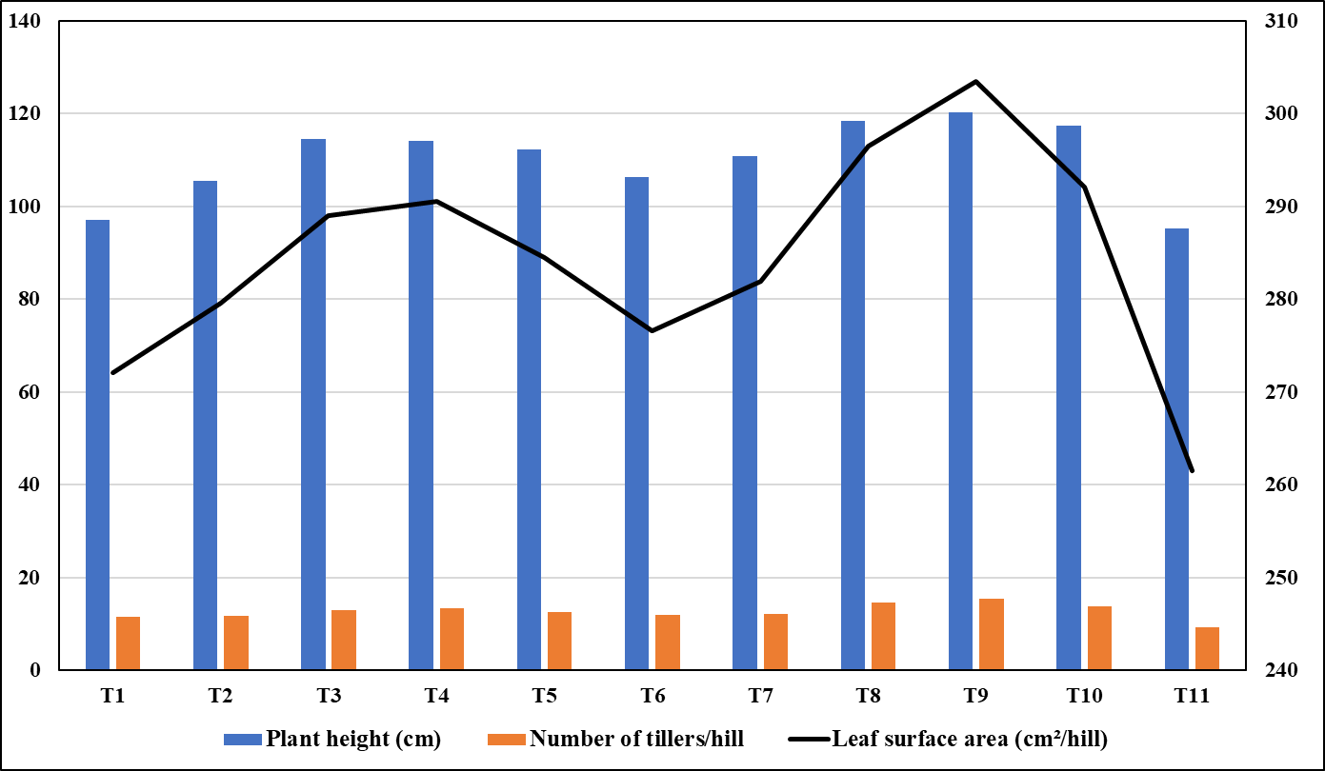
Figure 1: Effect of foliar spray of nano-chitosan tricyclazole conjugate (CNPT) on growth attributes of paddy under field conditions

T₁- FS with CNPT at 100 ppm at 30 DAT; T₂- FS with CNPT at 250 ppm at 30 DAT; T₃- FS with CNPT at 500 ppm at 30 DAT; T₄- FS with CNPT at 750 ppm at 30 DAT; T₅- FS with CNPT at 1000 ppm at 30 DAT; T₆- FS with CNPT at 100 ppm at 30 and 50 DAT; T₇- FS with CNPT at 250 ppm at 30 and 50 DAT; T₈- FS with CNPT at 500 ppm at 30 and 50 DAT; T₉- FS with CNPT at 750 ppm at 30 and 50 DAT; T₁₀- FS with CNPT at 1000 ppm at 30 and 50 DAT; T₁₁- Control

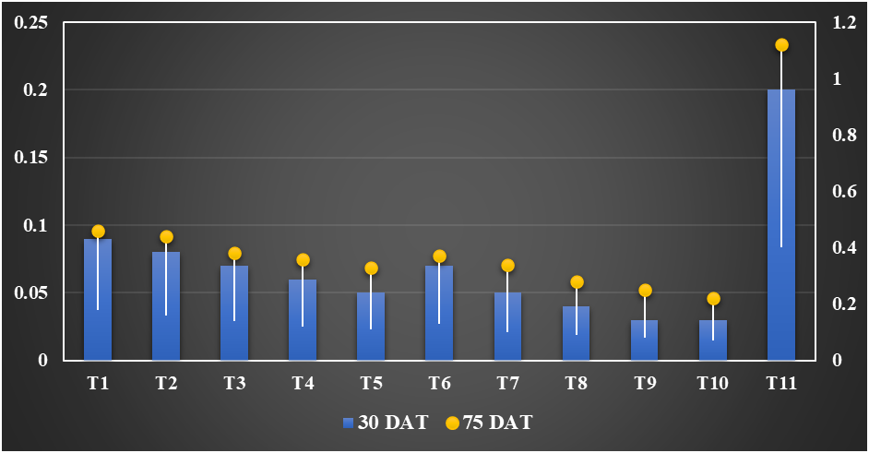
Figure 2: Progression of leaf blast lesion size under different treatment regimes over time

T₁- FS with CNPT at 100 ppm at 30 DAT; T₂- FS with CNPT at 250 ppm at 30 DAT; T₃- FS with CNPT at 500 ppm at 30 DAT; T₄- FS with CNPT at 750 ppm at 30 DAT; T₅- FS with CNPT at 1000 ppm at 30 DAT; T₆- FS with CNPT at 100 ppm at 30 and 50 DAT; T₇- FS with CNPT at 250 ppm at 30 and 50 DAT; T₈- FS with CNPT at 500 ppm at 30 and 50 DAT; T₉- FS with CNPT at 750 ppm at 30 and 50 DAT; T₁₀- FS with CNPT at 1000 ppm at 30 and 50 DAT; T₁₁- Control

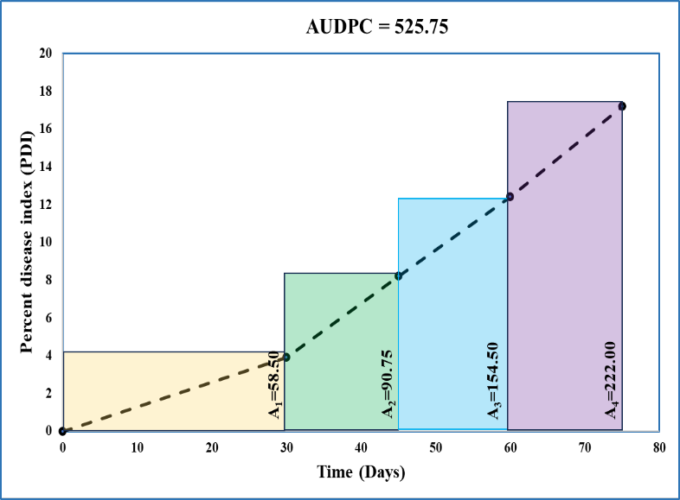
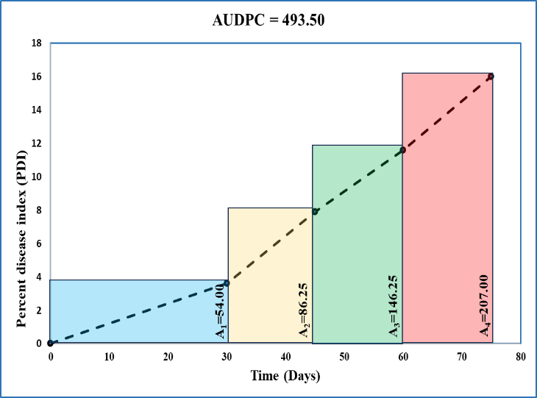
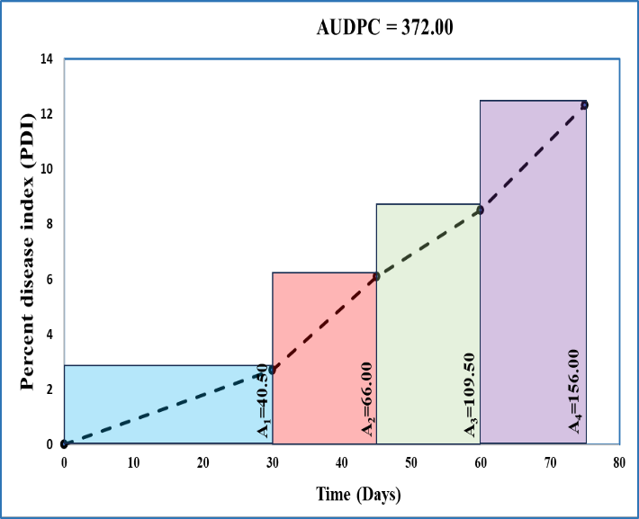
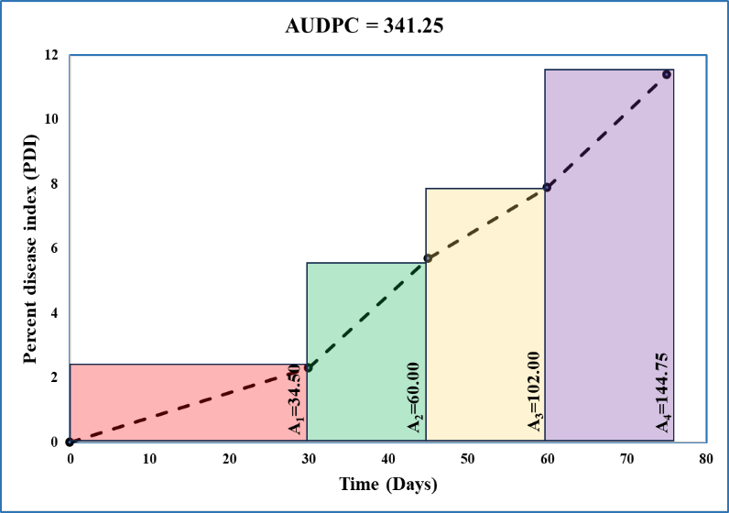
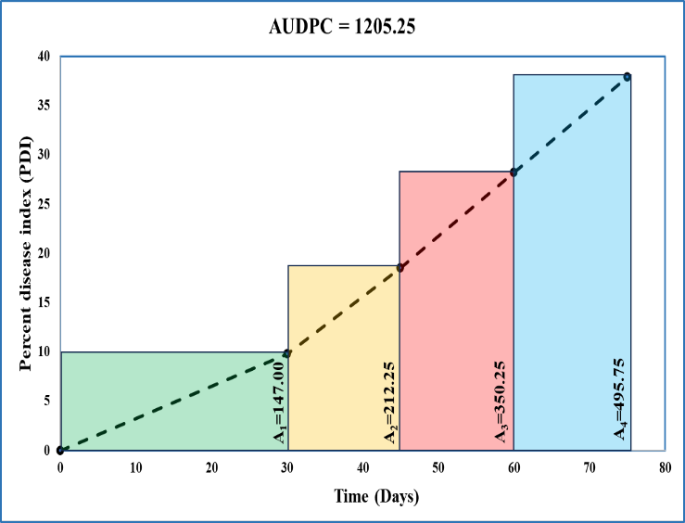
A
B
C
D
E
Figure 3: Comparison of rate of leaf blast disease progression using AUDPC between single and double sprays of best treatments of Nano-chitosan Tricyclazole conjugate (CNPT) during phytotoxicity assessment under field conditions
(A) T₄- Single spray of CNPT @ 750 ppm, (B) T₅- Single spray of CNPT @ 1000 ppm, (C) T₉- Double spray of CNPT @ 750 ppm, (D) T₁₀- Double spray of CNPT @ 1000 ppm, (E) T₁₁- Control

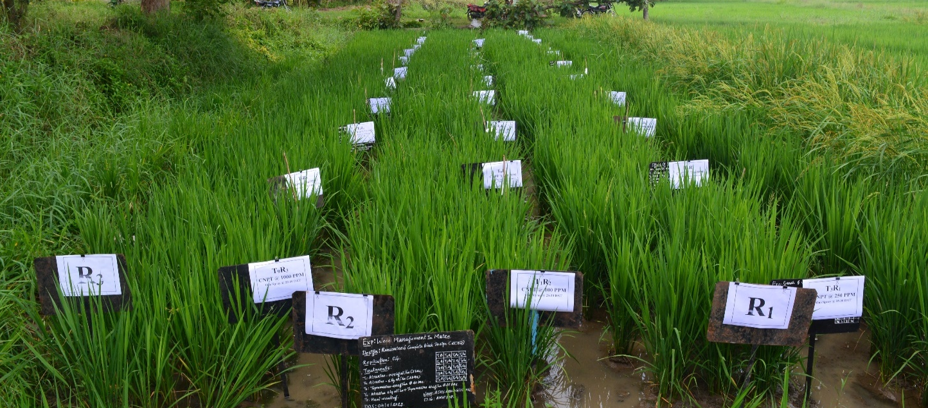
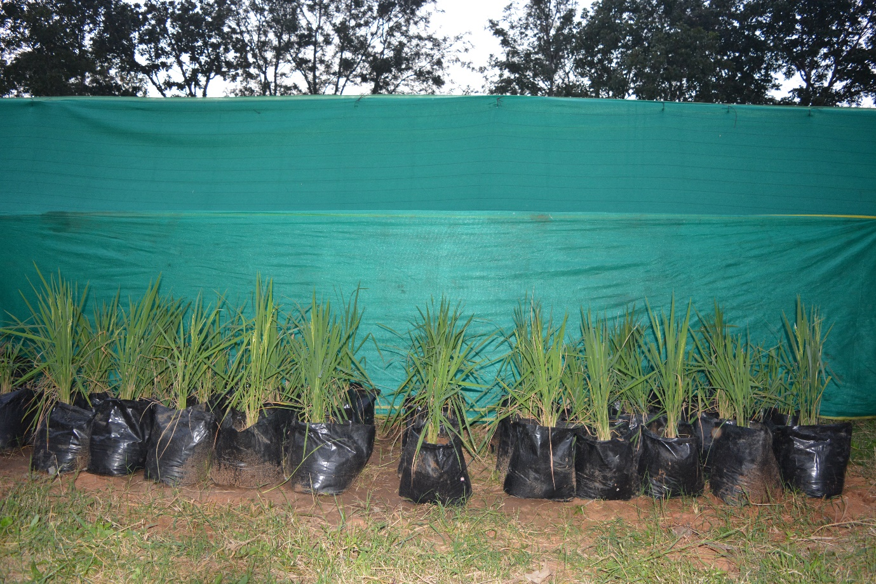
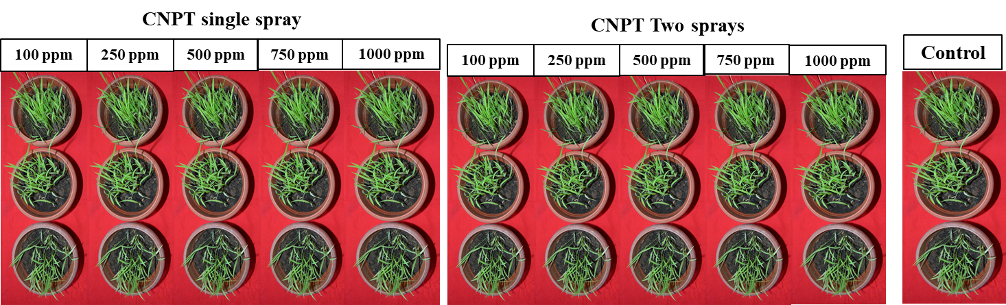
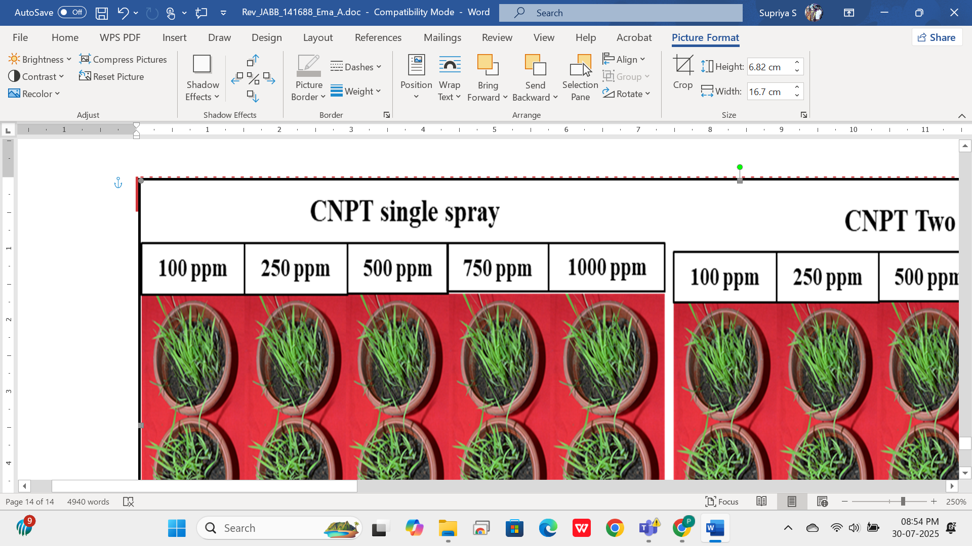
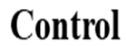
Phytotoxicity study
Plate 1: Phytotoxic effect of synthesized CNPT through foliar spray under greenhouse and field conditions
A. Nursery stage assessment under greenhouse conditions
B. Susceptible growth stages assessment under greenhouse conditions
C. Susceptible growth stages assessment under field conditions

conjugate
B
C
A

