EFFECT OF PRE-SOWING TREATMENT
ON SEED GERMINATION OF BAHEDA (Terminalia bellirica Roxb)
Abstract
This current study investigated the effectiveness of various pre-sowing treatments on the germination of Terminalia bellirica (Baheda) seeds, is a very important tree species and valuable tree for the timber and medicinal value. That is belongs to Combretaceae family. A species facing decline due to overexploitation and poor natural regeneration. The research was conducted in Charama, Kanker District, Chhattisgarh, from March to June 2025. The study employed a completely randomized design with five treatments, including a control (T₀), and three replications. The treatments included soaking seeds in cold water for 24 hours (T₁), cold water for 48 hours (T₂), cow dung slurry for 24 hours (T₃), and seed pelleting (With adhesive gum and clay powder) (T₄). Results showed that pre-sowing treatments significantly improved germination. Soaking seeds in cold water for 48 hours (T₂) resulted in the fastest seedling emergence (17 days after sowing - DAS)and the highest germination percentage (75%), mean daily germination (0.50%), peak value (4.23), and germination value (2.1). Soaking in cow dung slurry for 24 hours (T3) also showed positive effects, with seedling emergence at 20 DAS and a germination percentage of 61.6%. The control group (T0) exhibited the slowest emergence (35 DAS) and the lowest germination percentage (41.6%). can effectively overcome the natural dormancy of Terminalia bellirica seeds, promoting faster and more uniform germination, which is crucial for conservation and sustainable utilization of this valuable medicinal plant.
Keywords:Conservation, complete randomized design, seedlings, soaking, dormancy.

1. INTRODUCTION
A big tree that can reach a height of 40 meters, Terminalia bellirica Roxb.is a member of the Combretaceae family. Its widely elliptic, petiolate leaves are grouped around the tips of the branches. It produces single, basic axillary spikes that are greenish yellow in color. Except for drier regions, it can be found in deciduous forests over most of India. It can be found in the Konkan region, South India, West Bengal, Bihar, Orissa, Chhota Nagpur, and the upper Gangetic plains. The word Bellirica is taken from the scientific name to tree and distinguish this myrobalan from the ulha one (Chebulic myrobalan). It is the secondary host of tasar silkworm (Anonymous, 1976). Terminalia belliricais known as Vibhitaka and vibhitaki in Sanskrit, Tanni and Thandrikai in Tamil, Bahera, and Birha in Punjabi and Bellirica myrobalan in English. It contains different chemical constituents in different parts viz. stem, bark, fruit, etc. Its flowering starts in March to May and fruit ripens in December to February. Terminalia bellirica is important tree from commercial as well as traditional indigenous medicinal value. Its seeds are edible and are important components of "Triphla churn" used in bronchitis eouyl pebble in dyspepsia, cortication, impurity of bloods and stomach problem, etc. (CSIR, 1985).It leaves are highly valued as fodder for milk cattle and are fed to tsar silkworm and they arelopped repeatedly for this purpose. It poles are used for making the beams of houses, handloom ofagricultural implements and furniture to Species has been over-exploited for to multiple uses.
The IUCN Red List indicates that "more than 3,000 metric tons of plant parts derived from this species are traded annually in India. “Certain regions in India, like parts of Madhya Pradesh, are known for higher concentrations of Terminalia belliricaand related trade. An economic times article stated, that "According to the forest department, the production of MAPs is about 87,065 metric ton in the state but the maximum is being supplied to other states as raw material".Baheda, or Terminalia bellirica, is a significant non-timber forest product (NTFP) in India, valued for its medicinal properties and its role in traditional Ayurvedic formulations like Triphala. These essential plant resources are fast declining as a result of overexploitation (due to its many uses), extreme population pressure, rural poverty, a lack of suitable government policy, the rapid increase of synthetic medications, and improper usage of forest products. In addition, the forest department excludes certain species from its afforestation and/or reforestation initiatives due to the poor, unpredictable, and lengthy germination period of natural regeneration by seeds.Plants are propagated and grown to a size that can be planted in a nursery. A quality nursery stock is necessary to create a good plantation. The necessity of forest nurseries in order to properly nurture seedlings before planting them on land that needs to be replanted (Bargahet al., 2024)
Seedlings are small plants with enough potential to grow into mature trees. These seedlings grow naturally, but they can also be propagated by seeding and germinating, which helps them to sprout quicker and boost their chances of survival. The factors must be optimal to produce a health and vigorous seedlings, and among them, the genes and the nursery environment determine to a large degree how a tree can survive(Bargahet al., 2024)
Seed germination is a complex process that leads to the resumption of active growth in the embryonic axis, rupture of seed cover and emergence of the young plants (Bargahet al., 2025). The stiff seed coat and thick, fleshy pericarp of the species' fruits are thought to be the cause of this delay and irregularity in seed germination (Shivannaet al., 2007). The fruit's pericarp has a high concentration of phenolic compounds, which have also been shown to prevent many plant species' seeds from germinating. Pre-sowing treatments are thought to have a significant effect on the germination of Terminalia bellirica (Beheda) seeds. Certain pre-sowing treatments, such as depulping the fruits, soaking the seeds in hot or cold water for hours, scarifications, H₂SO₄ treatment, etc., are thought to have been used in some studies to examine the germination potentials of T. chebula and T. bellirica in comparison to untreated control seeds.The germination of seeds with a hard seed coat is enhanced by pre-sowing treatments (Palani et al., 1996; Hossain et al., 2005; Anand et al., 2012).
Seed germination can be enhanced by soaking them in cold water for a few hours. Higher germination rates were seen in de-pulped fruit that was immersed in cow dung slurry for hours. According to Jyoti and Bhandari (2016), seed coating and pelleting technologies were initially developed for seed signaling, supplying nutrients, bioactive chemicals, and beneficial microbes, as well as for planting in both dry and wet conditions. With the help of these treatments, T.belliricaseeds should be able to overcome their natural dormancy mechanisms and germinate more evenly and quickly. Additionally, it is predicted that the efficiency of pre-sowing treatments would differ based on the particular treatment used, with certain treatments being more successful than others at causing this species to break dormancy and encourage germination.

2. MATERIALS AND METHODOLOGY
2.1 Study Site
The investigation was conducted at theCharamaduring the months of March to June 2025, an experiment was carried out in Kanker District. The district will be located between 20.4788° N, 81.3751° E. Charama.TheCharama district in Kanker, Chhattisgarh experiences a tropical climate characterized by hot, humid conditions, particularly during the summer months. The district's climate is influenced by the monsoons, leading to a rainy season that lasts from March to November. Temperatures can reach 48°C (100°F) during the summer. Rainfall is bimodal, with peaks in April-May and August-October.TheCharama district in Kanker has primarily red loamy/sandy Alfisols and Yellow/Red Brown Ultisols. The district's soils are also influenced by granite, gneiss, sand, and khedar formations.
2.2 Soil: Soil serves as a fundamental medium composed of an unconsolidated matrix of minerals, organic matter, microorganisms, and nutrients, all of which collectively influence its physico-chemical and biological properties (Maitryet. al., 2025).The sandy loam soil's pH was determined to be between 6.81- 6.82, which was used for the current experiment. Contains the soil analysis data pertaining to accessible nutrients. Data analysis showed that the soil had low levels of available potassium (46 mg/kg), available phosphorous (23 mg/kg), and available nitrogen (16 mg/kg). The sandy loam soil was found to have a somewhat low NPK within the typical range (Sahu and Nema, 2025).

2.3 Preparation of growing media: The preparation of growing media is used for the simple and effective method for promoting healthy plant growth their ratio is 1:1:1 (Soil: Sand: Vermi compost).
2.4 Pre-sowing treatments
Seeds of Terminalia bellirica were treated to five different pre-sowing treatments to assess the germination behavior of seeds in different treatments. Table 1 lists the specifics of five treatment different treatments.
Table 1: Different methods of pre-sowing
Treatments
S. No. | Treatment | Notation to be used
1 | Control | T₀
2 | Soaked in cold water for 24 hours | T₁
3 | Soaked in cold water for 48 hours | T₂
4 | Soaked in cow dung slurry for 24 hours | T₃
5 | Seed pelleting | T₄

2.5 Experimental design:A complete randomized design (CRD) was used to set up the germination test. Each treatment had three replications, and there were five treatments altogether, including a control. Twenty seeds were seeded in poly bags for each replication (one seed in each poly bag) in order to examine the impact of pre-sowing interventions on Terminalia bellirica seed germination. For the experiment, 60 seeds from each treatment were selected and sown in polybags. To investigate the germination behavior of Terminalia bellirica seeds, the following observation was made. Both the number of days and the number of seedlings that had completely erupted above the soil surface were noted.

2.6 Germination percent
Germination of seeds in each treatment was recorded daily up to 90 days. The seeds were considered as germinated when the cotyledonary leaves emerged out of the soil. From the daily germination count, percent seed germination was recorded.
2.6.1 Germination percentage(GP)
Number of seeds germinated
(%)= ×100
Number of seeds sown

2.6.2 Mean daily germination (%)
Cumulative percent germination
(MDG) =
Total number of days
2.6.3 Peak value(PV)
= Maximum mean daily germination reached at any stage of the germination period.
2.6.4 Germination value
= Mean daily germination × peak value
2.6.5 Shoot/Root Ratio
Shoot length
Root length

3. RESULT AND DISCUSSION
The current study set out to determine the effects of various pre sowing techniques on Terminalia bellirica seed germination.
3.1. Number of days to seedling emergence
Pre-sowing treatments have a positive impact on control treatment. The number of days needed for seedling germination was statistically significant as a result of various pre-sowing treatments. The seed which is treated with T₂ cold water for 48 hours recorded the fewer numbers of days for the emergence of seedlings (17 DAS) followed by T₃ – Dipping under cow dung 24 hours slurry for the germination occurs 20 DAS followed by T₁ – Dipping under cold water treatment 24 hours seed germinated in 25 DAS and followed by T₄ – seed pelleting method with clay powder and adhesive gum arabic as a materials in 25 DAS. In control treatment (T₀) the seed germination took place 35 DAS is tabulated in (Fig 1).
3.2 Effect of Different Pre-Sowing Treatments on Germination Percentage.
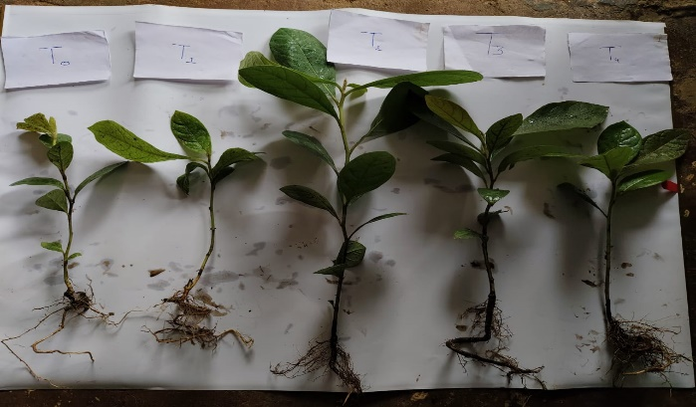
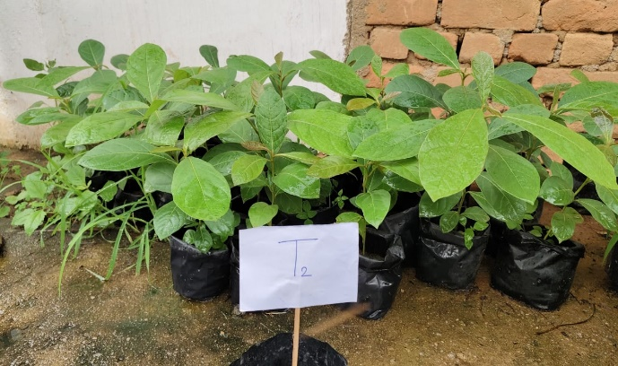
The highest germination percentage (75 %) was observed in treatment T₂ – soaked in cold water for 48 hours followed by T₃ - dipping in cow dung slurry for 24 hours (61.6 %) followed by T₁ -soaked in cold water for 24Hours (58.3%) and T₄seed pelleting with clay powder as filler material and gum arabic as binding material (51.6 %) followed by T₀ –The control treatment had the lowest germination percentage (41.6 %) that is tabulated in (Fig 1).

3.3 Effect of different pre sowing treatment means daily germination
The highest (0.50) Mean daily germination was observed in seeds that were T₂ – soaked in cold water for 48 hours followed by T₃ – soaked in cow dung slurry for 24 hours (0.41), followed by T₁ – soaked in cold water for 24 hours (0.38) and T₄ – seed pelleting with clay powder as filler material and gum arabic as binding material (0.34), while the lowest (0.27) was observed in
Plate 1: pre sowing treatments
T₀control treatment is tabulated in (Fig 1).

3.4 Effect of different pre sowing treatment on peak value
The peak value was significantly varied due to various pre-sowing treatments. The highest (4.23) peak value was observed in Seeds that is treated with T₂ – soaked in cold water for 48 hours followed by T₃ – dipped in cow dung slurry for 24 hours (3.04), T₁ – soaked in cold water for 24 hours (2.27), T₄ – seed pelleting with clay powder as filler material and gum arabic as binding material (2.02), and while the minimum (1.17) was observed in the T₀ control treatment is tabulated in (Fig 1).
3.5 Effect of different pre sowing treatment on germination value
The highest (2.1) germination value was observed in seeds that were treated with T₂ – soaked in cold water for 48 hours followed by T₃ – dipped in cow dung slurry for 24 hours, (1.2), T₁ – soaked in cold water for 24 hours (0.8), T₄ – seed pelleting with clay powder as filler material and gum arabic as binding material (0.6), and while the lowest (0.3) was observed in control is tabulated in (Fig 1).

Fig.1: Growth Performance of Emerged Seedlings Under Different Seed Treatment

3.6 Effect of different pre sowing treatment on Shoot length
Fig (2) presents the impact of five seed treatments on seedling growth, focusing on parameters: seedling length, and the number of leaves per seedling. Root Length (cm): T₂ has the highest average seedling length (28.7 cm), indicating strong growth, T₃ – dipped in cow dung slurry for 24 hours, (25.6), T₄ – seed pelleting with clay powder as filler material and gum arabic as binding material (22.8) and T₀ shows the lowest seedling length (18.0 cm), suggesting a negative impact. T₁ also performs poorly with an average of 22.2 cm.The T₂ consistently outperformed the other treatments in seedling length with the highest increases observed compared to T₀ and T₁.

3.7 Effect of different pre sowing treatment on Root length
Fig (2) presents the impact of five seed treatments on seedling growth, focusing on parameters: seedling length, and the number of leaves per seedling. Root Length (cm): T₂ has the highest average seedling length (30.1 cm), indicating strong growth, T₃ – dipped in cow dung slurry for 24 hours, (28.3), T₄ – seed pelleting with clay powder as filler material and gum arabic as binding material (24.1) and T₀ shows the lowest seedling length (19.3 cm), suggesting a negative impact. T₁ also performs poorly with an average of 24.0 cm.
b
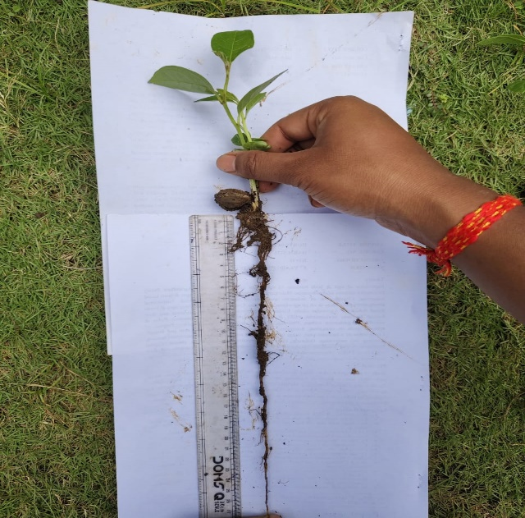
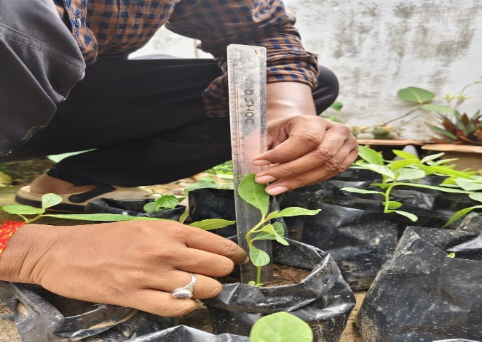
The T₂ consistently outperformed the other treatments in seedling length with the highest increases observed compared to T₀and T₁.
a
Plate 2: Measuring the (a) Root and (b) shoot lengths

3.8 Effect of different pre sowing treatment on Root/Shoot Ratio
The root/shoot ratio was significantly varied due to various pre-sowing treatments. The highest (0.95) root/shoot ratio was observed in Seeds that is treated with T₂ – soaked in cold water for 48 hours and T₄ – seed pelleting with clay powder as filler material and gum arabic as binding material and followed by T₃ – dipped in cow dung slurry for 24 hours (0.93), T₁ – soaked in cold water for 24 hours (0.93), and while the minimum (0.90) was observed in the T₀ control treatment is tabulated in (Fig 2).
3.9 Effect of different pre sowing treatment on number of leaves
The number of leaves was significantly varied due to various pre-sowing treatments. The highest (15) number of leaves was observed in Seeds that is treated with T₂ – soaked in cold water for 48 hours followed by T₃ – dipped in cow dung slurry for 24 hours (14), T₁ – soaked in cold water for 24 hours (11), T₄ – seed pelleting with clay powder as filler material and gum arabic as binding material (11) and while the minimum (8) was observed in the T₀ control treatment is tabulated in (Fig 2).

Fig. 2:Effect of Emerged Seedlings Under Different Seed Treatment

CONCLUSION
The findings of this study confirm the significant positive impact of pre-sowing treatments on the germination behavior of Terminalia bellirica seeds. Including treatment a control (T₀), and three replications. The treatments included soaking seeds in cold water for 24 hours (T₁), cold water for 48 hours (T₂), cow dung slurry for 24 hours (T₃), and seed pelleting (T₄). Among the tested methods, soaking seeds in cold water for 48 hours (T₂) proved to be the most effective, leading to the quickest seedling emergence, highest germination percentage, and superior mean daily germination, peak value, and germination value. The substantial improvement observed in treated seeds compared to the control highlights the role of these interventions in overcoming the natural dormancy caused by the stiff seed coat and high phenolic content in the pericarp. These results are crucial for developing effective strategies for the propagation and conservation of Terminalia bellirica, a species under threat due to overexploitation and poor natural regeneration. Implementing such pre-sowing treatments can contribute significantly to the sustainable management of this economically and medicinally important tree, supporting afforestation and reforestation initiatives that have previously excluded this species due to its germination challenge

Disclaimer (Artificial intelligence)
Author(s) hereby declare that NO generative AI technologies such as Large Language Models (ChatGPT, COPILOT, etc.) and text-to-image generators have been used during the writing or editing of this manuscript.

REFERENCES

Anand, B., Devagiri, G. M., Maruti, G., Vasudev, H. S.andKhaple, A. K. (2012). Effects of pre-sowing seed treatments on germination and seedling growth performance of Melia dubia CAV: an important multipurpose tree. International Journal of Life Sciences, 1(3): 59-63.
Bali, R.S., Chauhan, D. S. and Todaria, N.P. (2013). Effect of growing media, nursery beds and containers on seed germination and seedling establishing of Terminalia bellirica (Gaertn.) Roxb.A multipurpose tree. International Society for Tropical Ecology, 54(1):59-66.
Bargah, A. S., Pratap Toppo, D. L. S., Tuteja, S. S., Mankur, M. K., &PainkraandPankaj, D. S. Effect of nutrient management on growth performance of Geranium (Pelargonium graveolens) under Karanj (Pongamiapinnata) based agroforestry system in Chhattisgarh plain.
Bargah, A. S., Sharma, D., Kumar, R., Nag, R., & Pradhan, R. (2025). Enhancing Germination of Forest Tree Seeds in Chhattisgarh through PGR-Based Treatments: A Review. Journal of Advances in Biology & Biotechnology, 28(7), 851-863.
Bhardwaj, S.D. and Chakraborty, A.K. (1994). Studies on Time of Seed collection, Sowing and Pre sowing Seed Treatments of Terminalia belliricaRoxb.AndTerminaliachebula Retz.
Bohra, N. K., Manda, M., Jat, R. and Dudi,H. (2024). Effect of Seed size and pre-sowing treatment on seed germination of Terminalia bellirica. Middle East Journal of Applied Science & Technology, 3(7):01-12.
Chakraborty, A. K., Pandey, O. N.and Bhardwaj, S.D. (1992). Pre sowing treatment on seeds of Terminalia bellirica. Journal of Research, Birsa Agricultural University, 4(1): 95-98.
Das, H., Nayak, S. and Sadangi, D. (2020). Variation in morphometric characters, germination and oil content of Terminalia bellirica (Gaertn.) Roxb.Seeds collected from various provenances of Odisha, India. Journal of Applied and Natural Science, 12(3):319-327.
Hossain, A. M., Arefin, M. K., Khan, B. M. and Rahman, M. A. (2005). Effects of seed treatments on germination and seedling growth attributes of Horitaki (Terminalia chebula Retz.) in the nursery. Research Journal of Agriculture and Biological Sciences, 1(2): 135-141.
Hossain, A.M., Uddin, M.S., Shumi, W. and Shukor, N.A.A. (2014). Depulping of Fruits and Soaking the Seeds Enhances the Seed Germination and Initial Growth Performance of Terminalia belliricaRoxb. Seedlings. American Journal of Plant Sciences, 5: 714-725.
Jyoti, B. and Bhandari, S. (2016). Seed pelleting-A key for enhancing the seed quality. Rashtriya Krishi, 11(1): 76-77.
Kumar, V. (2016). Effect of Pre-sowing Seed Treatment on Germination and Seedling Growth of Terminalia bellirica (Gaetn.) Roxb. Indian Journal of Ecology, 43(1): 223-238.
Kuniyal, C.P., Purohit, V., Butola, J.S. and Sundriyal, R.C. (2013). Seed size correlates seedling emergence in Terminalia bellerica. South African Journal of Botany, 87:92-94.
lebbeck(L) Benth. Annals of Forestry 4(1): 85-88
lebbeck(L) Benth. Annals of Forestry 4(1): 85-88
lebbeck(L) Benth. Annals of Forestry 4(1): 85-88
lebbeck(L) Benth. Annals of Forestry 4(1): 85-88
lebbeck(L) Benth. Annals of Forestry 4(1): 85-88
lebbeck(L) Benth. Annals of Forestry 4(1): 85-88
lebbeck(L) Benth. Annals of Forestry 4(1): 85-88
Maitry, A., Patil, G., Dubey, P., & Sharma, D. (2025) Estimation of enzymatic activities under various forest tree species as index of mine soil genesis in Chrono sequence limestone mine spoils.
Minj, N., Toppo, P., Tuteja, S. S., Singh, L., Mankur, M. K., Bargah, A. S., & Verma, S. Effect of Different Potting Media on Seeds Germination & Growth of Dahiman (Cordia macleodii Hook.) in Nursery.
of pre-sowing treatment on growth attributes of Albizia
of pre-sowing treatment on growth attributes of Albizia
of pre-sowing treatment on growth attributes of Albizia
of pre-sowing treatment on growth attributes of Albizia
of pre-sowing treatment on growth attributes of Albizia
of pre-sowing treatment on growth attributes of Albizia
of pre-sowing treatment on growth attributes of Albizia
Palani M, Dasthagir MG, Kumaran K and Jerlin R 1996. Effect
Palani M, Dasthagir MG, Kumaran K and Jerlin R 1996. Effect
Palani M, Dasthagir MG, Kumaran K and Jerlin R 1996. Effect
Palani M, Dasthagir MG, Kumaran K and Jerlin R 1996. Effect
Palani M, Dasthagir MG, Kumaran K and Jerlin R 1996. Effect
Palani M, Dasthagir MG, Kumaran K and Jerlin R 1996. Effect
Palani M, Dasthagir MG, Kumaran K and Jerlin R 1996. Effect
Palani, M., Dasthagir, M. G., Kumaran, K. and Jerlin, R. (1996). Effect of pre-sowing treatment on growth attributes of Albizialebbeck (L) Benth. Annals of Forestry, 4(1): 85-88.
Sahu and Nema. Assessment of seed germination and seedling biomass of endangered species Pterocarpus santalinus. International journal of Advanced Biochemistry Research 2025; 9(4):249-253.
Shivanna, H., Balachandra, H.C. and Suresh, N.L. (2007). Effect of Pre-Sowing Treatment on Germination of Terminalia bellerica (Ber). Karnataka Journal of Agricultural Sciences, 20: 442-443.
Sood, K.S., Ahmed, F., Raina and N.S. (2018). Effect of container and Growing Media on Terminalia belliricaRoxb. Seedling Performance under Nursery Conditions. Indian Journal of Ecology, 45(2): 270-275.
Urooj, A., Hashir, M., Akram, M. and Zaidi, S.S. (2023). Efficacy of Terminalia bellirica(Balela): A Review. Indian Journal of Unani Medicine. 16(2): 138-142.
Verma, S., Toppo, P., Bhariya, S. K., Singh, L., Mankur, M. K., Bargah, A. S., &Minj, N. Effect of different potting mixture on seedling growth and performance of wild jackfruit (Artocarpuslacucha Buch.) in nursery.

