**Parental Polymorphism and Hybrid testing in linseed *(Linum usitatissimum* L.) by using molecular markers**

**Abstract:** Linseed (*Linum usitatissimum* L.) is a valuable oilseed crop known for its nutritional and industrial significance. Despite its importance, linseed yield remains suboptimal in India due to limited genetic advancement. This study aimed to assess parental polymorphism and confirm hybrid purity using Random Amplified Polymorphic DNA (RAPD) markers. A linseed hybrid (FR.111 × LSL.93) and its parental lines, including a dwarf genotype, were evaluated both morphologically and molecularly. Variation in characteristics like plant height, days to blooming, and seed output per plant were found by morphological analysis, suggesting heterosis in the F₁ generation. DNA was isolated by using CTAB method and amplified with five RAPD primers. Electrophoresis of PCR products generated clear banding patterns that were used to assess genetic similarity and hybridity. The presence of parent-specific bands in F₁ individuals confirmed the hybrid's genetic authenticity and purity. The study demonstrated the effectiveness of RAPD markers in detecting polymorphism and verifying hybrid identity. These findings highlight the utility of molecular markers in linseed breeding programs, offering a rapid and reliable method for hybrid confirmation. Integration of marker-assisted selection (MAS) can significantly enhance the efficiency of linseed improvement and support the development of high-yielding, genetically diverse cultivars.

**Keywords:** Linseed (*Linum usitatissimum* L.), Oilseed crop, Random Amplified Polymorphic DNA (RAPD).

**INTRODUCTION**

Linseed (*Linum usitatissimum* L.; 2n=30), a member of the *Linaceae* family and order *Geraniales*, is one of the earliest domesticated crops, valued for its dual utility as both an oilseed and Fiber crop. The genus *Linum* comprises over 300 species, although *L. usitatissimum* is the only species cultivated extensively for economic purposes. Commonly referred to as flax or flaxseed, linseed has been utilized since ancient times for food, Fiber, and medicinal applications, with historical records indicating its cultivation as early as 10,000 BCE in the Fertile Crescent. It later spread through trade routes and colonization to regions such as North America and Australia (Muir *et al*., 2003). Linseed holds significant nutritional and industrial value. It is abundant in alpha-linolenic acid (ALA), an essential omega-3 fatty acid with cardioprotective and anti-inflammatory properties (Simopoulos, 2002). The seeds are also abundant in protein, dietary Fiber, magnesium, and B-complex vitamins, making them a key ingredient in food, cosmetic, pharmaceutical, and textile industries (Wojtasik *et al.,* 2015).Globally, linseed is cultivated on approximately 3 million hectares, with Canada, China, the USA, and India being major producers (FAO, 2024). In India, linseed is an important oilseed crop cultivated on about 468,000 hectares, with states like Maharashtra contributing significantly despite relatively low average yields. Agronomic practices suggest that linseed grows best in temperate regions with loamy soils, and is often rotated with cereal crops to manage root diseases (CFIA, 2012). Modern plant breeding programs have increasingly adopted molecular marker technologies to enhance crop improvement efforts. Techniques such as RAPD, SSR, and AFLP have been used to study genetic diversity, identify breeding lines, and support marker-assisted selection (MAS) (Bastia *et al*., 2001; *Fu et al.,* 2005). These tools are crucial for assessing parental polymorphism and verifying hybrid purity—two key aspects for ensuring the success of breeding programme. Given the agronomic, economic, and nutritional importance of linseed, it is essential to enhance its genetic potential through molecular breeding approaches. The present study aims to investigate “Parental polymorphism and hybrid testing in linseed (*Linum usitatissimum* L.) using molecular markers”**,** with objectives: asessment the phenotypic characteristics of parents and F₁ hybrids in linseed. By using molecuular markers evaluation of hybrid purity in F1 population.

**MATERIAL AND METHODS**

Seeds of linseed hybrid namely FR. 111 × LSL. 93 (Medium) and parental line LSL-93 (Dwarf), FR. 111 (Medium) was collected from Oilseed Research Station Latur (MS). The experiment was conducted at Department of Plant Biotechnology, Vilasrao Deshmukh College of Agricultural Biotechnology, Latur (M.S.) during the year 2024-25.

**Methodology**

**2.1.1 Morphological analysis**

Five randomly selected plant taken for observations. The following observations wre made with respect to different agronomical characters in linseed germplasm.

**2.1.2 Height of plants (cm)**

The plant height was measured in centimeters from the base to the tip of the main stem.

**2.1.3 Number of branches per plant**

Five plants of each genotype were chosen at random, and the number of branches growing from the main stem was noted.

**2.1.4 Number of capsules per plants**

The number of capsules on the plant that contained seeds was counted and noted.

**2.1.5 Duration for 50% flowering**

From day of sowing to 50% of flowering was recorded and notes.

**2.1.6 Weight of seeds (gm)**

Weights of 1000 seeds were recorded in gram in respect of each select plant in each replication.

**2.1.7 Number of seeds per capsules**

Each genotype was given five capsules of seeds at different heights, and the average number of seeds per capsule was noted.

**2.1.8 Yield per plant (gm)**

Yield per plant will be record in grams in respect of each select plant in each replication.

**2.1.9 Day of maturity**

From the date of sowing until 50% of the main branches have ripe capsules and the color of the capsules has changed from green to brownish, the day to maturity will be calculated**.**

**2.2 DNA extraction and Quantification.**

DNA was extracted using Doyle and Doyle's (1990) Cetyl Trimethyl Ammonium Bromide (CTAB) technique, and a spectrophotometer was used for quantification. The DNA was diluted to 50 ng/microliter in 0.1 T. E buffer for PCR analysis.

**2.3 Primer screening and polymerase chain reaction**

The PCR reaction was carried out using a 25 μl reaction mixture that contained 10X PCR buffer with MgCl2, 10 mM dNTPs, 10 pmol primer, 1 U of Taq DNA polymerase, 50 ng/µl template DNA, and sterile distilled water. The DNA thermal cycler (Sens Quest Lab cycler, Germany) was set up for DNA amplification as follows: incubation at 94°C for 10 min; 35 cycles at 94°C for 1 minute (denaturation), 37°C for 1 minute (annealing), and 72°C for 1 minute (extension), followed by a final extension cycle of 10 minutes at 72°C. Following the completion of the cycles, the samples were stored at 4°C until electrophoresis. The amplified products were resolved on 1.5% for RAPD marker at 5V/cm for 1 to 1.5 hours. After electrophoresis, observation of banding pattern and clicked on a Gel Documentation System (Alpha-Inno tech, USA).

**Table No 1: List of RAPD primers used for hybrid purity assessment**

|  |  |  |  |
| --- | --- | --- | --- |
| **Sr. No** | **Primer** | **Sequences** | **No of Base Pairs** |
| 1 | OPA-3 | AGTCAGCCAC | 10 |
| 2 | OPA-4 | AATCGGGCTG | 10 |
| 3 | OPA-1 | CAGGCCCTTC | 10 |
| 4 | OPA-2 | TGCCGAGCTG | 10 |
| 5 | OPA-5 | CTGAGACGGA | 10 |

**Purity Test in Hybrid Seeds**

The percentage of hybrid genetic purity were calculated based on banding pattern that appears on the individual plant samples, with the following formula.

Purity hybrid (%) = {1-[NH/TS]} × 100%

Where: TS (total sample) =number of samples/individual plants were tested.

NH (non-hybrid) = number of samples/individual plants having the same banding pattern with female or male parents.

**RESULTS AND DISCUSSION**

**3.1 Development of F1**

In this current study, two paternal genotypes one dwarf and the other tall were crossed. Use of the LSL-93 (Dwarf) as the male parent and the FR-111 (Tall) as the female parent. A tall hybrid was successfully created by crossing these genotypes. Once the seeds had set and reached maturity, the F1 hybrid seeds were extracted from the specific cross.

**3.2 Development of F1 hybrid**

**3.2.1 Crossing programme**

In this study, two parental linseed genotypes the male parent LSL-93 was dwarf, and the female parent FR-111 was tall were crossed. To create a tall hybrid, these genotypes were successfully crossed. After seed set and maturation, the F1 hybrid seeds were extracted from the cross.

**3.2.2 Morphological characterization**

Morphological traits of hybrid and its parental lines were observed throughout growing season.

**3.2.3 Number of capsules per plant**

The mean performance of parents for the capsules per plant ranged from 68.29 (FR-111). The cross FR-111x LSL-93 (71.98) produced.

**3.2.4 Duration for 50 percent flowering**

The variation for days to 50 per cent flowering ranged from 39 days (LSL-93) to 47 days (FR-11) While crosses have 50% flowering is 43 days (FR-111 x LSL-93)

**3.2.5 Plant height (cms)**

The height of male parent LSL-93 is36.70 and female parent FR-111 is 50.15. in hybrid it is higher i.e. 70.36 cm.

**3.2.6 Number of branches on each plant**

The number of branches per plant for different parents FR-111 is 3.50 and 2.70. and branches of per hybrid as (FR-111 x LSL-93) varies from 4. 10.

**3.2.7 1000 Weight of seeds (gm)**

The 1000 seeds weight of parents ranged from 5.90 g to 8.80 g. The line, FR-111 (5.90 g) had the lowest weight and the tester LSL-93 (8.80 g) had the highest weight. Among crosses weight of 1000 seeds is 8.82g (FR-111 x LSL-93).

**3.2.8 Yield from each plant (gm)**

The mean performance of the parents for yield each plant ranged from 2.20 g to 3.30. The line, FR-111 (2.60 g) had the lowest weight and the tester LSL-93 (3.25 g) had the highest weight. Among crosses yield per plant is 3.90 g (FR-111 x LSL-93)

**3.2.9 Number of seeds per casules**

Among the parents, the number of seeds per capsule varied from 6.95 (FR-111) and 7.45 (LSL-93). While crosses have no of seeds per capsules is 6.15 (FR-111 x LSL-93).

**3.2.10 Day of maturity**

The lines, FR-111 (93 days) and tester LSL-93 (85 days) were found earlier than all the parents. Among the crosses, days to maturity ranged from 90 days (FR-111 x LSL-93).

**Table No 2. Agromorphological characteristics of parents and F1 cross estimated mid parent heterosis and heterobeltiosis**

|  |  |  |  |  |  |  |
| --- | --- | --- | --- | --- | --- | --- |
| Sr. No | Character | Female Parent FR-111 | Male Parent LSL-93 | Hybrids FR-111 X LSL-93 | Mid Parent Heterosis (%) | Heter-Obeltosis (%) |
| 1 | Days to 50 percent flowering | 47 | 34 | 43 | 6.96 | -8.51 |
| 2 | Days to maturity | 93 | 95 | 90 | -10 | -3.23 |
| 3 | Plant height (cm) | 50.15 | 36.23 | 47.08 | 9.25 | -6.12 |
| 4 | Number of branches each plant | 3.4 | 3.1 | 4.1 | 22.5 | 17.14 |
| 5 | Number of capsules per plant | 68.29 | 47.11 | 71.98 | 24.74 | 5.4 |
| 6 | Number of seeds per capsules | 6.95 | 8.45 | 6.15 | -20.12 | 5.15 |
| 7 | 1000 seed weight (g) | 5.9 | 8.8 | 8.82 | 20.03 | 7.82 |
| 8 | Seed yield per plant (g) | 2.6 | 3.25 | 3.9 | 33.22 | 4.85 |

Agromorphological characteristics of parents (P1 and P2) and F1 cross were recorded and also estimated mid parent heterosis for 12 characteristics. F1 plants had highest seed yield per plant (3.9 g) than both parents thus showed significant positive relative heterosis (4.85%). In breeders view a yield contributing character plays important role in selection of parents. Hence, for increasing production the selection of these parents will be key event. However, negative hererosis observed in cross characters viz. days to 50% flowering (-8.51), days to maturity (-3.23) and plant height (-6.1). Rathva *et al*. (2023).

**3.2 DNA extraction and quality assessment**

By using the modified Cetyl Trimethyl Ammonium Bromide (CTAB) DNA extraction method described by Doyle and Doyle (1990), the genomic DNA was isolated from the young leaves of the linseed hybrid and their respective parents. Both quantitatively and qualitatively pure genomic DNA was produced using this technique. The absorbance at 260 nm wavelengths was used to quantify the isolated DNA. The absorbance ratio of A260/280 for protein contamination was used to verify the purity of the DNA. In order to do both quantitative and qualitative examination, DNA was resolved on a 0.8% agarose gel. All samples had values that ranged from 500 to 1400 ng/μl. In order to achieve final concentrations of 50 ng/μl for RAPD analysis, working samples were prepared by diluting them with sterile nuclease-free water.

**3.3 Hybrid validation based on RAPD fingerprint profile**

In order to detect true hybrids and confirm the parentage of the hybrids and lines/cultivars, RAPD analysis would be very helpful in breeding for quick and early hybrid population verification as well as purity testing of various seed batches. Verification of paternity and hybridization of other crop plants has been accomplished with success using RAPD analysis. For hybrid confirmation, RAPD marker fingerprinting data was utilized. To identify the linseed hybrid (FR-111×LSL-93), as well as its female (FR-111) and male (LSL-93) paternal lines, the current study used a total of five RAPD markers. In the section that follows, hybrid confirmation was done by contrasting the banding patterns of hybrids with those of their respective parents, as explained by

Were,

+ indicates presence of band

– indicates absence of band.

**MPS**-Male parent-oriented band

**FPS**-Female parent-oriented band

**Table No 3: RAPD marker types found in hybrids and their parents**

|  |  |  |  |  |  |
| --- | --- | --- | --- | --- | --- |
| **Markers Type** | **Male**  **(M)** | **Female (F)** | **Cross (H)** | **Nature** | **Remark** |
| 1 | **+** | **+** | **+** | Monomorphic | Good marker whichconfirm hybrid of its respective parents (male and/or female |
| 2 | **-** | **+** | **+** | MPS |
| 3 | **-** | **+** | **+** | FPS |
| 4 | **-** | **+** | **-** | - | Good markers to identify self and off types |
| 5 | **+** | **-** | **-** | - |
| 6 | **-** | **-** | **+** | Cross specific | Useful in recongnization of crosses |

Akhare *et al.* (2008). Various marker types have been assigned for hybrid confirmation in cotton (Mehetre *et al.,* 2004) and coffee arabica (Mishra *et al*., 2011) based on convenience. Banding patterns were seen in both the parents and hybrids for the purpose of hybrid purity analysis (Table No. 2). OPA-1, OPA-2, OPA-3, OPA-4, and OPG-5 (Figs. No. 1, 2, 3, 4, and 5) are the five RAPD primers that were employed to verify the hybrid's identity and purity. Three primers were used to confirm the hybrid. They amplified the specific allele sizes of OPG-5 (300 bp) and OPA-3 (350 bp) in the hybrid and male parent, but not in the female parent. To verify the actual hybrid, this primer was utilized. The MPS band of the Type 2 marker was created by these primers (Fig No. 5 and 3). In the hybrid and female parents, OPA-1 and OPA-4 amplified the particular allele of size 500 bp and 600 bp, respectively, but not in the male parent. These primers were utilized for hybrid confirmation and generated the Type 3 maker's FPS band (Fig. No. 1 and 4). One primer out of all the others was discovered to be monomorphic of the Type 1 marker, OPA-2 (Fig No. 2). In maize (Asif *et al*., 2006; Mrutu 2015), as well as other crops like sorghum (Shaikh, 2015; Akhare *et al*., 2008), rice (Deshmukh *et al.,* 2013), and cotton (Asif *et al*., 2009 and Dongre *et al.* 2005), similar studies based on RAPD analysis have been successfully used for parentage verification, hybrid confirmation, cultivar identification, and purity testing.

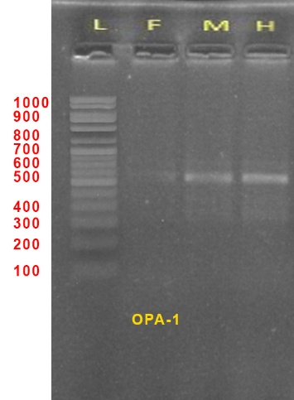

Fig No 1: Banding Profile by Primer OPA-1 on hybrid and parents obtained

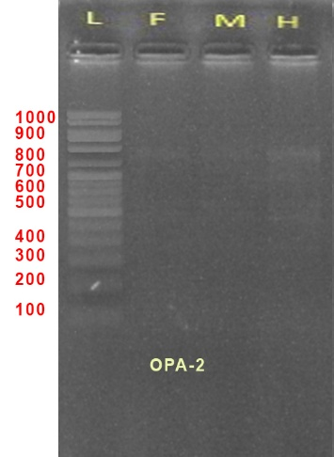

Fig No 2: Banding Profile by primer OPA-2 on hybrid and parents obatained

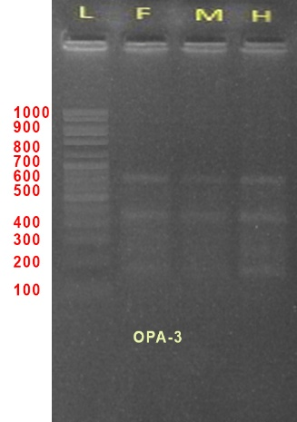

Fig No 3: Banding Profile by primer OPA-3 on hybrid and parents obatained

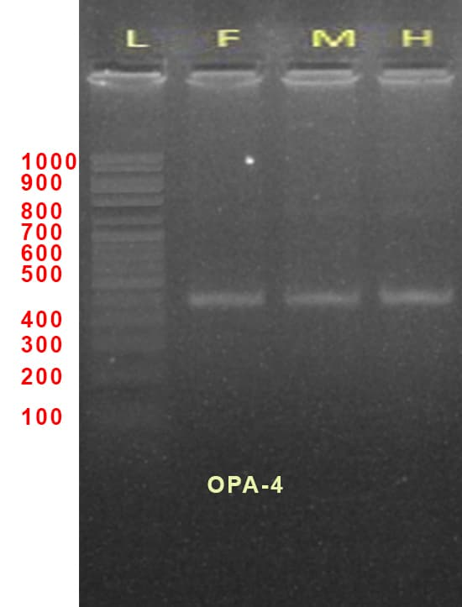

Fig No 4: Banding Profile by primer OPA-4 on hybrid and parents obatained

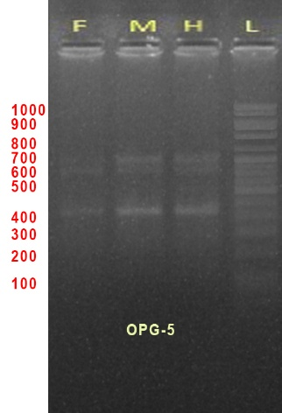

Fig No 5: Banding Profile by primer OPA-5 on hybrid and parents obatained

**Conclusion**

The study confirmed the effectiveness of RAPD markers in assessing genetic polymorphism and verifying hybrid purity in linseed, paving the way for marker-assisted selection to enhance breeding efficiency. These findings can significantly contribute to the development of high-yielding, genetically diverse linseed cultivars, ultimately improving crop productivity and sustainability.

Disclaimer (Artificial intelligence)

Option 1:

Author(s) hereby declare that NO generative AI technologies such as Large Language Models (ChatGPT, manuscript.

Option 2:

Author(s) hereby declare that generative AI technologies such as Large Language Models, etc. have been used during the writing or editing of manuscripts. This explanation will include the name, version, model, and source of the generative AI technology and as well as all input prompts provided to the generative AI technology

Details of the AI usage are given below:

1.

2.

3.

**REFERENCES**

Akhare AA, Sakhare SB, Kulwal PL, Dhumale DB, Kharkar, A. RAPD profile studies in sorghum for identification of hybrid and their parents. Intl. J. Integrative Biol 2008; 3:1-18.

Asif M, Rahman MU and Zafar Y. Genotyping analysis of six maize (*Zea mays* L.) hybrid using DNA fingerprinting technology. Pak. J. Bot 2006; 38:1425- 1430. 3.

Asif M, Rahman MU, Mirza JI and Zafar Y. Parentage Confirmation of Cotton Hybrids Using Molecular Markers. Pak. J. Bot 2009;41(2):695-701.

Bastia, T., & Singh, R. (2001). Molecular markers for genetic diversity in linseed (*Linum usitatissimum* L.). Journal of Genetics and Breeding, 55(2), 147-155

Deshmukh CU, Saxena RR, Xalxo SM, Sharma D and Verulkar SB. Hybrid purity testing in rice (*Oryza sativa* L) using microsatellite markers. Elec. J. Plant Breed 2013;4(1):1021-1026.

Dongre A and Pakhi V. Identification of cotton hybrid through the combination of PCR based RAPD, ISSR and microsatellite markers. Jr. Plant Biochem. Biotechnol 2005; 14:53-55.

Doyle JJ and Doyle JL. Isolation of plant DNA from fresh tissue. Focus 1990; 12:13–15.

Fu. Y. B. (2005). Geographic patterns of RAPD variation in cultivated flax. Crop Science, 45(3),

Mehetre SS, Gomes M and Eapen S. RAPD analysis of hybrid nature of the offspring of Gossypium hirsutum × G. raimond. Current Sci 2004; 87:25-28.

Mishra MK, Narayana S, Bhat AM, Nayani S, Kumar SS, Kumar A and Jayarama. Genetic molecular analysis of Coffea arabica (Rubiaceae) hybrids using SRAP markers. Rev. Biol. Trop 2011;59(2):607-617.

Mrutu BA. Assessment of seed genetic purity of hybrid maize variety UH6303 in southern highlands of Tanzania by random amplified polymorphic DNA (RAPD) markers. African J. Agric. Res 2015; 10:2911-2918.

Rathva, P., Patel, M. P., Solanki , U., & Pali , V. (2023). Heterosis Analysis Over Environments for Seed Yield and Its Attributing Traits in Linseed (Linum usitatissimum L.). International Journal of Environment and Climate Change, 13(4), 251–284. <https://doi.org/10.9734/ijecc/2023/v13i41734>

Rathva, P., Patel, M. P., Solanki , U., & Pali , V. (2023). Combining Ability Analysis for Seed Yield and Attributing Traits in Linseed (Linum usitatissimum L.). International Journal of Plant & Soil Science, 35(8), 34–63. <https://doi.org/10.9734/ijpss/2023/v35i82880>

Simopoulos, A. P. (2002). The importance of the ratio of omega-6/omega-3 essential fatty acids. Biomedicine & pharmacotherapy, 56(8), 365-379.

Wojtasik, W., Zieliński, H., & Miśta, M. (2015). Flax - a multipurpose crop: A review of its uses. Journal of Food Science and Technology, 52(4), 2485-2494. doi: 10.1007/s13394-014 1435-9.

Shinde, N. A., Bharose, A. A., Sarode, D. K., Swathi, R. S., Pimpale, P. A., & Shinde, S. S. (2021). Assessment of hybrid purity in maize (Zea mays L.) using RAPD and SSR markers. Pharma Innov J, 10, 870-874.