**Effect of Fertility Levels and Integrated Nutrient Management on Productivity, Profitability and Quality of Indian mustard (*Brassica juncea* L.)**

**ABSTRACT**

A field experiment was conducted at Research Farm, Chatha, Jammu during the winter season of 2022-23 to study the effect of different fertility levels with FYM (farm yard manure) enriched macro and micronutrients on productivity, nutrient uptake and quality of Indian Mustard. The treatment consisted of three fertility levels *viz.,* F1: control; F2: 100% NPK (60:30:15 kg/ha); and F3: 125% NPK (75:37.5:18.75 kg/ha) in main plots and seven macro and micronutrient treatments namely, N1: control; N2: 20 kg S+2.5 kg Zn+0.5 kg B/ha; N3: 30 kg S+3.75 kg Zn +0.75 kg B/ha; N4: 40 kg S +5 kg Zn + 1 kg B/ha; N5: 20 kg S+2.5 kg Zn + 0.5 kg B/ha enriched with FYM @ 500 kg/ha; N6: 30 kg S+ 3.75 kg Zn +0.75 kg B/ha enriched with FYM @ 500 kg/ha; and N7: 40 kg S+5 kg Zn + 1 kg B/ha enriched with FYM @ 500 kg/ha in sub plots, which were laid out in split plot design with three replications. The results showed that the application of F3: 125% NPK (75:37.5:18.75 kg/ha) along with N7: 40 kg S+5 kg Zn + 1 kg B/ha enriched with FYM @ 500 kg/ha recorded a significant increase in yield attributes, seed and oil yield, nutrient uptake as well as gross and net returns. However, the highest B: C was achieved with the application of F3: 125% NPK (75:37.5:18.75 kg/ha) in combination with N5: 20 kg S+2.5 kg Zn + 0.5 kg B/ha enriched with FYM @ 500 kg/ha.

**Key words:** Fertility levels, Indian mustard, Nutrient uptake, Quality, Yield

**Introduction**

Indian Mustard is one of the major oilseed crops of the country. In India, oilseeds hold the second most important position in agriculture after cereals, serving as major sources of essential fatty acids and vitamin E. Globally, India ranks as the fourth largest producer of oilseeds after the USA, China and Argentina. Rapeseed-mustard crops are cultivated across 41.95 million hectares worldwide with an average production of 91.0 million tonnes and productivity of 21.10 quintals per hectare (AICRP, 2023). Among all oilseed crops in the country, rapeseed-mustard holds the largest share in terms of acreage (Bharat *et al.,* 2022). Out of the total domestic oilseed production of 39.59 million tonnes, rapeseed-mustard contributes the most significantly, accounting for 33.24% of the output. Rapeseed mustard crop is highly sensitive to the deficiency of sulphur, boron and zinc which is common in mustard growing areas of subtropical plains of Jammu. However, the major cause of lower productivity of rapeseed mustard is imbalanced fertilization with non-application of secondary macronutrient like sulphur (S) and other micronutrients like boron (B) and zinc (Zn). Thus, potential productivity of rapeseed mustard can only be achieved by balanced use of nutrients including secondary macro and micro-nutrients. The application of chemical fertilizers in combination with essential micronutrients like sulphur, zinc, boron and farm yard manure (FYM) has proven to be a highly effective strategy in enhancing the productivity of Indian mustard (*Brassica juncea*). Chemical fertilizers, primarily providing macronutrients such as nitrogen, phosphorus and potassium, serve as the primary nutrient source to meet the crop's immediate requirements. Likewise, Indian mustard also benefits greatly from the addition of micronutrients like sulphur, zinc and boron, which are crucial for its growth and development. Sulphur plays a vital role in the synthesis of amino acids and is also involved in the function of sulphydryl (SH-) groups, which contribute to the formation of sinigrin that is primarily responsible for the pungent flavor in oilseeds (Lakkineni and Abrol, 1994; Kour *et al*., 2017). Likewise, zinc plays an important role in various enzymatic and physiology processes in plant system. Better zinc nutrition of crop encouraged both primary and secondary branches, which results in higher seed and stover yield at harvest (Maqsood *et al*., 2009). Similarly, boron is essential for flower and seed development. It plays a significant role in meristematic activity, auxin metabolism, cell wall development, protein synthesis and pectin metabolism. The inclusion of these micronutrients ensures that the crop has a comprehensive nutrient profile, thus promoting robust growth and higher yields. The combination of chemical fertilizers, sulphur, zinc, boron and FYM fosters a balanced and sustainable nutrient management system, improving nutrient-use efficiency and overall crop performance. This strategy not only leads to higher Indian mustard yields but also contributes to long-term soil health and environmental sustainability, which are critical factors in modern agriculture. In view of the above, the present study was undertaken to identify suitable FYM enriched sulphur, zinc and boron levels and optimum fertilizer levels.

**MATERIALS AND METHODS**

A field experiment was conducted during the winter season of 2022-23 at the Oilseed Experimental Area, Research Farm, Sher-e- Kashmir University of Agricultural Sciences and Technology of Jammu (32039΄33΄΄ N, 74048΄45΄΄ E and 293 meters above mean sea level) in the subtropical foothills of the Shivalik Himalayas. The soil of the experimental site was sandy clay loam in texture, slightly alkaline in nature having pH of 7.48, EC (0.26 dS/m), low in organic carbon (4.09 g/kg) and available nitrogen (250.61 kg/ha), medium in phosphorus (12.12 kg/ha) and potassium (152.32 kg/ha), sulphur (21.4 mg/kg), zinc (0.55 mg/kg) and boron (0.30 mg/kg). The experiment was conducted in split plot design (SPD) replicated thrice with fertilizer levels as main plot treatment, *viz.,* F1: control; F2: 100% NPK (60:30:15 kg/ha); and F3: 125% NPK (75:37.5:18.75 kg/ha), while macro & micro nutrients levels were kept in sub plots, *viz.,* N1: control; N2: 20 kg S+2.5 kg Zn+0.5 kg B/ha; N3: 30 kg S+3.75 kg Zn +0.75 kg B/ha; N4: 40 kg S +5 kg Zn + 1 kg B/ha; N5: 20 kg S+2.5 kg Zn + 0.5 kg B/ha enriched with FYM @ 500 kg/ha; N6: 30 kg S+ 3.75 kg Zn +0.75 kg B/ha enriched with FYM @ 500 kg/ha; and N7: 40 kg S+5 kg Zn + 1 kg B/ha enriched with FYM @ 500 kg/ha. The enrichment of nutrients with FYM @ 500 kg/ha was done fifteen days prior to sowing. The recommended dose of N: P2O5: K2O was 60:30:15 kg/ha for 100 % fertilizer level and 75:37.5:18.75 kg/ha for 125 % fertilizer level. Half of the nitrogen was applied as basal dose along with the full doses of phosphorus, potassium, sulphur, zinc and boron either alone or in enriched form at the time of sowing as per the treatment plan. The remaining half dose nitrogen was used as a top dressing. The nutrients sources were urea, diammonium phosphate, muriate of potash, sulphur bentonite, zinc sulphate monohydrate and borax. The Indian mustard variety RH-725 was sown on 22nd October, 2022 using seed rate of 5 kg/ha. The crop was sown in lines 30 cm apart. Only one irrigation was applied at the initial stage of crop growth. Subsequently, the crop received water primarily through rainfall during various growth stages throughout the experimental period. Harvesting was carried out manually using sickles on 23 March 2023, when approximately 80% of the siliquae had turned yellow. After harvesting, the crop was bundled, tagged and left in the plots for sun drying. Once adequately dried, threshing was performed manually using sticks and the seed yield for each plot was recorded using an electronic balance. The recorded data was statistically analyzed using two-way analysis of variance (ANOVA). To compare the treatment means showing significant differences, Fisher's test at a 5% probability level was employed. All statistical analyses were carried out using OP STAT software, while graphs were prepared using R software version 4.2.2.

**RESULTS AND DISCUSSION**

*Yield attributes and yield*: Successive increase in fertilizer significantly improved the number of branches/plant, number of siliquae/plant, number of seeds/siliqua, 1000-seed weight, seed yield and stover yield of Indian mustard. Significantly highest number of branches/plant (20.44), number of siliquae/plant (179.82), number of seeds/siliqua (12.47), 1000-seed weight (4.24), seed yield (17.07 q/ha) and stover yield (52.74 q/ha) were recorded under F3 (100 % NPK) than F2 (125 % NPK). However, lowest number of branches/plant (12.81), number of silquae/plant (106.90), number of seeds/siliqua (8.29), 1000-seed weight (3.04 g), seed yield (8.06 q/ha), stover yield (28.06 q/ha) and harvest index (22.29 %) was observed in F1 (control) (Table 1). This improvement in yield attributes were due to higher nutrient availability resulting in better growth and more translocation of photosynthates from source to sink. Higher fertilizer levels might have enhanced the tissue differentiation from somatic to reproductive, meristematic activity and development of floral primordial which caused greater production of flowers and resulted in higher number of siliquae with higher seeds. Similar findings were also reported by Bhari *et al*. (2000) and Premi and Kumar (2004). Among the macro and micronutrients, significantly highest number of branches/plant (19.16), number of siliquae/plant (166.93), number of seeds/siliqua (11.60), 1000-seed weight (4.09 g), seed yield (15.11 q/ha) and stover yield (46.88 q/ha) were recorded under the treatment N7 (40 kg S/ha + 5 kg/ha + 1 kg B/ha enriched with FYM @ 500 kg/ha). It was found statistically at par with N6 (30 kg S+ 3.75 kg Zn +0.75 kg B/ha enriched with FYM @ 500 kg/ha) and N5 (20 kg S+2.5 kg Zn + 0.5 kg B/ha enriched with FYM @ 500 kg/ha) (Table 1). This might be due to better availability of sulphur at directly enhanced chlorophyll formation, protein synthesis, carbohydrate metabolism, and the movement of photosynthates within the plant. These results are in agreement with Thompson *et al*. (1986). The combined application of boron (B) and zinc (Zn) also positively influenced the development of reproductive structures in mustard. Similar findings were also reported by Alloway (2008) and Shireen *et al*. (2018). However, the interaction effects between fertility levels and macro and micronutrients on yield attributes and yield were found to be non-significant.

*Quality parameters*: Significantly maximum protein content (18.36 %), oil content (39.52 %) and oil yield (677.24 kg/ha) was recorded in treatment F3 than the rest of the treatments (Table 2). The increase in protein content may be attributed to enhanced nitrogen availability, which facilitates greater translocation of photosynthates toward protein synthesis. This shift in metabolic allocation can lead to a reduced supply of carbohydrates for degradation via acetyl Co-A, thereby limiting the synthesis of fatty acids. These observations are consistent with the findings of Tripathi *et al.* (2011). Simultaneously, the increase in oil content could be due to the application of NPK fertilizers, which may activate key enzymes involved in lipid biosynthesis, resulting in higher oil accumulation. This is in agreement with the results reported by Singh and Pal (2011). Among the macro and micronutrients, the highest value of protein content (18.05 %), oil content (39.64 %) and oil yield (606.61 kg/ha) was significantly recorded under the treatment N7 (40 kg S + 5 kg Zn + 1 kg B/ha enriched with FYM @ 500 kg/ha) which was statistically at par with N6 (30 kg S+ 3.75 kg Zn +0.75 kg B/ha enriched with FYM @ 500 kg/ha) and N5 (20 kg S+2.5 kg Zn + 0.5 kg B/ha enriched with FYM @ 500 kg/ha) (Table 2). The marked improvement in protein content can be attributed to the increased availability and supply of sulphur through additional sulphur application. This enhanced sulphur availability likely promoted greater amino acid synthesis, resulting in higher protein accumulation in the seeds, as also reported by Singh *et al.* (2010). Additionally, the increase in oil content may be due to the crucial role of sulphur in enhancing acetyl Co-A carboxylase activity, a key enzyme involved in fatty acid and oil biosynthesis. Furthermore, zinc may have contributed by activating enzymes responsible for oil synthesis. These findings are supported by the observations of Tisdale *et al.* (1997) and Meena *et al.* (2016).

*Nutrient uptake*: The fertility levels as well as macro and micro nutrients has a major effect on nutrient uptake. Maximum uptake of nitrogen (74.37 kg/ha), phosphorous (17.76 kg/ha), potassium (84.93 kg/ha), sulphur (26.30 kg/ha), zinc (204.04 kg/ha) and boron (161.30 kg/ha) were recorded in treatment F3 (125% NPK) which was higher than all other treatments (Fig 1). The higher uptake of nutrients might be due to increasing phosphorous levels which effected root proliferation and degree of diffusion of nitrogen, phosphorous and potassium in the soil. These results are in agreement with Jain *et al*. (1995) and Kour *et al.* (2017). Amongst macro and micronutrients, significantly maximum nutrient uptake was observed in treatment N7 (40 kg S + 5 kg Zn + 1 kg B/ha enriched with FYM @ 500 kg/ha). It was found statistically at par with treatment with N6 (30 kg S+ 3.75 kg Zn +0.75 kg B/ha enriched with FYM @ 500 kg/ha) and N5 (20 kg S+2.5 kg Zn + 0.5 kg B/ha enriched with FYM @ 500 kg/ha) (Fig 1). The combined application of various macro and micronutrients enhanced nutrient uptake in the mustard crop by increasing nutrient availability to the plants and improves the physical condition of the soil, as also reported by Chakraborty and Das (2000) and Kour *et al*. (2017).

*Economics*: Fertility levels as well as macro and micronutrients treatments significantly influenced the gross returns, net returns and B: C. Among the fertility levels, F3 (125 % NPK) recorded highest gross returns (1065.06 $/ha), net returns (771.22 $/ha) and B: C (2.62) followed by F2 (100 % NPK) and F1 (control) (Table 2). Apart from this, N7 (40 kg S + 5 kg Zn + 1 kg B/ha enriched with FYM @ 500 kg/ha) treatment obtained higher gross returns (942.36 $/ha) and net returns (646.05 $/ha), whereas the B: C (2.13) was higher under treatment N5 (20 kg S+2.5 kg Zn + 0.5 kg B/ha enriched with FYM @ 500 kg/ha) (Table 2). This might be due to enhanced yield attributes and seed yield with lower cost of cultivation.

**CONCLUSION**

Based on the above findings, it may be concluded that F3 (125 % NPK) when supplemented with application of N5 (20 kg S+2.5 kg Zn + 0.5 kg B/ha enriched with FYM @ 500 kg/ha) was found to be most economical treatment which resulted in significant increase in the seed yield significantly due to higher yield attributing characters as well as nutrient uptake and better quality of Indian mustard in Jammu region.

Disclaimer (Artificial intelligence)

Option 1:

Author(s) hereby declare that NO generative AI technologies such as Large Language Models (ChatGPT, COPILOT, etc.) and text-to-image generators have been used during the writing or editing of this manuscript.

Option 2:

Author(s) hereby declare that generative AI technologies such as Large Language Models, etc. have been used during the writing or editing of manuscripts. This explanation will include the name, version, model, and source of the generative AI technology and as well as all input prompts provided to the generative AI technology

Details of the AI usage are given below:

1.

2.

3.

**REFERENCES**

AICRP (Rapeseed-Mustard). 2023. Annual Progress Report. ICAR-Directorate of Rapeseed-Mustard Research, Sewar, Bharatpur, Rajasthan.

Alloway B J. 2008. *Zinc in Soils and Crop Nutrition* (2nd Eds). IZA and IFA Publication. p 139.

Bharat R, Gupta V, Gupta M, Rai S K. 2022. Effect of different sowing schedules and planting geometry on yield and productivity of *Brassica juncea* L. *Bangladesh Journal of Botany*, **51**(3): 631-635.

Bhari N R, Siaz R K and Mann P S. 2000. Response of Indian mustard (*Brassica juncea* L.) to nitrogen and phosphorous on torripsamments of North Western Rajasthan. *Indian Journal of Agronomy*, **45**(4): 746-751.

Chakraborty A K and Das D K. 2000. Interaction between B and S on different quality parameters of rape (*Brassica compastris*). *Research on Crops*, **1**:   
326-329.

Jain N K, Vyas A K and Singh A K. 1995. Effect of phosphorous and sulphur fertilization on growth and nutrient uptake by mustard (*Brassica juncea* L. Czern and Coss*). Annals of Agricultural Research*, **16**: 389-390.

Kour S, Gupta M, Bharat R, Sharma V. 2017. Effect of zinc and boron on yield, nutrient uptake and economics of mustard (*Brassica juncea* L.) in mustard-maize cropping sequence. *Bangladesh Journal of Botany*, **46**(2): 817-21.

Kour S, Gupta M, Kachroo D, Bharat R. 2017. Direct and residual effect of zinc and boron on productivity, nutrient uptake and quality on mustard (*Brassica juncea*) and succeeding maize (*Zea mays*) in subtropical inceptisols of Jammu. *Journal of Indian Society of Soil Science*, **65**(3): 334-40.

Lakkineni K C and Abrol Y P. 1994. *Sulfur Requirement of Crop Plants: Physiological Analysis, Fert News*. p 11.

Maqsood M A, Rahmatullah K S, Aziz T and Ashraf M. 2009. Evaluation of Zn distribution among grain and straw of twelve indigenous wheat (*Triticum aestivum* L.) genotypes*. Pakistan Journal of Botany*, **41**(1): 225-231.

Meena M K, Yadav B L and Meena N R. 2016. Effect of organic sources of nitrogen on quality and yield of Indian mustard under sodic water irrigation. *Journal of Oilseed Brassica,***7**(2): 148-155.

Premi O P and Kumar M. 2004. Response of Indian mustard to different levels of nitrogen and phosphorous under rainfed condition. *Indian Journal of Agronomy*, **38**(1): 47-48.

Shireen F, Nawaz M A, Chen C, Zhang Q, Zheng Z, Sohail H, Sun J S, Cao H, Huang Y. and Bie Z. (2018). Boron: Functions and approaches to enhance its availability in plants for sustainable agriculture. *International Journal of Molecular Science*, **19**: 1856.

Singh R K, Singh Y, Singh A K, Kumar R and Singh V K. 2010. Productivity and economics of mustard (*Brassica juncea*) varieties as influenced by different fertility levels under late sown conditions. *Indian Journal of Soil Conservation*, **38**(2):   
121-124.

Singh S P and Pal M S. 2011. Effect of integrated nutrient management on productivity, quality, nutrient uptake and economics of mustard (*Brassica juncea* L*.). Indian Journal of Agronomy*, **56**(4): 381-387.

Thompson, J. F., Smith, I. K., & Madison, J. T. (1986). Sulfur metabolism in plants. Sulfur in agriculture, 27, 57-121.

Tisdale S L, Nelson W L, Beaton J D and Havlin J L. 1997 (5th eds.). *Soil fertility and fertilizer use*, Prantice Hall of India, New Delhi. p 634.

Tripathi M K, Chaturvedi S, Shukla D K and Saini S K. 2011. Influence of integrated nutrient management on growth, yield and quality of Indian mustard (*Brassica Juncea* L.) in *tarai* region of northern India. *Journal of Crop and Weed*, **7**(2):   
104-107.

**Table 1.** Effect of fertility levels and nutrient management on yield attributes and yield in Indian mustard

|  |  |  |  |  |  |  |
| --- | --- | --- | --- | --- | --- | --- |
| **Treatment** | **No. of branches/plant** | **No. of siliquae/plant** | **No. of seeds /siliqua** | **1000- seed weight (g)** | **Seed yield (q/ha)** | **Stover yield (q/ha** |
| **Fertilizer levels** | | | | | | |
| **F1:** Control | 12.81 | 106.90 | 8.29 | 3.04 | 8.06 | 28.06 |
| **F2:** 100% NPK (60:30:15 kg/ha) | 18.07 | 163.12 | 11.13 | 3.86 | 15.42 | 49.51 |
| **F3:** 125% NPK (75:37.5:18.75 kg/ha) | 20.44 | 179.82 | 12.47 | 4.24 | 17.07 | 52.74 |
| SEm (±) | 0.39 | 3.48 | 0.21 | 0.08 | 0.23 | 0.77 |
| CD (p≤0.05) | 1.53 | 13.67 | 0.81 | 0.33 | 0.91 | 3.04 |
| **Macro and micronutrients** | | | | | | |
| **N1:** Control | 14.36 | 128.93 | 9.31 | 3.21 | 11.37 | 38.18 |
| **N2:** 20 kg S+2.5 kg Zn+0.5 kg B/ha | 16.07 | 142.56 | 10.13 | 3.52 | 12.67 | 41.42 |
| **N3:** 30 kg S+3.75 kg Zn +0.75 kg B/ha | 16.55 | 145.42 | 10.38 | 3.61 | 13.27 | 42.98 |
| **N4:** 40 kg S +5 kg Zn + 1 kg B/ha | 17.40 | 150.16 | 10.79 | 3.78 | 13.72 | 43.53 |
| **N5:** 20 kg S+2.5 kg Zn + 0.5 kg B/ha enriched with FYM @ 500 kg/ha | 17.82 | 155.93 | 10.95 | 3.83 | 14.12 | 44.94 |
| **N6:** 30 kg S+ 3.75 kg Zn +0.75 kg B/ha enriched with FYM @ 500 kg/ha | 18.41 | 159.69 | 11.22 | 3.94 | 14.40 | 46.15 |
| **N7:** 40 kg S+5 kg Zn + 1 kg B/ha enriched with FYM @ 500 kg/ha | 19.16 | 166.93 | 11.60 | 4.09 | 15.11 | 46.88 |
| SEm (±) | 0.48 | 4.31 | 0.27 | 0.10 | 0.37 | 1.04 |
| CD (p≤0.05) | 1.39 | 12.35 | 0.78 | 0.29 | 1.06 | 2.97 |
| Interaction (F×M) | NS | | | | | |

**Table 2.** Effect of fertility levels and nutrient management on quality and economics in Indian mustard

|  |  |  |  |  |  |  |  |
| --- | --- | --- | --- | --- | --- | --- | --- |
| **Treatment** | **Protein content (%)** | **Oil content (%)** | **Oil yield (kg/ha)** | **Cost of cultivation ($/ha)** | **Gross returns ($/ha)** | **Net returns ($/ha)** | **B: C** |
| **Fertilizer levels** | | | | | | | |
| **F1:** Control | 16.14 | 37.23 | 301.29 | 219.14 | 503.01 | 253.29 | 1.01 |
| **F2:** 100% NPK (60:30:15 kg/ha) | 17.54 | 39.44 | 610.55 | 254.59 | 962.28 | 677.12 | 2.37 |
| **F3:** 125% NPK (75:37.5:18.75 kg/ha) | 18.36 | 39.52 | 677.24 | 263.27 | 1065.06 | 771.22 | 2.62 |
| SEm (±) | 0.19 | 0.21 | 6.59 | - | - | - | - |
| CD (p≤0.05) | 0.76 | 0.83 | 25.88 | - | - | - | - |
| **Macro and micronutrients** | | | | | | | |
| **N1:** Control | 16.25 | 37.27 | 433.82 | 219.14 | 709.11 | 463.45 | 1.83 |
| **N2:** 20 kg S+2.5 kg Zn+0.5 kg B/ha | 17.01 | 38.00 | 488.21 | 240.17 | 790.21 | 523.52 | 1.92 |
| **N3:** 30 kg S+3.75 kg Zn +0.75 kg B/ha | 17.13 | 38.25 | 514.62 | 250.19 | 827.64 | 550.93 | 1.94 |
| **N4:** 40 kg S +5 kg Zn + 1 kg B/ha | 17.25 | 38.56 | 531.59 | 261.21 | 855.65 | 567.91 | 1.93 |
| **N5:** 20 kg S+2.5 kg Zn + 0.5 kg B/ha enriched with FYM @ 500 kg/ha | 17.82 | 39.40 | 559.32 | 248.75 | 881.02 | 605.75 | 2.15 |
| **N6:** 30 kg S+ 3.75 kg Zn +0.75 kg B/ha enriched with FYM @ 500 kg/ha | 17.94 | 39.64 | 573.69 | 258.78 | 898.15 | 612.84 | 2.10 |
| **N7:** 40 kg S+5 kg Zn + 1 kg B/ha enriched with FYM @ 500 kg/ha | 18.05 | 39.95 | 606.61 | 269.79 | 942.36 | 646.05 | 2.13 |
| SEm (±) | 0.25 | 0.20 | 13.09 | - | - | - | - |
| CD (p≤0.05) | 0.71 | 0.58 | 37.55 | - | - | - | - |
| Interaction (F×M) | NS | | | - | | | |

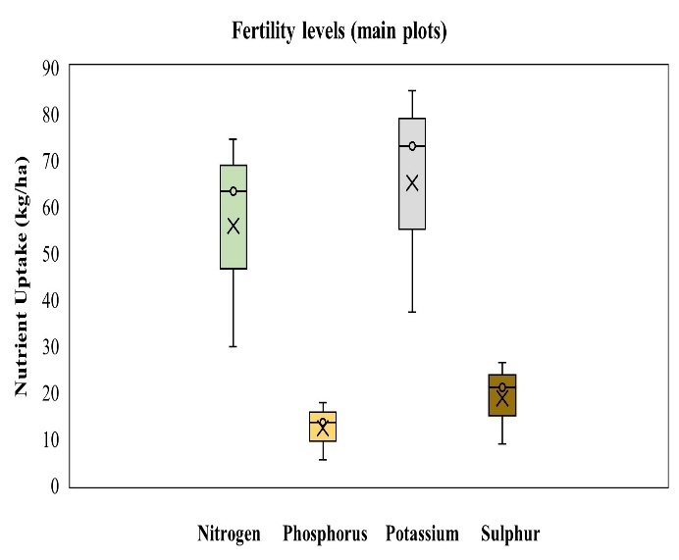 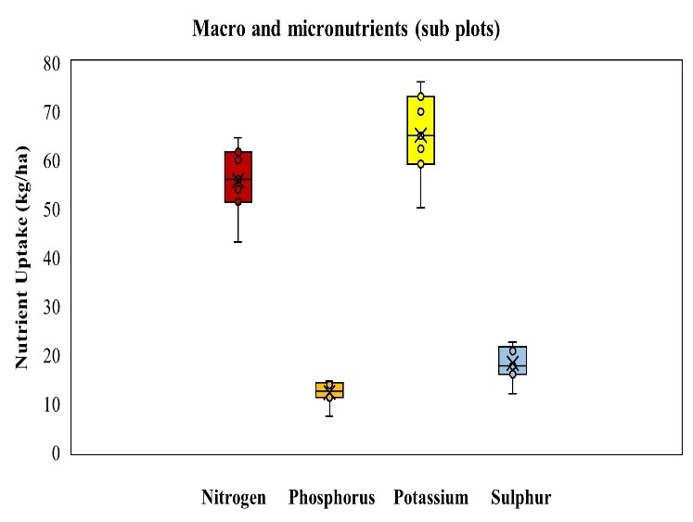

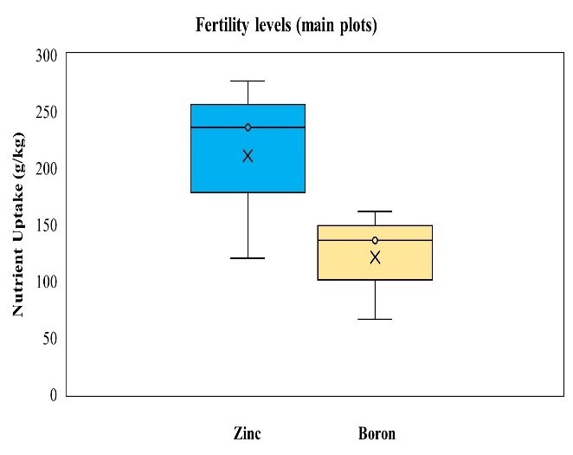 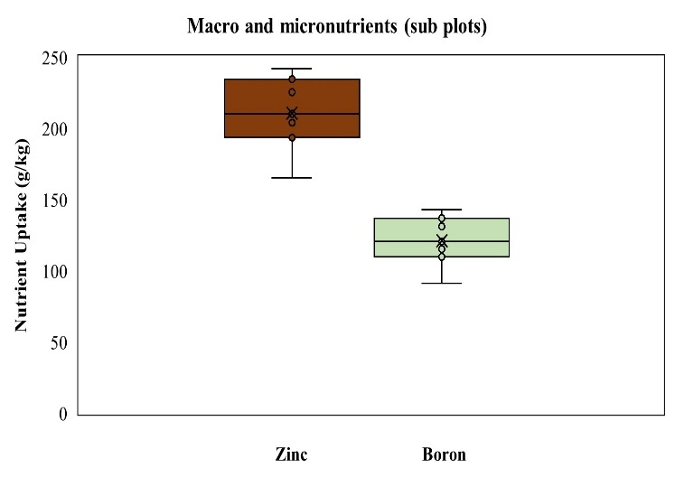

**Fig 1.** Effect of fertility levels and nutrient management on total nutrient uptake in Indian mustard