**Isolation and Identification of Endophytic Fungi associated with roots of Soybean plant and their antagonist activity against *Fusarium* spp.**

**ABSTRACT:** Soybean (Glycine max), an essential oilseed crop, is severely affected by soil-borne fungal pathogens, particularly Fusarium solani, which causes destructive diseases such as root rot and charcoal rot. The growing prevalence of these diseases, along with the negative environmental impacts associated with chemical control strategies, highlights the need for eco-friendly and sustainable disease management solutions. One promising alternative is the use of endophytic fungi as biological control agents. In the present study, healthy soybean root tissues were collected and subjected to surface sterilization followed by culturing on Potato Dextrose Agar (PDA) for endophyte isolation. Five fungal endophytes—Penicillium chrysogenum, Aspergillus niger, Aspergillus flavus, Cladosporium sp., and Curvularia sp.—were successfully isolated. Morphological and microscopic analyses confirmed their identity, and pathogenicity tests indicated that all isolates were non-pathogenic to the host plant. The antagonistic activity of these endophytes against Fusarium solani was evaluated using the dual culture technique. Among them, Penicillium chrysogenum and Aspergillus flavus showed the highest inhibition (55.56%), followed by Aspergillus niger (46.67%), Cladosporium (44.44%), and Curvularia (30.55%). Overall, the findings demonstrate the biocontrol potential of endophytic fungi associated with soybean roots, supporting their application as a sustainable approach for managing Fusarium-induced root diseases in soybean cultivation.

**Keywords: -** Glycine max, fungal endophytes, antagonistic

# **INTRODUCTION**

Soybean (Glycine max), a leguminous crop under the Fabaceae family, stands as one of the most economically and nutritionally significant crops on a global scale. It is believed to have been domesticated over 9000 years ago in China, from where its cultivation extended to other East Asian countries such as Japan and Korea, eventually achieving worldwide agricultural importance. Soybean was present in India as early as the 19th century, particularly in the Himalayan foothills and Central India; however, its commercial cultivation began only in the 1960s and 1970s, marking the start of its emergence as a vital component of Indian agriculture. (Singh *et.al.,* 2006) Its ability to thrive in varied agro-climatic conditions, along with its high nutritional content, has reinforced its role as a key staple crop across the world.

Known as a "miracle crop," soybean is prized for its high protein (about 45%) and oil content (around 18%). It serves multiple purposes, including use in food products, animal feed, and a variety of industrial applications such as the manufacture of paints, plastics, lecithin, resins, and soaps. Additionally, soybeans help combat protein-energy malnutrition, especially in developing countries. In India, the crop is grown on an estimated 11.7 million hectares, with an annual output of around 10.75 million metric tons. The primary soybean-producing regions in the country include Madhya Pradesh and Maharashtra

Despite its numerous benefits, soybean cultivation faces major challenges, particularly from biotic stresses such as fungal infections. Among these, Fusarium solani is a prominent soilborne pathogen that causes diseases like root rot and charcoal rot in soybean plants. This fungus can infect over 500 different plant species and has been linked to considerable yield losses worldwide. Soybean root rot caused by various Fusarium spp. can result in 10–60% yield reduction depending on severity and environmental conditions (Ma *et al*., 2022)."The pathogen thrives in environments with compacted, waterlogged, and poorly drained soils, where it often coexists with other soil-borne pathogens, complicating management efforts.

Fusarium solani is known for its persistence in the soil, where it survives through long-lasting spores called chlamydospores. Factors such as soil pH, temperature, structure, and the presence of pests like soybean cyst nematodes influence its infection cycle. Symptoms typically start with root browning and decay, followed by stunted growth, leaf yellowing, wilting, and eventual defoliation—leading to reduced plant vigor and productivity.

While chemical fungicides are commonly used to control such infections, prolonged reliance on them poses environmental and health risks and may lead to the development of resistant strains. As a result, there is a growing focus on sustainable biological alternatives. One such promising approach is the use of endophytic fungi—microorganisms that live within plant tissues without causing disease.

First described by Anton de Bary in 1866, endophytes enhance plant health by producing growth-promoting substances, improving stress tolerance, and synthesizing antimicrobial compounds (Suryanarayanan *et al*., 2012; Azevedo *et al*., 2000). In soybean, endophytic microbes have been shown to produce phytohormones like indole‑3‑acetic acid (IAA), secrete siderophores, and solubilize phosphate, alongside exhibiting antagonistic activity against pathogens (e.g., Singh *et al*., 2020).

Given their potential, this study focuses on isolating and identifying endophytic fungi from soybean roots, characterizing them morphologically and molecularly, and assessing their antagonistic activity against Fusarium solani, thereby contributing to sustainable disease management in soybean cultivation. Here have the following objectives:

1. To isolate different Endophytic fungi from roots of soybean plant.
2. Morphological characterization of endophytic fungi and it’s *in vitro* antagonist activity against *fusarium* species.

**METHODOLOGY**

The present research was conducted during 2024–2025 at the Department of Plant Biotechnology, Vilasrao Deshmukh College of Agricultural Biotechnology, Latur (Vasantrao Naik Marathwada Krishi Vidyapeeth, Parbhani).

**2.1** **Collection and Isolation of Fusarium spp. from Infected Soybean Roots**

During the *Kharif* season (July to October) of 2024–2025, soybean plants exhibiting symptoms of root and charcoal rot were collected from agricultural fields located in Beed, Ambajogai, Latur, Ahemadpur, and Udgir. The samples, putatively infected withFusarium solani*,* were placed in sterile paper bags and transported to the laboratory for further analysis. Under sterile conditions within a laminar airflow cabinet, infected root tissues were cultured on Potato Dextrose Agar (PDA) medium. To maintain aseptic conditions and prevent contamination, surface sterilization was carried out using 70% ethanol, followed by UV treatment and flame sterilization of tools and glassware.

**2.2** **Morphological and Pathogenic Evaluation of Fusarium solani Isolates**

To evaluate the characteristics of Fusarium solani, isolates were cultured on Potato Dextrose Agar (PDA) in 90 mm Petri plates and incubated at a temperature of 28 ± 2°C. After 5 to 7 days, morphological features were examined, and colony diameters were measured to categorize isolates based on their growth rates as slow, moderate, or fast-growing. For microscopic examination, small sections of fungal mycelium were stained with lactophenol cotton blue, mounted on a slide, and observed under a compound microscope (VISION 2000 LABOMED). Identification was done based on the morphological characters such as colour or with microscopic observation of colony spore formation, shape of conidia etc. of isolate.

The pathogenic behavior of Fusarium solani was assessed using a **root-dip inoculation method,** similar to established protocols applied in studies of other soil-borne pathogens (e.g. Kaya *et al*., 2017). Spore suspensions were obtained from 7–10-day-old cultures grown in Potato Dextrose Broth (PDB). Roots of 20-day-old soybean seedlings were trimmed and immersed in the spore suspension (1 × 10⁶ spores/mL) for 30 minutes. The seedlings were then transplanted into 15 cm pots containing a 1:1 mixture of sterilized soil and sand. Prior to planting, pots were disinfected with 0.1% mercuric chloride (Tiwari, Singh and Rajam, 2023). Control plants were treated similarly but dipped in sterile distilled water. Disease symptoms were regularly observed to determine the pathogenicity of the isolates.

**2.3 Identification of *Fusarium solani***

The test pathogen (*Fusarium solani*) was identified on the basis of charcoal rot typical symptoms expressed (both on naturally and artificially diseased) on soybean plants, symptoms including browning, decay, and white fungal mycelial growth on the root surface. These symptoms were used as indicators to identify the affected plant parts by *F. solani.*

**2.4 Sample collection Sterilization and Isolation of endophytic fungi**

During the *Kharif* season (July to October) of 2024–2025 season, soybean plants intended for endophytic fungal isolation were collected from experimental plots located near Vilasrao Deshmukh College of Agricultural Biotechnology, Latur, Maharashtra, India. Only healthy, mature, and visibly disease-free plants at the reproductive growth stage were selected. Root tissues were carefully harvested, placed in sterile zip-lock bags, and transported to the laboratory for processing within 24 hours to preserve sample integrity. To eliminate surface contaminants, plant materials were first washed thoroughly under running tap water and then cut into standardized segments—5–6 mm for leaves and 1–2 cm for stems and roots. Surface sterilization was performed under sterile conditions in a laminar airflow chamber, involving sequential treatment with 75% ethanol for 1 minute, 4% sodium hypochlorite for 3–5 minutes, followed by a second rinse in 75% ethanol for 30 seconds. The tissues were then rinsed three times with sterile distilled water and left to dry on sterile filter paper. Sterilized root segments were inoculated onto Potato Dextrose Agar (PDA) plates and incubated at 27 ± 2°C for up to 10 days. Emerging fungal growth was monitored, and actively growing hyphal tips were sub cultured onto fresh PDA to promote sporulation. The resulting pure cultures were preserved on PDA slants at 8°C for further morphological and molecular characterization.

**2.5 Pathogenicity Testing of Endophytic Fungi isolated from Soybean Roots**

To determine their non-pathogenic nature, a root-drenching technique was applied, where fungal cultures grown in Potato Dextrose Broth (PDB) were introduced to the root zones of soybean seedlings cultivated in a sterilized mixture of soil, sand, and farmyard manure (2:1:1). The seedlings were monitored over a period of 2–3 weeks for any symptom development, while control plants received sterile distilled water for comparative evaluation.

**2.6 *In Vitro* Evaluation of Antagonistic Activity of Endophytic Fungi Against *Fusarium solani***

The antagonistic potential of selected endophytic fungi against *Fusarium solani* was assessed using the dual culture technique. In this assay, 5 mm diameter mycelial discs of both the endophytic fungus and *F. solani* were placed on at both ends of Potato Dextrose Agar (PDA) plates. The plates were incubated at 28 ± 2°C, and the radial growth of the pathogen was measured daily until the control plate (inoculated with *F. solani* alone) was completely covered with mycelium.

The experiment was laid out in a Completely Randomized Design (CRD) with three replications. The treatments included five endophytic fungal isolates and one control:

* **T₁**: *Aspergillus niger*
* **T₂**: *Aspergillus flavus*
* **T₃**: *Penicillium chrysogenum*
* **T₄**: *Cladosporium* sp.
* **T₅**: *Curvularia* sp.
* **T₆**: Control (*Fusarium solani* alone)

The percentage of pathogen growth inhibition (PGI) was calculated using the formula:

PGI (%) = R1-​R2​ ​​×100

R1

Where,  
R₁ = Colony diameter in control plate  
R₂ = Colony diameter in treatment plate

**RESULTS AND DISCUSSION**

**3.1. Symptomatology of Fusarium Root Rot in Soybean**

Symptoms of root rot in soybean caused by Fusarium solani were prominently observed during the early growth stages in field conditions. Affected plants exhibited noticeable stunting, foliar chlorosis, wilting, and premature leaf senescence. Root systems developed dark brown to reddish-brown lesions, which progressively led to severe cortical degradation. In advanced stages, the epidermal tissue of the roots detached, exposing a thread-like stele. In some instances, the infection extended upward to the stem base, resulting in vascular discoloration that impaired water uptake and caused pre-mature plant death before pod development. These symptoms were more prevalent in poorly drained or compacted soils.

### **3.2. Isolation and Identification of Fusarium solani**

Fusarium solani was successfully isolated from infected root tissues of symptomatic soybean plants using Potato Dextrose Agar (PDA) medium. The colonies initially appeared white and fluffy, later forming a pink to violet pigmentation at the center with a whitish margin. Microscopic analysis revealed septate hyphae and three distinct spore types: unicellular, kidney-shaped microconidia; sickle-shaped macroconidia with 3–5 septa; chlamydospores located terminally or intercalarily. These features were in accordance with established morphological descriptions, confirming the pathogen’s identity.

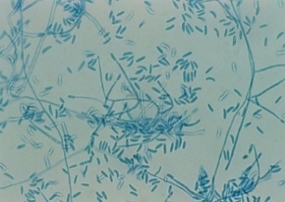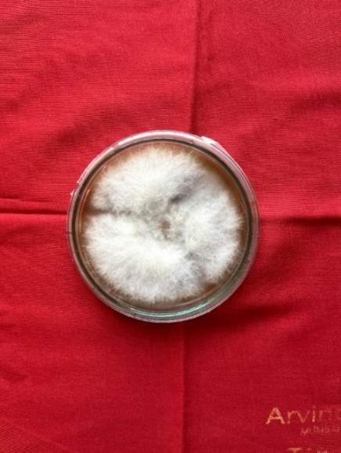

**Fig.No.1: -** Pure Culture of *Fusarium solani* and its

### Microscopic characterization

### **3.3. Pathogenicity Assessment**

To verify pathogenicity, F. solani was inoculated onto soybean seedlings using the root dip method under controlled screen house conditions. The inoculated seedlings displayed typical disease symptoms, such as seed rot, post-emergence damping-off, chlorosis, and decay of both roots and stem bases. Re-isolation of the same fungal species from infected tissues confirmed Koch’s postulates, establishing the pathogenic nature of the isolate.

### **3.4. Isolation and Micro-morphological** **Characterization of Endophytic Fungi**

Five endophytic fungal strains—Penicillium chrysogenum, Cladosporium sp., Curvularia sp., Aspergillus niger, and Aspergillus flavus—were isolated from surface-sterilized roots of healthy soybean plants. The isolates were cultivated on PDA and identified based on colony morphology, spore characteristics, and sporulation patterns through standard mycological techniques.

### **3.5. Non-Pathogenicity Evaluation of Endophytes**

The pathogenic potential of the isolated endophytes was tested using a root drenching method on healthy soybean plants. Over a 2–3-week observation period, none of the treated plants exhibited disease symptoms, confirming the non-pathogenic behavior of all five isolates. This supports their classification as true endophytes, which typically exist in mutualistic or neutral association with their host plants.

### **3. 6. Morphological Characteristics of Endophytes**

Each endophyte displayed distinct morpho-cultural features. The five endophytic fungi isolated from healthy soybean roots were morphologically characterized on Potato Dextrose Agar (PDA) and through microscopic observations:

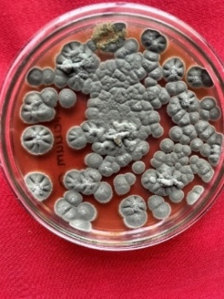**3.6.1** ***Penicillium chrysogenum*** the colony morphology fast-growing, blue-green with velvety texture—and microscopic features including brush‑like conidiophores and flask-shaped phialides forming globose conidia in basipetal chains—are consistent with detailed descriptions in the *Chrysogena* section, specifically in *P. chrysogenum* (Houbraken *et al*., 2012).

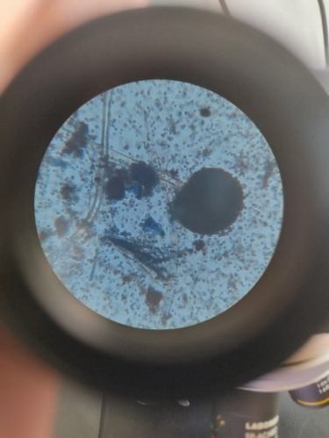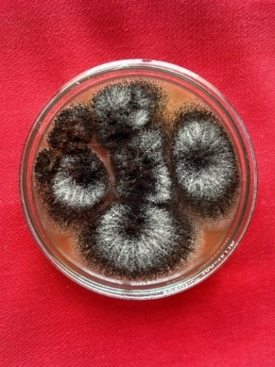

**Fig.No.2: -** Pure Culture of ***Penicillium chrysogenum*** and its microscopic characterization

* + 1. 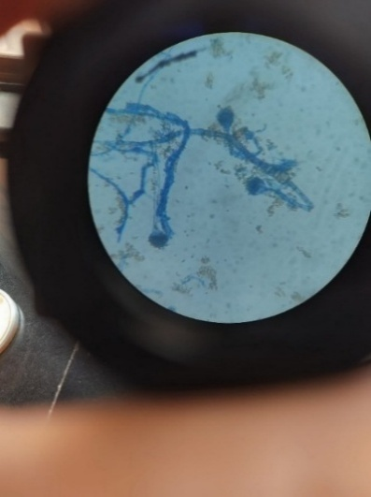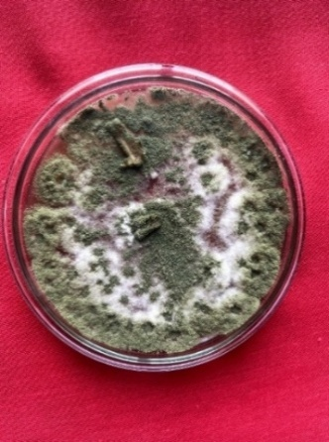The **Cladosporium sp.** exhibited **olivaceous-green, suede‑like colonies** and **septate, branched conidiophores** producing **lemon‑shaped, pale‑to‑dark brown conidia with visible hila,** aligning with descriptions by Nam *et al*. (2015).

**Fig.No.3: -** Pure Culture of ***Cladosporium*** and its microscopic characterization

* + 1. **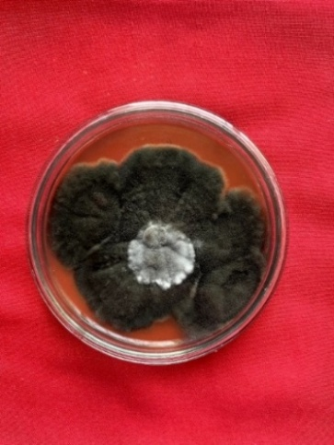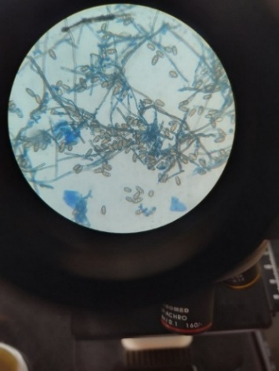*Curvularia* sp.** showed rapid growth with dark brown, woolly colonies and produced curved, typically 3–5‑septate conidia with a prominently darker and swollen central cell. (Priyadharsini *et al*., 2017).

**Fig.No.4: -** Pure Culture of ***Curvularia*** and its microscopic characterization

* + 1. **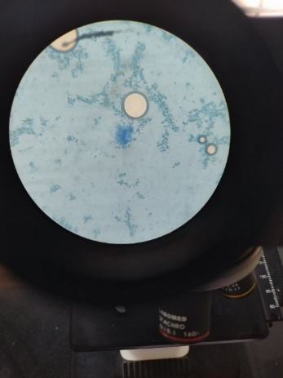*Aspergillus niger*** the isolate displayed **dense, black granular colonies** and **septate conidiophores ending in biseriate conidial heads,** producing **rough-walled, spherical conidia,** consistent with detailed descriptions for Aspergillus niger (Silva *et al*., 2023).

**Fig.No.5: -** Pure Culture of ***Aspergillus niger*** and its microscopic characterization

* + 1. **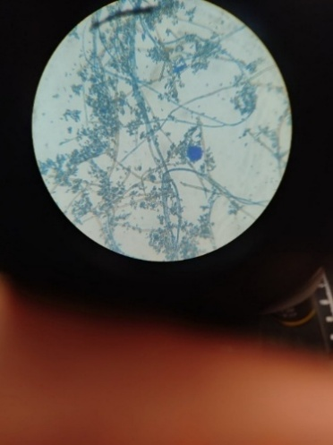*Aspergillus flavus its*** morphology observed**—yellow‑green, powdery/granular colonies, uniseriate and biseriate conidial heads,** and **echinulate globose conidia arranged in long chains**—is consistent with detailed descriptions of Aspergillus flavus taxonomy (Rudramurthy *et al*., 2019).

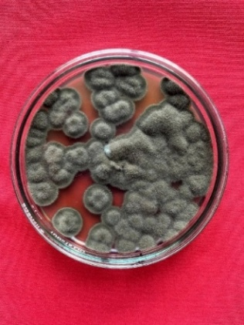

**Fig.No.6: -** Pure Culture of ***Aspergillus flavus and*** its microscopic characterization

### **3.7 *In Vitro* Evaluation of Endophytic Fungi Against Fusarium solani**

The in vitro antagonistic activity of five endophytic fungal isolates derived from healthy soybean roots was assessed against Fusarium solani, the pathogen responsible for root rot, using the dual culture technique. The experiment followed a completely randomized design (CRD) with three replications. The effectiveness of each isolate was measured by comparing the radial growth of F. solani in treated and untreated (control) plates, with results summarized in Table 1.

**Table 1. *In vitro* antagonistic activity of endophytic fungi against Fusarium solani**

|  |  |  |  |
| --- | --- | --- | --- |
| **Tr. No.** | **Endophytic Fungal Isolate** | **Colony Diameter (mm)** | **% Inhibition** |
| 1 | Penicillium chrysogenum | 20.0 | 55.56 |
| 2 | Cladosporium sp. | 25.0 | 44.44 |
| 3 | Curvularia sp. | 30.0 | 30.55 |
| 4 | Aspergillus niger | 23.3 | 46.67 |
| 5 | Aspergillus flavus | 20.0 | 55.56 |
| 6 | Control (untreated) | 45.0 | 0.00 |
|  | **SE±** | **0.59** | **0.47** |
|  | **CD (P = 0.01)** | **1.82** | **1.50** |

All five fungal endophytes significantly inhibited the radial growth of F. solani compared to the control, demonstrating varying degrees of antagonistic potential. Penicillium chrysogenum and Aspergillus flavus were the most effective isolates, each achieving 55.56% inhibition of pathogen growth and reducing the colony diameter from 45.0 mm (in control) to 20.0 mm. Their high level of suppression suggests strong antagonistic interactions, likely involving mechanisms such as antibiosis, competition for nutrients and space, or enzymatic degradation of the pathogen.

Aspergillus niger also showed notable efficacy, inhibiting F. solani by 46.67% with a corresponding colony diameter of 23.3 mm. Cladosporium sp. exhibited moderate suppression (44.44% inhibition), while Curvularia sp. was the least effective among the isolates, reducing pathogen growth by only 30.55%.

In contrast, the untreated control showed the highest colony diameter (45.0 mm) and no inhibition, confirming the virulence of F. solani under in vitro conditions in the absence of antagonistic agents. Overall, the results highlight Penicillium chrysogenum and Aspergillus flavus as promising candidates for biological control of F. solani in soybean.

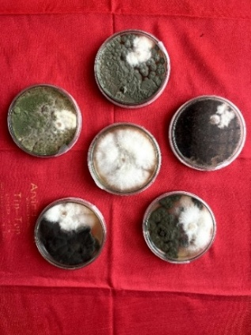

**Fig.No.7:** - *In vitro* efficacy of endophytic fungi of soybean against *Fusarium solani*

**CONCLUSION**

This study successfully isolated and identified five endophytic fungal species—*Penicillium chrysogenum*, *Aspergillus flavus*, *Aspergillus niger*, *Cladosporium* sp., and *Curvularia* sp.—from the root tissues of healthy soybean (*Glycine max*) plants. Using standard sterilization and culturing techniques, the fungi were obtained in pure culture, morphologically characterized, and confirmed to be non-pathogenic through pathogenicity testing on soybean seedlings. These isolates were then evaluated for their antagonistic potential against *Fusarium solani*, a major soil-borne pathogen known to cause root rot and charcoal rot in soybean crops, particularly under poorly drained or compacted soil conditions.

The antagonistic activity of the fungal isolates was tested using the dual culture technique, which clearly demonstrated varied but significant inhibitory effects on the radial growth of *F. solani*. Among all tested isolates, *Penicillium chrysogenum* and *Aspergillus flavus* showed the strongest antagonism, each achieving 55.56% inhibition. *Aspergillus niger* followed with 46.67% inhibition, while *Cladosporium* sp. and *Curvularia* sp. showed moderate suppression at 44.44% and 30.55%, respectively. These findings suggest that the endophytic fungi may act through mechanisms such as antibiosis, competition for space and nutrients, or production of lytic enzymes, thereby limiting the growth and spread of the pathogenic *Fusarium* species.

The results affirm that endophytic fungi associated with soybean roots have significant potential as biological control agents. Their ability to inhibit *F. solani* without causing harm to the host plant underscores their suitability for development into eco-friendly alternatives to synthetic fungicides. Utilizing these fungi in disease management strategies could reduce the environmental and health impacts associated with chemical control methods and help address the issue of fungicide resistance in pathogens.

For broader agricultural application, further research is recommended. Molecular-level identification and functional analysis of the antifungal compounds produced by these endophytes will deepen understanding of their biocontrol mechanisms. Additionally, greenhouse and field trials are necessary to validate their performance under natural environmental conditions and agronomic practices.

In conclusion, the study demonstrates that endophytic fungi from soybean roots, particularly *Penicillium chrysogenum* and *Aspergillus flavus*, hold promise as sustainable biocontrol agents against *Fusarium solani*. These fungi could contribute significantly to the development of integrated, environmentally responsible disease management strategies in soybean cultivation.

**FUTURE SCOPE**

The study emphasizes the potential of endophytic fungi as effective biocontrol agents against Fusarium solani in soybean. Future research should focus on *in vivo* trials under field conditions to validate their efficacy. Molecular characterization and metabolomic profiling can uncover bioactive compounds and antifungal mechanisms. Developing bio fungicide formulations and exploring synergistic effects with other beneficial microbes may enhance plant resistance. Integrating these endophytes into Integrated Pest Management (IPM) strategies could offer a sustainable and eco-friendly solution for managing soybean root diseases.

Disclaimer (Artificial intelligence)

Option 1:

Author(s) hereby declare that NO generative AI technologies such as Large Language Models (ChatGPT, COPILOT, etc.) and text-to-image generators have been used during the writing or editing of this manuscript.

Option 2:

Author(s) hereby declare that generative AI technologies such as Large Language Models, etc. have been used during the writing or editing of manuscripts. This explanation will include the name, version, model, and source of the generative AI technology and as well as all input prompts provided to the generative AI technology

Details of the AI usage are given below:

1.

2.

3.

**REFERENCES**

1. Azevedo, J. L., Maccheroni, W., Pereira, J. O., & Araujo, W. L. (2000). *Endophytic microorganisms: A review on insect control and recent advances on tropical plants*. Electronic Journal of Biotechnology, 3(1), 40–65.
2. Barnett, H. L., & Hunter, B. B. (1998). *Illustrated Genera of Imperfect Fungi* (4th ed.). APS Press.
3. Tiwari, R., Singh, A. K., & Rajam, M. V. (2023). Improved and reliable plant regeneration and Agrobacterium-mediated genetic transformation in soybean (Glycine max L.). Journal of Crop Science and Biotechnology, 26(3), 275-284.
4. Compant, S., Duffy, B., Nowak, J., Clément, C., & Barka, E. A. (2005). *Use of plant growth-promoting bacteria for biocontrol of plant diseases: Principles, mechanisms of action, and future prospects*. Applied and Environmental Microbiology, 71(9), 4951–4959.
5. Houbraken, J., Frisvad, J. C., Seifert, K. A., et al. (2012). New penicillin-producing Penicillium species and an overview of section Chrysogena. Persoonia – Molecular Phylogeny and Evolution of Fungi, 29, 84–97. <https://doi.org/10.3767/003158512X660583>
6. Kaya, A., Maden, S., Cevik, C., & Özer, N. (2017). Comparison of inoculation methods for assessing pathogenicity of Fusarium solani, F. oxysporum, Macrophomina phaseolina, and Rhizoctonia solani from pepper (Capsicum annuum) seedlings. Journal of Phytopathology, 165(1), 18–28. <https://doi.org/10.1111/jph.12618>  (author and year not match)
7. Ma, X., Yu, Z., Zheng, Y., Zhao, Y., Li, M., & Gao, C. (2022). Changes in the density and composition of rhizosphere pathogenic Fusarium and beneficial Trichoderma contributing to reduced root rot of intercropped soybean. Pathogens, 11(4), 478. https://doi.org/10.3390/pathogens11040478
8. Nam, S.‑Y., Nguyen, H.‑N., Lee, I.‑S., & Lee, T.‑G. (2015). Cladosporium cladosporioides and C. tenuissimum cause blossom blight in strawberry in Korea. Mycobiology, 43(3), 291–301. <https://doi.org/10.5941/MYCOBIO.2015.43.3.291>
9. Priyadharsini, P., Perumalsamy, P., & Gopalakrishnan, S. (2017). The root endophytic fungus Curvularia geniculata from Parthenium hysterophorus roots improves plant growth through phosphate solubilization and phytohormone production. Fungal Ecology, 24, 122–130. https://doi.org/10.1016/j.funeco.2016.12.001
10. Rudramurthy, S. M., Paul, R. A., Chakrabarti, A., Mouton, J. W., & Meis, J. F. (2019). Invasive Aspergillosis by Aspergillus flavus: Epidemiology, Diagnosis, Antifungal Resistance, and Management. Journal of Fungi, 5(3), 55. <https://doi.org/10.3390/jof5030055>
11. Schubert, K., Groenewald, J. Z., Braun, U., Dijksterhuis, J., Starink, M., Hill, C. F., ... & Crous, P. W. (2007). *Biodiversity in the Cladosporium herbarum complex (Davidiellaceae, Capnodiales), with standardisation of methods for Cladosporium taxonomy and diagnostics*. Studies in Mycology, 58, 105–156.
12. Singh, B. B. (2006). Success of soybean in India: The early challenges and pioneer promoters. Asian Agri‑History, 10(1), 43–53. <https://www.researchgate.net/publication/237527373_Success_of_Soybean_in_India_The_Early_Challenges_and_Pioneer_Promoters> [soyinfocenter.com+13](https://www.researchgate.net/publication/237527373_Success_of_Soybean_in_India_The_Early_Challenges_and_Pioneer_Promoters?utm_source=chatgpt.com)
13. Silva, F. O., et al. (2023). Identification and biodiversity patterns of Aspergillus species from Brazilian maize samples: morphological and molecular characterization. Journal of Fungi, 9(5), 100. <https://doi.org/10.3390/jof9050100>
14. Singh, G., Rajput, R. B. S., & Gupta, S. (2020). Synergism of Pseudomonas aeruginosa (LSE‑2) nodule endophyte with Bradyrhizobium sp. (LSBR‑3) for improving plant growth, nutrient acquisition and soil health in soybean. International Journal of Environmental Research and Public Health, 18(3), Article 931. <https://doi.org/10.3390/ijerph18030931>
15. Song, Q., Lin, C., & Hsiang, T. (2024). Morphological and phylogenetic characterization of endophytic fungi isolated from Zingiber officinale (ginger). Scientific Reports, 14, Article 68428. <https://doi.org/10.1038/s41598-024-68428-1>
16. **Suryanarayanan, T. S., Thirunavukkarasu, N., Govindarajulu, M. B., & Gopalan, V.** (2012). Fungal endophytes: An untapped source of biocatalysts. Fungal Diversity, 54, 19–30. <https://doi.org/10.1007/s13225-012-0168-7>