**Genetic diversity studies using D2 statistics in Finger Millet (Eleusine coracana (L.) Gaertn.) Genotypes for Agro-Morphological and Biochemical Traits**

=====================================================================

**Abstract**

The present experiment was undertaken in a set of fifty five diverse genotypes of finger millet to extract information on genetic variability, genetic diversity, correlation coefficient, path coefficient and stability analysis based on morphological and quality characters. The research was carried out at four different locations *viz*., Waghai, Vanarasi, Navsari and Dediyapada during *kharif*, 2023 in Randomized Block Design with three replications. The D2 analysis indicated wider genetic diversity among fifty five genotypes of finger millet which were grouped in five different clusters by Tocher's method. The results indicated that a maximum number of diverse genotypes (41 genotypes) were appeared in cluster I followed by cluster II (11 genotypes), whereas cluster III, IV and V were mono-genotypic, consisted of single genotype. These genotypes are likely to have extreme form of expression for particular character. Based upon inter-cluster distances, it is advisable to attempt crossing between genotypes belonging to cluster III and V, to derive transgressive segregants for trait of interest to improve in Finger millet. It was observed that grain yield per plant, fingers per panicle, calcium content, ear head length, fodder yield per plant, iron content, days to 50% flowering, 1000 grain weight, finger width, protein content, plant height, ear head weight, productive tillers per plant contributed much towards total genetic divergence. On the basis of cluster means for different characters, it could be concluded that high yielding genotypes coupled with other important physiological traits could be selected as parents for hybridization programme.

**Key words: Finger millet, D2 analysis, Genetic divergence**

**Introduction**

“Finger millet (*Eleusine coracana* (L.) Gaertn.) is an important annual *kharif* crop, commonly known as *Ragi*. It is a self-pollinated tetraploid species (2n = 4x = 36; AABB), belonging to the family Poaceae and genus *Eleusine*. Finger millet is primarily cultivated in two major continents Africa and Asia for both grain and fodder purposes. The name "finger millet" is derived from its distinctive inflorescence structure, where the spikes resemble human fingers. Globally, finger millet ranks as the sixth most important cereal after wheat, rice, maize, sorghum, and pearl millet, and it holds the fourth position among millets. In India, it is predominantly grown in Karnataka, Tamil Nadu, Andhra Pradesh, Maharashtra, Odisha, Gujarat, Jharkhand, Uttar Pradesh, Madhya Pradesh, and Uttarakhand. It is widely regarded as a food-security crop due to its excellent nutritional profile and superior storage qualities” (Patel *et al*., 2020).

“Finger millet grains are rich in nutrients, containing 65–75% carbohydrates, 2.5–3.5% minerals, 5–8% protein, and 15–20% dietary fiber. It is particularly notable for its high calcium content (344 mg/100 g), which is approximately ten times higher than wheat, maize, or rice and nearly three times higher than milk” (Rachie *et al.*, 1975). “Additionally, its low glycemic index and high fiber content make it beneficial in managing diabetes, obesity, and hypertension.” (Udit *et al.* 2021)

“Exploitation of the existing genetic variability is the cornerstone of any crop improvement program. An understanding of the magnitude of variability for important agro-morphological traits is critical to facilitate effective selection” (Jayaraman *et al*., 1997). “Genetic improvement depends on the diversity and adaptability of genotypes across different environments. The characterization and evaluation of germplasm are essential to identify useful alleles and superior genotypes for breeding programs.” (Sundararaj and Thulasidas, 1976)

“Phenotypic expression of a trait is the result of interaction between genotype and environment. Therefore, it is essential to partition phenotypic variability into genotypic and environmental components to determine the heritable fraction of variation. Heritability, in broad sense, estimates the proportion of observed variation that is genetic in nature, while genetic advance provides an estimate of the expected improvement through selection. High heritability combined with high genetic advance suggests the predominance of additive gene action, and such traits are ideal targets for selection” (Allard, 1999).

“Multivariate analysis through principal component analysis and Mahalanobis D2 statistics is a vital tool to study morphologically complex individuals as well as for determining the degree of divergence across the populations. It is widely employed in genetic diversity study, whether it is morphological, molecular or biochemical analysis” (Walle *et al*., 2019). “Using principal component analysis and Mahalanobis D2 statistics, the current work was attempted to estimate the genetic diversity for different characteristics in finger millet genotypes.” (Panse and Sukhatme, 1985)

**Materials and methods**

The experiment was conducted during *kharif,* 2023 having 55 diverse finger millet genotypes, evaluated in randomized block design at Hill Millet Research Station, Navsari Agricultural University, Waghai, Gujarat; Niger Research Station, Navsari Agricultural University, Vanarasi, Gujarat and College Farm, N. M. College of Agriculture, Navsari Agricultural University, Navsari, Gujarat and KVK, Dediyapada during *kharif*, 2023. The seedlings were planted at 22.5 x 10 cm2 spacing. All recommended practices were followed and timely plant protection measures were taken to avoid damage through insect-pests and diseases.

The observations on five randomly selected plants were recorded for 15 morphological and quality characters were considered for statistical analysis, *viz.*, plant height (cm), days to 50 % flowering, Days to maturity, Productive tillers per plant, Fingers per panicle, finger width (cm), ear head length (cm), ear head weight (g), 1000 seed weight (g), grain yield per plant (g), fodder yield per plant (g), harvest index (%), iron content (mg/100g), calcium content (mg/100g) and protein content (%). Mahalanobis D2 statistics were used to analyse the data for fifteen characteristics in order to explore genetic diversity. Mahalanobis D2 statistics can be used to quantify the degree of genetic divergence and provide a quantitative assessment of the relationship between geographic and genetic diversity based on generalized distance, are an established and useful tool (Mahalanobis, 1936). To investigate morphologically complex individuals and gauge the degree of population divergence, multivariate analysis is a crucial technique. For analysing several measurements on one study subject, multivariate techniques are helpful. It is frequently employed in genetic diversity study, regardless of whether the method is morphological, molecular or biochemical.

**Results and Discussions**

**Mahalanobis D2 Analysis**

Multivariate test using Wilk's criterion was carried out to test the difference among fifty-five finger millet entries. Wilk's criterion was significant and eventually the differences among entries were also significant. Mahalanobis-D2 statistic was computed between all possible pairs of fifty-five finger millet genotypes and the genetic diversity presented among the genotypes was assessed.

**Distribution of genotypes into clusters**

Fifty-five genotypes of finger millet were grouped into five clusters by Tocher's method. The composition of clusters is given in Table 1 and Fig. 1. The results indicated that a maximum number of diverse genotypes (41 genotypes) were appeared in cluster I followed by cluster II (11 genotypes), whereas cluster III, IV and V were mono- genotypic, consisted of single genotype. These genotypes are likely to have extreme form of expression for particular character. Genotypes of different geographical areas were fall in one group and also the genotypes of the same geographical area were clubbed into different groups indicating there is no formed relationship between geographical diversity and genetic diversity. These results are in close agreement with Patel *et al*. (2018) (in little millet), Patel *et al*. (2020), Anuradha *et al*. (2020), Suthediya *et al*. (2021), Karvar *et al*. (2022) and Ketan *et al*. (2024).

In heterosis breeding, genotypes of diverse groups were known to play very important role of potential parents and when each genotype of different clusters were inter crossed, which are likely to produce heterotic combinations. (Singamsetti *et al.* 2018)

**Intra and Inter Cluster Distances**

The intra and inter cluster distances (D) between all possible pairs of five clusters were computed and presented in Table 2 as well as shown in fig. 2. A study of the data revealed that the inter-cluster distance (D) ranged from 59.44 to 225.28. The maximum inter-cluster distance (D=225.28) was observed between cluster III and V followed by those between cluster IV and V (D=194.97) and cluster II and V (D=160.63). The minimum inter-cluster distance (D=59.44) was observed between cluster I and IV followed by the cluster III and IV (D=62.02) and cluster I and III (D=62.6). Intra-cluster distance (D) ranged from 0.00 to 36.91. At intra-cluster level, cluster II had the highest intra cluster distance (D=44.84) followed by cluster I (D=36.91) which involved 11 and 41 genotypes, respectively. The intra-cluster distance within cluster III, IV and V was zero (0) because these clusters were composed of only single genotype.

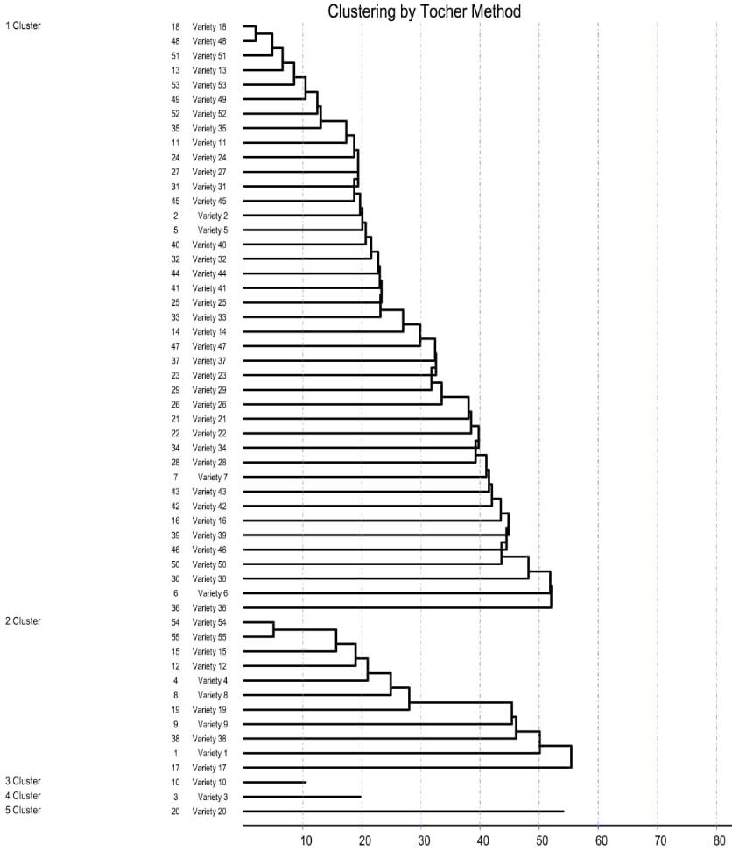

**Fig 1. Clustering by Tocher’s method**

**Table 1. Distribution of fifty-five genotypes of finger millet into five different clusters based Mahalanobis D2 statistics**

|  |  |  |
| --- | --- | --- |
| **Cluster** | **Total no. of**  **genotypes** | **Genotypes** |
| **I** | 41 | WN-591, WN-566, FM-3026, FM-3005, FM-3004, FM-3022, FM 3027, FM-4006, WN-561, WN-572, FM-4003, WN-575, FM-4002, FM-3015, FM-3006, FM-4007, FM-3014, FM-4010, FM-3023, FM-3028, WN 494, FM-3010, WN-544, FM-3024, FM-3016, WN-548, FM-3021, WN-550, WN-560, FM-3025, WN-569, FM-4008, WN-581, FM-4012, FM-3017,FM-4004, WN- 562, FM-4001, FM-3002, FM-4009, FM-4005 |
| **II** | 11 | FM-3009, FM-3003, FM-4011, FM-3013, FM-3018, FM-3019, FM-3001, FM-3008, FM-3007, WN-577, WN-592 |
| **III** | 1 | FM-3020 |
| **IV** | 1 | FM-3012 |
| **V** | 1 | FM-3011 |

**Table 2. Average intra and inter-cluster distance for different genotypes**

|  |  |  |  |  |  |
| --- | --- | --- | --- | --- | --- |
| **Cluster** | **I** | **II** | **III** | **IV** | **V** |
| **I** | 36.91 | 75.85 | 62.6 | 59.44 | 129.43 |
| **II** |  | 44.84 | 68.00 | 149.31 | 160.63 |
| **III** |  |  | 0 | 62.02 | 225.28 |
| **IV** |  |  |  | 0 | 194.97 |
| **V** |  |  |  |  | 0 |

The intra and inter cluster distances were considerably high revealing very interesting genetic diversity. The range of intra cluster distance was from 0.00 (mono- genotypic clusters) to 44.84 (cluster II). Cluster II showed high intra cluster distance. Higher intra cluster distance indicated higher diversity among the genotypes. Similar result for cluster III was reported by Suryanarayana et al. (2014). Similar and nearby intra-cluster range was reported by Selvarani and Chandirasekaran (2000) (in banyard millet), Patel *et al*. (2020), Anuradha *et al*. (2020), Suthediya *et al*. (2021), Karvar *et al*. (2022) and Ketan *et al*. (2024).

As far as inter-cluster distance was concerned, high value of inter-cluster distance pointed out towards high amount of diversity between the clusters involved. Hence, from the above discussions, it was concluded that the genotypes from the cluster III and V were more divergent than any other cluster. Same results were reported by Selvarani and Chandirasekaran (2000), Anuradha *et al*. (2020) and Patel *et al*. (2020). As we discussed above magnitude of heterosis largely depended on the degree of genetic diversity in the parental lines. Hence, the genotypes belonged to the distinct cluster (III and V) could be used in hybridization program for obtaining a wide spectrum of variability among the segregates. From the results of this investigation, it was found that number of clusters contained at least one genotype with the desirable traits, which ruled out the possibility of selecting directly one genotype for immediate use. Therefore, hybridization between the selected genotypes from divergent clusters is essential to judiciously combine all the targeted traits.

**Contribution of Various Characters Towards Genetic Divergence**

The analysis for estimating the contribution of various characters towards the expression of genetic divergence (presented in Table 3 and Fig. 3) indicated that the traits *viz.,* grain yield per plant (g) (11.58%), fingers per panicle (11.04%), calcium content (mg/100g) (9.76%), ear head length (cm) (9.09%), fodder yield per plant (g) (8.48%), Iron content (mg/100g) (7.95%), days to 50% flowering (6.94%), 1000 grain weight (g) (6.67%), finger width (cm) (6.06%), protein content (%) (5.93%), plant height (cm) (5.93%), ear head weight (g) (4.78%), productive tillers per plant (4.51%), harvest index (%) (0.88%) and days to maturity (0.40%) contributed towards genetic divergence in the present material under study (Table 3). Those accounted nearly 100% of total divergence available in the genotypes.

In the present study, grain yield per plant (g) (11.58%), fingers per panicle (11.04%), calcium content (mg/100g) (9.76%), ear head length (cm) (9.09%), fodder yield per plant (g) (8.48%), Iron content (mg/100g) (7.95%), days to 50% flowering (6.94%), 1000 grain weight (g) (6.67%), finger width (cm) (6.06%), protein content (%) (5.93%), plant height (cm) (5.93%), ear head weight (g) (4.78%), productive tillers per plant (4.51%) appeared to be the most important traits contributing maximum towards genetic divergence, while only 2 morphological parameters harvest index (%) (0.88%) and days to maturity (0.40%) contributed very low towards total divergence in the present study. Similar results were also obtained by Shind5e *et al*. (2013), Nirubana *et al*. (2017), Patel *et al*. (2020), Ladumor *et al.* (2021) and Anuradha *et al*. (2023).

**Cluster Means for Different Characters**

Cluster mean for all the fifteen characters were presented in Table 4 . The results clearly indicated appreciable difference among cluster means for most of the characters.

The cluster mean for plant height (cm) ranged between 121.58 and 104.00. The maximum cluster mean for plant height (cm) was observed in cluster II (121.58) followed by cluster I (120.47), cluster IV (114.00) and cluster V (108.66). The minimum cluster mean was observed in cluster III (104). Selection of genotypes for plant height (cm) from cluster III (104) will be highly promising had short plant stature than rest of the cluster.

The cluster mean for days to 50% flowering ranged between 77.60 and 70.68. The maximum cluster mean for days to 50% flowering was observed in cluster II (77.60) followed by cluster V (77.47), cluster I (76.57) and cluster IV (72.39). The minimum cluster mean was observed in cluster III (70.68). Selection of genotypes for days to 50% flowering from cluster III (70.68) will be highly desirable had very short flowering period and suitable for early maturing.

The cluster mean for days to maturity ranged between 116.34 and 110.42. The maximum cluster mean for days to maturity was observed in cluster II (116.34) followed by cluster V (116.14), cluster I (114.78) and cluster IV (112.48). The minimum cluster mean was observed in cluster III (110.42). Selection of genotypes for days to maturity from cluster III (110.42) will be highly desirable had very short maturity period and suitable for early maturing.

The cluster mean for productive tillers per plant ranged between 5.30 and 4.86. The maximum cluster mean for productive tillers per plant was observed in cluster II (5.30) followed by cluster I (5.22), cluster IV (5.09) and cluster V (4.96). The minimum cluster mean was observed in cluster II (4.86). Selection of genotypes for productive tillers per plant from cluster II (5.30) will be highly desirable had maximum productive tillers per plant that contribute to yield.

The cluster mean for fingers per panicle ranged between 7.29 and 4.92. The maximum cluster mean for fingers per panicle was observed in cluster V (7.29) followed by cluster II (7.18), cluster I (6.62) and cluster IV (6.40). The minimum cluster mean was observed in cluster III (4.92). Selection of genotypes for fingers per panicle from cluster V (7.29) will be highly desirable had maximum fingers per panicle that contribute to yield.

The cluster mean for finger width (cm) ranged between 0.91 and 0.78. The maximum cluster mean for finger width (cm) was observed in cluster IV (0.91) followed by cluster II (0.89), cluster V (0.86) and cluster I (0.85). The minimum cluster mean was observed in cluster III (0.78). Selection of genotypes for finger width (cm) from cluster IV (0.91) will be highly desirable had maximum finger width that contribute to yield.

The cluster mean for ear head length (cm) ranged between 13.29 and 4.53. The maximum cluster mean for ear head length (cm) was observed in cluster V (13.29) followed by cluster II (9.26), cluster I (7.52) and cluster III (5.41). The minimum cluster mean was observed in cluster IV (4.53). Selection of genotypes for ear head length (cm) from cluster V (13.29) will be highly desirable had maximum ear head length that contribute to yield.

The cluster mean for ear head weight (g) ranged between 16.79 and 14.15. The maximum cluster mean for ear head weight (g) was observed in cluster IV (16.79) followed by cluster I (16.01), cluster II (15.92) and cluster III (14.51). The minimum cluster mean was observed in cluster V (14.15). The minimum cluster mean was observed in cluster IV (4.53). Selection of genotypes for ear head weight (g) from cluster IV (16.79) will be highly desirable had maximum ear head weight (g) that contribute to yield.

The cluster mean for 1000 grain weight (g) ranged between 2.83 and 2.67. The maximum cluster mean for productive tillers per plant was observed in cluster II (2.83) followed by cluster III (2.67), cluster I (2.65) and cluster IV (2.39). The minimum cluster mean was observed in cluster V (2.23). Selection of genotypes for 1000 grain weight (g) from cluster II (2.83) will be highly desirable had maximum 1000 grain weight that contribute to yield.

The cluster mean for grain yield per plant (g) ranged between 7.69 and 5.72. The maximum cluster mean for grain yield per plant (g) was observed in cluster II (7.69) followed by cluster I (6.98), cluster IV (6.31) and cluster III (5.92). The minimum cluster mean was observed in cluster V (5.72). Selection of genotypes for grain yield per plant (g) from cluster II (7.69) will be highly promising had maximum yield per plant that contribute to yield.

The cluster mean for fodder yield per plant (g) ranged between 18.75 and 14.25. The maximum cluster mean for fodder yield per plant (g) was observed in cluster I (18.75) followed by cluster II (18.48), cluster V (16.88) and cluster III (14.67). The minimum cluster mean was observed in cluster IV (14.25). Selection of genotypes for fodder yield per plant (g) from cluster I (18.75) will be highly promising had maximum biomass per plant that contribute to fodder yield.

The cluster mean for harvest index (%) ranged between 30.74 and 30.33. The maximum cluster mean for harvest index (%) was observed in cluster IV (30.74) followed by cluster III (30.33), cluster II (29.54) and cluster I (27.53). The minimum cluster mean was observed in cluster V (25.36). Selection of genotypes for harvest index (%) from cluster IV (30.74) will be highly promising had maximum harvest index that contribute to yield.

The cluster mean for iron content (mg/100g) ranged between 3.99 and 2.04. The maximum cluster mean for iron content (mg/100g) was observed in cluster II (3.99) followed by cluster III (3.72), cluster I (2.92) and cluster IV (2.35). The minimum cluster mean was observed in cluster V (2.05). Selection of genotypes for iron content (mg/100g) from cluster II (3.99) will be highly promising had maximum iron content that is essential micronutrient. The cluster mean for calcium content (mg/100g) ranged between 324.30 and 249.08. The maximum cluster mean for calcium content (mg/100g) was observed in cluster III (324.30) followed by cluster IV (287.78), cluster II (283.27) and cluster I (274.75). The minimum cluster mean was observed in cluster V (249.08). Selection of genotypes for calcium content (mg/100g) from cluster III (324.30) will be highly promising had maximum calcium content that is essential micronutrient.

The cluster mean for protein content (%) ranged between 9.26 and 7.15. The maximum cluster mean for protein content (%) was observed in cluster III (9.26) followed by cluster V (8.75), cluster IV (8.63) and cluster II (7.91). The minimum cluster mean was observed in cluster I (7.15). Selection of genotypes for protein content (%) from cluster III (9.26) will be highly promising had maximum protein content that is lacking in cereal.

On the basis of cluster means for different characters, it could be concluded that high yielding genotypes coupled with other important morphological and biochemical traits could be selected as parents for hybridization program. Clustering pattern are generally utilized in selection of diverse parents. It is well established that more the genetic divergence in parents used for hybridization program, the greater will be the heterotic potential of the consequent segregants and chance of appearance of broad-spectrum variability in segregating generations. Genotypes of any cluster with high mean could be used either for direct adoption or for hybridization, followed by selection. Therefore, based upon inter-cluster distances, it is advisable to attempt crossing between genotypes belonging to cluster III and V, to derive highly heterotic hybrids or to derive transgressive segregants for traits of interest to improve finger millet (Bedis *et al.,* 2007 and Ujjawal *et al.,* 2024).

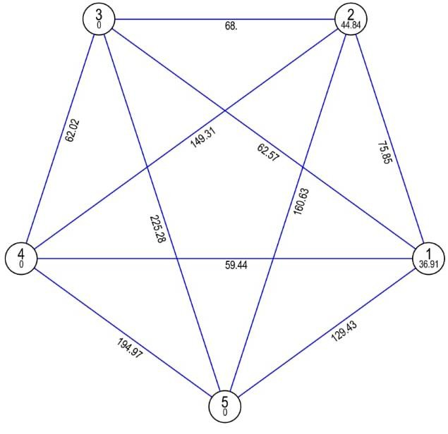

**Mahalanobis Euclidean Distance (Not to the scale)**

**Fig. 2 Clustering pattern in finger millet genotypes based on morphological characters.**

**Table 3. Contribution of fifteen characters under study towards total divergence in finger millet**

|  |  |  |  |
| --- | --- | --- | --- |
| **SN.** | **Characters** | **No. of times ranked first** | **Contribution towards divergence** |
| **1** | Plant height (cm) | 88 | 5.93 % |
| **2** | Days to 50 % flowering | 103 | 6.94 % |
| **3** | Days to maturity | 6 | 0.40 % |
| **4** | Productive tillers per panicle | 67 | 4.51 % |
| **5** | Fingers per panicle | 164 | 11.04 % |
| **6** | Finger width (cm) | 90 | 6.06 % |
| **7** | Ear head length (cm) | 135 | 9.09 % |
| **8** | Ear head weight (g) | 71 | 4.78 % |
| **9** | 1000 Grain weight (g) | 99 | 6.67 % |
| **10** | Grain yield per plant (g) | 172 | 11.58 % |
| **11** | Fodder yield per plant (g) | 126 | 8.48 % |
| **12** | Harvest index (%) | 13 | 0.88 % |
| **13** | Iron content (mg/100 g) | 118 | 7.95 % |
| **14** | Calcium content (mg/100 g) | 145 | 9.76 % |
| **15** | Protein content (%) | 88 | 5.93 % |
|  | **Total** | **1485** | **100** |

**Table 4. Cluster means for fifteen characters in fifty-five genotypes of finger millet**

|  |  |  |  |  |  |  |  |  |
| --- | --- | --- | --- | --- | --- | --- | --- | --- |
| **Character**  **Cluster** | **Plant height (cm)** | **Days to 50 % flowering (days)** | **Days to maturity (days)** | **Productive tillers per plant** | **Fingers per panicle** | **Finger width (cm)** | **Ear head length (cm)** | **Ear head weight (gm)** |
| **I** | 120.47 | 76.57 | 114.78 | 5.22 | 6.62 | 0.85 | 7.52 | 16.01 |
| **II** | 121.58 | 77.60 | 116.34 | 5.30 | 7.18 | 0.89 | 9.26 | 15.92 |
| **III** | 104 | 70.68 | 110.42 | 4.86 | 4.92 | 0.78 | 5.41 | 14.51 |
| **IV** | 114 | 72.39 | 112.48 | 5.09 | 6.4 | 0.91 | 4.53 | 16.79 |
| **V** | 108.66 | 77.47 | 116.14 | 4.96 | 7.29 | 0.86 | 13.29 | 14.15 |

|  |  |  |  |  |  |  |  |
| --- | --- | --- | --- | --- | --- | --- | --- |
| **Character**  **Cluster** | **1000 Grain weight (gm)** | **Grain yield**  **per plant (gm)** | **Fodder yield per plant (gm)** | **Harvest index (%)** | **Iron content (mg/100g)** | **Calcium content(mg/100g)** | **Protein content (%)** |
| **I** | 2.65 | 6.98 | 18.75 | 27.53 | 2.92 | 274.75 | 7.15 |
| **II** | 2.83 | 7.69 | 18.48 | 29.54 | 3.99 | 283.27 | 7.91 |
| **III** | 2.67 | 5.92 | 14.67 | 30.33 | 3.72 | 324.3 | 9.26 |
| **IV** | 2.39 | 6.31 | 14.25 | 30.74 | 2.35 | 287.78 | 8.63 |
| **V** | 2.23 | 5.72 | 16.88 | 25.36 | 2.04 | 249.08 | 8.75 |



4.78%

6.67%

Calcium content( mg/100g)

Protein content (%)

9.09%

11.58%

Ear head length (cm)

Ear head weight (gm) 1000 Grain weight (gm) Grain yield per plant (gm)

6.06% Fodder yield per plant (gm)

Harvest index (%)

Iron content (mg/100g)

8.48%

11.04%

0.88%

Finger width (cm)

7.95%

Productive tillers per plant

Fingers per panicle

4.51%

Days to maturity (days)

0.40%

Plant height (cm)

Days to 50 % flowering (days)

6.94%

9.76%

5.93%

5.93%

Percentage Contribution towards diversity

**Fig: 3 Percent contribution towards diversity**

**Conclusion**

The D2 analysis indicated wider genetic diversity among fifty five genotypes of finger millet which were grouped in five different clusters by Tocher's method. The results indicated that a maximum number of diverse genotypes (41 genotypes) were appeared in cluster I followed by cluster II (11 genotypes), whereas cluster III, IV and V were mono-genotypic, consisted of single genotype. These genotypes are likely to have extreme form of expression for particular character.

Intra-cluster distance (D) ranged from 0.00 to 36.91. At intra-cluster level, cluster II had the highest intra cluster distance followed by cluster I which involved 11 and 41 genotypes, respectively. The intra-cluster distance within cluster III, IV and V was zero (0) because these clusters were composed of only single genotype.

The maximum inter-cluster distance (D=225.28) was observed between cluster III and V followed by those between cluster IV and V and cluster II and V. It was concluded that the genotypes from the cluster III and V were more divergent than any other cluster. Hence, the genotypes belonged to the distinct cluster (III and V) could be used in hybridization program for obtaining a wide spectrum of variability among the segregates in finger millet.

Selection of genotypes for plant height (cm) had short plant stature, days to 50% flowering and days to maturity had very short flowering period and suitable for early maturing from cluster III will be highly desirable. Selection of genotypes for productive tillers per plant had maximum productive tillers per plant, 1000 grain weight and grain yield per plant from cluster II will be highly promising. Selection of genotypes for fingers per panicle and ear head length from cluster V will be highly promising. Selection of genotypes for finger width (cm), ear head weight (g) and harvest index (%) from cluster IV will be highly desirable. Selection of genotypes for fodder yield per plant (g) from cluster I will be highly promising had maximum biomass per plant that contribute to fodder yield. Selection of genotypes for calcium content (mg/100g) and protein content (%) from cluster III will be highly promising had maximum protein and calcium content that is lacking in cereals.

In the present study, grain yield per plant, fingers per panicle, calcium content, ear head length, fodder yield per plant, Iron content, days to 50% flowering, 1000 grain weight, finger width, protein content, plant height, ear head weight, productive tillers per plant appeared to be the most important traits contributing maximum towards genetic divergence, while harvest index and days to maturity contributed very low towards total divergence.

Disclaimer (Artificial intelligence)

Author(s) hereby declare that NO generative AI technologies such as Large Language Models (ChatGPT, COPILOT, etc.) and text-to-image generators have been used during the writing or editing of this manuscript.

**References**

Allard, R. W. (1999). Principles of Plant Breeding. John Wiley and Sons, Inc., New York. pp. 85–95.

Anuradha, N., Patro, T. S. S. K., Triveni, U., & Rao, P. J. (2020). Assessment of genetic variability in finger millet (*Eleusine coracana* L. Gaertn.). Journal of Pharmacognosy and Phytochemistry, 9(4), 764–767.

Bedis, M. R., Patil, H. S., Patil, V. S., & Jangale, G. D. (2007). Genetic divergence in finger millet (*Eleusine coracana* G.). National Journal of Plant Improvement, 9(1), 58–59.

Ujjaval Patel, Harshal Patil, Vipul Parekh, Gopal Vadodariya and Alok Shrivastava. (2024). Genetic variability, heritability and genetic advance in finger millet (*Eleusine coracana* L.) genotypes. 15 (2), 471 to 477.

Jayaraman, N., Suresh, S., Nirmala, A., & Ganeshan, N. M. (1997). Genetic enhancement and breeding strategies in small millets. National Seminar on Small Millets, Coimbatore, India, pp. 19–21.

Karvar, S. H., Kadam, D. J., & Jadhav, P. S. (2022). Genetic divergence studies in foxtail millet (*Setaria italica* (L.) Beauv.). The Pharma Innovation Journal, 11(1), 256–259.

Ladumor, V. L., Patil, H. E., & Modha, K. G. (2021). Genetic diversity in finger millet (*Eleusine coracana* (L.) Gaertn.) using principal component analysis. The Pharma Innovation Journal, 10(9), 1827–1831.

Nirubana, V., Ganesamurthy, K., Ravikesavan, R., & Chitdeshwari, T. (2017). Genetic diversity studies in kodo millet (*Paspalum scrobiculatum* L.) germplasm accessions based on biometrical and nutritional quality traits. International Journal of Current Microbiology and Applied Sciences, 6(10), 832–839.

Panse, V. G., & Sukhatme, P. V. (1985). Statistical Methods for Agricultural Workers. ICAR, New Delhi.

Patel, S. N., Patil, H. E., Patel, S. P., & Patel, U. M. (2018). Genetic diversity study in relation to yield and quality traits in little millet (*Panicum sumatrense* Roth. ex Roemer and Schultes). International Journal of Current Microbiology and Applied Sciences, 7(6), 2702–2711.

Patel, S., Patil, H. E., Pali, V., & Patel, B. K. (2020). Genetic diversity analysis in finger millet (*Eleusine coracana* (L.) Gaertn.). Journal of Pharmacognosy and Phytochemistry, 9(1), 677–680.

Rachie, K. O. (1975). The Millets: Importance, Utilization and Outlook. ICRISAT Publication, Hyderabad, India.

Selvarani, A., & Chandirasekaran, S. (2000). Genetic variability in barnyard millet. Madras Agricultural Journal, 87(7–9), 459–461.

Shinde, S. R., Desai, S. V., & Pawar, R. M. (2013). Genetic diversity pattern in finger millet (*Eleusine coracana* (L.) Gaertn.). Electronic Journal of Plant Breeding, 4(3), 1242–1245.

Singamsetti, S., Reddy, P. S., & Reddy, S. B. (2018). Studies on genetic variability and correlation analysis in finger millet (*Eleusine coracana* L.). Indian Journal of Agricultural Sciences, 88(2), 303–308.

Sundararaj, D. P., & Thulasidas, G. (1976). Botany of Field Crops. Macmillan Publishers, India, pp. 509.

Suthediya, V. R., Desai, S. S., Pethe, U. B., Naik, K. V., Mahadik, S. G., & Pendyala, S. (2021). Genetic diversity studies in kodo millet (*Paspalum scrobiculatum* L.). Electronic Journal of Plant Breeding, 12(4), 1337–1344.

Walle, T., Mekbib, F., Berhanu, A., & Melaku, G. (2019). Genetic diversity of Ethiopian cowpea (*Vigna unguiculata* (L) Walp) genotypes using multivariate analysis. Ethiopian Journal of Agricultural Sciences, 29(3), 89–104.

Mahalanobis, P. C. (1936). On the generalized distance in statistics. Proc. Nat. Inst. Sci. India, 2, 49-55.

Udit M Nakarani, Diwakar Singh, Kiran P Suthar, Nilima Karmakar, Priti Faldu, Harshal E. Patil.(2021). [*Nutritional and phytochemical profiling of nutracereal finger millet (Eleusine coracana* L.) genotypes](https://www.sciencedirect.com/science/article/pii/S0308814620321336). [Food Chemistry](https://www.sciencedirect.com/journal/food-chemistry), [341(2](https://www.sciencedirect.com/journal/food-chemistry/vol/341/part/P2)), 128271.

Bottom of Form

Ketan, A., Bhuyan, J., Zaman, S., Choudhary, H., Sonowal, S., Rajkumar, A. and Kro, A. (2024). Assessment of Genetic Variability, Heritability, Genetic Advance, and Diversity Analysis for Morpho Physiological Traits in Finger Millet [*Eleusine coracana* (l.) Gaertn.]. International Journal of Plant & Soil Science. 36 (4): 352-361.