***Original Research Article***

**Breaking dormancy in elephant foot yam [*Amorphophallus paeoniifolius* (Dennst.) Nicolson] using organic and inorganic amendments**

**ABSTRACT**

The present study was conducted at Instructional Farm, College of Agriculture, Vellayani, Thiruvananthapuram, Kerala, from December 2021 – February 2022, to assess the effectiveness of the treatments [cow dung, Trichoderma, Pink Pigmented Facultative Methylotrophs (PPFM) isolate, potassium nitrate and gibberellic acid (GA3)] in enhancing the early sprouting in Amorphophallus. Among the various tuber crops, amorphophallus is found exhibit a dormancy for about three to five months, which is a significant agricultural challenge. Hence the study was to promote the early sprouting of the corms using various organic and inorganic amendments and the variation was studied in terms of sprouting percentage, number of days taken for sprout initiation and 50 per cent sprouting, shoot and root length and vigour index. The experiment comprised of nine treatments *viz.* T1: Cow dung slurry @ 2.5 kg 5 L-1 , T2 : *Trichoderma* enriched FYM (5g kg corm-1), T3 : T1 + PPFM 38 @ 2 %, T4 : T1 + PPFM 38 @ 5 %, T5 : T1 + PPFM 38 @ 2 % soil drench, T6 : T1 + PPFM 38 @ 5 % soil drench, T7 : 1 % potassium nitrate spray on corms, T8 : GA3 @ 200 mg kg-1 spray on corms, T9 : Control), replicated thrice. The results revealed that, the sprouting percentage, number of days to sprout initiation and 50 percent sprouting were significantly lower for the treatment T1 (Cow dung slurry @ 2.5 kg 5 L-1). The sprout length (3.93 cm) and seedling vigour index II (52839.0) was found to significantly higher on treating the corms with cow dung slurry. However, the treatment T2: *Trichoderma* enriched FYM (5g kg corm-1) has resulted in an increased root length (24.50 cm) and seedling vigour index I when compared with the other treatments. For all the above-mentioned parameters the control treatment was found to be the least beneficial. The study revealed that the the treatment of cow dung slurry @ 2.5 kg 5 L -1 with the amorphophallus corms was found to effectively break the dormancy and enhance the emergence in amorphophallus.

*Key words: Trichoderma, seedling vigour index, dormancy, gibberellic acid*

1. **INTRODUCTION**

Tuber crops are being extensively cultivated across various regions of South India, North Eastern India, the Konkan region of Maharashtra, Gujarat, Andhra Pradesh, Odisha, Kerala, and Tamil Nadu (Nedunchezhiyan *et al*., 2006). Amorphophallus, commonly referred to as elephant foot yam [*Amorphophallus paeoniifolius* (Dennst.) Nicolson], constitutes a highly biologically efficient and economically rewarding stem tuber crop that is gaining prominence within the nation owing to its shade tolerance, ease of cultivation, broad adaptability, consistent demand, and relatively favorable market price. It has surfaced as an economically sustainable agricultural product owing to its high yield; its possibilities for exportation continue to be considerable, whereas conventional cooking techniques are generally not employed adeptly to harness its characteristics. In the state of Kerala, amorphophallus occupied an area of 5134 hectares during 2021-22 (FIB, 2024). The extended shelf life of corms, coupled with a low incidence of pests and diseases, along with minimal labor requirements, incentivizes farmers to engage in amorphophallus cultivation despite the crop's lengthy growth duration.

Amorphophallus is propagated through vegetative means utilizing corms, specifically by segments of corm that contain a portion of the apical meristem or by employing diminutive corms referred to as cormels. The corms exhibit a dormancy period ranging from three to five months post-harvest, and the alleviation of this dormancy is critical for expediting the sprouting process in the corms (Muthuraj *et al*., 2017). Dormancy in elephant foot yam is a significant agricultural challenge, as it affects the timing of sprouting and subsequent crop yield. The dormancy is primarily influenced by physiological and biochemical factors, including the presence of growth regulators and environmental conditions. Understanding these factors can help in developing strategies to manage dormancy and improve cultivation practices.

Mondal and Sen (2004) documented an elevated sprouting percentage (98%) when the apical section of the corm was utilised as planting material, in contrast to the sprouting rates observed with corm segments derived from the lower half of the mother corm. However, this resulted in an approximate 25 percent loss of harvested produce designated as planting materials. The application of chemical treatments to the lower half of the corms significantly enhanced the sprouting efficacy of these corms. Keeping the above information on hand, the present study was envisaged to assess the efficiency of various organic and inorganic amendments in breaking the dormancy in amorphophallus.

1. **MATERIALS AND METHODS**

A sack culture experiment was conducted at Instructional Farm, College of Agriculture, Vellayani, Thiruvananthapuram, Kerala, from December 2021 – February 2022, to evaluate the treatments (cow dung, Trichoderma, Pink Pigmented Facultative Methylotrophs (PPFM) isolate, potassium nitrate and GA3) for enhancing the early sprouting in Amorphophallus. The experiment comprised of nine treatments (T1: Cowdung slurry @ 2.5 kg 5 L-1 , T2 : *Trichoderma* enriched FYM (5g kg corm-1), T3 : T1 + PPFM 38 @ 2 %, T4 : T1 + PPFM 38 @ 5 %, T5 : T1 + PPFM 38 @ 2 % soil drench, T6 : T1 + PPFM 38 @ 5 % soil drench, T7 : 1 % potassium nitrate spray on corms, T8 : GA3 @ 200 mg kg-1 spray on corms, T9 : Control) replicated thrice. Sacks of 40 kg capacity were used for the experiments and were filled with about 25 kg mixture of soil, farmyard manure and sand in the ratio 1:1:1. In these sacks corms of 750 g were planted and the observations were taken. The Trichoderma formulation and culture of PPFM isolate 38 used in the experiment was made available from the Department of Agricultural Microbiology, College of Agriculture, Vellayani. The observations were taken from the initiation of the sprouting in amorphophallus. The statistical tool R and AI Solutions in Inferential Statistics (RAISINS), was used for the data analysis.

1. **RESULT AND DISCUSSION**
   1. **Sprouting Percentage**

The results on the effect of the treatments on sprouting percentage of amorphophallus are presented in Table 1.

Hundred per cent emergence was observed in the treatments T1 (cowdung slurry @ 2.5 kg 5 L-1), T3 (T1 + PPFM 38 @ 2 %), T5 (T1 + PPFM 38 @ 2 % soil drench) and T7 (1 % potassium nitrate spray on corms). The lowest sprouting percentage was for the control treatment. Cow dung slurry is an abundant source of bacteria which extensively aids in the nutrient solubilization, especially phosphate and zinc, and in plant growth promotion by production of phytohormones like indole-3-acetic acid (IAA) (Banerjee *et al*., 2023).

The stimulatory effect of PPFM is presumably due to their ability to produce plant growth regulators and Vitamin B12 (Basile *et al*., 1985; Freyermuth *et al*., 1996). Chandrasekaran *et al*. (2017) also observed similar results in tomato where seed treatment with 2 per cent PPFM enhanced the germination and emergence in tomato.

**3.2 Days to First Sprout Initiation and Days to 50 per cent Sprouting**

The effect of the treatments on the number of days to the initiation of first sprout and 50 percentage sprouting is elicited in Table 1 and Fig. 1.

The number of days required for the initiation of the first sprouting varied significantly with the treatments. It was found to be significantly lower in corms treated with cow dung slurry @ 2.5 kg 5 L -1 (T1) which was followed by the treatment with potassium nitrate (1%) (T7). The trend remained the same in case of days to 50 percentage sprouting, where the treatment T1 exhibited 50 per cent sprouts in 23 days and T7, 26 days. The control treatment (T9) exhibited the longest days for sprout initiation (46 days).

The cow dung slurry can be considered as a good source of microorganisms which promotes the growth of the plants. Apart from the presence of various growth promoting organisms, cow dung slurry aids in the sprouting and growth of plants through HCN production. The presence of HCN leads to increased levels of hydrogen peroxide and superoxide anions in embryonic axes which play a crucial role in dormancy breaking and enhanced sprouting (Oracz *et al*., 2009). HCN also influences the expression of genes related to ROS production and signaling, such as NADPH oxidase and ethylene response factors which has an indirect impact on dormancy breaking (Kępczyński and Sznigir, 2014).

**3.3 Length of Sprout**

The results on the effect of treatments on the length of sprouts in Amorphophallus are depicted in Table 2.

The sprout length of Amorphophallus corms exhibited significant variation due to the various treatment application. The application of cow dung slurry @ 2.5 kg 5 L -1 resulted in significantly longer sprouts (3.93 cm). It was followed by the treatment T6 (T1 + PPFM 38 @ 5 per cent soil drench) which was comparable with that of T4 (T1 + PPFM 38 @ 5 per cent). The shortest sprout length was observed for the control treatment (0.93 cm).

Cow dung is found to produce siderophores in considerable quantities and these siderophores may possess great influence on breaking dormancy and in aiding growth promotion in Amorphophallus. These compounds enhance iron availability, which is crucial for plant development (Swinburne, 1986). Siderophores, produced by various bacteria in cow dung, chelate iron from the soil, making it accessible to plants, thereby promoting growth and potentially aiding in breaking dormancy. Studies show that siderophores can significantly increase root and shoot growth in various plants, by reducing oxidative stress and promoting iron remobilization (Truong *et al*., 2024). The result obtained was in tune with those of Deb & Tatung, 2024.

Cow dung slurry also acts as a coating forming a physical barrier and blocks respiration of major pests and disease-causing organisms (Shaheen and Khaliq, 2005; Prasad and Ramprasad, 2006). It also has germicidal properties (Swain *et al*., 2008; Swain and Ray, 2009) which would enable the better sprouting and growth of the corms.

**3.4Length of Root**

The results depicting the variation in the root length of sprouted Amorphophallus corms is given in Table 2.

Among the various treatments, the application of the corm pieces with *Trichoderma* enriched FYM (5g kg corm-1) resulted in significantly longer roots (24.50 cm) when compared with other treatments. It was followed by the treatment with 1 per cent potassium nitrate spray on corms which was on par with the treatments T8 and T6. The treatment of cow dung slurry @ 2.5 kg 5 L -1 followed by PPFM 38 application @ 5 per cent has resulted in relatively shorter roots in comparison with the other treatments.

Trichoderma species have been known as plant growth promoter agents along with its impact in the initiation of plant defence mechanisms (Shoresh *et al*., 2010, Harman, 2011). The growth regulating property of Trichoderma was shown by Tančić-Živanov *et al*. (2020) in pepper plants. The influence of Trichoderma on root development is substantial, as demonstrated by numerous investigations that elucidate its contribution to the augmentation of root biomass and structural organization across various plant taxa (Kumar *et al*., 2024). Species of Trichoderma facilitate root development via mechanisms including hormonal synthesis such as indole -3- acetic acid (IAA), enhanced nutrient assimilation, and alleviation of stress, culminating in the establishment of healthier and more vigorous root systems (Battaglia *et al*., 2024).

The above mechanisms to enhance the plant root growth was aided through several signalling molecules such as IAA, Anthranilic acid (2-AA), cytokinins and various volatile organic compounds. The major mechanism underlying here is the interaction of Trichoderma metabolites with plant hormone signalling pathways (Khan *et al*., 2023). The presence of Trichoderma along with the positive growth promoting effects cow dung might have resulted in the longer roots in the amorphophallus sprouts.

**3.5 Vigour Index**

The effect of the treatments on the seedling vigour index of amorphophallus are elicited in Table 3 and Fig. 2.

The treatment of amorphophallus corms with Trichoderma enriched cow dung slurry (T2), resulted in significantly higher seedling vigour index I which was followed by treatments T6 which was comparable with that of T7. The seedling vigour index II was found to be significantly higher for the corms treated with that of cow dung slurry @ 2.5 kg 5 L -1 which was on par with the T3, T5 and T7.

Trichoderma species, known for their symbiotic relationships with plants, have been shown to improve germination rates, root and shoot lengths, and overall seedling vigour index in various plants. Seedling vigour index I is highly depended on the root length of the plant and the root length of the amorphophallus sprouts were greatly influenced by hormone production by the Trichoderma application. This might have resulted in the increased seedling vigour index I of amorphophallus. These results are in support of the findings of Zheng and Shetty (2000) where the Trichoderma spp. caused the phenolic compound production in the plant during seed germination and led to enhancement of seed vigour. Similar results were observed by Sunkad *et al*. (2023) in rice.

The seedling vigour index II is depended on the germination percentage of the corms and the application of cow dung was capable of inducing a higher germination percentage due to the presence various growth promoting organisms and by the production of HCN (Kępczyński and Sznigir, 2014). These organisms were found to produce growth promoting hormones and HCN promotes the signalling pathways. This might be the reason for the higher seedling vigour index II.

1. **CONCLUSION**

The present study revealed that the treatment of cow dung slurry @ 2.5 kg 5 L -1 with the amorphophallus corms exhibited better performance in terms of the sprouting percentage, number of days for sprout initiation and fifty percentage sprouting, length of shoot and seedling vigour index II. However, the treatment of corms with Trichoderma enriched cow dung slurry resulted in an increased root growth and the seedling vigour index I when compared with the other treatments. Thus, in the field there might be a positive effect of the Trichoderma culture in the growth and other yield aspects of Amorphophallus. Hence, further study undertaking both the above-mentioned treatments is required in the field to assess the best among the two treatments.

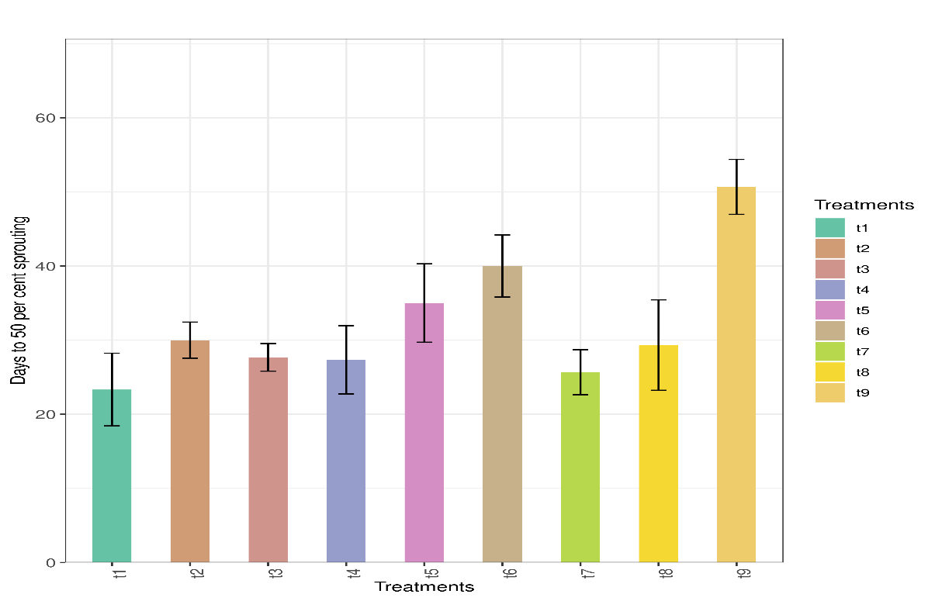

Figure 1. The effect of the treatments on the number of days to 50 per cent sprouting in amorphophallus

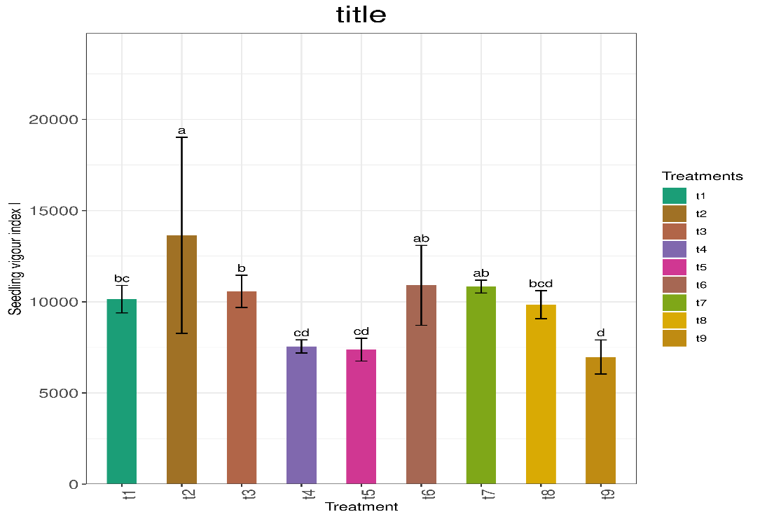

Figure 2. The effect of the treatment on the seedling vigour index I of amorphophallus.

Table 1. The effect of treatments on the sprouting percentage, no. of days to first sprout initiation and no. of days to 50 per cent sprouting in amorphophallus

Note: The transformed means are given in parathesis

|  |  |  |  |
| --- | --- | --- | --- |
| Treatments | Sprouting percentage (%) | Days to first sprout initiation | Days to 50 percentage sprouting |
| T1  (Cow dung slurry @ 1 kg 2 L -1) | 1.00 (1.47) | 19.67 | 23.00 |
| T2  (*Trichoderma* enriched FYM (5g kg corm-1)) | 0.83 (1.19) | 24.67 | 30.00 |
| T3  (T1 + PPFM 38 @ 2 per cent) | 1.00 (1.47) | 23.33 | 28.00 |
| T4 (T1 + PPFM 38 @ 5 per cent ) | 0.92 (1.33) | 23.00 | 27.00 |
| T5 (T1 + PPFM 38 @ 2 per cent soil drench) | 1.00 (1.47) | 28.67 | 35.00 |
| T6  (T1 + PPFM 38 @ 5 per cent soil drench) | 0.58 (0.87) | 34.33 | 40.00 |
| T7  (1 % potassium nitrate spray on corms) | 1.00 (1.47) | 21.00 | 26.00 |
| T8  (GA3 @ 200 mg kg-1 spray on corms) | 0.83 (1.19) | 28.00 | 29.00 |
| T9  (Control) | 0.42 (0.70) | 46.00 | 51.00 |
| SE m (±) | 0.09 | 1.474 | 2.00 |
| CD (0.05) | 0.27 | 4.38 | 6.00 |

|  |  |  |
| --- | --- | --- |
| Treatments | Shoot length (cm) | Root length (cm) |
| T1  (Cow dung slurry @ 1 kg 2 L -1) | 3.93 | 15.27 |
| T2  (*Trichoderma* enriched FYM (5g kg corm-1)) | 2.80 | 24.50 |
| T3  (T1 + PPFM 38 @ 2 per cent) | 2.57 | 19.43 |
| T4 (T1 + PPFM 38 @ 5 per cent ) | 3.23 | 13.10 |
| T5 (T1 + PPFM 38 @ 2 per cent soil drench) | 1.90 | 13.90 |
| T6  (T1 + PPFM 38 @ 5 per cent soil drench) | 3.60 | 19.63 |
| T7  (1 % potassium nitrate spray on corms) | 2.53 | 20.63 |
| T8  (GA3 @ 200 mg kg-1 spray on corms) | 1.60 | 19.57 |
| T9  (Control) | 0.93 | 14.63 |
| SE m (±) | 0.25 | 1.97 |
| CD (0.05) | 0.74 | 5.87 |

Table 2. The effect of the treatments on the shoot and root length of sprouted amorphophallus (cm)

Table 3. Effect of the treatments on seedling vigour index I and seedling vigour index II.

|  |  |  |
| --- | --- | --- |
| Treatments | Seedling vigour index I | Seedling vigour index II |
| T1  (Cow dung slurry @ 1 kg 2 L -1) | 10143.8 | 52839.0 |
| T2  (*Trichoderma* enriched FYM (5g kg corm-1)) | 13645.9 | 41633.1 |
| T3  (T1 + PPFM 38 @ 2 per cent) | 10573.9 | 48046.0 |
| T4 (T1 + PPFM 38 @ 5 per cent ) | 7553.3 | 42474.7 |
| T5 (T1 + PPFM 38 @ 2 per cent soil drench) | 7372.9 | 46657.0 |
| T6  (T1 + PPFM 38 @ 5 per cent soil drench) | 10902.3 | 27443.7 |
| T7  (1 % potassium nitrate spray on corms) | 10834.4 | 46767.0 |
| T8  (GA3 @ 200 mg kg-1 spray on corms) | 9841.9 | 28191.2 |
| T9  (Control) | 6975.3 | 18693.8 |
| SE m (±) | 966.6 | 5032.6 |
| CD (0.05) | 2871.9 | 14952.7 |

Disclaimer (Artificial intelligence)

Author(s) hereby declares that NO generative AI technologies such as Large Language Models (ChatGPT etc.) are used for the manuscript.

REFERENCES

Banerjee, S., Kanaujia, A., and Sharma, S. Importance of Indigenous Cow Dung and its Microbiota. *Int. J Curr. Microbiol. App Sci.* 2023; 12(4): 26-36.

Basile, D.V., Basile, M.R., Li, Q.Y., and Corpe, W.A. Vitamin B12 - stimulated growth and development of *Jungermannia leiantha* Grolle and *Gymnocolea inflata* Dum. (Hepaticae). *Bryologist.* 1985; 88: 77-81.

[Battaglia](https://onlinelibrary.wiley.com/authored-by/Battaglia/Marina+E.), M, E.,  [Martinez](https://onlinelibrary.wiley.com/authored-by/Martinez/Sergio+I.), S, I.,  [Covacevich](https://onlinelibrary.wiley.com/authored-by/Covacevich/Fernanda), F., and [Verónica, F.](https://onlinelibrary.wiley.com/authored-by/Consolo/Ver%C3%B3nica+F.) *Trichoderma harzianum* enhances root biomass production and promotes lateral root growth of soybean and common bean under drought stress. 2024. 185(1):36- 48.

Chandrasekaran, P., Sivakumar, R., Nandhitha, G.K., Vishnuveni, M., Boominathan, P., and Senthilkumar, M. Impact of PPFM and PGRs on seed germination, stress tolerance index and catalase activity in tomato (*Solanum lycopersicum* L.) under drought. *Inter. J. Curr. Microbiol. Appl. Sci.* 2017; 6 (6): 540-549.

Deb, C, R. and Tatung, M. Siderophore producing bacteria as biocontrol agent against phytopathogens for a better environment: A review. *South African J Bot.* 2024; 165: 153-162.

FIB [Farm Information Bureau]. *Farm guide.* Department of Agriculture, Government of Kerala, Kowdiar, 2024; 409p.

Freyermuth, S.K., Long, R.L., Mathur, S., Holland, M.A., Holstford, T.P., Stebbins, N.E., Morris R.O., and Polacco, J.C. Metabolic aspects of plant interaction with commensal methylotrophs. In: Lindstorm, M. and Tabita, R. (eds), *Microbial Growth on Cl Compounds*, Kluwer Academic Publishers, New York ,1996; pp. 21-134.

Harman, G.E. Trichoderma – not just for biocontrol anymore. *Phytoparasitica*. 2011; 39:103-108.

Hoai-Nam Truong, H., Fournier, C., Hichami, S., Dole, L., Leroy, F., David Wendehenne, D., Nicolas-Franc`es , V., and Besson-Bard, A. Apo-siderophores promote growth of iron-deficient Arabidopsis plants by mobilizing iron from roots to shoots and reducing oxidative stress in roots. *Plant Stress* 2024; 12: 100488.

Ke˛pczyn´ski, J and Sznigir, P. Participation of GA3, ethylene, NO and HCN in germination of *Amaranthus retroflexus* L. seeds with various dormancy levels. *Acta Physiol Plant* 2014; 36:1463–1472.

Khan, R.A.A., Najeeb, S., Chen, J., Wang, R., Zhang, J., and Hou, J. Insights into the molecular mechanism of Trichoderma stimulating plant growth and immunity against phytopathogens. *Physiologia Plantarum*, 2023;175(6): e14133.

Kumar, R., Biswas, S. K., Kumar, S., Kumar, S. and Lal, K. Effect of Trichoderma Culture Filtrates of as Inducer on Growth Parameters of Tomato (*Solanum lycopersicum* L.) against Fusarium Wilt. *J Advances Bio. & Biotech*, 2024 ; 27(10): 636–649.

Mondal, S. and Sen, H. Seed corm production of elephant foot yam through agronomical manipulation. *J. Root Crops* 2004; 30: 115 – 119.

Nedunchezhiyan, M., Saurabh, A., and Ranasingh, N. Elephant foot yam: A commercial crop for Orissa. *Orissa Rev*. 2006; 63 (1): 71-72.

Muthuraj, R., George, J., & Sunitha, S. Effect of Growth Regulator and Chemical Treatment on Dormancy Breaking in Elephant Foot Yam (*Amorphophallus paeoniifolius* (Dennst.) Nicolson). *J Root Crops*, 2017; 42(2), 75–80.

Oracz, K., El-Maarouf-Bouteau, H., Kranner, I., Bogatek, R., Corbineau, F., and Bailly, C. The mechanisms involved in seed dormancy alleviation by hydrogen cyanide unravel the role of reactive oxygen species as key factors of cellular signaling during germination. *Plant Physiol* 2009; 150: 494–505.

Prasad, G. K. and Ramprasad, V. Disseminating traditional seed storage practices through peoples participation. *Leisa India September* 2006, 2006; pp. 34–35.

Shaheen, F. A. and Khaliq, A. Management of pulse beetle, *Callosobrachus chinensis* L. (Coleoptera : Bruchidae) in stored chickpea using ashes, red soil powder and turpentine oil. *Pakistan Ento* 2005; 27 (2): 19–24.

Shoresh, M., Harman, G.E., and Mastouri, F. Induced systemic resistance and plant responses to fungal biocontrol agents. *Ann Rev Phytopath.* 2010; 48:21-43.

Sunkad, G., Gour, A., Joshi, R., and Patil, M. Antagonistic potential and growth promoting activities of novel indigenous strains of Trichoderma. *J Biol Control*, 2022; 36(2&3): 112-119.

Swain, M. R. and Ray, R. C. Biocontrol and other beneficial activities of Bacillus subtilis isolated from cowdung microflora. *Microbiol. Research* 2009;164: 121–130.

Swain, M. R., Ray, R. C., and Nautiyal, C. S. Biocontrol efficacy of Bacillus subtilis strains isolated from cowdung against post-harvest yam (Dioscorea rotundata L.) pathogens. *Current Microbiol* 2008; 57: 407–411.

Swinburne, T. R. (1986). *Iron, Siderophores, and Plant Diseases*. Available online : <http://ci.nii.ac.jp/ncid/BA03635250>.

Tančić-Živanov, S., Medić-Pap, S., Danojević, D., and Prvulović, D. Effect of Trichoderma spp. on growth promotion and antioxidative activity of pepper seedlings. *Brazilian Archives Bio Technol.* 2020; 63: e20180659.

Zheng, Z and Shetty, K. Enhancement of pea (*Pisum sativum*) seedling vigour and associated phenolic content by extracts of apple pomace fermented with Trichoderma spp. *Process Biochem* 2000;36: 79-84.