Original Research Article
Pathological Investigation of Fowl Adenovirus Infections Associated with Respiratory Diseases in Broilers

ABSTRACT
Objective: The present study was aimed at pathological investigation of fowl adenovirus infections associated with respiratory diseases in broilers in and around Indore.
Materials and methods: Broiler mortalities with respiratory symptoms from 12 farms in the Indore region were examined for gross lesion and microscopically, with a focus on postmortem investigations to detect Fowl Adenovirus (FAdV) infections.
Results: Clinically affected broilers exhibited signs of lethargy, huddling, facial oedema, reduced feed and water intake, and severe respiratory distress, including laboured breathing and nasal discharge. Postmortem findings revealed gross lesions in the trachea, lungs, and liver. The gross lesions ranged from mild congestion to severe haemorrhages. Microscopically, deciliation and basophilic intranuclear viral inclusions were observed. Pulmonary lesions included focal emphysema, haemorrhages, and red hepatization, while hepatic lesions showed enlargement, congestion, and necrosis. Microscopically, intranuclear viral inclusions were evident in both the lungs and liver, further indicating adenoviral replication in these organs. Based on symptoms, gross lesions and microscopic lesions with the presence of intranuclear basophilic inclusion bodies in respiratory epithelium, it is concluded that Fowl adenovirus is involved in the respiratory diseases of broilers in Indore and nearby areas. Fowl adenovirus infection in birds causes mild to severe respiratory distress resulting in low to high mortality.

Key Words: FADv, Fowl adenovirus, Respiratory disease

- INTRODUCTION
Fowl adenovirus (FAdV) infections have emerged as a major threat to the poultry industry worldwide, particularly affecting broiler chickens through diseases such as inclusion body hepatitis (IBH), hydropericardium-hepatitis syndrome (HHS), and adenoviral gizzard erosion (AGE). (Ghorani et al., 2025) These diseases not only result in significant morbidity and mortality among broiler flocks, but also contribute to substantial economic losses due to reduced productivity, increased mortality, and the costs associated with management and control measures. Recent epidemiological reports highlight a noticeable rise in the incidence and geographical spread of FAdV-associated diseases in commercial broiler operations, with certain serotypes, especially FAdV-4 and FAdV-8b, being predominantly implicated in outbreaks of HHS and IBH, respectively (Sadekuzzaman et al., 2024).
Despite the rapid development of the poultry industry, periodic outbreaks of diseases continue to hinder its progress. Viral diseases, in particular, have assumed threatening proportions, and among these, avian adenoviruses form a highly diverse group that causes diseases in both domestic and wild birds. Fowl adenovirus infections are caused by non-enveloped, icosahedral viruses belonging to the genus Aviadenovirus in the family Adenoviridae, with linear double-stranded DNA ranging in size from 25 to 46 kbp. Adenoviruses isolated from poultry are classified into five Fowl adenovirus (FAdV) species, FAdV-A to FAdV-E, comprising 12 serotypes: FAdV-1 to 8a, and FAdV-8b to 11. Adenovirus strains are distributed worldwide, with different types reported in various geographic regions (Lebdah et al., 2022).
Fowl adenoviruses are commonly found in healthy birds but can also cause a range of diseases, with pathogenicity varying from 10% to 90%, depending on the virulence of the strain, as demonstrated in poultry flocks worldwide (Schachner et al., 2018). Fowl adenovirus infection is considered an emerging disease, especially in regions where broilers are reared under intensive conditions (Asrani et al., 1997). The first isolation of an avian adenovirus from diseased birds was reported during an outbreak of respiratory disease in bobwhite quail (Bouquet et al., 1982).
Therefore, it becomes necessary to continuously monitor Fowl adenoviruses (FAdVs) linked to respiratory issues in chickens, due to the limited information available on the circulating FAdV strains associated with respiratory diseases. In light of this, the present study was undertaken with the objective of studying the pathology of Fowl adenovirus infections associated with respiratory diseases in broilers in and around Indore.

- MATERIALS AND METHODS
  - Location and Place of Work
The research work was conducted at the Department of Veterinary Pathology, College of Veterinary Science and Animal Husbandry, Mhow (M.P.). The research work was carried out from August 2023 – July 2024.
  - Sample Collection
Mortalities from 12 commercial farms in and around Indore (M.P.) were submitted to the Department of Veterinary Pathology, College of Veterinary Science and Animal Husbandry, Mhow for Gross post-mortem examination. Affected birds ranged from 3 to 6 weeks of age. Data on flock size, bird age and total mortality were recorded. After recording the gross lesions, tissues from different organs—such as the lungs, trachea, and liver—were collected in 10% neutral buffered formalin and processed using routine dehydration and paraffin embedding techniques.
  - Histopathology
Different tissue samples were collected in 10% neutral buffered formalin (NBF) and kept for 24–48 hours for fixation. After fixation in 10% NBF, the tissue samples were cut into 2 to 3 mm thick pieces and washed overnight under running tap water. The tissues were then processed by the routine method of dehydration in graded alcohol, cleared in xylene, and embedded in paraffin wax. To remove water, the tissues were dehydrated in a graded series of acetone: 50%, 70%, 90%, and 100%—for 30 minutes in each concentration. Clearing was done with two changes of benzene for 1 hour each. The tissues were embedded in paraffin wax through four changes of 1 hour each, and wax blocks were moulded using L-molds. Tissue sections were cut at a thickness of 4–5 microns using a semiautomatic microtome and mounted on slides precoated with egg albumin-glycerol mixture (in a 1:1 ratio) (Lillie and Fullmer, 1976).
  - Staining procedure
Before staining, the slides were slightly warmed in a hot air oven and placed in a jar containing xylene, which was replaced with fresh xylene after 10–15 minutes to remove paraffin from the tissue sections. After deparaffinization, the slides were passed through a descending series of alcohol: first through two changes of absolute alcohol, followed by 90%, 70%, and 50% alcohol for 2 minutes in each concentration.
Following this, the slides were washed under running tap water. They were stained with haematoxylin for 10–15 minutes, with gentle shaking 2–3 times to ensure even staining. The tissue sections were given 3–4 dips in ammonia water, washed again in running tap water, and then counterstained with 2% aqueous eosin for 2–5 minutes. After eosin staining, the slides were dehydrated through an ascending series of concentrated ethanol, cleared in xylene, and mounted with a coverslip using DPX. Finally, the slides were cleaned, labelled, and examined for microscopic lesions (Lillie and Fullmer, 1976).

- RESULTS AND DISCUSSION
Affected broilers typically appeared depressed and lethargic, often observed huddling together in corners of the pen. They exhibited ruffled feathers, drooping wings and a general unthrifty appearance, indicative of systemic illness. The birds showed marked reluctance to move, along with significantly reduced feed and water intake, which contributed to uneven growth rates within the affected flock. Occasional facial edema was noted, particularly around the eyes and submandibular region, suggesting systemic inflammation or circulatory compromise. A majority of the birds exhibited profuse, watery white diarrhoea, likely a result of hepatic dysfunction associated with inclusion body hepatitis. Severe respiratory distress was a prominent feature, characterized by rapid, open-mouth breathing, frequent head shaking and audible wheezing. Copious mucopurulent nasal discharge was also present in many birds, further indicating upper respiratory tract involvement. These clinical signs are in close agreement with previously reported descriptions of inclusion body hepatitis (IBH) and respiratory manifestations of fowl adenovirus infections, suggesting a systemic and respiratory tropism of the circulating viral strain.The clinical signs and symptoms recorded in the present study were similar to the findings of Bayraktar et al., (2024): Gowthaman et al. (2012); Sun et al. (2019); Bisht et al. (2019); El-Deeb and Mandour, (2019); Levkutova et al. (2023) and Hussein et al. (2023), Thaeer and Ameer (2025) and Azli et al. (2025).
Gross pathological examination of the trachea revealed mild to severe congestion of the tracheal rings. In several cases, the tracheal lumen contained a pale, moist, mucopurulent exudate, which was occasionally hemorrhagic in nature. Microscopically, mild cases exhibited an intact columnar epithelium with submucosal congestion and mild infiltration of inflammatory cells. In more severe cases, the tracheal tissue showed extensive hemorrhages in the mucosa, karyomegaly, deciliation of the columnar epithelium, degenerative changes, submucosal edema and hemorrhages, along with infiltration of mononuclear cells (Fig 1).

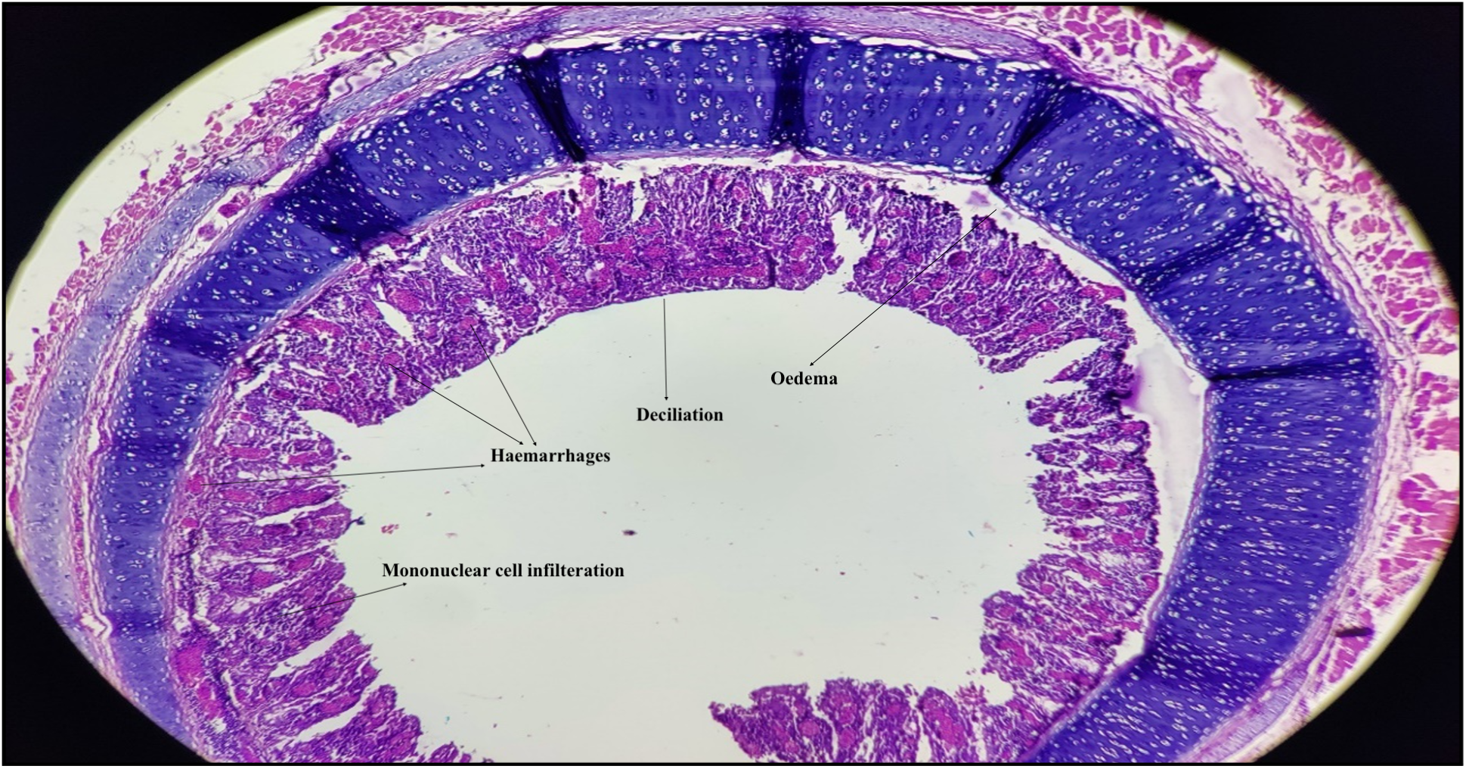
Fig 1: Microphotograph of trachea showing haemorrhages in mucosa, deciliation of columnar epithelium with degenerative changes, oedema, submucosal haemorrhages and infiltration of mononuclear cells in a FAdV positive 37 days old broiler (H & E 10x)

Microscopic lesions were further characterized by extensive epithelial destruction, with loss of ciliary architecture and desquamation of the lining epithelium. Prominent degenerative changes such as cytoplasmic vacuolation and nuclear pyknosis were evident, particularly in the surface epithelial cells. Mucosal hemorrhages were commonly observed, often accompanied by subepithelial oedema and vascular congestion. The lamina propria showed infiltration by a mixed population of inflammatory cells, predominantly lymphocytes and macrophages, with occasional heterophils, indicating a localized immune response. Notably, basophilic intranuclear inclusion bodies were observed in both intact and sloughed tracheal epithelial cells, often occupying most of the nuclear space and displacing the chromatin marginally (Fig. 2). These inclusions are characteristic of adenoviral replication and serve as a key histopathological marker for confirming FAdV infection in the upper respiratory tract.
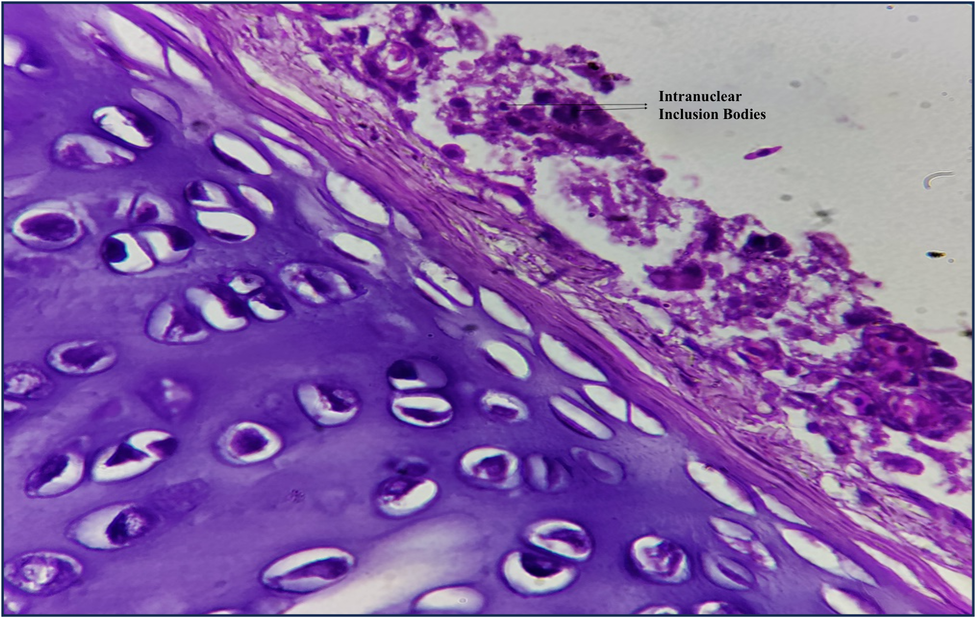
Fig 2: Microphotograph of trachea showing basophilic intranuclear inclusion bodies in the tracheal epithelial cells (H & E 100x) (arrows)

The gross lesions observed in this study are consistent with those previously reported by Meulemans et al. (2001) and in the experimental findings of Dhillon and Kibenge (1987). Similarly, the microscopic features align with the descriptions provided by De Herdt et al. (2013) and Kardoudi et al. (2025). The detection of characteristic basophilic intranuclear inclusion bodies in the tracheal epithelium, suggesting active replication of Fowl adenovirus, corroborates the findings of Zadravec et al. (2011). However, these observations contrast with those of Bisht et al. (2019), who reported eosinophilic intranuclear inclusion bodies in the laryngeal and tracheal epithelium.
Gross examination of the lungs revealed rounding of the lobar borders and marked congestion, along with focal areas of emphysema (Fig. 3). The affected lung tissue appeared firm and failed to collapse, suggesting underlying consolidation. In several birds, petechial haemorrhages were also noted on the pleural surface. Microscopically, lungs from mildly affected birds displayed vascular congestion and focal hemorrhages, primarily in the parabronchial regions. In more severely affected cases, multifocal areas of extensive hemorrhage were observed, with alveolar spaces engorged with red blood cells, consistent with red hepatization (Fig. 4). These lesions reflected acute inflammatory response and compromised pulmonary function. Additionally, coagulative necrosis of the lung parenchyma was evident, characterized by preserved tissue architecture but with loss of nuclear detail (Fig. 5). Basophilic intranuclear inclusion bodies were frequently observed within the nuclei of alveolar epithelial cells (Fig. 6) signifying active viral replication and providing a definitive histological marker of adenoviral infection in the respiratory tract.

Fig 3: Photograph of congested lungs showing focal areas of emphysema in FAdV positive broiler
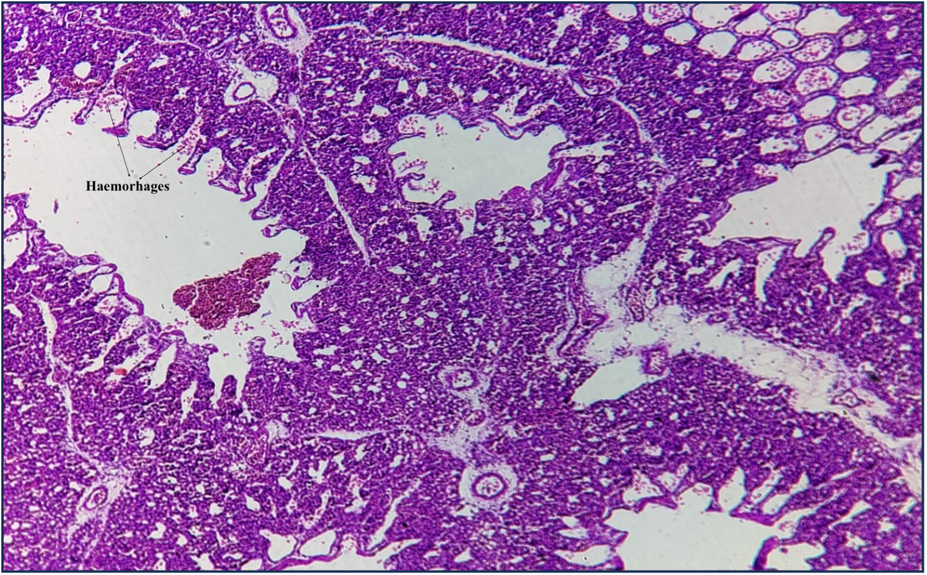
Fig 4: Microphotograph of lungs showing multifocal areas of severe haemorrhages, alveoli filled with RBCs indicating red hepatization of lungs and haemorrhages in the parabronchial lumen (H & E 10x)

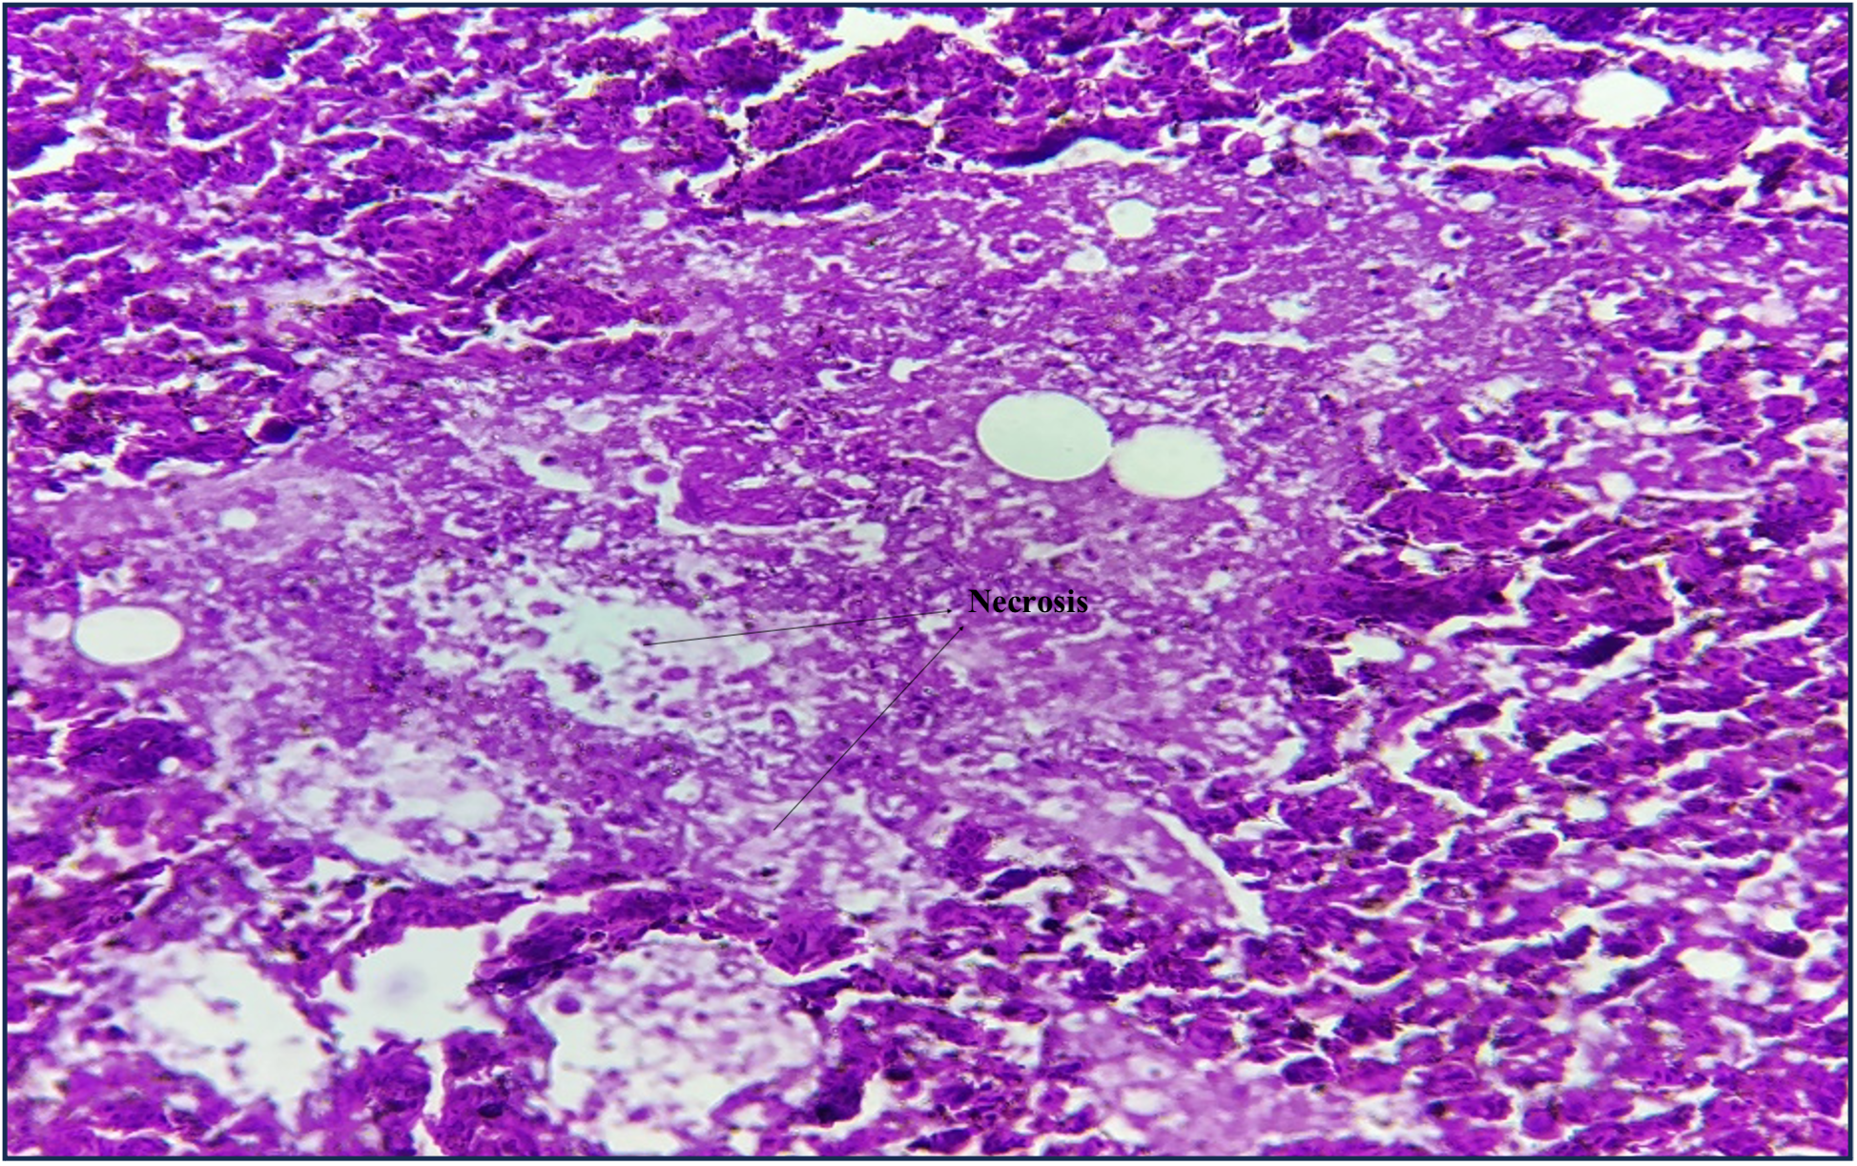
Fig 5: Microphotograph of lungs showing coagulative necrosis in the lung parenchyma (H & E 40x)

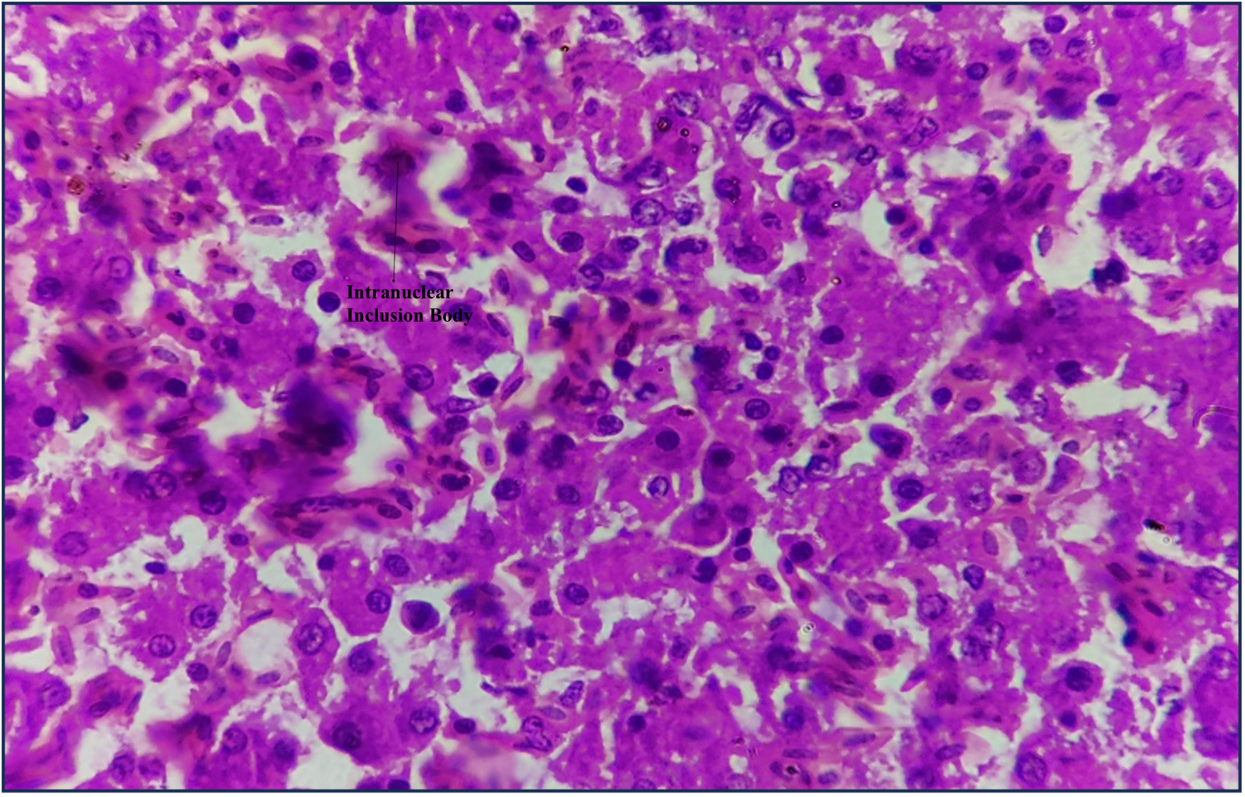
Fig 6: Microphotograph of lungs showing basophilic intranuclear inclusion bodies in alveolar epithelium (H & E 100x) (arrows)

The gross and histopathological pulmonary lesions documented in the present study are in agreement with the findings of Radwan et al. (2019), Lebdah et al. (2022) and Abdellatif et al. (2025) further supporting the pathogenic role of Fowl adenovirus in inducing severe respiratory pathology in broilers.
Gross lesions observed in the liver of broilers affected by FAdV included enlarged, swollen, pale and congested liver with multiple haemorrhagic areas (Fig. 7 and 8). The liver capsule appeared tense and the parenchyma was friable upon sectioning, indicating severe hepatic damage. Microscopically, the liver showed focal necrotic areas surrounded by mononuclear cell infiltration and fatty change represented by large and small vacuoles. Other lesions recorded were multiple areas of haemorrhages, oedema and mild infiltration. Degenerative changes varied and included fatty change (Fig. 9). The hepatic cords were often disorganized and sinusoidal spaces appeared dilated. Numerous hepatocytes displayed characteristic basophilic intranuclear inclusion bodies (Fig. 10), which are pathognomonic for adenoviral infection.

Fig 7: Broilers showing congested and swollen liver
Fig 8: 37 days old broiler showing pale and swollen liver with multiple haemorrhages

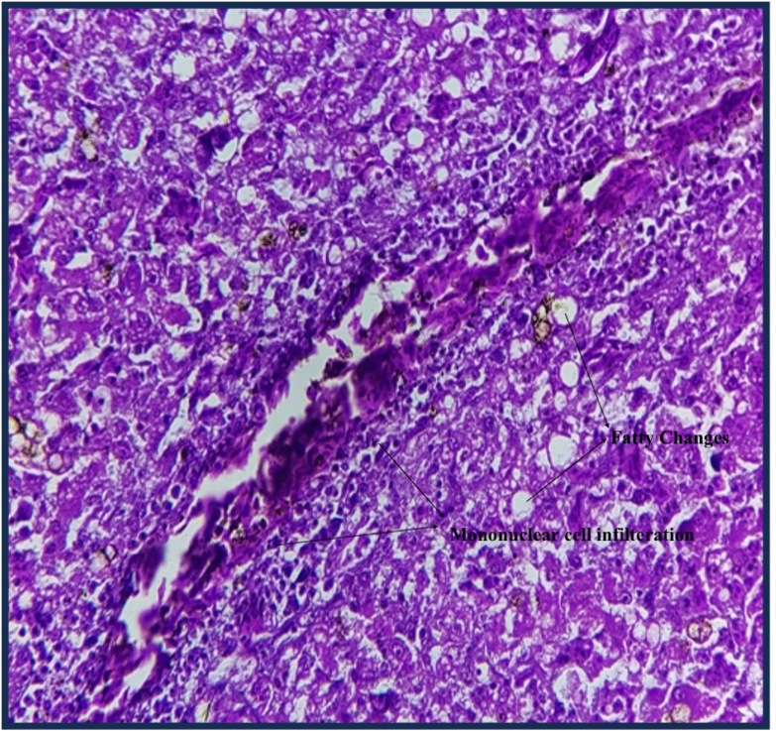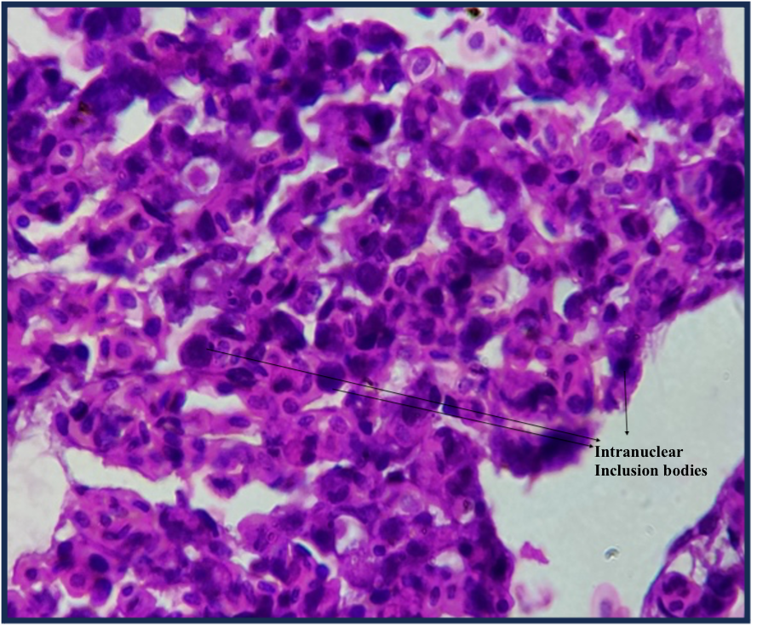
Fig 10: Microphotograph of liver showing basophilic intranuclear inclusion bodies in hepatocytes of 37 days old broiler affected with FAdV (H & E 100x) (arrows)
Fig 9: Microphotograph of liver showing fatty change and infiltration of mononuclear cells (H & E 40x)

Gross lesions recorded in the present study were similar to findings recorded in the research done by De Herdt et al. (2013); Mariappan et al. (2018); El-Deeb and Mandour, (2019); Chitradevi et al. (2021) and Sultan et al. (2021). Microscopic lesions in the present study were consistent with the findings of De Herdt et al. (2013); Shrivastava et al. (2019); El-Deeb and Mandour, (2019); Cizmecigil et al. (2020); Safwat et al. (2022); Helmy et al. (2024) and Faria de et al. (2025) and and Zhang et al. (2025) In the present study, characteristic basophilic intranuclear inclusion bodies were observed in the hepatocytes, which are considered a hallmark of adenoviral infection. These findings contrast with the observations of Chitradevi et al. (2021), who reported eosinophilic intranuclear inclusion bodies, suggesting possible variation in viral strains or differences in host response. The presence of these distinct basophilic inclusion bodies in the nuclei of cells from the trachea, lungs and liver provides strong evidence of active viral replication in these tissues, as also documented by Cook (1983). Such inclusions indicate the virus’s tropism for epithelial and parenchymal cells in vital organs. No significant gross lesions were observed in other organs, except for occasional mild congestion, which might be incidental or secondary to systemic effects of the infection.
Conclusion
The present study provides strong evidence implicating Fowl adenovirus (FAdV) as a significant etiological agent in the respiratory diseases affecting broiler chickens in Indore and surrounding regions. This conclusion is supported by the clinical signs observed in affected birds, including respiratory distress, reduced feed intake, and depression, along with characteristic gross lesions such as congestion and mucoid exudates in the trachea and lungs. Histopathological examination revealed consistent microscopic changes, including epithelial degeneration, hemorrhages, and most notably, the presence of prominent intranuclear basophilic inclusion bodies in the respiratory epithelium—hallmark features of adenoviral infection. The findings of this study underscore the role of FAdV in inducing a spectrum of respiratory pathology ranging from mild to severe, often leading to varying levels of morbidity and mortality in commercial broiler flocks. Given the economic implications of such infections, early diagnosis, regular surveillance, and appropriate biosecurity measures are essential for effective disease control. Future studies focusing on molecular characterization of circulating FAdV strains and their pathogenic potential would further contribute to developing targeted vaccines and management strategies.

Disclaimer (Artificial intelligence)
Author(s) hereby declare that NO generative AI technologies such as Large Language Models (ChatGPT, COPILOT, etc.) and text-to-image generators have been used during the writing or editing of this manuscript.
REFERENCE:
Abdellatif, D. M., El-Sawah, A. A., Elkady, M. F., Ali, A. and Shany, S. A. (2025). Inclusion Body Hepatitis: A Comprehensive Overview of Disease Impact and Control in Poultry. Egyptian Journal of Veterinary Sciences, 1-17.
Abi-Rizk, A., Ghorayeb, E. and El Hage, J. (2025). Emerging Co-infection of avian adenovirus and astrovirus in Lebanese poultry. Microbial Pathogenesis, 204: 107581.
Asrani, R.K., Gupta, V.K., Sharma, S.K., Singh, S.P. and Katoch, R.C. (1997). Hydropericardium-hepatopathy syndrome in Asian poultry. The Veterinary Record, 141(11): 271-273.
Azli, B., Salim, N. F., Hair-Bejo, M., Omar, A. R., Mohamed Sohaimi, N., Clifford, U. C. and Mat Isa, N. (2025). Temporal dynamics of chicken host’s molecular response against Fowl adenovirus serotype 8b infection via RNA-sequencing. BMC Genomics, 26(1): 1-23.
Bisht, R., Kumar, R., Pandey, G., Tiwari, A., Yadav, R. and Bhatt, P. (2019). Isolation and serological characterization of the fowl adenoviruses associated with respiratory disease in domestic chicken. Indian Journal of Comparative Microbiology, Immunology and Infectious Diseases, 43(1): 22-28.
Bouquet, J.F., Moreau, Y., McFerran, J.B. and Connor, T.J. (1982). Isolation and characterisation of an adenovirus isolated from Muscovy ducks. Avian Pathology, 11(2): 301-307.
Chitradevi, S., Sukumar, K., Suresh, P., Balasubramaniam, G.A. and Kannan, D. (2021). Molecular typing and pathogenicity assessment of fowl adenovirus associated with inclusion body hepatitis in chicken from India. Tropical Animal Health and Production, 53(4): 1-12.
Cizmecigil, U.Y., Umar, S., Yilmaz, A., Bayraktar, E., Turan, N., Tali, B. and Yilmaz, H. (2020). Characterization of fowl adenovirus (FAdV-8b) strain concerning the geographic analysis and pathological lesions associated with inclusion body hepatitis in broiler flocks in Turkey. Journal of Veterinary Research, 64(2): 231-237.
Cook J. K. (1983). Fowl adenoviruses: Studies on aspects of the pathogenicity of six strains for 1-day-old chicks. Avian Pathology: Journal of the World Veterinary Poultry Association, 12(1): 35–43.
De Herdt, P., Timmerman, T., Defoort, P., Lycke, K. and Jaspers, R. (2013). Fowl adenovirus infections in Belgian broilers: a ten-year survey. Vlaams Diergeneeskundig Tijdschrift, 82(3): 125-133.
Dhillon, A.S. and Kibenge, F.S. (1987). Adenovirus infection associated with respiratory disease in commercial chickens. Avian diseases, 31(3): 654–657.
El-Deeb, M. E.S. and Mandour, M. A. (2019). The role of histopathology in diagnosis of fowl adenoviral infection in broiler chickens-a case study. Egyptian Poultry Science Journal, 39(2): 381-389.
Gowthaman, V., Singh, S.D., Dhama, K., Barathidasan, R., Kumar, M.A., Desingu, P.A., Mahajan, N.K. and Ramakrishnan, M.A. (2012). Fowl adenovirus (FAdV) in India: Evidence for emerging role as primary respiratory pathogen in chickens. Pakistan Journal of Biological Sciences, 15(18): 900-903.
Helmy, M., Adel, A., Hassan, A. and Doghim, R. (2024). Molecular, Histopathological and Immunohistochemical Characteristics of Fowl Adenovirus, Serotype 7 (Species E), in Egyptian Broiler Breeders: First Report. Egyptian Journal of Veterinary Sciences.
Hussein, E., Anwar, N.F., Elsebaey, H.S., Abdelmagid, M.A., Elkhair, M.A. and Mahana, O. (2023). Isolation and Characterization of Fowl Adenoviruses Associated with Hydro-pericardium Syndrome from Broiler Chickens in Egypt. Journal of World's Poultry Research, 13(1): 149-160.
Kardoudi, A., Benani, A., Allaoui, A., Kichou, F., Biskri, L., Ouchhour, I. and Fellahi, S. (2025). Fowl Adenovirus Serotype 1: From Gizzard Erosion to Comprehensive Insights into Genome Organization, Epidemiology, Pathogenesis, Diagnosis, and Prevention. Veterinary Sciences, 12(4): 378.
Lebdah, M., Alshaya, D.S., Jalal, A.S., Mousa, M.R., Radwan, M.M., Samir, M., Adel, A., Albaqami, N.M., El-Saadony, M.T. and El-Tarabily, K.A. (2022). Molecular characterization of aviadenovirus serotypes and pathogenicity of the identified adenovirus in broiler chickens. Poultry Science, 101(12): 101918.
Levkutova, M., Levkut, M., Herich, R., Revajova, V., Seman, V., Cechova, M. and Levkut, M. (2023). Fowl adenovirus-induced different manifestations of the disease in two consecutive chicken breeding flocks in a poultry hall. Veterinary Medicine, 68(1): 38.
Lillie, R.D. and Fullmer, H.M. (1976). Histopathologic technique and practical histochemistry, 4th Edn., The Blakiston Publication. McGraw-Hill Co., New York, pp 25-197.
Mariappan, A.K., Munusamy, P., Latheef, S.K., Singh, S.D. and Dhama, K. (2018). Hepato nephropathology associated with inclusion body hepatitis complicated with citrinin mycotoxicosis in a broiler farm. Veterinary World, 11(2): 112-117.
Meulemans, G., Boschmans, M., Van den Berg, T.P. and Decaesstecker, M. (2001). Polymerase chain reaction combined with restriction enzyme analysis for detection and differentiation of fowl adenoviruses. Avian Pathology, 30(6): 655-660.
Safwat, M., Sayed, A., Ali Elsayed, M.F. and Ibrahim, A.A. (2022). Genotyping and pathogenicity of fowl adenovirus isolated from broiler chickens in Egypt. BMC Veterinary Research, 18(1): 325.
Schachner, A., Matos, M., Grafl, B. and Hess, M. (2018). Fowl adenovirus-induced diseases and strategies for their control – A review on the current global situation. Avian Pathology, 47(2): 111-126.
Shrivastava, N., Shukla, S., Chhabra, D., Jatav, G.P. and Mehta, H.K. (2019). Prevalence of fowl adenovirus infection in broilers and kadaknath birds in Malwa region of Madhya Pradesh. Indian Journal of Veterinary Sciences and Biotechnology, 14(3): 10-13.
Sultan, H., Arafa, A.E., Adel, A., Selim, K., Hossiny, M. and Talaat, S. (2021). Molecular detection of a novel fowl adenovirus serotype-4 (FadV-4) from an outbreak of hepatitis hydropericardium syndrome in commercial Broiler chickens in Egypt. Avian Diseases, 65(3): 385-390.
Sun, J., Zhang, Y., Gao, S., Yang, J., Tang, Y. and Diao, Y. (2019). Pathogenicity of fowl adenovirus serotype 4 (FAdV-4) in chickens. Infection, Genetics and Evolution, 75: 104017.
Thaeer, Walaa and Ameer Al-Azzawi, A. (2025). Histopathological Investigation of Fowl Adenovirus (FAdV) Infections in Broiler Chickens: A Study in Diyala Governorate. Diyala Journal for Veterinary Sciences, 3(1): 48-67.
Zadravec, M., Slavec, B., Krapez, U., Kajan, G.L., Racnik, J., Juntes, P., Cizerl, R.J., Benko, M. and Rojs, O.Z. (2011). Inclusion Body Hepatitis Associated with Fowl Adenovirus type 8b in Broiler Flock in Slovenia - a Case Report. Slovenian Veterinary Research, 48(3): 107-113.
Zhang, X., Wang, X., Zhao, Y., Li, S. and Xu, X. (2025). Unveiling the role of hexon-associated host proteins in fowl adenovirus serotype 4 replication. Frontiers in Veterinary Science, 12: 1562872.
Ghorani, M., Shahbazfar, A., Ghorbiani, M., Ghorbanzadeh, B., and Kamyabi, R. (2025) Molecular and histopathological characterization of fowl adenovirus serotype 4 in broiler chickens in Kashan, Iran: implications for disease control and prevention in the poultry industry Vet Res Forum15;16(1):19–25.
Sadekuzzaman, M., Miah, M.S., Parvin. R., Haque, M.E., Islam, T.R., Sigma, S.H., Hossain, M.G., Hayat, S., Hossain, M.T and, Islam, M.A. (2024) Pathological investigation, molecular characterization and first-time isolation of the predominant serotypes of fowl adenovirus (FAdV-D and E) from commercial poultry in Bangladesh. Front. Microbiol. 15:1490255. doi: 10.3389/fmicb.2024.1490255
Bayraktar, E., Aydin, O., Tali, H.E., Yilmaz, S., Turan, N., Bamac, O., Ozturk, A., Erdem, A., Kelleci, M., Sadeyen, J., Chang, P., Yolmaz, H. and Iqbal, M. (2024). Molecular characterisation of fowl adenovirus associated with hydropericardium hepatitis syndrome in broiler and layer breeders in Azerbaijan. BMC Vet Res 20, 244 (2024). https://doi.org/10.1186/s12917-024-04081-0

