Original Research Article

Fortification of Sugarcane Juice with Aloe vera Ginger Lemon Extract: A Study on its Nutritional, Functional and Sensory Properties

ABSTRACT
Aims: The primary aim of the study is to develop a sugarcane beverage with high medicinal and antioxidant property whose quality has been enhanced with the addition of aloe vera ginger and lemon extract.
Methodology: The study used Completely Randomized Design and carried out at the Agricultural Research Station, Thiruvalla, Kerala Agricultural University, during January 2020 to April 2020. For finding out the perfect combination of sugarcane juice with aloe vera extract, various treatments were carried out. The formulation was preserved using microwave pasteurization and potassium metabisulphite. After these treatments sugarcane juice was packed in PET bottles. Samples were analyzed for physio - chemical, microbial and sensory parameters at an interval of 7 days over refrigerated storage upto 5 weeks.
Results: This study developed a functional beverage by fortifying sugarcane juice with Aloe vera extract (5%), ginger (0.5%), and lemon juice (1%) to enhance its nutritional profile, shelf life and sensory acceptability. Among different combinations, treatment T₁₂ (5% aloe vera extract ,1% lemon juice and 0.5% ginger extract in sugarcane juice) was found to be the best with a stable brix of 17.667, pH of 4.567, brix:acid ratio of 116.230, vitamin C content of 38.75 and microbial stability (< 2.4 × 10³ CFU/mL). Results indicated that the fortified sugarcane juice with Aloe vera extract retained optimal quality parameters and sensory evaluation confirmed superior acceptability in colour, taste and overall preference.
Conclusion: This study presents a viable method to produce a shelf-stable, high-quality, nutrient-rich, fortified sugarcane beverage with potential commercial and health applications.
Keywords: fortification; aloe; functional beverage; preservatives; microwave pasteurization

1.INTRODUCTION
Sugarcane juice is obtained from the Noble cane, Saccharum officinarum L., which belongs to the Poaceae family. Sugarcane is a dollar-earning crop that sustains millions of livelihoods, making it a significant contributor to the global economy (Tamilchelvan et al., 2025). Sugarcane juice is a nutritionally and therapeutically significant beverage, particularly in India, the world’s second-largest sugarcane producer after Brazil. According to the Indian Ministry of Agriculture and Farmers’ Welfare (2024), India produced 494 million metric tons (MMT) of sugarcane in 2023–2024 with an average yield of 72.3 tons/ha. In India, sugarcane juice is historically drunk as a ready-to-drink product, both urban and rural locations. Sugarcane juice is available during the greater part of the year throughout the country and the delicious drink enjoys wide popularity in view of its characteristic flavour, pleasing taste and refreshing tingle. It is an excellent substitute for soft drinks and energizes the body instantly, as it is rich in carbohydrates with no simple sugars (Yadav and Solomon, 2006). Sugarcane juice has long been utilized as a primary medicinal ingredient in India, particularly in Ayurveda (Singh et al., 2015). The biochemical profile of the juice includes 12–16% sucrose, 0.4–0.6% reducing sugars, minerals, vitamins and a spectrum of polyphenols contributing to its antioxidant capacity (Dhansu et al., 2023; Chen et al., 2024). Low glycemic index and high potassium support its use in diabetic and hypertensive diets (Ellis et al., 2016). Pharmacological studies attribute its bioactivity, viz., antibacterial, anti-inflammatory and hepatoprotective effects (Chinnadurai 2017; Ali et al. 2021; Singh et al., 2023).
Research in the field of food technology and nutritional sciences, has paved the way for the development of novel functional beverages. In the modern era, people are more health conscious and beverages which provide extra benefits beyond the basics are preferred (Boghani et al., 2012). The demand for functional beverages is expected to propel the growth of the Indian sugarcane juice market at 5.73 % compound annual growth rate (CAGR) during 2025- to 2033 (IMARC, 2024). Blended and fortified beverages are an alternative for the development of novel products enriched with taste and nutrition as well as medicinal properties. Fortification with functional ingredients enhances nutraceutical properties, including immunomodulation and probiotic synergy. Recent studies highlight the potential of natural additives like Aloe vera, ginger and citrus to improve stability and functionality in beverages. Aloe vera juice offers an incredibly rich combination of vitamins, minerals and trace elements and can be blended with different fruit juices. Aloe vera gel possesses antimicrobial, antioxidant properties and the ability to extend shelf life, so it can be considered as a natural and safe alternative to artificial preservatives (Sharma and Sharma, 2021; Iannitti et al., 2024). Aloe vera gel, rich in acemannan and polyphenols, extends shelf life by inhibiting microbial growth and lipid oxidation (Ahlawat et al., 2021). Citric acid can act as a chelating agent, contributing to the stabilization of food color, aroma and texture (Li et al., 2024).
Although raw sugarcane juice has nutritional and medicinal benefits, it is typically challenging to preserve. The primary issues are spontaneous fermentation, enzymatic browning and heat sensitivity. Shelf life is shortened by microbial fermentation and enzymatic browning, mainly by polyphenol oxidase activity (Sao and Singh, 2019; Vu et al., 2020). We can only keep sugarcane juice in the refrigerator for eight hours without adding chemicals and not more than a week with chemicals (Jha et al., 2023).
The exquisite flavour of the juice is adversely affected by traditional heat processing (Jha et al., 2023). Hence, the fermentation process in sugarcane juice needs to be managed using certain preservation methods and recent advances advocate for hurdle technology, which combines mild heat, citric acid and natural antimicrobials to prolong stability (Garud et al. 2018; Hithamani et al. 2018). Microwave-assisted heating has been reported to be effective in polyphenol oxidase inactivation and thereby reducing microbial load, while preserving phytochemicals also (Zia et al., 2019; Martins et al., 2021; Nowak et al., 2024). A three-minute microwave treatment can extend the sugarcane juice's shelf life (Pradhan, 2019). Sugarcane juice's safety and quality can be maintained with preservatives and microwave pasteurization (Shakoor et al.,2025). Application of antimicrobial preservatives increase shelf life in sugarcane juice seems to be a promising strategy (Kaavya et al., 2019). Chemical preservatives function to prevent microbial growth and metabolism, while microwave heating can permeate and damage microbial cells (Adulvitayakorn et al., 2020). KMS (Potassium Metabisulphite) at 150 ppm was advocated for various fruit juice treatments by Gupta and Sharma (2022). The sugarcane juice beverage containing potassium metabisulphite and citric acid exhibited negligible alterations in sensory characteristics when stored at ambient temperature and in refrigeration (Chauhan et al., 2002).

2.MATERIALS AND METHODS
The study was carried out at the Agricultural Research Station, Thiruvalla, Pathanamthitta, Kerala Agricultural University. Sugarcane var. ‘Madhuri’, developed at the station, was selected for this study. ‘Madhuri’ is a popular choice for cultivation, having a sweet taste, sturdy stalks and resistance to red rot disease. Fresh, healthy and disease-free stems of sugarcane are washed, peeled and pressed in a mill to extract the juice. Aloe vera, ginger and lemons were sourced locally. Various treatments were carried out to find out the perfect combination of sugarcane juice with Aloe vera extract. Appropriate quantities of pasteurized sugarcane juice were taken and mixed with different concentrations of Aloe vera extract, ranging from 4 to 7 % by checking its acceptability. Microwave pasteurization for 1 minute along with 150 ppm KMS (FSSAI, 2023 standards), was applied for the reduction of microbial load. For improving flavour and taste of the drink, 0.5 % of ginger and 1 % of lemon juice were included as treatment for the sensory evaluation study. Table 1 lists the treatments showing different blends of sugarcane juice and extracts. Experiments are laid out in Completely Randomized Design.

Table 1. Different treatment combinations under study
T₁: Sugarcane juice+4% Aloe vera juice+ KMS
T₂: Sugarcane juice+5% Aloe vera juice+ KMS
T₃: Sugarcane juice+6% Aloe vera juice+ KMS
T₄: Sugarcane juice+7% Aloe vera juice+ KMS
T₅: Sugarcane juice+ KMS
T₆: Sugarcane juice+4% Aloe vera juice+ 0.5% Ginger extract+ 1% Lemon juice
T₇: Sugarcane juice+5% Aloe vera juice+ 0.5% Ginger extract+ 1% Lemon juice
T₈: Sugarcane juice+6% Aloe vera juice+ 0.5% Ginger extract+ 1% Lemon juice
T₉: Sugarcane juice+7% Aloe vera juice+ 0.5% Ginger extract+ 1% Lemon juice
T₁₀: Sugarcane juice+ 0.5% Ginger extract+ 1% Lemon juice
T₁₁: Sugarcane juice+4% Aloe vera juice+ 0.5% Ginger extract+ 1% Lemon juice+ KMS
T₁₂: Sugarcane juice+5% Aloe vera juice+ 0.5% Ginger extract+ 1% Lemon juice+ KMS
T₁₃: Sugarcane juice+6% Aloe vera juice+ 0.5% Ginger extract+ 1% Lemon juice+ KMS
T₁₄: Sugarcane juice+7% Aloe vera juice+ 0.5% Ginger extract+ 1% Lemon juice+ KMS
T₁₅: Sugarcane juice+ 0.5% Ginger extract+ 1% Lemon juice+ KMS

All the treatments were stored in airtight sterilized PET bottles and refrigerated at 4°C ± 1°C.PET bottles are resistant, light weight, recyclable and economically affordable. During this time, it underwent comprehensive analysis at weekly intervals to evaluate various physico-chemical, microbial and sensory attributes. Sensory analysis with the help of a 9-point hedonic scale (Larmond, 1991) ranging from “extremely disliked” (1) to “extremely liked” (9) was carried out for varying attributes like appearance, taste, smell, sweetness and overall acceptability. The sugarcane juice samples were analysed for total soluble solids, pH, titratable acidity and brix: acid ratio by the methods described by Ranganna (1995). Vitamin C content was analysed by AOAC method (2005) and microbiological analysis was done by Total Plate Count using Plate Count Agar (ISO 4833-1:2022) at 37°C for 48 hr. The statistical analysis of the data was done using an analysis of variance (ANOVA).

3. RESULTS AND DISCUSSION
3.1 Physio -chemical analysis of juice
Physico-chemical properties of sugarcane juice under different treatments were studied at weekly interval up to 5 weeks. The results of Total Soluble Solids (TSS), titratable acidity, pH are presented in Fig. 1,2,3,4.
3.1.1 Total soluble solids
A general decrease in total soluble solids (TSS) was noted in fruit juices during storage (Bhupinder et al.,1991). Treatments T₁₁ to T₁₅, particularly T₁₂, showed minimal degradation due to the synergistic effect of lime juice and KMS. Reduction of total soluble solids and total sugars of sugarcane juice during storage was limited by the microwave pasteurization and the addition of lime juice. Citric acid in lime juice acted as a natural preservative and helped in the restriction of degradation of total soluble solids. These observations are in agreement with the findings of Rani and Thakur (2020). The highest sweetness is observed in T₁₂ which maintained an equal taste of sugarcane and Aloe vera. T₁₂ exhibited an initial and final brix value of 17.667 and 17.2 respectively, which is attributed to Aloe vera’s polysaccharides stabilizing sugars. As the storage period increased, sugarcane juice's TSS dropped (Krishnakumar and Devadas 2006; Manikantan et al. 2017). The treatment T₂ (without ginger and lemon) has shown a drastic reduction in brix readings.

Fig.1.Change in total soluble solids (Brix) of sugarcane juice during storage

3.1.2 Titratable acidity
The titratable acidity of sugarcane juice directly influences the taste, flavor and overall quality of the juice over time. Acidity increased during storage of sugarcane juice (Bhupinder et al., 1991). The primary reason for the increased acidity and decreased pH during storage is the metabolic activity of microorganisms present in the juice. These microbes produce organic acids as byproducts, leading to the observed changes. Addition of potassium metabisulfite to juice restricted microbial activity during storage, resulting in less increase in acidity of T₁₂. Lime juice works well as a natural biopreservative in a mixture of fruit juices, controlling pH fluctuations and inhibiting microbial development (Oladipo and Emmanuel, 2020). The efficacy of potassium metabisulfite as a microbial inhibitor in food preservation has been documented in several (Chauhan et al., 2002). T₁₂ was found on par with T₄ and T_{11.} T₁₀ (sugarcane juice+ 0.5% ginger extract+ 1% lemon juice) showed the maximum increase in titrable acidity.

Fig.2.Change in titrable acidity of sugarcane juice during storage

3.1.3 pH
During storage, the pH of the sugarcane juice will drop due to microbial action. Addition of potassium metabisulfite to juice restricted microbial activity during storage, resulted in less reduction in pH of T₁₂. T₁₂ was on par with T₁₅ and T₁₁ and was found significantly different from other treatments.

Fig 3. Change in pH of sugarcane juice during storage

3.1.4 Brix: acid ratio
The Brix: acid ratio is a pivotal indicator of sensory quality, reflecting the balance between sweetness and acidity. T₁₂ exhibited the most favourable brix: acid ratio, reflecting in the superior taste scores which can be attributed to the sugarcane–Aloe vera synergy (Gupta and Sharma, 2022; Rani and Thakur, 2020). Addition of citric acid along with KMS improves microbiological stability and prolongs shelf life. A study by Ali et al. (2021) reported that sugarcane juice treated with 100–150 ppm KMS maintained stable pH and titratable acidity levels over a 90-day storage period, effectively preserving the brix: acid ratio and sensory attributes. Monitoring the brix: acid ratio and other quality parameters like pH and titratable acidity, is essential for assessing the shelf life and overall quality of fruit juice

Fig 4. Change in brix: acid ratio of sugarcane juice during storage

3.1.5 Vitamin C
Treatments T₂, T₅ and T₁₂, which revealed different outcomes for other parameters were selected for vitamin C estimation (Table 2.). T₅ was taken as control. The treatment T₅ shows a very low nearly null quantity of vitamin C. Vitamin C content declined progressively, but the loss was significantly slower in KMS treated samples. Treatment T₁₂ showed significantly higher vitamin C content compared to the control throughout the storage. Furthermore, the vitamin C levels showed only less variation, suggesting a degree of stability (Table 3). This stability is attributed to the combined antioxidant action of Aloe vera extract and lemon juice present in the sample, which likely protected the vitamin C from degradation. Microwave pasteurization for one minute preserved 15% more vitamin C than thermal processing (Martins et al., 2021). The marked decrease in vitamin C in T₂ highlights the need for careful selection of preservation techniques to maintain the nutritional value of sugarcane juice during storage. These findings are crucial for developing effective strategies to produce nutrient-rich and shelf-stable sugarcane juice products.
Table 2. Scores of vitamin C under best treatments (mg/100g)
Treatments | Day 1 | Day 7 | Day 14 | Day 21 | Day 28
T₂ | 32.5 | 30.51 | 28.3 | 26.5 | 25
T₅ | 0.625 | 0.60 | 0.57 | 0.55 | 0.51
T₁₂ | 38.75 | 35.12 | 34.51 | 32.9 | 31.52

3.2 Sensory analysis of the juice
The sensory analysis of juices fortified or preserved with natural extracts may be regarded as the most crucial component (Yu et al., 2018). The juice under different treatments was awarded sensory scores ranging from 1to 9 using a hedonic scale for colour, taste, smell, sweetness and overall acceptability by the panelists. The individual scores are given in the Fig. 5 to 8.
3.2.1 Color/appearance
Colour is a crucial visual indicator, describing whether the alterations induced by any treatment are desirable or not (Mukhtar et al., 2022). Fresh sugarcane juice appeared olive green and showed clear signs of degreening during processing and storage. The colour of sugarcane juice is influenced by the presence of phenolic compounds, which in turn influences consumer acceptability (Bomdespacho et al., 2018). All treatments exhibited a decline in color scores over time; however, T₁₂ showed the least reduction, maintaining a score of 8.6 on the first day. The addition of lime juice resulted in a bleaching effect of the juice, hence making treatments from T₆ to T₁₅ more appealing.

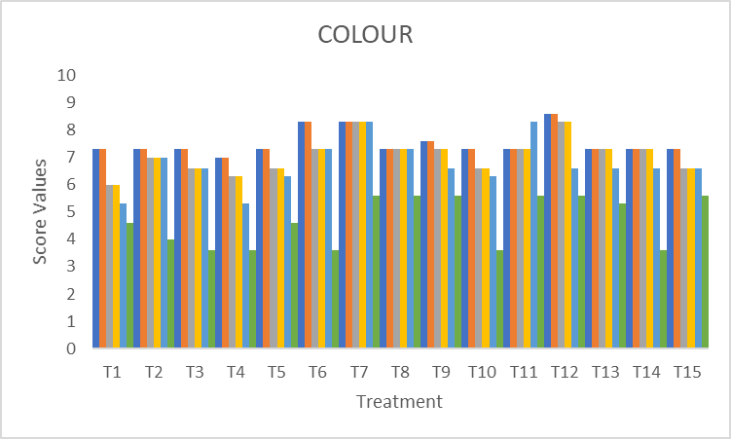
Fig.5.Change in colour of sugarcane juice during storage

3.2.2 Taste/ flavour
Treatment T₁₂ recorded the lowest reduction in sensory scores for taste. Taste scores declined across all treatments during storage. This decrease could be due to the loss of volatile aromatic substances responsible for taste and due to decrease in pH of the juice as it become more acidic (Reddy et al., 2014). Sugarcane juice fortified with Aloe vera lemon ginger extract not only improve the flavor but also act as a natural antimicrobial agent and hence assist the added preservatives.

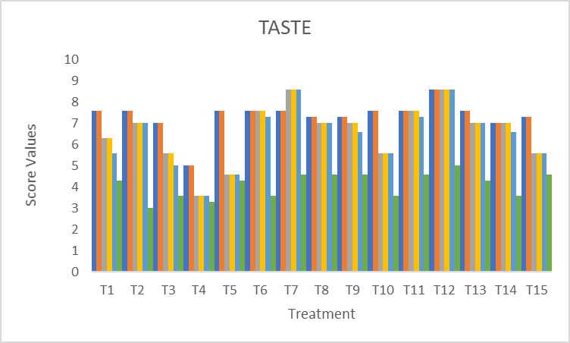
Fig.6.Change in taste of sugarcane juice during storage

3.2.3 Smell / odour
This decrease could be due to the high level of acid that reacts with the product and results in an unpleasant volatile odour and this could be due to the slight fermentation of juice and gas production (Reddy et al., 2014). Treatment T₇ and T₁₂ recorded a lower reduction in scores. Microwave pasteurization, addition of lime juice and potassium metabisulfite had prevented changes in smell in the treatment T₁₂.

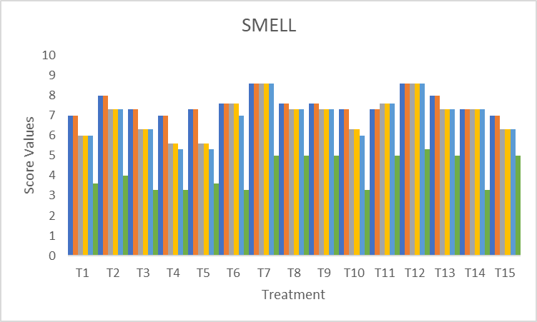
Fig.7.Change in smell of sugarcane juice during storage

3.2.4 Sweetness
Results in the Fig.8 reveal that there was a considerable reduction in sensory scores for sweetness with the advancement of the storage period. Initially, treatments T₂ and T₁₂ recorded the highest scores 8.6 and 9, respectively, for sweetness but the treatment T₁₂ only retained the highest score during the storage period.
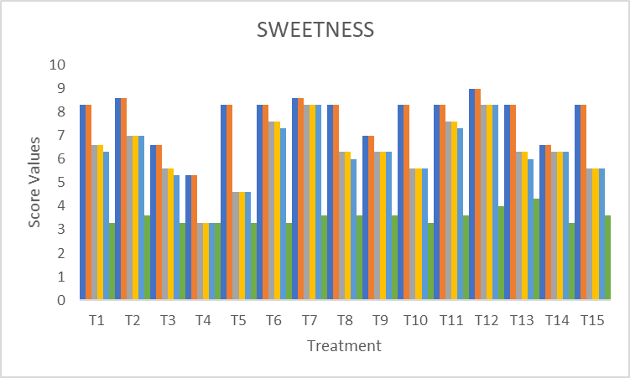
Fig.8.Change in sweetness of sugarcane juice during storage

3.2.5 Overall acceptability
After conducting sensory analysis using a 9-point hedonic scale, T₁₂ was found to be the best. The treatment T₁₂ was found to be acceptable till the end of the study. Panelists noted a balance of sweetness and refreshing citrus aroma with Aloe vera infusion, aligning with trends in functional beverages. T₁₂ scored highest in overall acceptability (8.6/9), with citrus aroma and ginger masking Aloe vera’s bitterness. The higher level of extract (>5%) might increase the acidity and flavour become stringent (Ajayi et al. 2019). Here the concentration of Aloe vera fixed at 5 % (T₁₂) was found to be superior to other Aloe vera concentrations. Ascorbic acid and Aloe vera flavonoids reduced oxidation. Treatment T₁₂ is significantly more effective in maintaining the overall sensory acceptability of sugarcane juice during storage compared to the other treatments, including the control (T₅). The combination of these natural extracts and KMS appears to have a synergistic effect in preserving the desirable sensory characteristics of the juice. The stability in individual sensory attributes likely contributed to the sustained high overall acceptability scores observed for this treatment. Variation in overall acceptability during the storage perod is given in rador diagram (Fig.9).
a.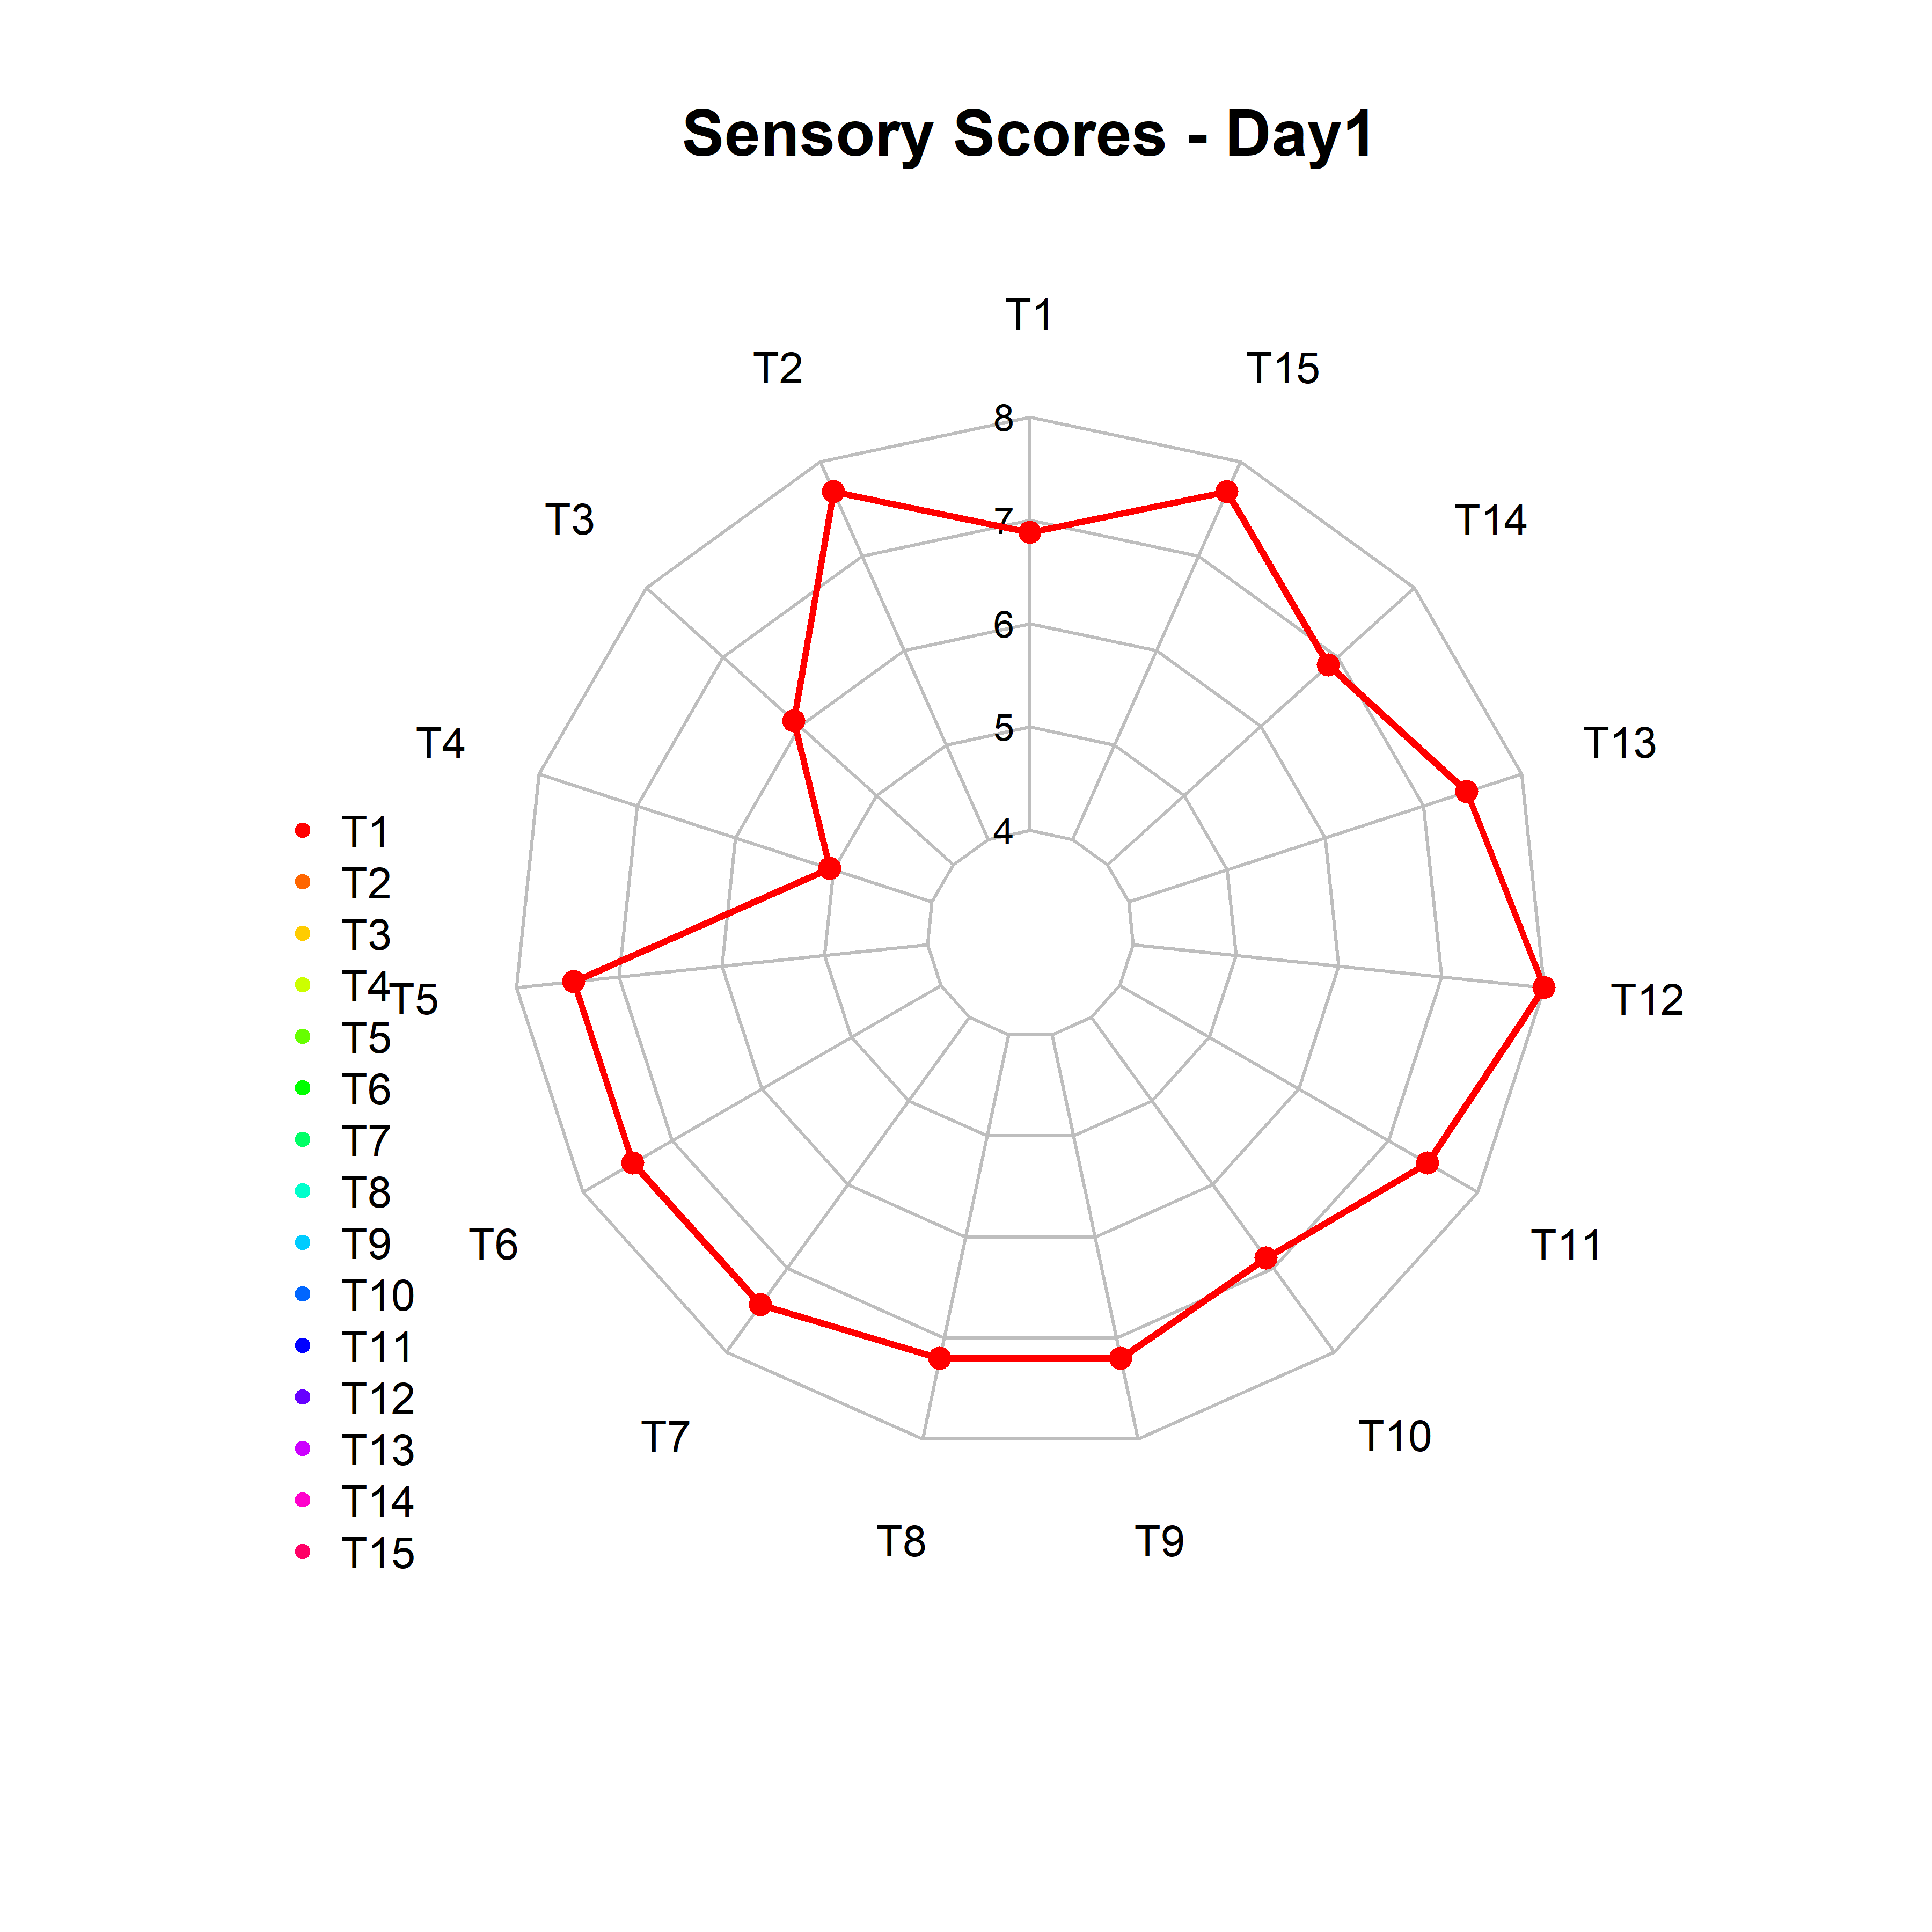 b.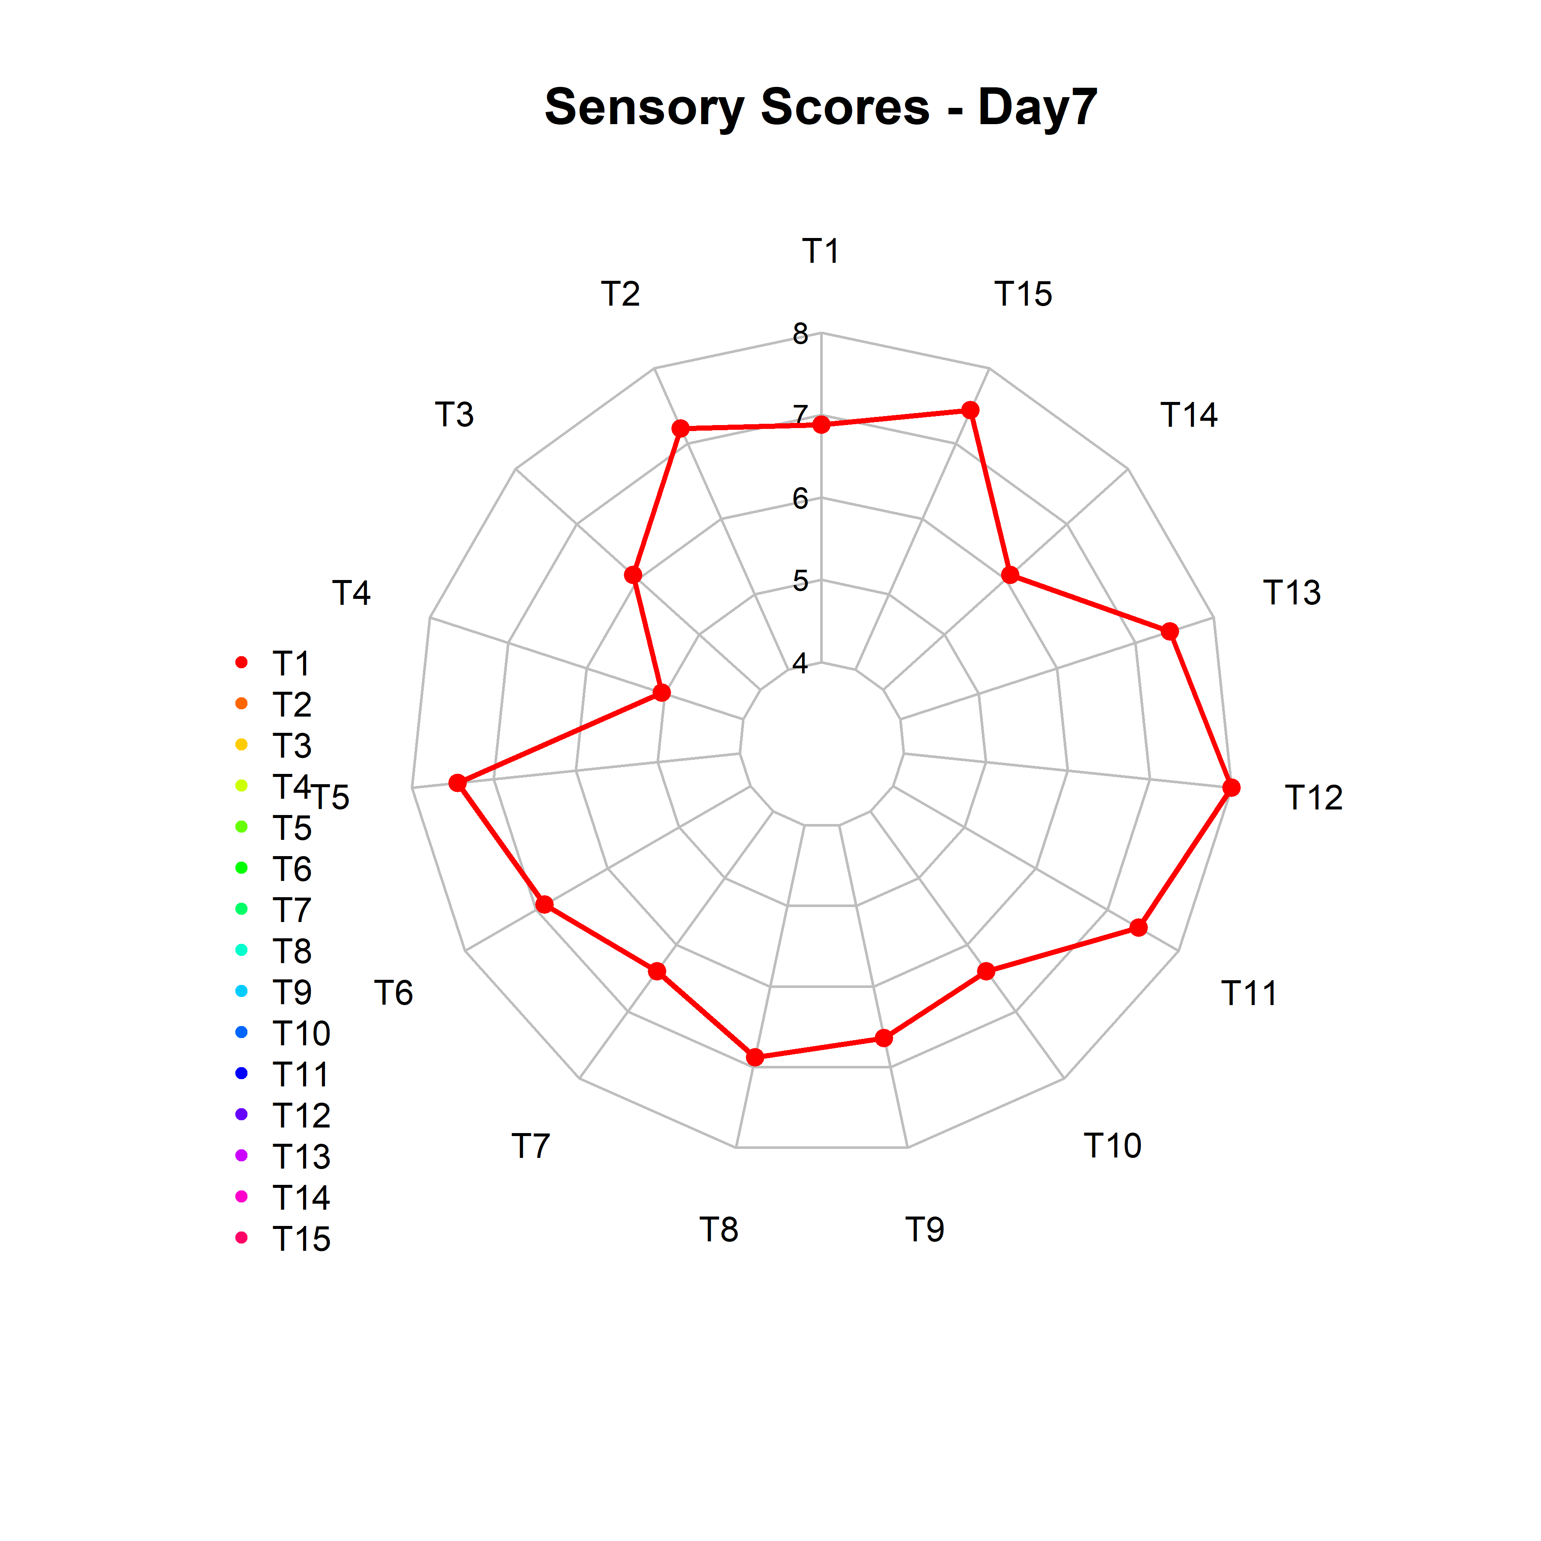 c. 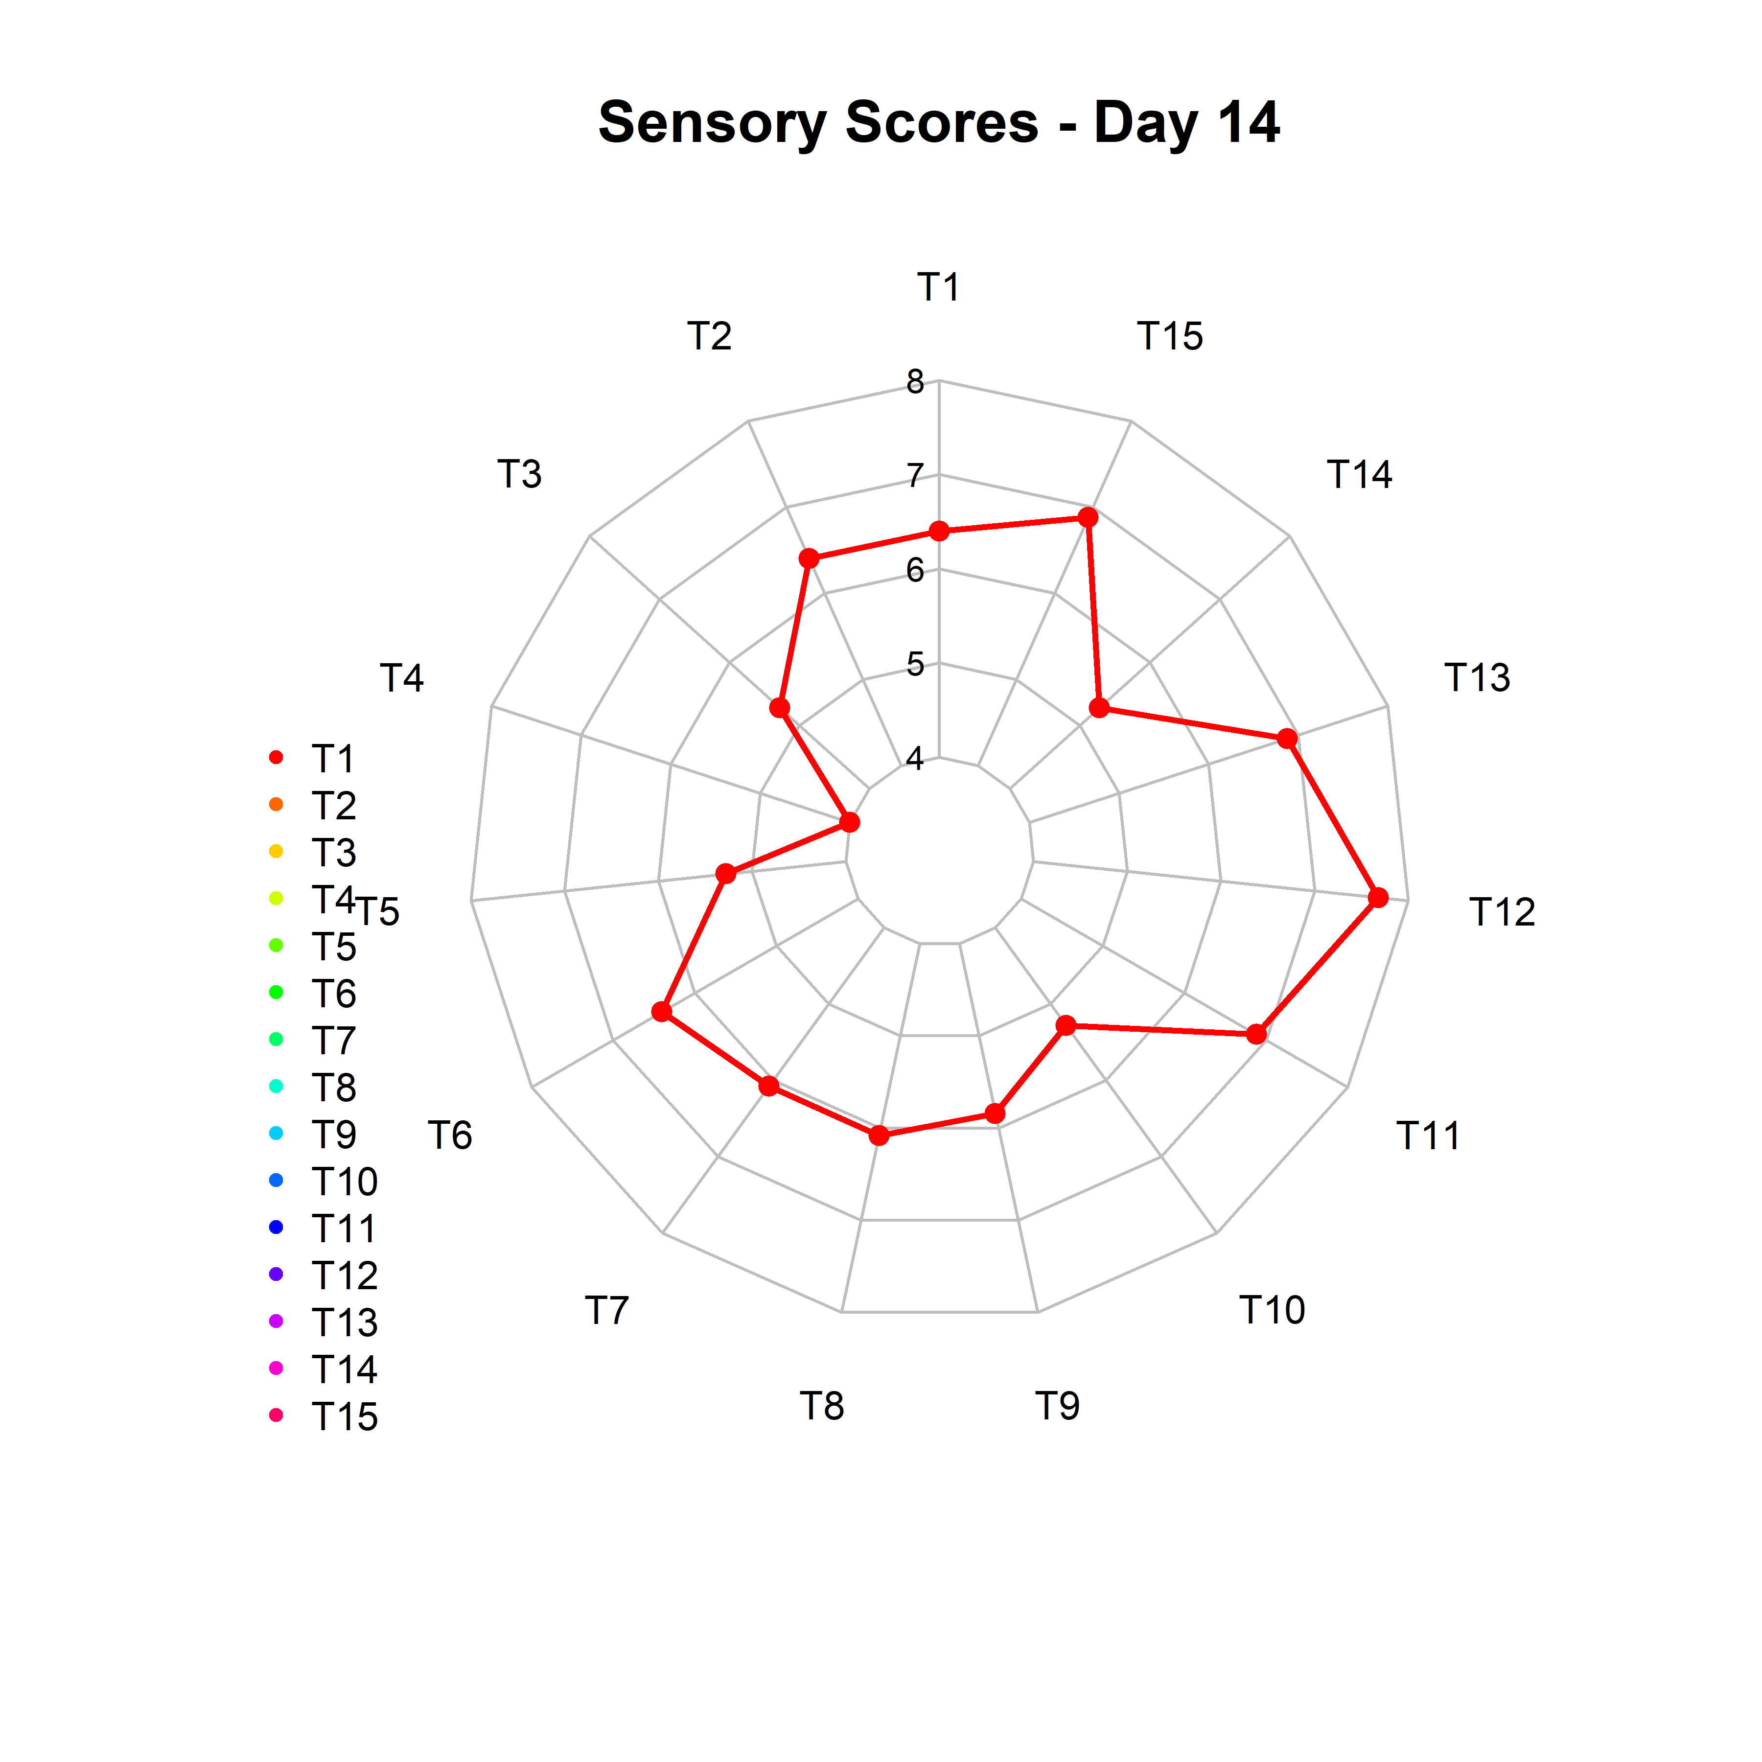
d.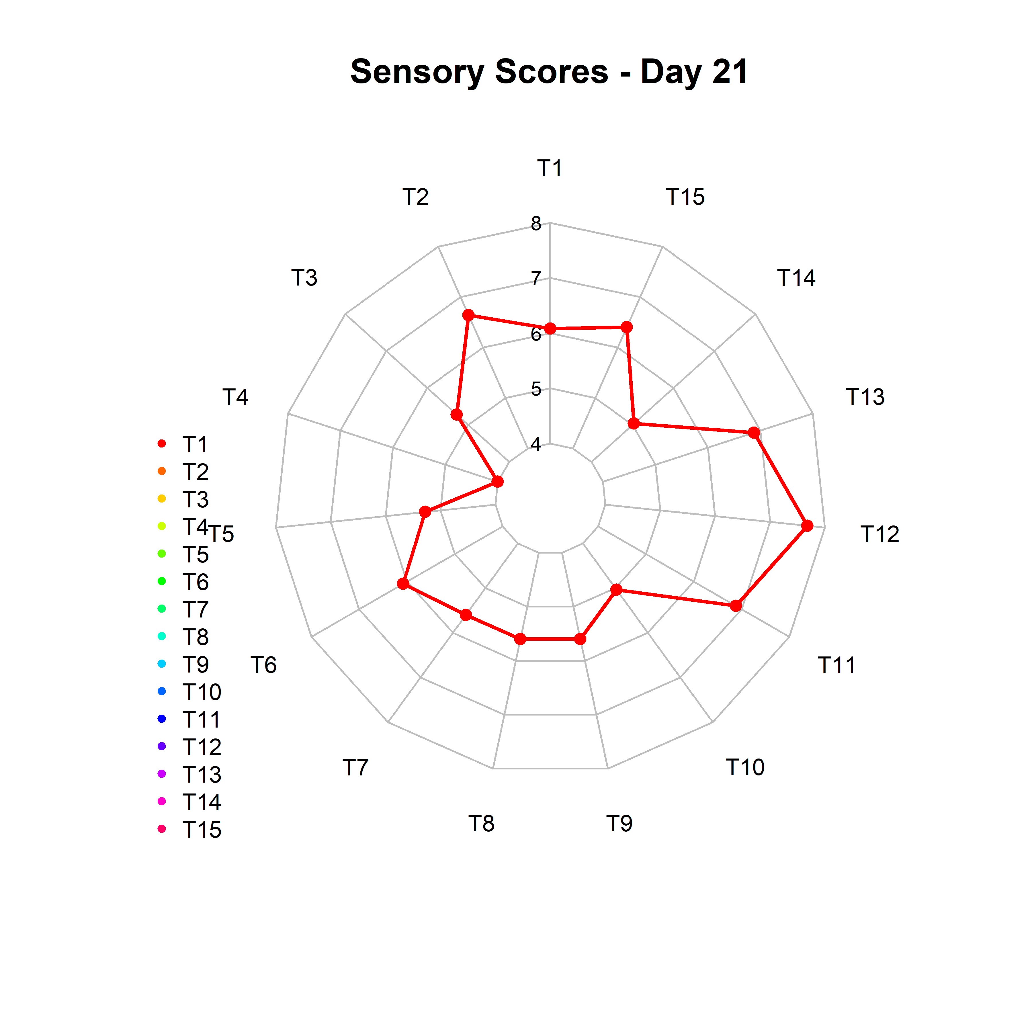 e . 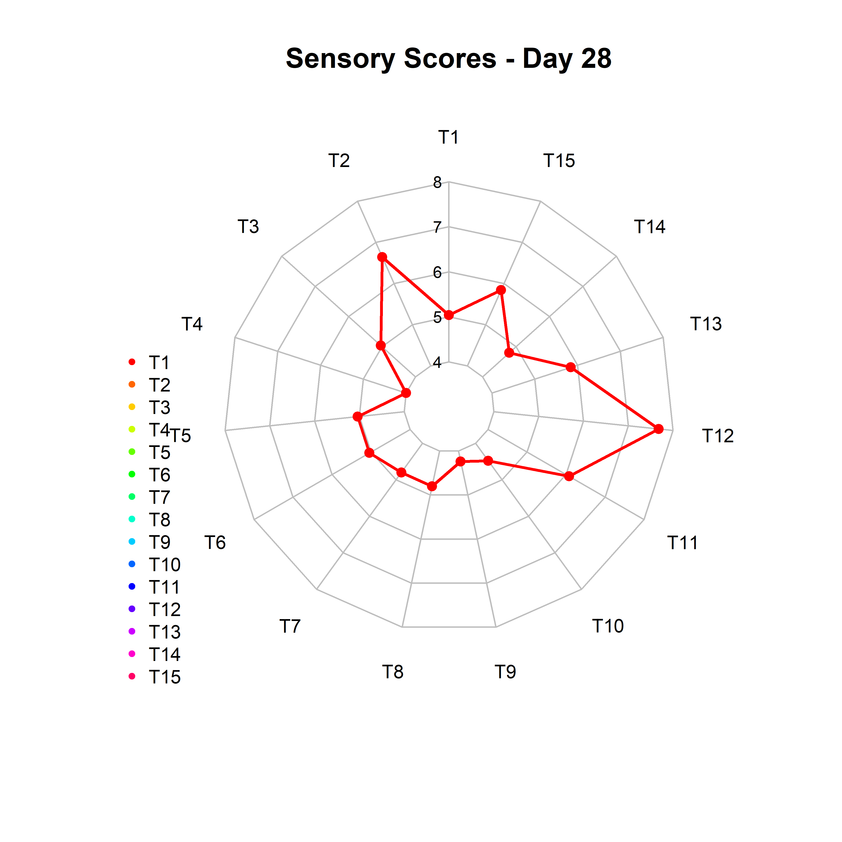 f.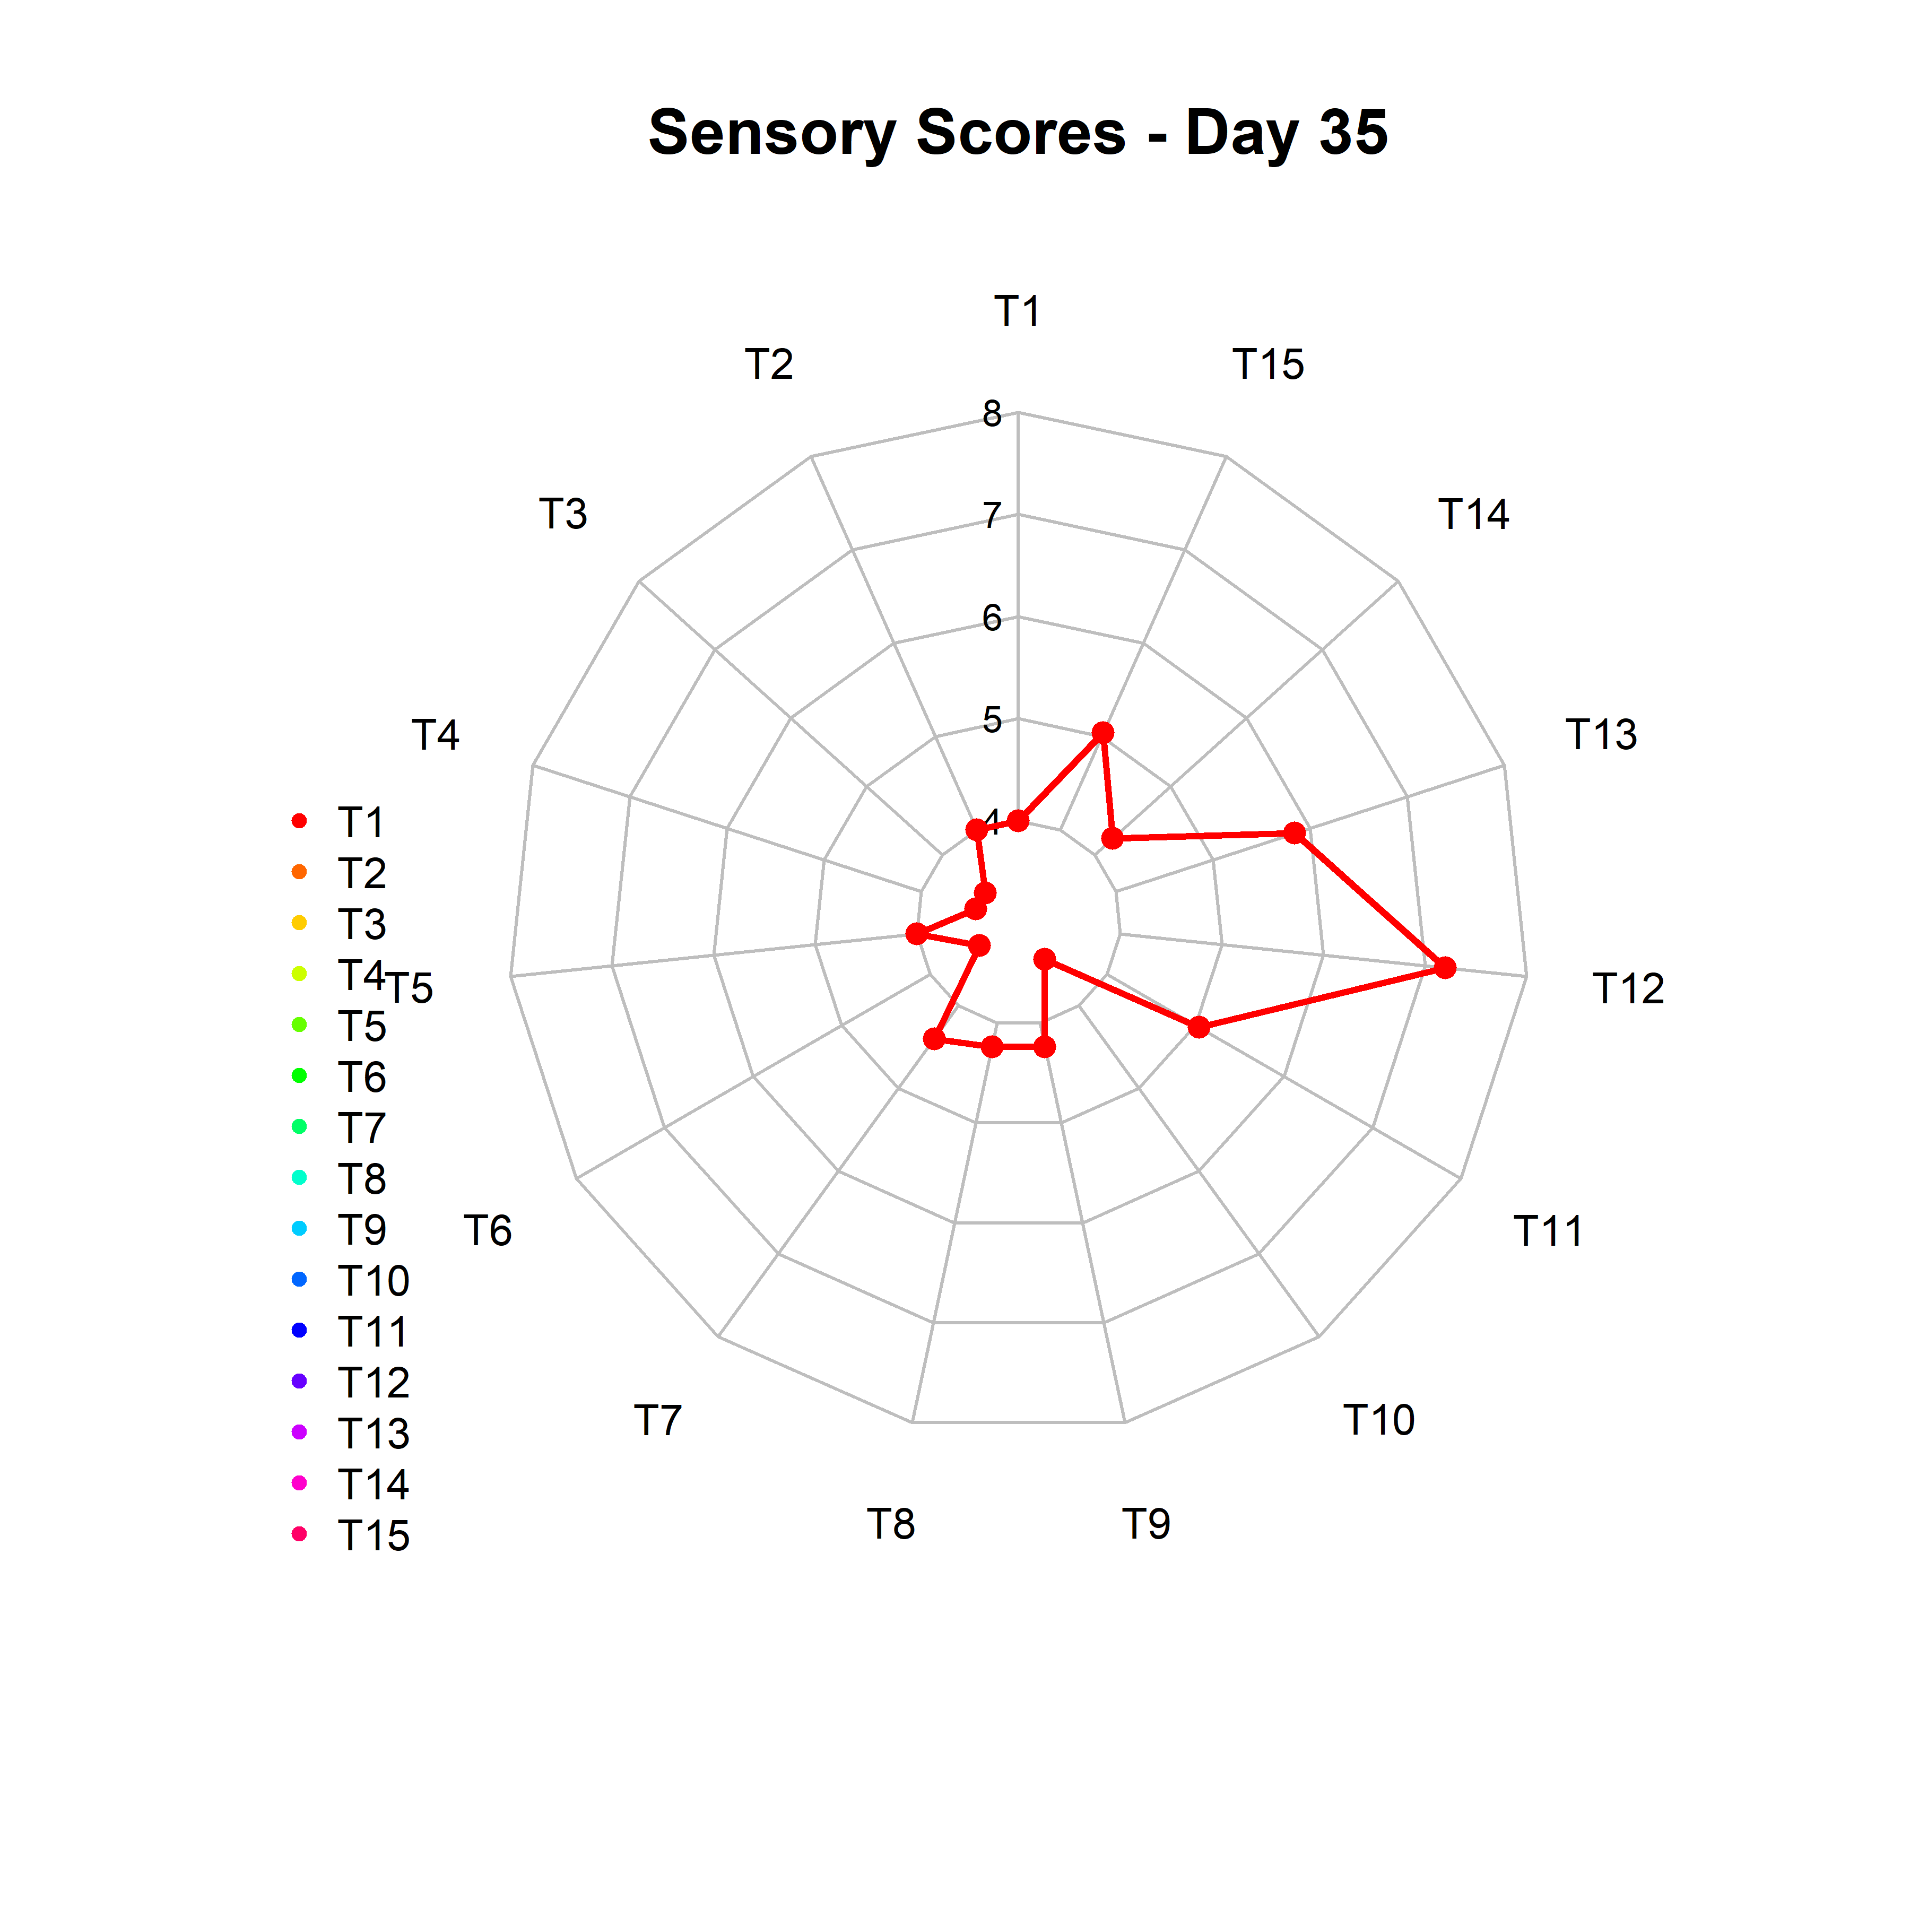
Fig 9. Change in overall acceptability of sugarcane juice during storage period

3.3 Microbial quality
The total plate count (TPC) of treatments T₅, T₂ and T₁₂ were conducted during the study and is depicted in Table 3. The treatment T₁₂ recorded the highest score in sensory evaluation and also exhibited much microbial stability. TPC was 1.2 × 10³ CFU/mL (day 1) and 2.4 × 10³ CFU/mL (day 28) respectively which was below FSSAI’s safe limit (10⁴ CFU/mL). Microwave heat treatment likely played a crucial role in inactivating biochemical processes within the fresh juice (Adulvitayakorn et al., 2020). Aloe vera gel, rich in acemannan and polyphenols, extends shelf life by inhibiting microbial growth and lipid oxidation (Ahlawat et al., 2011). Ginger (6-gingerol) and lemon (citric acid/ascorbic acid) synergistically enhance antimicrobial activity and sensory appeal (Shukla et al., 2007).

Table 3. Scores for Total Plate Count
Treatments | Day 7 | Day 14 | Day 21 | Day 28 | Day 35
T₂ | 1.2x10³ | 2.4x10³ | 2.7x10³ | 3x10³ | 4.2x10³
T₅ | 3x10³ | 3.6x10³ | 4x10³ | 5x10³ | 6x10³
T₁₂ | 1x10³ | 2x10³ | 2.4x10³ | 2.7x10³ | 3.6x10³

Sulphitation with potassium metabisulphite and acidification with citric acid, combined with pasteurization showed the best results for extending shelf life under refrigeration. This was in confirmation with the findings of Dhansu et al. (2023). The citric acid in the lime juice gave a preservative action and inhibited the growth of microorganisms during storage. Synergy between citric acid (lemon) and KMS suppressed 99% of spoilage microbes (Shukla et al., 2007; Aneja et al., 2021). Chauhan et al. (2002) similarly reported that adding citric acid (lemon juice) along with 150 ppm KMS virtually halted microbial growth in sugarcane juice. The highest stability in total soluble solids was demonstrated by preservative and microwave pasteurization combinations (Shakoor et al., 2025). Low temperature storage combined with natural preservatives was found to be an effective way of preservation with acceptable sensory qualities (Ramachandran et al., 2017). The combination of natural antimicrobials with microwave pasteurization proved effective in reducing microbial load while preserving the sensory attributes of the juice. Microwave treatment offers rapid heating, minimizing nutrient loss compared to conventional pasteurization methods.​ The microbiological analysis, in conjunction with the physico-chemical and sensory evaluations, demonstrates the effectiveness of the preservation protocol employed in Treatment T₁₂ (microwave pasteurization combined with Aloe vera extract, lemon juice, ginger extract and potassium metabisulphite) in maintaining the quality and extending the potential shelf life of sugarcane juice. The synergistic antimicrobial action of citric acid from lemon juice, the broad-spectrum inhibition of KMS, and potentially other bioactive compounds in Aloe vera and ginger extracts contributed to the significant reduction in microbial growth. This microbiological stability, in turn, helped preserve the nutritional (vitamin C), physico-chemical and sensory attributes of the juice, resulting in high overall acceptability even after a considerable storage period.
4.CONCLUSION
Among different combinations, T₁₂, 5% Aloe vera extract, 1% lemon juice and 0.5% ginger extract in sugarcane juice was found to be the best, with good keeping quality with a stable brix, titratable acidity, brix: acid ratio, vitamin C content. In summary, the integration of Aloe vera extract, lemon juice, ginger extract and KMS, coupled with microwave pasteurization, significantly enhances the sensory stability of sugarcane juice during refrigerated storage. This combination effectively mitigates common degradation issues such as browning, off-flavors and sweetness loss, thereby extending the product's shelf life and consumer acceptability, thus addressing the challenges posed by its rapid deterioration. This protocol will be very useful for the introduction of a new value-added product to the market, which pays more attention to the consumer’s health rather than just being a general refreshment drink. Fortification with Aloe vera extract makes it a healthy drink instead of a simple refreshment juice. Ginger extract and lemon juice were added to enhance the taste, smell and hence induce a pleasing flavour to the product. Besides the health benefits and medicinal value of ginger and lemon juice, they act as natural antimicrobials also. So it can be concluded that ginger-flavoured Aloe sugarcane drink can be called a ‘healthy drink’ or an ‘energy drink’, which can be consumed by people of all ages. This study highlights the potential of developing value-added bottled sugarcane juice products with enhanced health benefits and extended shelf life, catering to consumer demands for both quality and safety.

ACKNOWLEDGEMENTS
Authors are grateful to Kerala Agricultural University for providing the necessary facilities, resources, support and guidance that contributed to the successful completion of this work.

COMPETING INTERESTS DISCLAIMER
Authors have declared that they have no known competing financial interests OR non-financial interests OR personal relationships that could have appeared to influence the work reported in this paper.

DISCLAIMER (ARTIFICIAL INTELLIGENCE)
We, hereby declare that NO generative AI technologies such as Large Language Models (ChatGPT, manuscript were used during the preparation of this article. No AI-generated content was included.

REFERENCES
Adulvitayakorn, S., Azhari, S. H. & Hasan, H. (2020). The effects of conventional thermal, microwave heating, and thermosonication treatments on the quality of sugarcane juice. Journal of Food Processing and Preservation, 44(2), e14322.

Ahlawat, K. S., & Khatkar, B. S. (2011). Processing, food applications and safety of aloe vera products: a review. Journal of food science and technology, 48, 525-533.

Ajayi, O. A., Lessor, A. G., & Akinwunmi, O. O. (2019). Quality Evaluation of Zobo (Hibiscus sabdariffa) juice preserved with Moringa (Moringa oleifera) or Ginger (Zingiber officinale) extracts at different storage conditions. Journal of Microbiology, Biotechnology and Food Sciences,2019, 730–736.

Ali SE, Yuan Q, Wang S. & Farag MA (2021) More than sweet: a phytochemical and pharmacological review of sugarcane (Saccharum officinarum L). Food Biosci 44:101431. https://doi.org/10.1016/j.fbio.2021.101431

Aneja, K. R., Dhiman, R., Aggarwal, N. K., & Aneja, R. (2021). Microbial spoilage of beverages and preservation: A review. Beverages, 7(3), 44. https://doi.org/10.3390/beverages7030044

AOAC (2005) Official Methods of Analysis, 18th ed. : Association ofOfficial Analytical Chemists, Ch 50, pp. 4–5.

Bhupinder, K.; Sharma, K.P. &Harinder, K. Studies on the Development and Storage Stability of Ready-to-Serve Bottled Sugarcane Juice. International Journal of Tropical Agriculture 1991, 9 (2), 1287134.

Boghani, A.H., Raheem, A. & Hashmi, S.I. 2012. Development and Storage Studies of Blended Papaya-Aloe vera Ready to Serve (RTS) Beverage. J Food Process Technol., 3: 185.

Bomdespacho, L. D. Q., Silva, B. T. R. D., Lapa-Guimarães, J., Ditchfield,C., & Petrus, R. R. (2018). Cultivar affects the color change kinetics of sugarcane juice. Food Science and Technology, 38, 96–102.
.
Chauhan, O. P., Singh, D., Tyagi, S. M., & Balyan, D. K. (2002). Studies on preservation of sugarcane juice. International journal of food properties, 5(1), 217-229

Chinnadurai, C. (2017). Potential health benefits of sugarcane. Sugarcane biotechnology: Challenges and prospects, 1-12.

Chen, R., Yu, M., Jiang, B. & Chen, J. (2024). Effect of different sterilization methods on the appearance, composition, and flavor of sugarcane juice. Journal of Food Science, 89(3), 1755-1772.

Dhansu, P., Ram, B., Singh, A. K., Tomar, S. K., Karuppaiyan, R., Kumar, R. & Pandey, S. K. (2023). Different Treatments for Sugarcane Juice Preservation. Foods, 12(2), 311.

Ellis, T. P., Wright, A. G., Clifton, P. M. & Ilag, L. L. (2016). Postprandial insulin and glucose levels are reduced in healthy subjects when a standardised breakfast meal is supplemented with a filtered sugarcane molasses concentrate. European journal of nutrition, 55, 2365-2376.

Garud, S. R., Priyanka, B. S., Rastogi, N. K., Prakash, M., & Negi, P. S.(2018). Efficacy of ozone and lactic acid as nonthermal hurdles for preservation of sugarcane juice. Ozone: Science & Engineering, 40(3),198–208.
Gupta, P., & Sharma, R. (2022). Effect of microwave pasteurization on microbial load and nutritional quality of fruit juices. Journal of Food Science and Technology, 59(4), 1340–1348. https://doi.org/10.1007/s13197-021-05153-z

Hithamani, G., Medappa, H., Chakkaravarthi, A., Ramalakshmi, K., & Raghavarao, K. S. M. S. (2018). Effect of adsorbent and acidulants on enzymatic browning of sugarcane juice. Journal of Food Science & Technology, 55, 4356–4362.
Iannitti, T.,Moba, B., Palmieri, B., & Esposito, A. (2024). How Aloe vera’s medicinal properties make it essential in medicine, cosmetics, and food products. News-Medical.net.

Jha, R, Bodhankar,H and Kenwala, S. (2023) To Study Sugarcane Juice and to Study its Shelf Life ,International Journal of Trend in Research and Development, Volume 10(2), ISSN: 2394-9333 ,

Kaavya, R., Pandiselvam, R., Kothakota, A., Priya, E. B., & Prasath, V. A. (2019). Sugarcane juice preservation: A critical review of the state of the art and way forward. Sugar Tech, 21(1), 9–19.

Krishnakumar, T., & Devadas, C. T. (2006). Quality changes in sugarcane juice by delayed extraction and storage. Beverage and Food World, 33(2), 76-78.

IMARC (2024) Ready-to-Drink Beverages Market Report by Product Type (RTD Tea, RTD Coffee, Energy Drinks, Yogurt Drinks, Dairy-based Beverages, and Others), Packaging (Bottles, Tetra Pack, Sachet, Tin Can, and Others), Distribution Channel (Business to Business (Foodservice), Business to Consumers), and Region 2025-2033 Report ID: SR112025A7116
Li, W., Xiong, S. G., Liu, C. H., & Jiang, A. L. (2024). Citric acid treatment maintains fresh-cut sweet potatoes storage quality by reducing browning levels and increasing antioxidant capacity. Journal of Food Measurement and Characterization, 18(9), 7480-7494.
Larmond, E., 1991. Laboratory Methods for Sensory Evaluation of Food. 2nd Edn., Canadian Department of Agriculture Publication, Ottawa
Manikantan, M. R., Arumuganathan, T., Rani, C. I., Kasturi, R., & Varadharaju, N. J. S. T. (2017). Storage stability of sugarcane juice in polypropylene-based nanocomposite packaging films. Sugar Tech, 19, 438-445.

Martins, C. P., Cavalcanti, R. N., Cardozo, T. S., Couto, S. M., Guimarães, J. T., Balthazar, C. F. & Cruz, A. G. (2021). Effects of microwave heating on the chemical composition and bioactivity of orange juice-milk beverages. Food Chemistry, 345, 128746.

Mukhtar A, Latif S, Salvatierra-Rojas A., &Muller J (2022) Catalase activity in Hot-Air Dried Mango as an Indicator of Heat exposure for Rapid Detection of Heat Stress. Appl Sci 12:1305. h t t p s : / / d o i . o r g / 1 0 . 3 3 9 0 / a p p 1 2 0 3 1 3 0 5

Nowak, A., Rybczyński, M., & Wiktor, A. (2024). Evaluating the Impact of Microwave vs. Conventional Pasteurization on NFC Apple–Peach and Apple–Chokeberry Juices: A Comparative Analysis at Industrial Scale. Applied Sciences, 14(14), 6008.

Oladipo, O. O., & Emmanuel, O. (2020). Lime potentials as biopreservative as alternative to chemical preservatives in pineapple, orange and watermelon juice blend. Food Research, 4(6), 1878-1884.

Pradhan N, Kumar D, Pisalkar P.S., & Singh P. Effect of microwave on sugarcane juice preservation. Food Science Research Journal. 2019; 10(1):57-62.

Ranganna, S. 1991. Handbook of Analysis and Quality Control for Fruit and Vegetable Products. 3rd edition.TataMcgrawHill Publishing Col. Ltd.NewDelhi

Ramachandran, C., Sudha Rani, R., Lavanya, K., Nivetha, S., & Usha, A. (2017). Optimization of shelf stability of sugarcane juice with natural preservatives. Journal of Food Processing and Preservation, 41(1), e12868.
Rani, S., & Thakur, R. (2020). Comparative efficacy of citric acid and potassium metabisulphite in maintaining the quality of sugarcane juice during storage. Journal of Food Processing and Preservation, 44(5), e14401. https://doi.org/10.1111/jfpp.14401

Reddy, Y.S.K. & Madhuri, K.N., 2014. Impact of delayed crush on post-harvest deterioration of promising early maturing sugarcane clones.

Shakoor, S., Saleem, S., Raheem, I. U., Mukhtar, A., Asghar, M. T., & Azmat, M. A. (2025). Exploring various preservative methods in extending the shelf-life of sugarcane juice. Journal of Food Science and Technology, 1-11.

Sharma, A. &and Sharma, V. V. (2021). Aloe vera: an alternative to chemical preservatives for fruits and vegetables – a review. International Journal of Advanced Research in Innovation and Ideas in Education, 7(4), 92-99.

Shukla, Y., & Singh, M. (2007). Cancer preventive properties of ginger: a brief review. Food and chemical toxicology, 45(5), 683-690.

Sao, S & Singh., R.2019 “Bacteriological Assessment for Iced Sugarcane Juice in Korba, Chhattisgarh, India". Acta Scientific Microbiology 2.8 (2019): 03-07.

Singh, A., Lal, U. R., Mukhtar, H. M., Singh, P. S., Shah, G., & Dhawan, R. K. (2015). Phytochemical profile of sugarcane and its potential health aspects. Pharmacognosy reviews, 9(17), 45.

Singh, A. K., Kumar, P., Rajput, V. D., Mishra, S. K., Tiwari, K. N., Singh, A. K. and Pandey, A. K. (2023). Phytochemicals, antioxidant, anti-inflammatory studies, and identification of bioactive compounds using GC–MS of ethanolic novel polyherbal extract. Applied Biochemistry and Biotechnology, 195(7), 4447-4468.

Tamilchelvan, A., Thirumurugan, T., Sassikumar, D., Jeyaprakash, P., Arul, L., Thangeswari, S., S Nithila., S. & Porkodi, G. (2025). Evaluation of key undesirable morphological traits in Sugarcane (Saccharum spp.) hybrid progenies. Plant Science Today. https://doi.org/10.14719/pst.6060

Yadav, R. L. & Solomon, S. (2006). Potential of developing sugarcane by-product based industries in India. Sugar Tech Vol. 8, No. 2/3, 104-111

Yu, P., Low, M. Y., & Zhou, W. (2018). Design of experiments and regression modelling in food flavour and sensory analysis: A review. Trends in Food Science & Technology, 71, 202–215.

Vu T, LeBlanc &Chou CC (2020) Clarification of sugarcane juice by ultrafiltration membrane: toward the direct production of refined cane sugar. J Food Eng 264:109682.

