Genic microsatellite markers based characterization in relation to aerobic adaptation of rice genotypes

Abstract
This study aimed to evaluate the genetic variation among rice genotypes to identify the entries with superior adaptation under aerobic cultivation and to determine the candidate gene-derived SSR markers based differentiation and divergence in relation to aerobic adaptation. The current experiment was conducted in the Department of Agricultural Biotechnology and Molecular Biology of the Dr. Rajendra Prasad Central Agricultural University, Pusa Samastipur, Bihar, during the two Kharif seasons (2023 and 2024). Adopting a randomized complete block design with three replications, 36 rice genotypes were evaluated across two consecutive growing seasons for grain yield per plant under aerobic and normal conditions, and genetic variation among rice genotypes was assessed using candidate gene-derived SSR markers. Genotypic performance was further analyzed using best linear unbiased prediction (BLUP) and genotypic adaptation was assessed based on relative mean performance and percentage change. Analysis of variance revealed significant (p < 0.01) genetic variation and genotype × environment interaction for this trait. Based on the relative mean performance and percentage change, 17 genotypes were classified as highly adapted to aerobic condition. Molecular profiling based on ten candidate gene-targeted genes specific 16 newly developed microsatellite markers detected altogether 47 allelic variants with an average of 2.9 alleles per primer. Allelic richness was observed for OsSAUR45a, OsNAR2.1a and OsNBS-LRRa, which are functionally associated with root architecture, nitrate uptake and aerobic adaptation, respectively. Polymorphism information content values ranged from 0.415 to 0.742, with a mean of 0.555, indicating a moderate to high level of polymorphism, suitable for diversity analysis. Cluster analysis based on molecular data grouped the genotypes into four major clusters, with PCoA supporting the spatial distribution of genetic profiles. This highlighted substantial genetic differentiation and divergence within the panel of genotypes under evaluation. The polymorphic markers identified along with the aerobically adapted and genetically diverse genotypes, offer valuable tools for genetic improvement in breeding programs aimed at developing rice cultivars optimized for aerobic production systems.
Keywords: Aerobic adaptation, BLUP values, candidate gene, genetic divergence, rice, relative mean performance, yield per plant
Introduction
Rice is a major staple crop for over half the global population, contributing significantly to caloric and micronutrient intake (Fukagawa and Ziska, 2019). Traditional flooded rice systems support weed control and nutrient uptake but require high water inputs (Kalita et al., 2020). Climate change, including increased drought and reduced rainfall, threatens the sustainability of such water-intensive practices (Li et al., 2023). Additionally, flooded conditions lead to substantial methane emissions, intensifying global warming (Bao et al., 2024). To ensure future food security and resource efficiency, more sustainable rice cultivation methods are urgently needed.
Aerobic rice cultivation, involving non-flooded, well-drained soils with supplemental irrigation, reduces water use and greenhouse gas emissions (Rajendra et al., 2011). Genotypes for this system are bred for moisture stress tolerance and stable yields (Bouman et al., 2001). Breeding efforts have utilized upland germplasm and high-yielding lines, but current aerobic cultivars often show lower yield and grain quality compared to irrigated varieties (Zahra et al., 2022). Therefore, improving genetic potential for yield and adaptation in aerobic rice remains a key breeding goal.
Genetic diversity in rice is fundamental for breeding programs targeting adaptation to changing agro-climatic conditions (Hour et al., 2020). Assessing this diversity supports effective use and conservation of germplasm. While morphological traits, though environmentally influenced, aid in identifying adaptive features, aerobic cultivation requires specific adaptations such as altered leaf architecture, stomatal behavior, and biomass allocation for improved water-use efficiency and stress tolerance (Gaballah et al., 2022; Zayed et al., 2023). Comparative phenotypic evaluation under aerobic and normal systems helps identify stable, high-yielding genotypes.
Phenotypic methods are often influenced by environmental factors, limiting their precision (Amom and Nongdam, 2017). In contrast, molecular markers, particularly simple sequence repeats (SSRs), offer reliable and environment-independent tools for assessing genetic variation due to their high polymorphism, co-dominant inheritance, and reproducibility (Kalia et al., 2011). Candidate gene-targeted SSRs improve resolution by focusing on loci associated with specific adaptive or agronomic traits, enabling trait-linked genetic analysis (Kumari et al., 2019).
The application of SSR markers in molecular characterization also provides insights into the genetic architecture of rice populations, supporting the management and strategic use of genetic resources in breeding programs (Verma et al., 2023). By integrating morphological and molecular data, it is possible to gain a comprehensive understanding of genotype performance and genetic divergence, which is crucial for identifying elite donors and developing improved cultivars.
In this context, the present study was undertaken to evaluate genetic divergence among 36 rice genotypes through integrated yield assessment and molecular characterization using newly developed candidate gene-derived SSR markers. The primary objectives were to identify genotypes with superior adaptation to aerobic environments based on grain yield performance, to detect polymorphic and informative genic SSR markers and to quantify the extent and pattern of genetic differentiation among the genotypes.
Material and methods
Plant material and experimental design
A total of 36 rice genotypes, comprising advanced breeding lines with potential for aerobic adaptation, near-isogenic lines and both national (DRR Dhan 54, Vandana) and local check (Rajendra Nilam) varieties were evaluated in this study (Table 1). The field experiment was conducted at the RPCAU rice research farm, Pusa, Bihar, during the Kharif seasons of 2023 and 2024. During Kharif 2023, temperatures ranged from 18.9 °C to 35.6 °C, rainfall from 0.0 to 369.7 mm, and mean relative humidity was 93.27%. In Kharif 2024, temperatures varied between 21.8 °C and 34.4 °C, rainfall from 0.0 to 121.1 mm, with 93.07% average humidity. The trial was laid out in a Randomized Block Design (RBD) with three replications and repeated across two consecutive years to account for seasonal variation. Each plot measured 2 m × 1 m, with inter-row and intra-row spacing of 20 cm and 15 cm, (39 plants per plot) respectively. Under puddled conditions, 21-day-old seedlings were manually transplanted into saturated soil and continuous standing water was maintained from transplanting until approximately two weeks before physiological maturity. For aerobic cultivation, 2-3 seeds per hill were directly sown into non-puddled soil within a rainout shelter designed to exclude excess precipitation. Post-emergence, seedlings were thinned to achieve uniform plant density. Aerobic soil conditions were sustained throughout the crop cycle with supplemental surface irrigation applied as needed to prevent water stress.

Phenotyping for gain yield of rice genotypes
Phenotyping for grain yield per plant was conducted on a set of genotypes cultivated under both aerobic and normal conditions over two consecutive growing seasons. Grain yield per plant (g/plant) was assessed by harvesting and weighing the yield from five randomly selected plants per genotype within each replication. This procedure was performed consistently across all experimental plots. Data collection was carried out across both years to account for inter-annual environmental variability and to ensure robust estimation of genotype performance under varying conditions.
Statistical analysis
Analysis of variance was conducted using GenStat software on replication-wise mean values for yield per plant, derived from five randomly selected plants per genotype. This analysis aimed to evaluate genotypic differences and genotype-by-environment (G×E) interactions for grain yield. To further account for environmental variation and improve the accuracy of genotype performance estimates, phenotypic data collected under two distinct environmental conditions were analyzed using a mixed linear model approach to compute Best Linear Unbiased Predictions (BLUPs) via the Meta-R software package (Alvarado et al., 2020). This approach enabled the estimation of random effects associated with genotypes across environments. The BLUP values were used for the further analysis of relative mean performance and percentage change.

Table 1. List of 36 rice genotypes evaluated in the present investigation
Sl. No. | Name of Genotype | Designation | Source
1 | RCPR93-IR 106312-50-1-1-1 | RCG-01 | IIRR Hyderabad
2 | RP6616-CGR 7 | RCG-02 | IIRR Hyderabad
3 | PAU7592-366-1-1-B (RYT4009) | RCG-03 | IIRR Hyderabad
4 | NVSR 911 | RCG-04 | IIRR Hyderabad
5 | RNR 28373 | RCG-05 | IIRR Hyderabad
6 | R 2220-39-1-4-1 | RCG-06 | IIRR Hyderabad
7 | NWGR 17133 | RCG-07 | IIRR Hyderabad
8 | NVSR 929 | RCG-08 | IIRR Hyderabad
9 | DRR Dhan 54 | Dhan54 | IIRR Hyderabad
10 | RP 6327-13-171-3-2 (PSV-1128) | RCG-09 | IIRR Hyderabad
11 | CR 4402-(1,2,3,4)-89-1-3-1 | RCG-10 | IIRR Hyderabad
12 | IIABR-13/IIAB-4/IR15L1505 | RCG-11 | IIRR Hyderabad
13 | CR 4403-5-1-IR117841-4-1 RGA-1 RGA-1 RGA-2 | RCG-12 | IIRR Hyderabad
14 | TRC GN 116-B-B-14-2 | RCG-13 | IIRR Hyderabad
15 | CR Dhan 202 | Dhan202 | IIRR Hyderabad
16 | CR 3553-1-5-1-2-1-1 | RCG-14 | IIRR Hyderabad
17 | RNR 39027 | RCG-15 | IIRR Hyderabad
18 | RP 5594-97-5-1 (PSV 222) | RCG-16 | IIRR Hyderabad
19 | 4521 RCPR 92-IR 97069-1-1-1-1 | RCG-17 | IIRR Hyderabad
20 | 4522 RP 6252-BV/RIL-BV2024 | RCG-18 | IIRR Hyderabad
21 | 4523 CR 3516-11-2-2-1-1-1 | RCG-19 | IIRR Hyderabad
22 | Varalu | Varalu | NRRI, Cuttack
23 | MTU 1010 | MTU1010 | NRRI, Cuttack
24 | IR-14F717 | RCG-20 | RPCAU, Pusa
25 | IR-16F1172 | RCG-21 | RPCAU, Pusa
26 | Rajendra Nilam | R.Nilam | RPCAU, Pusa
27 | Sahbhagi Dhan | Sahbhagi | RPCAU, Pusa
28 | CRR 809-11-1-9-B | RCG-22 | NRRI, Cuttack
29 | Vandana | Vandana | NRRI, Cuttack
30 | CRR 752-3-1-B | RCG-23 | NRRI, Cuttack
31 | RP 6613-MSM-65-Bio-36-4-15 | RCG-24 | NRRI, Cuttack
32 | Anjali | Anjali | NRRI, Cuttack
33 | CRR744-74-41-B | RCG-25 | NRRI, Cuttack
34 | IR-64 | IR-64 | NRRI, Cuttack
35 | CRR749-109-1-B-B | RCG-26 | NRRI, Cuttack
36 | RP 6612-MSM 63-Bio-62-4-15 | RCG-27 | NRRI, Cuttack

The relative performance of each genotype for the evaluated traits was determined based on the ratio of trait values under aerobic to those under normal conditions (Yue et al., 2006). On the basis of the relative mean performance and standard deviation (SD), rice genotypes were categorized as highly adapted (>mean+0.5SD), moderately adapted (mean±0.5SD) and slightly adapted (<mean-0.5SD) group. Furthermore, the percentage change in trait performance between the two environments was calculated using Microsoft Excel, according to the following formula: Percentage Change = (Value under normal condition – Value under aerobic condition) / (Value under normal condition) × 100.
Primer designing for candidate gene-specific microsatellite loci
Candidate genes associated with root development and aerobic adaptation in rice were identified through an extensive review of relevant literature. Based on this review (Khahani et al., 2021; Sandhu et al., 2019; Phule et al., 2019), ten candidate genes were selected: OsAIR1, OsMGT1, OsPIN3t, OsFBK1, OsAMTR1, OsSAUR45, OsWEG1, OsNAR2.1, MDR-like ABC transporter and NBS-LRR protein (Table 2). The corresponding nucleotide sequences for these genes were retrieved from publicly accessible databases, including the National Center for Biotechnology Information (NCBI) and the Rice Genome Annotation Project. Microsatellite loci within these gene sequences were identified and gene-specific primer pairs were designed using the BatchPrimer3 v1.0 software (Table 3). The designed primers were selected based on key parameters such as expected product size, melting temperature (Tm) and GC content, to ensure optimal specificity and amplification efficiency for downstream molecular characterization and genotyping.
Genotyping of rice genotypes
DNA isolation
Using set of 36 rice genotypes, candidate genes based molecular profiling was conducted. These genotypes were used for the extraction of genomic DNA. All experimental procedures were conducted in the Department of Agricultural Biotechnology and Molecular Biology at Dr. Rajendra Prasad Central Agricultural University, Pusa, Samastipur, Bihar. Genomic DNA was isolated from the juvenile leaf tissue of each genotype using a modified cetyltrimethylammonium bromide (CTAB) extraction method (Murray and Thompson,1980) and further refined (Ferdous et al., 2012). RNA contamination was eliminated by treatment with RNase A (2 µL of 10 mg/mL). The DNA samples were subsequently stored at -20 °C for downstream applications. The quality and integrity of the extracted DNA were assessed through 0.8% (w/v) agarose gel electrophoresis. Samples displaying extensive degradation or shearing were discarded, while high-quality, intact DNA samples were selected for primer-directed polymerase chain reaction amplification.
Table 2. List of candidate genes derived during molecular profiling for aerobic adaptation in rice genotypes
Sl. No. | Candidate gene | Gene id | Chr. No | Function of the candidate gene
1 | OsAIR1 | Os05g0497600 | 5 | Gene affecting root architecture and contributing to drought tolerance
2 | OsMGT1 | Os01g0869200 | 1 | Control root architecture during salinity stress
3 | OsPIN3t | Os01g0643300 | 1 | Control root architecture under water deficit conditions
4 | OsFBK1 | Os01g0659900 | 1 | Control root architecture under water deficit conditions
5 | OsAMTR1 | Os05g0475400 | 5 | Affects root architecture under water deficit conditions
6 | OsSAUR45 | Os09g0546100 | 9 | Regulates root length and other related root traits
7 | OsWEG1 | Os09g0509300 | 9 | Novel gene that regulates root-related traits in water deficit conditions
8 | OsNAR2.1 | Os02g0595900 | 2 | Play a major role in nitrate uptake
9 | MDR-like ABC transporter | Os01G0723800 | 1 | Unique role in aerobic adaptation
10 | NBS-LRR protein | LOC_Os11g10570 | 11 | Involved in the adaptation of upland rice to aerobic conditions.

Table 3. List of 16 designed SSR primers employed during amplification of genomic DNA template isolated from 36 genotypes of rice
Sl. No. | Marker (Primer) | ChrNo | SSR  start | SSR end | Forward primer sequence | Reverse primer sequence | Repeat Motif | SSR Length | Tm  ˚C
1 | OsAIR1 | 5 | 307 | 452 | CACGTGGAAGGAGGAGGT | GTCGTCGTTGGGAACTCA | (TAG)5 | 15 | 52
2 | OsMGT1a | 1 | 1355 | 1502 | GTGATCTAAACAGGGCCTAAT | CTTCAGATTCCTGACGTGAT | (TCTCTG)2 | 12 | 50
3 | OsMGT1b | 1 | 2697 | 2850 | ACGGAGGATTACATCAACATA | GGTCTTTCATCAGGTCGAT | (CGACGG)2 | 12 | 47
4 | OsPI3ta | 1 | 1352 | 1558 | GTCTCCCGTCTCAGAAGTC | ATGTTTAGAGTTGCACATGGA | (GGC)6 | 18 | 48
5 | OsPI3tb | 1 | 2413 | 2573 | ACAGTCACACAATAGCGTTTC | CCGGAACAGTAAATATCAACA | (CTA)5 | 15 | 50
6 | OsFBK1a | 1 | 3 | 196 | ATAAATCCGAACGGCCTCT | CCGACAGACGATGCTAAC | (GCCTC)3 | 15 | 51
7 | OsFBK1b | 1 | 2041 | 2198 | CTGCTTAACTTGAGGGAGAAG | AACTCACCAAATCCTTGAAAT | (CTGGTT)2 | 12 | 53
8 | AMTR1 | 5 | 1082 | 1246 | CGTCTTGTGCTAGTAGTCTGC | TCAGGAATCCAATCTTTAACA | (CATATG)2 | 12 | 48
9 | OsSAUR45a | 9 | 364 | 511 | ATGCTGTGGTAATGGAGTATG | CAAGAAATATGCTGGTTGACT | (TGCT)2 | 8 | 50
10 | OsSAUR45b | 9 | 392 | 543 | CTTGCTCAAGAGAAATGCTT | GAAGACTTGGCTCTTCTTCAG | (CTTG)2 | 8 | 50
11 | WEG1 | 9 | 1 | 185 | AAAGAATTCCCCATTTCCT | CTCCCTCCCTCACCTACC | (TC)8 | 16 | 50
12 | OsNAR2.1a | 2 | 267 | 438 | CACGGTGAAGGTATATAACAA | AATTTAGAAACCGCTGGATAA | (TGA)4 | 12 | 50
13 | OsNAR2.1b | 2 | 78 | 283 | GGGTTGATATCCAGAATCAGT | TATATACCTTCACCGTGCTTG | (GGTTT)2 | 10 | 50
14 | OsMDR | 1 | 5879 | 6043 | GGCTCTTCAGAAATAAACTGC | GACCTCTTGAAAGACAAGTTCT | (TTC)4 | 12 | 49
15 | OsNBS-LRRa | 11 | 210 | 369 | GACACTGAAGATGCAAGAATG | CAACAATCTCCAAAGTTTTCA | (AGAA)2 | 8 | 48
16 | OsNBS-LRRb | 11 | 558 | 720 | CCGAGTTGAGAATATCAGTTG | AATGATGACAAGTTCTGCAAG | (TCAT)2 | 8 | 54

Molecular profiling of genotypes
A total of 16 primer pairs were employed for the amplification of targeted genomic regions across 36 aerobic rice genotypes (Table 3). Polymerase chain reaction (PCR) was performed in a thermal cycler using 15 µL reaction volume containing 3.0 µL of 10X PCR buffer, 1.0 µL of 10mM MgCl₂, 3.0 µL of 1.0 mM dNTPs, 2.0 µL of genomic DNA (~20 ng), 0.5 µL of Taq DNA polymerase (1.0 U), 1.0 µL each of 5 µM forward and reverse primers and 3.5 µL of nuclease-free water to make up the final volume. PCR amplification was carried out using primer-specific thermal profiles involving an initial denaturation at 94 °C for 5 minutes, followed by 35 amplification cycles comprising denaturation at 94 °C for 30 seconds, annealing at 47–64 °C for 45 seconds, and extension at 72 °C for 45 seconds. A final extension was performed at 72 °C for 10 minutes. The amplified products were resolved on 2% (w/v) agarose gels, stained with ethidium bromide and visualized under a gel documentation system (BioRad).
Data analysis:
The molecular sizes of amplified fragments corresponding to each microsatellite locus were estimated using the AlphaView Gel Documentation System (Alpha Innotech) in combination with a 50 bp DNA ladder (Fermentas) as a molecular weight reference. Relative mobility values were calculated by assigning the origin (position of the loading well) as Rf = 0 and the terminal migration point of the tracking dye as Rf = 1. The vertical position (Y-axis) of each amplified band on the agarose gel was used to estimate the size of the DNA fragments. Amplified bands were classified as either shared or unique based on their occurrence across the genotypes. The Polymorphism Information Content (PIC) for each primer pair was calculated using the formula (Anderson et al., 1993):
PIC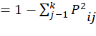
where k is the total number of alleles detected for a marker; P_{ij} is the frequency of the j^{th} allele for i^{th} marker and the summation extends over k alleles. Polymorphism detection was based on the presence or absence of each amplified product among the 36 aerobic rice genotypes. Bands were scored in a binary format '1' indicating presence and '0' indicating absence and the resulting data were compiled into a binary matrix for subsequent analyses. Genetic similarity between all pairwise combinations of genotypes was calculated using the Dice similarity coefficient (Dice, 1945): 2a/(2a+b+c) where a, b and c represent the number of bands shared between J^{th} and K^{th} genotypes, number of bands present in J^{th} genotype but absent in K^{th} genotype and number of bands absent in J^{th} genotype but present in K^{th} genotype respectively. Cluster analysis was performed using the Sequential Agglomerative Hierarchical Non-overlapping clustering algorithm, and the resulting dendrogram was constructed using the Unweighted Pair Group Method with Arithmetic Mean based on the calculated similarity coefficients. All statistical analyses were conducted using NTSYS-pc software (Rohlf, 1997. To further elucidate the genetic structure and relationships among the aerobic rice genotypes, Principal Coordinate Analysis (PCoA) using NTSYS-pc software was employed to visualize the genotypic distribution in two-dimensional space based on genetic profiles.
Results and discussion
Morphological evaluation and categorization of rice genotypes
Analysis of variance revealed highly significant (p < 0.01) genotypic differences for grain yield per plant across all tested genotypes under both normal and aerobic conditions over multiple years. A significant (p < 0.01) genotype-by-environment (G × E) interaction was detected for grain yield per plant, suggesting differential genotypic responses across environments (Sharifi et al., 2017). Based on replicated experimental data, BLUP for grain yield per plant were calculated and subsequently utilized during further statistical and comparative analyses (Wang et al., 2021).
Relative mean performance of genotypes under both conditions was assessed using BLUP values (Table 4). Mean value along with standard deviation (SD) was used as threshold criterion for genotype classification into the categories of highly adapted (>mean+0.5SD), slightly adapted (<mean−0.5SD) and moderately adapted (mean±0.5SD), following more or less similar approach adopted by earlier researcher (Mohan et al., 2022). According to this classification, 18 genotypes, such as RCG-01, RCG-04, Dhan54, RCG-09, RCG-10, Dhan202, RCG-14, RCG-19, RCG-20, RCG-21, Rajendra Nilam, Sahbhagi, RCG-22, Vandana, RCG-23, RCG-24, RCG-26 and RCG-27 were identified as highly adapted to aerobic conditions. Eight genotypes, namely, RCG-02, RCG-03, RCG-07, RCG-11, RCG-16, RCG-17, Varalu and Anjali were considered as moderately adapted to aerobic condition. The remaining 10 genotypes, namely, RCG-05, RCG-06, RCG-08, RCG-12, RCG-13, RCG-15, RCG-18, MTU1010, RCG-25 and IR-64 were classified as less adapted to aerobic conditions (Table 5). Using the BLUP values, the percentage change in yield per plant of genotypes under aerobic and normal conditions were also calculated (Table 4). The maximum percentage change was observed in genotype RCG-08 (20.72%), whereas the minimum value was recorded for genotype RCG-10 (0.87%). Additionally, the classification of highly adaptive response of genotypes in terms of percentage change in yield under aerobic condition showed a similar trend (except RCG-27) to that recorded on the basis of relative mean performance of genotypes under aerobic condition (Table 5).
Table 4. Relative mean performance and percentage change of 36 rice genotypes evaluated for yield per plant across years
Sl. No. | Genotype | Yield per plant
Sl. No. | Genotype | Normal | Aerobic | RMP | Pc
1 | RCG-01 | 18.47 | 17.85 | 0.97 | 03.32
2 | RCG-02 | 17.73 | 16.76 | 0.95 | 05.49
3 | RCG-03 | 17.42 | 16.13 | 0.93 | 07.39
4 | RCG-04 | 18.17 | 17.61 | 0.97 | 03.06
5 | RCG-05 | 20.58 | 16.72 | 0.81 | 18.75
6 | RCG-06 | 20.58 | 17.81 | 0.87 | 13.49
7 | RCG-07 | 16.08 | 14.80 | 0.92 | 07.97
8 | RCG-08 | 20.87 | 16.54 | 0.79 | 20.72
9 | Dhan54 | 20.27 | 19.91 | 0.98 | 01.78
10 | RCG-09 | 18.27 | 17.95 | 0.98 | 01.72
11 | RCG-10 | 20.70 | 20.52 | 0.99 | 00.87
12 | RCG-11 | 18.52 | 17.63 | 0.95 | 04.78
13 | RCG-12 | 17.72 | 15.76 | 0.89 | 11.02
14 | RCG-13 | 18.92 | 17.05 | 0.9 | 09.86
15 | Dhan202 | 18.90 | 18.60 | 0.98 | 01.59
16 | RCG-14 | 20.48 | 19.98 | 0.98 | 02.44
17 | RCG-15 | 20.22 | 17.86 | 0.88 | 11.65
18 | RCG-16 | 17.08 | 16.06 | 0.94 | 05.98
19 | RCG-17 | 19.02 | 17.83 | 0.94 | 06.22
20 | RCG-18 | 20.50 | 17.47 | 0.85 | 14.77
21 | RCG-19 | 20.27 | 19.99 | 0.99 | 01.34
22 | Varalu | 18.98 | 17.54 | 0.92 | 07.61
23 | MTU1010 | 19.58 | 17.46 | 0.89 | 10.84
24 | RCG-20 | 19.17 | 18.94 | 0.99 | 01.16
25 | RCG-21 | 17.33 | 16.93 | 0.98 | 02.31
26 | R.Nilam | 18.17 | 17.96 | 0.99 | 01.15
27 | Sahbhagi | 18.83 | 18.35 | 0.97 | 02.55
28 | RCG-22 | 15.75 | 15.37 | 0.98 | 02.40
29 | Vandana | 17.41 | 16.91 | 0.97 | 02.87
30 | RCG-23 | 15.39 | 14.96 | 0.97 | 02.81
31 | RCG-24 | 18.60 | 17.93 | 0.96 | 03.58
32 | Anjali | 17.90 | 16.50 | 0.92 | 07.82
33 | RCG-25 | 17.62 | 16.17 | 0.92 | 03.66
34 | IR-64 | 16.95 | 15.25 | 0.9 | 10.03
35 | RCG-26 | 15.34 | 14.92 | 0.97 | 02.73
36 | RCG-27 | 18.23 | 17.53 | 0.96 | 03.85
Footnote: RMP= Relative mean performance; Pc= Percentage change
Table 5. Classification of rice genotypes into relatively highly, moderately and slightly adapted groups based on mean performance
Criteria | Highly adapted (>Mean+0.5SD) | Moderately adapted  (Mean±0.5SD) | Slightly adapted  (<Mean-0.5SD)
RMP | RCG-01, RCG-04,Dhan54, RCG-09, RCG-10, Dhan202, RCG14, RCG-19, RCG-20, RCG-21, R.Nilam, Sahbhagi, RCG-22, Vandana, RCG-23, RCG-24, RCG-26 and RCG-27 | RCG-02, RCG-03, RCG-07, RCG-11, RCG-16, RCG-17, Varalu and Anjali | RCG-5, RCG-06, RCG-08, RCG-12, RCG-13, RCG-15, RCG-18, MTU1010, RCG-25 and IR-64
Pc | RCG-01, RCG-04, Dhan54, RCG-09, RCG-10, Dhan202, RCG-14, RCG-19, RCG-20, RCG-21, R.Nilam, Sahbhagi, RCG-22, Vandana, RCG-23, RCG-24 and RCG-26 | RCG-02, RCG-03, RCG-07, RCG-11, RCG-16, RCG-17, Varalu, Anjali,  RCG-25 and RCG-27 | RCG-05, RCG-06, RCG-08, RCG-12, RCG-13, RCG-15,  RCG-18, MTU1010 and IR-64
Footnote: RMP=Relative mean performance; SD= Standard deviation; Pc= Percentage change
Identification of candidate gene-derived microsatellites
Microsatellite primers specific to the candidate genes were designed using BatchPrimer3 v1.0 software. Among the ten candidate genes analyzed, a single SSR primer pair was identified for four genes, while two SSR primer pairs were identified for each of the remaining six genes (Table 3). The identified SSR motifs ranged from dinucleotide to hexanucleotide repeats, with repeat lengths varying between 8 and 18 base pairs (Table 3).
Scoring of alleles
Differential level of polymorphism was revealed by different candidate gene specific designed primer pairs with remarkably different ability to determine variability among the entries. Molecular level genetic polymorphism was visualized on the basis variation in the position of bands (Fig. 1). Revealing variation in the length of simple sequence repeats among the entries, some of the primers generated several allelic variants while others generated only few allelic variants (Table 6). Altogether 47 allelic variants were detected among the 36 aerobic rice genotypes with an average of 2.9 alleles per primer pair. The number of alleles amplified per primer pair exhibited considerable variation, ranging from two at the OsFBK1a, OsWEG1, OsMDR and OsNBS-LRRb loci to four at the OsSAUR45a, OsNAR2.1a and OsNBS-LRRa loci (Table 6). Among the ten candidate genes analyzed using gene-specific primers, the allelic richness per primer was observed to be the highest for OsSAUR45a, OsNAR2.1a, and OsNBS-LRRa each representing distinct allelic variant of the genes. These genes are known to be functionally associated with the regulation of root length and related root architectural traits (OsSAUR45a), nitrate uptake efficiency (OsNAR2.1a) and the adaptation of upland rice to aerobic soil conditions (OsNBS-LRRa) (Table. 2). The elevated allelic diversity detected at these loci reflects a high degree of genetic polymorphism among the rice genotypes under investigation, in contrast to the comparatively lower diversity observed for the other candidate genes under consideration. Consistent with these findings, the PIC values for the primer pairs corresponding to OsSAUR45a, OsNAR2.1a, and OsNBS-LRRa were 0.705, 0.702 and 0.742, respectively, indicating a high level of informative potential for these markers. This allelic variation among loci reflects a substantial degree of genetic polymorphism within the rice genotypes examined, corroborating the findings of earlier studies (Rathi et al., 2014).
Table 6. Analysis of polymorphism revealed by primer pairs used for the amplification of targeted genomic regions in 36 aerobic rice genotype
Sl. No. | Primer name | Chr. No | Size of alleles  (bp) | No. of unique alleles | No. of shared alleles | Total no. of alleles | PIC
1 | OsAIR1 | 5 | 144-155 | 0 | 3 | 3 | 0.486
2 | OsMGT1a | 1 | 135-144 | 0 | 3 | 3 | 0.586
3 | OsMGT1b | 1 | 150-161 | 0 | 3 | 3 | 0.606
4 | OsPIN3ta | 1 | 234-240 | 1 | 2 | 3 | 0.415
5 | OsPIN3tb | 1 | 162-180 | 0 | 3 | 3 | 0.512
6 | OsFBK1a | 1 | 210-216 | 0 | 2 | 2 | 0.461
7 | OsFBK1b | 1 | 150-161 | 0 | 3 | 3 | 0.569
8 | OsAMTR1 | 5 | 176-183 | 0 | 3 | 3 | 0.508
9 | OsSAUR45a | 9 | 148-160 | 0 | 4 | 4 | 0.705
10 | OsSAUR45b | 9 | 140-152 | 0 | 3 | 3 | 0.619
11 | OsWEG1 | 9 | 196-202 | 0 | 2 | 2 | 0.486
12 | OsNAR2.1a | 2 | 173-185 | 0 | 4 | 4 | 0.702
13 | OsNAR2.1b | 2 | 231-243 | 0 | 3 | 3 | 0.537
14 | OsMDR | 1 | 161-165 | 0 | 2 | 2 | 0.475
15 | OsNBS-LRRa | 11 | 145-161 | 0 | 4 | 4 | 0.742
16 | OsNBS-LRRb | 11 | 153-162 | 0 | 2 | 2 | 0.475
Footnote: PIC: Polymorphism information content

Genetic similarity evaluation using candidate gene-derived SSR markers primers
Genetic similarity coefficients, derived from molecular size variations of amplified products targeting specific genomic regions, ranged from 0.06 to 1.00 among pairwise comparisons of rice genotypes while using 16 polymorphic, candidate gene-specific primers. The highest genetic similarity (1.00) with respect to nucleotide sequence composition at primer binding sites and the length of the simple sequence repeats was observed between RCG-05 and RCG-04, RCG-12 and RCG-11 as well as RCG-20 and MTU1010. Conversely, the lowest similarity coefficients (0.06) were recorded between MTU1010 and RCG-10, RCG-20 and RCG-10, Sahbhagi and RCG-10 as well as between Vandana and RCG-10. The broad range of similarity values reflects a high degree of genetic differentiation and divergence at the molecular level among the genotypes analyzed. These findings provide strong evidence for the presence of considerable molecular-level differentiation among the 36 genotypes examined in this study. The substantial genetic variation detected supports the reliability of subsequent assessments of genetic divergence and inter-genotypic relationships, in agreement with earlier studies (Sridevi et al., 2022).
Clustering of entries
Hierarchical cluster analysis based on similarity coefficients showed that rice genotypes were broadly accommodated into two multi-genotypic groups: Cluster I, consisting of 17 genotypes and Cluster II comprising 19 genotypes (Fig. 2). When the phenon line was set at 25 similarity units, these two main groups were further resolved into four sub-clusters: Cluster 1a (9 genotypes), Cluster 1b (8 genotypes), Cluster 2a (12 genotypes), and Cluster 2b (7 genotypes). Exhibiting complete genetic similarity with similarity coefficient equal to unity with respect to the molecular size of the genomic regions targeted by the primer pairs, RCG-04 and RCG-05 were accommodated into the first cluster. In addition to these two entries, seven other genotypes, namely, RCG-01, RCG-02, RCG-03, RCG-06, Dhan54, RCG-07 and RCG-08 were also accommodated in this cluster. Despite moderate intra-cluster similarity, clear genetic separation among the genotypes was evident, suggesting the existence of ample genetic diversity within the dataset. The use of microsatellite markers in this investigation facilitated the detection of substantial molecular variation even among genotypes displaying similar adaptive response. The high levels of polymorphism exhibited by the microsatellite primers enabled precise genotypic differentiation of the majority of aerobic rice accessions under evaluation. The polymorphic nature and allelic richness of these markers, as demonstrated in this study and supported by prior research (Wankhade et al., 2020), underscore their effectiveness for genetic characterization and classification of rice genotypes. Spatial distribution of genetic profiles was found consistent with the hierarchical classification pattern derived from similarity coefficients, revealing four distinct and well-separated genotype clusters (Fig. 3). Both hierarchical cluster analysis and principal coordinate analysis provided robust evidence of considerable genetic divergence at the molecular level and associated with adaptation to aerobic conditions in rice genotypes (Kumari et al., 2018).
The identification of genotypes exhibiting superior performance under aerobic condition along with informative candidate gene-based SSR markers provides a valuable framework for future genetic improvement of rice. The selection of genotypes from the diverse clusters displaying more consistency in yield performance under aerobic condition and harboring favorable alleles at key loci such as OsSAUR45a, OsNAR2.1a, and OsNBS-LRRa holds significant potential for enhancing aerobic adaptation. Subsequent breeding efforts should prioritize the introgression of beneficial alleles into relatively less aerobically adapted genetic backgrounds. Such targeted breeding strategies will accelerate the development of high-yielding, water-use-efficient rice cultivars optimized for aerobic production systems, thereby contributing to sustainable rice cultivation under water-scarce environments.

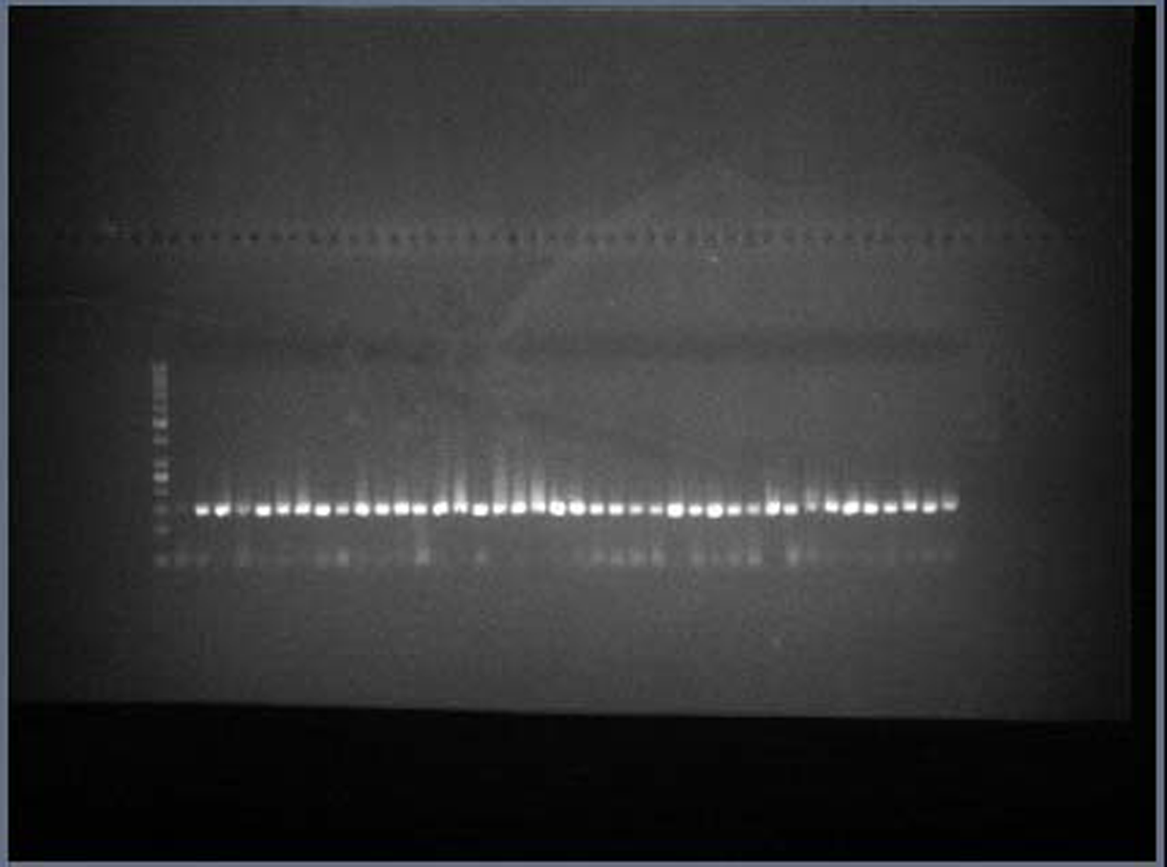
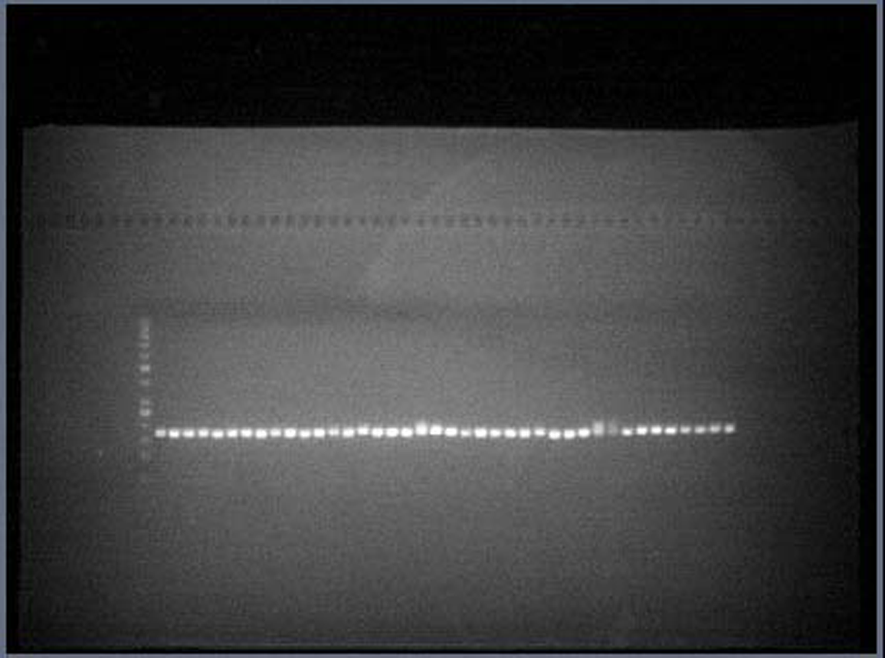
L 1 2 3 4 5 6 7 8 9 10 11 12 13 14 15 16 17 18 19 20 21 22 23 24 25 26 27 28 29 30 31 32 33 34 35 36
OsNAR2.1a
1KB
50bp
L 1 2 3 4 5 6 7 8 9 10 11 12 13 14 15 16 17 18 19 20 21 22 23 24 25 26 27 28 29 30 31 32 33 34 35 36
1KB
50bp
OsSAUR45a

1 | RCG-01 | 2 | RCG-02 | 3 | RCG-03 | 4 | RCG-04 | 5 | RCG-05 | 6 | RCG-06
7 | RCG-07 | 8 | RCG-08 | 9 | Dhan54 | 10 | RCG-09 | 11 | RCG-10 | 12 | RCG-11
13 | RCG-12 | 14 | RCG-13 | 15 | Dhan202 | 16 | RCG-14 | 17 | RCG-15 | 18 | RCG-16
19 | RCG-17 | 20 | RCG-18 | 21 | RCG-19 | 22 | Varalu | 23 | MTU1010 | 24 | RCG-20
25 | RCG-21 | 26 | R. Nilam | 27 | Sahbhagi | 28 | RCG-22 | 29 | Vandana | 30 | RCG-23
31 | RCG-24 | 32 | Anjali | 33 | RCG-25 | 34 | IR-64 | 35 | RCG-26 | 36 | RCG-27
Fig. 1. Candidate gene-derived SSR markers microsatellite primers dependent amplification patterns of targeted genomic regions of 36 aerobic rice genotypes.

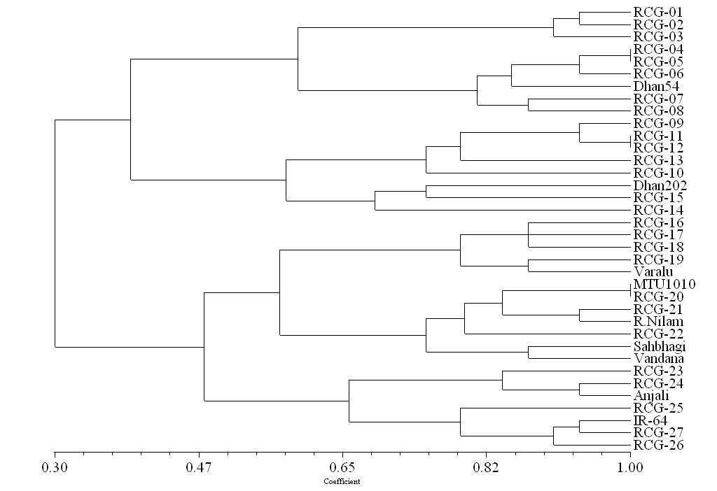
Fig. 2. Similarity indices based dendrogram using un-weighted paired group method based on mathematical averages.

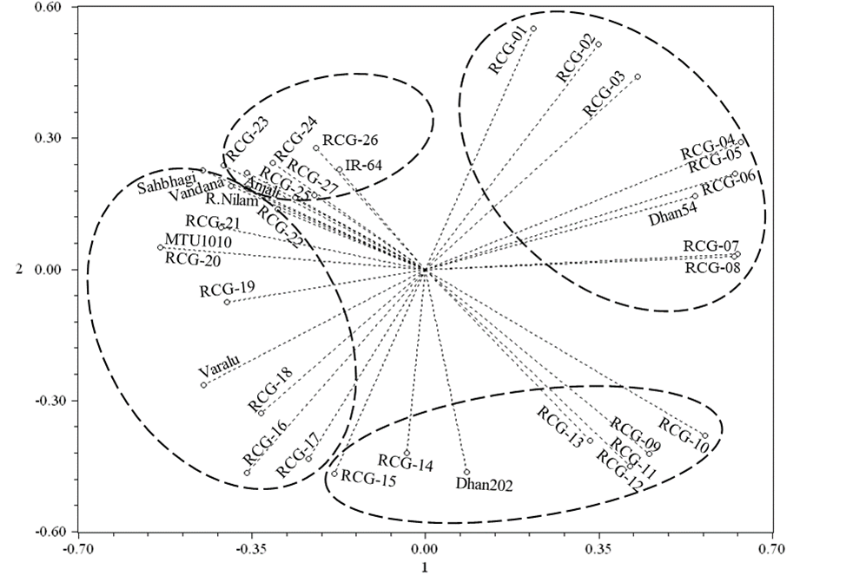
Fig.3 Spatial distribution pattern of rice genotypes based on candidate genes specific microsatellite primers dependent genetic profiles.
Conclusion:
A comprehensive evaluation of a set of rice genotypes under aerobic and normal conditions revealed significant genotypic variation in grain yield per plant, as revealed by analysis of variance. Classification of the adaptive response based on relative mean performance and percentage change enabled the identification of 17 genotypes, notably RCG-10, RCG-19, RCG-20, R.Nilam, Dhan54, RCG-09, Dhan202, RCG-14, RCG-21, RCG-22 with superior aerobic adaptation. The study further validated the efficiency of BatchPrimer3 in designing gene-specific microsatellite markers with successful amplification achieved using 16 genic primers across 36 genotypes. Notably, primers OsSAUR45a, OsNAR2.1a and OsNBS-LRRa exhibited high polymorphism and informativeness with considerably greater ability to detect genetic variation. Genotypic clustering into four groups was found closely aligned with principal coordinate analysis, confirming substantial genetic diversity. Integration of phenotypic and genotypic data offers a robust framework for the molecular breeding of rice cultivars optimized for aerobic environments.

Disclaimer (Artificial intelligence)
Option 1:
Author(s) hereby declare that NO generative AI technologies such as Large Language Models (ChatGPT, COPILOT, etc.) and text-to-image generators have been used during the writing or editing of this manuscript.

References
- Fukagawa, N. K. & Ziska, L. H. (2019). Rice: Importance for global nutrition. Journal of Nutritional Science and Vitaminology, 65(Supplement), S2–S3.
- Kalita, J., Ahmed, P. & Baruah, N. (2020). Puddling and its effect on soil physical properties and growth of rice and post rice crops: A review. Journal of Pharmacognosy and Phytochemistry, 9(5), 503–510.
- Li, S., Zhuang, Y., Liu, H., Wang, Z., Zhang, F., Lv, M. & Zhang, L. (2023). Enhancing rice production sustainability and resilience via reactivating small water bodies for irrigation and drainage. Nature Communications, 14, 3794. https://doi.org/10.1038/s41467-023-39395-z
- Bao, T., Wang, L., Huang, Y., Li, H., Qiu, L., Liu, J. & Jiang, Y. (2024). Elevated [CO₂] reduces CH₄ emissions from rice paddies under in situ straw incorporation. Agriculture, Ecosystems & Environment, 370, 109055.
- Rajendra Prasad, R. P. (2011). Chapter four-Aerobic rice systems. In Advances in Agronomy (Vol. 111, pp. 207–247). Academic Press.
- Bouman, B. A. M. & Tuong, T. P. (2001). Field water management to save water and increase its productivity in irrigated lowland rice. Agricultural Water Management, 49(1), 11–30.
- Xu, P., Yang, J., Ma, Z., Yu, D., Zhou, J., Tao, D. & Li, Z. (2020). Identification and validation of aerobic adaptation QTLs in upland rice. Life, 10(5), 65.
- Zahra, N., Hafeez, M. B., Nawaz, A. & Farooq, M. (2022). Rice production systems and grain quality. Journal of Cereal Science, 105, 103463.
- Hour, A. L., Hsieh, W. H., Chang, S. H., Wu, Y. P., Chin, H. S. & Lin, Y. R. (2020). Genetic diversity of landraces and improved varieties of rice (Oryza sativa L.) in Taiwan. Rice, 13, 1–12.
- Gaballah, M. M., Ghoneim, A. M., Rehman, H. U., Shehab, M. M., Ghazy, M. I., El-Iraqi, A. S. & Chen, Y. (2022). Evaluation of morpho-physiological traits in rice genotypes for adaptation under irrigated and water-limited environments. Agronomy, 12(8), 1868.
- Zayed, B. A., Ghazy, H. A., Negm, M. E., Bassiouni, S. M., Hadifa, A. A., El-Sharnobi, D. E. & Yaseen, Z. M. (2023). Response of varied rice genotypes on cell membrane stability, defense system, physio-morphological traits and yield under transplanting and aerobic cultivation. Scientific Reports, 13(1), 5765.
- Amom, T. & Nongdam, P. (2017). The use of molecular marker methods in plants: A review. International Journal of Current Research and Review, 9(1), 1–7.
- Kalia, R. K., Rai, M. K., Kalia, S., Singh, R. & Dhawan, A. K. (2011). Microsatellite markers: An overview of the recent progress in plants. Euphytica, 177(3), 309–334.
- Kumari, K., Kumar, P., Sharma, V. K. & Singh, S. K. (2019). Genomic marker assisted identification of genetic loci and genes associated with variation of grain zinc concentration in rice. Journal of Genetics, 98(5), 111.
- Verma, H., Theunuo, S., Das, S. P., Sarma, R. N., Kumar, A., Choudhury, B. U. & Mishra, V. K. (2023). Genetic diversity and marker trait association analysis for grain quality, yield and yield attributes in hilly rice of North-Eastern Himalayan region.
- Alvarado, G., Rodriguez, F. M., Pacheco, A., Burgueño, J., Crossa, J., Vargas, M., Pérez-Rodríguez, P. & Lopez-Cruz, M. A. (2020). META-R: A software to analyze data from multi-environment plant breeding trials. The Crop Journal, 8, 745–756.
- Yue, B., Xue, W., Xiong, L., Yu, X., Luo, L., Cui, K., Jin, D., Xing, Y. & Zhang, Q. (2006). Genetic basis of drought resistance at reproductive stage in rice: Separation of drought tolerance from drought avoidance. Genetics, 172(2), 1213–1228.
- Khahani, B., Tavakol, E., Shariati, V. & Rossini, L. (2021). Meta-QTL and ortho-MQTL analyses identified genomic regions controlling rice yield, yield-related traits and root architecture under water deficit conditions. Scientific reports, 11(1), 6942.
- Sandhu, N., Subedi, S. R., Singh, V. K., Sinha, P., Kumar, S., Singh, S. P., ... & Kumar, A. (2019). Deciphering the genetic basis of root morphology, nutrient uptake, yield, and yield-related traits in rice under dry direct-seeded cultivation systems. Scientific reports, 9(1), 9334.
- Phule, A. S., Barbadikar, K. M., Maganti, S. M., Seguttuvel, P., Subrahmanyam, D., Babu, M. P., & Kumar, P. A. (2019). RNA-seq reveals the involvement of key genes for aerobic adaptation in rice. Scientific reports, 9(1), 5235.
- Murray, M. G. & Thompson, W. F. (1980). Rapid isolation of high molecular weight plant DNA. Nucleic Acids Research, 8(19), 4321–4325.
- Ferdous, J., Hanafi, M. M., Rafii, M. Y. & Kharidah, M. (2012). A quick DNA extraction protocol: Without liquid nitrogen in ambient temperature. African Journal of Biotechnology, 11(27), 6956-6964.
- Anderson JA, Chhurchill GA, Autrique JE, Tanksley SD and Sorrells ME. 1993. Optimizing parental selection for genetic linkage maps. Genome 36:181-186.
- Dice, L. R. (1945). Measure of the amount of ecologic association between species. Ecology, 26(3), 297–302.
- Rohlf, F. (1997). NTSYS-pc: Numerical taxonomy and multivariate analysis system (Version 2.02). Exeter Software.
- Sharifi, P., Aminpanah, H., Erfani, R., Mohaddesi, A., & Abbasian, A. (2017). Evaluation of genotype× environment interaction in rice based on AMMI model in Iran. Rice science, 24(3), 173-180.
- Wang, A., Jiang, Y., Shu, X., Zha, Z., Yin, D., Liu, Y., ... & Zheng, A. (2021). Genome-wide association study-based identification genes influencing agronomic traits in rice (Oryza sativa L.). Genomics, 113(3), 1396-1406.
- Mohan, D., Sendhil, R., Gupta, O. P., Pandey, V., Krishnappa, G. & Singh, G. P. (2022). Wheat quality index: New holistic approach to identify quality superior genotypes. Cereal Research Communications, 50(4), 1105–1115.
- Rathi, S., Yadav, R. N., Pathak, S. K. & Sarma, R. N. (2014). Genetic diversity in upland rice of Assam assessed through SSR markers. Indian Journal of Genetics, 74(2), 238–242.
- Sridevi, G., Raju, B. R., Mohan Kumar, M. V. & Shesh Shayee, M. S. (2012). Assessment of genetic diversity across differentially adopted rice ecotypes. Electronic Journal of Plant Breeding, 3(4), 634–638.
- Wankhade, S. D., Cornejo, M. J. & Mateu-Andres, I. (2010). Microsatellite marker-based genetic variability in Spanish rice cultivars and landraces. Spanish Journal of Agricultural Research, 8(4), 995–1004.
- Kumari, R., Kumar, P., Sharma, V. K. & Kumar, H. (2018). Seedling stage salt stress response specific characterization of genetic polymorphism and validation of SSR markers in rice. Physiology and Molecular Biology of Plants.

