Original Research Article
Demonstration of Kharif Pulses in Darrang District of Assam under the IIPR-Pulse Programme

Abstract:
Krishi Vigyan Kendra, Darrang implemented the IIPR Pulse Demonstration Programme during Kharif 2024–25, focusing on blackgram (Vigna mungo, var. SBC 40) and greengram (Vigna radiata, var. SGC 16) under rainfed agro-ecological conditions. The programme covered an area of 30.0 hectares for blackgram and 10.0 hectares for greengram. The demonstrations revealed a considerable disparity between the potential and realized yields, primarily attributed to gaps in technology adoption and extension outreach. Application of improved agronomic practices led to substantial increases in grain yield, with blackgram and greengram recording mean seed yields of 7.7 q/ha and 7.5 q/ha, respectively—representing a 29.87% and 33.33% enhancement over traditional farmer practices (5.9 q/ha and 5.6 q/ha).
The technology gap averaged 2.3 q/ha for blackgram and 2.5 q/ha for greengram, while the extension gap was recorded at 1.8 q/ha and 1.9 q/ha, respectively. Demonstration plots consistently outperformed the control plots, clearly indicating the efficacy of the improved technological package. From an economic standpoint, blackgram generated significantly higher net returns per hectare, with benefit-cost (B:C) ratios of 2.20 and 2.65 for blackgram and greengram, respectively—underscoring the profitability and cost-effectiveness of the interventions. The technology index, ranging from 23% to 25%, highlights the untapped potential for increasing productivity through adoption of location-specific, evidence-based technologies.
These findings underscore the urgent need for intensified extension interventions to scale up adoption among resource-constrained farmers, thereby contributing to enhanced productivity, sustainability, and income generation. The outcomes of this study hold strong future prospects for strengthening climate-resilient pulse production systems and guiding region-specific policy and research initiatives for nutritional and livelihood security.
Keywords: IIPR, Pulses, NEH Region, Frontline Demonstration, Technology Gap, Yield Enhancement, Sustainable Intensification, Darrang, Assam

Introduction:
Pulses, a diverse group of leguminous crops, occupy a central position in India’s agri-nutritional paradigm, particularly for its predominantly vegetarian population. Their exceptional nutritional profile—characterized by a protein content ranging from 20–30% on a dry seed basis—makes them a crucial dietary supplement to cereal-based diets, which are otherwise protein-deficient. The Indian government also actively promotes pulses production by offering minimum support prices (MSP) for cultivators.
Black gram advantages include enhanced digestion, enhanced energy levels, increased bone density, regulated blood sugar levels, and skin health promotion. Black gram helps in relieving joint pain and promoting heart health, aiding in detoxification, and by including it in your diet, it can enhance well-being (Kadyan et. al., 2024). Beyond macronutrients, pulses are rich in vital micronutrients such as iron, zinc, magnesium, and B vitamins, and play an instrumental role in mitigating malnutrition, anemia, and non-communicable diseases. In addition to their nutritional benefits, pulses contribute significantly to sustainable agriculture through biological nitrogen fixation, water-use efficiency, and enhanced soil health, thus reinforcing their relevance in climate-resilient farming systems.
The Indian Institute of Pulses Research (IIPR), a premier institute under the Indian Council of Agricultural Research (ICAR), plays a pivotal role in advancing pulse science. Its mandate spans the development of high-yielding varieties, integrated crop management technologies, breeder seed production, and above all, Frontline Demonstrations (FLDs) and Cluster Frontline Demonstrations (CFLDs) that operationalize technology transfer at the farm level. These on-field demonstrations are recognized as powerful extension tools for bridging the technology adoption gap by enabling farmers to witness the comparative advantages of improved practices under real farming conditions.
While the efficacy of such interventions has been broadly established, region-specific studies remain limited—especially in the context of kharif pulse promotion in North Eastern India. The unique agro-climatic and socio-economic conditions of Assam demand tailored interventions and localized validation of technologies. Despite national progress in pulse production, the adoption and expansion of kharif pulses in districts like Darrang remain constrained due to low awareness, limited varietal access, and agronomic unfamiliarity. Darrang district of Assam, exemplifies both the latent potential and prevailing constraints in kharif pulse cultivation. In the agricultural year 2022–23, the district reported a total pulse area of 4,700 hectares with a production of 3,941 tonnes, translating to a modest average yield of 0.84 t/ha. These figures underscore a substantial yield gap that can be addressed through improved agronomic practices and strategic technology dissemination.
This research aims to critically evaluate the impact of scientific intervensions on the adoption, yield performance, and economic returns of kharif pulses in Darrang district.

Materials and Method:
The study was conducted by Krishi Vigyan Kendra, Darrang, Assam Agricultural University to assess the effect of IIPR Pulse demonstration programme on kharif pulses (Black gram & Green gram) crop in mostly Char areas of Darrang district during kharif season 2024-25.
The demonstrations were being conducted in farmers’ field at five different villages (Barthekerabari, 2 no. Bargarakhuti, Cherengchapori, lengerimari, Gadhowa Chapori) of Darrang district during 2024-25. District Darrang comes under North Bank Plain Agro climatic zone of Assam. The soil of the district ranges from old alluvial to new alluvial type. The soil is sandy to sandy loam in texture and acidic in reaction and is characterized by medium to high organic carbon, low to medium phosphorus and potash content. The mean of available soil nitrogen, phosphorus and potassium were 231, 15.9 and 290 kg ha⁻¹, respectively.
A total area of 30.0 ha under black gram and 10.0 ha under green gram crop was considered under the study. Before conducting IIPR pulse demonstrations, a list of farmers was prepared (75 farmers for black gram cultivation and 25 farmers for green gram cultivation) from group meeting and specific skill training and awareness programmes were arranged by KVK officials at different locations to make the farmers aware about the scientific cultivation practices of the crop.
High yielding black gram variety SBC 40 and green gram variety SGC-16 was used for the study. SBC 40 is short duration black gram variety (70 – 75days) which has high yield potential (11.89 q/ha) and protein content (25.20 %) with resistance to Cercospora Leaf Spot (CLS)& Yellow Mosaic Virus (YMV), moderate resistance to Web Blight etc. Similarly, Green gram variety SGC-16 is also a short duration green gram variety (65-70 days), with high yield potential (12-13 q/ha) suitable for both kharif and summer season and resistant to CLS and YMV. The local varieties used by the farmers in the nearby field was kept as farmer’s practices.
The seed rate of demonstration plot for both black gram and green gram was 22.5 kg/ ha. Since the demonstrations were carried out in farmers’ field they practiced the broadcasting method of sowing for both the crop between mid- August to mid- September. For the demonstration plot, the seeds were inoculated with Biofertilizer- Rhizobium as seed treatment @ 50g/ kg seeds. Fertilizers in the form of Urea @ 22 kg/ha, SSP @ 220/ha and MOP @ 25 kg/ha was applied for demonstration plots of both the crop.
The inputs (seeds) were supplied to the selected farmers and stage wise monitoring of the demonstration plots by KVK Scientists ensured proper guidance to the farmers. The sowing of the crop was done during kharif season (mid-August to -mid-September) under rain fed condition in both the years. Crop yield as well other morphological data were recorded from the demonstration and check plots at the time of harvest.
The economic-parameters (gross return, net return and B:C ratio) were worked out on the basis of prevailing market prices of inputs and minimum support prices of outputs. The yield increase in demonstrations over farmers’ practice was calculated by using the following formula as suggested by Yadav et. al., (2004).
Percent increase in yield over farmers’ practice = Demonstration yield – farmers’ plot yield / Farmers’ plot yield x 100.
Estimation of extension gap, technological gap and technological index along with the benefit cost ratio by following (Samui et al., 2000) as given below:
Technology gap = Potential yield-Demonstration yield
Extension gap = Demonstration yield-Farmer’s yield
Technology index = (Technology gap/potential yield) x 100
The economics of the demonstration and farmers’ practice were recorded. Based on the economics net return was calculated as Gross Return (Rs.) minus (-) the Gross Cost (Rs.)
Results and discussions:
A. Yield:
From the above study, it was observed that the high yielding black gram variety SBC 40 as well as green gram variety SGC 16 out yield the farmers practice in the same farming situation. The seed yield of black gram for the season 2024-25 under demonstration was recorded to be as 7.7 q ha⁻¹ against the farmers practice 5.9 q ha⁻¹ and 7.50 q/ha for green gram against farmers practice 5.6 q/ha. The percent increase in yield of demonstration plots over farmers’ plots ranged from 29.87 percent in Black gram and 33.33 percent in green gram during 2024-25.
Same results for the crop black gram under IIPR Pulse demonstration was recorded earlier by Mary et.al (2024). The poor productivity in farmers practice might be mainly due to factors like use of nondescript local variety and low level of agronomic management in addition to non-availability of resources in time. The result clearly depicts the positive effects of demonstrations over the existing practices towards enhancing the yield of black gram and green gram in Darrang district.
Table 1: Influence of IIPR Pulse demonstration yield, technology gap, extension gap, technology index in black gram variety SBC40 and green gram variety SGC 16
Crop | Year | Potential yield  (q/ha) | IIPR demo (q/ha) | FP (q/ha) | Percent increase in yield over farmers’ practise | Tech gap (qha⁻¹ ) | Extension gap (qha-1) | Technology index (%)
Black gram | 2024-25 | 10.0 | 7.7 | 5.9 | 29.87 | 2.3 | 1.8 | 23
Green gram | 2024-25 | 10.0 | 7.5 | 5.6 | 33.33 | 2.5 | 1.9 | 25
N.B.: No. of farmers- 75 nos. for black gram and 25 nos. for green gram
B. Analysis of Technology Gap:
In the present study, technology gap is recorded to be 2.3 qha⁻¹ and 2.5 qha⁻¹ in black gram and green gram respectively. The observed technological gap may be attributed to the dissimilarity in the soil fertility status, insect pest attack and erratic weather conditions that prevailed during crop season at different locations. (Table 1)
C. Analysis of Extension Gap:
Extension gap is gap between yield of demonstrated plot and farmers’ practice. Extension gap is recorded to be 1.8 qha⁻¹& 1.9 q ha⁻¹ in black gram & green gram respectively which is solely due to non-adoption of high yielding varieties and delayed sowing (1st week of October). Maximum use of the latest production technologies with high yielding recommended varieties of pulse crops will subsequently help in reducing this alarming trend of galloping extension gap. (Table 1)
D. Analysis of Technology Index:
Technology index indicates the feasibility of the evolved technology in the farmers’ field. The lower value of technology index, higher is the feasibility of the improved technology. It was observed that the mean technology index of 23 percent & 25 percent was recorded in IIPR Pulse demonstration programmes under the clusters, which showed the efficacy of good performance of technical interventions. The existence of strong gap in technology generated by the research institutes and technology dissemination to the farmers can only be overcome by IIPR Pulse demonstration programme which can accelerate the level of adoption of improved technologies and help in attaining self-sufficiency in pulse production and getting more income of farmers. (Table 1)
E. Economic analysis of Kharif Pulse Production:
The present study showed that due to adoption of improved package of practices, demonstration plots of both the crop recorded higher average seed yield over local check. (Table 2; Chart 1 and 2) It was further observed that in terms of economics, black gram crop recorded higher net returns/ha compared to farmer’s practice i.e. Rs. 23,138.00. Similar case was seen in the economics of green gram. The benefit cost ratio of black gram and green gram was recorded as 2.2 and 2.65, respectively.
Table 2: Economic analysis of the data of crop Black gram and Green gram
Crop | Demonstrated Plot (variety name) | Yield(q/ha) | Gross Cost (Rs/ha) | Gross Return  (Rs./ha.) | Net Return (Rs./ha.) | B:C Ratio
Black gram (Technology) | SBC-40 | 7.66 | 18750.00 | 41,888.00 | 23,138.00 | 2.2
Black gram  (Farmers’ Practise) | Local | 5.90 | 18750.00 | 32,263.56 | 13513.56 | 1.72
Crop | Demonstrated Plot (variety name) | Yield(q/ha) | Gross Cost (Rs/ha) | Gross Return  (Rs./ha.) | Net Return (Rs./ha.) | B:C Ratio
Green gram (Technology) | SGC-16 | 7.5 | 19800.00 | 52,500.00 | 32,700.00 | 2.65
Green gram (Farmers’ Practise) | Local | 5.60 | 19800.00 | 39200.00 | 19400.00 | 1.97

The economic analysis of the data for the year 2024-25 showed better performance of the demonstration over the check plot. The gross return, net return and B.C ratio of the crop black gram for the year is recorded to be Rs. 41,888.00, Rs. 23,138.00, 2.2 & for green gram Rs. 52,500.00, Rs. 32,700.00 & 2.65 respectively. Similar results were seen in the study carried out by Thakur et.al., in 2017. While in farmers plot the results obtained are Gross return (Rs. 32,263.56), Net return (Rs. 13513.56), B: C ratio 1.72 for the crop black gram and Gross return (Rs. 39200.00), Net return (Rs. 19400.00), B: C ratio 1.97 for the crop green gram. Similar results were seen in the study carried out by Nissa et. al., in 2020.
Chart 1: Economic analysis of the data of crop Black gram

Chart 2: Economic analysis of the data of crop Green gram

F. Other morpho physiological traits
Seed yield is governed by number of factors, which have direct or indirect impacts. nn it. The improvement in seed yield is achieved through improvement in yield attributing characters viz., number of pods per plant, number of seeds per pod, plant height etc. In case of demonstration plot of Black gram, the average no. of pods were 27 and the average no. of seeds per pod was 7. In case of green gram, Black gram, the average no. of pods was 25 and the average no. of seeds per pod was 7. Similar results were seen in the study carried out by Thakur et al., in 2017.
Table 3: Morpho physiological characters of the Kharif Pulses
Crop | Plant Heights  (cm) | No. of pods per plants | No. of seeds per pod
Black gram | 50.5 | 27 | 7
Green gram | 47.5 | 25 | 7

G. Extension Activities Carried out under the IIPR Kharif Pulses Programme
The objective of the demonstration under IIPR Pulses Programme is to promote scientific technologies through training, awareness programmes, method demonstrations etc. Photographs 1 shows few of these activities taken up by KVK Darrang under this programme.
Photographs 1: Extension activities conducted by KVK, Darrang under IIPR-Pulse Demonstration programme
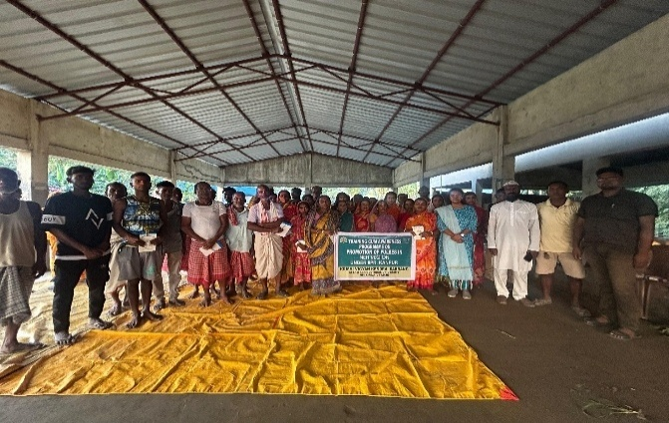 | 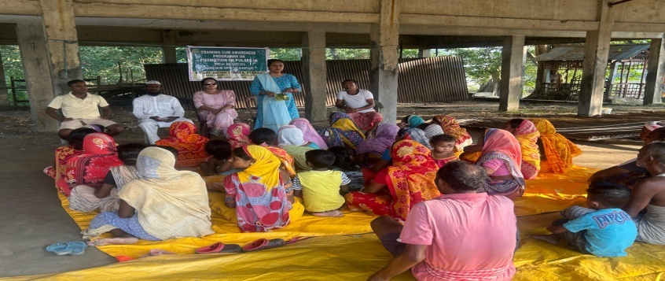
Training cum Awareness Programme under Promotion of Pulses under IIPR in Chereng Sapori village of Darrang District of Assam
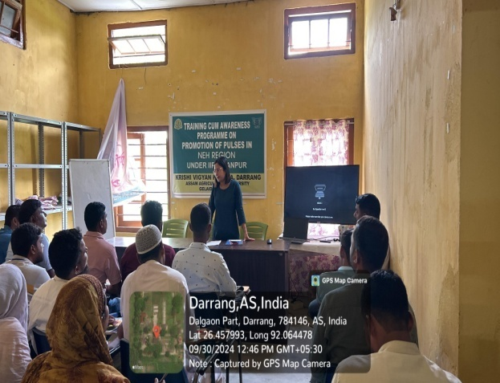 | 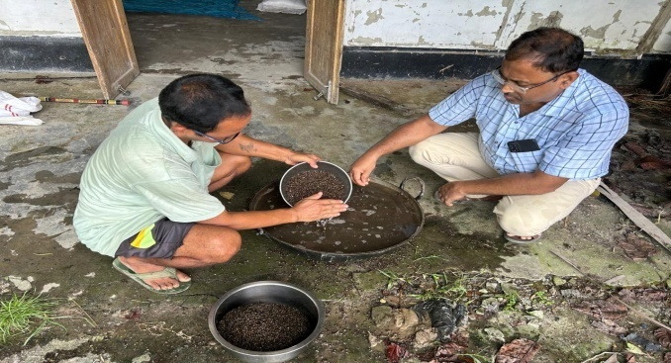
Training cum Awareness Programme under Promotion of Pulses under IIPR at KVK, Darrang | Method Demonsreation on Application of Biofertilizers as Seed Treatment in Black gram
Photographs 2 : Action Photographs of the Demonstration on Kharif Pulses conducted by KVK, Darrang under IIPR-Pulse Demonstration programme.
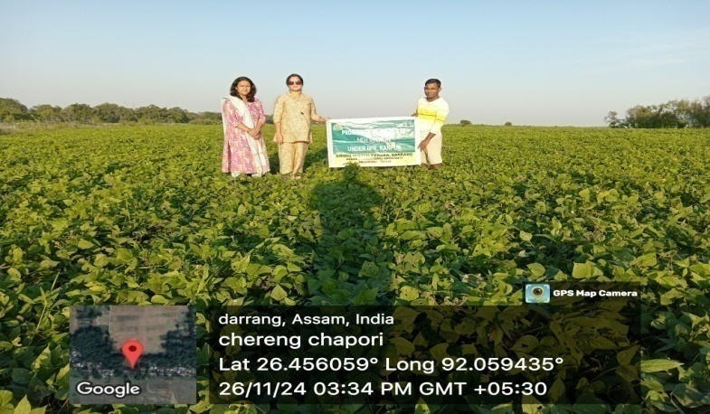 | 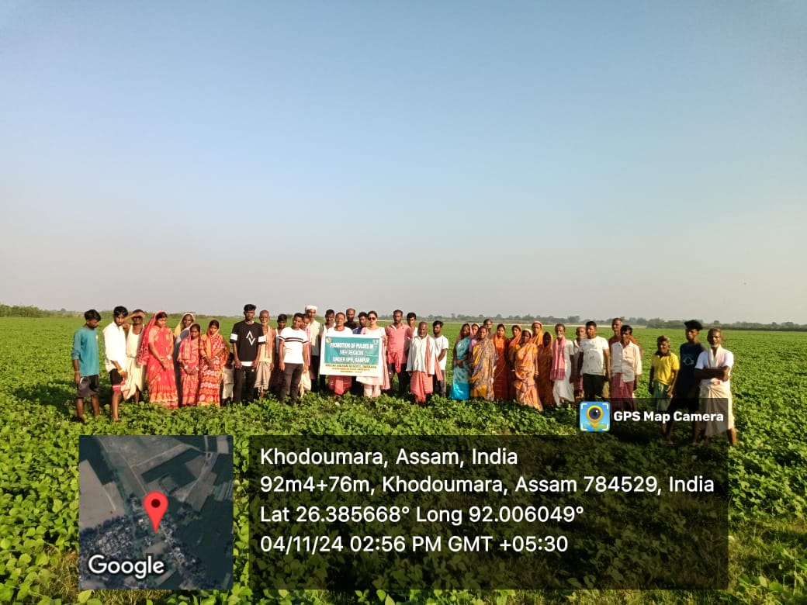
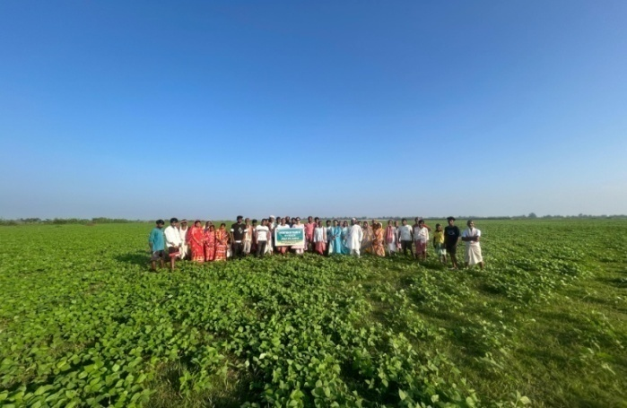 | 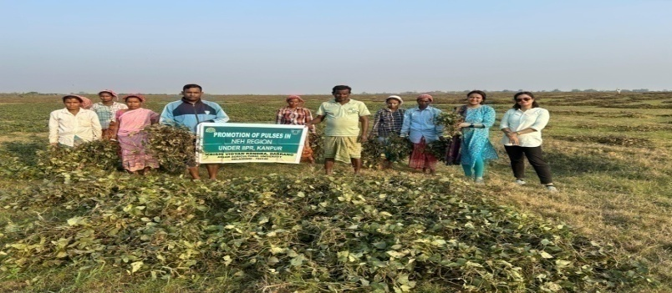
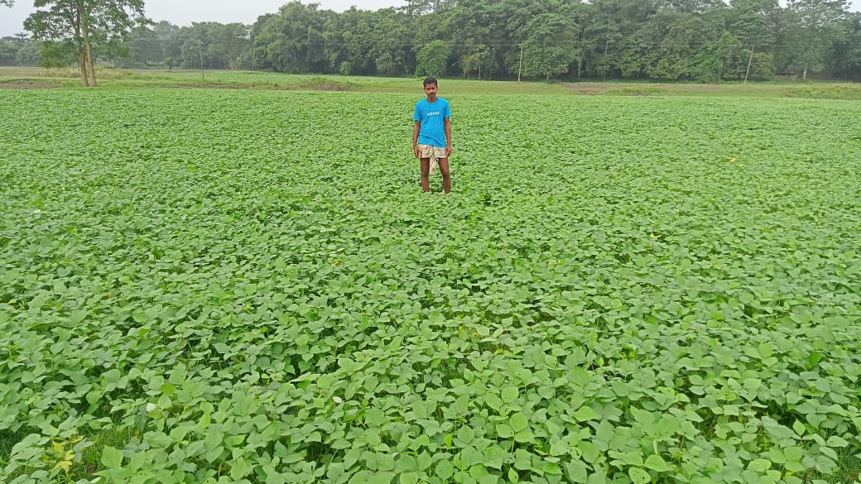 | 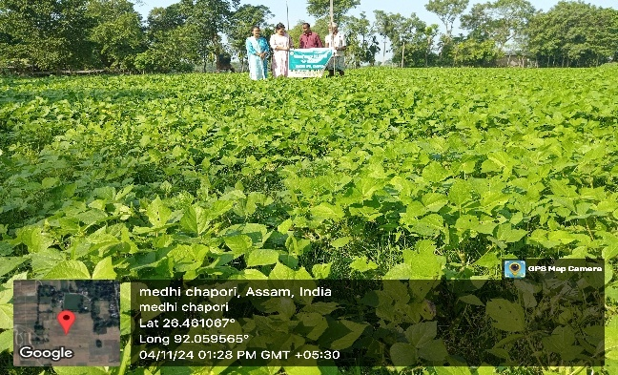
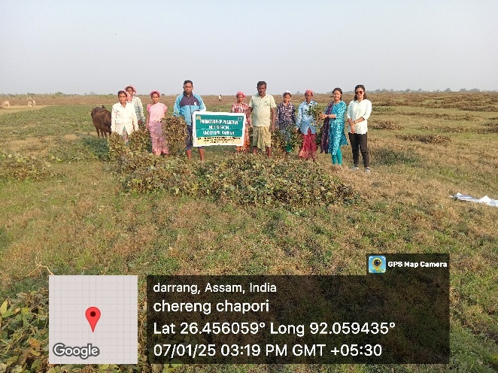 | 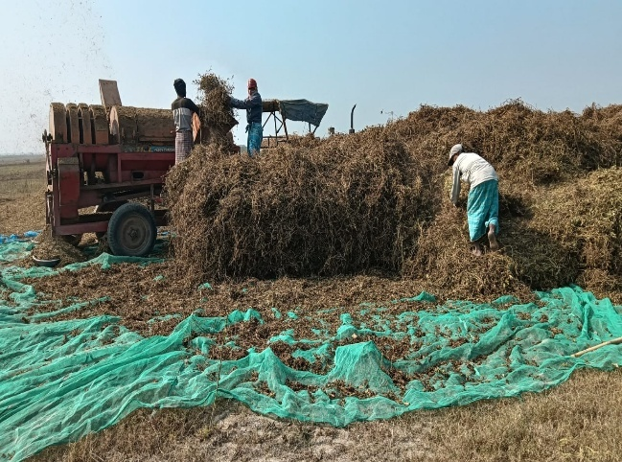
Conclusion
The findings of the study unequivocally demonstrate that the adoption of improved agro-techniques and high-yielding varieties significantly enhanced the yield and economic returns of black gram and green gram crops in the Darrang district. The grain yield obtained under the IIPR Pulse Demonstrations consistently outperformed traditional farmer practices, underscoring the efficacy of scientific interventions in pulse production. Nevertheless, the full genetic potential of the demonstrated varieties remains underutilized and could be further realized through the systematic adoption of recommended agronomic practices.
The study highlights the critical need for robust extension mechanisms to facilitate the dissemination of improved technologies at the grassroots level. Structured training programs, on-field demonstrations, and location-specific advisory services are essential to bridge the gap between research innovations and on-farm adoption. Empowering farmers with knowledge and access to proven agro-technologies is key to maximizing productivity and enhancing livelihood resilience in the region.
Disclaimer (Artificial intelligence)
Option 1:
Author(s) hereby declare that NO generative AI technologies such as Large Language Models (ChatGPT, COPILOT, etc.) and text-to-image generators have been used during the writing or editing of this manuscript.
Option 2:
Author(s) hereby declare that generative AI technologies such as Large Language Models, etc. have been used during the writing or editing of manuscripts. This explanation will include the name, version, model, and source of the generative AI technology and as well as all input prompts provided to the generative AI technology
Details of the AI usage are given below:
1.
2.
3.

References:
1. Anuratha A, Ravi R, Selvi J. Productivity enhancement in black gram by cluster front line demonstrations. J Krishi Vigyan. 2018;7(1):242-4.
2. Kadyan, M., Kumari, M., Pandey, A. and Kumar, K. 2024. The Strategies Used in the Cultivation Practices of Black Gram (Vigna mungo L.) in Summer Season. Vigyan Varta 5(12): 46-50.
3. Kumar, P. and Radder, B.M. Effect of Zinc Sulphate on Yield and Yield Attributes of Green Gram (Vigna Radiata). Int.J.Curr.Microbiol.App.Sci. 2020; 9(02): 2209-2213.
4. Kumar S, Singh R, Singh A. Assessment of gaps in pulse production in Hamirpur district of Himachal Pradesh. Indian Res J Ext Edu. 2014;14(2):20-4.
5. Rajashekar, B., Rajashekhar, M., Reddy, T. P., Reddy, M. J. M., Shankar, A., Shaila, O., Ramakrishna, K., & Jyoshna, E. (2024). Impact of Cluster Frontline Demonstrations on Promotion of Pulse Crops in Farmers Fields of Telangana, India. Journal of Experimental Agriculture International, 46(9), 624–632. https://doi.org/10.9734/jeai/2024/v46i92861
6. Sarma SM, Ojah I, Khaund A, Das KB, Hafiz A. Yield enhancement of toria through cluster frontline demonstration in Darrang district of Assam. The Pharma Innovation Journal. 2024;13(4):41-4.
7. Samui SK, Maitra S, Roy DK, Mandal AK, Saha D. Evaluation on front line demonstration on groundnut. J Indian Soc Coastal Agr Res. 2000;18(2):180-3.
8. Seerat un Nissa, Sabiya Bashir, S.A. Dar, Jahangeer A. Baba, S.A. Hakeem, R.A. Wani, M. Najeeb Mughal and Yusra A. Basu. Effect of Rhizobium and PSB in Combination with Phosphorus on the Enrichment of Soil Fertility and its Effect on Yield of Green Gram (Vigna radiata L.). Int.J.Curr.Microbiol.App.Sci. 2017; 6(11): 3648-3652.
9. Thakur, V, Patil RP, Patil JR, Suma TC and Umesh MR. Influence of foliar nutrition on growth and yield of blackgram under rainfed condition Journal of Pharmacognosy and Phytochemistry 2017; 6(6): 33-37.
10. Yadav DB, Kamboj BK, Garg RB. Increasing the productivity and profitability of sunflower through crop demonstrations in irrigated agro ecosystem of eastern Haryana. Haryana J Agron. 2004;20(1&2):33-5.

