Nutrient-Doped Carbon Nanodots: Enhancing Seed Quality and Germination in Chilli

Abstract
Nutrient deficiency in chilli plants significantly impacts growth, yield, and seed quality. To address this, a laboratory experiment was conducted during the Rabi season of 2022-23 at PJTSAU, Hyderabad using nutrient-doped carbon nanodots (CNDs). Seventeen treatments, including various concentrations of Zn, Fe, Cu, Mn, Ca, and B, were evaluated. Results revealed that iron-doped (T4) and manganese-doped (T8) carbon nanodot treatments significantly improved germination (up to 6% higher) and reduced abnormalities (by up to 5%), while higher doses of calcium (T11) and boron (T14) showed lower efficacy. These findings suggest the potential of nutrient-doped CNDs as innovative seed treatment agents to enhance seed quality and germination in chilli.
KEYWORDS: Chilli, Seed Quality, carbon nanodots, manganese-doped

- Introduction:
Chilli (Capsicum spp.) is a globally significant spice and vegetable crop, valued for its unique pungency, rich flavor, and vibrant color. Originating in the Americas, it is now a key ingredient in diverse cuisines and traditional medicine. India, one of the largest producers and exporters of chillies, plays a crucial role in the global market. Andhra Pradesh is a leading state in chilli production, contributing over 627,000 metric tons in the 2023 fiscal year (Statista, 2023). Telangana and Madhya Pradesh are also significant producers, with Telangana achieving the highest yield of 1,833 kilograms per acre in the 2022-2023 period (PJTSAU, 2023).
Chilli cultivation is highly dependent on balanced nutrient availability to ensure optimal plant growth, flowering, and fruit development while maintaining high seed quality and longevity. A well-managed nutrient regime promotes plant vigor, higher yields, and improved seed germination and storage potential. Nutrient deficiencies, particularly of zinc, iron, and boron, can result in stunted growth, delayed flowering, and reduced productivity, ultimately compromising seed viability (Vimera et al., 2012). Seed coating, which involves applying exogenous materials like plant growth regulators, micronutrients, and microbial inoculants, has proven effective in protecting seeds against phytopathogens and promoting germination and plant growth (Rocha et al., 2019).
Among the innovative materials for seed enhancement, carbon nanodots (CNDs) have gained significant attention. These nanoscale carbon-based materials, typically less than 10 nanometers in size, are known for their exceptional photoluminescence, water solubility, biocompatibility, and low toxicity (Li et al., 2012). Additionally, carbon-based hybrid materials have been extensively explored in fields such as energy storage and corrosion protection due to their high conductivity, chemical stability, and large surface area (Manfo & Laaksonen, 2025; Ali et al., 2025; Manfo et al., 2025).
Recent studies suggest that nitrogen-doped carbon nanodots (N-FCNs) show promise in improving seed performance. N-FCNs enhance the uptake and transportation of water and nutrients, facilitating absorption and transport within the plant. These nanomaterials regulate plant metabolism and early development, making them an ideal biocompatible medium for promoting seed growth (Chen et al., 2021). Studies by Iavicoli et al. (2017) and Mirbakhsh (2023) emphasize how nanotechnology can address climate change, food insecurity, and sustainable farming practices by improving agricultural inputs and monitoring systems, while also calling for further research on the long-term impacts and safety of nanomaterials.
Although nanotechnology has been explored for enhancing seed quality and storage potential in various crops, there is a lack of comprehensive studies focused on the use of nutrient-doped carbon nanodots (CNDs) for improving chilli seed quality, particularly during extended storage. Therefore, the objective of this study is to identify the best performing nutrient-doped carbon nanodots for enhancing seed quality in chillies, addressing a significant gap in the current literature.
2. Materials and methods:
The present investigation was planned to study the effect of nutrient-doped carbon nanodots for enhancing seed quality parameters. The experiment was conducted in the Department of seed science and technology, College of agriculture, PJTSAU, Rajendranagar, Hyderabad, Telangana, during the year november,2022 to June 2023. Chilli seed of hybrid -5557 (500 grams) with high seed germination (86%) was collected from Kaveri seed company limited, Pamulaparthy, Medchal, Hyderabad, Telangana. For each treatment, 40 grams of seed were coated and stored under cold storage conditions. Seed quality parameters were evaluated at bimonthly intervals over a period of 18 months.
A bio-friendly red polymer was collected from Sairadhya organics and seed technology Pvt. Ltd., Hyderabad. Nutrients doped carbon nanodots (C-dots) were prepared using zinc, iron, copper, manganese, calcium, and boron formulations obtained from Immunologyx Private Limited, Hyderabad. The synthesis involved dissolving a carbon source (glucose and tartaric acid) with optional nitrogen sources, followed by hydrothermal treatment at 250–300°C, filtration, centrifugation, and dialysis for purification. Minerals were bound to the CQDs through chemical functionalization or ligand exchange to enhance their properties for various applications.
The selected nutrient concentrations were based on the previous trails indicating that levels between 0.25% and 1.50% of the nutrients, optimize seed growth and germination without causing toxicity. The polymer coating was included to improve nutrient absorption and slow nutrient release, enhancing seed quality over time. This combination of nutrients had been chosen to test synergistic effects and identify the most effective treatments for improving seed performance in chilli.

Table 1. The details of the treatments are:
T₁ | Zinc doped Carbon Nanodots (0.50%) @ 2.5 ml/kg seed + Polymer @ 25 ml/kg seed
T₂ | Zinc doped Carbon Nanodots (1.00%) @ 5.0 ml/kg seed + Polymer @ 25 ml/kg seed
T₃ | Zinc doped Carbon Nanodots (1.50%) @ 7.5 ml/kg seed + Polymer @ 25 ml/kg seed
T₄ | Iron doped Carbon Nanodots (0.25%) @ 1.25 ml/kg seed + Polymer @ 25 ml/kg seed
T₅ | Iron doped Carbon Nanodots (0.50%) @ 2.5 ml/kg seed + Polymer @ 25 ml/kg seed
T₆ | Copper doped Carbon Nanodots (0.25%) @ 1.25 ml/kg seed + Polymer @ 25 ml/kg seed
T₇ | Copper doped Carbon Nanodots (0.50%) @ 2.5 ml/kg seed + Polymer @ 25 ml/kg seed
T₈ | Manganese doped Carbon Nanodots (0.25%) @ 1.25 ml/kg seed + Polymer @ 25 ml/kg seed
T₉ | Manganese doped Carbon Nanodots (0.50%) @ 2.5 ml/kg seed + Polymer @ 25 ml/kg seed
T₁₀ | Calcium doped Carbon Nanodots (0.25%) @ 1.25 ml/kg seed + Polymer @ 25 ml/kg seed
T₁₁ | Calcium doped Carbon Nanodots (0.50%) @ 2.5 ml/kg seed + Polymer @ 25 ml/kg seed
T₁₂ | Boron doped Carbon Nanodots (0.25%) @ 1.25 ml/kg seed + Polymer @ 25 ml/kg seed
T₁₃ | Boron doped Carbon Nanodots (0.50%) @ 2.5 ml/kg seed + Polymer @ 25 ml/kg seed
T₁₄ | Boron doped Carbon Nanodots (1.00%) @ 5.0 ml/kg seed + Polymer @ 25 ml/kg seed
T₁₅ | Carbon nanodots (0.25%) @ 1.25 ml/kg seed + Polymer @ 25 ml/kg seed
T₁₆ | Polymer @ 25 ml/kg seed
T₁₇ | Untreated Control

The germination test was conducted according to the ISTA valuated between paper method (ISTA,2023). Four replications of 100 seeds were taken from each treatment and placed on germination paper with uniform spacing and rolled. The rolled towel was placed in germination chamber at 25°C temperature and 95 percent relative humidity. On the day of final count (14th day), number of normal seedlings were evaluated and the formula used for calculating germination percentage is as follows:

Number of normal seedlings
Germination (%) = ------------------------------------- x 100
Total number of seeds sown

On the final count day of seed germination evaluation, all the seedlings that are not considered normal i.e. damaged, deformed, decayed in germination test are considered as abnormal seedlings and the formula used for calculating:

Number of abnormal seedlings
Seed abnormality (%) = ------------------------------------- x 100
Total number of seeds sown

Number of dead seeds evaluated from germination test are used for calculating mortality percentage and the formula:

Number of dead seeds
Seed mortality (%) = ------------------------------------- x 100
Total number of seeds sown

- Results and discussion:
  - Effect on seed germination:
Data was recorded on the impact of seed coatings with nutrient-doped carbon nanodots on the germination and longevity of high-initial germination chilli seeds and presented in Table 1. Throughout the storage period of 18 months, a significant improvement in germination and longevity was observed with these coatings followed by storage under cold conditions. About 1-2% improvement (from 81 to 83%) in the mean chilli seed germination was observed from 0 to 8 months after seed coating and storage. However, a gradual decline was observed from the 10th to 18th month of storage (from 77 to 73%, respectively).
Immediately after coating, significant improvement in chilli seed germination (6%) was observed with treatments T4 (Iron-doped Carbon Nanodots 0.25% @ 1.25 ml/kg seed + Polymer @ 25 ml/kg seed) and T8 (Manganese-doped Carbon Nanodots 0.25% @ 1.25 ml/kg seed + Polymer @ 25 ml/kg seed). These treatments were on par with T7 (Copper-doped Carbon Nanodots 0.50% @ 2.5 ml/kg seed + Polymer @ 25 ml/kg seed), T15 (Carbon Nanodots 0.25% @ 1.25 ml/kg seed + Polymer @ 25 ml/kg seed) and T16 (Polymer @ 25 ml/kg seed).
  - Effect on longevity:
Throughout the storage period of 18-month under cold conditions, chilli seeds coated with T4 (Iron-doped Carbon Nanodots 0.25% @ 1.25 ml/kg seed + Polymer @ 25 ml/kg seed) and T8 (Manganese-doped Carbon Nanodots 0.25% @ 1.25 ml/kg seed + Polymer @ 25 ml/kg seed) showed highest germination followed by T6 and T7 (Copper-doped Carbon Nanodots). In contrast, consistently lowest germination was observed with the treatments, T14 and T13 (Boron-doped Carbon Nanodots) and T11 (Calcium-doped Carbon Nanodots).
After 18 months of cold storage, the highest germination (78%) was observed in chilli seeds treated with T4 (Iron-doped Carbon Nanodots 0.25% @ 1.25 ml/kg seed + Polymer @ 25 ml/kg seed). Significantly comparable germinations (76-77%) are recorded for treatments T6, T7, T8, T15, and T16. In contrast, the lowest germination (64%) was observed with T11 (Calcium-doped Carbon Nanodots 0.50% @ 2.5 ml/kg seed + Polymer @ 25 ml/kg seed).
Compared to the untreated chilli seed (T17), 1 to 8% improvement in seed germination was observed in chilli seeds coated with nutrient-doped carbon nanodots (T4, T6, T7, T8, T9, T15, and T16) over a period of 18-months storage. On the other hand, low reduction in germination (2-3%) was observed with treatments T11(Calcium 0.50%), T5 (Iron @0.50%) and T14 (Boron 1%) (Figure 1.). Compared to chilli seed coated with polymer (T16), 1 to 7% improvement in seed germination was observed in chili seeds coated with nutrient-doped carbon nanodots (T4, T6, T7, T8, T9, and T15) over 18-months of storage. However, high reduction in germination (4-5%) was observed with treatments T11, T5 and T14 (Figure 2). The polymer coating might have helped by protecting the seeds and enabling a slow release of nutrients, resulting in improved germination over the 18-month storage period. Compared to chilli seed coated with carbon nanodots (T15), 1 to 4% improvement in seed germination was observed in chili seeds coated with nutrient-doped carbon nanodots (T4, T6, T8 and T9) over 18-months of storage. However, highest average reduction in germination (6-7%) was observed with treatments T11, T5 and T14 (Figure 3).
These findings are in consistent with those of Alam et al. (2015), who demonstrated that treating wheat seeds with iron nanoparticles at an optimal concentration of 2.0 ppm significantly increased germination % and seedling growth. Vyushina et al. (2021), also reported that the application of manganese, especially with polyvinylpyrrolidone (PVP) as a stabilizer, enhanced germination and seedling development.
  - Effect on seedling abnormality and mortality:
The effect of nutrient-doped carbon nanodots on seedling abnormality (%) was evaluated for high-germination chilli seeds during 18 months of cold storage and the data is presented in Table 2. Statistical analysis (CRD) indicated significant differences among treatments at the 5% level across all storage intervals. Seedling abnormality increased over time, from 4% at the start to 8% after 18 months. T4 (Iron-doped Carbon Nanodots 0.25% + Polymer) showed the lowest seedling abnormality (4%) throughout the storage period, followed by T8 (Manganese-doped Carbon Nanodots 0.25% + Polymer).
In contrast, T3 (Zinc-doped Carbon Nanodots 1.5% + Polymer) recorded the highest abnormality (12%). Compared to untreated (T17), polymer control (T16), and carbon nanodots control (T15), treatments like T4, T8, and T7 consistently reduced seedling abnormality by 1–5% over 18 months. Seed mortality (%) was also analyzed over 18 months, with significant differences among treatments (p < 0.05). Mortality increased from 15% to 19% during the storage period, with stability observed until 8 months and a gradual rise thereafter and the data is presented in Table 3.

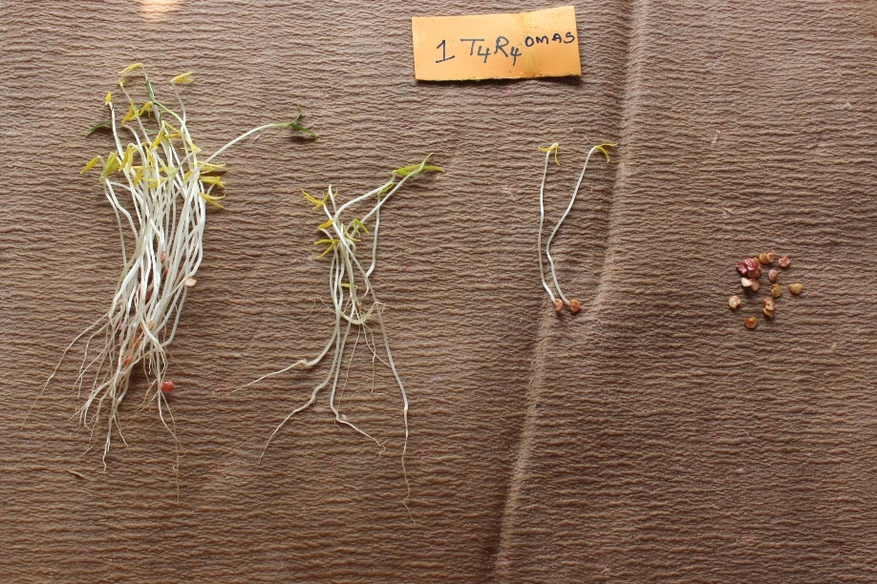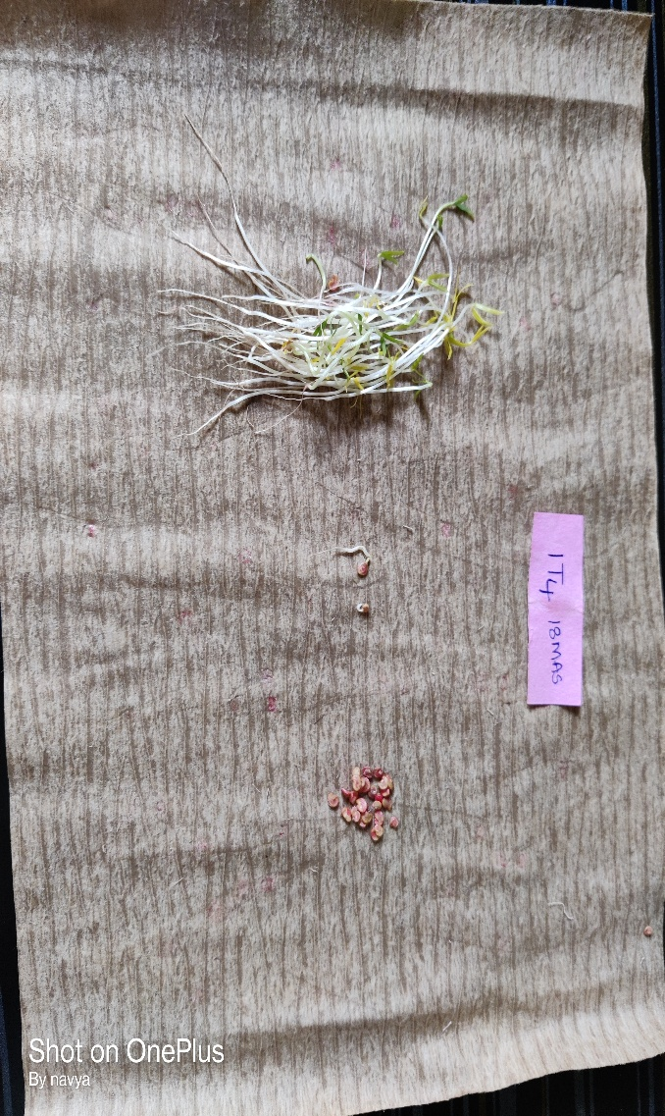
image 1. Paper Towels at 0MAS and 18MAS indicating healthy seedlings, abnormal seedlings, and dead seeds

The images above represent the paper towels at 0MAS and 18MAS, demonstrating healthy seedlings, abnormal seedlings, and dead seeds.

Table 2. Effect of nutrients doped carbon nanodots on germination % of chilli seed.

Treatments | Details | 0MAS | 2MAS | 4MAS | 6MAS | 8MAS | 10MAS | 14MAS | 18MAS
T1 | Zinc CND (0.50%) | 78 | 85 | 83 | 83 | 85 | 78 | 76 | 73
T2 | Zinc CND (1.00%) | 77 | 82 | 80 | 83 | 85 | 76 | 75 | 70
T3 | Zinc CND (1.50%) | 76 | 81 | 76 | 76 | 80 | 75 | 73 | 71
T4 | Iron CND (0.25%) | 86 | 86 | 83 | 88 | 84 | 82 | 79 | 78
T5 | Iron CND (0.50%) | 81 | 86 | 82 | 80 | 83 | 70 | 68 | 66
T6 | Copper CND (0.25%) | 83 | 83 | 85 | 85 | 84 | 85 | 78 | 77
T7 | Copper CND (0.50%) | 84 | 86 | 86 | 84 | 82 | 80 | 78 | 76
T8 | Manganese CND (0.25%) | 86 | 86 | 86 | 86 | 84 | 83 | 78 | 76
T9 | Manganese CND (0.50%) | 80 | 80 | 86 | 86 | 86 | 82 | 78 | 75
T10 | Calcium CND (0.25%) | 83 | 83 | 82 | 84 | 85 | 75 | 74 | 72
T11 | Calcium CND (0.50%) | 75 | 81 | 81 | 82 | 80 | 68 | 66 | 64
T12 | Boron CND (0.25%) | 75 | 80 | 83 | 85 | 80 | 75 | 73 | 72
T13 | Boron CND (0.50%) | 83 | 80 | 80 | 79 | 80 | 78 | 76 | 71
T14 | Boron CND (1.00%) | 81 | 79 | 78 | 78 | 80 | 75 | 73 | 69
T15 | CND (0.25%) | 85 | 85 | 85 | 84 | 83 | 83 | 78 | 77
T16 | Polymer@25ml/kg seed | 84 | 84 | 83 | 83 | 83 | 78 | 76 | 76
T17 | Untreated Control | 80 | 79 | 83 | 82 | 82 | 77 | 75 | 74
 | Mean | 81 | 83 | 82 | 83 | 83 | 77 | 76 | 73
 | CD at 5% | 2.341 | 2.275 | 2.565 | 2.592 | 3.619 | 2.650 | 2.720 | 2.872
 | P Value | 0.000 | 0.000 | 0.000 | 0.000 | 0.004 | 0.000 | 0.000 | 0.000
 | CV | 2.040 | 1.943 | 2.196 | 2.208 | 3.090 | 2.409 | 2.560 | 2.782
 | SE(D) | 1.166 | 1.133 | 1.278 | 1.291 | 1.803 | 1.320 | 1.355 | 1.431
 | SE(M) | 0.825 | 0.801 | 0.903 | 0.913 | 1.275 | 0.933 | 0.958 | 1.012

Note: MAS (Months after storage), CND (Carbon nanodots)

Table 3. Effect of nutrients doped carbon nanodots on seedling abnormality % of chilli seed.

Treatments | Details | 0MAS | 2MAS | 4MAS | 6MAS | 8MAS | 10MAS | 14MAS | 18MAS
T1 | Zinc CND (0.50%) | 6 | 8 | 8 | 7 | 7 | 8 | 8 | 7
T2 | Zinc CND (1.00%) | 7 | 6 | 7 | 6 | 6 | 7 | 8 | 11
T3 | Zinc CND (1.50%) | 7 | 6 | 5 | 6 | 5 | 8 | 9 | 12
T4 | Iron CND (0.25%) | 1 | 4 | 5 | 2 | 4 | 4 | 5 | 5
T5 | Iron CND (0.50%) | 4 | 3 | 4 | 5 | 4 | 9 | 8 | 7
T6 | Copper CND (0.25%) | 7 | 6 | 6 | 5 | 4 | 7 | 7 | 8
T7 | Copper CND (0.50%) | 6 | 4 | 3 | 3 | 4 | 5 | 3 | 5
T8 | Manganese CND (0.25%) | 2 | 6 | 6 | 4 | 2 | 5 | 4 | 4
T9 | Manganese CND (0.50%) | 7 | 7 | 6 | 6 | 8 | 9 | 8 | 8
T10 | Calcium CND (0.25%) | 5 | 6 | 8 | 4 | 3 | 5 | 6 | 7
T11 | Calcium CND (0.50%) | 3 | 2 | 3 | 6 | 6 | 8 | 8 | 8
T12 | Boron CND (0.25%) | 4 | 5 | 5 | 5 | 5 | 9 | 5 | 11
T13 | Boron CND (0.50%) | 6 | 5 | 6 | 7 | 5 | 6 | 4 | 10
T14 | Boron CND (1.00%) | 4 | 4 | 5 | 6 | 6 | 9 | 5 | 11
T15 | CND (0.25%) | 2 | 4 | 6 | 5 | 6 | 5 | 3 | 6
T16 | Polymer@25ml/kg seed | 2 | 4 | 4 | 4 | 5 | 6 | 5 | 9
T17 | Untreated Control | 3 | 4 | 6 | 8 | 8 | 9 | 9 | 11
 | Mean | 4 | 5 | 5 | 5 | 5 | 7 | 6 | 8
 | CD at 5% | 2.329 | 2.080 | 1.998 | 2.082 | 2.003 | 2.251 | 1.556 | 2.295
 | P Value | 0.000 | 0.000 | 0.000 | 0.000 | 0.000 | 0.000 | 0.000 | 0.000
 | CV | 38.6 | 30.564 | 26.435 | 28.914 | 28.382 | 23.19 | 18.31 | 19.805
 | SE(D) | 1.16 | 1.036 | 0.995 | 1.037 | 0.998 | 1.121 | 0.775 | 1.143
 | SE(M) | 0.82 | 0.733 | 0.704 | 0.733 | 0.705 | 0.793 | 0.548 | 0.808

Table 4. Effect of nutrients doped carbon nanodots on seed mortality % of chilli seed.

Treatments | Details | 0MAS | 2MAS | 4MAS | 6MAS | 8MAS | 10MAS | 14MAS | 18MAS
T1 | Zinc CND (0.50%) | 16 | 8 | 9 | 10 | 8 | 14 | 17 | 20
T2 | Zinc CND (1.00%) | 17 | 12 | 13 | 11 | 10 | 18 | 17 | 19
T3 | Zinc CND (1.50%) | 18 | 14 | 20 | 18 | 16 | 18 | 19 | 19
T4 | Iron CND (0.25%) | 14 | 10 | 12 | 10 | 13 | 16 | 17 | 17
T5 | Iron CND (0.50%) | 16 | 12 | 15 | 16 | 13 | 21 | 24 | 27
T6 | Copper CND (0.25%) | 10 | 11 | 10 | 11 | 12 | 9 | 16 | 15
T7 | Copper CND (0.50%) | 9 | 11 | 11 | 13 | 14 | 15 | 19 | 20
T8 | Manganese CND (0.25%) | 13 | 9 | 9 | 11 | 15 | 12 | 19 | 20
T9 | Manganese CND (0.50%) | 14 | 13 | 9 | 8 | 7 | 10 | 15 | 17
T10 | Calcium CND (0.25%) | 13 | 11 | 11 | 13 | 12 | 21 | 21 | 22
T11 | Calcium CND (0.50%) | 23 | 18 | 17 | 12 | 15 | 26 | 26 | 28
T12 | Boron CND (0.25%) | 21 | 16 | 12 | 11 | 16 | 18 | 22 | 17
T13 | Boron CND (0.50%) | 12 | 15 | 14 | 15 | 16 | 16 | 20 | 20
T14 | Boron CND (1.00%) | 16 | 18 | 17 | 17 | 15 | 16 | 22 | 19
T15 | CND (0.25%) | 14 | 12 | 10 | 11 | 11 | 13 | 19 | 17
T16 | Polymer@25ml/kg seed | 15 | 12 | 13 | 14 | 12 | 15 | 20 | 15
T17 | Untreated Control | 17 | 18 | 12 | 11 | 11 | 14 | 16 | 16
 | Mean | 15 | 13 | 12 | 12 | 13 | 16 | 19 | 19
 | CD at 5% | 3.335 | 2.918 | 3.067 | 2.445 | 3.584 | 2.778 | 2.469 | 2.214
 | P Value | 0.000 | 0.000 | 0.000 | 0.000 | 0.000 | 0.000 | 0.000 | 0.000
 | CV | 15.755 | 16.178 | 17.446 | 14.058 | 20.148 | 12.377 | 9.076 | 8.156
 | SE(D) | 1.661 | 1.454 | 1.528 | 1.218 | 1.785 | 1.384 | 1.230 | 1.103
 | SE(M) | 1.175 | 1.028 | 1.08 | 0.861 | 1.262 | 0.978 | 0.870 | 0.780

Figure 1. Effect of seed coating with nutrient doped carbon nanodots on the percentage change in seed germination compared to untreated control in chilli.

Figure 2. Effect of seed coating with nutrient doped carbon nanodots on the percentage change in seed germination compared to Polymer control in chilli.

Figure 3. Effect of seed coating with nutrient doped carbon nanodots on the percentage change in seed germination compared to carbon nanodots control in chilli.

- Conclusion:
The study concluded that nutrient doped carbon nanodots effectively improve seed quality and longevity in high-germination chilli seeds during 18 months of cold storage. Iron doped (T4) and Manganese doped (T8) carbon nanodots significantly enhanced germination and reduced seedling abnormality and mortality, with Copper doped treatments (T6, T7) also showing favorable results. Calcium doped (T11) and Boron doped (T14) treatments exhibited lower efficacy, with increased abnormalities and reduced germination. Polymer coatings further enhanced seed performance by providing controlled nutrient release. These results establish nutrient doped carbon nanodots as a promising approach for preserving seed quality in long-term storage.

Conflict of interest
The authors declare no competing interests.
Plant Guidelines
The authors confirm that the use of plants in the present study complies with international, national and/or institutional guidelines.
Funding: This research received no external funding
Data availability statement: N/A
Competing interest: not applicable

Disclaimer (Artificial intelligence)
Option 1:
Author(s) hereby declare that NO generative AI technologies such as Large Language Models (ChatGPT, COPILOT, etc.) and text-to-image generators have been used during the writing or editing of this manuscript.
Option 2:
Author(s) hereby declare that generative AI technologies such as Large Language Models, etc. have been used during the writing or editing of manuscripts. This explanation will include the name, version, model, and source of the generative AI technology and as well as all input prompts provided to the generative AI technology
Details of the AI usage are given below:
1.
2.
3.

- References:
Alam, M. J., Sultana, F and Iqbal, M. T. (2015). Potential of iron nanoparticles to increase germination and growth of wheat seedling. Journal of Nanoscience with Advanced Technology, 1(3), 14-20.
Ali, I. H., Sharifi, R., Javidparvar, A. A., Nwanonenyi, S. C., Oguzie, E. E., & Manfo, T. A. (2025). Repurposing expired Remdesivir as a sustainable anti-corrosion agent for plain steel in hcl medium: Insights from electrochemical and molecular dynamics studies. Journal of Industrial and Engineering Chemistry.
Chen, Q., Ren, X., Li, Y., Liu, B., Wang, X., Tu, J and Ci, L. (2021). Promotion effect of nitrogen-doped functional carbon nanodots on the early growth stage of plants. Oxford Open Materials Science, 1(1), itab002.
Iavicoli, I., Leso, V., Beezhold, D. H., & Shvedova, A. A. (2017). Nanotechnology in agriculture: Opportunities, toxicological implications, and occupational risks. Toxicology and applied pharmacology, 329, 96-111.
ISTA. 2023. International rules for seed testing. International Seed Testing Association, Zurich, Switzerland.
Li, H., Kang, Z., Liu, Y and Lee, S. T. (2012). Carbon nanodots: synthesis, properties and applications. Journal of materials chemistry, 22(46), 24230-24253.
Manfo, T. A., & Laaksonen, H. (2025). A review of carbon-based hybrid materials for supercapacitors. New Carbon Materials, 40(1), 81-110.
Manfo, T. A., Şahin, M. E., & Altuntaş, D. B. (2025). Development of quasi-flexible solid polymer blend electrolytes and boron carbide reinforced tea waste electrodes for supercapacitors. Journal of Energy Storage, 111, 115442.
Mirbakhsh, M. (2023). Role of Nano-fertilizer in Plants Nutrient Use Efficiency (NUE)-A mini-review. arXiv preprint arXiv:2305.14357.
PJTSAU. (2023). Chilli - November 2023: Agricultural market intelligence report.
Rocha, I., Ma, Y., Souza-Alonso, P., Vosátka, M., Freitas, H and Oliveira, R. S. (2019). Seed coating: a tool for delivering beneficial microbes to agricultural crops. Frontiers in plant science, 10, 1357.
Statista. (2023). Production volume of chilies across India in financial year 2023, by state.
Vimera, K., Kanaujia, S. P., Singh, V. B and Singh, P. K. (2012). Integrated nnutrient management for quality production of king chilli (Capsicum chinense Jackquin) in an acid alfisol. Journal of the Indian Society of Soil Science, 60(1), 45-49.

