***Review Article***

**Plant Virus Transmission: Modes and Vectors**

**ABSTRACT**

Viruses are tiny, obligate intracellular parasites that, by definition, carry either an RNA or DNA genome enclosed within a protective protein shell encoded by the virus itself. Plant viruses are obligate intracellular parasites that depend on various transmission methods, presenting major challenges to global agriculture and food security. The study aims to examine the modes and vectors of plant virus transmission. They cause over $30 billion in crop losses annually and are responsible for nearly half of all emerging plant diseases (Hilaire *et al*., 2022). Transmission involves spreading viruses from infected to healthy hosts (Gresikova, 2022), with approximately 1,600 plant viruses transmitted through various mechanisms (Peter, 2024). Transmission occurs via horizontal and vertical modes. Horizontal transmission includes mechanicalmeans, vegetative propagation, and vectors. Examples include Tobacco Mosaic Virus (mechanical sap transmission) and Citrus Tristeza Virus (vegetative propagation). Vector-mediated transmission, the most significant pathway, involves fungi, nematodes, and insects, with over 75% of known phytoviruses transmitted through insect carriers such as aphids, whiteflies, and leafhoppers (Bragard *et al*., 2013). These relationships are divided into three classes according to transmission duration: non-persistent, semi-persistent, and persistent exemplified by The whitefly *Bemisia tabaci* serves as a vector for Tomato Yellow Leaf Curl Virus persistently, and *Myzus persicae* spreads Banana Bunchy Top Virus. Other vectors include dodders (*Cuscuta* spp.), fungi, and soil nematodes like NEPO Virus and NETU Virus (e.g., *Xiphinema* spp., *Trichodorus* spp.), which carry viruses externally or on spores. Vertical transmission, by contrast, occurs through seeds or pollen, allowing viruses to infect progeny directly. The diversity of transmission methods complicates the management of plant viral diseases. Mechanical transmission, for example, involves physical damage to plant cells. Vegetative transmission, such as through grafting or cuttings. Moreover, seed-borne and pollen-mediated transmission play crucial roles in spreading plant viruses over long distances, sometimes without obvious symptoms in the host. Understanding these pathways and vector-virus interactions is critical for developing integrated management strategies, reducing virus-induced crop losses, and supporting sustainable agricultural practices. Given the global nature of agricultural trade and the movement of plant material, it is imperative to implement comprehensive measures, including quarantine protocols, vector control, and the use of resistant plant varieties, to mitigate the impact of plant viruses and safeguard food production systems worldwide.

**Keywords:** Plant viruses, Transmission, Mechanical Sap Transmission, NETU virus and NEPO virus**.**

**INTRODUCTION**

Viruses and microorganisms such as bacteria, archaea, protozoa, microscopic fungi, and algae play an essential role in all types of ecosystems, affecting positively or negatively human health, the quality of air and water, soil fertility, and properties (Ivanov & Stabnikov, 2022). Viruses are tiny, obligate intracellular parasites that, by definition, carry either an RNA or DNA genome enclosed within a protective protein shell encoded by the virus itself (Hans R. Gelderblom, 1996). Structurally, viruses can be remarkably simple, consisting of genetic material encased in a protein shell known as the capsid, which is made up of smaller subunits called capsomers (Gallet et al., 2018; Ng & Perry, 2004). The combination of the viral genome and its capsid is referred to as a nucleocapsid. Some viruses also possess additional structural elements, the most common being a lipid-based membrane called an envelope that surrounds the nucleocapsid (Mauck et al., 2012). Among these, plant-infecting viruses pose a growing threat to agriculture, causing an estimated $30 billion in crop losses annually and accounting for nearly half of all emerging plant diseases globally, posing a serious risk to global food security (Shi et al., 2021). In the ensuing decades, research focused on discovering and eliminating viral threats to plant and animal health. However, recent conceptual and methodological revolutions have made it clear that viruses are not merely agents of destruction but essential components of global ecosystems. As plants make up over 80% of the biomass on Earth, plant viruses likely have a larger impact on ecosystem stability and function than viruses of other kingdoms (Lefeuvre et al., 2019). Plants and fungi are closely associated through parasitic or symbiotic relationships in which bidirectional exchanges of cellular contents occur. Recently, a plant virus was shown to be transmitted from a plant to a fungus, but it is unknown whether fungal viruses can also cross host barriers and spread to plants (Bian et al., 2020).

**TRANSMISSION OF PLANT VIRUS**

Transmission refers to the process by which viruses are transferred from an infected host to a new host, leading to the spread of diseases (Gresikova, 2022). It is a fundamental property of plant viruses. Viral diseases are emerging more and more rapidly due to the movement of crops from centres of domestication to distant continents where they are grown as monocultures. Introduced crops are many times infected with plant viruses that spread from natural plants (Jones 2018; Jones 2020). Till now, 1600 plant viruses are transmitted by several modes like seed, pollens and vectors, etc. (Peters, 2024)

**TYPES OF TRANSMISSION**

1. **Horizontal transmission** refers to the movement of plant viruses from one plant to another through contact, mechanical injury, or both. This mode of transmission involves external agents like insect vectors, human intervention, pruning, farming tools, and other forms of direct or indirect contamination. In this process, viruses are passed between individuals within the same generation.
2. **Vertical transmission** takes place when a virus is passed from an infected parent plant to its offspring. This can happen through asexual methods such as cuttings, grafting, or budding, or through sexual reproduction via infected seeds. In this mode of transmission, the virus is inherited by the next generation, either through the egg surface known as “transovum transmission” or within the egg itself, referred to as “transovarian transmission”.

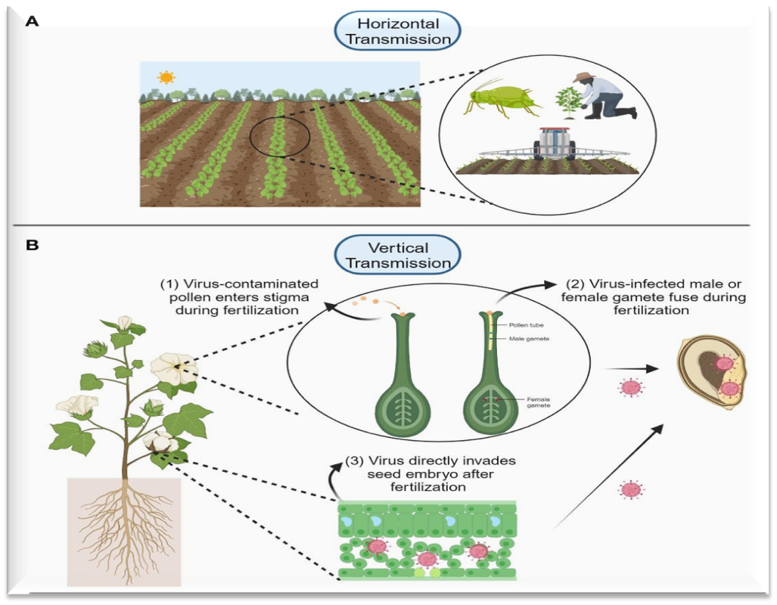

**FIG.1** Types and Their Different Modes of Plant Virus Transmission ([Escalante](https://loop.frontiersin.org/people/2209708) C., 2024)

**MODES OF TRANSMISSION**

**1. Mechanical Sap Transmission**

It entails the direct entry of a virus into a suitable plant site through physical means, cells through wounds and abrasions in the plant surface. It can occur when plants come into contact with one another, such as through leaf rubbing, or through the actions of animals and humans. This method is commonly applied in laboratory settings for experimental purposes and is referred to as sap inoculation. However, viruses that reside in the phloem are generally challenging to transmit using mechanical sap inoculation techniques (Hull, 2002; 2014).  
**Examples include:** Tobacco Mosaic Virus, Potato Virus X, and Pea Enation Mosaic Virus.

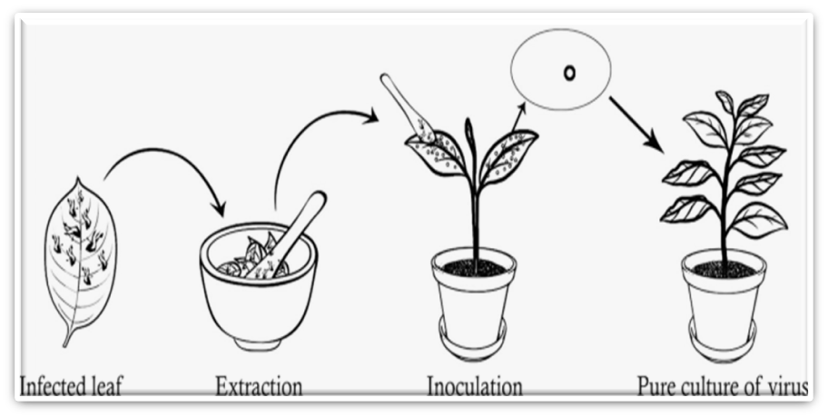

**FIG.2** Illustrative diagram depicting the procedures involved in mechanical sap inoculation of viruses (Kado CI, 1972).

**2. Vegetative Transmission**

Around 700 plant viruses are transmitted via vegetative transmission (J. of Gen. Virology, 2024). When plant viruses are propagated by budding, grafting by cutting or tubers, rhizomes, bulbs and corns, the virus present in the mother or parent is transmitted to the progeny. Grafting is a common horticultural technique used for various purposes. In this method, a shoot (scion) or bud taken from one plant is attached to the rooted base (stock) of another plant, and together they grow as a single plant. If either the scion or the stock is infected with a virus, the resulting grafted plant will also carry the virus. The time it takes for the virus to be transmitted through grafting can range from a few days to several months.

E.g., Colour Breaking of Tulip, Citrus Tristeza Virus, etc.

**3. Vector Transmission**

A vector is a living organism that carries the disease-causing agent from reservoirs to the host. These vectors are generally known as immunology vectors. Almost 827 viruses are transmitted by the vectors (Peter, 2024). Most plant viruses depend on vectors for their movement between plants. Structural proteins of the virus are essential for retaining the virion at specific locations within the vector. In some cases, non-structural proteins are needed to facilitate the connection between the virion and the insect vector. Additionally, many circulative and replicative viruses rely on non-structural proteins to spread effectively within their vectors.

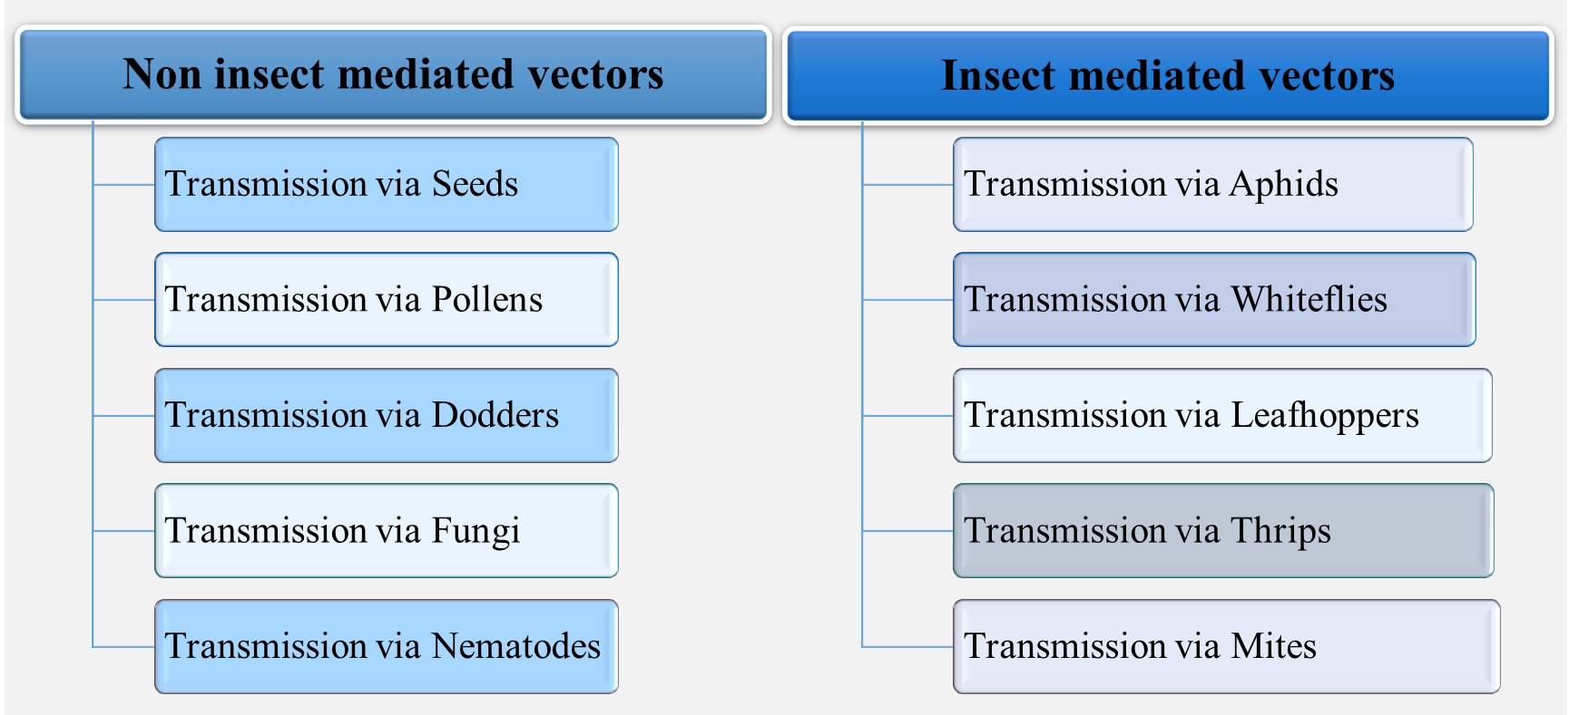

chart 1 : Vector Transmission

**NON-INECT MEDIATED VECTORS**

**a. By Seeds**

More than 190 phyto viruses are known to be seed-transmitted (Journal of General Virology, 2024), accounting for roughly one-seventh of all identified plant viruses. Since these viruses can remain viable in seeds for long durations, the distribution of infected seeds can lead to extensive and long-distance spread of viral diseases. Seed transmission plays a crucial role in the ecology and epidemiology of many plant viruses, serving as a primary source of inoculum that enables further spread within a region via vectors. Several genera—including Hordeivirus, Ilarvirus, Nepovirus, Potyvirus, Cucumovirus, Tobamovirus, Tobravirus—as well as viroids, are naturally seed-borne.

E.g., Barley Strip Mosaic Virus and White Clover Crypto. Virus etc.

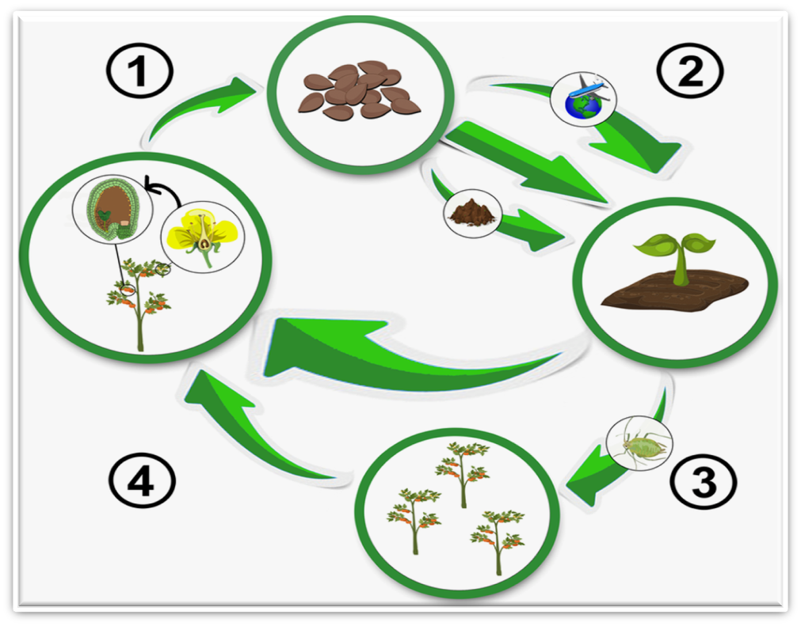

**FIG.3** Silent Spreaders: The Hidden Role of Seeds in Plant Virus Transmission by P. Israel

**b. By Pollens**

Pollen from virus-infected plants can act as a natural source of infection, transmitting viruses to healthy plants. When such virus-containing pollen lands on the stigma of a female plant, it can germinate and enable the virus to reach and infect the ovules. These are referred to as *pollen-borne viruses*. The spread of infected pollen can occur via wind, insects, or human activity. Pollen-mediated transmission can take place both vertically (to offspring) and horizontally (between plants). Genera such as Ilarvirus, Nepovirus, Sobemovirus, Idaeovirus, Potyvirus, along with various viroids, are known to spread through pollen.  
**Examples include** Raspberry Bushy Dwarf Virus and Tobacco Streak Virus.

**c. By Dodders**

Dodder (*Cuscuta* spp.) is an obligate parasitic flowering plant that targets higher plants. It is distinguished by its rootless, thread-like green or yellow stems, small scale-like leaves, and minimal chlorophyll content (Machado and Zetsche, 1990). Dodder establishes intimate physical connections with its host and is completely dependent on the host for the supply of assimilates and water. At points of contact with the host, the dodder tendrils produce a haustorium, a specialised organ that penetrates host tissues. Dodder forms direct contact with the host xylem. A well-known aspect of host dodder connections is the transmission of plant viruses: a single dodder’s dual attachment to different hosts allows it to serve as a conduit for virus transmission between plants.

Table 1 Physical connections of viruses and dodder

|  |  |  |  |
| --- | --- | --- | --- |
| **S. No.** | **Virus** | **Dodder** | **References** |
| 1. | Tomato ringspot virus | *Cuscuta gronovii* | L. Welliver (1992) |
| 2. | Apple mosaic virus | *Cuscuta* spp. | Yarwood (1955) |
| 3. | Little cherry virus | *Cuscuta europea* | Jelkmann *et al*. (1997) |

1. **By Fungi**

Viruses remain on the surface of zoospores and resting spores of fungi during transmission. Root infecting fungal-like organisms can spread a minimum of 30 different plant viruses. Genera that act as vectors are Olpidium, Polymyxa and Spongospora. Viruses from the genera Bymovirus, Furovirus, Tombusvirus, and Varicosavirus are transmitted by fungi through either non-persistent or persistent mechanisms. When these fungi parasitise the roots of virus-infected plants, their zoospores acquire the virus either externally on their surface or internally. Once these zoospores infect the roots of healthy plants, they introduce the virus, leading to new infections.

Table 2: Physical connections of viruses and fungi

|  |  |  |  |
| --- | --- | --- | --- |
| **S. No.** | **Fungus** | **Viruses** | **References** |
| 1. | *Olpidium brassicae* | Tobacco Necrosis Virus | Hiruki (1994) |
| 2. | *Polymyxa betae* | Beet Necrotic Yellow Vein Virus | Tamada *et al*. (1996) |
| 3. | *Polymyxa graminis* | Barley Yellow Mosaic Virus | Adam *et al*. (1988) |
| 4. | *Spongospora subterranean* | Potato Mop-Top Virus | Arif *et al*. (1995) |

1. **By Nematodes**

Seventeen plant viruses are known to be transmitted by soil-dwelling ectoparasitic nematodes. These nematodes spread viruses by feeding on the roots of infected plants and then transferring the virus as they feed on the roots of healthy plants. Two major groups of plant viruses are transmitted by various nematode species:

* **NEPO viruses** (characterised by polyhedral-shaped particles) are transmitted by nematodes belonging to the *Xiphinema* and *Longidorus* genera.
* **Tobra viruses or NETU virus** (viruses with tabular or rod-shaped molecules): transmitted by *Trichodorus* and *Paratrichodorus* species.

Table 3 : Physical connections of viruses and nematodes

|  |  |  |  |
| --- | --- | --- | --- |
| S. No. | Viruses | Nematodes | References |
| 1. | Grapevine Fanleaf Virus | *Xiphinema index* | Hewitt, Das and Raski (1968), Demangeat (2010) |
| 2. | Raspberry Ringspot Nepovirus | *Longidorus elongatus* | Taylor (1962) |
| 3. | Tobacco Rattle Virus | *Paratrichodorus* spp*.* | Boutsika *et al*. (2004) |
| 4. | Pea Early Browning Virus | *Trichodorus pachydermus* | Taylor and Robertson (1970) |

**INSECT-MEDIATED VECTORS**

More than 75% of identified plant viruses that lead to plant diseases rely on living vectors for their transmission and persistence (Whitfield *et al*., 2015). Among insect vectors, aphids, leafhoppers, and whiteflies are considered the most destructive (Bragard *et al*., 2013).

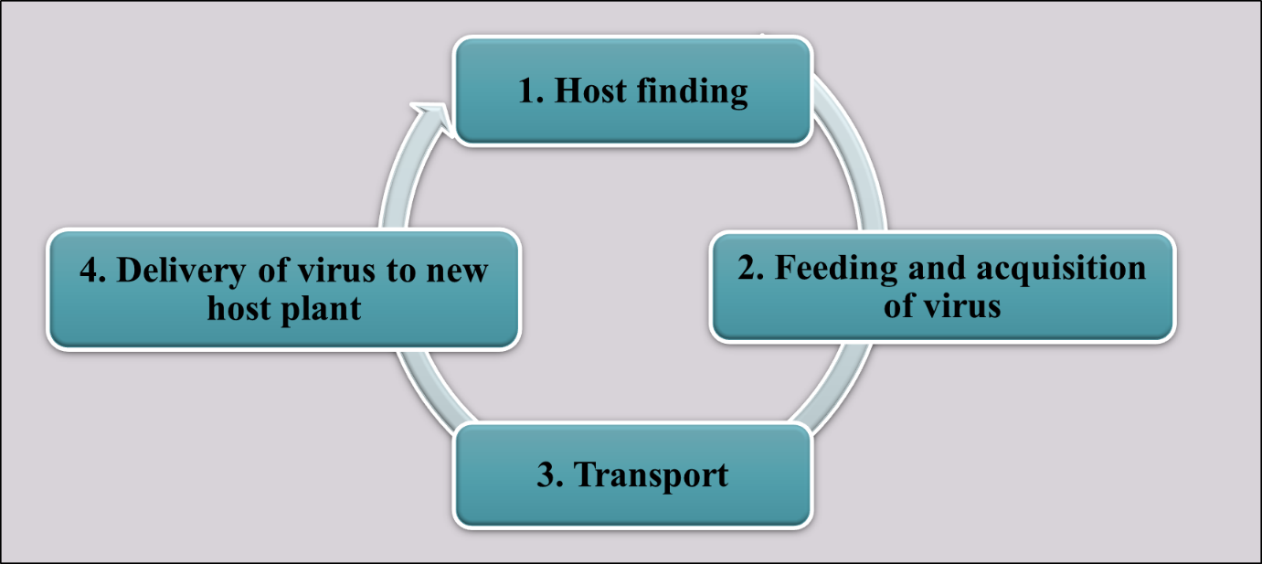

**FIG.4** The Insect-Virus Transmission Cycle

**VIRUS VECTOR RELATIONSHIP**

**Watson and Robert (1939)** gave the basic concept of the virus vector relationship

1. Non-circulative or non-persistent
2. Circulative or persistent
3. Non-circulative and Semi-persistent **(Sylvester,1958)**

Plant viruses can be transmitted to new host plants by vectors within **seconds to weeks** after ingesting sap from an infected plant, and sometimes through the next generation.

* 1. **By Aphids**

Most aphid vectors are classified under the order *Homoptera* (Blackman and Eastop, 2000). Aphids are responsible for transmitting more than 100 plant viruses, with the green peach aphid (*Myzus persicae*) recognised as one of the most effective and damaging vectors (Jayasinghe *et al*., 2022). Several distinct characteristics contribute to the efficiency of aphids in virus transmission, including:

* A broad host range in certain species, such as *Myzus persicae*
* The presence of a slender, needle-like stylet capable of penetrating plant tissues (Harris, 1977)

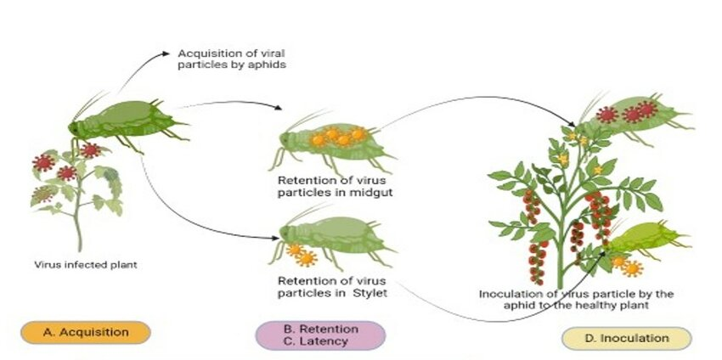

**FIG.5** Summary of molecular mechanisms underlying the virus–aphid vector relationship: NA, 2023

Table 4: Efficiency of aphids in virus transmission

|  |  |  |
| --- | --- | --- |
| **S.No.** | **Virus** | **Vectors** |
| 1. | Papaya Ringspot Virus | *Myzus persicae* |
| 2. | Cucumber Mosaic Virus | *Myzus persicae, Aphis gossypii, Aphis craccivora* |
| 3. | Banana Bunchy Top Virus | *Pentalonia nigronervosa* |

* 1. **By Leafhoppers**

They are piercing-sucking Hemiptera insects (Hohn, 2007). These sap-sucking insect vectors spread phytoplasma in a persistent manner. Approximately 66 known plant viruses are transmitted by leafhopper (J. of Gen. Virology, 2024) in a circulative manner. The majority of leafhoppers and planthoppers transmit plant viruses multiply within the vector body. A few viruses, such as wound tumour virus and potato yellow dwarf virus, are transmitted in a transovarial passage manner (Sinha and Shelley, 1965; Black, 1953).

E.g.: Sugar Beet Curly Top Virus, Aster Yellow Virus and Rice Tungro Virus

* 1. **By Whiteflies**

Whiteflies (*Bemisia tabaci*, order Hemiptera) are highly effective vectors, capable of transmitting around 180 plant viruses. They engage in non-persistent, semi-persistent, and persistent transmission modes. While the majority of viruses spread by whiteflies belong to the Begomovirus genus within the Geminiviridae family, they also transmit members of other genera, including Crinivirus, Ipomovirus, Torradovirus, and some Carlavirus spp. (Castillo *et al*.,2011). **Examples include:** Bean Golden Mosaic Virus, Sweet Potato Leaf Curl Virus, and Tomato Yellow Leaf Curl Virus.

**DISCUSSION**

Phyto viruses represent a substantial danger to global agriculture, causing extensive education to crop productivity and threats to food supply stability. Viruses, which are small obligate intracellular parasites, rely on various transmission modes to disperse from virus-carrying plants to susceptible ones. These modes of transmission are generally categorised as horizontal or vertical. Horizontal transmission takes place via either direct or indirect interactions between plants, typically via mechanical means or vector-mediated spread. In contrast, vertical transmission involves the inheritance of viruses from parent to offspring through infected seeds or asexual propagation, thus ensuring the persistence of the virus across generations.

The diversity of transmission methods complicates the management of plant viral diseases. Mechanical transmission, for example, involves physical damage to plant cells, often during human or animal activities, facilitating the virus’s entry into new host plants. Vegetative transmission, such as through grafting or cuttings, further amplifies the spread, as infected plant material is used to propagate new plants. Moreover, seed-borne and pollen-mediated transmission play crucial roles in spreading plant viruses over long distances, sometimes without obvious symptoms in the host.

Vector-mediated transmission is one of the most common and impactful modes of virus spread. Insects such as aphids, leafhoppers, and whiteflies are primary vectors, carrying the virus from one plant to another. These vectors acquire the virus by feeding on infected hosts and transmit it to healthy plants during subsequent feeding. Additionally, non-insect vectors such as fungi, nematodes, and dodders contribute to the spread, highlighting the complexity of virus dissemination.

**CONCLUSION**

Transmitting plant viruses is a multi-dimensional process that includes both biotic and abiotic factors. Horizontal and vertical transmission, along with mechanical and vector-mediated methods, ensure that viruses continue to spread across different ecosystems. The role of insect vectors, in particular, is critical for the rapid and widespread transmission of many plant viruses. Understanding the various transmission pathways is indispensable for developing effective strategies to control viral diseases in crops. Given the global nature of agricultural trade and the movement of plant material, it is imperative to implement comprehensive measures, including quarantine protocols, vector control, and the use of resistant plant varieties, to mitigate the impact of plant viruses and safeguard food production systems worldwide.

Disclaimer (Artificial intelligence)

Option 1:

Author(s) hereby declare that NO generative AI technologies such as Large Language Models (ChatGPT, manuscript.

Option 2:

Author(s) hereby declare that generative AI technologies such as Large Language Models, etc. have been used during the writing or editing of manuscripts. This explanation will include the name, version, model, and source of the generative AI technology and as well as all input prompts provided to the generative AI technology

Details of the AI usage are given below:

1.

2.

3.

**REFERENCES**

**Black, L.M. 1953.** Occasional transmission of some plant viruses through eggs of their insect vectors. *Phytopathology*., 43: 9-10.

**Bragard, C., Caciagli, P., Lemaire, O., Lopez-Moya, J.J., Mac, F. S., Peters, D., Susi, P. and Torrance, L. 2013.** Status and prospects of plant virus control through interference with vector transmission. *Annual Review of Phytopathology*., 51(1):177 – 201.

**Castillo, J.N., Olive, E.F. and Campos, S.S. 2011.** Emerging virus diseases transmitted by Whiteflies. *Ann. Rev. Phytopatho*.,*.* 49: 2019-2248.

**Escalante, C., Sanz-Saez, A., Jacobson, A., Otulak-Kozieł, K., Kozieł, E., Balkcom, K.S., Zhao, C. and Conner, K. 2024.** Plant virus transmission during seed development and implications to plant defense system. *Front. Plant Sci*., 15:1385456.

**Grešíková, S. 2022**. The transmission of plant viruses. Review. *Agriculture (Poľnohospodárstvo)*.,68(3): 119 –126.

**Hans, R. G. 1996**. Robert Koch Institute Structure and Classification of Viruses book: *Medical Microbiology* Edition: 4th Chapter 41 Publisher: University of Texas Medical Branch at Galveston.

**Harris, K.F. and Maramorosch, K. 1977**. Aphids as Virus Vectors. New York: Academic Press.

[**Hilaire**](https://pubmed.ncbi.nlm.nih.gov/?term=Hilaire+J&cauthor_id=35310134), **J.,**[**Tindale**](https://pubmed.ncbi.nlm.nih.gov/?term=Tindale+S&cauthor_id=35310134), **S.,**[**Jones**](https://pubmed.ncbi.nlm.nih.gov/?term=Jones+G&cauthor_id=35310134), **G.,** [**Bacnik**](https://pubmed.ncbi.nlm.nih.gov/?term=Ba%C4%8Dnik+K&cauthor_id=35310134), **K.,**[**Ojo**](https://pubmed.ncbi.nlm.nih.gov/?term=Ojo+M&cauthor_id=35310134), **M. and [Frewer](https://pubmed.ncbi.nlm.nih.gov/?term=Frewer+LJ&cauthor_id=35310134)**, **J. 2022.** Risk perception associated with an emerging agri-food risk in Europe: plant viruses in agriculture. *Agriculture Food Security*., 11(1):21.

**Hohn, T. 2007**. Plant virus transmission from the insect point of view. *Proc. Natl Acad. Sci. USA*., 104, 17905–17906.

**Hull, R. 2002.** Matthews’ plant virology, 4th edn. Academic, San Diego.

**Hull, R. 2014**.Matthews’ plant virology, 5th edn. Academic, San Diego, CA.

**Jayasinghe, W. H., Akhter, M. S., Nakahara, K. and Maruthi, M. N. 2022.** Effect of aphid biology and morphology on plant virus transmission. *Pest Management Science*., 78(2): 416-427.

**Kado, CI. 1972.** Mechanical and biological inoculation principles. In: Kado CI, Agrawal HO (eds).

**Machado, M.A. and Zetsche, K. 1990**.A structural, functional and molecular analysis of plastids of the holoparasite *Cuscuta reflexa* and *C. europea*. *Planta*.,181:91–96.

**Peter, D., Matsumura, E. and Vredendaal, P. 2024.** The Plant Virus Transmissions Database *Journal of General Virology*.,105(3):001957.

**Singh, S., Awasthi, L.P. and Jangre, A. 2020.** Transmission of plant viruses in ﬁelds through various vectors. *In Appl. Plant Virol.,* Academic Press, pp. 313-334.

**Sinha, R.C. and Shelley, S. 1965**. The transovarial transmission of wound-tumor virus. *Phytopathology*, 55: 324-327.

**Watson, M. A. and Roberts, F. M. 1939.** A comparative study of the transmission of *Hyoscyamus* virus 3, Potato virus Y and Cucumber virus 1 by the vectors *Myzus persicae* (Sulz.), *M*. *circumflexus* (Buckton) and *Macrosiphum gei* (Koch). *Proc. Roy Soc. London B*. 127, 543–76.

**Whitfield, A.E., Falk, B.W. and Rotenberg, D. 2015.** Insect vector-mediated transmission of plant viruses. *Virology*., 479:278–289.

Shi, X., Zhang, Z., Zhang, C., Zhou, X., Zhang, D., & Liu, Y. (2021). The molecular mechanism of efficient transmission of plant viruses in variable virus–vector–plant interactions. Horticultural Plant Journal, 7(6), 501-508.

Gallet, R., Michalakis, Y., & Blanc, S. (2018). Vector-transmission of plant viruses and constraints imposed by virus–vector interactions. Current opinion in virology, 33, 144-150..

Mauck, K., Bosque‐Pérez, N. A., Eigenbrode, S. D., De Moraes, C. M., & Mescher, M. C. (2012). Transmission mechanisms shape pathogen effects on host–vector interactions: evidence from plant viruses. Functional Ecology, 26(5), 1162-1175.

Ng, J. C., & Perry, K. L. (2004). Transmission of plant viruses by aphid vectors. Molecular plant pathology, 5(5), 505-511.

Ivanov, V., & Stabnikov, V. (2022). Introduction to viruses, bacteria, and fungi in the built environment. In Viruses, Bacteria and Fungi in the Built Environment (pp. 11-27). Woodhead Publishing.

Bian, R., Andika, I. B., Pang, T., Lian, Z., Wei, S., Niu, E., ... & Sun, L. (2020). Facilitative and synergistic interactions between fungal and plant viruses. Proceedings of the National Academy of Sciences, 117(7), 3779-3788.

Lefeuvre, P., Martin, D. P., Elena, S. F., Shepherd, D. N., Roumagnac, P., & Varsani, A. (2019). Evolution and ecology of plant viruses. Nature Reviews Microbiology, 17(10), 632-644.