Original Research Article
Harnessing weak and hydrogen bonding interactions for tailored crystal formation: A case study of Diisopropylammonium Phenylsulfonate

Abstract
The thoughtful design of a supramolecular molecule constructed from NH···OS-type hydrogen bonds is commonly used to create molecular architectures useful for industrial and medical applications. Here, we report for the first time a hydrogen bonding strategy for the formation of a crystalline diisopropylammonium phenylsulfonate molecule. Crystallographic analysis revealed that the diisopropylammonium cation forms hydrogen bonds with the phenylsulfonate anion. Furthermore, the anion, acting as a hydrogen bond acceptor, facilitates bonding between anions and cations through N–H···O hydrogen bonds, resulting in a supramolecular crystalline structure. Each oxygen atom participates in at least two hydrogen bonds, either C–H···O or both C–H···O and N–H···O, leading to the formation of a three-dimensional structure. an experimental study was conducted to examine the properties of this new crystal, including assessing the suitability of various DFT methods and the necessary adjustments to accurately describe its structural and spectroscopic characteristics. Using the DFT/B3LYP method with the 6-311++G(d,p), 6-311G(d,p), and 6-311+G(d,p) basis sets, we performed theoretical vibrational frequency calculations and evaluated geometric parameters such as bond lengths and angles for the first time. The DFT approach for determining bond lengths and angles was performed using the B3LYP method. These values, which fall within the characteristic range of hydrogen bonds, are consistent with crystallographic data. The dipole moment, as well as the HOMO (Highest Occupied Molecular Orbital) and LUMO (Lowest Unoccupied Molecular Orbital) energies, were also determined. This metal-free and eco-friendly synthetic process for producing supramolecular molecules holds significant potential for applications in both industry and the pharmaceutical field.

Keywords: Diisopropylammonium phenylsulfonate, Hydrogen bond, DFT, Crystallographic method
1. Introduction
Phenylsulfonic acid (or benzenesulfonic acid, C₆H₅SO₃H) is an organic compound containing a sulfonic acid group attached to a benzene ring. Compounds derived from phenylsulfonic acid have garnered increasing interest in the literature due to their numerous applications, particularly in the manufacture of various household products (Zaib et al. 2025), textiles (Nagdeve et al. 2024), pharmaceuticals (Lukin and Leszczynski 2002), etc. Various phenylsulfonic acid derivatives have been synthesized by several research teams (Bharate 2021; Muleva and Bharate 2023; Wu et al. 2021). For example, Gundlapalli et al. synthesized the Suvorexant-benzenesulfonic acid (BSA) compound, which is useful in the treatment of insomnia-related disorders (Gundlapalli et al. 2021). This compound is formed through hydrogen bonding interactions and crystallizes under favorable conditions to yield a solid salt (Gundlapalli et al. 2021). Furthermore, cilostazol benzenesulfonate has been developed once again via chemical synthesis techniques for pharmaceutical formulation (Bae et al. 2015). The rational design of a supramolecular molecule assembled through NH···OS hydrogen bonding is often employed to form molecular architectures such as truncated octahedra or Archimedean polyhedra (Y. Liu et al. 2011). To better understand the hydrogen bonding interactions in these phenylsulfonic acid derivatives, Density Functional Theory (DFT) calculations are essential tools. This approach has proven particularly effective in elucidating the mechanisms of hydrogen bond formation (Hao et al. 2024; Ireta et al. 2004). In particular, the use of the hybrid functional B3LYP is widely prevalent in the study of molecular systems involving hydrogen bonding interactions (Holikulov et al. 2025). In this context, it becomes essential to complement experimental studies on phenylsulfonic acid derivatives with quantum chemical calculations. Several studies conducted by researchers have reported experimental results aimed at elucidating these hydrogen interactions (Labella et al. 2025). A thorough review of the literature highlights the importance of the work carried out on these molecules (Sun et al. 2023). However, to our knowledge, no study based on density functional theory (DFT), especially using the B3LYP method, has yet been conducted on the compound diisopropylammonium phenylsulfonate. Moreover, the correlation between experimental crystallographic data and theoretical results for this compound remains unexplored. This emphasizes the importance of conducting a thorough study to determine geometric parameters such as bond lengths and angles, and to perform vibrational analysis based on theoretical spectra. Therefore, the current work aims to present both experimental and theoretical geometric parameters, the optimized structure of the compound, as well as its vibrational frequencies obtained through calculations. Given the conjugated nature of the benzene ring, the 6-311G(d,p), 6-311+G(d,p), and 6-311++G(d,p) basis sets were chosen to perform these calculations. These basis sets are renowned for their efficiency in delivering reliable results in molecular geometry and vibrational spectroscopy, while maintaining a good balance between accuracy and computational cost. Finally, the dipole moment, frontier orbitals (HOMO and LUMO), as well as the global descriptors of the compound, were also calculated and analyzed to complete the theoretical study.
2. Experimental section
2.1. Synthesis and Crystallization
Diisopropylamine (3.0 g; 3.0 mmol) and phenylsulfonic acid (5.0 g; 3.0 mmol) were combined in 50 milliliters of ethanol (scheme 1). After a mild reaction, colorless blocks of the title compound were formed by slowly evaporating the solvent at room temperature. Following a month of gradual evaporation at room temperature, crystals suitable for X-ray diffraction analysis were obtained.
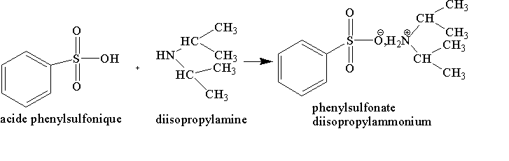
Scheme 1: Synthesis procedure of diisopropylammonium phenylsulfonate
2.2. Crystallographic analysis of diisopropylammonium phenylsulfonate
Data was collected using a 0.60 × 0.32 × 0.16 mm crystal. SAINT V8.37A (Bruker AXS Inc., 2015), XT, VERSION 2014/5, and SHELXL2014/7 (Sheldrick, 2014) software were used for the creation and refinement of the structure.
2.3. Computational details
All calculations were performed using the Gaussian 16 program (Lo et al. 2025) with the B3LYP method. This method is one of the most commonly used for studying non-covalent interactions (Barhoumi 2025; Şaş 2025; Sekar et al. 2025). In this work, the B3LYP method, combined with the 6-311G(d,p), 6-311+G(d,p), and 6-311++G(d,p) basis sets, was used to characterize the molecular structures and reactivity of the compound diisopropylammonium phenylsulfonate. These calculations were carried out in solution under standard temperature (298.15 K) and pressure (1 atm) conditions. The absence of imaginary frequencies among the vibrational frequencies calculated using the DFT method at the B3LYP level confirms that all structures correspond to energy minima (Lo et al. 2025). The minimum-energy geometries, associated energies, as well as the highest occupied molecular orbital (HOMO) and lowest unoccupied molecular orbital (LUMO), were determined for the molecule. These energy values were then used to estimate the energy gap (Egap) using equation (1).
Furthermore, several global reactivity descriptors — chemical hardness (η), electronegativity (χ), electrophilicity index (ω), and softness (σ) — were approximated from the HOMO and LUMO energies by applying equations (2), (3), (4), (5), and (6), respectively (De Souza et al. 2018).

E_{gap} = E_{LUMO} - E_{HOMO} (1)
$η= E_{LUMO} -\frac{E_{HOMO}}{2}$ (2)
$χ= {-E}_{HOMO}-\frac{E_{LUMO}}{2}$ (3)
$μ= - χ$ (4)
$ω= \frac{μ^{2}}{2 η}$ (5)
$σ= \frac{1}{η}$ (6)
3. Results and discussion
3.1. Crystallography studies
Figures 1, 2, and 3 represent the structures of diisopropylammonium phenylsulfonate, showing hydrogen bonding interactions, 3D architecture, and the type of C-H...O, NH...O bonds approximately along the a-axis. In Figure 1, it can be seen that the C-C and C-N bonds are similar to those reported for diisopropylammonium in previously reported works by (M.-L. Liu 2012; Seye et al. 2019). The nature of the S-O distances (1.334 (6) Å to 1.487 (7) Å) indicates delocalization. The weak C-H···O hydrogen bonds (2.944 (11) to 3.493 (4)) present lead to a supramolecular structure (Fig. 1A). The anions and cations are connected through N-H...O hydrogen bonds. The weak intermolecular hydrogen bonds C3-H3C...O1, C13-H13...O1, C12-H12...O3, C3-H3A...O4, and C6-H6...O2 are responsible for interactions between phenylsulfonate/phenylsulfonate and phenylsulfonate/cation (Fig. 1B). All oxygen atoms are involved in at least two bonds, either C-H...O or C-H...O and N-H...O bonds, contributing to the 3D architecture. The C-C and C-N bonds of the cation are similar to those previously observed for compounds containing the iPr2NH2+ cation (Sarr et al. 2019). The C-C and C-O bonds of the hydrogenophthalate anion are close to the values published for salts containing this anion (Macrae et al. 2006; Seye et al. 2018b). In the overall structure, the acid anions [PhCO2H(COO)]- are connected to the cations by N-H...O hydrogen bonds, leading to zigzag chains parallel to [010] (Fig. 1C) in which the cations and anions alternate.
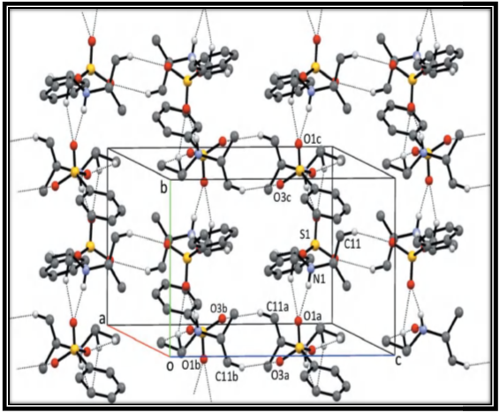
Figure 1A : Global structure of diisopropylammonium phenylsulfonate showing hydrogen bond interactions.
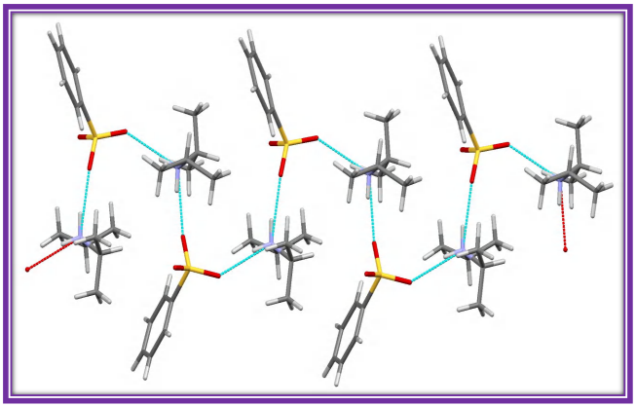
Figure 1B : Hydrogen bonds (N-H···O) along the a-axis
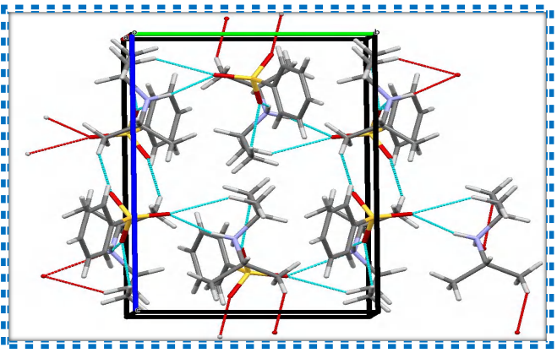
Figure 1C: Global structure of diisopropylammonium phenylsulfonate showing hydrogen bonding interactions along the a-axis
3.2. Optimized geometry
In order to study the hydrogen bonding interaction and determine the geometric parameters of the diisopropylammonium phenylsulfonate molecule, a structural optimization of this molecule was carried out using the B3LYP method with the 6-311G(d,p), 6-311+G(d,p), and 6-311++G(d,p) basis sets. Figure 2 illustrates the optimized structure of the most stable form of the molecule obtained with the B3LYP/6-311+G(d,p) method. As shown by this optimized structure, the molecule is composed of an assembly of phenylsulfonic acid and isopropylamine, connected by an intermolecular hydrogen bond (N–H···O). This interaction allows the molecule to adopt a conformation corresponding to a minimum energy state. A crystallographic study of this molecule has already been reported in the literature (Seye et al. 2018), indicating that the molecular structure of the compound is not planar. The zero-point vibrational energies obtained for this compound with the different basis sets used in this work are –1227.406877, –1227.421037, and –1227.421490 Hartree for the 6-311G(d,p), 6-311+G(d,p), and 6-311++G(d,p) basis sets, respectively. These values indicate increasing energetic stability, with the lowest energies obtained using the 6-311+G(d,p) and 6-311++G(d,p) basis sets.
The stability of the molecule is also strongly influenced by the length of the hydrogen bond. It is well established that the energy of a hydrogen bond depends both on the Y···H distance and the X–H···Y angle, where X is the proton donor and Y the acceptor. In general, a hydrogen bond is considered strong if the Y···H distance is less than or equal to 1.9 Å; beyond this value, it is classified as weak (Sukhanov et al. 2003). The geometric parameters (bond lengths and angles) were determined using the B3LYP method, as shown in Table 1. The hydrogen bond lengths (H38···O35) obtained are 1.670 Å, 1.697 Å, and 1.697 Å for the 6-311G(d,p), 6-311+G(d,p), and 6-311++G(d,p) basis sets, respectively. These values fall well within the characteristic range for hydrogen interactions (< 3.0 Å) (Jeffrey 1997). The calculated bond angles (N3H38O35) are 167.28°, 171.10° and 170.98° for the 6-311G(d,p), 6-311++G(d,p), and 6-311+G(d,p) basis sets, respectively. These data confirm the high likelihood of hydrogen bonding interactions, in agreement with experimental results. According to the criteria mentioned earlier, the hydrogen bond formed between phenylsulfonic acid and isopropylamine can be considered strong, as the distances are below 1.9 Å, indicating good stability compound. The experimental H38···O35 bond distance is 1.850 Å [18]. Comparing this experimental value with the theoretical ones, it is evident that the obtained values are very close, thus reinforcing the validity of the theoretical model. Based on the combination of theoretical and experimental results, particularly the geometric parameters, the existence of an intermolecular hydrogen bond stabilizing the structure of the diisopropylammonium phenylsulfonate molecule can be confirmed.
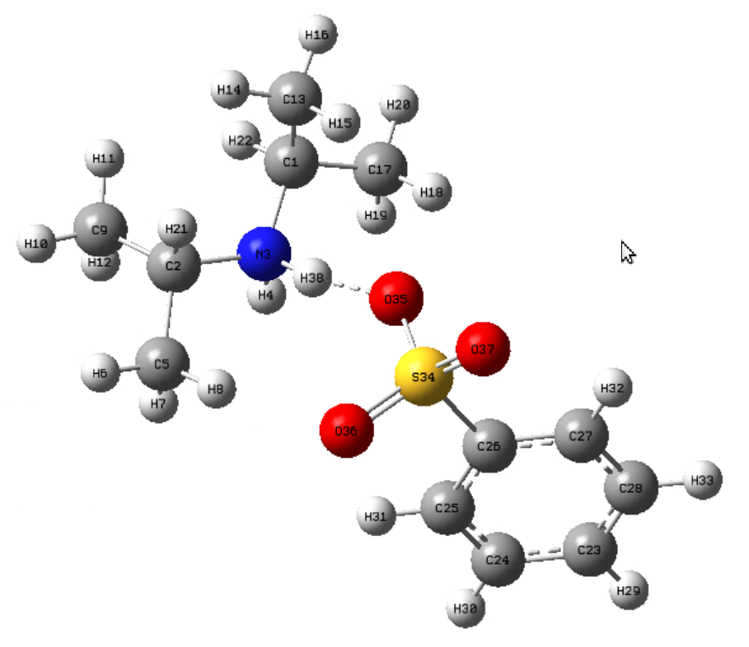
Figure 2. The optimized structure of the most stable diisopropylammonium phenylsulfonate molecule at B3LYP/6-311+G(d,p) level with atom labeling scheme

Table 1. Bond lengths (A) and bond angles (⁰) for the diisopropylammonium phenylsulfonate molecule
Bonds lengths | Experimental | Theoretical
Bonds lengths | Experimental | B3LYP/6-311G(d,p) | B3LYP/6-311G+(d,p) | B3LYP/6-311G++(d ,p)
C1-N3 | 1,501 | 1.520 | 1.521 | 1.521
C1-C13 | 1,507 | 1.525 | 1.525 | 1.525
C1-C17 | 1,519 | 1.527 | 1.528 | 1.528
C1-H22 | 1,000 | 1.090 | 1.090 | 1.090
C2-N3 | 1,508 | 1.520 | 1.520 | 1.521
C2-C5 | 1,516 | 1.528 | 1.528 | 1.528
C2-C9 | 1,504 | 1.525 | 1.525 | 1.525
C2-H21 | 1,000 | 1.090 | 1.090 | 1.091
N3-H4 | 0,860 | 1.022 | 1.023 | 1.023
N3-H38 | 0,910 | 1.055 | 1.051 | 1.052
C5-H6 | 0,980 | 1.091 | 1.092 | 1.092
C5-H7 | 0,980 | 1.094 | 1.094 | 1.095
C5-H8 | 0,980 | 1.091 | 1.092 | 1.092
C9-H10 | 0,980 | 1.091 | 1.091 | 1.092
C9-H11 | 0,980 | 1.091 | 1.091 | 1.091
C9-H12 | 0,980 | 1.094 | 1.094 | 1.094
C13-H14 | 0,980 | 1.091 | 1.091 | 1.091
C13-H15 | 0,980 | 1.092 | 1.092 | 1.092
C13-H16 | 0,980 | 1.091 | 1.091 | 1.091
C17-H18 | 0,980 | 1.092 | 1.092 | 1.092
C17-H19 | 0,980 | 1.093 | 1.093 | 1.093
C17-H20 | 0,980 | 1.092 | 1.091 | 1.091
C23-C24 | 1,354 | 1.396 | 1.395 | 1.396
C23-C28 | 1,339 | 1.394 | 1.395 | 1.395
C23-H29 | 0,950 | 1.084 | 1.084 | 1.084
C24-C25 | 1,403 | 1.392 | 1.394 | 1.394
C24-H30 | 0,950 | 1.084 | 1.084 | 1.084
C25-C26 | 1,372 | 1.396 | 1.395 | 1.395
C25-H31 | 0,950 | 1.083 | 1.083 | 1.083
C26-C27 | 1,373 | 1.393 | 1.394 | 1.394
C26-S34 | 1,771 | 1.807 | 1.810 | 1.810
C27-C28 | 1,381 | 1.395 | 1.395 | 1.395
C27-H32 | 0,950 | 1.082 | 1.083 | 1.083
C28-H33 | 0,950 | 1.084 | 1.084 | 1.084
S34-O35 | 1,481 | 1.506 | 1.509 | 1.509
S34-O36 | 1,396 | 1.481 | 1.485 | 1.485
S34-O37 | 1,439 | 1.483 | 1.483 | 1.483
O35-H38 | 1.850 | 1.670 | 1.696 | 1.697
Bonds angles
N3-C1-C13 | 110,50 | 110.34 | 110.47 | 110.50
N3-C1-C17 | 107,70 | 107.99 | 108.01 | 107.94
N3-C1-H22 | 108,70 | 106.03 | 105.94 | 106.04
C13-C1-C17 | 112,30 | 112.49 | 112.82 | 112.77
C13-C1-H22 | 108,70 | 110.38 | 110.17 | 110.15
C17-C1-H22 | 108,70 | 109.37 | 109.18 | 109.19
N3-C2-C5 | 108,00 | 107.83 | 107.93 | 107.79
N3-C2-C9 | 110,68 | 111.40 | 111.28 | 111.48
N3-C2-H21 | 108,60 | 105.33 | 105.26 | 105.27
N3H38O35 | 167.00 | 167.28 | 171.10 | 170.98
C5-C2-C9 | 112,20 | 112.68 | 112.67 | 112.57
C5-C2-H21 | 108,60 | 109.15 | 109.23 | 109.30
C9-C2-H21 | 108,60 | 110.15 | 110.17 | 110.14
C1-N3-C2 | 116,82 | 118.55 | 118.47 | 118.64
C1-N3-H4 | 108,30 | 107.79 | 107.80 | 107.76
C1-N3-H38 | 112,80 | 108.56 | 107.82 | 107.70
C2-N3-H4 | 107,70 | 107.76 | 107.80 | 107.81
C2-N3-H38 | 104,00 | 107.54 | 108.31 | 108.19
H4-N3-H38 | 107.00 | 105.97 | 105.98 | 106.07
C2-C5-H6 | 109,50 | 109.19 | 109.01 | 109.05
C2-C5-H7 | 109,50 | 111.08 | 111.00 | 110.93
C2-C5-H8 | 109,50 | 111.11 | 111.65 | 111.75
H6-C5-H7 | 109,50 | 107.96 | 107.80 | 107.84
H6-C5-H8 | 109,50 | 108.50 | 108.20 | 108.34
H7-C5-H8 | 109,50 | 108.90 | 109.04 | 108.82
C2-C9-H10 | 109,50 | 108.69 | 108.63 | 108.54
C2-C9-H11 | 109,50 | 112.67 | 112.74 | 112.80
C2-C9-H12 | 109,50 | 111.19 | 111.20 | 111.26
H10-C9-H11 | 109,50 | 107.51 | 107.51 | 107.48
H10-C9-H12 | 109,50 | 107.86 | 107.82 | 107.80
H11-C9-H12 | 109,50 | 108.75 | 108.75 | 108.78
C1-C13-H14 | 109,50 | 112.50 | 112.42 | 112.43
C1-C13-H15 | 109,50 | 110.53 | 110.94 | 110.92
C1-C13-H16 | 109,50 | 108.67 | 108.65 | 108.67
H14-C13-H15 | 109,50 | 109.22 | 108.85 | 108.84
H14-C13-H16 | 109,50 | 107.55 | 107.54 | 107.53
H15-C13-H16 | 109,50 | 108.23 | 108.31 | 108.31
C1-C17-H18 | 109,50 | 110.85 | 111.09 | 111.05
C1-C17-H19 | 109,50 | 111.51 | 111.54 | 111.53
C1-C17-H20 | 109,50 | 109.00 | 109.09 | 109.14
H18-C17-H19 | 109,50 | 109.33 | 108.82 | 108.78
H18-C17-H20 | 109,50 | 108.35 | 108.43 | 108.46
H19-C17-H20 | 109,50 | 107.70 | 107.76 | 107.77
C24-C23-C28 | 120,30 | 120.02 | 120.02 | 120.02
C24-C23-H29 | 119,90 | 119.96 | 119.97 | 119.97
C28-C23-H29 | 119,90 | 120.02 | 120.00 | 120.00
C23-C24-C25 | 120,50 | 120.18 | 120.17 | 120.16
C23-C24-H30 | 119,80 | 120.12 | 120.14 | 120.15
C25-C24- H30 | 119,80 | 119.70 | 119.69 | 119.69
C24-C25-C26 | 118,80 | 119.41 | 119.38 | 119.38
C24-C25-H31 | 120,60 | 120.49 | 120.58 | 120.58
C26-C25-H31 | 120,60 | 120.10 | 120.04 | 120.10
C25-C26-C27 | 119,80 | 120.80 | 120.89 | 120.89
C25-C26-S34 | 119,83 | 119.51 | 119.49 | 119.42
C27-C26-S34 | 120,32 | 119.63 | 119.59 | 119.66
C26-C27-C28 | 119,80 | 119.41 | 119.36 | 119.36
C26-C27-H32 | 120,10 | 119.65 | 119.91 | 119.87
C28-C27-H32 | 120,10 | 120.93 | 120.72 | 120.76
C23-C28-C27 | 120,80 | 120.17 | 120.18 | 120.18
C23-C28-H33 | 119,60 | 120.16 | 120.15 | 120.16
C27-C28-H33 | 119,60 | 119.67 | 119.66 | 119.66
C26-S34-O35 | 104,49 | 104.83 | 105.34 | 105.28
C26-S34-O36 | 107,50 | 106.71 | 106.41 | 106.48
C26-S34-O37 | 107,70 | 106.33 | 106.42 | 106.43
O35-S34-O36 | 112,20 | 111.54 | 111.87 | 111.85
O35-S34-O37 | 111,30 | 112.38 | 111.60 | 111.60
O36-S34-O37 | 115,10 | 114.27 | 114.48 | 114.46
S34-O35-H38 | - | 130.46 | 135.56 | 133.22

3.3. Vibrational analysis
The B3LYP method was used to calculate the vibrational spectra of diisopropylammonium phenolsulfonate. However, after making anharmonic corrections, the vibrational frequencies are shown in the figure 3 without scaling.
3.3.1. Region from 3500 à 2500 cm⁻¹.
The specific ranges of CH stretching vibrations for benzene, alkyl CH, and NH are observed in the high frequency range (3500 to 2500 cm⁻¹) (Akash and Rehman 2025). NH vibrations associated with hydrogen bonding are found around 3500 cm⁻¹ for all bases B3LYP /6-311++G(d,p), B3LYP /6-311G(d,p), and B3LYP /6-311+G(d,p). In this research, the OH extension is not identified in the FTIR spectra. In acidic molecules, hydrogen bonds complex condensed-phase vibrational spectra, as the OH stretching frequency is shifted to the lower region and superimposed on CH and NH stretching vibrations (Amna Sherin et al. 2025). Peaks between 3000 and 3300 cm⁻¹ are attributed to the C-H3 vibrations present in the composition of diisopropylammonium phenolsulfonate. The intense band appears at 2950 cm⁻¹ for bases 6- 311++G (d,p) and 6-311G(d,p), while at 2900 cm⁻¹ for base 6-311+G(d,p), both of which are attributed to the CH stretching vibrations of benzene.
3.3.2. Region from 2500 à 1300 cm⁻¹
The υC=C and υC-N bands at 1681 and 1574 cm⁻¹, respectively, are observed in the spectra of diisopropylammonium phenylsulfonate. These phenyl-related bands confirm that the benzene moiety is present in the structure of the synthesized molecule. The theoretical results obtained using the B3LYP/6-31++G (d, p) method for the stretching modes of υC=C and υC=N in benzene are in approximate agreement with the values reported in the literature. C-C bond stretching vibrations ypically occur between 1590 and 1430 cm⁻¹ (Al-Wahaibi et al. 2024). In this case, the C-C stretching vibrations were assigned to 1367 and 1493 cm⁻¹. These assignments align with those proposed in previous research (Lo et al. 2025).
3.3.3. Region below 1300 cm⁻¹
Analysis of the infrared spectrum shows that the valence vibrations of SO3 cause the strong absorption band seen between 1000 and 1200 cm⁻¹, which appears consistently in all the spectra of the B3LYP bases calculated. Additionally, the three bands around 600 cm⁻¹ represent the deformation vibrations of the SO3 group. This attests to the participation of phenylsulfonate in the configuration of the diisopropylammonium phenylsulfonate molecule. Hydrogen bonding is of low intensity for SO3 groups. The spectra show S-C stretching, with a detectable band at 937 cm⁻¹ (Rennebaum et al. 2024). These results indicate that the coupling process does not involve the carbon bound to the SO3 group. The calculated CH out-of-plane deformation vibration is assigned to 872 cm⁻¹ for all bases. These results are in agreement with those reported in the literature (Rennebaum et al. 2024).
Figure 3: IRTF calculed by DFT using B3LYP bases a)B3LYP /6-311++G(d,p) b)B3LYP /6-311G(d,p) c)B3LYP /6-311+G(d,p)
3.4. Frontier molecular orbital analyses
The energy levels of the studied compound were theoretically determined using Density Functional Theory (DFT), employing the hybrid functional B3LYP coupled with the 6-311G(d,p), 6-311+G(d,p), and 6-311++G(d,p) basis sets, as implemented in the GAUSSIAN 16 software. Particular attention was given to the characterization of the frontier molecular orbitals (FMOs), due to their crucial role in electronic and optical properties as well as in various quantum reactivity calculations (Soni and Sahu 2023; Tabti et al. 2018).
The highest occupied molecular orbital (HOMO) acts as an electron donor, while the lowest unoccupied molecular orbital (LUMO) serves as an electron acceptor (Daoui et al. 2021). Consequently, a molecule’s ionization potential is closely related to the energy of the HOMO, while its electron affinity depends on the energy of the LUMO (Gałyńska et al. 2024). A small energy gap between these two orbitals indicates high polarizability and increased chemical reactivity (Akintemi et al. 2022).
The values of the HOMO and LUMO energies, the energy gap, as well as global reactivity descriptors (hardness (η), electronegativity (χ), chemical potential (μ), electrophilicity index (ω), softness (σ)), and the dipole moment (D) are summarized in Table 2. The electronic transition HOMO → LUMO is illustrated in Figure 4.
Analysis of the HOMO–LUMO energy gap allows classification of the molecule as "hard" or "soft": a large gap indicates a hard molecule, while a small gap suggests a soft one (Akintemi et al. 2022). In our case, the energy gap values are 4.041 eV, 4.041 eV, and 4.097 eV for the B3LYP/6-311G(d,p), B3LYP/6-311+G(d,p), and B3LYP/6-311++G(d,p) levels, respectively. These very close values confirm the stability and hard nature of the studied compound, regardless of the basis set used (Akintemi et al. 2022).
These energy gaps also allow for the calculation of global reactivity descriptors (GRDs), which are essential for understanding the structural and reactive properties of the molecule. As shown in Table 2, the electrophilicity index (ω) reaches its maximum value with the B3LYP/6-311+G(d,p) basis set, at 25.797 eV, suggesting that under this configuration, the compound has a strong tendency to accept electrons. This indicates good thermodynamic stability of the system resulting from electrophilic interaction.
The dipole moments of the compound vary with the 6-311G(d,p), 6-311+G(d,p), and 6-311++G(d,p) basis sets and are respectively 15.8468, 16.8611, and 16.8677 Debye. It is generally accepted that a higher dipole moment reflects greater molecular stability [(Shariatinia et al. 2012)]. Thus, the compound appears more stable when described with the 6-311++G(d,p) and 6-311+G(d,p) basis sets.
Finally, it should be noted that hydrogen bond formation significantly alters the polarity of the compound through redistribution of the electron cloud, which directly influences the observed dipolar properties (Alirezapour et al. 2025; Costa et al. 2001; Dyer and al 2006).

Table 2. The energies of the HOMO and LUMO orbitals (EHOMO and ELUMO), the LUMO-HOMO gap (Egap), the global reactivity descriptors (hardness (η), electronegativity (χ), chemical potential (μ), electrophilicity index (ω), softness (σ)), and the dipole moment (D) of diisopropylammonium phenylsulfonate.

DFT/B3LYP | E_{HOMO} (eV) | E_{LUMO} (eV) | E_{LUMO}-E_{HOMO} (eV) | $η= E_{LUMO} -\frac{E_{HOMO}}{2}$ | $χ= {-E}_{HOMO}-\frac{E_{LUMO}}{2}$ | $μ= - χ$ | $$ω= \frac{μ^{2}}{2 η}$$ | $$σ= \frac{1}{η}$$ | D (Debye)
6-311Gdp | -6,10 | -2,06 | 4,040 | 0,99 | 7,14 | -7,14 | 25,77 | 1,01 | 15,85
6-311++ Gdp | -6,03 | -1,94 | 4,09 | 1,08 | 7,01 | -7,01 | 22,78 | 0,93 | 16,86
6-311+G(d,p) | -6,10 | -2,06 | 4,04 | 0,99 | 7,14 | -7,14 | 25,80 | 1,01 | 16,87

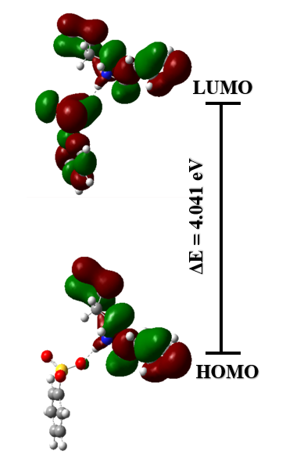
Fig. 4. Frontier molecular orbitals of diisopropylammonium phenylsulfonate at B3LYP/311+G(d,p) level
4. Conclusion
In this study, we evaluated the performance of the hybrid functional B3LYP in describing the hydrogen bond in the diisopropylammonium phenylsulfonate compound, resulting from the reaction between phenylsulfonic acid and isopropylamine. The analysis was carried out using three different basis sets: 6-311G(d,p), 6-311+G(d,p), and 6-311++G(d,p). Emphasis was placed on the synthesis of the compound and the study of both experimental (X-ray diffraction, bond lengths, and angles) and theoretical data (bond lengths and angles, IR spectra, HOMO/LUMO orbitals, energy gap, and global molecular descriptors). The calculated structural parameters show good agreement with the experimental data. The three previously mentioned basis sets used to generate the infrared spectra using the B3LYP approach validate the compound's structure as established both theoretically and experimentally. Low chemical reactivity and excellent compound stability are revealed by analyzing the energy gap between the global descriptors and the frontier molecular orbitals.
The overall results suggest that diisopropylammonium phenylsulfonate exists in a salt form, stabilized by an intermolecular hydrogen bond, and that the B3LYP method is a reliable tool for the structural study of this type of compound. Further research is underway in this area, particularly on the determination of the free enthalpy of complexation and the hydrogen bond energy, among other aspects.

Data Availability Statement: We declare that all data are available in the manuscript file.
Conflicts of Interest: Conflicts of Interest: The authors declare no conflict of interest.

Disclaimer (Artificial intelligence)
Option 1:
Author(s) hereby declare that NO generative AI technologies such as Large Language Models (ChatGPT, COPILOT, etc.) and text-to-image generators have been used during the writing or editing of this manuscript.
REFERENCES
Akash, M. S. H., & Rehman, K. (2025). Comprehensive Insights into Infrared Spectroscopy. In Essentials of Pharmaceutical Analysis (pp. 161–208). Singapore: Springer Nature Singapore. https://doi.org/10.1007/978-981-96-5996-8_4
Akintemi, E. O., Govender, K. K., & Singh, T. (2022). A DFT study of the chemical reactivity properties, spectroscopy and bioactivity scores of bioactive flavonols. Computational and Theoretical Chemistry, 1210, 113658. https://doi.org/10.1016/j.comptc.2022.113658
Alirezapour, F., Bamdad, K., Babamir, Y., & Khanmohammadi, A. (2025). Insight from DFT Calculation on the Increasing Effect of the Cation-π Interaction on the Intramolecular Hydrogen Bond in Methyl Salicylate Complex with the Presence of Different Solvents. Chemical Research in Chinese Universities, 41(3), 545–556. https://doi.org/10.1007/s40242-025-4229-3
Al-Wahaibi, L. H., El-Emam, A. A., Hassan, H. M., Mary, Y. S., Mary, Y. S., Costa, R. A., et al. (2024). DFT Studies and Acetylcholinesterase Inhibition Capacity Analysis of an Adamantane-Isothiourea Derivative via Docking and MD Calculations. Polycyclic Aromatic Compounds, 44(3), 1880–1895. https://doi.org/10.1080/10406638.2023.2209254
Amna Sherin, T., Abdul Nazar, P. V., Savita, S., Shahid, M., Siddiqui, N., & Javed, S. (2025). Computational and experimental insights into the spectroscopy, electronic states, and molecular docking of (2S)-2,6-diaminohexanoic acid [DAHA]. BMC Chemistry, 19(1), 151. https://doi.org/10.1186/s13065-025-01511-4
Bae, S. K., Park, J. B., Seo, J. H., Choi, W.-K., Park, S., Sung, Y. J., & Oh, E. (2015). Improved oral absorption of cilostazol via sulfonate salt formation with mesylate and&nbsp;besylate. Drug Design, Development and Therapy, 3961. https://doi.org/10.2147/DDDT.S87687
Barhoumi, M. (2025). Investigation of the Impact of the Ferromagnetic and Antiferromagnetic Order on the Electronic and Optical Properties of 2D CrOCl Using DFT(PBE)+U and DFT(B3LYP)+U. Journal of Superconductivity and Novel Magnetism, 38(4), 180. https://doi.org/10.1007/s10948-025-07021-7
Bharate, S. S. (2021). Recent developments in pharmaceutical salts: FDA approvals from 2015 to 2019. Drug Discovery Today, 26(2), 384–398. https://doi.org/10.1016/j.drudis.2020.11.016
Costa Cabral, B. J., Guedes, R. C., Pai-Panandiker, R. S., & Nieto De Castro, C. A. (2001). Hydrogen bonding and the dipole moment of hydrofluorocarbons by density functional theory. Physical Chemistry Chemical Physics, 3(19), 4200–4207. https://doi.org/10.1039/b102879k
Daoui, S., Baydere, C., Akman, F., Kalai, F. E., Mahi, L., Dege, N., et al. (2021). Synthesis, X-ray crystallography, vibrational spectroscopy, thermal and DFT studies of (E)-6-(4-methylstyryl)-4,5-dihydropyridazin-3(2H)-one. Journal of Molecular Structure, 1225, 129180. https://doi.org/10.1016/j.molstruc.2020.129180
De Souza, T. N. V., De Carvalho, S. M. L., Vieira, M. G. A., Da Silva, M. G. C., & Brasil, D. D. S. B. (2018). Adsorption of basic dyes onto activated carbon: Experimental and theoretical investigation of chemical reactivity of basic dyes using DFT-based descriptors. Applied Surface Science, 448, 662–670. https://doi.org/10.1016/j.apsusc.2018.04.087
Dyer, P. J., & Cummings, P. T. (2006). Hydrogen bonding and induced dipole moments in water: Predictions from the Gaussian charge polarizable model and Car-Parrinello molecular dynamics. The Journal of Chemical Physics, 125(14), 144519. https://doi.org/10.1063/1.2355485
Gałyńska, M., Tecmer, P., & Boguslawski, K. (2024). Exploring Electron Affinities, LUMO Energies, and Band Gaps with Electron-Pair Theories. The Journal of Physical Chemistry A, 128(51), 11068–11073. https://doi.org/10.1021/acs.jpca.4c06904
Gundlapalli, S., Devarapalli, R., Mudda, R. R., Chennuru, R., & Rupakula, R. (2021). Novel solid forms of insomnia drug suvorexant with improved solubility and dissolution: accessing salts from a salt solvate route. CrystEngComm, 23(44), 7739–7749. https://doi.org/10.1039/D1CE01269J
Hao, D., Sun, Y., Xie, D., Chu, F., Wang, W., Zhou, A., et al. (2024). Metal- and alkali-free aerobic oxidation of 5-hydroxymethylfurfural to 5-formyl-2-furancarboxylic acid facilitated by the multiple hydrogen bond interactions in the deep eutectic solvent. Chemical Engineering Journal, 483, 149127. https://doi.org/10.1016/j.cej.2024.149127
Holikulov, U., Kazachenko, A. S., Issaoui, N., Al-Dossary, O. M., & Zhouyang, X. (2025). Non-covalent interactions in binary mixtures of sulfamic acid and methylurea. Journal of Molecular Liquids, 433, 127788. https://doi.org/10.1016/j.molliq.2025.127788
Ireta, J., Neugebauer, J., & Scheffler, M. (2004). On the Accuracy of DFT for Describing Hydrogen Bonds: Dependence on the Bond Directionality. The Journal of Physical Chemistry A, 108(26), 5692–5698. https://doi.org/10.1021/jp0377073
Jeffrey, G. A. (1997). An introduction to hydrogen bonding. New York: Oxford University Press.
Labella, J., López-Serrano, E., Labrador-Santiago, J., Barberá, J., Folcia, C. L., Sierra, T., & Torres, T. (2025). Tuning the liquid crystal behavior of subphthalocyanines: effects of substitution, chirality, and hydrogen bonding. Journal of Materials Chemistry C, 13(26), 13184–13189. https://doi.org/10.1039/D5TC01417D
Liu, M.-L. (2012). 3-Methylanilinium hydrogen phthalate. Acta Crystallographica Section E Structure Reports Online, 68(1), o228–o228. https://doi.org/10.1107/S1600536811054353
Liu, Y., Hu, C., Comotti, A., & Ward, M. D. (2011). Supramolecular Archimedean Cages Assembled with 72 Hydrogen Bonds. Science, 333(6041), 436–440. https://doi.org/10.1126/science.1204369
Lo, M., Dieng, M., Seye, D., Faye, D., Diop, C. A. B., Ngom, A., et al. (2025). Electropolymerization by self-doping of 4-amino-3-hydroxynaphthalene sulfonic acid: spectroscopy characterization and DFT for growth mechanism. Journal of Molecular Structure, 1346, 143136. https://doi.org/10.1016/j.molstruc.2025.143136
Lukin, O., & Leszczynski, J. (2002). Rationalizing the Strength of Hydrogen-Bonded Complexes. Ab Initio HF and DFT Studies. The Journal of Physical Chemistry A, 106(29), 6775–6782. https://doi.org/10.1021/jp0145154
Macrae, C. F., Edgington, P. R., McCabe, P., Pidcock, E., Shields, G. P., Taylor, R., et al. (2006). Mercury : visualization and analysis of crystal structures. Journal of Applied Crystallography, 39(3), 453–457. https://doi.org/10.1107/S002188980600731X
Muleva, C. T., & Bharate, S. S. (2023). Halide counterions in FDA-approved pharmaceutical salts. Journal of Drug Delivery Science and Technology, 89, 104999. https://doi.org/10.1016/j.jddst.2023.104999
Nagdeve, R. D., Thakur, J. S., Chandrashekharappa, S., Bairagi, K. M., Deb, P. K., Venugopala, K. N., et al. (2024). Crystal structure, hydrogen bonding interactions, Hirshfeld surfaces, energy frameworks, and DFT calculation of Diethyl 3-(4-substitutedbenzoyl)indolizine-1,2-dicarboxylates. Journal of Molecular Structure, 1308, 138080. https://doi.org/10.1016/j.molstruc.2024.138080
Rennebaum, T., Gerven, D. V., Herwede, F. C. H., & Wickleder, M. S. (2024). N₂ H₄ Derived Sulfonic Acids: Hydrazine Disulfonate, [(SO₃ )HNNH(SO₃ )]²⁻ , and Hydrazine Iso ‐disulfonate, [H₂ NN(SO₃ )₂ ]²⁻. Chemistry – A European Journal, 30(62), e202402337. https://doi.org/10.1002/chem.202402337
Sarr, B., Mbaye, A., Diop, C. A. K., Sidibe, M., & Rousselin, Y. (2019). Synthesis, structure determination and characterization by UV–Vis and IR spectroscopy of bis(diisopropylammonium) cis -dichloridobis(oxalato-κ² O¹ , O² )stannate(IV). Acta Crystallographica Section E Crystallographic Communications, 75(6), 742–745. https://doi.org/10.1107/S2056989019006030
Şaş, E. B. (2025). Optical, non-linear optical and electronic properties of 1,3,4-oxadiazole derivative: a combined experimental and theoretical study. Journal of Materials Science: Materials in Electronics, 36(20), 1241. https://doi.org/10.1007/s10854-025-15214-y
Sekar, L., Jayavarthanan, T., Manogaran, K., Sengeny, P., Venkatachalapathy, V. S. K., Soundhariya, S., et al. (2025). A DFT-based study on CFBP: Structural, solvent spectroscopic analysis and ligand protein interaction with the antipsychotic characteristics. Journal of Molecular Liquids, 426, 127361. https://doi.org/10.1016/j.molliq.2025.127361
Seye, D., Diop, C. A. K., Diop, L., & Geiger, D. K. (2018a). Diisopropylammonium benzenesulfonate. IUCrData, 3(6), x180876. https://doi.org/10.1107/S2414314618008763
Seye, D., Diop, L., Diop, C. A. K., & Geiger, D. K. (2018b). Diisopropylammonium hydrogen phthalate. IUCrData, 3(5), x180704. https://doi.org/10.1107/S2414314618007046
Seye, D., Toure, A., Lo, M., Abdoul Khadir Diop, C., Diop, L., & Geiger, D. (2019). Crystal Structure of Diisopropylammonium Hydrogen Maleate. Science Journal of Chemistry, 7(6), 110. https://doi.org/10.11648/j.sjc.2019070612
Shariatinia, Z., Erben, M. F., & Della Védova, C. O. (2012). DFT calculations on the hydrogen bonding interactions between adrenaline and trimethoxysilylpropylamine. Main Group Chemistry, 11(4), 275–284. https://doi.org/10.3233/MGC-120080
Soni, A. K., & Sahu, V. K. (2023). Platinum Difluoride: A Theoretical and Computational Based Study. Advances in Biological Chemistry, 13(06), 236–246. https://doi.org/10.4236/abc.2023.136017
Sukhanov, O. S., Shishkin, O. V., Gorb, L., Podolyan, Y., & Leszczynski, J. (2003). Molecular Structure and Hydrogen Bonding in Polyhydrated Complexes of Adenine: A DFT Study. The Journal of Physical Chemistry B, 107(12), 2846–2852. https://doi.org/10.1021/jp026487a
Sun, P., Liu, Y., Mo, F., Wu, M., Xiao, Y., Xiao, X., et al. (2023). Efficient photocatalytic degradation of high-concentration moxifloxacin over dodecyl benzene sulfonate modified graphitic carbon nitride: Enhanced photogenerated charge separation and pollutant enrichment. Journal of Cleaner Production, 393, 136320. https://doi.org/10.1016/j.jclepro.2023.136320
Tabti, S., Djedouani, A., Aggoun, D., Warad, I., Rahmouni, S., Romdhane, S., & Fouzi, H. (2018). New Cu (II), Co(II) and Ni(II) complexes of chalcone derivatives: Synthesis, X-ray crystal structure, electrochemical properties and DFT computational studies. Journal of Molecular Structure, 1155, 11–20. https://doi.org/10.1016/j.molstruc.2017.10.084
Wu, Y., Zheng, H., Li, H., Sun, Y., Zhao, C., Zhao, R., & Zhang, C. (2021). Magnetic nickel cobalt sulfide/sodium dodecyl benzene sulfonate with excellent ciprofloxacin adsorption capacity and wide pH adaptability. Chemical Engineering Journal, 426, 127208. https://doi.org/10.1016/j.cej.2020.127208
Zaib, S., Khan, I., Ibrar, A., Ali, H. S., Rana, N., Munir, R., et al. (2025). Synergistic effect of hydrogen bonding and C–H…π interactions to modulate the supramolecular assemblies of isobenzofuranones: X-ray crystallography, DFT analysis and antihyperglycemic potential. Journal of Molecular Structure, 1321, 140263. https://doi.org/10.1016/j.molstruc.2024.140263

