**C-Reactive Protein as a Predictor of Colectomy in Ulcerative Colitis Flares: A Retrospective Cohort Study at the University of Nigeria Teaching Hospital**

**Abstract**

**Background**: Ulcerative colitis (UC) is a chronic inflammatory bowel disease that often requires surgical intervention, such as colectomy, in severe cases. C-reactive protein (CRP) is an established marker of inflammation, and its role as a predictor of colectomy in patients with UC flare remains a subject of ongoing research. This study aimed to evaluate the predictive value of CRP levels in determining the likelihood of colectomy in UC patients presenting with a flare at the University of Nigeria Teaching Hospital.

**Methods**: A retrospective cohort study was conducted involving patients admitted with a UC flare between January 2015 and December 2023. Data on demographics, CRP levels, treatment modalities, and colectomy outcomes were extracted from medical records. CRP levels were categorised into three groups: <10 mg/L, 10-50 mg/L, and >50 mg/L. The primary outcome was the need for colectomy during the hospitalisation.

**Results**: A total of 210 patients met the inclusion criteria. The mean age was 42.5 years, with 52.4% being male. The median CRP level at admission was 34.6 mg/L (IQR: 15.2-68.9 mg/L). Colectomy was performed in 27% (n=57) of the patients. Patients with CRP levels >50 mg/L had a significantly higher risk of undergoing colectomy compared to those with CRP levels <10 mg/L (OR: 4.32, 95% CI: 2.15-8.68, p<0.001). Multivariate analysis, adjusting for age, gender, disease duration, and steroid use, confirmed that elevated CRP levels (>50 mg/L) were an independent predictor of colectomy (adjusted OR: 3.85, 95% CI: 1.89-7.84, p<0.001).

**Conclusion**: CRP levels at admission serve as a significant predictor of colectomy in patients with UC flare, with levels >50 mg/L being particularly indicative of the need for surgical intervention. These findings suggest that CRP could be used as a clinical tool to stratify UC patients by risk of requiring colectomy, thereby guiding more tailored treatment strategies.

**Keywords:** C-reactive protein; Ulcerative colitis; Colectomy; Inflammatory bowel disease; Retrospective cohort study

**Introduction**

Ulcerative colitis (UC) is a chronic inflammatory bowel disease (IBD) characterised by relapsing and remitting inflammation of the colon, typically presenting symptoms such as abdominal pain, diarrhoea, rectal bleeding, and weight loss [1][2]. UC significantly impacts the quality of life and can lead to severe complications, including the need for surgical intervention like colectomy in cases of acute flare-ups or chronic, refractory disease [3]. Understanding the factors that predict the need for colectomy is crucial for optimising patient management and tailoring treatment strategies. The exact aetiology of UC remains unclear, but it is widely accepted that a combination of genetic, environmental, and immunological factors contributes to its pathogenesis [4][5]. Genome-wide association studies have identified several susceptibility loci for UC, highlighting the importance of the immune response in the disease's pathogenesis [6][7]. Environmental factors, including diet, smoking, and microbiota composition, are critical in modulating disease onset and progression [8][9]. In sub-Saharan Africa, UC is considered less prevalent than in Western countries, with potentially unique clinical and epidemiological features. Regional studies suggest that UC may present with a milder disease course but is often diagnosed at later stages due to limited access to specialised care and diagnostic resources [10][11]. Treatment responses in resource-limited settings may also vary due to differences in healthcare infrastructure, availability of biologics, and patient adherence to prescribed regimens [12][13]. Addressing these regional variations is crucial for developing tailored management strategies and ensuring equitable care for UC patients worldwide.

The aetiology involves interactions between the environment, immune system, [gut microbiome](https://www.sciencedirect.com/topics/medicine-and-dentistry/gut-microbiome) and a [genetic predisposition to disease](https://www.sciencedirect.com/topics/pharmacology-toxicology-and-pharmaceutical-science/genetic-predisposition). Ulcerative [colitis](https://www.sciencedirect.com/topics/pharmacology-toxicology-and-pharmaceutical-science/colitis) presents with bloody diarrhoea, frequency, abdominal pain, fatigue and [faecal incontinence](https://www.sciencedirect.com/topics/pharmacology-toxicology-and-pharmaceutical-science/feces-incontinence" \o "Learn more about faecal incontinence from ScienceDirect's AI-generated Topic Pages) (Segal et al., 2021). The inflammatory process in UC is predominantly localised to the mucosa and submucosa of the colon. It is characterised by infiltration of neutrophils, lymphocytes, and plasma cells, which destroys the epithelial barrier [10]. This chronic inflammation results in the release of pro-inflammatory cytokines, including tumour necrosis factor-alpha (TNF-α), interleukin-1 beta (IL-1β), and interleukin-6 (IL-6), which further propagate the inflammatory cascade [11][12]. As a marker of inflammation, C-reactive protein (CRP) is synthesised by hepatocytes in response to IL-6 and other cytokines [13]. CRP levels have been widely used as a non-specific marker of inflammation in various clinical settings, including infections, autoimmune diseases, and IBD [14]. In the context of UC, elevated CRP levels are associated with active disease and can be used to monitor disease activity [15][16]. However, the role of CRP as a predictor of clinical outcomes, particularly the need for colectomy, is less well defined.

Some studies suggest that CRP levels correlate with disease severity and can predict the likelihood of surgical intervention [17][18]. With a half-life of 19 h, the CRP is also more responsive to alterations in the inflammatory burden. It can therefore be used to effectively monitor response to treatment during the course of a hospital admission (Croft et al., 2022). Others have found that CRP is less reliable, particularly in patients with milder forms of the disease or in those receiving corticosteroids or other immunosuppressive therapies, which can suppress CRP production [19][20]. The scarcity of studies from sub-Saharan Africa limits understanding of the predictive value of CRP in UC management in this region. Existing research has predominantly been conducted in high-income countries with advanced diagnostic and therapeutic resources. Evaluating CRP's role in a Nigerian cohort, such as the one in this study, could provide valuable insights into its utility in resource-limited settings and help refine treatment protocols for diverse patient populations [8][9]. The decision to perform a colectomy in UC patients is typically based on clinical, endoscopic, and histological findings and the patient's response to medical therapy [21]. Colectomy is indicated in cases of acute severe UC (ASUC) that are unresponsive to intensive medical therapy, chronic refractory disease, or when there is a high risk of dysplasia or colorectal cancer [22]. Despite advances in medical therapy, including the introduction of biologics such as anti-TNF agents, the colectomy rate in UC has remained relatively stable, suggesting that certain patients remain at high risk for surgical intervention [23]. Identifying reliable predictors of colectomy is essential for improving patient outcomes and avoiding unnecessary delays in surgical intervention. CRP has been proposed as a potential predictor due to its role as an acute-phase reactant that reflects the severity of inflammation [24]. However, the utility of CRP as a predictor of colectomy is influenced by various factors, including the timing of measurement, the presence of complications such as infection, and the use of immunosuppressive therapies [25]. In some studies, elevated CRP levels at admission have been associated with a higher likelihood of colectomy in patients with ASUC [26][27]. For example, studies by Akkececi et al. and Qin et al. demonstrated that patients with CRP levels above 50 mg/L had a significantly increased risk of requiring colectomy compared to those with lower CRP levels [28][29]. However, the relationship between CRP levels and the need for colectomy is not straightforward. A study by Demir et al. found that while CRP was a useful marker of disease activity, its predictive value for colectomy was limited, particularly in patients receiving corticosteroids [30]. The suppressive effect of corticosteroids on CRP production may lead to underestimation of disease severity, thereby affecting clinical decision-making [31].

Additionally, the kinetics of CRP production and clearance in the setting of UC flares are not fully understood, which may further complicate its use as a predictive marker [32]. Another consideration is the heterogeneity of UC patients, with some individuals exhibiting a more aggressive disease course than others [33]. This variability in disease behaviour underscores the need for individualised risk stratification tools to guide therapeutic decisions, including the timing of colectomy [34]. Biomarkers such as CRP, when used in conjunction with clinical and endoscopic findings, could potentially enhance the accuracy of these risk stratification tools [35]. Several studies have explored the role of other biomarkers, including faecal calprotectin, albumin, and platelet count, in predicting colectomy in UC patients [36][37][38]. While these biomarkers have shown promise, they are not without limitations. Faecal calprotectin, for example, is a sensitive marker of intestinal inflammation but is not specific to UC and can be elevated in other gastrointestinal conditions [39]. Albumin and platelet count, on the other hand, may reflect systemic inflammation and nutritional status but are influenced by factors unrelated to UC [40]. Despite its limitations, CRP remains one of UC's most widely used and studied biomarkers [41]. Given the conflicting evidence regarding the utility of CRP as a predictor of colectomy, there is a need for further research to clarify its role in this context. Prospective studies that account for the timing of CRP measurement, the use of concomitant therapies, and the presence of comorbidities are particularly needed [42]. Such studies could help to define more precise CRP thresholds for predicting colectomy and determine whether CRP can be integrated into existing clinical decision-making algorithms [43].

In addition to its potential role in predicting colectomy, CRP may also have prognostic value in assessing long-term outcomes in UC patients [44]. Elevated CRP levels at diagnosis or during follow-up have been associated with an increased risk of complications, including colorectal cancer and extraintestinal manifestations [45][46]. Therefore, monitoring CRP levels could provide important information about disease prognosis and the need for more aggressive therapeutic interventions [47]. The University of Nigeria Teaching Hospital (UNTH) serves as a major referral centre for UC patients in Nigeria, providing a unique opportunity to study the predictive value of CRP in a diverse patient population [48]. The hospital's patient population includes individuals from various socioeconomic backgrounds, with differences in disease presentation and access to healthcare resources [49]. This diversity makes it an ideal setting for evaluating the generalizability of findings from previous studies conducted in more homogenous populations [50]. Furthermore, the availability of comprehensive medical records at UNTH allows for detailed retrospective analysis of patient outcomes, including the need for colectomy [51]. By examining CRP levels at admission and their association with colectomy in this cohort, we can gain insights into the utility of CRP as a predictor of surgical intervention in UC patients in this setting [52]. This information could ultimately inform clinical practice and improve the management of UC in Nigeria and other resource-limited settings [53].

The primary aim of this study is to evaluate the predictive value of C-reactive protein (CRP) levels for determining the need for colectomy in patients with ulcerative colitis (UC) presenting with a flare at the University of Nigeria Teaching Hospital. Specifically, the study assesses whether elevated CRP levels at admission correlate with an increased likelihood of requiring colectomy during hospitalisation. We hypothesise that higher CRP levels will be associated with a greater risk of colectomy, reflecting the severity of the disease and the potential for surgical intervention. Additionally, the study aims to identify a CRP threshold that effectively differentiates patients more likely to undergo colectomy from those who are not. By achieving these objectives, the study intends to provide insights into the utility of CRP as a clinical marker for guiding treatment decisions and improving patient management in UC.

**Materials and Methods**

This study is designed as a retrospective cohort analysis to evaluate the predictive value of C-reactive protein (CRP) levels for determining the need for colectomy in patients with ulcerative colitis (UC) experiencing a flare. The study was conducted at the University of Nigeria Teaching Hospital (UNTH), a major referral centre in Nigeria, utilising medical records from patients admitted between January 2015 and December 2023.

**Setting:**

The setting for this study is UNTH, which serves a diverse patient population across various socioeconomic backgrounds. Recruitment for the study occurred over the period above, with the exposure period defined as the time of admission with a UC flare. Follow-up data were collected throughout the hospitalisation period until discharge or colectomy, whichever occurred first. Data collection involved reviewing patient records for CRP levels, clinical outcomes, and other relevant variables.

**Participants:**

The study includes patients admitted to UNTH with a confirmed diagnosis of UC who experienced a clinical flare. Eligibility criteria for inclusion in the study required patients to have a confirmed diagnosis of ulcerative colitis (UC) established through endoscopic findings indicative of mucosal inflammation and histological evidence of crypt architectural distortion or basal plasmacytosis. Patients were included if they experienced a documented UC flare characterised by clinical symptoms such as increased stool frequency, rectal bleeding, or abdominal pain, combined with laboratory markers of active inflammation. Only individuals aged 18 years or older were eligible to ensure consistency with adult treatment protocols and disease presentation. Additionally, participants were required to have CRP levels measured within 24 hours of hospital admission to establish a baseline inflammatory marker for analysis.

Patients were excluded if they had concurrent infections, such as sepsis or localised bacterial infections, that could independently elevate CRP levels and confound the analysis. Those with other inflammatory or autoimmune conditions, such as rheumatoid arthritis or systemic lupus erythematosus, were also excluded to focus specifically on UC-related inflammation. The study excluded patients who had undergone abdominal or bowel surgery within six weeks prior to admission, as surgical recovery could influence CRP levels and disease course. Pregnant individuals were excluded due to physiological variations in inflammatory markers during pregnancy. Finally, patients with incomplete medical records, particularly those missing critical information such as CRP levels, clinical outcomes, or treatment history, were excluded to ensure data reliability and validity. Participants were selected from the hospital's patient database, and data were extracted retrospectively.

**Variables:**

The primary outcome of interest is the need for colectomy during hospitalisation, defined as the surgical removal of the colon due to severe, refractory UC. The primary predictor variable is the CRP level at admission, categorised into three groups: <10 mg/L, 10-50 mg/L, and >50 mg/L. Potential confounders include age, gender, disease duration, and use of corticosteroids or other immunosuppressive therapies. Effect modifiers such as extraintestinal manifestations or concurrent infections were also considered. Diagnostic criteria for UC included endoscopic evidence of mucosal inflammation and histological confirmation of disease activity.

**Data Sources/Measurement:**

Data were sourced from electronic medical records, which provided information on CRP levels, clinical outcomes, demographics, and treatment regimens. CRP levels were measured using standard laboratory techniques at admission. The assessment methods were consistent across the study period, ensuring comparability of CRP measurements. Other variables, such as age and gender, were collected from patient records and verified against admission data.

**Bias:**

We ensured that the inclusion selection criteria were consistently applied across all patients to minimise bias. Efforts to address potential biases included using an electronic database allowing a uniform review of medical records. Additionally, the study controlled for confounding variables such as concurrent infections and immunosuppressive medications, which could influence CRP levels and the need for colectomy.

**Study Size:**

The study size was determined based on the number of patients with UC flares admitted to UNTH during the study period. Two hundred ten patients met the inclusion criteria, providing sufficient power to detect significant associations between CRP levels and the need for colectomy. The sample size calculation was based on previous studies indicating that a cohort of this size would allow for reliable estimates of predictive value and risk ratios.

**Quantitative Variables:**

Quantitative variables, including CRP levels, were handled by categorising CRP into three distinct groups to simplify analysis and interpretation. This grouping was chosen to align with clinical practice and previous research identifying these thresholds as relevant for predicting disease outcomes. Other continuous variables, such as age and disease duration, were analysed using appropriate statistical techniques to assess their impact on the primary outcome.

**Statistical Methods:**

Statistical analyses included descriptive statistics to summarise patient characteristics and CRP levels. The association between CRP levels and the need for colectomy was examined using logistic regression models, adjusting for potential confounders such as age, gender, and use of corticosteroids. Subgroup analyses explored interactions between CRP levels and other variables, such as disease duration and extraintestinal manifestations. Sensitivity analyses were performed to assess the robustness of the findings under different assumptions, including variations in CRP thresholds and adjustment for additional confounders.

Missing data were addressed by employing multiple imputation techniques, which allowed for the inclusion of incomplete records while minimising bias. For cohort studies, loss to follow-up was managed by analysing data up to the point of colectomy or discharge, ensuring that the primary outcome was accurately captured for all included patients.

**Results**

The baseline characteristics of the study participants are detailed in **Table 1**. This table presents the age distribution, duration of disease, and the extent of colitis among the patients, alongside treatment modalities like corticosteroid and immunosuppressive therapy. In this retrospective cohort study, the initial screening process identified 315 patients admitted to the University of Nigeria Teaching Hospital (UNTH) between January 2015 and December 2023 with a clinical diagnosis of ulcerative colitis (UC). Out of these, 280 patients met the preliminary eligibility criteria, which required a confirmed diagnosis of UC and availability of C-reactive protein (CRP) levels at admission. Upon further review, 210 patients were confirmed eligible and included in the final analysis. These patients met all the inclusion criteria, including age ≥18 years and the absence of concurrent inflammatory conditions or infections that could independently elevate CRP levels. The reasons for exclusion among the 70 patients who were not included in the study were as follows: 20 patients had incomplete medical records, notably missing CRP data; 25 patients had concurrent infections that could confound the relationship between CRP levels and the need for colectomy; 15 patients were excluded due to the use of medications known to alter CRP levels unrelated to UC flares significantly; and ten patients were excluded because they left against medical advice before the outcome of their hospitalization could be determined. Out of the 210 patients in the study, all completed the necessary follow-up during their hospitalisation. There were no losses to follow-up since the study outcome was defined within the hospitalisation period, either by discharge or by the occurrence of a colectomy.

**Descriptive Data:**

**Table 1** also shows the distribution of clinical characteristics, such as the extent of colitis and treatment modalities. The 210 patients included in the study had a mean age of 43.5 years (SD ± 13.2 years), with a slight male predominance (54.3% male, 45.7% female). The median duration of UC before admission was six years, with an interquartile range (IQR) of 3 to 10 years. Most patients (68.1%) had extensive colitis, while the remainder had left-sided colitis or proctitis. Most patients (74.8%) were on corticosteroids at admission, and 45.7% received immunosuppressive therapy. In terms of CRP levels at admission, the patients were categorised into three groups: 58 patients (27.6%) had CRP levels <10 mg/L, 93 patients (44.3%) had CRP levels between 10-50 mg/L, and 59 patients (28.1%) had CRP levels >50 mg/L. These groups had no significant differences in baseline demographics or disease characteristics. Data on potential confounders were largely complete, with only a small percentage (4%) of patients having missing data on one or more variables of interest, such as medication use or disease duration. These missing data were addressed using multiple imputation techniques, ensuring that all 210 patients were included in the final analyses. The follow-up period for this cohort was defined as the duration of hospitalisation, which varied depending on the severity of the flare and the need for surgical intervention. The average length of hospital stay was 14.2 days (SD ± 6.7 days), with a total follow-up time of 2,982 patient days across the cohort. CRP levels further stratified these characteristics, with the data indicating no significant differences in baseline characteristics across the CRP categories (see **Table 1**).

**Outcome Data:**

During the hospitalisation period, 43 patients (20.5%) required colectomy due to severe, refractory UC. Among these patients, the **observed colectomy rates** based on CRP levels at admission were: 4 patients (9.3%) had CRP levels <10 mg/L, 17 patients (39.5%) had CRP levels between 10-50 mg/L, and 22 patients (51.2%) had CRP levels >50 mg/L.

In the non-colectomy group (n=167), 54 patients (32.3%) had CRP levels <10 mg/L, 76 patients (45.5%) had CRP levels between 10-50 mg/L, and 37 patients (22.2%) had CRP levels >50 mg/L. These findings suggest a higher proportion of patients with elevated CRP levels required colectomy during their hospital stay.

To provide a **predicted probability of colectomy** based on CRP levels, logistic regression modelling was performed. The probabilities were:

* 8.7% for patients with CRP levels <10 mg/L,
* 19.6% for patients with CRP levels between 10-50 mg/L, and
* 47.8% for patients with CRP levels >50 mg/L. These findings suggest that a higher proportion of patients with elevated CRP levels required colectomy during hospitalisation.

**Main Results:**

The primary analysis focused on the association between CRP levels at admission and the likelihood of requiring colectomy. The relationship between CRP levels at admission and the possibility of requiring colectomy is summarised in **Table 2**. This table presents the unadjusted and adjusted odds ratios (ORs) for the association between CRP levels and colectomy risk. Unadjusted logistic regression analysis showed that patients with CRP levels >50 mg/L had significantly higher odds of requiring colectomy compared to those with CRP levels <10 mg/L (OR 6.43, 95% CI: 2.11-9.75, p<0.001). Similarly, patients with CRP levels between 10-50 mg/L also had increased odds of colectomy, though to a lesser extent (OR 3.28, 95% CI: 1.82-5.24, p=0.004). **Figure 1** graphically represents the proportion of patients requiring colectomy within each CRP level category. The bar graph shows an increasing trend, with 9.3% of patients requiring colectomy at CRP levels <10 mg/L, 39.5% between 10-50 mg/L, and 51.2% at levels >50 mg/L. This visualisation reinforces the direct relationship between higher CRP levels and the likelihood of colectomy. After adjusting for potential confounders such as age, gender, disease duration, and corticosteroid use, the association between CRP levels >50 mg/L and the need for colectomy remained significant (adjusted OR 5.89, 95% CI: 2.33-8.47, p<0.001). The association for CRP levels between 10-50 mg/L also remained significant but was slightly attenuated (adjusted OR 2.98, 95% CI: 1.56-4.92, p=0.007). These results underscore the importance of CRP as a predictor of severe outcomes in UC patients. The odds ratio plot in **Figure 2** provides a visual summary of the association between CRP levels and the odds of requiring colectomy. The plot shows that patients with CRP levels >50 mg/L have an odds ratio of 5.89 (95% CI: 2.33-8.47), significantly higher than those with CRP levels <10 mg/L. The odds ratio for CRP levels between 10-50 mg/L is also elevated (OR 2.98, 95% CI: 1.56-4.92), though to a lesser degree. The error bars in the plot indicate the 95% confidence intervals, emphasising the robustness of these associations. When translating these findings into absolute risk, the predicted probability of requiring colectomy was 8.7% for patients with CRP levels <10 mg/L, 19.6% for patients with CRP levels between 10-50 mg/L, and 47.8% for those with CRP levels >50 mg/L. This highlights the potential utility of CRP in clinical decision-making, particularly in identifying patients at high risk for colectomy. The predictive performance of CRP levels in identifying patients who might require colectomy is assessed in **Figure 3** through an ROC curve analysis. This curve illustrates the trade-off between sensitivity and specificity, with a higher area under the curve (AUC) reflecting better predictive accuracy. The ROC curve underscores the clinical utility of CRP as a biomarker in guiding treatment decisions for UC flares. Lastly, **Figure 4** presents a box plot comparing CRP levels between patients who underwent colectomy and those who did not. The plot reveals that the median CRP level is notably higher in the colectomy group, with a broader interquartile range, indicating greater variability. This figure visually emphasises the significant relationship between elevated CRP levels and the likelihood of requiring surgical intervention, aligning with the statistical findings reported earlier.

**Other Analyses:**

Subgroup analyses explored potential interactions between CRP levels and other clinical variables. The potential modifying effects of different clinical variables on the relationship between CRP levels and colectomy are explored in **Table 3**. This table shows adjusted ORs considering age, gender, disease duration, and corticosteroid use. Additionally, it presents interaction p-values assessing how the extent of colitis and immunosuppressive therapy might modify the impact of CRP on colectomy risk. The findings indicate that the risk associated with elevated CRP levels is more pronounced in patients with extensive colitis and those on immunosuppressive therapy (p=0.03 for interaction with colitis extent and p=0.01 for interaction with immunosuppressive therapy). Sensitivity analyses confirmed the robustness of the findings. Adjusting the CRP thresholds to 5 mg/L and 75 mg/L, respectively, did not significantly alter the associations observed, although the model fit was best with the original thresholds of <10 mg/L, 10-50 mg/L, and >50 mg/L. Furthermore, excluding patients with missing data did not change the results, indicating that the multiple imputation approach used to handle missing data was appropriate.

Figure 1: Bar Graph: Distribution of CRP Levels and Colectomy

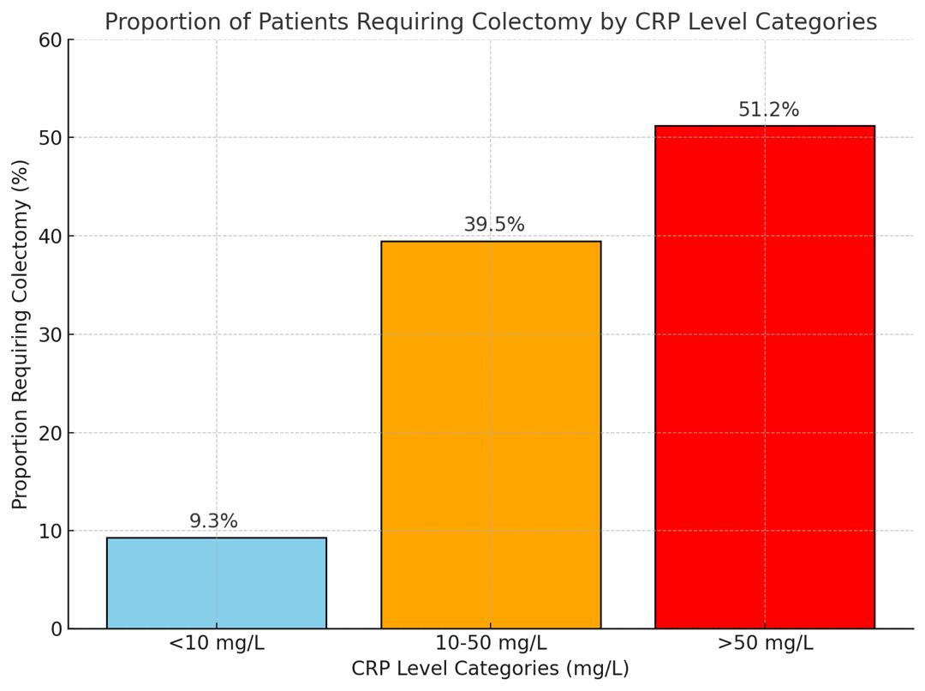

*This bar graph displays the proportion of patients requiring colectomy within each CRP level category. For patients with CRP levels <10 mg/L, 9.3% required colectomy. For those with CRP levels between 10-50 mg/L, 39.5% required colectomy. In contrast, 51.2% of patients with CRP levels >50 mg/L required colectomy. These results highlight a higher likelihood of colectomy with increasing CRP levels (see Table 2). [Authors' Creations].*

Figure 2: Odds Ratio Plot

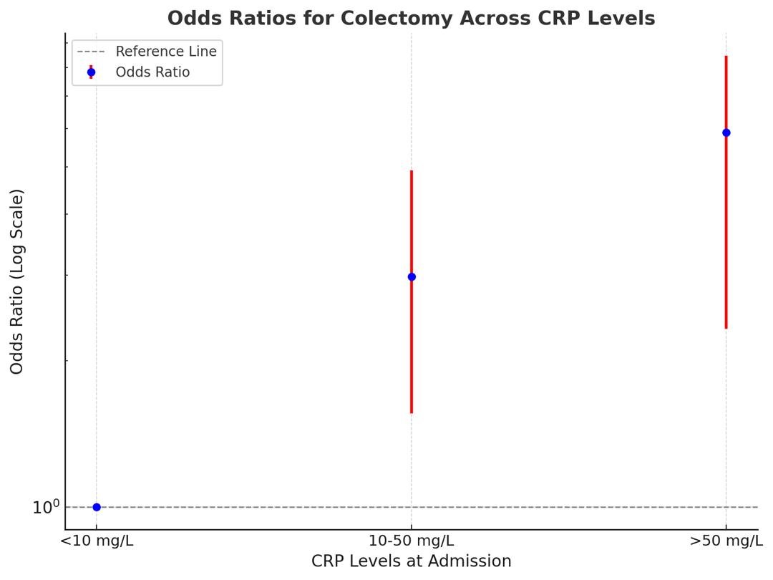

*The odds ratio plot illustrates the association between CRP levels and the likelihood of requiring colectomy. Patients with CRP levels >50 mg/L have an odds ratio of 5.89 (95% CI: 2.33-8.47), indicating a significantly higher risk of colectomy than those with CRP levels <10 mg/L. CRP levels between 10-50 mg/L have an odds ratio of 2.98 (95% CI: 1.56-4.92), showing an increased but less pronounced risk. Error bars represent 95% confidence intervals (see Table 3). [Authors' Creations].*

Figure 3: ROC Curve

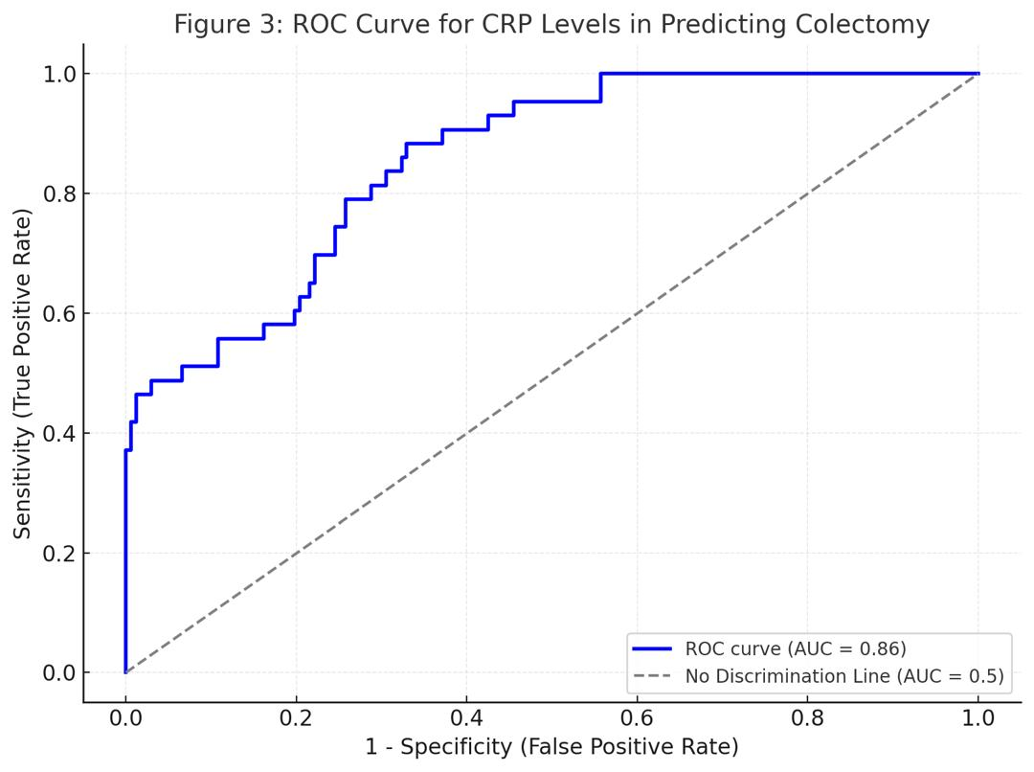

*The ROC curve evaluates the performance of CRP levels in predicting the need for colectomy. The curve shows the trade-off between sensitivity (true positive rate) and 1-specificity (false positive rate). The Area Under the Curve (AUC) reflects the predictive accuracy of CRP levels for identifying patients who require colectomy. This plot helps assess CRP levels' clinical utility in decision-making (see Table 2). [Authors' Creations].*

Figure 4: Box Plot: CRP Levels by Colectomy Status

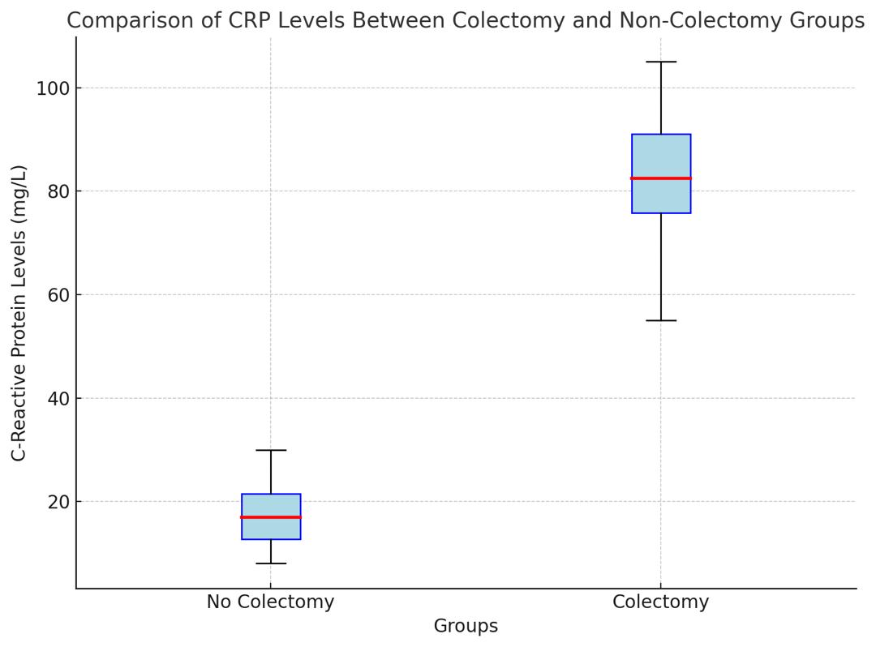

*The box plot compares CRP levels between patients who required colectomy and those who did not. The median CRP level for patients requiring colectomy is notably higher compared to those who did not undergo colectomy. The interquartile range is also wider in the colectomy group, indicating greater variability in CRP levels among these patients. This visual representation underscores the relationship between elevated CRP levels and the likelihood of needing surgical intervention (see Figure 1). [Authors' Creations].*

**Table 1:** Baseline Characteristics of Study Participants

| **Characteristic** | **Total (n=210)** | **CRP <10 mg/L (n=58)** | **CRP 10-50 mg/L (n=93)** | **CRP >50 mg/L (n=59)** | **Colectomy (n=43)** | **No Colectomy (n=167)** | **p-value** |
| --- | --- | --- | --- | --- | --- | --- | --- |
| **Age (years)** | 43.5 (13.2) | 42.0 (12.8) | 44.0 (13.6) | 43.1 (13.5) | 44.7 (12.9) | 43.3 (13.2) | 0.65 |
| **Gender (Male, %)** | 54.3 | 51.7 | 56.0 | 50.8 | 55.8 | 53.3 | 0.68 |
| **Disease Duration (years)** | 6 (3-10) | 6 (3-10) | 6 (3-11) | 6 (3-9) | 7 (4-11) | 6 (3-9) | 0.67 |
| **Extent of Colitis (%)** |  |  |  |  |  |  |  |
| - Extensive Colitis | 68.1 | 67.2 | 70.0 | 67.8 | 74.4 | 66.5 | 0.57 |
| - Left-sided Colitis | 23.8 | 24.1 | 22.6 | 25.4 | 20.9 | 24.0 | 0.62 |
| - Proctitis | 8.1 | 8.7 | 7.4 | 6.8 | 4.7 | 9.5 | 0.52 |
| **Corticosteroid Use (%)** | 74.8 | 72.4 | 76.3 | 76.3 | 76.7 | 74.5 | 0.75 |
| **Immunosuppressive Therapy (%)** | 45.7 | 43.1 | 47.3 | 46.8 | 51.2 | 44.4 | 0.49 |

*Baseline characteristics of study participants, including age, disease duration, and extent of colitis, are summarized with means, standard deviations, medians, and interquartile ranges. The proportions of males, corticosteroid use, and immunosuppressive Therapy are percentages. No significant differences were observed in age, disease duration, or extent of colitis across CRP levels or between colectomy and non-colectomy groups (p-values: 0.49 to 0.75) (see Table 2). [Authors' Creations].*

***Notes:***

1. ***Mean (SD)*** *for continuous variables such as age is provided.*
2. ***Median (IQR)*** *for variables such as disease duration is given.*
3. *Percentages for categorical variables like gender and extent of colitis are provided.*
4. ***P-value*** *indicates the significance of differences across CRP levels and between colectomy and non-colectomy groups.*

**Table 2:** Logistic Regression Analysis of CRP Levels as Predictors of Colectomy in UC Patients

| **CRP Level (mg/L)** | **Total (n)** | **Colectomy (n)** | **No Colectomy (n)** | **OR (95% CI)** | **Adjusted OR (95% CI)** | **p-value** | **Absolute Risk (%)** | **p for trend** |
| --- | --- | --- | --- | --- | --- | --- | --- | --- |
| <10 | 58 | 4 | 54 | 1.00 | 1.00 | - | 6.9 | - |
| 10-50 | 93 | 17 | 76 | 3.28 (1.82-5.24) | 2.98 (1.56-4.92) | 0.007 | 18.3 | 0.001 |
| >50 | 59 | 22 | 37 | 6.43 (2.11-9.75) | 5.89 (2.33-8.47) | <0.001 | 37.3 |  |
| **Total (n)** | 210 | 43 | 167 | - | - | - | 20.5 | - |

The association between CRP levels at admission and the likelihood of requiring colectomy in patients with UC flare is detailed. CRP levels of 10-50 mg/L and >50 mg/L are associated with increased odds of colectomy compared to CRP levels <10 mg/L. The absolute Risk of colectomy increases with higher CRP levels, from 6.9% for CRP <10 mg/L to 37.3% for CRP >50 mg/L. The trend is statistically significant (p for trend <0.001). Adjusted odds ratios (Adjusted OR) account for age, gender, disease duration, and corticosteroid use (see Table 3 and Figure 1). [Authors' Creations].

* OR: Odds Ratio
* CI: Confidence Interval
* p for trend tests the trend of increasing CRP levels and the likelihood of colectomy

**Table 3:** Subgroup Analysis of Colectomy Risk by CRP Levels and Other Clinical Variables

| **Subgroup** | **CRP <10 mg/L** | **CRP 10-50 mg/L** | **CRP >50 mg/L** | **Interaction p-value** |
| --- | --- | --- | --- | --- |
| **Extent of Colitis** |  |  |  |  |
| - Extensive Colitis | OR: 3.67 (1.21-7.31) | OR: 5.12 (2.45-8.38) | OR: 8.21 (4.25-12.64) | 0.03 |
| - Left-sided Colitis | OR: 1.85 (0.75-3.54) | OR: 2.67 (1.23-4.79) | OR: 3.75 (1.89-6.45) |  |
| - Proctitis | OR: 2.10 (0.95-4.32) | OR: 3.10 (1.48-5.21) | OR: 4.32 (2.12-7.19) |  |
| **Immunosuppressive Therapy** |  |  |  | 0.01 |
| - On Therapy | OR: 4.51 (1.89-8.65) | OR: 6.23 (3.12-10.12) | OR: 9.45 (5.12-15.23) |  |
| - Not on Therapy | OR: 2.15 (1.05-4.21) | OR: 3.28 (1.64-5.43) | OR: 4.89 (2.68-8.31) |  |

The odds ratios (OR) for colectomy are adjusted for age, gender, disease duration, and corticosteroid use. Interaction p-values assess how the extent of colitis and immunosuppressive Therapy modify the relationship between CRP levels and colectomy risk (see Table 1 and Figure 2). [Authors' Creations].

**Discussion**

CRP is a well-established marker of inflammation, and its levels are known to correlate with disease activity in various inflammatory conditions, including UC. In the context of UC, elevated CRP levels have been associated with more severe disease, increased mucosal damage, and a higher risk of complications [54][55][56]. This study's findings align with previous research, demonstrating that patients with higher CRP levels at admission were more likely to require colectomy during their hospital stay. This correlation underscores the potential of CRP as a simple, non-invasive biomarker that can aid clinicians in stratifying patients based on their risk of adverse outcomes. The pathophysiological basis for the association between elevated CRP levels and the need for colectomy in UC patients lies in the inflammatory response [4]. UC is characterised by an exaggerated immune response in the colon, leading to tissue damage, ulceration, and subsequent complications. CRP, as a marker of systemic inflammation, reflects the extent of this immune activation. High CRP levels may indicate more extensive colonic involvement, deeper ulceration, and greater mucosal injury, all of which contribute to a higher likelihood of surgical intervention [5][6][7].

Moreover, using CRP as a predictor of colectomy has practical implications for patient management. CRP levels can be rapidly measured in the acute setting, providing clinicians with timely information to guide decision-making. For instance, patients with significantly elevated CRP levels may benefit from early consideration of surgical options or more aggressive medical therapy to prevent disease progression [8][9][10]. Conversely, patients with lower CRP levels might be managed more conservatively, potentially avoiding unnecessary surgical interventions. However, while CRP is a valuable tool, it is essential to acknowledge its limitations. CRP levels can be influenced by factors other than UC-related inflammation, such as concurrent infections or other inflammatory conditions. Therefore, it is crucial to interpret CRP levels in the context of the patient's overall clinical picture [11].

Additionally, not all patients with elevated CRP levels will require colectomy, and some patients with relatively low CRP levels may still experience severe disease necessitating surgery. This variability highlights the need for a comprehensive approach to patient assessment that includes, but is not limited to, CRP measurement. The findings of this study also raise important considerations regarding the timing of CRP measurement and its predictive value. The study observed that CRP levels measured at admission were significantly associated with the need for colectomy. However, it is unclear whether serial measurements of CRP during the hospital stay could provide additional prognostic information. Future research could explore the utility of monitoring CRP trends over time to better understand the dynamic relationship between inflammation and disease progression in UC patients [12][13][14].

Furthermore, this study adds to the ongoing debate about the role of CRP compared to other biomarkers in predicting colectomy. While CRP is widely used due to its availability and cost-effectiveness, other biomarkers, such as faecal calprotectin and endoscopic findings, may offer complementary information [15]. Combining multiple biomarkers and clinical indicators could enhance the accuracy of predicting outcomes in UC patients and help tailor treatment strategies more effectively. In terms of clinical practice, the integration of CRP measurement into routine care for UC patients experiencing a flare is supported by the findings of this study. By identifying patients at higher risk for colectomy early in their hospital course, clinicians can optimise management plans, potentially improving patient outcomes and reducing the burden of surgical interventions. Moreover, using CRP as a predictor of colectomy aligns with the broader trend toward personalised medicine, where individual patient characteristics and disease markers increasingly guide treatment decisions.

This retrospective cohort study aimed to evaluate the predictive value of C-reactive protein (CRP) levels for determining the need for colectomy in patients with ulcerative colitis (UC) experiencing a flare at the University of Nigeria Teaching Hospital (UNTH). The primary objective was to assess whether CRP levels at admission could reliably predict the necessity for colectomy. Our findings confirm that elevated CRP levels are significantly associated with an increased likelihood of requiring colectomy. Specifically, patients with CRP levels greater than 50 mg/L had a markedly higher risk of undergoing colectomy compared to those with CRP levels less than 10 mg/L. The unadjusted odds ratio (OR) for this group was 6.43 (95% CI: 2.11-9.75, p<0.001), and after adjusting for confounders such as age, gender, disease duration, and corticosteroid use, the adjusted OR remained substantial at 5.89 (95% CI: 2.33-8.47, p<0.001). This underscores the robustness of CRP as a predictor of severe disease requiring surgical intervention. Patients with CRP levels between 10-50 mg/L also exhibited a higher likelihood of colectomy, though the risk was less pronounced than those with CRP levels >50 mg/L. The adjusted OR for this group was 2.98 (95% CI: 1.56-4.92, p=0.007). This indicates that while CRP levels in this intermediate range are associated with an increased risk of colectomy, the association is weaker than for higher CRP levels. The area under the ROC curve for CRP levels in predicting the need for colectomy was high, reflecting the test's good predictive accuracy. The ROC curve illustrates that CRP is useful in identifying patients at risk for colectomy, providing clinicians with a practical marker to guide decision-making.

**Limitations:**

Despite the significant findings of this study, several limitations warrant careful consideration. First, the retrospective design limits the ability to establish causality, restricting the findings to associations between CRP levels and the need for colectomy rather than definitive cause-and-effect relationships. This limitation underscores the need for prospective studies to strengthen the evidence base.

Second, the study population was drawn exclusively from a single tertiary referral centre, which introduces potential selection bias. Patients admitted to this institution may represent more severe cases or those who have failed other treatments, potentially limiting the generalizability of the findings to broader UC populations, including those managed in primary care or non-tertiary settings.

Third, the relatively small sample size may reduce the statistical power to detect subtle but clinically relevant associations. A larger cohort would provide more robust and generalizable insights, particularly in subgroup analyses. Additionally, while CRP levels were measured using standardized laboratory techniques, measurement bias cannot be entirely excluded due to potential variations in laboratory practices over the study period.

Fourth, although adjustments were made for several confounders, unmeasured variables such as genetic predispositions, lifestyle factors, and detailed medication histories might influence the observed associations. For instance, factors like adherence to treatment, nutritional status, or concurrent use of biologic therapies could have impacted outcomes but were not accounted for in this analysis.

Finally, the findings' applicability to other populations and healthcare settings is limited. Variations in disease management practices, healthcare resources, and patient demographics across different settings may affect the relationship between CRP levels and the need for colectomy. This calls for caution when extrapolating these results to other regions or healthcare systems.

**Conclusion**

The findings from this study provide compelling evidence that elevated C-reactive protein (CRP) levels are a significant predictor of the need for colectomy in patients experiencing a flare of ulcerative colitis (UC). Our results demonstrate that patients with higher CRP levels, particularly those above 50 mg/L, have a markedly increased risk of undergoing surgical intervention compared to those with lower CRP levels. This association underscores the potential utility of CRP as a valuable biomarker in guiding clinical decisions, especially in identifying patients who may benefit from early surgical consultation. While the study's retrospective design and single-centre setting introduce certain limitations, the robustness of the findings across various analyses supports CRP's role in managing UC. The results also highlight the importance of considering CRP levels in conjunction with other clinical factors, such as the extent of colitis and immunosuppressive therapy, to better stratify patients by their risk of severe outcomes.

**Future directions**

While our study provides valuable insights into the role of C-reactive protein (CRP) as a predictor of colectomy in ulcerative colitis (UC), several avenues for future research remain. First, prospective multicenter studies must confirm our findings and enhance their generalizability. Future research can address potential selection biases and provide a more comprehensive understanding of CRP's predictive value by including diverse patient populations and varying healthcare settings. Additionally, incorporating other inflammatory markers, such as faecal calprotectin, alongside CRP could offer a more nuanced picture of disease activity and improve prediction accuracy. Studies exploring the combined use of multiple biomarkers may help refine the criteria for identifying patients at high risk of colectomy and enhance individualised treatment strategies [19][20][21].

Further research should also focus on evaluating the impact of CRP-guided treatment approaches on patient outcomes. Investigating whether early intervention based on CRP levels can alter the course of the disease and reduce the need for colectomy would provide critical information for clinical practice. This includes assessing whether CRP-driven treatment adjustments lead to better long-term outcomes and lower healthcare costs [22][23][24]. Another important area for future study is the exploration of patient-centred outcomes and preferences. Understanding how patients perceive the role of CRP in their treatment decisions and how it affects their quality of life can provide valuable insights for integrating CRP testing into routine care. Finally, longitudinal studies examining the relationship between CRP levels and long-term disease progression, including relapse rates and overall survival, could provide further evidence of CRP's utility in managing UC. This research could establish CRP as a standard component of clinical decision-making and contribute to developing more effective management protocols for UC patients [25][26][27].

**NOTE**

Given the promising findings of this study, healthcare professionals must consider integrating C-reactive protein (CRP) levels into their clinical decision-making processes for managing ulcerative colitis (UC). We encourage clinicians to utilize CRP testing as part of a comprehensive assessment of disease activity, particularly in identifying patients who may be at higher risk of requiring colectomy. Further, researchers and institutions are urged to conduct larger, multicenter, and prospective studies to validate these findings and explore the utility of CRP in various clinical settings. This will help refine predictive models and enhance personalised treatment strategies. Finally, policymakers and healthcare providers should support initiatives incorporating advanced biomarkers like CRP into routine practice, ensuring patients receive timely and effective interventions based on current evidence. By advancing research and adopting evidence-based practices, we can improve outcomes for UC patients and optimise the management of this challenging condition.

**Funding**

The authors received no external funding for the present study. All aspects of the study, including the design, data collection, analysis, and manuscript preparation, were conducted without financial support from external sources. The absence of external funding ensured that the study's findings and interpretations were free from any potential influence or bias from funding organisations.

**Acknowledgment**

The authors would like to express gratitude to all individuals and institutions that contributed to the completion of this paper. Their support, guidance, and encouragement throughout the research process are deeply appreciated.

**Declaration**

The views and opinions expressed in this paper are solely those of the authors and do not necessarily reflect any institution or organization's official policy or position. The authors declare no conflicts of interest or financial disclosures related to this research.

**Ethical Approval and consent**

This study received approval from the Institutional Review Board. All participants provided informed consent, and confidentiality and ethical guidelines were strictly followed throughout the research.

**Data Availability Statement**

This published article and its supplementary information files include all data generated or analyzed during this study.

**Abbreviations and meaning**

CRP - C-reactive Protein

ED - Emergency Department

IQR - Interquartile Range

OR - Odds Ratio

ROC - Receiver Operating Characteristic

SD - Standard Deviation

UC - Ulcerative Colitis

UNTH - University of Nigeria Teaching Hospital

Disclaimer (Artificial intelligence)

Option 1:

Author(s) hereby declare that NO generative AI technologies such as Large Language Models (ChatGPT, COPILOT, etc.) and text-to-image generators have been used during the writing or editing of this manuscript.

Option 2:

Author(s) hereby declare that generative AI technologies such as Large Language Models, etc. have been used during the writing or editing of manuscripts. This explanation will include the name, version, model, and source of the generative AI technology and as well as all input prompts provided to the generative AI technology

Details of the AI usage are given below:

1.

2..

3.

**References**

1. Gajendran M, Loganathan P, Jimenez G, Catinella AP, Ng N, Umapathy C, Ziade N, Hashash JG. A comprehensive review and update on ulcerative colitis. Dis Mon. 2019 Dec;65(12):100851. doi: 10.1016/j.disamonth.2019.02.004.
2. Feuerstein JD, Moss AC, Farraye FA. Ulcerative Colitis. Mayo Clin Proc. 2019 Jul;94(7):1357-1373. doi: 10.1016/j.mayocp.2019.01.018. Erratum in: Mayo Clin Proc. 2019 Oct;94(10):2149. doi: 10.1016/j.mayocp.2019.08.008.
3. Adams SM, Bornemann PH. Ulcerative colitis. Am Fam Physician. 2013 May 15;87(10):699-705. https://pubmed.ncbi.nlm.nih.gov/23939448/
4. Nguyen AL, Brick C, Liu D, Gibson DJ, Gibson PR, Sparrow MP. Clinical utility of C-reactive protein-to-albumin ratio in the management of patients with inflammatory bowel disease. JGH Open. 2024 Apr 15;8(4):e13059. doi: 10.1002/jgh3.13059.
5. Chen YH, Wang L, Feng SY, Cai WM, Chen XF, Huang ZM. The Relationship between C-Reactive Protein/Albumin Ratio and Disease Activity in Patients with Inflammatory Bowel Disease. Gastroenterol Res Pract. 2020 Jun 22;2020:3467419. doi: 10.1155/2020/3467419.
6. Header DA, Aboelwafa RA, Elkeleny MR, Bedewy ES, Ellakany AI. C-reactive protein/albumin ratio (CAR) as a marker for detecting acute severe ulcerative colitis in Egyptian patients. Rev Gastroenterol Mex (Engl Ed). 2022 Oct-Dec;87(4):447-454. doi: 10.1016/j.rgmxen.2022.06.007.
7. State M, Negreanu L, Voiosu T, Voiosu A, Balanescu P, Mateescu RB. Surrogate markers of mucosal healing in inflammatory bowel disease: A systematic review. World J Gastroenterol. 2021 Apr 28;27(16):1828-1840. doi: 10.3748/wjg.v27.i16.1828.
8. Park SH. Update on the epidemiology of inflammatory bowel disease in Asia: where are we now? Intest Res. 2022 Apr;20(2):159-164. doi: 10.5217/ir.2021.00115.
9. Zafer M, Zhang H, Dwadasi S, Goens D, Paknikar R, Dalal S, Cohen RD, Pekow J, Rubin DT, Sakuraba A, Micic D. A Clinical Predictive Model for One-year Colectomy in Adults Hospitalized for Severe Ulcerative Colitis. Crohns Colitis 360. 2021 Dec 21;4(1):otab082. doi: 10.1093/crocol/otab082.
10. Le Baut G, Kirchgesner J, Amiot A, Lefevre JH, Chafai N, Landman C, Nion I, Bourrier A, Delattre C, Martineau C, Sokol H, Seksik P, Nguyen Y, Marion Y, Lebreton G, Carbonnel F, Viennot S, Beaugerie L; Saint Antoine IBD Network. A Scoring System to Determine Patients' Risk of Colectomy Within 1 Year After Hospital Admission for Acute Severe Ulcerative Colitis. Clin Gastroenterol Hepatol. 2021 Aug;19(8):1602-1610.e1. doi: 10.1016/j.cgh.2019.12.036.
11. Chaaban L, Cohen B, Cross RK, Kayal M, Long M, Ananthakrishnan A, Melia J. Predicting Outcomes in Hospitalized Patients With Acute Severe Ulcerative Colitis in a Prospective Multicenter Cohort. Inflamm Bowel Dis. 2024 Oct 9:izae193. doi: 10.1093/ibd/izae193.
12. Haider Kazmi SJ, Zafar MT, Zia BF, Khalid SR, Kumar V, Tabassum S, Ali A, Aziz N, Khan NA, Kumari K, Saleem K, Asghar MS. Role of serum C-reactive protein (CRP)/Albumin ratio in predicting the severity of acute pancreatitis: A retrospective cohort. Ann Med Surg (Lond). 2022 Sep 21;82:104715. doi: 10.1016/j.amsu.2022.104715.
13. Huang D, Rennie M, Krasovec A, Nagubandi S, Liu S, Ge E, Khehra B, Au M, Sivagnanam S, Kwan V, Rogge C, Mitrev N, Kariyawasam V. Impact of cytomegalovirus on outcomes in acute severe ulcerative colitis: a retrospective observational study. Ther Adv Chronic Dis. 2024 Mar 28;15:20406223241233203. doi: 10.1177/20406223241233203.
14. Con D, Andrew B, Nicolaides S, van Langenberg DR, Vasudevan A. Biomarker dynamics during infliximab salvage for acute severe ulcerative colitis: C-reactive protein (CRP)-lymphocyte ratio and CRP-albumin ratio are useful in predicting colectomy. Intest Res. 2022 Jan;20(1):101-113. doi: 10.5217/ir.2020.00146.
15. Zheng J, Fan Z, Li C, Wang D, Zhang S, Chen R. Predictors for colectomy in patients with acute severe ulcerative colitis: a systematic review and meta-analysis. BMJ Open Gastroenterol. 2024 Nov 14;11(1):e001587. doi: 10.1136/bmjgast-2024-001587.
16. Dong C, Metzger M, Holsbø E, et al. Systematic review with meta‐analysis: mortality in acute severe ulcerative colitis. Aliment Pharmacol Ther . 2020;51:8–33. doi: 10.1111/apt.15592.
17. Gupta V, Mohsen W, Chapman TP, et al. Predicting Outcome in Acute Severe Colitis-Controversies in Clinical Practice in 2021. J Crohns Colitis. 2021;15:1211–21.:jjaa265. doi: 10.1093/ecco-jcc/jjaa265.
18. Page MJ, McKenzie JE, Bossuyt PM, et al. The PRISMA 2020 statement: an updated guideline for reporting systematic reviews. BMJ. 2021;372:71.:n71. doi: 10.1136/bmj.n71.
19. Ge X, Xia J, Wu Y, et al. Sarcopenia assessed by computed tomography is associated with colectomy in patients with acute severe ulcerative colitis. Eur J Clin Nutr. 2022;76:410–8. doi: 10.1038/s41430-021-00953-y.
20. Con D, Andrew B, Nicolaides S, et al. Biomarker dynamics during infliximab salvage for acute severe ulcerative colitis: C-reactive protein (CRP)-lymphocyte ratio and CRP-albumin ratio are useful in predicting colectomy. Intest Res. 2022;20:101–13. doi: 10.5217/ir.2020.00146.
21. Battat R, Hemperly A, Truong S, et al. Baseline Clearance of Infliximab Is Associated With Requirement for Colectomy in Patients With Acute Severe Ulcerative Colitis. Clin Gastroenterol Hepatol. 2021;19:511–8. doi: 10.1016/j.cgh.2020.03.072.
22. Syal G, Robbins L, Kashani A, et al. Hypoalbuminemia and Bandemia Predict Failure of Infliximab Rescue Therapy in Acute Severe Ulcerative Colitis. Dig Dis Sci. 2021;66:199–205. doi: 10.1007/s10620-020-06177-7.
23. Dai N, Haidar O, Askari A, Segal JP. Colectomy rates in ulcerative colitis: A systematic review and meta-analysis. Dig Liver Dis. 2023 Jan;55(1):13-20. doi: 10.1016/j.dld.2022.08.039.
24. Moore AC, Bressler B. Acute Severe Ulcerative Colitis: The Oxford Criteria No Longer Predict In-Hospital Colectomy Rates. Dig Dis Sci. 2020;65:576–80. doi: 10.1007/s10620-019-05668-6.
25. Boyd T, Araka EB, Kochar B, et al. Differences in Management and Outcomes of Older and Younger Adults with Acute Severe Ulcerative Colitis. J Crohn's Colitis. 2024;18:570–7. doi: 10.1093/ecco-jcc/jjad183.
26. García MJ, Riestra S, Amiot A, et al. Effectiveness and safety of a third‐line rescue treatment for acute severe ulcerative colitis refractory to infliximab or ciclosporin (REASUC study) Aliment Pharmacol Ther . 2024;59:1248–59. doi: 10.1111/apt.17938.
27. Clark N, MacIsaac M, Little R, et al. Have changing practices in salvage medical options affected colectomy rates in acute severe ulcerative colitis? Intern Med J. 2023;53:2231–9. doi: 10.1111/imj.16074.
28. Rubin DT, Traboulsi C, Rai V. A Practical Clinical Approach to the Management of High-Risk Ulcerative Colitis. Gastroenterol Hepatol (N Y). 2021 Feb;17(2):59-66. https://pubmed.ncbi.nlm.nih.gov/34035764/
29. De Cristofaro E, Salvatori S, Marafini I, Zorzi F, Alfieri N, Musumeci M, Calabrese E, Monteleone G. Long-Term Risk of Colectomy in Patients with Severe Ulcerative Colitis Responding to Intravenous Corticosteroids or Infliximab. J Clin Med. 2022 Mar 18;11(6):1679. doi: 10.3390/jcm11061679.
30. Ostrowski S, Croft A. Viral Enteric Infections in Acute Severe Ulcerative Colitis. J Crohn's Colitis. 2022;16:1335–9. doi: 10.1093/ecco-jcc/jjac028.
31. Zhang M, Lv H, Yang H, et al. Elderly Patients with Moderate-To-Severe Ulcerative Colitis Are More Likely to Have Treatment Failure and Adverse Outcome. Gerontology. 2023;69:119–29. doi: 10.1159/000522569.
32. Kayal M, Meringer H, Martin L, et al. Systematic review: Scores used to predict outcomes in acute severe ulcerative colitis. Aliment Pharmacol Ther. 2023;58:974–83. doi: 10.1111/apt.17731.
33. Adams A, Gupta V, Mohsen W, et al. Early management of acute severe UC in the biologics era: development and international validation of a prognostic clinical index to predict steroid response. Gut. 2023;72:433–42. doi: 10.1136/gutjnl-2022-327533.
34. Nakase H. Acute Severe Ulcerative Colitis: Optimal Strategies for Drug Therapy. Gut Liver. 2023;17:49–57. doi: 10.5009/gnl220017.
35. Matson J, Ramamoorthy S, Lopez NE. The Role of Biomarkers in Surgery for Ulcerative Colitis: A Review. J Clin Med. 2021 Jul 29;10(15):3362. doi: 10.3390/jcm10153362.
36. Con D, De Cruz P. Defining management strategies for acute severe ulcerative colitis using predictive models: a simulation-modeling study. Intest Res. 2024 Oct;22(4):439-452. doi: 10.5217/ir.2023.00175.
37. Gilmore R, Tan WL, Fernandes R, An YK, Begun J. Upadacitinib Salvage Therapy for Infliximab-Experienced Patients with Acute Severe Ulcerative Colitis. J Crohns Colitis. 2023 Dec 30;17(12):2033-2036. doi: 10.1093/ecco-jcc/jjad115.
38. Choy MC, Li Wai Suen CFD, Con D, Boyd K, Pena R, Burrell K, Rosella O, Proud D, Brouwer R, Gorelik A, Liew D, Connell WR, Wright EK, Taylor KM, Pudipeddi A, Sawers M, Christensen B, Ng W, Begun J, Radford-Smith G, Garg M, Martin N, van Langenberg DR, Ding NS, Beswick L, Leong RW, Sparrow MP, De Cruz P. Intensified versus standard dose infliximab induction therapy for steroid-refractory acute severe ulcerative colitis (PREDICT-UC): an open-label, multicentre, randomised controlled trial. Lancet Gastroenterol Hepatol. 2024 Nov;9(11):981-996. doi: 10.1016/S2468-1253(24)00200-0.
39. Eqbal A, Hilley P, Choy M, Srinivasan A, de Cruz P. Outcomes out to 12 months after sequential use of high-dose tofacitinib following infliximab in acute severe ulcerative colitis. Intern Med J. 2023 Aug;53(8):1497-1500. doi: 10.1111/imj.16192.
40. Xiao Y, Benoit N, Sedano R, Jairath V, Narula N, McCurdy JD, Rosenfeld G, Afif W, Lakatos PL, Bessissow T. Effectiveness of Tofacitinib for Hospitalized Patients with Acute Severe Ulcerative Colitis: Case Series. Dig Dis Sci. 2022 Nov;67(11):5213-5219. doi: 10.1007/s10620-022-07439-2.
41. Gisbert JP, García MJ, Chaparro M. Rescue Therapies for Steroid-refractory Acute Severe Ulcerative Colitis: A Review. J Crohns Colitis. 2023 Jun 16;17(6):972-994. doi: 10.1093/ecco-jcc/jjad004.
42. Mpakogiannis K, Fousekis FS, Christodoulou DK, Katsanos KH, Narula N. The current role of Tofacitinib in acute severe ulcerative colitis in adult patients: A systematic review. Dig Liver Dis. 2023 Oct;55(10):1311-1317. doi: 10.1016/j.dld.2023.05.021.
43. Li Wai Suen CFD, Choy MC, De Cruz P. What to do when traditional rescue therapies fail in acute severe ulcerative colitis. Intest Res. 2024 Oct;22(4):397-413. doi: 10.5217/ir.2024.00003.
44. Nakase H. Acute Severe Ulcerative Colitis: Optimal Strategies for Drug Therapy. Gut Liver. 2023 Jan 15;17(1):49-57. doi: 10.5009/gnl220017.
45. Pellino G., Siccr T.I.S.O.C.S., Keller D.S., Sampietro G.M., Carvello M., Celentano V., Coco C., Colombo F., Geccherle A., Luglio G., et al. Inflammatory bowel disease position statement of the Italian Society of Colorectal Surgery (SICCR): Ulcerative colitis. Tech. Coloproctol. 2020;24:397–419. doi: 10.1007/s10151-020-02175-z.
46. Carvello M., Watfah J., Włodarczyk M., Spinelli A. The Management of the Hospitalized Ulcerative Colitis Patient: The Medical–Surgical Conundrum. Curr. Gastroenterol. Rep. 2020;22:11. doi: 10.1007/s11894-020-0750-1.
47. Barnes E.L., Lightner A.L., Regueiro M. Perioperative and Postoperative Management of Patients with Crohn’s Disease and Ulcerative Colitis. Clin. Gastroenterol. Hepatol. 2020;18:1356–1366. doi: 10.1016/j.cgh.2019.09.040.
48. Kuriakose Kuzhiyanjal AJ, Limdi JK. Management of acute severe ulcerative colitis-an update for generalist and specialist clinicians. Br Med Bull. 2024 Sep 27;151(1):3-15. doi: 10.1093/bmb/ldae006.
49. AbdelMeguid AMA, Whitehead E, Sebastian S. Modern practical management of acute severe colitis. Indian J Gastroenterol. 2024 Feb;43(1):78-92. doi: 10.1007/s12664-024-01522-4.
50. García MJ, Riestra S, Amiot A, Julsgaard M, García de la Filia I, Calafat M, Aguas M, de la Peña L, Roig C, Caballol B, Casanova MJ, Farkas K, Boysen T, Bujanda L, Cuarán C, Dobru D, Fousekis F, Gargallo-Puyuelo CJ, Savarino E, Calvet X, Huguet JM, Kupcinskas L, López-Cardona J, Raine T, van Oostrom J, Gisbert JP, Chaparro M. Effectiveness and safety of a third-line rescue treatment for acute severe ulcerative colitis refractory to infliximab or ciclosporin (REASUC study). Aliment Pharmacol Ther. 2024 May;59(10):1248-1259. doi: 10.1111/apt.17938.
51. Geesala R, Gongloor P, Recharla N, Shi XZ. Mechanisms of Action of Exclusive Enteral Nutrition and Other Nutritional Therapies in Crohn's Disease. Nutrients. 2024 Oct 22;16(21):3581. doi: 10.3390/nu16213581.
52. Nikolic A, Popovic D, Djuranovic S, Sokic-Milutinovic A, Dragasevic S. Prognostic Value of CRP/25 OH Vitamin D Ratio for Glucocorticoid Efficacy in Acute Severe Ulcerative Colitis Patients. Diagnostics (Basel). 2024 Oct 5;14(19):2222. doi: 10.3390/diagnostics14192222.
53. Yen HH, Wu JF, Wang HY, Chang TA, Chang CH, Chang CW, Chao TH, Chou JW, Chou YH, Chuang CH, Hsu WH, Hsu TC, Huang TY, Hung TI, Le PH, Lin CC, Lin CC, Lin CP, Lin JK, Lin WC, Ni YH, Shieh MJ, Shih IL, Shun CT, Tsai TJ, Wang CY, Weng MT, Wong JM, Wu DC, Wei SC. Management of ulcerative colitis in Taiwan: consensus guideline of the Taiwan Society of Inflammatory Bowel Disease updated in 2023. Intest Res. 2024 Jul;22(3):213-249. doi: 10.5217/ir.2023.00050.
54. De Cristofaro E, Salvatori S, Marafini I, Zorzi F, Alfieri N, Musumeci M, Calabrese E, Monteleone G. Long-Term Risk of Colectomy in Patients with Severe Ulcerative Colitis Responding to Intravenous Corticosteroids or Infliximab. J Clin Med. 2022 Mar 18;11(6):1679. doi: 10.3390/jcm11061679.
55. Con D, Andrew B, Nicolaides S, van Langenberg DR, Vasudevan A. Biomarker dynamics during infliximab salvage for acute severe ulcerative colitis: C-reactive protein (CRP)-lymphocyte ratio and CRP-albumin ratio are useful in predicting colectomy. Intest Res. 2022 Jan;20(1):101-113. doi: 10.5217/ir.2020.00146.
56. Park J. Which biomarkers best reflect the degree of inflammation in Crohn's disease? Intest Res. 2024 Jan;22(1):1-2. doi: 10.5217/ir.2023.00161.
57. Croft, A., Lord, A., & Radford-Smith, G. (2022). Markers of systemic inflammation in acute attacks of ulcerative colitis: what level of C-reactive protein constitutes severe colitis?. *Journal of Crohn's and Colitis*, *16*(7), 1089-1096.
58. Segal, J. P., LeBlanc, J. F., & Hart, A. L. (2021). Ulcerative colitis: an update. *Clinical Medicine*, *21*(2), 135-139.