Restoring Facial Harmony with a two-piece magnet retained orbital prosthesis: A case report

Abstract
Introduction: Orbital exenteration, often required in severe infections like mucormycosis, leads to facial defects affecting appearance and mental health. Maxillofacial prosthetic rehabilitation is essential to restore function and aesthetics.
Case Report: A patient post-exenteration due to mucormycosis was rehabilitated with a custom two-piece orbital prosthesis. It included an acrylic inner shell and a silicone outer layer, joined by magnets for easy placement and stability. Skin-tone matching achieved a lifelike appearance.
Discussion: The magnet-retained design offered a non-invasive, patient-friendly solution, especially suitable when implants are contraindicated. The prosthesis provided functional and psychological benefits, with favourable follow-up outcomes.
Conclusion: A magnet-retained, two-piece orbital prosthesis is a practical and effective method for rehabilitating post-exenteration defects. Success depends on personalized planning, suitable materials, and consistent follow-up.
Keywords: orbital prosthesis, mucormycosis, exenteration, magnetic retention, silicone prosthesis, facial rehabilitation

Introduction
Orbital exenteration is a radical procedure involving removal of the eye and surrounding tissues, often performed for aggressive malignancies or severe infections like mucormycosis. ^{[1]} Mucormycosis is an opportunistic fungal infection seen in immunocompromised individuals, particularly those with uncontrolled diabetes or post-COVID-19 complications that can rapidly invade blood vessels, causing tissue necrosis and necessitating surgical intervention.^{[2]} Post exenteration, patients face profound aesthetic, psychological, and functional challenges due to facial disfigurement. Orbital prostheses are essential in restoring facial symmetry, improving quality of life, and supporting psychological well-being. ^{[3]} Fabrication of a well-fitting, lifelike orbital prosthesis requires careful assessment, material selection, and advanced digital or conventional prosthetic techniques to achieve optimal esthetics and retention. ^{[4,5]}
This case report presents the rehabilitation of a patient who underwent orbital exenteration due to mucormycosis and was successfully rehabilitated with a customized orbital prosthesis.
Case Report
A 65-year-old male reported to the Department of Prosthodontics, GDCH Chhatrapati Sambhajinagar with the complaint of unesthetic appearance due to loss of the left eye from orbital exenteration and partial maxillectomy following post-COVID-19 mucormycosis. On examination, a Kesting’s Type IV orbital defect (penetrating orbito-maxillary defect) ^{[6]} was present (Fig. 1), causing regurgitation of food with an opening in the nasal wall that caused discharge of mucous. The patient had previously received a palatal obturator that improved speech and mastication but could not prevent nasal discharge or improve facial aesthetics. The defect had adequate undercuts for prosthesis retention.
Treatment Plan
A two-piece orbital prosthesis was planned: an inner acrylic shell to block the defect and an outer silicone portion to restore aesthetics. The acrylic shell was made of flexible acrylic material and made hollow, both of which helped in reducing the bulk and weight of the prosthesis thus enhancing patient comfort. The defect had favourable undercuts in all the four walls which helped in retention of the shell without the need of any additional retentive aids. The two parts were joined to each other using magnets ensuring proper orientation and fit.
Fabrication Steps
- Facial Moulage:
Defect depth was blocked with gauze. The facial region was boxed with modeling wax, leaving nostrils open. With the right eye closed, irreversible hydrocolloid was applied, followed by wet gauze and a Type II plaster base (Kalabhai Kaldent plaster, Kalabhai Karson Pvt. Ltd., Mumbai, India) (Fig. 2). The impression was poured with Type III dental stone (GoldStone, Asian chemicals, Rajkot, India) to create a moulage used for custom tray fabrication and iris orientation.
- Final Impression and Split Cast:
A custom tray made with self-cured acrylic (MAARC, Shiva products, Palghar, Inida) was used with addition silicone- putty and light body(Aquasil, Dentsply Sirona, Pennsylvania, United States) to record the defect. The master cast was poured in two sections using Type IV dental stone(Pearl Stone, Asian chemicals, Rajkot, India) with orientation grooves for easy separation and reassembly (Fig. 3).
- Inner Acrylic Shell:
Modeling wax was adapted to the cast with a central wax cylinder adjusted to 4 mm below wall height. After try-in and adjustments, the wax was processed with Valplast Flexible Partial Resin (Valplast, Valplast International Corporation, Brookfield, United States) using injection molding. A 10×10×2 mm Neodymium magnet (DNA Technology, Nashik, India) was embedded centrally. The finished shell was polished and tried in the patient (Fig. 4).
- Iris Orientation & Wax Pattern:
Facial measurements were marked on an OHP sheet and transferred to the moulage. A prefabricated eye shell matching the contralateral eye was positioned with wax (Fig. 5), followed by sculpting to replicate the natural eye. After trial and corrections, a 10×10×2 mm Neodymium magnet was attached on the inner side of the eye shell using clear self-cured acrylic resin (Dental Products of India, Mumbai, Maharashtra) in alignment with the magnet on the inner acrylic shell (Fig. 6).
- Silicone Fabrication:
The finalized wax-up was flasked and dewaxed. RTV silicone (Medical Grade RTV Silicone, MP Sai Enterprises, Mumbai, India) was shade-matched using a standardized pigment kit (MP Sai Enterprises, Mumbai, India) which contained 5 colours (Red, Yellow, Brown, Purple and White) and packed in layers into the mould. The flask was cured for 24 hours. The prosthesis was then finished and artificial eyelashes attached (Fig. 7).
Prosthesis Delivery
The prosthesis fitted well, with the acrylic shell engaging undercuts and magnets providing stable retention of the silicone portion (Fig. 8). Powered eyeglasses improved adaptation and masked margins. The patient was given hygiene and maintenance instructions.
At 6 months follow-up, the patient did not report any discomfort, looseness of prosthesis or degradation of the prosthesis quality.
Discussion
Orbital defects, whether arising from congenital anomalies, traumatic injuries, or ablative surgeries such as exenteration performed for malignancies or fulminant infections like mucormycosis, result in severe facial disfigurement. The orbital defects can be categorized into orbital exenteration (Removal of the globe, extraocular muscles, eyelids orbital fat and periorbita), orbital enucleation (Removal of the globe with its contents but sparing the surrounding structures) or orbital evisceration (Removal of contents of globe including cornea, leaving sclera and extraocular muscles intact).^{[6]}
These anatomical losses not only challenge physical reconstruction but also deeply impact the patient's psychological well-being, social confidence and interpersonal interaction. Multiple studies affirm that restoring facial appearance through prosthetics can significantly reduce depression, restore patient morale, and enable re-engagement in social and occupational activities ^{[7]}. A holistic rehabilitation process, therefore, must involve an interdisciplinary team, including maxillofacial prosthodontists, surgeons, psychologists and trained technicians, to adequately address the patient’s functional and emotional needs. Timely counseling and psychological support throughout the treatment journey enhance acceptance and satisfaction with the prosthesis.
In this case, the provision of a custom orbital prosthesis restored facial contour and symmetry, ultimately enhancing the patient's self-perception and psychosocial reintegration. The success of such prosthetic rehabilitation depends significantly on the selection of appropriate materials and the precision of fabrication techniques. Silicone elastomers remain the material of choice for extraoral maxillofacial prostheses due to their softness, adaptability to tissue movement and capability for lifelike characterization through intrinsic and extrinsic coloration ^{[8]}. Their resemblance to human skin and ease of manipulation during shade matching make them especially suited for orbital defects.
Retention is a critical factor in orbital prostheses. Various methods exist, including spectacles, magnets, adhesives, sockets of electric plugs, and implants. ^{[9-13]} While osseointegrated implants offer superior retention, they may be limited by anatomical, financial or personal factors. Conservative approaches, such as spectacle or magnet-retained prostheses, remain practical and accessible.^{[14]} In this case, a conservative yet effective design was chosen, comprising an inner custom acrylic shell and an outer silicone prosthesis. These were aligned and retained using embedded neodymium magnets, which provided secure yet retrievable coupling. Additionally, spectacle frames served both as a mechanical support and a cosmetic adjunct to conceal prosthetic margins and further reinforce positioning.

Silicone’s susceptibility to environmental degradation manifesting as discoloration, loss of elasticity or microbial colonization, necessitates regular maintenance and timely replacement to preserve esthetics and hygiene. Moreover, the longevity and success of the prosthesis are closely tied to patient education and ongoing professional supervision. Patients must be thoroughly instructed in cleaning protocols, daily handling, safe storage, and early detection of wear or microbial contamination. Routine follow-up appointments are essential for monitoring tissue compatibility, assessing retention, stability and making necessary adjustments to the prosthesis for sustained esthetics and comfort.^{[15]}
Limitations of the current approach include the possible corrosion and loss of retention of the magnets after prolonged used thus requiring subsequent replacement of the magnets. Also, iris positioning and wax-up was a tedious task which required some chairside alterations and thus prolonged treatment time. An alternative to this could be the use of facial scanners and designing softwares to efficiently replicate the facial comtours and skin texture.
Conclusion
This case report emphasizes the importance of individualized treatment planning in the successful rehabilitation of orbital defects. The use of a magnet-retained two-piece prosthesis proved to be a practical and satisfactory solution, offering both aesthetic and emotional benefits to the patient. Future developments in material science and digital technologies hold promise for improving the outcomes of maxillofacial prosthetic rehabilitation.^{[16]}
Consent
As per international standards or university standards, patient(s) written consent has been collected and preserved by the author(s).

Disclaimer (Artificial intelligence)
Author(s) hereby declare that NO generative AI technologies such as Large Language Models (ChatGPT, COPILOT, etc.) and text-to-image generators have been used during the writing or editing of this manuscript.
References
- Cornely OA, Alastruey-Izquierdo A, Arenz D, Chen SCA, Dannaoui E, Hochhegger B, et al. Global guideline for the diagnosis and management of mucormycosis: an initiative of the European Confederation of Medical Mycology in cooperation with the Mycoses Study Group Education and Research Consortium. Lancet Infect Dis. 2019;19(12):e405–21. doi:10.1016/S1473-3099(19)30312-3.
- Sen M, Honavar SG, Bansal R, Sengupta S, Rao R, Kim U, et al. Epidemiology, clinical profile, management, and outcome of COVID-19-associated rhino-orbital-cerebral mucormycosis in 2826 patients in India—Collaborative OPAI-IJO Study on Mucormycosis (COSMIC), Report 1. Indian J Ophthalmol. 2021;69(7):1670–92. doi:10.4103/ijo.IJO_1565_21.
- Gupta S, Ghosh S, Gaurav S, Dhirawani RB, Vyas N, Singhal P. Prosthetic rehabilitation of post-COVID mucormycosis patients: An innovative approach. J Indian Prosthodont Soc. 2022;22(3):280–6. doi:10.4103/jips.jips_293_21.
- Dabas J, Upadhyaya V, Bhatia S, Yadav S. Prosthetic rehabilitation of facial defects following mucormycosis in post-COVID-19 patients: A case series. J Prosthet Dent. 2022;128(6):1267–73. doi:10.1016/j.prosdent.2022.02.026.
- Sykes LM, Wolfaardt JF, Sukha NR. Prosthetic rehabilitation of the exenterated orbit: ocular, orbital, and facial prostheses. Int J Prosthodont. 2005;18(1):50–7.
- Vincent A, Kohlert S, Kadakia S, Sawhney R, Ducic Y. Prosthetic Reconstruction of Orbital Defects. Semin Plast Surg. 2019 May;33(2):132-137. doi: 10.1055/s-0039-1685479. Epub 2019 Apr 26. PMID: 31037051; PMCID: PMC6486384.
- Goiato MC, dos Santos DM, Bannwart LC, Moreno A, Pesqueira AA, Haddad MF, dos Santos EG. Psychosocial impact on anophthalmic patients wearing ocular prosthesis. Int J Oral Maxillofac Surg. 2013 Jan;42(1):113-9. doi: 10.1016/j.ijom.2012.05.028. Epub 2012 Jul 7. PMID: 22776781.
- Polyzois GL, Tarantili PA, Frangou MJ, Andreopoulos AG. Physical properties of a silicone prosthetic elastomer stored in simulated skin secretions. J Prosthet Dent. 2000 May;83(5):572-7. doi: 10.1016/s0022-3913(00)70017-5. PMID: 10793391.
- Pruthi G, Jain V, Rajendiran S, Jha R. Prosthetic rehabilitation after orbital exenteration: a case series. Indian J Ophthalmol. 2014 May;62(5):629-32. doi: 10.4103/0301-4738.133523. PMID: 24881615; PMCID: PMC4065520.
- Dixit, Abhay & Solanki, Neeti & Singh, Saumyendra & Singh, Raghuwar & Arya, Deeksha. (2023). A simplified approach to enhance the retention of an orbital prosthesis. The Journal of Prosthetic and Implant Dentistry. 6. 10.55231/jpid.2023.v06.i02.06.
- Pruthi G, Jain V, Sikka S. A novel method for retention of an orbital prosthesis in a case with continuous maxillary and orbital defect. J Indian Prosthodont Soc. 2010 Jun;10(2):132-6. doi: 10.1007/s13191-010-0025-x. Epub 2010 Dec 8. PMID: 21629458; PMCID: PMC3081256.
- Kavlekar, Namitha A; Kulkarni, Sudhindra S.1; Guttal, Satyabodh Shesharaj2. Silicone orbital prosthesis retained by a solitary dental implant placed in the inferior lateral orbital rim with a unique magnetic attachment framework. Journal of Dental Implants 13(2):p 114-117, Jul–Dec 2023. | DOI: 10.4103/jdi.jdi_11_23
- Pruthi, G., Jain, V., & Sikka, S. (2010). A novel method for retention of an orbital prosthesis in a case with continuous maxillary and orbital defect. The Journal of Indian Prosthodontic Society, 10(2), 132-136.
- Baba, Nadim. (2013). Maxillofacial Rehabilitation: Prosthodontic and Surgical Management of Cancer-Related, Acquired, and Congenital Defects of the Head and Neck, Third Edition. Journal of Prosthodontics. 22. 10.1111/jopr.12041.
- Aziz T, Waters M, Jagger R. Analysis of the properties of silicone rubber maxillofacial prosthetic materials. J Dent. 2003 Jan;31(1):67-74. doi: 10.1016/s0300-5712(02)00084-2. PMID: 12615022.
- Liu H, Bai S, Yu X, Zhao Y. Combined use of a facial scanner and an intraoral scanner to acquire a digital scan for the fabrication of an orbital prosthesis. J Prosthet Dent. 2019 Mar;121(3):531-534. doi: 10.1016/j.prosdent.2018.05.019. Epub 2018 Nov 30. PMID: 30509547.

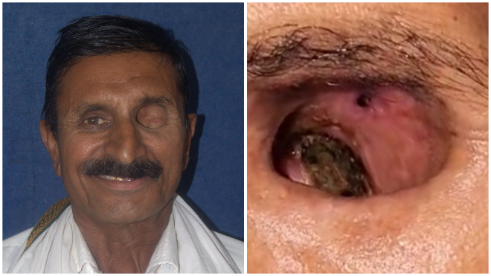
FFig. 1: Pre-rehabilitation images of the defect
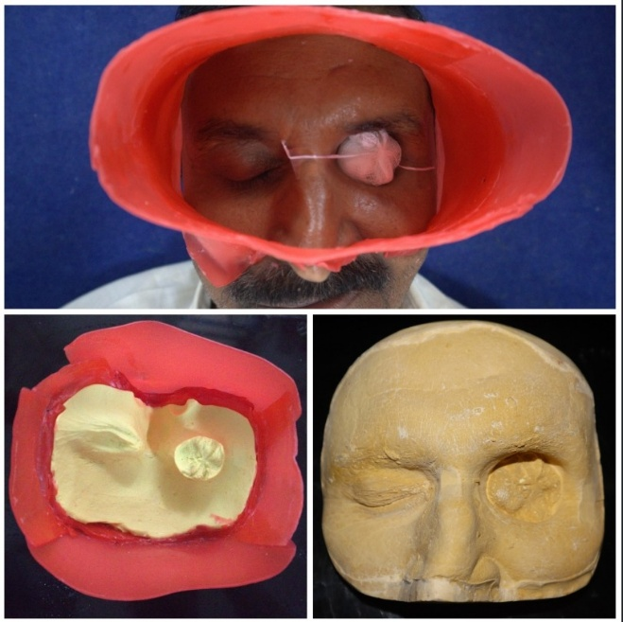
Fig. 2: Impression for making facial moulage
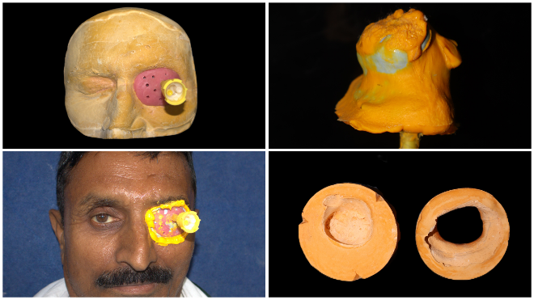
Fig. 3: Custom tray fabrication, final impression and split cast
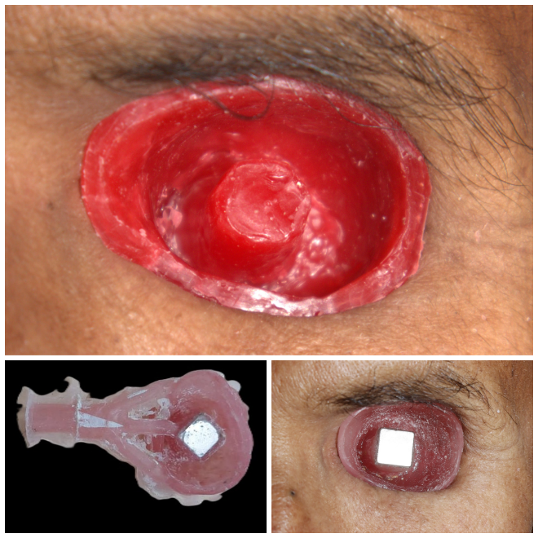
Fig. 4: Fabrication of inner acrylic shell
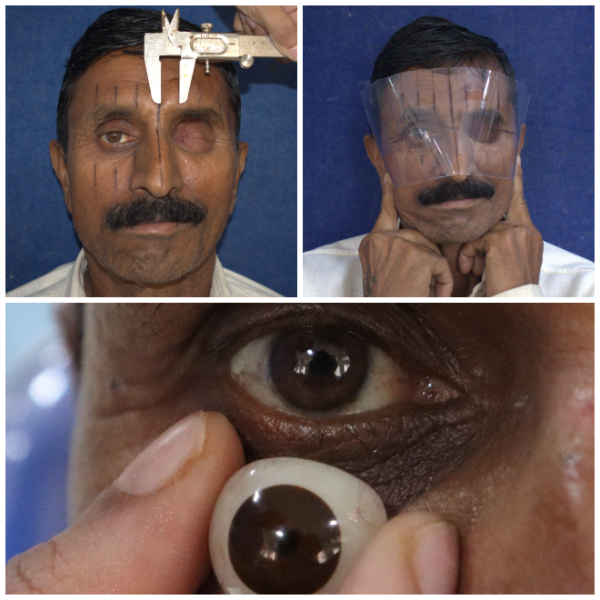
Fig. 5: Facial measurements and selection of prefabricated eye shell
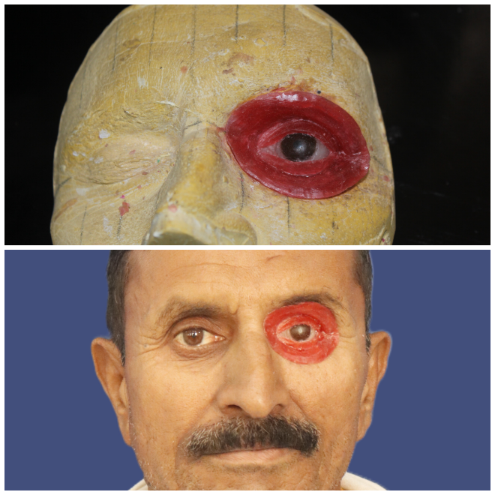
Fig. 6: Wax pattern fabrication and trial
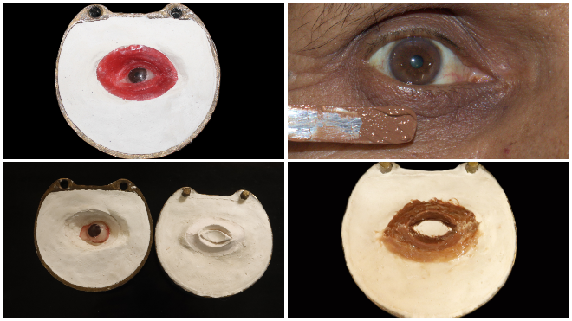
Fig. 7 Flasking, dewaxing, shade matching and packing
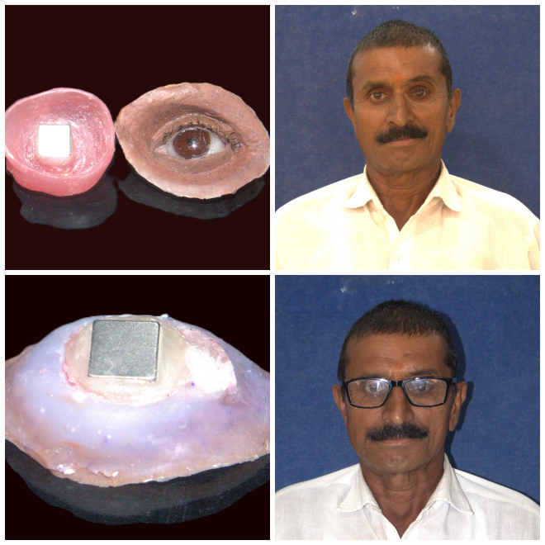
Fig. 8 Final prosthesis

