Case report
A COMMON YET OVERLOOKED LESION: LOWER LIP MUCOCELE IN FOCUS

ABSTRACT
In the oral cavity, mucoceles are the most frequently encountered lesions of the minor salivary glands and are among the most frequently biopsied oral pathologies in paediatric and adolescent populations. A 20-year-old female came to out-patient department with a painless swelling on the lower lip that had persisted for one week. She reported a history of habitual lip-biting. Clinical examination revealed a dome-shaped lesion soft in consistency with a pearly bluish hue on the surface of the right lower labial mucosa. On palpation the lesion was mobile, superficial and not attached to underlying tissues. Based on the signs and symptoms it is diagnosed as mucocele. Under local anaesthesia, an excisional biopsy was taken from the lesion and the excised specimen was sent for histopathological examination. Microscopic analysis revealed a mucous-filled cystic cavity surrounded by compressed connective tissue stroma with areas of chronic inflammatory infiltration, confirming the diagnosis of mucocele. At the 10-day postoperative follow-up, healing was satisfactory with no evidence of infection or recurrence. The patient remains asymptomatic and hemodynamically stable.
Mucoceles are common, benign lesions of the minor salivary glands, typically presenting as painless, dome-shaped swellings. Although their appearance may be concerning to patients, especially due to rapid onset or bluish coloration, mucoceles are non-neoplastic and carry no malignant potential. Recognizing their benign nature is essential to alleviate patient anxiety and to guide simple, effective management approaches."
Mucoceles are noncancerous lesions that, although common, can cause concern due to their appearance and recurrence potential. Reassuringly, they are benign and, when diagnosed promptly, can be easily treated and eliminated through simple surgical excision under the care of a dental surgeon. Early intervention not only improves outcomes but also alleviates patient anxiety regarding the nature of the lesion.
KEYWORDS: Mucocele, Minor salivary gland lesion, Lip injuries, Extravasation cyst.

INTRODUCTION
Mucoceles is the most commonly encountered disease associated with the minor salivary glands in the oral cavity. They are one of the most common biopsied oral lesions in pediatric and adolescent populations. Mucoceles predominantly occur on the lower lip, particularly in children and young adults, often following trauma or irritation to the minor salivary glands [9]. Despite their benign nature, their tendency to fluctuate in size and potentially recur makes them a significant clinical consideration in younger populations. Prompt diagnosis and appropriate management are crucial to avoid discomfort and functional difficulties. Depending on the size and persistence of the lesion, the standard course of treatment is either simple monitoring and follow-up or surgical excision [10]. This manuscript highlights a common yet often overlooked lesion—lower lip mucocele—bringing much-needed attention to its clinical significance, diagnosis, and management. Despite its frequent occurrence, mucoceles are frequently misdiagnosed or neglected, leading to delayed or inappropriate treatment. By emphasizing its distinguishing features and potential complications, this study contributes valuable insights to clinicians, aiding in early recognition and improved patient outcomes. This case report fills an important gap in routine oral pathology awareness, promoting better education and clinical vigilance within the scientific and dental communities.(1)

CASE REPORT
A 20-year-old female presented to the out-patient department of Oral Medicine and Radiology at Amrita School of Dentistry with a primary complaint of swelling on the right lower lip, which had been present for one week. She reported no associated pain or discomfort but described a gradual increase in the swelling’s size over this time. She also acknowledged a habitual lip-biting tendency, especially while studying. Her medical, drug, surgical, and dental histories were non-contributory.
A thorough general examination of the patient revealed no additional conditions. History of systemic symptoms, including fever, weight loss, night sweats, fatigue, and changes in appetite was present. Systemic examination was normal and no abnormalities were present. No signs of lymphadenopathy, masses, or tenderness over neck and cervical region. Extraoral assessment showed normal facial symmetry, intact temporomandibular joint function, and normal muscle activity.
Intraoral examination identified a well-defined, soft, dome-shaped swelling on the right lower labial mucosa at the level of the occlusal plane of teeth 42 and 43. The lesion measured approximately 1.4 × 1.1 cm, displayed a bluish hue with a pearly to translucent surface, and was mobile and non-adherent to underlying tissues. The overlying mucosa remained intact without ulceration or signs of secondary infection.
Based on the signs and clinical features, a provisional diagnosis of mucocele was established. Surgical excision was planned for definitive treatment and histopathological confirmation. Under local anaesthesia (2 ml of lignocaine with adrenaline), an incision was made over the swelling, followed by blunt dissection to expose the mucocele along with associated minor salivary glands. The lesion was carefully grasped using Ellis forceps and completely excised along with adjacent minor salivary gland tissue to reduce the likelihood of recurrence. Suturing was done using 3-0 silk sutures to promote optimal healing.
Tissue sample was sent for histopathological examination. Microscopic analysis revealed a mucous-filled cystic cavity surrounded by compressed connective tissue stroma with areas of chronic inflammatory infiltration and numerous mucous salivary gland acini with dilated ducts were seen. The overlying epithelium was keratinized stratified squamous in nature. These findings were consistent with an organizing type of mucocele. Sutures were removed on the fourth postoperative day, and the patient was reviewed on the tenth day, at which time healing was found to be satisfactory.
DISCUSSION
The oral cavity can develop two distinct varieties of mucoceles: the extravasation type and the retention type. ⁽¹⁾ Retention mucoceles are uncommon in adolescents, while extravasation mucoceles are frequently observed. Extravasation mucoceles happen when a salivary gland duct breaks, causing mucus to leak into nearby soft tissues and form a pseudocyst. ⁽²⁾ In contrast, the retention type is less common and happens when there is a blockage in the salivary gland duct, causing mucus to build up inside the duct and stopping or reducing the secretion from the gland. ⁽³⁾
The basic process for both types is the same, as the buildup of mucus causes swelling, which usually happens in the lower lip, but can also occur in other areas of the mouth. Mucoceles usually go through three stages: first, mucus leaks from the injured duct into nearby tissue; second, the body reacts by forming a granuloma; and finally, a capsule forms around the area, but it doesn't have a lining like normal tissue. The salivary gland duct often gets hurt or broken when someone accidentally bites their lip or cheek, causing mucus to build up in nearby tissues and creating a cyst-like structure. ⁽⁴⁾
Trauma is the most common cause of mucoceles. Chronic irritation from dental appliances or pointed teeth can also be a factor. Repetitive trauma or compression of the salivary ducts may result from orthodontic issues, including crowding, deep bites, or misaligned teeth. ⁽⁵⁾ Salivary duct blockage caused by sialolithiasis (salivary stones) is a rare reason, which can lead to mucus buildup and backflow. The current situation necessitated a comprehensive diagnostic approach due to lip enlargement.(2) A notable variant of mucocele is the ranula, which occurs specifically on the floor of the mouth and typically arises from the sublingual gland. While mucoceles are usually small, superficial, and found on the lower lip, ranulas are larger, deeper, and often present as bluish, fluctuant swellings in the floor of the mouth, sometimes crossing the midline or extending into the neck (known as a plunging ranula). While both arise due to mucus retention or extravasation, ranulas typically originate from trauma or obstruction of the sublingual gland ducts (Bartholin’s duct).(3)
In this case, the patient's habitual lip biting during periods of stress, particularly while studying, substantially contributed to the formation of the mucocele and likely caused chronic trauma. Surgical excision is the general approach to management, particularly for persistent or recurrent lesions. ^{(6,7)} However, alternative therapeutic approaches have also been reported, including cryosurgery and laser ablation, which offer minimally invasive options with reduced healing time and lower recurrence rates. These methods can be especially valuable in cases where surgical excision is contraindicated or the lesion's location complicates access. Including these options in the clinical armamentarium can help clinicians tailor treatment strategies based on lesion characteristics and patient preferences.
Our patient underwent a complete excision and is currently disease-free. Epidermoid cyst, dermoid cyst, lymphoepithelial cyst, lingual cyst, cystic schwannoma, neurofibroma, and minor salivary gland tumors are all conditions that could be mistaken for an oral mucocele. ⁽⁸⁾ In our case, the retention type of mucocele was confirmed by classic histopathologic findings, which ruled out these possibilities.
CONCLUSION
In summary, mucoceles are benign lesions that are most frequently precipitated by obstruction or trauma to the ducts of minor salivary glands, particularly in the lower lip. The development and risk of recurrence of these conditions are influenced by a multifaceted inflammatory response. Surgical excision is typically the primary method of effective treatment to prevent persistence or recurrence.

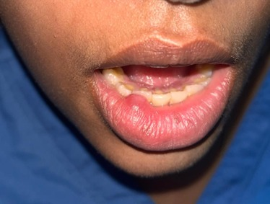
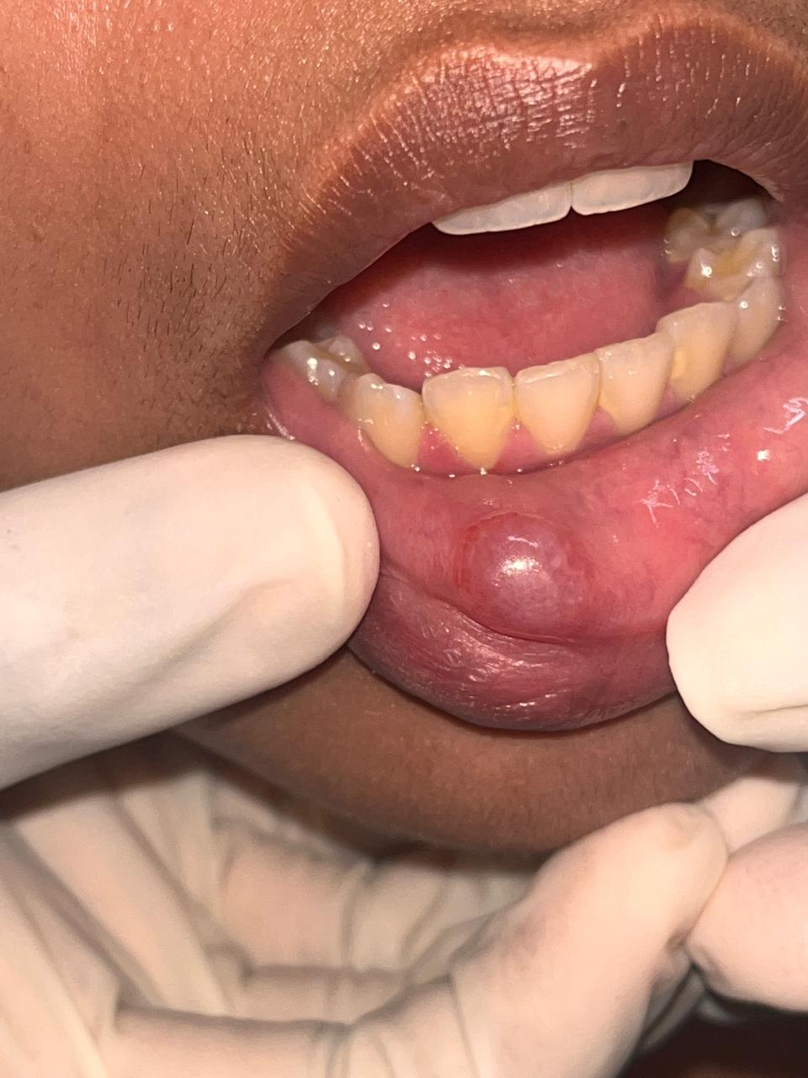
B
A
FIGURE 1 (A & B). Mucocele measuring 1.4* 1.1 cm on right side of the lower lip.

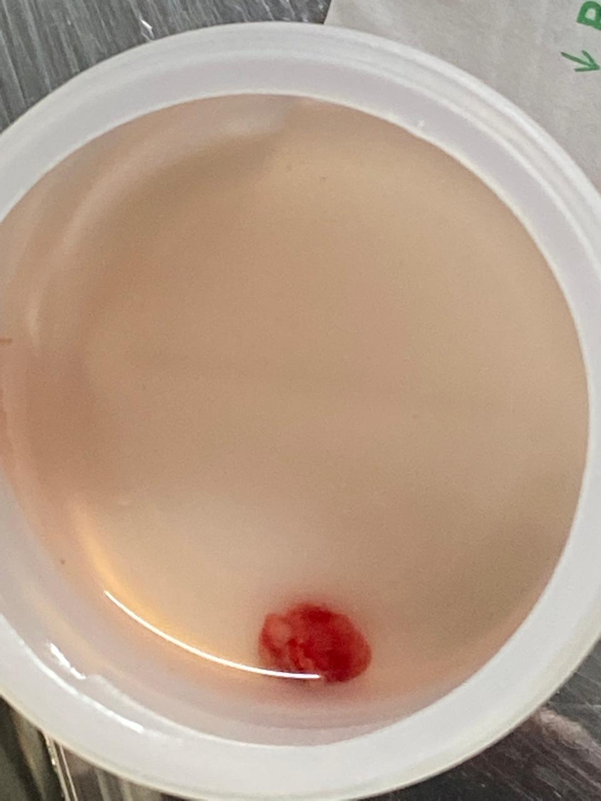
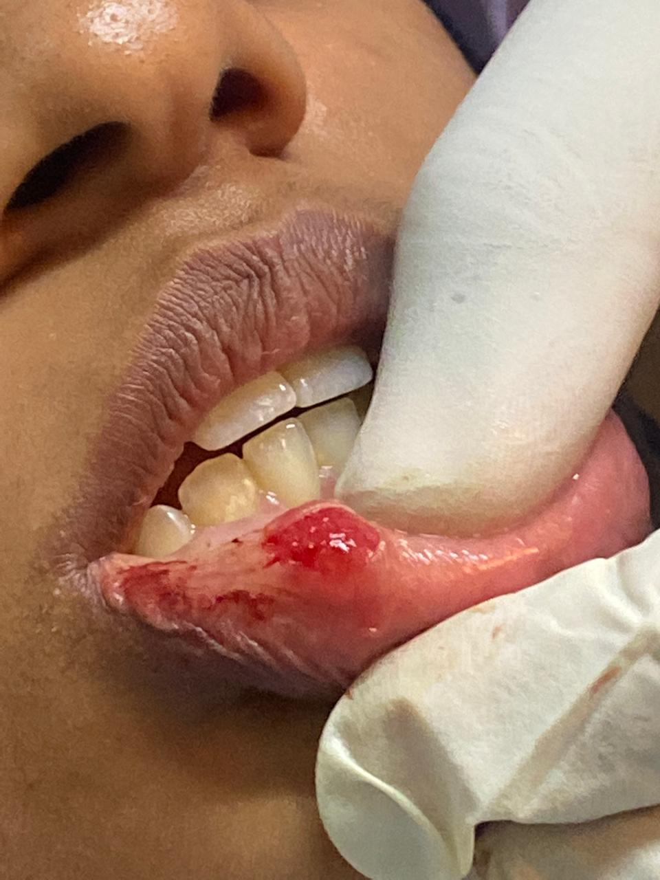
FIGURE 2. Surgical removal of the lesion.
FIGURE 3. Surgically removed mucocele.

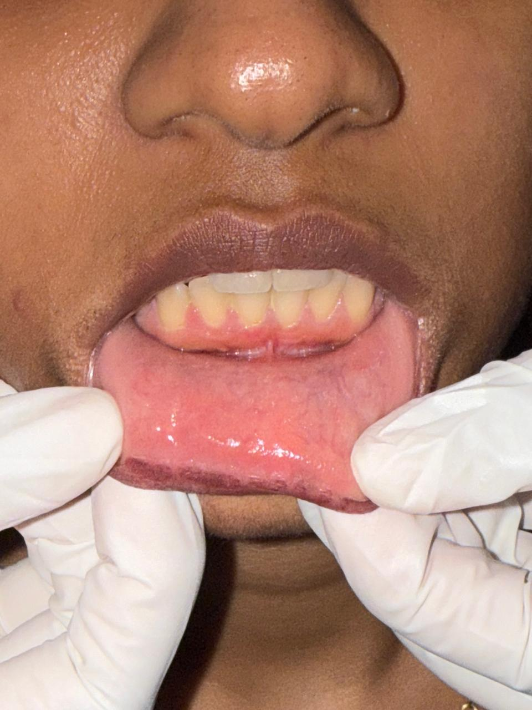
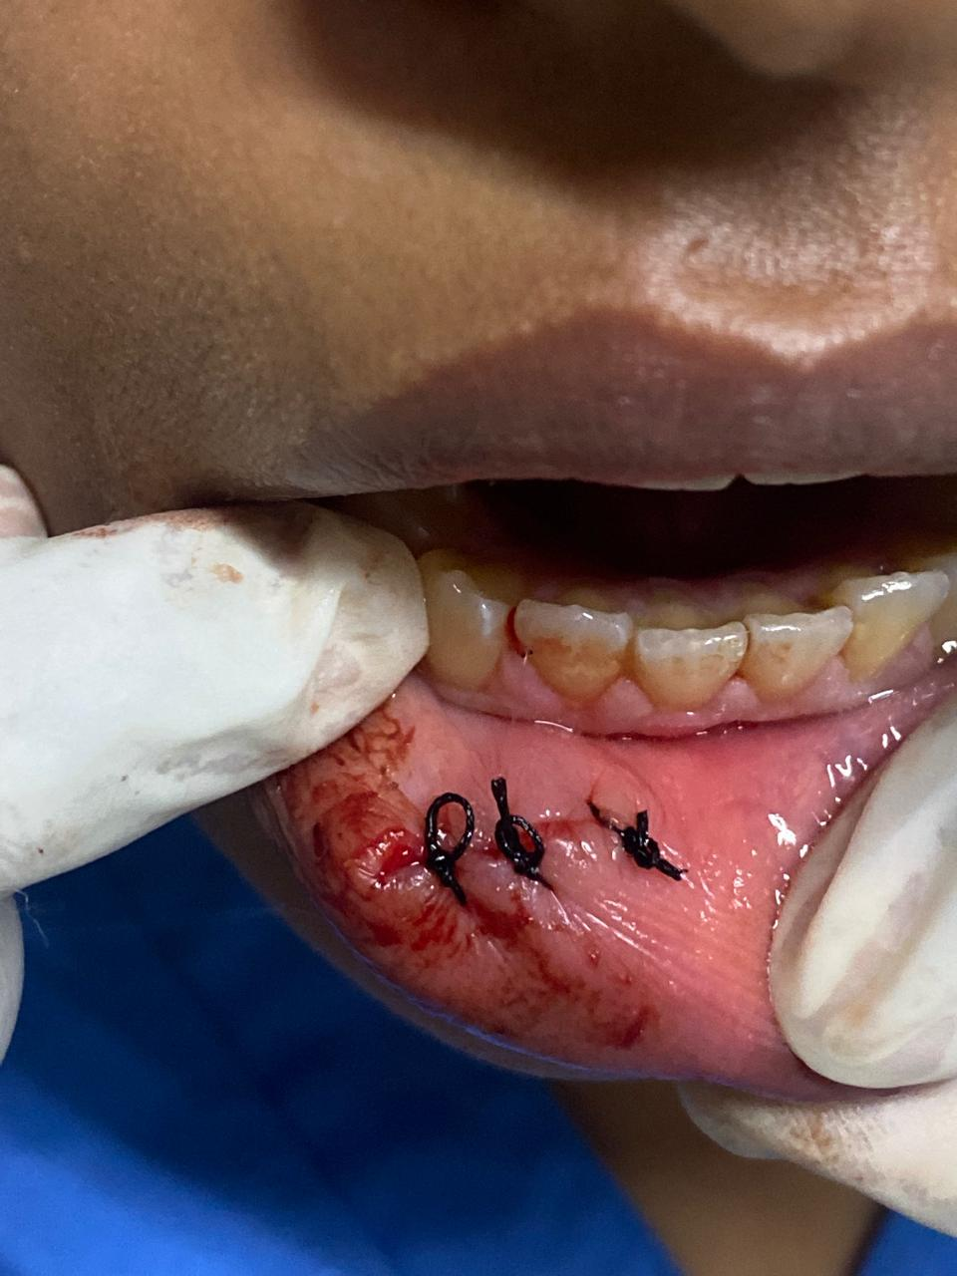

FIGURE 5 shows post operative image after 10 days.
FIGURE 4 shows operated area with 3 simple interrupted suture.

Disclaimer (Artificial intelligence)
Option 1:
Author(s) hereby declare that NO generative AI technologies such as Large Language Models (ChatGPT, manuscript.
Option 2:
Author(s) hereby declare that generative AI technologies such as Large Language Models, etc. have been used during the writing or editing of manuscripts. This explanation will include the name, version, model, and source of the generative AI technology and as well as all input prompts provided to the generative AI technology
Details of the AI usage are given below:
1.
2.
3.

REFERENCES
- Shih AN, Jin YT, Sun A, Chiang CP. Concurrent occurrence of a salivary duct cyst and two mucoceles in the lower lip. J Dent Sci. 2025 Jul;20(3):1950-1952. doi: 10.1016/j.jds.2025.05.005. Epub 2025 May 16. PMID: 40654441; PMCID: PMC12254835.
- Bowers EMR, Schaitkin B. Management of Mucoceles, Sialoceles, and Ranulas. Otolaryngol Clin North Am. 2021 Jun;54(3):543-551. doi: 10.1016/j.otc.2021.03.002. PMID: 34024482.Pandiar D, Sutharshan GS, Krishnan RP: Morphometric analysis of papillary synovial metaplasia-like changes in oral mucoceles. Oral Dis. 2024, 30:3052-5. 10.1111/odi.14777
- Kannan N, Ramalingam K, Kizhakkoottu S, Ramani P. The Diagnostic Considerations and Clinical Management of Lower Lip Swellings in Adolescents: A Narrative Review. Cureus. 2024 Oct 17;16(10):e71707. doi: 10.7759/cureus.71707. PMID: 39553086; PMCID: PMC11568828.
- Shirbhate U, Bajaj P, Patil M, Dare S: Mucous extravasation cyst associated with the lower lip and its management: a case report. Cureus. 2023, 15:e46557. 10.7759/cureus.46557
- Nagar SR, Fernandes G, Sinha A, Rajpari KN: Mucocele of the tongue: a case report and review of literature . J Oral Maxillofac Pathol. 2021, 25:S37-41. 10.4103/jomfp.jomfp_396_20
- Chaitanya P, Praveen D, Reddy M: Mucocele on lower lip: a case series . Indian Dermatol Online J. 2017, 8:205-7. 10.4103/idoj.IDOJ_151_16
- Sathiyamoorthy S, Gheena S, Jain RK: Prevalence of oral mucocele among outpatients at saveetha dental hospital, india. Bioinformation. 2020, 16:1013-18. 10.6026/973206300161013
- Miranda GG, Chaves-Junior SC, Lopes MP, et al.: Oral mucoceles: a Brazillian multicenter study of 1,901 cases. Braz Dent J. 2022, 33:81-90. 10.1590/0103-6440202204965
- Lakhani S, Barnett S, Tappuni AR, Rajakulasingam RK: Recurrent lip swelling: a diagnostic challenge . BMJ Case Rep. 2014, 2014:bcr2013203018. 10.1136/bcr-2013-203018
- Nair V, Dey B, Deshpande AH, Nigam JS: Cystic schwannoma of tongue masquerading as mucocele: a cytological pitfall. J Cytol. 2018, 35:125-6. 10.4103/JOC.JOC_50_1
- Kannan, N., Ramalingam, K., Ramani, P., & Krishnan, M. (2024). Mucocele of the Lower Lip and Its Surgical Management. Cureus, 16(10).
- Bodner, L., Manor, E., Joshua, B. Z., & Shaco‐Levy, R. (2015). Oral mucoceles in children—analysis of 56 new cases. Pediatric Dermatology, 32(5), 647-650.

