Bılateral Type I Dens Invagınatus In Maxıllary Lateral Incısors: A Case Report

Abstract

Aim and Background:
Dens invaginatus (DI), also referred to as dens in dente, is a developmental dental anomaly characterised by the invagination of the enamel organ into the dental papilla during the morphodifferentiation stage of tooth development. DI is a rare congenital dental anomaly characterised by the infolding of enamel or cementum into the dentin. The case report aims to describe bılateral type I Dens Invagınatus in maxıllary lateral incisors. This structural irregularity predisposes the tooth to caries, pulp infection, necrosis, and periradicular lesions due to its complex anatomy. Management strategies are determined by the type of DI and the presence or absence of infection, ranging from conservative sealing techniques to root canal therapy or intentional replantation.

Case Description:
A 9-year-old female pediatric patient presented with a complaint of food lodgment in the maxillary right lateral incisor. Clinical and radiographic evaluation revealed a Type I dens invaginatus with #12 and #22, which is limited to the crown and does not extend beyond the cemento-enamel junction. As the invagination was non-infected and localised, a conservative approach was chosen. The affected area was debrided and sealed using flowable composite resin to prevent further bacterial ingress, thereby reducing the risk of caries progression and associated complications.

Conclusion:
Early diagnosis and minimally invasive management of Type I dens invaginatus can prevent the progression to more severe complications, preserving tooth vitality and function. Advances in imaging technology and a better understanding of the molecular mechanisms underlying tooth development offer promising avenues for more effective diagnosis and management of this condition, such as an operating microscope and ultrasonic instrument.

Clinical Significance:

This case highlights the importance of early detection of dens invaginatus in pediatric patients. Conservative sealing using flowable composite resin is an effective method for managing non-infected Type I DI, helping to prevent pulp pathosis and maintain oral health.

Keywords:
Dens invaginatus, Dens in dente, Developmental dental anomaly, Conservative treatment, Flowable composite resin.

Introduction:

Dens invaginatus (DI) is a developmental anomaly resulting in a deepening or invagination of the enamel organ into the dental papilla before calcification of the dental tissues (Chaturvedula et al., 2021). It also referred to as dens in dente, is a developmental dental anomaly characterised by the invagination of the enamel organ into the dental papilla during the morphodifferentiation stage of tooth development. This structural abnormality can lead to complex internal anatomy, increasing the risk of caries, pulp infections, and other endodontic complications. DI can manifest in both primary and permanent dentition; however, it is more commonly observed in permanent teeth. Studies report a prevalence ranging from 0.04% to 10%, with variations influenced by population, diagnostic methods, and classification criteria.¹ Management of teeth with dens invaginatus includes preventive sealing or filling of the invagination, or if the pulp is affected, therapeutic options include vital pulp therapy, nonsurgical root canal treatment, apexification or regenerative endodontic procedures, periradicular surgery, intentional replantation, or extraction (Siqueira Jr et al., 2022).
The earliest known description of dens invaginatus (DI) in human teeth dates back to 1856, when a dentist named Socrates first documented this anomaly (Schulze, 1970). Later, in 1873, Mühlreiter reported the presence of anomalous cavities in human teeth, followed by Baume in 1874 and Busch in 1897, who further contributed to the understanding of this malformation. A significant milestone in the study of DI was achieved in 1887 when Sir John Tomes provided a detailed description in his textbook, A System of Dental Surgery. Tomes observed that while the enamel covering the tooth crown appeared well-developed, certain areas exhibited slight depressions marked by small dark spots.
The first classification of invaginated teeth was introduced by Hallett in 1953, but the most widely accepted system was proposed by Oehlers in 1957. He categorised the anomaly into three types based on its anatomical extent:
- Type I: Minor invagination confined to the crown, lined by enamel, without root involvement.
- Type II: Invagination extends into the root as a blind sac, possibly connected to the pulp, usually enamel-lined.
- Type III: Invagination penetrates through the root, forming a second apical or lateral foramen, without pulp communication; may be lined with enamel or cementum.¹
Oehlers (1957, 1958) also described variations in crown morphology, including normal crowns with deep lingual pits and altered shapes like conical, barrel-shaped, or peg-shaped teeth. Later, Ulmansky & Hermel (1964) and Vincent-Townend (1974) introduced the concept of ‘incipient dens in dente’—deep enamel-lined pits without pulp communication. Oehlers (1958) further documented radicular invaginations and cases where enamel extended from the surface into the invaginated cavity. Tomes’ earlier observations contributed to understanding the morphological complexity and pathological implications of dens invaginatus.
The prevalence of dens invaginatus (DI) varies significantly across populations and studies due to differing diagnostic criteria and methodologies⁶. The maxillary lateral incisor is consistently reported as the most commonly affected tooth ¹,⁴,⁵,⁶, while posterior and mandibular teeth are less frequently involved¹,². In a study of 1660 individuals, 0.43% of teeth exhibited DI, with 90% occurring in lateral incisors and 6.5% in posterior teeth². Although one study found no mandibular involvement, other reports have documented DI in mandibular teeth². Bilateral DI is debated, with some labelling it rare and others finding it in 43% of cases²,⁶. While DI is primarily observed in permanent teeth, several cases in primary dentition have been reported². No instances have been noted in deciduous lateral incisors¹. Gender prevalence remains inconclusive, with some studies reporting a higher occurrence in females and others noting no significant difference²,⁴. In the Indian population, prevalence ranges from 0.25% to 13.5%, depending on the region and diagnostic tools used⁴,⁵. A Western Indian CBCT-based study reported a 1.1% prevalence and found higher DI classifications significantly associated with periapical lesions^{3,} ⁴. In contrast, a North Indian study reported a 13.5% prevalence of DI and 7.3% for palatogingival groove, with notable radiographic pathologies linked to both anomalies⁵. Variability in prevalence is further compounded by evolving diagnostic standards, from early inconsistent criteria to the adoption of classification systems like those of Hallet and Oehlers⁶.
Dens invaginatus results from an infolding of the outer surface of a tooth. The clinical importance of dens invaginatus results from the risk of pulpal disease. So, all clinicians should be aware of this anomaly. It commonly occurs in maxillary permanent lateral incisors followed by the maxillary central incisors, premolars, canines and less often in the molars (Grover et al., 2023). DI is believed to result from a complex interplay of developmental, environmental, and genetic factors. Among developmental disturbances, rapid proliferation of the internal enamel epithelium into the dental papilla may disrupt tooth morphogenesis, forming enamel-lined invaginations that compromise structural integrity (Rushton, 1937)⁷,¹⁰,⁹,¹². Alternatively, DI may arise from focal growth failure of the enamel organ, allowing adjacent cells to envelop non-proliferating regions and create internal tissue pockets (Kronfeld, 1934)⁷,¹⁰,¹³. Mechanical distortion during development has also been proposed as a cause, where folding or displacement of the enamel organ results in invagination into the dental papilla (Oehlers, 1957)¹⁰,¹¹,¹⁶.

External influences such as physical pressure from adjacent developing teeth or trauma may mechanically compress the tooth germ, particularly in late-forming teeth like maxillary lateral incisors (Atkinson, 1943)⁷,¹⁵. Additionally, infections or trauma during odontogenesis may impair enamel organ coordination, triggering abnormal folding and invagination⁸,¹²,¹⁶.
Genetic and molecular contributions are increasingly recognised. Familial clustering supports a polygenic inheritance model, with up to 43% of affected individuals having first-degree relatives with DI¹³,⁶. Chromosomal anomalies, including deletions at 7q32, may disrupt genes regulating enamel organ folding⁶,¹⁶. Furthermore, molecular signalling pathways involving fibroblast growth factors (FGF) and bone morphogenetic proteins (BMP) are crucial in normal tooth morphogenesis; disruptions in these pathways may contribute to the development of DI¹⁶.

Case description:
A 9-year-old female patient reported to the Department of Pediatric and Preventive Dentistry for a routine dental check-up. The patient also complained of food lodgment in the maxillary right lateral incisor (tooth #12). There was no history of pain, swelling, or previous dental trauma.
Intraoral examination revealed the presence of a deep palatal groove on both maxillary lateral incisors (#12 and #22). The groove was explored with a periodontal probe, revealing a depth of approximately 4–5 mm and a grayish-black discoloration, indicating possible bacterial accumulation and early enamel demineralisation. No signs of pulpal involvement or periapical pathology were observed clinically.

Radiographic Evaluation and Diagnosis
Periapical radiographic imaging was performed to confirm the diagnosis. The radiograph revealed an enamel-lined invagination within the crown of tooth #12, consistent with Type I dens invaginatus according to Oehlers’ classification. There was no pulpal involvement, periapical pathology, or extension of the invagination beyond the CEJ. Based on clinical and radiographic findings, a final diagnosis of Type I dens invaginatus was made.

TREATMENT PLAN:
A conservative treatment approach was adopted as there was an absence of pulpal communication or periapical pathology, with the goal of preventing food impaction and bacterial colonisation in the invaginated groove. The procedure began with the isolation of the affected tooth to maintain a clean and moisture-free working environment. The invaginated area was thoroughly cleaned using an air-water spray to remove debris and surface contaminants. Subsequently, the groove was etched with 37% phosphoric acid for 15 seconds to promote micromechanical retention, followed by thorough rinsing and gentle air-drying. A bonding agent (Shofu Beautibond)was then applied over the etched surface and light-cured to ensure proper adhesion. To seal the groove, a flowable composite resin (Shofu Beautifil Bulk Flowable Composite-A1) was incrementally placed, ensuring complete adaptation to the surface contours and effective sealing against microbial ingress. Each layer was light-cured to enhance polymerisation and marginal integrity. Finally, the restoration was finished and polished using fine abrasives to contour the surface, enhance esthetics, and minimise plaque accumulation, thereby promoting long-term periodontal health.

Discussion:
Dens invaginatus (DI) remains a perplexing anomaly in dental development, with various theories proposed to explain its origin. While the exact cause is not yet fully understood, several key factors have emerged in the literature. According to Rushton et al. (1937), DI may have an embryological origin, resulting from the proliferation and inward growth of enamel organ cells into the dental papilla during tooth formation. On the other hand, Kronfeld et al. (1934) postulated that the condition arises from localised growth retardation within the enamel organ, allowing surrounding cells to proliferate normally, but leading to the formation of the invagination ^{1,2}. Atkinson et al. (1943) suggested that external forces, such as adjacent tooth germs or trauma, could exert pressure on the developing tooth germ, leading to the formation of the invagination.
The role of ectomesenchymal signalling in tooth morphogenesis is a significant factor, as disruptions in communication between the dental papilla and internal enamel epithelium have been shown to cause abnormal enamel organ folding and growth, as demonstrated by studies conducted in 2004 and 2000.⁵⁻⁶ Genetic factors have also been implicated in the development of dens invaginatus (DI). Evidence of familial clustering was reported in studies from 1959 and 1978, suggesting a hereditary component. Additionally, chromosomal abnormalities, such as a deletion at 7q32, have been associated with DI, as noted in a 1994 report. A genetic predisposition is further supported by findings from 1957, which highlighted a higher incidence of DI among individuals of Mongoloid descent.¹⁶
One of the most critical aspects of DI is the morphological variation of the invagination, which can range from mild, tear-shaped formations to more severe fissures communicating with the periodontal ligament. De Smit & Demaut (1982) reported irregular root canal morphology, including wave-like constrictions and dilatations, in association with DI. Such structural anomalies complicate endodontic treatment, with studies indicating the presence of multiple root canals in affected teeth (Walvekar & Behbehani, 1997; de Sousa & Bramante, 1998). Furthermore, histological and radiographic findings have been inconsistent regarding the nature of the invagination, with some studies suggesting structural discontinuities that could lead to bacterial infiltration and pulpal pathology (Kronfeld, 1934; Fischer, 1936; Hoepfel, 1936; Gustafson & Sundberg, 1950).¹
A noteworthy finding is the presence of enamel defects within the invagination, which may leave the underlying dentine exposed and more susceptible to bacterial invasion, leading to potential pulp infection. Morfis et al. (1993) used scanning electron microscopy (SEM) to report chemical differences in the enamel, such as a lack of magnesium and an increase in phosphate and calcium, while other studies observed hypomineralization in both enamel and dentine (Beynon et al., 1982). The variations in enamel composition may further contribute to the risk of bacterial contamination in affected teeth.
Despite these structural vulnerabilities, there is limited data on the actual incidence of pulpal complications in DI cases. While some studies have noted the presence of radiographic signs of pulpal pathology, such as in the study by Ruprecht et al. (1987), the true incidence remains unclear, as many cases may go undiagnosed or untreated until more severe complications arise. Ridell et al. (2001) found pulpal complications in 11.3% of cases, but these were difficult to interpret due to the inclusion of prophylactically treated teeth. The risk of pulp necrosis and other pulpal complications underscores the importance of early diagnosis and management ¹⁵
This case involved the diagnosis and preventive management of Dens Invaginatus as it was Type I in the maxillary lateral incisors (#12 and #22). Clinically, both teeth presented with deep lingual pits, and radiographic examination confirmed Type I invagination limited to the crown, with no pulpal involvement or periapical pathology. As a preventive approach, the treatment plan involved prophylactic sealing of the invaginated pits to prevent microbial ingress and potential pulpal complications. After cleaning the area with pumice, the pits were etched with 37% phosphoric acid, followed by the application of a bonding agent (Shofu Beautibond)and sealing with flowable composite resin (Shofu Beautifil Bulk Flowable Composite). The procedure was performed under isolation, ensuring proper adaptation of the material. Post-operative assessment showed successful sealing with no voids or occlusal interference. The patient was scheduled for routine follow-ups to monitor sealant integrity and pulpal health. Hence, the early intervention in such developmental anomalies is crucial to maintaining tooth vitality and preventing more invasive treatments in the future.

However, advanced imaging techniques, particularly cone beam computed tomography (CBCT), have proven to be invaluable in assessing the extent of invagination and in planning appropriate treatment strategies. These imaging modalities allow for more accurate detection and evaluation of structural anomalies, guiding clinicians in making informed decisions about the need for endodontic intervention or preventive care. Early diagnosis is crucial in preventing the need for extensive and challenging endodontic treatments later in life, as the complex anatomical features of DI predispose affected teeth to bacterial invasion and subsequent pulp damage.

Conclusion:
In conclusion, the aetiology of dens invaginatus is multifactorial, involving a combination of developmental disturbances, external influences, and genetic factors. The morphological variations of DI complicate diagnosis and treatment, requiring careful consideration of both clinical and radiographic findings. Advances in imaging technology and a better understanding of the molecular mechanisms underlying tooth development offer promising avenues for more effective diagnosis and management of this condition, such as an operating microscope and ultrasonic instrument.
Consent
As per international standards or university standards, patient(s) written consent has been collected and preserved by the author(s).

Disclaimer (Artificial intelligence)
Option 1:
Author(s) hereby declare that NO generative AI technologies such as Large Language Models (ChatGPT, COPILOT, etc.) and text-to-image generators have been used during the writing or editing of this manuscript.
Option 2:
Author(s) hereby declare that generative AI technologies such as Large Language Models, etc. have been used during the writing or editing of manuscripts. This explanation will include the name, version, model, and source of the generative AI technology and as well as all input prompts provided to the generative AI technology
Details of the AI usage are given below:
1.
2.
3.

References:
- Oehlers FA. Dens invaginatus (dilated composite odontome). I. Variations of the invagination process and associated anterior crown forms. Oral Surgery, Oral Medicine, Oral Pathology. 1957;10(11):1204-18.
- Hülsmann M. Dens invaginatus: Aetiology, classification, prevalence, diagnosis, and treatment considerations. International Endodontic Journal. 1997;30(2):79-90
- González-Mancilla S, Montero-Miralles P, Saúco-Márquez JJ, ArealQuecuty V, Cabanillas-Balsera D, Segura-Egea JJ. Prevalence of Dens Invaginatus assessed by CBCT: Systematic Review and Meta-Analysis. J Clin Exp Dent. 2022;14(11):e959-66.

- Hegde V, Mujawar A, Shanmugasundaram S, Sidhu P, Narasimhan S, Setzer FC, Nagendrababu V. Prevalence of dens invaginatus and its association with periapical lesions in a Western Indian population—a study using cone-beam computed tomography. Clinical Oral Investigations. 2022 Sep;26(9):5875-83.

- Varun K, Arora M, Pubreja L, Juneja R, Middha M. Prevalence of dens invaginatus and palatogingival groove in North India: A cone-beam computed tomography-based study. Journal of Conservative Dentistry. 2022 May 1;25(3):306-10.

- Alani A, Bishop K. Dens invaginatus. Part 1: classification, prevalence and aetiology. International endodontic journal. 2008 Dec;41(12):1123-36.

- Rushton MA. A collection of dilated composite odontomes. Br Dent J 1937;63:65-85.
- Atkinson SR. The permanent maxillary lateral incisor. Am J Orthodont 1943;29:685-698.
- Thakur S, Thakur NS, Bramta M, Gupta M. Dens invagination: A review of literature and report of two cases. Journal of natural science, biology, and medicine. 2014 Jan;5(1):218.
- Alani A, Bishop K. Dens invaginatus: Part 1—classification, prevalence, and aetiology. Int Endod J. 2008;41(12):1123-36.
- Poornima P, Meghana SB. Occurrence of Dens in Dente in Permanent Maxillary Lateral Incisors: A Case Report with Literature Review. CODS-Journal of Dentistry. 2019 Jun 1;9(2):50-4.
- Gallacher, A., Ali, R. & Bhakta, S. Dens invaginatus: diagnosis and management strategies. Br Dent J 221, 383–387 (2016). https://doi.org/10.1038/sj.bdj.2016.724
- Türk M, Gökçe B. Geographical prevalence of dens invaginatus in upper lateral teeth of young Turkish men. Gulhane Med J. 2021;63(1):1-8.
- Patel S, Dawood A, Pitt Ford T, Whaites E. The potential applications of cone beam computed tomography in the management of endodontic problems. Br Dent J. 2016;201(12):724-36.
- Hovland EJ, Block RM. Nonrecognition and subsequent endodontic treatment of dens invaginatus. J Endod. 1977;3(9):360-2.
- P okala P, Acs G. A constellation of dental anomalies in a chromosomal deletion syndrome (7q32): Case report. Pediatr Dent 1994;16:306-9.
- Ridell K, Mejare I, Matsson L. Dens invaginatus: a retrospective study of prophylactic invagination treatment. International journal of paediatric dentistry. 2001 Mar;11(2):92-7.

18. Siqueira Jr, J. F., Rôças, I. N., Hernández, S. R., Brisson-Suárez, K., Baasch, A. C., Pérez, A. R., & Alves, F. R. (2022). Dens invaginatus: clinical implications and antimicrobial endodontic treatment considerations. Journal of endodontics, 48(2), 161-170. 19. Chaturvedula, B. B., Muthukrishnan, A., Bhuvaraghan, A., Sandler, J., & Thiruvenkatachari, B. (2021). Dens invaginatus: a review and orthodontic implications. British dental journal, 230(6), 345-350.

20. Grover , J., Grover , R., Gupta , S., Gupta , T., & Mehra , M. (2023). A Rare Occurence of Dens Evaginatus with Two Dens Invaginations in a Single Tooth: A Case Report. Journal of Pharmaceutical Research International, 35(20), 32–35.

Figures
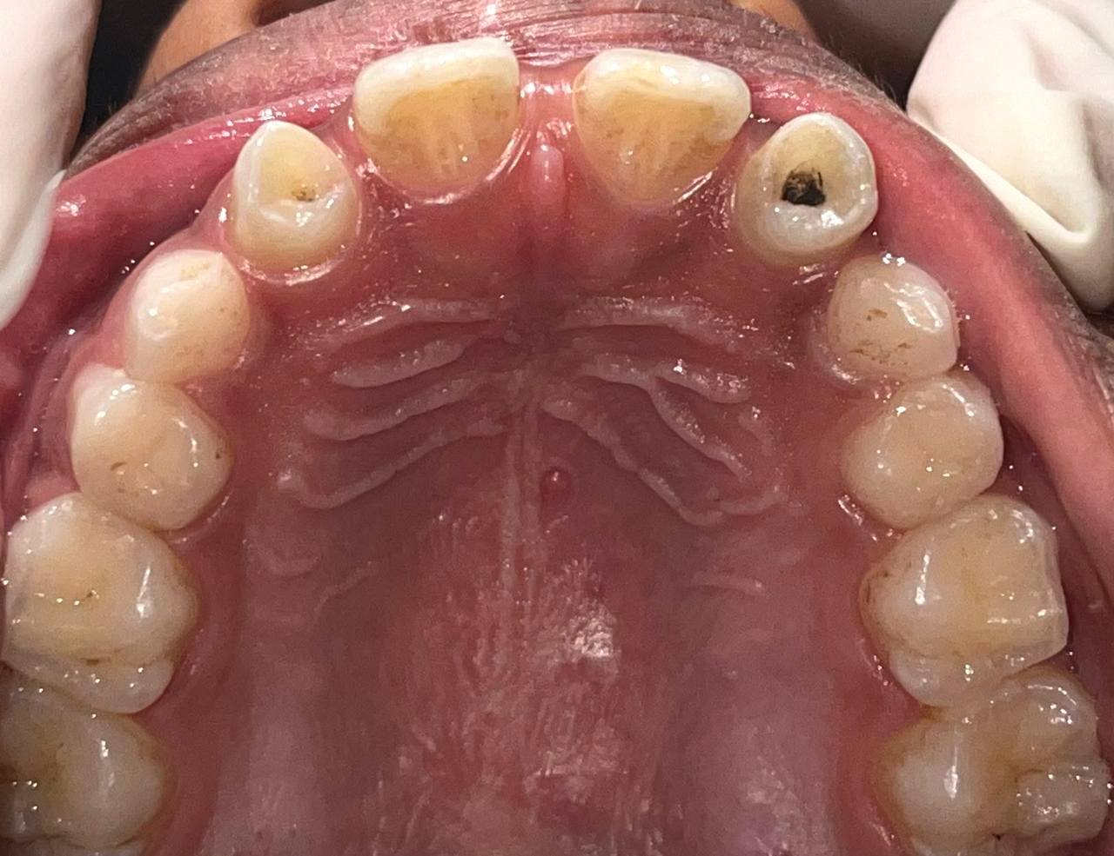

\

Figure 1: Intraoral photograph showing the palatal groove on the maxillary right lateral incisor (#12) and left lateral incisor(#22)

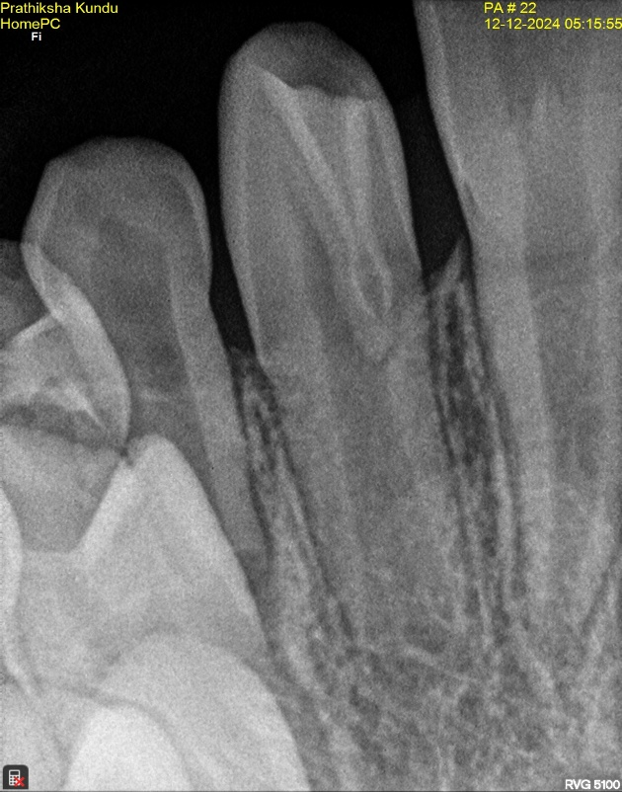
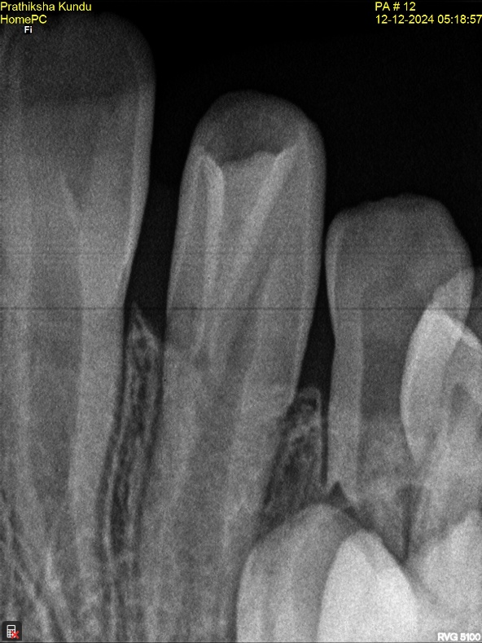
Figure:3 Radiograph showing Type 1 Dens invaginatus #22
Figure:2 Radiograph showing Type 1 Dens invaginatus #12

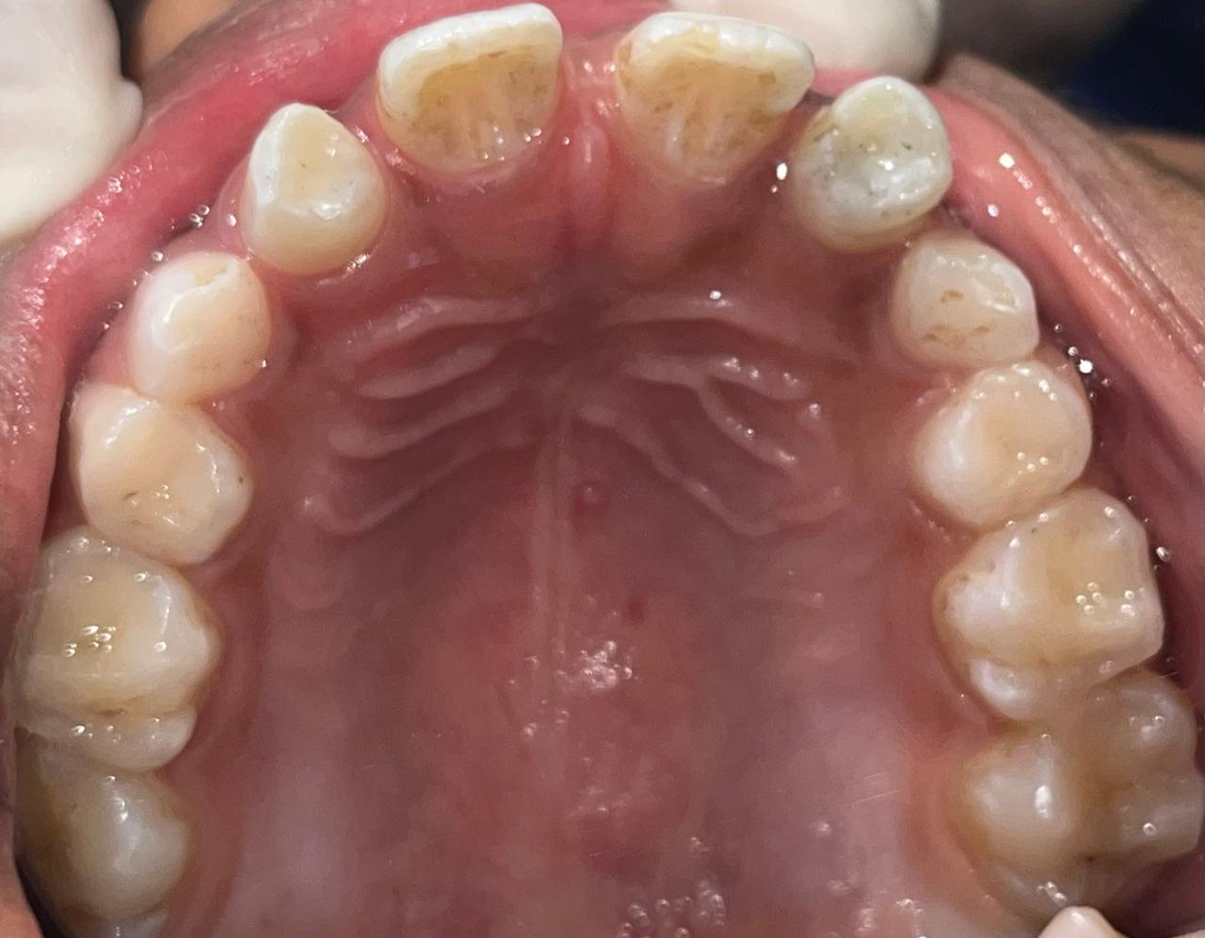

Figure 4: Post-treatment image showing the composite restoration sealing the invaginated groove.

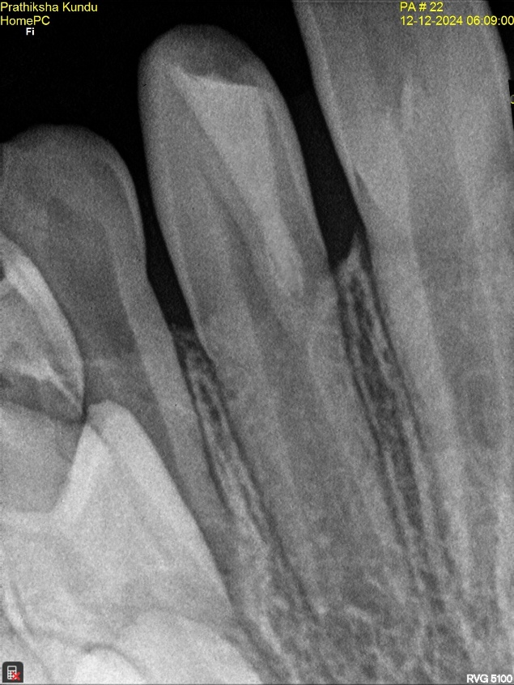
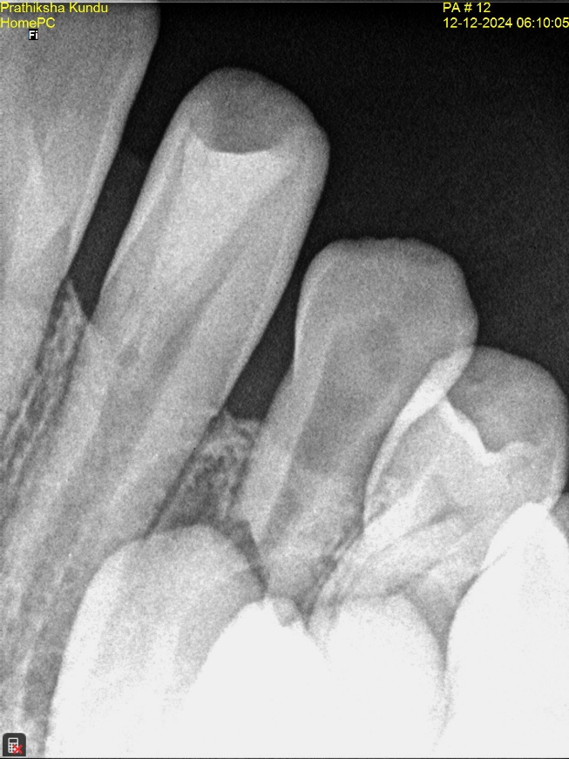

Figure: 6 Radiograph showing post operative sealing #22
Figure: 5 Radiograph showing post operative sealing #12

