Orthokeratinized Odontogenic Cyst:
A Case Series with Clinicopathologic Variation
ABSTRACT
Orthokeratinized Odontogenic Cyst (OOC) is a rare developmental odontogenic cyst, accounting for approximately 1% of all odontogenic cysts and 10% of all keratinizing odontogenic jaw cysts. The 2017 WHO classification considered OOC as a distinct entity. It is characterized by an Orthokeratinized stratified squamous epithelial lining, a benign nature, and a low recurrence rate of less than 2%. Unlike OKC, OOC lacks aggressive behaviour, showing minimal proliferative activity. Radiologically, OOCs often present with buccolingual expansion and cortical bone destruction, but their growth pattern is less invasive than that of OKC. Due to its favourable prognosis and low recurrence, OOCs should be differentiated from OKC for its appropriate diagnosis & management.
KEYWORDS:
Orthokeratinized Odontogenic Cyst, Odontogenic Cysts, Odontogenic Keratocyst, WHO
INTRODUCTION:
Orthokeratinized Odontogenic Cyst (OOC) is a rare, benign developmental odontogenic cyst, accounting for approximately 1% of all odontogenic cysts and about 10% of all keratinizing odontogenic jaw cysts [8, 16]. Schultz first recognised the cyst in 1927 and described it as an intraosseous dermoid cyst [3]. Historically, Philipsen in 1945 classified OOC as a histological variant of para-keratinized OKC and grouped under the Keratocystic Odontogenic Tumour (KCOT) classification owing to its same site, age of occurrence and origin [1, 19]. Wright in 1981 first described the distinct histological characteristics and clinical behaviour, proposing the term Orthokeratinized variant of OKC [2]. Li et al. (1998)
put forward the title of Orthokeratinized cystic lesion, and it is still acceptable today [8]. Subsequent research has confirmed that OOC differs significantly from OKC in its biological behaviour, histopathology, recurrence potential, and treatment response [4]. On the basis of these differences World Health Organization (WHO) classification (2017) redefined OOC as a separate entity [5].
Usually, OOC arises from remnants of the dental lamina & is lined by Orthokeratinized stratified squamous epithelium, typically 4–8 cell layers thick, with a prominent granular cell layer rich in keratohyalin granules. The basal layer consists of flat to cuboidal cells with bland nuclei, in contrast to the palisaded, hyperchromatic basal cells of OKC [2,4]. The cyst lumen frequently contains lamellated keratin debris while the surrounding fibrous connective tissue wall shows no inflammation unless secondarily infected [4,6].
Epidemiologically, OOC is prevalent in males and commonly presents in the third to fourth decade of life [1,4]. The most common site is the posterior mandible, particularly the molar–ramus region, and a strong association with impacted third molars has been observed [1]. Clinically, OOC is often asymptomatic and identified incidentally during routine radiographic examinations. When symptomatic, patients may present with swelling, mild pain, or delayed eruption of associated teeth.
Radiographically, OOC appears as a unilocular radiolucency with well-defined sclerotic borders. It may show buccolingual expansion and cortical plate thinning or perforation [1, 11]. Radiologically dentigerous cysts, OKCs, or unicystic ameloblastomas are considered in differential diagnosis. Hence, definitive diagnosis relies on histopathological evaluation.
Management of OOC, typically involves conservative surgical enucleation, with an excellent prognosis and a recurrence rate of less than 2% [6]. This is in stark contrast to OKC, which exhibits a recurrence rate ranging from 8–25% and may necessitate more aggressive approaches such as resection or peripheral ostectomy [7]. The significant differences in clinical behaviour and treatment outcomes emphasize the importance of differentiating OOC from other odontogenic cysts and tumours, particularly OKC.
This case series presents, three cases of Orthokeratinized Odontogenic Cyst (OOC), each demonstrating variable clinical and radiographic features. The lesions varied in location, associated findings, and initial diagnostic impressions, highlighting the diagnostic challenges posed by OOC.
CASE PRESENTATION
CASE 1: A 41-year-old female patient reported with a chief complaint of pain and swelling in the upper front region of the jaw for the past 6 months. The patient also gave history of trauma 3 years ago, which resulted in the intrusion of tooth 23. On extraoral examination, diffuse swelling 3cm × 4 cm was observed, extending supero-inferiorly from the left infraorbital region to the left corner of the mouth, and antero-posteriorly from the left ala of the nose to the zygomatic ridge (Figure A). Intraorally, the swelling extended from teeth 11 to 25, leading to obliteration of the buccal vestibule (Figure B). Electric pulp testing showed no response for teeth 11, 21, 22 and 24, suggestive of loss of vitality. Radiographic investigations revealed an ill-defined radiolucency extending from 11 to 25, involving the maxillary sinus and expanding supero-inferiorly up to 1 cm below the infraorbital ridge. A tooth corresponding to the intruded 23 was noted within the lesion. No evidence of root resorption was observed (Figure C). Based on the radiographic features, a provisional diagnosis of Odontogenic Keratocyst was made with differential diagnosis of Unilocular Ameloblastoma, Dentigerous cyst & Adenomatoid Odontogenic Tumour (AOT). The lesion was surgically enucleated and the cystic lining was carefully separated from the surrounding bone. The impacted tooth was also extracted from the lesional cavity (Figure D). Histopathological examination of the excised specimen showed cystic cavity lined by Orthokeratinized stratified squamous epithelium with prominent granular cell layer, basal layer contains low cuboidal cells without palisading nuclei. Epithelium and connective tissue interface are flat. Cystic cavity contains abundant keratin flecks. Fibro cellular connective tissue wall consisting of fibroblasts, fibrocytes, haphazardly arranged collagen fibre bundles. Mild degree of chronic inflammatory cell infiltrates chiefly plasma cells, lymphocytes throughout the stroma. Mild degree of vascularity seen (Figure E). Based on clinical, radiographic, and histopathological findings, a final diagnosis of Orthokeratinized Odontogenic Cyst (OOC) was confirmed. The follow up of patient was done at 1,3, 6 months interval postoperatively and no signs of recurrence were noted.
Case 1
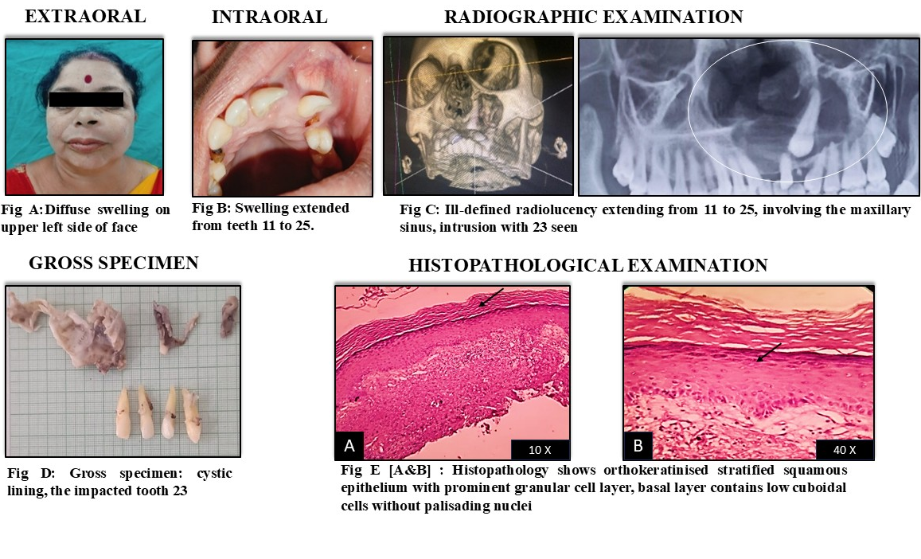
Fig 1. A final diagnosis of Orthokeratinized Odontogenic Cyst (OOC) of a 41-year-old female patient
CASE 2: A 34-year-old female patient presented with the chief complaint of pain and swelling in the upper front region of the jaw for the past 8 days. On clinical examination, a firm intraoral swelling was palpable extending from 12 to 15 region (Figure A&B). Radiographic evaluation revealed a poorly defined radiolucency measuring approximately 3.0 × 2.5 cm, extending from tooth 12 to 15 in the maxillary right quadrant, involving impacted teeth 13 and 14, with root resorption of over-retained 53 and 54 noted. (Figure C). Electric Pulp Testing (EPT) showed no response in over-retained 53, 54 and 15 suggesting non-vitality, whereas adjacent permanent teeth 12, 16 responded within normal limits Aspiration of the swelling yielded a cheesy white material; a classic finding often associated with cystic lesion rich in keratin. These finding was highly suggestive of OOC or OKC (Figure D). Surgical enucleation was performed, during which a well-defined cystic lining involving 13 & 14 was removed (Figure E). Based on the gross appearance and radiographic finding a provisional diagnosis of Adenomatoid Odontogenic tumour (AOT) was considered due to the irregular borders and impacted teeth, Orthokeratinized Odontogenic Cyst (OOC), unilocular ameloblastoma, and Dentigerous cyst were also considered in differential diagnosis. Histopathological examination exhibits cystic cavity lined by Orthokeratinized stratified squamous epithelium with varying degrees of proliferation. The cystic cavity contains abundant keratin flecks. The epithelium and connective tissue interface are flat (Figure F). Underlying connective tissue stroma is fibro cellular consisting of parallelly arranged collagen fibres with fibroblasts and fibrocytes. A moderate degree of chronic inflammatory cell infiltrate consisting of lymphocytes, plasma cells is seen with a mild degree of vascularity. Overall features were suggestive of “Orthokeratinized Odontogenic Cyst”. Regular follow-up of 1,3 and 9 months revealed satisfactory bone healing in area of cystic enucleation. The patient remained asymptomatic throughout the follow-up period. There was no evidence of recurrence during follow-up period.
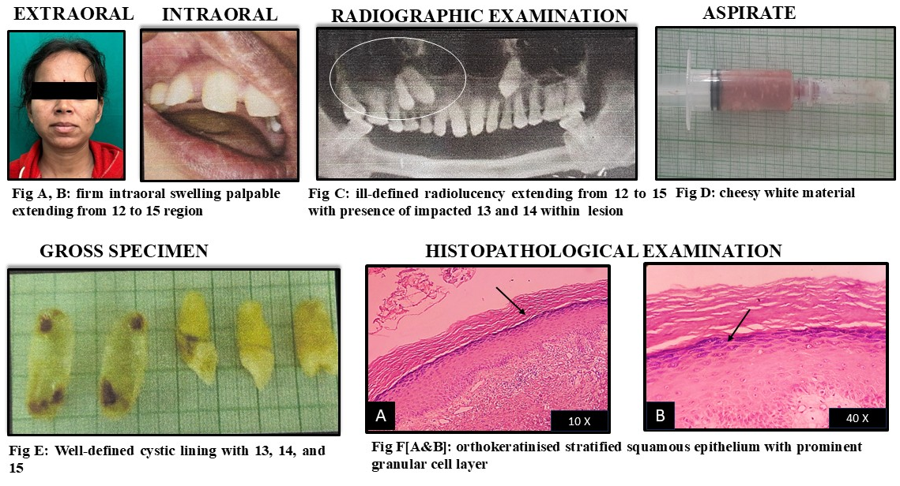
Fig 2. The images indicate of Orthokeratinised Odontogenic Cyst of a 34-year-old female patient
Case 2
CASE 3: A 34-year-old male patient presented with a chief complaint of pain in the lower right back region of the jaw for the past 2–3 days (Figure A). Clinical examination was unremarkable except for mild tenderness in the affected area (Figure B). Radiographic evaluation revealed a well-defined radiolucent lesion measuring approximately 2.5 × 2.0 cm, located in the right posterior mandible, extending from the distal aspect of tooth 46 to the ascending ramus, associated with impacted tooth 48. (Figure C). Electric pulp testing revealed no response in 46, 47 teeth, while adjacent teeth 44, 45 showed normal response, indicating a non-vital tooth associated with the lesion. Based on the clinical and radiographic findings, a provisional diagnosis of dentigerous cyst was made. Odontogenic keratocyst, Unicystic ameloblastoma was included in the differential diagnosis. Surgical enucleation of the lesion was performed, and the impacted 48 was extracted. Gross examination of the lesion yielded abundant keratin flecks within the cystic lumen (Figure D). Histopathological examination of the excised tissue revealed cystic cavity lined by orthokeratinized stratified squamous epithelium with prominent granular cell layer. Basal layer contained low cuboidal cells without palisading nuclei. Epithelial & connective tissue interface is flat. Cystic cavity contains abundant eosinophilic keratin flecks (Figure E). Fibro cellular connective tissue wall consisting of fibroblasts, fibrocytes, haphazardly arranged collagen fibre bundles. Mild degree of chronic inflammatory cell infiltrates chiefly plasma cells, lymphocytes throughout the stroma. Mild degree of vascularity is seen. Deeper section shows osseous trabeculae. Overall features were suggestive of “Orthokeratinized Odontogenic Cyst”. The patient was monitored postoperatively for one year. Normal healing with no recurrence was observed during the follow-up. A prosthodontic consultation was advised for long-term rehabilitation.
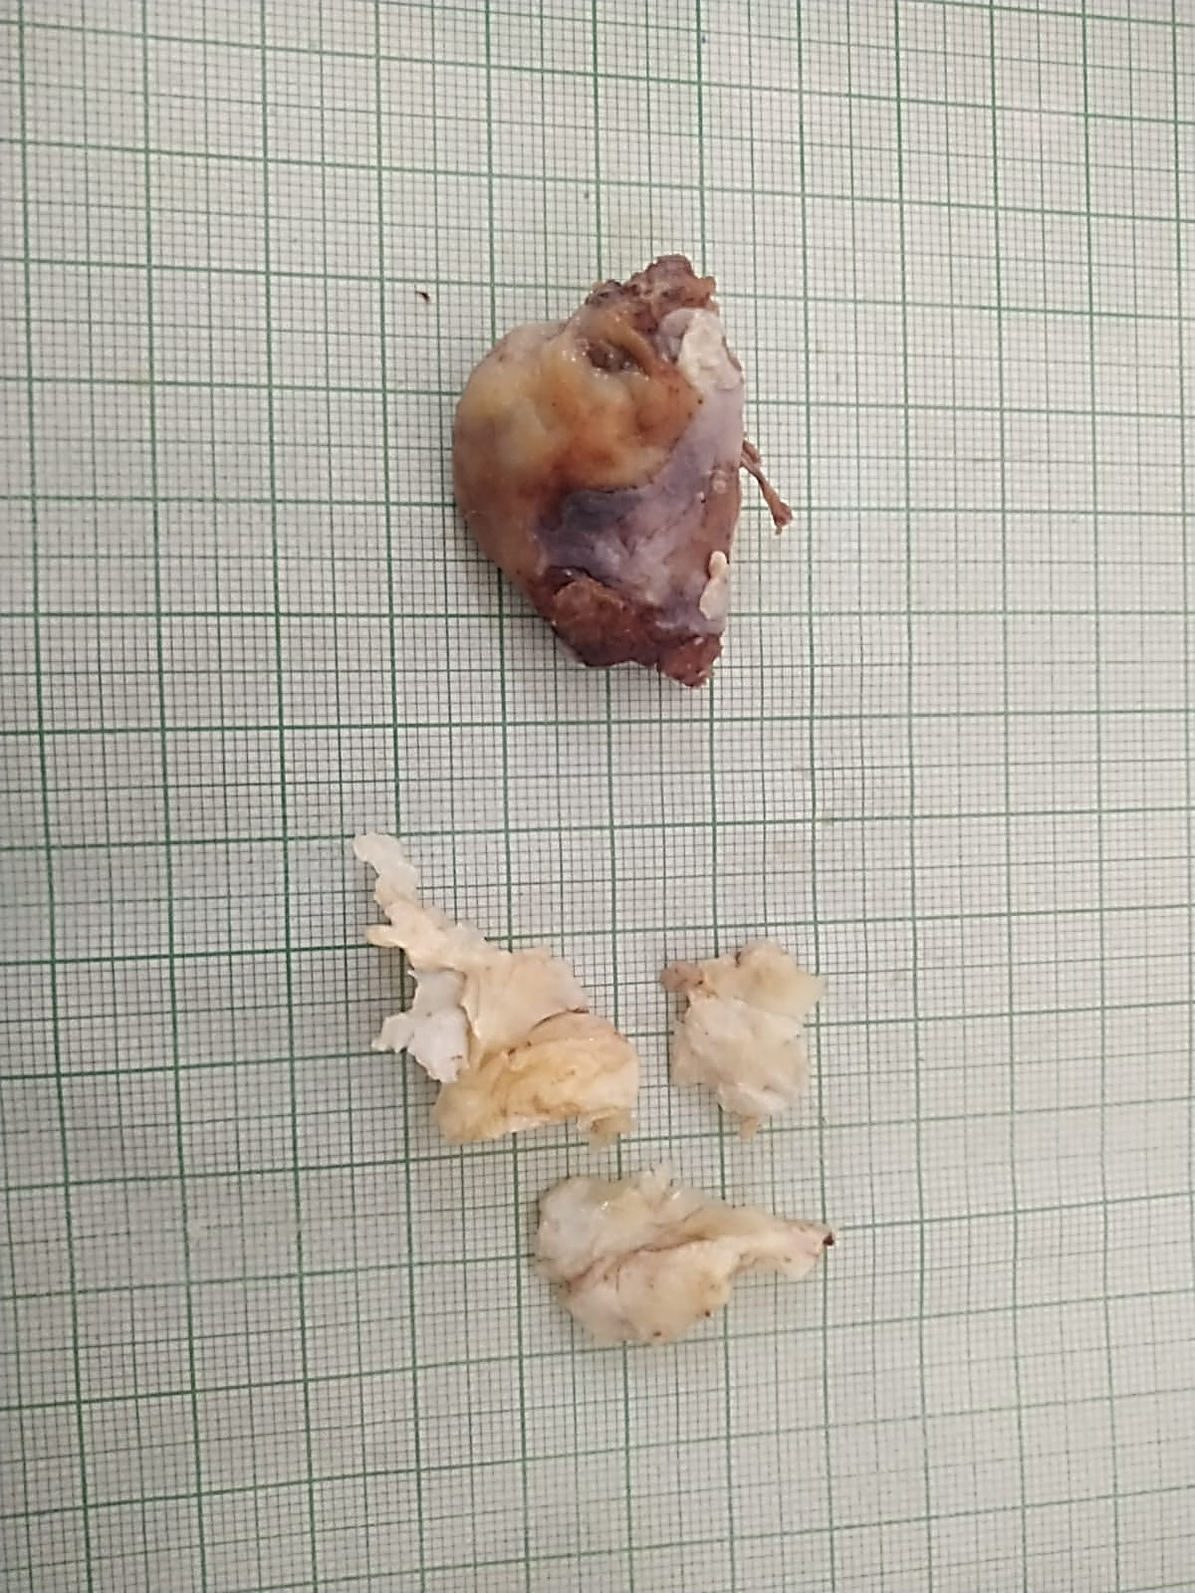
Case 3
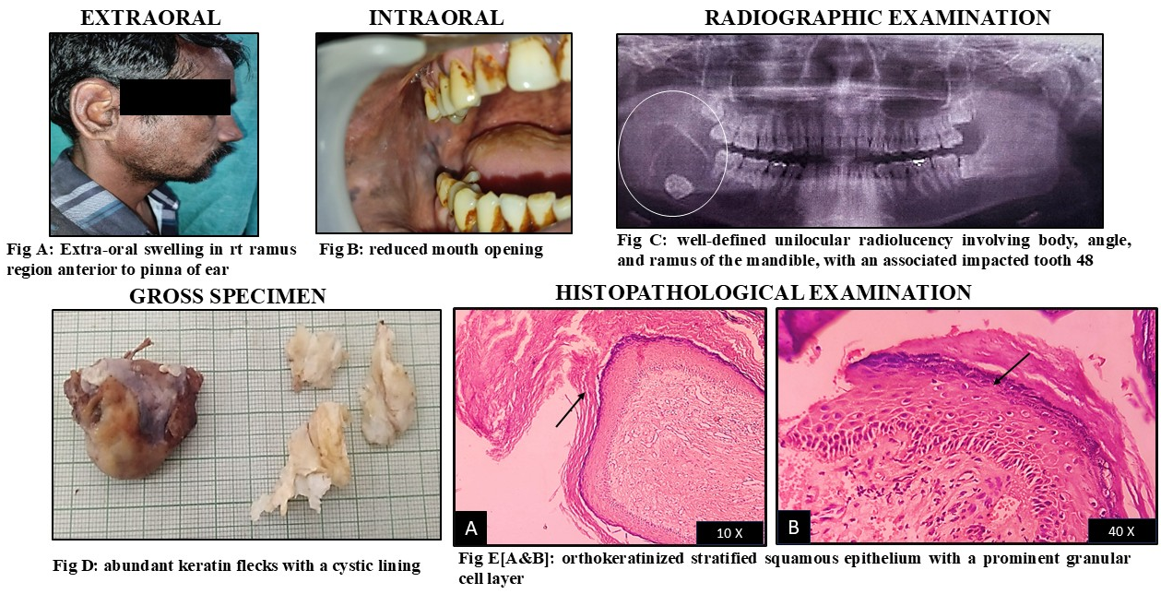
FIG 3. The above images' features were suggestive of “Orthokeratinised Odontogenic Cyst” of a 34-year-old male patient

DISCUSSION:
Orthokeratinized Odontogenic Cyst (OOC) typically affects young adult with a male-to-female ratio of 2:1 and shows a predilection for the posterior mandible, especially the molar-ramus area. OOC is believed to arise from remnants of the dental lamina (rests of Serres) influenced by the dental papilla, similar to OKC. However, their biological behaviours and histopathology is distinct. Radiographically OOC presents as a well-defined unilocular radiolucency. The size can vary from less than 1 cm to large lesions greater than 7 cm in diameter, often associated with an impacted tooth. Histologically, it is lined by orthokeratinized stratified squamous epithelium with a prominent granular cell layer and non-palisaded basal cells. OOC has a low recurrence rate (<2%). [1]
This case series contributes to the evolving understanding of Orthokeratinized Odontogenic Cyst (OOC) by showcasing its diverse clinical and radiographic presentations and the crucial role of histopathological evaluation in establishing a definitive diagnosis. In each case, the clinical diagnosis was—either a dentigerous cyst or an odontogenic keratocyst (OKC)—demonstrating the diagnostic challenges often encountered with intraosseous jaw lesions [1, 10].
Although OOC is often regarded as indolent, its variable presentation can obscure diagnosis. Most OOCs are seen in the posterior mandible with a slight male predilection and commonly associated with impacted teeth, but the first case was unique as it involved the anterior maxilla in a patient with a history of dental trauma and an intruded tooth—an unusual location and context for OOC. The second case presented with root resorption, a relatively rare but possible finding in OOC attributable to its longstanding duration. Considering this radiographic finding, a provisional diagnosis of radicular cyst was initially made, as root resorption is commonly associated with inflammatory cysts such as radicular cyst. The third case involved a mandibular third molar with mild buccolingual expansion, resembling a typical dentigerous cyst. These variations underscore the necessity of maintaining a broad differential diagnosis when evaluating unilocular radiolucent jaw lesions. [1, 10].
Radiographic features alone were insufficient for accurate diagnosis, as all three lesions appeared as well-circumscribed unilocular radiolucency with sclerotic margins—features that mimic other odontogenic cysts. This observation is consistent with findings by Uddin et al. (2019), who noted that radiological findings in OOC often mimic dentigerous cysts or OKCs, particularly when associated with impacted teeth [10]. Hence, surgical exploration followed by histopathological examination remains essential.
Microscopic examination of all cases showed a thin, orthokeratinized epithelial lining with a well-defined prominent granular layer and flat, non-palisaded basal cells. These features stand in stark contrast to OKC, which typically exhibits parakeratinization, basal cell palisading, and a higher mitotic index [9,1,2]. The absence of epithelial proliferation or satellite cysts in our cases further supported a diagnosis of OOC.
The distinction between OOC and OKC is critical not only for academic precision but also for clinical decision-making. OKC is known for its aggressive behaviour and high recurrence rates, often requiring extended surgical margins or adjunctive procedures [6]. In contrast, all three OOC cases in our series were successfully treated with enucleation alone, with no evidence of recurrence during the follow-up period. Dong et al. (2010) have emphasized that the biologically passive behaviour of OOC supporting its conservative management with excellent long-term outcomes [8].
Interestingly, one of the cases in our series demonstrated root resorption, a feature more commonly associated with inflammatory or aggressive cysts. Although rare in OOC, root resorption has been documented in same cases and may be attributed to longstanding pressure effects or secondary inflammation [10]. Such findings can further complicate preoperative diagnosis and making the indispensable role of histopathology.
Immunohistochemistry (IHC), although not performed in this series, can offer additional diagnostic support in ambiguous or inflamed specimens. OOC typically exhibits strong expression of cytokeratin 10 (CK10), reflecting orthokeratinization, while OKC demonstrates variable CK14 positivity and in some instances may show increased expression of proliferation markers such as Ki-67 and p53 [9]. da Silva et al. highlighted the utility of CK profiling in confirming OOC diagnosis, especially in cases where inflammatory changes obscure epithelial morphology [9, 11, 12].
Another important point of emphasis is the need to avoid overtreatment. Misdiagnosis of OOC as OKC, especially in lesions with subtle differences, may lead to aggressive surgery, increasing patient morbidity. Our findings reiterates that accurate identification of OOC enables minimally invasive, curative treatment. This reinforces the principle advocated by MacDonald-Jankowski (2010) who emphasized that proper classification of jaw cysts is not merely academic exercise but a practical necessity for optimal care [1].
In light of the current WHO classification, which distinguishes OOC as a separate entity, there is a need for continued clinical awareness and pathological vigilance. Our case series contributes to this understanding by demonstrating that OOC can occur in both common and uncommon sites, may mimic multiple cystic pathologies, and may present with features not typically expected, such as root resorption or anterior maxillary involvement. These findings highlight the evolving clinical spectrum of OOC & special emphasis on the importance of recognizing its distinct behaviour.

CONCLUSION:
Orthokeratinized Odontogenic Cyst (OOC) represents a distinct, benign odontogenic cyst with unique histopathological and clinical features that differentiate it from more aggressive entities like the odontogenic keratocyst (OKC). Despite its radiographic resemblance to other jaw cysts, OOC is characterized histologically by an orthokeratinized stratified squamous epithelium, a prominent granular cell layer, and a low proliferative index. OOC exhibits low recurrence rate (<2%) following conservative surgical enucleation underscores its indolent biological behaviour nature and favourable prognosis. However, due to frequent diagnostic overlap with OKC, dentigerous cysts, or unicystic ameloblastomas, accurate diagnosis is crucial to avoid overtreatment. This case series reinforces the importance of correlating clinical, radiological, and histopathological findings for precise diagnosis and optimal management.
Recognition of OOC’s unique features allows for minimally invasive, curative treatment thereby optimizing patient’s outcomes and reducing unnecessary surgical morbidity. Continued clinical awareness and diagnostic vigilance are essential to ensure appropriate management of odontogenic cysts.

Consent
As per international standards or university standards, patient(s) written consent has been collected and preserved by the author(s).
Disclaimer (Artificial intelligence)
Author(s) hereby declare that NO generative AI technologies such as Large Language Models (ChatGPT, manuscript.

REFERENCES:
1. MacDonald-Jankowski DS. Orthokeratinized odontogenic cyst: a systematic review. Dentomaxillofac Radiol. 2010;39(8):455–467.
2. Wright JM. The odontogenic keratocyst: orthokeratinized variant. Oral Surg Oral Med Oral Pathol. 1981;51(6):609–618.
3. Vuhahula E, Nikai H, Ijuhin N, Ogawa I, Takata T, Koseki T, et al. Jaw cysts with orthokeratinization: Analysis of 12 cases. J Oral Pathol Med 1993;22:35-40.
4. Li TJ, Kitano M, Chen XM, Itoh T. Orthokeratinized odontogenic cyst: a clinicopathologic and immunocytochemical study of 15 cases. Histopathology. 1998;32(3):242–251.
5. Philipsen HP, Reichart PA. Classification of odontogenic tumors: A historical review. J Oral Pathol Med. 2006;35(9):525–529.
6. Shear M, Speight PM. Cysts of the Oral and Maxillofacial Regions. 4th ed. Oxford: Blackwell Publishing; 2007.
7. Marx RE, Stern D. Oral and Maxillofacial Pathology: A Rationale for Diagnosis and Treatment. 2nd ed. Hanover Park: Quintessence Publishing; 2012.
8. Dong Q, Pan S, Sun L-S, Li T-J. Orthokeratinized odontogenic cyst: a clinicopathologic study of 61 cases. Arch Pathol Lab Med. 2010;134(2):271–275. doi:10.5858/134.2.271
9.da Silva MJ, de Sousa SO, Corrêa L, Carvalhosa AA, de Araújo VC. Immunohistochemical study of the orthokeratinized odontogenic cyst: a comparison with the odontogenic keratocyst. Oral Surg Oral Med Oral Pathol Oral Radiol Endod. 2002;94(6):732–737.
10. Uddin N, Zubair M, Abdul-Ghafar J, Khan ZU, Ahmad Z. Orthokeratinized odontogenic cyst (OOC): Clinicopathological and radiological features of a series of 10 cases. Diagn Pathol. 2019;14:1–7.
11. Zhou Q, Xu L, Li H, Xia RH. Orthokeratinized odontogenic cyst (OOC): Clinicopathological and radiological features of a series of 48 cases. Pathol Res Pract. 2022 Aug;236:153969. doi: 10.1016/j.prp.2022.153969. Epub 2022 Jun 6. PMID: 35696769.
12. Suzuki T, Kumamoto H, Kunimori K, Ooya K. Immunohistochemical analysis of apoptosis-related factors in lining epithelium of radicular cysts. J Oral Pathol Med. 2005 Jan;34(1):46-52. doi: 10.1111/j.1600-0714.2004.00248.x. PMID: 15610406.
13. Thosaporn W, Iamaroon A, Pongsiriwet S, Ng KH. A comparative study of epithelial cell proliferation between the odontogenic keratocyst, orthokeratinized odontogenic cyst, dentigerous cyst, and ameloblastoma. Oral Diseases. 2004 Jan;10(1):22-6.
14. Oh KY, Kim JE, Cho SD, Yoon HJ, Lee JI, Hong SD. Orthokeratinized odontogenic cyst: A large series and comprehensive literature review with emphasis on synchronous multiple occurrence and neoplastic transformation. Oral Surgery, Oral Medicine, Oral Pathology and Oral Radiology. 2022 Mar 1;133(3):e72-82.
15. Tsuji K, Wato M, Hayashi T, Yasuda N, Matsushita T, Ito T, Gamoh S, Yoshida H, Tanaka A, Morita S. The expression of cytokeratin in keratocystic odontogenic tumor, orthokeratinized odontogenic cyst, dentigerous cyst, radicular cyst and dermoid cyst. Medical molecular morphology. 2014 Sep;47(3):156-61.
16. Chan M. Park, Jeffrey A. Elo, Mark Mintline, Elizabeth Orbeta & Stephen Seongeun Koh (2024) An Orthokeratinized Odontogenic Cyst in an 8-Year-Old: A Case Report with Differential Diagnosis, Journal of the California Dental Association, 52:1, 2308964, DOI: 10.1080/19424396.2024.2308964
17. Crane H, Da Forno P, Kyriakidou E, Speight PM, Hunter KD. Multiple orthokeratinized odontogenic cysts: a report of two cases and review of the literature. Head and neck pathology. 2020 Jun;14(2):381-5.
18. Dineshkumar, Thayalan; Rameshkumar, Annasamy; Rajkumar, Krishnan; Ravindran, Swaathi. Orthokeratinized Odontogenic Keratocyst: Report of Nine Cases with Review of Literature. Journal of Microscopy and Ultrastructure 13(2):p 99-103, Apr–Jun 2025. | DOI: 10.4103/jmau.jmau_100_23
19. Bande CR, Prashant MC, Sumbh B, Pandilwar PK. Prevalence, treatment and recurrence of odontogenic keratocyst in central India. J Maxillofac Oral Surg. 2010 Jun;9(2):146–9. doi: 10.1007/s12663-010-0043-6.

