**Non-Invasive Management of Oral Mucoceles and Ranulas in Children: A Case Series Based Evaluation of Modified Micromarsupilization**

**Abstract:**

**Introduction:**

Mucocele and ranula are mucus extravasation or retention cysts occurring in major or minor salivary glands. The occurrence is more common in pediatric patients. Various treatment options such as emergency decompression, surgical excision, marsupialization, laser treatment, injectable sclerosing therapy, electrocautery, intralesional steroid injection, cryotherapy, micromarsupialization are available. The recurrence rate varies with different treatment modalities.

**Case presentation:**

This case series discusses the modified micromarsupilization technique 3 pediatric patients, in which one is a mucocele in the ventral surface of the tongue, which is a very rare presentation and two cases of ranula in the floor of the mouth. Since the patients were in Pediatric age group, in which the incidence is more and the patient co-operation will be less, necessitating the less invasive treatment approach.

**Discussion:**

The patients were treated with modified micromarsupilization technique. This involves multiple simple interrupted sutures along the larger dimension of mucocele or ranula, which facilitates drainage and helps in regression of the cyst.

**Conclusion:**

This case series highlights the simplicity of the procedure, patient and parent acceptance, and absence of recurrence in 5 months follow-ups

**Keywords:** Mucocele, ranula, micromarsupilization, conservative approach.

**Introduction**

A mucocele (muco – mucus and coele – cavity) is a cavity filled with mucus, originating from either major or minor salivary glands; is one of the common benign soft-tissue cysts of the oral cavity. “Ranula is derived from the Latin word ‘Rana’, meaning ‘frog’, as it resembles the underbelly of a frog. Ranula is used to describe a mucoele occurring in the floor of the mouth. These lesions develop due to trauma or obstruction of the excretory duct of the salivary gland situated in the submandibular or sublingual space. In general, they are asymptomatic, well-circumscribed, fluctuant, bluish coloured swelling present in the floor of the mouth”. (1–7).

“The prevalence rate of mucoceles is 2.4 cases per 1000 persons, with the highest percentage (70%) occurring in those ranging from 3-20 years old. The most common site of occurrence of mucoceles is the lower lip (80%), followed by the ventral surface of the tongue, represented mainly by the extravasation type. Retention mucoceles are usually located in the cheek, palate, and floor of the mouth (ranulas), with equal incidences in both sexes”. (1)

**Pathophysiology**

The development of mucous lesions typically follows two distinct pathophysiological mechanisms: mucus extravasation and mucus retention. The mucus extravasation type is more prevalent of the two, it generally occurs following trauma to the salivary duct, leading to the collection of secretions in the connective tissue. In contrast, mucus retention, which is a less common type, arises due to obstruction of the salivary duct, leading to the accumulation of saliva within the ductal system.

According to Ata-Ali et al., in 2010, the extravasation type will undergo three phases

* **Phase 1**: Mucus spills into surrounding tissue, accompanied by leukocytes and histiocytes.
* **Phase 2** (resorptive phase): Granulomas form, involving histiocytes, macrophages, and multinucleated giant cells, indicating a foreign body reaction.
* **Phase 3**: A non-epithelial pseudocapsule forms around the mucosa (8)

**Retention cysts** originate in the **sublingual space** due to obstruction of the sublingual or minor salivary glands**.** As they enlarge, they may extend into the **submandibular and parapharyngeal spaces**, forming a **plunging ranula**.(1)

Diagnosis of mucocele or ranula is usually made based on the clinical features. No definitive diagnostic test is available. Investigations such as mandibular occlusal radiograph can be used to rule out the presence of sialolith. Fine Needle Aspiration Biopsy (FNAB) is a valuable diagnostic method, particularly useful in differentiating vascular-like (angiomatous) lesions. In mucoceles, the aspirate typically reveals abundant mucin without epithelial elements, along with a significant presence of inflammatory cells, predominantly histiocytes.(8) When performed by experienced clinicians, high-resolution ultrasound is capable of identifying stones, abscesses, and cysts, and can accurately distinguish between benign and malignant tumors in up to 90% of cases. However, vascular anomalies necessitate the use of color Doppler imaging for proper evaluation. CT and MRI are rarely needed, except in cases of large plunging or cervical ranulas that extend through a defect in the mylohyoid muscle. They are particularly helpful in assessing the full extent of the swelling, which is essential for surgical planning.

A biopsy is necessary to distinguish between benign and malignant conditions.(9) A definitive diagnosis of a mucous extravasation phenomenon or mucous retention cyst can only be established through histopathological examination.

In cases of extravasation mucocele, histology typically reveals a mucin-filled cavity surrounded by a band of compressed fibrovascular connective tissue. Notably, glandular elements are often observed within the surrounding capsule. Occasionally, a severed or intact salivary duct may be seen in direct communication with the mucin pool; this is referred to as a “feeder duct.”

The histopathology of a retention cyst closely resembles that of an extravasation mucocele, with one key distinction: the presence of a true epithelial lining. This epithelial lining, derived from ductal epithelium, forms as a result of ductal dilation secondary to obstruction (commonly due to a sialolith). Over time, the obstructed duct enlarges and transforms into a cystic structure lined by ductal epithelium, qualifying it as a true cyst.

In contrast, extravasation mucoceles lack this epithelial lining, and are therefore categorized as pseudocysts.(10)

Mucoceles and ranulas located under the tongue can resemble several other conditions, making accurate diagnosis essential. The differential diagnosis for these lesions includes a wide range of possibilities such as hemangioma, lymphangioma, dermoid cyst, benign or malignant tumors of the salivary glands, lipoma, abscess, venous lake, fibroma, benign mesenchymal tumors.(9)

Untreated mucocele or ranula may undergo complications such as infections, rupture and reappearance of the ranula or mucocele, difficulty in eating, breathing, talking, and lifestyle compromises in case of large ranulas. Ranulas due to obstruction in the salivary duct may cause pain and discomfort while eating.

As for any medical condition, the treatment of a ranula will vary, depending upon the patient’s condition, that is: their general health, location, size and cause of the ranula. A surgical approach is usually used to treat the condition, although less invasive procedures could be applied, according to the particular situation. Treatment options for a ranula include:

**1. Emergency decompression**

It is an emergency management, in case the mucocele or ranula is causing discomfort to the patient and definitive treatment is not possible at the time. It consists of making an incision that allows the contents of the ranula to drain, thus reducing its size. However, this is not considered a definitive treatment, and the injury could persist.

**2. Surgical excision**

Excision or surgical removal of the lesion along with the salivary gland causing the problem has been reported as the most effective treatment for ranulas. By eliminating the cause, the probability of the ranula appearing again is very low. Although it is associated with complications such as hemorrhages, injury to adjacent salivary ducts, lingual nerve, which can cause numbness or loss of sensation in the tongue, temporarily or permanently.

Probability of injury to the marginal mandibular, lingual and hypoglossal nerves are common in transcervical approach.

Also, there is a risk of orocervical fistula formation and cervical scar in the cervical approach (7,11,12)

**3. Marsupialization**

A procedure in which a small window is opened and fixed with stitches, through which the liquid contained inside the ranula can drain continuously until the lesion disappears. However, if the ranula cannot be removed by this technique, it is necessary to perform surgical excision of the salivary gland.

**4. Laser treatment**

Lasers provide less aggressive therapies with shorter recovery periods that work for the treatment of small ranulas. Various lasers such as diode lasers, Er-YAG lasers, CO2 lasers are commonly used for excision of soft tissue lesions. (13)

**5. Injectable sclerosing therapy**

OK 432 can be injected into the area, producing an inflammatory reaction that helps resolve the ranula. However, more than one injection is usually required to achieve the desired effect. This therapy works in 91.2% of cases, but about 22% of cases could recur. Therefore, it is usually limited to the management of small ranulas.(2)

**6. Electrocautery:** Uses high-frequency electric current to burn and destroy the lesion. It is a minimally invasive option for small mucoceles. It provides less bleeding, fast healing. It may require local anesthesia; risk of scarring or recurrence is there if the lesion is not completely removed.

**7. Intralesional steroid injection:** Injection of corticosteroids (e.g., triamcinolone) directly into the lesion, reduces inflammation and inhibits mucin production. It is indicated for Small mucoceles or recurrent lesions; alternative to surgery in some cases. It is Non-surgical with minimal side effects. May need multiple injections; not effective for large or long-standing ranulas.

**8.Cryotherapy:** Cryotherapy works by destroying tissue through the application of extreme cold, using cryogenic agents like liquid nitrogen spray or nitrous oxide gas. When nitrous oxide expands from high to low pressure within the cryotip, it causes a rapid temperature drop that freezes the targeted tissue. This mechanism aligns with the principle that cell death requires temperatures to drop below −20°C. (14) It is difficult to precisely target only the lesion, especially in deeper or larger mucoceles/ranulas. This can result in incomplete treatment or damage to adjacent healthy tissues.(15)

**8. Micromarsupilisation:** A minimally invasive technique where multiple interrupted sutures are placed through the lesion to create a new epithelialized tract for continuous drainage. It is mainly used for pediatric patients. The procedure involves a suture technique to maintain an opening in the cyst wall. It is a simple procedure with a low recurrence rate; no general anesthesia is required. It is best for mucoceles and ranula, not effective for plunging ranulas.

This case series describes the non-invasive and effective clinical management of mucocele in tongue and ranula in the floor of the mouth with the micromarsupilization technique. Mucocele in the tongue is a rare presentation. So this case series would provide significant evidence in the management of such rare cases.

**Case presentation**

**Case1**

* + An 8-year-old boy reported to the Department of Pediatric and Preventive Dentistry OPD, with a chief complaint of painless swelling on the undersurface of the tongue for the past 2 weeks. History of presenting illness revealed a similar swelling but of a smaller size 2 months before. There was episodic enlargement and reduction in size. The lesion gradually increased and attained the present size.
  + Examination revealed a well-defined, sessile, ovoid, fluid-filled swelling of size 2.5cm x 1.5cm on the ventrolateral aspect of the tongue towards the right side with mild bluish discolouration and smooth surface.
  + On palpation, it was non-tender, soft to firm in consistency, non-compressible, and fluctuant. The anatomic location of the lesion was suggestive of involvement of the glands of Blandin & Nuhn.
  + Hence, a clinical diagnosis of mucocele was made, and micromarsupilization was planned. The patient had no other significant medical history.

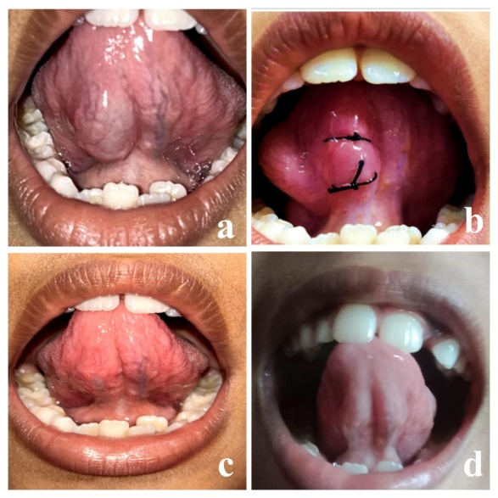

Figure 1a: Pre-operative mucocele of size 2.5*1.5cm, b: micromarsupilization with 2 sutures in the long axis of mucocele, c: 3 weeks after surgery, d: 2 months follow-up after surgery.

**Case 2:**

* A 10-year-old girl reported to the Department of Pediatric and Preventive Dentistry OPD with the chief complaint of swelling on the floor of the mouth for the past 1 month. The history of presenting illness revealed that the swelling was initially small, and gradually increased in size. Spontaneous rupture occurred once with temporary resolution of the lesion and recurred 3 days later with continuous mild to moderate pain. The patient had no other significant medical history.
* On examination, a 1×1 cm-sized, dome-shaped, soft, mildly tender, fluctuant swelling was noted at the junction of the alveolar mucosa and the floor of the mouth in the mandibular left canine premolar region. The overlying mucosa appeared normal without any signs of secondary infection. No restriction in tongue movement or salivary flow obstruction
* On radiographic examination, the mandibular anterior occlusal radiograph showed no evidence of sialolithiasis or bony involvement.
* Hence, the provisional diagnosis of ranula was given with the differential diagnosis of mucocele or dermoid cyst.
* Various treatment options were explained to the patient and parents. After the discussion, micromarsupilization with silk sutures was planned.
* Fluid was collected while passing the needle through the lesion using a disposable syringe and was sent for histopathological examination.
* Histopathological examination confirmed it as a mucus extravasation cyst consistent with a ranula.  Microscopy of aspirate showed scattered mixed inflammatory cells composed of plasma cells and lymphocytes, mucinophages and few epithelial cells in homogenous background, suggestive of inflammatory smear.

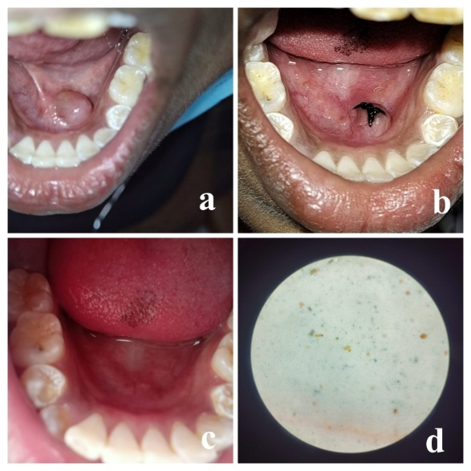

Figure 2a: Pre-operative ranula of size 1*1cm, b: micromarsupilization with suture in the long axis of ranula, c: 3 months follow-up after surgery, d: cytopatholgical view shows scattered mixed inflammatory cells composed of plasma cells and lymphocytes, mucinophages and few epithelial cells in homogenous background.

**Case 3:**

* A 5-year-old boy was brought to the Department of Pediatric and Preventive Dentistry OPD, with the chief complaint of swelling beneath the tongue for the past 5 days, with no history of pain or similar swelling before.
* On examination, a ranula of size 2*1*1cm was diagnosed on the left side of the floor of the mouth.
* Radiological examination with mandibular occlusal view confirmed the absence of sialolith. Various treatment options and their differential prognosis were explained to the parents.
* After the discussion, the micromarsupilization treatment procedure was planned.

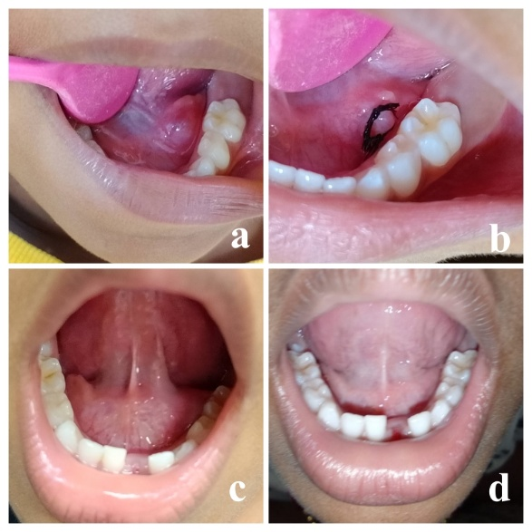

Figure 3a: Pre-operative ranula of size 2*1cm, b: micromarsupilization with 2 sutures in the long axis of ranula, c: 3 weeks after surgery, d: 2 months follow-up after surgery

**Treatment Procedure:**

Topical anaesthesia with benzocaine was applied for 1 minute and 2% lignocaine with 1: 200000 adrenaline was used to administer lingual nerve block . Two simple interrupted sutures were given across the larger dimension of the mucocele or ranula. Before ligating the suture, the thread was moved in to and fro motion in order to allow drainage of the cystic contents. Spillage of moderately thick mucus fluid and immediate reduction in size of the ranula was observed.

For postoperative care, clear instructions were provided for oral hygiene maintenance and for care of the suture to the patient and parents. The patient was followed up at 1 week, 1 month and 5 months. It showed no recurrence and satisfactory healing. No complications were reported.

In case number 3, 2 weeks after the procedure, patient gave the history of lost sutures, but on examination, satisfactory healing was present. The patient was reviewed one month later, which showed no recurrence or any other complications.

Flowchart 1 shows the timeline of all three cases.

*Flow chart 1: Timeline in diagnosis and management of mucocele and ranula.*

**Discussion**

Micromarsupilization has emerged as a preferred surgical technique for treating ranulas, particularly in pediatric cases, due to its lower morbidity and effective outcomes . In 1995, Morton and Bartley stated that a ranula can be treated by placing a silk suture in the dome of the cyst. Delbem et al in 2000 performed the micromarsupilization technique using a topical anesthetic on the entire lesion for 3 minutes and a single long 4.0 silk suture passed through the internal part of the lesion along its widest diameter. The suture was removed after 7 days.(3)

In 2007 Sandrini et al proposed modifications to the technique, which included;

1. Increased number of sutures (to increase the quantity of new epithelialized drainage pathways).
2. Decreased distance between the entrance and exit of the needle (to facilitate epithelialization of the new pathways formed by the sutures by reducing the length of the drainage tracts).
3. Longer period during which the sutures are maintained (permits the formation of a new permanent epithelialized tract along the path of the suture).(4)

In 2012 Amaral et al’s modifications of the micromarsupilization technique were:

1. The use of a 3.0 silk suture (Shalon1, Shalon Fios Ciru´rgicos, Goia´s, Brazil) with a round cross-section needle; increasing the thickness of the suture thread to 3.0mm improves mucous drainage and epithelialization of the mucosa around the suture thread, creating “new ducts” for spilling mucus.
2. The mechanical enlargement of the pathways performed by a to-and-fro movement using silk sutures.
3. The clearance of total mucus by conventional suction, together with local manual discrete pressure on the inside of the lesion. The sutures were placed in the mucosa and in the dome of the lesion at a distance of 3–5 mm from each other. The sutures were maintained for 30 days. (5)

In 2021 Arruda et al reported the use of synthetic suture material instead of a silk suture as it is inert, non-antigenic and non-pyogenic. Its absorption occurs by hydrolysis in a uniform and predictable manner with no need for professional removal of the suture thread, which is an added advantage in pediatric patients. (6)

In 2021, Fathima et al reported micromarsupilisation of ranula using absorbable synthetic suture material, Vicryl 3-0 (braided coated polyglactin 910 violet, 3/8 circle reverse cutting needle ) in an 11-year-old female under topical anesthesia, which showed successful healing with no recurrence at 6 months follow-up. This provides an added advantage in the treatment of ranula in young children.(16)

In pediatric patients, micromarsupilization has demonstrated effective outcomes with minimal complications, supporting its use as a first-line treatment for oral ranulas. This serves as strength of this approach. The only limitation of this procedure is the impossibility of performing a biopsy of the lesion; therefore, its diagnosis remains clinical. In addition, the oral cavity is at high risk of infections, and so it is essential to educate the patient on the management of oral hygiene and disinfection of the surgical wound in the post-operative period.

**Clinical Effectiveness**

* Success Rates: Huo et al, in 2024 stated that micromarsupilization has shown a high success rate, with approximately 98% of cases resolving effectively—comparable to outcomes seen with conventional surgical removal .(17)
* Recovery Time: Qassab & Alraad, 2019 conducted study on 18 patients with lower lip mucocele and 8 patients with ranula of the floor of the mouth with micromarsupilization showed that almost all cases healed in one to three weeks’ time.(18)
* Fewer Complications: This technique is associated with a significantly lower complication rate—around 7%—compared to nearly 25% observed with traditional excision methods .(17)

**Patient Comfort and Acceptance**

* Less Invasive Approach: Because it involves minimal tissue disruption, micromarsupilization is generally well-tolerated, particularly by pediatric patients who may be apprehensive about more invasive procedures.
* Avoids General Anesthesia: One of the major advantages is that it can be safely performed using only local anesthesia, reducing the risks and anxiety associated with general anesthesia, especially in children.

Despite its advantages, some practitioners may still prefer traditional methods due to familiarity or perceived effectiveness, highlighting the need for broader awareness and training in micromarsupilization techniques.

**Conclusion**

The simplicity of execution, the low invasiveness of the procedure, and the fact that no special care is required during recovery make this technique a good treatment option, especially in pediatric patients. Recent studies indicate that micromarsupilization is generally well-tolerated and has shown promising results in terms of lesion regression without significant recurrence. Further research is needed to solidify its standing as a first-line treatment option for oral small, superficial mucoceles and ranulas.

**Consent**

As per international standards, parental written consent has been collected and preserved by the author(s).

**Disclaimer (Artificial intelligence):**

Authors hereby declare that NO generative AI technologies such as Large Language Models (ChatGPT) has been to prepare this manuscript.

**Reference:**

1. Coit WE, Harnsberger HR, Osborn AG, Smoker WR, Stevens MH, Lufkin RB. Ranulas and their mimics: CT evaluation. Radiology. 1987 Apr;163(1):211–6.

2. Nayibe Cubillos NC. Treatment For Ranula: 5 Comprehensive And Effective Options [Internet]. 2023 [cited 2025 Jun 10]. Available from: https://worldofdentistry.org/treatment-for-ranula/

3. Delbem AC, Cunha RF, Vieira AE, Ribeiro LL. Treatment of mucus retention phenomena in children by the micro-marsupialization technique: case reports. Pediatr Dent. 2000;22(2):155–8.

4. Sandrini FAL, Sant’ana-Filho M, Rados PV. Ranula management: suggested modifications in the micro-marsupialization technique. J Oral Maxillofac Surg Off J Am Assoc Oral Maxillofac Surg. 2007 Jul;65(7):1436–8.

5. Amaral MBF, de Freitas JB, Mesquita RA. Upgrading of the micro-marsupialisation technique for the management of mucus extravasation or retention phenomena. Int J Oral Maxillofac Surg. 2012 Dec;41(12):1527–31.

6. de Arruda. Wiley Online Library. 2021 [cited 2025 Jun 11]. Micro‐marsupialization technique with suture thread modification for improving the management of oral mucoceles and ranulas: A case series. Available from: https://onlinelibrary.wiley.com/doi/10.1111/ors.12603?msockid=32dbd15519096ead2db7c2f018e36f32

7. Packiri, S, Gurunathan, D, Kathiravan S. Management of Paediatric Oral Ranula: A Systematic Review.

8. Ata-Ali J Balaguer, M Peñarrocha, M Peñarrocha. (PDF) Oral mucocele: Review of the literature. ResearchGate [Internet]. [cited 2025 Jun 13]; Available from: https://www.researchgate.net/publication/244952371_Oral_mucocele_Review_of_the_literature

9. Huzaifa M, Soni A. Mucocele and Ranula. In: StatPearls [Internet]. Treasure Island (FL): StatPearls Publishing; 2025 [cited 2025 Jun 22]. Available from: http://www.ncbi.nlm.nih.gov/books/NBK560855/

10. Mucous Retention Cyst – Review of Literature and a Case Report [Internet]. [cited 2025 Aug 1]. Available from: https://europub.co.uk/articles/mucous-retention-cyst-review-of-literature-and-a-case-report-A-328724

11. Yang Y, Hong K. Surgical results of the intraoral approach for plunging ranula. Acta Otolaryngol (Stockh). 2014 Feb;134(2):201–5.

12. Zhao YF, Jia Y, Chen XM, Zhang WF. Clinical review of 580 ranulas. Oral Surg Oral Med Oral Pathol Oral Radiol Endod. 2004 Sep;98(3):281–7.

13. M D, B E, C N, T S, P A. Management of Mucocele: A Case Report. Asian J Dent Sci. 2025 Jul 26;8(1):338–43.

14. Aulakh KK, Brar RS, Azad A, Sharma S, Anand A, Jyoti B. Cryotherapy for Treatment of Mouth Mucocele. Niger J Surg Off Publ Niger Surg Res Soc. 2016;22(2):130–3.

15. Garg A, Tripathi A, Chowdhry S, Sharma A, Biswas G. Cryosurgery: Painless and Fearless Management of Mucocele in Young Patient. J Clin Diagn Res JCDR. 2014 Aug;8(8):ZD04–6.

16. Fathima S, Suchithra M S,, Rita Zarina. Upgraded micro - marsupialization with suture thread modification for the management of ranula in a pediatric patientA case report. J Med Dent Sci Res. 8(6):20–4.

17. Huo BB. Retrospective comparative clinical study on clinical effect of suture micromarsupialization on ranula. Acta Odontol Scand. 2024 May 3;83:249–54.

18. Alan Haydar Mawlood Qassab*,Shehab Ahmed Hamad Alraad. Research gate. 2019 [cited 2025 Jun 25]. (PDF) Micro-marsupilization for Treatment of Mucocele and Ranula. Available from: https://www.researchgate.net/publication/338365061_Micro-marsupilization_for_Treatment_of_Mucocele_and_Ranula