Case report
SURGICAL MANAGEMENT OF OKC WITH CHEMICAL CAUTERIZATION USING TOPICAL 5-FLUOROURACIL AND SOFT TISSUE RECONSTRUCTION USING A NASOLABIAL FLAP:
A CASE REPORT

ABSTRACT
AIM: This case report evaluates the effectiveness of surgical enucleation with chemical cauterization using 5-fluorouracil (5-FU) and soft tissue reconstruction with a nasolabial flap in the management of odontogenic keratocyst (OKC).
STUDY DESIGN: Case Report.
PLACE AND DURATION OF STUDY: Department of Oral and Maxillofacial Surgery, C.S.M.S.S Dental College and Hospital, Chhatrapati Sambhajinagar, India with follow-up over 1.5 years.
METHODOLOGY: A 52 year female patient underwent surgical enucleation of the OKC, followed by chemical cauterization of the cystic cavity using 5% 5-fluorouracil (5-FU) to minimize recurrence. Postoperatively, soft tissue dehiscence was identified and managed with reconstruction using an inferiorly based nasolabial flap to restore the intraoral soft tissue integrity.
RESULTS: The combined approach of enucleation, chemical cauterization with 5-FU, and nasolabial flap reconstruction resulted in successful management of the lesion, minimal recurrence risk, and satisfactory functional and aesthetic outcomes. Postoperative recovery with excellent healing observed in follow-ups over 1.5 year
CONCLUSION: Surgical enucleation with adjunctive 5-FU chemical cauterization is a promising method for reducing OKC recurrence. The nasolabial flap is a versatile and reliable option for reconstructing small-to-moderate intraoral soft-tissue defects, even in cases with postoperative complications.
KEY WORDS : OKC , 5 FLUROURACYL (5-FU), BASAL CELL NEVOID CACINOMA SYNDROME , PTCH GENE , CARNOYS SOLLUTION , NASOLABIAL FLAP SURGERY , SMAS .
ABBREVIATIONS: KCOT = Keratocystic odontogenic tumor, NBCCS = nevoid basal cell carcinoma syndrome, OKC = Odontogenic Keratocyst, WHO = World Health Organization. RMT = Retromolar region , SMAS = superficial musculoskeletal aponeurotic system

INTRODUCTION
Odontogenic keratocysts (OKCs) are aggressive cystic lesions of the jaw that originate from the dental lamina and are characterized by rapid growth and high recurrence rates. They were first described by Philipson in 1956.^{[1]} They most commonly occur in the ramus or angle of the mandible, with frequent involvement of the third molar region.^{[1]} Various studies have reported that keratocystic odontogenic tumors (KCOT) account for 3–11% of all odontogenic cysts (Chuong et al., 1982; Payne 1972). Odontogenic keratocysts (OKCs) typically present as solitary lesions unless associated with nevoid basal cell carcinoma syndrome (NBCCS) (Payne, 1972; Chirapathomsakul and Sastravaha, 2006)[2]. In 2005, the World Health Organization (WHO) reclassified OKC as a keratocystic odontogenic tumor (KCOT), defining it as “a benign, uni- or multicystic, intraosseous tumor of odontogenic origin, characterized by a parakeratinized stratified squamous epithelial lining and a potential for aggressive and infiltrative behavior” (Barnes et al., 2005^{)[2]} . However, in the 2017 WHO classification, the term KCOT was reverted back to OKC due to insufficient evidence supporting its neoplastic nature^{[3]} Radiographically, OKCs present as uni- or multilocular radiolucencies, often mimicking ameloblastomas and dentigerous cysts. Histologically, they are divided into parakeratotic and orthokeratotic subtypes, respectively. The parakeratotic type shows increased keratin production, no keratohyalin granules, and sloughing of epithelial cells into the keratin layer. This classification helps in understanding their distinct behavior and characteristics.^{[3]} Various treatment options for OKCs include marsupialization, decompression, enucleation (with or without adjuncts such as Carnoy’s solution, cryotherapy, or peripheral ostectomy), and even jaw resection. Carnoy’s solution was once preferred for its lower recurrence rates, but its use declined after chloroform (a carcinogen) was banned, leading to the adoption of the less effective modified Carnoy solution. Recurrence is attributed to incomplete cyst removal, satellite cysts, residual epithelium, and new OKCs. Higher recurrence is seen with infection, fistulas, bony perforation, and multilocular lesions, as well as due to the lesion’s aggressive biology and proliferative markers.^{[3]}
Topical application of 5-fluorouracil (5-FU), an antimetabolite commonly used in basal cell carcinoma (BCC), has emerged as a promising adjunct for managing odontogenic keratocysts (OKCs). Its mechanism of action involves thymidylate synthetase inhibition, which disrupts DNA synthesis and induces cell death in proliferating cells. The molecular similarities between OKCs and BCCs, particularly the mutations in the PTCH1 gene and activation of the sonic hedgehog (SHH) pathway, support its use. Compared to traditional adjuncts such as Carnoy’s solution, 5-FU offers ease of application, minimal complications, and no reported neurotoxicity. A protocol involving 24-hour gauze application of 5% 5-FU post-enucleation has shown encouraging results; however, further studies are needed to validate its long-term efficacy. By blocking pyrimidine thymidine production, 5-FU causes a shortage of dTMP, triggering “thymine-less death” in rapidly dividing cells. ^{[3][1]} This case report explores 5-FU’s efficacy in treatment of OKC.^{[3],[1]}

CASE REPORT :
History: A 52-year-old woman presented with a complaint of swelling on the left side of the mandible for 6 months. The swelling was insidious in onset, progressively increased in size, and was associated with mild discomfort. The patient had no history of trauma, fever, or significant medical comoridities.
Clinical examination revealed soft tissue swelling in the left mandible, extending from the canine to the anterior border of the ramus. The swelling was firm, non-tender, non-fluctuant, and afebrile. The site was sutured with Vicryl, and the patient presented to our institute with an incisional biopsy report confirming an odontogenic keratocyst (OKC). [Refer fig 4 a] . CBCT imaging showed a single unilocular well-defined radiolucency with corticated margins showing an osteolytic lesion extending anteroposteriorly from the canine to the anterior border of the ramus (approximately 4–5 cm) and superoinferiorly from the alveolar crest to the inferior border of the mandible (approximately 3 cm) without any impacted teeth or external resorption of roots involved in the cyst, suggestive of a keratocystic odontogenic tumor (OKC) on the left side of the mandible, extending from the canine to the anterior ramus. [Refer fig 1,2, 3 ].

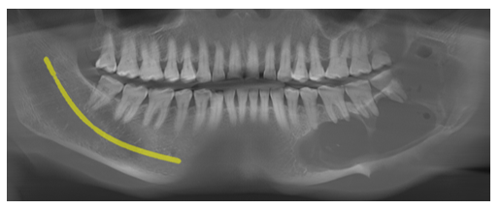
Fig 1. OPG Showing radiolucency from the canine to the ant br of the ramus anteroposteriorly and superoinferiorly extending from the alveolar crest to the inf border of the mandible.
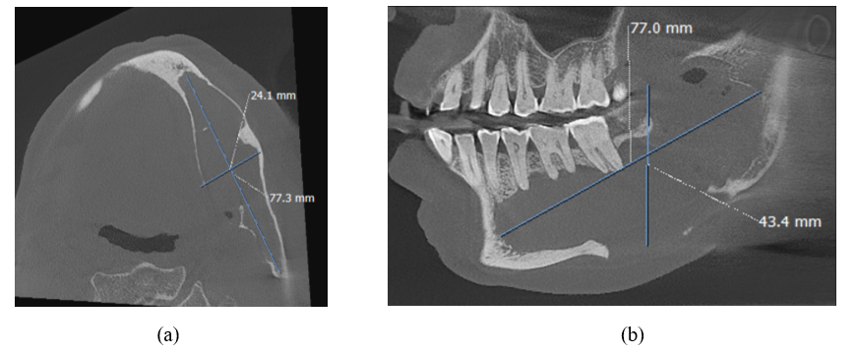
Fig 2 (a) CBCT axial view showing expansion of buccal corticle plate with unilocular radilucency extending anteroposteriorly from premolar zone to ant border of ramus 77 mmx24mm showing expansion buccal and lingual corticle plate (b) sagittal section showing approximate size of lesion: 77 mm × 43 mm × 24 mm.

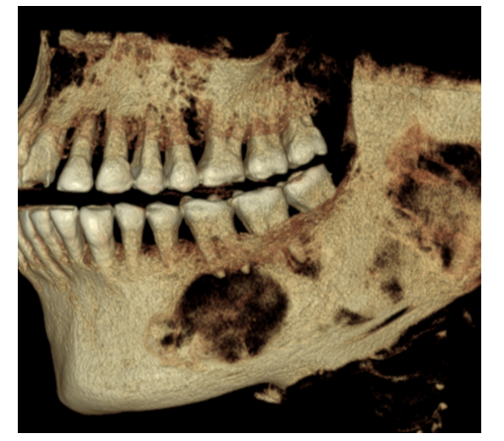
Fig 3 : CBCT showing osteolytic lession , without resorption of Buccal cortical plate

A provisional diagnosis of OKC was made based on the available clinical and radiographic findings. Depending on the clinical scenario, surgical enucleation with chemical quarterization using 5 FU was planned.
Informed written consent was obtained from the patient prior to the surgical procedure, including consent for clinical photography and publication of the case details.
Surgical Procedure: Under general anesthesia, an intraoral approach was used to access the lesion. An intraoral incision was made from the canine to the anterior border of the ramus, the full-thickness mucoperiosteal flap was reflected, and lateral corticotomy was performed to access the cystic cavity. The cyst was carefully enucleated, ensuring the complete removal of the cystic lining. Extraction of 38.37,36 done and the offending bone was removed using a bur. Thorough irrigation with Betadine and Inj metrogyl was performed. Chemical cauterization with 5-FU was performed by topical application of gauze soaked in 5 FU paste. The gauze was packed in the cystic cavity to target any residual epithelial cells for 24 h. Closure was performed with 3.0 mersilk, and the distal end of the guage was kept open in the buccal vestibule, corresponding to 33. [Refer fig.4,5,6]. The cystic lining was enucleated and sent for histopathological analysis. [Refer Fig 7 a,b]. Histopathological examination confirmed the diagnosis of OKC. [Refer fig 7 c]

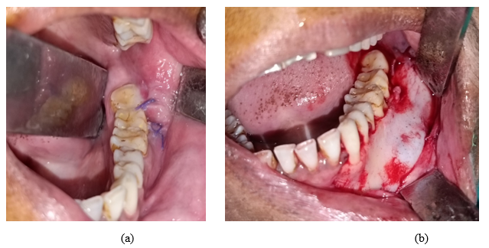
Fig 4 (a) Preoperative photograph ; (b) Incision taken from the canine to the anterior border of the ramus, refection of the full-thickness mucoperiosteal flap, and expansion of the buccal cortical plate can be appreciated.

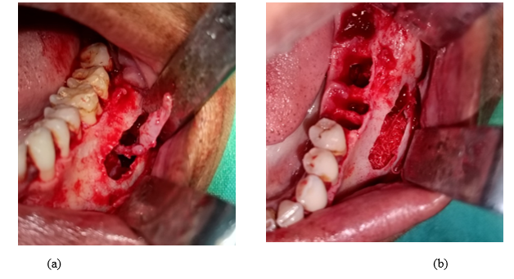
Fig 5 (a) Lateral corticotomy performed with enucleation of the cystic lining. (b) extraction of 38,37,36 . performed along with the removal of the affected bone.

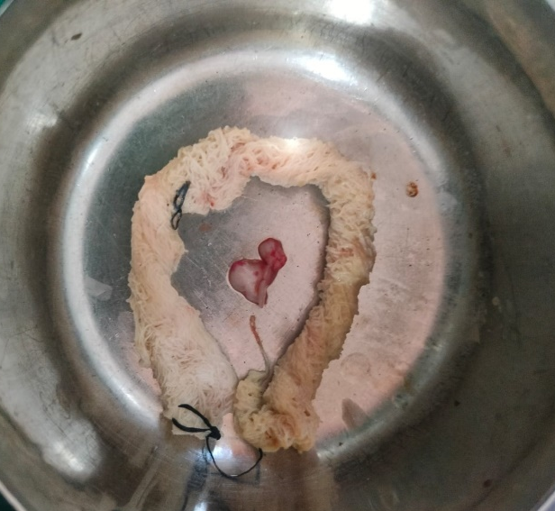
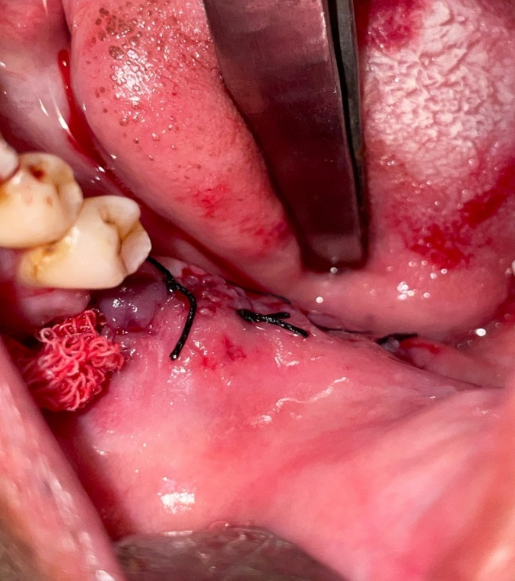
- (b)
Fig 6 Chemical quaternization performed with gauze impregnated with 5 FU paste kept in the cystic cavity. (b) gauze impregnated with 5 FU paste

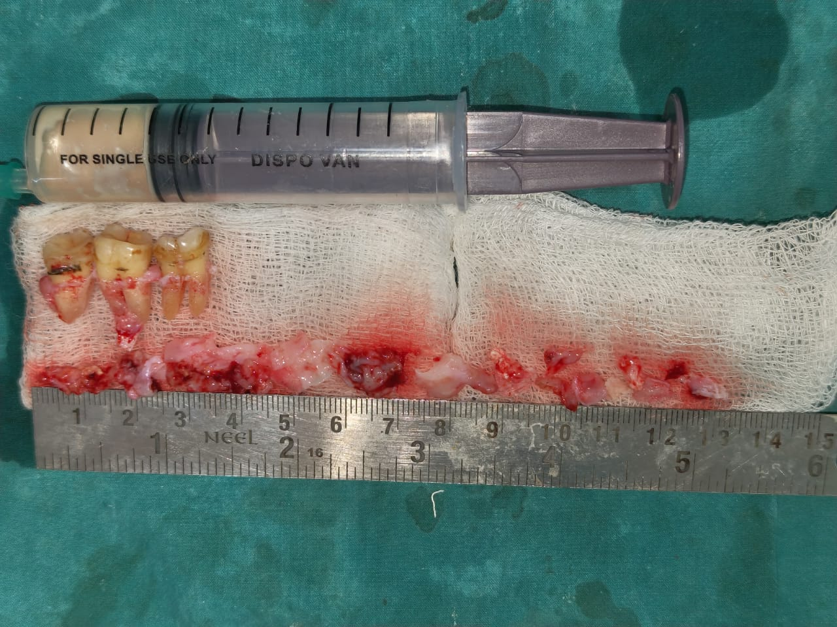
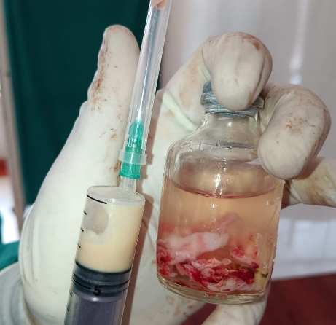
- (b)
Fig 7 (a) , (b) Specimen showing Chessy white aspirate along with cystic lining send for histopathological examination

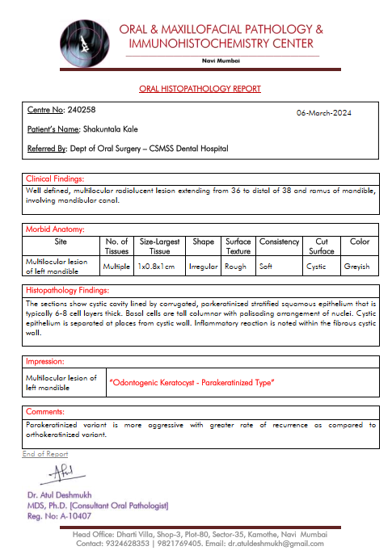

Fig 7 (c) Histopathological reports with final diagnosis as OKC

After 24 h, the gauze impregnated with 5 FU was removed, and the cavity was cleaned and irrigated with Betadine and saline. Primary closure was achieved using 3.0 mer silk.[Refer Fig 8, a ] Patients were followed up at 48 h intervals.
After 15 days, postoperative dehiscence was noted in the retromolar region, measuring approximately 3 × 3 cm. [Refer fig 8 b ] Since the tissue was devoid of the underlying periosteum, even after undermining and closing the flap again, dehiscences remained in the retromolar retromolar triangle (RMT) region. Therefore, Reconstruction using a nasolabial flap to ensure both functional and aesthetic restoration was planned.[Refer fig 9 a ]

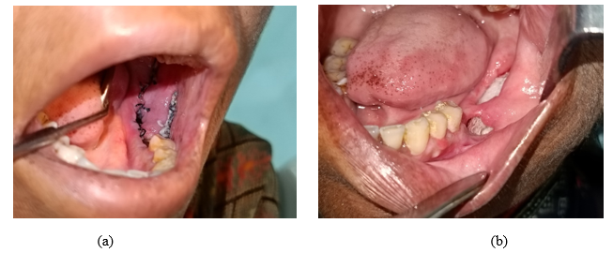
Fig 8 (a) Primary closure performed after removal of the gauze. (b) Postoperative dehiscence after 10 days.

For Nasolabial flap reconstruction surgery, the patient was placed under general anesthesia, the intraoral fibrous tissue was excised, and the margins were refreshed for better healing with the flap. An extraoral, unilateral, inferiorly based nasolabial flap of approximately 1.5 cm(width of flap) × 5 cm(length of flap) with a pedicle of 1 cm was designed. The incision was planned with the mesial margin corresponding to the nasolabial fold, 1.5 cm lateral to the corner of the mouth to avoid injury to the superficial labial artery[Refer Fig 9 b ]. An incision was made through the skin and subcutaneous tissue until the superficial musculoskeletal aponeurotic system (SMAS), just above the facial muscle.[Refer 1.10 a , b] The flap was harvested, and a tunnel was created to transport the harvested flap into the intraoral defect. Before flap transfer, de-epithelization of the flap corresponding to the tunnel is necessary to avoid postoperative fistula in single-staged surgery. De-epithelization was performed, the flap was transferred intraorally, and the defect was closed with the flap. Primary closure was obtained with a 3.o round body vicryl suture. [Refer fig 11 a, b ]
Postoperative nutrition was managed using a Ryles tube, and flap perfusion was checked intraorally by inspecting color changes in the flap and through a prick test.
Within 2 weeks, the patient’s functional aspects, tongue mobility, swallowing, and speech improved. Full functional recovery took 6 weeks.

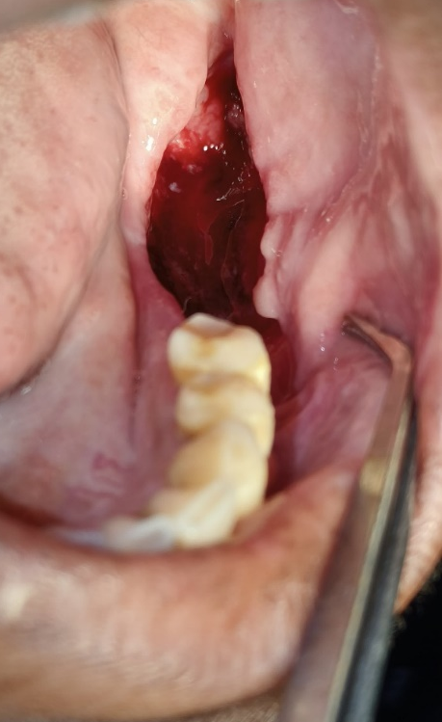
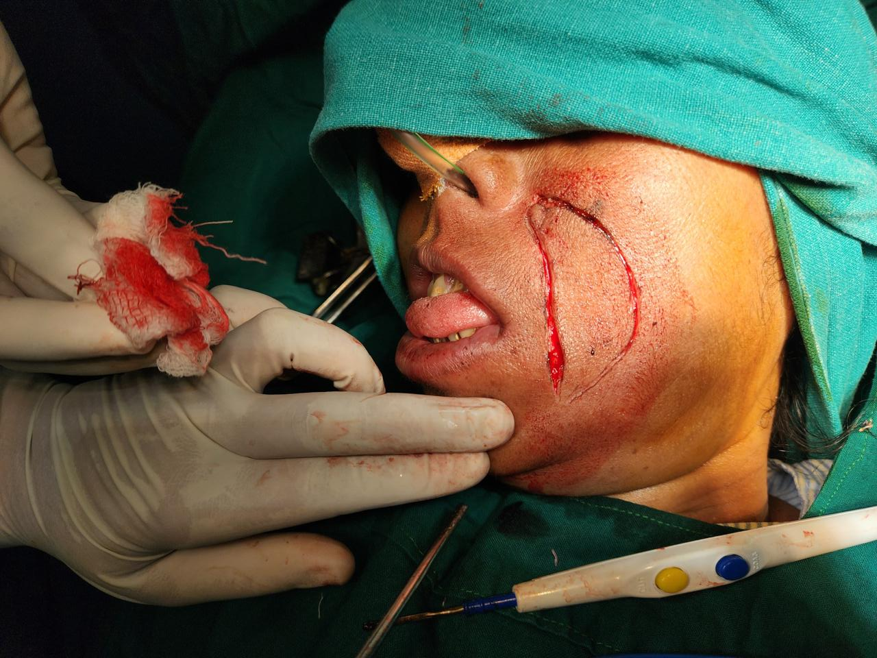

- (b)
Fig 9 (a) Postoperative soft-tissue dehiscence. (b) Incision for the nasolabial flap for the reconstruction of the intraoral soft tissue defect.

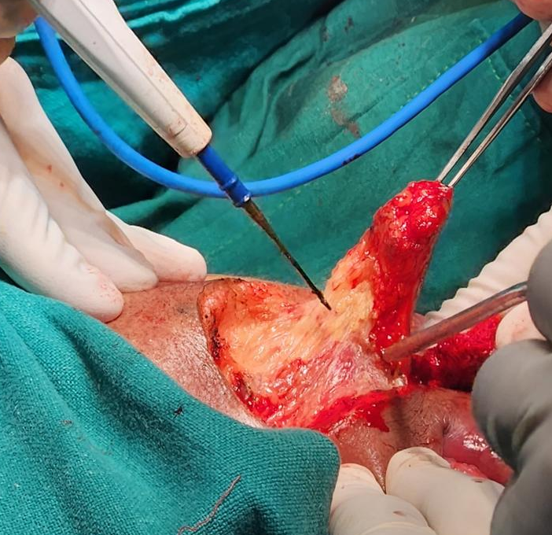
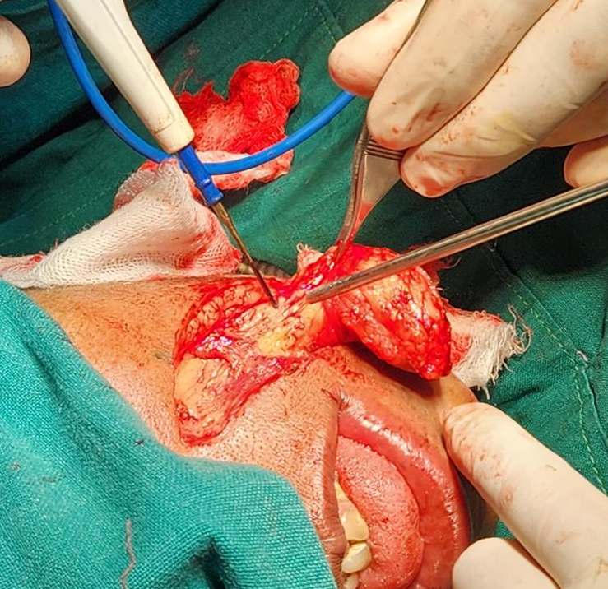
- (b)
Fig 10 Incision carried out through skin , subcutaneous tissue till SMAS , (b) nasolabial flap harvested

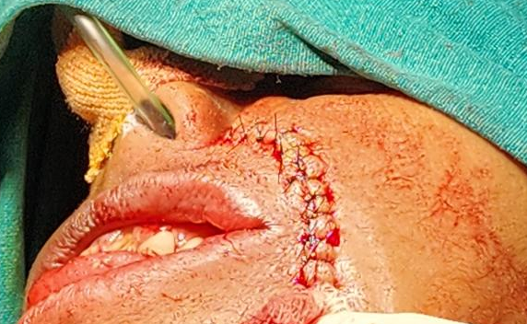
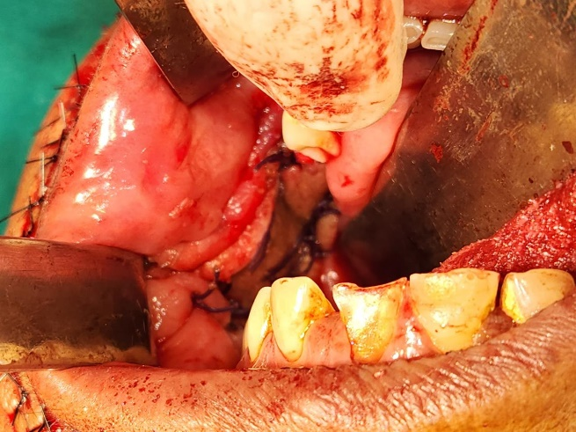
- (b)
Fig 11 (a) Flap transported intraorally and defect closed with 3.0 vycryl. (b) Donor site closed in layers with 3.0 vicryl and 3.0 ethilon sutures.

Postoperative follow-up at 1.5 years showed excellent soft tissue healing with minimal scarring and donor site morbidity. The flap was well accepted with no complications. A 1.5-year postoperative OPG revealed satisfactory bone regeneration without any other notable changes.[ Refer fig 12 a ,b,c ]

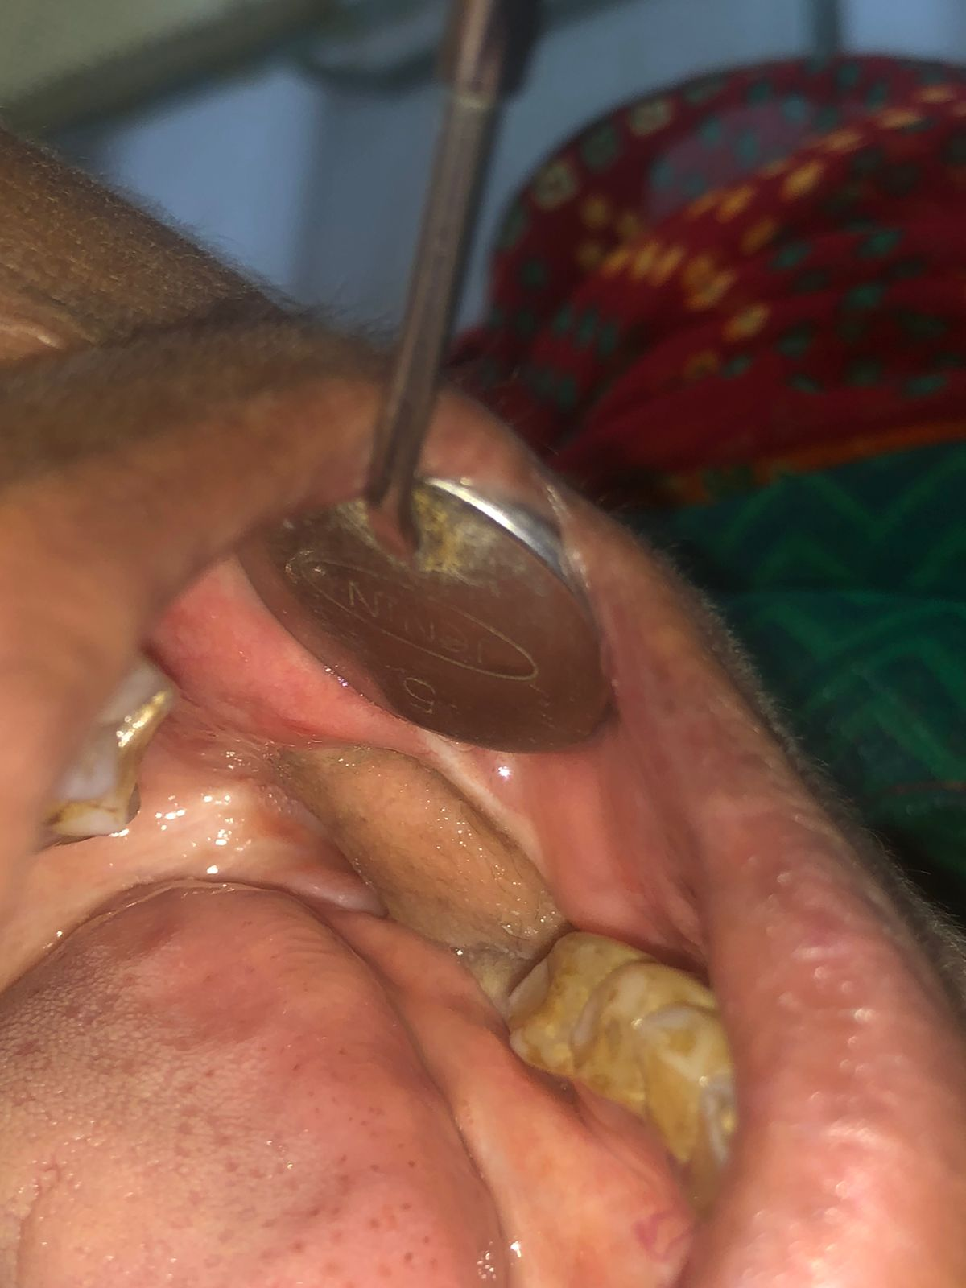


Fig 12 (a) (b)
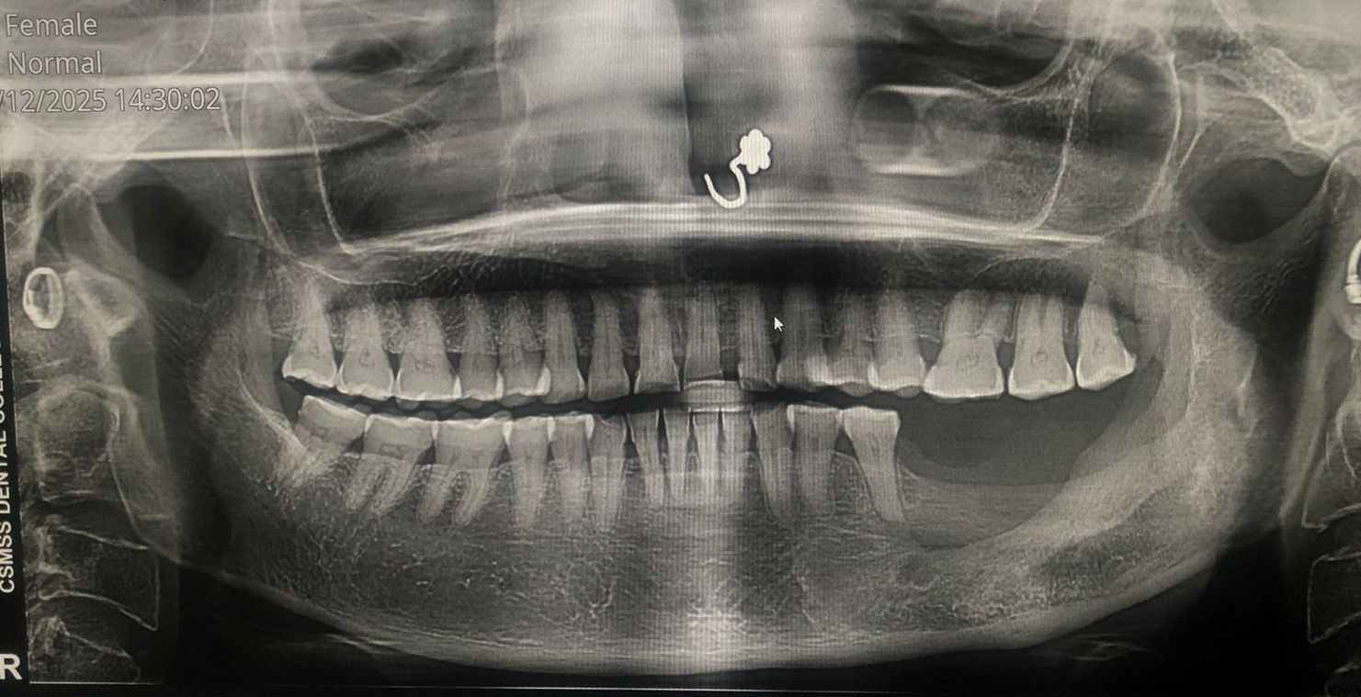
Fig 12 (c)
Fig 12 (a) : 1.5 yr follow up postoperative photograph of recipient site with healed flap at recipient site , (b) Postoperative healing of the donor sit postoperative) with minimal morbidity and scarring, (c) : OPG after 1 yr showing bone regeneration in operated site

Discussion:
A key feature of OKCs is the presence of daughter cysts formed by the budding of the basal layer into the surrounding connective tissue. The cyst wall was thin, with minimal inflammation. Recurrence rates vary widely (0–100%) owing to differences in follow-up duration, surgical techniques, and inclusion of NBCCS cases. Blanas et al. reported recurrence rates of 17–56% with simple enucleation, but the use of Carnoy’s solution post-enucleation reduced recurrence to 1.6%, comparable to resection but with less morbidity.^{[4]}
OKC is named because it exhibits keratinization of the cystic lining. The lumen contained a cheesy material resembling keratin debris and clear fluid. It is an Odontogenic Developmental, and Intraosseous cyst of epithelial origin in the oral and maxillofacial region. In 2004, Reichart and Philipsen proposed a revised classification for odontogenic tumors, reclassifying odontogenic keratocysts (OKC) as keratinizing cystic odontogenic tumors (KCOT). They categorized it under "benign neoplasms of odontogenic epithelium with mature fibrous stroma" due to its tendency for local destruction, aggressive biological behavior, high recurrence rate, and the presence of mitotic figures in the suprabasal layers.^{[5]}
Multiple OKCs are commonly seen as a manifestation of genetic conditions, such as Nevoid Basal Cell Carcinoma Syndrome (NBCCS) or Gorlin-Goltz syndrome. In syndromic cases, patients may develop several cysts simultaneously or experience multiple occurrences at different times throughout their lives. ^{[5]}
Reasons for Recurrence of OKC (13–62%) ^{[5]}
Nakamura et al^{[5]}:
- Thin walls and fragile epithelial lining
2. Epithelial lining is weakly attached to capsule
3. Extension of the cyst into cancellous bone
4. Dental lamina remnants in bone/overlying mucosa
5. In the case of perforation of the cortex, cyst lining adheres to adjoining bone or buccal or lingual mucosa (especially, lingual perforation is difficult to access during enucleation)
6. In dentate area (residual remnants in intraradicular areas)
7. Scalloped margins in multilocular variety
8. Desire to preserve adjacent vital structures
9. Location with difficult access
10. Extensive lesion involving coronoid/ascending ramus (difficult access) ^{[5]}

The targeted strategy for treating OKC (Early known) has emerged from advances in understanding its molecular genetics. Studies on the patched homolog (PTCH) tumor suppressor gene pathway, which is implicated in basal cell carcinomas (BCCs), have revealed that PTCH1 mutations in KOTs activate smoothened (SMO) and the sonic hedgehog (SHH) signaling pathway, promoting neoplastic growth. Recent findings by Rui et al. suggest that SMO gene alterations play a key role in KOT development, highlighting SHH pathway inhibitionvia SMO blockers and suppression of SHH transcription factorsas a potential therapeutic approach. Notably, vismodegib, an SHH inhibitor, has shown promise in reducing BCC and KOT burden in nevoid basal cell carcinoma syndrome patients^{.[6]} .
Additionally, 5-fluorouracil (5-FU), an antimetabolite, has been found to induce apoptosis through SHH pathway inhibition in hepatocellular carcinoma and is already used topically for superficial BCCs. Tumor response to 5-FU is influenced by enzymes such as thymidylate synthase (TS), dihydropyrimidine dehydrogenase (DPD), and thymidine phosphorylase (TP). Elevated TS expression correlates with 5-FU resistance, whereas its downregulation enhances efficacy. Low DPD levels improve treatment outcomes as DPD metabolizes 5-FU, whereas high TP expression increases responsiveness due to elevated production of active 5-FU metabolites, such as FdUMP. ^{[6][4][3][1]}
5-Fluorouracil (5-FU), an antimetabolite that targets pyrimidine synthesis, is an effective and well-tolerated topical treatment for superficial basal cell carcinomas (BCCs). Its active metabolite, fluorodeoxyuridine monophosphate, inhibits thymidylate synthase (TS), blocking thymidine production and causing DNA damage in proliferating cells^{.[7]}.
According to Tyler et al,. A systematic review and meta-analysis by Jacobs et al. (2024) demonstrates that 5-Fluorouracil (5-FU) is significantly more effective than Modified Carnoy’s solution (MCS) in managing odontogenic keratocysts (OKCs). The study found a 98% reduction in recurrence risk and a 56% lower rate of permanent peripheral nerve injury with 5-FU compared to MCS, following enucleation, curettage, and peripheral ostectomy. These results strongly support the use of 5-FU as a superior adjuvant therapy for OKCs.^{[8]}
Most studies favor the buccal fat pad for the reconstruction of oral defects because of its ease of harvest, minimal donor site morbidity, and reduced postoperative complications, making it suitable for moderate defects. The nasolabial flap offers greater tissue bulk and progressive improvement in mouth opening but is associated with intraoral hair growth and extraoral scarring. The platysma myocutaneous flap has emerged as a versatile alternative for larger or complex intraoral defects because of its excellent tissue bulk, color match, and minimal donor site morbidity. In a present case report operating surgeon has chosen nasolabial flap for reconstruction of postoperative soft tissue defect depending on soft tissue defect. ^{[9]}
In the present case, we designed a unilateral, inferior-based nasolabial flap for the reconstruction of the intraoral soft tissue defect.
Nasolabial Flap For Oral Cavity Reconstruction: The reconstruction of soft tissue loss following traumatic injuries or surgical excision often necessitates the use of soft tissue flaps. The nasolabial flap (NLF) is one of the oldest techniques used to restore orofacial soft tissue defects. Notably, Sushruta, an Indian surgeon in 600 BC, described a soft tissue flap remarkably similar to the modern nasolabial flap.^{[10]} The nasolabial flap, designed as a true myocutaneous flap based on the facial artery, is a durable and versatile option well-suited for single-stage reconstruction of oral cavity defects.^{[10]} This flap can be used unilaterally or bilaterally in the form of superiorly, inferiorly, or centrally based pedicle flaps. The nasolabial flap is a robust and versatile myocutaneous flap that is based on the facial artery. It is ideal for single-stage reconstruction of oral cavity defects or staged facial reconstruction. The flap harvested from the nasolabial fold region includes skin, subcutaneous tissue, and underlying musculature, ensuring excellent blood supply and viability. The technique involves careful design, elevation, and tunneling of the flap into the oral cavity with minimal donor site morbidity. Clinical applications include the reconstruction of defects in the alveolus, floor of the mouth, buccal cavity, and palate. The advantages of this method are its reliability, ease of harvest, and minimal impact on speech or function. Complications like mild upper lip weakness are rare and generally well tolerated.^{[10]}
The flap is a simple and versatile option for small to medium intraoral defects, offering good cosmetic and functional outcomes with minimal donor site morbidity. Complications were minimal, including wound dehiscence in three patients and one orocutaneous fistula. Despite facial artery ligation in some cases, flap viability was unaffected, highlighting the robust vascularity of the flap. The nasolabial flap remains an effective and reliable option for reconstructing anterior oral cavity defects, though larger defects may require alternative techniques^{[11]}.

Conclusion:
This case report presents the successful management of an odontogenic keratocyst (OKC) in a 52-year-old woman using surgical enucleation combined with chemical cauterization by topical application of 5-fluorouracil (5-FU). The lesion, located in the left mandible, was initially treated with enucleation and 5-FU-impregnated gauze to target residual epithelial cells and reduce the risk of recurrence. Postoperatively, the patient developed soft tissue dehiscence in the retromolar region. This was effectively reconstructed using an inferiorly based nasolabial flap, which provided excellent functional and aesthetic outcomes with minimal donor-site morbidity. This case highlights 5-FU’s role as a safe and effective alternative to Carnoy’s solution for chemical cauterization, reducing the risk of recurrence without neurotoxicity. The versatility of the nasolabial flap in repairing small to moderate intraoral soft tissue defects.

CONSENT
All authors declare that written informed consent was obtained from the patient for the publication of this case report and accompanying images. A copy of the written consent is available for review by our editorial office.
ETHICAL APPROVAL
All authors declare that all procedures were performed in accordance with the institutional guidelines and the Declaration of Helsinki. Ethical clearance was granted by the Institutional Ethics Committee.
Disclaimer (Artificial intelligence)
Option 1:
The author (s) hereby declare that NO generative AI technologies, such as Large Language Models (ChatGPT, COPILOT, etc.) and text-to-image generators, were used during the writing or editing of this manuscript.
Option 2:
The author (s) hereby declare that generative AI technologies, such as Large Language Models, have not been used during the writing or editing of this manuscript.

References

- Akhter Lone P, Ahmed Wani N, Ahmed Janbaz Z, Bibi M, Kour A. Topical 5-fluorouracil application in management of odontogenic keratocysts. J Oral Biol Craniofac Res. 2020 Oct-Dec;10(4):404-406. doi: 10.1016/j.jobcr.2020.07.008. Epub 2020 Jul 22. PMID: 32775182; PMCID: PMC7394907.
- Abdullah WA. Surgical treatment of keratocystic odontogenic tumour: A review article. Saudi Dent J. 2011 Apr;23(2):61-5. doi: 10.1016/j.sdentj.2011.01.002. Epub 2011 Jan 28. PMID: 24151416; PMCID: PMC3770236.
- Barua CG, Ali I, Tripathi A, Malakar A, Singha PK. The Role of 5-Fluorouracil in Preventing Recurrence After Enucleation of Odontogenic Keratocyst: A Case Report. Cureus. 2023 Sep 6;15(9):e44777. doi: 10.7759/cureus.44777. PMID: 37809265; PMCID: PMC10558008.
- Khan AA, Qahtani SA, Dawasaz AA, Saquib SA, Asif SM, Ishfaq M, Kota MZ, Ibrahim M. Management of an extensive odontogenic keratocyst: A rare case report with 10-year follow-up. Medicine (Baltimore). 2019 Dec;98(51):e17987. doi: 10.1097/MD.0000000000017987. PMID: 31860950; PMCID: PMC6940056.
- Bonanthaya K, Panneerselvam E, Manuel S, Kumar VV, Rai A, editors. Oral and Maxillofacial Surgery for the Clinician. Singapore: Springer; 2021. ISBN 978-981-15-1345-9 (print); 978-981-15-1346-6 (e-book). Available from: Chapter (11) https://doi.org/10.1007/978-981-15-1346-6 .
- Ledderhof NJ, Caminiti MF, Bradley G, Lam DK. Topical 5-Fluorouracil is a Novel Targeted Therapy for the Keratocystic Odontogenic Tumor. J Oral Maxillofac Surg. 2017 Mar;75(3):514-524. doi: 10.1016/j.joms.2016.09.039. Epub 2016 Sep 30. PMID: 27789270.
- Eid MK, Alqhtani NR, Atef AM, Sakka S. Application of topical 5-Fluorouracil to reduce the recurrence of odontogenic keratocyst: A prospective study with 2-year follow-up. Curr Probl Surg. 2024 Sep;61(9):101558. doi: 10.1016/j.cpsurg.2024.101558. Epub 2024 Jul 18. PMID: 39168535.
- Jacobs T, Patil D, Shanti R, Ziccardi VB. Comparing 5-Fluorouracil Versus Modified Carnoy's Solution for the Treatment of Odontogenic Keratocysts: A Systematic Review
and Meta-Analysis. J Oral Maxillofac Surg. 2024 Nov;82(11):1433-1440. doi: 10.1016/j.joms.2024.06.181. Epub 2024 Jul 5. PMID: 39038594.
- Tiwari P, Bera RN, and Chauhan N. What is the Optimal Reconstructive Option for Oral Submucous Fibrosis? A Systematic Review and Meta-analysis of Buccal Pad of Fat Versus Conventional Nasolabial and Extended Nasolabial Flap Versus Platysma Myocutaneous Flap. J Maxillofac Oral Surg. 2020 Dec;19(4):490-497. doi: 10.1007/s12663-020-01373-4. Epub 2020 May 5. PMID: 33071494; PMCID: PMC7524926.
- Wright H, Stephan S, Netterville J. Nasolabial flap for oral cavity reconstruction. In: Fagan JJ, editor. Open Access Atlas of Otolaryngology, Head & Neck Operative Surgery [Internet]. Cape Town: J. Fagan; [cited 2025 Jul 18]. Available from: https://www.entdev.uct.ac.za
- Singh S, Singh RK, Pandey M. Nasolabial flap reconstruction for oral cancer. World J Surg Oncol. 2012 Oct 30;10:227. doi: 10.1186/1477-7819-10-227. PMID: 23110587; PMCID: PMC3544680.

