Non-Surgical Endodontic Management of An Extraoral Cutaneous Sinus Tract of a Two Canal Mandibular Canine with Instrument Separation: A Case Report

ABSTRACT

Extraoral sinus tracts stemming from endodontic infections often mimic various other pathological conditions, making accurate differential diagnosis critical for proper management. Misdiagnosis can lead to ineffective treatment outcomes or unwarranted therapeutic interventions, underscoring the necessity of precise clinical evaluation. Hence, consideration of an odontogenic cause must be accounted while dealing with cutaneous sinus tracts involving the face or neck. This case report describes the complete resolution of an extraoral cutaneous sinus tract and healing of the periapical region through non-surgical endodontic therapy involving the separation of two instruments. The separation of two instruments in the apical portion further complicated the treatment as it did not allow the instruments to reach till the working length. Two-month follow-up showed closure of the sinus opening with minimal scar formation.

Keywords: periapical abscess, cutaneous sinus tract, extraoral sinus, sinus tract, sinus tract opening

INTRODUCTION
Odontogenic sinus tracts can drain intraorally as well as extra orally. A cutaneous sinus tract arising from an odontogenic source is a relatively rare occurrence ^{[1]}. An extraoral sinus develops as a consequence of a chronic odontogenic infection, often caused by trauma, dental caries, or, less commonly, periodontal disease. The ensuing inflammatory or pus-filled (suppurative) discharge escapes from the affected tooth or surrounding periodontal structures through an epithelial-lined pathway, which may open either intraorally or extra orally, depending on the position of the involved tooth ^{[2]}. When the tooth apices are positioned above the muscle attachments in the maxilla and below those in the mandible, the infection can potentially spread to extraoral areas ^{[3][4]}. These sinus tracts are more commonly associated with infections of mandibular teeth (80%) than with infections of maxillary teeth (20%) ^{[5][6]}. Accurately diagnosing cutaneous sinus tracts of dental origin can be challenging, as their initial presentation often mimics other conditions like skin infections, furuncles, ingrown hairs, blocked sweat gland ducts, osteomyelitis, tumours, tuberculosis, actinomycosis, congenital midline sinus of the upper lip, and carcinomas ^{[7]}. Hence, patients often consult dermatologists, family physicians, or general surgeons for these lesions, and may undergo several courses of antibiotics, surgical removals, biopsies, and even radiotherapy before the correct diagnosis is made ^{[1]}. Incorrect diagnosis potentiates the chronicity of the lesion and hampers facial aesthetics due to unnecessary treatments leading to scarring and dimpling ^{[8}]. Therefore, the differential diagnosis is a critical factor in managing these lesions ^{[1]}.
The present case report describes a case of an extraoral cutaneous sinus tract opening that was successfully managed by routine non-surgical endodontic therapy. The lesion showed complete resolution within one month after treatment.
CASE PRESENTATION
A 67-year-old woman reported to the Department of Conservative Dentistry and Endodontics, DAPM RV Dental College and Hospital, Bangalore, India with a chief complaint of pain in the lower right front tooth region and a pus draining from the chin area since 2 months. Medical history revealed that the patient is hypertensive and diabetic and under control and is on medications for the same. (Prolomet XL 25mg for hypertension and Metaglip- 500SR for diabetes).
Extraoral examination revealed a sinus opening located submentally, covered with dried exudate of pus leading to a crusty appearance. The surrounding skin was slightly erythematous and tender on touch [Fig 1(a)]. The lesion exuded pus on palpation. On intraoral examination, metal fixed partial denture was noted from 43 to 46. 43 was tender on percussion. No pockets were noted and gingival health was satisfactory.
Radiographic evaluation showed a periapical radiolucency with respect to 43 [Fig 1(b)]. A final diagnosis of chronic periapical abscess with an extraoral cutaneous sinus opening was made.
Dermatological origin of the lesion was ruled out since the patient’s primary complaint was of odontogenic origin. Further evaluation of the tooth intraorally led to the final diagnosis.
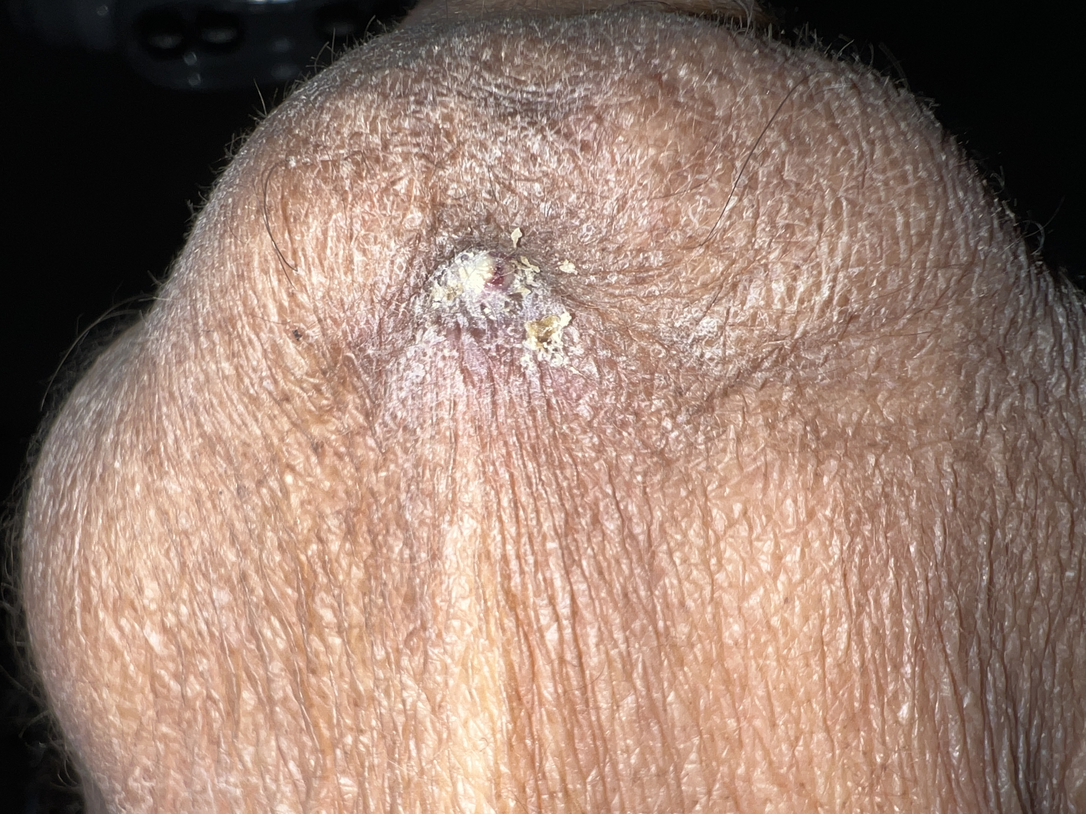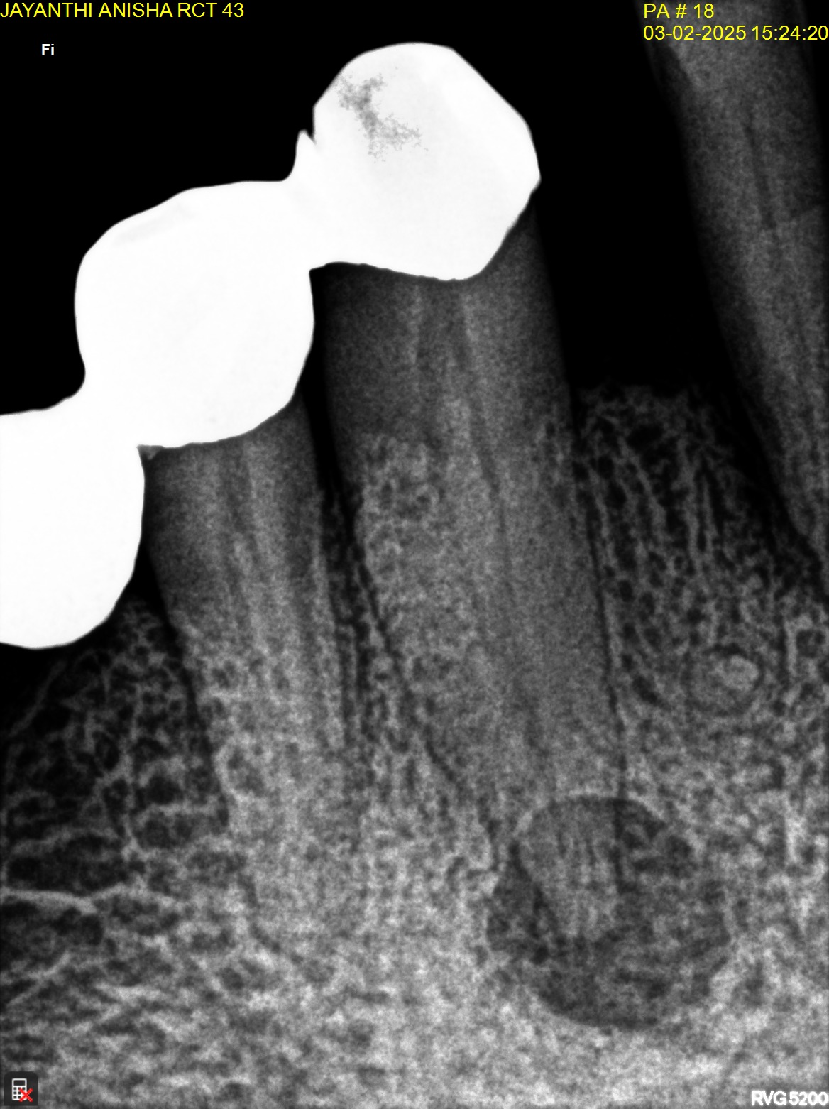
(a) (b)
Fig 1. Pre-op photograph and radiograph

TREATMENT
The treatment planned and proposed to the patient was to carry out endodontic treatment of 43. Considering the patient’s age and the span of the bridge, the decision was made to carry out the treatment through the bridge.
Access cavity preparation was done through the metal crown on 43. Two canal orifices were negotiated- buccal and lingual. Initial file used was stainless steel K-file #10 (MANI, Japan). While negotiating the lingual canal, there was a separation of K-file #10. In an attempt to bypass the separated instrument, another K-file #10 got separated. Two K-files #10 were separated in the apical one-third, at the junction of the buccal and lingual canal joining (Fig 2). The canal configuration was 2-1 (Weine’s Type II). One of the separated instruments was successfully retrieved through the buccal canal using ultrasonics around the files (Fig 3). The other separated instrument was bypassed and working length was determined. Bypassing of the instrument was done using an initial K-file #8 along the separated instrument. The file was used in watch-winding motion until a ‘catch’ was felt after which the file was used in peecking motion until it reached the apex. Bypassing of the instrument was confirmed radiographically (Fig 4). Cleaning and shaping was done upto 25-4% for the buccal and lingual canals. Copious irrigation was done using 2.5% NaOCl and 17% EDTA. Passive ultrasonic irrigation (PUI) was used for 30s to agitate and activate the irrigants. The canals were dried using paper points and calcium hydroxide with barium sulphate (NEOCAL, Orikam) intracanal medicament was placed was for 2 weeks.
In the subsequent appointment, the calcium hydroxide intracanal medicament was removed from the canal by thorough irrigation. The size of the extraoral sinus opening reduced in size and the patient reported no drainage of pus from the lesion. The canals were dried using paper points, master cones were selected (Fig 5) and obturation was done using 25-4% cones in the buccal and lingual canals (Fig 6). The access cavity was sealed with Cavit (3M, MN, USA) and permanent restoration using composite (Tetric-n-Ceram, Ivoclar Vivadent) was done after 6 days. Fig 7 shows the immediate post-operative photograph where there is complete resolution of the sinus opening with minimal scar formation.
Follow-up radiograph after 2 months shows ongoing healing of the periapical region and (Fig 8). Patient was asymptomatic and reported no signs of discomfort.
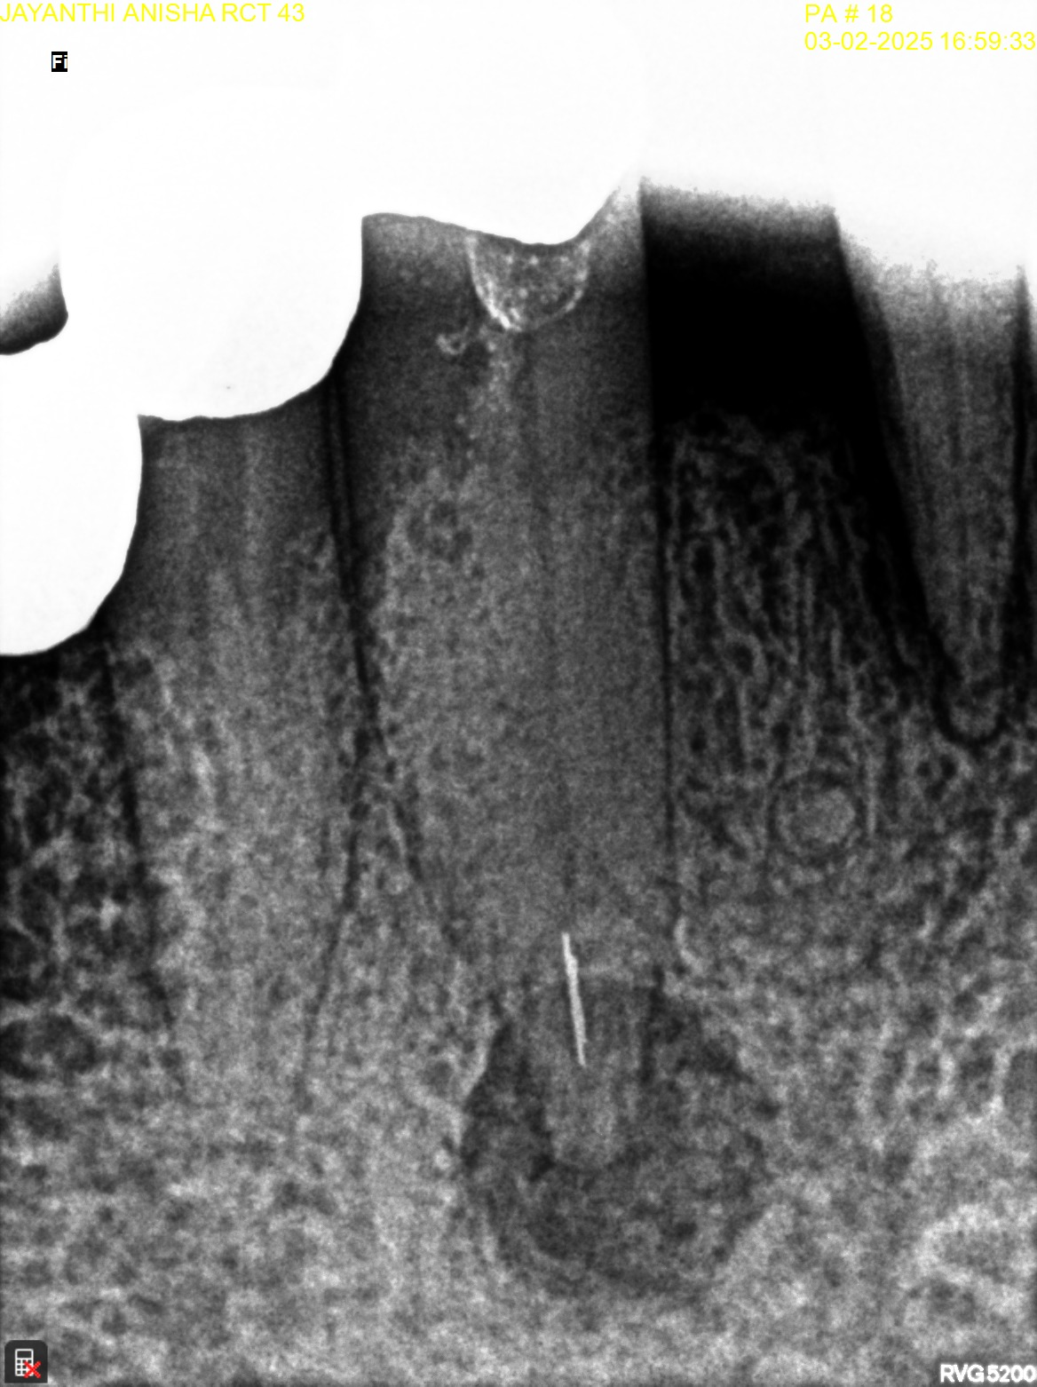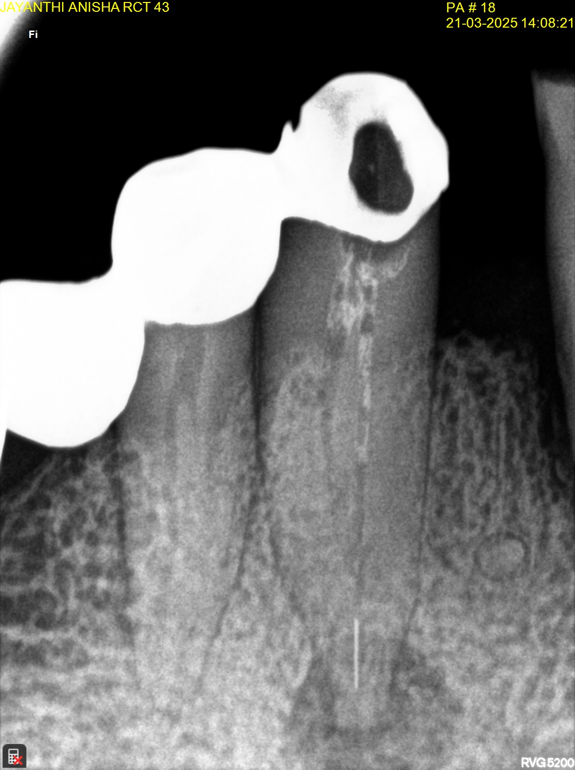
Fig 3. Retrieval of one K-file #10

Fig 2. Separation of 2 K-files #10

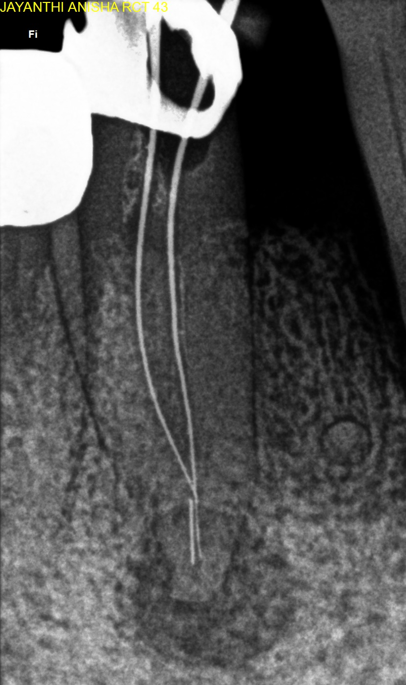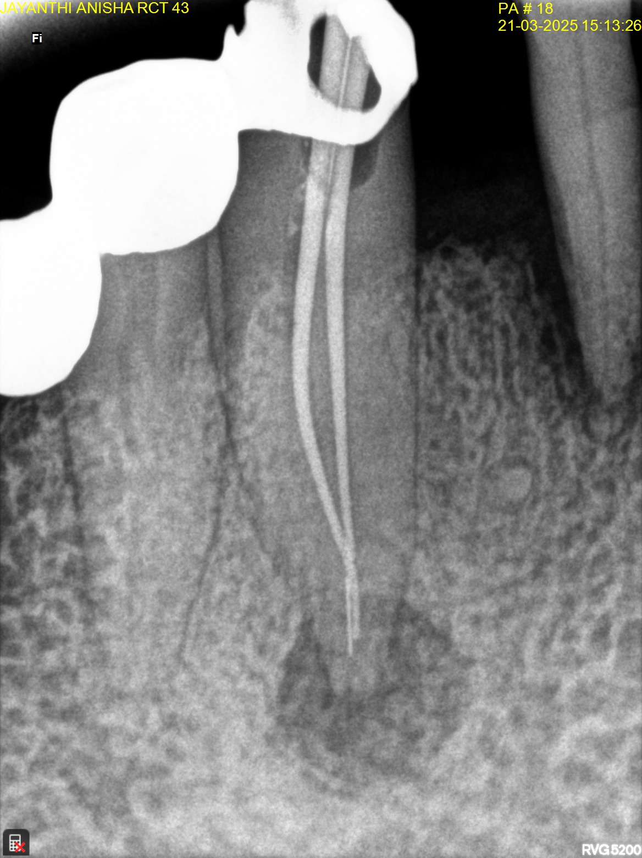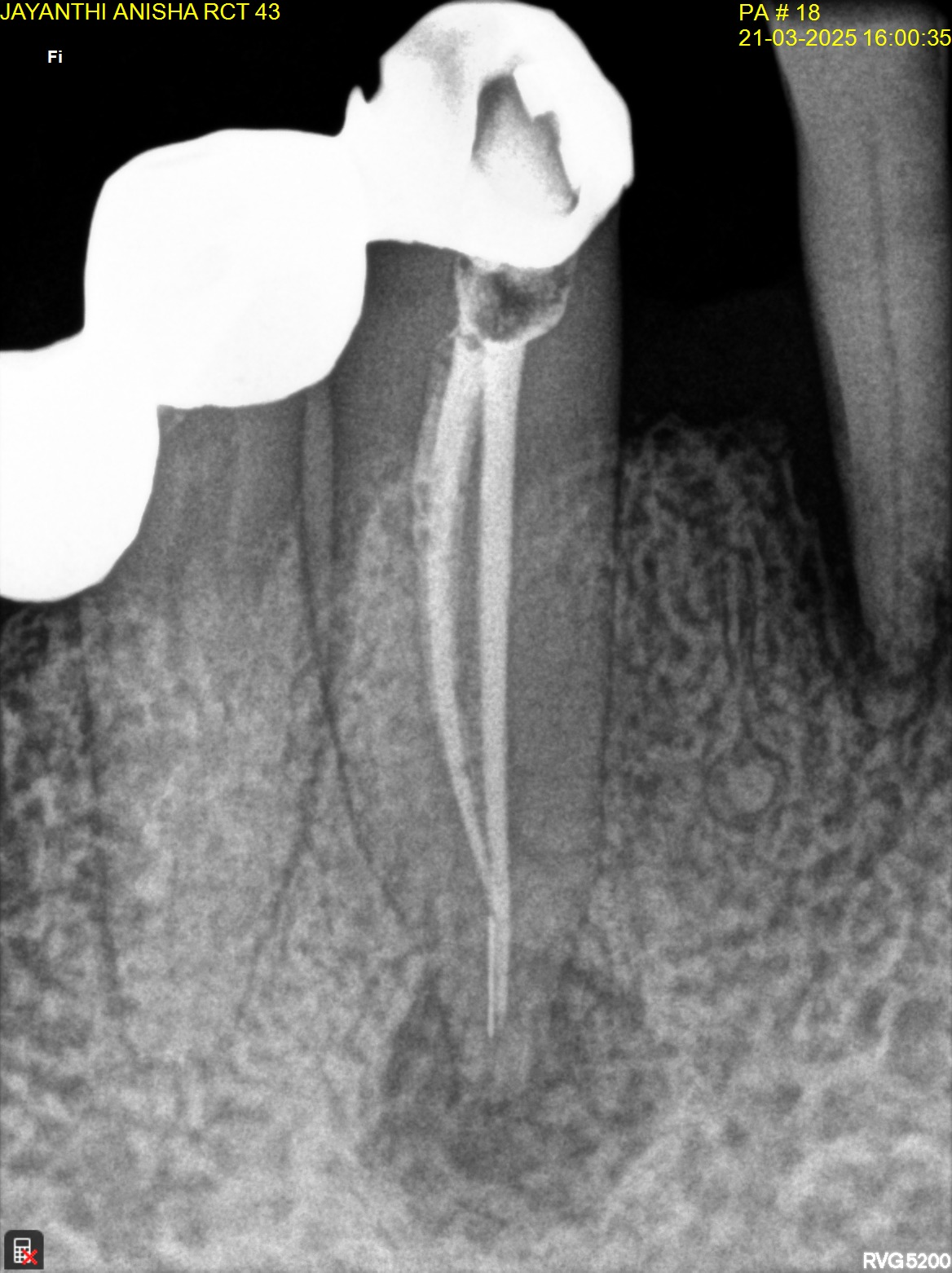
Fig 4. B and L canal negotiation, bypassing separated instrument; WL determined

Fig 5. Master cone radiograph

Fig 6. Obturation radiograph

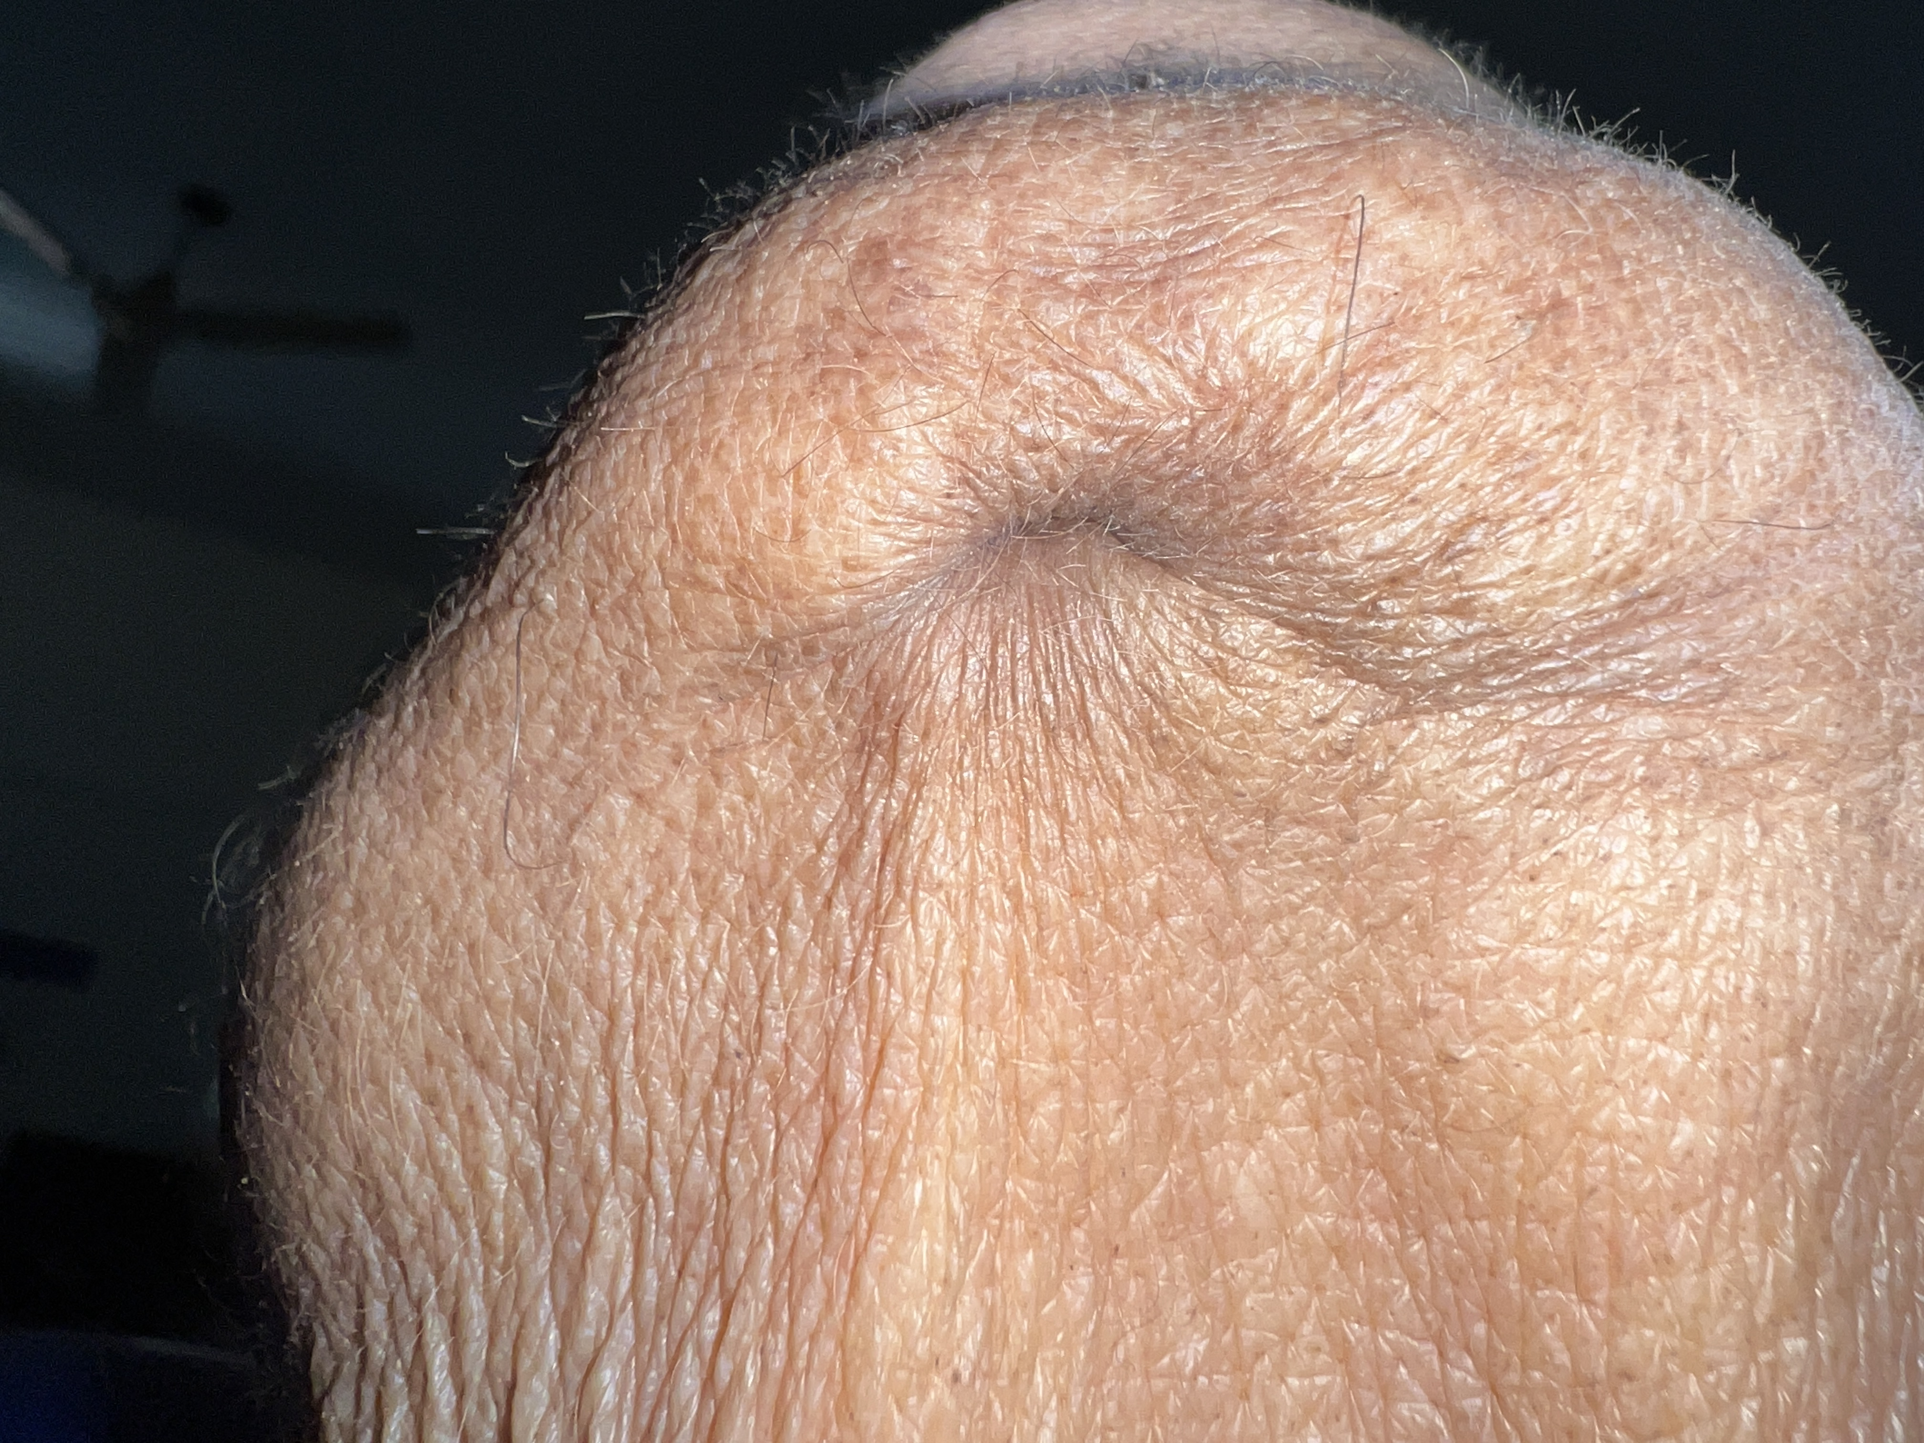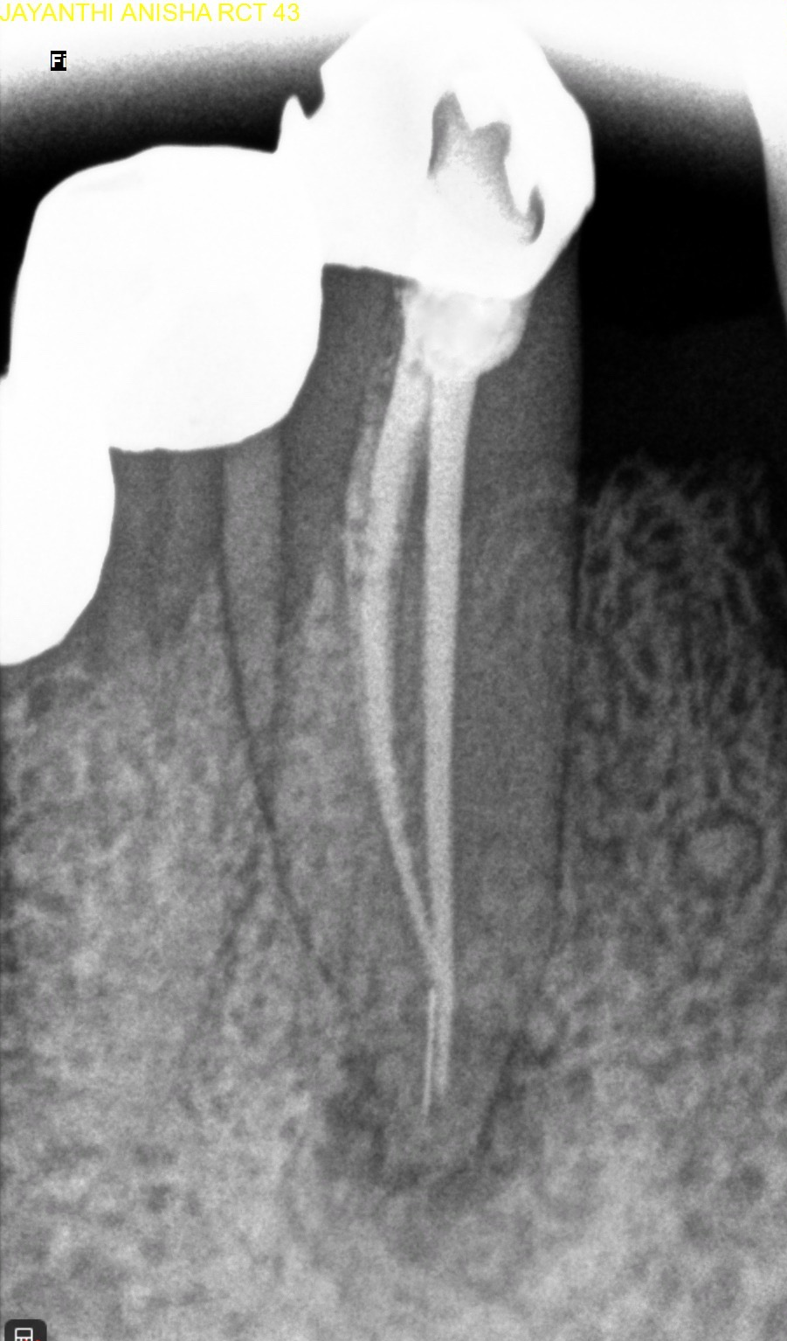
Fig 8. 2-month follow-up radiograph

Fig 7. Post-operative photograph

DISCUSSION

Long standing periapical abscesses associated with deep dentinal caries, chemical irritation or injury leads to the development of an extraoral cutaneous sinus tract mainly on the facial and cervical skin ^{[9]}. Studies suggest additional causes of extraoral odontogenic sinus tracts, such as retained tooth fragments, impacted teeth, odontogenic cysts, vertical root fractures, trauma-induced crown fractures, and failed dental implants ^{[7]}. A chronic periapical infection triggers progressive bone resorption through inflammation. The infection gradually destroys the alveolar bone and extends outward, following the path of least resistance along fascial planes and muscle insertions, ultimately penetrating the cortical bone and emerging through the skin. The development of an extraoral sinus tract is influenced by the location of the infected root tips in relation to nearby muscle attachments, as well as the thickness and density of the surrounding bone ^{[10]}. The submental region has been the most common site of occurrence of an extraoral sinus. Extraoral odontogenic sinus tracts have also been documented to drain through various facial regions, including the cheek, mandibular angle, canine space, nasolabial fold, nasal mucosa, upper lip, and medial eye canthus ^{[11]}.

The main objective of managing such lesions is to eliminate the source of infection. Diagnosing these cases presents multiple difficulties, particularly since the cutaneous lesions often appear distant from their odontogenic source ^{[3]}. Palpation often detects a firm, cord-like sinus tract connected to the alveolar bone near the affected tooth. Intraoral inspection frequently shows decayed or discoloured teeth, while pulp vitality tests typically yield negative responses in the involved teeth ^{[8][12]}. When dealing with a patent sinus tract, clinicians may carefully insert a gutta-percha cone or a sharp wire through the external opening and gently advance it along the tract until reaching the affected tooth area. A periapical radiograph should then be taken with the marker in place to trace the source of infection ^{[3][8][12][13]}. In this instance, radiographic evidence clearly demonstrated periapical pathology associated with the non-vital teeth identified through pulp testing and hence no sinus tracing was done.
As supported by existing research, standard endodontic treatment represents the primary therapeutic approach for such conditions ^{[9][11][12]}. With proper diagnosis and appropriate endodontic intervention, complete resolution of the sinus tract typically occurs within one to two weeks ^{[4]}. In the present case, the sinus opening healed after the initial treatment and placement of calcium hydroxide intracanal medicament. Calcium hydroxide is the preferred material of choice owing to its antibacterial effects. Studies support the application of calcium hydroxide paste as an effective treatment approach for promoting faster resolution of sinus tracts originating from non-vital teeth ^{[14]}. When calcium hydroxide is used as an intracanal medicament in teeth with periapical lesions, success rates of about 74% to 80.8% have been reported ^{[15]}. The need for systemic antibiotics is usually not indicated as the lesion is a localised entity. Systemic antibiotics will only result in a temporary drainage reduction and pseudohealing ^{[12][14]}.
The separated instrument in the canal had no adverse effect on the treatment outcome as it had been bypassed. Copious irrigation with NaOCl and EDTA also reduced the incidence of any complications. An invitro study by Uzunoglu-Özyürek E et. al concluded that while using PUI, NaOCl penetrates into the dentinal tubules 1mm from the apex even in the presence of an irretrievable instrument in the apical region ^{[16]}.

CONCLUSION

Dental causes must be included in the differential diagnosis of all orofacial cutaneous lesions. In the present case, complete resolution of the extraoral cutaneous sinus tract and periapical healing was achieved through non-surgical endodontic therapy. In the unforeseen case where the non-surgical treatment fails, or when there are non-negotiable canals, endodontic surgery may be considered. Effective collaboration between dental and medical professionals is crucial for the prompt diagnosis and management of these uncommon conditions.

Consent
As per international standards or university standards, patient(s) written consent has been collected and preserved by the author(s).

Disclaimer (Artificial intelligence)
Option 1:
Author(s) hereby declare that NO generative AI technologies such as Large Language Models (ChatGPT, manuscript.

REFERENCES

- Dincol ME, Yilmaz B, Ersev H, Mert Gunduz V, Arslanoglu B, Yalcin TY, Ekiz D, Erisen R. Treatment of extraoral cutaneous sinus tracts with non-surgical endodontic intervention: report of six cases. J Istanb Univ Fac Dent. 2015 Apr 29;49(2):35-40. doi: 10.17096/jiufd.73461. PMID: 28955534; PMCID: PMC5573483.
- Priyanka Rudrapada, Prashanth BR, Rupali Karale, Jaishri Khed, Manjula SP. Non-surgical management of extraoral cutaneous sinus tract with odontogenic origin of mandibular incisors - a case series. Int J Health SciRes. 2024; 14(5):234-241.
- Qazi SS, Manzoor MA, Qureshi R, Arjumand B, Hussain SM, Afridi Z. Nonsurgical endodontic management of cutaneously draining odontogenic sinus. J Ayub Med Coll Abbottabad. 2006;18(2):88–89.
- Varol A, Gülses A. An unusual odontogenic cutaneous sinus tract to the cervical region: a case report. OHDMBSC. 2009;8(3):43–45.
- Nakamura Y, Hirayama K, Hossain M, Matsumoto K. A case of an odontogenic cutaneous sinüs tract. Int Endod. 1999;32(4):328–331. doi: 10.1046/j.1365-2591.1999.00233.x
- Samir N, Al-Mahrezi A, Al-Sudairy S. Odontogenic cutaneous fistula: Report of two cases. Sultan Qaboos Univ Med J. 2011;11(1):115–118.
- Varghese LL, Bhattacharya A, Sharma P, Apratim A. Non-surgical management of an extraoral cutaneous sinus tract of odontogenic origin. BMJ Case Rep. 2020 Jul 20;13(7):e234699. doi: 10.1136/bcr-2020-234699. PMID: 32690568; PMCID: PMC7373307.
- Assery M, Al Shamranit S. Cutaneous facial sinuss tract of dental origin: a clinical case report. Saudi Dent J. 2011;13(1):37–39.
- Mardones F, Oroz J, Muñoz C, et al. Cutaneous facial sinus tract of dental origin. Pediatr Dermatol 2010;27:410–1. 10.1111/j.1525-1470.2010.01187.x
- Cioffi GA, Terezhalmy GT, Parlette HL. Cutaneous draining sinus tract: an odontogenic etiology. J Am Acad Dermatol 1986;14:94–100. 10.1016/S0190-9622(86)70012-1
- Janev E, Redzep E. Managing the cutaneous sinus tract of dental Origine. Vol. 4, open access Macedonian Journal of medical sciences. North Macedonia 2016:489–92
- Mittal N, Gupta P. Management of extra oral sinus cases: A clinical dilemma. J Endod. 2004;30(7):541–547. doi: 10.1097/00004770-200407000-00019.
- Abuabara A, Schramm CA, Zileak JC, Baratto-Filho F. Dental infection simulating skin lesion. An Bras Dermatol. 2012;87(4):619–621. doi: 10.1590/S0365-05962012000400017.
- Vyas K, Chaturvedi R. Cutaneous sinus tracts: an endodontic approach with case report. IJDRR. OCT 2011-MAR 2012:78–81.
- Fernandes M, de Ataide I. Nonsurgical management of periapical lesions. Journal of Conservative Dentistry and Endodontics. 2010 Oct 1;13(4):240-5.
- Uzunoglu-Özyürek E, Dik Güzel C, Dogan Buzoglu H. Effect of different irrigation methods in the presence of a separated instrument: an in vitro study. Acta Odontol Scand. 2020 Aug;78(6):409-416. doi: 10.1080/00016357.2020.1733076. Epub 2020 Feb 27. PMID: 32105162.
- Marinho-Siqueira, R., Silva-Filho, J. E. da, Beserra, E. dos S., Vasconcelos, B. C. de, Aguiar, B. A., & Feitosa, A. P. O. P. (2025). Impact of Cardiovascular Diseases on Endodontic Treatment: An Integrative Review of Risk Factors. Archives of Current Research International, 25(5), 314–322. https://doi.org/10.9734/acri/2025/v25i51211

