Original Research Article
Proximate Characterization and Interactions Among Improved Soybean Genotypes for Nutritional Improvement
ABSTRACT
Soybean [Glycine max (L.) Merrill] is a self-pollinated short-duration legume crop valued for its high protein and oil content, playing a pivotal role in food, feed, and industrial sectors. In India, its cultivation has expanded rapidly; however nutritional improvement remains a key breeding objective. This study aimed to evaluate the proximate composition viz. protein, oil, and ash of 55 improved soybean genotypes including 5 checks to identify superior lines for nutritional breeding. Field trials were conducted in RCBD design with three replications during Kharif 2024 at JNKVV, Jabalpur. Biochemical traits were quantified using standard AOAC methods, and statistical analyses were performed in R using ggplot2 and pheatmap for visualization. Results revealed substantial genetic variation. Protein ranged from 35.38% to 42.08%, oil from 17.60% to 22.55%, and ash from 3.28% to 7.96%. Genotypes such as JS 25-55 and JS 25-52 exhibited superior protein content, while NRC 190 and AMS 269 showed elevated oil levels. JS 21-72 and JS 25-01 recorded the highest ash content. Weak and non-significant correlations among traits; between protein and oil(r = -0.052, p value- 0.53); protein and ash (r = +0.12, p = 0.37); ash and oil (r = −0.09, p = 0.52). Genotype-labeled scatter plots and clustering analysis identified outliers and multi-trait donors, strengthening the potential for targeted nutritional enhancement. The study highlights JS 25-55 as a protein-rich donor and NRC 190 as an oil-rich candidate for divergent breeding. The independence of traits supports flexible selection strategies. These findings offer actionable insights for soybean improvement programs focused on nutritional quality, industrial value, and sustainable cultivation.
Keywords: Protein, Oils, Ash, Soybean, and Genetic Variations
INTRODUCTION
Soybean [Glycine max (L.) Merrill] is a globally significant leguminous crop, revered for its dual role as a rich source of vegetable protein and edible oil. Soybeans have evolved into a cornerstone of modern agriculture, contributing nearly 60% of the world’s protein meal and 30% of vegetable oil consumption (Ibanez et al. 2020). They have been domesticated for over 6,000 years in China. Its versatility spans food, feed, and industrial applications, making it indispensable in both developed and developing economies. Soybean is a short-day, self-pollinated annual crop belonging to the Fabaceae family. It exhibits a determinate or indeterminate growth habit, with trifoliate leaves, nodulated roots, and pods containing 2 to 4 seeds (Kumari et al. 2025). Soybean seeds are nutritionally dense, containing approximately 40% protein, 20% oil, and essential micronutrients such as iron, zinc, calcium and phosphorus, vitamins like A, B, C, D, amino acids and antioxidants making them vital for addressing protein-energy malnutrition and micronutrient deficiencies (Jin et al 2023, Amrate, 2024).
The versatility of soybean is evident in its widespread use across multiple sectors: its meal is a major component of livestock feed, while whole soybeans and processed derivatives are key in human nutrition (Uikey et al. 2022). The presence of certain biochemical compounds, such as isoflavones, saponins, phenolics, and tocopherols makes the plant stress resilience and possess various health-promoting properties for humans (Rahman et al. 2024). The crop’s expansion is driven by its economic value, adaptability to diverse agro-climatic zones, and rising demand for plant-based protein and biofuel.
In India, soybean has witnessed exponential growth since its commercial introduction in the 1970s. From a mere 0.03 million hectares in 1970, the cultivated area surged to over 11.97 million hectares by 2025, positioning India as the fifth-largest producer globally (NAAS et al 2017). The crop thrives predominantly in the rainfed agro-ecosystems of Madhya Pradesh, Maharashtra, Rajasthan, and parts of Karnataka and Chhattisgarh. Despite its vast acreage, India’s average productivity (~1.2 t/ha) remains below the global average (~2.2 t/ha), highlighting the need for improved genotypes and agronomic practices for enhancement of productivity (Pushpendra et al 2017; Jawarkar et al 2023). The development of shade-tolerant and nutrient-rich cultivars are aimed at bridging yield gaps and promoting sustainable cultivation under climate-resilient frameworks (Zhang et al 2025). Given its biochemical richness and agronomic potential, soybean remains a focal point for genetic improvement, biofortification, and value-added processing in India where most population is vegetarian. This study aimed to evaluate the proximate composition of elite soybean lines for potential use in breeding programs targeting nutritional enhancement.
MATERIALS AND METHODS
The present study was conducted during the kharif 2024 at Jawaharlal Nehru Krishi Vishwa Vidyalaya (JNKVV), Jabalpur, Madhya Pradesh. A total of 55 improved (=improved) soybean genotypes, along with five standard checks (JS 20-98, JS 20-34, JS 20-69, JS 335, and JS 20-116), were evaluated for their biochemical composition, specifically protein, oil (fat), and ash content.
Fat content was estimated using the Soxhlet extraction method based on AOAC (2002) guidelines. One gram of finely ground seed sample was placed in a fat-free cotton-sealed thimble and extracted with petroleum ether (AR grade, 60–80 °C) for six hours using a SOCS PLUS system (Pelican Equipment). After extraction, the solvent was evaporated and the residue was oven-dried at 80 °C for 4–6 hours. The crude fat percentage was calculated by comparing the weight of extracted fat to the initial sample weight.
Ash content was determined following the dry ashing procedure outlined by AOAC (2002). Two-gram seed samples were placed in crucibles, pre-charred over a low flame, and then ashed in a muffle furnace at approximately 600 °C for six hours. Crucibles were cooled in a desiccator and weighed repeatedly until constant weight was achieved. Ash percentage was calculated as the ratio of ash weight to sample weight.
Protein content was estimated using the standard Micro-Kjeldahl digestion and distillation method as described by AOAC (1984). A 0.2 gram sample was digested with concentrated sulfuric acid and a catalyst mixture (K₂SO₄, CuSO₄, and SiO₂) until the solution turned clear. The digest was distilled, and the released ammonia was absorbed in boric acid containing a mixed indicator, followed by titration with 0.1 N sulfuric acid. Nitrogen content was calculated based on titration volume, and crude protein percentage was derived using a nitrogen-to-protein conversion factor of 6.25. Statistical analysis was done in R.4.5.1, and plots were generated by using ggplot2 (Wickham et al. 2016) and pheatmap (Kolde, 2025).
RESULTS AND DISCUSSION
Substantial variation was observed among the 55 improved soybean genotypes for protein, oil, and ash content revealing rich biochemical diversity present in study (Table 1). Protein content ranged from 35.38 % (PS 16-96) to 42.08 % (JS 25-55), with a mean of approximately 39.6%. Oil content varied from 17.60% (EC 350664) to 22.55% (NRC 190), while ash content spanned from 3.28% (NRC 190) to 7.96% (JS 21-72), reflecting both nutritional and industrial relevance (Figure 1).
The observed variability across genotypes underscores the genetic richness within the soybean panel, offering ample scope for trait-based selection. The wide range in protein content (35.38–42.08%) reflects differential nitrogen assimilation and storage capacity, likely influenced by genotype-specific metabolic pathways. Genotypes having high protein content such as JS 25-55(42.08 %), JS 25-52(41.89), and JS 25-06 (41.06 %) may possess enhanced seed storage protein biosynthesis, making them potential parents for nutritional breeding. Similarly, the oil content variation (17.60–22.55%) suggests diversity in lipid metabolism, with NRC 190(22.55), and AMS 269(20.80) showing superior oil accumulation, potentially linked to favourable alleles in fatty acid biosynthetic genes.
Ash content ranged from 3.28% to 7.96% displayed the highest relative spread among the three traits, indicating significant variation in mineral uptake and deposition. Genotypes like JS 21-72(7.96%) and JS 25-01(7.88) with elevated ash levels- may be valuable for micronutrient enrichment, especially in regions where soils are deficient in minerals. The presence of genotypes with high protein and oil but moderate ash (e.g., JS 22-01, JS 21-72) suggests that these traits may be inherited independently, as it is further supported by the weak pairwise correlations discussed in the latter part of the paper.
Based on trait performance, the top five genotypes for each trait were for protein content, JS 25-55 (42.08%), JS 25-52 (41.89%), JS 25-06 (41.09%), JS 24-26 (41.12%), and JS 20-79 (41.20%) ranked highest. For oil content, NRC 190 (22.55%), AMS 269 (20.80%), JS 24-23 (20.69%), JS 25-08 (20.36%), and NRC 270 (20.35%) were superior. In terms of ash content, JS 21-72 (7.96%), JS 25-01 (7.88%), JS 335 (7.78%), JS 25-03 (7.43%), and JS 25-02 (7.37%) showed the highest values.
Anand et al. (2024) evaluated 60 soybean genotypes for oil, protein, and ash content, and reported significant differences among genotypes for all three traits. The observed range for oil content was 17.6% to 21.6%, protein ranged from 35.2% to 42.2%, and ash content varied between 3% and 6%, indicating substantial biochemical diversity. Banerjee et al. (2023) also reported significant genotypic variation for oil, protein, and ash traits, with ash content ranging from 3% to 6%, further supporting the scope for trait-based selection in soybean breeding.
Similarly, Upadhyay et al. (2022) assessed the proximate composition of soybean genotypes and recorded the highest protein content at 41.62% and oil content at 21.50%, highlighting the presence of nutritionally superior lines.
Significant genetic variation in protein and oil content has also been reported by Pawar et al. (2020), who evaluated 30 soybean genotypes and observed a protein range of 38.10% to 41.66% and oil content ranging from 18.00% to 20.63%. These results align with broader trends in soybean nutritional profiling, highlighting the inherent variability among genotypes.
The results of proximate composition in soybean genotypes are consistent with the genotype-specific variation reported by Sumangala and Kulkarni (2019). The study revealed significant differences in protein, fat, crude fiber, and ash in the studied genotypes. Notably, DSb 21 exhibited the highest protein content (43.63%), while DSM showed elevated crude fiber (6.30%) and ash (5.82%) levels meanwhile, Kalitur recorded the highest fat content (19.76%). These findings validate the nutritional diversity observed in our broader genotype set, particularly the inverse relationship between protein and fat content across genotypes.
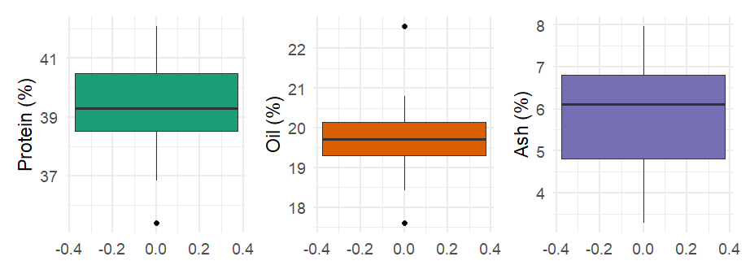
Fig. 1: Distribution of protein, oil and ash in 55 improved soybean genotypes

Association Relations among Protein, Oil, and Ash
The relationship between protein and oil content across 55 improved soybean genotypes was visualized using a scatter plot with a fitted trend line and genotype labels (Figure 2a & b). The overall trend indicated a weak negative non-significant correlation (-0.052), suggesting that increases in protein percentage may be modestly associated with reductions in oil content. This inverse relationship aligns with previous findings by Kambhampati et al. (2019), who reported a similar trade-off in Indian soybean germplasm. However, the Genotype-labeled plot revealed substantial variation around this trend and highlighted the presence of genotypes that deviate from the expected pattern. For instance, NRC 190 and PS 16-96 exhibited high oil content despite moderate protein levels, while AMS 269 and NRC 257 showed balanced trait profiles. This divergence underscores the potential for selecting genotypes that combine favourable levels of both traits, challenging the assumption of a strict trade-off.
Observations of the relationship between protein and oil content in soybean were also reported by Uikey et al. 2022. Study revealed that significant negative correlation was found between protein and oil content, results were slightly aligned with this study. The observed variability revealed that protein and oil content may be governed by partially independent genetic mechanisms, offering flexibility for breeding programs targeting dual trait enhancement.
The association between oil content and ash percentage across soybean genotypes was evaluated using a scatter plot with a fitted regression line and a genotype-labeled plot (Figure 3a and 3b). The correlation analysis revealed a weak negative relationship (r = −0.09, p = 0.52), indicating that ash accumulation does not significantly influence oil content. The trend line in Figure 3a shows a slight downward slope, but the wide confidence interval and scattered data points suggest high variability and a statistically nonsignificant association. Genotype-labeled visualization in Figure 3b highlighted individuals such as NRC 190, which exhibited high oil content despite moderate ash levels, and AMS 269, which showed balanced trait values. The lack of a strong correlation implies that oil and ash traits may be inherited independently, allowing breeders to select genotypes with desirable oil content without negatively impacting mineral composition. This independence supports flexible trait improvement strategies in soybean breeding programs focused on both nutritional and industrial quality.
Similarly for protein content and ash content relationship was examined using both Genotype-labeled and regression-based scatter plots (Figure 4a and 4b). The correlation analysis revealed a weak positive association (r = +0.12, p = 0.37), suggesting that genotypes with higher protein content tend to show slightly elevated ash levels however, the relationship is statistically non-significant. The regression line in Figure 4b shows a gentle upward slope, with a broad confidence interval indicating substantial variability for traits. Genotype-labeled visualization in Figure 4a identified individuals such as JS 21-72 and JS 22-01 with high protein and ash values, while AGS 163 and PS 16-95 exhibited low values for both traits. The modest positive trend may reflect the co-accumulation of nitrogenous compounds and mineral elements, as ash content often includes macro- and micronutrients associated with protein synthesis. However, the low correlation coefficient highlighted the independence of these traits may allow breeders to enhance protein content without significantly altering mineral composition.
Baisch et al. (2024) evaluated Brazilian lowlands soybean genotypes and found that protein and oil contents varied significantly across treatments, with a negative correlation between protein and oil. Ash content remained relatively stable and showed weak associations with both protein and oil, suggesting its independence from major seed composition traits.
In their 2023 study, Kholmurodova et al. evaluated soybean genotypes for variability and trait associations related to seed composition traits, including protein, oil, and ash content. They reported a significant negative correlation between protein and oil content, indicating a trade-off between these two nutritional components.

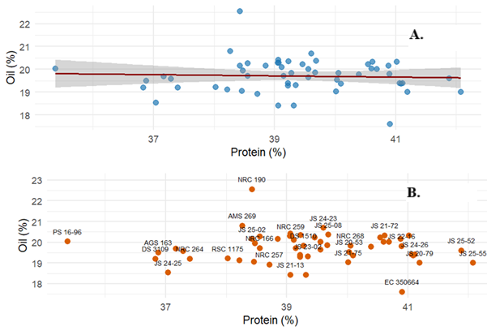
Figure 2. (a) Scatter plot showing the trend line between protein and oil content across 55 soybean genotypes. (b) Genotype-labeled scatter plot highlighting trait variation.
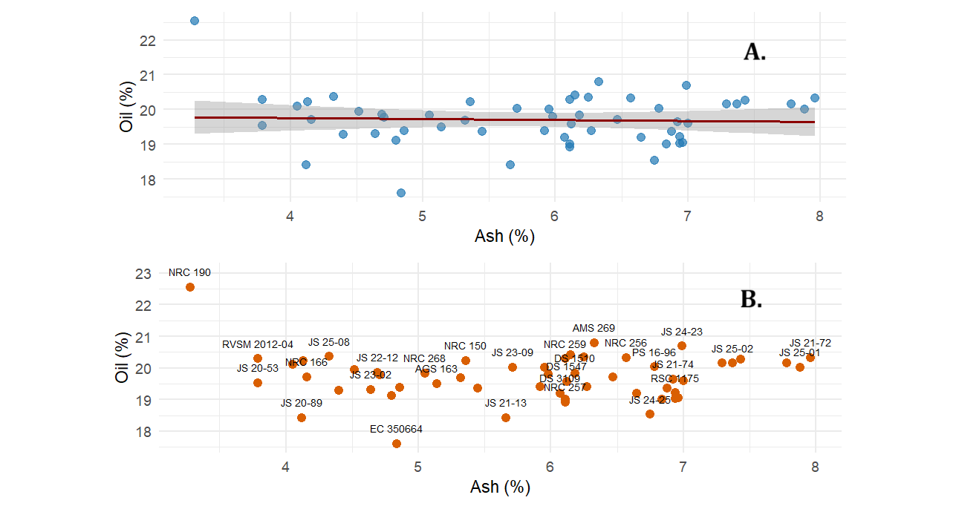
Figure 3. (a) Scatter plot showing the trend line between oil and ash content across 55 soybean genotypes. (b) Genotype-labeled scatter plot highlighting trait variation.

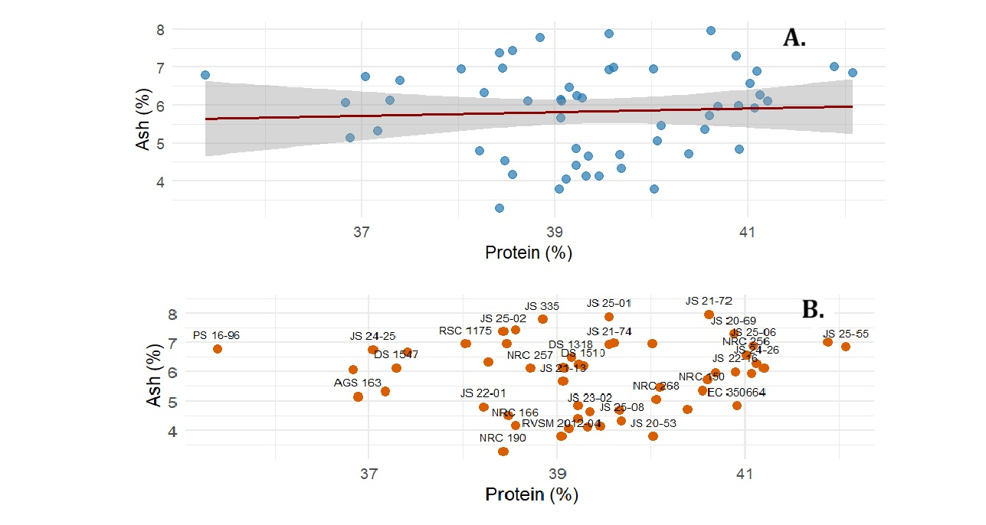
Figure 4. (a) Scatter plot showing the trend line between protein and ash content across 55 soybean genotypes. (b) Genotype-labeled scatter plot highlighting trait variation.
Hierarchical clustering
Hierarchical clustering of 55 improved soybean genotypes based on scaled values of oil, protein, and ash content revealed the formation of four distinct clusters, as visualized in the trait-wise heatmap (Figure 5). Cluster I comprised genotypes such as NRC 190, JS 22-01, and JS 21-72, characterized by elevated protein and oil content with moderate ash levels, suggesting their suitability for nutritional enhancement. Cluster II included genotypes like AGS 163 and PS 16-95, which consistently showed low expression across all three traits, indicating limited utility for quality improvement. Cluster III featured genotypes such as AMS 269 and DS 1510, marked by higher ash content and moderate protein and oil levels, potentially valuable for mineral enrichment. Cluster IV represented genotypes with balanced trait profiles, offering stable performance across nutritional and industrial parameters. The dendrogram structure underscored biochemical and possibly genetic affinities among genotypes, supporting trait-based selection strategies.
Several studies have demonstrated the utility of clustering in identifying genetically diverse and agronomically superior genotypes. For instance, Singh et al. (2021) evaluated 60 chickpea genotypes and found that Cluster II contained accessions with high seed yield and drought tolerance, suggesting its potential for breeding resilient cultivars. Similarly, Sharma et al. (2020) reported that genotypes in Cluster IV of soybean exhibited enhanced protein content and pod number, aligning with the current study’s observation that Cluster III harbors promising traits for selection. These findings collectively support the strategic use of cluster-based selection to harness genetic variability for crop improvement.
This multivariate visualization complements pairwise correlation analyses and provides a robust framework for identifying promising candidates for multi-trait breeding programs.
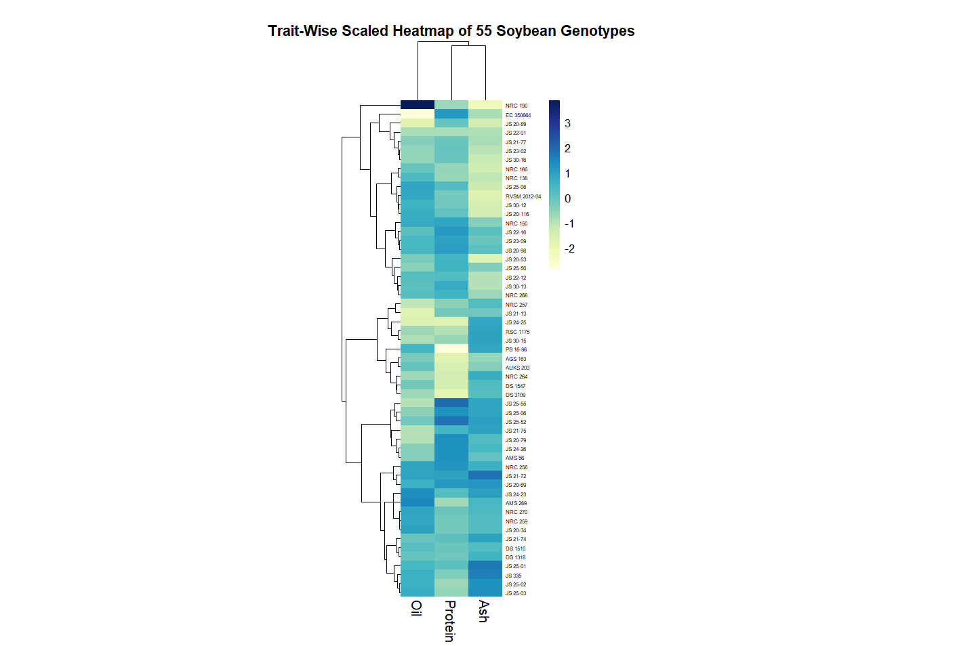

Figure 5: Hierarchical Clustering Heatmap of Scaled Oil, Protein, and Ash Content in 55 Soybean Genotypes

CONCLUSIONS
The nutritional characterization of 55 elite soybean genotypes revealed pronounced variability in protein, oil, and ash content offering a strategic foundation for breeding of these characters. JS 25-55 (42.08%) and JS 25-52 (41.89%) emerged as superior protein-rich genotypes potential donors for developing nutritionally enhanced varieties. NRC 190 (22.55%) recorded the highest oil content, positioning it as a prime candidate for industrial oil breeding. JS 21-72 (7.96%) exhibited maximum ash content, indicating potential line for mineral fortification and breeding. The weak negative correlation between protein and oil (r = -0.052) suggests these traits can be independently selected without compromising genetic gain. Trend line analysis revealed a consistent inverse relationship between protein and oil content across genotypes, reinforcing the biological compromise in seed composition. Genotype labelled scatter plots highlighted JS 25-55 and NRC 190 as outliers with exceptional protein and oil content respectively, making them strategic targets for divergent nutritional breeding. Cluster analysis delineated four distinct genotype groups, enabling targeted donor selection for multi-trait improvement. These findings provide actionable insights for advancing soybean nutritional breeding, enhancing both food quality and functional value in future cultivars.

COMPETING INTERESTS DISCLAIMER:
Authors have declared that they have no known competing financial interests OR non-financial interests OR personal relationships that could have appeared to influence the work reported in this paper.

Disclaimer (Artificial intelligence)
Author(s) hereby declare that NO generative AI technologies such as Large Language Models (ChatGPT, COPILOT, etc.) and text-to-image generators have been used during the writing or editing of this manuscript.

REFERENCES
Agarwal, D.K., Billore, S.D., Sharma, A.N., Dupare, D. U., and Shrivastava, S. K., (2013). Soybean: Introduction, Improvement, and Utilization in IndiaProblems and Prospects. Agricultural Research 2, 293–300 https://doi.org/10.1007/s40003-013-0088-0
Amrate, P.K., (2024). Survey and present status of soybean diseases in central India. International Journal of Bioresource and Stress Management, 15(5), 01–10.
Anand, K.J., Shrivastava, M.K., Amrate, P.K., Singh, Y., Patel, T., and Katara, V.K., (2024). Association and principal component analysis of proximate traits for identification of nutrient-rich line in soybean (Glycine max L. Merrill) germplasm International Journal of Advanced Biochemistry Research 8(11), 829-835
AOAC (1984) Official Methods of Analysis. 14th Edition, Association of Official Analytical Chemists Inc., William, S., Ed., USA, 1141 p.
AOAC (2000) Official Methods of Analysis. 17th Edition, The Association of Official Analytical Chemists, Gaithersburg, MD, USA. Methods 925.10, 65.17, 974.24, 992.16
Baisch JS, Grohs M, Ferreira PAA, Ugalde GA, Tres MV, Zabot GL. Protein and Oil Contents, Micro- and Macronutrients, and Other Quality Indicators of Soybean Cultivated in Lowland Fields. Foods. 2024; 13(23):3719. https://doi.org/10.3390/foods13233719
Banerjee, J., Shrivastava, M.K., Singh, Y., and Amrate, P.K., (2023). Estimation of genetic divergence and proximate composition in advanced breeding lines of soybean [Glycine max (L.) Merrill]. Environment and Ecology 41(3), 1960–1968.
Ibanez, M. A., De Blas, C., Cámara, L., & and Mateos, G. G. (2020). Chemical composition, protein quality and nutritive value of commercial soybean meals produced from beans from different countries: A meta-analytical study. Animal Feed Science and Technology, 267, 114531.
Jawarkar, S., Shrivastava, M., Amrate, P. K., Satpute, G. K., and Khare, V., (2023). Comprehensive analysis of phenotypic variation and selection strategies for yield-related traits in recombinant inbred lines of soybeans. Electronic Journal of Plant Breeding, 14(4), 1337-1344.
Jin, H., Yang, X., Zhao, H., Song, X., Tsvetkov, Y.D., Wu, Y., Gao, Q., Zhang R., and Zhang, J., (2023) Genetic analysis of protein content and oil content in soybean by genome-wide association study. Frontier Plant Science, 14:1182771. doi: 10.3389/fpls.2023.1182771
Kambhampati, S., Aznar-Moreno, J. A., Hostetler, C., Caso, T., Bailey, S. R., Hubbard, A. H., ... & Allen, D. K. (2019). On the inverse correlation of protein and oil: Examining the effects of altered central carbon metabolism on seed composition using soybean fast neutron mutants. Metabolites, 10(1), 18.
Kumari, S., Dambale, A. S., Samantara, R., Jincy, M., & Bains, G. (2025). Introduction, history, geographical distribution, importance, and uses of soybean (Glycine max L.). In Soybean Production Technology: Physiology, Production and Processing (pp. 1-17). Singapore: Springer Nature Singapore.
Kholmurodova, G., Tangirova, G., Rakhmankulov, M., & Yuldasheva, R. (2023). Analysis of protein and oil content in seeds of soybean collection varieties. In E3S Web of Conferences (Vol. 377, p. 03016). EDP Sciences.
Kolde R (2025). pheatmap: Pretty Heatmaps. R package version 1.0.13, https://github.com/raivokolde/pheatmap.
NAAS 2017. Sustaining Soybean Productivity and Production in India. National Academy of Agricultural Sciences, New Delhi: 52 p.
Pawar, M. G., Chaudhary, S. B., Pawar, V. S., & Chavan, S. B. (2020). Study of genetic variability in different soybean genotypes based on yield and yield contributing traits. International Journal of Current Microbiology and Applied Sciences, 9(9), 426–433. https://doi.org/10.20546/ijcmas.2020.909.054
Pushpendra, Singh Kamendra, Saxena S.C., Kumar Narendra, Singh K.P., Raverkar K.P., Shukla P.S., Gaur Neeta and Srivastava Ajay (2017). Five decades of soybean research at Pantnagar. Directorate of Experimental Station, Research Bulletin No. 214, Pp. 108.
Rahman, U., Younas, Z., Ahmad, I., Yousaf, T., Latif, R., Rubab, U., Hassan, H., Shafi, U., & Mashwani, Z. U. (2024). Enhancing health and therapeutic potential: innovations in the medicinal and pharmaceutical prop erties of soy bioactive compounds. Frontiers in pharmacology, 15, 1397872. https://doi.org/10.3389/fphar.2024.1397872
Sumangala, S., and Kulkarni, U. N. (2019). Physico-chemical properties of black and yellow soybean (Glycine max L.) genotype. The Pharma Innovation Journal, 8(7), 33–37.
Uikey, S., Sharma, S., Amrate, P.K., and Shrivastava, M.K., (2022). Identification of rich oil-protein and disease resistance genotypes in soybean [Glycine max (L.) Merrill]. International Journal Bio-resource Stress Management, 13(5),497506.
Upadhyay P, Shrivastava MK, Sharma S, Ramakrishnan RS, Nagre SP, and Mohare S. 2022. Evaluation of Growth, Physiological, and Quality Parameters on Seed Yield of Soybean [Glycine max (L.) Merrill]. International Journal of Plant & Soil Science 34 (18):39-44. DOI: 10.9734/ijpss/2022/v34i1831050
Wickham H (2016). ggplot2: Elegant Graphics for Data Analysis. Springer-Verlag New York. ISBN 978-3-319-24277-4, https://ggplot2.tidyverse.org.
Zhang, F., Hong, H., Liu, Wang, X., Zhang, C., Zhao, K., Yuan, R., Abdelghany, A.M.,Zhang, B., Lamlom. S.,F., Ren, H. (2025). Large-scale evaluation of soybean germplasm reveals geographic patterns in shade tolerance and identifies elite genotypes for intercropping systems. BMC Plant Biology, 25, 1092 https://doi.org/10.1186/s12870-025-07121-5

Table 1. Proximate composition of the fifty-five improved line of soybean
S. No. | Genotype | Protein % | Oil % (Crude fat) | Ash (%)
1 | AGS 163 | 36.88 | 19.5 | 5.14
2 | AUKS 203 | 37.17 | 19.68 | 5.32
3 | DS 1510 | 39.28 | 19.84 | 6.18
4 | DS 1547 | 37.29 | 19.58 | 6.12
5 | DS 3109 | 36.83 | 19.2 | 6.07
6 | EC 350664 | 40.91 | 17.6 | 4.84
7 | NRC 257 | 38.72 | 18.92 | 6.11
8 | NRC 259 | 39.07 | 20.29 | 6.11
9 | PS 16-96 | 35.38 | 20.03 | 6.78
10 | RSC 1175 | 38.03 | 19.21 | 6.94
11 | JS 21-74 | 39.56 | 19.64 | 6.92
12 | JS 21-75 | 40.02 | 19.02 | 6.94
13 | JS 23-02 | 39.35 | 19.31 | 4.64
14 | JS 24-23 | 39.61 | 20.69 | 6.99
15 | JS 24-25 | 37.04 | 18.53 | 6.75
16 | JS 24-26 | 41.12 | 19.4 | 6.27
17 | JS 25-01 | 39.56 | 20.01 | 7.88
18 | JS 25-02 | 38.43 | 20.15 | 7.37
19 | JS 25-03 | 38.56 | 20.27 | 7.43
20 | JS 25-06 | 41.09 | 19.37 | 6.88
21 | JS 25-08 | 39.69 | 20.36 | 4.33
22 | JS 21-72 | 40.62 | 20.33 | 7.96
23 | JS 22-12 | 39.67 | 19.86 | 4.69
24 | JS 22-16 | 40.9 | 19.8 | 5.98
25 | JS 23-09 | 40.6 | 20.02 | 5.71
26 | NRC 256 | 41.02 | 20.33 | 6.57
27 | JS 21-13 | 39.06 | 18.42 | 5.66
28 | AMS 56 | 41.07 | 19.4 | 5.92
29 | AMS 269 | 38.27 | 20.8 | 6.33
30 | DS 1318 | 39.15 | 19.72 | 6.47
31 | NRC 166 | 38.56 | 19.72 | 4.16
32 | NRC 190 | 38.43 | 22.55 | 3.28
33 | RVSM 2012-04 | 39.05 | 20.29 | 3.79
34 | JS 20-53 | 40.03 | 19.53 | 3.79
35 | JS 20-89 | 39.32 | 18.42 | 4.12
36 | JS 22-01 | 38.22 | 19.12 | 4.8
37 | JS 21-77 | 39.22 | 19.39 | 4.86
38 | JS 30-12 | 39.12 | 20.1 | 4.05
39 | JS 30-13 | 40.39 | 19.78 | 4.71
40 | JS 30-15 | 38.46 | 19.05 | 6.96
41 | JS 30-16 | 39.22 | 19.29 | 4.4
42 | NRC 138 | 38.48 | 19.94 | 4.52
43 | NRC 264 | 37.4 | 19.2 | 6.65
44 | JS 25-55 | 42.08 | 19 | 6.84
45 | NRC 268 | 40.06 | 19.83 | 5.05
46 | NRC 270 | 39.23 | 20.35 | 6.25
47 | NRC 150 | 40.55 | 20.23 | 5.36
48 | JS 20-79 | 41.2 | 19 | 6.11
49 | JS 25-50 | 40.1 | 19.36 | 5.45
50 | JS 25-52 | 41.89 | 19.6 | 7
51 | JS 20-34 | 39.06 | 20.41 | 6.15
52 | JS 20-69 | 40.88 | 20.15 | 7.29
53 | JS 20-98 | 40.69 | 20.01 | 5.95
54 | JS 20-116 | 39.46 | 20.22 | 4.13
55 | JS 335 | 38.85 | 20.15 | 7.78

