Original Research Article

Molecular characterization of mulberry germplasm through ISSR markers

ABSTRACT
Inter simple sequence repeat (ISSR)-PCR is a technique, which involves the use of microsatellite sequence as primers in a polymerase chain reaction to generate multilocus markers. Twenty-four mulberry accessions were obtained from the Central Sericulture Germplasm Resource Center, Hosur, Tamil Nadu were screened using Inter simple sequence repeat technique, with eight primers. Out of eight primers, only three primers viz., UBC 807, UBC 809 and UBC 811 produced 100 per cent polymorphism in mulberry accessions. The highest Polymorphism information content value was observed with the primer UBC 807 and the lowest PIC value was observed with the primer UBC 811. The mulberry accessions A18 (MI-0685) and A8 (MI-0535) were found to be the closest at the similarity coefficient of 0.93. Mean genetic diversity and PIC were 0.35 to 0.29, respectively. The genetic similarity coefficient ranged from 0.913 A18 (MI-0685) to 0.535 A8 (MI-0535). The phylogenetic tree was obtained using the UPGMA method using the total number of amplified Inter simple sequence repeat fragments. The result from the cluster analysis indicated that the mulberry accessions MI-0017, MI-0763, MI-0663, MI-0652, MI-0349, V-1 (check variety), MI-0034 and MI-0768 were distinct from other accessions

Key words: Mulberry, Molecular marker, Genetic diversity, Inter Simple Sequence Repeat.

INTRODUCTION
“Mulberry (Morus indica. L) a deep rooted perennial deciduous herb belonging to the family Moraceae is a high biomass producing foliage plant. It is exploited on a commercial scale for silk production. It has different ploidy levels and most of the genotypes available are diploids (2n=28), but the plant exhibits higher ploidy levels i.e., 3n=42, 4n=56, 6n=84 and docasaploid 22n=308” (Basaviah et al., 1989). “Leaf quality is an important parameter used for evaluation of mulberry plants aimed at selecting superior varieties for rearing performance. Around 60% of the total cost of cocoon production goes towards mulberry production alone in Sericulture” (Veerapuranarayanappa et al., 2013). “Germplasm resources are very much required for the continuous improvement of crop plants, where genetic characterization is essential for scientific germplasm conservation and characterization permits the estimation of genetic relatedness and diversity” (Keshavamurthy et al., 2013). “In order to assess the characterization among species, DNA markers have gained popularity among conservationists, geneticists and breeders basically because of its stability and ease to generate maximum information in comparatively less time. PCR based markers have the potential to screen large number of samples quickly to elucidate accurate genetic information” (Girish et al., 2015). “Recently, DNA based molecular markers have increasingly been applied in tree improvement programmes for quantification of genetic diversity. These markers have little been affected by environment and developmental stages” (Haines and Martin, 1995). “Markers also have important immediate application in supportive research for tropical hardwoods and non-industrial species mainly for quantification of genetic diversity. There are several methods based on DNA markers viz., RFLP (Restriction Fragment Length Polymorphism), RAPD (Randomly Amplified Polymorphic DNA), SSR (Simple Sequence Repeats), ISSR (Inter Simple Sequence Repeats), AFLP (Amplified Fragment Length Polymorphism) etc. Among these techniques, ISSR marker is very significant because this marker in its simplest form, does not require genomic knowledge to design arbitrary sequence oligonucleotide primers” (Gonzalez et al., 2005). But the use of molecular markers for genetic diversity studies in mulberry underscores the research needs.
MATERIALS AND METHODS
Plant materials
Table 1 lists the accessions of mulberry used in the current study and their origins. Twenty-four mulberry materials, were obtained from the Central Sericulture Germplasm Resource Center, Hosur, Tamil Nadu.
Table 1. List of mulberry test accessions under Morus indica used in this study
Sl. No | Accession Number | Name | Origin
1 | MI-0017 | Sujanpur – 5 | Punjab
2 | MI-0395 | Tingari | Uttar Pradesh
3 | MI-0349 | Garobadha – 2 | Meghalaya
4 | MI-0034 | Sujanpur – 1 | Punjab
5 | MI-0425 | Deharadun Local -11 | Tamil Nadu
6 | MI-0490 | Kakathodepaalam | Kerala
7 | MI-0652 | Pouri – 2 | Punjab
8 | MI-0535 | Araku Local - 2 | Himachal Pradesh
9 | MI-0543 | Palampur Local | Tamil Nadu
10 | MI-0536 | Ananthagiri Local | Tamil Nadu
11 | MI-0558 | Kollihills – 2 | Uttaranchal
12 | MI-0613 | Chandrapuri | Jammu and Kashmir
13 | MI-0615 | Ukhimath | Jammu and Kashmir
14 | MI-0651 | Rajouri | Jammu and Kashmir
15 | MI-0495 | Lingamala – 1 | Uttar Pradesh
16 | MI-0658 | Roop Nagar | Himachal Pradesh
17 | MI-0677 | Durgapur – 3 | Rajasthan
18 | MI-0685 | Khakad – 2 | Rajasthan
19 | MI-0686 | Mount Abu – 1 | Kerala
20 | MI-0763 | Saranath – 2 | Tripura
21 | MI-0718 | Chozhiakadu | Uttar Pradesh
22 | MI-0768 | Mangari | Uttar Pradesh
23 | MI-0663 | Chauntra - 2 | Rajasthan
24 | MI-0845 | Rajapur – 2 | Tripura
25 | V-1  (check variety) | Victory - 1

Extraction and quantification of genomic DNA
It is necessary to check the quality and concentration of DNA for carrying out PCR reaction. Genomic DNA was quantified using the spectrophotometer and the concentration of nucleic acids were determined by measuring the sample OD (optical density) at
260 nm against blank. The ratio A260/A280 was used to estimate the purity of nucleic acid. Pure DNA had a ratio approximately ~1.8-2.0. The quality of DNA was also checked using 0.8 per cent agarose gel electrophoresis. The DNA was then diluted to appropriate concentration for use in molecular analysis.
Polymerase chain reaction using ISSR primers
Extracted and quantified genomic DNA was subjected to polymerase chain reaction (PCR) using a thermal cycler (Eppendorf master cycler personal, Germany) for performing ISSR profiling (Williams et al., 1990) to identify polymorphism from the collected germplasm. This included random decamers as primers and the list of primers (Table 2) used for the polymorphic markers towards identification and characterization of the germplasm and the varieties within the species.
DNA from the collected twenty four test accessions along with V-1 as check variety was amplified using a set of 15 arbitary oligonucleotide decamer primers. Amplification reaction were in volume of 25.0 µL of sterilized double distilled water, 2.5 µL of 10 X buffer A, 1.0 µL of Dntp (2.5 Mm each), 1.0 µL of primer (1 µM) and 0.3 µL (~ 1.0 U) of Taq polymerase in 4.0 µL of the template DNA. Amplication were performed using 0.2 ml PCR tubes (Axygen Inc., USA) in an Eppendorf master cycler personal programmed for 40 cycles consisting of 30 seconds in 94 º C; one minute in 36 º C and 2.5 minutes in 72 º C denaturing, annealing and extension respectively. These cycles were proceeded by a step for an initial denaturation of five minutes at 94 º C and the cycles followed by a final extension of ten minutes at 72ºc. It was then programmed to maintain at 4ºC until usage for electrophoresis.
Electrophoresis of PCR products and its documentation
Amplified products along with the 6X tracking dye were resolved electrophoretically based on their molecular weight by running the products on a 1.2 per cent agarose gel matrix using a submarine electrophoresis with 1X TAE buffer (Sambrook and Russell, 2001) at 5 V cm⁻¹. After the run,the gel was stained using ethidium bromide (Sharp et al., 1973) solution for five to ten minutes and was destained using distilled water for two to three minutes. Ethidium bromide fluoresced orange upon UV illumination (310-320 nm). The gel image was documented using a Herolab documentation unit (Herolab 442 K, E.A.S.Y., Germany).
Data analysis
Documented gel was used to score polymorphism by the presence or absence of the bands. Also, monomorphic bands were scored to calculate the percentage of polymorphism.
Scoring of bands
Clear and unambiguous bands of ISSR markers were scored based on the presence or absence of the corresponding band among the genotypes. The scores ‘1’ and ‘0’ indicated the presence and absence of bands respectively. In case of binary coding, a data matrix computing of ‘1’ and ‘0’ was formed and subjected to cluster analysis. Sequential Agglomerative Hierarchial Non-overlapping (SAHN) clustering was performed on similarity matrix using dice coefficient for the binary data (obtained through scoring) utilizing the Unweighted Pair Group Method with Arithmetic Average (UPGMA) method. This was done by using NTSYSpc version 2.02 (Rohlf, 2002).
The confidence limits for the groupings by dendrogram were computed by using WINBOOT, a program for performing bootstrap analysis of binary data to determine the confidence limits of UPGMA based dendrograms (Yap and Nelson, 1996). Boot straping involved repeated sampling with replacement of the characters in matrix of operational taxonomic unit (OTU) characters to create numerous bootstrap matrices of the same size as the original matrix.
Computation of similarity indices
From the binary code matrices obtained from the ISSR markers, the Jaccard’s similarity indices were computed for the twenty four test accessions of Morus indica using the SIMQUAL programme of NTSYSpc version 2.02 as follows, Jaccard (1908) similarity index.
SI ij = a/(n-d)
Where,
SI ij = Similarity between i^{th} and j^{th} samples
a = Number of electromorphs/traits commonly shared
d = Number of electromorphs/traits absent in i^{th} and j^{th} samples but present in other samples
n = (b+c) i.e. the number of unmatches
b = Number of electromorphs/traits present in i^{th} samples but absent in j^{th} samples
c = Number of electromorphs/traits present in j^{th} samples but absent in i^{th}samples.

Polymorphosim information content
Polymorphism information content (PIC) or expected heterozygosity scores for each ISSR marker was calculated based on the formula given by Anderson et al. (1993).
n
PIC = 1- ∑ P_{ij}²
j = 1
Where,
P_{ij} is the frequency of j_{th} allele for the marker i and the summation extends over n alleles.

Table 2. List of primers used for ISSR amplication
S.No | Primers | Primer sequence 5’-3’
1 | UBC 807 | AGAGAGAGAGAGAGAGT
2 | UBC 809 | AGAGAGAGAGAGAGAGG
3 | UBC 811 | GAGAGAGAGAGAGAGAC
4 | UBC 820 | GTGTGTGTGTGTGTGTC
5 | UBC 821 | GTGTGTGTGTGTGTGTT
6 | UBC 834 | AGAGAGAGAGAGAGAGYT
7 | UBC 841 | GAGAGAGAGAGAGAGAYC
8 | UBC 856 | GTGTGTGTGTGTGTGTCTA

RESULTS
The details of the nucleotide sequence of selected primers used to generate PCR products, summary of total number of polymorphic DNA fragments generated and percentage of polymorphism. Out of 8 primers used, only three Primers (UBC 807, UBC 809 and UBC 811) showed polymorphism in twenty four accessions.
Polymorphism revealed by ISSR markers
For ISSR markers, the polymorphic information content values ranged from
0.29 to 0.35. The mean PIC value for polymorphic bands was 0.32 with the highest
PIC value of 0.35 with primer UBC 807 and the lowest PIC value of 0.29 with primer
UBC 811 (Table 3, Plate 1a, b, c).
Genetic variation and cluster analysis based on ISSR markers
The genetic distance between the analyzed individuals was calculated by simple matching method to obtain a matrix of genetic distance. The Jaccard’s co-efficient of similarity values ranged from 0.913 to 0.535 which indicated high level of genetic variation among the genotypes studied. The highest value of similarity coefficient of 0.913 was found between the A18 (MI-0685) and A8 (MI-0535) and it was followed by similarity coefficient of 0.535 between the genotypes A20 (MI-0763) and A4 (MI-0034) (Table 4, Fig 1). The average linkage between the genotypes was used for constructing a phylogenetic tree. The UPGMA cluster analysis indicated the presence of distinct major clusters. Among the clusters, cluster II and IV constituted only one accession each. The result provided valid guidelines for collection, conservation and identification of mulberry genetic resources.
Table 3. Random ISSR primers used for DNA amplication of test mulberry accessions
Sl. No | Primers | Sequence 5’ – 3’ | Total number of bands | PIC values
1 | UBC 807 | AGAGAGAGAGAGAGAGT | 10 | 0.35
2 | UBC 809 | AGAGAGAGAGAGAGAGG | 9 | 0.31
3 | UBC 811 | GAGAGAGAGAGAGAGAC | 7 | 0.29
Mean |  |  |  | 0.32

Plate 1. ISSR profile of test mulberry accessions

a. UBC 807 (AGAGAGAGAGAGAGAGT)
M 1 2 3 4 5 6 7 8 9 10 11 12 13 14 15 16 17 18 19 20 21 22 23 24 25
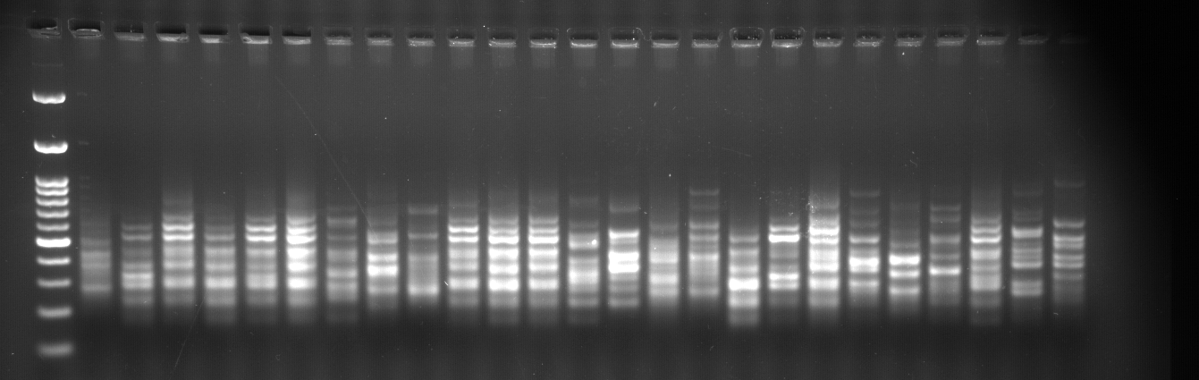

b. UBC 809 (AGAGAGAGAGAGAGAGG)
M 1 2 3 4 5 6 7 8 9 10 11 12 13 14 15 16 17 18 19 20 21 22 23 24 25
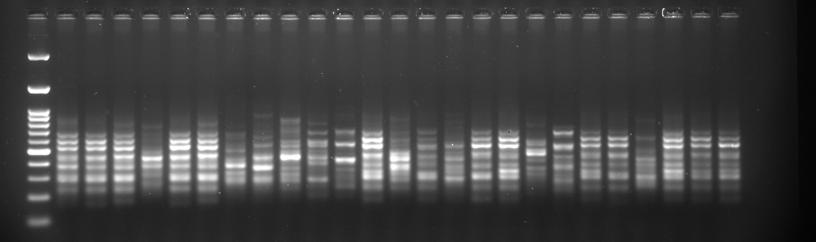

c. UBC 811 (GAGAGAGAGAGAGAGAC)
M 1 2 3 4 5 6 7 8 9 10 11 12 13 14 15 16 17 18 19 20 21 22 23 24 25
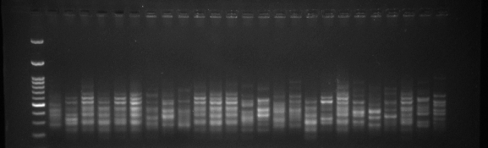

Table 4. ISSR similarity matrix of test mulberry accessions
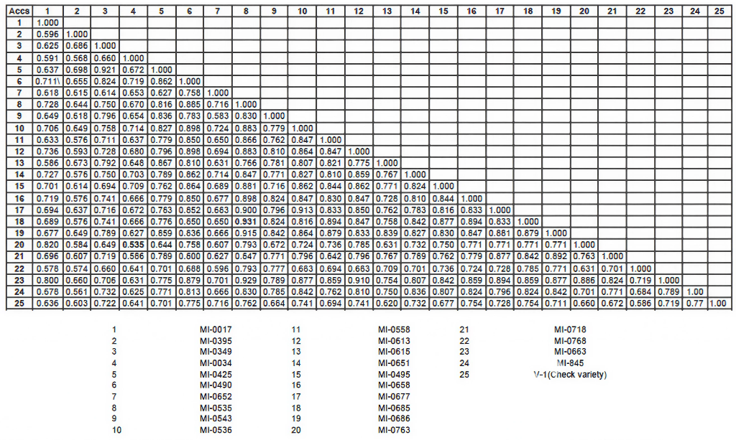

Fig 1. Dendogram of test mulberry accessions based on jaccard’s similarity coefficient
DISSCUSSION
“Assessment of genetic diversity is a prerequisite for efficient conservation and utilization of genetic resources. During the past two decades, several high-throughput PCR-based technologies such as inter-simple sequence repeats (ISSR) and amplified fragment length polymorphisms (AFLP) have been developed to assay genetic polymorphism at the DNA level” (Shyamsundar et al., 2014). “An advantage of ISSRs is that in their simplest form, no prior genomic knowledge is required to design arbitrary sequence oligonucleotide primers” (Gonzalez et al., 2005). “With the large array of molecular analytical techniques available, it has become possible to provide an accurate and unambiguous tool for evaluation of genetic diversity and identification of germplasm” (Simmons et al., 2007) and (Li et al., 2008). “Assessment of genetic variation within the species based on morphological and polypeptide descriptions, provide more speed, accurate and detailed information” (Williams et al., 1990). “DNA marker studies had been successfully employed in plants to understand provenance variation” (Chalmers et al., 1992), geotypic identity (Keil and Griffin 1994), molecular characterization of germplasm (Maechado et al., 1996), molecular systematics (Harris, 1995) genetic diversity (Varghese et al., 1997) and DNA finger printing studies of plants (Caetano-Anolles et al., 1991).
“ISSR has been used for diversity assessment by many researchers in tropical
and temperate plants. Extensive studies have already been reported in mulberry” (Karku et al., 1996). ISSR technique was used to study the genetic structure and relationship between species and populations. Similarity, DNA based ISSR techniques have been successfully utilized in many genera and species of mulberry Vijayan et al. (2004a) and (Ahmed sumbul, 2025). The variation in genetic distance among the different mulberry accessions revealed by ISSR tech-niques reflected a high level of polymorphism at the DNA level. Earlier studies by Sharma et al. (2000) using the AFLP tech-nique also showed a large genetic variation among different Morus genotypes.
In the present study, mulberry accessions showed 25 reproducible bands from
3 primers. The primers produced 100 per cent polymorphism (UBC 807, UBC 809 and UBC 811). The highest PIC values were observed with the primer UBC 807 and the lowest PIC values was observed with primer UBC 811. Polymorpic information content were documented by (Emine orhan et al. 2024). The present investigation revealed that mulberry accessions used for diversity through ISSR, showed moderate level of genetic variations. Polymorphism in mulberry accessions were documented by (Girish et al., 2015) and (Miran A et al., 2023). Similar findings were noticed by (Keshavamurthy et al., 2013) among 26 diverse germplasm of mulberry collected from germplasm bank at Bangalore University, India. The overall percentage of polymorphism was found to be 55.83 per cent by ISSR marker. Among the germplasm, S 36, V1, S54 and M5 showed close similarity. Zhao et al. (2007) further reported a higher value of 0.4912 within cultivated species of mulberry for the same. Aggarwal et al. (2004) also reported a higher Ho value of 0.59 across 45 mulberry genotypes from species of diverse origin using SSR markers.
In mulberry accessions, the average linkage between the accessions was used for constructing a phylogenetic tree. The association amongst different mulberry accessions was presented in the form of dendrogram. The accessions A18 (MI-0685) and accession A8 (MI-0535), were closest at the similarity coefficient 1.000. The accessions A20 (MI-0763) and A4 (MI-0034) were the farthest or most diverse and dissimilar to all others. Similar grouping pattern within species and related genotypes are evident from the earlier report in mulberry (Keshavamurthy et al., 2013) and (Girish et al., 2015). Koidzumi (1973) considered that M. lhou, M. multicaulis and M. latifolia are similar and belong to a single species. The percent polymorphic loci revealed an average of 74.47% in all the mulberry accessions studied using SSR markers. This value was lower than 85 and 91% shown in RAPD and DAMD markers by Bhattacharyya and Ranade (2001). Earlier, Sharma et al. (2000) had reported a higher average value of 81.2%. Additionally, a higher value of 86% was reported by Vijayan et al. (2004a) and Zhao et al. (2007). These values suggest a high level of genetic variability among the accessions studied. Such high level of genetic diversity can be attributed to the mode of reproduction of these accessions. Vegetatively propagated species such as mulberry often have minute unobserved changes in passage of time and accumulation of these changes can lead to significant changes in plant population. Such variability could come from mutation (Vijayan, 2009) and/or long cultivation periods (Bhattacharyya and Ranade 2001). Mulberry is a highly heterozygous and outcrossing species and therefore it is expectable that its accessions exhibit a high level of polymorphism (Awasthi et al., 2004).
In conclusion, these results obtained by ISSR analysis of mulberry accessions were in general agreement with our morphological classification, suggesting that ISSR is a simple and effective molecular marker technique and could be successfully applied to the study of genetic relationships, to the conservation and identification of mulberry collections, and to plant breeding. Our results also suggest that molecular tools should be used for the classification of the genus Morus.

Conclusion

these results obtained by ISSR analysis of mulberry accessions were in general agreement with our morphological classification, suggesting that ISSR is a simple and effective molecular marker technique and could be successfully applied to the study of genetic relationships, to the conservation and identification of mulberry collections, and to plant breeding. Our results also suggest that molecular tools should be used for the classification of the genus Morus.

Disclaimer (Artificial intelligence)
Option 1:
Author(s) hereby declare that NO generative AI technologies such as Large Language Models (ChatGPT, COPILOT, etc.) and text-to-image generators have been used during the writing or editing of this manuscript.

REFERENCE
Aggarwal, Udayakumar, D., Hendre, P., Sarkar, A., Singh and Li. (2004). Isolation and Characterization of six novel microsatelite markers for mulberry (Morus indica). Molecular Ecology, 4, 477-479.
Ahmed Sumbul (2025). Characterization of Genetic Diversity of Mulberry (Morus alba) Genotypes Growing Naturally in Northeastern Türkiye (Kelkit Valley) Using Morphological, Biochemical, and Molecular Markers. Nature based solutions to improve the sustainability of Horticulture Ecosystem. 11(3), 298.
Anderson, Churchill, G., Autrique, J., Tanksely, S and Sorrells, M. (1993). Optimizing parental selection for genetic linkage maps. Genome, 36, 181-186.
Awasthi, Nagaraja, G., Naik, G., Kanginakudru, S., Thangavelu, K and Nagaruja, J. (2004). Genetic diversity in mulberry (Genus Morus) as revealed by RAPD and ISSR marker assays,. BMC Genetics, 5, 1.
Basaviah, Dandin, S and Rajan, M. (1989). Microsporogensis in hexaploid Morus serrata Rexb. Cytologia, 54, 747-751.
Bhattacharyya and Ranade, S. (2001). Molecular distinction amongst varieties of mulberry using RAPD and DAMD profiles BMC Plant Biol. , 1(3), 1471-2279.

Emine Orhan, Meleksen Akin, Sadiye P. Eyduran and Sezai Ercisli. (2024). Molecular

characterization of mulberry genotypes and species in Turkey. Notulae Botanicae Horti

Agrobotanici Cluj-Napoca., 48(2), 579-557.
Girish, Dandin, S., Tikader , A and Pinto, M. V. (2015). Molecular diversity of wild mulberry (Morus spp) of Indian subcontinent. Indian journal of Biotechnology, 14, 334-343.
Gonzalez, Wong, A., Delgado-Salinas, A., Papa, R and Grepts, P. (2005). Assessment of inter simple sequence repeat markers to differentiate sympatric wild and domesticated populations of common bean. Crop Science, 45(2), 606-615.
Haines and Martin, B. (1995). Biotechnologie et production soutenue des bois tropicaux. Etude sur documents effectuee pour I'OIBT. Counsil International des Bois Tropicaux, Janvier., 20-23.
Jaccard. (1908). Nouvellesrecherches sur la distribution florable. Bull. Soc. Vaud. Nat, 44, 223-270.
Karku, Hume, M., Karjalainen, P., Karvonen, K., Karkkainen, K., Nedeand, D and Savolainen, O. (1996). Do molecular markers reflect pattern of differention in adaptive traits of conifers. Theor. Appl. Genet.
Keshavamurthy, Prakash, B. M., Hittalmani, S and Puttaraju, H. P. (2013). DNA marker-assisted evaluation of cultivated and local mulberry genotypes of southern India. Crop Breeding and Applied Biotechnology, 9, 239-245.
Koidzumi. (1973). Synopsis specierum generis Mori. Bull Imp SericultExp Stat, 11, 1-50.

Miran A. El- Haggar, Yasmin A.Mahagoub, Hesham. M Aly, Nabila. M. Ghazy, Fathy K. El- Fiky, Amr M. El- Hawiet (2023). DNA barcodes, ISSR, RAPD and SCAR markers as potential quality control tools for molecular authentication of black and white mulberry. Food control, vol 152.
Rohlf. (2002). NTSYS-pc: Numerical taxonomy system ver.2.1. Exerter Publishing Ltd., Setauket, New york.
Sambrook and Russell, D. (2001). Molecular cloning. A laboratory manual 3/e (Vol.I to III). Cold Spring Harbor Laboratory Press, Cold Spring Harbor, New York.
Sharp, Sugden, B and Sambrook, J. (1973). Detection of two restriction endonuclease activities in Haemophilus influenzae using analytical agarose-ethidium bromide electrophoresis. . Biochemistry, 12, 3055-3063.
Sharma, Sharma, R and Machii, H. (2000). Assessment of genetic diversity in a Morus spp germplasm collection using fluorescence-based AFLP markers. Theor. Appl. Genet, 101, 1049-1055.
Veerapuranarayanappa, Murthy, Y., Ramesh, H. L., Lokesh, G., Munirajappa and
Yadav, R. D. (2013). Assessment of six mulberry (Morus) germplasm varieties through moulting and bioassay parameters by using cross breed silkworms Bombyx mori L. for commercial exploitation in Kolar district, Karnataka. Int. Res. J. Biological Sci., 2(9), 69-75.
Vijayan, Kar, P., Tikader, A., Srivastava, P., Awasthi, A., Thangavelu, K and Saratchandra, B. a. P. B.-. (2004a). Molecular evaluation of genetic variability in wild populations of mulberry (Morus serrata Roxb.), Plant Breeding, 123, 568-572.
Vijayan. (2009). Approaches for enhancing salt tolerance in mulberry (Morus L). Plant Omics J, 2(1), 41-59.
Williams, Kubelik, A., Livak, K., Rafalski, J and Tingey, S. (1990). DNA polymorphisms amplified by arbitrary primers are useful as genetic markers. Nucleic Acids Res.
Yap and Nelson, R. (1996). WINBOOT: a program for performing bootstrap analysis for binary data to determine the confidence limits of UPGMA based dendrograms. . IRRI Disc. Ser. No. 14. Int. Rice Res. Inst., Manila, Phillippines.
Zhao, Zhou, Z., Miao, X., Zhang, Y., Wang, S., Huong, J and Huang, Y. (2007).
A comparison of genetic variation among wild and cultivated Morus species (Moraceae: Morus) as revealed by ISSR and SSR markers. Biodivers. Conserv, 16, 275-290.

