Sorghum midge [Stenodiplosis sorghicola (Coquillet, 1898)] dynamics and abundance study in the southern Sudanian and Sudano-Sahelian zones of Burkina Faso

.
ABSTRACT

Sorghum is one of the most widely grown and consumed cereals in Sahelian countries, particularly in Burkina Faso. However, its cultivation faces numerous constraints, both biotic and abiotic. Among the biotic constraints, insect pests, notably the sorghum midge, Stenodiplosis sorghicola (Coquillet, 1898), constitute one of the major obstacles to sorghum production in the Sahelian zone. This insect is responsible for yield losses ranging from 33% to 100%. The aim of this study was to analyze the population dynamics of this insect and to assess the level of infestation in sorghum fields. Data on midge populations were collected using yellow insect traps set in sorghum plots in the South Sudanian and Sudano-Sahelian agroecological zones of Burkina Faso. These data were collected during the 2023/2024 and 2024/2025 cropping seasons. Assessments of insect damage and field spikelet sampling were carried out in 48 villages in these two sorghums growing zones during 2024/2025 cropping season. The results showed that the sudano-sahelian zone had the highest rate of midge infestation, with two generations of populations observed in 2023 and three generations in 2024. In Southern Sudan agro-ecological zone, only one generation of midge populations was observed in 2023 while three generations were observed in 2024. In terms of damage caused by the insect, the results also showed that the highest damage rates were recorded in the northern sudan zone, with 42% damage compared with 17% in the southern sudan zone. Overall, midge population was low in southern-sudan areas than in northern-sudan site and result of midge damage is correlated with population abundance. These results could provide an essential basis for guiding agricultural policy decisions, particularly for the sustainable management of this pest.

Keywords: sorghum, midge, population dynamics, insects, traps,

1. INTRODUCTION
Global sorghum production is estimated at over 57.3 million tons in 2023, making it the fifth most important cereal crop (FAOSTAT, 2025). It is grown on 49.9 million ha across the five continents and constitute the staple food for rural populations, especially in the Sahelian countries of Africa (Dora et al., 2014). In Burkina Faso, it is grown on 1.83 million ha along with a production of 2.01 million tons during 2022/2023 agricultural season and thus represents the leading national cereal (DSS/DGESS/MAAH, 2023). It is the staple food of rural populations, especially in the Sahelian countries of Africa (Dora et al., 2014). Sorghum is known as very hard cereal with low input and water requirements, and also qualified as the future crop in the world due to its high adaptability in different agroecological zones (Clerget et al., 2004; IPCC, 2007 and Saïdou et al., 2014).
However, sorghum cultivation is currently facing numerous biotic and abiotic constraints (Ratnadass et al., 2012). Biotic constraints are mainly weeds, diseases and insect pests. Among insect pests, the most damaging are those that attack the plant's panicles directly (Gagné, 2010). In this respect, the sorghum midge, Stenodiplosis sorghicola (Coquillett, 1898) is reported to be the world's biggest pest of this crop, with yield losses ranging from 33% (Dakouo et al., 2005) to 100% when sown late (Elamein, 2014). Particularly in Burkina Faso, recent studies conducted by Ouedraogo et al. (2024) reported around 88% of yield loss in at Fada site. The insect has even developed some adaptive strategies to ensure its survival. In fact, he synchronizes its life cycle with that of the host plant by alternating between a diapause phase and an active life phase depending on the season (Amouroux et al. 2013). The adult female, whose lifespan is between 2 and 3 days, can lay between 75 and 100 eggs in the spikelets or lower glumes of flowers, mainly in the morning (Magallanes-Cedeno and Teetes, 1991). To survive, the larva, after hatching, feeds on the ovary and developing grain and completes its development cycle in about 2 weeks, leaving an empty panicle. The succession of generations of S. sorghicola to another one is determined by the availability of nutrient resources which is mainly constituted of sorghum flowering organs (Kadi Kadi et al., 2005).
For a better understanding of the insect, many studies have been carried out on its biology, however, few were oriented on the dynamics of the species at national level in Burkina Faso. To develop a suitable management or control of the insect, it was important to map its presence in different sorghum growing areas of the country. Thus, the present study has been undertaken to analyze the population dynamics of sorghum gall midge in the South Sudanian and Sudano-Sahelian agroecological zones of Burkina Faso, and to assess their impact on sorghum production in these different zones.
2. FRAMEWORK OF THE STUDY
2.1. Study sites

For the study of midge population dynamics and abundance, the study was conducted in two provinces located in different agro-climatic zones of Burkina Faso. The province of Houet (Bobo-Dioulasso) located in the southern Sudanian agro-climatic zone (900 mm of rainfall mm and above) and the province of Fada N'Gourma (Koaré) in the northern Sudanian zone (700-900 mm rainfall) (Monod, 1977 and Guinko, 1984). The study was carried out during the 2023 and 2024 cropping seasons. Geographical details and agro-climatic characteristics of studied sites during evaluation years are presented in the following Table I.

Table I: Characteristics of data collection sites

Sites | Year | Longitude | Latitude | Rainfall (mm) | Temperature
Fada N'Gourma | 2023 | 00°18'08,57''E | 11°58'49,27''N | 797,1 | 34°
Fada N'Gourma | 2024 |  | 11°58'49,27''N | 1034,4 | 32°
  00°18'08,57''E
Bobo-Dioulasso | 2023 | 0°17’48’’O | 11°56’16’’N 962,6 |  | 30°
Bobo-Dioulasso | 2024 | 0°17’48’’O | 11°56’16’’N 1149,1 |  | 28°

Sampling of sorghum spikelet’s and observations of midge damage were carried out during 2023 cropping season in farmers' fields in 48 villages spread across two different agro ecological zones of the country. Figure 1 below shows the different localities surveyed, with the collection sites represented in green dotted lines in these 48 villages. Each green dot represents a village or a locality in the town or village concerned (Figure 1).
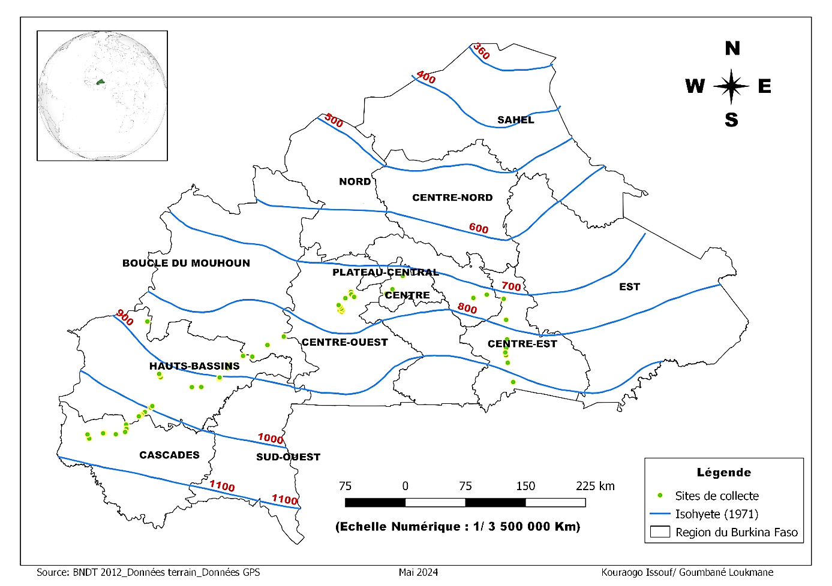
Figure 1: Map of data collection area by agro-climatic zone

Source: Kouraogo (2024)

3. MATERIALS AND METHODS
3.1. Equipment

The technical equipment used included:
- yellow plastic traps for catching insects, installed in sorghum fields;
- wooden supports 4 to 5 meters long were used to hold the traps in place in the field;
- rating sheets were used to record the data collected at the various study sites;
- white sheets were used to crush samples of sorghum spikelets taken from growers' plots;
- a pestle was used for crushing operations in the laboratory or directly at the sampling site. Photos 1 and 2 show some of the equipment and techniques used during the various activities.

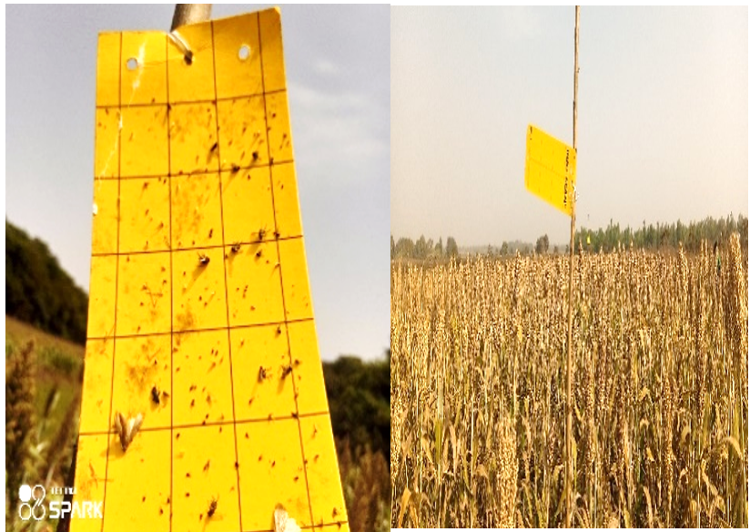
Photo 1: Illustration of the technique used to capture insects in sorghum fields
Source: Kouraogo (2024)

3.2. Methods
3.2.1. Insect capture in the field
In each site, three insect traps were set in each field. These traps were set at regular intervals in such a way to cover the entire area under cultivation (photo 1). The traps were set as soon as the sorghum plants started heading, and were replaced every week until the fields were harvested. The collected traps were sent to the entomology laboratory to count the number of midges caught weekly.
    - Spikelet crushing technique
Samples of sorghum spikelets taken from farmers' fields in the 10 provinces were used to estimate the damage caused by the insect in each locality. For each field or plot, 3 samples of 100 spikelets were crushed on white paper using pestle. The technique consists of crushing 100 sorghum spikelets on white paper by using laboratory pestle. Once crushed, the spikelet residues are poured off and the number of orange spots is counted. Each orange spot represents a developing midge larva, and the average were calculated from the three samples to determine the level of midge infestation in the field (Photo 2).
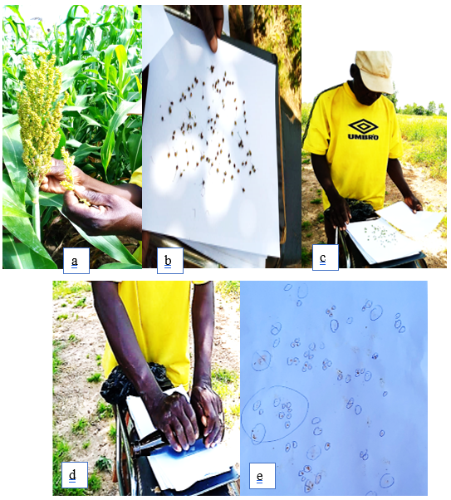
Photo 2: Technique of crushing sorghum spikelets
a: Sampling spikelets from panicles; b: Detaching and distributing 100 spikelets on a stalk leaf; c: Covering the spikelets with the second stalk leaf; d: Crushing the spikelets; e: Determining the number of orange spot impacts.
Source: Kouraogo (2024)

    - Monitored parameters
The collected data were essentially parameters linked to midge assessment through visual scores rating from 1 to 9 scale proposed by ICRISAT. Scores ranged from 1 to 9, with 1 = 1-10% of panicles attacked; 2 = 11-20% of panicles attacked; 3 = 21-30% of panicles attacked; 4 = 31-40% of panicles attacked; 5 = 41-50% of panicles attacked; 6 = 51-60% of panicles attacked; 7 = 61-70% of panicles attacked; 8 = 71-80% of panicles attacked; 9 > 80% of panicles attacked. These observations were made on the whole plot and on five (5) panicles randomly selected in the plot to estimate the average damage of these panicles (photo 3).
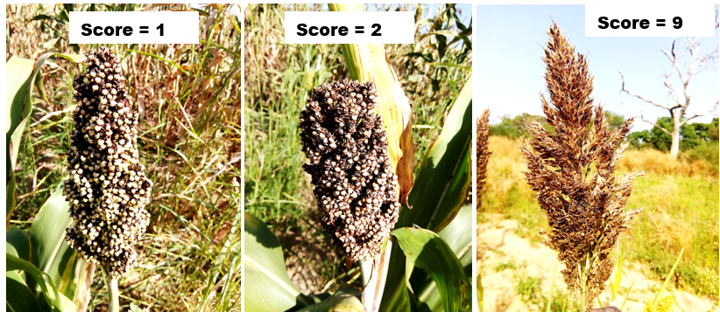
Photo 3: Illustration of midge damage assessment according to ICRISAT scale
Source : Kouraogo (2024)
  - Data analysis
The Excel spreadsheet, version 2016, was used to enter, manage data, and to produce curves showing evolution of the midge population in the two agro-ecological zones of Burkina Faso. Histograms were also produced to present midge infestation rates in the fields across these two agro-ecological zones.

4. RESULTS
4.1. Midge population dynamics in different agro-ecological zones
4.1.1. Midge population dynamics in the northern Sudan zone

In 2023, the results revealed that first midge insects were captured on this site around September 15, and a total number of 22 insects were found on the yellow traps at this date. From week to week, the number raised and reached out a first peak of 1167 adult insects on October 20, 2023. Thereafter, a gradual decline in the population was observed, with 566 individuals on October 27. However, a second peak, higher than the first, was recorded on November 10, 2023, with a total of 1352 midges. From November 10, the number of captured midge insects dropped out, until they disappeared completely on November 29, 2023 (Figure 2-a).
During 2024, the evolution of midge numbers was characterized by three successive generations, each corresponding to a population peak (figure 2-b). The first insects appeared on the study site around September 28, with an initial population of 58 midges. A first peak occurred earlier than the previous year (2023), although the population was low and reached out 623 insects on October 10, 2024. The second peak was observed on October 22, with a total of 1452 midges, followed by a third peak on November 9, which counted 140 individuals (figure 2-b).

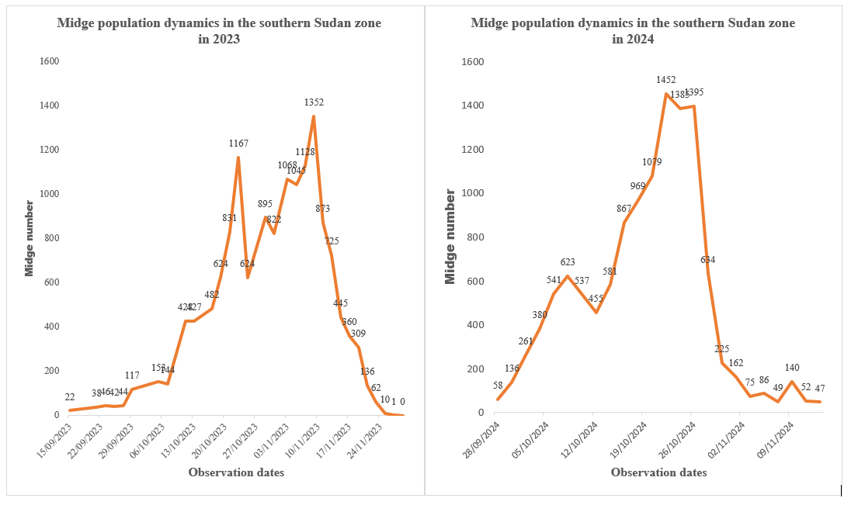 Figure 2-a: Midge numbers on the Kouaré site in 2023 Figure 2-b: Midge numbers on the Kouaré site in 2024

    - Midge population dynamics in the southern Sudan area
In 2023, the first midge individuals were reported on October 8, with a single individual on the study site. Only one generation of populations was observed with a peak on October 29. A total population of 24 insects was captured by the yellow traps. Later on, a significant decline on the number of insects was recorded, until their total disappearance around November 12, 2023 (Figure 3-a). in opposite, in 2024, the insect's dynamics were characterized by three successive generations along with three distinct peaks. The first peak occurred on October 12, with 16 individuals, followed by a second peak on October 26, with 15 individuals, and then a third peak on November 9, with 32 individuals. From November 23 until December 8, 2024, the insects’ number remained stable at 9 individuals (Figure 3-b). Compared to the previous year (2023), the midge insect remains in the field until harvesting stage.

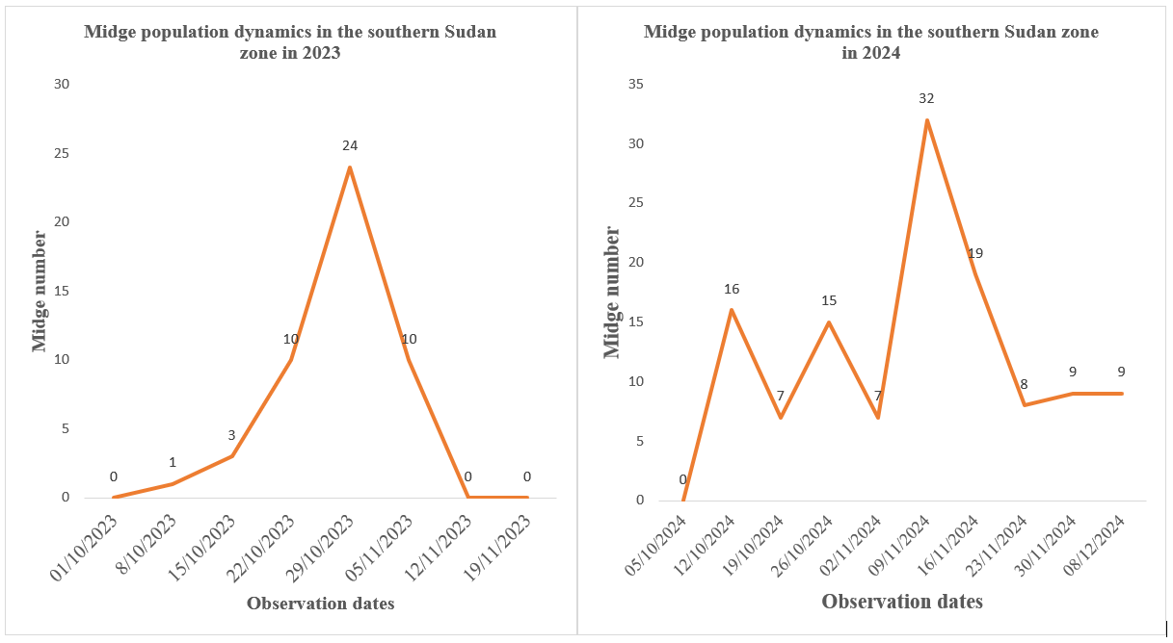
Figure 3-a: Midge numbers in the southern sudan zone in 2023
Figure 3-b : Midge numbers in the southern sudan zone in 2024

  - Assessment of midge damage in the two agro-ecological zones
    - Assessment of midge damage using the crushing method
In addition to midge population dynamics and abundance study, damage assessment was carried out in sorghum field to reveal yield shortage causes by the insect across agro-ecological zone in Burkina Faso. This analysis illustrated by graphics showing of midge infestation rate, involved 90 growers spread out over 27 communes in 10 provinces of the country. The crushing method was used to reveal infestation rates. The result showed that infestation rates varied according to zone. The infestation rate was low (17%) in the southern Sudanese zone, while, it was high (42%) in the northern Sudanese zone (Figure 4).

Figure 4: Average infestation rate of fields using the crush method
    - Assessment of midge damage in the field
Direct assessment of midge damage in the field was carried out by visual observation of damage over the whole plot. Five panicles were randomly selected in each farmers' field. The result revealed the different assessment methods were similar. The analysis indicates that the rate of panicle damage caused by midge in the two zones varied from 20 to 30%. Indeed, concerning visual scoring, the rate ranged from 2 to 3. The score was observed in the southern Sudanese zone and corresponds to 20% of midge-related damage while score 3 which corresponds to 30% of midge-related damage was observed in the northern Sudanese zone (Figure 5).

Figure 5: Average damage rate by ecological zone
- DISCUSSION
Comparative study of two consecutive years in different agro-ecological zones enabled us to reveal midge population dynamics and its impact on sorghum production. These analyses highlighted the fluctuations on the insect's population from one year to another one across different agro-ecological zones. Results showed that the first appearance of midge insect was observed in the northern Sudan zone during September 15, 2023, a week before flowering. This appearance was linked to the end of insect diapause and the beginning of its new life cycle. This is a natural phenomenon linked to environmental condition. Indeed, mid-September corresponds to high moisture period and moderate temperatures (20 and 30°C), favoring the emergence and development of midge populations which were in diapause (Baxendale and Teetes, 1983; Sharma and Nwanze, 1997). According to these authors, when average temperature is comprised between 20 and 30°C along with relative moisture above 60%, midge adults’ diapause ends their dormancy and become active again. During 2024 cropping season, midge insects’ appearance was observed on the same site around September 28. Previous study conducted by Ouedraogo et al. (2024) revealed that first midge insect appearance was done around early September (September 19) during cropping year 2022. These differences in the insect's behavior over three consecutive years can be attributed to agro-climatic condition variations within site. Indeed, the meteorological data recorded on rainfall showed that the quantities of rainfall were different on the sites over the three crop years. The lowest quantity (776.7 mm) was recorded in 2022 followed by a medium quantity (797.1 mm) in 2023 and high quantity (1034.4 mm) in 2024 cropping years respectively. These differences were also observed at disappearance periods of the insect which characterized the end of its active life and the start of its diapause. Midge numbers drop can be explained by the fact the insect is entering in diapause step. The reduction of midge numbers in the field corresponded to the periods marked by the end of plant flowering stage. Sorghum flowering organs are the insect's main food source and the scarcity of rain at the end of the cropping year was not favorable for the sorghum midge's development cycle (Ellwood et al., 2012; Amouroux, 2013). This could explain the insect's presence in the South Sudanese zone (the site of Bobo Dioulasso) until December during the 2024 cropping season. In fact, S. sorghicola adults were observed at the Bobo Dioulasso site until December 10, 2024. In opposite to the previous year (2023) when any insects were recorded after mid-November in the same areas. This difference could therefore be explained by a delay in harvesting operations in this area, which began only on December 15 of 2023. This is probably due to the presence of late-flowering varieties in the field and also the delay in planting time some of these fields. These late-flowering varieties thus served as a reservoir for the succession of generations of the insects, offering the nutritive resources required for the development of its life cycle (Kadi Kadi et al., 2005). These authors have shown that the emergence of midge diapauses depends on environmental conditions, while the maintenance of midge populations is ensured by the availability of nutritive resources in the environment. During the two years of the study, the midge population remained low between mid-September and early October in these two agro-ecological zones. However, between the end of October to mid-November, the population increased significantly, reaching several peaks, notably in the North Sudan agroecological zone, where maximum insect populations reached out 1352 insects in 2023 and 1452 insects in 2024. Similarly, Ouédraogo et al. (2024) observed maximum midge populations of 833 and 1650 insects respectively during the 2022 and 2023 cropping seasons in the same site. The low number of insects observed from mid-September to early October could be explained by the fact that the number of insects represents the very first midge population generations to emerge from diapause, having not yet time to multiply. This emergence coincides with the flowering of early-maturing sorghum varieties, which serve as egg-laying sites for the insect. This will facilitate its proliferation, leading to the population peaks observed few weeks later in various sites (Ouédraogo et al., 2024). Moreover, the number of peaks observed varied from one year to another one in the same agro-ecological zone. In the North Sudan agro-ecological zone, for example, the number of peaks raised from two in 2023 to three in 2024. Similarly, the initial insect populations and the maximum populations reached during each peak have also evolved. Ouédraogo et al. (2024) reported three peaks in 2022 and four peaks in 2023 in the same area, with different initial midge populations. These results suggest that the maximum number of insects reached per generation and the number of generations per campaign are closely linked to the initial insect population. These findings are correlated with the work of Pendleton et al. (1994) and Baxendale et al. (1984b), who observed two generations of midge on wild sorghum and five generations on cultivated sorghum. In addition, studies carried out by Kadi Kadi et al. (2005) in Niger, using light traps to capture adult midges, revealed two generations per year over three years of study, with significant population peaks reached in October. From these two agro-ecological zones, the northern Sudanian zone proved to be the most infested with sorghum midge, with population peaks exceeding 1,400 individuals over the two years, while the southern Sudanian zone never recorded more than 32 midge individuals. This makes the northern Sudanian zone the most affected by sorghum midge, particularly the Koaré site in Fada N'Gourma. These results confirm the observations of Dakouo et al. (2005) and Ouedraogo et al. (2024), who highlighted the importance of midge as a major problem for sorghum production in the southern, central-western and eastern zones of Burkina Faso. In addition to analyzing the population dynamics of sorghum midge, the study also investigated on damage caused by the insect to the crop in Burkina Faso within two agro-ecological zones. The assessment of insect-related damage in farmers' fields using the crush method and visual observation in the field, indicated that the impact of the midge was greater in the northern Sudan zone, whatever the assessment method. These results confirm those of Dakouo et al. (2005) and Ouattara et al. (2023), who showed that this zone constitutes a midge “hot spot” with well-infested localities, unlike the southern Sudanese zone.

CONCLUSION
This study of sorghum midge population dynamics and abundance provided an overview of the situation of this insect in several localities across these two agro-ecological zones of Burkina Faso. It highlighted the insect's active and diapause periods, depending on the country's different agricultural zones. The study also identified the peak periods in the insect's life cycle, thus determining the critical moments of its impact on sorghum cultivation during rainy season across study localities. The results show that the insect is present in all areas observed, although its intensity varies from region to region. The study clearly revealed that Fada N'Gourma, particularly the Koaré site, represents a midge “hot spot” in Burkina Faso. According the results, this area is of particular interest to research programs for studies on this insect pest, which represents a major challenge for this very important crop in Burkina Faso.

COMPETING INTERESTS DISCLAIMER:
Authors have declared that they have no known competing financial interests OR non-financial interests OR personal relationships that could have appeared to influence the work reported in this paper.

Disclaimer (Artificial intelligence)
Option 1:
Author(s) hereby declare that NO generative AI technologies such as Large Language Models (ChatGPT, COPILOT, etc.) and text-to-image generators have been used during the writing or editing of this manuscript.
REFERENCES
- Amouroux P., Normand F., Nibouche S. and Delatte H. 2013. Invasive mango blossom gall midge, Procontarinia mangiferae (Felt) (Diptera: Cecidomyiidae) in Reunion Island: ecological plasticity, permanent and structured Biological Invasions 15 (8):1677-1693. doi:10.1007/s10530-012-0400-0
- Barro-Kondombo PC, Chantereau J, Goze E, Weltzien E, Trouche G, Brocke VK. 2010. Participatory variety development for sorghum in Burkina Faso: Farmers' selection and farmers' criteria. Field Crops Research; 119:183-194.
- Baxendale F.P. and Teetes, G. L. 1983. Thermal Requirements for Emergence of Overwintered. Sorghum Midge (Diptera: Cecidomyiidae). Environmental Entomology 12 (4): 1078-1082.
- Baxendale F.P., Teetes G.L. and Sharpe P.J.H. 1984. Temperature-dependent model for development of nondiapausing sorghum midge (Diptera: Cecidomyiidae). Environmental Entomology 13 (6): 1572–1576.
- Chantereau J., Cruz J-F., Ratnadass A., Trouche G., Fliedel G., 2013. Sorghum, Éditions Quæ, CTA, Presses agronomiques de Gembloux, Paris, France. 249 p.
- Dakouo D., Trouche G., Bâ N.M., Neya A., Kaboré K.B., 2005. Genetic control of sorghum midge, Stenodiplosis sorghicola: a major constraint to sorghum production in Burkina Faso. Cahiers Agricultures, 14 (2): 201-208.
- Diarisso NY, Pendleton BB, Teetes GL, Peterson GC, Anderson RM. 1997. Relationship between sorghum glume closure and resistance to sorghum midge. Int Sorghum and Millets Newsl; 38:87-8.
- Elamein A.A.M., 2014. Screening of some sorghum Genotypes for resistance to sorghum Midge, Stenodiplosis sorghicola (Coq), under Rain-Fed conditions, Sudan. International journal of agricultural innovations and research, 2 (6): 1144-1146.
- IPCC, 2007. Climate Change 2007. Contribution of Working Groups I, II and III to the Fourth Assessment Report of the Intergovernmental Panel on Climate Change. Geneva, Switzerland, 103p.
- Kadi Kadi, H. A., Kapran I. and Pendleton B. B., 2005. Identification of sorghum genotypes resistant to sorghum midge in Niger. International Sorghum and Millets Newsletter 46:57-59.
- Magallanes-Cedeno R., Teetes G-L., 1991. Sorghum midge distribution in sorghum florets. Sorghum-Newsletter, 32: 51.
- Nwanzé K.F., 1988. Distribution and seasonal incidence of some major insect pests of sorghum in Burkina Faso. Insect Science and Its Application, 9:313-21.
- Ouédraogo N, Thio IB, Sanou A, Kouraogo I, Boro O, Sawadogo WPA, Yonli D, Gracen V, Nebie B. 2021. Agronomic performance and adaptability study of New Guinea lines in sudanian and sudano-sahelian zones. Journal of Applied Biosciences; Vol 167(4), p17320-17334 DOI : https://doi.org/10.35759/JABs.167.4
- Ouédraogo N, Thio IG, Drabo I, Kouraogo I, Sawadogo PWA, Gracen V and Nebie B. 2022. Impact of midge damage on the performance of new sorghum lines in eastern Burkina Faso. Agricultural Science Research Journal, Vol 12 (5): 84-92.
- Ouédraogo N, Kouraogo I, Sawadogo PWA, Gracen V and Nebie B. 2024. Determination of Twelve Sorghum (Sorghum bicolor L. Moench) Varietal Status to Midge Damage in Hotspot Area of Burkina Faso. Journal of Advances in Biology & Biotechnology, 27 (11): 1259-1268 DOI: https://doi.org/10.9734/jabb/2024/v27i111712
- Ouédraogo N, Sawadogo APW, Koala M, Kouraogo I, Nébié B and Gracen V. 2024. Genotype x Environment Interaction and Stability of Heading Time and Grain Yield of 12 Open Pollinated Sorghum Varieties across Different Agro-ecological Zones in Burkina Faso. Journal of Experimental Agriculture International, 46(8), 310–322. https://doi.org/10.9734/jeai/2024/v46i82709
- Pendleton B.B., Teetes G.L. 1994. Sorghum midge dispersal from sorghum. Southwestern Entomologist 19 (1): 1-9.
- Saïdou AA, Raimond C, Soler C, Cao Hamadou TV, Kenga R, Benoit L, Wencelius J, Fokou O, Chauvin C, Ekeke S. 2014. Histoire d’une innovation agricole récente à l’échelle régionale : quelle différenciation des sorghos repiqués dans le bassin du lac Tchad? Les Cahiers d’Outre-Mer 266 : 141-168.

- Sharma HC, Nwanzé KF. 1997. Mechanisms of resistance to insects in sorghum and their usefulness in crop improvement. ICRISAT Info Bull; 45:22-36.
- Zongo, J. D., 1991. Ressources génétiques des sorghos (Sorghum bicolor (L.) Moench) du Burkina Faso : Evaluation agromorphologique et génétique. Thèse de docteur ès science, sciences naturelles, Université d'Abidjan, Côte d'Ivoire, 219p.

