The Effectiveness of Foliar Nano Zinc Oxide Application on Nutrient Uptake and Quality of Wheat in Zinc Deficient Inceptisol

-------------------------------------------------------------------------------------------------------------------------------
ABSTRACT
A field experiment was carried out during the rabi season of 2024–25 at the Post Graduate Instructional Farm, College of Agriculture, Pune to study the effect of foliar application of nano zinc oxide on growth, yield and quality of wheat cultivated in Inceptisol. Treatments included foliar sprays of nano-ZnO at concentrations of 300, 600, 900 and 1200 ppm, alongside a comparative treatment of EDTA-Zn at 1200 ppm, applied at 45 and 65 days after sowing. All treatments received the general recommended dose of fertilizers except for absolute control. The results revealed that the application of GRDF combined with 1200 ppm nano-ZnO foliar spray led to the highest uptake of macronutrients viz. nitrogen (160.37 kg ha⁻¹), phosphorus (38.51 kg ha⁻¹), and potassium (177.03 kg ha⁻¹) as well as micronutrients including iron (1245 g ha⁻¹), manganese (751 g ha⁻¹), copper (50.07 g ha⁻¹), and zinc (554 g ha⁻¹). This treatment also significantly improved protein content (12.90 %) in grain and test weight (41.40 g) compared to other treatments. Overall, foliar application of nano-ZnO notably enhanced nutrient uptake, grain quality and soil nutrient status, while boosting wheat yield. These findings emphasized the potential of nano zinc oxide as a sustainable and efficient alternative to conventional micronutrient fertilizers, particularly in zinc-deficient Inceptisol.

Keywords: Wheat; nano; zinc oxide; foliar; effect; nutrient; uptake; quality

1. INTRODUCTION

The increasing global demand for food, coupled with the challenges of declining soil fertility and inefficient nutrient use, calls for innovative strategies to enhance crop productivity and nutritional quality. One such strategy gaining considerable attention is the application of nanotechnology in agriculture. Among various nanomaterials, zinc oxide nanoparticles (ZnO NPs) have emerged as promising tools due to their unique physicochemical properties, including high surface area, enhanced reactivity and controlled release behaviour.
Zinc is a vital micronutrient that supports numerous physiological and biochemical processes in plants, including enzyme activation, protein synthesis and hormonal balance. Its deficiency is prevalent across many Indian soils, especially in Inceptisols, which tend to have low zinc availability due to moderate weathering and leaching. Zinc contributes significantly to plant defense mechanisms by stabilizing cell membranes and mitigating oxidative stress. It activates key antioxidant enzymes such as superoxide dismutase, glutathione reductase and peroxidase, which neutralize reactive oxygen species.
In addition, zinc is essential for reproductive development and grain formation, as it facilitates the transport of photo-assimilates photosynthetic products distributed throughout the plant. Plants absorb zinc primarily as Zn²⁺ ions, which aid in phosphorus translocation and help mitigate the adverse effects of excess phosphorus uptake. Soil pH plays a critical role in zinc availability: acidic conditions enhance zinc solubility, whereas alkaline soils promote the formation of zincate complexes that bind with calcium, thereby limiting zinc uptake by plants (Bhardwaj et al., 2022).
____________________________________________________________________________

Nano-fertilizers offer superior nutrient transport and cellular delivery compared to conventional fertilizers, owing to their ability to traverse the narrow plasmodesmata channels (approximately 50-60 nm). This unique capability enhances nutrient uptake and efficiency while minimizing losses, ultimately boosting crop productivity by 6–17% and improving nutritional quality. By increasing nutrient bioavailability, nano-fertilizers positively influence key physiological and biochemical functions, stimulating metabolic activity, meristematic growth, and development in apical regions and photosynthetically active tissues (DeRosa et al., 2010).
Among these, zinc oxide (ZnO) nanoparticles have garnered significant interest due to their distinct physicochemical properties such as nanoscale dimensions, morphology, optical behaviour and chemical reactivity, which make them suitable for diverse agricultural applications. ZnO nanoparticles have demonstrated the ability to enhance plant metabolic functions, contributing to improved growth and yield (Zulfiqar et al., 2019). Their effectiveness is governed by factors including particle size, surface characteristics, chemical composition, reactivity and dosage (Shang et al., 2019).
Foliar application, which involves spraying nutrients directly onto plant leaves has proven more efficient than soil-based fertilization methods (Nasiri et al., 2010). When applied in nanoparticle form, foliar sprays can also stimulate enzymatic activity and the release of growth-promoting compounds through the roots, influencing microbial dynamics in the rhizosphere (Rathore and Tarafdar, 2015).
Wheat (Triticum aestivum L.), a key staple crop in India, responds well to zinc supplementation. Improving its nutrient uptake and grain quality through nano-formulations holds promise for enhancing food security and nutritional outcomes. This study investigates the impact of foliar-applied nano zinc oxide on wheat grown in Inceptisol soils, aiming to refine its application for sustainable and efficient crop production. By merging nanotechnology with conventional agronomic practices, the research seeks to advance innovative fertilization strategies for future agriculture.

2. MATERIALS & METHOD
A field experiment was conducted at the Post Graduate Instructional Farm, Division of Soil Science, College of Agriculture, Pune (MS) during rabi season of 2024-25. The performance of nano ZnO was evaluated by comparing the nine treatments as T₁ - Absolute control, T₂ - GRDF (120:60:40 N: P₂O₅: K₂O kg ha⁻¹ + FYM 10 t ha⁻¹), T₃ - GRDF + soil application of ZnSO₄ @20 kg ha⁻¹, T₄ - GRDF + water spray, T₅ - GRDF + foliar spray of 300 ppm nano-ZnO, T₆ - GRDF + foliar spray of 600 ppm nano-ZnO, T₇ - GRDF + foliar spray of 900 ppm nano-ZnO, T₈ - GRDF + foliar spray of 1200 ppm nano-ZnO and T₉ - GRDF + foliar spray of 1200 ppm EDTA Zn which were replicated three times in RBD design. A representative soil sample from the 0–30 cm layer was collected from the field both before sowing and after harvesting of the wheat crop. The initial soil of the experimental site before sowing of the crop was slightly alkaline (pH 7.82), low in electrical conductivity (EC) (0.59 dS m⁻¹), moderate in organic carbon (0.42 %) and calcium carbonate (7.73 %), low in available nitrogen (236.23 kg ha⁻¹) and available phosphorus (20.15 kg ha⁻¹) but high in available potassium (463.00 kg ha⁻¹) levels and deficient in DTPA zinc (0.56 mg kg⁻¹) levels. The soil pH, electrical conductivity (EC), organic carbon, calcium carbonate, DPA copper content were found non-significant after harvesting of the wheat crop, while the available nitrogen (258.36 kg ha⁻¹), available phosphorus (27.05 kg ha⁻¹), available potassium (477.00 kg ha⁻¹), DTPA iron (13.31 mg kg⁻¹), DTPA manganese (14.00 mg kg⁻¹) and DTPA zinc (0.68 mg kg⁻¹) content of soil significantly influenced due to GRDF + soil application of ZnSO₄ @20 kg ha⁻¹ in wheat crop over other treatments.
The nano zinc oxide particles were synthesized by using chemical precipitation method along with calcination and modified with pectin in the lab of Division of Soil Science, RCSM College of Agriculture, Kolhapur. The size, surface structure and topology of zinc oxide nanoparticles were disclosed by using Scanning Electron Microscope (SEM). It is revealed from the analytical report of Scanning Electron Microscope that the average size of nano zinc oxide particle is 42.37 nm. The NIAW-1994 (Phule Samadhan), variety of wheat was grown as a test crop.
The recommended dose of fertilizer (120:60:40 kg of N, P₂O₅ and K₂O+ 10 t FYM ha⁻¹) was applied except for absolute control. The required quantity of zinc was applied as per the treatments through various sources viz. nano zinc oxide, zinc sulphate heptahydrate and EDTA Zn except for absolute control. The zinc sulphate heptahydrate was incubated with FYM for 15 days before incorporating into soil. The nano zinc oxide and EDTA Zn were applied as foliar sprays at 45 and 65 days after sowing. The characterization of nano zinc oxide (ZnO) particles for size was done by using SEM analysis technique before starting of the experiment and given in Table 1 and Fig. 1.
The plant samples were collected upto ground level at harvest of wheat to analyze nutrient uptake and quality of wheat by using standard analytical methods. The data on nutrient uptake and quality of wheat were recorded and further statistical analysis was done. A randomized block design (RBD) with analysis of variance (ANOVA) was employed to assess treatment effects on all studied characteristics (Panse and Sukhatme, 1985).

Table 1 Characterization of nano-zinc oxide particles for size using SEM
Sr. No. | Size of nano-zinc oxide (nm) | Sr. No. | Size of nano-zinc oxide (nm)
1 | 20.23 | 13 | 36.45
2 | 21.63 | 14 | 37.77
3 | 22.93 | 15 | 40.83
4 | 24.32 | 16 | 41.03
5 | 28.36 | 17 | 44.84
6 | 29.12 | 18 | 54.11
7 | 29.68 | 19 | 61.52
8 | 29.71 | 20 | 66.63
9 | 31.03 | 21 | 66.91
10 | 32.38 | 22 | 73.95
11 | 35.49 | 23 | 75.41
12 | 36.42 | 24 | 76.33
Average | 42.37

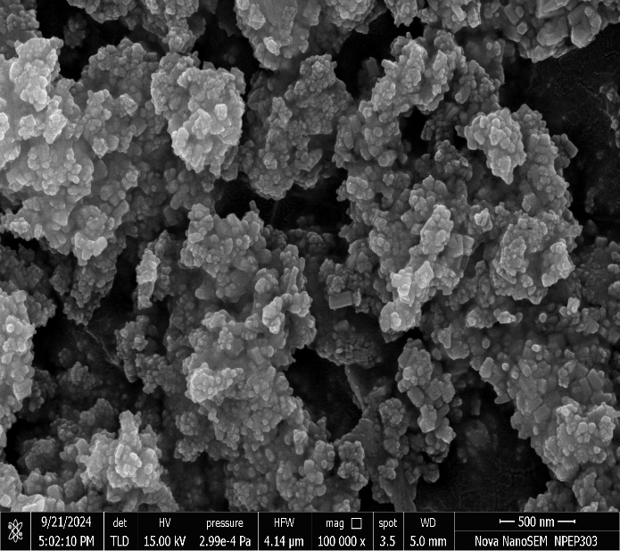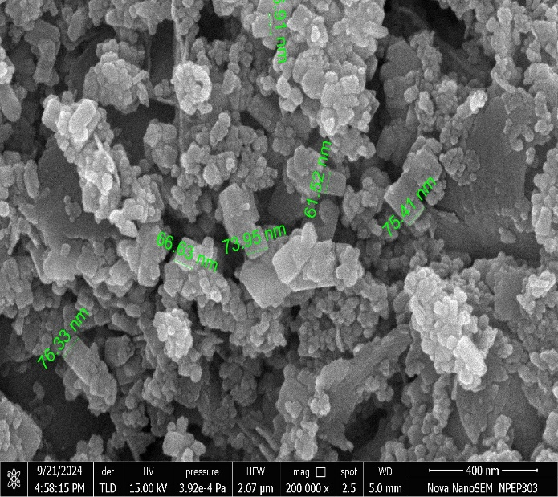
Fig. 1 (a) Characterization of nano zinc oxide (ZnO) particles for crystallography using SEM
Fig. 1 (b) Characterization of nano zinc oxide (ZnO) particles for size using SEM

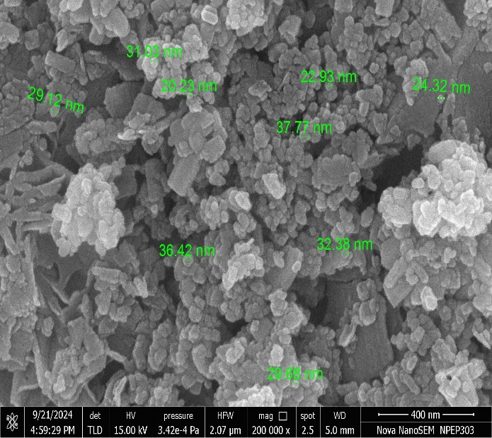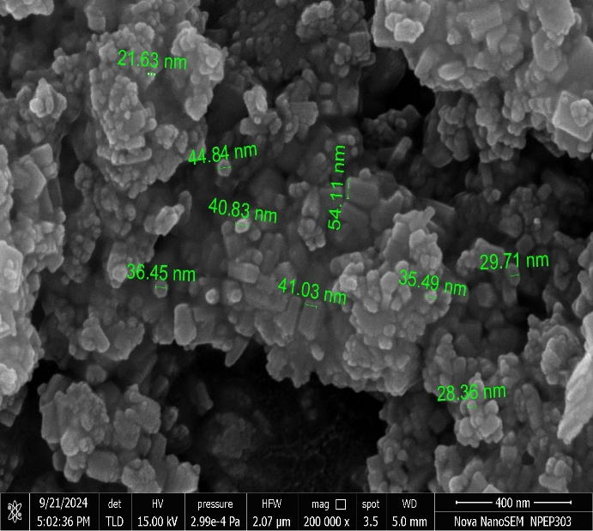
Fig. 1 (d) Characterization of nano zinc oxide (ZnO) particles for size using SEM
Fig. 1 (c) Characterization of nano zinc oxide (ZnO) particles for size using SEM
Fig. 1: Characterization of nano-zinc oxide particles for size and crystallography using Scanning Electron Microscopy (SEM)

3. RESULTS AND DISCUSSION
3.1 Effect of foliar application of nano zinc oxide on macronutrient uptake
3.1.1 Nitrogen Uptake
The uptake of nitrogen (160.37 kg ha⁻¹) in wheat was found significantly higher in treatment GRDF + foliar spray of 1200 ppm nano-ZnO, while treatments GRDF + foliar spray of 900 ppm nano-ZnO (155.60 kg ha⁻¹) and GRDF + foliar spray of 1200 ppm EDTA Zn (158.91 kg ha⁻¹) were at par with this treatment. The lower uptake of nitrogen (70.49 kg ha⁻¹) was observed in absolute control treatment.
3.1.2 Phosphorus Uptake
The uptake of phosphorus (38.51 kg ha⁻¹) in wheat was found significantly higher in treatment GRDF + foliar spray of 1200 ppm nano-ZnO, while treatments GRDF + foliar spray of 900 ppm nano-ZnO (37.63 kg ha⁻¹) and GRDF + foliar spray of 1200 ppm EDTA Zn (37.51 kg ha⁻¹) were at par with this treatment. The lower uptake of phosphorus (11.74 kg ha⁻¹) was observed in absolute control treatment.
3.1.3 Potassium Uptake
The uptake of potassium (177.03 kg ha⁻¹) was found significantly higher in treatment GRDF + foliar spray of 1200 ppm nano-ZnO, while treatments GRDF + foliar spray of 600 ppm nano-ZnO (160.22 kg ha⁻¹) GRDF + foliar spray of 900 ppm nano-ZnO (174.44 kg ha⁻¹) and GRDF + foliar spray of 1200 ppm EDTA Zn (175.39 kg ha⁻¹) were at par with this treatment. The lower uptake of potassium (64.87 kg ha⁻¹) was observed in absolute control treatment.

Table 2 Effect of foliar application of nano zinc oxide on macronutrient uptake in wheat in
Inceptisol
Tr. No. | Treatments | Nitrogen uptake  (kg ha⁻¹) | Phosphorus uptake  (kg ha⁻¹) | Potassium uptake  (kg ha⁻¹)
T₁ | Absolute Control | 70.49 | 11.74 | 64.87
T₂ | GRDF (120:60:40 N: P₂O₅: K₂O kg ha⁻¹ + FYM 10 t ha⁻¹) | 113.31 | 26.48 | 146.67
T₃ | GRDF + soil application of ZnSO₄ 20 kg ha⁻¹ | 132.45 | 28.24 | 162.23
T₄ | GRDF + water spray | 113.11 | 25.60 | 148.17
T₅ | GRDF + foliar spray of 300 ppm nano-ZnO | 128.68 | 27.59 | 156.34
T₆ | GRDF + foliar spray of 600 ppm nano-ZnO | 131.64 | 28.09 | 160.22
T₇ | GRDF + foliar spray of 900 ppm nano-ZnO | 155.60 | 37.63 | 174.44
T₈ | GRDF + foliar spray of 1200 ppm nano-ZnO | 160.37 | 38.51 | 177.03
T₉ | GRDF + foliar spray of 1200 ppm EDTA Zn | 158.91 | 37.51 | 175.39
 | SE(m) ± | 5.93 | 1.29 | 6.89
 | CD (0.05) | 17.78 | 3.88 | 20.68

Foliar application of nano zinc oxide might have improved macronutrient uptake by enhancing the overall health and function of plant cells. Nano zinc oxide helps plants to absorb more nitrogen by releasing zinc slowly and steadily, making it available for a longer time. Foliar application of nano zinc oxide boosts nitrogen uptake by delivering zinc directly to the leaves, where it is quickly absorbed and used to activate enzymes involved in nitrogen metabolism. Zinc supports enzyme activity and strengthens cell membranes, which helps in the movement and absorption of nitrogen, phosphorus and potassium within the plant. When applied to the leaves, the tiny nano zinc particles are easily absorbed and quickly support these processes. This improved nutrient transport system allows plants to uptake and uses these nutrients more efficiently, leading to better growth and stress resistance. It also improves chlorophyll production and photosynthesis, which gives the plant more energy to absorb and use major plant nutrients. These findings are also in familiar with the findings reported by Joseph et al. (2019), Miranda-Villagómez et al. (2019), Meena et al. (2021), Mazhar et al. (2023) and Nazir et al. (2024). These findings are also supported by Patil et al. (2020) and Lahari et al. (2021).

3.2 Effect of foliar application of nano zinc oxide on micronutrient uptake (Table 2)
3.2.1 Iron uptake
It was found that the application of GRDF + foliar spray of 1200 ppm nano-ZnO recorded significantly higher iron uptake (1245 g ha⁻¹), while treatments GRDF + foliar spray of 600 ppm nano-ZnO (1156 g ha⁻¹), GRDF + foliar spray of 900 ppm nano-ZnO (1230 g ha⁻¹), and GRDF + foliar spray of 1200 ppm EDTA Zn (1238 g ha⁻¹) were at par with this treatment. There was an increased iron uptake of around 54.85 percent and 15.06 percent as compared to absolute control and GRDF treatments.
3.2.2 Manganese uptake
The uptake of manganese was found significantly higher (751 g ha⁻¹) in treatment GRDF + foliar spray of 1200 ppm nano-ZnO, while treatments GRDF + foliar spray of 900 ppm nano-ZnO (729 g ha⁻¹) and GRDF + foliar spray of 1200 ppm EDTA Zn (740 g ha⁻¹) were at par with this treatment. When treatment GRDF + foliar spray of 1200 ppm nano-ZnO, is compared with absolute control and GRDF treatments, uptake of total manganese is increased upto 35.31 percent and 15.89 percent, respectively.
3.2.3 Copper uptake
The uptake of copper (50.07 g ha⁻¹) was found significantly higher in treatment GRDF + foliar spray of 1200 ppm nano-ZnO, while treatments GRDF + soil application of ZnSO₄ @20 kg ha⁻¹ (39.69 g ha⁻¹), GRDF + foliar spray of 300 ppm nano-ZnO (43.33 g ha⁻¹), GRDF + foliar spray of 600 ppm nano-ZnO (44.37 g ha⁻¹), GRDF + foliar spray of 900 ppm nano-ZnO (49.15 g ha⁻¹), and GRDF + foliar spray of 1200 ppm EDTA Zn (48.59 g ha⁻¹) were at par with this treatment.
3.2.4 Zinc uptake
The uptake of zinc (554 g ha⁻¹) was found significantly higher in treatment GRDF + foliar spray of 1200 ppm nano-ZnO, while treatments GRDF + soil application of ZnSO₄ @20 kg ha⁻¹ (459 g ha⁻¹), GRDF + foliar spray of 600 ppm nano-ZnO (455 g ha⁻¹), GRDF + foliar spray of 900 ppm nano-ZnO (501 g ha⁻¹) and GRDF + foliar spray of 1200 ppm EDTA Zn (527 g ha⁻¹) were at par with this treatment.

Foliar application of nano zinc oxide might have improved iron, manganese, copper and zinc uptake in wheat by enhancing the plant’s overall nutrient absorption processes. The small size of nano zinc particles allows them to easily enter the leaves and boost enzyme activity and metabolism, which helps the plant to absorb and use these micronutrients more efficiently. The nano zinc particles are easily absorbed through the leaves and help activate important metabolic processes that support the uptake and transport of micronutrients. It is reported that zinc improves root development and photosynthesis, which gives the plant more energy to absorb nutrients from the soil. As a result, wheat plants treated with nano zinc oxide might have shown better absorption these micronutrients uptake more efficiently, and leading to better growth and development. These findings are supported by Prajapati et al. (2018), Meena et al. (2021), Mazhar et al. (2023) and Nazir et al. (2024). When applied as foliar spray, nano zinc functions as a site-specific agent, allowing for enhanced uptake through absorption mechanisms. This targeted delivery might have contributed to the improved internal zinc concentrations observed in plants treated with foliar nano zinc. These findings are in agreement with the results reported by Apoorva et al. (2017), El-Said et al. (2019) and Sadak and Bakri (2020).

Table 3 Effect of foliar application of nano zinc oxide on micronutrient uptake in wheat in Inceptisol
Tr. No. | Treatments | Iron uptake  (kg ha⁻¹) | Manganese  uptake  (kg ha⁻¹) | Copper  uptake  (kg ha⁻¹) | Zinc  uptake  (kg ha⁻¹)
T₁ | Absolute Control | 804 | 555 | 18.19 | 143
T₂ | GRDF (120:60:40 N: P₂O₅: K₂O kg ha⁻¹ + FYM 10 t ha⁻¹) | 1082 | 648 | 33.98 | 351
T₃ | GRDF + soil application of ZnSO₄ 20 kg ha⁻¹ | 1090 | 677 | 39.69 | 459
T₄ | GRDF + water spray | 1036 | 650 | 33.92 | 354
T₅ | GRDF + foliar spray of 300 ppm nano-ZnO | 1077 | 665 | 43.33 | 421
T₆ | GRDF + foliar spray of 600 ppm nano-ZnO | 1156 | 672 | 44.37 | 455
T₇ | GRDF + foliar spray of 900 ppm nano-ZnO | 1230 | 729 | 49.15 | 501
T₈ | GRDF + foliar spray of 1200 ppm nano-ZnO | 1245 | 751 | 50.07 | 554
 | GRDF + foliar spray of 1200 ppm EDTA Zn | 1238 | 740 | 48.59 | 527
 | SE(m) ± | 45.45 | 23.6 | 4.93 | 33.26
 | CD (0.05) | 136.27 | 70.75 | 14.78 | 99.79

3.3 Effect of foliar application of nano zinc oxide on quality of wheat in Inceptisol
3.3.1 Protein content
The protein (12.90 %) content of wheat was found significantly higher in treatment GRDF + foliar spray of 1200 ppm nano ZnO, while treatments GRDF + soil application of ZnSO₄ @20 kg ha⁻¹ (12.24 %) GRDF + foliar spray of 300 ppm nano-ZnO (12.58 %), GRDF + foliar spray of 600 ppm nano-ZnO (12.59 %), GRDF + foliar spray of 900 ppm nano-ZnO (12.83 %) and GRDF + foliar spray of 1200 ppm EDTA Zn (12.73 %) were at par with this treatment.
3.3.2 Test weight
The test weight (41.40 g) of wheat was found significantly higher in treatment GRDF + foliar spray of 1200 ppm nano ZnO, while treatments GRDF + soil application of ZnSO₄ @20 kg ha⁻¹, GRDF + foliar spray of 300 ppm nano-ZnO, GRDF + foliar spray of 600 ppm nano-ZnO, GRDF + foliar spray of 900 ppm nano-ZnO and GRDF + foliar spray of 1200 ppm EDTA Zn (40.61, 40.63, 40.71, 40.89 and 40.76 g, respectively) were at par with this treatment. There was an increase of around 50.36 percent and 21.02 percent in the test weight of wheat in treatment GRDF + foliar spray of 1200 ppm nano ZnO as compared to the Absolute Control and GRDF treatment.

Foliar application of nano zinc oxide boosts nutrient uptake by delivering zinc directly to the leaves, where it is quickly absorbed and used to activate enzymes involved in nutrient metabolism. Zinc supports enzyme activity and strengthens cell membranes, which helps in the movement and absorption of macronutrients and micronutrients within the plant. When applied to the leaves, the tiny nano zinc particles are easily absorbed and quickly support these processes. This improved nutrient transport system allows plants to uptake and uses these nutrients more efficiently, leading to better growth and stress resistance. It also improves chlorophyll production and photosynthesis, which gives the plant more energy to absorb and use major plant nutrients. These beneficial effects of zinc in promoting protein synthesis due to its catalytic role in enzymatic activities related to protein formation. Zinc is known to be crucial for nitrogen absorption and protein synthesis and might have also influenced gene expression related to protein accumulation in grains, thus, results in proper and mature grain development leading good test weight. These findings are supported by Al-Juthery et al. (2019), Deepika et al. (2020), Gupta et al. (2023), Mishra et al. (2024) and Raza et al. (2025).
Table 4 Effect of foliar application of nano zinc oxide on quality of wheat in Inceptisol
Tr. No. | Treatments | Protein (%) | Test weight (g)
T₁ | Absolute Control | 7.42 | 27.54
T₂ | GRDF (120:60:40 N: P₂O₅: K₂O kg ha⁻¹ + FYM 10 t ha⁻¹) | 9.59 | 34.21
T₃ | GRDF + soil application of ZnSO₄ 20 kg ha⁻¹ | 12.24 | 40.61
T₄ | GRDF + water spray | 9.39 | 33.43
T₅ | GRDF + foliar spray of 300 ppm nano-ZnO | 12.58 | 40.63
T₆ | GRDF + foliar spray of 600 ppm nano-ZnO | 12.59 | 40.71
T₇ | GRDF + foliar spray of 900 ppm nano-ZnO | 12.83 | 40.89
T₈ | GRDF + foliar spray of 1200 ppm nano-ZnO | 12.90 | 41.40
 | GRDF + foliar spray of 1200 ppm EDTA Zn | 12.73 | 40.76
 | SE(m) ± | 1.04 | 2.19
 | CD (0.05) | 3.12 | 6.58

4. CONCLUSION
The present investigation evaluated the impact of foliar application of nano zinc oxide on nutrient uptake and grain quality of wheat cultivated in Inceptisol soils. Applying nano-ZnO @1200 ppm in combination with the general recommended dose of fertilizers (GRDF) led to enhanced uptake of macro and micronutrients, increased protein content and improved test weight. This treatment was at par with the treatments GRDF + soil application of ZnSO₄ @20 kg ha⁻¹, GRDF + foliar spray of 900 ppm nano-ZnO and GRDF + foliar spray of 1200 ppm EDTA Zn. Notably, both EDTA-Zn and ZnSO₄ treatments also significantly improved nutrient absorption and quality parameters. Overall, the integration of GRDF (120:60:40 N:P₂O₅:K₂O kg ha⁻¹ + 10 t FYM ha⁻¹) with two foliar sprays of nano-ZnO @600, 900, or 1200 ppm applied at tillering (45 DAS) and jointing (65 DAS) stages proved beneficial for wheat grown in zinc-deficient Inceptisol. Additionally, EDTA-Zn and ZnSO₄ emerged as promising zinc sources for wheat nutrition.
DISCLAIMER (ARTIFICIAL INTELLIGENCE)
We hereby declared that NO generative AI technologies such as Large Language Models (ChatGPT, COPILOT, etc.) and text-to-image generators have been used during the writing or editing of this manuscript.

COMPETING INTERESTS DISCLAIMER:
Authors have declared that they have no known competing financial interests OR non-financial interests OR personal relationships that could have appeared to influence the work reported in this paper.

REFERENCES
- Al-Juthery, H.W.A., Hassan, A.H., Kareem, F.K., Musa, R.F., and Khaeim, H.M. (2019) The response of wheat to foliar application of nano-micro nutrients. Plant Archives 19(Supplement 2), 827–831. DOI: 10.1104/pp.24.1.1.
- Apoorva, M.R., Rao, P.C. and Padmaja, G. (2017) Effect of Zinc with Special Reference to Nano Zinc Carrier on Yield, Nutrient Content and Uptake by Rice (Oryza sativa L.). International Journal of Current Microbiology and Applied Sciences 6(8), 1057–1063.
DOI: 10.20546/ijcmas.2017.608.131.
- Bhardwaj, G., Sharma, U. and Brar, P.S. (2020) Effect of phosphorus, zinc and mycorrhizae application on growth and nutrient uptake in capsicum under protected conditions. International Journal of Chemical Studies 8(2), 1993–1998. DOI: 10.22271/chemi.2020.v8.i2ad.9046.
- Bremner, J.M. and Mulvaney, C.S. (1982) A procedure for estimation of total nitrogen. In: Methods of Soil Analysis, part-2. Page, A. L. (Ed.), Madison, Wisconsin, USA, 225-245.
- Chapman, H.D. and Pratt, P.F. (1961) Methods of analysis for soils, plants, and waters. University of California, Division of Agricultural Sciences USA. Soil Science Society of American Journal, pp 21-23.
- Deepika, J., Prasad, T.N.V.K.V., Rao, S.C.H., Luther, M.M. and Rao, S.V. (2020) Emergence of nanoscale fertilizers in agriculture: A review. International Journal of Chemical Studies 8(6), 1164-1169. DOI: 10.22271/chemi.2020.v8.i6q.10919.
- DeRosa, M.C., Monreal, C., Schnitzer, M., Walsh, R. and Sultan, Y. (2010) Nanotechnology in fertilizers. Nature Nanotechnology 5, 91–94. DOI: 10.1038/nnano.2010.2.
- El-Said, R.E.A.H., El-Shazly, S.A.A., El-Gazzar, A.A.F.M., Shaaban, E.A.A. and Saleh, M.M.S. (2019) Efficiency of Nano-Zinc Foliar Spray on Growth, Yield and Fruit Quality of Flame Seedless Grape. Journal of Applied Sciences 19(6), 612–617. DOI: 10.3923/jas.2019.612.617.
- Gupta, A.K., Samaiya, R. K., Singh, Y., Rahangdale, S. and Nayak, P.S. (2023) Effect of Nano Zinc Oxide Seed Treatment on Physiological Growth and Biophysical Traits and Seed Quality of Soybean (Glycine max L.). International Journal of Environment and Climate Change 13(7), 687-99. DOI: 10.9734/IJECC/2023/v13i71921.
- Jackson, M. L. (1973). Soil analysis. Prentice Hall of India, New Delhi.
- Joseph, S., Morrison, M.J. and Hettiarachchi, G.M. (2019) A Review of the Latest in Phosphorus Fertilizer Technology: Possibilities and Pragmatism. Journal of Environmental Quality 48(5), 1300–1313. DOI: 10.2134/jeq2019.02.0067.
- Lahari, S., Hussain, S.A., Parameswari, Y.S. and Sharma, S.H.K. (2021) Grain Yield and Nutrient Uptake of Rice as Influenced by the Nano Forms of Nitrogen and Zinc. International Journal of Environment and Climate Change 11(7), 1–6. DOI: 10.9734/ijecc/2021/v11i730434.
- Mazhar, Z., Akhtar, J. and Alhodaib, A. (2023) Efficacy of ZnO nanoparticles in Zn fortification and partitioning of wheat and rice grains under salt stress. Scientific Reprise 13, 2022.
DOI: 10.1038/s41598-022-26039-8.
- Meena, R.H., Jat, G. and Jain, D. (2021) Impact of foliar application of different nano-fertilizers on soil microbial properties and yield of wheat. Journal of Environmental Biology 42(2), 302–308.
DOI: 10.22438/JEB/42/2/MRN-1465.
- Miranda-Villagómez, É., Trejo-Téllez, L.I., Gómez-Merino, F.C., Sandoval-Villa, M. and Sánchez-García, P. (2019) Nanophosphorus Fertilizer Stimulates Growth and Photosynthetic Activity and Improves P Status in Rice. Journal of Nanomaterials, pp 11, 5368027.
DOI: 10.1155/2019/5368027
- Mishra, S., Anjali, K., Panwar, M., Saini, P. and Guru, S.K. (2024). Enhancing Wheat Growth and Yield through Foliar Application of Zinc in Combination with Methionine, Histidine and Citric Acid as Chelators. Journal of Scientific Research and Reports, 30(7), 384–393. https://doi.org/10.9734/jsrr/2024/v30i72155
- Nasiri, Y.Z., Nasrullahzadeh S., Najati, N. and Ghasserni-Golezani, K. (2010) Effect of foliar application of micronutrients (Fe and Zn) on flower yield and essential oil of chamomile (Matricaria chamomilla L.). Journal of Medicinal Plant Resource 4(17), 1733-1737.
DOI: 10.5897/JMPR10.083.
- Nazir, M.A., Hasan, M. and Mustafa, G. (2024) Zinc oxide nano-fertilizer differentially effect on morphological and physiological identity of redox-enzymes and biochemical attributes in wheat (Triticum aestivum L.). Scientific Reprise 14, 13091. DOI: 10.1038/s41598-024-63987-9.
- Panse, V.G. and Sukhatme P.V. (1985) Statistical Methods for Agricultural Workers. Publication and information division, Indian Council of Agricultural Research, New Delhi; c1985. p 347.
- Patil, A.A., Durgude, A.G. and Pharande, A.L. (2020) Effect of silicon application along with chemical fertilizers on nutrient uptake and nutrient availability for rice plants. International Journal of Chemical Studies 6(1), 260–266. DOI: 10.22271/chemi.2020.v6.i1d.8237.
- Prajapati, B.J., Patel, S.B., Patel, R.P. and Ramani, V.P. (2018) Effect of zinc nano fertilizer on growth and yield of wheat (Triticum aestivum L.) under saline irrigation condition. Agropedology 28(1), 31–37. DOI: 10.47114/J.AGROPED.2018.JUN5.
- Rathore, I. and Tarafdar, J.C. (2015). Perspectives of biosynthesized magnesium nanoparticles in foliar application on wheat plant. Journal of Bionanoscience 9(3), 217–224.
- Raza, M.A.S., Muhammad, F., Farooq, M., Aslam, M.U., Akhter, N., Toleikienė, M., Binobead, M.A., Ali, M.A., Rizwan, M. and Iqbal, R. (2025) ZnO-nanoparticles and stage-based drought tolerance in wheat (Triticum aestivum L.): effect on morpho-physiology, nutrients uptake, grain yield and quality. Scientific Reports 15, 89718. DOI: 10.1038/s41598-025-89718-2.
- Sadak, M.S. and Bakry, B.A. (2020) Zinc-oxide and nano ZnO oxide effects on growth, some biochemical aspects, yield quantity, and quality of flax (Linum usitatissimum L.) in absence and presence of compost under sandy soil. Bulletin of the National Research Centre 44, 98.
DOI: 10.1186/s42269-020-00348-2.
- Shang, Y., Hasan, M.K., Ahammed, G.J., Li, M., Yin, H. and Zhou, J. (2019) Applications of nanotechnology in plant growth and crop protection: A Review. Molecules 24(14), 2558.
DOI: 10.3390/molecules24142558.
- Zasoski, R.J. and Burau, R.G. (1977) A rapid nitric‐perchloric acid digestion method for multi‐element tissue analysis. Communications in Soil Science and Plant Analysis 8(5), 425–436. DOI: 10.1080/00103627709366735.
- Zulfiqar F.M., Navarro, M., Ashraf, N.A., Akram, S. and Munné-Bosch. (2019) Nanofertilizer use for sustainable agriculture: Advantages and limitations. Plant Science 289, 110270.
DOI: 0.1016/j.plantsci.2019.110270.

