Investigating the Optimal Growing Media for Wheatgrass: A Study on Yield and Antioxidant Properties with Statistical Optimization Using Box-Behnken Designs
.
ABSTRACT

Aims: To evaluate the effect of different growing media on the yield and antioxidant properties of wheatgrass, with the goal of identifying the optimal medium for sustainable agriculture, urban and indoor farming, hydroponics, and functional food markets.
Study design: Experimental study using Response Surface Methodology (RSM) with a Box–Behnken design to optimize wheatgrass growing conditions.
Place and duration of study: Conducted in the School of Organic Farming, PAU Ludhiana under room temperature conditions, six experimental cycles from October 2021 to 2022.
Methodology: Wheat variety PBW 1 Zn was cultivated in plastic trays (45.5 cm × 35 cm × 6.8 cm) with different growing media viz. cocopeat, soil, and mixed substrates, each replicated four times. Seeds were pre-treated by rinsing, soaking for 12 hours and pre-germinating for 20–24 hours before sowing. Media were prepared with a uniform height of 5 cm; no additional fertilizers were applied. Wheatgrass was grown to 10–15 cm height, harvested and processed into juice for analysis of total soluble proteins, chlorophyll, Vitamin C, phenolics and carotenoids.
Results: Wheatgrass grown in cocopeat achieved 10.21% higher fresh weight than soil-grown plants and emerged 3.2 days earlier. Cocopeat-grown plants also had the highest levels of total soluble proteins, chlorophyll, Vitamin C, phenolics, and carotenoids, resulting in superior nutritional quality. The findings suggest cocopeat as the most effective medium for high-yield, nutrient-rich wheatgrass production, with applications in sustainable and space-efficient agriculture. These findings have direct applicability for farmers, home growers, and the health food sector, enabling them to achieve better yields along with enhanced nutritional value, thereby supporting both economic and health benefits.

Keywords: Antioxidants, cocopeat, wheatgrass, growth media, health benefits, response surface methodology

1. INTRODUCTION

Wheat (Triticum aestivum), a member of the Gramineae family, is the world’s most widely cultivated cereal crop, and its young grass, known as wheatgrass, has long been valued for its medicinal properties. Recently popularized as a health tonic, wheatgrass juice is considered a nutritional powerhouse, rich in chlorophyll, enzymes, vitamins, and other bioactive compounds that address various chronic ailments (Jain and Argal, 2014). Its clinical applications range from common illnesses to severe conditions such as cancer, with notable antioxidant properties offering therapeutic benefits against degenerative diseases like diabetes and cardiovascular disorders (Afroz et al., 2012). Reported health benefits include treating anemia, eczema, kidney inflammation, and constipation, while also stimulating metabolism, restoring blood alkalinity, and reducing overacidity through its alkaline minerals. Wheatgrass juice is further acclaimed for detoxification, immune enhancement, weight management, and even delaying hair greying (Sharma et al., 2016). Antioxidant enzymes like superoxide dismutase (SOD) help neutralize reactive oxygen species (Chawla et al., 2015; Virdi et al., 2021). Given its wide-ranging health benefits, regular consumption of wheatgrass is recommended (Kumar et al., 2016). Its exceptional nutritional value has earned it the title of “Panacea on Earth,” with claims equating 15 pounds of wheatgrass to the nutritional value of 350 pounds of carrots, lettuce, and celery (Mujoriya and Bodla, 2011).
The use of wheatgrass juice and powder in herbal nutritional therapy has gained significant importance, with various formulations such as extracts, powders, and tablets now widely available. In India, fresh wheatgrass is also supplied daily through home delivery services, reflecting its demand as a health tonic. Rich in chlorophyll, amino acids, vitamins, minerals, and enzymes (Mujoriya, 2011), wheatgrass has shown therapeutic potential against cancer, bacterial infections, thalassemia major, and anemia (Desai and Goyal, 2005). Reports indicate healing in gangrene patients consuming wheatgrass juice regularly (Mathur et al., 2017), while its enzymes neutralize toxins and protect against carcinogens (Rana et al., 2011; Kaur et al., 2021). It also exhibits strong anti-ulcer, antibacterial, and detoxifying properties, alongside reducing chemotherapy side effects (Lalsolanki and Bhaidpatel, 2015). Organoleptic acceptability has been noted in its diluted and flavored forms (Kumari et al., 2012). Furthermore, wheatgrass demonstrates anti-leukemia activity with minimal immune toxicity (Alitheen et al., 2011), promotes blood-building in thalassemia patients (Chauhan, 2014), and inhibits leukemia cell growth (Kumar et al., 2016). Given its therapeutic range and accessibility, wheatgrass represents a valuable natural remedy with wide applications in herbal nutritional therapy and modern dietary practices.
For optimization of processes where many factors and interactions affect the responses, Response surface methodology (RSM) has become a useful technique (Loh et al., 2005). Response Surface Methodology (RSM) encompasses a range of statistical and mathematical methods designed to assess the impact of multiple factors and identify the optimal conditions for a chosen response, all while minimizing the number of required experiments. This approach not only saves time but also reduces the consumption of chemicals and materials. Among the various RSM tools, the Box-Behnken design (BBD) is particularly popular and widely used by researchers for optimizing experimental trials. BBD excels in determining precise optimal values for experimental parameters and allows for the evaluation of interactions between variables, all with fewer experiments (Rai et al., 2009).
Boakye et al. (2022), Hunter et al. (2020), Waldron et al. (2006), Mistry et al. (2025) and Barro et al. (2022) has documented wheatgrass production in various regions of Asia, particularly in the western and eastern areas. However, due to the significant variability in soil properties across different geographical locations, directly applying these findings to other regions may result in inaccurate conclusions. Given these regional differences, it is crucial to conduct an independent study focused on optimizing the parameters for wheatgrass production specifically in the Indian Punjab. This would ensure that the unique soil characteristics and climatic conditions of the region are properly accounted for, leading to more accurate and applicable results. Therefore, the primary objective of this study is to establish specific recommendations for the production technology of wheatgrass by investigating the optimal growing media, addressing the current lack of standardized guidelines that result in variable quality and yield. By systematically evaluating the impact of different growing media viz. cocopeat, soil, farmyard manure (FYM), and their combinations on yield, bioactive compounds, and antioxidant properties of wheatgrass, the study aims to identify the medium that produces the highest quality wheatgrass. The study incorporates an experimental design optimizing the production of wheatgrass using independent variables such as composition of cocopeat, depth of filling and seed rate through Box-Behnken designs. The findings from the study will provide consumers with guidelines for growing high-quality wheatgrass at home or in community gardens, improving nutritional intake by enhancing the bioactive and antioxidant properties. Additionally, this research aims to contribute to standardized production techniques for consistent quality and yield, offering greater therapeutic benefits potentially aiding in managing conditions like cancer, diabetes and cardiovascular diseases. By supporting local economies through promoting small-scale wheatgrass farms and businesses, the study provides economic opportunities. Moreover, it seeks to enhance the practical cultivation of wheatgrass and maximize its health benefits, contributing to better overall health and well-being for consumers.
2. material and methods

2.1 Experimental details
The experiment was conducted six times during the year 2021-2022 starting from October 2021 at room temperature in the school building (Table 1). Wheat variety PBW 1 Zn was raised. Cultivation of wheatgrass was done in plastic trays (45.5 cm × 35 cm× 6.8 cm) with holes below for drainage of excess water under different media with four replications. The media were filled up to 5 cm height. The seeds were rinsed with tap water and any damaged or infested grains were discarded. The seeds were soaked for 12 hours before sowing and then pre-germinated for 20-24 hours. Consistent sources were used for soil, FYM, and cocopeat throughout the study. Cocopeat bricks were soaked in water for one and a half hours prior to filling the trays. The seeds were densely broadcasted, covered with a layer of media, and moistened with sufficient water. The growth performance of wheatgrass under different media is illustrated in Fig. 1. No additional nutrients or fertilizers were applied. Tap water was used for watering the grass, which was allowed to grow to a height of 10-15 cm. The wheatgrass was harvested by cutting just above the soil surface with a clean, sharp knife. The harvested grass was rinsed under running tap water. Wheatgrass juice was prepared by crushing the wheatgrass in an electric grinder with a 1:2 ratio of wheatgrass to water, followed by filtration through a 1 mm mesh. The fresh wheatgrass juice was then subjected to nutritional and biochemical analysis.
Table 1. Experimental details
Name of the operation | Month and year
Name of the operation | October 2021 | November 2021 | December 2021 | June  2022 | July  2022 | August 2022
Variety | PBW 1 Zn
Sowing | 11/10/2021 | 10/11/2021 | 10/12/2021 | 10/06/2022 | 11/07/2022 | 10/08/2022
Seed rate | 80 g/tray (500g/m²)  Tray size - 45.5 cm × 35 × 6.8 cm  Depth of filling - 5 cm
Method of sowing | Broadcasting and mixing with soil/cocopeat  Seeds were soaked for 12 hours prior to sowing and then pre germinated for 20-24 hours
Growing environment | Room temperature conditions
Treatments (Media) | - Soil (100%)  - Soil + FYM (50:50)  - Soil + cocopeat (50:50)  - Cocopeat (100%)
Quantity of media used in one tray | - 5 kg soil  - 2.5 kg soil + 2.5 kg FYM  - 2.5 kg soil + 1.5 kg cocopeat  - 3 kg cocopeat
Chemical analysis of media | Soil used had 350 kg/ha available N, 45.5 kg/ha available P and 150 kg/ha available K  FYM used had 0.7 % N, 0.3% P and 0.8% K  Cocopeat used had 0.41% N, 0.6% P and 1.1% K
2.2 Proximate composition of wheatgrass
Moisture content was determined by following the oven drying method (AOAC 2010). Five grams of sample was taken in triplicate, in a previously weighed, dried aluminium box that was kept partially covered in a hot air oven at 130 ± 3°C for one hour. The lids were placed tightly over the aluminium boxes which were then removed from the oven and kept in desiccator for cooling and then weighed. The process was repeated to a constant weight. The loss in weight represented the moisture content (%) of the sample. Total soluble solids (TSS) were determined by using a hand refractometer. pH of juice was determined using a digital pH meter (Phan pH meter, LabIndia).
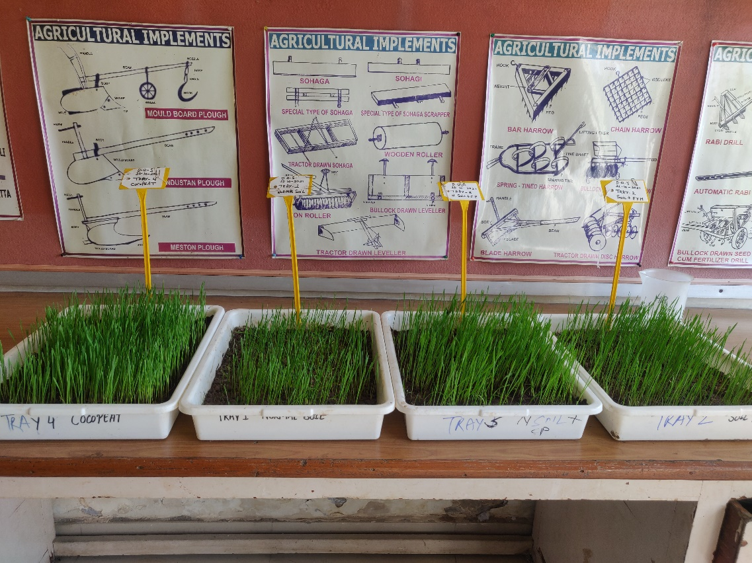
Fig. 1. Growth of wheatgrass under different growing media showing variation in plant vigor and biomass.
2.3 Extraction and estimation of total soluble proteins and chlorophyll content
Hundred milligrams of leaf tissue was suspended in 10 ml of 0.1 N NaOH by keeping the test tubes with water condenser for overnight in the refrigerator. The samples were centrifuged at 5000×g and the resulting supernatant was used to estimate total soluble proteins following the method of Lowry et al. (1951). To 100 µl of the protein sample, 2.5 ml of reagent C was added. The mixture was thoroughly combined and allowed to stand at room temperature for 10 minutes. Subsequently, 250 µl of reagent D was added and mixed quickly. After 30 minutes, the intensity of the blue color developed was measured at 520 nm. Total soluble proteins content was expressed as mg/g. Chlorophyll content was estimated by following the procedure of Hiscox and Israelstam (1979). Leaf tissue (200 mg) was homogenized with 5 ml dimethylsulphoxide in pestle and mortar. The homogenates were filtered and used for estimation of total chlorophyll content. The content was expressed as g/100g.
2.4 Extraction and estimation of Vitamin C, Total phenolics and total flavonoids
Vitamin C was extracted from 0.1 g of leaf tissue in 2 ml of 5% ice cold meta-phosphoric acid and centrifuged at 4°C (10,000 x g) for 10 minutes. The content was estimated by following the procedure of Law et al (1983) with minor modifications. The supernatant (0.4 ml), 0.4 ml EDTA, 0.8 ml TCA, 0.8 ml FeCl₃, 0.8 ml o-phosphoric acid and 0.8 ml bipyridyl were added in a test tube. The mixture was incubated at 40°C for 40 minutes and measured at 525 nm against the reagent blank. The concentration of ascorbic acid was expressed as mg/g. Total phenolics were extracted thrice in 5 ml 80% aqueous methanol and incubated at 60-80°C for one hour. The contents were filtered using Whatman filter paper no. 1. The total volume of the filtered extract was made to 10 ml with 80% methanol and was used in estimation of total phenols (Swain and Hillis 1959). The absorbance of the developed blue colour was noted at 760 nm against a reagent blank. The concentration of total phenols was expressed as mg/g. Total flavonoids were extracted from 200 mg of leaf tissue by using 6 ml distilled water. The extraction process involved placing the test tubes in a boiling water bath for 1 hour followed by filtration through Whatman No. 1 filter paper. The filtrate (3 ml) was taken in a separate test tube, to this 1.25 ml distilled water and 75 µl of 5% NaNO₂ were added. After 6 minutes, 150 µl of 10% AlCl₃.6H₂O was added in the test tubes. Following 5 minutes incubation at room temperature, 0.5 ml of 1M NaOH was added. The volume was adjusted to 2.5 ml and subsequently, the absorbance was recorded at 510 nm (Balabaa et al 1974). The content was expressed as mg/g.
2.5 Extraction and estimation of antinutritional factors
Total saponins were quantified following the method of Fenwick and Oakenfull (1983). Five hundred milligrams of leaf tissue were soaked overnight in 5 ml of acetone, after which the solvent was removed. The extraction process was repeated with methanol for 24 hours, and the volume was then adjusted to 12.5 ml with methanol. One milliliter of the methanolic extract was evaporated to dryness in a hot air oven. The residue was cooled to room temperature, 2 ml of ethyl acetate was added, and the mixture was well combined. Subsequently, 1 ml of reagent A and 1 ml of sulfuric acid were added. The mixture was kept at room temperature for 10 minutes, and the absorbance was read at 430 nm. The saponin content was expressed as mg/g. For tannin determination, 1 g of the sample was suspended in 40 ml of 10% methanol and boiled for 1-2 hours in a water bath. The volume was adjusted to 50 ml after filtration. A 1 ml aliquot was taken, diluted with distilled water to 8.5 ml, and 0.5 ml of Folin-Denis reagent was added. After 3 minutes, 1 ml of saturated sodium carbonate solution was added and mixed thoroughly. The mixture was kept at room temperature for 30 minutes, and the absorbance was measured at 760 nm, with the tannin content expressed as mg/g. Phytic acid was extracted and estimated using the method of Vaintraub and Lapteva (1988). Five hundred milligrams of leaf tissue were homogenized in 10 ml of 3.5% HCl. The homogenate was stirred for 1 hour using a magnetic stirrer and then centrifuged at 10,000×g at 10°C for 10 minutes to obtain the supernatant. A 1 ml aliquot was diluted with 2 ml of 3.5% HCl, and 1 ml of Wade’s reagent was added. The mixture was centrifuged again, and the absorbance was measured at 500 nm, with the phytic acid content expressed as mg/g.
2.6 Statistical analysis
Response surface methodology (RSM) utilizing a three-factor, three-level Box-Behnken design (BBD) was used to optimize parameters for efficient wheat grass production. The design included 15 experimental runs with each factor varying at three levels: -1 (low), 0 (medium), and 1 (high). Table 2 details the independent variables and their corresponding levels. The Minitab 17 statistical software (Minitab Inc.) was employed to create the mathematical model and perform regression analysis, ANOVA, and response surface analysis.
The second-order polynomial regression model was used to express the percent yield (Y) as a function of three independent variables as follows:
$$Y=β_{0}+\sum_{i=1}^{k}{β_{i}χ_{i}}+ \sum_{i=1}^{k}{β_{ii}}χ_{i}^{2}+\sum_{i=1}^{k}{\sum_{j=1}^{k}{β_{ij}χ_{i}}}χ_{j}+ ϵ$$
where Y - response; $β_{0}$ is a constant representing model intercept coefficient; $β_{i}$ is the first order (linear) main effect, $β_{ii}$ is the quadratic (squared) effect, $β_{ij}$ is the interaction effect, $χ_{i}$ and $χ_{j}$represents the coded independent variables, respectively and $ϵ$ is the random error which allows description of uncertainties between predicted and measured values. The fitness of the second order model was expressed by regression coefficients R² and determination of its statistical significance was done by F test. The significance of regression was evaluated using t Test.
Table 2. Independent variables and their levels for Box-behnken design
Independent variables | Level
Independent variables | -1 | 0 | 1
Composition of cocopeat (A) | 0 | 50 | 100
Seed rate (g) (B) | 40 | 80 | 150
Depth of filling (cm) (C) | 0 | 5 | 10

3. results and discussion
3.1 Optimization of wheat grass production using RSM-BBD
A mathematical model was created using RSM-BBD to predict the impact of main and interaction effects of independent variables on wheatgrass yield. The model was derived from experimental data and represented by a second-order polynomial equation incorporating linear, quadratic, and interaction terms (Table 3). These equations facilitated the construction of response surfaces to explore the relationship between independent variables and wheatgrass yield. ANOVA assessed the model's fit, the statistical significance of independent variables and their interactions, using metrics such as the coefficient of determination (R²), F-value, and p-value (Table 3). All p-values less than 0.001 and higher F-values indicated significant model performance. The R² and adjusted R² values, which were close to 1, confirmed that the quadratic model was highly effective in predicting wheatgrass production outcomes (Table 3).

Table 3. Regression coefficient and analysis of variance (ANOVA) for response surface polynomial model for production of wheatgrass
Terms | p value | F value
Model | 0.000 | 47.00
Linear | 0.000 | 134.30
A | 0.000 | 348.71
B | 0.002 | 34.21
C | 0.007 | 19.98
Square | 0.081 | 4.12
A*A | 0.189 | 2.31
B*B | 0.292 | 1.39
C*C | 0.025 | 10.01
Two-way interaction | 0.167 | 2.57
A*B | 0.349 | 1.07
A*C | 0.461 | 0.64
B*C | 0.058 | 6.01
R² | 0.988
Adjusted R² | 0.967
Quadratic equation | $$Yield=238.90+11.17*A+3.50*B-2.67*C-1.33*AA-1.03*BB-2.78*CC+0.87*AB-0.67*AC-2.07*BC$$

The impact of each parameter on wheatgrass yield or production was analyzed using three-dimensional response surface plots. These plots were generated by setting one variable at its zero level and varying the other two variables within the experimental range being studied. Fig. 2 shows interactive plots for the production of wheatgrass. The interaction effect of composition of cocopeat and seed rate in Fig. 2a showed that as composition of cocopeat and seed rate increases, the yield of wheatgrass increases which could be probably because cocopeat is known to enhance soil aeration and moisture retention, providing better conditions for wheatgrass growth. Along with, higher seed rates likely result in more plants per unit area increasing the overall yield. Fig. 2b represents the interaction plot of composition of cocopeat and depth of filling. The results indicated that increase in cocopeat composition improves soil conditions, enhancing plant growth and greater depth of filling can provide more space for root development, although the effect is less pronounced compared to the composition of cocopeat. In Fig. 2c, increasing the seed rate leads to a higher yield while yield initially increases with the depth of filling but then slightly decreases. The reason could be because higher seed rates result in more plants and thus higher yield. However, an optimal depth of filling is necessary; too shallow may not support root development well, and too deep could hinder seedling emergence.

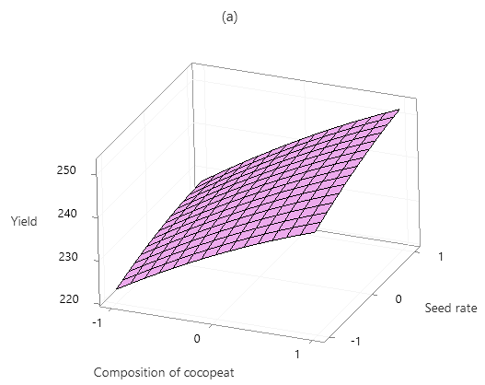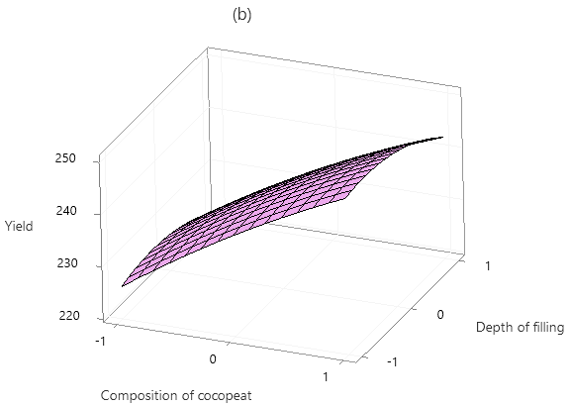
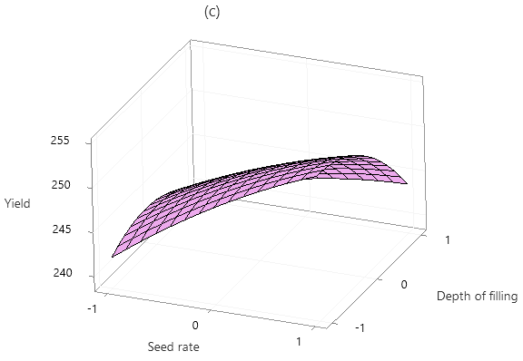
Fig. 2. Response surface plots showing different interaction effects for production of wheatgrass
The verification experiments were conducted under optimal conditions to assess the model's accuracy. Parity plots, shown in Fig. 3, compare experimental and predicted mean percent yields for wheatgrass production. The experimental yields closely matched the predicted values, with discrepancies between them being less than 10%. The parity plots demonstrated a strong correlation, as the data points were near the diagonal line (Fig. 3). Statistical analysis confirmed that the developed model was appropriate and dependable for identifying optimal conditions for wheatgrass production.
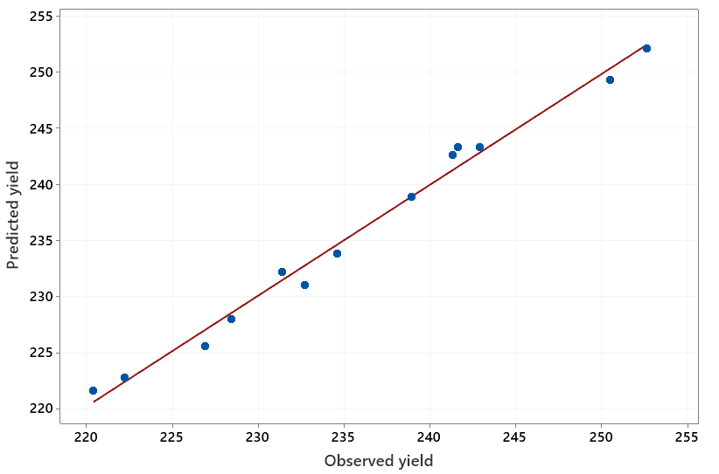
Fig. 3. Parity plot showing experimental and predicted values for production of wheatgrass
3.2 Yield, proximate, antioxidative and antinutritional analysis
The results in Table 4-7 revealed that wheatgrass grown in cocopeat media not only exhibited a significantly higher fresh weight but also demonstrated the fastest emergence compared to other growth media, including soil + cocopeat (50:50), soil + FYM (50:50) and 100% soil. Specifically, wheatgrass in cocopeat showed a 10.21% increase in fresh weight over that grown in 100% soil and the emergence occurred in just 3.2 days which was quickest among all tested media. This could be due to excellent moisture retention in cocopeat, combined with its superior drainage and aeration properties, creates an optimal environment for both seed germination and plant growth. The fine, loose structure of cocopeat reduces mechanical resistance, allowing seeds to emerge more quickly and roots to develop freely, resulting in faster growth and greater biomass accumulation (Tiong et al., 2024). Additionally, the neutral pH of cocopeat ensures that nutrients are readily available to the plants, promoting healthier and more vigorous growth. In contrast, soil and soil-based mixtures tend to have denser compositions, which can hinder both seed emergence and root development. These media are more prone to compaction and crust formation, leading to delayed emergence and potentially limiting nutrient uptake. The presence of organic matter in soil + FYM, while beneficial for long-term soil fertility, may introduce variability in moisture retention and microbial activity, further slowing down seedling emergence.
The proximate composition of wheat grass viz., moisture content, TSS, juice pH and total soluble proteins displayed significant variation in different growing media (Table 4; Table 7). The study revealed that wheatgrass grown in a soil+cocopeat mixture exhibited the highest moisture content (1.98%) compared to other growth media such as soil, soil+ FYM and cocopeat alone. This elevated moisture level was sustained for up to five months, highlighting the significant impact of cocopeat when combined with soil. Cocopeat has high water retention capacity, due to its fibrous and porous nature, enhances the overall water holding ability of the growth medium when mixed with soil (Atzori et al., 2021). Compared to soil alone, which often suffers from compaction and poor water retention and soil+FYM, which adds organic matter but not as much moisture retention, the soil+cocopeat mixture provides superior moisture sustainability. Initially, cocopeat-treated wheatgrass showed lower moisture content which may delay deterioration processes caused by microorganisms and chemical reactions, but from three to five months, its moisture content became comparable to that of soil treated wheatgrass. By the sixth month, cocopeat alone showed a noticeable decline in moisture content indicating that while cocopeat is effective, combining it with soil creates an optimal growth environment. This synergy results from soil’s structural support and nutrient profile complementing cocopeat’s moisture retention properties. The sustained high moisture content in the soil+cocopeat mixture supports better plant growth and resilience by ensuring a steady water supply, reducing water stress and improving overall plant health.
Total soluble solids were significantly higher in cocopeat treated plants as compared to other treatments during third and fourth months of growing period (Table 7). The content remained constant at 5.27 for two months in cocopeat treated wheatgrass. This trend can be attributed to cocopeat’s superior nutrient retention and release properties. Cocopeat, being an organic growing medium, has excellent cation exchange capacity which allows it to hold and slowly release nutrients thereby providing a consistent supply to the plants (Atzori et al., 2021). This steady nutrient availability could lead to higher levels of soluble solids in the plants. Additionally, the stable moisture content maintained by cocopeat ensures that plants are not subjected to water stress, which can negatively impact nutrient uptake and overall plant metabolism. The constant soluble solid content observed in cocopeat treated wheatgrass further indicates that cocopeat provides a balanced and sustained nutrient environment, promoting healthy growth and metabolic activity. This consistency in nutrient availability and moisture content creates optimal conditions for the accumulation of soluble solids explaining the observed results.
Table 4. Fresh weight and moisture content of wheatgrass under different growing media
Treatments | Fresh weight (g/m²) |  |  |  |  |  |  | Moisture content (%)
Treatments | Oct 2021 | Nov 2021 | Dec 2021 | June  2022 | July  2022 | Aug 2022 | Mean | Oct 2021 | Nov 2021 | Dec 2021 | June  2022 | July  2022 | Aug 2022
Soil | 228.6 | 238.5 | 225.3 | 235.1 | 220.4 | 233.6 | 230.3 | 81.6 | 82.3 | 80.2 | 82.9 | 80.8 | 81.9
Soil + FYM | 238.9 | 243.5 | 240.3 | 237.9 | 232.6 | 233.5 | 237.8 | 81.7 | 80.1 | 80.9 | 81.5 | 80.5 | 82.0
Soil + cocopeat | 246.6 | 242.6 | 240.8 | 243.9 | 246.3 | 245.8 | 244.3 | 85.1 | 83.6 | 82.4 | 83.3 | 85.7 | 84.4
Cocopeat | 265.6 | 252.7 | 247.4 | 258.6 | 257.6 | 250.6 | 255.4 | 87.2 | 86.9 | 87.3 | 88.8 | 89.2 | 88.1
CD (p=0.05) | 3.5 | 4.3 | 2.7 | 3.6 | 3.8 | 3.2 | 4.2 | 2.0 | 2.5 | 1.8 | 1.5 | 2.3 | 1.8

Table 5. Days taken to emergence of wheatgrass under different growing media
Treatments  (growing media) | Days taken to emergence
Treatments  (growing media) | October 2021 | November 2021 | December 2021 | June  2022 | July  2022 | August 2022 | Mean
Soil | 5.0 | 4.0 | 5.0 | 5.0 | 6.0 | 5.0 | 5.0
Soil + FYM | 4.0 | 4.0 | 3.0 | 5.0 | 5.0 | 5.0 | 4.3
Soil + cocopeat | 3.0 | 4.0 | 3.0 | 4.0 | 4.0 | 5.0 | 3.8
Cocopeat | 3.0 | 2.0 | 3.0 | 4.0 | 4.0 | 3.0 | 3.2
CD (p=0.05) | 0.8 | 1.1 | 0.9 | 0.8 | 1.2 | 0.5 | 0.7

Table 6. Days taken to harvestable height (10-15 cm) of wheatgrass under different growing media
Treatments  (growing media) | Days taken to harvestable height (10-15 cm)
Treatments  (growing media) | October 2021 | November 2021 | December 2021 | June  2022 | July  2022 | August 2022 | Mean
Soil | 10 | 10 | 10 | 10 | 11 | 11 | 10.3
Soil + FYM | 10 | 09 | 09 | 11 | 11 | 10 | 10.0
Soil + cocopeat | 09 | 08 | 09 | 10 | 09 | 10 | 9.2
Cocopeat | 07 | 07 | 08 | 08 | 09 | 08 | 7.8
CD (p=0.05) | 0.5 | 0.5 | 0.4 | 0.5 | 0.6 | 0.5 | 0.5
Table 7. Bioactive components and antioxidant activity of wheatgrass juice under different growing media (Pooled mean)
Bioactive compounds | Treatments (growing media)
Bioactive compounds | Soil | Soil + FYM | Soil + cocopeat | Cocopeat | CD (p=0.05)
TSS of Juice (ºBrix) | 5.0 | 4.8 | 5.0 | 5.2 | NS
pH of Juice | 6.7 | 7.2 | 7.3 | 6.8 | 0.1
Total soluble protein (g/100g) | 26.8 | 25.2 | 27.1 | 29.2 | 1.5
Total chlorophyll (g/100g) | 2.4 | 2.2 | 2.4 | 2.8 | 0.2
Vitamin C (mg/100g) | 4.0 | 4.9 | 5.8 | 6.8 | 0.5
Phenolics (mg/g) GAE | 12.5 | 12.6 | 13.3 | 16.8 | 0.8
Carotenoids (mg/g) | 3.6 | 3.7 | 3.7 | 3.9 | 0.4
Tannins (mg/100g) | 6.3 | 6.3 | 6.3 | 6.2 | NS
Phytic acid (mg/100g) | 3.0 | 3.0 | 3.0 | 2.9 | NS
Saponins (g/100g) | 1.0 | 1.0 | 1.0 | 1.1 | NS
Antioxidant activity (%) | 45.2 | 45.4 | 45.6 | 45.9 | NS

The pH of wheatgrass varied from slightly acidic to slightly alkaline, depending on the treatment. Wheatgrass grown in cocopeat and soil exhibited a slightly acidic pH while those grown in soil+FYM and soil+cocopeat had a slightly alkaline pH (Table 7). The slightly acidic pH in cocopeat and soil treated plants can be likely attributed to the high content of secondary metabolites such as phenolic acids and tannins, which are known to contribute to acidity (Atzori et al., 2021). The presence of phenolic acids and tannins in cocopeat and soil treated wheatgrass suggested that these growing media may enhance the production or retention of these compounds. Phenolic acids and tannins are important for plant defense and can influence the plant’s overall metabolic profile. Their higher concentrations in the juice could be due to the specific nutrient profiles and microbial interactions in cocopeat and soil, which may promote the synthesis of these metabolites. In contrast, the slightly alkaline pH observed in soil+FYM and soil+cocopeat treatments might be due to the buffering capacity provided by the organic amendments like FYM. FYM typically contains calcium and magnesium carbonates, which can neutralize acidity and lead to a more alkaline pH. The combination of soil with cocopeat and FYM likely creates a more balanced nutrient environment, reducing the overall acidity of the plant juice.

Total soluble proteins were highest in cocopeat treated wheatgrass during third (29.58g/100g) and fourth (29.12 g/100g) months of growing period (Table 7). This elevated protein content can be attributed to the unique properties of cocopeat as a growing medium. Cocopeat’s high water retention and aeration capabilities create an optimal environment for root growth and nutrient uptake. The consistent moisture availability prevents water stress which can adversely affect protein synthesis in plants. Additionally, cocopeat has the ability to maintain a balanced supply of nutrients over time supports sustained metabolic activity, which is crucial for protein production (Tiong et al., 2024). The peak in soluble protein content during the third and fourth months suggests that these are critical periods for protein accumulation in wheatgrass. During these months, the plants are likely experiencing a phase of rapid growth and metabolic activity, necessitating higher protein synthesis for cellular functions and development. The stability of protein content during this period indicates that cocopeat provides a reliable nutrient environment that supports continuous protein production without significant fluctuations.
Cocopeat-treated wheatgrass consistently maintained high chlorophyll content (2.51-2.99 g/100g) over six months. This stable chlorophyll level indicates a robust photosynthetic capacity, likely due to the optimal water retention and aeration properties of cocopeat, which support healthy root development and nutrient uptake. This prolonged chlorophyll retention is crucial for sustained plant growth and vitality.
Cocopeat-treated wheatgrass exhibited the highest levels of vitamin C, total phenolics and flavonoids, averaging 6.75 mg/100g, 16.83 mg/g, and 14.05 mg/g, respectively, throughout the six-month period (Table 7). This superior performance in antioxidative components underscores the potential of cocopeat as a growth medium that enhances the nutritional quality of wheatgrass. High vitamin C content, an essential water-soluble vitamin known for its antioxidative properties, suggests that wheatgrass grown in cocopeat can be an excellent source of this nutrient (Tiong et al., 2024). Given that humans cannot synthesize vitamin C and must obtain it from their diet, the consistent high levels in cocopeat-treated wheatgrass make it a valuable dietary source. Vitamin C helps scavenge reactive oxygen species (ROS), protecting cells from oxidative damage and supporting overall health. The elevated total phenolic and flavonoid contents in cocopeat-treated wheatgrass highlight its enhanced capacity to regulate defensive metabolism. Phenolic compounds act as substrates for antioxidative enzymes like peroxidase and polyphenol oxidase, which counteract ROS's harmful effects. Additionally, these compounds directly scavenge ROS, protecting vital cellular components such as DNA, lipids, and proteins from oxidative damage. This antioxidative potential makes cocopeat-treated wheatgrass an excellent source of phytochemicals and nutrients that support cellular health and overall well-being.
No significant alterations in antinutritional attributes such as tannins, phytic acid, and saponins were observed among the different treatments (Table 7). This indicates that while cocopeat enhances beneficial compounds, it does not increase undesirable antinutritional factors, maintaining the overall quality of the wheatgrass.
Taken together, the findings from this research indicated that cocopeat-treated wheatgrass not only sustains high chlorophyll and protein content but also enriches antioxidative components like vitamin C, phenolics, and flavonoids. This makes it a superior choice for producing nutrient-dense wheatgrass, providing essential vitamins, proteins, and antioxidants. The consistency in these beneficial attributes over six months underscores effectiveness of cocopeat as a growth medium, offering a reliable and enriched source of nutrients for human consumption. Future studies could further explore the mechanisms by which cocopeat influences these biochemical constituents and evaluate its impact on other plant species and growth conditions to optimize its use in sustainable agriculture.

4. Conclusion

Based on high R² values, low p values and higher F-values obtained using box-behnken designs, model demonstrated a good fit and effectively identified the optimal growing conditions. Wheatgrass grown in cocopeat demonstrated a significantly higher fresh weight, with a 10.21% increase over soil (100%) treatment and the fastest emergence time (3.2 days). Analysis of wheatgrass juice showed no significant variation in total soluble sugars among treatments, while juice from soil and cocopeat-treated wheatgrass had a slightly acidic pH and soil + FYM and soil + cocopeat treatments had a neutral pH. Cocopeat-treated wheatgrass also had the highest total soluble proteins (25.2-29.2 g/100g) and total chlorophyll content (2.8 g/100g). Additionally, vitamin C, phenolics, and carotenoids were most abundant in wheatgrass grown in cocopeat, with no significant differences in antinutritional factors (tannins, phytic acid, and saponins) across treatments. The study concludes that cocopeat significantly enhances the nutritional quality of wheatgrass juice by increasing the content of non-enzymatic antioxidants, making it an excellent choice for health-conscious consumers and potentially boosting its commercial value in the health food market. These findings can serve as a basis for future research on optimizing growing media for other functional crops and provide practical guidelines for farmers, urban growers, and the health food industry to adopt resource-efficient and sustainable wheatgrass cultivation practices.

COMPETING INTERESTS DISCLAIMER:
Authors have declared that they have no known competing financial interests that could have appeared to influence the work reported in this paper.
DISCLAIMER (ARTIFICIAL INTELLIGENCE)
Author(s) hereby declares that NO generative AI technologies such as Large Language Models (ChatGPT, COPILOT, etc.) and text-to-image generators have been used during the writing or editing of this manuscript.
References

Afroz, R. D., Nurunnabi, A. S. M., Hossain, M. Z., Kham, M. I., Parvin, S., & Rahman, H. (2012). Study on effects of wheatgrass (Triticum aestivum) juice on serum triglyceride of experimentally induced hypercholestroleamic male long Evans rats. Journal of Dhaka Medical College, 21, 197–203.
Alitheen, N., Oon, C. L., Keong, Y. P., Chuan, T. K., Li, H. K., & Yong, H. W. (2011). Cytotoxic effects of commercial wheatgrass and fibre towards human acute promyelocytic leukemia cells (HL60). Pakistan Journal of Pharmaceutical Sciences, 24(3), 243–250.
AOAC. (2010). Official methods of analysis of Association of Official Analytical Chemists (18th ed.). Washington, DC: AOAC International.
Atzori, G., Pane, C., Zaccardelli, M., Cacini, S., & Massa, D. (2021). The role of peat-free organic substrates in the sustainable management of soilless cultivations. Agronomy, 11(6), 1236–1253.
Balabaa, S. I., Zaki, A. Y., & ElShamy, A. M. (1974). Total flavonoids and rutin content of the different organs of Sophora japonica L. Journal of the Association of Official Analytical Chemists, 57, 752–755.
Barro, R., Cortés, R., Pérez, J., Ciria, C. S., Fernández, M., & Ciria, P. (2022). Nitrogen fertilisation and harvest time on biomass production and composition of tall wheatgrass in Mediterranean marginal conditions. Biomass and Bioenergy, 158, 106382.
Boakye, P. G., Okyere, A. Y., Kougblenou, I., Kowalski, R., Ismail, B. P., & Annor, G. A. (2022). Optimizing the extrusion conditions for the production of expanded intermediate wheatgrass (Thinopyrum intermedium) products. Journal of Food Science, 87(8), 3496–3512.
Chauhan, M. (2014). A pilot study on wheat grass juice for its phytochemical, nutritional and therapeutic potential on chronic diseases. International Journal of Chemical Studies, 2(4), 27–34.
Chawla, P., Kaur, D., Sunaina, Kaur, G., Shah, G., Chawla, A., & Dhawan, R. K. (2015). Wheat grass: A review on pharmacognosy and pharmacological aspects. International Journal of Phytopharmacology, 6(2), 80–85.
Desai, T. R., & Goyal, R. K. (2005). Investigation into the mechanism of action and effects of Triticum aestivum (wheat) grass. Agronomy, 67, 56–67.
Fahey, J. W., Stephenson, K. K., Dinkova-Kostova, A. T., Egner, P. A., Kensler, T. W., & Talalay, P. (2005). Chlorophyll, chlorophyllin and related tetrapyrroles are significant inducers of mammalian phase 2 cytoprotective genes. Carcinogenesis, 26, 1247–1255.
Fenwick, D. E., & Oakenfull, D. (1983). Saponin content of food plants and some prepared foods. Journal of the Science of Food and Agriculture, 34, 186–191.
Hiscox, J. D., & Israelstam, G. F. (1979). A method for extraction of chlorophyll from leaf tissue without maceration. Canadian Journal of Botany, 57, 1332–1334.
Hunter, M. C., Sheaffer, C. C., Culman, S. W., & Jungers, J. M. (2020). Effects of defoliation and row spacing on intermediate wheatgrass I: Grain production. Agronomy Journal, 112(3), 1748–1763.
Jain, G., & Argal, A. (2014). Pharmacognostic and phytochemical investigation of young leaves of Triticum aestivum Linn. International Current Pharmaceutical Journal, 3, 280–285.
Kaur, N., Singh, B., Kaur, A., Yadav, M. P., Singh, N., Ahlawat, A. K., & Singh, A. M. (2021). Effect of growing conditions on proximate, mineral, amino acid, phenolic composition and antioxidant properties of wheatgrass from different wheat (Triticum aestivum L.) varieties. Food Chemistry, 341, 128201.
Kumar, N. S., Murali, M., Nair, A. M., & Nair, A. S. (2016). Green blood therapy of wheatgrass – Nature’s finest medicine: A literature review. IOSR Journal of Pharmacy and Biological Sciences, 11, 57–64.
Kumari, S., Singhal, A., Singh, R. R., Kumar, S., & Rajendran, N. (2012). Wheatgrass: An alternative household nutritional food security. International Research Journal of Pharmacy, 3(7), 246–250.
Lalsolanki, M. S. J. K., & Bhaidpatel, L. (2015). Clinical efficiency evaluation of wheat grass tablets as supportive treatment in leukaemia patients. Research Journal of Pharmaceutical, Biological and Chemical Sciences, 6(4), 1450–1454.
Loh, J., Green, R. E., Ricketts, T., Lamoreux, J., Jenkins, M., Kapos, V., & Randers, J. (2005). The Living Planet Index: Using species population time series to track trends in biodiversity. Philosophical Transactions of the Royal Society B, 360, 289–295.
Lowry, O. H., Rosebrough, N. J., Farr, A. L., & Randall, R. J. (1951). Protein measurement with the folin phenol reagent. Journal of Biological Chemistry, 193, 265–275.
Mathur, S., Mathur, R., & Kohli, G. K. (2017). Therapeutic use of wheat grass juice for the treatment of anemia in young women of Ajmer city (Rajasthan, India). International Journal of Nutrition Sciences, 2(1), 1014–1024.
Mistry, D., Patel, R., Sengar, S. H., & Tarsariya, J. (2025). Growing of Tender Wheatgrass Under Pyramid Type Solar Structure and Comparative Evaluation of Tray and Solar Tunnel Drying Methods for Powder Production. Journal of Experimental Agriculture International, 47(5), 456-465.
Mujoriya, R. (2011). A study on wheat grass and its nutritive value. Food Science Quality Management, 2, 1–8.
Mujoriya, R., & Bodla, R. B. (2011). A study on wheatgrass and its nutritional value. Food Science Quality Management, 2, 1–8.
Pannu, J. S., & Kapoor, R. K. (2014). “The green blood” wheatgrass juice, a health tonic having antibacterial potential. World Journal of Pharmaceutical Research, 4(3), 46–54.
Rai, A. K., Sakhare, P. Z., & Suresh, P. V. (2009). Optimization of acid hydrolysis conditions of delimed tannery by response surface methodology. Journal of Scientific and Industrial Research, 68, 967–974.
Rana, S., Kamboj, J., & Gandhi, V. (2011). Living life the natural way – Wheatgrass and health. Functional Foods in Health and Disease, 1(1), 444–456.
Shah, K., Tirgar, P., & Sheth, D. (2011). Anti-ulcer activity of Triticum aestivum on ethanol induced mucosal damage in Wistar rats. Pharmacologyonline, 2, 929–935.
Sharma, M. R., Nair, T. A., Harak, S. S., Patil, D. T., & Shelke, P. S. (2016). Wheat grass juice – Nature’s powerful medicine. World Journal of Pharmacy and Pharmaceutical Sciences, 5(7), 384–391.
Sundaresan, A., Selvi, A., & Manonmani, H. K. (2015). The anti-microbial properties of Triticum aestivum (Wheat Grass) extract. International Journal of Biotechnology and Wellness Industries, 4(3), 84–91.
Swain, T., & Hillis, W. E. (1959). The phenolic constituents of Prunus domestica I-The quantitative analysis of phenolic constituents. Journal of the Science of Food and Agriculture, 10, 63–68.
Tiong, Y. W., Sharma, P., Xu, S., Bu, J., An, S., Foo, J. B. L., Wee, B. K., Wang, Y., Lee, J. T. E., Zhang, J., He, Y. (2024). Enhancing sustainable crop cultivation: The impact of renewable soil amendments and digestate fertilizer on crop growth and nutrient composition. Environmental Pollution, 342, 123132.
Vaintraub, I. A., & Lapteva, N. A. (1988). Colorimetric determination of phytate in unpurified extracts of seeds and the products of their processing. Analytical Biochemistry, 175, 227–230.
Virdi, A. S., Singh, N., Bains, K. K., & Kaur, A. (2021). Effect of photoperiod and growth media on yield and antioxidant properties of wheatgrass juice of Indian wheat varieties. Journal of Food Science and Technology, 58(8), 3019-3029.
Waldron, B. L., Robins, J. G., Jensen, K. B., Palazzo, A. J., Cary, T. J., & Berdahl, J. D. (2006). Population and environmental effects on seed production, germination, and seedling vigor in western wheatgrass (Pascopyrum smithii [Rydb.] A. Löve). Crop Science, 46(6), 2503–2508.

