Original Research Article
Fungal biopriming: Ophiocordyceps neovolkiana mycelial extract enhances rice (Oryza sativa L) seed germination
ABSTRACT
Rice (Oryza sativa L.) is an important global staple, with promising germination being a pivotal factor for optimum yield and crop establishment. This study investigated the potential of Ophiocordyceps neovolkiana, an entomopathogenic fungus native to Kerala, as a novel biopriming agent to increase rice seed germination. Rice seeds of the Jyothi variety were sterilized and bioprimed by soaking in mycelial extract of O. neovolkiana for 30 minutes. Percent germination was observed over one week. Results demonstrated a significant increase in germination percentage for seeds treated with the mycelial extract (94%) compared to both the solvent control (79%) and the absolute control (80%). Furthermore, the mycelial extract treatment induced earlier germination (3.25 days) compared to the solvent control (5 days) and the absolute control (4.75 days). These findings align with existing research on various microbial biopriming agents that enhance seed vigor and early seedling development. This study provides convincing evidence that O. neovolkiana mycelial extract is a promising biological tool for improving rice seed germination, offering a sustainable method to boost crop establishment and productivity.
KEY WORDS: Rice, Biopriming, Germination, Ophiocordyceps neovolkiana
INTRODUCTION
Cordyceps, a genus of parasitic fungi, has been used in traditional Chinese medicine for centuries. Well-known species like Ophiocordyceps sinensis and Cordyceps militaris are recognized for their diverse medicinal properties, including antiviral, antifungal, antibacterial, anticancer, and immunomodulatory actions. Beyond medicinal values, the non-pathogenic efficiency of this entomopathogen is also reported. Several studies have documented the endophytic nature of Ophiocordyceps (Evans et al., 2011; Gazis et al., 2014; Wang et al., 2020; Saltamachia and Araujo, 2020). Seed treatment with Cordyceps fumosorosea on brinjal seeds significantly improved plant growth and reduced the incidence of the sucking pest Bemisia tabaci (Sun et al., 2020). Ophiocordyceps neovolkiana, a species endemic to the Kasaragod district of Kerala, India, parasitizes coconut root grubs (Leucopholis coneophora Burm.). The comprehensive characterization of O. neovolkiana, including its morphology, physiology, and molecular characteristics, has been previously documented (Laya, 2018). This study investigates the impact of O. neovolkiana mycelial extract on the germination of 'Jyothi', a prominent rice variety cultivated in Kerala. Rice is a globally significant crop, with approximately 163.1 million hectares cultivated worldwide, yielding 520.5 million metric tons at an average of 4.00 tons per hectare (FAO, 2023). Asia dominates both global rice production and consumption. Achieving rapid and uniform seed germination and seedling emergence is crucial for optimizing rice yield and quality. Poor germination and seedling uniformity can severely reduce production. High-vigor seeds, characterized by uniform and rapid germination, are essential for robust seedling growth, enhanced tolerance to adverse conditions, and ultimately, higher yields. The initial stages of plant development are foundational for the entire crop cycle. Uniform germination promotes more effective competition with weeds and optimizes resource utilization, including light, water, and nutrients (Joshi et al., 2013; Dass et al., 2017). Furthermore, a strong start during germination minimizes the incidence of pests and diseases, fostering healthier plants and increasing yield potential (Chithrashree et al., 2011; Pal et al., 2021; Xu et al., 2023 ). Efficient germination is particularly vital in direct-sown rice systems, where planting depth control is limited (Farooq et al., 2009). Studies indicate that rice cultivars with superior germination rates often exhibit higher yields due to the development of robust root systems that support growth and nutrient uptake throughout the crop cycle (Yang et al., 2022; Zhang et al., 2023). Moreover, enhanced germination efficiency reduces seed usage, thereby offering economic advantages to farmers and supporting environmentally sustainable agricultural systems. Thus, achieving a high germination rate is a critical determinant for successful rice growth and productivity.
MATERIALS AND METHODS
Isolation and culturing of the fungus
Isolation of the fungus was carried out from the stroma of a fresh fruiting body by following standard tissue culture technique. The sample was washed under running tap water and cut into small pieces, then disinfected with 1% sodium hypochlorite solution for one minute. After three washings using sterilized distilled water, the tissue bits were placed aseptically on solidified potato dextrose agar (PDA) medium in sterile Petri dishes under a laminar airflow chamber. All dishes were incubated at room temperature (28 ± 2⁰C) and observed from the next day onwards. The fungal growth obtained was subsequently subcultured to Yeast Extract Potato Fructose broth (Laya, 2018).
Mycelial extract preparation
After complete growth, the mycelium was harvested from the growing medium and freeze-dried. The dried sample was then extracted by stirring with methanol (40 ml methanol/1g sample) for 1 hour in a magnetic stirrer and subsequently filtered through Whatman No. 1 filter paper. The residue was then extracted again with methanol (20 ml methanol/1g sample) for 1 hour by following the same procedure. The combined methanolic extract was evaporated to dryness at 40°C in a rotary evaporator and re-suspended in sterile distilled water (Reis et al., 2013).
Biopriming
Rice seeds (100 grains per treatment) were surface sterilized with 1% sodium hypochlorite solution for two minutes, followed by three rinses with sterile distilled water. Subsequently, 25 sterile seeds were placed into each of four replicate Petri plates and soaked in 20 mL of the mycelial extract for 30 minutes (Purwanto et al., 2020). These treated seeds were then transferred to Petri plates lined with double-layered moist cotton, which were then covered with an upper lid containing moist blotter paper. For comparative analysis, a solvent control (treated with methanol) and an absolute control (treated with sterile distilled water) were maintained (Figure 1). All setups were incubated for one week in a plant growth chamber under optimum temperature and relative humidity. Seed germination was then assessed across all treatments.
RESULTS AND DISCUSSION
There was a significant increase in percent germination in the mycelial extract treatment (94%) compared to the solvent control (79%) and absolute control (80%) (Figure 2, Table 1, Graph 1). It was also observed that there was an induction of early germination in the mycelial extract treatment (3.25 days) compared to the solvent control (5 days) and absolute control (4.75 days) (Table 2, Graph 2). Data were subjected to analysis of variance (ANOVA) using the statistical package GRAPES (General R-based Analysis Platform for Experimental Statistics) developed by the Department of Agricultural Statistics, Kerala Agricultural University (Gopinath et al., 2020).
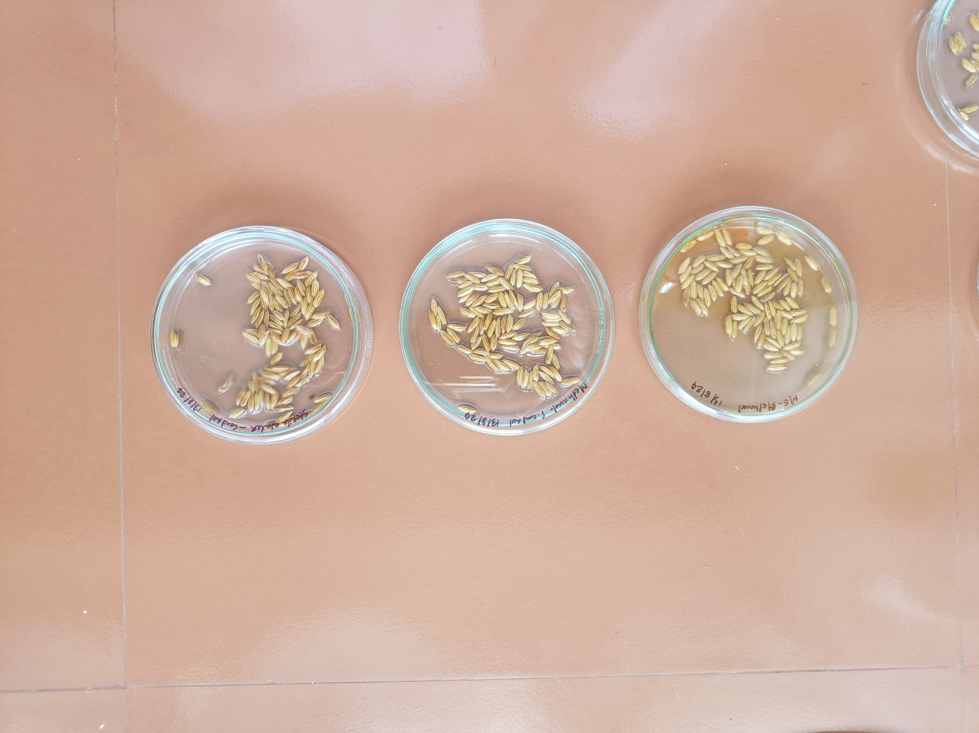
Solvent control (Methanol treated)
Mycelial extract treated
Absolute control (Sterile distilled water treated)

Figure 1: Rice seeds treated with mycelial extract, methanol and distilled water

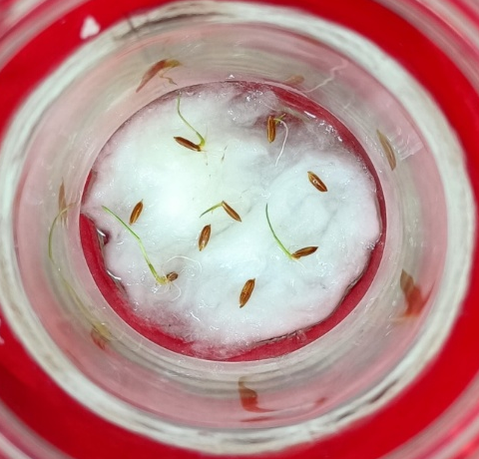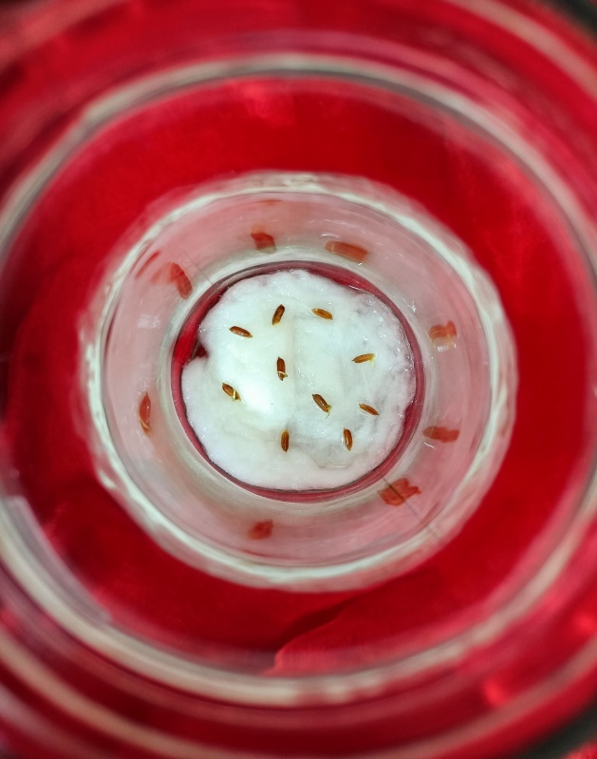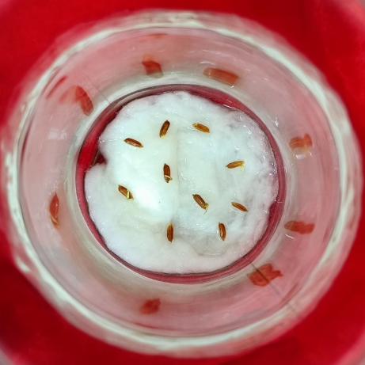
Absolute control (Sterile distilled water treated)

Mycelial extract treated
Solvent control (Methanol treated)
Figure 2: Germinated rice seeds in different treatments

Treatments | Per cent germination±SD
Mycelial extract treated | 94±2.31ª
Solvent control | 79±8.64^{b}
Absolute control | 80±10.00^{b}
CD | 12.39
SE(m) | 3.87
Graph 1: Per cent germination in different treatments

Table 1: Per cent germination in different treatments (mean of four replications, figures followed by same
letter do not differ significantly according to LSD test, p-value is 0.04, since this is less than 0.05, there is a significant difference between at least one pair of treatments.)

Treatments | Days to germination±SD
Mycelial extract treated | 3.25±0.50^{b}
Solvent control | 5±0.50ª
Absolute control | 4.75±0.82ª
CD | 1.00
SE(m) | 0.31
Table 2: Days to germination in different treatments (mean of four replications, figures followed by same
letter do not differ significantly according to LSD test, p-value is 0.007, since this is less than 0.05, there is a significant difference between at least one pair of treatments)

Graph 2: Days to germination in different treatments

The positive outcomes observed in the present study regarding the effect of O. neovolkiana mycelial extract on rice germination are well-supported by and align with a growing body of research demonstrating the efficacy of biological priming agents in enhancing seed performance. Similar to the significant improvements in seed germination rates, growth parameters, and root traits reported with Bacillus megaterium 3456789 by Vaishnavi et al. (2024), Li et al. (2025) reported that multiple plant growth-promoting fungi, such as Aspergillus tubingensis, A. brunneoviolaceus, several Penicillium species, and Talaromyces purpureogenus isolated from converted non-grain land, substantially enhanced rice seedling height, root development, and fresh/dry biomass. These enhancements were achieved through mechanisms including phosphate solubilization, siderophore production, and IAA synthesis. The O. neovolkiana extract likely promotes initial seed development and overall seedling vigor through similar mechanisms. This aligns with findings on liquid microbial cultures in paddy by Raja et al. (2017), which also showed enhanced and more uniform germination rates, even under suboptimal conditions, suggesting a broad resilience-improving effect that the O. neovolkiana extract might also confer. The effectiveness of specific microbial isolates, such as the superior performance of Trichoderma harzianum WAI-D in improving germination and vigor in rice, provides a precedent for the study on targeted benefits of particular fungal extracts by Devi et al. (2019), indicating that O. neovolkiana could similarly possess unique beneficial properties. Furthermore, the enhanced photosynthetic efficiency and increased antioxidant activity seen with yeast extract priming in rice done by Johnson and Puthur (2021), which led to reduced oxidative stress and improved stress adaptation, suggest that the O. neovolkiana extract might also induce beneficial physiological and biochemical changes within the germinating seeds. This concept is further reinforced by the general understanding that beneficial microorganisms, as discussed in a review on various crops by Cardarelli (2022), improve nutrient uptake and plant resilience to abiotic stress, contributing to overall better plant growth, a benefit likely shared by the O. neovolkiana treatment. The remarkable increases in dry weight, fresh weight, and root length observed with plant endophyte extracts on rice seedlings in the study by Wang (2014) underscore the potential for substantial growth promotion beyond just germination, a broader impact that future studies on O. neovolkiana could investigate. Moreover, just as in the study conducted by Makhaye (2021) on biopriming with seaweed extract and microbial-based biostimulants influenced various germination parameters in Abelmoschus esculentus, the O. neovolkiana extract likely optimizes the timing and success rate of germination. The study on mycorrhizal fungi in curly chili carried out by Meo (2024), which improved germination quality and vigor, further highlights the diverse fungal agents capable of enhancing early plant establishment. Finally the improved seedling establishment and yield from seed priming combined with Trichoderma application in Boro rice by Rahman (2015), and significant enhancements in germination speed, root/shoot growth, dry matter production, and vigor index achieved by biopriming rice seeds with phosphobacteria by Sivakumar (2017), and, noticeable enhancements in rice growth metrics on biopriming using rhizobacteria (e.g., Bacillus altitudinis, Herbaspirillum huttiense, Pseudomonas mohnii) by Ishaq et al. (2025) collectively provide strong evidence that the positive results from the O. neovolkiana mycelial extract represent a promising avenue for sustainable agricultural practices aimed at improving rice crop performance.
CONCLUSION
The application of O. neovolkiana mycelial extract significantly enhances rice seed germination, leading to both a higher percentage of germination and an induction of early sprouting compared to control groups. These positive results align comprehensively with a growing body of scientific literature that demonstrates the efficacy of various biological priming agents in improving seed vigor and seedling establishment across different crops. The observed improvements in germination, root and shoot development, and overall plant health in these comparative studies suggest that O. neovolkiana mycelial extract holds considerable promise as a novel biostimulant for rice. This research underscores the potential for sustainable agricultural practices, offering an eco-friendly alternative to conventional methods for improving rice productivity and ensuring robust crop establishment, which is crucial for global food security. Further investigation into the specific mechanisms of action and optimal application strategies for O. neovolkiana mycelial extract could pave the way for its broader adoption in rice cultivation.
COMPETING INTERESTS DISCLAIMER
Authors have declared that they have no known competing financial interests or non-financial interests or personal relationships that could have appeared to influence the work reported in this paper.
DISCLAIMER (ARTIFICIAL INTELLIGENCE)
Author(s) hereby declares that no generative AI technologies such as Large Language Models (ChatGPT, COPILOT, etc.) and text-to-image generators have been used during the writing or editing of this manuscript.
ACKNOWLEDGEMENTS
Authors are grateful to Kerala Agricultural University, Thrissur, Kerala, India for providing facilities to carry out this study in the Department of Plant Pathology, College of Agriculture, Vellanikkara, Thrissur, Kerala, India.
REFERENCES
- Evans, H. C., Elliot, S. L., & Hughes, D. P. (2011). Ophiocordyceps unilateralis: A keystone species for unraveling ecosystem functioning and biodiversity of fungi in tropical forests? Communicative & Integrative Biology, 4(5), 598–602. https://doi.org/10.4161/cib.16721
- Gazis, R., Skaltsas, D., & Chaverri, P. (2014). Novel endophytic lineages of Tolypocladium provide new insights into the ecology and evolution of Cordyceps-like fungi. Mycologia, 106(6), 1090–1105. https://doi.org/10.3852/13-346
- Wang, Z., Li, M., Ju, W., Ye, W., Xue, L., Boufford, D.E., Gao, X., Yue, B., Liu, Y. and Pierce, N.E. (2020). The entomophagous caterpillar fungus Ophiocordyceps sinensis is consumed by its lepidopteran host as a plant endophyte. Fungal Ecology, 47, p.100989.
- Saltamachia, S. J., & Araújo, J. P. M. (2020). Ophiocordyceps desmidiospora, a basal lineage within the “Zombie-Ant Fungi” clade. Mycologia, 112(6), 1171–1183. https://doi.org/10.1080/00275514.2020.1732147
- Sun, T., Shen, Z., Shaukat, M., Du, C., & Ali, S. (2020). Endophytic isolates of Cordyceps fumosorosea to enhance the growth of Solanum melongena and reduce the survival of whitefly (Bemisia tabaci). Insects, 11(2). https://doi.org/10.3390/insects11020078
- Laya, P. K. (2018). Characterization of medicinal mushroom, Cordyceps sp. from Kasargod district M.Sc. (Ag) thesis, Kerala Agricultural University, Thrissur, 94p.
- FAO. (2025). Land statistics 2001–2023 – Global, regional and country trends. FAOSTAT Analytical Briefs, No.107. Rome.
- Joshi, E., Kumar, D., Lal, B., Nepalia, V., Gautam, P. and Vyas, A.K. (2013). Management of direct seeded rice for enhanced resource-use efficiency. Plant Knowledge Journal, 2(3), pp.119-134.
- Dass, A., Shekhawat, K., Choudhary, A. K., Sepat, S., Rathore, S. S., Mahajan, G., & Chauhan, B. S. (2017). Weed management in rice using crop competition-a review. In Crop Protection (Vol. 95, pp. 45–52). Elsevier Ltd. https://doi.org/10.1016/j.cropro.2016.08.005
- Chithrashree, Udayashankar, A. C., Chandra Nayaka, S., Reddy, M. S., & Srinivas, C. (2011). Plant growth-promoting rhizobacteria mediate induced systemic resistance in rice against bacterial leaf blight caused by Xanthomonas oryzae pv. oryzae. Biological Control, 59(2), 114–122. https://doi.org/10.1016/j.biocontrol.2011.06.010
- Pal, G., Mehta, D., Singh, S., Magal, K., Gupta, S., Jha, G., Bajaj, A., & Ramu, V. S. (2021). Foliar Application or Seed Priming of Cholic Acid-Glycine Conjugates can Mitigate/Prevent the Rice Bacterial Leaf Blight Disease via Activating Plant Defense Genes. Frontiers in Plant Science, 12. https://doi.org/10.3389/fpls.2021.746912
- Xu, G., She, S., Gui, W., Ma, C., Zhang, Y., Qian, M., & Yang, G. (2023). Seed Priming of Rice Varieties with Decoyinine Improve Their Resistance against the Brown Planthopper Nilaparvata lugens. Agronomy, 13(1). https://doi.org/10.3390/agronomy13010072
- Farooq, M., Basra, S. M. A., & Ahmad, N. (2009). Enhancing the performance of transplanted rice by seed priming. Pakistan Journal of Botany, 43(2), 1125-1135.
- Yang, W., Xu, D., Li, S., Tang, X., Pan, S., Chen, X., & Mo, Z. (2022). Emergence and Seedling Establishment of Rice Varieties at Different Sowing Depths. Journal of Plant Growth Regulation, 41(4), 1672–1686. https://doi.org/10.1007/s00344-021-10408-0
- Zhang, H., Zhang, X., Gao, G., Ali, I., Wu, X., Tang, M., Chen, L., Jiang, L., & Liang, T. (2023). Effects of various seed priming on morphological, physiological, and biochemical traits of rice under chilling stress. Frontiers in Plant Science, 14. https://doi.org/10.3389/fpls.2023.1146285
- Reis, F. S., Barros, L., Calhelha, R. C., Ćirić, A., van Griensven, L. J. L. D., Soković, M., & Ferreira, I. C. F. R. (2013). The methanolic extract of Cordyceps militaris (L.) Link fruiting body shows antioxidant, antibacterial, antifungal and antihuman tumor cell lines properties. Food and Chemical Toxicology, 62, 91–98. https://doi.org/10.1016/j.fct.2013.08.033
- Purwanto, P., Oktaviani, E., & Leana, N. W. A. (2022). Seed Bio-Priming to Enhance Seed Germination and Seed Vigor of Rice Using Rhizobacteria from The Northern Coast of Pemalang, Central Java, Indonesia. PLANTA TROPIKA: Jurnal Agrosains (Journal of Agro Science), 10(2), 152–159. https://doi.org/10.18196/pt.v10i2.13722
- Gopinath, P. P, Parsad, R, Joseph, B, Adarsh, V. S. (2020). GRAPES: General Rshiny Based Analysis Platform Empowered by Statistics. https://www.kaugrapes.com/home. version 1.0.0. DOI: 10.5281/zenodo.4923220
- Vaishnavi, D., Ravichandran, V., Sritharan, N., Anandakumar, S., Prabukumar, G., & Latha, M. (2024). Biopriming of seeds with microbial biostimulant (Bacillus megaterium) on improvement of seedling growth, biochemical and root traits of rice (Oryza sativa L.). Plant Science Today, 11(sp4). https://doi.org/10.14719/pst.5541
- Li, X., Ren, X., Chen, H., Xin, Y., Zhou, T., Yan, J., Xu, J., Ijaz, M., Ahmed, T., Li, B., & Ali, Q. (2025). Isolation of multiple plant growth-promoting fungi and their effect on rice growth improvement on non-grain converted land. Frontiers in Plant Science, 16. https://doi.org/10.3389/fpls.2025.1618073
- Raja, K., Sivasubramaniam, K., & Anandham, R. (2017). Manipulation of Seed Germination and Vigour by Biopriming with Liquid Microbial Cultures in Paddy (Oryza sativa L.). International Journal of Current Microbiology and Applied Sciences, 6(10), 1612–1618. https://doi.org/10.20546/IJCMAS.2017.610.193
- Devi, K. S., Devi, Ph. S., Sinha, B., Singh, L., Chanu, W. T., Maibam, N., & Devi, H. C. (2019). Effects of bio priming of rice seeds with native Trichoderma spp. isolated from rice rhizospheric soil. Journal of Pharmacognosy and Phytochemistry, 8(4), 1968–1971
- Johnson, R., & Puthur, J. T. (2021). Biostimulant priming in Oryza sativa: a novel approach to reprogram the functional biology under nutrient-deficient soil. Cereal Research Communications, 1–8. https://doi.org/10.1007/S42976-021-00150-4
- Cardarelli, M., Woo, S. L., Rouphael, Y., & Colla, G. (2022). Seed Treatments with Microorganisms Can Have a Biostimulant Effect by Influencing Germination and Seedling Growth of Crops. Plants, 11(3), 259. https://doi.org/10.3390/plants11030259
- Wang, N. (2014). Effects of Extracts of Plant Endophyte on Growth of Rice. Journal of Jilin Agricultural University. https://en.cnki.com.cn/Article_en/CJFDTotal-JLNY201401002.htm
- Makhaye, G., Aremu, A. O., Aremu, A. O., Gerrano, A. S., Tesfay, S. Z., du Plooy, C. P., & Amoo, S. O. (2021). Biopriming with Seaweed Extract and Microbial-Based Commercial Biostimulants Influences Seed Germination of Five Abelmoschus esculentus Genotypes. 10(7), 1327. https://doi.org/10.3390/PLANTS10071327
- Meo, M., Bao, A. P., & Demu, M. (2024). The Effectiveness of Seed Biopriming with Mycorrhiza Fungi as an Effort to Improve the Quality of Germination and Curly Chili Production (Capsicum annum). Jurnal Biologi Tropis, 24(1b), 148–155. https://doi.org/10.29303/jbt.v24i1b.8029
- Sivakumar, T., Ambika, S., & Balakrishnan, K. (2017). Biopriming of rice seed with phosphobacteria for enhanced germination and vigour. ORYZA-An International Journal on Rice, 54(3), 346. https://doi.org/10.5958/2249-5266.2017.00048.0
- Rahman, M., Ali, J., & Masood, M. (2015). Seed Priming and Trichoderma Application: A Method for Improving Seedling Establishment and Yield of Dry Direct Seeded Boro (Winter) Rice in Bangladesh. Universal Journal of Agricultural Research, 3(2), 59–67. https://doi.org/10.13189/UJAR.2015.030205
- Ishaq, S., Belduz, A. O., Ceylan, E., Senocak, A. N., Munawar, W., Alkowlani, A. T. H., Terzi, R., Bektas, K. I., & Canakci, S. (2025). Plant growth-promoting bacteria from Uzungöl forest stimulate rice growth via seed biopriming and root inoculation: isolation and functional characterization of potent PGPR strains from rhizosphere soils of different trees. Frontiers in Plant Science, 16. https://doi.org/10.3389/fpls.2025.1622951

