Original Research Article
Do Ralstonia solanacearum-resistant tomato varieties withstand root-knot nematodes? A greenhouse evaluation of Meloidogyne enterolobii impact

ABSTRACT
Root-knot nematode (Meloidogyne enterolobii) is an emerging threat to tomato production due to its wide host range and ability to overcome existing resistance. This study evaluated whether tomato varieties resistant or susceptible to Ralstonia solanacearum also exhibit resistance to M. enterolobii. Twelve tomato genotypes, AVTO 1955-15, CLN 2498D, CLN 4018G, CLN 4270F, Padma 108 F1, Cobra 26, Thorgal, Mongal, Petomech +, Tropimech, Akikonkouin and Tounvi, were screened under greenhouse conditions by inoculating each plant with 1,000 second-stage juveniles (J2) and eggs of M. enterolobii in the first experiment and 1,500 nematodes in the repeat experiment. Both experiments were laid out in completely randomized design with five replicates. Nematode reproduction factor (RF), galling index (GI), plant growth parameters, and physiological traits such as chlorophyll content and photochemical yield (Fv/Fm) were assessed. At harvest, the GI values ranged from 4.0 to 7.8 and RF values > 2. This suggests that all varieties were susceptible to M. enterolobii under tested conditions, although F1 Cobra 26 and CLN 4018G showed relatively lower nematode reproduction and root galling. Nematode infection significantly reduced plant growth and photosynthetic efficiency. These findings highlight the need for integrated nematode management and support the inclusion of nematode resistance screening in tomato breeding programs, particularly for dual-pathogen environments.
Keywords: Bacterial wilt, root-knot nematodes, screening for resistance, Solanum lycopersicum, vegetable crops

1. INTRODUCTION
Plant-parasitic nematodes (PPNs) are microscopic worms that feed on plant tissues, causing severe crop yield losses estimated at 14%, corresponding to approximately $125 billion annually worldwide (Abd-Elgawad and Askary, 2015; Mesa-Valle et al., 2020). Among these, root-knot nematodes (Meloidogyne spp., RKNs) represent the most economically damaging group (Jones et al., 2013; Bhat et al., 2023) and are a key constraint to tomato production, particularly in tropical regions (Coyne et al., 2018; Hallmann and Meressa, 2018). RKNs disrupt water and nutrient uptake by inducing gall formation on roots, leading to impaired plant physiology (Walia and Khan, 2023). Infested tomato plants exhibit yellowing leaves, premature leaf drop, and reduced growth and development (Deseager et al., 2023). Furthermore, RKNs predispose infested crops to secondary infections by fungi, bacteria, and viruses, leading to increased yield losses (Walia and Khan, 2023).
The soil-borne bacterium Ralstonia solanacearum, one of the most devastating pathogens of vegetable crops (Wang et al., 2025), has been reported to interact with RKNs. In tropical and subtropical regions where R. solanacearum is primarily found, the bacterial wilt caused by this pathogen can severely reduce the yield and quality of vegetable crops (Zhao et al., 2023; Parrado and Quintanilla, 2024). Under favourable conditions, R. solanacearum can cause 72-100% yield losses in tomato (Sikirou et al., 2017; Dossoumou et al., 2023). Previous reports also indicated losses of 50-100% and up to 100% in other crops, such as potato, ginger, banana, tobacco, and peppers (Habetewold et al., 2015; Mamphogoro et al., 2020; Ahmed et al., 2022).
Host plant resistance has been considered as a suitable approach to control R. solanacearum and a number of resistant varieties have been developed (Oussou et al., 2020; Zohoungbogbo et al., 2021). However, Deberdt et al. (1999) indicated that RKN infestation compromises bacterial wilt resistance in tomatoes through physical disruption of roots tissues induced by gall formation, thereby facilitating R. solanacearum invasion in resistant varieties. This synergistic interaction has been widely documented across solanaceous crops. Previous studies on pepper have confirmed that co-infection with R. solanacearum and RKN exacerbates the severity of bacterial wilt (Asghar et al., 2020; Wang et al., 2025). RKN infection creates entry points that enable vascular colonization by R. solanacearum (Kidane et al., 2019; Junaid et al., 2020), with nematode galls providing ideal micro-environments for bacterial proliferation (Wang et al., 2025). Such dual-pathogen synergism represents a threat to crop production.
Considering the wide geographical distribution of RKNs and R. solanacearum and their co-existence, particularly in vegetable fields (Furusawa et al., 2019; Archana et al., 2023; Azandeme-Hounmalon et al., 2023), it is essential to provide growers with varieties resistant to both pathogens or appropriate crop protection options. Therefore, this study evaluated whether commercial hybrids and newly introduced tomato varieties, including those resistant to R. solanacearum, exhibit resistance to Meloidogyne enterolobii.
2. material and methods
2.1. Experimental site
The study was conducted under greenhouse conditions at the Nematology Unit (UNema) research station in Sekou, Benin (06°37’30.8”N; 002°13’56.9”E; 74 m asl) from November 2023 to June 2024. The research station is located in the Guinean biogeographical zone and characterized by a sub-equatorial climate with two wet seasons (April to mid-July and mid-September to end October) and two dry seasons (Affokpon et al., 2021).
2.2. Planting material
Twelve tomato varieties with different resistance levels to Ralstonia solanacearum (Table 1) were assessed for their resistance to Meloidogyne enterolobii infestation. They included six commercial hybrids cultivated in West Africa, four varieties developed by the World Vegetable Center (WorldVeg), and two local cultivars from Benin used as controls.
Table 1. Bacterial wilt host status of the tomato varieties
Tomato varieties | Type of varieties | Bacterial wilt status | Reference/Source
AVTO 1955-15 | WorldVeg variety | Resistant | Zohoungbogbo et al., 2021
CLN 2498D | WorldVeg variety | Resistant | WorldVeg Online Catalog
CLN 4018G | WorldVeg variety | Resistant | WorldVeg Online Catalog
CLN 4270F | WorldVeg variety | Resistant | WorldVeg
Padma 108 F1 | Commercial hybrid | Highly resistant | Dossoumou et al., 2021
F1 Cobra 26 | Commercial hybrid | Moderately resistant | Dossoumou et al., 2021
F1 Thorgal | Commercial hybrid | Moderately resistant | Oussou et al., 2020
Mongal F1 | Commercial hybrid | Moderately resistant | Oussou et al., 2020
Petomech + | Commercial hybrid | Susceptible | Provider sheet (Technisem)
Tropimech | Commercial hybrid | Highly susceptible | Dossoumou et al., 2021
Akikonkouin | Local | Highly susceptible | Dossoumou et al., 2021
Tounvi | Local | Highly susceptible | Dossoumou et al., 2021
2.3. Preparation of nematode inoculum
A pure population of M. enterolobii maintained in the greenhouse of the Nematology Unit was multiplied in 3-liter pots on tomato cv. Tounvi for 90 days. Eggs and second-stage juveniles (J₂) were extracted from infested roots using the sodium hypochlorite (NaOCl) method (Coyne and Ross, 2014). Briefly, infested roots were washed, cut into small segments, and blended in 0.5% NaOCl solution. The resulting suspension was filtered through a series of sieves (200, 100, 38, and 25 μm), and the eggs and J₂ retained on the 25 μm-sieve were collected. Subsequently, the inoculum density was quantified based on five nematode counts under an optical microscope at 40x magnification.
2.4. Experimental details and design
The experiment was conducted in November 2023 and repeated once in April 2024. The pots were arranged in a completely randomized design with five replicates. Three-week-old seedlings grown in sterilized soil were individually transplanted into 1.5-L pots filled with 1000 cm³ of sterilized substrate (1:1 sand-topsoil mixture, loam-sandy texture: 76.56% sand, 16.2% silt, 6.4% clay; organic matter: 1.90%; C/N ratio: 16.97; EC: 0.1 dSm⁻¹ and pH (H₂0): 6.47). Seven days after transplanting, a freshly prepared, counting dish-standardized suspension of 1000 M. enterolobii (24% hatched J₂ and 76% eggs) in 1.5 ml was inoculated into four 2 cm-deep root zone holes in each pot. In the repeat experiment, seedlings were transplanted into 2-L pots filled with 1500 cm³ of the same substrate and individually inoculated with 1.5 ml suspension containing 1500 nematodes (7% J₂ and 93% eggs). Plants were watered twice a day with 25–50 ml tap water and fertilized with 2% NPK (15-15-15) 35 days after transplanting. Daily temperatures and relative humidity (RH) were recorded throughout the experiments using digital thermohygrometer placed inside the greenhouse. During the first experiment, the temperatures ranged from 27°C to 39°C and RH was between 44% and 95%. During the repeat experiment, the temperatures varied from 27°C to 38°C and the RH was between 66% and 95%. Each experiment was concluded eight weeks after nematode inoculation.
2.5. Assessment of nematode population densities and root galling
In both experiments, nematode population densities and root galling were assessed at harvest. Plants were uprooted, and the root system was used to assess the galling index (GI) and the numbers of galls, egg masses, and eggs per egg mass. GI was estimated on the entire root system using 0-10 scale, where 0 = no galling damage and 10 = 91-100 % galled roots (Affokpon et al., 2012). Visible galls were counted per gram of roots. The number of egg masses was determined after the roots were stained with 20% McCormick red food colour for 15 minutes. Ten egg masses were then randomly removed from each root system and crushed in 10-ml sterile distilled water using slides to release eggs. Thereafter, eggs were counted from 2 x 1 ml aliquots under an optical microscope (Euromex iScope IS.1153-PLi) at 40x magnification to estimate the average number of egg per egg mass for each plant.
Thereafter, final nematode population densities were determined per pot by extracting J₂ and eggs from 250 cm³ soil and 5 g root sub-samples using the centrifugation technique described by Affokpon et al. (2011). The reproductive factor (RF) was then calculated as the ratio between the total number of soil and root J₂ and eggs per pot at harvest and the initial nematode inoculum.
Based on GI and RF, tomato varieties were categorized into four groups: resistant (GI ≤ 2 and RF ≤ 1), tolerant (GI ≤ 2 and RF > 1), susceptible (GI > 2 and RF > 1), and hypersusceptible (GI > 2 and RF ≤ 1) (Sasser et al., 1984).
2.6. Measurement of crop growth characters
At the end of each experiment, the shoot length, root length, stem girth, number of leaves, shoot fresh weight, root fresh weight, and shoot dry weight were determined. Shoot and root lengths were measured using a centimeter scale and stem girth with a digital Vernier caliper. Shoot and root fresh weight was measured immediately after uprooting the plants using a precision electronic balance, with roots being carefully washed and blotted dry. Shoot dry weight was obtained after oven drying at 60°C for 72 hours.
2.7. Measurement of physiological parameters
Physiological parameters, such as leaf photochemical yield (Fv/Fm) and chlorophyll content, were additionally assessed in the repeat experiment. Three well-developed leaves were selected from the upper portion of each plant and used to evaluate each parameter. Fv/Fm was then measured using a portable fluorometer (Model OS-30P+), and chlorophyll content was quantified with a Soil Plant Analysis Development (SPAD)-502 Plus chlorophyll meter. Values from the three leaves were averaged to generate a single data point per plant.
2.8. Statistical analyses
Statistical analyses were performed using R software version 4.4.2 (R Core Team, 2024). Each experiment was analyzed separately because the variety x experiment interaction was significant at 5%. Prior to statistical analysis, counting data were log₁₀(x+1)-transformed to conform to normal distribution (Gomez and Gomez, 1984). Within each experiment, all data were subjected to one-way analysis of variance (ANOVA), and means were separated by Tukey’s Honest Significant Difference (HSD) test at a 5% level of significance. To understand the relationships between key nematological, plant growth, and physiological parameters, Pearson’s correlation coefficient was computed in the repeat experiment and correlation matrix was visualized using the “ggcorrplot” R-package (Kassambara, 2019).
3. results and discussion

3.1. Nematode population densities and damage
In the first experiment, final nematode population densities, RF, and GI varied significantly (P < .001) between tomato varieties (Table 2). The variety CLN 4018G had the lowest juvenile densities in roots, with a reduction of 58% compared with the control Tounvi (Supplementary Table 1). Although inter-varietal differences in egg numbers were observed among the improved varieties, they did not outperform the local cultivars overall (Supplementary Table 1). Five varieties showed significantly lower RF than the two local cultivars, among which the commercial hybrids F1 Cobra 26 and Mongal F1 and the WorldVeg variety CLN 4018G had RF ≤ 2.75 (Table 2).
The galling index varied between 5.2 and 7.8 over 10, ranging from moderate to high damage levels (Table 2). The commercial varieties Mongal F1, Tropimèche, and F1 Cobra 26 showed the lowest GI (≤ 5.4), which was significantly lower than that of the local “Tounvi” (6.2). Similar trends were observed for egg mass production, with F1 Cobra 26 and Tropimèche having significantly fewer number of egg masses per g roots than the local cultivar “Akinkonkouin” (Supplementary Table 2). Among the ten varieties assessed in this study, seven had significantly lower numbers of eggs per egg mass than the local cultivars (Supplementary Table 2).
Table 2. Nematode reproductive factor (RF) and gall index (GI) on tomato varieties eight weeks after inoculation with 1000 M. enterolobii in 1000 cm³ sterilized soil
Varieties | RF = Pf/Piª | Gall index^{b}  (0-10)
F1 Cobra 26 | 2.46 f | 5.4 fg
CLN 4018G | 2.54 f | 7.0 bc
Mongal F1 | 2.75 f | 5.2 g
F1 Thorgal | 4.01 ef | 7.4 ab
CLN 2498D | 4.02 def | 6.0 ef
CLN 4270F | 4.59 cde | 7.8 a
AVTO 1955-15 | 5.25 cde | 6.8 bcd
Padma 108 F1 | 5.76 cd | 6.4 cde
Akikonkouin | 5.88 c | 5.4 fg
Tropimèche | 5.95 c | 5.2 g
Petomech + | 7.74 b | 7.2 ab
Tounvi | 10.72 a | 6.2 de
Fisher | 43.6 | 11.34
P value | < .001 | < .001
Data are means of five replicates. Values in columns followed by different letters are significantly different (P ≤ .05) based on Tukey's Honest Significant Difference (HSD) test using one-way ANOVA. ªRF (nematode reproductive factor) = final density of eggs and juveniles per pot / initial nematode inoculum per pot. ^{b}Gall index was assessed on a scale of 0-10, where 0 = no galling and 10 = 91-100 % galled roots (Affokpon et al., 2012).
In the repeat experiment, nematode multiplication and root galling varied significantly (P < .001) between varieties (Table 3). Compared with the local cultivars “Akikonkouin” and “Tounvi”, the juvenile population densities in the roots of the variety F1 Cobra 26 were significantly lower (reduction by up to 87%) (Supplementary Table 3). The nematode RF was significantly lower in most varieties than in the local cultivar “Tounvi”, but remained similar to that in the local “Akikonkouin” (Table 3). Varieties F1 Cobra 26, CLN 4018G, and CLN 4270F exhibited the lowest RF values (2.0 - 2.5).
The galling index varied between 4 and 6.8 (Table 3). Although they differed significantly among improved varieties, no significant reduction was observed between improved varieties and local cultivars. Similar observations were reported for the mean number of galls (Supplementary Table 4). Mongal F1 had the lowest number of egg masses, with 54% and 75% reductions compared with the local cultivars “Tounvi” and “Akinkonkouin”, respectively. The number of eggs per egg mass varied significantly between improved varieties, but was similar to that of the local cultivar (Supplementary Table 4).
Table 3. Nematode reproductive factor (RF) and gall index (GI) on tomato varieties eight weeks after inoculation with 1500 M. enterolobii in 1500 cm³ sterilized soil
Varieties | RF = Pf/Piª | Gall index^{b}  (0-10)
F1 Cobra 26 | 2.01 c | 5.8 abc
CLN 4018G | 2.30 c | 6.6 ab
CLN 4270F | 2.45 c | 6.4 ab
AVTO 1955-15 | 3.73 c | 6.6 ab
F1 Thorgal | 3.79 c | 4.4 cd
Akikonkouin | 3.79 c | 5.6 abcd
CLN 2498D | 4.64 c | 6.8 a
Padma 108 F1 | 5.79 c | 4.0 d
Tropimèche | 6.01 bc | 5.0 bcd
Mongal F1 | 10.10 ab | 6.8 a
Petomech + | 12.28 a | 5.8 abc
Tounvi | 13.34 a | 5.6 abcd
Fisher | 20.440 | 2.47
P value | < .001 | .015
Data are means of five replicates. Values in columns followed by different letters are significantly different (P ≤ .05) based on Tukey's Honest Significant Difference (HSD) test using one-way ANOVA. ªRF (nematode reproductive factor) = final density of eggs and juveniles per pot / initial nematode inoculum per pot. ^{b}Gall index was assessed on a scale of 0-10, where 0 = no galling and 10 = 91-100 % galled roots (Affokpon et al., 2012).
Our study showed significant differences in final nematode populations and root galling among tomato varieties, reflecting varying degrees of responses to M. enterolobii infection and variability in genetic background. In previous studies, many authors have reported variability in the responses of tomato varieties to RKN infections in various screening pot experiments (Seid et al., 2017; Dhillon et al., 2020; Markova et al., 2024). All the varieties assessed against M. enterolobii had GI ≥ 4 and RF > 2, corresponding to susceptible cultivars according to the scale established by Sasser et al. (1984). This result underscores the ability of M. enterolobii to reproduce in all these varieties. Meloidogyne enterolobii is known to be aggressive and capable of overcoming traditional plant resistance mechanisms (Collett et al., 2021). Karssen and Moens (2006) and Dhillon et al. (2020) noted that susceptible genotypes allowed nematodes to penetrate and develop in roots, leading to high reproduction rates, as observed in the local susceptible variety “Tounvi”. However, in our study, F1 Cobra 26 and CLN 4018G had consistently lower RF than the local susceptible cultivars despite the difference in initial nematode densities in the two experiments. The findings suggest partial suppression of nematode reproduction, potentially via reduction of the number of eggs per egg mass or inhibition of gall development induced by invading juveniles that could fail to reproduce (Affokpon et al., 2011). The mechanisms underlying this lower susceptibility could be enhanced when these varieties are supplemented with integrated nematode management strategies.
3.2. Effect of nematode infections on plant growth
The shoot and root length, stem girth, number of leaves, fresh and dry shoot weights, and fresh root weight varied significantly among tomato varieties (P < .001) (Fig. 1 and Fig. 2). In the first experiment, regardless of the plant growth parameters, none of the commercial or WorldVeg varieties performed better than the local cultivars (Fig.1), except Padma 108 F1, which performed better than Tounvi for shoot length (Fig. 1a). Similar results were observed for the repeat experiment (Fig. 2), except that CLN 4270F outperformed better than Akikonkouin in terms of shoot length (Fig. 2a).
This finding suggests that root galling induced by RKN severely undermines plant growth. Heavy galled roots loose most of the secondary roots, which seriously disturbs the ability of the plants to uptake water and nutrients, resulting in reduction of shoot growth, wilting, and/or yellowing (Hallmann and Meressa, 2018; Desaeger et al., 2023). Meloidogyne enterolobii is a global threat to tomato production due to the lack of known resistance in commercially accepted varieties, including those carrying the Mi-1 gene (Seid et al., 2015; Philbrick et al., 2020; Sikandar et al., 2024). Rawat and Kumar (2020) also reported that an inoculum starting from 500 M. enterolobii J₂ per kg soil significantly reduced the growth parameters on tomato cv Bhagya and Kashi Anupam.

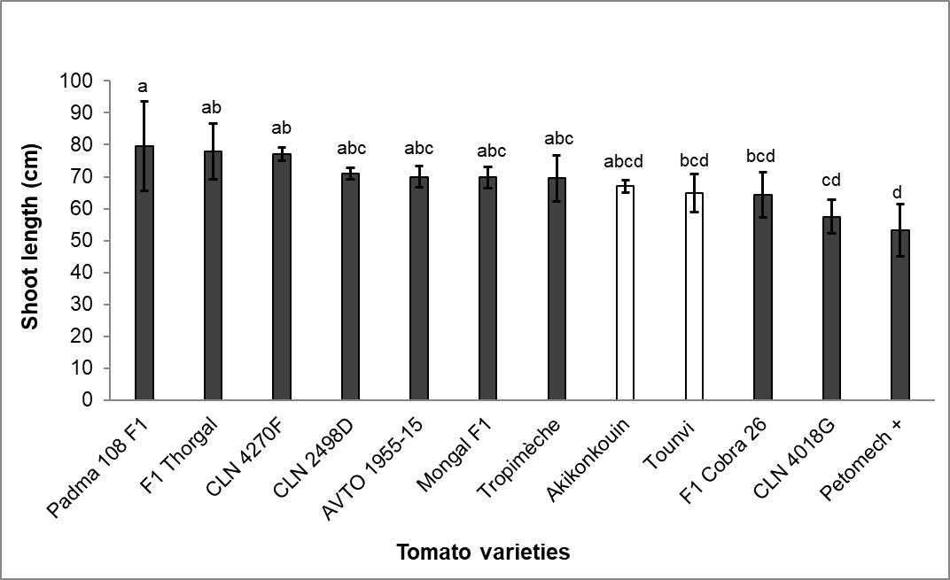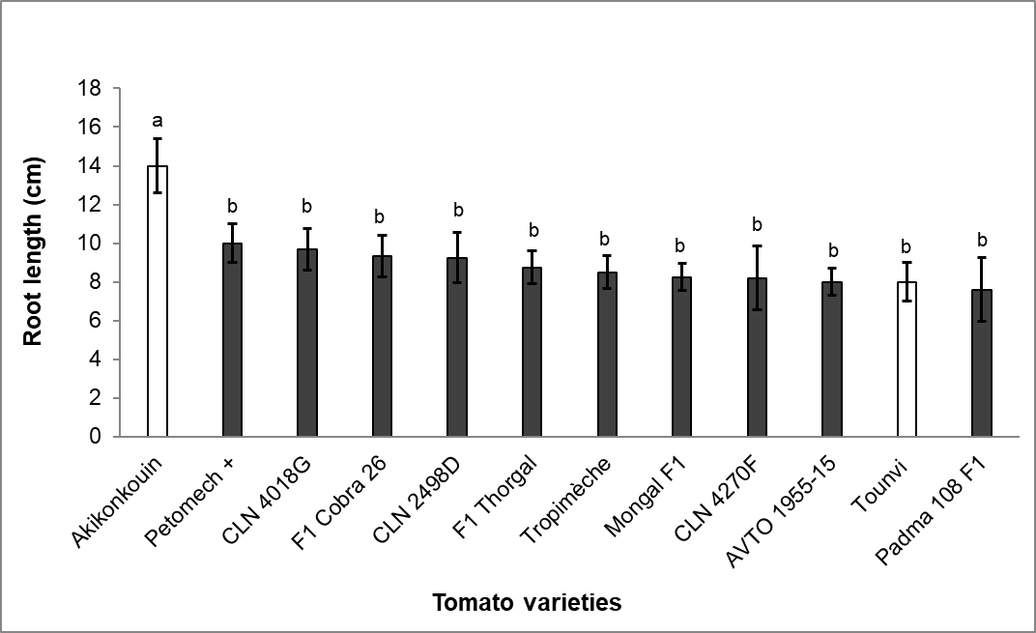
(d)
(c)
(b)
(a)
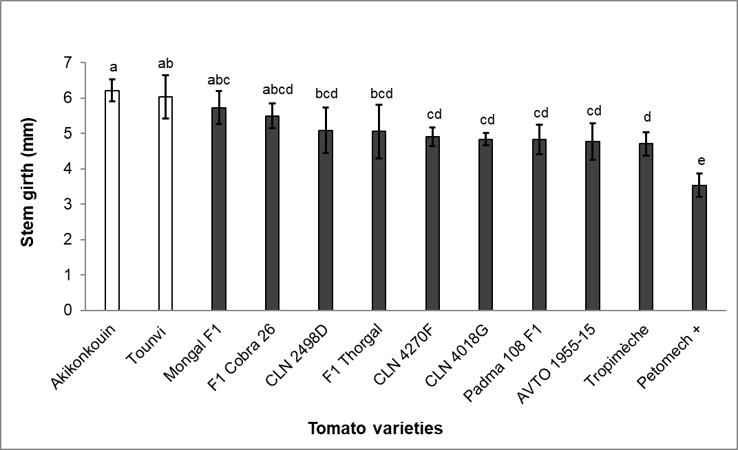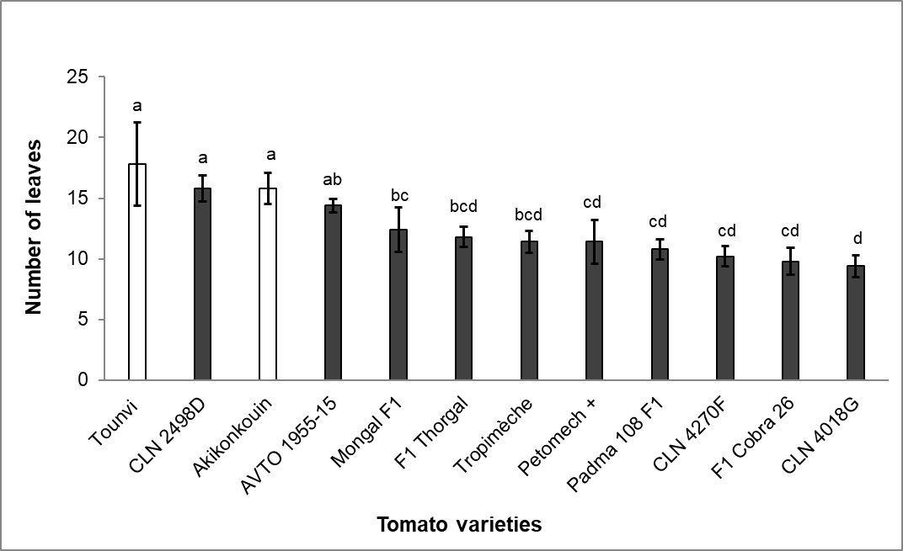

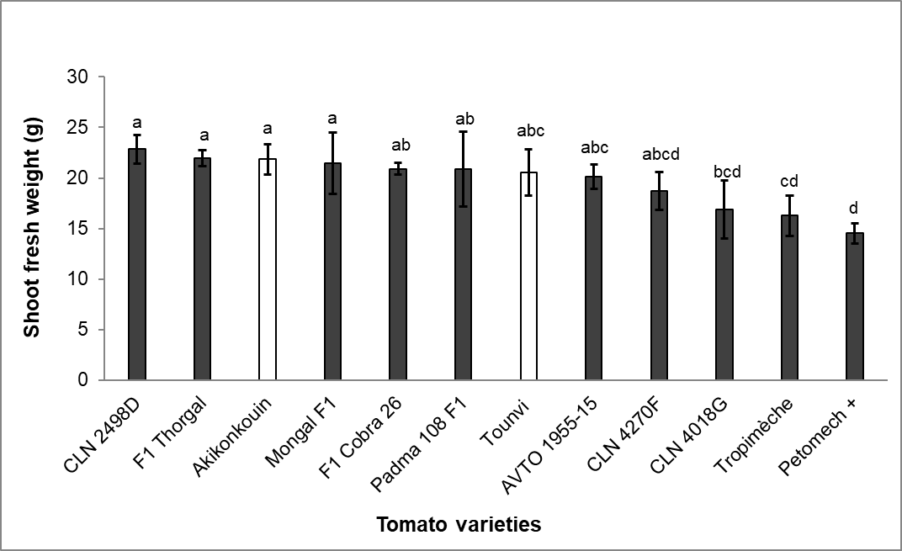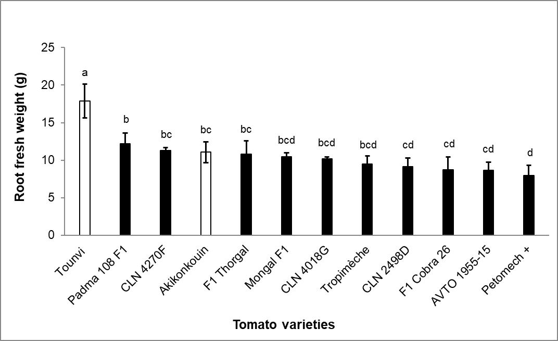
(e)
(g)
(f)
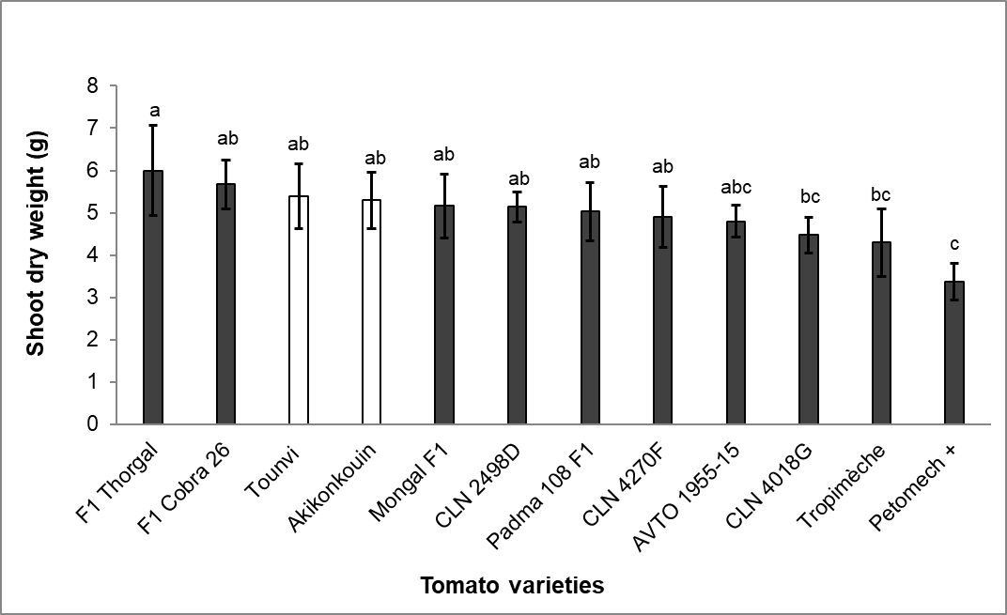
Fig. 1. Shoot length (a), root length (b), stem girth (c), number of leaves (d), shoot fresh weight (e), root fresh weight (f), shoot dry weight (g) of tomato varieties eight weeks after inoculation with 1000 M. enterolobii in 1000 cm³ sterilized soil
Data are means of five replicates. Bars followed by different letters are significantly different (P ≤ .05) based on Tukey's Honest Significant Difference (HSD) test using one-way ANOVA.

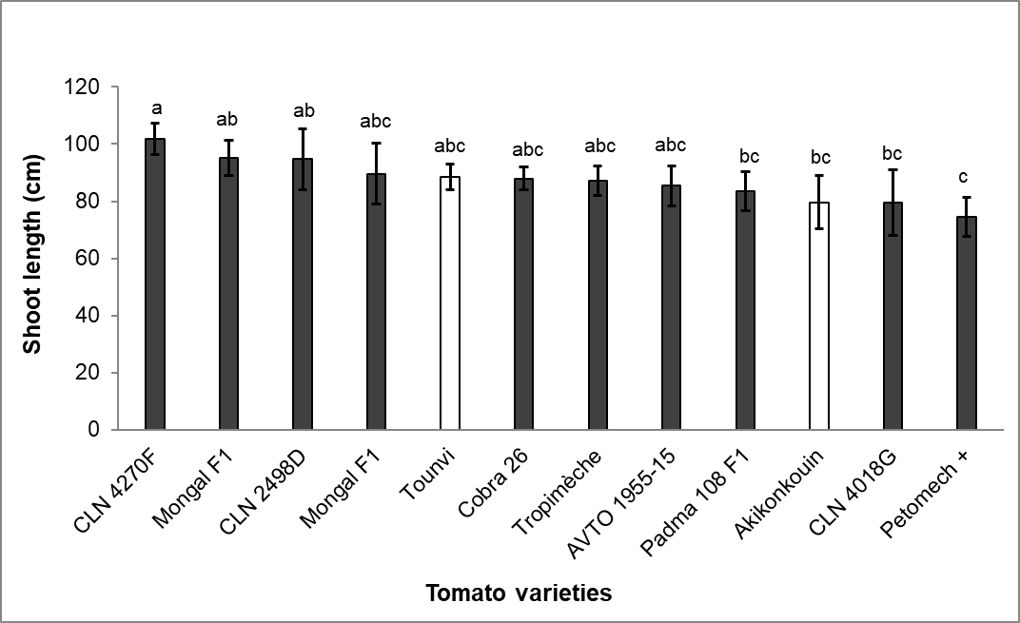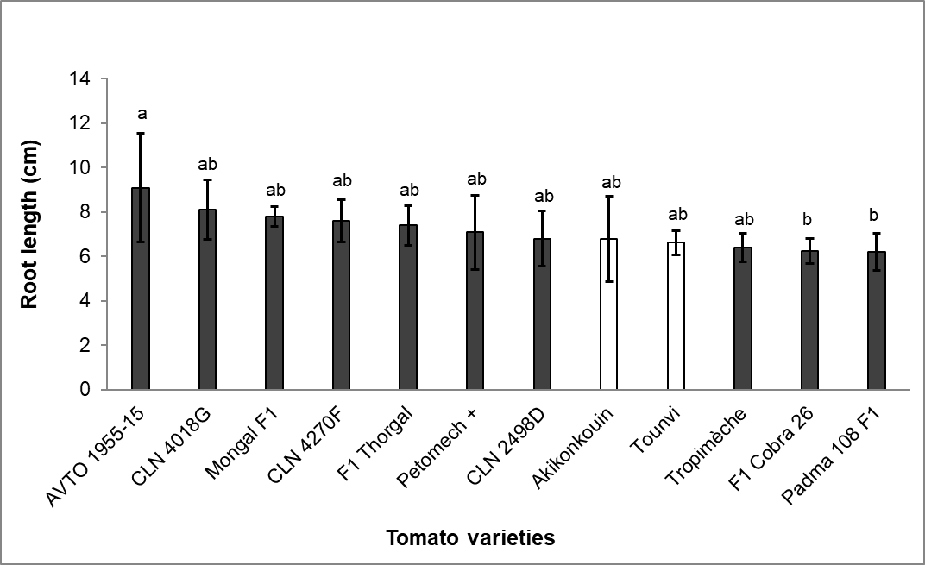
(b)
(a)
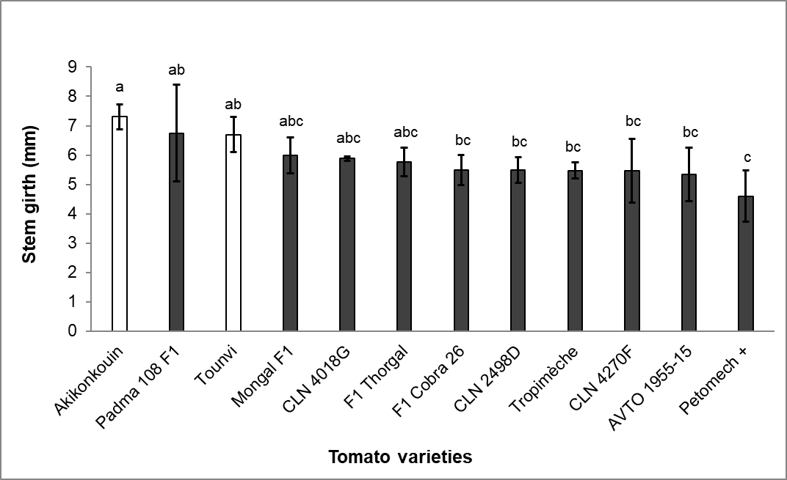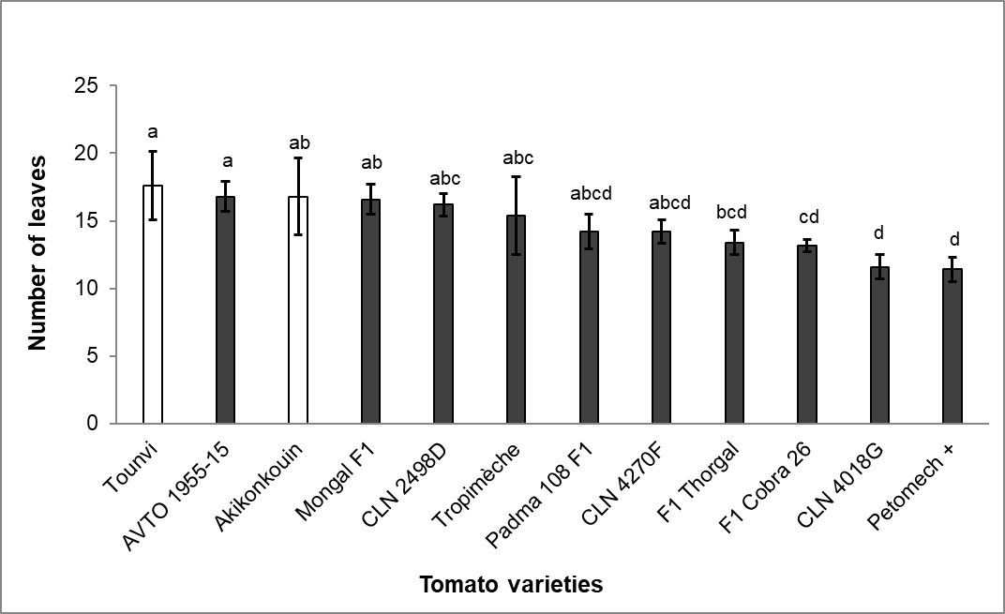
(d)
(c)
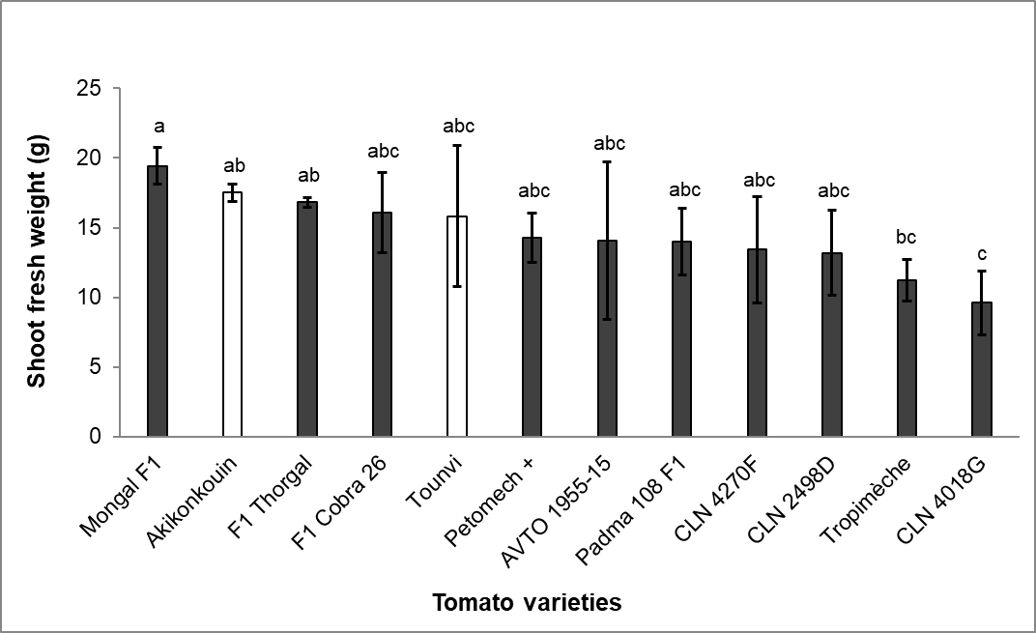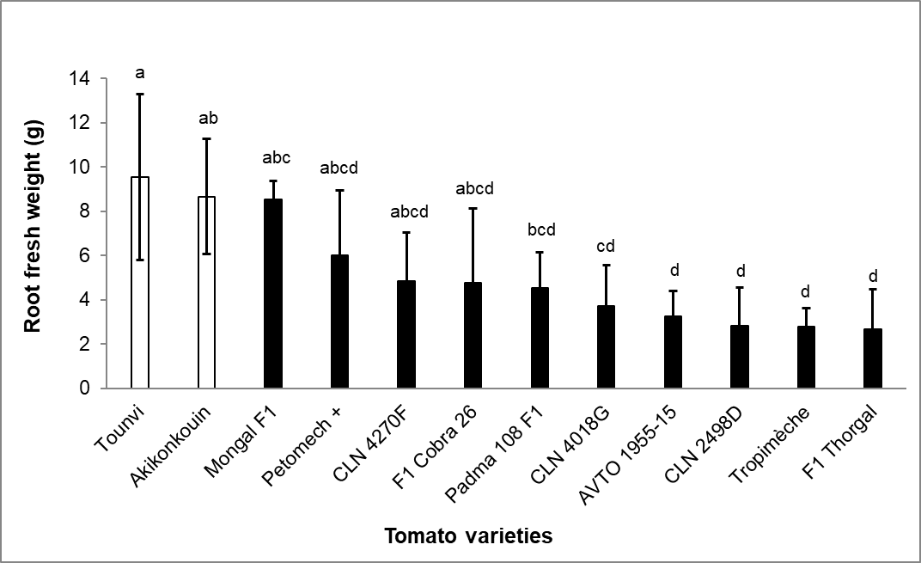
(f)
(e)

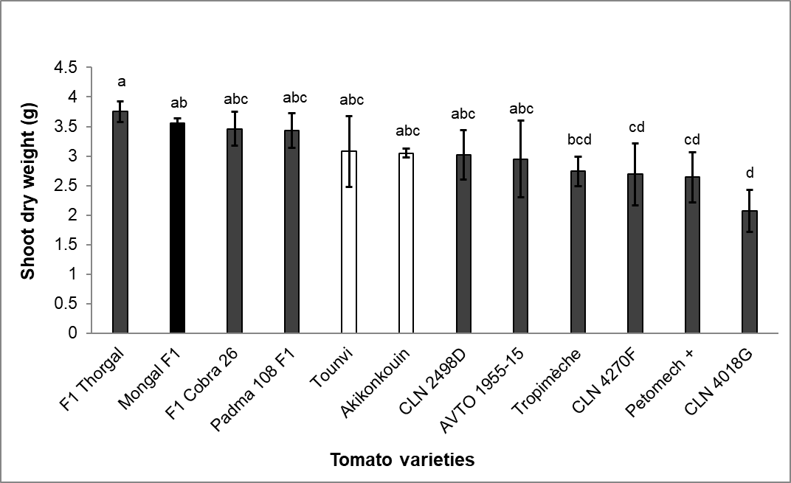
(g)
Fig. 2. Shoot length (a), root length (b), stem girth (c), number of leaves (d), shoot fresh weight (e), root fresh weight (f), shoot dry weight (g) of tomato varieties eight weeks after inoculation with 1500 M. enterolobii in 1500 cm³ sterilized soil
Data are means of five replicates. Bars followed by different letters are significantly different (P ≤ .05) based on Tukey's Honest Significant Difference (HSD) test using one-way ANOVA.

3.3. Physiological traits across varieties and their correlation with nematode infections and tomato growth
Results from the repeat experiment showed significant variations in Fv/Fm (Fig. 3) and leaf chlorophyll content (Fig. 4) across tomato varieties (P < .001). Regarding the photochemical traits, very few varieties had higher Fv/Fm than the local cultivar “Tounvi” whereas no significant difference was observed when considering the local cultivar “Akikonkouin” (Fig. 3). Similar results were observed with the leaf chlorophyll content (Fig. 4).
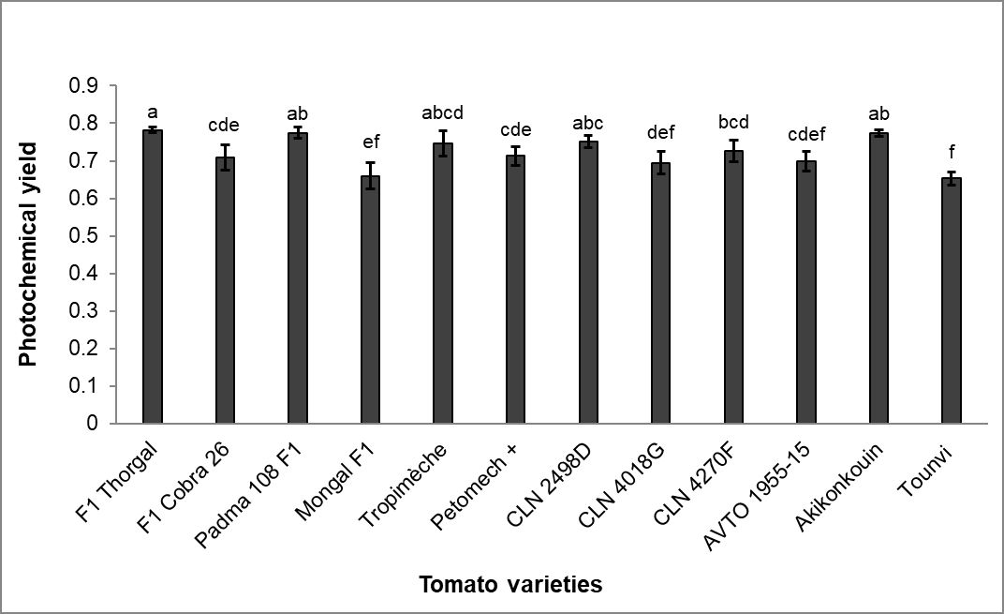
Fig. 3. Photochemical yield (Fv/Fm) of tomato varieties eight weeks after inoculation with 1500 M. enterolobii
Data are means of five replicates. Bars followed by different letters are significantly different (P ≤ .05) based on Tukey's Honest Significant Difference (HSD) test using one-way ANOVA.

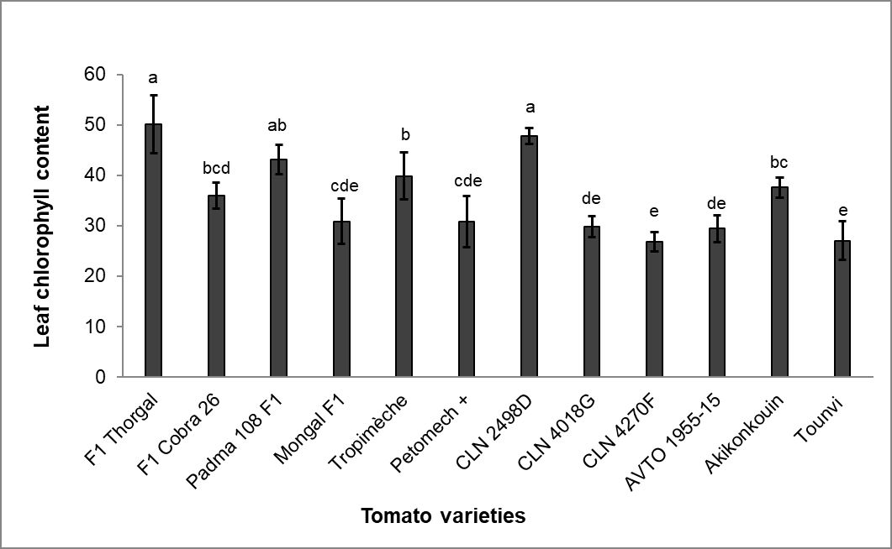
Fig. 4. Leaf chlorophyll content of tomato varieties eight weeks after inoculation with 1500 M. enterolobii
Data are means of five replicates. Bars followed by different letters are significantly different (P ≤ .05) based on Tukey's Honest Significant Difference (HSD) test using one-way ANOVA.
Fv/Fm is an important indicator of plant health, with optimal values of approximately 0.83 in non-stressed conditions (Maxwell and Johnson, 2000) whereas leaf chlorophyll content indicates the photosynthetic capacity of the plant (Jiang et al., 2017). In our study, the observed Fv/Fm (0.65 - 0.78) and chlorophyll content (26,82 - 47,74) suggest that M. enterolobii may induce physiological stress in plants following infections, affecting particularly the photosystem II (Ghasemzadeh et al., 2019). Sikandar et al. (2024) also observed a significant decrease in chlorophyll fluorescence parameters and chlorophyll content on tomato plants cv Zhongza 09 with M. enterolobii population density ranging from 100 to 2000 J₂ per plant. According to these authors, chlorophyll content reductions can be attributed to increasing oxidative stress and degradation of chlorophyll pigments due to M. enterolobii pressure.
Pearson correlation analysis showed significant associations (P < .05) between key nematological, growth, and physiological parameters (Fig. 5). Nematode reproductive factor negatively correlated with the Fv/Fm (r = -0.41; P = .0013). Similarly, the gall index negatively correlated with the Fv/Fm (r = -0.30; P = .02) and leaf chlorophyll content (r = -0.32; P = .013). Likewise, root fresh weight was negatively correlated with the Fv/Fm (r = -0.34; P = .0087) and chlorophyll content (r = -0.35; P = .0058).
The significant correlations between key nematological, growth, and physiological parameters provide valuable information on the host plant-nematode interactions. High reproductive factor and gall index reduced photosynthetic function and chlorophyll levels, suggesting that RKNs may take over plant nutrients to the detriment of plant growth, thus affecting physiological processes such as photosynthesis (Ghasemzadeh et al., 2019; Sikandar et al., 2024). This situation was observed in the repeat experiment with a significant negative correlation between nematode parameters and Fv/Fm and chlorophyll content, resulting in their lower values and reflecting the stress induced by nematode infections.
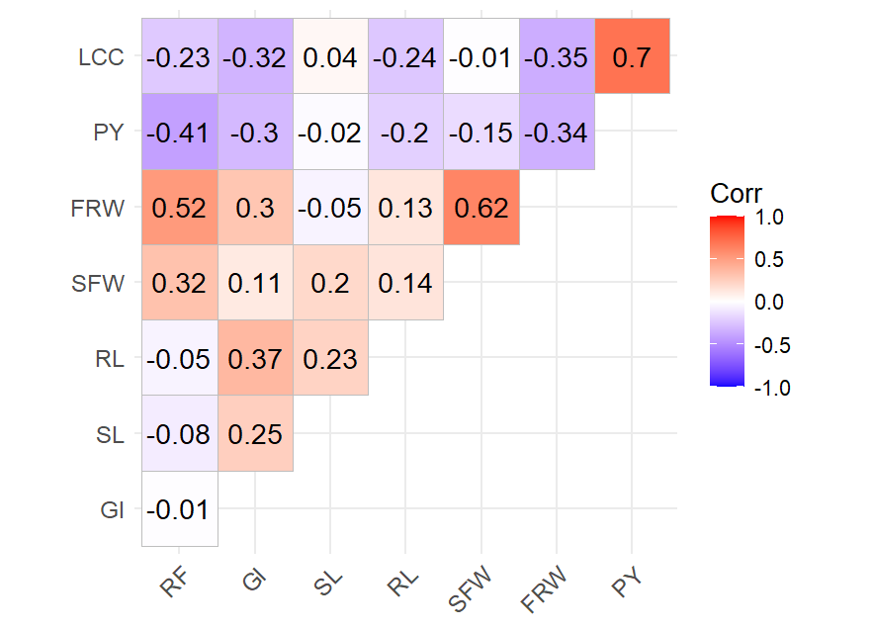
Fig. 5. Pearson’s correlation coefficient based on nematological, growth and physiological parameters of tomato varieties eight weeks after inoculation with 1500 M. enterolobii in 1500 cm³ sterilized soil
Pearson coefficients (Corr) are calculated across pooled data from all varieties in the repeat experiment
RF: Reproductive factor; GI: Gall index; SL: Shoot length; RL: Root length; SFW: Shoot fresh weight; FRW: Fresh root weight; PY: Photochemical yield; LCC: Leaf chlorophyll content
4. Conclusion
The current study demonstrates that all twelve tomato varieties are susceptible to M. enterolobii, thus confirms that developing tomato genotypes resistant to M. enterolobii for vegetable growers remains a key challenge. The results point out significant correlations between nematode parameters, plant growth, and physiological traits, showing in particular that the nematode reproductive factor and the galling index were negatively correlated with Fv/Fm and chlorophyll content. Given that RKN infections can weaken the genetic resistance of tomato varieties to R. solanacearum, appropriate RKN management strategies should be developed and advised to producers when using these tomato varieties in nematode-infested fields. The valuable information provided in this study calls the attention of breeders to consider nematode-related parameters in the breeding programme against R. solanacearum.
COMPETING INTERESTS DISCLAIMER
Authors have declared that they have no known competing financial interests.
Disclaimer (Artificial intelligence)
Author(s) hereby declare that NO generative AI technologies such as Large Language Models (ChatGPT, COPILOT, etc.) and text-to-image generators have been used during the writing or editing of this manuscript.
References

Abd-Elgawad, M.M., & Askary, T.H. (2015). Impact of phytonematodes on agriculture economy. In: Askary, T. H. & Martinelli, P. R. P. (Eds). Biocontrol agents of phytonematodes. CABI, Wallingford UK, pp. 3-49.
Affokpon, A., Coyne, D.L., Htay, C.C., Dossou Agbèdè, R., Lawouin, L., & Coosemans, J. (2011). Biocontrol potential of native Trichoderma isolates against root-knot nematodes in West African vegetable production systems. Soil Biology & Biochemistry, 43(3), 600-608.
Affokpon, A., Dan, C.B.S., Houedjissi, M.E., Hekpazo, B.A., & Tossou, C. (2012). L’efficacité des dérivés de graines de neem contre les nématodes à galles en cultures maraîchères diffère en fonction du type de dérivé. Bulletin de la Recherche Agronomique du Bénin, 72, 48-58.
Affokpon, A., Coffi, D.N.E., Atchadé, J.M.C.O., Tossou, C., Coyne, D.L., Adoukonou-Sagbadja, H., & Dansi, A. (2021) (Research Application Summary). Population build-up and damage of Scutellonema bradys and Meloidogyne spp. on local yam cultivars under field and storage conditions in Benin. Ruforum Working Document Series N°19 (1) : 33-42. ISSN 1607-9345.
Ahmed, W., Yang, J., Tan, Y., Munir, S., Liu, Q., Zhang, J., Ji, G., & Zhao, Z. (2022). Ralstonia solanacearum, a deadly pathogen: Revisiting the bacterial wilt biocontrol practices in tobacco and other Solanaceae. Rhizosphere, 21, 100479.
Archana, T.S., Kumar, D., Kumar, V., & Shukuru, B.N. (2023). Root-Knot Disease Complex: An Interactive Perspective with Microorganisms. In: Ahmad, F., & Blázquez, G.N. (Eds.), Root-Galling Disease of Vegetable Plants. Springer Nature Singapore, Singapore, pp. 237-251.
Asghar, A., Mukhtar, T., Raja, M.U., & Gulzar, A. (2020). Interaction between Meloidogyne javanica and Ralstonia solanacearum in chili. Pakistan journal of Zoology, 52(4), 1525-1530.
Azandeme-Hounmalon, Y.G., Houngbo, E., Dossoumou, M.E., Mensah, G.C.A., Affokpon, A., Douro Kpindou, O.K., & Sikirou, R. (2023). Facteurs de développement et de distribution du flétrissement bactérien et des principaux ravageurs des solanacées en maraîchage au Bénin. Document Technique et d’Information., Dépôt légal N° 14969 du 17/01/2023, 1er trimestre 2023, Bibliothèque Nationale (BN) du Bénin. ISBN: 978-99982-59-66-9, 72 pages.
Bhat, A., Shakeel, A., Waqar, S., Handoo, Z., & Khan, A. (2023). Microbes vs. Nematodes: Insights into Biocontrol through Antagonistic Organisms to Control Root-Knot Nematodes. Plants, 12, 451.
Collett, R.L., Marais, M., Daneel, M., Rashidifard, M., & Fourie, H. (2021). Meloidogyne enterolobii, a threat to crop production with particular reference to sub-Saharan Africa: an extensive, critical and updated review. Nematology, 23(3), 247-285.
Coyne, D.L., Cortada, L., Dalzell, J.J., Claudius-Cole, A.O., Haukeland, S., Luambano, N., & Talwana, H. (2018). Plant-Parasitic Nematodes and Food Security in Sub-Saharan Africa. Annual Review of Phytopathology, 56, 381-403.
Coyne, D.L., & Ross, J. (2014). Protocol for nematode resistance screening: root knot nematodes, Meloidogyne spp. International Institute of Tropical Agriculture (IITA), Ibadan, Nigeria. 27 pp.
Deberdt, P., Quénéhervé, P., Darrasse, A., & Prior, P. (1999). Increased susceptibility to bacterial wilt in tomatoes by nematode galling and the role of the Mi gene in resistance to nematodes and bacterial wilt. Plant pathology, 48(3), 408-414.
Desaeger, J., Khan, M.R., & Silva, E.H.C. (2023). Chapter 10 - Nematode problems in tomato, okra, and other common vegetables, and their sustainable management. In: Rahman Khan, M., & Quintanilla, M. (Eds.), Nematode Diseases of Crops and their Sustainable Management. Academic Press, pp. 223-250.
Dhillon, N.K., Kaur, S., Jindal, S.K., & Buttar, H.S. (2020). Phenotypic and genotypic characterization of tomato genotypes for resistance to root-knot nematode, Meloidogyne incognita. Phytoprotection, 100(1), 28-33.
Dossoumou, M.E., Sikirou, R., Adandonon, A., Gonroudobou, J., & Baba-Moussa, L. (2021). Tomato hybrid and local varieties screened for resistance to bacterial wilt caused by Ralstonia solanacearum under screen house and field conditions. American Journal of Plant Sciences, 12(8), 1222-1235.
Dossoumou, M.E., Sikirou, R., Zannou, A., Paret, M., & Baba-Moussa, L. (2023). Bacterial wilt and dissemination factors in tomato production areas of Benin, West Africa. Archives of Phytopathology and Plant Protection, 56(18), 1427-1449.
Furusawa, A., Uehara, T., Ikeda, K., Sakai, H., Tateishi, Y., Sakai, M., & Nakaho, K. (2019). Ralstonia solanacearum colonization of tomato roots infected by Meloidogyne incognita. Journal of phytopathology, 167(6), 338-343.
Ghasemzadeh, A., Jamali, S., Esfahani, M., & Pedramfar, H. (2019). Assessment of photosynthetic fluorescence in tomato cultivars infested with root-knot nematode. Pakistan Journal of Nematology, 37(1), 91-101.
Gomez, K.A., & Gomez, A.A. (1984). Statistical procedures for agricultural research. Wiley, J. & Sons Inc. New York, USA. 68 p.
Hallmann, J., & Meressa, B.H. (2018). Nematode parasites of vegetables. In Sikora, R.A., Coyne, D., Hallmann, J., Timper, P. (Eds.), Plant parasitic nematodes in subtropical and tropical agriculture. CAB International Wallingford UK, pp. 346-410.
Jiang, C., Johkan, M., Hohjo, M., Tsukagoshi, S., & Maruo, T.J.H. (2017). A correlation analysis on chlorophyll content and SPAD value in tomato leaves. HortResearch, 71, 37-42.
Jones, J.T., Haegeman, A., Danchin, E.G., Gaur, H.S., Helder, J., Jones, M.G., Kikuchi, T., Manzanilla‐López, R., Palomares‐Rius, J.E., & Wesemael, W.M. (2013). Top 10 plant‐parasitic nematodes in molecular plant pathology. Molecular plant pathology, 14(9), 946-961.
Junaid, M., Musharaf Ahmad, & A, S. (2020). Investigating the impact of root-knot nematode double infection on bacterial wilt of tomato. Pure Applied Biology, 9(2), 1347-1353.
Karssen, G., & Moens, M. (2006). Root-knot nematodes. In: Perry, R.N., & Moens, M. (Eds.), Plant nematology. CABI, pp. 59–90.
Kassambara, A. (2019). ggcorrplot: Visualization of a Correlation Matrix using 'ggplot2'. R package version 0.1.4.999, https://github.com/kassambara/ggcorrplot.
Kidane, E., Seid, A., & Kebede, M. (2019). Reaction of tomato (Solanum lycopersicum) cultivars towards root-knot nematode (Meloidogyne incognita) and bacterial wilt (Ralstonia solanacearum). Nematropica, 49(2), 246-253.
Mamphogoro, T.P., Babalola, O.O., & Aiyegoro, O.A. (2020). Sustainable management strategies for bacterial wilt of sweet peppers (Capsicum annuum) and other Solanaceous crops. Journal of Applied Microbiology, 129(3), 496-508.
Markova, D., Yankova, V., Ganeva, D., & Ilieva, Z. (2024). Differential response of tomato accessions to Meloidogyne arenaria (Neal) Chitwood infection. Bulgarian Journal of Agricultural Science, 30(5), 865-869.
Maxwell, K., & Johnson, G.N. (2000). Chlorophyll fluorescence—a practical guide. Journal of Experimental Botany, 51(345), 659-668.
Mesa-Valle, C.M., Garrido-Cardenas, J.A., Cebrian-Carmona, J., Talavera, M., & Manzano-Agugliaro, F. (2020). Global research on plant nematodes. Agronomy, 10(8), 1148.
Oussou, G.F.G.N., Sikirou, R., Etchiha, A., E, S.a.P., Dossoumou, M.E.E.A., Boukari, S.A., Komlan, F.A., & Zocli, B. (2020). Resistance assessment of tomato (Solanum lycopersicum L.) and Gboma (Solanum macrocarpon L.) cultivars against bacterial wilt caused by Ralstonia solanacearum in Benin. Pakistan Journal of Phytopathology, 32(2), 241-249.
Parrado, L.M., & Quintanilla, M. (2024). Plant-parasitic nematode disease complexes as overlooked challenges to crop production. Frontiers in Plant Science, 15, 1439951.
Philbrick, A.N., Adhikari, T.B., Louws, F.J., & Gorny, A.M. (2020). Meloidogyne enterolobii, a major threat to tomato production: current status and future prospects for its management. Frontiers in plant science, 11, 606395.
R Core Team, 2024. R: a language and environment for statistical computing. R Foundation for Statistical Computing, Austria, Vienna.
Rawat, N., & Kumar, S. (2020). Effect of different inoculum levels of root knot nematode (Meloidogyne enterolobii) on various growth parameters of tomato plant CV- Bhagya and Kashi Anupam. International Journal of Chemical Studies, 8, 2501-2504.
Sasser, J.N., Carter, C.C. and Hartman, K.M., 1984. Standardization of host suitability studies and reporting of resistance to root-knot nematodes. North Carolina State University, Department of Plant Pathology, Raleigh. N.C., USA, 7 pp.
Seid, A., Fininsa, C., Mekete, T., Decraemer, W., & Wesemael, W. (2017). Resistance screening of breeding lines and commercial tomato cultivars for Meloidogyne incognita and M. javanica populations (Nematoda) from Ethiopia. Euphytica, 213(4), 1-15.
Seid, A., Fininsa, C., Mekete, T., Decraemer, W., & Wesemael, W.M. (2015). Tomato (Solanum lycopersicum) and root-knot nematodes (Meloidogyne spp.)–a century-old battle. Nematology, 17(9), 995-1009.
Sikandar, A., Wu, F., He, H., Ullah, R.M.K., & Wu, H. (2024). Growth, physiological, and biochemical variations in tomatoes after infection with different density levels of Meloidogyne enterolobii. Plants, 13(2), 293.
Sikirou, R., Beed, F., Ezin, V., Hoteigni, J., & Miller, S.A. (2017). Distribution, pathological and biochemical characterization of Ralstonia solanacearum in Benin. Annals of Agricultural Sciences, 62(1), 83-88.
Walia, R.K., & Khan, M.R. (2023). Root-knot Nematodes (Meloidogyne spp.). In: Ahmad, F., & Blázquez, G.N. (Eds.), Root-Galling Disease of Vegetable Plants. Springer Nature Singapore, Singapore, pp. 1-60.
Wang, S., Wang, Y., Yao, Y., Li, W., Hu, Z., Li, D., & Sun, R. (2025). Integrated Management of Bacterial Wilt and Root-Knot Nematode Diseases in Pepper: Discovery of Phenazine-1-Carboxamide from Pseudomonas aeruginosa W-126. International Journal of Molecular Sciences, 26, 3335.
Zhao, Q., Cao, J., Cai, X., Wang, J., Kong, F., Wang, D., & Wang, J. (2023). Antagonistic activity of volatile organic compounds produced by acid-tolerant Pseudomonas protegens CLP-6 as biological fumigants to control tobacco bacterial wilt caused by Ralstonia solanacearum. Applied Environmental Microbiology, 89(2), e01892-01822.
Zohoungbogbo, H., Quenum, A., Honfoga, J., Chen, J.-R., Achigan-Dako, E., Kenyon, L., & Hanson, P. (2021). Evaluation of resistance sources of tomato (Solanum lycopersicum L.) to phylotype I strains of Ralstonia solanacearum species complex in Benin. Agronomy for Sustainable Development, 11(8), 1513.

Supplementary Table 1. Final root-knot nematode population densities on tomato varieties eight weeks after inoculation with 1000 M. enterolobii in 1000 cm³ sterilized soil
Varieties | Juveniles/  5 g rootsª |  | Eggs /  5 g rootsª |  | Juveniles/  250 cm³ soilª
F1 Thorgal | 4375 bc |  | 192 bc |  | 78 c
F1 Cobra 26 | 3843 bc |  | 160 c |  | 45 de
Padma 108 F1 | 5391 b |  | 1072 abc |  | 159 a
Mongal F1 | 4258 bc |  | 179 bc |  | 37 ef
Tropimèche | 6515 b |  | 909 ab |  | 177 a
Petomech + | 15168 a |  | 292 abc |  | 25 f
CLN 2498D | 3829 bcd |  | 1537 a |  | 76 c
CLN 4018G | 2594 c |  | 192 bc |  | 69 cd
CLN 4270F | 3922 bc |  | 317 abc |  | 147 ab
AVTO 1955-15 | 6783 b |  | 403 abc |  | 89 c
Akikonkouin | 6149 b |  | 398 abc |  | 180 a
Tounvi | 6201 b |  | 687 abc |  | 91 bc
Fisher | 10.91 |  | 3.754 |  | 42.65
P value | < .001 |  | < .001 |  | < .001
Data are means of five replicates. Values in columns followed by different letters are significantly different (P ≤ .05) based on Tukey's Honest Significant Difference (HSD) test using one-way ANOVA. ªStatistical analysis based on log₁₀ (x+1), backtransformed data presented.

Supplementary Table 2. Root galling and egg mass production in tomato varieties eight weeks after inoculation with 1000 M. enterolobii in 1000 cm³ sterilized soil
Varieties | no galls/  g of rootsª | no egg masses/  g of rootsª | no eggs/  egg massª
F1 Thorgal | 362 ab | 55 bc | 226 ab
F1 Cobra 26 | 204 e | 22 f | 155 cd
Padma 108 F1 | 277 cde | 71 ab | 267 a
Mongal F1 | 236 cde | 42 cd | 120 d
Tropimèche | 226 de | 26 ef | 169 bc
Petomech + | 363 ab | 54 bc | 137 cd
CLN 2498D | 267 cde | 65 ab | 111 d
CLN 4018G | 286 cd | 32 de | 123 d
CLN 4270F | 392 a | 58 bc | 191 abc
AVTO 1955-15 | 304 bc | 89 a | 144 cd
Akikonkouin | 220 de | 35 d | 258 a
Tounvi | 279 cd | 53 bc | 260 a
Fisher | 13.1 | 44.32 | 20.7
P value | < .001 | < .001 | < .001
Data are means of five replicates. Values in columns followed by different letters are significantly different (P ≤ .05) based on Tukey's Honest Significant Difference (HSD) test using one-way ANOVA. ªStatistical analysis based on log₁₀(x+1), backtransformed data presented.

Supplementary Table 3. Final root-knot nematode population densities on tomato varieties eight weeks after inoculation with 1500 M. enterolobii in 1500 cm³ sterilized soil
Varieties | Juveniles/  5 g rootsª | Eggs/  5 g rootsª | Juveniles/ 250 cm³ soilª | Eggs/ 250 cm³ soilª
F1 Thorgal | 5761 def | 78 bcd | 848 ab | 2 ab
F1 Cobra 26 | 1926 i | 217 d | 354 abc | 2 ab
Padma 108 F1 | 7949 cd | 1163 ab | 1122 ab | 6 ab
Mongal F1 | 21346 a | 1827 ab | 278 bc | 3 ab
Tropimèche | 3859 fgh | 1014 ab | 1311 a | 11 ab
Petomech + | 21256 a | 5275 a | 360 abc | 0 b
CLN 2498D | 6537 cde | 174 abcd | 1002 ab | 43 a
CLN 4018G | 2341 hi | 92 cd | 482 abc | 8 ab
CLN 4270F | 4636 efg | 33 d | 390 abc | 2 ab
AVTO 1955-15 | 9411 bc | 592 abc | 454 abc | 2 ab
Akikonkouin | 3418 gh | 227 bcd | 555 abc | 6 ab
Tounvi | 14862 ab | 2621 a | 235 c | 6 ab
Fisher | 59.34 | 8.652 | 4.001 | 2.048
P value | < .001 | < .001 | < .001 | .044
Data are means of five replicates. Values in columns followed by different letters are significantly different (P ≤ .05) based on Tukey's Honest Significant Difference (HSD) test using one-way ANOVA. ªStatistical analysis based on log₁₀(x+1), backtransformed data presented.

Supplementary Table 4. Root galling and egg mass production in tomato varieties eight weeks after inoculation with 1500 M. enterolobii in 1500 cm³ sterilized soil
Varieties | no galls/ g of rootsª | no egg masses/ g of rootsª | no eggs/ egg massª
F1 Thorgal | 435 a | 181 a | 141 ab
F1 Cobra 26 | 199 ab | 88 ab | 82 bc
Padma 108 F1 | 201 ab | 80 ab | 88 bc
Mongal F1 | 133 b | 17 c | 163 a
Tropimèche | 262 ab | 156 ab | 103 abc
Petomech + | 202 ab | 84 ab | 103 abc
CLN 2498D | 222 ab | 67 ab | 78 c
CLN 4018G | 289 ab | 46 bc | 99 abc
CLN 4270F | 243 ab | 48 bc | 144 abc
AVTO 1955-15 | 185 b | 77 ab | 146 ab
Akikonkouin | 156 b | 73 ab | 120 abc
Tounvi | 197 ab | 37 bc | 100 abc
Fisher | 3.007 | 5.464 | 3.966
P value | .004 | < .001 | < .001
Data are means of five replicates. Values in columns followed by different letters are significantly different (P ≤ .05) based on Tukey's Honest Significant Difference (HSD) test using one-way ANOVA. ªStatistical analysis based on log₁₀ (x+1), backtransformed data presented.

