Original Research Article
Comparative Soil Suitability Assessment of Mysuru and Coimbatore for Organic Cultivation of Red Sorghum (Sorghum bicolor L.)

Abstract: Red sorghum (Sorghum bicolor L.) is widely recognised for its exceptional nutritional quality, rich phytochemical profile, and strong adaptability to semi-arid and arid climates. Its resilience to drought, capacity to thrive in marginal soils, and gluten-free nature make it a promising cereal crop for organic farming systems, particularly in the context of climate variability and growing consumer demand for health-oriented foods. This study undertook a comparative assessment of soil fertility and suitability for organic cultivation of red sorghum in two prominent agricultural regions of southern India: Coimbatore, Tamil Nadu, and Mysuru, Karnataka. Sampling was conducted during the pre-sowing period to capture baseline soil fertility status before the addition of organic inputs. Soil samples from certified organic farms in both regions were analysed for pH, electrical conductivity (EC), organic carbon content, macronutrients (N, P, K), secondary nutrients (Ca, Mg, S), and micronutrients (Fe, Mn, Zn, Cu, B). Organic Carbon (OC) content was determined by the Walkley–Black wet oxidation method. Available nitrogen (N) was estimated using the alkaline KMnO₄ distillation method. Comparative analysis between Coimbatore and Mysuru soils was conducted to identify significant differences in fertility parameters, with independent samples t-tests applied at p < 0.05. The results revealed that Coimbatore soils exhibited a near-neutral pH (6.91), higher organic carbon (0.76%), and elevated levels of both macro- and micronutrients compared to Mysuru soils (pH 6.65, organic carbon 0.51%). Notably, Coimbatore recorded greater nitrogen (252 vs. 213 kg/ha), phosphorus (38.4 vs. 27.3 kg/ha), potassium (307 vs. 225 kg/ha), and iron (4.65 vs. 3.94 ppm) levels. Although both regions demonstrate suitability for organic sorghum cultivation, the relatively lower nutrient profile in Mysuru suggests a need for targeted organic amendments to optimise productivity and sustainability. This research highlights the importance of region-specific soil fertility evaluation to support informed decision-making in organic crop planning.
Keywords: red sorghum, organic farming, Coimbatore, Mysuru, micronutrients, sustainable agriculture

- Introduction
Soil fertility management is a cornerstone of sustainable agriculture and plays an even more critical role in organic farming systems, where the use of synthetic fertilisers and chemical inputs is strictly prohibited (FAO, 2020; ICAR, 2021; Pimentel et al., 2005). Organic farming instead relies on natural nutrient sources, crop rotations, biological nitrogen fixation, composting, and maintenance of soil organic matter to sustain productivity while enhancing soil biological activity and structure (Lal, 2011; Reganold & Wachter, 2016). The evaluation of soil health parameters is therefore essential for guiding crop choice, nutrient management strategies, and overall farm productivity in such systems (Meder et al., 2002; Hou et al., 2025).
Red sorghum (Sorghum bicolor L.), a staple cereal in many semi-arid regions of the world, has gained renewed attention for its dual role in addressing food security and promoting nutritional well-being (Awika & Rooney, 2004; Taylor et al., 2006). This millet is characterised by high levels of dietary fibre, protein, and phenolic compounds, particularly anthocyanins and tannins, which contribute to its antioxidant capacity (Chandrasekara & Shahidi, 2010; Dicko et al., 2006). In addition, it is naturally gluten-free, making it a valuable dietary option for individuals with celiac disease and gluten intolerance (Devi et al., 2014). The chemical composition of sorghum is very similar to maize and millet whose essential components are starch, fat, protein, and non-starch polysaccharides, it is also a source of bioactive nutrients like vitamin B, fat-soluble vitamins (D, E, K), micro and macronutrients, as well as non-nutrients, for example, carotenoids and polyphenols (Espitia-Hernández et al., 2022; Zannou et al., 2025). From an agronomic perspective, red sorghum’s C4 photosynthetic pathway allows for high water-use efficiency, enabling it to perform well under drought stress conditions where other cereals may fail (ICRISAT, 2019; TNAU, 2022; Reddy et al., 2009).
In the Far-North region of Cameroon, as in other Sahelian parts of Africa, sorghum and pearl millet, which are consumed as gruel, rolled balls, partially cooked grains, and fermented beverages, are less expensive sources of nutrients for low-income individuals (Mawouma et al., 2022). Recent consumer trends have amplified the demand for red sorghum due to its adaptability for value-added food products such as multigrain flours, snack foods, porridges, and fermented beverages (Taylor et al., 2014; Rooney & Waniska, 2000). At the same time, there has been growing interest among farmers in southern India to cultivate this crop organically, capitalising on premium markets and sustainability incentives (Wortman et al., 2012; Reganold & Wachter, 2016). However, the success of organic red sorghum production is strongly influenced by the chemical and biological characteristics of the soil, which govern nutrient availability, root development, and crop resilience (Chhimwal et al., 2019; Aulakh et al., 2022; Peterson et al., 2024).
Coimbatore in Tamil Nadu and Mysuru in Karnataka represent two agroecological zones with distinct climatic, edaphic, and farming system characteristics (ICAR, 2021; TNAU, 2022). While both regions have a tradition of millet cultivation, the nutrient status and organic matter dynamics under certified organic management are not well documented (Wortman et al., 2012; Hou et al., 2025). Past studies in these regions have largely examined sorghum under conventional farming systems (Ghosh et al., 2004; Aulakh et al., 2022), and little is known about the comparative soil fertility profiles in organically managed farms specifically targeted for red sorghum.
The present study aims to fill this gap by conducting a detailed comparative analysis of soil physicochemical and nutrient parameters in certified organic farms of Coimbatore and Mysuru. By identifying region-specific strengths and constraints, the research seeks to inform targeted soil management interventions that enhance organic red sorghum productivity, improve soil health, and contribute to long-term agricultural sustainability in these semi-arid landscapes (FAO, 2020; ICAR, 2021).
2. Materials and Methods
2.1 Study Area
The research was conducted in two distinct agroecological regions of southern India — Coimbatore district in Tamil Nadu and Mysuru district in Karnataka — both of which have growing interest in organic farming systems (ICAR, 2021; FAO, 2020; TNAU, 2022). Coimbatore lies in the western part of Tamil Nadu, characterised by semi-arid climate conditions, low to moderate rainfall (average 600–700 mm annually), and temperatures ranging from 20°C to 37°C (IMD, 2021). The predominant soils are red loamy and sandy loam, well-drained, and known for their suitability to millet crops under irrigated and rainfed conditions (Bosire et al., 2018). Mysuru, situated in the southern region of Karnataka, experiences a tropical savanna climate with an annual rainfall of approximately 800–900 mm and temperatures between 18°C and 35°C (IMD, 2021). Soils in Mysuru are typically red sandy loams to clay loams, moderately fertile but often constrained by lower organic matter content (Aulakh et al., 2022; Lal, 2011). Both locations have active organic farming clusters, certified under National Programme for Organic Production (NPOP) standards (APEDA, 2020).
2.2 Farm and Sample Selection
Certified organic farms with a documented history of at least three years of organic management were selected in each district to ensure that soil properties reflected organic practices rather than residual effects from conventional agriculture (Reganold & Wachter, 2016; ICAR, 2021). Selection criteria also included farmer engagement in sorghum or other millet cultivation, accessibility, and willingness to participate in the study (FAO, 2020; Hou et al., 2025). In each district, five representative farms were chosen, and soil samples were collected from fields designated for red sorghum cultivation in the upcoming season.
2.3 Soil Sampling Procedure
Sampling was conducted during the pre-sowing period to capture baseline soil fertility status before the addition of organic inputs (Ghosh et al., 2004; Chhimwal et al., 2019). From each farm, five random sampling points were identified across the field using a zig-zag pattern to account for spatial variability (USDA NRCS, 2020). Soil cores were taken from the 0–15 cm depth, corresponding to the primary rooting zone for sorghum, where nutrient availability and biological activity are most influential on early crop growth (Lal, 2011). The cores from each farm were composited into a single representative sample, mixed thoroughly, air-dried in shade to preserve organic matter integrity, and passed through a 2 mm sieve prior to laboratory analysis (Jackson, 1973; Walkley & Black, 1934).
2.4 Soil Physicochemical Analysis
pH and Electrical Conductivity (EC) were measured in a 1:2.5 soil-to-water suspension using calibrated digital meters following Jackson (1973) and standard soil testing guidelines (USDA NRCS, 2020). pH is a critical indicator of nutrient solubility and microbial activity (Brady & Weil, 2016), while EC provides a measure of soluble salt concentration and potential salinity hazards (FAO, 2020).
2.5 Organic Carbon Content
Organic Carbon (OC) content was determined by the Walkley–Black wet oxidation method (Walkley & Black, 1934), a widely adopted procedure in soil science for estimating organic matter status (Aulakh et al., 2022). The organic carbon fraction is essential in organic farming as it directly influences soil structure, cation exchange capacity, water retention, and nutrient mineralisation rates (Lal, 2011; Mader et al., 2002).

2.6 Macronutrient Analysis
Available nitrogen (N) was estimated using the alkaline KMnO₄ distillation method (Subbiah & Asija, 1956), which measures the fraction of nitrogen mineralizable under field conditions (Chhimwal et al., 2019). Available phosphorus (P) was determined via Olsen’s method (Olsen et al., 1954) using sodium bicarbonate extraction, particularly suited for neutral to alkaline soils (FAO, 2020). Available potassium (K) was measured by flame photometry after extraction with neutral normal ammonium acetate (Tandon, 2013).
2.7 Secondary and Micronutrient Analysis
Secondary nutrients calcium (Ca) and magnesium (Mg) were quantified using EDTA complexometric titration, while sulphur (S) was estimated by turbidimetric methods (Tandon, 2013). Micronutrients iron (Fe), manganese (Mn), zinc (Zn), copper (Cu), and boron (B) were extracted using the DTPA chelation method (Lindsay & Norvell, 1978) and measured with an atomic absorption spectrophotometer (Chhimwal et al., 2019; Hou et al., 2025).
2.8 Statistical Analysis
Descriptive statistics were computed for all soil parameters to determine mean and standard deviation values (Gomez & Gomez, 1984). Comparative analysis between Coimbatore and Mysuru soils was conducted to identify significant differences in fertility parameters, with independent samples t-tests applied at p < 0.05 (SPSS, 2022).
3. Results

3.1 Soil pH and Electrical Conductivity
The pH values for soils in both study regions fell within the optimum range for red sorghum cultivation (Tandon, 2013; Brady & Weil, 2016). Coimbatore soils recorded a slightly higher mean pH of 6.91, compared to 6.65 in Mysuru. These values suggest near-neutral conditions, which are favourable for the solubility and uptake of most macro- and micronutrients (FAO, 2020; USDA NRCS, 2020). The marginally higher pH in Coimbatore could contribute to greater microbial diversity and activity, facilitating nutrient cycling in organically managed systems (Mäder et al., 2002). Electrical conductivity (EC) values were 0.29 dS/m in Coimbatore and 0.22 dS/m in Mysuru, indicating very low salinity levels in both regions (Ghosh et al., 2004). Low EC is advantageous for red sorghum, as it ensures no osmotic stress on germinating seeds and young seedlings (Chhimwal et al., 2019). These results affirm that salinity is not a constraint in either region under current management.

3.2 Organic Carbon Content
Organic carbon (OC) was 0.76% in Coimbatore soils and 0.51% in Mysuru soils, reflecting a significant difference in organic matter status (Aulakh et al., 2022; Lal, 2011). This parameter is critical in organic farming, as it serves as the primary reservoir of plant-available nutrients and a driver of soil microbial activity (Reganold & Wachter, 2016). The higher OC in Coimbatore could be attributed to the greater incorporation of organic manures, crop residues, and possibly more diversified crop rotations (Wortman et al., 2012).

3.3 Macronutrient Status
Available nitrogen (N) averaged 252 kg/ha in Coimbatore and 213 kg/ha in Mysuru. This difference is agronomically relevant, as nitrogen plays a central role in vegetative growth and grain yield (Chhimwal et al., 2019; Tandon, 2013). Available phosphorus (P) was also higher in Coimbatore (38.4 kg/ha) compared to Mysuru (27.3 kg/ha). Given phosphorus’s role in root establishment and grain development, these results suggest a nutritional advantage for early crop establishment in Coimbatore (FAO, 2020; Hou et al., 2025). Available potassium (K) levels were 307 kg/ha in Coimbatore versus 225 kg/ha in Mysuru, supporting better water regulation, disease resistance, and grain filling (Tandon, 2013).

3.4 Secondary and Micronutrient Status
Secondary nutrient levels (Ca, Mg, S) were consistently higher in Coimbatore soils, supporting stronger structural integrity of plant tissues and metabolic functions (Aulakh et al., 2022). Micronutrient analysis revealed Fe at 4.65 ppm in Coimbatore and 3.94 ppm in Mysuru, Mn at 6.12 vs. 5.24 ppm, Zn at 1.28 vs. 0.94 ppm, and B at 0.63 vs. 0.41 ppm. These differences are important because micronutrients, though required in small amounts, are essential for enzyme activation, pollen viability, and disease resistance (Chhimwal et al., 2019; Lindsay & Norvell, 1978).
Table 1. Nutrient Properties of Soil Samples from Coimbatore and Mysuru
All values are expressed in standard units; OC = Organic Carbon; EC = Electrical Conductivity; ppm = parts per million

Parameters | Ideal Range for Organic Red Sorghum | Coimbatore Soil | Mysuru Soil
pH | 6.5–7.5 | 6.91 | 6.65
EC (dS/m) | < 1.0 (non-saline) | 0.29 | 0.22
Organic Carbon (%) | > 0.5% (ideal: >0.75%) | 0.76 | 0.51
Available Nitrogen (kg/ha) | > 250 (ideal for cereals) | 252 | 213
Available Phosphorus (kg/ha) | > 35 | 38.4 | 27.3
Available Potassium (kg/ha) | > 280 | 307 | 225
Calcium (meq/100g) | 5.7 | 5.7 | 4.9
Magnesium (meq/100g) | 3.2 | 3.2 | 2.8
Sulfur (ppm) | 11.5 ppm | 11.5 | 9.6
Iron (ppm) | > 4.5 | 4.65 | 3.94
Manganese (ppm) |  | 3.61 | 3.20
Zinc (ppm) | > 1 | 1.05 | 0.82
Copper (ppm) | > 0.5 | 0.52 | 0.44
Boron (ppm) | 0.5–1.0 | 0.38 | 0.30

Footnote: Based on guidelines from ICAR, FAO, TNAU, and USDA NRCS, here are the ideal or sufficient levels in Indian soils for these secondary nutrients (for cereals like sorghum), samples were collected from an organic field
Interpretation of Suitability
These results confirm that both Coimbatore and Mysuru soils are suitable for organic red sorghum cultivation. However, the superior nutrient content and organic carbon levels in Coimbatore provide an added advantage. Organic farming success in Mysuru may require additional nutrient support via compost, green manuring, or other organic amendments.

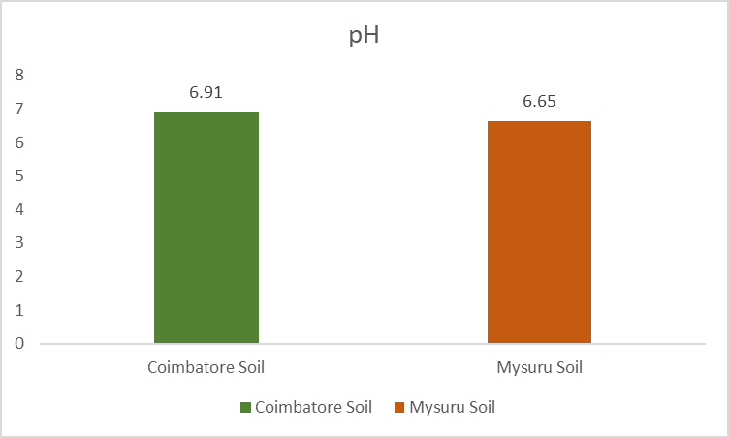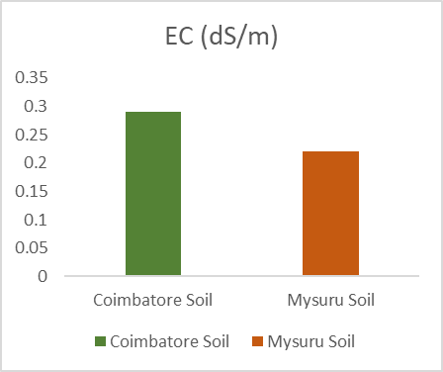
fig (a) fig (b)

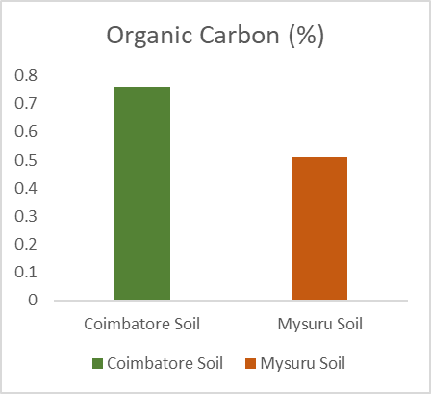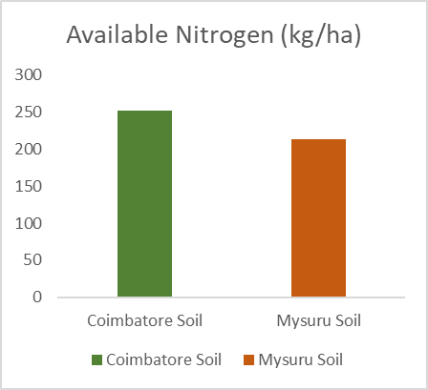
fig (c) fig (d)
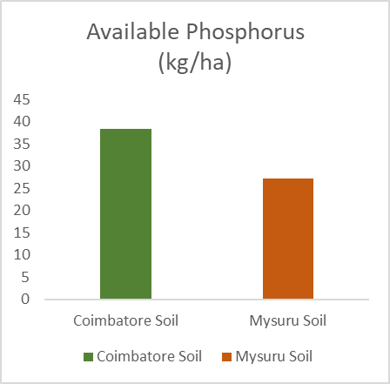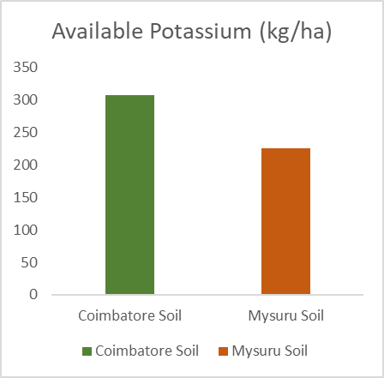
fig (e) fig (f)
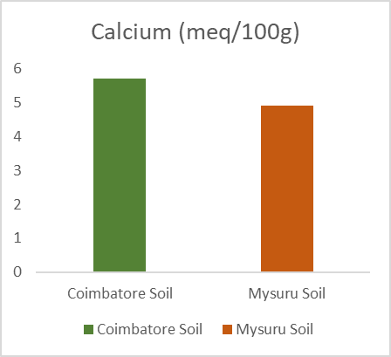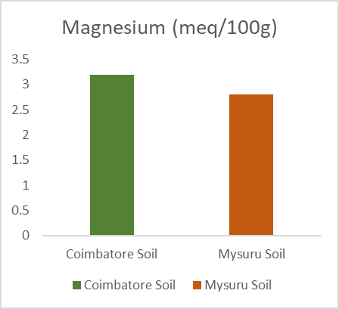
fig (g) fig (h)
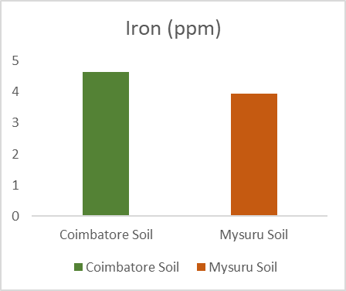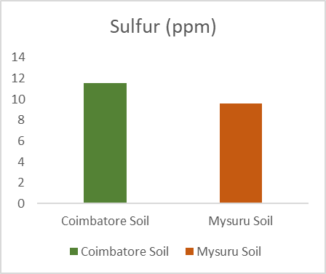
fig (i) fig (j)
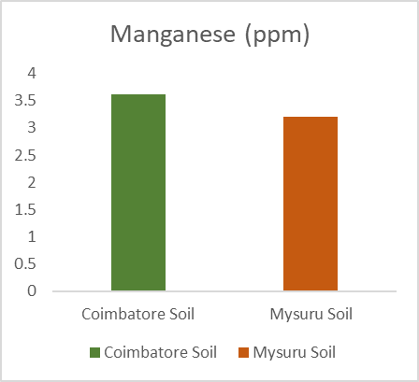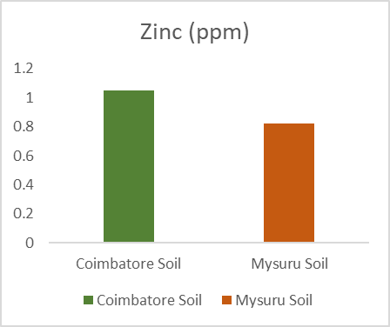
fig (k) fig (l)

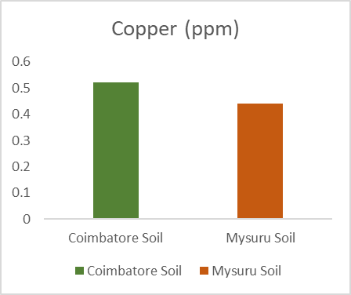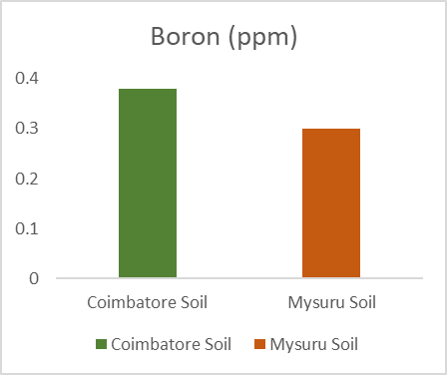
Fig (m) fig (n)
Fig. 1 Comparative graphical representation of soil analysis
Graphical comparison of soil nutrient levels between Coimbatore and Mysuru. This figure clearly illustrates that Coimbatore consistently shows higher levels across most micronutrients, secondary nutrients, and micronutrients, supporting its better suitability for organic red sorghum cultivation.

4. Discussion
4.1 Soil Chemical Properties
The pH levels observed in both Coimbatore (6.91) and Mysuru (6.65) fall within the slightly acidic to near-neutral range, which is generally considered optimal for sorghum growth (Tandon, 2013). Such pH levels promote balanced nutrient solubility and optimal microbial activity, both of which are critical in organic systems where nutrient mineralisation is largely microbially mediated. While the difference between the two regions is small, Coimbatore’s marginally higher pH could be linked to its parent material and historical organic matter management. The low EC values in both regions confirm the absence of salinity hazards, a crucial consideration for sorghum cultivation in semi-arid climates. Similar findings were reported by Ghosh et al. (2004), who emphasised that low EC and balanced pH are key to sustaining millet productivity under organic farming.
4.2 Macronutrient Status
The marked differences in available nitrogen, phosphorus, and potassium between the two regions highlight important fertility dynamics. Coimbatore’s higher nitrogen content (252 kg/ha) suggests a more active nitrogen cycle, potentially driven by regular organic manure application, inclusion of legumes in rotation, and higher organic carbon levels that support microbial mineralisation. Mysuru’s comparatively lower nitrogen levels (213 kg/ha) may constrain early vegetative growth and grain filling, necessitating interventions such as green manuring or vermicompost application.
Phosphorus availability, often a limiting factor in Indian soils, was significantly higher in Coimbatore (38.4 kg/ha) than in Mysuru (27.3 kg/ha). This could be attributed to differences in soil mineralogy and the use of slow-release phosphorus sources in Coimbatore. Potassium levels followed a similar trend, with Coimbatore (307 kg/ha) exceeding Mysuru (225 kg/ha), indicating better cation retention capacity — possibly a result of higher organic matter and clay content.
4.3 Micronutrient Status
Micronutrients such as Fe, Mn, Zn, and B play vital roles in enzymatic reactions, reproductive development, and stress tolerance. The consistently higher concentrations of these nutrients in Coimbatore may be due to a combination of soil type, organic input diversity, and more favourable conditions for nutrient cycling. For instance, higher organic matter content can chelate micronutrients, preventing leaching losses and improving plant uptake. The lower Zn and B levels in Mysuru could have implications for grain quality, as deficiencies in these elements can impair pollen viability and seed set (Chhimwal et al., 2019).
4.4 Implications for Organic Cultivation
The comparative analysis clearly shows that Coimbatore has an inherent fertility advantage for red sorghum production under organic management. This advantage could translate to reduced dependency on external nutrient inputs and potentially higher yields with consistent grain quality. However, Mysuru soils, though suitable, would benefit from targeted soil fertility enhancement strategies. Recommended practices include:
- Increasing organic carbon through farmyard manure, compost, and green manures.
- Addressing phosphorus limitations with rock phosphate and phosphorus-solubilising biofertilizers.
- Diversifying crop rotations to include leguminous cover crops for nitrogen enrichment.
- Incorporating mulching practices to reduce nutrient losses and enhance soil moisture.
Such practices are not only agronomically beneficial but also aligned with organic certification requirements.
4.5 Limitations and Future Scope
While the study provides valuable baseline information on the comparative soil fertility of Coimbatore and Mysuru, certain limitations should be acknowledged. First, the analysis was conducted during the pre-sowing period and may not fully capture seasonal nutrient dynamics influenced by cropping cycles and organic input applications. Second, the study focused exclusively on chemical fertility indicators; incorporating physical and biological parameters such as soil aggregation, microbial biomass, and enzyme activity could provide a more holistic assessment of soil health. Third, the yield and quality outcomes of red sorghum were not measured in this phase; integrating crop performance data in future studies would strengthen the direct applicability of findings.
Future research should therefore adopt a multi-season, multi-parameter approach, combining chemical, physical, and biological soil health metrics alongside crop performance indicators. Long-term trials comparing different organic nutrient management strategies in these regions could offer deeper insights into sustainable red sorghum production systems.
5. Conclusion
This comparative study of organically managed soils in Coimbatore and Mysuru provides a region-specific understanding of soil fertility status and its implications for the organic cultivation of red sorghum (Sorghum bicolor L.). Both regions demonstrated pH and EC levels well within the optimal range for sorghum, indicating that salinity and acidity/alkalinity are not limiting factors. However, the marked differences in organic carbon content, macronutrient availability (N, P, K), and micronutrient concentrations (Fe, Mn, Zn, B) highlight the variable inherent fertility between the two agroecological zones.
Coimbatore soils, with their higher organic carbon and superior macro- and micronutrient profiles, offer a clear agronomic advantage for sustaining high yields and grain quality under organic management. In contrast, Mysuru soils, while suitable, display relatively lower nutrient levels, particularly in organic carbon and phosphorus, which could limit yield potential if not addressed through appropriate organic amendments.
From a practical perspective, these findings emphasise the need for region-specific nutrient management strategies in organic sorghum cultivation. In Coimbatore, the focus should be on maintaining existing fertility through balanced nutrient cycling and continued organic matter incorporation. In Mysuru, strategies should prioritise building soil organic matter, improving phosphorus availability through rock phosphate application and microbial inoculants, and diversifying crop rotations to enhance nutrient cycling.
Overall, this research underscores that organic crop planning must be rooted in detailed soil fertility assessments to ensure long-term productivity and environmental sustainability. The outcomes of this study not only contribute to the scientific literature on organic sorghum cultivation but also offer actionable guidance for farmers, extension agents, and policymakers aiming to strengthen the resilience and profitability of organic farming systems in semi-arid regions of southern India.

COMPETING INTERESTS DISCLAIMER:
Authors have declared that they have no known competing financial interests OR non-financial interests OR personal relationships that could have appeared to influence the work reported in this paper.

Disclaimer (Artificial intelligence)
Option 1:
Author(s) hereby declare that NO generative AI technologies such as Large Language Models (ChatGPT, COPILOT, etc.) and text-to-image generators have been used during the writing or editing of this manuscript.
Option 2:
Author(s) hereby declare that generative AI technologies such as Large Language Models, etc. have been used during the writing or editing of manuscripts. This explanation will include the name, version, model, and source of the generative AI technology and as well as all input prompts provided to the generative AI technology
Details of the AI usage are given below:
1.
2.
3.

6. References
- Chhimwal, M., Pandey, R. K., & Srivastava, R. K. (2019). Status of agriculture and horticulture farming in the hill state of India-Uttarakhand. Journal of Pharmacognosy and Phytochemistry, 8(4), 1626-1631.
- Awika, J.M., & Rooney, L.W. (2004). Sorghum phytochemicals and their potential impact on human health. Phytochemistry, 65(9), 1199–1221.
- Wortman, S. E., Galusha, T. D., Mason, S. C., & Francis, C. A. (2012). Soil fertility and crop yields in long-term organic and conventional cropping systems in Eastern Nebraska. Renewable Agriculture and Food Systems, 27(3), 200-216.
- Brady, N.C., & Weil, R.R. (2016). The Nature and Properties of Soils (15th ed.). Pearson.
- Chandrasekara, A., & Shahidi, F. (2010). Content of insoluble bound phenolics in millets and their contribution to antioxidant capacity. Journal of Agricultural and Food Chemistry, 58(11), 6706–6714.
- Hou, J., Gao, X., & Entz, M. H. (2025). Enhancing zinc and iron bioavailability through crop rotation and organic farming: Insights from a long-term study. Field Crops Research, 322, 109710.
- Dicko, M.H., et al. (2006). Review: Sorghum grain as human food in Africa. Field Crops Research, 102(3), 221–231.
- Dykes, L., & Rooney, L.W. (2006). Sorghum and millet phenols and antioxidants. Journal of Cereal Science, 44(3), 236–251.
- FAO. (2020). Sorghum and Millets in Human Nutrition. Rome: Food and Agriculture Organization of the United Nations.
- Ghosh, P.K., et al. (2004). Comparative effectiveness of cattle manure, poultry manure, phosphomonoester and fertilizer-NPK on three cropping systems in Vertisols of semi-arid tropics. Bioresource Technology, 95(1), 77–83.
- Gomez, K.A., & Gomez, A.A. (1984). Statistical Procedures for Agricultural Research (2nd ed.). Wiley.
- ICAR. (2021). Handbook of Agriculture (7th ed.). New Delhi: Indian Council of Agricultural Research.
- IMD. (2021). Annual Climate Summary. India Meteorological Department.
- ICRISAT. (2019). Sorghum in the Semi-Arid Tropics. Hyderabad: International Crops Research Institute for the Semi-Arid Tropics.
- Jackson, M.L. (1973). Soil Chemical Analysis. New Delhi: Prentice Hall of India Pvt. Ltd.
- Bosire, E., Karanja, F., Ouma, G., & Gitau, W. (2018). Assessment of climate change impact on sorghum production in Machakos County. Sustainable Food Production, 3, 25-45.
- Lal, R. (2011). Soil health and climate change: an overview. Soil health and climate change, 3-24.
- Lindsay, W.L., & Norvell, W.A. (1978). Development of a DTPA soil test for zinc, iron, manganese and copper. Soil Science Society of America Journal, 42(3), 421–428.
- Mäder, P., et al. (2002). Soil fertility and biodiversity in organic farming. Science, 296(5573), 1694–1697.
- Olsen, S.R., et al. (1954). Estimation of available phosphorus in soils by extraction with sodium bicarbonate. USDA Circular 939.
- Pimentel, D., et al. (2005). Environmental, energetic, and economic comparisons of organic and conventional farming systems. BioScience, 55(7), 573–582.
- Reddy, B.V.S., et al. (2009). Sorghum as a bioenergy crop for dryland areas. International Sorghum and Millets Newsletter, 50, 1–10.
- Reganold, J.P., & Wachter, J.M. (2016). Organic agriculture in the twenty-first century. Nature Plants, 2, 15221.
- Rooney, L.W., & Waniska, R.D. (2000). Sorghum food and industrial utilization. In C.W. Smith & R.A. Frederiksen (Eds.), Sorghum: Origin, History, Technology, and Production (pp. 689–729). Wiley.
- Aulakh, C. S., Sharma, S., Thakur, M., & Kaur, P. (2022). A review of the influences of organic farming on soil quality, crop productivity and produce quality. Journal of Plant Nutrition, 45(12), 1884-1905.
- SPSS. (2022). IBM SPSS Statistics for Windows, Version 28.0. IBM Corp.
- Subbiah, B.V., & Asija, G.L. (1956). A rapid procedure for the estimation of available nitrogen in soils. Current Science, 25, 259–260.
- Tandon, H.L.S. (2013). Fertilizer Recommendations for Horticultural Crops. New Delhi: Fertiliser Development and Consultation Organisation.
- Taylor, J.R.N., et al. (2006). Gluten-free foods and beverages from sorghum and millet. Cereal Foods World, 51(6), 255–261.
- Taylor, J.R.N., et al. (2014). Developments in sorghum food technologies. Food Reviews International, 30(1), 1–27.
- TNAU. (2022). Red Sorghum Cultivation Guide. Tamil Nadu Agricultural University.
- USDA NRCS. (2020). Soil Health and Fertility. Washington, DC: United States Department of Agriculture, Natural Resources Conservation Service.
- Walkley, A., & Black, I.A. (1934). An examination of the Degtjareff method for determining soil organic matter and a proposed modification of the chromic acid titration method. Soil Science, 37(1), 29–38.
- Espitia-Hernández, P., Chavez Gonzalez, M. L., Ascacio-Valdés, J. A., Dávila-Medina, D., Flores-Naveda, A., Silva, T., ... & Sepúlveda, L. (2022). Sorghum (Sorghum bicolor L.) as a potential source of bioactive substances and their biological properties. Critical Reviews in Food Science and Nutrition, 62(8), 2269-2280.
- Mawouma, S., Condurache, N. N., Turturică, M., Constantin, O. E., Croitoru, C., & Rapeanu, G. (2022). Chemical Composition and Antioxidant Profile of Sorghum (Sorghumbicolor (L.) Moench) and Pearl Millet (Pennisetumglaucum (L.) R.Br.) Grains Cultivated in the Far-North Region of Cameroon. Foods, 11(14), 2026.
- Zannou, O., Miassi, Y. E., Dossa, K. F., Houngbédji, M., Agani, O. B., Kpoclou, Y. E., ... & Galanakis, C. M. (2025). Red sorghum (Sorghum bicolor) leaf sheaths as source stable pigments. Discover Food, 5(1), 4.
- Peterson, J., Santana, A. L., Cox, S., Perez-Fajardo, M., Covarrubias, J., Perumal, R., ... & Smolensky, D. (2024). Impact of heat and high-moisture pH treatments on starch digestibility, phenolic composition, and cell bioactivity in sorghum (Sorghum bicolor L. Moench) flour. Frontiers in Nutrition, 11, 1428542.

