Distribution and Occurrences of Parasitic Nematodes Associated with Beans (Phaseolus vulgaris L.) in the Sotuba Market Gardening Area in Mali
Original Research Article

ABSTRACT
A nematological faunistic study was carried out on common bean plots in Bamako between June and September 2023. It took place on the experimental plots of the fruit and vegetable program of the Sotuba Agricultural Research Center. The objective of the study was to identify the occurrence of nematode genera associated with beans. Two varieties of beans were concerned: Blanc de Kati and GLP. The trials were set up on two 400 m² plots and ten samples were taken using a systematic method using an auger. In the laboratory, two extraction techniques were used: sieving and the modified Baermann technique. Plant-parasitic nematodes were observed and identified under an optical microscope at x400 magnification. The observations revealed the presence of 8 genera of nematodes in the soil and 6 in the roots. The genera found in the soil are: Scutellonema, Tylenchorhynchus, Paratylenchus, Helicotylenchus, Meloidogyne, Pratylenchus Criconemella and Hoplolaimus). Those found in the roots were Scutellonema, Paratylenchus, Helicotylenchus, Meloidogyne, Heterodera and Pratylenchus). The analysis of the results shows that the genera Pratylenchus Tylenchorhynchus and Helicotylenchus are the most important with 69% of the nematodes identified. Among the nematodes identified were species dangerous for crops in general, including Meloidogyne. Analysis of physicochemical parameters indicates a trend of variation in the distribution of nematodes depending on the soil structure This study demonstrates the need to monitor pest thresholds to prevent extreme outbreaks that can cause significant yield declines.
Keywords : Occurrence, parasitic nematodes, Phaseolus vulgaris, densities, Sotuba

1. INTRODUCTION
The common bean (Phaseolus vulgaris L.) is a legume of the Fabaceae family. It is native to Latin America. The genus Phaseolus includes approximately 80 cultivated and wild species, but P. vulgaris is the most widely cultivated species (Romero-Astudillo, 2024).
In Africa, common beans are cultivated on an area estimated at approximately four million hectares, primarily by women. Its legume status makes it a fertilizer, a source of food, and income for producer households. Beans represent an important source of income for rural farmers. Annual sales in Africa amounted to more than $580 million in 2005. Beans, with a protein content of 22%, represent a source of protein for nearly one hundred million people. In addition to protein, they also contain iron, zinc, fiber, and complex carbohydrates. East Africa holds the world record for bean consumption per capita, at approximately 60 kg per year (Coulibaly, 2024).
In Mali, bean production is estimated at 4,252 tonnes (Delhove, 2023). The Bamako district and the Koulikoro region are the two main green bean production regions in 2019, with local consumption of around 3,300 tonnes, or around 97% of national production (Delhove et al, 2023).
Despite this good production and all the nutritional importance linked to the consumption of beans, its production remains subject to numerous constraints such as climate change, low soil fertility, etc. In addition to these abiotic constraints, there are parasites such as fungi, insects and especially nematodes. The latter occupy an important place among the biotic constraints. Nematodes of the genus Meloidogyne and Pratylenchus are important pests of beans. Their attacks induce the formation of root galls (Figure 1) and necrosis respectively (Delhove et al., 2023). The yield losses they cause in tropical and subtropical countries are estimated at 14.6% in developed countries (Nicol et al., 2013). In terms of money, these crop losses were estimated at nearly 150 billion US dollars per year (Coyne et al., 2018).
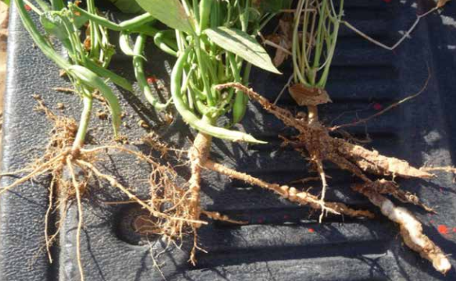
Figure 1. Meloidogyne spp. galls on beans (Chabrier, 2014)
2. MATERIALS AND METHODS
2.1. Location and description of the study site
From June to September 2023, during the rainy season, this faunal study was carried out on two common bean plots, each measuring 400 m². It took place on two experimental plots at the Sotuba Agronomic Research Center in Bamako, Mali (Table 1). Two bean varieties related to the two plots were involved: Blanc de Kati (12°39’45’’N; 7°55’27’’W) and GLP (12°39’34’’N; 7°55’13’’W).
Table 1: Geographic coordinates of the experimental plots
Plots | Phaseolus Variety |  | Plot Coordinates
Plot 1 | Blanc de Kati | 12°39’45’’N ; 7°55’27’’W
Plot 1 | GLP | 12°39’34’’N ; 7°55’13’’W
Plant Material
The plant material covered in this study consists of two varieties of common bean (Phaseolus vulgaris): the first is called Blanc de Kati, a variety known to be adapted to poor soils, and the second is called GLP, a variety resistant to several diseases (Figure 2). These are both large-grained varieties with a yield of two tons per hectare (MA, 2024). For all these reasons, these two varieties are highly valued by producers and have been the subject of numerous studies aimed at improving food security, income, and the health of producers on the African continent.
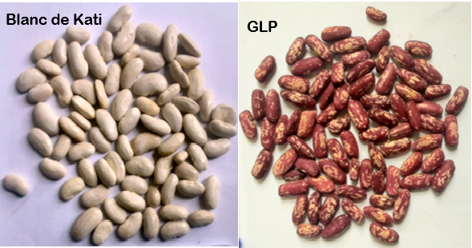
Figure 2: Grains of the two varieties of P. vulgaris: Blanc de Kati on the left and GLP on the right Soil sample collection:

2.2. Samples collection
Soil Samples
Soil samples were collected using a systematic method, i.e., one that took into account the plot as a whole and the aggregate distribution of nematodes. Soil samples were taken at a depth of 30 cm using a soil auger. For each of the 400 m² plots, 10 samples were taken on the diagonals and mixed to form a composite sample. 250 g of this sample was placed in a plastic bag, labeled with the date, crop, site and plot number, then placed in a cooler for transport to the laboratory.
Root Collection
To collect the roots, randomly uprooted bean plants using a trowel. After gently shaking off most of the adhering soil, the roots were cut with scissors. Ten bean plants were collected from each plot. These roots, along with the soil, were placed in plastic bags, labeled, and then placed in a cooler for transport to the laboratory.
2.3. Nematological Analyses
2.3.1. Extraction of nematodes from the soil using the modified Baermann technique.
Using a beaker, 100 ml of soil from the plots were collected, the clods of soil were broken up, and large debris such as stones, twigs, roots, etc. were removed. The soil was placed on a Kleenex-type filter, then on a 1 mm mesh sieve, and the entire sample was placed in a plate. Water was then added to the sample so that it was completely moistened but not completely submerged (Figure 3). This device was covered with another labeled plate and left for 48 hours. After these two days, all the water in the plate was filtered through a 38 µm sieve. The resulting filtrate was placed in a 100 ml beaker for decantation and pipetting. This decantation lasts at least two hours. Following this decantation, the nematode suspension is reduced to the pellet by carefully reducing the amount of water in the surface part using a Pasteur pipette with a bulb. This pipetting is done in such a way as to maintain a suspension of approximately 25 ml (V). From this suspension, an aliquot of 5 ml (v) was taken and then placed in a counting box for observation under a microscope.
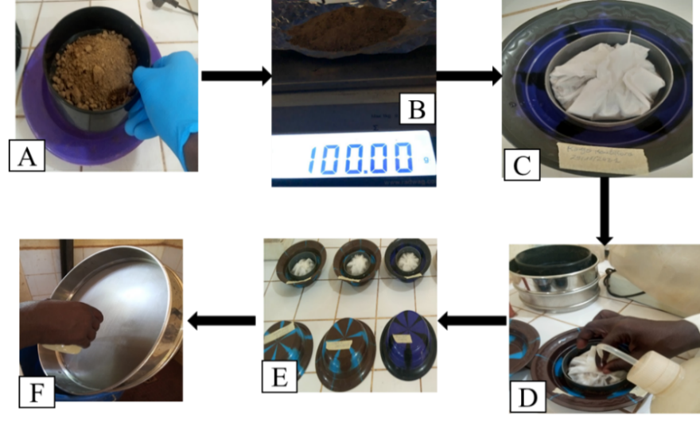
Figure 3: Illustration of the modified Baermann technique. Key: A: Soil sieving; B: 100 ml of soil; C= Kleenex containing the soil; D and E: active passage and F: Filtration
2.3.2. Extraction of nematodes from the roots
The roots were gently cleaned under a running tap to remove soil and several saprophytic nematodes. The roots were cut into small pieces and disinfected by soaking in a bleach solution (1% active chlorine) for 4 minutes to brighten them, then rinsed with tap water for 15 minutes. A 20g subsample was taken from the composite sample and ground with water using a kitchen blender. The roots were ground for three 30-second periods, separated by a brief settling period. The analysis process was conducted according to the Baermann technique described above.
2.3.3. Nematode identification
Nematode Fixation for Counting:
The nematodes were fixed by immersion in a boiling FA solution (10 ml formalin; 1 ml glacial acetic acid; 89 ml distilled water) (Coyne et al., 2018). The technique consisted of adding the heated FA solution to the nematode suspension in equal volumes (v/v) in a small, stoppered bottle. This fixation allows the nematodes to be preserved for at least one month.
Observation
The nematode suspension obtained after decanting and pipetting was adjusted to 25 ml (V) by adding distilled water. From this volume (V), a 5 ml aliquot (v) was taken and placed in a counting dish for microscopic observation at 400X magnification. Nematode Identification:
The nematodes were identified using the key from (Mai and Mullin, 1996) and the discriminating morphological characteristics reported by (Mateille and Tavoillot, 2016): the length and shape of the stylet, the shape of the head and tail, the covering (i.e., the arrangement of the esophageal gland relative to the intestine), and the position of the vulva.
Nematode Counting
This is done under a microscope by placing the solution in a transparent dish with a gridded bottom.
2.4. Soil Data
Soil samples from both plots were sent to the Soil Water Plant Laboratory (LABOSEP) in Sotuba, where a physicochemical analysis was performed to determine the pH, the different particle size fractions (sand, clay, and fine silt), and the carbon, nitrogen, potassium, and phosphorus contents. The texture triangle was used to determine the soil texture of the different sites.

2.5. Nematological Data
The data were entered into an Excel spreadsheet and analyzed. The importance of each nematode genus was determined by calculating the density and frequency of occurrence by genus and plot. An analysis of variance was performed to compare the average densities of nematodes living in the rhizosphere of the two bean varieties.
Nematode Frequency
Occurrence provides information on the environmental preference of a given species. It consists of counting the number of times species x appears in the samples. This number is expressed as a percentage of the total number of records and provides information on the species frequently encountered in the environment. According to (Dajoz 1985) we distinguish: constant species (F ≥ 50%), accessory species (25% < F< 50%), accidental species (F ≤ 25%).
3. RESULTS
3.1. Nematological Analysis
3.1.1. Importance of Soil Nematodes
Analysis of soil samples from the two plots revealed the presence of eight genera of phytonematodes belonging to six families (Table 2): Scutellonema, Tylenchorhynchus, Paratylenchus, Helicotylenchus, Meloidogyne, Pratylenchus, Criconemella, and Hoplolaimus. Among these nematodes, three genera accounted for 69% of the nematodes recorded: Pratylenchus, Tylenchorhynchus, and Helicotylenchus. The eight genera were found in the rhizosphere of the Blanc de Kati, compared to five around the GLP variety (Figure 4). Average densities varied from one plot to another. The highest proliferation was observed for the genus Pratylenchus in the rhizosphere of the GLP variety, with a density of 233 individuals per 100g of soil. On the other hand, the lowest density was that of the genus Scutellonema around the GLP variety with 10 individuals/100g of soil. Statistical analysis of the average densities per variety showed a significant difference between the means (Anova, p<5%).
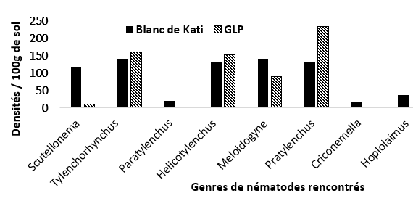
Figure 4: Average nematode densities in the rhizosphere of the two bean varieties
3.1.2. Root nematodes
From the analysis of the roots of the two varieties, six genera of nematodes were observed. These were: Scutellonema, Tylenchorhynchus, Paratylenchus, Helicotylenchus, Meloidogyne, and Pratylenchus. Nematode densities varied by genera and by plot. Overall, the GLP variety showed a higher proliferation. The Helicotylenchus genus was the highest, with a density of 684 nematodes/20g of fresh roots. The lowest density was noted for the Paratylenchus genus, with 37 nematodes/20g of roots. For Kati white, the genus Scutellonema is the densest genus with 330 individuals/20g of roots and the lowest density is that of Paratylenchus with 20 individuals/20g (figure 5).
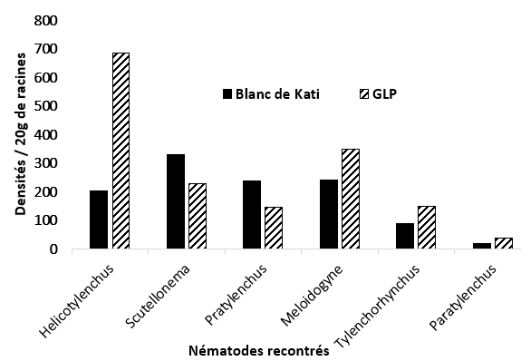
Figure 5: Average nematode density in the roots of the two bean varieties
3.1.3. Nematode Occurrence Frequency
The frequency of occurrence allowed us to analyze the structure of the stands. The results showed that eight and five genera were found around the Blanc de Kati and GLP varieties, respectively (Table 2). All these genera were consistent, with an occurrence frequency ≥ 50%.
Table 2: Nematode occurrence frequencies in the two plots combined
Genres | Famillies | Frequencies Of occurrence % |  | Types Of occurrence
Scutellonema | Hoplolaimidae |  | 100 | Constant
Tylenchorhynchus | Belonolaimidae |  | 100 | Constant
Paratylenchus | Paratylenchidae |  | 100 | Constant
Helichotylenchus | Hoplolaimidae |  | 100 | Constant
Meloidogyne | Heteroderidae |  | 100 | Constant
Pratylenchus | Pratylenchidae |  | 100 | Constant
Criconemella | Criconematidae |  | 100 | Constant
Hoplolaimus | Hoplolaimidae |  | 50 | Constant

3.2. Soil Data
The soil data included physicochemical and particle size parameters. The results for the physicochemical parameters are shown below in the figure 6.
3.2.1. Physicochemical Parameters
Regarding Hydrogen Potential (pH), almost similar values were found in the different plots. These values were below the neutral threshold (pH > 7). A comparison of these values shows that they ranged from 5.7 in the GLP plot to 6.5 in the Kati White plot (Figure 6). This acidic soil trend, highlighted by the low values in all plots, could be due to oxidation of organic matter. Regarding organic carbon, the levels did not vary greatly between plots; the percentages fluctuated slightly between 0.88 and 0.91 (Figure 6). These lower levels are explained by the intensification of cropping at the experimental site. Indeed, intensive soil exploitation can reduce the organic matter content, leading to a drop in fertility. For organic nitrogen, the levels are low and perfectly similar. A rate of 0.02 was in both plots (Figure). As for available phosphorus, it is expressed in ppm; the highest values were recorded in the Kati white plot at 12.99 ppm compared to 12.52 ppm in the GLP plot (Figure 6).

Figure 6: Chemical parameters of the plots
3.2.2. Grain Size Parameters
Grain size encompasses three measured parameters: sand (Sb) refers to particles larger than 0.05 mm, fine silt (Lf) is formed by particles between 0.05 and 0.002 mm, and clay (Ag) by those smaller than 0.002 mm. Overall, the sand content was higher than that of the other grain size parameters, followed by silt (Figure), with a sand content of 65.5%, fine silt 27.5%, and clay 7%. The soil texture determined using the triangle shows a sandy loam soil type.
4. DISCUSSIONS
4.1. Fauna study
This study provides information on the diversity and structure of nematodes associated with beans in the experimental plots of the Sotuba Agronomic Research Center in Mali. Eight genera belonging to 6 families were encountered, namely: Scutellonema, Tylenchorhynchus, Paratylenchus, Helicotylenchus, Meloidogyne, Pratylenchus Criconemella and Hoplolaimus. Previous studies in other countries have revealed the presence of several genera of plant-parasitic nematodes associated with beans that reduce yields and cause significant economic losses. For example, in Ghana, a study on nematodes associated with common beans reported the presence of 5 genera such as Meloidogyne, Pratylenchus, Rotylenchus, Helicotylenchus and Trychodorus (Adomako et al., 2022). In Burkina Faso, a greater diversity of phytoparasitic nematodes was reported by (Traoré et al., 2014) on another Fabaceae (Vigna unguiculata). There, seven genera were found with a higher rate of Meloidogyne.
Greater diversity was found in Ivory Coast on vegetable crops where nine genera were found: Meloidogyne, Helicotylenchus, Radopholus, Pratylenchus, Hemicycliophora, Rotylenchulus, Hoplolaimus, Xiphinema and Heterodera (Sandrine et al, 2024). All these studies report the frequency of the genus Meloidogyne spp on vegetable crops such as Solanaceae, Cucurbitaceae and Compositae (Bui et al., 2022). Thus in Egypt El-Nuby et al., 2019 report that the genus Meloidogyne was common on eggplants (55.8%) and watermelons (61.9%). It was also common in rice fields (49%) in India (Nisa et al., 2022). Delhove et al., 2023 report that Meloidogyne, Pratylenchus are very polyphagous with preferences for Poaceae, Solanaceae (tomato, potato), Cucurbitaceae, Arachis hypogeae, Zea mays, tobacco, pineapple, sweet potato etc. This sedentary endoparasite is recognized as the most economically damaging in many countries on several crops, because it has a wide host range (Isgouhi and Teixeir, 2019; Sandrine et al, 2024). Its development leads, among other things, to poor plant growth, a drop in crop yield, etc.
4.2. Relationships between soil properties and nematode densities
Root analysis of both varieties revealed that nematode distribution could be linked to the higher sand (69%) and clay (9%) levels around the GLP variety. Indeed, 59% of nematodes were found around this variety, compared to 41% associated with Kati White. This result demonstrates the importance of soil structure in nematode distribution. For example, in the USA, (Escalante Ortiz and Brye, 2023), during a study on soybeans, they reported that physicochemical parameters influence nematode population densities and indicated that a good understanding of the variation in these soil properties could provide a solution for nematode control.
Conclusion
This study revealed the presence of eight genera of nematodes in the rhizosphere of common beans. These nematodes belong to six families. The most significant proliferation of populations was observed around the variety known as: Blanc de Kati. Specifically, the most important genus in terms of density is Pratylenchus. Physicochemical analyses of the soil studied gave very similar values. Hence the distribution of nematodes around common bean varieties probably does not depend on soil structure. The difference in diversity could be due to a preference of nematodes for the Blanc de Kati variety. The constant type of frequency of occurrence for all genera encountered shows the susceptibility of the bean to phytoparasitic nematodes. High frequencies greater than or equal to 50% deserve special attention in research programs on crop protection in the Republic of Mali because among these nematodes there is a genus particularly damaging to crops: Meloidogyne spp. Future studies could be oriented towards research on the severity of attacks, population dynamics during the year to better control nematodes and ensure healthy vegetable production.
Conflicts interest
The authors declare that there is no conflict of interest between them. Author(s) hereby declare that NO generative AI technologies such as Large Language Models (ChatGPT, COPILOT, etc.) and text-to-image generators have been used during the writing or editing of this manuscript.
Disclaimer (Artificial intelligence)
Option 1:
Author(s) hereby declare that NO generative AI technologies such as Large Language Models (ChatGPT, COPILOT, etc.) and text-to-image generators have been used during the writing or editing of this manuscript.
Option 2:
Author(s) hereby declare that generative AI technologies such as Large Language Models, etc. have been used during the writing or editing of manuscripts. This explanation will include the name, version, model, and source of the generative AI technology and as well as all input prompts provided to the generative AI technology
Details of the AI usage are given below:
1.
2.
3.
References
Adomako, J., Yeboah, S., Asamoah, JF., Amankwaa-Yeboah, P., Adjei, E.A., Obeng, EA. and al. (2022). Survey of plant parasitic nematodes and disease severity of common bean lines evaluated for reaction to root knot nematodes infestation. African Crop Science Journal. Flight. 30, No. 2, pp. 147 – 154; ISSN 1021-9730/2022. DOI: https://dx.doi.org/10.4314/acsj.v30i2.3.
Bui H.X, Gu M, Riva G and Desaeger J.A. (2022). Research/Investigation Meloidogyne Spp. Infecting Asian Vegetables in Central Florida, USA. Nematropica. 52: 56–63.
Chabrier, C. (2014). Nematode Control Solutions in Senegal. Mission Report to Senegal from January 26 to February 6, 2014; COLEAD/PIP. 50p.
Coulibaly F.S. 2024. Inventory of Nematodes Associated with Beans (Phaseolus vulgaris L) in the Sotuba Market Gardening Area in Bamako (Mali). Master's Thesis; in Biological Sciences, Specialization: Applied Biological Sciences, Option: Plant Improvement and Protection. Faculty of Science and Technology, USTTB. 59p.
Coyne, D.L., Cortada, L., Johnathan, J., Dalzell, Abiodun O. Claudius-Cole, et al. (2018). Plant-Parasitic Nematodes and Food Security in Sub-Saharan Africa. Annual Review of Phytopathology; 2018. 56:381–403. https://www.annualreviews.org; https://doi.org/10.1146/annurev-phyto-080417-045833. 23p.
Delhove, G., Dioh, S., Jacques, A., Lehmann, E., De Bauw, P. (2023). Sustainable Green Bean Production Guide, COLEAD: https://resources.colead.link/fr/e-bibliotheque/guide production-durable-lharicot-ver. Brussels, Belgium, 376p.
El-Nuby, E.I., Ahmed S.M., Sayed A.M and Ismail A.E.K. (2019). Diversity of plant parasitic nematodes associated with some vegetables in Sinai peninsula, Egypt. Egypt. J. Desert Res. DOI: 10.21608/EJDR.2021.16271.1032 69:77–100.
Escalante Ortiz, L.E. and Brye, K.R. (2023) Relationships among Soil Properties, Nematode Densi ties, and Soybean Yield in a Long-Term, Double-Crop System in Eastern Arkansas. Agricultural Sciences, 14, 1605-1623. https://doi.org/10.4236/as.2023.1412104.
Isgouhi K and Teixeir M. (2019). Advances in plant_ematode interactions with emphasis on the notorious nematode genus Meloidogyne. Phytopathol. Rev. 109 No. 12: 1988–1996. https://doi.org/10.1094/PHYTO-05-19-0163-IA.
May, W.F., and Peter G. Mullin. (1996). Plant-Parasitic Nematodes: A Pictorial Key to Genera. 5th ed. Ithaca: Comstock Pub. Associates, Cornell University Press, New York, USA. 277p.
Mateille, Thierry, and Johannes Tavoillot. 2016. Identification of plant-parasitic nematodes. http://ephytia.inra.fr/.Info-Bioaggressors - Nematodes. Accessed August 2, 2025.
Nicol, J.M., Turner, SJ., Coyne, DL., Nijs, L., Hockland, Den S and Thana, MZ. (2011). In Current nematode threats to world agriculture In Genomics and Molecular Genetics of Plant-Nematode Interactions.Chapter: pp 21–43. Jones J, Gheysen G, Fenoll C. Springer.
Nisa, UK; Nisa, A.U.; Hroobi, A.A.; Shah, A.A.; Tantray, A.Y. Year-Long Assessment of Soil Nematode Diversity and Root Inhibition-Indicator Nematode Genera in Rice Fields. Biology 2022, 11, 1572. https://doi.org/10.3390/biology11111572.
Romero-Astudillo, M.J.; Tapia, C.; Giménez de Azcárate, J.; Montalvo, D. Diversity of Common Bean (Phaseolus vulgaris L.) and Runner Bean (Phaseolus coccineus L.) Landraces in Rural Communities in the Andes Highlands of Cotacachi—Ecuador. Agronomy 2024, 14, 1666. https://doi.org/10.3390/agronomy1408166.
Sandrine Y.A., Gnenakan Y., Jacob N., Eric-Olivier T., Martial K.K.F.J., Gilchrist K.E.Y., and al (2024). Plant parasitic nematodes associated with vegetable crops in the main agroecological zones of Côte d’Ivoire. Asian J. Agric. Biol. 2024(2): 2023128. DOI: https://doi.org/10.35495/ajab.2023.128
Traoré, M., Ouattara, B., Lompo, F., Ouattara, K. (2014). Study of plant-parasitic nematodes of soil and roots under four levels of mineral fertilization in cowpea crops. Int. J. Biol. Chem. Sci. 8 (3): 891–902, DOI: 10.4314/ijbcs. v8i3.6. June 2014. 13 p.

