Effect of Biochar Application on Soil Fertility and SOC Dynamics in Maize-Based Vertisol Systems of Akola Region, Maharashtra, India

ABSTRACT
In many countries, after harvesting, farmers choose to burn crop residues in their fields as waste material. As a result, burning of crop residues like cotton stalks, maize stalks, rice husk, etc., releases a lot of carbon dioxide (CO₂) into the atmosphere, contributing to climate change, which causes air pollution. The primary objective of this research was to practically demonstrate the conversion of biomass into biochar and to explore its application as a valuable substance with an aim to discuss the impact of biochar application on soil properties and SOC stock at harvest of maize grown on Vertisols. The field trial was carried out in 2020-21 (Kharif) at Research Farm, Department of Agronomy, Dr. PDKV, Akola, Maharashtra, India. The experiment was conducted by using a Randomised Block Design (RBD) with eight treatments comprised of control, different rates of nitrogen and their combinations with 2.5 and 5.0 t ha⁻¹ biochar and three replications. The data were subjected to statistical analysis. Based on the results obtained from analysis, the physical and chemical properties of soil such as water holding capacity (55.35%), organic carbon (6.48 g kg⁻¹), available nitrogen (249.33 kg ha⁻¹), phosphorus (21.63 kg ha⁻¹) and potassium (358 kg ha⁻¹) after harvest of maize were found to be significantly higher by applying 125 % RDN + 5 t ha⁻¹ of Biochar, while, the bulk density, electrical conductivity and soil pH were found to be non-significant by various treatments. Increasing the doses of biochar resulted in a slight increase in the availability of Zn, Cu, Fe & Mn, but the differences among the treatments were found to be statistically non-significant. The higher the quantity of biochar applied, the greater the soil organic carbon (SOC) stock was recorded. Based on the current study, it can be concluded that, application of 100% RDN + 5 t ha⁻¹ Biochar improves the available nutrient status and physical-chemical properties of soil after the harvest of maize. Additionally, a favourable impact on the soil organic carbon (SOC) stock is also noted.

Keywords: Biochar, Soil properties, Soil Organic Carbon Stock, Nitrogen, Carbon

Introduction
The management and disposal of crop residues left in the field after harvesting is a major challenge across various agricultural sectors. In many countries, after harvesting, farmers choose to burn crop residues in their fields as waste material. As a result, burning of crop residues like cotton stalks, maize stalks, rice husk, etc., releases a lot of carbon dioxide (CO₂) into the atmosphere, contributing to climate change, which causes air pollution (Kranthi and Kranthi 2023). Instead of burning these residues, farmers can utilise them as raw materials for the production of biochar, biogas, ethanol, or other biofuels. The Conversion of organic waste into biochar via pyrolysis significantly enhances natural carbon sequestration capacity in the soil, promoting soil health and fertility essential for sustainable agriculture and acting as a potential tool in reducing the impact of greenhouse gases on global climate change (FAO, 2023).
Biochar is a solid, black, porous, fine-grained and carbon-rich material that is highly resistant to microbial decomposition. It is produced through the thermo-chemical conversion of plant biomass via Pyrolysis at low temperature (350-600°C) under limited or no oxygen supply (Amonette and Joseph, 2009). As per the analysis report by Yeboah (2009), chemically biochar contains 38.8% organic carbon, 1 g kg⁻¹ Total P₂O_{5,} 3.3 g kg⁻¹ K₂O, 5.7 g kg⁻¹ CaCO₃ and a C: N ratio of 68.2. Biochar is not pure carbon; rather, it is a heterogeneous mixture of carbon (C), hydrogen (H), oxygen (O), nitrogen (N), sulphur (S) and ash in varying proportions (Masek, 2009). Similar to traditional manures and fertilisers, biochar plays a key role in maintaining valuable nutrient sources by creating a favourable soil environment for plant growth. Typically, it contains over 60% carbon, and because of its multifunctional properties, biochar is often referred to as "Black Gold" of agriculture. Biochar is known for its exceptional features, such as a high composition of stable carbon. This aids long-term carbon immobilisation in soil and improves fertility due to its controlled release of locked-up carbon and nutrients for several decades. This also helps to ameliorate climate change due to reduced atmospheric carbon and gases from recurring fertiliser applications (Ighalo et al., 2025).

Application of biochar mixed with mineral fertilisers increased soil pH, organic carbon and improved the availability of nutrients. This combined application also improves plant growth, crop yield and quality by enhancing soil biological activity (Saha et al., 2019). Additionally, it also enhances the water holding and cation exchange capacity of soil, which helps to retain a higher amount of nutrients and reduces losses of applied mineral fertilisers through leaching (Sohi et al., 2010). Biochar is considered the most important soil amendment, which improves nutrient and water retention capacity of soil, fighting against global climate change by capturing carbon dioxide (CO₂) from the air and storing it in the soil for a long time (Lorenz and Lal, 2014; Han et al., 2022). Biochar as a soil amendment provides solutions to the most recent threats to soil health and the mitigation of climate change. However, as biochar technologies are relatively new, there is a lack of data regarding short and especially long-term stabilisation of SOC stocks and their fate after biochar amendment (Gross et al., 2021; Shyam et al., 2025). Therefore, it is essential to raise awareness among farmers about the benefits of organic sources, including biochar, to promote environmentally sustainable and economically viable farming practices.
Materials and methods
The field trial was conducted during 2020-21 (Kharif) at Research Farm, Department of Agronomy, Dr. PDKV, Akola, by using a Randomised Block Design (RBD) with eight treatments and three replications. The treatments composed of T_{1:} Control, T_{2:} 100 % RDN, T_{3:} 75% RDN + 2.5 t ha⁻¹ Biochar, T_{4:} 100% RDN +2.5 t ha⁻¹ Biochar, T_{5:} 125% RDN +2.5 t ha⁻¹ Biochar, T₆: 75% RDN + 5.0 t ha⁻¹ Biochar, T_{7:} 100% RDN + 5.0 t ha⁻¹ Biochar & T₈: 125% RDN + 5.0 t ha⁻¹ Biochar. Biochar was produced from hardwood forest biomass using the drum method via pyrolysis, a process that involves thermal decomposition of organic material in the absence of or a low-oxygen environment. Biochar @ 2.5 & 5.0 t ha⁻¹ was incorporated into the soil one week prior to sowing, according to the respective treatments. Nitrogen in the form of urea (46%N) was applied in two splits doses i.e., basal dose and at 30 DAS while, full doses of P₂O₅ and K₂O in the form of SSP (16% P₂O₅) and MOP (60 % K₂O) were applied to all the treatments as per recommended dose of fertilizers (120-60-30 N, P, K kg ha⁻¹) except in the treatment control.
Various physicochemical properties of biochar were analysed using the following standard methods. pH & EC (1:2.5 solution) were determined by pH meter & conductivity meter respectively (Jackson, 1973), total carbon content by Dry combustion method (Batjes, 2005), total nitrogen by Micro-Kjeldahl’s distillation method (Keeny & Nelson, 1982), total phosphorus by Modified procedure of Change and Jackson (Peterson & Corey, 1966), total potassium by H₂SO₄, HCIO₄ and HF digestion (Jackson, 1973) & C:N ratio by Dry Combustion: Micro Kjeldahl’s method.
Soil samples collected before sowing and after the harvest of maize were subjected to analysis for various physical and chemical properties using standard methodologies. Physical properties, i.e. Bulk density, were determined using the clod coating method (Blake & Hartge, 1986) and maximum water holding capacity by Keen-Raczkowski boxes (Gupta & Dakshinamoorthi, 1980). Soil pH & Electrical conductivity (EC) (1:2.5 soil to water suspension) were measured by using a pH meter & conductivity meter respectively (Jackson, 1973). Organic carbon content was analysed using the wet oxidation method (Nelson & Sommers, 1982), available nitrogen by the alkaline potassium permanganate distillation method (Subbiah & Asija, 1956), available phosphorus by 0.5 M NaHCO₃ and measured spectrophotometrically (Watanabe and Olsen, 1965), available potassium by flame photometry (Jackson, 1973) and available micronutrients (Zn, Cu, Fe & Mn) by DTPA extraction using atomic absorption spectrophotometry (Lindsay & Norvell, 1978).
The soil organic carbon (SOC) stock at each depth was calculated using the following formula
Table 1: Initial properties of soil at the start of the experiment
Sr. No | Biochar Properties | Nutrient content
1 | Bulk density (Mg m⁻³) | 1.58
2 | Water holding capacity (%) | 47.50
3 | pH 1:2.5) | 7.72
4 | EC (dSm⁻¹) | 0.27
5 | OC (g kg⁻¹) | 5.70
6 | Available N (kg ha⁻¹) | 221.12
7 | Available P (kg ha⁻¹) | 15.46
8 | Available K (kg ha⁻¹) | 339
9 | Zinc (mg kg⁻¹) | 0.53
10 | Copper (mg kg⁻¹) | 2.16
11 | Iron (mg kg⁻¹) | 4.23
12 | Maganese (mg kg⁻¹) | 9.20
13 | SOC stock (mg ha⁻¹) | 13.51

The data were subjected to statistical analysis as per the method described by Gomez & Gomez (1984).
Results and Discussion
Production and Chemical composition of biochar

Biochar was prepared from hardwood forest biomass by using the drum method through a pyrolysis process with the aim of maximising carbon content and minimising ash content. Based on the analysis by standard methods, the biochar was found to be alkaline in nature with a pH of 8.70 and EC 0.60 (dSm⁻¹). This result might be due to the formation of carbonates and the contents of the inorganic alkali group (Ding et al., 2014), which resulted in a more alkaline pH of biochar. The biochar prepared from hardwood biomass contains 0.47% nitrogen, 0.23% phosphorus, 1.26% potassium, 74.14% total carbon and a C: N ratio of 157.40 (Table 1). This composition can vary based on the feedstock material and the pyrolysis temperature used for biochar production.

Table 2. Chemical composition of biochar
Sr. No | Biochar Properties | Nutrient content
1 | pH 1:2.5) | 8.70
2 | EC (dSm⁻¹) | 0.60
3 | Total Carbon (%) | 74.14
4 | Total Nitrogen (%) | 0.47
5 | Total Phosphorus (%) | 0.23
6 | Total Potassium (%) | 1.26
7 | C:N ratio | 157.40

Impact of Biochar on Soil properties

Due to its high content of stable carbon and porous structure, biochar offers multiple benefits (Lehmann, 2007; Oni et al., 2019) that enhance the physical, chemical and biological properties of soil (Joseph et al., 2010; Burrell et al., 2016) than other organic amendments. Biochar releases base cations like K⁺, Ca⁺ and Mg^{2+,} thereby increasing nutrient availability in the soil (Bandara et al., 2017).
Physical properties of soil
Bulk density (BD)
The findings revealed that the bulk density of soil at harvest of crop was non-significantly affected by various treatments, and a numerical reduction in bulk density was observed in all biochar-treated plots compared to the treatments without biochar, i.e.T₁ and T₂ (Fig. 1). This result is likely due to lower bulk density and greater compression resistance of biochar (Ulyett et al., 2014) than the mineral soils. Similar findings were reported by Pandian et al (2016), who reported that application of biochar can increase the specific volume of soil per unit weight, thereby reducing its bulk density.
Water holding capacity (WHC)
The results indicated a significant increase in the soil water holding capacity across the various treatments. The Highest water holding capacity (55.35%) was recorded with the application of 125 % RDN + 5 t ha⁻¹ Biochar (T₈), which was statistically at par with the treatments T₇ & T₆ (Fig. 1). Conversely, the treatment control recorded the lowest water holding capacity (47.21%). Increase in water holding capacity of soil due to biochar might be due to improvement in soil structure, its high specific surface area, an extensive pore structure (Sun et al., 2019) and the strong water-adsorptive nature of biochar (Herath et al., 2013).
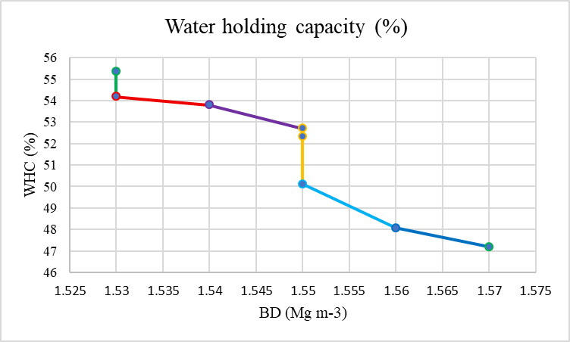
Fig 1. Impact of biochar application on the physical properties of soil
Chemical properties of soil
Soil pH
Based on the analysis by standard methods, the soil pH was non-significantly affected by various treatments, ranging from 7.66 to 7.71, which is moderately alkaline in nature. The highest pH (7.71) was observed in treatment control (T₁), while the lowest pH (7.66) was recorded in treatments T₈ & T₇ (Table 3). Biochar surface contains active oxygen-containing functional groups such as hydroxyl (OH⁻) and carboxyl (COOH⁻), which can react with metal cations in the soil, leading to changes in soil pH (Gan et al., 2015). Addition of biochar to alkaline soil has been reported to decrease soil pH (Liu and Zhang, 2012) due to the formation of the acidic functional groups on the biochar surface, which neutralise soil alkalinity by releasing H⁺ ions, eventually lowering the soil pH. Similar findings were reported by Lee et al. (2021).
Electrical conductivity (EC)
The results of the study showed an increase in the EC from 0.26 to 0.30 dSm⁻¹ (Fig 1) by biochar application, but the effect was non-significant across the various treatments. The highest EC (0.30 dSm⁻¹) was observed in treatments T₈ & T_{7,} while the lowest EC (0.26 dSm⁻¹) was recorded in treatment control (T₁). The application of biochar generally increases Electrical conductivity (EC) of the soil due to its non-saline nature, which is dominated by carbonates of alkali and alkaline earth metals, variable amounts of silica, sesquioxide and small amounts of organic and inorganic nitrogen (Nigussie et al., 2012). This increase is also attributed to the desorption of weakly bound nutrients into the soil solution and the soluble salt concentration in wood-derived biochar (Sara et al., 2018).
Treatment details |  | pH | EC (dS m⁻¹)
T₁ | Control | 7.71 | 0.26
T₂ | 100% RDN | 7.70 | 0.28
T₃ | 75% RDN + 2.5 t ha⁻¹ Biochar | 7.69 | 0.28
T₄ | 100% RDN + 2.5 t ha⁻¹ Biochar | 7.68 | 0.29
T₅ | 125% RDN + 2.5 t ha⁻¹ Biochar | 7.68 | 0.29
T₆ | 75% RDN + 5.0 t ha⁻¹ Biochar | 7.67 | 0.28
T₇ | 100% RDN + 5.0 t ha⁻¹ Biochar | 7.66 | 0.30
T₈ | 125% RDN + 5.0 t ha⁻¹ Biochar | 7.66 | 0.30
 | S.E. (m) ± | 0.01 | 0.006
 | C.D. at 5% | - | -
Table 3: Impact of biochar application on chemical properties of soil

Soil Organic carbon
An increase in application rates of biochar significantly increases the soil organic carbon (SOC) from 5.91 to 6.48 g kg⁻¹, indicating a medium to moderately high SOC status. Significantly, the highest soil organic carbon (6.48 g kg⁻¹) was recorded with the application of 125 % RDN + 5 t ha⁻¹ Biochar (T₈), while the lowest value (5.91) was recorded in treatment control (T₁) (Fig. 2). This enhancement is attributed to high organic carbon content in the applied biochar (Nigussie et al., 2012) and the mineralisation of organic matter adsorbed by biochar, which provides microspores that serve as a habitat for beneficial micro-organisms, thereby increasing the organic carbon content in soil at harvest. Comparable results have also been observed by Laharia et al (2020).
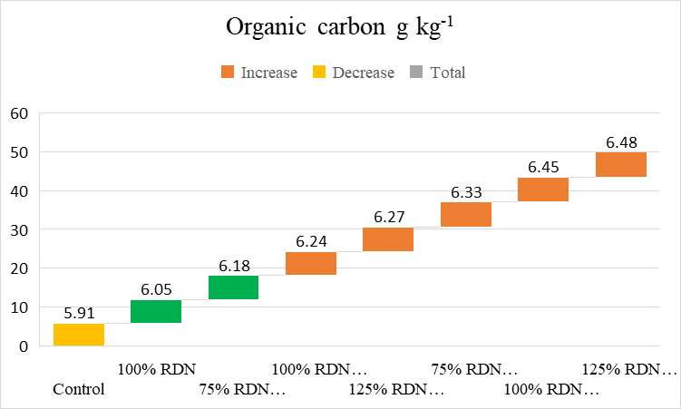
Fig 2. Impact of biochar on the organic status of soil after harvest of maize (0-15 cm)

Available nutrient (NPK) status of soil
Available nitrogen
The results of the study showed a significant increase in the available nitrogen in soil, from 219.67 to 249.33 kg ha⁻¹, indicating a low nitrogen status despite the various nitrogen and biochar applied treatments. Significantly, the highest available nitrogen (249.33 kg ha⁻¹) in soil was recorded under application of 125 % RDN + 5 t ha⁻¹ Biochar (T₈) and it was statistically at par with other treatments (Fig. 3). Similar findings were reported by Gao, et al. (2018) who noticed that different levels of biochar addition increases the availability of nitrogen in the soil than that of the control treatment, which plays an essential role in the nutrient cycle in such a way that it affects nitrogen retention in soil.
Available phosphorus
The results of the study showed a significant increase in the available nitrogen in soil, from 15.46 to 21.63 kg ha⁻¹, indicating a medium availability of phosphorus by the various biochar treatments. Significantly, the highest available phosphorus (21.63 kg ha⁻¹) in soil was recorded under application of 125 % RDN + 5 t ha⁻¹ Biochar (T₈) and it was statistically at par with other treatments (Fig. 3). Addition of biochar increases phosphorus availability in soils by enhancing the mobility of phosphate ions in the soil solution (Husien et al., 2017) and by increasing the microbial population, which solubilizes insoluble phosphorus thereby, improving its availability (Liu et al., 2017).

Available potassium
The results of the study showed a significant increase in the available potassium in soil, from 328 to 358 kg ha⁻¹, indicating a high availability of potassium by the various biochar treatments. Significantly, the highest available potassium (358 kg ha⁻¹) in soil was recorded under application of 125 % RDN + 5 t ha⁻¹ Biochar (T₈), and it was statistically at par with other treatments (Fig. 3). Similar findings were reported by Islami et al. (2011), who observed that application of biochar to soils significantly increases the availability of potassium as compared to the soil without biochar. This effect might be due to the high concentration of potassium in the biochar (Chan et al., 2007) and the increase in soil surface charge, which holds positively charged ions, which minimise the nutrient leaching losses (Sukartono et al., 2011).
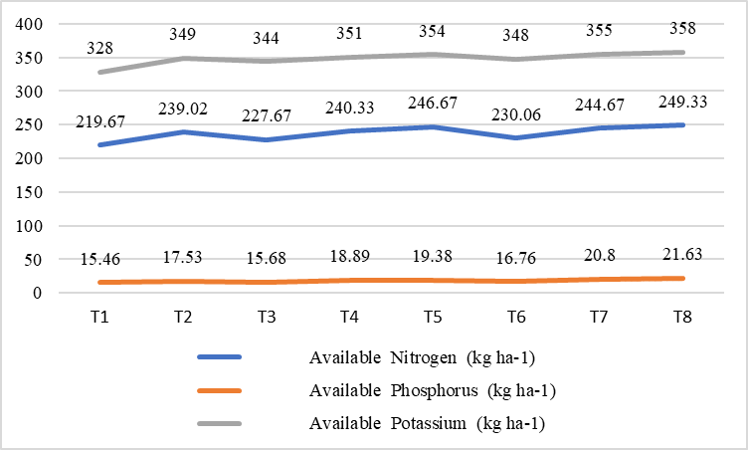
Fig 3. Effect of biochar application on the available NPK content in soil
DTPA extractable micronutrients in soil
The highest availability of Zn (0.62 mg kg⁻¹), Cu (2.34 mg kg⁻¹), Fe (4.42 mg kg⁻¹) & Mn (9.47 mg kg⁻¹) was observed under the application of 125 % RDN + 5 t ha⁻¹ Biochar (T₈), compared to other treatments (Table 3). The lowest micronutrient content was observed in treatment control (T₁). The results indicated that increasing the doses of biochar resulted in a slight increase in the availability of Zn, Cu, Fe & Mn, but the differences among the treatments were found to be statistically non-significant. Salmani et al. (2014) reported that Cu content was significantly higher in the biochar-amended soil compared to the soil, even in the absence of external copper application. Similarly, Lentz & Ippoliti (2011) observed an increase in the availability of manganese due to biochar addition, suggesting that biochar may act as a source of manganese. Hass et al. (2012) also reported a similar result that biochar application enhances the availability of extractable micronutrients (Zn, Cu, Fe & Mn) in soil.
Treatment details |  | Available micronutrients (mg kg⁻¹)
 |  | Zn | Cu | Fe | Mn
T₁ | Control | 0.54 | 2.18 | 4.24 | 9.22
T₂ | 100% RDN | 0.55 | 2.19 | 4.26 | 9.25
T₃ | 75% RDN + 2.5 t ha⁻¹ Biochar | 0.57 | 2.23 | 4.28 | 9.27
T₄ | 100% RDN + 2.5 t ha⁻¹ Biochar | 0.58 | 2.26 | 4.31 | 9.32
T₅ | 125% RDN + 2.5 t ha⁻¹ Biochar | 0.59 | 2.28 | 4.33 | 9.36
T₆ | 75% RDN + 5.0 t ha⁻¹ Biochar | 0.61 | 2.30 | 4.35 | 9.41
T₇ | 100% RDN + 5.0 t ha⁻¹ Biochar | 0.61 | 2.33 | 4.41 | 9.45
T₈ | 125% RDN + 5.0 t ha⁻¹ Biochar | 0.62 | 2.34 | 4.42 | 9.47
 | S.E. (m) ± | 0.005 | 0.03 | 0.09 | 0.13
 | C.D. at 5% | - | - | - | -
Table 4. Effect of biochar application on micronutrient status in soil

Soil organic carbon (SOC) stock
The results indicated a significant increase in the soil organic carbon (SOC) stock across the various treatments. Significantly, the highest soil organic carbon (SOC) stock (14.87 Mg ha⁻¹) was recorded with the application of 125 % RDN + 5 t ha⁻¹ Biochar (T₈) which was statistically at par with treatments T₇ & T₆ (Fig. 4). Higher the quantity of biochar applied, greater the soil organic carbon (SOC) stock recorded, which might be attributed to biochar amendment, which can influence microbial activity and organic matter dynamics in soil, contributes in increasing SOC stock (Wardle et al., 2008). Dahal et al. (2018) also observed that biochar application enhances the accumulation of carbon both in above-ground biomass and in soil organic carbon, thereby increasing the incremental rates of SOC stocks in all biochar-applied treatments compared to the control. Biochar can potentially play a significant role in long-term storage of carbon and in reducing the emissions of harmful gases into the atmosphere. Because of its potential applications, it minimises nutrient losses from soil, making it a valuable tool for carbon sequestration in soils, which contributes to enhancing microbial activity and promotes overall soil health (Yadav et al., 2023).
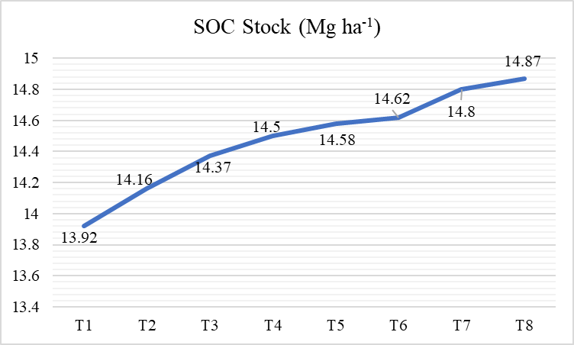
Fig 4. Impact of biochar application on soil organic carbon stock
Conclusion
Based on the analysis result, the application of 125 % RDN + 5 t ha⁻¹ Biochar significantly improved several physical and chemical properties of soil. However, bulk density, electrical conductivity and soil pH were non-significantly affected by the various treatments. Increasing the doses of biochar resulted in a slight increase in the availability of Zn, Cu, Fe & Mn, but the differences among the treatments were statistically non-significant. Notably, soil organic carbon (SOC) stock was also significantly higher with the application of 125% RDN + 5.0 t ha⁻¹, which suggests that a higher quantity of biochar application leads to greater SOC stock accumulation in the soil.
Based on the current study, we can conclude that, application of 100% RDN +5 t ha⁻¹ Biochar improves the available nutrient status and physical-chemical properties of soil after the harvest of maize. Additionally, a favourable impact on the soil organic carbon (SOC) stock is noted.

Disclaimer (Artificial intelligence)
Option 1:
Author(s) hereby declare that NO generative AI technologies such as Large Language Models (ChatGPT, COPILOT, etc.) and text-to-image generators have been used during the writing or editing of this manuscript.
Option 2:
Author(s) hereby declare that generative AI technologies such as Large Language Models, etc. have been used during the writing or editing of manuscripts. This explanation will include the name, version, model, and source of the generative AI technology and as well as all input prompts provided to the generative AI technology
Details of the AI usage are given below:
1.
2.
3.

References
Amonette, J. and S. Joseph, 2009. Characteristics of biochar: Micro-chemical properties. In: Biochar for environmental management: Science and technology, London, 7:33-52.
Bandara T., I. Herath, P. Kumarathilaka S. Mihiri, S. Gamini, M. Vithanag, O.S. Yong and R. Nishanta, 2017. Role of woody biochar and fungal- bacterial co-inoculation on enzyme activity and metal immobilization in serpentine soil. Journal of Soils Sediments, 17 (3):665-673.
Batjes, N.H., 1996. Total carbon and nitrogen in the soils of the world. European Journal of Soil Science, 47:151-163.

Batjes, N.H., 2005. Organic carbon stocks in the soils of Brazil. Soil Use and Management, 21 (1):22-24.
Blake, G.R. and K. H. Hartage, 1986. Bulk density. In Klute, A., (EDS) Methods of Soil Analysis: Part I: Physical and Mineralogical properties. 2nd Edn. American Society of Agronomy, Wisconsin, USA, pp. 363-375.
Burrell, L. D., F. Zehetner, N. Rampazzo, B. Wimmer and G. Soja, 2016. Long-term effects of biochar on soil physical properties. Geoderma, 282: 96–102.

Chan, K.Y., L.V. Zwieten, I.A. Meszaros, A. Downie and S. Joseph, 2007. Agronomic values of green waste biochar as a soil amendment. Aust. J. Soil Res., 45: 629-634.
Dahal, N., R.M. Bajracharya and L.M. Wagle, 2018. Biochar Effects on Carbon Stocks in the Coffee Agroforestry Systems of the Himalayas: Sustainable Agriculture Research, 7:103-114.
Ding, W., X. Dong, I. M. Ime, B. Gao and L. Q. Ma, 2014. Pyrolytic temperatures impact lead sorption mechanisms by bagasse biochars. Chemosphere, 105: 68-74.

Food and Agriculture Organization of the United Nations, 2023. Biochar in sustainable soil management: potential and constraints. Intergovernmental technical panel on soils, Soil letters: 1-8.

Gan, C., Y. Liu, X. Tan, S. Wang, G. Zeng, B. Zheng, T. Li, Z. Jiang and W. Liu, 2015. Effect of porous zinc–biochar nanocomposites on Cr (VI) adsorption from aqueous solution. Rsc Advances, 5 (44):35107-35115.

Gao, T., M. Gao, J. Peng and N. Li, 2018. Effects of different amount of biochar on nitrogen, phosphorus and potassium nutrients in soil. IOP Conf. Ser. Mater. Sci. Eng., 394: 022-043.
Gomez, K.A. and A.A. Gomez, 1984. Statistical procedures for agricultural research (2 Ed.). John Wiley and sons, New York, 680p.

Gupta, R.P. and C. Dakshinamoorthy, 1980. Procedures for physical analysis of soil and collection of agro meteorological data. Division of Agricultural Physics, IARI, New Delhi.
Han, J., A. Zhang, Y. Kang, J. Han, B. Yang, Q. Hussain, X. Wang, M. Zhang and M. A. Khan, 2022. Biochar promotes soil organic carbon sequestration and reduces net global warming potential in apple orchard: A two-year study in the Loess Plateau of China. Science of the Total Environment, 803, 150035.

Hass A., M.G. Javier, M.L. Isabel, W.G. Harry, J.H. Jonathan and G.B. Douglas, 2012. Chicken manure biochar as liming and nutrient source for acid Appalachian soil. Journal of Environ. Qual., 41(4):1096-1106.

Herath, H.M.S.K., M., Camps-Arbestain and M. Hedley, 2013. Effect of biochar on soil physical properties in two contrasting soils: an alfisol and an andisol. Geoderma, 209: 188-197.

Husien, A., B. Bedadi and N. Dechassa, 2017. Effect of biochar, Farmyard manure and nitrogen fertilizers on soil chemical properties in Sinana district, south eastern oromia, Ethiopia. International Journal of Applied Agricultural Sciences, 3(6): 148-153.
Islami, T., B. Guritno, N. Basuki and A. Suryanto, 2011. Biochar for sustaining productivity of cassava-based cropping system in the degraded lands of East Java, Indonesia. Journal of Tropical Agriculture, 49 (1-2):40-46.
Jackson, M.L., 1973. Soil Chemical Analysis, Prentice- Hall of India Pvt. Ltd., New Delhi, pp. 458.
Joseph, S.D., M. C. Arbestain, Y. Lin, P. Munroe, C. H. Chia, J. Hook, L. van Zwieten, S. Kimber, A. Cowie, B. P. Singh and J. Lehmann et al., 2010. An investigation into the reactions of biochar in soil. Australian Journal of Soil Research, 48(7):501-515.

Kranthi, K. and S., Kranthi, 2023. Production of biochar from cotton stalks using the cone-pit open earth kiln technique. The ICAC Recorder, 6-23.

Keeny, D.R. and D.W. Nelson, 1982. Nitrogen-inorganic forms In Method of Soil Analysis Part 2, Chemical and Mineralogical Properties, Page, A.L. (Ed) II Edn. American Society of Agronomy, Inc. and Soil Science Society of America Inc. Madison, Wisconsin, USA. pp. 643-693.
Laharia, G.S., Y.D. Kadam, A.B. Age, S.D. Jadhao, D.V. Mali and O.S. Rakhonde, 2020. Interactive effect of biochar, FYM and nitrogen on soil properties and yield of black gram grown in Vertisols. Journal of pharmacognosy and photochemistry, 9 (6):249-253.
Lee, Y.L., O.H. Ahmed, S.A. Wahid, Z. Fitri and A.B. Aziz, 2021. Biochar tablets with and without Embedded Fertilizer on the Soil Chemical Characteristics and Nutrient Use Efficiency OF Zea mays. Sustainability, 13(9): 4878.
Lehmann, J., 2007. A handful of carbon. Nature, 447 (7141):143-144.
Lentz, R.D. and J.A. Ippolito, 2011. Biochar and manure affect calcareous soil and corn silage nutrient concentrations and uptake. Journal of Environmental Quality, 41: 1033-1043.
Lindsay, W. L. and W. L. Norvell, 1978. Development of DTPA soil test for Zn, Fe, Mn and Cu. Soil Science Society of American Journal, 42:421-428.
Liu, S., J. Meng, L. Jiang, X. Yang, Y. Lan, X. Cheng and W. Chen, 2017. Rice husk biochar impacts soil phosphorous availability, phosphatase activities and bacterial community characteristics in three different soils. Applied Soil Ecology, 116: 12-22.
Liu, X. H. and X. C, Zhang, 2012. Effect of Biochar on pH of Alkaline Soils in the Loess Plateau: Results from Incubation Experiments. International Journal of Agriculture and Biology, 14(5): 745–750.

Lorenz, K. and R. Lal, 2014. Biochar application to soil for climate change mitigation by soil organic carbon sequestration. Journal of plant nutrition and soil science, 177 (5): 651-670.
Masek, O., 2009. Biochar production technologies, http://www.geos.ed.ac.uk/sccs/biochar/documents/BiocharLaunch-O.Masek.pdf.
Nelson, D. W. and L. E. Sommers, 1982. Total carbon, organic carbon and Organic matter. In. Methods of soil Analysis, Part-II, Page, A.L. (Ed.), American Society of Agronomy, Inc. Soil Science America Inc. Madison, Wisconsin, USA, pp. 539-579.
Nigussie, A., E. Kissi, M. Misganaw and G. Ambaw, 2012. Effect of biochar application on soil properties and nutrient uptake of Lettuces (Lactuca sativa) grown in chromium polluted soils. American- Eurasian Journal of Agriculture and Environmental Science, 12 (3): 369-376.
Oni, B. A., O. Oziegbe and O. O. Olawole, 2019. Significance of Biochar application to the environment and economy. Annals of Agricultural Sciences, 64:222-236.

Pandian, K., P. Subramaniayan, P. Gnasekaran and S. Chitraputhirapillai, 2016. Effect of biochar amendment on soil physical, chemical and biological properties and groundnut yield in rainfed Alfisol of semi- arid tropics. Archives of Agronomy and Soil Science, 62(9):1293-1310.
Peterson, G.W. and R.B. Corey, 1966. A modified Change and Jackson procedure routine fraction of inorganic soil P. Soil Science Society of America Journal, 30:363-565.

Salmani, M.S., F. Khorsandi, J. Yasrebi and N. Karimian, 2014. Biochar effects on copper availability and uptake by sunflower in a copper contaminated calcareous soil. International Journal of Plant, Animal and Environmental Sciences, 4(3): 389-394.
Saha, A., B. B. Basaka, N. A. Gajbhiyea, K. A. Kalariyaa and P. Manivel, 2019. Sustainable fertilization through co-application of Biochar and chemical fertilizers improves yield, quality of Andrographis paniculata and soil health. Industrial Crops and Products, 140(4): 111607.

Sara, Z. Shah and T. Shah, 2018. Residual effect of biochar on soil properties and yield of maize (Zea mays L.) under different cropping systems. Open Journal of Soil Science, 8 (01):16-25.

Sohi, S. P., E. Krull, E. Lopez-Capel and R. Bol, 2010. A review of biochar and its use and function in soil. Advances in Agronomy, 105 (1): 47-82.

Subbiah, B.V. and G.L. Asija, 1956. A procedure for estimation of available nitrogen in soils. Current Science, 25: 259- 260.
Sukartono, W. H., Utomo. Z. Kusuma and W.E. H., Nugroho, 2011. Soil fertility status nutrient uptake and maize (Zea mays L.) yield following biochar and cattle manure application on sandy soils of Lombok, Indonesia. Journal of Tropical Agriculture, 49 (1-2):47-52.

Sun, H., S. Weiming, M. Zhou, X. Ma and H. Zhang, 2019. Effect of biochar on nitrogen use efficiency, grain yield and amino acid content of wheat cultivate on saline soil. Plant, Soil and Environment, 65 (2): 83:89.

Ulyett, J., R. Sakrabani, M. Kibble white and M. Hann, 2014. Impact of biochar addition on water retention, nitrification and carbon dioxide evolution from two sandy loam soils. European Journal of Soil Science, 65: 96–104.
Wardle, D.A., M.C. Nilsson and O. Zackrisson, 2008. Forest -derived charcoal causes loss of forest humus. Science, 320:629.
Watanabe, F.S. and S.R. Olsen, 1965. Test of ascorbic acid method for determining phosphorus in water and sodium bicarbonate extracts of soils. Soil Science Society of America Proceedings, 29:677-678.
Yadav, S. P., S. Bhandari, D. Bhatta, A. Poudel, S. Bhattarai, P. Yadav, et al., 2023. Biochar application: a sustainable approach to improve soil health. Journal of Agriculture and Food Research, 11:100498
Yeboah, E., 2009. Improving soil productivity through biochar amendments to soils. African Journal of Environmental Science and Technology, Vol. 3 (2), pp. 034-041.
Ighalo, J. O., Ohoro, C. R., Ojukwu, V. E., Oniye, M., Shaikh, W. A., Biswas, J. K., ... & Rangabhashiyam, S. (2025). Biochar for ameliorating soil fertility and microbial diversity: From production to action of the black gold. Iscience, 28(1).
Gross, A., Bromm, T., & Glaser, B. (2021). Soil Organic Carbon Sequestration after Biochar Application: A Global Meta-Analysis. Agronomy, 11(12), 2474.
Shyam, S., Ahmed, S., Joshi, S. J., & Sarma, H. (2025). Biochar as a Soil amendment: implications for soil health, carbon sequestration, and climate resilience. Discover Soil, 2(1), 18.

