**Original Research Article**

**Optimising seed quality of tomato with Naphthyl Acetic Acid (NAA) foliar spray and training system**

**Abstract**

The present study was conducted in the Department of Seed Science and Technology at Dr Yashwant Singh Parmar University of Horticulture and Forestry, Solan, Himachal Pradesh, during the summer of 2024. The research aimed to examine the effects of NAA as a foliar spray (at concentrations of 0, 25, 50, and 75 ppm) and various training systems (two-stem, four-stem, and no training) on the seed quality attributes of indeterminate tomato cv. *Solan Lalima*. Foliar sprays were applied at 30 days after transplanting and at 50% flowering. Tomato fruits were harvested upon reaching red ripeness, and seeds were extracted through fermentation methods. Seed quality parameters were assessed under laboratory and observations were noted. The experimental results indicate that spraying tomato plants with 50ppm NAA along with retention of two-stem yielded seeds of superior quality viz., increased 1000-seed weight (3.52g), longer seedlings (18.70), greater seedling dry weight (21.10 mg), improved seed vigour indices (SVI-I:1655.60 & SVI-I-1867.50), accelerated germination (23.31), along with reduced EC values of seed leachates (4.36). Also, this treatment combination improved the germination of seeds by 22% and 23.5% both before and after accelerated ageing, Therefore, the implementation of a two-stem training strategy combined with NAA @50 ppm spray can be recommended for commercial tomato seed production programs.

**Keywords:** Naphthyl Acetic Acid (NAA), foliar spray, stem-training, indeterminate tomato, seed quality, source/sink relationship.

1. **Introduction**

Tomato, (*Solanum lycopersicum* L.) with chromosome number 2n = 2x = 24 belongs to the Solanaceae family. With its origin in South American Andes, tomato is one of the most cultivated and relished fruit vegetable worldwide. Beyond its culinary variability, tomato plays a vital role in human nutrition serving as a rich source of antioxidants such as lycopene, vitamins A, B, and C, calcium, minerals, and ß-carotene (Bose and Som, 1990; Ali *et al*., 2020). In India, tomato is cultivated across tropical, subtropical and mild cold climate regions and in 2021-22, approx. 865.29 million hectares of area were under tomato cultivation with an estimated production of 20300.19 tons (Anamika *et al.,* 2024). In the mid hills of Himachal Pradesh, tomato is considered as a lucrative and remunerative crop and is cultivated extensively to ensure off-season availability of produce. High seed quality, particularly regarding viability and vigour, is crucial for vegetable seedling development in nurseries and successful plant establishment in the field (Doijode, 1988). This necessitates the need of high-quality seeds of improved tomato varieties.

Studies indicates that growth promoting phytohormones can effectively regulate vegetative and reproductive growth, overcome the problems of pollination and fertilization and are considered as an important signalling molecule in seed development, thereby improving seed yield and quality attributes as well. Plants synthesize growth regulators by themselves; however, many researchers support the usefulness of exogenous applications of synthetic plant growth regulators as well (Hasnain *et al*., 2020). Extensive application of plant growth regulators (PGRs) has gained traction globally for achieving superior production in agriculture in the 21st century (de Andrade *et al.,* 2023). However, efficacy of PGRs depends on crop, variety, type of hormone & its concentration, stage of administration and intensity of application. Auxin is one such crucial phytohormone that regulates almost every aspect of plant growth and development ([Enders and Strader, 2015](javascript:;); [Paque and Weijers, 2016](javascript:;)). The natural auxin i.e. Indole-3-acetic acid (IAA) is known to degrade quickly, limiting its applicability (Small and Degenhardt, 2018), whereas, synthetic auxins like α-Naphthalene acetic acid (NAA), Indole-3-butyric acid (IBA) are resistant to oxidation in plant tissue. Naphthyl acetic acid help in the upward transport of nutrients and enhance the levels of proteins, carbohydrates, sugar and antioxidant enzymes in plants. At appropriate concentrations, foliar application of NAA effectively modulates plant physiology, upgrades the potential of plants, and acts as a growth controller to increase crop production (Ma *et al.,* 2018; Khan *et al.,* 2019; Mir *et al.,* 2020).

Indeterminate tomato sequentially put forth numerous side shoots/suckers with continued flower and fruit formation. Retention of all sucker in an indeterminate cultivar leads to competition for vital resources, negatively impacting the yield and quality. Modification of plant architecture by altering the relative growth and positioning of vegetative and reproductive organs in the canopy is known as stem-training. Stem-training improves light interception, air flow, and nutrient distribution, improving plant's overall health and productivity. Franco *et al.* (2009) stated that adoption of proper training and pruning techniques creates balance in the source/sink relationship and the carbon/nitrogen (C/N) ratio thereby effectively optimising the performance of indeterminate tomato varieties. Studies on foliar application of NAA combined with stem-training systems is very scarce. Hence, the present investigation attempts to determine the impact of foliar application of NAA in combination with training systems on the seed quality attributes of tomato.

1. **Materials and Methods**

The field experiment was conducted during the summer season in the year 2024 at the experimental farm of the Department of Seed Science and Technology, Dr. Y S Parmar University of Horticulture and Forestry, Nauni, Solan, Himachal Pradesh in tomato cv*. Solan Lalima*. The seeds were sown in nursery beds in lines about 5 cm apart and 1-2 cm deep on the second fortnight of February during both the year and transplanted at 4-5 leafy stage. The experimental plot size was 2.2 m x 1.2 m with 90 cm×30cm accommodating 12 plants per plot. The recommended dose of N, P2O5 and K2O nutrients were added in the form of Urea, SSP and MOP @ 218,475 and 90 kg ha-1, respectively.

The experiment was laid out in Randomised Complete Block Design (RCBD) with 12 treatments and three replications. The treatment details are as follows in Table 1.

Table 1: Treatment details

|  |  |
| --- | --- |
| **Treatment No.** | **Details of treatment** |
| T1 | Foliar spray of NAA-25 ppm with Two-stem training system |
| T2 | Foliar spray of NAA-25ppm with Four-stem training system |
| T3 | Foliar spray of NAA -25 ppm with No training |
| T4 | Foliar spray of NAA-50 ppm with Two-stem training system |
| T5 | Foliar spray of NAA-50 ppm with Four-stem training system |
| T6 | Foliar spray of NAA-50 ppm with No training |
| T7 | Foliar spray of NAA-75 ppm with Two-stem training system |
| T8 | Foliar spray of NAA-75 ppm with Four-stem training system |
| T9 | Foliar spray of NAA-75 ppm with No training |
| T10 | No spray with Two-stem training system |
| T11 | No spray with Four-stem training system |
| T12 | No spray with No training |

* 1. Application of treatments:
     1. The foliar application of NAA was made twice: first schedule at 30 days after transplanting (DAT) and 2nd spray was at 50% flowering (i.e. when 50% of the plants in the plot showed flowering). A volume of 200 mL NAA solution was required/plot to thoroughly wet the aerial parts of the plants. NAA was applied with the help of knapsack sprayer and precautions were taken to avoid the mixing of sprays from one treatment combination to another. Preparation of stock solution of Naphthalene acetic acid (NAA): 1 g of NAA was carefully measured and first dissolved with ethanol, then added distilled water to the beaker until the total volume reaches 1 litre to make it 1000 ppm. To prepare a working solution from the stock solution, the dilution formula **C1V1=C2V2** used, where: C1​ = concentration of the stock solution, V1​ = volume of the stock solution to be taken, C2 = desired concentration of the working solution, and V2​ = final volume of the working solution.
     2. Training systems:

1. Two-stem training: Here, first two stems (or branches) that appear on the plant after its established, is retained. These two stems are then trained to grow upward, and the rest of the side shoots or branches are removed to maintain only these two primary stems to bear fruits for seed production. As the two primary stems grow, they are tied to a support structure using plastic wire to keep them upright.
2. Four-stem training: first four branches (or stems) that appear on the plant are selected to grow and bear fruit for seed production. All other side shoots or branches that emerge from the plant are pruned or removed regularly. The four primary branches are supported and trained to grow upright, by tying them to a support structure using plastic wires.
3. No training: in this case, no physical intervention is made to control the number of stems or branches, or to direct the plant’s growth. The plant is allowed to grow naturally, following its inherent growth patterns without any training.

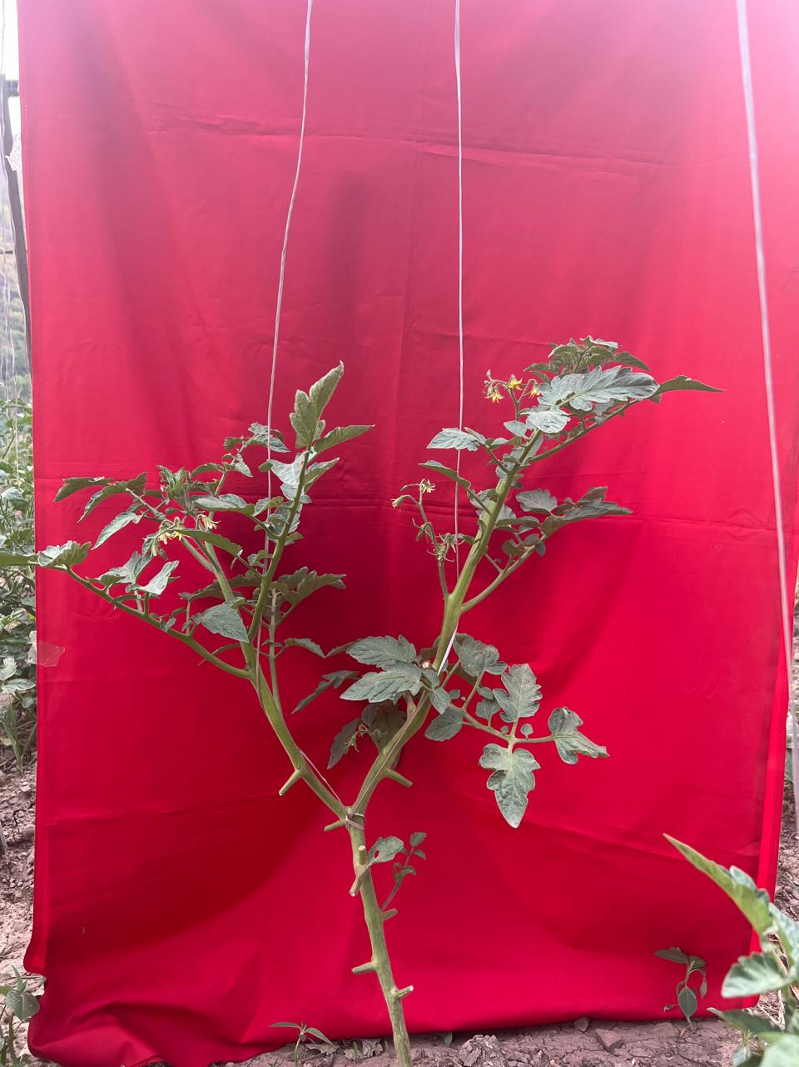 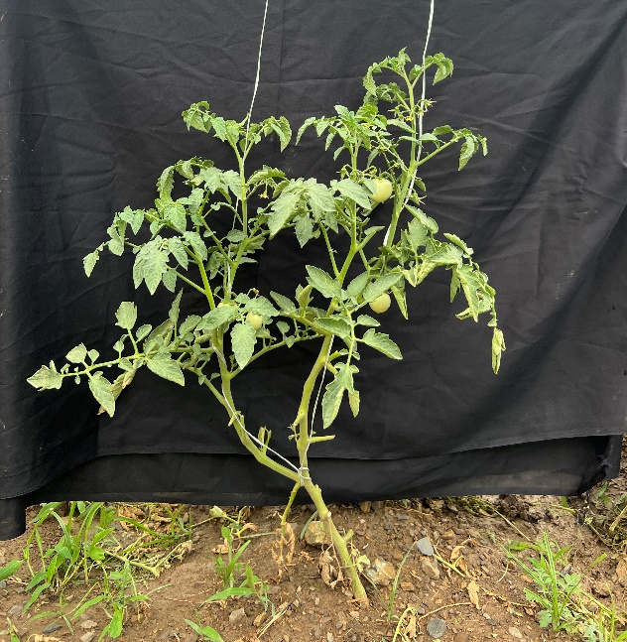 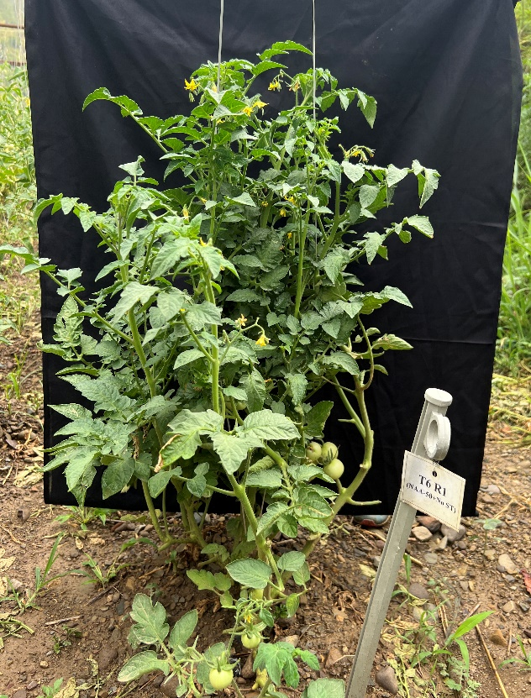

Fig.1: **Different training strategy adopted in the study (a) Two-stem training (b) Four-stem training and (c) No-stem training**

Experimental plots were irrigated as and when required, also, plant protection practices were taken up for the control of insect pest and decreases during trial period.

* 1. Observation recorded

For seed quality analysis, fruits were harvested when they turned red-ripe, and seeds were extracted using natural fermentation methods (Pozhilarasi *et al.,* 2022) and is illustrated below:

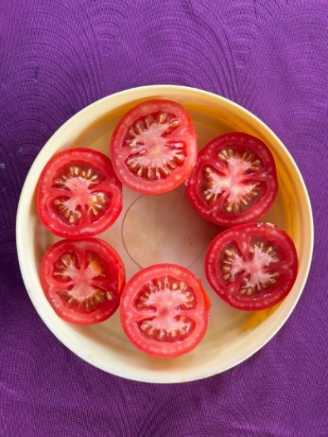 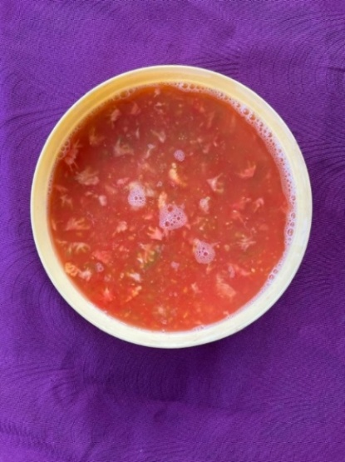

**Crushed fruits consisting of pulp along with seeds are mixed with water and kept for 24 hours**

**Fruits were sliced to take out seeds**

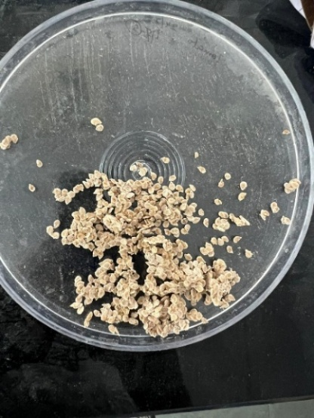 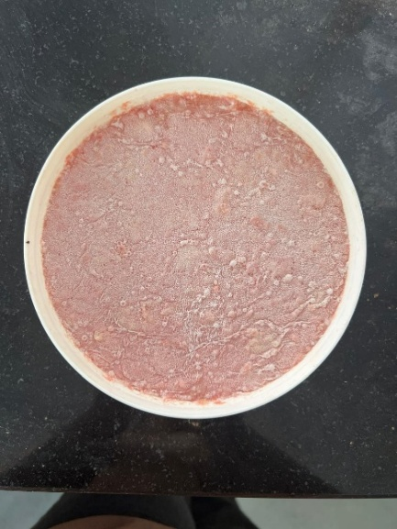

**Seeds are dried following repeated washing with water**

**Decayed pulp with seed settled at bottom**

Fig.2: Schematic representation of seed extraction through fermentation method

Observations for seed quality parameters were recorded in the laboratory with 4 replications.

Germination test was conducted by roll towel method with 100 seeds each under controlled condition of 25±2oC and 95±2% of temperature and RH respectively (ISTA, 2020).

$$Germination \%=\frac{Number of seeds germinated}{Total number of seeds sown}×100$$

From the germination test, ten normal seedlings were selected randomly from each treatment on the day of the final count (14th day) and length was measured from shoot tip to root tip. The same 10 seedlings were dried for 24 hours in a hot-air oven to measure seedling dry weight. Seedling vigour index-length (SVI-I) and Seedling vigour index-mass (SVI-II) was calculated as per the formula given by Abdul-Baki and Anderson (1973):

$$SVI-I=Germination\left(\%\right)×Seedling length \left(cm\right)$$

$$SVI-II=Germination\left(\%\right)×Seedlingdry weight (mg)$$

The Electrical conductivity (EC) of seed leachates was determined using digital EC meter and expressed in micro-Siemens per centimetre (µS/cm).

Speed of germination was calculated by the following formula given by Czabator (1962).

Speed of germination= $\frac{n1}{d1}$ + $\frac{n2}{d2}$ + $\frac{n3}{d3}$ +……

where, n = number of germinated seeds on dth day, and d= number of days (up to 14 days).

The seeds were artificially aged as suggested by Delouche and Baskin (1973) by placing seeds inside the dessicator filled with 100 ml of KOH solution and transferred to accelerated ageing chamber (40 ±1 °C, >95% relative humidity). After the ageing period (8 days), samples were taken out from the chamber and the seeds of each treatment were tested for germination.

* 1. Statistical analysis was carried out using KAU-GRAPES version 1.10. Data were subjected to analysis of variance and means were compared. Conclusions were drawn only on significant differences between the treatment mean at 0.05 level of probability. The least significant difference test was used to decipher the effect of treatments at 5% level of significance (P=0.05).

1. **Results and Discussions**

After the harvest of crop, the extracted seeds were analysed for various seed quality parameters. The results regarding the combined effect of foliar spray of NAA and training systems on the seed quality of tomato cv. *Solan Lalima* are presented in Table 2 and discussed below for each recorded observation:

1000-seed weight (g): The 1000-seed weight showed no significant differences among treatment T7 (NAA-75ppm with two-stem training), with a numerically higher value of 3.62 g and is comparable with T4 (50ppm NAA+two-stem training) with a value of 3.52g. The lowest value (2.75g) was found in T12 (No spray+No training) and is statistically at par (2.80 g) with T11 (No spray+four-stem training). According to Afshari *et al.* (2011), test weight is reliant upon the reserve food materials present in the endosperm. The interaction between optimum dose of NAA and two-stem training might have enhanced the efficiency of assimilate transport and its accumulation in seed, resulting in greater test weight.

Germination percent: Germination percentage (Fig.3) depicted significant differences among treatment. Seeds harvested from plants treated with 50 ppm & 75 ppm NAA, and those trained to two stems (T4 and T7), exhibited the highest germination percentage at 88.50%, which was closely followed by T1@ 25 ppm+ two-stem training (86.75%) and T8 @ 75 ppm NAA+four-stem training (86.25%), whereas, lowest germination (72.50%) was observed in T12 (No spray+No training). Previous studies have shown that spraying with NAA promotes the synthesis of sucrose, enhances the proper transport and partitioning of sugars from the source to the sink (Chen *et al*., 2022). In addition, NAA facilitates the synthesis of hydrolytic enzymes to degrade starchy endosperm, resulting in enhanced germination. Higher germination percentages were observed in chilli seeds when plants were sprayed with 10 ppm NAA (Sultana *et al.,* 2006). Lal *et al.* (2016) observed that bell pepper plants retained with two-stems resulted in production of seeds with enhanced stored reserves, leading to improved seed germination.

Seedling length: Longer seedlings (18.70cm) were recorded in T4 (NAA@50ppm+two-stem training) and was found statistically at par with T7@75ppm+two-stem training (18.26cm). In contrast, shorter seedlings were found in T11@no spray+four-stem training(15.41cm) and T12@no spray+no training (14.49cm).

Seedling dry weight (mg): Different treatments exerted significant effect on seedling dry weight. The application of NAA@ 50 ppm with two-stems (T4) recorded significantly the highest seedling dry weight (21.20mg). However, minimum values for this trait were recorded in treatment T11(15.20mg) and T12 (14.93mg).

Seed vigour indices: Maximum seed vigour index-I (1655.60) was observed in case of treatment T4(NAA @50ppm along with two-stem training), which was closely followed by T7@NAA-75ppm and trained to two-stems (1616.53) and the least (1050.08) in T12 (No spray+no training). Similarly, SVI-II followed same trend followed as of SVI-I with T4 (1867.50) having the highest value and least (1082.25) in T12.

The application of NAA enhanced seedling vigour, as evidenced by increased germination, seedling length, and dry matter production. This improvement may be attributed to auxin's role in enhancing cell wall plasticity and facilitating the deposition of additional cellulose molecules within the cell wall. This aligns with the findings of Geetharani *et al.* (2008) in onion. Arvindkumar *et al.* (2012) found that spraying bitter gourd plants with NAA at 50 ppm resulted in seeds with enhanced physiological qualities. In ridge gourd, Lambat *et al.* (2015) reported better seed quality when crop was sprayed with NAA @50 ppm. According to Ullah *et al*. (2021), NAA application elevates endogenous IAA levels, which, in turn, results in increases in superoxide dismutase (SOD), catalase (CAT) and ascorbate peroxidase (APX) activities that decrease in oxidative damage and improve vigour. In case of training systems, Pathirana *et al.* (2015) showed that pruning tomato plants can improve the vigour indices of the harvested seeds. Hence, it can be inferred that the interaction between NAA spray and training methods might have enhanced translocation and assimilation of photosynthates from the source to the sink (seeds), resulting in higher percentage of bolder seeds with increased test weight.

Speed of germination: Faster germination determines the better success of seedling establishment under field condition. The values for speed of germination ranged from 14.01 (T12@ no spray with no training) to 23.31(T4@50ppm NAA+two-stem training) in different treatments (Fig.3). It can be inferred that combination of optimal training system, along with the appropriate dosage of NAA might have resulted in the development of heavy seeds with sufficient storage reserves and endogenous hormonal balance, thus accelerating the germination process.

Electrical conductivity (µScm-1): The electrical conductivity (EC) of a seed implies the integrity of the cell membrane of its coat. A higher EC value of the seed leachate indicates chance of cell membrane damage (Thakur *et al.,* 2022). There was significant variation in the values of electrical conductivity in given treatments. The lowest EC value of 4.36 µScm-1 was observed in treatment T4 (50 ppm NAA +Two-stem training system) and was found statistically at par with T7 (4.56 µScm-1). In contrast, treatment T12 (No spray+No training) and T3 (NAA-25 ppm+no training) were having the higher values, 7.00 µScm-1and 6.99 µScm-1, respectively. With treatment T4, sound seeds with better membrane permeability might have developed.

Germination percent after accelerated ageing test (AAT): Accelerated ageing, also known as controlled deterioration treatment, has been employed to evaluate the vigour and longevity of seed cultivars under conditions of high temperature and high relative humidity (Samarah, 2006; Pournik *et al.,* 2019). Seeds harvested from tomato cv. *Solan Lalima* exhibited a significant variation in germination after forced ageing (Fig.2). Treatment T7 (NAA@ 50 ppm+ Two-stem training) was superior (74.25%) compared to the other treatments, while the lowest germination percent (59.50%) following accelerated ageing was recorded in T12 (No spray+ no training). Righetti *et al.* (2015) proposed a potential connection between the regulation of seed longevity and increased auxin levels during seed maturation, possibly through interactions with HSFA9 (heat shock factor A9) and ABI3 (abscisic acid insensitive3)-regulated genes. Also, seeds harvested from double-stemmed tomato plants may tolerate accelerated ageing more effectively due to the production of healthy, well-filled, vigorous seeds (Santhosh, 2020).

Figure 3. Germination percent before and after accelerated ageing test

**Table 2. Effect of NAA foliar spray and training system on seed quality parameters in tomato cv. Solan Lalima**

|  |  |  |  |  |  |  |  |  |  |
| --- | --- | --- | --- | --- | --- | --- | --- | --- | --- |
| Treatment | 1000-seed weight (g) | Germination (%) | Seedling length (cm) | Seedling dry weight (mg) | SVI-Length (SVI-I) | SVI-Mass (SVI-II) | Speed of germination | Electrical conductivity (µScm-1) | Germination % after AAT |
| T1 | 3.28BC | 86.75AB (9.37) | 16.61D | 17.50E | 1441.01BC | 1518.00C | 21.26C | 4.93E | 71.75ABC [57.88] |
| T2 | 3.15D | 82.50CD (9.14) | 15.54E | 16.28F | 1282.22D | 1342.98DE | 19.47F | 5.97C | 67.75DE [55.38] |
| T3 | 3.11D | 80.50DE (9.03) | 15.04F | 15.28G | 1210.84D | 1229.75F | 17.55HI | 6.99A | 65.25E [53.86] |
| T4 | 3.52A | 88.50A (9.46) | 18.70A | 21.10A | 1655.60A | 1867.50A | 23.31A | 4.36F | 73.50AB  [59.01] |
| T5 | 3.33B | 84.75BC (9.26) | 17.75B | 18.38C | 1505.21B | 1556.38C | 20.46E | 5.43D | 71.25ABC [57.56] |
| T6 | 3.13D | 82.00CDE (9.11) | 17.03CD | 17.20E | 1396.73C | 1410.13D | 17.70GH | 6.21BC | 69.00CD [56.16] |
| T7 | 3.62A | 88.50A (9.46) | 18.26A | 19.55B | 1616.53A | 1730.38B | 22.93B | 4.56F | 74.25A [59.50] |
| T8 | 3.31B | 86.25AB (9.34) | 17.35BC | 17.93D | 1496.17B | 1546.25C | 20.82D | 5.49D | 72.50AB [58.36] |
| T9 | 3.19CD | 81.75CDE (9.09) | 16.85D | 16.50F | 1377.42C | 1348.85DE | 18.01G | 6.38B | 70.75BCD [57.24] |
| T10 | 3.00E | 80.75DE (9.04) | 15.56E | 16.23F | 1256.18D | 1310.20E | 17.34I | 5.39D | 69.25CD [56.31] |
| T11 | 2.80F | 79.25E (8.96) | 15.41EF | 15.20G | 1220.44D | 1204.70F | 16.19J | 6.07BC | 65.50E [54.03] |
| T12 | 2.75F | 72.50F (8.57) | 14.49F | 14.93G | 1050.08E | 1082.25G | 14.01K | 7.00A | 59.50F [50.46] |
| CD (0.05) | 0.11 | 3.20 | 0.47 | 0.40 | 75.72 | 69.09 | 0.34 | 0.36 | 3.19 |

Figures in the ( ) parenthesis are square root transformed values [ ] are arc sine transformed values.

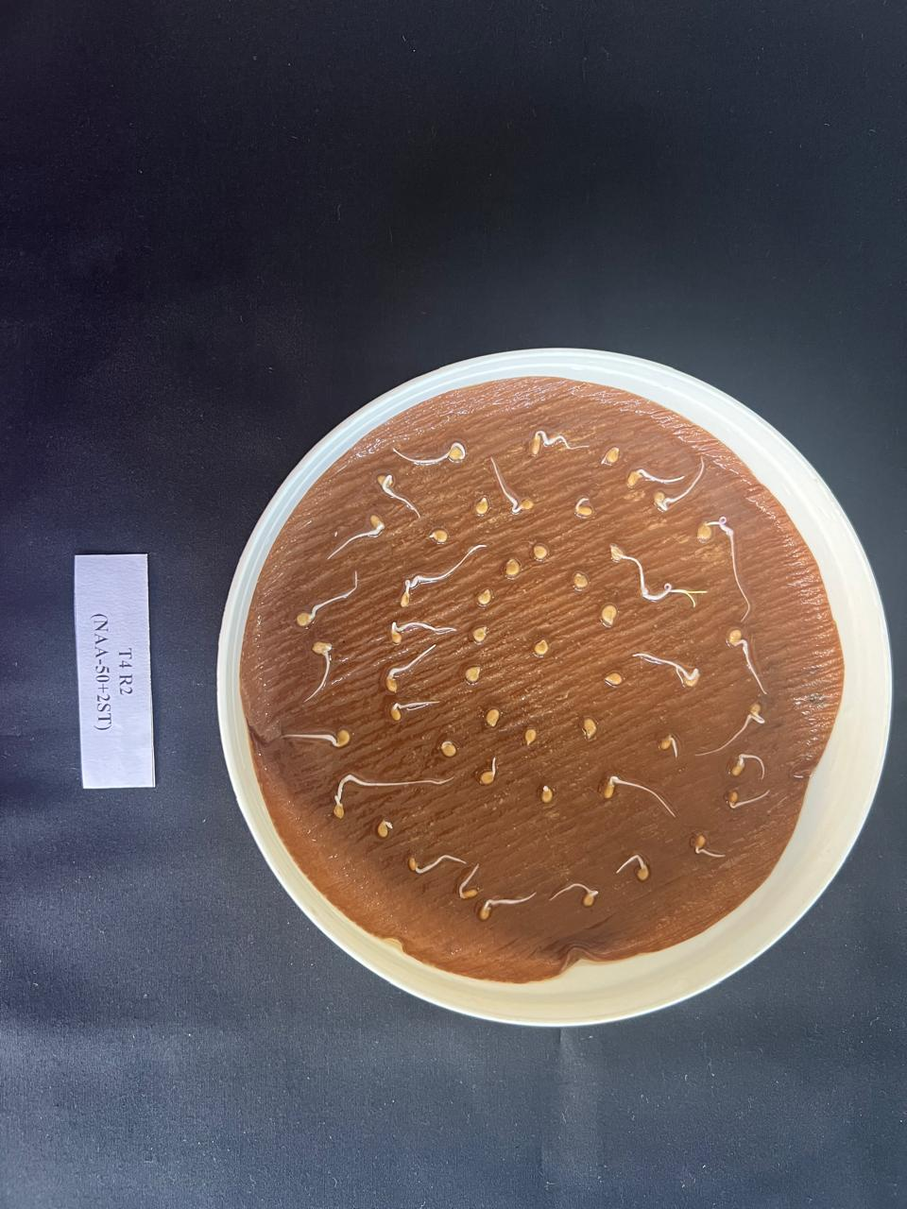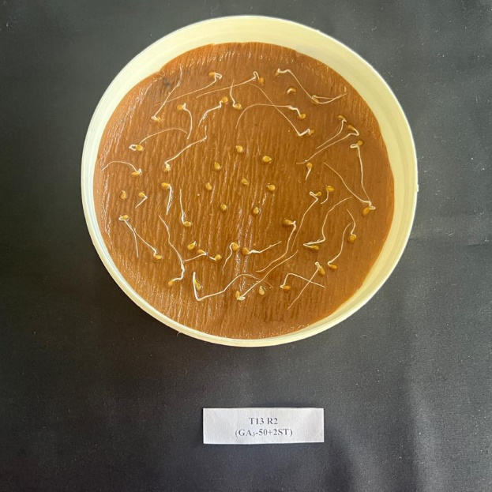

B

A

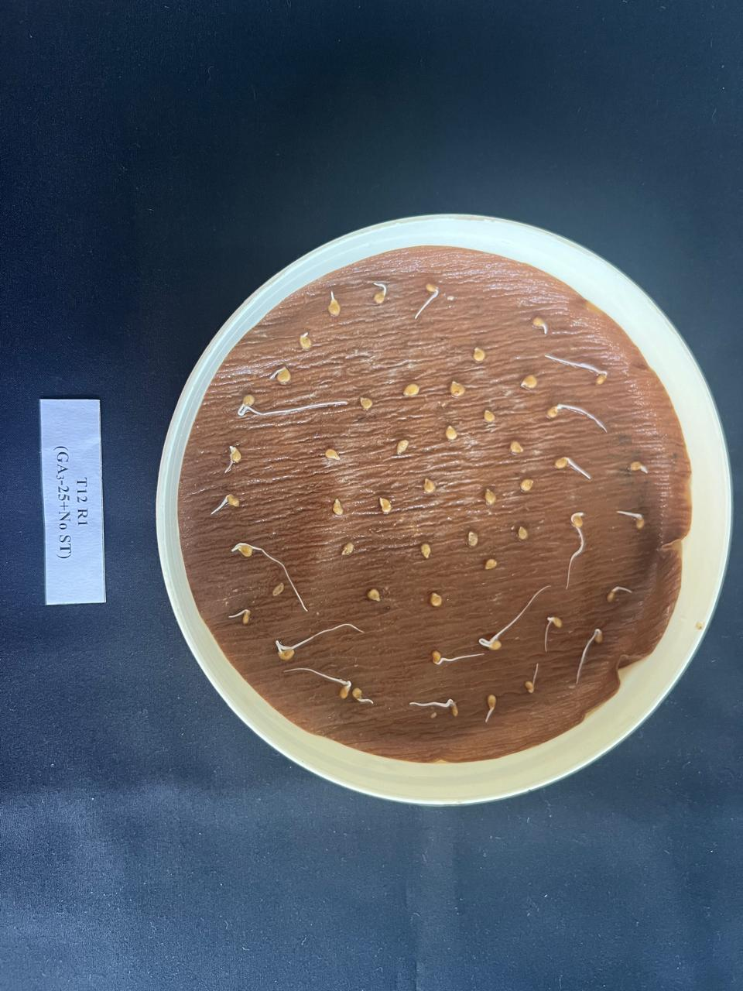

C

Figure 4: Speed of germination on 3rd day (A): T4 (NAA@50ppm with two-stem training and

(B): T7 (Foliar spray of NAA-75 ppm with Two-stem training system and (C): T12 (No spray with no training)

**Conclusion**

Quality seed is a vital input in crop production as it is the cheapest input that affect crop performance as well as agricultural progress. A critical analysis of the results reveals that in tomato cv. *Solan Lalima*, application of NAA@50 ppm along with training to two-stems was found to enhance all the seed quality attributes studied. The treatments with NAA coupled with optimised training methods during tomato seed production can be considered as a suitable technique to achieve better quality seed for farmers following suitable regional validation.

**Conflict of interest**: None.

**COMPETING INTERESTS DISCLAIMER:**

Authors have declared that they have no known competing financial interests OR non-financial interests OR personal relationships that could have appeared to influence the work reported in this paper.

**Disclaimer (Artificial intelligence)**

Author(s) hereby declare that NO generative AI technologies such as Large Language Models (ChatGPT, COPILOT, etc.) and text-to-image generators have been used during the writing or editing of this manuscript.

**References**

1. Abdul‐Baki AA, Anderson JD. Vigor determination in soybean seed by multiple criteria 1. Crop Sci. 1973;13(6):630-33.
2. Afshari H, Eftekhari M, Faraji M, Ebadi AG, Ghanbarimalidareh A. Studying the effect of 1000 grain weight on the sprouting of different species of Salvia L. grown in Iran. J Med Plant Res. 2011;5(16):3991-993.
3. Ali MY, Sina AA, Khandker SS, Neesa L, Tanvir EM, Kabir A, Khalil MI, Gan SH. (2020). Nutritional composition and bioactive compounds in tomatoes and their impact on human health and disease: A Review. *Foods.* 2020;10(1):45. https://doi: 10.3390/foods10010045.
4. Anamika GS, Goyal M, Mehla S, Malik JS, Yadav E. 2024. Growth trend in area, production and productivity of tomato in India and Haryana. Indian J Ext Educ. 2024; 60(3):72-76.
5. Arvindkumar PR, Vasudevan SN, Patil MG, Rajrajeshwari C. Influence of NAA, triacontanol and boron spray on seed yield and quality of bitter gourd (*Momordica charantia*) cv. Pusa visesh. Asian J Hortic. 2012;7(1):36–39.
6. Bose TK, Som MG. Vegetable crops in India. Naya Prakash, Calcutta, India. 1990; 687-691.
7. Chen C, Wu XM, Pan L, Yang YT, Dai HB, Hua B, et al. Effects of exogenous α-naphthaleneacetic acid and 24-epibrassinolide on fruit size and assimilate metabolism-related sugars and enzyme activities in giant pumpkin. Int J Mol Sci. 2022;23(21):13157.
8. Czabator FJ. Germination value: An index combining speed and completeness of pine seed germination. For Sci. 1962;8:386-95.
9. de Andrade JC, Galvan D, Kato LS, Conte-Junior CA. Consumption of fruits and vegetables contaminated with pesticide residues in Brazil: A systematic review with health risk assessment. Chemosphere. 2023;322:138244. <https://doi.org/10.1016/j.chemosphere.2023.138244>.
10. Delouche JC, Baskin CC. Accelerated aging techniques for predicting the relative storability of seed lots. Seed Sci Technol. 1973;1:427-52.
11. Doijode SD. (1988). Studies on vigour and viability of seeds as influenced by maturity in chilli (*Capsicum annuum* L.). Haryana Agric Univ J Res. 1988;17(1-2):94-96.
12. Enders TA, Strader LC. 2015. Auxin activity: past, present, and future. Am J Bot. 2015;102(2):180-96.
13. Franco JL, Rodriguez N, Diaz M, Camacho F. Influence of different pruning methods in cherry tomato grown hydroponically in a cropping spring cycle: effects on the production and quality. Acta Hortic. 2008;843:165-170.
14. Geetharani P, Ponnuswamy AS, Manivannan MI, Rajangam J, Natarajan S. Enhancing the sowing quality of seed by grading in onion (*Allium cepa* var. aggregatum). Asian J Hortic. 2008;3(2):301-03.
15. Hasnain Z, Bakhsh I, Hussain I, Sheheryar, Khan EA. Naphthalene acetic acid and irrigation regimes influence paddy yield and its economics under arid conditions. Planta Daninha. 2020;38:1-8.
16. International Seed Testing Association [ISTA]. International Rules for Seed Testing. ISTA, Bassersdorf, Germany; 2020.
17. Khan T, Ullah S, Shuaib M, Alsamadany H, Alzahrani Y, Alharbi N, et al. Effect of naphthyl acetic acid foliar spray on amelioration of salt stress tolerance in maize (*Zea mays* L.). Appl Ecol Environ Res. 2019;17(2);1817-834.
18. Lal M, Kanwar HS, Kanwar R, Lal C. Effect of planting density and training on plant health and seed quality of bell pepper (*Capsicum annuum* L.) under protected conditions. J Appl Nat Sci. 2016;8(3):1219-222.
19. Lambat A, Charjan S, Gadewar R, Lambat P, Mate G, Parate R, Charde PN. (2015). Seed quality as influenced by plant growth regulators in ridge gourd. Int J Res Biosci Agric Technol. 2015;2(3):322-23.
20. Ma Q, Grones P, Robert S. Auxin signaling: a big question to be addressed by small molecules. J Exp Bot. 2018;69(2);313-328.
21. Mir AR, Siddiqui H, Alam P, Hayat S. Foliar spray of Auxin/IAA modulates photosynthesis, elemental composition, ROS localization and antioxidant machinery to promote growth of Brassica juncea. Physiol Mol Biol Plant. 2020;26(12);2503-520.
22. Paque S, Weijers D. Auxin: the plant molecule that influences almost anything. *BMC Biol*. 2016;14(67);1-5. <https://doi.org/10.1186/s12915-016-0291-0>.
23. Pathirana CK, Sajeevika IDC, Pathirana PRS, Fonseka H, Fonseka RM. (2015). Effects of canopy management and fruit thinning on seed quality of tomato (*Solanum lycopersicum* L.) variety Thilina. Trop Agric Res. 2015;25(2):171-79.
24. Pournik S, Abbasi-Rostami M, Sadeghipour HR, Ghaderi-Far F. True lipases beside phospholipases contribute to walnut kernel viability loss during controlled deterioration and natural aging. Environ Exp Bot. 2019;164:71-83.
25. Pozhilarasi SR, Ranjith S, Samuel R, Gracy P. 2022. Effects of different seed extraction methods on seed quality parameters in tomato var pkm.1. Int J Curr Microbiol App Sci. 2022;11(01):199-204. <https://doi.org/10.20546/ijcmas.2022.1101.023>.
26. Righetti K, Vu JL, Pelletier S, Vu BL, Glaab E, Lalanne D, et al. Inference of longevity-related genes from a robust coexpression network of seed maturation identifies regulators linking seed storability to biotic defense-related pathways. Plant Cell. 2015;27(10):2692-708.
27. Samarah NH. Effect of air‐drying immature seeds in harvested pods on seed quality of common vetch (*Vicia sativa* L.). N Z J Agric Res. 2006;49(3):331-39.
28. Santhosh K. Studies on planting dates and training systems on seed yield and quality in tomato *(Solanum lycopersicum L.)* grown under protected conditions. M Sc Thesis, Dr Y S Parmar University of Horticulture and Forestry, Solan. 2020;pp.113.
29. Small CC, Degenhardt D. Plant growth regulators for enhancing revegetation success in reclamation: A review. Ecol Eng. 2018;118:43-51.
30. Sultana W, Fattah QA, Islam MS. Yield and seed quality of chilli (*Capsicum annuum* L.) as affected by different growth regulators. Bangladesh J Bot. 2006;35(2):195-97.
31. Thakur N, Vasudevan SN, Doddagoudar SR, Tembhurne BV, MacHa SI, Paul MG. Planting ratio and plant growth regulators affecting seed quality in CGMS based chilli (*Capsicum annuum)* hybrid. Indian J Agric Sci. 2022;92(8):982-85.
32. Ullah S, Afzal I, Shumaila S, Shah W. 2021. Effect of naphthyl acetic acid foliar spray on the physiological mechanism of drought stress tolerance in maize (*Zea mays* L.). Plant Stress. 2021;2:100035.