Remote Sensing of Soil Moisture Dynamics: Applications in Agriculture, Hydrology, and Climate Studies

Abstract
Soil moisture is a critical state variable within the Earth's system, fundamentally governing the exchange of water and energy between the land surface and the atmosphere. Its dynamics directly influence agricultural productivity, hydrological processes, and climate patterns across multiple scales. This comprehensive review examines the evolution, principles, and applications of remote sensing technologies for monitoring soil moisture. We provide a detailed analysis of the primary remote sensing methodologies, including optical, thermal infrared, and microwave techniques, elucidating their physical bases, operational characteristics, and respective advantages and limitations. The significant contributions of key satellite missions, such as the Soil Moisture and Ocean Salinity (SMOS), Soil Moisture Active Passive (SMAP), and Sentinel-1 missions, are evaluated in the context of advancing global soil moisture monitoring capabilities. The paper explores the transformative impact of remotely sensed soil moisture data across three principal domains. In agriculture, these data facilitate precision irrigation, enhance crop yield forecasting, and support robust drought monitoring and early warning systems. In hydrology, the applications extend to improved flood forecasting, quantitative assessment of groundwater recharge, and more effective watershed management. For climate studies, soil moisture data are crucial for understanding land-atmosphere interactions, validating and improving climate models, and conducting long-term environmental monitoring. Despite significant technological progress, persistent challenges remain, particularly the trade-off between spatial and temporal resolution and the confounding effects of vegetation and surface roughness. The integration of advanced machine learning algorithms with multi-sensor data fusion techniques is highlighted as a promising pathway to overcome these limitations. Future directions, including next-generation satellite missions, the deployment of CubeSat constellations, and the synergy with Internet of Things (IoT) systems, are expected to further revolutionize the field, providing unprecedented insights into terrestrial water dynamics and supporting global efforts toward sustainable resource management.

Keywords
Soil Moisture, Remote Sensing, Synthetic Aperture Radar (SAR), Precision Agriculture, Hydrological Modeling, Climate Change

1. Introduction
1.1. The Critical Role of Soil Moisture in the Earth System
Soil moisture, the water held in the unsaturated vadose zone of the soil column, represents a minuscule fraction of the Earth's total water budget, yet its importance is disproportionately large (Mohanty, Cosh, Lakshmi, & Montzka, 2017).
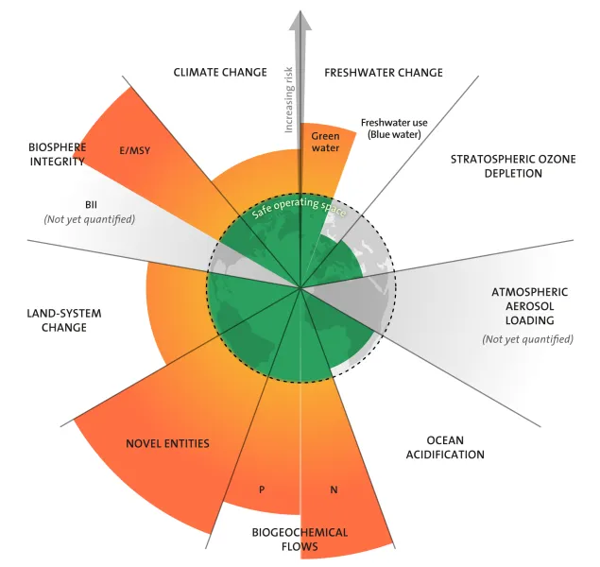
Fig. 1: Critical Role of Soil Moisture in the Earth System
It functions as a central nexus in the global water cycle, regulating the partitioning of precipitation at the land surface into critical hydrological fluxes: infiltration into the soil profile, surface runoff into rivers and streams, and evapotranspiration (ET) back into the atmosphere (Zhang & Zhou, 2016). This partitioning directly determines the water available for plant uptake, which is the foundation of terrestrial ecosystems and global food production (Barnes, Steele‐Dunne, Wagner, Oliveira, Bosch, Coopersmith, & Schieder, 2022). Furthermore, soil moisture is a key driver of the surface energy balance (Qiu, Gao, Wang, & Su, 2016). It controls the allocation of incoming solar radiation into latent heat flux (energy used for ET) and sensible heat flux (energy that heats the air), thereby profoundly influencing near-surface air temperature and humidity (Petropoulos, Ireland, & Barrett, 2015). Through these coupled water and energy pathways, soil moisture dynamics exert a strong control on weather patterns, climate variability, and the frequency and intensity of hydro-meteorological extremes such as droughts and floods (Ahmad, Zhang, & Nichols, 2011). Its significance is formally recognized through its designation as an Essential Climate Variable (ECV) by the Global Climate Observing System (GCOS), highlighting its indispensability for monitoring, understanding, and predicting the state of the global climate system Gruber et. al. (2024).
1.2. The Inadequacy of Traditional In-Situ Measurement Techniques
For decades, the standard for quantifying soil moisture involved direct, in-situ measurements. Gravimetric sampling, which involves weighing, drying, and re-weighing soil samples, remains the most accurate primary method but is destructive and extremely labor-intensive (Ahmad et al., 2011). The development of electromagnetic techniques, such as Time-Domain Reflectometry (TDR), Frequency-Domain Reflectometry (FDR), and capacitance probes, provided a non-destructive means for continuous point-scale monitoring (Zucco, Brocca, Moramarco, & Morbidelli, 2014). While these instruments offer high temporal resolution and accuracy at their specific location, their fundamental limitation is their point-scale nature. Soil moisture exhibits extreme spatial heterogeneity, varying significantly over distances of meters to kilometers due to complex interactions between soil texture, topography, vegetation cover, and meteorological forcing (Zappa, Forkel, Xaver, & Dorigo, 2019). Consequently, extrapolating point measurements from a sparse network of sensors to represent the mean condition of a larger area, such as a farm field, a watershed, or a climate model grid cell, is fraught with significant sampling errors and uncertainties (Escorihuela & Quintana-Seguí, 2016). This spatial sampling limitation has historically been a major barrier to progress in many areas of hydrology, agriculture, and climate science that require spatially continuous data.
1.3. The Emergence and Evolution of Remote Sensing for Soil Moisture Monitoring
The advent of Earth observation from satellite platforms initiated a paradigm shift, offering the potential to overcome the spatial limitations of ground-based networks (Wang & Qu, 2009). Remote sensing provides a unique capability to observe the Earth's surface repeatedly and synoptically, enabling the characterization of soil moisture dynamics over vast areas. The field has undergone a remarkable evolution. Early efforts in the 1970s and 1980s focused on indirect methods using optical and thermal infrared sensors, inferring moisture status from vegetation health or surface temperature anomalies (Zhang & Zhou, 2016).
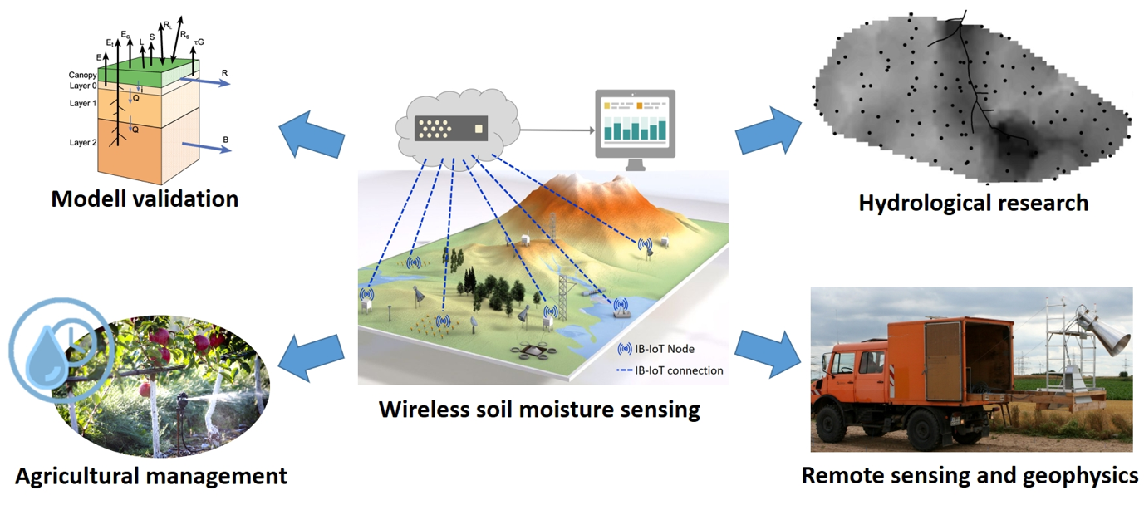
Fig.2: Emergence and Evolution of Remote Sensing for Soil Moisture Monitoring
While useful, these methods were often qualitative and limited by cloud cover and vegetation. The true revolution began with the development and refinement of microwave remote sensing, which offers a more direct physical link to soil water content through its effect on the soil's dielectric properties (Mohanty et al., 2017). The launch of dedicated satellite missions carrying specialized microwave instruments marked a new era of quantitative global soil moisture monitoring. Key milestones include the European Space Agency's (ESA) Soil Moisture and Ocean Salinity (SMOS) mission, launched in 2009, which pioneered the use of L-band interferometric radiometry (Piles, Camps, Vall-llossera, Corbella, Panciera, Rudiger, ... & Walker, 2011), and the National Aeronautics and Space Administration's (NASA) Soil Moisture Active Passive (SMAP) mission, launched in 2015, which combined active (radar) and passive (radiometer) sensors to create a high-resolution global product (Jackson et al., 2010). Concurrently, the operational provision of high-resolution Synthetic Aperture Radar (SAR) data from missions like ESA's Sentinel-1 has opened up new possibilities for field-scale applications (Torres et al., 2012).
1.4. Objectives and Structure of the Review
This review paper aims to provide a comprehensive and in-depth synthesis of the current state-of-the-science in soil moisture remote sensing. It is intended for a broad audience, including researchers, students, and practitioners in the fields of environmental science, agriculture, hydrology, and climatology. The primary objectives are: (1) to elucidate the fundamental physical principles underpinning the various remote sensing techniques for soil moisture estimation; (2) to provide a detailed overview of the transformative applications of these data in agriculture, hydrology, and climate studies, supported by specific examples; (3) to critically evaluate the persistent challenges and limitations of current technologies; and (4) to explore the emerging technologies and future missions that are poised to shape the next frontier of soil moisture monitoring. The paper is structured as follows: Section 2 details the principles of optical, thermal, and microwave remote sensing. Sections 3, 4, and 5 are dedicated to a thorough exploration of applications in agriculture, hydrology, and climate science, respectively. Section 6 addresses the major challenges and the advanced solutions being developed, with a focus on data fusion and machine learning. Section 7 provides a forward-looking perspective on the future of the field. Finally, Section 8 offers a concluding summary of the key findings and the overall significance of soil moisture remote sensing.

2. Principles of Soil Moisture Remote Sensing
The estimation of soil moisture via remote sensing is based on detecting changes in the electromagnetic energy emitted or reflected from the Earth's surface that are caused by variations in water content. The sensitivity and penetration depth of the signal depend heavily on the wavelength used, leading to three distinct families of techniques.
2.1. Optical and Multispectral Remote Sensing (VIS/NIR/SWIR)
2.1.1. Physical Basis: Reflectance and Absorption: Optical remote sensing operates in the visible (VIS, 0.4-0.7 µm), near-infrared (NIR, 0.7-1.3 µm), and shortwave-infrared (SWIR, 1.3-2.5 µm) regions of the electromagnetic spectrum (Zhang & Zhou, 2016). The fundamental principle is straightforward: the spectral reflectance of soil is inversely related to its moisture content.
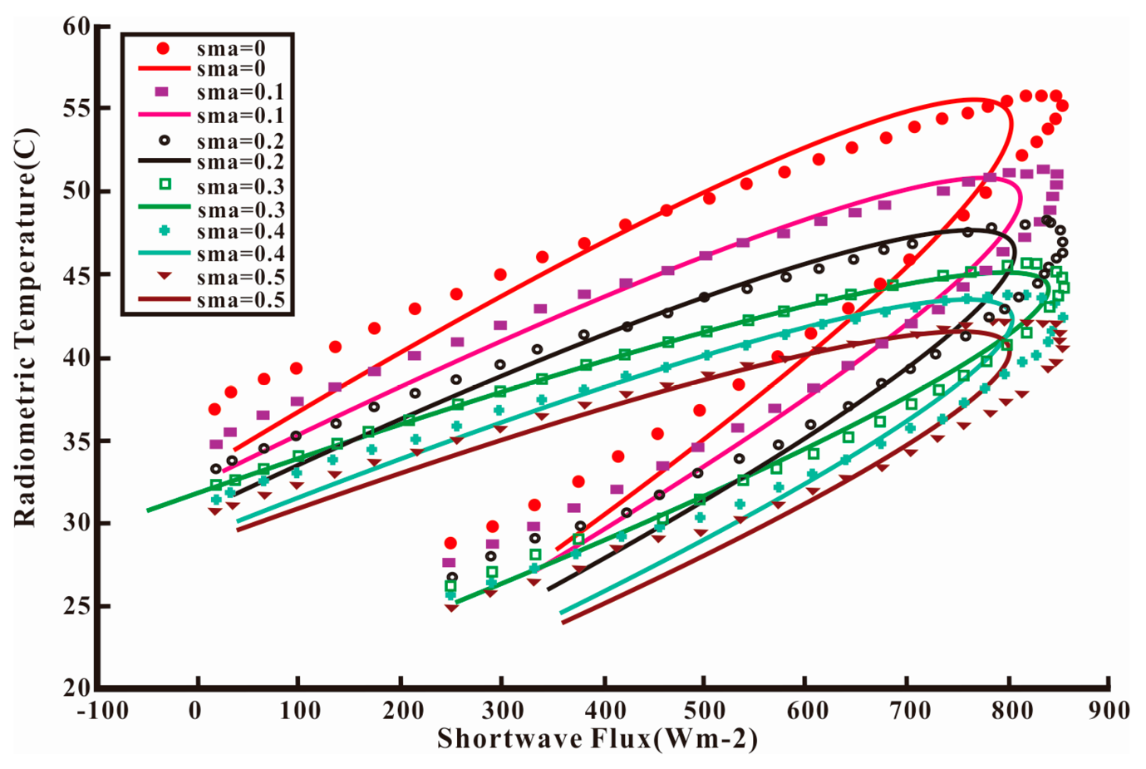
Fig. 3: Physical Basis: Reflectance and Absorption
As water is added to soil, it fills pore spaces and forms a thin film around soil particles, which reduces the amount of light that is scattered back to the sensor and increases absorption, making the soil appear darker (Wang & Qu, 2009). This effect is particularly pronounced at specific water absorption bands in the NIR and SWIR regions (around 1.4, 1.9, and 2.5 µm) (Gao, Wang, Johnson, Tian, Wang, Verrelst, ... & Zhou, 2021).
2.1.2. Key Indices and Models: This physical relationship has led to the development of numerous spectral indices. For bare or sparsely vegetated soils, indices like the Normalized Difference Water Index (NDWI) or the Normalized Soil Moisture Index (NSMI) are used, which leverage the differential reflectance between a non-absorptive NIR band and a water-absorptive SWIR band (Akash, Mohan Kumar, Bhaskar, Deepthi, & Sukhdev, 2024). A more sophisticated and widely used approach, particularly for vegetated areas, is the "optical trapezoid" or "triangle" method (Sridhar, Hubbard, You, & Hunt, 2008). This method plots pixels in a two-dimensional space defined by Land Surface Temperature (LST, derived from thermal data) on one axis and a vegetation index (like NDVI) on the other. The resulting scatterplot typically forms a triangular or trapezoidal shape. The vertices of this shape represent theoretical limits: cold/wet fully vegetated canopy, hot/dry bare soil, and cold/wet bare soil. The relative position of any given pixel within this space is then interpreted as an indicator of its moisture availability, often expressed as a soil moisture index or evaporative fraction (Petropoulos et al., 2015).
2.1.3. Strengths and Inherent Limitations: The primary strength of optical remote sensing is the high spatial resolution of many operational sensors. Satellites like Landsat-8/9 and Sentinel-2 provide data at 10-30 meter resolution, which is highly suitable for field-scale agricultural management (Celik, Isik, Yuzugullu, Fajraoui, & Erten, 2022). The technology is also mature, with long-term data archives extending back several decades. However, the limitations are severe. The optical signal only senses the very top skin layer of the soil (a few millimeters at most) and cannot provide information about root-zone moisture. More critically, optical sensors cannot see through clouds, which is a major constraint in many regions of the world, particularly during rainy seasons when soil moisture information is most needed. Finally, the signal is strongly obscured by even moderate vegetation canopies, making it difficult to retrieve soil moisture directly in most vegetated landscapes (Zhang & Zhou, 2016).
2.2. Thermal Infrared (TIR) Remote Sensing
2.2.1. Physical Basis: Thermal Inertia and Land Surface Temperature: Thermal infrared (TIR) remote sensing measures the thermal radiation emitted by the Earth's surface (typically in the 8-14 µm atmospheric window) to determine Land Surface Temperature (LST) (Petropoulos et al., 2015). The link to soil moisture is based on the principle of thermal inertia—the resistance of a substance to a change in temperature. Water has a very high specific heat capacity and thermal conductivity, meaning it can absorb and transfer a large amount of heat energy with only a small change in temperature (Zhang & Zhou, 2016). Consequently, wet soils have a much higher thermal inertia than dry soils. During the day, a dry soil surface will heat up rapidly, while a wet soil will remain cooler due to both its higher thermal inertia and the cooling effect of evaporation. At night, the dry soil will cool down quickly, while the wet soil will release its stored heat more slowly and remain warmer. The difference between the maximum daytime and minimum nighttime LST (the diurnal temperature range) is therefore inversely related to soil moisture content (Zhao & Li, 2013).
2.2.2. Key Indices and Models: The most direct application of this principle is the estimation of Apparent Thermal Inertia (ATI), which is calculated from the diurnal LST range and the surface albedo (reflectivity) (Wang & Qu, 2009). For vegetated areas where the soil is not directly visible, an indirect approach based on the Crop Water Stress Index (CWSI) is often used (Celik et al., 2022). The CWSI compares the observed temperature of the plant canopy to the temperatures of a non-stressed (fully transpiring) and a fully-stressed (non-transpiring) canopy under the same meteorological conditions. A higher canopy temperature indicates greater water stress, which is linked to lower soil moisture availability in the root zone.
2.2.3. Strengths and Inherent Limitations: TIR sensors on polar-orbiting satellites like Landsat and MODIS can provide LST data at moderate to high spatial resolution (100 m to 1 km). However, like optical sensors, they are completely blocked by clouds. The most significant limitation for thermal inertia methods is the need for multiple observations per day to capture the diurnal temperature cycle. This is only feasible using geostationary satellites (e.g., GOES, MSG), which provide data every 15-30 minutes but at a very coarse spatial resolution (3-5 km), making them unsuitable for local-scale applications (Zhao & Li, 2013).
2.3. Microwave Remote Sensing
Microwave remote sensing is the most direct and powerful method for monitoring soil moisture from space due to the unique dielectric properties of water in this spectral region (Mohanty et al., 2017).
2.3.1. The Dielectric Properties of Water and Soil: The dielectric constant of a material describes its ability to store electrical energy in an electric field. At the microwave frequencies used for remote sensing, there is a massive contrast between the dielectric constant of liquid water (≈80) and that of dry soil minerals (≈3-5) (Ahmad et al., 2011). Because the dielectric constants of the other soil components (minerals and air) are low and relatively stable, the bulk dielectric constant of a soil-water-air mixture is overwhelmingly determined by the volume of water it contains. This strong physical relationship is the foundation of all microwave soil moisture retrieval algorithms Zhang et. Al. (2025).
2.3.2. Passive Microwave (Radiometry): Passive microwave sensors, or radiometers, are highly sensitive thermometers that measure the naturally emitted thermal radiation from the Earth's surface at microwave frequencies, a quantity known as brightness temperature (TB) (Jackson et al., 2010). According to the principles of radiative transfer, the TB is the product of the surface's physical temperature and its emissivity. The emissivity of the soil is inversely related to its dielectric constant Zhao et. Al. (2024) . Therefore, as soil moisture increases, the soil's dielectric constant rises, its emissivity drops, and the measured brightness temperature decreases significantly (Rahman, Di, & Yu, 2017). This provides a strong, direct signal for retrieving soil moisture. Lower frequencies (L-band, ~1.4 GHz, 21 cm wavelength) are preferred because they are less affected by atmospheric water vapor, can penetrate deeper into the soil (top ~5 cm), and can see through moderate amounts of vegetation (Piles et al., 2011). This is why the premier global soil moisture missions, SMOS and SMAP, both operate at L-band. The major drawback of passive systems is their inherently coarse spatial resolution (25-50 km), which arises from the physical requirement of a very large antenna to collect the weak, naturally emitted signal with sufficient quality (Ahmad et al., 2011).
2.3.3. Active Microwave (SAR): Active microwave sensors, such as Synthetic Aperture Radar (SAR), operate like a camera with its own flash. They transmit a pulse of microwave energy towards the surface and measure the strength of the signal that is scattered back to the sensor, known as the backscatter coefficient (σ°) (Akash et al., 2024). The backscattered signal is also highly sensitive to the soil's dielectric constant; a wetter soil surface reflects more of the radar energy back to the sensor, resulting in a higher backscatter value (Torres et al., 2012). The great advantage of SAR is that the "synthetic aperture" technique allows it to achieve very high spatial resolutions (as fine as a few meters), independent of the antenna size. Missions like Sentinel-1 provide operational SAR data at 10-20 m resolution, ideal for many management applications. However, the SAR signal is significantly more complex than the passive signal. It is strongly influenced by two other major factors: surface roughness and vegetation structure (Zribi, Muddu, Bousbih, Al Bitar, Tomer, Baghdadi, & Bandyopadhyay, 2019). A rougher surface will scatter more energy back to the sensor, mimicking the effect of higher moisture. Similarly, vegetation scatters the radar signal in complex ways (e.g., volume scattering from the canopy, double-bounce scattering between stems and the ground). Disentangling these confounding effects from the true soil moisture signal is the primary challenge in SAR-based retrieval and often requires sophisticated models or multi-temporal change detection approaches (Wu, Walker, Rüdiger, Panciera, & Gao, 2017).
2.3.4. Comparison of Microwave Frequencies: The choice of microwave frequency (or band) involves important trade-offs. L-band (~1.4 GHz) offers the best penetration through vegetation and the deepest sensing depth (~5 cm), making it optimal for soil moisture. C-band (~5.4 GHz) has less penetration capability and is more sensitive to smaller vegetation elements and surface roughness, but it is widely available from sensors like Sentinel-1 and RADARSAT. X-band (~9.6 GHz) has even less penetration and is highly sensitive to vegetation, making it generally less suitable for soil moisture retrieval except over bare or very sparsely vegetated surfaces.
Table 1: Detailed Comparison of Remote Sensing Methods for Soil Moisture Estimation
Method | Physical Principle | Advantages | Limitations | Typical Spatial Resolution | Key Satellite Missions | Reference(s)
Optical/Multispectral | Soil reflectance decreases with increasing moisture due to water absorption features. | Very high spatial resolution; long data records; mature technology. | Completely obstructed by clouds; poor penetration of vegetation; senses only the skin layer (<1 cm); indirect relationship in vegetated areas. | 10-30 m | Landsat series, Sentinel-2, MODIS, VIIRS | (Zhang & Zhou, 2016; Gao et al., 2021)
Thermal Infrared (TIR) | Thermal inertia (resistance to temperature change) increases with moisture, reducing the diurnal temperature range. | Moderate to high spatial resolution; provides information related to plant water stress (CWSI). | Completely obstructed by clouds; thermal inertia requires multiple daily observations, which is only possible with coarse-resolution geostationary satellites. | 100 m - 4 km | Landsat series, MODIS, ASTER, GOES, MSG | (Petropoulos et al., 2015; Zhao & Li, 2013)
Passive Microwave | Brightness temperature decreases as soil moisture increases due to the strong effect of water on the soil's dielectric constant and thus its emissivity. | Most direct physical relationship to soil moisture; weather independent (penetrates clouds); penetrates vegetation canopies (especially at L-band); provides global coverage. | Very coarse spatial resolution; signal can be contaminated by Radio-Frequency Interference (RFI); shallow sensing depth (~5 cm). | 25-50 km | SMOS, SMAP, AMSR-E/2, GCOM-W1 | (Ahmad et al., 2011; Jackson et al., 2010; Piles et al., 2011)
Active Microwave (SAR) | Backscatter coefficient increases with soil moisture due to the strong effect of water on the soil's dielectric constant and thus its reflectivity. | Very high spatial resolution; weather independent; sensitive to soil structure and freezing/thawing. | Signal is highly confounded by surface roughness and vegetation structure, making retrieval complex; longer revisit times than passive systems. | 3-100 m | Sentinel-1, RADARSAT-2, ALOS-2, TerraSAR-X, NISAR | (Akash et al., 2024; Torres et al., 2012; Zribi et al., 2019)

3. Applications in Modern Agriculture
The advent of reliable, operational soil moisture data from remote sensing has catalyzed a new green revolution, often termed Agriculture 4.0 or digital agriculture. It provides farmers and agronomists with an unprecedented ability to monitor and manage water, a primary limiting factor in crop production worldwide.
3.1. Precision Irrigation Scheduling and Water Management
Precision irrigation represents a fundamental shift from uniform, calendar-based water application to a data-driven, spatially variable approach (Kasim, Li, Xu, Huang, & Huang, 2025).
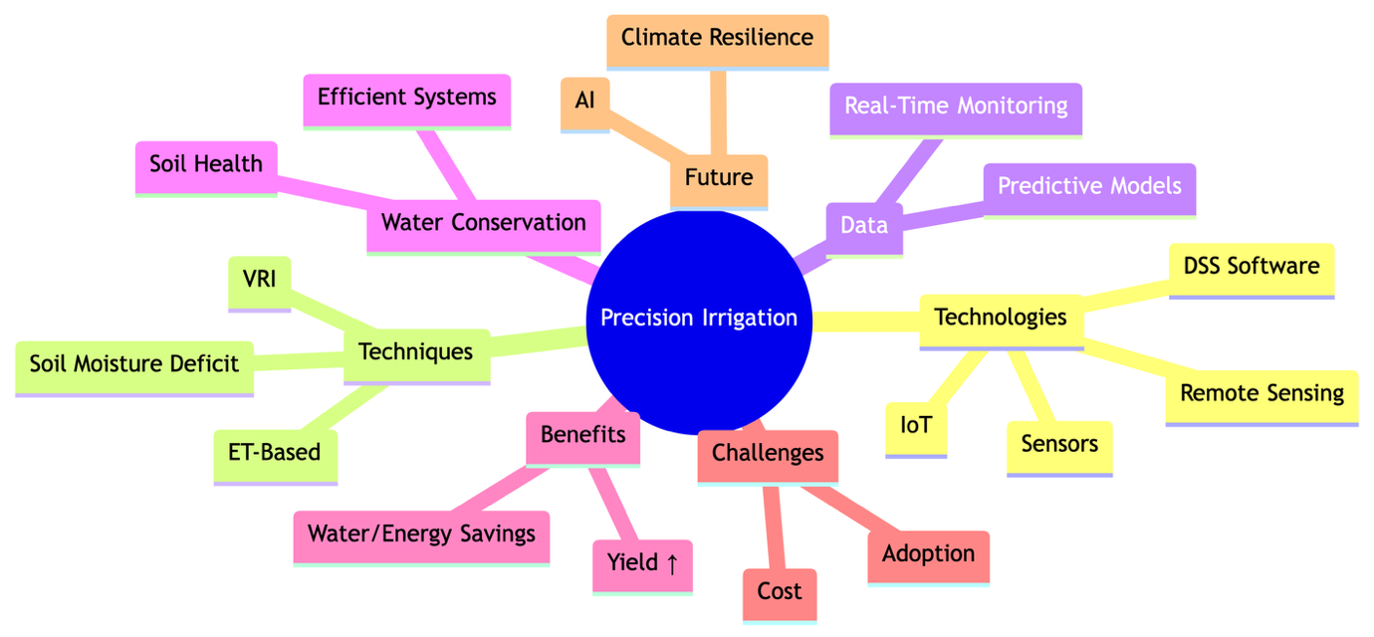
Fig. 4: Precision Irrigation Scheduling and Water Management
The goal is to apply water at the right amount, in the right place, and at the right time. Remotely sensed soil moisture is the key enabling technology for this paradigm. High-resolution soil moisture maps, typically derived from SAR data (e.g., Sentinel-1) or downscaled passive microwave products, are used to delineate management zones within a single field (Chen et al., 2025). These maps reveal that soil moisture can vary significantly across a field due to differences in soil texture, elevation, or previous crop management. This information can be fed directly into modern variable-rate irrigation (VRI) systems, which are equipped with GPS and individually controlled sprinkler heads (Lievens, Martens, Verhoest, Hahn, Reichle, & Miralles, 2017). The VRI system then applies more water to drier zones and less to wetter zones, optimizing water distribution. This not only leads to substantial water savings (often 15-30%) but also improves crop yields by preventing both waterlogging in wet areas and water stress in dry areas (Malbéteau, Merlin, Molero, Rüdiger, & Bacon, 2016). Furthermore, it reduces the energy required for pumping and minimizes the runoff of fertilizers and pesticides into adjacent water bodies, providing significant environmental co-benefits.
3.2. Crop Yield Forecasting and Agricultural Intelligence
The availability of soil moisture during critical growth stages is a dominant factor controlling final crop yield (Barnes, Steele‐Dunne, et al., 2022). Water stress during germination, flowering, or grain-filling can have irreversible negative impacts on productivity. By providing continuous monitoring of soil moisture conditions throughout the growing season, remote sensing offers a powerful tool for large-scale crop condition assessment and yield forecasting. Global soil moisture datasets from missions like SMAP and SMOS are now routinely assimilated into process-based crop growth models (Mohanty et al., 2017). These models simulate the daily growth of a crop based on inputs like weather, soil type, and management practices. Incorporating satellite soil moisture observations provides a powerful constraint on the model's water balance calculations, leading to a much more realistic simulation of crop water stress and its impact on biomass accumulation and final grain yield. This information is of immense value not only to individual farmers but also to larger entities. Agribusinesses use it for supply chain management, insurance companies use it for risk assessment and damage estimation, and national and international agencies use it for ensuring food security and stabilizing commodity markets.
3.3. Agricultural Drought Monitoring and Early Warning Systems
Drought is a slow-onset, creeping natural disaster with devastating impacts on agriculture. Agricultural drought is specifically defined by a deficit of soil moisture in the root zone that leads to widespread crop stress and yield loss (Huang, Zhang, Chen, Ma, Fu, Guo, ... & Xiao, 2022). Satellite remote sensing provides the only practical means to monitor the onset, spatial extent, intensity, and duration of agricultural drought over large regions. Long-term, consistent soil moisture datasets, such as the ESA Climate Change Initiative (CCI) product which merges data from multiple passive and active microwave sensors, are used to calculate soil moisture anomalies (Sridhar et al., 2008). These anomalies, which show how the current soil moisture deviates from the long-term average for that time of year, are powerful and direct indicators of drought conditions. This information is a cornerstone of operational drought early warning systems worldwide, such as the U.S. Drought Monitor and the European Drought Observatory. By providing timely and objective information, these systems enable governments, water managers, and farmers to implement proactive drought mitigation measures, such as activating contingency plans, providing financial aid, or recommending drought-tolerant crops, thereby significantly reducing the socio-economic impact of droughts (Akash et al., 2024).
3.4. Soil Salinity and Health Assessment
While not a direct measurement, soil moisture data can contribute to the monitoring of other aspects of soil health, such as salinity. Soil salinization is a major form of land degradation, particularly in arid and semi-arid irrigated regions. High soil salinity can be inferred from remote sensing through its impact on soil moisture and vegetation health (Singh, Bhardwaj, & Verma, 2021). Saline soils often exhibit unusual moisture patterns and can inhibit water uptake by plants, leading to vegetation stress that is detectable by optical and thermal sensors. By combining soil moisture data with vegetation indices and thermal data over time, it is possible to identify areas at risk of or already affected by salinization. This information can guide management interventions, such as improving drainage or applying soil amendments, to reclaim degraded lands and prevent further salinization.
Table 2: Detailed Applications of Remotely Sensed Soil Moisture in Agriculture
Application | Objective | Key Remote Sensing Data & Techniques | Primary Benefits | Reference(s)
Precision Irrigation | To optimize water application by matching it to the spatially and temporally variable crop water needs within a field. | High-resolution SAR (Sentinel-1); Downscaled passive microwave (SMAP/SMOS); Thermal-based CWSI. | Increased water use efficiency; enhanced crop yield and quality; reduced energy and pumping costs; minimized nutrient leaching and runoff. | (Chen et al., 2025; Kasim et al., 2025; Lievens et al., 2017)
Crop Yield Prediction | To forecast agricultural production at field to regional scales well before harvest. | Assimilation of passive microwave data (SMAP, SMOS) into process-based crop growth models (e.g., DSSAT, WOFOST); Machine learning models combining soil moisture with optical/thermal data. | Early risk assessment for insurance; supply chain logistics planning; national/global food security assessment; market intelligence and price stabilization. | (Barnes, Steele‐Dunne, et al., 2022; Mohanty et al., 2017)
Drought Monitoring | To detect and characterize the onset, spatial extent, intensity, and duration of agricultural drought. | Calculation of anomalies from long-term, multi-mission passive microwave datasets (e.g., ESA CCI); Integrated drought indices (e.g., Vegetation Health Index, which combines thermal and optical data). | Timely activation of drought early warning systems; proactive implementation of mitigation strategies; targeted aid distribution; improved water resource allocation. | (Huang et al., 2022; Sridhar et al., 2008; Akash et al., 2024)
Soil Health Assessment | To indirectly monitor soil degradation processes like salinization and compaction. | Combined analysis of soil moisture (microwave), vegetation stress (optical), and surface temperature (thermal) time series. | Identification of degraded areas for targeted remediation; guidance for sustainable land management practices; prevention of further land degradation. | (Singh, Bhardwaj, & Verma, 2021)

4. Applications in Contemporary Hydrology
The ability to observe the spatial and temporal patterns of a key hydrological state variable has provided hydrologists with a powerful new tool to understand, model, and manage water resources from the watershed to the continental scale.
4.1. Flood Forecasting, Modeling, and Risk Mitigation
The amount of water stored in the soil prior to a storm event—the antecedent soil moisture—is a first-order control on runoff generation and flood response (Petropoulos et al., 2015). If the soil is dry, it can absorb a significant portion of the incoming rainfall, attenuating the flood peak. If the soil is already near saturation, most of the rainfall will be converted into surface runoff, potentially leading to a severe and rapid flood. Traditional hydrological models often had to rely on crude estimates or model spin-up procedures to initialize this critical state variable. The availability of spatially distributed soil moisture data from satellites like SMAP and Sentinel-1 has revolutionized this process (Escorihuela & Quintana-Seguí, 2016). Through a technique called data assimilation, these observations are merged with the hydrological model in near real-time. This process nudges the model's internal state to be more consistent with the real-world observations, resulting in a much more accurate initial condition. Numerous studies have shown that assimilating satellite soil moisture data can dramatically improve the accuracy of flood forecasts, particularly the prediction of flood peak timing and magnitude. This leads to more reliable and timely flood warnings, giving emergency responders more lead time to evacuate communities and mitigate potential damages.
4.2. Groundwater Recharge Estimation and Aquifer Management
Groundwater is a hidden but vital component of the global water supply, sustaining ecosystems and providing drinking and irrigation water for billions of people. Its sustainable management depends on knowing the rate at which it is being replenished, a process known as groundwater recharge. Recharge is notoriously difficult to measure directly over large areas. It occurs when water infiltrates the surface and percolates down through the vadose zone to reach the water table, a process heavily controlled by the soil moisture status of the overlying soil layers (Piles et al., 2011). Satellite remote sensing provides crucial information for estimating recharge. L-band microwave sensors (SMOS and SMAP) provide information on surface soil moisture, which controls the infiltration rate. When these data are combined with precipitation data and integrated into a soil water balance model, the deep drainage component (i.e., the water leaving the root zone) can be estimated as a residual term, providing a proxy for potential recharge (Sadeghi, Tabatabaeenejad, Tuller, Moghaddam, & Jones, 2017). On longer timescales, data from the Gravity Recovery and Climate Experiment (GRACE) and its Follow-On mission, which measure changes in total terrestrial water storage (groundwater + soil moisture + surface water), can be combined with satellite soil moisture data to help isolate the groundwater component, providing further constraints on recharge and depletion rates.
4.3. Watershed-Scale Water Balance and Management
Effective and integrated watershed management requires a comprehensive understanding of the stocks and fluxes of water within the catchment boundary. Remote sensing of soil moisture provides a spatially explicit picture of one of the most dynamic water stores in the landscape (Zucco et al., 2014). This information allows water managers and hydrologists to assess the impacts of land use and land cover change on the watershed's hydrological response. For example, converting a forest to agricultural land or urban area can drastically alter infiltration-runoff partitioning, and the effects of these changes can be monitored through the resulting shifts in spatial soil moisture patterns. Satellite data can also be used to evaluate the effectiveness of various watershed management interventions and nature-based solutions. For instance, managers can assess whether the implementation of conservation tillage, the construction of retention ponds, or the restoration of wetlands is successfully increasing water storage in the landscape by analyzing multi-temporal soil moisture data before and after the intervention. This provides a means to quantify the return on investment for environmental restoration projects.
4.4. Snowmelt Runoff Forecasting
In many mountainous regions, the seasonal snowpack is the primary source of water for downstream communities and ecosystems. The timing and volume of spring snowmelt runoff are critical for water supply planning. The soil moisture condition of the ground beneath the snowpack when it begins to melt is a key factor influencing the efficiency of runoff generation. If the soil is frozen and saturated, most of the meltwater will run off quickly. If the soil is dry and unfrozen, it can absorb a large portion of the initial meltwater, delaying and reducing the peak streamflow. Microwave remote sensing, particularly at L-band, can penetrate dry snow and provide information on the underlying soil state (frozen or thawed, wet or dry). This information is increasingly being incorporated into snow hydrology models to improve forecasts of spring runoff, which is vital for reservoir operations, water allocation, and flood management in snow-dominated basins.
Table 3: Detailed Applications of Remotely Sensed Soil Moisture in Hydrology
Application | Objective | Key Remote Sensing Data & Techniques | Primary Benefits | Reference(s)
Flood Forecasting | To improve the accuracy of flood prediction by providing realistic initial watershed wetness conditions. | Data assimilation of near real-time passive microwave (SMAP) or SAR (Sentinel-1) data into distributed hydrological models. | More accurate and reliable flood warnings; increased lead time for emergency response; improved risk assessment and mitigation planning. | (Petropoulos et al., 2015; Escorihuela & Quintana-Seguí, 2016)
Groundwater Recharge | To estimate the rate of water percolating to aquifers for sustainable groundwater management. | Integration of L-band passive microwave data (SMOS, SMAP) into soil water balance models; Combined analysis with GRACE terrestrial water storage data. | Improved quantification of groundwater resources; guidance for setting sustainable extraction limits; better understanding of surface-groundwater interactions. | (Piles et al., 2011; Sadeghi et al., 2017)
Watershed Management | To assess the hydrological impacts of land use change and evaluate the effectiveness of conservation practices. | Analysis of multi-temporal, multi-sensor soil moisture time series (e.g., ESA CCI) to detect changes in hydrological response. | Evidence-based land use planning; quantification of the benefits of nature-based solutions; improved understanding of ecohydrological processes. | (Zucco et al., 2014; Barnes, Steele‐Dunne, et al., 2022)
Snowmelt Forecasting | To improve forecasts of spring runoff volume and timing in snow-dominated basins. | L-band microwave remote sensing (SMAP, SMOS) to determine the soil state (frozen/thawed, wet/dry) beneath the snowpack prior to melt. | More efficient reservoir operation; better water supply allocation for agriculture and municipalities; enhanced flood management during the melt season. | (Mohanty et al., 2017)

5. Applications in Climate Science and Global Change
As a designated Essential Climate Variable (ECV), soil moisture plays a fundamental role in the climate system. The development of global, multi-decadal satellite soil moisture datasets has been a boon for climate scientists, enabling new insights into climate processes and change.
5.1. Investigating Land-Atmosphere Feedbacks
The land surface is not a passive recipient of atmospheric forcing; it actively communicates back to the atmosphere, creating feedback loops that can amplify or dampen climate variability. Soil moisture is at the heart of many of these feedbacks (Qiu et al., 2016). The most studied of these is the soil moisture-precipitation feedback. In some regions and seasons, anomalously wet soils can enhance local evapotranspiration, moistening and cooling the planetary boundary layer. This can increase the likelihood of afternoon convective cloud formation and precipitation, creating a positive feedback loop where "wet soils get wetter" (Chen et al., 2025). Conversely, dry soils can lead to a stronger sensible heat flux, a warmer and deeper boundary layer, and suppressed precipitation, amplifying drought conditions in a "dry soils get drier" feedback. Global satellite datasets have, for the first time, allowed scientists to observe the spatial patterns and strength of these feedbacks across the globe, identifying regional "hotspots" where these interactions are particularly strong and important for seasonal climate predictability.
5.2. Validation and Improvement of Climate and Earth System Models
Earth System Models (ESMs) are unconstrained numerical simulations of the climate system that are formulated to learn about the past climate and predict the future climate change. These models have land surface model (LSM) components that model the flows of water and energy such as the soil moisture. Nevertheless, how you represent the processes is the key component of uncertainty in ESMs (Lievens et al., 2017). Monitors The use of satellites to collect global, consistent satellite soil moisture products in order to establish an essential observational benchmark to test and advance these models is an imperative. By comparing the results of a model with a LSM in terms of spatial patterns, seasonal cycle, and interannual variability of soil moisture with satellite-based estimations (e.g. ESA CCI product) model developers can tell the systematic bias and limitations in the physics input and parameterization of their models. This model analysis can be regarded as important to gain confidence in climate forecasts and limit the uncertainty concerning the changes in the water cycle, warming, and extreme weather (Zhang, He, & Zhang, 2017).
5.3. Monitoring Climate Change Impacts on the Terrestrial Water Cycle
This tendency of the global water cycle to strengthen is one of the most sound predictions of global climate change, and can be colloquially stated as the water cycle behavior of "wet places are wetter, and dry places are drier." A test of this hypothesis and tracking the actual-world consequences of a warming climate on terrestrial water availability is through long-term, more-or-less stable soil moisture records on satellites (Mohanty et al., 2017). Since scientists make use of coordinated multi-decadal records which combine the observations of a succession of various satellite measurements, they can conduct examination of long-term trends. Such analysis can disclose statistically significant drying trends in subtropical areas, such as the Mediterranean and southern Africa, and pulverizing trends in parts of high latitudes, observational evidence of climatic change in operation, much needed. The datasets are also employed to monitor the variations in the patterns (rate, period, and extent) of droughts and pluvials (long intervals of extreme wetness) amid the global scale, which forms a crucial evidence base when assessing climate on an international level, especially when it comes to the Intergovernmental Panel on Climate Change (IPCC) assessments.
5.4. Contribution to Global Climate Reanalysis Products
Climate reanalysis products, such as ERA5 from the European Centre for Medium-Range Weather Forecasts (ECMWF) or MERRA-2 from NASA, are among the most widely used datasets in all of Earth science. They provide a complete and consistent "best estimate" of the state of the atmosphere, land, and oceans over the past several decades by assimilating a vast array of historical observations into a modern weather forecasting model. Satellite soil moisture data are a key input to these systems (Lievens et al., 2017). Assimilating these observations helps to constrain the land surface component of the reanalysis model, leading to a more realistic representation of soil moisture and its influence on surface energy and water fluxes. This, in turn, improves the quality of the entire reanalysis product, including variables like near-surface air temperature and precipitation, making reanalysis a more valuable tool for a wide range of climate studies.
Table 4: Detailed Applications of Remotely Sensed Soil Moisture in Climate Studies
Application | Objective | Key Remote Sensing Data & Techniques | Primary Benefits | Reference(s)
Land-Atmosphere Feedbacks | To observe and quantify the strength and spatial patterns of coupling between soil moisture, evapotranspiration, and precipitation. | Analysis of co-variability between global passive microwave soil moisture (SMAP, SMOS) and atmospheric data (e.g., precipitation, temperature). | Improved understanding of climate system dynamics; enhanced seasonal climate predictability; better representation of land processes in models. | (Qiu et al., 2016; Chen et al., 2025)
Climate Model Evaluation | To validate, diagnose biases in, and improve the land surface components of Earth System Models. | Comparison of model outputs against long-term, globally consistent benchmark datasets like the ESA CCI soil moisture product. | Identification of model deficiencies; reduction of uncertainty in climate projections; increased confidence in model-based climate change assessments. | (Lievens et al., 2017; Zhang, He, & Zhang, 2017)
Climate Change Monitoring | To detect and attribute long-term trends in the terrestrial water cycle and the frequency of hydro-meteorological extremes. | Trend analysis of harmonized, multi-decadal (1978-present) merged passive and active microwave datasets. | Direct observational evidence of climate change impacts; input for international climate assessments (e.g., IPCC); monitoring of ecosystem resilience. | (Mohanty et al., 2017; Qiu et al., 2016)
Climate Reanalysis | To improve the quality of historical climate reconstructions by constraining the land surface state. | Assimilation of satellite soil moisture observations (e.g., from SMOS, SMAP, ASCAT) into reanalysis systems like ERA5 and MERRA-2. | More accurate and consistent historical climate records; improved understanding of past climate variability and extremes. | (Lievens et al., 2017)

6. Persistent Challenges and Advanced Solutions
Despite the immense progress, the field of soil moisture remote sensing is not without its challenges. These challenges are the focus of intense research, with innovative solutions emerging from the intersection of sensor technology, physics, and data science.
6.1. The Spatio-Temporal Resolution Dichotomy
This remains the most fundamental challenge in the field (Escorihuela & Quintana-Seguí, 2016). The physics of microwave remote sensing dictates an inverse relationship between spatial resolution and temporal revisit frequency for a single satellite. Passive microwave radiometers provide excellent temporal resolution (1-3 days) but at a coarse spatial scale (25-50 km), making them unsuitable for applications requiring fine-scale detail. Active SAR systems provide excellent spatial resolution (10-100 m) but with a much longer revisit time (6-12 days), meaning they can miss important short-term soil moisture events.
- 6.1.1. Downscaling and Sharpening Algorithms: A major area of research is dedicated to downscaling, or "sharpening," the coarse-resolution passive microwave data using higher-resolution auxiliary information. A variety of techniques have been developed, ranging from simple polynomial fitting to more complex, physically-based methods. The DISPATCH (DISaggregation based on Physical And Theoretical scale Change) algorithm, for example, uses the relationship between soil moisture, soil temperature, and vegetation indices observed at the coarse scale to predict soil moisture at the finer scale of optical/thermal sensors (e.g., 1 km) (Malbéteau et al., 2016).
- 6.1.2. Multi-sensor Data Fusion Strategies: The ultimate solution lies in synergistically merging data from different sensor types to create a product that has the strengths of all its inputs. The original design of the SMAP mission embodied this concept, combining its L-band radar (high resolution) and L-band radiometer (high accuracy) to produce a 9 km soil moisture product. Although the radar failed shortly after launch, the concept remains a "holy grail" for the community. Current fusion efforts often use advanced statistical methods like Kalman filtering or machine learning to merge data from passive microwave, SAR, and optical/thermal sensors to generate high-resolution, temporally frequent soil moisture datasets (Rahman, Di, & Yu, 2017).
6.2. Mitigating Confounding Environmental Factors
The microwave signal is not solely influenced by soil moisture; other environmental factors can contaminate or obscure the signal, leading to retrieval errors.
- 6.2.1. Vegetation Canopy Effects: Vegetation is the largest source of error in most soil moisture retrieval algorithms (Jackson et al., 2010). The canopy absorbs and scatters the microwave signal from the underlying soil and also adds its own emission/backscatter. This effect is quantified by the vegetation optical depth (VOD), a measure of the "opaqueness" of the canopy. Retrieval algorithms must accurately estimate and correct for VOD, typically using a "tau-omega" model. However, accurately parameterizing VOD is challenging, and retrievals are generally considered unreliable once the VOD exceeds a certain threshold (e.g., ~0.8, corresponding to dense forests).
- 6.2.2. Surface Roughness and Topography: Surface roughness, at scales comparable to the sensor wavelength, significantly increases the microwave backscatter (for SAR) and emission (for radiometers), an effect that can be mistaken for a change in soil moisture (Zribi et al., 2019). While physical models exist to correct for this, they require detailed information about the surface that is rarely available. Topography also complicates retrievals by altering the local incidence angle of the sensor.
- 6.2.3. Radio-Frequency Interference (RFI): The L-band frequency range, which is ideal for soil moisture sensing, is also used by various ground-based communication and surveillance systems (e.g., air traffic control radar). These man-made signals can be much stronger than the natural microwave emission from the Earth and can contaminate the satellite measurements, leading to erroneously high brightness temperatures. Sophisticated on-board and ground-based detection and mitigation algorithms are required to identify and remove RFI-contaminated data before it is used in retrieval algorithms.
6.3. The Role of Machine Learning and Artificial Intelligence
The explosion in the volume and variety of Earth observation data, coupled with advances in computing, has led to a paradigm shift towards data-driven methods using machine learning (ML) and artificial intelligence (AI) (Barnes, Steele‐Dunne, et al., 2022).
- 6.3.1. Supervised Learning for Retrieval and Downscaling: ML algorithms can learn complex, non-linear relationships directly from data without requiring explicit physical models. Supervised learning algorithms like Random Forests, Support Vector Machines, and Gradient Boosting are now widely used for soil moisture retrieval and downscaling (Gao et al., 2021). They are trained on datasets where satellite observations (from multiple sensors) are paired with known soil moisture values (from in-situ networks or model outputs). Once trained, these models can often outperform traditional physically-based algorithms, particularly in complex landscapes.
- 6.3.2. Deep Learning for Feature Extraction and Time-Series Analysis: Deep learning, a subset of ML using neural networks with many layers, is particularly well-suited for handling the large, multi-dimensional datasets in remote sensing. Convolutional Neural Networks (CNNs) are excellent at learning spatial patterns and are used for tasks like downscaling and data fusion. Recurrent Neural Networks (RNNs) and Long Short-Term Memory (LSTM) networks are designed to handle sequential data and are being used to analyze soil moisture time series, fill gaps in the data, and forecast future soil moisture conditions (Chen et al., 2025).

7. Future Directions and Emerging Frontiers
The field of soil moisture remote sensing is dynamic and rapidly evolving, with several exciting developments on the horizon that promise to overcome current limitations and open up new scientific and application frontiers.
7.1. Next-Generation Satellite Missions and Sensor Technologies
With the kind of quality of data that will be made available through a new generation of sophisticated satellite missions, the later has the potential of becoming a lot smarter. An upcoming NASA - Indian Space Research Organization (ISRO) Synthetic Aperture Radar (NISAR) mission will revolutionize the game (Torres et al., 2012). It will have L-band and S-band SAR and will map out almost the whole earth 12 day once. Its L-band capability will especially be powerful in detecting soil moisture where it will provide high resolution and have superior vegetation penetration compared to current available C-band SAR sensors. Other suggested missions include the investigation of such things as multi-frequency passive microwave systems or large deployable mesh antennas to attain better spatial resolution on radiometers. The Surface Water and Ocean Topography (SWOT) mission, while focused on surface water, will also provide data that can be used synergistically with soil moisture observations to better understand total water storage.
7.2. The Paradigm of CubeSat Constellations
Perhaps the most disruptive innovation is the rise of small, inexpensive satellites known as CubeSats (Chen et al., 2025). While a single large satellite is expensive and has a fixed revisit time, a constellation of dozens or even hundreds of low-cost CubeSats equipped with miniaturized sensors (e.g., GPS-reflectometry receivers or small radars) could work in concert to provide global coverage at both high spatial resolution and unprecedented temporal resolution (potentially multiple times per day). This would effectively shatter the traditional spatio-temporal trade-off and revolutionize our ability to monitor highly dynamic processes like flash flooding, irrigation events, and diurnal water cycles. Companies and space agencies are actively developing and launching such constellations.
7.3. Synergy with the Internet of Things (IoT) and Citizen Science
The future of environmental monitoring lies in the integration of different observing systems. A powerful emerging paradigm is the synergy between satellite remote sensing and ground-based Internet of Things (IoT) sensor networks (Singh, Bhardwaj, & Verma, 2021). Networks of low-cost, wireless soil moisture sensors can provide continuous, real-time, hyper-local information. This ground data is invaluable for calibrating and validating satellite retrieval algorithms (a process known as "cal/val") and for providing information at scales finer than the satellite can resolve. In return, the satellite data provides the crucial spatial context, allowing the point-based IoT measurements to be intelligently extrapolated across the landscape. This integrated system can support fully autonomous "smart" farms and provide high-fidelity environmental monitoring. Citizen science initiatives, where members of the public collect data using simple tools or mobile apps, also represent a promising new source of ground data.
7.4. The Advent of Explainable AI (XAI) and Digital Twins
As ML and AI models become more complex and integral to soil moisture products, there is a growing demand for transparency and trustworthiness. The field of Explainable AI (XAI) aims to develop techniques that can "look inside the black box" of these models to understand why they make a particular prediction (Barnes, Steele‐Dunne, et al., 2022). This is crucial for scientific discovery and for building user confidence. A more ambitious future concept is the "Digital Twin" of the Earth—a fully integrated, dynamic, virtual replica of the planet that assimilates all available observations in real-time to simulate Earth system processes. High-resolution, real-time soil moisture data would be a cornerstone of such a system, which could be used to run what-if scenarios to test the impact of different climate policies or management strategies.

8. Conclusion
The capacity to monitor soil moisture from space has transformed from a scientific curiosity into a mature, operational capability that provides indispensable information for science and society. Over the past four decades, the field has progressed from rudimentary, indirect methods to sophisticated, physically-based microwave techniques, culminating in a constellation of dedicated satellite missions that provide daily global snapshots of this vital Earth system variable. The applications of these data are vast and impactful, revolutionizing practices in precision agriculture, enhancing the management of hydrological hazards and resources, and fundamentally improving our understanding of the climate system and its ongoing changes.
Despite this remarkable success, the work is far from complete. Persistent challenges, most notably the inherent trade-off between spatial and temporal resolution and the confounding influences of vegetation and surface roughness, continue to drive innovation. The path forward is being paved by a powerful convergence of technologies. The fusion of data from multiple sensors, powered by the ever-increasing sophistication of machine learning and artificial intelligence, is breaking down old barriers. A new generation of advanced satellite missions, coupled with the disruptive potential of large CubeSat constellations and the synergy with ground-based IoT networks, promises to deliver soil moisture data with a level of detail and frequency previously thought unattainable. This continued evolution in our ability to observe and understand soil moisture dynamics is not merely an academic pursuit; it is essential for building more resilient food and water systems, for mitigating the impacts of climate change, and for safeguarding the health of our planet for future generations.

COMPETING INTERESTS DISCLAIMER:
Authors have declared that they have no known competing financial interests OR non-financial interests OR personal relationships that could have appeared to influence the work reported in this paper.

Disclaimer (Artificial intelligence)
Option 1:
Author(s) hereby declare that NO generative AI technologies such as Large Language Models (ChatGPT, COPILOT, etc.) and text-to-image generators have been used during the writing or editing of this manuscript.
Option 2:
Author(s) hereby declare that generative AI technologies such as Large Language Models, etc. have been used during the writing or editing of manuscripts. This explanation will include the name, version, model, and source of the generative AI technology and as well as all input prompts provided to the generative AI technology
Details of the AI usage are given below:
1.
2.
3.

References
Ahmad, A., Zhang, Y., & Nichols, S. (2011). Review and evaluation of remote sensing methods for soil-moisture estimation. SPIE Reviews, 2(1), 028001. https://doi.org/10.1117/1.3534910
Akash, M., Mohan Kumar, P., Bhaskar, P., Deepthi, P. R., & Sukhdev, A. (2024). Review of estimation of soil moisture using active microwave remote sensing technique. Computers and Geosciences, 187, 105584. https://doi.org/10.1016/j.cageo.2024.105584
Barnes, E. B., Steele‐Dunne, S. C., Wagner, W., Oliveira, R. S., Bosch, D. D., Coopersmith, E. J., & Schieder, M. (2022). Remotely sensed soil moisture can capture dynamics relevant to plant water uptake. Water Resources Research, 58(12), e2022WR033814. https://doi.org/10.1029/2022WR033814
Celik, M. F., Isik, M. S., Yuzugullu, O., Fajraoui, N., & Erten, E. (2022). Soil moisture prediction from remote sensing images coupled with climate, soil texture and topography via deep learning. Remote Sensing, 14(21), 5584. https://doi.org/10.3390/rs14215584
Chen, L., Xu, L., Yang, X., Wang, K., Zhang, X., Chen, Y., ... & Li, F. (2025). Using remote sensing and machine learning to generate high-spatial-resolution multi-layer soil moisture data for agricultural applications. Agricultural Water Management, 308, 109076. https://doi.org/10.1016/j.agwat.2024.109076
Escorihuela, M. J., & Quintana-Seguí, P. (2016). Comparison of remote sensing and simulated soil moisture datasets in Mediterranean landscapes. Remote Sensing of Environment, 180, 99-114. https://doi.org/10.1016/j.rse.2016.02.046
Gao, L., Wang, X., Johnson, B. A., Tian, Q., Wang, Y., Verrelst, J., ... & Zhou, Y. (2021). Advances in soil moisture retrieval from multispectral remote sensing using unoccupied aircraft systems and machine learning techniques. Hydrology and Earth System Sciences, 25(5), 2739-2758. https://doi.org/10.5194/hess-25-2739-2021
Gruber, A., Dorigo, W. A., Hahn, S., Paulik, C., & Wagner, W. (2024). ESA CCI Soil Moisture for improved Earth system understanding: Version 08.1 data release and climate assessment. Earth System Science Data, 16(2), 1025–1054.
Huang, S., Zhang, X., Chen, N., Ma, H., Fu, G., Guo, D., ... & Xiao, C. (2022). Soil moisture prediction from remote sensing images coupled with climate, soil texture and topography via deep learning. Remote Sensing, 14(21), 5584. https://doi.org/10.3390/rs14215584
Jackson, T. J., Cosh, M. H., Bindlish, R., Starks, P. J., Bosch, D. D., Seyfried, M., ... & Pachepsky, Y. (2010). Validation of advanced microwave scanning radiometer soil moisture products. IEEE Transactions on Geoscience and Remote Sensing, 48(12), 4256-4272.
Kasim, A. A., Li, B., Xu, X., Huang, Y., & Huang, J. (2025). Remote sensing of root zone soil moisture: A review of methods and validation. Journal of Hydrology, 631, 130789. https://doi.org/10.1016/j.jhydrol.2024.130789
Lievens, H., Martens, B., Verhoest, N. E., Hahn, S., Reichle, R. H., & Miralles, D. G. (2017). Assimilation of global radar backscatter and radiometer brightness temperature observations to improve soil moisture and land evaporation estimates. Remote Sensing of Environment, 189, 194-210.
Malbéteau, Y., Merlin, O., Molero, B., Rüdiger, C., & Bacon, S. (2016). DisPATCh as a tool to evaluate coarse-scale remotely sensed soil moisture using localized in situ measurements: Application to SMOS and AMSR-E data in Southeastern Australia. International Journal of Applied Earth Observation and Geoinformation, 45, 221-234.
Mohanty, B. P., Cosh, M. H., Lakshmi, V., & Montzka, C. (2017). Soil moisture remote sensing: State-of-the-science. Vadose Zone Journal, 16(1), 1-9. https://doi.org/10.2136/vzj2016.10.0105
Petropoulos, G. P., Ireland, G., & Barrett, B. (2015). Surface soil moisture retrievals from remote sensing: Current status, products & future trends. Physics and Chemistry of the Earth, 83, 36-56.
Piles, M., Camps, A., Vall-llossera, M., Corbella, I., Panciera, R., Rudiger, C., ... & Walker, J. P. (2011). Downscaling SMOS-derived soil moisture using MODIS visible/infrared data. IEEE Transactions on Geoscience and Remote Sensing, 49(9), 3156-3166.
Qiu, J., Gao, Q., Wang, S., & Su, Z. (2016). Comparison of temporal trends from multiple soil moisture data sets and precipitation: The implication of irrigation on regional soil moisture trend. International Journal of Applied Earth Observation and Geoinformation, 48, 17-27.
Rahman, M. S., Di, L., & Yu, E. (2017). A unified approach for land surface and root zone soil moisture retrieval using L-band radiometer. Remote Sensing, 9(4), 424.
Sadeghi, M., Tabatabaeenejad, A., Tuller, M., Moghaddam, M., & Jones, S. B. (2017). Advancing NASA's AirMOSS P-band radar root zone soil moisture retrieval algorithm via incorporation of Richards' equation. Remote Sensing, 9(1), 17.
Singh, S., Bhardwaj, A., & Verma, V. K. (2021). Remote sensing and GIS applications for monitoring and assessment of the salt-affected soils. Remote Sensing Applications: Society and Environment, 23, 100567.
Sridhar, V., Hubbard, K. G., You, J., & Hunt, E. D. (2008). Development of the soil moisture index to quantify agricultural drought and its "user friendliness" in severity-area-duration assessment. Journal of Hydrometeorology, 9(4), 660-676.
Torres, R., Snoeij, P., Geudtner, D., Bibby, D., Davidson, M., Attema, E., ... & Rostan, F. (2012). GMES Sentinel-1 mission. Remote Sensing of Environment, 120, 9-24.
Wang, L., & Qu, J. J. (2009). Satellite remote sensing applications for surface soil moisture monitoring: A review. Frontiers of Earth Science in China, 3(2), 237-247.
Wu, X., Walker, J. P., Rüdiger, C., Panciera, R., & Gao, Y. (2017). Medium resolution soil moisture retrieval using the Bayesian merging method. Remote Sensing, 9(6), 613.
Zappa, L., Forkel, M., Xaver, A., & Dorigo, W. (2019). Deriving field scale soil moisture from satellite observations and ground measurements in a hilly agricultural region. Remote Sensing, 11(22), 2596.
Zhang, D., & Zhou, G. (2016). Estimation of soil moisture from optical and thermal remote sensing: A review. Sensors, 16(8), 1308. https://doi.org/10.3390/s16081308
Zhang, D., Yang, K., Qin, J., Lu, H., & Chen, Y. (2025). Deep learning for downscaling satellite soil moisture with synergistic use of optical/thermal and topographic data: Enhancing agricultural drought monitoring. IEEE Journal of Selected Topics in Applied Earth Observations and Remote Sensing, 18, 1160–1173.
Zhang, L., He, C., & Zhang, M. (2017). Multi-scale evaluation of the SMAP product using sparse in-situ network over a high mountainous watershed, Northwest China. Remote Sensing, 9(11), 1111.
Zhao, T., Shi, J., Hu, L., Cui, Q., Xu, H., & Wigneron, J. P. (2024). Assimilating multi-frequency passive microwave soil moisture into a distributed hydrologic model for improved flood forecasting. Journal of Hydrology, 630, 130718.
Zhao, W., & Li, A. (2013). A downscaling method for improving the spatial resolution of AMSR-E derived soil moisture product based on MSG-SEVIRI data. Remote Sensing, 5(12), 6790-6811.
Zribi, M., Muddu, S., Bousbih, S., Al Bitar, A., Tomer, S. K., Baghdadi, N., & Bandyopadhyay, S. (2019). Analysis of L-band SAR data for soil moisture estimations over agricultural areas in the tropics. Remote Sensing, 11(9), 1122.
Zucco, G., Brocca, L., Moramarco, T., & Morbidelli, R. (2014). Influence of land use on soil moisture spatial–temporal variability and monitoring. Journal of Hydrology, 516, 193-199.

