**Original Research Article**

**Influence of Paddy Straw Biochar in Combination with Organic Amendments on Growth Dynamics and Yield of Field Bean (*Lablab purpureus* L.)**

**Abstract:** A pot culture experiment was conducted during 2022-2023 to determine the impact of different biochar doses combined with organic amendments on plant growth and yield. Biochar doses of 8, 10, and 12 t/ha were applied in combination with organic amendments such as farmyard manure (FYM), vermicompost (VC), Ghanajeevamruth (GA) and their various combinations. The study reveals that the application of 12 t ha-1 of biochar along with farmyard manure and vermicompost (T17), significantly enhanced plant height (89.63 cm), number of branches (22.50), number of leaves (97) number of pods (20.25), pod weight (27.41 g), biomass yield (154.88 g) and projected pod yield (61.42 q ha-1) relative to control and other treatments. In contrast, specific leaf area and specific leaf weight did not differ significantly among treatments. SPAD chlorophyll values increased markedly during early flowering and reproductive phase (reaching 37.44). These results demonstrate that integrating biochar with farmyard manure and vermicompost offers a sustainable strategy to boost field bean productivity.

**Key words:** Biochar, organic amendments, FYM, Ghanajeevamruth, vermicompost, field bean, growth parameters and yield parameters.

**Introduction:** Growing population demands have resulted in unsustainable farming practises and a significant reliance on chemical pesticides and fertilisers, which have degraded the soil quality (Vijay *et al*. 2021). The application of organic manures produced from biomass and animals plays a significant role in nutrient recycling through improving nutrient availability and soil physical properties (Hasler *et al*. 2015). Apart from the traditionally used organic manures like farmyard manure and vermicomposting, one of the key areas that captured global attention is the application of recalcitrant biochar produced from agricultural biomass (Bruun *et al.* 2016; Speratti *et al.* 2018).There are numerous studies indicated the role of biochar in boosting crop productivity and encouraged plant development (Major *et al*. 2010 and Zhang *et al.* 2010). Biochar addition affects several mechanisms, including initial addition of soluble nutrients contained in the biochar (Sohi *et al*. 2010), mineralization of the labile fraction of biochar containing organically bound nutrients (Lehmann *et al.* 2015), reduction of nutrient leaching due to biochar's physicochemical properties (Liang *et al.* 2006), and retention of N, P, and S associated with plants, have been proposed for increasing plant nutrient availability in nutrient-limited agroecosystems (Pietikainen *et al.* 2000). There are many formulations that mix biochar with different types of organic matter to create "terra pretta" like planting substrates (Wolf and Wedig, 2007). Terra pretta also known as Amazonian black soil was historically created by the charring of vegetation and the addition of organic materials like leaf litter, kitchen waste, and faeces. The pre-Columbian inhabitants of the amazon basin were aware of the advantages such soil amendments have on plant development and growth (Kammann *et al*. 2016). Recent years have seen the development of scientific data to support these traditional methods (Lehmann and Joseph, 2015). The vast majority of studies revealed that applying biochar along with compost yielded superior results in terms of plant development than doing it individually. This is because of the nutrient absorption, particularly nitrate, and their subsequent gradual release into the soil (Joseph *et al*. 2013) Such co-composting data on biochar shows its positive effects on plant growth and development.

Although the interaction between biochar and organic amendments has been acknowledged in the literature, the number of studies examining this relationship remains limited (Rawat *et al*. 2019). Consequently, insufficient guidance exists regarding the optimal types and quantities of organic resources to apply alongside biochar. In response to this knowledge gap, our research aimed to evaluate how varying combinations of organic fertilizers with biochar influence on plant growth and productivity.

**Material and methods:** The research entitled Influence of Paddy Straw Biochar in Combination with Organic Amendments on Growth Dynamics and Yield of Field Bean (*Lablab purpureus* L.) was undertaken. In this study, a potted experiment was conducted at GKVK campus, Bangalore (13°08 'N and 77°57 'E) during 2022-2023. The region received an average rainfall of 412.4 mm during the cropping period (November to March). Maximum temperature ranged from 26.6°C to 33.3°C and minimum temperature ranged from 13.5°C to 21.1°C. The soil used for the experiment was neutral to alkaline with a pH of 7.17 and was acquired from the Research Institute on Organic Farming, GKVK, Bangalore. Based on the textural categorization using the international pipette technique(Jena *et al.,* 2013), the soil was identified as sandy loam (62.73 % sand, 20.41 % silt, and 16.86 % clay).The soil organic carbon content is 0.72% (less than 1%).

Field beans (*Vicia faba*) variety, Hebbal avare from the Research institute on organic farming, University of Agricultural Sciences, Bangalore was used for this study. Three doses of biochar (8, 10 and 12 t/ha) were amended with organic amendments such as FYM, Vermicompost and ganajeevamruth. Apart from these soils with different doses of biochar without any organic amendments were kept as control. Thus a total of nineteen treatments were repeated three times in the 18 ×18 inches pot for the experiment.

**General description of the product**

Paddy straw Biochar: Biochar prepared from paddy straw was used. Raw material paddy straw was finely shredded and allowed for pyrolysis. The paddy straw biochar was produced at relatively high temperature (500°C) for about 5 hours was used in the present experiment and burnt material was ground to pass through 0.2 mm sieve. Characterization of biochar The biochar used in this present study was characterized for its various physico-chemical properties. The biochar was characterised in accordance with accepted procedures. Keen Raczkowski Cup method was adopted to measure bulk density (g/cc) and water holding capacity (%) (Piper, 1966). Potentiometry was adopted to measure pH and electrical conductivity (Jackson, 1973). The wet oxidation method was adopted to calculate the % of total carbon (Walkley and Black, 1934). Total nitrogen % was calculated using the alkaline potassium permanganate method (Subbiah and Asija, 1956). Phosphorus % was calculated by using Bray’s extraction, Colorimetry method (Bray and Kurtz, 1945). Potassium % by ammonium acetate extraction flamephotometry method (Jackson, 1973). Calcium (%) and magnesium (%) by ammonium acetate extraction, Versenate titration (Jackson, 1973). Sulphur (ppm) was analysed by 0.15 % CaCl extraction and turbidity analysis (Lucheta and Lambais 2012). The biochar was subjected to a proximate analysis using the guidelines outlined by ASTM, 2007. Table 1 lists the characteristics of the rice straw biochar that were used in the study.

The study involved different dosages of biochar along with various organic amendments including farmyard manure (FYM), vermicompost (VC), ganajeevamruth (GA) and their combinations. The preparation of ganajeevamruth (GA) included mixing 10 kg of desi cow dung, 500 g of pulse flour, 500 ml of desi cow urine, 100 g of jaggery, and a handful of soil. This mixture was then powdered and applied in the experiment. Each polybag is filled with 10 kg of soil. Initially, 6 kg of soil is added to the polybag, followed by the remaining 4 kg, where the required quantities of inputs are added according to the specified treatments. The organic inputs including farmyard manure, vermicompost, and ganajeevamruth, are calculated and applied based on the crop requirements, using a hectare basis for the application rate as mentioned in Table 2. The experiment was laid out in a complete randomized method (CRD) having 19 treatment combinations and replicated 5 times on a net packet as given in Table 3.

**Table 1: Characterization of paddy straw biochar**

|  |  |  |
| --- | --- | --- |
| 1 | % Organic carbon | 35.15 |
| 2 | % Nitrogen | 0.41 |
| 3 | % Phosphorus | 0.04 |
| 4 | % Potassium | 3.83 |
| 5 | % Calcium | 2.39 |
| 6 | % Magnesium | 0.24 |
| 7 | % Sulfur | 0.07 |
| 8 | pH | 10.29 |
| 9 | EC (dS m-1) | 3.287 |
| 10 | Bulk density (Mg m-3) | 0.56 |
| 11 | Water holding capacity (%) | 64.35 |

**Table 2: Quantity of inputs added per packet (g)**

|  |  |  |  |  |  |
| --- | --- | --- | --- | --- | --- |
| **Treatments** | **Details** | **Biochar** | **FYM** | **VC** | **GJ** |
| T1 | 8 tons ha-1 of BC | 35.71 | - | - | - |
| T2 | 10 tons ha-1 of BC | 44.64 | - | - | - |
| T3 | 12 tons ha-1 of BC | 53.57 | - | - | - |
| T4 | 8 tons ha-1 of BC+ FYM | 35.71 | 33.48 | - | - |
| T5 | 8 tons ha-1 of BC+ VC | 35.71 | - | 16.07 | - |
| T6 | 8 tons ha-1 of BC+ GJ | 35.71 | - | - | 4.46 |
| T7 | 8 tons ha-1 of BC+ FYM+ VC | 35.71 | 33.48 | 16.07 | - |
| T8 | 8 tons ha-1 of BC+ FYM+ GJ | 35.71 | 33.48 | - | 4.46 |
| T9 | 10 tons ha-1 of BC+ FYM | 44.64 | 33.48 | - | - |
| T10 | 10 tons ha-1 of BC+ VC | 44.64 | - | 16.07 | - |
| T11 | 10 tons ha-1 of BC+ GJ | 44.64 | - | - | 4.46 |
| T12 | 10 tons ha-1 of BC+ FYM+ VC | 44.64 | 33.48 | 16.07 | - |
| T13 | 10 tons ha-1 of BC+ FYM+ GJ | 44.64 | 33.48 | - | 4.46 |
| T14 | 12 tons ha-1 of BC+ FYM | 53.57 | 33.48 | - | - |
| T15 | 12 tons ha-1 of BC+ VC | 53.57 | - | 16.07 | - |
| T16 | 12 tons ha-1 of BC+ GJ | 53.57 | - | - | 4.46 |
| T17 | 12tons ha-1 of BC+ FYM+ VC | 53.57 | 33.48 | 16.07 | - |
| T18 | 12 tons ha-1 of BC+ FYM+ GJ | 53.57 | 33.48 | - | 4.46 |
| T19 | Control | **-** | - | - | - |

NOTE: 7.5 t ha-1 of Farm yard manure (FYM), 3.6 t ha-1 of Vermicompost (VC), 1 t ha-1 of Ghanajeevamrutha (GJ)

**Growth and yield parameters of field bean**

Plant height of field bean: The plant height was measured at 30, 60 days after sowing and at harvest and the mean plant height from 5 plants was worked out and expressed in centi meter (cm). Number of leaves per plant of field bean: The number of leaves per plant was counted at 30, 60 days after sowing and at harvest stages and the average number of branches per plant was documented. Number of branches per plant of field bean: The number of branches per plant was counted at 30, 60 days after sowing and at harvest stages and the average number of branches per plant was documented. Number of pods per plant of field bean: After harvest number of pods from each plant is counted. Pod weight per plant of field bean: Pods per plant were weighed and the data was documented. Pod yield of field bean: Pod weight per plant was recorded after harvest and converted into q ha-1. Growth indices of field bean: Specific leaf area (SLA) and specific leaf weight (SLW) SLA was estimated by collecting each leaf (third leaf from top) and measured by the leaf area meter. The dry weight was measured separately for each replicate after oven drying at 60°C for 3days. The specific leaf weight was estimated by taking reciprocal of specific leaf area2.

SLA was calculated using the formula: SLA (cm2 /g) =

**Statistical analysis of data**: The comparative study of experimentally collected results was carried out by implementing Fisher's system of measurement of variance. The significance level used in the' F' evaluation was offered at 5 per cent. Critical difference (CD) values are presented at a significance level of 5 per cent in the table, wherever the ‘F’ measure was found to be relevant at 5 per cent.

**Results and discussion:** The study demonstrates the synergistic effects of combining biochar and organic amendments on crop growth and yield.

**Plant height (cm) of field bean:** The effect of the various dosages of paddy straw biochar in combination with organic amendments on the growth and yield of field bean were studied at different growth stages is presented in Table 3. At 30 days after sowing (DAS), significantly higher plant heights were observed in the treatments that received biochar in combination with organic inputs. The treatment with the greatest plant height was T17, which received 12 t ha-1 of biochar along with FYM and VC, and recorded a maximum height of 28.20 cm followed by T18, with 12 t ha-1 of biochar along with FYM and GJ, recorded a height of 26.50 cm and followed by T12, with 10 t ha-1 of biochar along with FYM and VC, reaching a height of 26.20 cm. The minimum plant height was recorded in control treatment (11.80 cm), without biochar and organic inputs. At 60 days after sowing (DAS), the plant height exhibited a significant increase in T17, where biochar was applied at a rate of 12 t ha-1 along with FYM and VC (68.90 cm), which was on par with the treatment T18, which received 12 t ha-1 of biochar in combination with FYM and GJ (66.40 cm). The lowest recorded plant height value of 39.40 cm was observed in T19, which is in control. The plant height data at harvest showed a similar pattern to that observed at 60 days.

**Table 3: Effect of paddy straw biochar on plant height at 30, 60 DAS and at harvest (90-120 DAS)**

|  |  |  |  |
| --- | --- | --- | --- |
| **Treatment details** | **Plant height ( cm )** | | |
| **30 DAS** | **60 DAS** | **Harvest** |
| **T1:** 8 tons ha-1 of BC | 18.20 | 45.40 | 55.20 |
| **T2:** 10 tons ha-1 of BC | 20.60 | 45.00 | 55.60 |
| **T3:** 12 tons ha-1 of BC | 23.60 | 49.80 | 57.60 |
| **T4:** 8tons ha-1 of BC+ FYM | 22.25 | 45.60 | 52.90 |
| **T5:** 8 tons ha-1 of BC+ VC | 22.60 | 46.80 | 58.30 |
| **T6:** 8 tons ha-1 of BC+ GJ | 21.25 | 44.40 | 52.10 |
| **T7:** 8 tons ha-1 of BC+ FYM+ VC | 24.20 | 59.31 | 70.40 |
| **T8:** 8 tons ha-1 of BC+ FYM+ GJ | 23.00 | 57.60 | 69.00 |
| **T9:** 10 tons ha-1 of BC+ FYM | 22.60 | 63.50 | 69.30 |
| **T10:**10 tons ha-1 of BC+ VC | 24.00 | 63.88 | 58.10 |
| **T11:** 10 tons ha-1 of BC+ GJ | 22.00 | 61.25 | 68.70 |
| **T12:** 10 tons ha-1 of BC+ FYM+ VC | 26.20 | 65.30 | 80.80 |
| **T13:** 10 tons ha−1 of BC+ FYM+ GJ | 24.50 | 64.20 | 76.40 |
| **T14:** 12 tons ha-1 of BC+ FYM | 25.75 | 64.30 | 72.58 |
| **T15:** 12 tons ha-1 of BC+ VC | 27.00 | 65.00 | 79.50 |
| **T16:** 12 tons ha-1 of BC+ GJ | 25.00 | 62.60 | 82.38 |
| **T17:** 12tons ha-1 of BC+ FYM+ VC | 28.20 | 68.90 | 89.63 |
| **T18:** 12 tons ha-1 of BC+ FYM+ GJ | 26.50 | 66.40 | 84.40 |
| **T19:** Control | 11.80 | 39.40 | 51.10 |
| **S. Em±** | 2.89 | 0.71 | 1.15 |
| **C.D@5%** | 8.14 | 1.99 | 3.22 |

Note: BC-Biochar, VC-Vermicompost, FYM- Farm yard manure, GJ- Ghanajeevamrutha and DAS- Days after sowing

**Number of leaves:** Table 4 represents the effect of different dosages of biochar and organic amendments on number of leaves. At 30 days after sowing (DAS), the application of biochar did not result in any significant differences among the treatments. At 60 days after sowing (DAS), the application of biochar showed a significant improvement in the number of leaves. The highest leaf number was observed in T17, where biochar was applied at a rate of 12 t ha-1 in combination with FYM and VC (55.40) followed by T18, where 12 t ha-1 of biochar was applied along with FYM and GJ (50.80). The lowest leaf count was recorded in control treatment i.e. T19 (26.60).

# Table 4: Effect of paddy straw biochar on number of leaves per plant at 30, 60 DAS and at harvest (90-120 DAS)

|  |  |  |  |
| --- | --- | --- | --- |
| **Treatment details** | **Number of leaves per plant** | | |
| **30 DAS** | **60 DAS** | **Harvest** |
| **T1:** 8 tons ha-1 of BC | 20.60 | 30.40 | 44.00 |
| **T2:** 10 tons ha-1 of BC | 20.00 | 31.80 | 48.20 |
| **T3:** 12 tons ha-1 of BC | 21.50 | 32.80 | 48.80 |
| **T4:** 8tons ha-1 of BC+ FYM | 20.67 | 32.40 | 47.00 |
| **T5:** 8 tons ha-1 of BC+ VC | 21.00 | 34.00 | 49.80 |
| **T6:** 8 tons ha-1 of BC+ GJ | 19.40 | 31.00 | 50.00 |
| **T7:** 8 tons ha-1 of BC+ FYM+ VC | 22.40 | 36.00 | 71.60 |
| **T8:** 8 tons ha-1 of BC+ FYM+ GJ | 21.25 | 34.60 | 70.40 |
| **T9:** 10 tons ha-1 of BC+ FYM | 22.40 | 40.40 | 53.00 |
| **T10:**10 tons ha-1 of BC+ VC | 23.67 | 44.60 | 54.60 |
| **T11:** 10 tons ha-1 of BC+ GJ | 21.00 | 38.80 | 58.80 |
| **T12:** 10 tons ha-1 of BC+ FYM+ VC | 23.75 | 49.20 | 64.00 |
| **T13:** 10 tons ha−1 of BC+ FYM+ GJ | 22.20 | 48.40 | 61.67 |
| **T14:** 12 tons ha-1 of BC+ FYM | 24.00 | 44.20 | 75.60 |
| **T15:** 12 tons ha-1 of BC+ VC | 24.80 | 47.00 | 81.00 |
| **T16:** 12 tons ha-1 of BC+ GJ | 22.00 | 43.40 | 88.40 |
| **T17:** 12tons ha-1 of BC+ FYM+ VC | 26.80 | 55.40 | 97.00 |
| **T18:** 12 tons ha-1 of BC+ FYM+ GJ | 24.60 | 50.80 | 95.40 |
| **T19:** Control | 19.25 | 26.60 | 40.20 |
| **S. Em±** | 3.35 | 0.83 | 1.21 |
| **C.D@5%** | NS | 2.34 | 3.40 |

Note: BC-Biochar, VC-Vermicompost, FYM- Farm yard manure, GJ- Ghanajeevamrutha and DAS-Days after sowing

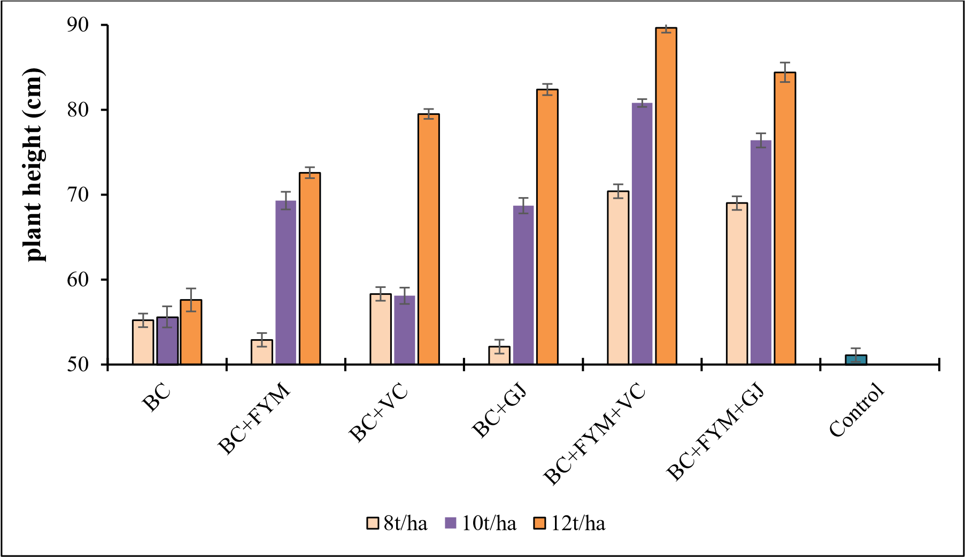

**Fig. 1: Effect of paddy straw biochar on plant height at 90-120 days after sowing of field bean**

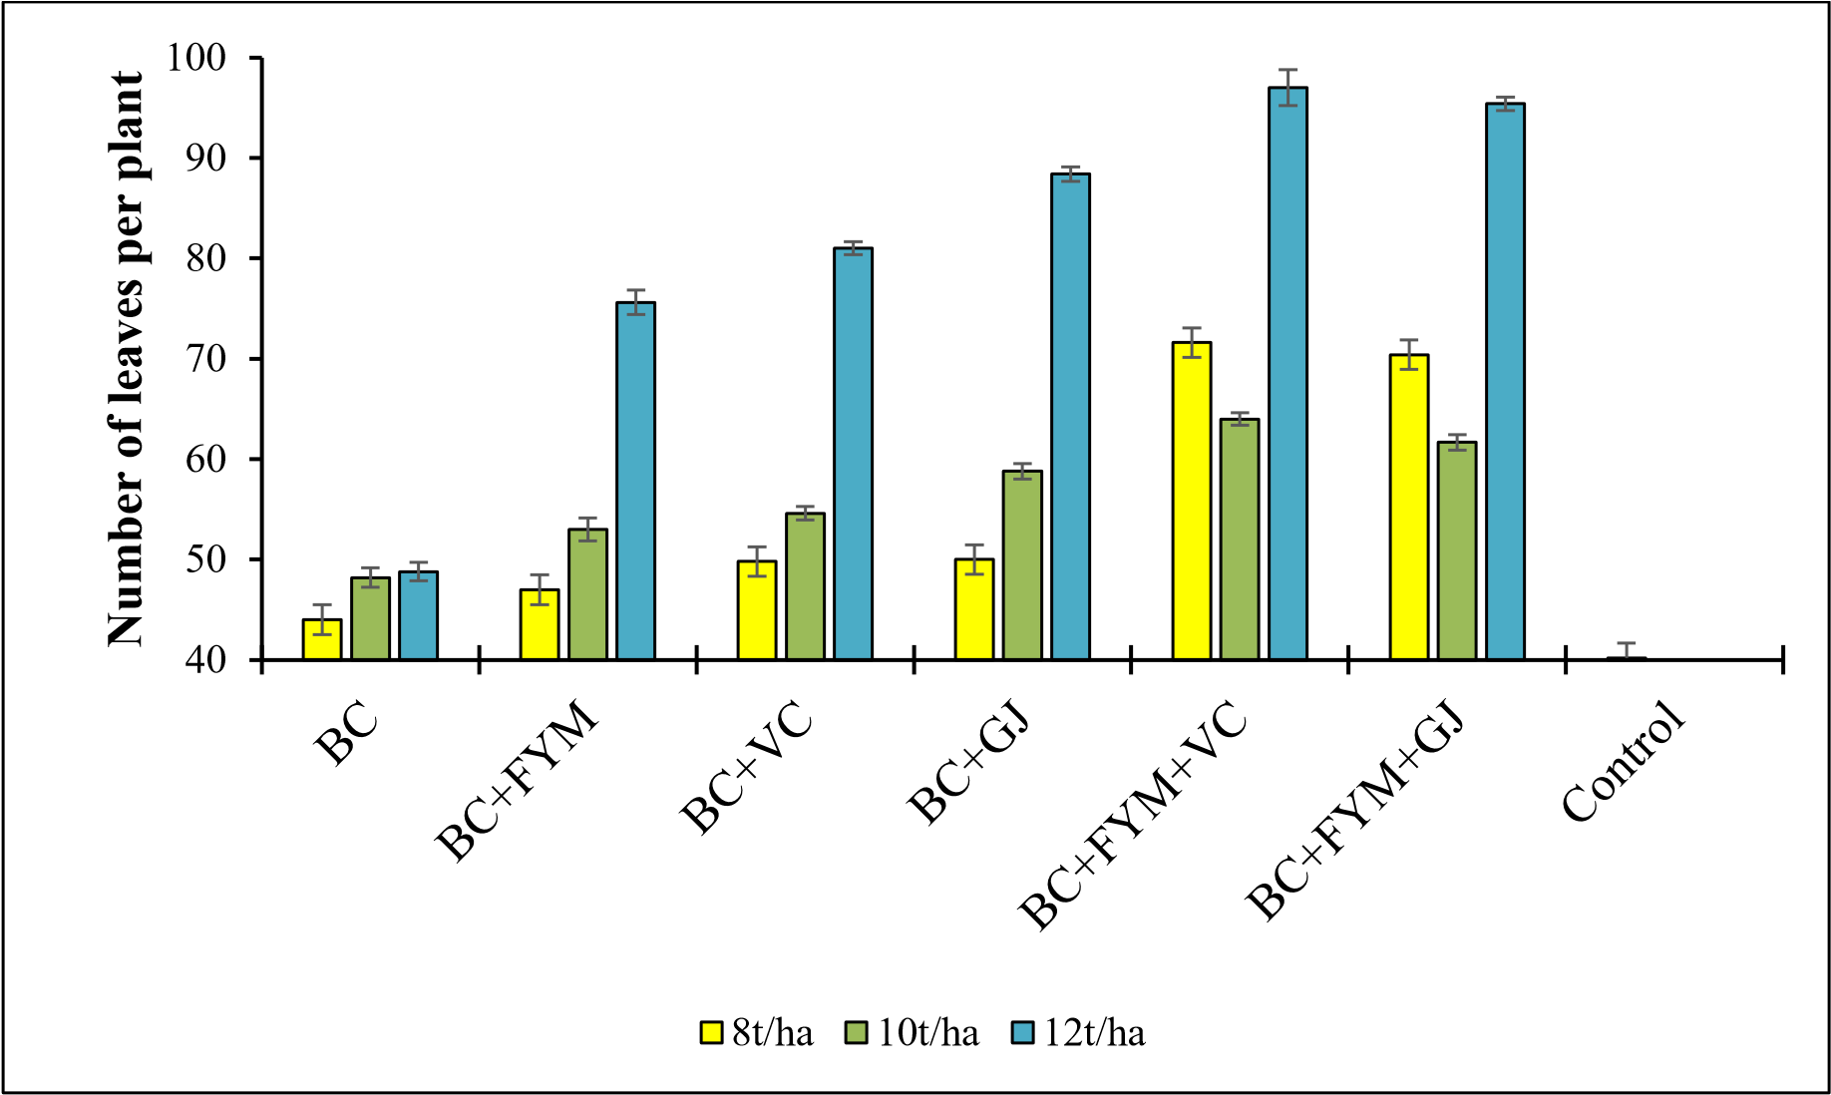

**Fig. 2: Effect of paddy straw biochar on number of leaves per plant at 90-120 days after sowing of field bean.**

**Number of branches:**  The data pertaining to the effect of biochar and organic amendments on number of branches are presented in Table 5. At 30 days after sowing (DAS), significantly more number of branches were observed in the treatments that received biochar in combination with other organic amendments. The highest number of branches was found in the treatment T17, which received 12 t ha-1 of biochar along with FYM and VC (6.80) and was on par with T18 (6.20) receiving 12 t ha-1 of biochar in combination with FYM and GJ and lowest number 0f branches was found in the control treatment i.e. T19 (2.60). Treatment receiving 12 t ha-1 of biochar along with FYM and VC (T17) recorded significantly higher number of branches per plant (12.60) at 60 DAS and was on par with T18 (11.50) received 12 t ha-1 of biochar + FYM + GJ and the lowest value was recorded in T19 (6.80) in the control treatment. During harvest, the data follows a similar trend to that observed at the 60 days. Maximum number of branches (22.50) was recorded in the treatment receiving 12 t ha-1 of biochar + FYM and VC (T17), and the lowest number of branches was recorded in control treatment i.e. T19 (11.00).

**Table 5: Effect of paddy straw biochar on number of branches per plant at 30, 60 DAS and at harvest (90-120 DAS).**

|  |  |  |  |
| --- | --- | --- | --- |
| **Treatment details** | **Number of branches per plant** | | |
| **30 DAS** | **60 DAS** | **Harvest** |
| **T1:** 8 tons ha-1 of BC | 3.60 | 8.20 | 12.67 |
| **T2:** 10 tons ha-1 of BC | 4.60 | 9.00 | 14.40 |
| **T3:** 12 tons ha-1 of BC | 5.40 | 9.60 | 15.50 |
| **T4:** 8tons ha-1 of BC+ FYM | 4.80 | 9.00 | 13.00 |
| **T5:** 8 tons ha-1 of BC+ VC | 5.20 | 9.40 | 13.60 |
| **T6:** 8 tons ha-1 of BC+ GJ | 4.60 | 9.20 | 12.67 |
| **T7:** 8 tons ha-1 of BC+ FYM+ VC | 5.80 | 9.80 | 17.40 |
| **T8:** 8 tons ha-1 of BC+ FYM+ GJ | 5.40 | 9.60 | 17.80 |
| **T9:** 10 tons ha-1 of BC+ FYM | 5.40 | 10.20 | 12.75 |
| **T10:**10 tons ha-1 of BC+ VC | 5.80 | 10.80 | 13.33 |
| **T11:** 10 tons ha-1 of BC+ GJ | 5.00 | 10.00 | 16.20 |
| **T12:** 10 tons ha-1 of BC+ FYM+ VC | 6.20 | 11.20 | 14.25 |
| **T13:** 10 tons ha−1 of BC+ FYM+ GJ | 6.00 | 11.00 | 19.67 |
| **T14:** 12 tons ha-1 of BC+ FYM | 5.80 | 10.80 | 18.33 |
| **T15:** 12 tons ha-1 of BC+ VC | 6.00 | 11.20 | 18.67 |
| **T16:** 12 tons ha-1 of BC+ GJ | 5.60 | 10.60 | 18.00 |
| **T17:** 12tons ha-1 of BC+ FYM+ VC | 6.80 | 12.60 | 22.50 |
| **T18:** 12 tons ha-1 of BC+ FYM+ GJ | 6.20 | 11.50 | 21.20 |
| **T19:** Control | 2.60 | 6.80 | 11.00 |
| **S. Em±** | 0.36 | 0.35 | 2.99 |
| **C.D@5%** | 1.01 | 0.98 | 8.43 |

Note: BC-Biochar, VC-Vermicompost, FYM- Farm yard manure, GJ- Ghanajeevamrutha and DAS-Days after sowing

The application of 12 t ha-1 of BC + FYM + VC (T17) resulted in a substantial improvement in growth parameters, including increased plant height, number of leaves and number of branches in the field bean plant. The enhancement of crop growth attributes through biochar application is influenced by numerous factors, which can operate either independently or in combination with organic amendments. Synergistic interaction between biochar and organic manures created a favourable soil environment, resulting in enhanced nutrient availability for crops. The combination of microbially enriched biochar, along with farmyard manure (FYM) and vermicompost, likely contributed to improved soil fertility. Consequently, this combination enhanced nutrient availability while reducing soil compaction, ultimately leading to the facilitation of root proliferation and thereby promotion of crop growth parameters, similar research findings were also observed (Saranya *et al.,* 2011; Elangovan and Sekaran 2014).

**Growth indices:** The impact of paddy straw biochar on growth indices, including specific leaf area and specific leaf weight did not exhibit statistically significant differences across all the treatment groups, as indicated in Table 6.

**Table 6: Effect of paddy straw biochar on growth indices of field bean at harvest.**

|  |  |  |
| --- | --- | --- |
| **Treatment details** | **SLA (cm2 /g)** | **SLW (g/cm2)** |
| **T1:** 8 tons ha-1 of BC | 58.81 | 0.011 |
| **T2:** 10 tons ha-1 of BC | 53.50 | 0.010 |
| **T3:** 12 tons ha-1 of BC | 55.77 | 0.020 |
| **T4:** 8tons ha-1 of BC+ FYM | 55.98 | 0.013 |
| **T5:** 8 tons ha-1 of BC+ VC | 61.04 | 0.034 |
| **T6:** 8 tons ha-1 of BC+ GJ | 59.78 | 0.020 |
| **T7:** 8 tons ha-1 of BC+ FYM+ VC | 63.93 | 0.011 |
| **T8:** 8 tons ha-1 of BC+ FYM+ GJ | 66.37 | 0.012 |
| **T9:** 10 tons ha-1 of BC+ FYM | 66.21 | 0.012 |
| **T10:**10 tons ha-1 of BC+ VC | 63.18 | 0.024 |
| **T11:** 10 tons ha-1 of BC+ GJ | 64.19 | 0.018 |
| **T12:** 10 tons ha-1 of BC+ FYM+ VC | 67.40 | 0.025 |
| **T13:** 10 tons ha−1 of BC+ FYM+ GJ | 59.07 | 0.010 |
| **T14:** 12 tons ha-1 of BC+ FYM | 61.73 | 0.021 |
| **T15:** 12 tons ha-1 of BC+ VC | 72.63 | 0.013 |
| **T16:** 12 tons ha-1 of BC+ GJ | 64.88 | 0.008 |
| **T17:** 12tons ha-1 of BC+ FYM+ VC | 77.95 | 0.015 |
| **T18:** 12 tons ha-1 of BC+ FYM+ GJ | 72.21 | 0.008 |
| **T19:** Control | 55.10 | 0.007 |
| **S. Em±** | 4.83 | 0.01 |
| **C.D@5%** | NS | NS |

Note: BC-Biochar, VC-Vermicompost, FYM- Farm yard manure, GJ- Ghanajeevamrutha, SLA- Specific leaf area and SLW- Specific leaf weight.

**Number of pods:** Table 7 shows the substantial impact of combining biochar and organic amendments on the yield parameters of field bean. The number of pods exhibited significant variation with the application of different biochar dosages in combination with organic inputs. The highest pod count per plant (20.25) was observed in treatment T17, which received 12 t ha-1 of biochar along with FYM and VC. However, it was on par with T18 (19.40), which received 12 t ha-1 of biochar in combination with FYM and GJ. The lowest pod yield per plant was recorded in absolute control treatment T19 (5.40).

# Table 7: Effect of paddy straw biochar on yield parameters of field bean.

|  |  |  |  |
| --- | --- | --- | --- |
| **Treatment details** | **No. of pods** | **Pod weight(g)** | **Yield**  **(q ha-1)** |
| **T1:** 8 tons ha-1 of BC | 6.60 | 9.98 | 22.34 |
| **T2:** 10 tons ha-1 of BC | 6.80 | 11.71 | 26.23 |
| **T3:** 12 tons ha-1 of BC | 7.50 | 15.02 | 33.65 |
| **T4:** 8tons ha-1 of BC+ FYM | 6.67 | 13.23 | 29.64 |
| **T5:** 8 tons ha-1 of BC+ VC | 10.00 | 13.92 | 31.17 |
| **T6:** 8 tons ha-1 of BC+ GJ | 10.67 | 14.31 | 32.05 |
| **T7:** 8 tons ha-1 of BC+ FYM+ VC | 7.40 | 14.64 | 32.78 |
| **T8:** 8 tons ha-1 of BC+ FYM+ GJ | 11.60 | 16.38 | 36.70 |
| **T9:** 10 tons ha-1 of BC+ FYM | 14.25 | 18.36 | 41.12 |
| **T10:**10 tons ha-1 of BC+ VC | 14.67 | 18.78 | 42.08 |
| **T11:** 10 tons ha-1 of BC+ GJ | 14.00 | 18.89 | 42.31 |
| **T12:** 10 tons ha-1 of BC+ FYM+ VC | 18.50 | 19.96 | 44.71 |
| **T13:** 10 tons ha−1 of BC+ FYM+ GJ | 16.33 | 23.91 | 46.10 |
| **T14:** 12 tons ha-1 of BC+ FYM | 17.67 | 22.35 | 50.07 |
| **T15:** 12 tons ha-1 of BC+ VC | 19.33 | 23.57 | 52.81 |
| **T16:** 12 tons ha-1 of BC+ GJ | 17.25 | 25.05 | 56.11 |
| **T17:** 12tons ha-1 of BC+ FYM+ VC | 20.25 | 27.41 | 61.42 |
| **T18:** 12 tons ha-1 of BC+ FYM+ GJ | 19.40 | 26.80 | 60.04 |
| **T19:** Control | 5.40 | 9.10 | 20.39 |
| **S. Em±** | 2.75 | 3.60 | 0.75 |
| **C.D@5%** | 7.74 | 10.14 | 2.12 |

Note: BC-Biochar, VC-Vermicompost, FYM- Farm yard manure and GJ- Ghanajeevamrutha

**Biomass yield:** The growth parameters exhibited their highest values in the soils treated with 12 t ha-1 of biochar, either in combination with FYM + VC and FYM + GJ, consistently throughout the various growth stages of field bean. There were significant differences in biomass yield attributable to the dosage of biochar and the combinations of organic amendments (Table 8). When biochar was applied at higher doses in combination with FYM, VC, and GJ, a substantial increase in biomass yield was observed. The greatest biomass production was observed in T17, where 12 t ha-1 of biochar was applied along with FYM and VC, resulting in a total biomass of 154.88 g per plant, which was on par with T18 (141.11 g per plant), where 12 t ha-1 of biochar was applied along with FYM and GJ, and followed by T16 (136.10 g per plant), received 12 t ha-1 biochar + FYM. The lowest total biomass was recorded in T19 (41.48 g per plant), i.e., in absolute control. In conclusion, the application of either 12 t ha-1 of biochar with FYM and VC, or 12 t ha-1 of biochar with FYM and GJ led to increased pod and biomass yields.

**Table 8: Effect of paddy straw biochar on the yield of biomass after harvest**

|  |  |  |  |
| --- | --- | --- | --- |
| **Treatment details** | **Above Biomass (g)** | **Below Biomass (g)** | **Total Biomass (g)** |
| **T1:** 8 tons ha-1 of BC | 49.55 | 5.61 | 55.17 |
| **T2:** 10 tons ha-1 of BC | 45.64 | 6.03 | 51.67 |
| **T3:** 12 tons ha-1 of BC | 50.47 | 6.68 | 57.15 |
| **T4:** 8tons ha-1 of BC+ FYM | 45.03 | 6.36 | 51.39 |
| **T5:** 8 tons ha-1 of BC+ VC | 54.60 | 6.58 | 61.19 |
| **T6:** 8 tons ha-1 of BC+ GJ | 50.51 | 5.60 | 55.03 |
| **T7:** 8 tons ha-1 of BC+ FYM+ VC | 61.85 | 7.80 | 69.66 |
| **T8:** 8 tons ha-1 of BC+ FYM+ GJ | 59.31 | 7.68 | 66.99 |
| **T9:** 10 tons ha-1 of BC+ FYM | 66.98 | 9.10 | 76.09 |
| **T10:** 10 tons ha-1 of BC+VC | 61.11 | 7.95 | 69.06 |
| **T11:** 10 tons ha-1 of BC+ GJ | 65.68 | 10.71 | 76.39 |
| **T12:** 10 tons ha-1 of BC+ FYM+ VC | 72.75 | 13.67 | 86.42 |
| **T13:** 10 tons ha−1 of BC+ FYM+ GJ | 68.89 | 19.04 | 87.94 |
| **T14:** 12 tons ha-1 of BC+ FYM | 96.35 | 11.39 | 107.74 |
| **T15:** 12 tons ha-1 of BC+ VC | 88.03 | 13.39 | 101.43 |
| **T16:** 12 tons ha-1 of BC+ GJ | 108.17 | 27.92 | 136.10 |
| **T17:** 12tons ha-1 of BC+ FYM+ VC | 122.69 | 32.19 | 154.88 |
| **T18:** 12 tons ha-1 of BC+ FYM+ GJ | 111.06 | 30.04 | 141.11 |
| **T19:** Control | 37.25 | 5.46 | 41.48 |
| **S. Em±** | 1.49 | 0.48 | 1.60 |
| **C.D@5%** | 4.20 | 1.36 | 4.50 |

Note: BC-Biochar, VC-Vermicompost, FYM- Farm yard manure and GJ- Ghanajeevamrutha

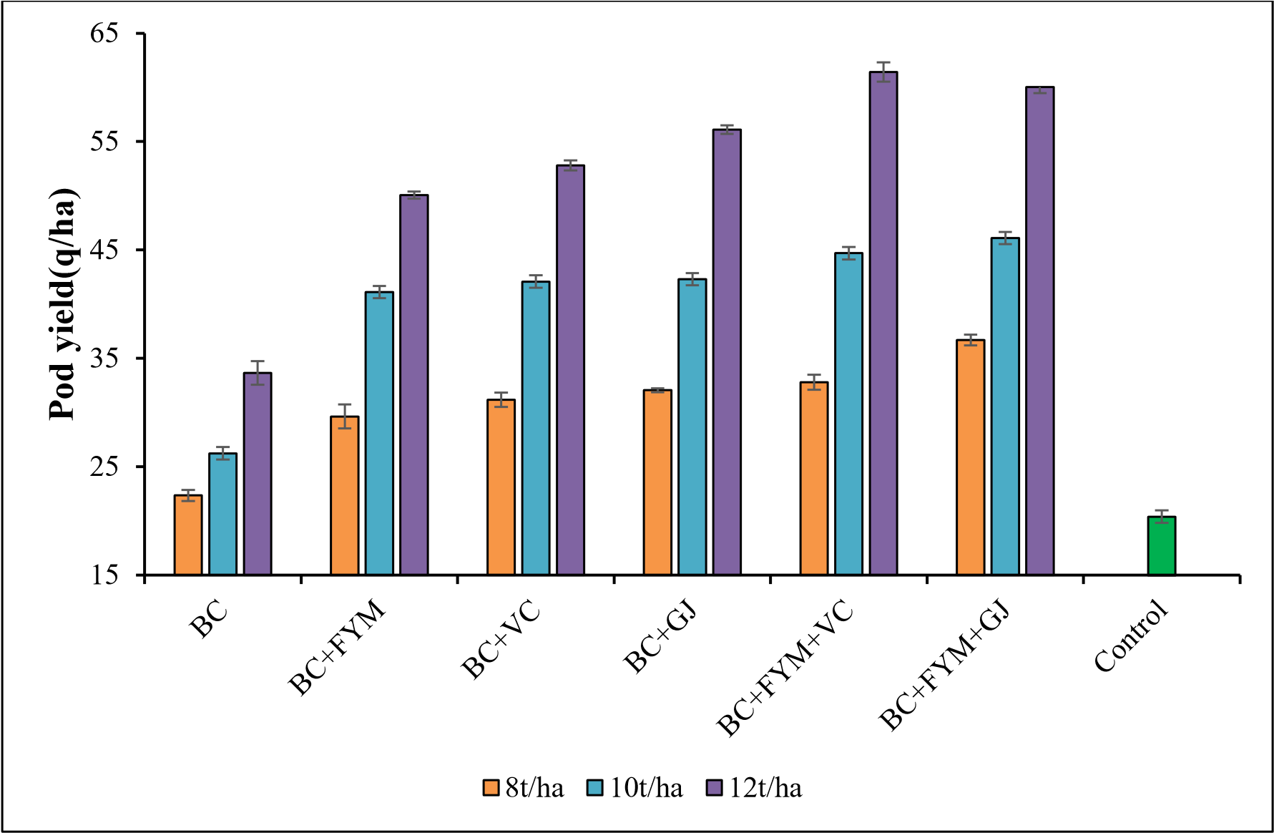

**Fig 3: Effect of paddy stubble biochar on pod yield of field bean**

Hence, combining biochar, FYM, vermicompost and ghanajeevamrutha is recommended to boost the field bean yield. The increase in field bean yield due to the application of biochar can be attributed to its nutritional effects, alongside the improvements it brings to the physical and chemical properties of the soil. When biochar is combined with farmyard manure (FYM), vermicompost and ghanajeevamrutha results in a higher yield of field bean. Research has shown that biochar has led to increased yields in rice, sugarcane, and maize production fields. The boost in field bean yield in pots treated with biochar is likely a result of biochar's positive impact on soil physico-chemical properties, such as enhanced water retention capacity, increased cation exchange capacity, and its ability to serve as a medium for plant nutrient absorption while creating favourable conditions for soil microorganisms (Gandahi *et al.,* 2015). Chen *et al*. (2010) also reported an increase in sugarcane yield due to the application of nitrogen-rich biochar.

Table 9 shows the impact of varying biochar dosages and organic amendments on number of days taken for 50% flowering. The application of biochar in combination with organic inputs showed a significant difference in duration taken for 50% flowering in fieldbean as compared to control. The early flowering was found at 37.66 days in treatment T17, receiving 12 t ha-1 + FYM + VC, and was on par with T18 (39.00 days), which received 12 t ha-1 + FYM + GJ. Maximum days for flowering (49.33 days) observed in the control treatment.

**Table 9: Effect of paddy straw biochar on number of days for 50% flowering in field bean crop**

|  |  |
| --- | --- |
| **Treatment details** | **Duration (days) for 50% flowering** |
| **T1:** 8 tons ha-1 of BC | 45.60 |
| **T2:** 10 tons ha-1 of BC | 45.30 |
| **T3:** 12 tons ha-1 of BC | 42.30 |
| **T4:** 8tons ha-1 of BC+ FYM | 43.00 |
| **T5:** 8 tons ha-1 of BC+ VC | 42.30 |
| **T6:** 8 tons ha-1 of BC+ GJ | 45.60 |
| **T7:** 8 tons ha-1 of BC+ FYM+ VC | 42.60 |
| **T8:** 8 tons ha-1 of BC+ FYM+ GJ | 47.00 |
| **T9:** 10 tons ha-1 of BC+ FYM | 45.66 |
| **T10:**10 tons ha-1 of BC+ VC | 42.00 |
| **T11:** 10 tons ha-1 of BC+ GJ | 46.33 |
| **T12:** 10 tons ha-1 of BC+ FYM+ VC | 40.33 |
| **T13:** 10 tons ha−1 of BC+ FYM+ GJ | 43.66 |
| **T14:** 12 tons ha-1 of BC+ FYM | 42.66 |
| **T15:** 12 tons ha-1 of BC+ VC | 39.33 |
| **T16:** 12 tons ha-1 of BC+ GJ | 43.66 |
| **T17:** 12tons ha-1 of BC+ FYM+ VC | 37.66 |
| **T18:** 12 tons ha-1 of BC+ FYM+ GJ | 39.00 |
| **T19:** Control | 49.33 |
| **S. Em±** | 0.89 |
| **C.D@5%** | 2.54 |

Note: BC-Biochar, VC-Vermicompost, FYM- Farm yard manure and GJ- Ghanajeevamrutha

It can be concluded from these results that applying biochar in combination with organic manures promotes early flowering in field bean. The results are inclining with the finding of (Rab *et al.,* 2016), that biochar interferes with soil carbon content which leads to increase in C:N ratio and microbial population, thereby enhancing early flowering.

**Table 10: Effect of paddy straw biochar on SPAD Values at different growth intervals.**

|  |  |  |
| --- | --- | --- |
| **Treatment details** | **SPAD values at**  **vegetative stage** | **SPAD values at reproductive stage** |
| **T1:** 8 tons ha-1 of BC | 33.21 | 30.09 |
| **T2:** 10 tons ha-1 of BC | 38.85 | 33.60 |
| **T3:** 12 tons ha-1 of BC | 35.81 | 29.01 |
| **T4:** 8tons ha-1 of BC+ FYM | 37.65 | 33.36 |
| **T5:** 8 tons ha-1 of BC+ VC | 36.63 | 29.32 |
| **T6:** 8 tons ha-1 of BC+ GJ | 37.62 | 33.22 |
| **T7:** 8 tons ha-1 of BC+ FYM+ VC | 39.36 | 36.06 |
| **T8:** 8 tons ha-1 of BC+ FYM+ GJ | 39.09 | 36.43 |
| **T9:** 10 tons ha-1 of BC+ FYM | 39.26 | 36.04 |
| **T10:**10 tons ha-1 of BC+ VC | 38.11 | 31.45 |
| **T11:** 10 tons ha-1 of BC+ GJ | 37.62 | 29.36 |
| **T12:** 10 tons ha-1 of BC+ FYM+ VC | 40.21 | 36.94 |
| **T13:** 10 tons ha−1 of BC+ FYM+ GJ | 37.23 | 35.92 |
| **T14:** 12 tons ha-1 of BC+ FYM | 41.45 | 33.20 |
| **T15:** 12 tons ha-1 of BC+ VC | 38.90 | 30.87 |
| **T16:** 12 tons ha-1 of BC+ GJ | 34.70 | 31.35 |
| **T17:** 12tons ha-1 of BC+ FYM+ VC | 39.30 | 37.44 |
| **T18:** 12 tons ha-1 of BC+ FYM+ GJ | 38.00 | 36.40 |
| **T19:** Control | 28.14 | 26.09 |
| **S. Em±** | 4.85 | 4.36 |
| **C.D@5%** | NS | 12.26 |

Note: BC-Biochar, VC-Vermicompost, FYM- Farm yard manure and GJ- Ghanajeevamrutha.

The application of varying dosages of biochar has a significant impact on the physiological parameters of field beans. The SPAD (Soil Plant Analysis Development) index serves as an indicator of the plant's relative chlorophyll content. The results revealed that during the vegetative stages, there is no statistically significant effect observed in any of the treatments on the leaf SPAD value. However, this effect showed a positively significant one during the reproductive stages, as illustrated in Table 10.

During the vegetative growth stage, there was relatively no significant difference in SPAD values. However, the highest value of 41.45 was observed in T14, which received 12 t ha-1 of biochar + FYM, and was on par with T12 (40.21), receiving 10 t ha-1 BC + FYM + VC. During the reproductive growth stage, there was a gradual increase in SPAD values in higher application rates of biochar, along with other organic amendments. The highest recorded value was observed in treatment T17 (37.44), where biochar was applied at a rate of 12 t ha-1 in combination with FYM and VC, followed by T12 (36.94), receiving 10 t ha-1 BC + FYM + VC. The lowest SPAD value of 26.09 was observed in absolute control treatment. SPAD values reduced from the vegetative phase to reproductive phase of Field bean which may be attributed to the diminished chlorophyll content in aging leaves that occurs during the reproductive phase.

The findings indicated that the presence of both biochar and organic amendments led to higher chlorophyll content in field bean as compared to control. This improvement in chlorophyll content was attributed to the organic inputs, which enhanced nitrogen availability for plants during the late growth stage (Salehi *et al.,* 2016). The increased leaf SPAD value observed during pod-filling likely contributed to sustained photosynthetic activity, thereby favourably promoting higher field bean yield.

**Correlation between SPAD value and total biomass**

The application of biochar in combination with organic inputs resulted in a substantial enhancement of both above-ground and below-ground biomass in field bean, ultimately leading to a significant increase in field bean yield. However, it did not show much positive outcome was supported by the positive association observed in the SPAD values (R2 = 0.197) with total biomass, as depicted in Figure 4.

y = 4.4411x

-

64.943

R² = 0.1978

0

40

80

120

160

200

20

25

30

35

40

**Total biomass(g)**

**SPAD values**

**Fig. 4: Correlation between SPAD and total biomass of field bean (dry weight).**

In the conducted study, the co-application of biochar and organic amendments resulted in increased soil's C/N ratio, leading to a notable enhancement in the biomass of field bean. This surge in dry matter production can be attributed to an increase in chlorophyll content, primarily facilitated by organic fertilizer's capacity to enhance nitrogen availability during the late growth stage (Salehi *et al*., in 2016). Furthermore, the increased SPAD value observed in leaves during the reproductive stages signifies improved photosynthetic activity, favourably impacting pod formation and subsequently contributing to higher field bean yield. The analysis of nutrient physiological use efficiency, indicating the proportion of nutrients absorbed by the plants that are ultimately converted into pod yield (Zhang *et al.*, 2018), confirms that the application of organic amendments and biochar has a positive impact on this efficiency. This improvement can be attributed to the enhanced photosynthesis of field bean resulting from the use of biochar and organic amendments. However, the increased field bean yield can be primarily attributed to increased nutrient uptake and improved nutrient utilization efficiency.

**Summary:** Growth parameters like plant height, number of leaves and number of branches recorded significantly highest at 30, 60 days and at harvest of the crop growth stage in treatment T17 which received 12 t ha-1 of biochar in combination with FYM and vermicompost. Significantly higher numbers of pods (20.25) and greater pod weights (27.41 g per plant) were observed with the application of 12 t ha-1 of biochar + FYM + VC (T17). The lowest numbers of pods and pod weights were recorded in absolute control treatment. The application of 12 t ha-1 of biochar, combined with FYM and VC (T17), resulted in significantly higher pod yield at 61.42 q ha-1 and biomass yield at 154.88 g per plant compared to control treatment. However, the control treatment (T19) exhibited the lowest pod yield of 20.39 q ha-1 and a biomass yield of 41.48 g per plant. During the vegetative growth stage, there were no significant differences observed in the SPAD values, whereas variations became evident during the reproductive growth stage. Notably, there exists a positive correlation between nitrogen content and SPAD value (R2= 0.578).

**Conclusion:** The study findings highlights that when organic inputs are coupled with biochar at a rate of 12 t ha-1 along with farmyard manure and vermicompost, significantly enhances plant growth and yield. These findings confirm the potential benefits of combining biochar with organic inputs as a sustainable approach to improving agricultural productivity, providing valuable insights for efficient nutrient management in farming systems. Future studies should focus on evaluating impact of biochar application on physio-chemical properties of soil and economic feasibility of large-scale paddy biochar production and its integration into mainstream agriculture.

**DISCLAIMER (ARTIFICIAL INTELLIGENCE)**

Author(s) hereby declares that NO generative AI technologies such as Large Language Models (ChatGPT, COPILOT, etc.) and text-to-image generators have been used during the writing or editing of this manuscript.

**REFERENCES**

Astm, I. (2007). Standard test methods for flexural properties of unreinforced and reinforced plastics and electrical insulating materials. ASTM D, 790-07.

Bray, R. H., & Kurtz, L. T. (1945). Determination of total, organic and available forms of phosphorus in soils. *Soil sci*., 59(1), 39-46.

Bruun, E., Cross, A., Hammond, J., Nelissen, V., Rasse, D. P., & Hauggaard-Nielsen, H. (2016). Biochar carbon stability and effect on greenhouse gas emissions. In Biochar in European soils and agriculture., pp. 187- 205. (Routledge)

Chen, Y., Shinogi, Y., & Taira, M. (2010). Influence of biochar use on sugarcane growth, soil parameters and ground quality. *Aust. J. Soil Res*., 48, 526-530.

Dudeja, S. S., & Chaudhary, P. (2005). Fast chlorophyll fluorescence transient and nitrogen fixing ability of chickpea nodulation variants. *Photosynthetica*, 43(2), 253- 259.

Elangovan, R., & Sekaran, N. C. (2014). Effect of biochar application on growth, yield and soil fertility status in cotton. *Asian J. Soil Sci*., 9(1), 41-49.

Gandahi, A. W., Baloch, S. F., Sarki, M. S., Gandahi, R., & Lashari, M. S. (2015). Impact of rice husk biochar and macronutrient fertilizers on fodder maize and soil properties. *Int. J. Biosci*., 7(4), 12-21.

Hasler, K., Bröring, S., Omta, S. W. F., & Olfs, H. W. (2015). Life cycle assessment (LCA) of different fertilizer product types. *Europ. J. Agrono.,* 69, 41-51.

Hikosaka, K., & Tsujimoto, K. (2021). Linking remote sensing parameters to CO2 assimilation rates at a leaf scale. *J. Plant. Res*., 134(4), 695-711.

Jackson, M. L., 1973. Soil chemical analysis. Prentice Hall of India, New Delhi, 1, 485- 486.

Jena, R. K., Jagadeeswaran, R., & Sivasamy, R., (2013). Analogy of soil parameters in particle size analysis through laser diffraction techniques.

Joseph, S., Graber, E. R., Chia, C., Munroe, P., Donne, S., Thomas, T., Nielsen, S., Marjo, C., Rutlidge, H., & Pan, G. X. (2013). Shifting paradigms: development of high-efficiency biochar fertilizers based on nano-structures and soluble components. *Carbon Manage*., 4(3),323-343.

Kammann, C., Glaser, B., & Schmidt, H. P. (2016). Combining biochar and organic amendments. In ‘Biochar in European Soils and Agriculture’ pp. 158-186. (Routledge).

Lehmann, J., & Joseph, S. (2015). Biochar for environmental management: An introduction. In ‘Biochar for environmental management’ pp. 1-13. (Routledge).

Lucheta, A. R., & Ambais, M. R. (2012). Sulfur in agriculture. Revista Brasileira de Ciência do Solo, 36, 1369-1379.

Major, J., Rondon, M., Molina, D., Riha, S. J., & Lehmann, J. (2010). Maize yield and nutrition during 4 years after biochar application to a Colombian savanna oxisol. *Plant and soil*., 333(1),117-128.

Pietikäinen, J., Kiikkilä, O., & Fritze, H. ( 2000). Charcoal as a habitat for microbes and its effect on the microbial community of the underlying humus. Oikos., 89(2), 231-242.

Piper, C. S. (1966). Soil and plant analysis, Hans Pub: Bombay, 7, 368-369.

Rab, A., Khan, M. R., Haq, S. U., Zahid, S., Asim, M., Afridi, M. Z., & Munsif, F. (2016). Impact of biochar on mungbean yield and yield components. *Pure Appl. Bio*., 5, 632–640.

Rawat, J., Saxena, J., & Sanwal, P.(2019). Biochar: a sustainable approach for improving plant growth and soil properties.In ‘ Biochar-an imperative amendment for soil and the environment’.(Eds Abrol V, Sharma P) pp 1-17.

Salehi, A., Tasdighi, H., & Gholamhoseini, M. (2016). Evaluation of proline, chlorophyll, soluble sugar content and uptake of nutrients in the German chamomile (Matricaria chamomilla L.) under drought stress and organic fertilizer treatments. *Asian* *Pac. J. Trop. Biomed*., 6(10), 886-891.

Saranya, K., Krishnan, P. S., Kumutha, K., & French, J. (2011). Potential for biochar as an alternate carrier to lignite for the preparation of biofertilizers in India. *Int. J.* *Agric*., 4(2), 26-30.

Sohi, S. P., Krull, E., Lopez-capel, E., & Bol, R. (2010). A review of biochar and its use and function in soil. *Advan. Agrono.,* 105,47- 82.

Speratti, A. B., Johnson, M. S., Sousa, H. M., Dalmagro, H. J., & Couto, E. G. (2018). Biochar feedstock and pyrolysis temperature effects on leachate: DOC characteristics and nitrate losses from a Brazilian Cerrado Arenosol mixed with agricultural waste biochars. *J. Environ. Manage*., 211**,** 256-268.

Subbaiah, A. Y., & Asija, G. K. (1956). A rapid procedure for the estimation of available nitrogen in soils. *Curr. Sci*., 25, 270-280.

Vijay, V., Shreedhar, S., Adlak, K., Payyanad, S., Sreedharan, V., Gopi, G., Sophia Van Der voort, T., Malarvizhi, P., Yi, S., Gebert, J., & Aravind, P. V. 2021. Review of large-scale biochar field-trials for soil amendment and the observed influences on crop yield variations. Frontiers in Energy Research. 9, 710-766.

Walkley, A., & Black, I. A. (1934). An examination of the Degtjareff method for determining soil organic matter and a proposed modification of the chromic acid titration method. *Soil Sci*., 37(1), 29-38.

Wolf, R., & Wedig, H. (2007). Process for manufacturing a soil conditioner. US Patent No WO, 2010055139, p.A1.

Zhang, A., Cui, L., Pan, G., Li, L., Hussain, Q., Zhang, X., Zheng, J., & Crowley,D. (2010). Effect of biochar amendment on yield and methane and nitrous oxide emissions from a rice paddy from Tai Lake plain, China. *Agric. Ecosyst*. *Environ*., 139(4), 469-475.

Zhang, X., Can, C., Xiaomin, C., Pengchuang, T., Zewen, J., & Zhaoqiang, H. (2018). Persistent effects of biochar on soil organic carbon mineralization and resistant carbon pool in upland red soil, China. *Environ. Earth Sci.,* 77(3), 1-8.