Original Research Article

Character Association and Path Analysis for Yield and Yield-Contributing Traits in Linseed (Linum usitatissimum L.)

.
ABSTRACT

Linseed (Linum usitatissimum L.), a self-pollinated annual crop with 2n = 30 chromosomes, is typically grown in the Rabi season and is mainly valued for its oil and flax fiber because of its economic importance. Yield is a complex trait governed by multiple genes, and its performance is significantly affected by environmental factors. Because of its complex polygenic nature, direct selection for yield may not always lead to significant genetic improvement unless the genetic basis of its component traits is considered. Understanding the relationship between yield and its contributing traits is crucial, as it provides insights into these relationships, enhancing selection efficiency. Path coefficient analysis is a method that breaks down the relationship between traits and yield into direct and indirect effects. While simple correlation shows how traits are related, path analysis explains how much each trait directly or indirectly affects yield. This analysis helps breeders identify the traits that most impact yield and guides them in selecting the best traits for breeding programs. The current study focused on examining the relationship between seed yield and its contributing traits in linseed. A total of 36 genotypes were assessed at the Oilseeds Research Station, College of Agriculture, Latur, during the Rabi season of 2024-2025, utilizing a randomized block design with two replications. The trial was planted on November 23, 2024, with a spacing of 30 × 5 cm. The analysis revealed that traits such as 1000-seed weight, number of capsules per plant, number of seeds per capsule, number of branches per plant, harvest index, and plant height exhibited highly significant and positive correlations with seed yield per plant. Furthermore, path coefficient analysis indicated that the number of capsules per plant had the highest positive direct effect on seed yield, followed by 1000-seed weight, harvest index, number of branches per plant, plant height, days to maturity, and oil content.

Keywords: Correlation coefficient analysis, Path coefficient analysis, Indirect effect, Positive significant, Negative significant, Residual effect, Genotypic, Phenotypic.

1. INTRODUCTION
“Linseed, commonly referred to as flax, alsi, or jawas, is a significant oilseed crop belonging to the Linaceae family, which comprises over 14 genera and 200 species. It is believed to have originated in Southwest Asia, particularly in India” (Richharia, 1952). This crop is mainly cultivated during the Rabi season. The optimal temperature range for its vegetative and reproductive phases is between 21°C and 27°C. However, when temperatures rise above 32°C, particularly during the flowering period, along with moisture stress, there is a tendency for seed yield to decline. Linseed primarily undergoes self-pollination, although a minor degree of outcrossing (less than 2%) occurs due to insect activity.
Linseed is highly regarded for its remarkable nutritional profile, featuring oil content that varies between 33% and 45% and a protein content of approximately 24%, depending on the specific variety. It is particularly rich in unsaturated fatty acids, including oleic acid (16–24%) and linoleic acid (18–24%). Importantly, linseed serves as a major source of alpha-linolenic acid (ALA), which constitutes 52–53% of its total fatty acid composition. ALA is an omega-3 fatty acid that is vital for human health, known for its positive effects on reducing cholesterol levels and promoting cardiovascular health.
Russia is the leading producer of linseed globally, with 2 million hectares under cultivation and a production of 1.7 million tonnes. Kazakhstan follows, with 1.3 million hectares and an output of 800,000 tonnes. Canada, although it cultivates only 300,000 hectares, achieves a higher productivity rate, yielding 450,000 tonnes. In contrast, China and India have comparable cultivation areas of around 200,000 hectares; however, India's production (126,000 tonnes) falls significantly short of China's (290,000 tonnes), indicating a notable yield gap (ICAR- IIOR, 2022-23; Tihan-tech OSIS)
Within India, Madhya Pradesh is the leading producer, followed by Uttar Pradesh and Jharkhand. Rajasthan boasts the highest productivity at 1071 kg/ha, while Maharashtra shows moderate productivity at 475 kg/ha (MH State APY, 2023–24).
Linseed is a valuable crop that plays an important role in the livelihoods of Indian farmers. However, despite the large area under cultivation and its many uses, the productivity of linseed in India is relatively low at 535 kg/ha, compared to the global average of 1013 kg/ha. Several factors contribute to this issue, including the low yield potential and late maturity of current varieties, the vulnerability of modern varieties to pests and diseases, lack of stability in yields, and the cultivation of the crop on marginal lands with poor agronomic practices. Additionally, linseed crops grown in tropical and semi-tropical climates are increasingly facing the challenges of rising temperatures and extreme soil moisture stress, which further hamper their growth and productivity.
The identification of factors contributing to increased seed yield presents a considerable challenge, as yield is a quantitatively inherited trait governed by multiple genes and is profoundly influenced by environmental interactions. Given its complex nature, yield is essentially the cumulative result of several interrelated traits. To achieve genetic improvement in yield, it is imperative for plant breeders to address this complexity by effectively managing yield components, particularly those exhibiting negative associations. A systematic and informed breeding approach necessitates a thorough understanding of the nature and magnitude of correlations among various yield-contributing traits, along with insights into their qualitative and quantitative effects on overall yield performance. In light of this, the present study was undertaken to investigate the association between seed yield and its component traits through correlation and path coefficient analysis.

2. material and methods

2.1 Experimental Site and Experimental Design

The current study was carried out at the Oilseeds Research Station in Latur during the Rabi season of 2024-25, under normal irrigated conditions. The experimental setup included 36 genotypes, comprising two control varieties, and was analyzed using a Randomized Block Design with two replications. The planting method employed was line sowing. To promote healthy crop growth, all recommended fertilizers and cultural practices were implemented. Morphological data for 10 quantitative traits were collected by randomly selecting 5 plants from each plot and replication. Each genotype was sown in rows measuring 5 meters in length, with a spacing of 30 cm between rows and 5 cm between individual plants. To mitigate border effects, border rows were planted around all sides of the experimental plots. All recommended practices were strictly followed to ensure optimal crop growth, and the total plot size was 5 x 11.6 m².

2.2 Characters Studied
Morphological observations were conducted to assess 10 quantitative traits by randomly selecting five plants from each plot and replication. The traits measured included: days to 50% flowering, days to maturity, plant height (in centimeters), number of branches per plant, number of capsules per plant, number of seeds per capsule, 1000-seed weight (in grams), harvest index (expressed as a percentage), oil content (expressed as a percentage), and seed yield per plant (in grams).The number of days to 50% flowering was recorded when 50% of the plants in each plot had reached the flowering stage, while the days to maturity were noted at the point of physiological maturity of the plants. Plant height was measured from the base to the apex of the tallest stem. The reproductive potential was evaluated by counting the number of branches per plant, capsules per plant, and seeds per capsule. The 1000-seed weight was determined by weighing a random sample of 1000 seeds. The harvest index was calculated as the ratio of seed yield to total plant biomass, expressed as a percentage. The oil content percentage was determined using the NMP facility available at the Regional Research Station in Raichur.
2.3 Stastical Analysis
The genotypic and phenotypic correlation coefficients were computed based on the variance and covariance components following the method outlined by Al-Jibouri et al. (1958). The path coefficient analysis, which determines the direct and indirect contributions of various traits towards a dependent variable, was carried out as per the approach proposed by Dewey and Lu (1959). All statistical computations were conducted using R software version 4.5.1.

3. results and discussion

3.1 Correlation coefficient analysis

The genetic association between two traits may arise due to pleiotropy or linkage. Pleiotropy involves a single gene affecting multiple traits, whereas linkage refers to the closeness of genes influencing different traits on the same chromosome. In both cases, correlations may be positive or negative depending on whether the genes involved enhance or suppress the expression of the associated traits. The correlation coefficient quantifies the strength and direction of such relationships, thereby aiding in the understanding of trait interactions and their combined influence on yield.

“The observed genotypic correlation coefficients were found to be greater than the phenotypic correlation coefficients for most traits, which have a significant influence on seed yield (see Table 1 &2). Indirect selection proves to be effective for traits exhibiting low heritability” (Singh et al. 2024). These correlation studies provide valuable guidance for breeders in selecting traits that contribute to the enhancement of yield and quality in linseed.

At the genotypic level, seed yield per plant showed highly significant and positive correlations with 1000-seed weight (0.6858**), number of capsules per plant (0.6733**), number of branches per plant (0.5726**), number of seeds per capsule (0.6420**), harvest index (0.5255**) and significant and positive correlation with plant height (0.3559*) indicating these traits are major contributors to yield improvement.

At the phenotypic level, seed yield per plant also showed significant and positive correlations with 1000-seed weight (0.5062**), number of capsules per plant (0.5614**), number of branches per plant (0.3551**), number of seeds per capsule (0.4336**), harvest index (0.4002**), and signficant and positive correlation with plant height (0.2609*). Similar findings were reported by Rajanna et al. (2018), Gudmewad et al. (2015), Choudhary et al (2017), Patial et al. (2018), Dogra et al (2020), Kumar et al. (2024), Karla et al. (2024) and Singh et al. (2024)

The trait oil content has a positive but non-significant association with seed yield per plant. The trait days to 50% flowering had a negative and significant correlation with seed yield per plant, in agreement with Gudmewad et al. (2018), Meena et al. (2020), and Korra et al. (2024). Days to maturity have a negative and non-significant association with seed yield per plant agreement with Gudmewad et al. (2018), Patial et al. (2018), Meena et al. (2020), Choudhary et al. (2023). Days to maturity have negative and non-significant association with seed yield per plant. These results are in agreement with Sonwane et al. (2015), Gudmewad et al. (2018) and Meena et al. (2020).

3.2 Path analysis

The correlation between yield and its related traits can sometimes be confusing, as it may not show the true nature of their relationship. This is because many traits influence yield at the same time, which can make the correlation appear stronger or weaker than it really is. To get a clearer picture, path coefficient analysis is used to separate the total effect into direct and indirect effects. By using both correlation and path analysis together, we can better understand how each trait contributes to yield and make more effective choices during selection in breeding programs.

The higher direct effect of phenotypic path coefficients relative to genotypic path coefficients suggests a notable interaction between genotype and environment for the expressed traits. This is supported by the results of the path analysis detailed in Table 3 & 4 and Figures 1 and 2.

The direct effect of the phenotypic path coefficient value is found to be greater for the majority of the traits when compared to the genotypic path coefficient value. This suggests a significant genotype × environment interaction for the traits expressed. The findings of the path analysis are presented in Table 2 and Figures 1 and 2 revealed that, at the genotypic level, the trait exerting the maximum positive direct effect on seed yield per plant was the number of capsules per plant (0.26760), 1000-seed weight (0.22652), number of branches per plant (0.14958), harvest index (0.14328), and number of seeds per capsule (0.12175). Traits such as oil content (0.01657), days to maturity (0.00887), and plant height (0.00803) had smaller positive direct effects.

At the phenotypic level, the highest direct effect was recorded for the number of capsules per plant (0.31234), followed by 1000-seed weight (0.18723), harvest index (0.11031), number of seeds per capsule (0.098), and number of branches per plant (0.05369). Smaller direct effects were observed for plant height (0.02355). similar result was recorded by Comparable findings were also observed by Tadesse et al. (2009), Hussain et al. (2016), Gudmewad et al. (2016), Leelavathi et al. (2018), Meena et al. (2020), Dogra et al. (2020), Paul et al. (2020), Patel et al. (2023) and Paliwal et al (2024).

The maximum indirect and positive effect on seed yield per plant was recorded for 1000 seed weight (P = 0.16694, G = 0.16714), harvest index (P = 0.16207, G = 14514), number of seeds per capsule (P = 0.13996, G = 0.16910), number of branches per plant (0.10763, G = 0.10540) and plant height (0.11047, G = 0.09827) through number of capsules per plant. Whereas the maximum indirect negative effect on seed yield per plant was recorded for days to 50 per cent flowering through 1000 seed weight (P = -0.06141, G =-0.07729) followed by number of seeds per capsule (P = -0.03149, G = -0.04281) and for days to maturity through days to 50 per cent flowering (P = -0.04511, G = -0.10153) and number of capsules per plant (P = -0.02452, G = -0.02157).

Days to 50 per cent flowering had a negative direct effect on seed yield per plant (-0.0058 and -0.0343 respectively) at both genotypic and phenotypic levels, confirming their negative connection. Similar findings reported by Tadesse et al. (2009) include a negative indirect influence on days to maturity, the number of branches per plant, the number of secondary branches per plant, and the number of capsules per plant. Also days to maturity had a negative direct effect on seed yield per plant ( -0.06964 and -0.00887 respectively) at both phenotypic genotypic and genotypic levels Similar findings reported by Leelavathi et al. (2018), Kasana et al. (2018) and Patial et al. (2018).

4. Conclusion

The current research concluded that correlation analysis revealed that seed yield per plant was positively and highly significant association with the 1000-seed weight, number of capsules per plant, number of seeds per capsule, number of branches per plant, harvest index, and plant height. This suggests that improvement in any of these traits is likely to contribute to increased seed yield per plant. The presence of positive correlations among these desirable traits is particularly beneficial, as it enables the simultaneous improvement of multiple characters through selection. Traits including the number of capsules per plant, 1000-seed weight, number of seeds per capsule, oil content, number of branches per plant, plant height, days to maturity, and harvest index were found to exert a positive direct effect on seed yield. This suggests that these characters have a direct and substantial influence on yield performance. Consequently, incorporating these traits as selection criteria in breeding programmes would be advantageous for the development of high-yielding linseed genotypes.

Disclaimer (Artificial intelligence)
Option 1:
Author(s) hereby declare that NO generative AI technologies such as Large Language Models (ChatGPT, COPILOT, etc.) and text-to-image generators have been used during the writing or editing of this manuscript.
Option 2:
Author(s) hereby declare that generative AI technologies such as Large Language Models, etc. have been used during the writing or editing of manuscripts. This explanation will include the name, version, model, and source of the generative AI technology and as well as all input prompts provided to the generative AI technology
Details of the AI usage are given below:
1. Option 1 Author(s) hereby declare that NO generative AI technologies such as Large Language Models (ChatGPT, COPILOT, etc.) and text-to-image generators have been used during the writing or editing of this manuscript.
2.
3.

References

ICAR-IIFOR. 2023. Linseed Crop Statistics Report (2022–23). Indian Council of Agricultural Research – Indian Institute of Fibres and Oilseed Research, Hyderabad, India.
Government of Maharashtra. 2024. State Agricultural Production and Yield Report (2023–24). Department of Agriculture, Maharashtra.
Al-jibouri, H.A., Miller, P.A., and Robinson, H.F. (1958). Genotypic environment variances in an upland cotton cross of interspecific origin. Journal of Agronomy, 50, 633-637.
Deway, D.R. and Lu, K.H. (1959). Correlation and path coefficient analysis of crested wheat grass seed production. Agronomy Journal 51: 515-518.
Singh, S. P., Aware, S. A., Tiwari, A., Sindha, S.B., Chellem, S. R., & Singh, D. V. (2024). Estimates of indirect selection parameters through correlation and path analysis in linseed (Linum usitatissimum L.). Plant Cell Biotechnology and Molecular Biology, 25(3-4), 54–61.
Rajanna, B.; Biradar, S.A. & Ajithkumar, K. (2014). Correlation and path analysis in linseed. The bioscan. 9(4), 1599-1602.
Ranjana Patiala, Satish Paul and Devender Sharma, (2018), Correlation and path coefficient analysis for improvement of seed yield in Linseed (Linum usitatissimum L.). International Journal of Current Microbiology and Applied Sciences,7(3): 1853- 1860.
Gudmewad, R., Misal, A., Dhutmal, R. & Pole, S. (2016). Correlation and path analysis studies in linseed. Annals of Plant and Soil Research, 18(2), 123-126.
Choudhary, A.K., Marker, S. and Rizvi, A.F. 2017. Genetic variability and character association for seed yield in linseed (Linum usitatissimum L.) under rainfed conditions. Journal of Pharmacognosy and Phytochemistry, 6(5): 457–460.
Patial, R., Paul, S. and Sharma, D., (2018). Correlation and path coefficient analysis for improvement of seed yield in linseed (Linum usitatissimum L.). International Journal of Current Microbiology and Applied Sciences. 7(3), 1853-1860.
Dogra, R., Paul, S., & Satasiya, P. (2020). Assessment of genetic variability, correlation and path analysis for yield and it’s components in Linseed (Linum usitatissimum L.). Journal of Pharmacognosy and Phytochemis try. 9(5), 2384-2389.
Kumar, A., Kumar, R. and Nirala, R.B.P. 2024. Genetic Variability, Correlation and Path Coefficient analysis of Linseed (Linum usitatissimum L.) in Bihar, India. Plant archives Vol. 24, No.2, 2024pp. 2018-2024.
Karla, U., Sharma, H., Yadav, P., Dadeech, A., Dubey, R.B. and Jain, D. (2024). Correlation and path coefficient analysis for identifying important traits contributing to seed yield in Linseed (Linum usitatissimum L.). Ecology, Environment and Conservation 30 (October Supplementary Issue): 2024; pp. (S239-S243)
Meena, A. K., Kulhari, S., Kumar, M., Koli, N. R., Tak, Y., Meena, D., & Meena, N. (2020). Studies on genetic variability and character association in linseed (Linum usitatissimum L.) genotypes. International Journal of Current Microbiology and Applied Sciences. 9(7), 3949-3957.
Choudhary, S.K., Nirala R.B., & Kumar, A. (2023). Character Association and Path coefficient Analysis for Yield and Yield Components in Linseed (Linum usitatissimum L.). Biological Forum – An International Journal 15(3): 40-44.
Sonwane, A. G., Kathale, M. N., Ghodke, M. K. & Ingle, A. U. (2015). Correlation and path analysis studies for yield and yield contributing characters in linseed (Linum usitatissimum). Trends in Biosciences, 8(14), 3655- 3659.
Gudmewad. R. B, Ghodke. M.K & Dhuppe. M.V, (2018). Genetic and association studies in linseed. Journal of Genetics, Genomics and Plant Breeding 2(2) 7-14. 2581-3293.
Tadesse, T., Singh, H. and Weyessa, B., (2009), Correlation and path coefficient analysis among seed yield traits and oil content in Ethiopian linseed germplasm. International Journal of Sustainable Crop Production, 4: 8-16.
Hussain, M. E., Moitra, P. & Goyal, V. (2016). Genetic variability, correlation and path coefficient analysis in linseed (Linum usitatissimum L.). The Bioscan 11(4), 3111-3115.
Gudmewad, R., Misal, A., Dhutmal, R. & Pole, S. (2016). Correlation and path analysis studies in linseed. Annals of Plant and Soil Research, 18(2), 123-126.
Leelavathi, T. M. & Mogali, S. C. (2018). Genetic variability, character association and path analysis for yield and yield components in mutant population of linseed. Journal of farm sciences, 31(1), 17-20.
Paul. S, Satasiya. P & Kumar. A. (2020) Genetic variability, correlation and path coefficient analysis of introduced genotypes of linseed in mid hills of North West Himalayas. Journal of Pharmacognosy and Phytochemistry 9(1): 1189- 11992.
Patel A.V., Patel N.B., P.P., Tiwari K. K., Mahla J.S., Roul S. (2023). Morphological characterization and genetic divergence studies in linseed (Linum usitatissimum L.). Pharma Innovation;12(3):3279-3284.
Paliwal, S., Tripathi, M.K., Sikarwar, R.S. and Sharma, S. 2024. Study of genetic variability and path analysis for yield attributing traits in linseed (Linum usitatissimum L.). International Journal of Plant and Soil Science, 36(7): 20–29.
Kasana, R. K., Singh, P. K., Tomar, A., Mohan, S., & Kumar, S. (2018). Selection parameters (heritability, genetic advance, correlation and path coefficient) analysis in linseed (Linum usitatissimum L.). The Pharma Innovation Journal. 7(6), 16-1

Table 1 : Genotypic correlation coefficients among seed yield and yield-contributing traits in linseed
Characters | Days to 50 %  Flowering | Days to maturity | Plant height (cm) | Number of  branches per plant | Number of  capsules per plant | Number of seed per capsule | 1000  Seed weight  (g) | Harvest index (%) | Oil  Content  (%) | Seed yield per plant (g)
Days to 50 % flowering | 1 ** | 0.6805 ** | 0.0486 | -0.2482 | -0.3059 | -0.3516 * | -0.3412 * | -0.1041 | 0.1908 | -0.3936 *
Days to maturity |  | 1 ** | 0.3477 * | -0.0024 | -0.0806 | -0.1909 | -0.0617 | 0.0141 | 0.2165 | -0.1434
Plant height (cm) |  |  | 1 ** | 0.1707 | 0.3672 * | 0.3851 * | 0.4971 ** | 0.4399 ** | 0.3475 * | 0.3559 *
Number of branches per plant |  |  |  | 1 ** | 0.3939 * | 0.5749 ** | 0.5858 ** | 0.5248 ** | 0.0829 | 0.5726 **
Number of capsules per plant |  |  |  |  | 1 ** | 0.6319 ** | 0.6246 ** | 0.5424 ** | 0.1666 | 0.6733 **
Number of seed per capsule |  |  |  |  |  | 1 ** | 0.7057 ** | 0.3501 * | 0.0788 | 0.6420 **
1000 seed weight (g) |  |  |  |  |  |  | 1 ** | 0.4045 * | 0.3780 * | 0.6858 **
Harvest index (%) |  |  |  |  |  |  |  | 1** | 0.3123 | 0.5255 **
Oil content (%) |  |  |  |  |  |  |  |  | 1 ** | 0.1898
Seed yield per plant (g) |  |  |  |  |  |  |  |  |  | 1 **

* Significant at 5% level of significance; ** Significant at 1% level of significance

Table 2 : Phenotypic correlation coefficients among seed yield and yield-contributing traits in linseed
Characters | Days to 50 %  Flowering | Days to maturity | Plant height (cm) | Number of  branches per plant | Number of  capsules per plant | Number of seeds per capsule | 1000 Seed weight (g) | Harvest index (%)) | Oil  content (%) | Seed yield per plant  (g)
Days to 50 % flowering | 1 ** | 0.6415 ** | 0.0509 | -0.2088 | -0.2683 * | -0.3213 ** | -0.3286 ** | -0.0912 | 0.1590 | -0.3151 **
Days to maturity |  | 1 ** | 0.3111 ** | 0.0084 | -0.0785 | -0.0997 | -0.0633 | 0.0461 | 0.1996 | -0.1521
Plant height (cm) |  |  | 1 ** | 0.1657 | 0.3537 ** | 0.2518 * | 0.4336 ** | 0.4001 ** | 0.3189 ** | 0.2609 *
Number of branches per plant |  |  |  | 1 ** | 0.3448 ** | 0.4259 ** | 0.4833 ** | 0.4179 ** | 0.0839 | 0.3551 **
Number of capsules per plant |  |  |  |  | 1 ** | 0.4481 ** | 0.5346 ** | 0.5189 ** | 0.1476 | 0.5614 **
Number of seed per capsule |  |  |  |  |  | 1 ** | 0.563 ** | 0.3051 ** | 0.0478 | 0.4336 **
1000 seed weight (g) |  |  |  |  |  |  | 1 ** | 0.3646 ** | 0.3181 ** | 0.5062 **
Harvest index (%) |  |  |  |  |  |  |  | 1 ** | 0.2330 * | 0.4002 **
Oil content (%) |  |  |  |  |  |  |  |  | 1 ** | 0.1021
Seed yield per plant (g) |  |  |  |  |  |  |  |  |  | 1 **

* Significant at 5% level of significance; ** Significant at 1% level of significance

*

Table 3 : Direct and indirect effects (genotypic) of different characters on seed yield per plant in linseed.
Characters | Days to 50 %  Flowering | Days to maturity | Plant height (cm) | Numberof  branches per plant | Number of  capsules per plant | Number of seeds per capsule | 1000  seed weight  (g) | Harvest index (%) | Oil  content (%) | Seed yield per plant  (g)
Days to 50 % flowering | -0.1492 | 0.00604 | 0.00039 | -0.03712 | -0.08187 | -0.04281 | -0.07729 | -0.01491 | 0.00316 | -0.3936
Days to maturity | -0.10153 | 0.00887 | 0.00279 | -0.00036 | -0.02157 | -0.02324 | -0.01398 | 0.00202 | 0.00359 | -0.1434
Plant height (cm) | -0.00725 | 0.00308 | 0.00803 | 0.02553 | 0.09827 | 0.04688 | 0.11261 | 0.06302 | 0.00576 | 0.3559
Number of branches per plant | 0.03703 | -0.00002 | 0.00137 | 0.14958 | 0.1054 | 0.06999 | 0.13270 | 0.07519 | 0.00137 | 0.5726
Number of capsules per plant | 0.04564 | -0.00071 | 0.00295 | 0.05892 | 0.26760 | 0.07693 | 0.14148 | 0.07771 | 0.00276 | 0.6733
Number of seed per capsule | 0.05246 | -0.00169 | 0.00309 | 0.08599 | 0.16910 | 0.12175 | 0.15986 | 0.05016 | 0.00131 | 0.6420
1000 seed weight (g) | 0.05091 | -0.00055 | 0.00399 | 0.08763 | 0.16714 | 0.08592 | 0.22652 | 0.05796 | 0.00626 | 0.6858
Harvest index (%) | 0.01553 | 0.00013 | 0.00353 | 0.0785 | 0.14514 | 0.04262 | 0.09164 | 0.14328 | 0.00517 | 0.5255
Oil content (%) | -0.02846 | 0.00192 | 0.00279 | 0.0124 | 0.04458 | 0.0096 | 0.08563 | 0.04475 | 0.01657 | 0.1898

[Residual effect = 0.3619] Dark figure denotes direct effect

Table 4 : Direct and indirect effects (phenotypic) of different characters on seed yield per plant in linseed.

Characters | Days to 50 %  Flowering | Days to maturity | Plant height (cm) | Numbe  of  branches per plant | Number of  capsules per plant | Number of seed per capsule | 1000  seed weight  (g) | Harvest index (%)) | Oil content (%) | Seed yield per plant  (g)
Days to 50 % flowering | -0.07031 | -0.04467 | 0.0012 | -0.0112 | -0.0838 | -0.03149 | -0.06141 | -0.01006 | -0.00336 | -0.3151
Days to maturity | -0.04511 | 0.06964 | 0.00733 | 0.00046 | -0.02452 | -0.00976 | -0.01183 | 0.00509 | -0.00421 | -0.1521
Plant height (cm) | -0.00358 | -0.02167 | 0.02355 | 0.00889 | 0.11047 | 0.02468 | 0.08105 | 0.04413 | -0.00673 | 0.2609
Number of branches per plant | 0.01468 | -0.00059 | 0.00391 | 0.05369 | 0.10763 | 0.04157 | 0.0905 | 0.04610 | -0.00178 | 0.3551
Number of capsules per plant | 0.01886 | 0.00547 | 0.00833 | 0.01848 | 0.31234 | 0.04391 | 0.09989 | 0.05724 | -0.00312 | 0.5614
Number of seed per capsule | 0.02259 | 0.00694 | 0.00593 | 0.02275 | 0.13996 | 0.0980 | 0.10527 | 0.03368 | -0.00101 | 0.4336
1000 seed weight (g) | 0.0231 | 0.00441 | 0.01022 | 0.02597 | 0.16694 | 0.0552 | 0.18723 | 0.04024 | -0.00672 | 0.5062
Harvest index (%) | 0.00641 | -0.00321 | 0.00942 | 0.02241 | 0.16207 | 0.02992 | 0.06817 | 0.11031 | -0.00492 | 0.4002
Oil content (%) | -0.01119 | -0.0139 | 0.00751 | 0.00453 | 0.0461 | 0.00468 | 0.05948 | 0.02569 | -0.02111 | 0.1021

[Residual effect = 0.5874] Dark figure denotes direct effect

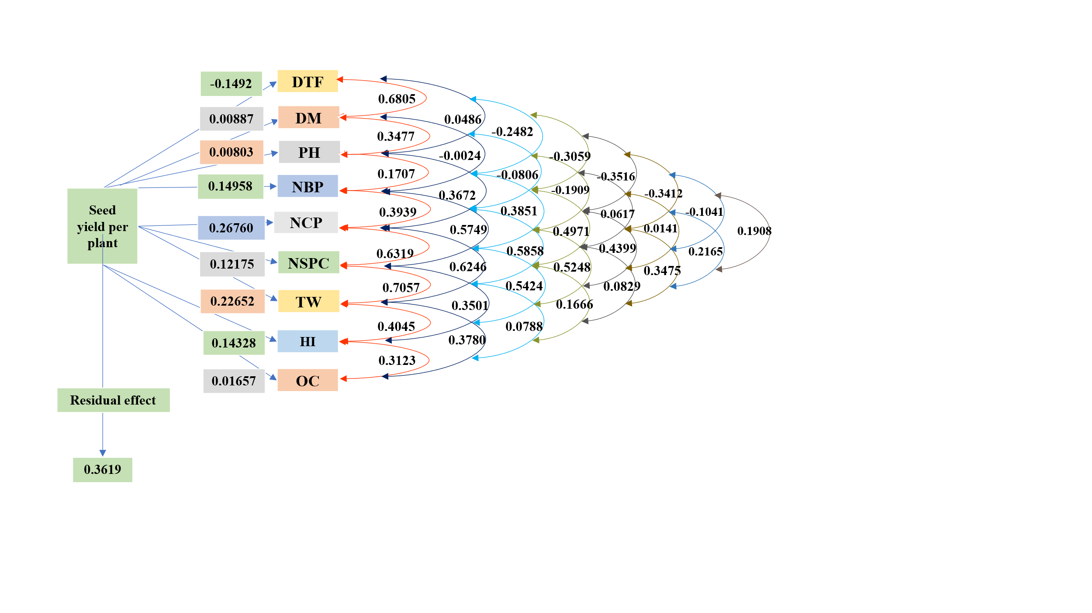

Fig. 1. Direct and indirect effects of yield components on seed yield per plant at the genotypic level
DTF : Days to 50 % flowering, DM : Days to maturity, , PH : Plant height, NBP : Number of branches per plant, NCP : Number of capsules per plant, NSPC : Number of seeds per capsule, TW : Thousand seed weight, HI : Harvest Index, OC : Oil content.

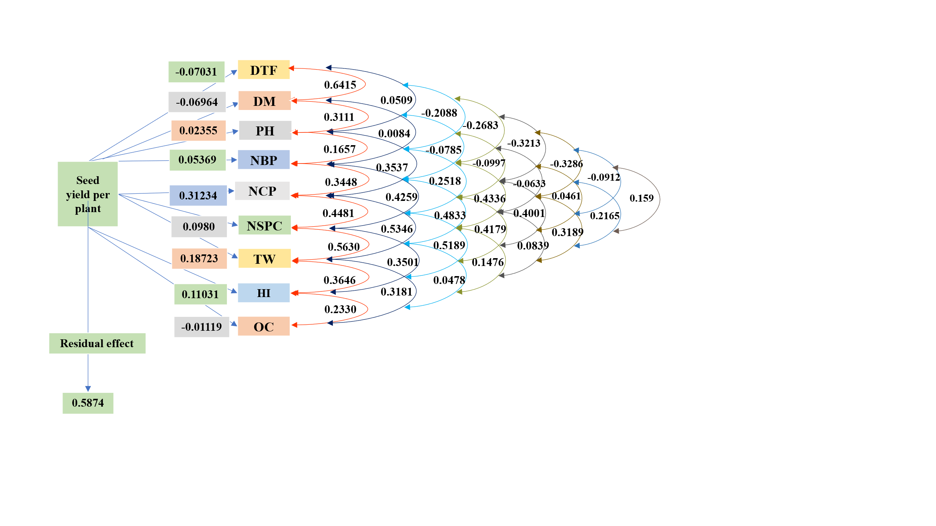

Fig. 2. Direct and indirect effects of yield components on seed yield per plant at the phenotypic level

DTF : Days to 50 % flowering, DM : Days to maturity, PH : Plant height, NBP : Number of branches per plant, NCP : Number of capsules per plant, NSPC : Number of seeds per capsule, TW : Thousand seed weight, HI : Harvest Index, OC : Oil content.

