**Original Research Article**

**Effect of different nitrogen sources on growth, yield and seed quality parameters in onion under mid-hill conditions of Himachal Pradesh, India**

**ABSTRACT**

Selecting the appropriate nitrogen source for onion cultivation requires alignment with specific production objectives. To improve seed yield and quality of onion, a study was conducted in 2020-2021 at Dr YS Parmar University of Horticulture and Forestry, Nauni, Solan (HP), using nine treatments with varying nitrogen sources (CAN, urea and calcium nitrate) in RCBD with three replications. Treatment Trt1 in which 100% N (147.5 g/plot)was applied as CAN showed superior vegetative growth, early bolting (91.33 days), highest umbel size (7.43 cm), seeds per umbel (1143.80), and seed quality traits such as germination (91.50%), seedling vigour and lowest electrical conductivity (0.109 dS m⁻¹). However, Treatment Trt5 (75% CAN + 25% calcium nitrate) excelled in leaf length and seed yield (766.52 kg ha⁻¹). Both Trt1 and Trt5 showed high nitrogen use efficiency and residual soil nitrogen. Moreover, T1 recorded the highest benefit-cost ratio (3.53), making it the most effective nitrogen source for enhancing onion seed yield and quality under mid-hill conditions of Himachal Pradesh.

**Key words**: Calcium ammonium nitrate, Nitrogen use efficiency, Productivity, Urea

**Introduction**

The genus *Allium* is highly prevalent among monocotyledonous plants, comprising over 800 species (Fu et al., 2019; Huo et al., 2019). Of these, *Allium cepa* L. is the most extensively grown and consumed (Kiani et al., 2023; Nissa et al., 2024). Globally, it ranks as the second most produced vegetable, following tomato (FAO, 2024). Onion is a highly nutritious vegetable offering several health benefits, including better cardiovascular health, increased bone mineral density, and improved regulation of blood sugar levels (Esakki et al., 2024) . Onion is a major source of flavonoids, and regular intake of these compounds has been associated with a lower risk of diabetes, cancer, and cardiovascular diseases.

**India** and **China** dominates in onion production, contributing **28.6 %** and **22.2 %** respectively, together producing half of the worlds total. Following them, **Egypt** (3.3%), **the United States** (2.64%), **Bangladesh** (2.3%) and **Turkey** (2.1%) were the next largest producers, while all other countries each accounted for under 1% (FAO, 2024). In addition to variations in growing conditions, one of the main reasons for low productivity in India is the lack of quality seeds, especially high-yielding hybrid variety. Therefore, increasing the supply of high-quality onion seeds is essential, and this can be done in part by raising the crop's productivity (Yallamale and Tomar 2019).

Nutrients are vital for boosting onion bulb production, which in turn supports the development of high-quality seeds. Therefore, producing superior quality onions is a primary objective for growers. Due to their shallow, unbranched root systems, onions are among the least efficient crops at absorbing nutrients, making them highly dependent on and responsive to fertilizer application. Achieving a good onion yield requires the application of optimal fertilizer levels, the use of suitable varieties, and the implementation of proper agronomic practices tailored to the specific environmental conditions. A highly effective way to boost onion yields is through the careful and proper application of fertilizers, especially nitrogen. Notably, optimizing fertilizer use not only improves crop productivity but also enhances the plant's nutritional quality (Ghosh et al. 2022).

Various nitrogen fertilizers can be used to supply nitrogen to crops. With Nangal Calcium ammonium nitrate (CAN) no longer in production, most farmers now depend mainly on urea, which is a cost-effective nitrogen source due to its high nitrogen content. However, continuous use of urea can negatively affect soil health and, over time, reduce crop productivity. A new option, Narmada CAN, has recently become available and is soil-neutral, meaning it does not cause issues with soil acidity or alkalinity. Selecting the right nitrogen fertilizer is essential for achieving high seed yield and quality in onions. Therefore, identifying the most suitable nitrogen source for optimal plant growth and development is crucial. Therefore the present research was conducted to determine the optimal nitrogen source for onion seed production and to evaluate its effects on plant growth, seed yield and seed quality parameters.

**Materials and Methods**

**Experimental Details**

The current field and lab experiment was carried out at Dr. Yashwant Singh Parmar University of Horticulture and Forestry's Department of Seed Science and Technology in Nauni, Solan, India. The field experiment was carried out at Pandah Research Farm, which is located in the mid-hill region of Himachal Pradesh, India, at a height of 1250 feet above mean sea level, with latitudes of 35.50o N and longitudes of 77.80o E. The experimental farm's soil was a loam to clay loan with an electrical conductivity of 0.094 dSm-1 and a pH of 5.75. Mean temperature, rainfall and relative humidity received during cropping seasson were 26.150C, 58.95 mm and 53.12 (Fig 1)

Onion variety *Palam Lohit* was used in experiment. Field experiment was conducted during Rabi 2020-21 seasin with 9 treatments with 3 replications and design of experiment was randomized completely block design. Plot size was 2.1 × 1.65 m with spacing of 45 × 45 cm and number of plants per plot was 20 and total number of plots were 27. Recommended rate for urea , CAN and calcium nitrate for onion seed production is 250 kg/ha, 425 kg/ha and 742 kg/ha respectively.

The three separate doses of nitrogen fertilizer were applied during bulb planting, one month after the first dose and one month after the second dose. Treatment used in experiments were Trt 1- 100%N through CAN (147.5 g/plot), Trt2- 100%N (86.62 g/plot) through urea, Trt3- 100%N through calcium nitrate(256.9g/plot), Trt4- 75% N through CAN (110.63 g) + 25% N through urea(21.66 g/plot), Trt5 - 75% N through CAN(110.63 g) + 25% N (64.25 g) through calcium nitrate, Trt6- 50 % N (73.75 g/plot) through CAN + 25 % N through urea (21.66 g) + 25 % N through calcium nitrate (64.25 g/plot), Trt7- 50 % N (73.75 g/plot) through CAN + 50 % N through urea (43.31 g/plot), Trt8- 50 % N through CAN (73.75 g/plot) + 50 % N through calcium nitrate (128.45 g/plot) and Trt9- control.

**Sowing, cultural operations and harvesting**

The soil was prepared into a fine tilth by performing one deep ploughing, followed by three successive harrowings. All residues from the previous crop and any weeds were cleared from the experimental plot. Finally, the land surface was evened out using a plank. Medium-sized bulbs (approximately 2.5 cm in diameter) of the *Palam Lohit* onion variety - harvested the previous year and stored in the Department of Seed Science and Technology - served as planting material. On 28 October 2020, they were manually planted at 45 cm × 45 cm spacing. Immediately after planting, irrigation was applied. Farmyard manure was applied at a full rate of 25000 kg ha⁻¹, along with 475 kg ha⁻¹ of superphosphate and 100 kg ha⁻¹ of muriate of potash, all incorporated at the time of bulb planting. Nitrogen fertilizer was then added according to the treatment plan, divided into three separate applications throughout the growth period.

The experimental plots were inspected regularly in the early mornings to monitor onion growth, development, and identify any emerging issues. Throughout the entire cultivation period, four manual weedings were performed, followed by earthing up. Irrigation was administered to experimental plots as required, based on soil moisture monitoring and crop water demand to prevent moisture stress. Standard agronomic practices were employed consistently to ensure a healthy and well-established seed crop. Once the seed capsules turned black and about 25-30% of the black seeds were visible on the umbels, each umbel was carefully cut with a 5-7 cm section of flower stalk attached. Harvesting was done in stages, and the umbels were air-dried in the sun. The seeds were then released by gently beating and rubbing the umbels by hand. Following threshing, the seeds were cleaned and sun-dried for three to four days until moisture content dropped below 8 %.

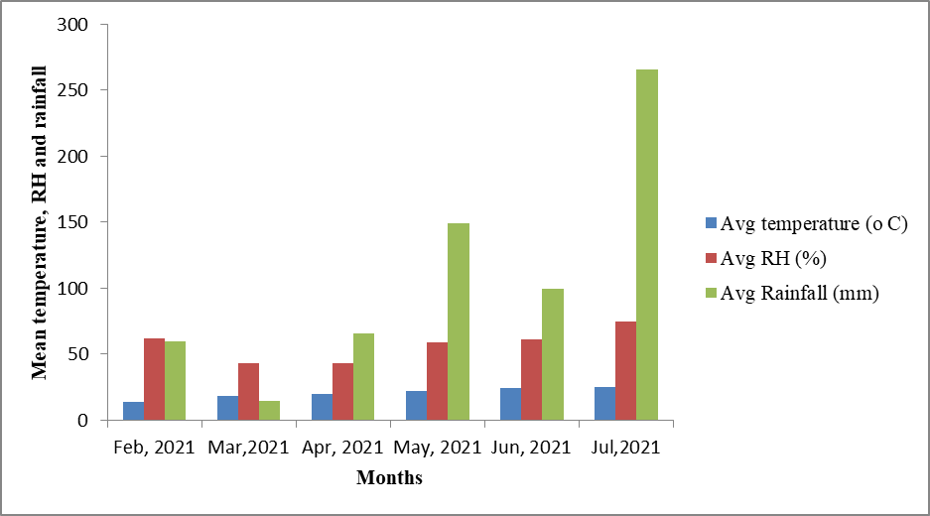

**Figure 1: Mean monthly meteorological data for the year 2020-2021**

**Parameters recorded**

Field parameters, seed quality and soil parameters were recorded during the experiment. Field parameters included number of leaves per plant, leaf length (cm), days to 50% bolting, number of bolters per plant, umbel diameter(mm), number of umbels per plant, number of seeds per umbel, 1000 seed weight and seed yield/plot/ha(kg/ha) were recorded at their respective stages.

Ten plants were selected at random, and at 30, 60 and 90 days after bulb planting, the total number of leaves and leaf length from bulb neck to longest leaf on each plant was recorded. The average leaf count and leaf length across these ten plants was then calculated for each of the three sampling dates. The number of days from planting until 50 % of the flower stalks had emerged was recorded for each replicate within each treatment group. The number of bolters per plant was counted from the 10 randomly selected plants in each replication. Mean number per plant was then calculated. The size of umbel was measured with the help of vernier Calipers from the 25 randomly selected umbels in each replication at the time of harvesting. Ten plants were randomly chosen in each replicate, and the total number of umbels on each plant was counted. The average number of umbels per plant was then calculated. Twenty-five umbels were randomly selected from each treatment, and the seeds on each of those umbels were counted. The mean value was then calculated and expressed as the average number of seeds per umbel. The seed yield per plot was determined by harvesting all plants from each plot, extracting the seeds, and then calculating the average seed output per plant by dividing the total seed weight by the number of plants. Formula used for calculating seed yield/ha

|  |  |
| --- | --- |
| $$Seedyieldhectare-1(kg)=$$ | $$Seedyieldperplot(g)8000$$ |
| $$plot(m2)1000$$ |

When calculating seed yield per hectare, 20% of the field area was allocated for the construction of channels, and the remaining 80% was used in the calculations.

Seed quality parameters such as 1000 seed weight, germination (%), seedling length (cm), & dry weight (g), seed vigour index-I & II, speed of germination were also observed. For 1000 seed weight a random sample of 1,000 dried seeds was taken from each replication within each treatment. These seeds were weighed using an electronic balance, and the weight was recorded in gram. Germination (%) was recored by using method of ISTA (1985). Formula used were:

|  |  |
| --- | --- |
| $$Germination(\text{\%})=$$ | $$Numberofnormalseedlings100$$ |
| $$Totalnumberofseedsplanted$$ |

Twelve days after the onset of germination, seedling length was measured using the paper roll method. Ten healthy seedlings were randomly selected from each replication, and each seedling’s total length from the tip of the primary leaf to the tip of the primary root was measured with a scale. The mean length was then calculated and expressed in centimeters and for seedling dry weight 10 of the seedlings previously selected for measuring length were also used. These seedlings were dried in a hot-air oven at 80 °C for 48 hours, weighed on an electronic balance, and the mean dry weight was expressed in milligrams. Seed vigour index- I and II were calculated using the formula given byAbudul Baki and Anderson (1973):

Seed Vigour index- I = Germination (%) × seedling length (cm)

Seed Vigour index-II = Germination (%)× seedling dry weight(mg)

Speed of germination was calculated using formula given by Maguire (1962):

Speed of germination: $\frac{X1}{Y1}$ + $\frac{X2}{Y2}$ +----------- $\frac{Xn}{Yn}$

X1, X2,Xn , are number of seeds germianted on first, second and nth day while Y1,Y2,Yn are number of days from first sowing to nth days.

Soil samples were also analysed for nitrogen (Kg/ha-1) using alakline permagnate method (Subbiah and Asija, 1956). The alkaline permanganate method estimates plant-available nitrogen in soil by oxidizing organic matter using alkaline KMnO₄. Ammonia released during the reaction is captured in boric acid and quantified via titration. Nitrogen use efficiencey (Kg/ha-1) and caluclated using formula (Fageria and Baligar 2003):

NUE = $\frac{SeedYield∈thefertilizedplot\left(\frac{kg}{ha}\right)-Seedyield∈controlplot(\frac{kg}{ha})}{Qunatityofnitrogenapplied(\frac{kg}{ha})}$

The benefit‑to‑cost ratio was estimated by comparing production costs with returns. The **cost of cultivation** comprised both fixed costs and variable costs. **Gross returns** were calculated as seed yield multiplied by market price, while **net returns** were determined by subtracting total cultivation costs from gross returns. The **benefit‑to‑cost ratio** was then obtained by dividing net returns by total expenditure. All figures in Indian rupees were converted to US dollars using the prevailing exchange rate as of July 2025.

**Stastical Analysis**

The data were evaluated using the statistical procedures detailed by Gomez and Gomez (1984) for both Randomized Complete Block Design (RCBD) and Completely Randomized Design (CRD). Differences among treatment means were determined using the Critical Difference (CD) at a 0.05 significance level (p < 0.05). All analyses were conducted using the OPSTAT software. Principal component analysis was calculated using google colab software was used.

**Results and Discussion**

**Growth and Seed Yield Parameters**

The data on the number of leaves influenced by various nitrogen sources is summarized in Fig 2 At 30 days after field emergence, the highest number of leaves per plant (23.43) was recorded in treatment Trt1 (100% nitrogen applied through CAN), in contrast, the lowest number of leaves (16.50) was observed in Trt9 (Control). At 60 days, the maximum leaf count (33.10) was found in Trt8 (50% N through CAN + 50% N through calcium nitrate), and the minimum number of leaves at this stage (24.76) was again recorded in the control treatment Trt9. At 90 days after emergence, Trt1 (100% N through CAN) produced the highest number of leaves (37.16, while the lowest count (26.76) was observed in Trt9 (Control).

Nitrogen fertilization promotes vegetative growth and increases leaf number by enhancing the plant's absorption and assimilation processes (Aminifard et al., 2012). Nitrogen, being a key component of chlorophyll and other compounds, supports vigorous growth. Higher leaf numbers in CAN-treated plants may be attributed to better nitrogen availability, boosting dry matter accumulation in leaves. Antille et al. (2015) found that calcium ammonium nitrate (CAN) facilitated a somewhat higher rate of nitrogen uptake in the period between fertilizer application and the first harvest. Thus, CAN proved to be a more efficient nitrogen source compared to urea, likely because urea suffered greater nitrogen losses from ammonia volatilization. Takebe et al. (1995) suggested that increases in leaf dry weight could stem from the synergistic effects of nitrogen combined with photosynthetic products—such as glucose, ascorbic acid, amino acids, and proteins—that are generated during photosynthesis. Their findings indicate that using a mix of fertilizers at lower application rates yielded the best results. The authors propose this might be because applying different fertilizers at minimal concentrations harnesses their complementary benefits while minimizing potential harm to the plant, soil, and environment.

Marzi et al. (2020) reported that applying nitrogen at a rate of 200 kg/ha resulted in the maximum number of leaves.

The data on leaf length as affected by various nitrogen sources, presented in Fig3 showed that at 30 days after emergence, the longest leaves (26.02 cm) were recorded in treatment Trt5 which was statistically similar to Trt1 (25.03 cm) and Trt8 (25.55 cm). The shortest leaves (17.24 cm) were noted in the control (Trt9). At 60 days, T5 again showed the greatest leaf length (42.47 cm), which was statistically comparable to Trt1 (40.56 cm) and Trt8 (41.03 cm), while the minimum length (27.52 cm) was recorded in Trt9. At 90 days, the maximum leaf length (54.66 cm) was observed in Trt5, which remained statistically at par with Trt1 (52.54 cm) and Trt8 (50.41 cm), whereas the shortest leaves (37.88 cm) were again found in the control treatment Trt9. Treatments with a higher proportion of CAN resulted in superior vegetative growth, likely due to greater nitrogen uptake and assimilation by the plants, along with reduced leaching losses compared to other nitrogen fertilizers.

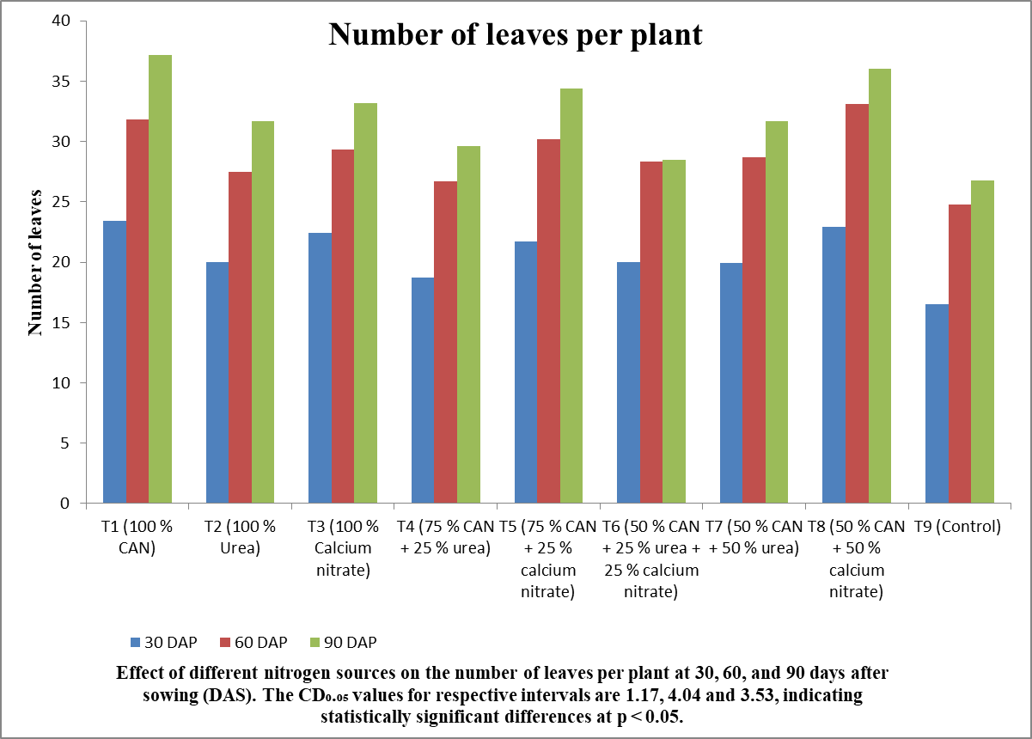

**Fig 2. Effect of different nitrogen sources on number of leaves per plant in onion**

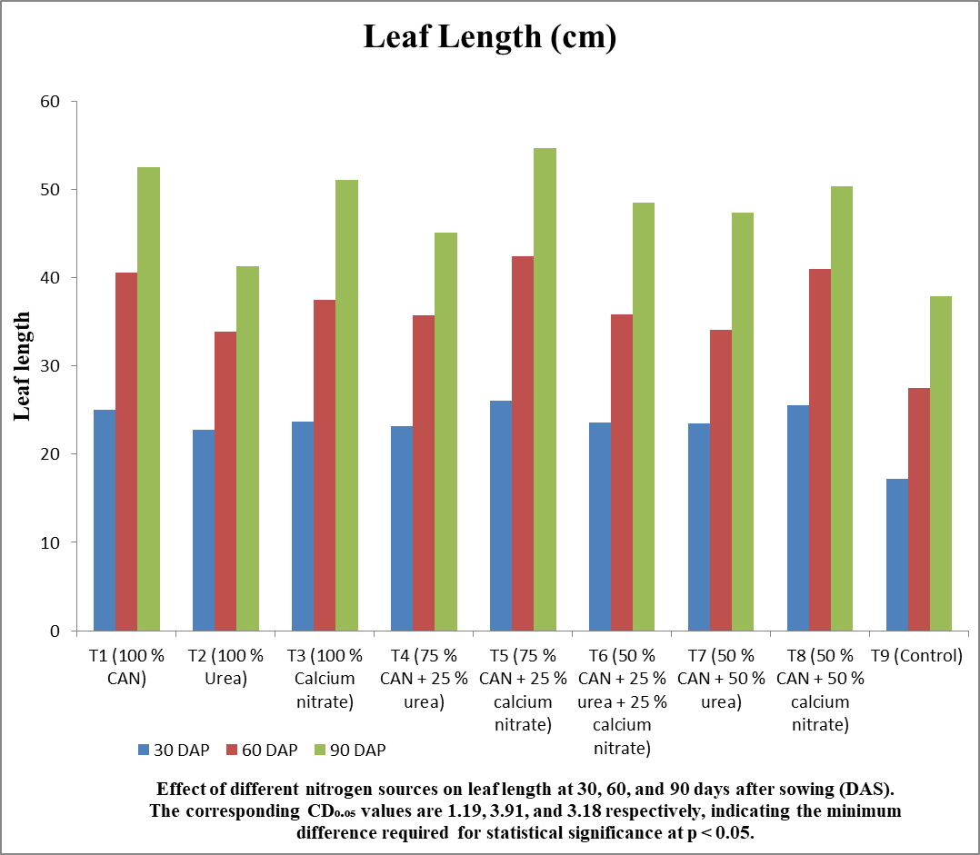

**Fig 3. Effect of different nitrogen sources on leaf length (cm) in onion**

Malagoli et al. (2005) demonstrated that nitrogen promotes significantly greater dry matter accumulation. Additionally, nitrogen supports the biosynthesis and activity of phytohormones—particularly cytokinins, which stimulate cell division. Elevated cytokinin levels in plants are often associated with increased auxin concentrations in the shoots; auxin, in turn, encourages cell elongation (Marshner, 1995).

The highest number of bolters per plant (8.63) was observed in treatment Trt1, which was statistically similar to Trt3 (8.13) and Trt5 (8.53). In contrast, the lowest number of bolters per plant (5.83) was recorded in the control treatment (Trt9) (Table 1).

CAN provide nitrogen in two forms and has minimal leaching losses compared to other nitrogen sources (Sommer and Jensen, 1994). A sufficient nitrogen supply also enhances the uptake of other nutrients like phosphorus, which is crucial for flowering (Brady and Weil, 2002). This may explain why plots receiving CAN alone or in combination had better nitrogen and phosphorus availability, resulting in a higher number of bolters per plant. Antille et al. (2015) noted that urease enzyme activity is reduced at low temperatures (during winter), leading to slower nitrogen release from urea. This slower release may have resulted in lower nitrogen availability in urea-treated plots, thereby reducing the number of bolters per plant.

The shortest time to reach 50% bolting (91.33 days) was recorded in treatment Trt1, which was statistically comparable to Trt2 (92.33 days) and Trt5 (93.33 days). In contrast, the longest duration to 50% bolting (102.67 days) was observed in the control treatment (Trt9) while largest umbel size (7.34 cm) was recorded in treatment Trt1 , showing statistical similarity with Trt3 (6.90 cm), Trt5 (7.10 cm), and Trt8 (7.12 cm). In contrast, the smallest umbel size (5.83 cm) was observed in the control treatment (Trt9). The larger umbel size observed in plants treated with CAN alone or combined with other nitrogen sources may be attributed to increased dry matter accumulation during early growth stages, along with more efficient partitioning of photosynthates from the vegetative parts (source) to the reproductive organs (sink), and their effective translocation to reproductive structures (Malagoli et al., 2005).

The seed count per umbel is an important yield-determining characteristic in onion (Yalamalle et al., 2019). The highest number of seeds per umbel (1134.80) was recorded in treatment Trt1 , which was statistically similar to Trt3 (1101.66) and Trt5 (1079.30). In contrast, the lowest seed count per umbel (686.80) was noted in the control treatment (Trt9). Plants supplied with nitrogen through CAN produced a higher number of seeds per umbel, likely due to the superior umbel quality observed in CAN-treated plants compared to those receiving other nitrogen fertilizers. Jain (2001) in African marigold reported similar results.

Plants treated with calcium ammonium nitrate (CAN) produced a greater number of seeds per umbel, likely due to the superior quality of umbels developed under CAN as compared to other nitrogen sources. These results align with the findings of Jain (2001) in African marigold

The highest seed yield (16.60 g per plant, 0.332 kg per plot, and 766.52 kg per hectare) were obtained in treatment Trt5 (75% N through CAN + 25% N through calcium nitrate), which was statistically comparable to Trt1 (16.55 g per plant, 0.331 kg per plot, and 764.21 kg/ha) and Trt8 (15.46 g per plant, 0.309 kg per plot, and 762.68 kg/ha). In contrast, the lowest seed yields (10.93 g per plant, 0.219 kg per plot, and 504.86 kg/ha) were recorded in the control treatment Trt9. Yield performance is shaped by a complex interplay of genetic traits, environmental conditions, and agronomic practices. A lack of nitrogen can impair plant growth, decrease photosynthetic efficiency, and restrict the energy required for seed development, ultimately resulting in reduced yield (Geisseler et al., 2022; Qi et al., 2023)

Plants receiving nitrogen through CAN produced the highest seed yields compared to other nitrogen sources. This may be due to the greater number of bolters or umbels, larger umbel size, and increased seed count per umbel, all of which contributed to higher overall seed production. Hossain et al. (2017) reported that applying 114 kg of nitrogen resulted in the highest seed yield per plant (4.21 g), whereas the lowest yield (3.20 g) was obtained with 57 kg of nitrogen. Similarly, Debashis et al. (2017) found that a nitrogen dose of 175 kg/ha produced the maximum number of seeds per plant.

**Seed Quality Parameters**

Onion seeds generally have poor storability, as their viability tends to decline more rapidly than that of many other vegetable crops (Taylor, 2020). Balanced nutrition during crop growth, particularly adequate nitrogen supply, is a major factor affecting seed storability and vigour. Nitrogen is vital for healthy plant development, improved photosynthesis, and the production of proteins and enzymes necessary for seed formation. Sufficient nitrogen enhances seed vigour by promoting efficient nutrient absorption, resulting in robust seedlings with better germination potential (Girase et al., 2025). Maximum seed germination (91.50 %), seedling length (17.13 cm), seedling dry weight (23.30 mg), seed vigour index-I & II (1567.78 &2132.02), and 1000 seed weight (3.90 g) were recorded in Trt1-1(100 % N through CAN) as compared to control, while speed of germination (8.00) highest in Trt-5 (75 % CAN + 25 % calcium nitrate) (Table 2) Nitrogen fertilization boosts seed quality and storability by enhancing germination, seedling development, and overall vigour. These benefits are linked to improved nutrient availability and higher tocopherol levels- antioxidants that safeguard seeds from oxidative damage, preserve membrane integrity, and promote efficient metabolic activity (Girase et al. 2025). Similar results were reported by Girase et al. (2025) in onion when nitrogen @100kg/ha was applied.

**Soil Parameters**

Intital avilable nitrogen in soil was 265.6 kg ha-1 . The data in Fig indicate that various nitrogen sources significantly affected the level of available soil nitrogen after harvest. The highest value (286.20 kg/ha) was observed in treatment Trt1 (100% N through CAN), which was statistically similar to Trt3 (281.23 kg/ha), Trt5 (283.40 kg/ha), and T8 (280.33 kg/ha). In contrast, the lowest available soil nitrogen (261.43 kg/ha) was recorded in the control treatment (Trt9) (Fig4) The notable rise in available soil nitrogen after harvest may be attributed to the increase in both ammonium and nitrate ions, along with the microbial conversion of ammonium to nitrate through nitrification, which occurs when nitrogen availability in the soil is enhanced by different nitrogen sources. These results align with the findings of Jeet (2016), who reported increased nitrogen levels with the use of various nitrogen fertilizers. , Similarly highest nitrogen use efficiency (0.643 kg/kg) was recorded in treatment Trt5 (75% N through CAN + 25% N through calcium nitrate), which was statistically comparable to Trt1 (0.637 kg/kg), Trt3 (0.627 kg/kg), Trt6 (0.523 kg/kg), and Trt8 (0.640 kg/kg) (Fig 5). In contrast, the lowest nitrogen use efficiency (0.227 kg/kg) was observed in treatment Trt7 (50% N through CAN + 50% N through urea). Higher nitrogen use efficiency in plots treated with CAN may be attributed to greater nitrogen availability for plant uptake.

**Economics**

The economic analysis of different nitrogen source treatments, as shown in Table 3, revealed that treatment Trt1 generated the highest net returns (2,030.75 USD), followed by T5 (2,148.21). Trt1 also recorded the highest benefit-cost (B:C) ratio of 3.53, with Trt5 close behind at 3.29. In contrast, the lowest net returns (1,832.56) and B:C ratio (2.31) were observed in the control treatment (Trt9).(Table 3).

**Principal Component Analysis**

The principal component analysis (PCA) was performed using a set of fourteen variables for the years 2021. As shown in Fig. 6. PC1 and PC2 explained 86.9% and 4.6% of the total variation. The relationships between the variables in the first two principal components (PC1 and PC2) are depicted in Fig. 6, along with the contribution of each variable to the main components. All variables except the 50%B are positioned in positive coordinate of PC1, however in PC2 SDW, 1000SW, NBP, NOS/U, UD are positioned in negative coordinate and remianing varibale are in positive coordinate. The PCA analysis identified four distinct treatment clusters. Cluster I include parameters such SOG, Sypt, SypH, SVI, SVII, G%,SDW,SL, Cluster II showed the value for 1000SW, NBP, NOS/U, UD and cluster IV include parameter 50%B.

|  |  |  |  |  |  |  |  |
| --- | --- | --- | --- | --- | --- | --- | --- |
| **Treatments** | **Number of bolters per plant** | **Days to 50 %**  **bolting** | **Size of umbel**  **(cm)** | **Number of seeds per umbel** | **Seed Yield per plant**  **(g)** | **Seed yield per plot**  **(kg)** | **Seed Yield per hectare (kg)** |
| Trt1 (100 % CAN) | 8.63 | 91.33 | 7.34 | 1134.80 | 16.55 | 0.331 | 764.21 |
| Trt2 (100 % Urea) | 7.70 | 92.33 | 6.82 | 975.43 | 14.15 | 0.283 | 653.39 |
| Trt3 (100 % Calcium nitrate) | 8.13 | 97.66 | 6.90 | 1101.66 | 14.96 | 0.299 | 758.05 |
| Trt4 (75 % CAN + 25 % urea) | 7.43 | 99.33 | 6.29 | 819.56 | 13.63 | 0.273 | 629.53 |
| Trt5 (75 % CAN + 25 % calcium nitrate) | 8.53 | 93.33 | 7.10 | 1079.30 | 16.60 | 0.332 | 766.52 |
| Trt6 (50 % CAN + 25 % urea + 25 % calcium nitrate) | 7.83 | 96.66 | 6.64 | 860.93 | 13.86 | 0.277 | 711.11 |
| Trt7 (50 % CAN + 50 % urea) | 7.56 | 97.33 | 6.78 | 946.93 | 12.83 | 0.257 | 592.59 |
| Trt8 (50 % CAN + 50 % calcium nitrate) | 7.73 | 98.00 | 7.12 | 982.00 | 15.46 | 0.309 | 762.68 |
| Trt9 (Control) | 5.83 | 102.67 | 5.83 | 686.80 | 10.93 | 0.219 | 504.86 |
| **Mean** | **7.71** | **97.18** | **6.75** | **954.15** | **14.33** | **0.286** | **682.54** |
| **CD**0.05 | **0.65** | **4.94** | **0.45** | **127.71** | **1.54** | **0.031** | **93.93** |

**Table 1 Effect of different nitrogen fertilizers on various growth and yield parameters in onion**

|  |  |  |  |  |  |  |  |
| --- | --- | --- | --- | --- | --- | --- | --- |
| **Treatments** | **1000 seed weight (g)** | **Germination (%)** | **Speed of germination** | **Seedling length (cm)** | **Seedling dry weight (mg)** | **Seed Vigour Index-I** | **Seed Vigour Index-II** |
| Trt1 (100 % CAN) | 3.90 | 91.50 (9.61) | 7.97 | 17.13 | 23.30 | 1567.78 | 2132.02 |
| Trt2 (100 % Urea) | 3.72 | 88.25 (9.44) | 6.63 | 14.15 | 22.45 | 1248.94 | 1981.17 |
| Trt3 (100 % Calcium nitrate) | 3.75 | 90.00 (9.53) | 6.93 | 15.86 | 22.57 | 1427.17 | 2031.70 |
| Trt4 (75 % CAN + 25 % urea) | 3.61 | 85.25 (9.28) | 7.46 | 14.37 | 21.70 | 1225.46 | 1849.87 |
| Trt5 (75 % CAN + 25 % calcium nitrate) | 3.88 | 90.75 (9.57) | 8.00 | 16.50 | 23.27 | 1498.23 | 2112.17 |
| Trt6 (50 % CAN + 25 % urea + 25 % calcium nitrate) | 3.62 | 82.00 (9.11) | 6.79 | 14.61 | 19.67 | 1198.73 | 1613.27 |
| Trt7 (50 % CAN + 50 % urea) | 3.63 | 83.50 (9.19) | 6.45 | 14.11 | 21.07 | 1178.19 | 1759.70 |
| Trt8 (50 % CAN + 50 % calcium nitrate) | 3.73 | 89.75 (9.52) | 7.02 | 15.46 | 22.87 | 1388.22 | 2053.02 |
| Trt9 (Control) | 3.37 | 80.25 (9.01) | 6.52 | 10.50 | 18.37 | 842.90 | 1474.55 |
| **Mean** | **3.69** | **86.80** | **7.08** | **14.74** | **21.69** | **1286.18** | **1889.71** |
| **CD**0.05 | **0.16** | **0.05** | **0.78** | **0.78** | **0.23** | **70.78** | **23.04** |

**Table 2 Effect of different nitrogen fertilizers on various seed quality parameters of harvested onion seed**

|  |  |  |  |  |
| --- | --- | --- | --- | --- |
| **Treatments** | **Cost of Cultivation (USD)** | **Gross Return (USD)** | **Net Return (USD)** | **B:C Ratio** |
| Trt1 (100 % CAN) | 2,030.75 | 9,204.94 | 7,174.19 | 3.53 |
| Trt2 (100 % Urea) | 1,891.12 | 7,869.16 | 5,978.88 | 3.16 |
| Trt3 (100 % Calcium nitrate) | 2,501.84 | 8,325.30 | 6,629.37 | 2.65 |
| Trt4 (75 % CAN + 25 % urea) | 1,996.75 | 7,582.29 | 5,585.54 | 2.79 |
| Trt5 (75 % CAN + 25 % calcium nitrate) | 2,148.21 | 9,234.22 | 7,086.01 | 3.29 |
| Trt6 (50 % CAN + 25 % urea + 25 % calcium nitrate) | 2,113.01 | 8,325.30 | 6,450.97 | 3.05 |
| Trt7 (50 % CAN + 50 % urea) | 1,961.54 | 7,137.23 | 5,175.69 | 2.63 |
| Trt8 (50 % CAN + 50 % calcium nitrate) | 2,266.89 | 8,601.08 | 6,334.19 | 3.05 |
| Trt9 (Control) | 1,832.56 | 6,082.17 | 4,249.61 | 2.31 |
| **Mean** | 2,030.75 | 9,204.94 | 7,174.19 | 3.53 |
| **CD**0.05 | 1,891.12 | 7,869.16 | 5,978.88 | 3.16 |

**Table 3 Effect of different nitrogen sources on economics of seed production in onion**

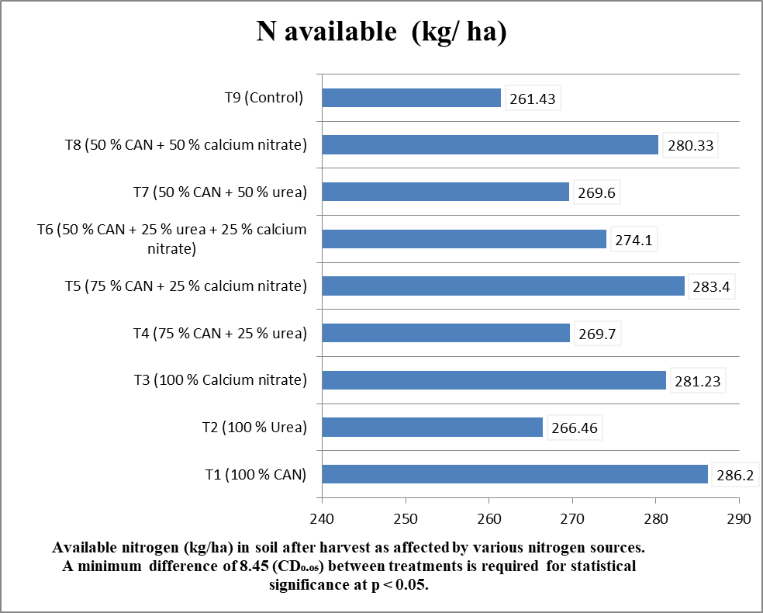

**Fig 4. Effect of different nitrogen sources on available nitrogen after harvest of crop (kg/ha)**

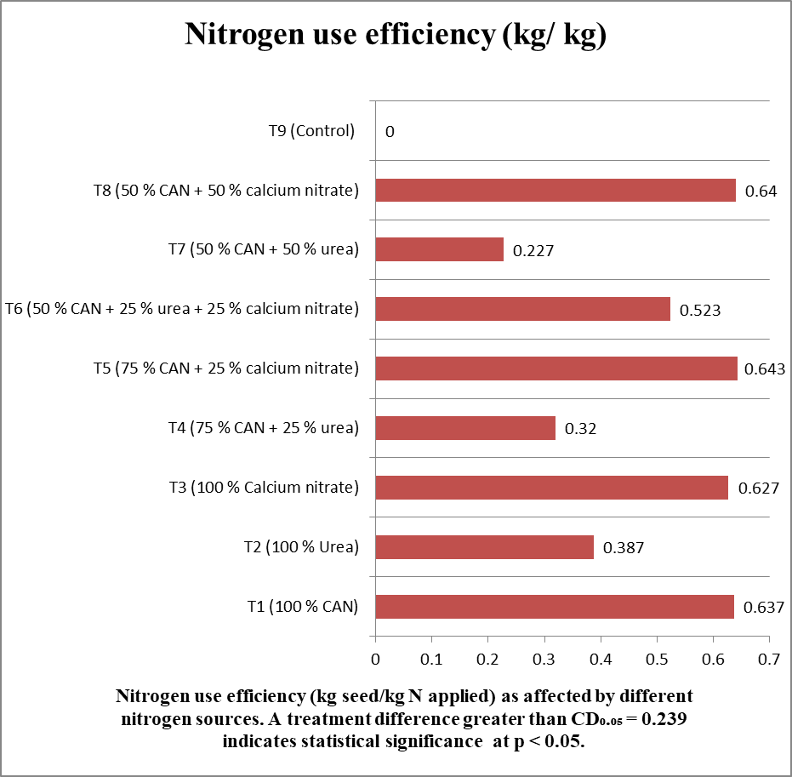

**Fig 5. Effect of different nitrogen sources on nitrogen use efficiency**

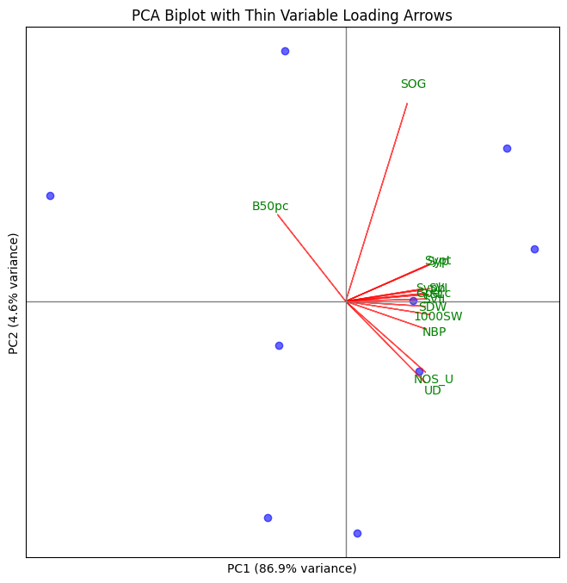

**Fig 6.** Principal component analysis showing PC1 and PC2 values of parameters in different cluster. SOG – Speed of germination, Sypt-Seed yield per plot, SypH- Seed yield her hectare, SVI- Seed vigour index-I, SVII – Seed vigour index-II, G% - Germination, SDW- Seedling dry weight, SL-Seedling length, 1000SW – 1000 Seed weight NBP- Number of bolters/plant NOS/U – Number of seeds per umbel, UD-Umbel diameter, 50%B- 50% Bolting

**Conclusion**

It was concluded that treatment Trt1 (100% N through CAN) performed best in terms of plant growth, seed yield, seed quality, nitrogen use efficiency and benefit-cost ratio. Therefore, it appears to be a more effective nitrogen source for promoting healthy growth and higher seed yield in onion under the mid-hill conditions of Himachal Pradesh and may be recommended following multi-location trials.

**Competing interests disclaimer:**

Authors have declared that they have no known competing financial interests OR non-financial interests OR personal relationships that could have appeared to influence the work reported in this paper.

Disclaimer (Artificial intelligence)

Option 1:

Author(s) hereby declare that NO generative AI technologies such as Large Language Models (ChatGPT, COPILOT, etc.) and text-to-image generators have been used during the writing or editing of this manuscript.

**References :**

Aminifard MH, Aroiee H, Nemati H, Azizi M and Khayyat M. 2012. Effect of nitrogen fertilizer on vegetative and reproductive growth of pepper plants under field conditions. *Journal of* *Plant Nutrition* **35**:235-242.

Antille DL, Hoekstra NJ and Lalor STJ. 2015. Field-scale evaluation of calcium ammonium nitrate, urea and urea treated with N-(N-Butyl) thiophosphosphoric triamide applied to grassland in Ireland. *Communication in Soil Science and Plant Analysis* **46**:1345-1361.

Brady NC and Weil RR. 2002. *The nature and properties of soils*, 13th ed. Delhi, India: Pearson Education Asia. 960p.

Debashis M, Maity TK and Basu AK. 2017. Response of quality seed production of onion (Allium Cepa L.) to different levels of nitrogen and potassium application. *Research Journal of Chemical and Environmental Sciences* *5*(2):38-45.

FAOSTAT. 2024. Reference database of cropland nutrient budgets and nutrient use efficiency: nitrogen, phosphorus and potassium. *Earth System Science Data*, 16(1):525-541.

Fu J, Zhang H, Guo F, Ma L, Wu J, Yue M, Zheng X, Qiu Z and Li L. 2019. Identification and characterization of abundant repetitive sequences in Allium cepa. *Scientific reports*, 9(1):16756.

Geisseler D, Ortiz RS and Diaz J. 2022. Nitrogen nutrition and fertilization of onions (*Allium cepa* L.)-A literature review. *Scientia Horticulturae*, 29(1):110591.

Ghosh S, Zhang S, Azam M, Gebregziabher BS, Abdelghany AM, Shaibu AS, Qi J, Feng Y, Agyenim-Boateng KG, Liu Y and Feng H. 2022. Natural variation of seed tocopherol composition in diverse world soybean accessions from maturity group 0 to VI grown in China. *Plants*, 11(2):206.

Girase IP, Rai PK, Sahi VP, Thangasamy A, Ahammed TS and Yalamalle VR. 2025. Nitrogen enhances seed oil, tocopherols, seed yield and seed quality in onion. *Scientia Horticulturae*. 349: 114225.

Hossain MM, Khatun K, Haq ME, Ahmed M and Shefat-Al-Maruf M. 2017. Macro and micro nutritional effect on seed yield of onion. *Advances in Research*, 12(1):1-9.

Huo Y, Gao L, Liu B, Yang Y, Kong S, Sun Y, Yang Y and Wu X. 2019. Complete chloroplast genome sequences of four Allium species: comparative and phylogenetic analyses. *Scientific reports*, 9(1):12250.

Jain R. 2001. Effect of date of planting and different source of nitrogen on flower and seed yield in African marigold (Tagetes erecta L.). M Sc Thesis, Department of Floriculture and Landscape Architecture, Dr Y S Parmar University of Horticulture and Forestry, Solan. 72p.

Kiani Z, Mashayekhi K, Golubkina N, Mousavizadeh SJ, Nezhad KZ and Caruso G. 2023. Agronomic, physiological, genetic and phytochemical characteristics of onion varieties influenced by daylength requirements. *Agriculture*, *13*(3):697.

Malagoli P, Laine P, Rossato L and Ourry A. 2005. Dynamics of nitrogen uptake and mobilization in field-grown winter oilseed rape (*Brassica napus*) from stem extension to harvest. II. AN 15N-labelling-based simulation model of N partitioning between vegetative and reproductive tissues. *Annals of Botany* 95:1187-1198.

Marschner H. 1995. Mineral Nutrition of Higher Plants. 2nd ed. Academic Press. New York. 889p.

Marzi M, Shahbazi K, Kharazi N and Rezaei M. 2020. The influence of organic amendment source on carbon and nitrogen mineralization in different soils. *Journal of Soil Science and Plant Nutrition*, 20(1):177-191.

Nissa K, Sharma R, Bharat NK and Thakur A. 2024. Effect of ZnSO4 Priming on Storability, Seed Quality and Bulb Yield in Onion under mild hills conditions of north-western Himalayas. *International Journal of Plant & Soil Science*, 36(7):817-825.

Qi J, Li M, Wang L, Hu Y, Liu W, Long Z, Zhou Z, Yin P and Zhou M. 2023. National and subnational trends in cancer burden in China, 2005-20: an analysis of national mortality surveillance data. *The Lancet Public Health*, 8(12):943-e955.

Sommer S G and Jensen C. 1994. Ammonia volatilization from urea and ammonical fertilizers surface applied to winter wheat and grassland. *Springer* **37**:85-92.

Taylor AG. 2020. Seed storage, germination, quality, and enhancements. In *The physiology of vegetable crops* (pp. 1-30). Wallingford UK: CABI.

Takebe M, Ishihara T, Matsuna K, Fojimoto J and Yoneyama T. 1995. Effect of nitrogen application on the content sugars, ascorbic acid, nitrate and oxalic acid in spinach (Spinacia oleracea L.) and kamatsuna (Brassica campestris L.). Japanese Journal of Soil Science and Plant Nutrition 66: 238-246.

Yalamalle VR and Tomar BS. 2019. Effect of scape regulation on seed yield and quality in onion (*Allium cepa*). *The Indian Journal of Agricultural Sciences*, 89(1):56-59.