Study of genetics and tagging of gene linked to spotted stem borer (Chilo partellus) resistance in maize

Abstract
The maize spotted stem borer, Chilo partellus (Swinhoe), is a serious pest that causes yield losses of 24.3-36.3% Knowledge of the genetics of resistance is a prerequisite for the development of resistant cultivars. The present investigation was carried out to study the genetics of resistance to the spotted stem borer and to identify linked SSR markers using BSA. Twenty- eight inbreds, along with 2 checks, were screened for C. partellus resistance by considering damage parameters namely, LIR, exit hole, dead heart, and percent stem tunnelling in a field trial at ICAR-IIMR, New Delhi. Maize genotypes WNZPBTL 2 and HKI 1352 were selected as resistant and susceptible parents, respectively. Individuals of the F₂ mapping population developed from WNZPBTL 2 and HKI 1352 were phenotyped for the LIR and classified into 1 to 9 scales. F₂ distribution of LIR indicates monogenic control of spotted stem borer resistance in maize with dominance of resistance. Screening of parents with 200 simple sequence repeat (SSR) markers identified 37 polymorphic markers across the genome. Chromosomes 1, 5, and 6 were revealed to carry the most distinct genomes, whereas chromosome 8 was more similar between parents. Only one marker (bnlg1057) at map location bin1.06 showed polymorphism between parents as well as bulks with distinct frequency of resistant and susceptible alleles. Strength of linkage between marker and trait in F₂ was assessed by binary logistic regression, which was significant with a value of regression coefficient 1.453. An additional twelve markers from identified bin1.06 flanking bnlg1057 were selected to identify a closer marker to the gene, but the absence of polymorphism between parents for these markers suggests the use of a different population to find more closely linked markers.
Key words:Maize, spotted stem borer, Genetics, BSA, SSR and linkage analysis.

Introduction
Several pests affect nearly 46% of maize growing and cause a loss annually, by 24.5%. Fifty-two million tons of grain, valued at about $5.7 billion, are lost. Again use of insecticide worth of US $550 million is used annually to curb losses (Munyiri and Mugo 2017).Maize is known as the queen of cereal owing to its great yield potential and existing genetic diversity (Prasanna, 2012 & Sherakhane et al 2025). In India, maize is the third most important cereal crop next to rice and wheat and is produced over an area of 9.09 mha with an annual production of 24.26 mt, and productivity of 2.56 mt/ha (Yadavet al. 2015). However, maize cultivation in India is regularly under severe attack by both biotic and abiotic stresses. Maize (Zea mays L.) is attacked by many insect pests in India. Lepidopteran pests, particularly stem borers, are major constraints to productivity and of economic importance in most maize-growing countries around the world. Of these, the maize stem borer, Chilo partellus (Swinhoe), is an important pest and causes direct economic damage to the crop. A severe attack could result in the death of the affected plant's heart, leading to significant yield loss. Estimated yield losses due to its occurrencehave been reported to vary between 24.3-36.3% ( Saraswati et al., 2022). Exploitation of host plant resistance to develop resistant cultivars using conventional methods has always remained the most acceptable due to the lack of any bio-safety concerns. The development and use of insect-resistant cultivars are non-polluting, stable, and durable both across time and environments. Resistant cultivars can also be successfully incorporated into an integrated pest management strategy. Breeding for host plant resistance, therefore, deserves major emphasis in maize improvement programmes. Breeding for host plant resistance, therefore, deserves major emphasis in maize improvement programmes. An Inheritance study of stem borer resistance in maize is a prerequisite for determining an effective plant breeding strategy for the development of resistant cultivars. However there are limited studies available about the genetics of stem borer resistance in maize. However, identification of cultivars based on phenotype alone is laborious, prolonged, and expensive. In contrast, molecular markers are not affected by the environment independent and scorable at any stage of crop growth, which also ensures quicker and clearer cut analysis at lower cost (Selviet al., 2002, Satishet al., 2009, and Yueyingli et al., 2010). Identification of genomic region of stem borer resistance linked to molecular markers would have paramount importance for improving efficiency in marker assisted breeding (MAB) programme. Closely linked markers to resistant loci are being routinely used to introgress and select associated traits in early generations to minimize the costly phenotypic analysis (Drinic et al., 2004). Earlier many authors documented molecular markers associated with resistance to a number of pests in maize (Schonet al 1993, Bohn et al 1997, Khairallahet al 1998, Cardinal et al 2001, Jampotnet al., 2002, and Krakowshyet al., 2007). QTLs for different maize stem-borer specieshave been reported in some temperate and tropical maize germplasm (Bohn et al., 2000; Jiménez-Galindo et al., 2017 and 2019). Monogenetic resistance against stem borer in maize observed by Girhotra and Saxena 2005, Anil Cholla et al 2018, Anil kumar cholla et al 2019 Suby et al 2020) Therefore an attempt was made in present study to study the inheritance of C. partellus resistance and to identify SSR marker linked to C. partellus resistance in maize using Bulked Segregant Analysis (BSA) approach.
Materials and Methods:
Plant material:
Twenty-eight maize inbred viz.,CM-202,CM-501, JCY2-2-4-1, PFSR R3-7, PFSR 51016/1, WNZPBTL 2, WNZPBTL 3, WNZPBTL 6, WNZPBTL 8, WNZPBTL 9, WNZPBTL 10 (9 F), WNZPBTL 11 (57 D), AEB (Y) C5 F 38-1, AEB (Y) C5 F43-1, V 351, P 72 CL BRASIL 1177-2-2-1, HK I-PC-5, HKI-161, HKI-163, HKI-193-1, HKI-170 (1+2+3), HKI-1378, HKI-1354-2, HKI-1352, HKI-335, HKI-295, HKI-1332 and HKI-488, along with two checks CM-500(resistant) and Basilocal Selection (susceptible) were tested for their response to spotted stem borer infestation under field condition at IIMR, Pusa campus, New Delhi during Kharif season 2012.
Phenotypic screening:
Phenotypic screening for spotted stem borer (SSB) damage parameters was carried out for 28 inbreds along with the two checks for selection of contrasting parents to develop an F2 mapping population. Each entry was sown in 2-row plots of 4 m row length with three replications in a randomized complete block design (RCBD). Infestation with neonates was done at 15 days of seedling emergence (DAE). Five freshly hatched of larvae C. partellus were carefully picked up with the help of a fine brush and placed in the whorl of the plant. The maize plant leaf whorl was gently tapped before infestation to avoid drowning of the larvae in water retained in the leaf whorl. Larvae started feeding on and growing inside the plant immediately. After 25 days of infestation (DAI), all the plants in each replication were observed for the leaf injury and rating was done using Leaf Injury Rating (LIR) scale of 1 (healthy plant) to 9 (dead heart) employing the scale developed by Sarup (1983). Where 1 to 9 scale represents the degree of damage to different plant parts viz., 1: indicates healthy plant, 2: Plant showing slightest damage on leaf or few pinholes on 1-2 leaves, 3: Plant showing more pin holes of shot holes on 3-4 leaves, 4: Plant showing injury (pin holes, shot holes, slits) in about one third of total number of leaves and mid-rib tunnelling on1-2 leaves, if any, 5: Plant showing 50 % of leaf damage (pin holes, shot-holes, slits, streaks and mid-rib damage, if any), 6: Plant showing varied types of leaf injury in about two-third of the total number leaves, 7: Plants with every type of the leaf injury and almost all the leaves damaged, 8: The entire plant shows a maximum of the leaf injury and is likely to form dead-heart (such a plant usually shows stunted growth), and 9: Dead heart.Data on the number of plants with C. partellus dead hearts were recorded at 25 days after infestation for each entry. The number of dead-hearts is then expressed as a percentage of the total number of plants for that entry. Stem tunnelling was recorded at maturity; the main stem of plants infested with spotted stem borer larvae was split open from the base to the apex, and the tunnel length was measured in centimeters. Exit holes per plant were also recorded at maturity, and the number of exit holes was counted per plant after selecting five randomlyselected plants in each replication.
Development of F₁ and F₂ mapping population:
Phenotypic screening was performed for selecting resistant and susceptible inbred parents by conducting rigorous screening tests like no-choice and multi choice tests for adult ovipositional preference and the leaf injury ratings, percent Dead -Hearts for larval damage (Anil Cholla et al., 2018, Anil Kumar Cholla et al., 2019). The F₁ was developed from a cross between the selected susceptible parent (HKI 1352) as the female and the resistant parent (WNZPBTL 2) as the male. From a single self-pollinated F₁ individual, a F₂ population was raised and individual plants were phenotyped for response to spotted stem borer. One hundred forty individuals in the F₂ mapping population were scored only for LIR as mentioned above to classify them as resistant or susceptible.
When phenotyping is correlated with genotyping, LIR will be the more appropriate measure, since a score will be assigned for all the plants. Whereas, a null value for tunnel length will be recorded for plants with LIR 1 and 9. LIR 1 is a healthy plant, and LIR 9 is the ‘dead heart’. The dead- heart is formed in the V6-8 stage, with only 2 above-ground internodes under development, which are completely eaten up by the larvae, and the F2 population can’t be replicated. Hence, LIR was only used for F2 phenotyping in our experiment.
Genomic DNA isolation:

DNA was extracted from leaves of parents and individuals of F₂ mapping population when plants at thirty days old, following the method of Saghai-Maroof et al., (1984) with minor modifications. Fresh leaves (1gm) were ground into a fine powder in liquid nitrogen, and then transferred to 2 ml centrifuge tubes containing 1 ml pre-warmed CTAB extraction buffer (1M Tris-Cl, 0.5M EDTA, 2% CTAB, pH 8.0). Sample tubes were incubated in a water bath at 65°C for 1 h with occasional swirling. After centrifuged at 10000 rpm for 10 min at 4°C, the supernatant was transferred to a new tube. An equal volume of the chloroform: isoamyl alcohol (24:1 v/v) was added to the tubes and mixed thoroughly, followed by centrifuged at 10000 rpm for 10 min at 4°C. The upper aqueous phase was pipetted out carefully into a fresh tube. The tubes were kept overnight at -20°C after adding 0.6 volume of isopropanol and 120µl of sodium acetate. Tubes were centrifuged at 5000 rpm for 5 min, the supernatant was discarded and pellets were washed twice with 70% ethanol. Finally, dried pellet was dissolved in 100µl TE buffer (100 mMTris-Cl, 10 mM EDTA, pH 8.0) and RNAse treatment was given for 2hours at 37°C.
PCR amplification:
The PCR amplification cycle consisted of initial denaturation at 94°C for 4 min followed by 35 cycles of denaturation at 94°C for 45 seconds, primer annealing at 60°C for 45 seconds, and primer extension at 72°C for 1 min. The final extension step was performed at 72°C for 7 min. The amplified products were resolved on 4% agarose gel along with a 100bp ladder. The gel was run in 1x TBE buffer at a constant voltage of 100 V for about 6 h (until the tracking dye migrated to the end of the gel). The gel image was captured using a gel documentation system (AlphaImager® HP).
Bulked Segregant Analysis (BSA):
DNA was isolated from each F₂ plant, and two contrasting bulks were prepared by mixing10 highly susceptible (LIR score 7.1 ), and 10 highly resistant individuals (LIR score 2.1). This was achieved by pooling DNA (50 ng/μl) of an equivalent amount from each individual. A large set SSR markers (200) uniformly distributed across the 10 chromosomes had been selected from the maize GDB (www.maizegdb.org) to conduct the parental polymorphism survey. Only the polymorphic markers between parents were used to amplify the two bulks DNA. The marker, which shows polymorphism between parents as well as bulks were used to screen the entire F₂ population.
Data analysis:
Replicated data for all the damage parameters on this set of inbreds were subjected to analysis of variance (ANOVA) and DMRT((Duncan's Multiple Range Test) in SPSS 16.0 to rank the genotypes. Individuals of the F₂ population were scored manually for the SSR marker as resistant homozygote (A), susceptible homozygote (B) and heterozygote (H) based on the alleles amplified. Frequency distribution chart of F₂ individual was prepared for phenotype, genotype and,LIR in Excel 2010. Chi-square test of goodness of fit was performed for phenotypic data (3:1), and marker data (1:2:1) in F_{2,} whereas susceptible and resistant allele frequency in bulks was compared observed data with expected in SPSS16.0. Association of the marker bnlg1057 with the phenotype was confirmed by regression analysis using SPSS 16.0.

Results and Discussion:
The damage parameters and choice of parents:
Inbred were screened for damage parameters, viz. LIR, dead heart, exit hole and percent stem tunnelling. The leaf injury rating score ranged from 2.16 to 7.71 with mean 5.38 and genotype PFSR 51016/1 (2.16) and HKI-1352 (8.74) recorded lowest and highest score, respectively (Table 1). Mean values for exit hole count was 7.37 with a maximum exit hole recorded by genotype CM500 (10.88), whereas a minimum value was revealed by WNZPBTL 2(5.06). Similarly range for dead-heart and percent stem tunnel varied from 55.94 (HKI-1378) to 14.03 (WNZPBTL 2), and 44.75(HKI-1378) to 13.75(WNZPBTL 2) with mean values 30.36 and 31.34, respectively. The analysis of variance based on transformed data (arc sine transformation for dead heart and stem tunnelling and square root for LIR and exit holes per plant) of damage parameters revealed presence of significant variation between the genotypes for LIR (p=0.00), dead heart (p=0.00) and stem tunnelling (p=0.00) but not for exit holes (p=0.44).
The selection of parents for mapping population development was based on the ranking of genotypes using DMRT test of genotypes for these three traits. WNZPBTL 2 recorded the least score for dead- heart (14.03) and stem tunnelling (13.75), and classified in the same group with the least scoring genotype for LIR, viz. PFSR 51016/1 (2.15). Hence, WNZPBTL 2 was selected as the resistant parent to develop the mapping population. In the same manner, HKI-1352 was identified as a susceptible parent, and observed with the highest LIR (8.74), followed by HKI-1378 for dead heart (55.11), and stem tunnelling (43.44), with no significant difference among them.
Genetics of stem borer resistance:
The complete F₂ population was phenotyped only for LIR in 1 to 9 scaling for spotted stem borer incidence during kharif 2015. Figure 1 indicates the number of F₂ plants belonging to different scores (1-9) of the LIR scale. The frequency distribution curve is skewed toward resistant score which indicates involvement of major genes in controlling spotted stem borer resistance. Individual F₂ plants scored LIR rating 1 to 5 was considered as resistant individuals whereas 6 to 9 as susceptible individuals. Thus all the individuals were classified into two broader groups as resistant and susceptible which classified 104 as resistant and 36 plants as susceptible (Figure: 2). Chi-square test (Table 2) for goodness of fit for single gene model resulted non-significant (0.845), value which indicates monogenic control of spotted stem borer infestation (LIR) in maize with resistance as dominant over susceptible. Girhotra et al., (2005) also reported monogenic inheritance of leaf injury grades for spotted stem borer in maize but resistance as recessive. Resistance to spotted stem borer under natural infestation is controlled by major genes in sorghum has been reported by Hagi (1984). Pechan et al., (1999) reported that the single major gene mir1confers resistance to Spodoptera frugiperda in maize. Single dominant gene has also been reported to determine resistance to corn leaf aphid Rhopalosiphum maidis (Cartier and Painter; 1956). In contrast, the findings of this study, polygenic inheritance of spotted stem borer resistance has been reported by Rana and Murthy (1971) and Pathak and Olelea (1983) in sorghum.
Bulked Segregant analysis (BSA):
BSA is a rapid and simple means of identifying a marker linked to the target gene. The linkage between a molecular marker and the gene may vary from complete linkage to incomplete linkage depending on the distance between the gene and the marker. In complete linkage no recombinants between the gene and the markers are expected, and both are inherit together. Incomplete linkage produces recombinants in different proportions depending on the map distance. Considerable amount of genetic dissimilarity between parents in the target region is important to find out a reliable linked molecular marker (Michelmore et al., 1991). A set of 200 SSR primers distributed uniformly around the 10 chromosomes was selected initially to screen the parents. Thirty-seven polymorphic primers between parents were identified (Table 3). Most of the polymorphism was revealed by chromosomes 1, 5, and 6, each with 6 markers and least by chromosomes 8 with only 1 marker. Each of these polymorphic markers was used to screen the DNA pool of resistant and susceptible bulk made from F₂ individuals. More the number of individuals used to constitute the bulk less is the chance of false positive. However, probability of any dominant RAPD marker giving false positive in bulks with 10 individual is as low as 2 x 10⁻⁶ (Michelmore et al., 1991). Hence bulking of DNA from 10 individuals is sufficient to draw confirmed conclusion.
BSA identified only one marker (bnlg1057) to be linked to spotted stem borer resistance which, was able to distinguish between susceptible and resistant bulks (Fig: 3), whereas the rest of the 36 markers were monomorphic between susceptible and resistant bulks. This identified marker (bnlg1057) amplified a single allele in the susceptible bulk, whereas both alleles in the resistant bulk. However, the intensity of resistant allele was much stronger than the susceptible allele in resistant bulk, which indicates lesser frequency of this allele in resistant bulk. Individuals used to constitute the bulk were further genotyped with bnlg1057. Among the susceptible bulk all the individuals were susceptible homozygotes except one heterozygote and within the resistant bulk, one was susceptible homozygote, four resistant homozygote and five were resistant heterozygote. Homozygote resistant and heterozygote genotypes are likely to be present in the resistant bulk as both represent resistance reaction. But the presence of a susceptible homozygote in resistant bulk and heterozygote in susceptible bulk indicates a possible crossing over event between the causal gene and an incompletely linked marker (bnlg1057). Frequency of susceptible and resistant allele in individuals of susceptible bulk was 0.95 and 0.05, respectively, whereas the same in resistant bulk was 0.65 and 0.35 respectively (χ2: 81.00; 9.00 respectively). Disequilibrium in the frequency of resistant and susceptible alleles in these two bulks also indicates association of the marker bnlg1057 with spotted stem borer resistance. Absence of resistant allele in the susceptible bulk could be due to preferential amplification during the initial PCR cycle of a susceptible allele because of its many -fold concentration.

Segregation analysis in F₂:
Once the marker is identified that distinguishes bulks, segregation analysis in mapping population can reveal the strength of the marker to identify the trait (Michelmore et al., 1991). Individuals of the F2 population were screened with bnlg1057, and the segregation behaviour of this primer was tested by chi-square statistic for goodness of fit. Out of 140 F₂ individuals 37, were found to be resistant homozygote (R), 68 were heterozygotes, and 35 were susceptible homozygotes (S). The marker segregation was as per the expectation (1:2:1; χ2: 0.171) with no segregation distortion (Table 4). F₂ individuals were also classified in a two - way table based on both genotype and phenotype (Table 5). Out of 140 F₂ individuals, 36 individuals were scored phenotypically susceptible and 104 individuals as resistant. Of these 36 susceptible individuals 17 were susceptible by genotype, 14 were heterozygotes and 5 are resistant. Out of 104 resistant individuals 18 were genotypically susceptible, 54 were heterozygotes, and 32 were resistant homozygotes. Binary logistic regression analysis was performed to quantify the strength of association between the putative marker and the trait by taking the marker genotype as an independent variable and the phenotype as a dependent variable. The effect of the marker was a significant (p=.001) with a regression of coefficient 1.453. The regression model at (p=.001) with chi-square was 11.826, however, the model described about 11.9 % of variation. Low R² value of the model indicates the marker is located away from the actual gene. Though a functional marker, in the absence of crossing over between marker and gene was ideal marker- assisted selection (Gupta et al., 2013), but the simple co-dominant SSR markers identified in this study can be effectively used to discriminate resistant and susceptible parents.
Additional markers from the map:
The map location of bnlg1057 was available from the maize GDB linkage map (IBM2 2004 neighbors 1) at bin1.06. Twelve additional markers (umc1924, bnlg1908, umc1668, bnlg2057, umc1811, bnlg1615, bnlg1273, umc1396, umc1398, umc1664, umc1748, and umc2235) flanking bnlg1057 from bin1.06 were selected to find the more closely linked marker to the gene, but none of them polymorphism between the parents. In the absence of parental polymorphism in the target region, it necessitates the use of distinct source germplasm to find marker to the gene.
Conclusion:
Screening of 28inbreds of Indian origin for LIR helped to identify two contrasting resistant and susceptible plants. Complete phenotyping of F₂ individuals revealed that spotted stem borer resistance in this investigation is established as under monogenic control with dominance of resistance over susceptibility. One potential SSR marker (bnlg 1057) has been identified to be linked with our gene of interest using BSA. Further investigation is required to identify a closer marker to the gene.

Table 1: Phenotype of F₂ population (3:1) obtained from the cross between HKI 1352 and WNZPBTL 2 infested with C. partellus larvae
Total No.of plants | Resistant (R) | Susceptible (S) | Expected ratio | χ2 | P value | df
140 | 104 | 36 | 3:1 | 0.038 | 0.845 | 1

Table 2: Segregation of bnlg1057 (1:2:1) in F₂obtained from the cross between HKI 1352 and WNZPBTL 2 infested with C. partellus larvae based on genotype
Total no f plants | Category |  |  | χ2 | P value | df
Total no f plants |  | Observed | Expected | χ2 | P value | df
140 | Resistant Homozygote (R) | 37 | 35 | 0.171 | 0.918 | 2
140 | Heterozygote | 68 | 70 | 0.171 | 0.918 | 2
140 | Susceptible homozygote (S) | 35 | 35 | 0.171 | 0.918 | 2
 | Total number of plants | 140 | 140 | 0.171 | 0.918 | 2

Table 3: Classification of F₂ individuals based on genotype and phenotype

Genotype Phenotype | Susceptible (B) | Heterozygote (H) | Resistant (A)
Susceptible | 17 | 14 | 5
Resistant | 18 | 54 | 32

Figure 1: Distribution of leaf injury rating in F2 mapping population the cross between HKI 1352 and WNZPBTL 2maize genotypes infested with chilo partellus larvae.
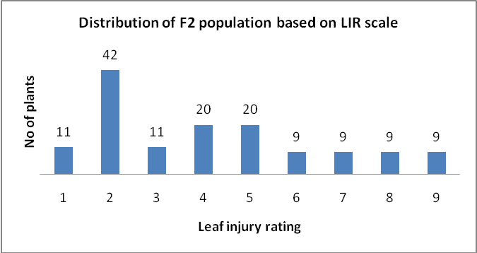

Figure 2: Distribution of F2 mapping population (140) based on phenotype the cross between HKI 1352 andWNZPBTL 2maize genotypes infested with C. partellus larvae.
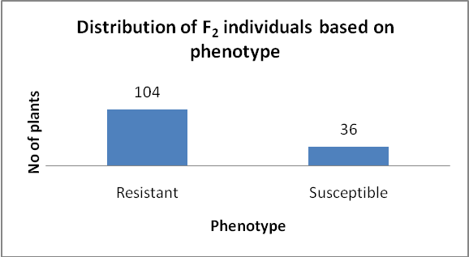

. 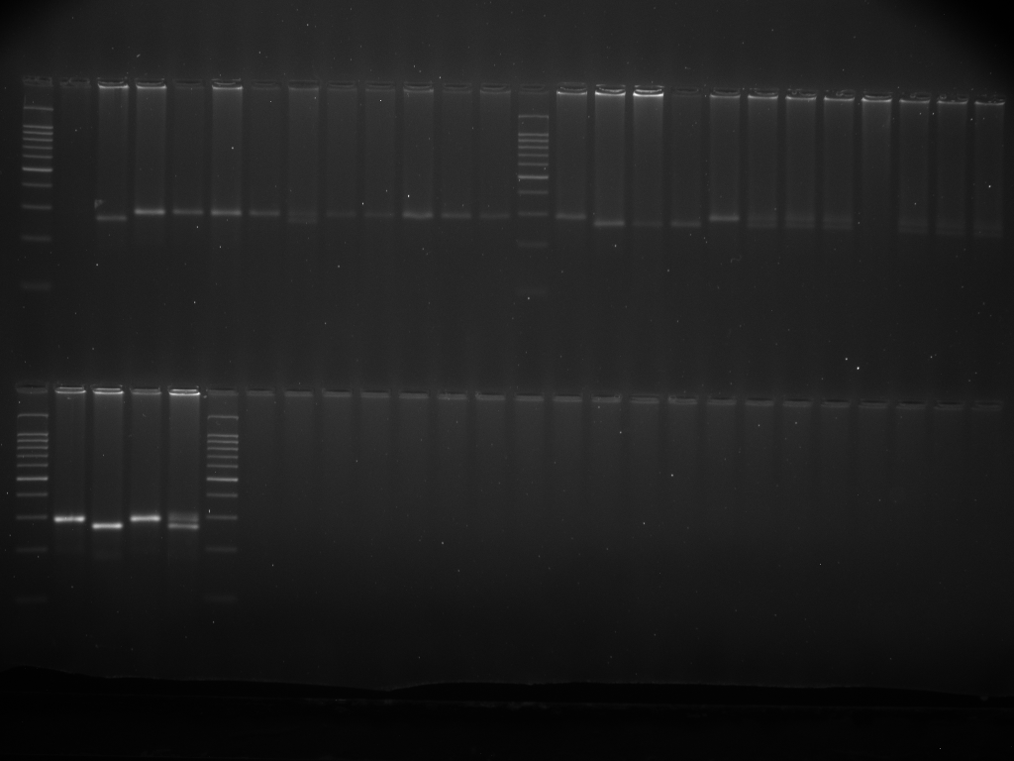
L SP RP SB RB L
Fig 3: PCR products generated by SSR primer bnlg 1057 with SP, RP, SB and RP respectively, during segregant analysis. SP- Susceptible parent, RP- Resistant parent, SB- Susceptible bulk and RB-Resistant bulk

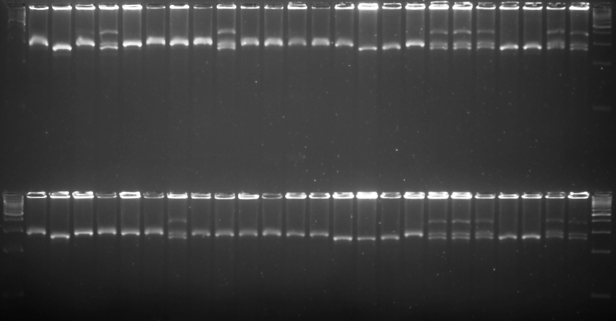
L SP RP SB RB S1 S2 S3 S4 S5 S6 S7 S8 S9 S10 R1 R2 R3 R4 R5 R6 R7 R8 R9 R10 L

Fig 4: PCR products generated by SSR primer bnlg 1057 with SP, RP, SB , RB ten susceptible and ten resistant individuals respectively, during segregant analysis. SP- Susceptible parent, RP- Resistant parent, SB- Susceptible bulk and RB-Resistant bulk, Ten Susceptible individuals (S1 to S10), ten resistant individuals (R1 to R10),L-100 bp Ladder

Table 4: List of polymorphic SSR markers between parents (HKI 1352 andWNZPBTL 2)
Sl.no | SSR marker | Bin location | Sequence
Sl.no | SSR marker | Bin location | Forward | Reverse
1 | umc2183 | 1.00 | TTAGAGCATGTGGCTCTTAGTCCC | TCTACTGCCAAGAAGAAATCCTGG
2 | umc1305 | 1.01 | TGCTGTGTGTTTGATGCTTTAGTTT | CAATTTGATGCTGGGATTCAGATA
3 | umc2185 | 1.02 | CTTCTTCTGCCACAGCACGAAC | CAAGGTTAAGAGCATGTACGCGAT
4 | umc1734 | 1.05 | TTGTGCATTTTGCAGAAACTAGGA | AGTACTTGTCGGTGGAGACTGGAG
5 | bnlg 1057 | 1.06 | TTCACCGCCTCACATGAC | GCAACGCTAGCTAGCTTTG
6 | bnlg1023 | 1.06 | CGGACGATTGAAAAGGAAAA | TTGCAAGGGTCATTCGTAGT
7 | umc1422 | 2.02 | GAGATAAGCTTCGCCCTGTACCTC | CTCATCGCGATCTCCCAGTC
8 | umc2252 | 2.05 | CACTGCACTGCAAGGTACATACG | GTCTTTGACCCCTTCCTCTTCTTG
9 | nc132 | 2.05 | TCATCTTGCTCTGATGCTCG | TGTGGGGGCACGTTAATTAC
10 | umc2101 | 3.01 | CCCGGCTAGAGCTATAAAGCAAGT | CTAGCTAGTTTGGTGCGTGGTGAT
11 | bnlg1022 | 3.05 | GTGTTGTCGATCCACTCCCT | GCAAAGATCTGTGAGGGGAC
12 | umc1690 | 3.07 | ACCTTAGTTACACAGGCACACGGT | GGTGATGGGATTTTCGCATTATTA
13 | Phi088 | 3.08 | GATTGCGATAAGCATTGCGGCAGTT | CTTCTGTTCCGCCATCCAGTATGT
14 | bnlg252 | 4.05 | CGTTCTCCGTACAGCACAGACCAACGT | CTCAGATGAACTCCTCAGCAGCTGTAGCCT
15 | bnlg1444 | 4.08 | AGACGACGAAGCTTTTGCAT | GCATGGATGGAGAAAGAGGA
16 | phi098 | 4.08 | GAGATCACCGGCTAGTTAGAGGA | GTATGGTTGGGTACCCGTCTTTCTA
17 | umc2036 | 5.01 | TCAATCAAGCCTCTCGTAAGGAAC | CTCTTGATCTCAACCGAAATCCTG
18 | phi396160 | 5.02 | GGAGCCTCCTCAACCCTT | GCTCGAGGTCCATGAGCA
19 | umc1587 | 5.02 | AGGTGCAGTTCATAGACTTCCTGG | ATGCGTCTTTCACAAAGCATTACA
20 | umc1192 | 5.04 | GATCGAACTGCAGAGGAACAAGAG | CGCTCCACATCCACATCTACAC
21 | phi087 | 5.06 | GAGAGGAGGTGTTGTTTGACACAC | ACAACCGGACAAGTCAGCAGATTG
22 | bnlg386 | 5.09 | CACCCTCCCTTTGCAGGTA | TGGTTTATCAGATAACGATTCAGC
23 | bnlg426 | 6.01 | TGCATTAATTAGAAGGCTATCAAA | GGTTTGGTGACTGGACTGACTT
24 | bnlg2243 | 6.01 | ATCTATCACGACGAACGGGA | ATCTCCCTAGCTCGCTCTCC
25 | umc1572 | 6.02 | CAAGGTGTCCTTGGTGTGTATCAG | AATCCTTCTCTGCGTCCTTTCTCT
26 | phi389203 | 6.03 | GACGAAAAGGTGGCTCGT | TGCAGTCCTAGATCAGTTCCAA
27 | umc1424 | 6.06 | CCGGCTGCAGGGGTAGTAGTAG | ATGGTCAGGGGCTACGAGGAG
28 | bnlg1759 | 6.07 | AGACGGAGTCCTCGTTTGC | ACCGGTTCGTACCACTCACT
29 | umc1986 | 7.02 | CTACTTACGAACGGAAACGCCC | ACGAGACGGTCGACAAGGAAG
30 | phi116 | 7.06 | GCATACGGCCATGGATGGGA | TCCCTGCCGGGACTCCTG
31 | umc1858 | 8.04 | GTTGTTCTCCTTGCTGACCAGTTT | ATCAGCAAATTAAAGCAAAGGCAG
32 | bnlg1714 | 9.04 | CATCATGGAGGCATATGTCG | ACACATTTAGACCCACCCCA
33 | umc1657 | 9.07 | ATGGATGAATATGATCCCACGG | GATCCGCACGTAGCTTTTCG
34 | bnlg619 | 9.07 | ACCCATCCCACTTTCCACCTCCTCCT | GCTTTCAGCGAATACTGAATAACGCGGA
35 | phi059 | 10.02 | AAGCTAATTAAGGCCGGTCATCCC | TCCGTGTACTCGGCGGACTC
36 | phi052 | 10.02 | CAGAATGGGACGACAAGGTCATC | GGGACACTTCTAGCAGGATCTGTTT
37 | umc1432 | 10.03 | GGCCATGATACAGCAAGAAATGAT | TACTAGATGATGACTGACCCAGCG

COMPETING INTERESTS DISCLAIMER:
Authors have declared that they have no known competing financial interests OR non-financial interests OR personal relationships that could have appeared to influence the work reported in this paper.
Disclaimer (Artificial intelligence)
Option 1:
Author(s) hereby declare that NO generative AI technologies such as Large Language Models (ChatGPT, COPILOT, etc.) and text-to-image generators have been used during the writing or editing of this manuscript.
Option 2:
Author(s) hereby declare that generative AI technologies such as Large Language Models, etc. have been used during the writing or editing of manuscripts. This explanation will include the name, version, model, and source of the generative AI technology and as well as all input prompts provided to the generative AI technology
Details of the AI usage are given below:
1.
2.
3.

References

Anil Cholla, Subhash Chander, Jaswinder Kaur, S. B. Suby and Pradyumn Kumar. 2018. Improved method of screening maize Germplasm for resistance aganst Chilo partellus (Swinhoe). Indian journal of genetics and plant breeding. 78(4): 454-459.
Anil Kumar Cholla, Pradyumn Kumar, Subhash Chander , Abhijit Kumar Das, Suby, S.B, Sunil Chandra Dubey and J.C .Sekhar. 2019. Identification of key damage parameters and plant morphological traits associated with Chilo partellus resistance in maize (Zea mays L.) Journal of Entomology and Zoology studies. 7 (2): 1300-1305.
Bohn, M., Khairallah, M.M. Jiang, C. González-de-León, D. Hoisington, D.A.Utz, H.F. Deutsch, J.A. Jewell, D.C. Mihm, J.A. andMelchinger, A.E. 1997. QTL mapping in tropical maize: II. Comparison of genomic regions for resistance to Diatraea spp. Crop Science. 37: 1892-1902.
Bohn, M., Schulz, B. , Kreps, R. Klein, D.andMelchinger, A.E. 2000. QTL mapping for resistance against the European corn borer (OstriniaNubilalisH.) in early maturing European dent germplasm.Theoretical and Applied Genetics.101: 907-917.
Cardinal, A.J., Lee, M. Sharopova, N. Woodman-Clikeman, W.L.and Long, M.J. 2001. Genetic mapping and analysis of quantitative trait loci for resistance to stalk tunneling by the European corn borer in maize. Crop Science. 41: 835-845.
Cartier, J.J. and Painter, R.H. 1956. Differential reaction of two biotypes of the corn leaf aphid to resistant and susceptible varieties, hybrids and selections of sorghum. Journal of Economic Entomology.49: 498-508.
Chatterji S.M., Young W.R., Sharma G.C., Sayi I.V., Chahai B.S., Khare B.P., RathoreY.S., PanwarV.P.S. andSiddiqui K.H. 1969. Estimation of loss in yield of maize due to insect pests with special reference to borers.Indian Journal of Entomology 31(2):109-115.
Drinic SM, Micic DI, Eric I, Andelkovic V, Jelova D, Konstantinov K (2004).Biotechnology in breeding.Genetika 36:93-109.
FAOSTAT, 2013. FAOSTAT Statistics Division: Agricultural data, Food and Agriculture Organization of the United Nations, Rome.
Girhotra, R. P. ,Saxena, V. K. andMalhi, N. S. 2005. Genetics of Resistance to Maize Stem Borer (Chilo portellus[Swinhoe]) in Maize. Proceedings of the Ninth Asian Regional Maize workshop. Pp 199-206. Beijing, China
Gupta, H.S, Babu, R. Agrawal, P.K. Mahajan, V. and Hossain, F. 2013: Accelerated development of quality protein maize hybrid through marker-assisted introgression of opaque-2 allele. Plant Breeding. 132:77–82.
Hagi, H. M. 1984. Gene affects for resistance to stem borer (Chilo partellus Swinhoe) in sorghum Sorghumbicolor (L.) (Moench).M.Sc. thesis, Andhra Pradesh Agricultural University, Hyderabad, Andhra Pradesh, India.
Jampatong, C., McMullen, M.D. Barry, B.D. Darrah, L.L. Byrne, P.F. andKross, H. 2002. Quantitative trait loci for first- and second-generation European corn borer resistance in the maize inbred Mo47. Crop Science. 42: 584-593.
Jiménez-Galindo JC, Ordás B, Butrón A, Samayoa FL, Malvar RA (2017). QTL Mapping for Yield and Resistance against Mediterranean Corn Borer in Maize. Front. Plant Sci. 8:698.
Khairallah, M.M., Bohn, M., Jiang, C. Deutsch, J.A. Jewell, D.C., Mihm, J.A.Melchinger, A.E. Gonzales-de-Leon, D.and Hoisington, D.A. 1998. Molecular mapping of QTLs for southwestern corn borer resistance, plant height, and flowering in tropical maize. Plant Breeding .117: 309-318.
Krakowsky, M.D., M. Lee and J.B. Holland. 2007. Genotypic correlation and multivariate QTL analyses for cell wall components and resistance to stalk tunnelling by the European corn borer in maize. Crop Science. 47: 485-490.
Mathur L.M.L. 1987. Bibliography of maize pests in India. New Delhi, India: AICRP, Indian Agricultural Research Institute.
Michelmore, R. W. Paran, I and. Kesseli, R. V .1991. Identification of markers linked to disease-resistance genes by bulked segregant analysis: A rapid method to detect markers in specific genomic regions by using segregating populations. Proceedings of the National Academy of Sciences. USA. 88: 9828-9832.
Pathak, R. S. and Olela, J. C. 1983. Genetics of host plant resistance in foods crops with special reference to sorghum stem borer. Insect Sci Appl4: 127 – 34.
Pechan, T.B., D. Jiang, L. Steckler, L .Ye, and L. Lin, 1999: Characterization of three distinct cDNA clones encoding cysteine proteinases from maize (Zea mays L.) callus. Plant Molecular Biology. 40:111-19
Prasanna BM, 2012. Diversity in global maize germplasm: characterization and utilization. J Biosci 37(5): 2843–855
Rana, B. S. and Murty, B. R. 1971.Genetic analysis of resistance to stem borer in sorghum.Indian journal of Genetics and Plant Breeding. 31: 521-529.
S. B. Suby, Sunil Kumar Jha, Chikkappa G. Karjagi, Pradyumn Kumar, Javaji Chandra Sekhar, Jaswinder Kaur, Anil Kumar Cholla, P. Lakshmi Soujanya, Rakesh Kumar Sharma & Sujay Rakshit. 2020. Penetration resistance of second above ground internode in V6–10 stage maize plants confer resistance to stalk boring larvae of Chilo partellus (Swinhoe) in maize. Phytoparasitica 48 :455–469
SagahiMaroof, M., Soliman, K., Jorgenesis, R. and Allard, R. 1984. Ribosomal DNA spacer length polymorphisms in barley: Mendalian inheritance, chromosome location and population dynamics, Proceeding of National Academy of Sciences .81: 8018.
Saraswati Neupane, Subash Subedi, Ramesh Kumar Shrestha and Sunita Pandey. 2022. Damage and yield loss estimate in maize varieties owing to stem borer (Chilo partellus Swinhoe) infestation and insecticidal control. Journal of Agriculture and Natural Resources 5(1): 1-11
Sarup.P. (1983) Standardization of techniques for scoring of lines against the stalk borers of maize.In Techniques of scoring for resistance to the major insectpe.st.s of maize.cd. Joginder Singh, pp.64-72. All India Coordinated Maize Improvement Project. IARI.New Delhi.
Satish, K., Srinivas, G., Madhusudhana, R., Padmaja, P. G., Nagaraja Reddy, R., Murali Mohan, and S. Seetharama, N. 2009. Identification of quantitative trait loci for resistance to shoot fly in sorghum [Sorghum bicolor (L.)Moench].Theoretical and Applied Genetics .119.1425-1439
Schon, C.C., Lee, M., Melchinger, A.E. Guthrie, W.D. and Woodman, W.L. 1993. Mapping and characterization of quantitative trait loci affecting resistance against second-generation European corn borer in maize with the aid of RFLPs. Heredity, 70: 648-659.
Selvi.A, Shanmugasundaram, P, Mohan, Mohan Kumar, S. and Raja, J.A.J. 2002. Molecular markers for yellow stem borer Scirpophagaincertulas (Walker) resistance in rice. Euphytica.124: 371-377.
Sherakhane M, Parashivamurthy, H. C. L, G. S. SK, Gowda B, R. S, G. K. Genetic Purity Assessment of Maize Hybrid (Zea mays L.) and Its Parental Lines Employing SSR Markers. J. Adv. Biol. Biotechnol. [Internet]. 2025 Feb. 27 [cited 2025 Jul. 7];28(2):779-85. Available from: https://journaljabb.com/index.php/JABB/article/view/2038
www.maizegdb.org
Yadav O P, Hossain F, Karjagi C G, Kumar B, Zaidi P H, Jat S L, Chawla J S, Kaul J, Hooda K S, Kumar P, Yadava P and Dhillon B S. 2015. Genetic improvement of maize in India – retrospect and prospects.Agricultural Research 4: 325–38.
Yueyingli.,Lijun Chen, Feng Lin, Khalid Hussain and Jianquizou. 2010. Identification of SSR markers linked to resistance against the spotted stem borer in sorghum. Middle East Journal of Scientific Research.6 (5): 505-511.

