Original Research Article
Phytotoxic Effects of Neem Oil Nanoemulsion on Maize (Zea mays L.) Seed Germination and Seedling Vigour

ABSTRACT
Aim: This study aimed to develop a stable, eco-friendly antifungal seed treatment using neem oil nanoemulsion (NON) enhanced with green-synthesised silver nanoparticles (AgNPs) derived from Terminalia cattapa leaf extract. The NON was characterised by a mean particle size of 44.58 nm and a polydispersity index (PDI) of 0.945, indicating high stability.
Study Design: Experimental Laboratory Study
Place and duration of study: Department of Crop Protection, Faculty of Agriculture, University of Abuja, and Centre for Genetic Engineering and Biotechnology, Federal University of Technology, Minna. Nigeria, between September and November 2024.
Methodology: Neem oil nanoemulsion (NON) achieved 100% fungal growth inhibition at all tested concentrations (600–1000 mg/mL), with identical inhibition zones (34.00 ± 0.50 mm; p > 0.05), suggesting a saturation effect at the lowest tested dose. Low concentrations (6.25–25 mg/mL) significantly enhanced germination (94.4–100%; p < 0.05) and vigour index (0.52–0.60), while higher concentrations (50–100 mg/mL) suppressed germination (≤77.8%) and induced phytotoxicity. Antioxidant assays showed superior radical scavenging activity (DPPH: 80.12%; FRAP: 86.59%) compared to raw neem oil.
Result: Agar well diffusion assays demonstrated complete fungal growth inhibition (100%) across concentrations of 600–1000 mg/mL, with consistent inhibition zones (34.00 ± 0.50 mm). Phytotoxicity assessments revealed that low NON doses (Ne6.25–Ne25 mg/mL) enhanced germination (94.4–100%) and seedling vigour, while higher doses (Ne50–Ne100 mg/mL) suppressed growth and reduced germination (≤77.8%). Antioxidant assays demonstrated superior radical scavenging activity (DPPH: 80.12%; FRAP: 86.59%) compared to raw neem oil.
Conclusion: NON is a promising sustainable alternative to synthetic fungicides, with dual benefits of pathogen suppression and growth stimulation at low doses. However, precise dose calibration is essential to avoid phytotoxic effects. Field validation, long-term stability testing, and environmental safety assessments are recommended.
Keywords: Neem oil nanoemulsion; seed-borne fungi; phytotoxicity; green synthesis
Introduction
Maize (Zea mays L.) is a critical staple crop globally, but its productivity and nutritional security are severely threatened by seed-borne fungal pathogens such as Aspergillus flavus, Aspergillus parasiticus, and Fusarium graminearum (Anjorin et al., 2022). These fungi not only reduce seed viability and seedling vigour but also produce mycotoxins, including aflatoxins, which pose significant health risks to humans and livestock (Loy and Lundy, 2019). Contaminated maize grains contribute to economic losses and food insecurity, particularly in regions like sub-Saharan Africa, where smallholder farmers rely heavily on untreated seeds (Onumah et al., 2021). Traditional management strategies, such as synthetic fungicides, face challenges like environmental toxicity, resistance development, and high costs, necessitating sustainable alternatives (Titus et al., 2020).
Neem (Azadirachta indica) oil, a natural biopesticide, has gained attention for its broad-spectrum antifungal properties. Rich in bioactive compounds like azadirachtin, it disrupts fungal cell membranes and inhibits spore germination (Rodrigues et al., 2019). However, its practical application is limited by inherent drawbacks, including volatility, poor water solubility, and rapid degradation under field conditions (Campos et al., 2016). These limitations reduce its efficacy and necessitate frequent reapplication, undermining its viability as a standalone solution for seed treatment.
Nanoemulsion technology offers a promising avenue to overcome these challenges. By encapsulating neem oil within nanoscale droplets stabilised by surfactants, nanoemulsions enhance physicochemical stability, bioavailability, and targeted delivery of active compounds (São Pedro et al., 2013). Silver nanoparticles (AgNPs), synthesised through green methods using plant extracts like Terminalia cattapa, further improve antifungal activity by increasing surface area and reactivity (Singh et al., 2024). Studies demonstrate that Nanoformulations of essential oils exhibit prolonged activity against fungal pathogens while reducing phytotoxicity risks compared to raw extracts (Zhao et al., 2017). However, the dual role of nanoparticles, enhancing antifungal properties at low concentrations while inducing oxidative stress at high doses, remains underexplored in seed treatment applications (Michałek et al., 2018).
Despite the growing interest in nanoemulsions, limited research has focused on the phytotoxic effects of neem oil nanoemulsion (NON) on seed germination and early seedling development. While low concentrations of AgNPs are reported to stimulate plant growth, higher doses can impair cellular processes, leading to reduced germination rates and stunted growth (Szőllősi et al., 2020). This knowledge gap is critical, as optimising the balance between antifungal efficacy and phytotoxicity is essential for developing safe, effective seed treatments.
This study aimed to evaluate the antifungal activity of NON against key maize seed-borne fungi and assess its dose-dependent effects on seed germination and seedling vigour. By synthesising NON through green methods and characterising its physicochemical properties, we investigated its potential as a sustainable alternative to synthetic fungicides. The findings provide insights into the safe application of nanoemulsions in agriculture, addressing both food security and environmental sustainability challenges.
2. MATERIALS AND METHODS
2.1 Synthesis and Characterisation of Neem Oil Nanoemulsion (NON)
The study was carried out at the Centre for Genetic Engineering and Biotechnology, Federal University of Technology, Bosso Campus, Minna, Niger State, and the Department of Crop Protection, Faculty of Agriculture, University of Abuja, Nigeria.
The neem oil nanoemulsion (NON) was synthesised using a green approach. Silver nanoparticles (AgNPs) were first prepared by reducing silver nitrate (AgNO₃) with an aqueous extract of Terminalia cattapa leaves. Fresh leaves were washed, destalked, and boiled in distilled water (20 g leaves in 200 mL) at 60°C for 30 minutes. The filtered extract was mixed with 0.1 M AgNO₃ (1:1 ratio), and sodium hydroxide (NaOH, 1 M) was added to adjust the pH to 10. The mixture was incubated under sunlight for 30 minutes to stimulate reduction, resulting in a dark-brown AgNP suspension (Asif et al., 2022).
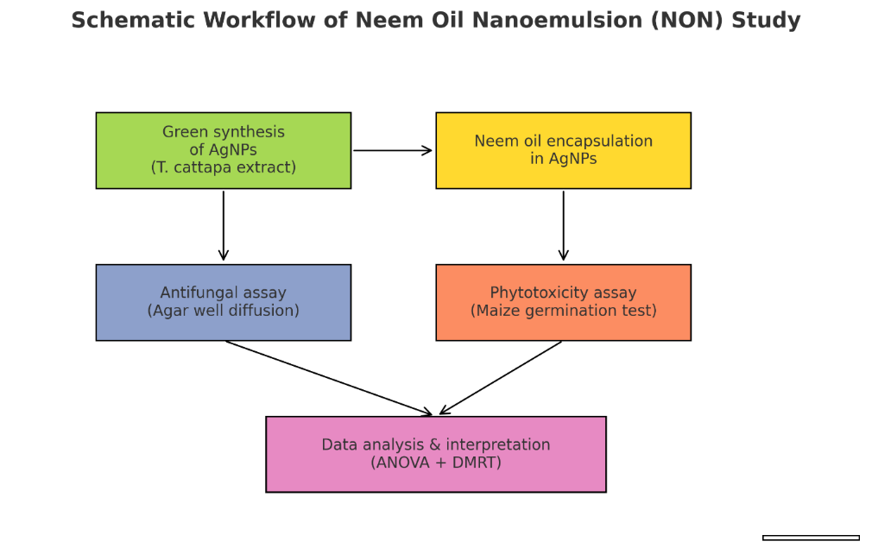
Neem seed oil was encapsulated into AgNPs by titrating 20 mL of oil into 20 mL of AgNP solution, followed by adding 2 mL of TWEEN-80 as an emulsifier. The mixture was stirred magnetically for 2 hours to form a stable nanoemulsion. The NON was characterised using UV-visible spectroscopy (Shimadzu 1800-series), which confirmed a peak absorbance at 419 nm, indicative of AgNP formation (Singh et al., 2024). Dynamic light scattering (Malvern Zetasizer Nano ZS) revealed an average particle size of 44.58 nm and a polydispersity index (PDI) of 0.945, confirming homogeneity.

Image 1. Schematic workflow showing the synthesis of neem oil nanoemulsion (NON) and the experimental assays performed
2.2 Antifungal Activity Assay
The antifungal efficacy of NON was evaluated against A. flavus, A. parasiticus, and Fusarium graminearum using the agar well diffusion method. Potato Dextrose Agar (PDA) was prepared (19.5 g in 500 mL distilled water), sterilised (121°C, 15 psi, 15 minutes), and poured into Petri dishes. Fungal cultures were inoculated on PDA plates, and wells (8 mm diameter) were punched into the agar. Neem oil Nanoemulsion (NON) was tested at concentrations of 600, 800, and 1000 mg/mL, with 20 µL aliquots loaded into each well. Plates were incubated at 37°C for 72 hours, and zones of inhibition (ZOI) were measured (Bauer et al., 1966).
2.3 Phytotoxicity Tests
Maize seeds were surface-sterilised with 1% sodium hypochlorite and rinsed with distilled water. For germination assays, seeds were soaked in NON at concentrations of 6.25 (Ne6.25), 12.5 (Ne12.5), 25 (Ne25), 50 (Ne50), and 100 (Ne100) mg/mL for 30 minutes. Controls included seeds treated with distilled water and raw neem oil. Treated seeds were placed on moist filter paper in sterilised Petri dishes (10 seeds per dish, three replicates per treatment) and incubated at 25°C.
Germination parameters were recorded daily for 7 days using the following formula:
Germination percentage: $GP= \frac{Number of germinated seeds}{Total seeds}$ x 100
Germination rate: $GR= \frac{Number of germinated seeds}{Days}$
Mean germination time: $MGT= \frac{∑(Number of germinated seeds×Days)}{Total germinated seeds}$
Seedling vigour was assessed at 7 days after sowing (DAS):
Radicle and plumule lengths were measured using a digital calliper. Seedling dry weight (SDW) was obtained by oven-drying at 70°C for 48 hours. The SVI formula computed the seedling vigour index,
Where SVI=Germination percentage (GP) × Seedling dry weight (SDW)
(Abdul-Baki and Anderson, 1973).

2.4 Statistical Analysis
Data were analysed using SPSS version 20. One-way ANOVA followed by Duncan’s Multiple Range Test (DMRT) at p<0.05 determined significant differences between treatments. Results are presented as mean ± standard deviation of three replicates.
3. RESULTS AND DISCUSSION
3.1 Antifungal Activity of Neem Oil Nanoemulsion
The neem oil nanoemulsion (NON) exhibited potent antifungal activity against A. flavus, A. parasiticus, and Fusarium graminearum at all tested concentrations (600–1000 mg/mL). The agar well diffusion assay revealed a consistent zone of inhibition (ZOI) of 34.00 ± 0.50 mm for all three fungi, with no significant differences (p>0.05) between concentrations (Table 1). Complete mycelial growth inhibition was observed at 3 days after inoculation (DAI), confirming NON’s efficacy as a broad-spectrum antifungal agent (Plates 1, 2, 3, 4).
The neem oil nanoemulsion (NON) demonstrated exceptional antifungal efficacy, achieving 100% inhibition of A. flavus, A. parasiticus, and Fusarium graminearum at all tested concentrations (600–1000 mg/mL). This potent activity can be attributed to the synergistic effects of neem oil’s bioactive compounds (e.g., azadirachtin) and the enhanced bioavailability conferred by silver nanoparticles (AgNPs). The encapsulation of neem oil within AgNPs likely increased its stability and penetration into fungal cell membranes, disrupting ergosterol synthesis and mitochondrial function (Al-Othman et al., 2014; Zhao et al., 2017). These findings align with studies on nanoformulated essential oils, where smaller particle sizes improved interaction with microbial targets, leading to rapid mycelial inhibition (São Pedro et al., 2013; Li et al., 2015). Notably, the consistent zone of inhibition (34 mm) across concentrations suggests that even minimal doses of NON are sufficient for fungal control, reducing the risk of over application in agricultural settings. The identical inhibition zones across 600–1000 mg/mL NON indicate that maximum antifungal efficacy is achieved at the lowest tested concentration, likely due to a saturation effect in fungal membrane disruption. Similar findings were reported by Costa et al. (2021) and Singh et al. (2024), where nanoencapsulated plant oils exhibited maximum inhibitory potential at threshold doses. Mechanistic studies (Ju et al., 2022) have shown that neem oil combined with AgNPs inhibits ergosterol biosynthesis, compromises cell membrane integrity, and increases intracellular reactive oxygen species (ROS), collectively leading to fungal death. Silver nanoparticles can disrupt fungal cell membrane integrity and induce ROS production, thereby enhancing antifungal activity, while ergosterol biosynthesis pathways remain critical targets for antifungal intervention (Bortolini et al., 2024; Tortella et al., 2024).

Table 1
Antifungal Activity of Neem Oil Nanoemulsion against Seed-Borne Fungi
Fungal Species | Concentration (mg/mL) | Zone of Inhibition (mm, Mean ± SD)
Aspergillus flavus | 600 | 34.00 ± 0.50ᵃ
 | 800 | 34.00 ± 0.00ᵃ
 | 1000 | 34.00 ± 0.00ᵃ
Aspergillus parasiticus | 600 | 34.00 ± 0.50ᵃ
 | 800 | 34.00 ± 0.50ᵃ
 | 1000 | 34.00 ± 0.00ᵃ
Fusarium graminearum | 600 | 34.00 ± 0.75ᵃ
 | 800 | 34.00 ± 0.00ᵃ
 | 1000 | 34.00 ± 0.50ᵃ
Note. Means with the same superscript (ᵃ) within columns are not significantly different (p>0.05) by Duncan’s test.

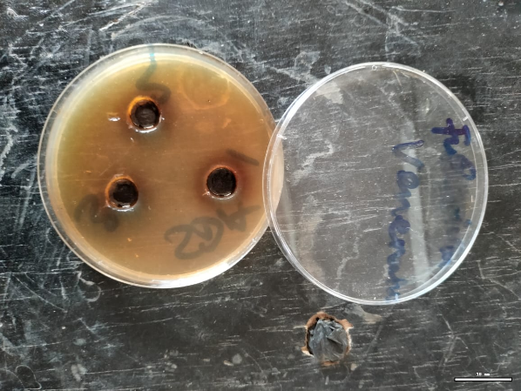 | 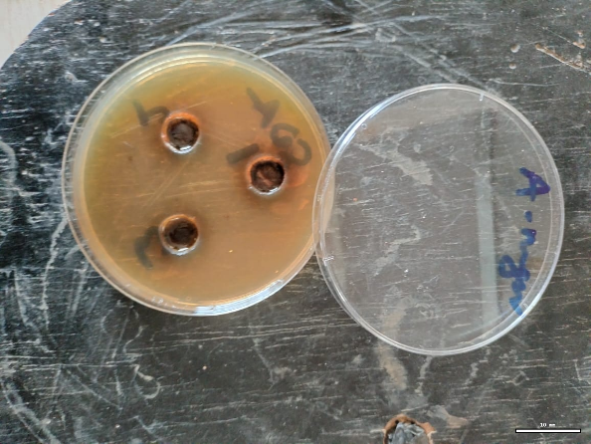
Plate 1. Fusarium graminearum + neem seed oil nano emulsion | Plate 2. A. niger + neem seed oil nanoemulsion

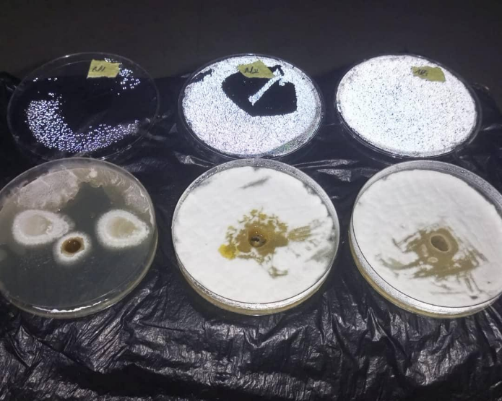 | 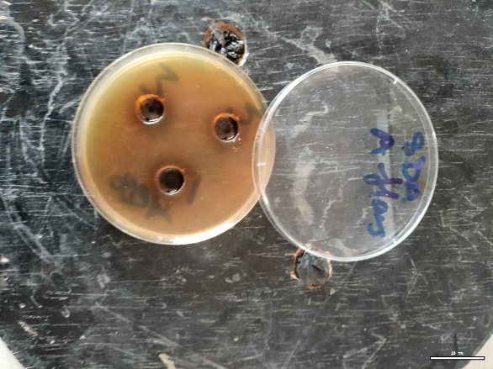
Plate 3: Mycelium growth of A. flavus of mycelium treated with neem seed oil at 3DAI | Plate 4: Total inhibition of neem seed oil nanoemulsion on the growth of A. flavus mycelium at 3DAI
Plates showing the antifungal effect of neem oil nanoemulsion (NON) against A. flavus, A. parasiticus, and Fusarium graminearum at 3 days after inoculation (DAI). Complete inhibition of mycelial growth (no visible hyphae) is observed around wells treated with NON (600–1000 mg/mL), while untreated controls exhibit dense fungal colonisation.

3.2 Phytotoxic Effects on Seed Germination and Seedling Vigour
The phytotoxicity of NON was concentration-dependent (Table 2). At low concentrations (Ne6.25–Ne25 mg/mL), germination percentages (83.3–100%) and seedling vigour indices (0.52–0.60) were significantly higher (p<0.05) than the control (77.8% germination, vigour index = 0.21). In contrast, Ne100 mg/mL caused severe phytotoxicity, reducing germination to 16.7% and stunting radicle/plumule growth (Plate 9; Figure 2). The phytotoxic effects of NON exhibited a clear dose-dependent trend. At low concentrations (Ne6.25–Ne25 mg/mL), germination rates (83.3–100%) and seedling vigour indices (0.52–0.60) surpassed those of the control, indicating a stimulatory role. From a practical standpoint, NON at 6.25–25 mg/mL emerges as a promising seed treatment for maize, offering dual benefits of pathogen suppression and vigour enhancement. Its antioxidant properties, evidenced by superior DPPH (80.12%) and FRAP (86.59%) activities compared to raw neem oil, further support its role in mitigating abiotic stress during early seedling development (Rinaldi et al., 2017). The observed biphasic effect stimulation at low doses and inhibition at high doses is consistent with hormesis in nanoparticle–plant interactions (Szőllősi et al., 2020). Low NON concentrations may promote nutrient uptake and antioxidant defence, while excessive AgNP accumulation at higher doses induces oxidative stress, membrane damage, and impaired cell division.

Table 2
Germination Parameters and Seedling Vigour of Maize Seeds Treated with NON
Treatment (mg/mL) | Germination (%) | Germination Rate | Mean Germination Time (Days) | Seedling Vigour Index
Ne6.25 | 94.4 ± 2.9ᵇ | 1.89 ± 0.12ᵇ | 2.00 ± 0.00ᵃ | 0.52 ± 0.03ᵇ
Ne12.5 | 83.3 ± 3.3ᵇ | 1.67 ± 0.15ᵇ | 2.08 ± 0.12ᵃ | 0.37 ± 0.02ᶜ
Ne25 | 100.0 ± 0.0ᵃ | 2.00 ± 0.00ᵃ | 2.00 ± 0.00ᵃ | 0.60 ± 0.04ᵃ
Ne50 | 77.8 ± 4.4ᶜ | 1.56 ± 0.10ᶜ | 2.35 ± 0.09ᵇ | 0.31 ± 0.02ᶜ
Ne100 | 16.7 ± 2.9ᵈ | 0.22 ± 0.03ᵈ | 2.67 ± 0.15ᵇ | 0.03 ± 0.01ᵈ
Control | 77.8 ± 3.3ᶜ | 1.55 ± 0.08ᶜ | 2.00 ± 0.00ᵃ | 0.21 ± 0.01ᵈ
Note. Values are mean ± SD (n=3). Means with different superscripts (ᵃ, ᵇ, ᶜ, ᵈ) within columns differ significantly (p<0.05) by Duncan’s test.

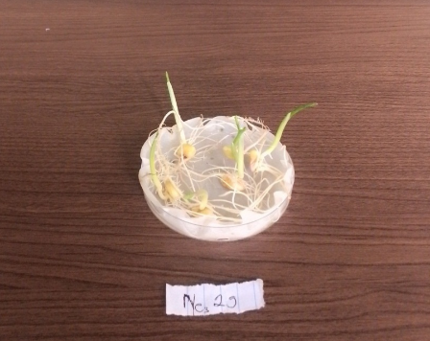 | 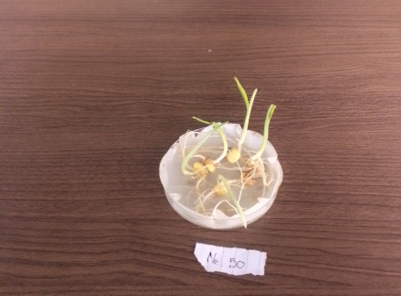
Plate 5: Germination of maize seeds treated with Ne25 at 7DAS. | Plate 6: Germination of maize seeds treated with Ne50 at 7DAS.
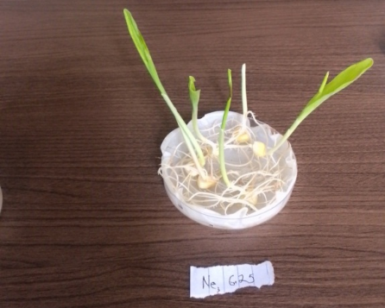 | 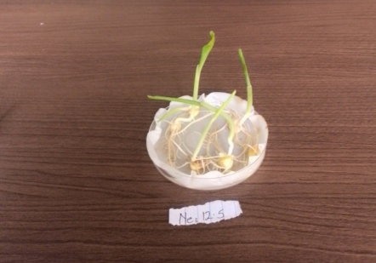
Plate 7: Germination of maize seeds treated with Ne6.25 at 7DAS. | Plate 8: Germination of maize seeds treated with Ne12.5 at 7DAS.
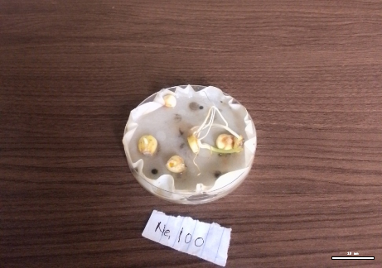 | 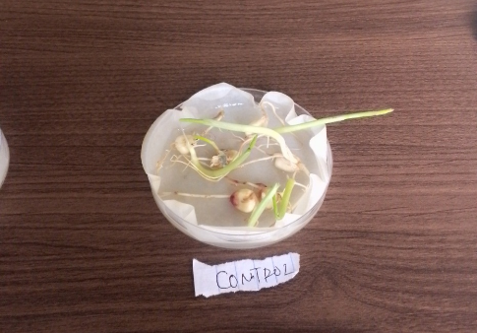
Plate 9: Germination of maize seed treated with Ne100 at 7DAS | Plate 10: Germination of maize seeds with no treatment (Control) at 7DAS.
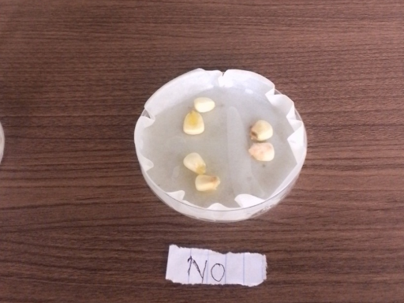 | Plate 11: Maize seeds treated with raw neem seed oil at 7DAS

Comparative visualisation of maize seed germination at 7 days after sowing (DAS). Seeds treated with Ne25 and Ne6.25 mg/mL NON demonstrate strong germination (100% and 94.4%, respectively) with healthy radicle emergence, whereas Ne100-treated seeds exhibit limited germination (16.7%) and necrotic symptoms.

3.2.1 Radicle and Plumule Growth
Radicle and plumule elongation were significantly enhanced at low NON concentrations (Ne6.25–Ne25 mg/mL) but inhibited at higher doses (Ne50–Ne100 mg/mL). At 7 days after sowing (DAS), Ne25-treated seedlings exhibited the longest radicles (14.24 ± 0.72 cm) and plumules (7.44 ± 0.38 cm), while Ne100 caused complete growth arrest (Table 3, Plate 9). . This enhancement may stem from the nanoemulsion’s ability to deliver nutrients and antioxidants directly to seeds, mitigating oxidative stress during germination (Surendhiran et al., 2019). Conversely, higher doses (Ne50–Ne100 mg/mL) significantly suppressed germination (16.7–77.8%) and stunted radicle/plumule growth, likely due to nanoparticle-induced oxidative damage or membrane disruption (Szőllősi et al., 2020). Similar biphasic responses have been reported for AgNPs, where low concentrations promote root elongation via hormesis, while high doses trigger reactive oxygen species (ROS) accumulation (Michałek et al., 2018).
Table 3
Radicle and Plumule Lengths of Maize Seedlings Treated with NON
Treatment (mg/mL) | Radicle Length (cm) | Plumule Length (cm)
Ne6.25 | 14.72 ± 0.65ᵃ | 7.78 ± 0.30ᵃ
Ne12.5 | 12.21 ± 0.54ᵇ | 8.79 ± 0.42ᵃ
Ne25 | 14.24 ± 0.72ᵃ | 7.44 ± 0.38ᵃ
Ne50 | 8.47 ± 0.33ᶜ | 6.14 ± 0.25ᵇ
Ne100 | 3.63 ± 0.18ᵈ | 2.53 ± 0.12ᶜ
Control | 5.59 ± 0.24ᶜ | 5.37 ± 0.22ᵇ
Note. Values are mean ± SD (n=3). Means with different superscripts (ᵃ, ᵇ, ᶜ, ᵈ) within columns differ significantly (p<0.05).

Figure 1. Radicle elongation in seedlings treated with NON.

Figure 2. Plumule elongation in seedlings treated with NON
Bar graphs illustrating the dose-dependent effects of NON on radicle and plumule lengths. Low concentrations (Ne6.25–Ne25 mg/mL) significantly enhance elongation compared to the control, while Ne100 mg/mL causes severe growth inhibition. Error bars represent standard deviation (n=3).
3.3 Antioxidant Activity of NON
The DPPH and FRAP assays demonstrated that NON possessed significantly higher (p<0.05) antioxidant activity compared to raw neem oil. At 100 µg/mL, NON scavenged 80.12 ± 0.45% of DPPH radicals and exhibited a FRAP value of 86.59 ± 0.31%, whereas raw neem oil showed 48.34 ± 0.28% and 56.96 ± 0.22%, respectively (Table 4).
Table 4
Antioxidant Activity of NON and Raw Neem Oil
Sample | DPPH Scavenging (%) | FRAP Activity (%)
NON (100 µg/mL) | 80.12 ± 0.45ᵃ | 86.59 ± 0.31ᵃ
Raw Neem Oil (100 µg/mL) | 48.34 ± 0.28ᵇ | 56.96 ± 0.22ᵇ
Ascorbic Acid (Control) | 89.32 ± 0.30ᵃ | 93.20 ± 0.61ᵃ
Note. Values are mean ± SD (n=3). Means with different superscripts (ᵃ, ᵇ) within columns differ significantly (p<0.05).

5. CONCLUSION
The neem oil nanoemulsion (NON) synthesised in this study demonstrated remarkable potential as a sustainable alternative to synthetic fungicides for maize seed protection. At low concentrations (6.25–25 mg/mL), NON effectively suppressed seed-borne fungal pathogens (A. flavus, A. parasiticus, and Fusarium graminearum) while enhancing seed germination (83.3–100%) and seedling vigour (vig]l[ur index = 0.52–0.60). The antifungal activity, attributed to the synergistic effects of neem oil’s bioactive compounds and the enhanced bioavailability of silver nanoparticles (AgNPs), aligns with recent advancements in nanoformulated essential oils (Zhao et al., 2017; Singh et al., 2024). However, high concentrations (50–100 mg/mL) induced phytotoxicity, reducing germination to 16.7% and stunting radicle/plumule growth, likely due to nanoparticle-induced oxidative stress (Szőllősi et al., 2020). These findings underscore the importance of optimising NON dosage to balance pathogen control and crop safety.
In conclusion, NON represents a sustainable alternative to synthetic fungicides, but its application requires precise dose calibration (25- 6.25mg/ml). Beyond laboratory validation, field trials across diverse agroecological zones are essential to confirm efficacy under real farming conditions. Long-term stability studies should investigate the residual activity of NON and its environmental interactions, including possible accumulation of AgNPs in soil. By addressing scalability, stability, and environmental safety, NON could contribute to global food security goals while reducing reliance on synthetic agrochemicals.

9. CONSENT
All authors have read and approved the final manuscript and consent to its publication in this journal.
10. ETHICAL APPROVAL
This study adhered to ethical guidelines for plant-based research. No human or animal subjects were involved. Conflicts of interest are declared as none.
Disclaimer (Artificial Intelligence)
Author(s) hereby declare that generative AI technologies such as Large Language Models have been used during the writing and editing of this manuscript.
Details of the AI usage are given below:

- Refining language, structure, and clarity to enhance scholarly readability.
- Generating schematic diagrams to summarise the experimental workflow for improved visual communication.
Name, version, model, and source of the generative AI technology:
Name: ChatGPT
Version: GPT-5
Source: OpenAI (https://openai.com)
Prompts included requests for:
- Rewriting abstract, discussion, and conclusion to be more clearer with academic tone.
- Requests to create a schematic diagram illustrating neem oil nanoemulsion synthesis and experimental design.

REFERENCES
Abdul-Baki, A.A., Anderson, J.D. (1973). Vigour determination in soybean seed by multiple criteria. Crop Science, 13, 630–633.
Al-Othman M.R., Abd El-Aziz A.R.M., Mahmoud M.A., Eifan S.A., El-Shikh M.S. and Majrashi M. (2014). Application of silver nanoparticles as antifungal and antiaflatoxin B1 produced by Aspergillus flavus, Dig. J. Nanomater. Biostruct. 9 (1) 151e157. http:// www.chalcogen.ro/151.
Anjorin, T.S., Adeleke, D.B., Olowo, J.O., Bello, F.O., Akande, A. (2022). Effects of humus, Albit®, garlic, and wood ash extracts on the growth of Aspergillus flavus and seed vigour of maize (Zea mays L). African Journal of Agriculture and Allied Sciences, 2(1), 43–58.
Asif, M., Yasmin, R., Asif, R., Ambreen, A., Mustafa, M., Umbreen, S. (2022). Green synthesis of silver nanoparticles (AgNPs), structural characterisation, and their antibacterial potential. Dose-Response, 20(1), 15593258221088709.
Bauer, A.W., Kirby, M.M., Sherris, J.C., Turck, M.D. (1966). Antibiotic susceptibility testing by a standardised single disk method. American Journal of Clinical Pathology, 45(4), 493–496.
Bortolini, C., Pham, C.D., Jordan, M.R., Revankar, S.G. (2024). Ergosterol biosynthesis and regulation impact the antifungal resistance and virulence of Candida spp. International Journal of Molecular Sciences, 4(4), 41.
Campos, E.V.R., Oliveira, J.L., Pascoli, M., Lima, R., Fraceto, L.F. (2016). Neem oil and crop protection: From now to the future. Frontiers in Plant Science, 7, 1494.
Costa, E. N., Forim, M. R., Costa, E. S., Nogueira, L., de Moraes, R. F. O., & Boica Junior, A. L. (2021). Lignin-based compounds for the microencapsulation of neem extract for the control of Diabrotica speciosa larvae on maize roots. Phytoparasitica, 49(5), 959–970. https://doi.org/10.1007/s12600-021-00915-x
Ju, J., Guo, Y., Cheng, Y., & Yaoc, W. (2022). Analysis of the synergistic antifungal mechanism of small molecular combinations of essential oils at the molecular level. Industrial Crops and Products, 188, 115612. https://doi.org/10.1016/j.indcrop.2022.115612.
Li, H. B., Shen, Q. S., Zhou, W., Xu, L. C., Zhang, Y. Y., & Shen, J. Z. (2015). Nanocapsular dispersion of cinnamaldehyde for enhanced inhibitory activity against aflatoxin production. Molecules, 20(4), 6022–6032.
Loy, D.D., Lundy, E.L. (2019). Nutritional properties and feeding value of corn and its coproducts. In: Serna-Saldivar, S.O. (Ed.), Corn (Third Edition). AACC International Press.
Michałek, S., Świeciło, A., Molas, J.E. (2018). Effect of silver nanoparticles and ions on seeds’ epiphytic microorganisms activity and early stages of sweetcorn development. Przemysław Chemiczny, 97, 1654–1658.
Onumah, G., Dhamankar, M., Ponsioen, T., Bello, M. (2021). Maize value chain analysis in Nigeria. European Union Report.
Rinaldi F., Hanieh PN., Longhi C., Carradori S., Secci D., Zengin G., Ammendolia M.G., Mattia E., Del Favero E., Marianecci C. and Carafa M. (2017). Neem oil nanoemulsions: characterization and antioxidant activity. J Enzyme Inhib Med Chem. 2017 Dec;32(1):1265-1273. doi: 10.1080/14756366.2017.1378190. PMID: 28965424; PMCID: PMC6009939.
Rodrigues MP, Astoreca AL, Oliveira ÁA, Salvato LA, Biscoto GL, Keller LAM, Rosa CADR, Cavaglieri LR, Azevedo MI, Keller KM.(2019) In Vitro Activity of Neem (Azadirachta indica) Oil on Growth and Ochratoxin A Production by Aspergillus carbonarius Isolates. Toxins (Basel). 2019 Oct 5;11(10):579. doi: 10.3390/toxins11100579. PMID: 31590398; PMCID: PMC6833479.
São Pedro, A., Espirito Santo, C., Silva, C.V., Detoni, C., Albuquerque, E. (2013). The use of nanotechnology as an approach for essential oil-based formulations with antimicrobial activity.
Singh J., Kumar A., Nayal A., Vikal S., Shukla G., Singh A., Singh A., Goswami S., Kumar D., Gautam Y.K., Verma Y., Gaurav S. and Pratap D (2024). Comprehensive antifungal investigation of green synthesized silver nanoformulation against four agriculturally significant fungi and its cytotoxic applications. Sci Rep 14, 5934 https://doi.org/10.1038/s41598-024-56619-9
Szőllősi, R., Molnár, Á., Kondak, S., Kolbert, Z. (2020). Dual effect of nanomaterials on germination and seedling growth: Stimulation vs. phytotoxicity. Plants, 9(12), 1745.
Titus, E.O., Anjorin, T.S., Asala, S.W. (2020). Effect of Psorospermum guineense stem bark and leaf extracts on germination, seedling vigour, and seed-borne fungi associated with maize. Journal of Applied Agricultural Research, 8(1), 100–111.
Tortella, G., Rubilar, O., Pieretti, J.C., Fincheira, P., Fernández-Baldo, M.A., Seabra, A.B. (2024). Advances in silver nanoparticles: a comprehensive review on their potential as antimicrobial agents and their mechanisms of action elucidated by proteomics. Frontiers in Microbiology, 15, 1440065.
Zhao, X., Cui, H., Wang, Y., Sun, C., Cui, B., Zeng, Z. (2017). Development strategies and prospects of nano-based smart pesticide formulation. Journal of Agricultural and Food Chemistry, 66, 6504–6512.

