Case report
Kikuchi-Fujimoto disease revealing lupus nephritis: a case report in sub-Saharan Africa

Abstract
Introduction: Kikuchi-Fujimoto disease is a rare and benign condition. It most frequently affects young women. It manifests as predominantly cervical lymphadenopathy. Its diagnosis relies on lymph node histology, which reveals acidophilic necrosis, CD68+ histiocyte infiltration, the presence of plasmacytoid monocytes, numerous apoptotic cells (CD8+ T lymphocytes) with nuclear debris, an immunoblastic reaction, and the absence of neutrophils or eosinophils. Spontaneous recovery within a few weeks is the norm. The disease can be associated with systemic lupus erythematosus.
Aim: we aimed to report a rare case lupus nephritis revealed by Kikuchi-Fujimoto disease
Case presentation: we reported here an observation of Kikuchi-Fujimoto disease associated with lupus nephritis. It involved a young African black woman who presented cervical lymphadenopathy associated with hepatosplenomegaly and fever. Infectious investigations were negative. Lymph node biopsy concluded Kikuchi-Fujimoto disease. The course was towards spontaneous recovery. Systematic screening showed positivity for antinuclear antibodies, and significant proteinuria. Renal biopsy confirmed lupus nephritis.
Conclusion: lupus with cutaneous manifestations is the most often pathology associated with Kikuchi-Fujimoto disease; lupus glomerulonephritis is rarely described.
Keywords: Kikuchi-Fujimoto disease, lupus nephritis, black subject, Senegal
Introduction
Kikuchi-Fujimoto disease (KFD) is a benign necrotizing lymphadenitis occurring in young subjects. It is a rare and unknown etiology disease. It most often affects women (Astudillo, 2010).
Polyadenopathy is the main clinical sign. It is most often localized to the cervical region. More rarely, it is diffuse and may be associated with splenomegaly, hepatomegaly, and fever. Biological inflammatory is frequent (Astudillo, 2010).
The diagnosis relies on histology revealing necrotizing lymphadenitis with acidophilic necrosis, CD68+ histiocyte infiltration, the presence of plasmacytoid monocytes, numerous apoptotic cells (CD8+ T lymphocytes) with nuclear debris, an immunoblastic reaction, and the absence of neutrophils or eosinophils (Astudillo, 2010).
KFD generally has a benign and spontaneously favorable course. Relapses are exceptional. Corticosteroid therapy may be proposed in certain situations (Deaver, et al., 2014). Systemic lupus erythematosus is the most frequently disease associated with KFD. It can be simultaneous or prior to the diagnosis of lupus or even occur during the disease. The search for lupus is necessary after a diagnosis of KFD (Leyral, et al., 2005). We report the case of a black African patient presenting with Kikuchi-Fujimoto disease revealing lupus nephritis.
Case Report
A 26-year-old black woman consulted in 2023 for prolonged moderate fever associated with altered general condition evolving for 3 months. In her history, she had been followed for lichen planus since the age of 12. Her clinical examination revealed tender firm cervical polyadenopathy and anemia. Biology showed normocytic anemia, thrombocytosis, hyperleukocytosis, accelerated erythrocyte sedimentation rate but negative CRP. Infectious investigations, including tuberculosis, HIV, and viral hepatitis B and C, were all negative (table 1).
Table 1: Biological parameters at the diagnosis of Kikuchi-Fujimoto disease
Parameters | Patients results | Normal range
White blood cells (/mm³) | 11360 | 4000 – 1000
Hemoglobin (g/dl) | 8,1 | 12 - 15
VGM (fl) | 92 | 82 – 98
CCMH (%) | 31,5 | 31- 36
Platelets (/mm³) | 485000 | 150000 – 400000
Sedimentation rate H1 (mm) | 70 | <20
C reactiv protein (mg/l) | 05 | <6
AgHbs | Negative
Anti HCV antibodies | Negative
HIV serology | Negative
Computer tomography found homogeneous hepatosplenomegaly. Lymph node biopsy revealed eosinophilic necrosis areas rich in apoptotic cells and macrophages with tingible bodies, interspersed with small lymphocytes, plasma cells, and rare immunoblastic cells. There were no signs of malignancy or granuloma. Immunohistochemical study showed CD3+ staining in the mantle zone. Histology concluded necrotizing histiocytic lymphadenitis of Kikuchi-Fujimoto (figure 1).
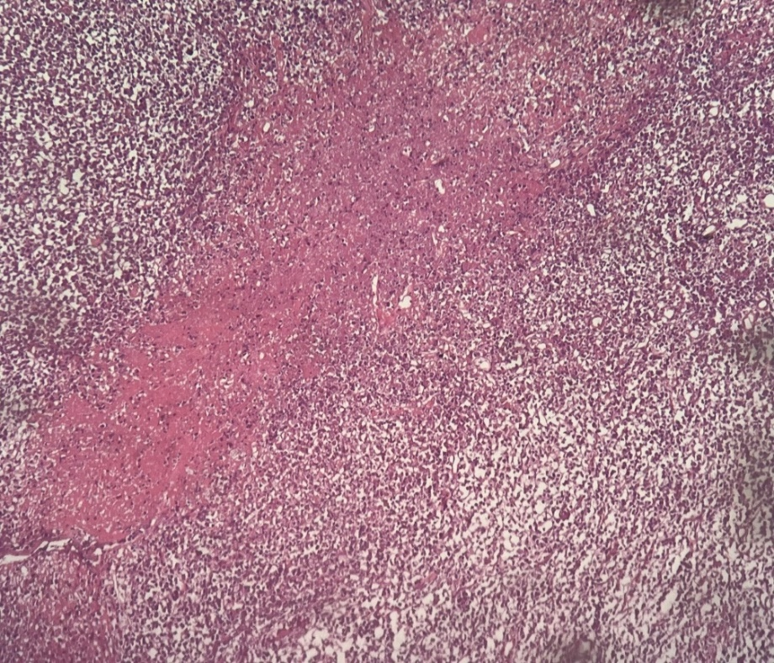
Fig. 1: Eosinophilic necrosis patch with numerous apoptotic cells and macrophages containing tingible bodies, among polymorphic inflammatory cells.
While awaiting histology results, the clinical course was spontaneously favorable with stable apyrexia and secondary regression of lymphadenopathy.
In the search for systemic lupus erythematosus associated with Kikuchi-Fujimoto disease, there were no suggestive clinical manifestations (especially cutaneous-articular). Physical examination only found lichen lesions on the legs. Immunological investigations found positivity for antinuclear antibodies (1/1000), anti-SSA, anti-SSB, and nucleosome antibodies. In renal exploration, we found proteinuria at 2.4 g/24h, leukocyturia at 47453/ml, hematuria at 1189900/ml with sterile urine culture, normal uremia and creatinine (table 2).
Table 2: Biological and immunological data at the diagnosis of systemic lupus erythematosus
Parameters | Patients results | Normal range
Creatinine level (mg/l) | 07 | 07 - 13
Urea level (g/l) | 0,18 | 0,15 - 0,5
Antinuclear antibodies | Positive 1/1000 | <1/160
Anti-SSA antibodies | 140 | 0 – 5
Anti-SSB antibodies | 153 | 0 – 5
Anti-nucleosome | 20 | 0 - 5
24-hour proteinuria (g/24H) | 2,4 | <0,23
Leukocyturia (/ml) | 47553 | <10000
Hematuria (/ml) | 1189900 | <5000
Renal ultrasound was normal. Renal biopsy showed mesangioproliferative and extramembranous lupus glomerulonephritis (class 2+5 according to ISN/RPS). Vessels were normal.
The patient was treated with hydroxychloroquine, corticosteroids (0.5 mg/kg), mycophenolate mofetil, and angiotensin-converting enzyme inhibitor.
Clinical and biological monitoring was instituted. The course was marked by a decrease in proteinuria to 1.6 g/24h at four months of treatment.
Discussion
KFD or necrotizing histiocytic lymphadenitis is a rare, benign, and inflammatory lymph node disease (Deb et al., 2024).
First described in Japan, it is more common in the Asian population than in Caucasians and blacks. It affects young subjects, aged on average 25 to 30 years, with a female predominance in all series (Astudillo, 2010; Deaver, et al., 2014; Mahajan, et al., 2023, Castañeda et al., 2025). In Africans, isolated cases are reported (Gallien, et al.,2008; Elfihri, et al., 2017; Lame, et al., 2017).
The etiology of KFD remains unknown. The etiopathogenic hypotheses are based on a delayed hypersensitivity reaction with T-lymphocyte activation by a stimulus. The latter could be a virus (Epstein–Barr virus, human herpesvirus types 6, 7, and 8, herpes simplex virus, HIV, human T-lymphotropic virus, and parvovirus B19) or a bacterium, but there is no formal proof of their involvement to date. The second hypothesis, the autoimmune one, is based on the association with other autoimmune diseases, in particular systemic lupus erythematosus (Astudillo, 2010; Deaver, et al., 2014; Hutchinson, et al.,2010; Lage et al., 2024).
Lymphadenopathy is the main clinical manifestation of KFD, found in all cases. They are most often localized and cervical, less often diffuse. Fever is present in about a third of cases. General signs such as weight loss, anorexia, and sweats are more rarely reported. Potential cutaneous manifestations are polymorphic, nonspecific, and evolve in parallel with lymphadenopathy. Arthralgia, myalgia, hepatomegaly, and splenomegaly are more rarely found. Involvement of other organs is very rarely described. Biological signs are variable with an inflammatory syndrome sometimes present. Leukopenia is often noted. The presence of antibodies mainly reflects an association with an autoimmune disease (Leyral, et al., 2005; Mahajan, et al., 2007). In our tropical context, this clinical presentation prompts a search for infection as a priority, particularly tuberculosis (Gallien, et al.,2008; Elfihri, et al., 2017; Lame, et al., 2017]. In our observation, CRP and infection search were negative. Lymph node histology ruled out tuberculosis and lymphoma.
The diagnosis relies on histology by demonstrating acidophilic coagulation necrosis in irregular patches in the cortex, histiocytic hyperplasia surrounding the necrosis, patches of plasmacytoid cells, numerous apoptotic cells with much nuclear debris, immunoblastic hyperplasia, and the absence of neutrophils or eosinophils in and around the necrosis (major negative sign). Three forms are identified: proliferating, necrotizing, which is the most common, and xanthomatous. These forms could represent evolutionary stages of the disease. Immunohistochemical staining finds CD8+, CD68+, and CD3+ cells (Astudillo, 2010; Deaver, et al., 2014; Mahajan, et al., 2023; Perry, et al., 2018).
The disease often does not require treatment. To reduce the duration of evolution or in case of association with an autoimmune disease, corticosteroid treatment may be proposed. The spontaneously favorable course observed in our patient is the norm. The resolution of signs occurs within a few weeks to a few months. Relapses are exceptional. A few cases of life-threatening lymphohistiocytic activation syndrome are described (Astudillo, 2010; Mahajan, et al., 2023).
The association of KFD with systemic or tumor diseases is described. But the most frequent association is with lupus. The search for the latter is necessary in case of KFD. It can be prior, concomitant, or posterior to lupus (Mahajan, et al., 2007; Jagadeesan, et al., 2022; Baenas, et al., 2016; Vithoosan, et al., 2019; Yousefi, et al., 2023; Zaccarelli, et al., 2023 ; Cadório et al., 2025). These two diseases share several characteristics, including female predominance, young age, fever, lymphadenopathy, leukopenia, and arthralgia. Usually, the histopathology of lymphadenopathy during systemic lupus erythematosus reveals nonspecific lymphadenitis. However, an aspect of necrotizing lymphadenitis like KFD can be observed. These two entities can be differentiated by the presence, in lupus lymphadenitis, of follicular hyperplasia, plasma cells, neutrophils, and hematoxylin bodies. Also, in KFD, there is a predominance of T lymphocytes, whereas conversely in lupus, B lymphocytes predominate (Astudillo, 2010). The association of KFD with lupus suggests a pathophysiological link between the two entities. Indeed, KFD could correspond to a lupus disease limited to the lymph node sphere, prompting regular clinical and biological monitoring of these patients. Lymph node cell apoptosis, possibly triggered by an infectious process, could lead to the presentation of nuclear antigens and the activation of autoreactive lymphocyte clones, then to the production of antinuclear antibodies. In a predisposed individual, this autoimmune response could exceed the capacities of regulation and immune tolerance and lead to the development of an authentic systemic disease (Leyral, et al., 2005). In the association of KFD with lupus, cutaneous manifestations are the most frequent (Deaver, et al., 2014). In the literature, we found an observation of KFD occurring during systemic lupus erythematosus with known renal involvement in a young African American woman (Rana, et al., 2023). In our observation, lupus nephritis was the only and revealing manifestation of lupus in a patient with KFD nine months earlier. Glomerulonephritis was found during systematic screening in the context of KFD, which constitutes the originality of this observation. Lupus nephritis is indeed more frequent and severe in black subjects. The discovery of lupus glomerulonephritis required immunosuppressive therapy.
Conclusion
KFD is a benign lymphadenitis of unknown etiology. It manifests as cervical lymphadenopathy occurring in young subjects. It’s possible association with systemic lupus erythematosus makes it potentially serious. The diagnosis of KFD requires systematic screening for systemic lupus erythematosus. Unlike cutaneous manifestations, lupus glomerulonephritis is rarely reported during KFD. It is in this sense that our observation is original.

Consent: all authors declare that ‘written informed consent was obtained from the patient for publication of this case report and accompanying images.
Disclaimer (artificial intelligence) :
Author(s) hereby declare that generative AI technologies such as Large Language Models, etc. have been used during the writing or editing of manuscripts. This explanation will include the name, version, model, and source of the generative AI technology and as well as all input prompts provided to the generative AI technology
- we used ChatGPT for english traduction
References
1. Astudillo L. Kikuchi-Fujimoto disease. Rev Med Interne. 2010;31:757–765. https://doi.org/10.1016/j.revmed.2010.01.011
2. Deaver D, Horna P, Cualing H, and Sokol L. Pathogenesis, Diagnosis, and Management of Kikuchi–Fujimoto Disease. Clin Med Insights Pathol. 2014;21(4):313-321. DOI: 10.1177/107327481402100407
3. Leyral C, Camou F, Perlemoine C, Caubet O, Pellegrin JL, Viallard JF et al. Pathogenic links between Kikuchi's disease and lupus: a report of three new cases. Rev Med Interne. 2005;26:651–655. https://doi.org/10.1016/j.revmed.2005.03.018
4. Deb A, Fernandez V, Kilinc E, Bahmad HF, Camps NS, Sriganeshan V et al. Kikuchi-Fujimoto Disease: A Case Series and Review of the Literature. Diseases. 2024 Nov 1;12(11):271. doi: 10.3390/diseases12110271.
5. Mahajan VK, Sharma V, Sharma N, Rani R. Kikuchi-Fujimoto disease: A comprehensive review. World J Clin Cases. 2023;11(16):3664–3679. https://doi.org/10.12998/wjcc.v11.i16.3664
6. Castañeda Martinez JM, Zamora Diaz JJIY, Rodriguez Avila AA, Somarriba Dominguez SB, Nava Fuentes LA. Kikuchi-Fujimoto disease, case report. Oxf Med Case Reports. 2025 Mar 28;2025(4):omae211. doi: 10.1093/omcr/omae211.
7. Gallien S, Lagrange-Xelot M, Crabol Y, Brière J, Galicier L, Molina JM. Systemic lupus erythematosus and Kikuchi-Fujimoto disease mimicking tuberculosis. Med Mal Infect. 2008;38:392–395. https://doi.org/10.1016/j.medmal.2008.03.010
8. Elfihri S, Laine M, Kettani F, Ben Amor J, Bourkadi JE. Kikuchi-Fujimoto disease: a case report. Pan Afr Med J. 2017;27:144. doi: 10.11604/pamj.2017.27.144.12102
9. Lame CA, Loum B, Fall AK, Cucheroussetc J, Ndiaye AR. Kikuchi-Fujimoto disease, a rare cause of lymphadenopathy in Africa. Description of the first case in Senegal and review of the literature. Eur Ann Otorhinolaryngol Head Neck Dis. 2017;134:333–335. doi: 10.1016/j.aforl.2016.12.003
10. Hutchinson CB, Wang E. Kikuchi-Fujimoto Disease. Arch Pathol Lab Med. 2010; 134:289–293. DOI: 10.5858/134.2.289
11. Lage JV, Guerra AT, Costa F, Martins A, Correia P, Luis C. Kikuchi-Fujimoto - an enigmatic and rare disease: a report of 3 cases and brief review of the literature. ARP Rheumatol. 2024 Oct-Dec;3(4):324-329. doi: 10.63032/GDNJ6221.
12. Mahajan T, Merriman RC, Stone MJ. Kikuchi-Fujimoto disease (histiocytic necrotizing lymphadenitis): report of a case with other autoimmune manifestations. Proc (Bayl Univ Med Cent). 2007; 20:149–151. DOI: 10.1080/08998280.2007.11928275
13. Perry AM, Choi SM. Kikuchi-Fujimoto Disease A Review. Arch Pathol Lab Med. 2018; 142:1341-1346. DOI: 10.5858/arpa.2018-0219-RA
14. Jagadeesan S, Rani S, Porwal YC, et al. Lupus and Kikuchi-Fujimoto Disease: A Combination for Catastrophe. Cureus. 2022;14(7): e27423.doi: 10.7759/cureus.27423
15. Baenas DF, Diehl FA, Haye Salinas MJ, Riva V, Diller A, Lemos PA. Kikuchi–Fujimoto disease and systemic lupus erythematosus. Int Med Case Rep J. 2016; 9:163-167. DOI: 10.2147/IMCRJ.S106396
16. Vithoosan S, Karunarathna T, Shanjeeban P, Piranavan P, Matthias T, Gamlaksha D et al. Kikuchi–Fujimoto disease associated with systemic lupus erythematosus complicated with hemophagocytic lymphohistiocytosis: a case report. J Med Case Rep. 2019; 13:173. doi:10.1186/s13256-019-2100-1
17. Yousefi M, Rukerd MRZ, Binafar H, Shoaie S, Mirkamali H, Pourzand P et al. The co‑occurrence of Kikuchi–Fujimoto disease and systemic lupus erythematosus: a case report. J Med Case Rep. 2023; 17:448. DOI: 10.1186/s13256-023-04186-4
18. Zaccarelli F, de Vincentiis M, D'Erme G, Greco A, Natalucci F, Fusconi M. Kikuchi-Fujimoto Disease: A Distinct Pathological Entity but also an "Overlap" Autoimmune Syndrome: A Systematic Review. Curr Rheumatol Rev. 2023;19(2):159-167. doi: 10.2174/1573397118666220903123128.
19. Cadório MJ, Oliveira J, Gama J, Duarte C. Kikuchi-Fujimoto disease and primary Sjögren's syndrome coexisting: A case-based literature review. Mod Rheumatol Case Rep. 2025 Jan 16;9(1):110-116. doi: 10.1093/mrcr/rxae058.
20. Rana MBM, Fatima M, Rana IM, Haseeb ul Rasool M, Abosheaishaa M, Abrudescu A et al. Kikuchi-Fujimoto Disease with Systemic Lupus Erythematosus and Systemic Sclerosis Overlap: A Unique Clinical Presentation. Cureus. 2023;15(9): e44986. doi:10.7759/cureus.44986.

