Lateral Medullary Syndrome with Cerebellar Infarct in A Young Hypertensive Diabetic Patient with Bilateral Otomastoiditis: A Rare Case Report

ABSTRACT
Background:
Lateral medullary syndrome (LMS) is a rare posterior circulation stroke that can present with diverse neurological symptoms, making diagnosis challenging. Its occurrence in young adults with combined metabolic and infectious comorbidities is uncommon.
Case Presentation:
A 35-year-old female with uncontrolled type 2 diabetes mellitus and hypertension presented with acute-onset giddiness, vomiting, palpitations, and cough for two days. She denied fever, trauma, seizure, loss of consciousness, or neck stiffness. On examination, she was alert, oriented, hypertensive (BP 172/106 mmHg), and had a pulse rate of 88/min. Neurological assessment revealed left upper eyelid ptosis, horizontal nystagmus, and left-sided gait ataxia without limb weakness or sensory deficits. ENT evaluation showed bilateral mastoid tenderness, and otoscopic examination confirmed bilateral otomastoiditis. CT brain revealed subtle hypodensity in the left cerebellar hemisphere and bilateral otomastoiditis. MRI with MR angiography demonstrated acute infarcts in the left cerebellar hemisphere and left lateral medulla, with poor visualization of the left vertebral artery, confirming LMS due to posterior circulation ischemic stroke. She was treated with dual antiplatelet therapy, antihypertensives, insulin, and empirical antibiotics. Supportive physiotherapy and fall precautions were recommended. Regular medication adherence and symptom monitoring were emphasized to prevent recurrence.
Conclusion:
This case highlights the importance of considering posterior circulation stroke in young adults presenting with atypical vestibular or cerebellar symptoms, particularly in the presence of metabolic and infectious risk factors. Early imaging and multidisciplinary care can lead to favorable outcomes.
Keywords:
Lateral medullary syndrome, Posterior circulation stroke, Cerebellar infarct, Otomastoiditis, Hypertension, Diabetes mellitus
- INTRODUCTION
Stroke in young adults—defined as occurring before the age of 45—accounts for approximately 10–15% of all ischemic strokes, and the incidence is increasing globally ⁽¹⁾. Posterior circulation ischemic strokes (PCS), involving the vertebrobasilar arterial system, make up about 20–25% of ischemic strokes. PCS often presents with nonspecific symptoms such as vertigo, nausea, vomiting, and gait instability, which frequently leads to misdiagnosis or delayed management ⁽²⁾.
Lateral medullary syndrome (LMS), or Wallenberg syndrome, is an uncommon but important clinical entity most frequently caused by infarction of the lateral portion of the medulla oblongata, typically due to thrombotic or embolic occlusion of the vertebral artery or the posterior inferior cerebellar artery (PICA). ⁽³⁾
It is characterized by a distinctive neurological syndrome including ipsilateral facial sensory loss, dysphagia, contralateral pain–temperature deficit, limb ataxia, and Horner’s syndrome; concurrent cerebellar infarction may exacerbate gait ataxia and vomiting ⁽⁴⁾
While hypertension and type 2 diabetes mellitus (T2DM) are well-recognized risk factors for stroke, their presence in younger adults is relatively uncommon and significantly raises the risk of early cerebrovascular events⁽⁵⁾
Otomastoiditis, a chronic or recurrent infection of the middle ear and mastoid air cells, is a rare but important potential source of intracranial infectious complications, including stroke. The spread of infection to adjacent intracranial vessels can provoke local arterial inflammation, thrombosis, or embolic phenomena, especially in patients with additional vascular risk factors such as hypertension and diabetes⁽⁶⁾⁽⁷⁾
This report describes a rare and complex case of posterior circulation stroke in a young adult female with pre-existing hypertension, diabetes, and bilateral otomastoiditis, presenting with both lateral medullary syndrome and cerebellar infarction. The case highlights the importance of early neuroimaging, thorough etiological evaluation, and multidisciplinary management in young adults with atypical presentations of stroke.

- PRESENTATION OF CASE
A 35year of female patient with known history of type 2 diabetics mellitus and hypertension was brought to the emergency department with complaints of giddiness,4 episodes of vomiting ,palpitation, cough for 2 days. There was no history of fever, trauma, seizure, loss of consciousness or neck stiffness
On examination the patient was conscious, alert and oriented. Her vital signs were notable for blood pressure 172/106 mm/hg and pulse rate 88 beats per minute. Neurological examination revealed left upper eyelid ptosis, horizontal nystagmus, left sided gait ataxia, no limb weakness and no sensory deficits. ENT examination reveal bilateral mastoid tenderness and otoscopic examination imaging confirm bilateral otomastoiditis
Table 1: Laboratory Parameters
Parameter | Value | Normal Range
WBC | 13800 | 4000-11000
Hb | 13.3 g/dL | 12-16g/dL
Platelet count | 149000 | 150000-400000
MCV | 77fL | 80-100fL
Random blood sugar | 215 mg/dL | <200mg/dL
Blood urea | 30mg/dL | 10-50mg/dL
Serum creatinine | 1.0mg/dL | 0.6-1.3mg/dL
SGOT | 20U/L | 0-35U/L
SGPT | 22U/L | 0-35U/L
Serum sodium | 140mmol/L | 135-145mmol/L
Serum potassium | 3.9mmol/L | 3.5-5mmol/L

Neuro Imaging;
Ct brain; No acute hemorrhage or space-occupying lesion. Settle hypodensity was noted in the left cerebellar hemisphere. Bilateral otomastoiditis noted.
MRI brain with MR Angiography and venography; Multiple punctate foci of T2 flair hyperintensity and diffusion restriction noted in the left cerebellar hemisphere and left lateral medulla. Suggestive of acute infracts in the posterior circulation territory .Asymmetrical and diffusion restriction also noted in the left posterior parietal lobe, likely representing additional ischemic changes.
Differential diagnoses considered at presentation included vestibular neuritis, acute labyrinthitis, demyelinating disorders such as multiple sclerosis, and infectious cerebellitis. However, the presence of neurological deficits including dysphagia, ataxia, and limb numbness, combined with neuroimaging findings of lateral medullary and cerebellar infarct, confirmed the diagnosis of posterior circulation stroke.
Final diagnosis;
The final diagnosis was posterior circulation stroke left cerebellar infract with bilateral otomastioditis with lateral medullary syndrome
Management:
The patient was managed for a hypertensive emergency with posterior circulation stroke involving the cerebellum and lateral medulla. High Blood pressure at admission was managed with telmisartan 40 mg, amlodipine 5 mg, and propranolol 40 mg once daily. Dual antiplatelet therapy with aspirin 150 mg and clopidogrel 75 mg was initiated to prevent further ischemic events. Glycemic control was achieved with human Mixtard insulin (30/70) administered subcutaneously twice daily. Pantoprazole 40 mg once daily was prescribed for gastric protection, and paracetamol 500 mg as needed for pain. Pregabalin 75 mg and amitriptyline 10 mg once daily were included to manage neuropathic pain and possible cerebellar-related symptoms. ENT consultation advised conservative management for bilateral otomastoiditis with amoxicillin-clavulanate empirically.
At discharge, the patient remained hemodynamically stable with BP of 140/100 mmHg, SpO₂ of 99%, and pulse rate of 84 bpm. Though clinical improvement was noted, the patient continued to experience upper and lower limb pain. She was discharged with advice for home blood pressure monitoring, continued insulin use with dietary control, and scheduled follow-up with neurology, ENT, and diabetology departments. Neurological assessment using the NIH Stroke Scale (NIHSS) revealed a score of 8 at admission, indicating moderate neurological impairment. At discharge, the NIHSS score improved to 1, reflecting near-complete neurological recovery.
Supportive physiotherapy and fall precautions were recommended. Regular medication adherence and symptom monitoring were emphasized to prevent recurrence.

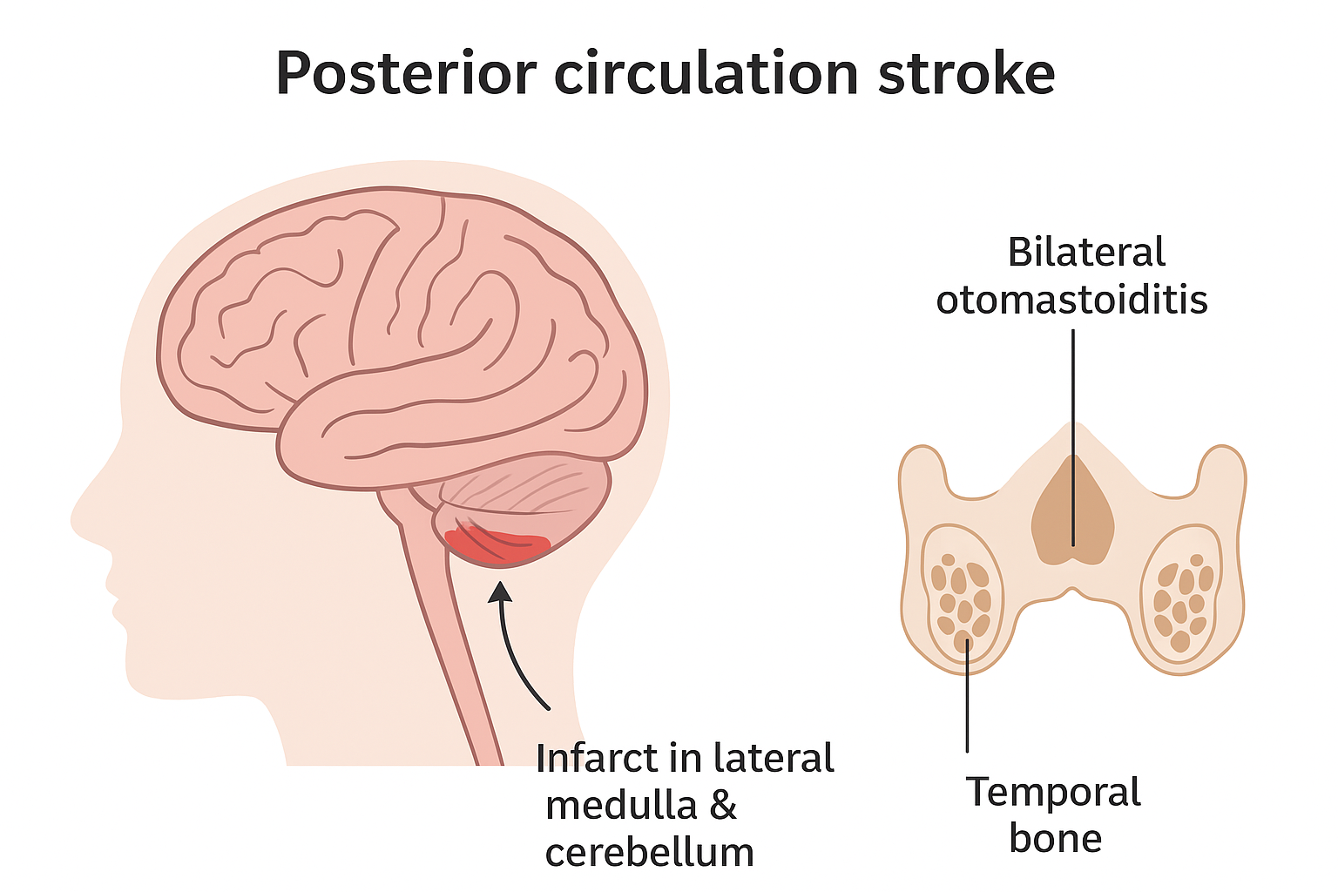
Figure 1: Schematic illustration showing infarct in the lateral medulla and cerebellum(left) along with bilateral otomastoiditis involving mastoid air cells (right)

3. DISCUSSION
This case describes a 35-year-old woman with poorly controlled hypertension and type 2 diabetes mellitus (T2DM) who developed lateral medullary syndrome (LMS) and left cerebellar infarction, with concurrent bilateral otomastoiditis.
Lateral medullary syndrome (LMS) and cerebellar infarction are uncommon but clinically important posterior circulation strokes, particularly when they occur together in young adults. This case underscores the multifactorial nature of stroke in younger patients, with both conventional risk factors and rare etiologies playing significant roles. Lateral medullary syndrome (Wallenberg syndrome) results from infarction in the dorsolateral medulla, typically due to occlusion of the vertebral artery or posterior inferior cerebellar artery (PICA). Clinical features may include ipsilateral facial sensory loss, contralateral pain–temperature deficit, ataxia, dysphagia, and ocular findings like nystagmus or ptosis^{.(5)} Pathogenesis primarily involves large-vessel atherosclerosis or dissection, and risk factors include hypertension and small-vessel disease, as in our patient⁽⁸⁾
In young adults, posterior circulation strokes are more likely to result from arterial dissection or less common causes such as infection, rather than atherosclerosis. Studies demonstrate that, despite sometimes dramatic presentation, posterior circulation strokes in young adults generally have favorable prognoses when promptly recognized and managed⁽⁹⁾
Hypertension and diabetes, traditionally associated with older adults, are increasingly observed among young stroke patients, reflecting changing epidemiology and rising prevalence of these risk factors in younger populations. Their combination exponentially increases stroke risk, worsens outcomes, and mandates strict long-term management⁽¹⁰⁾.Studies consistently confirm that early detection and optimal control of hypertension, glycemic status, and associated comorbidities are as essential as treating the acute stroke event itself⁽¹⁾.
A rare but notable aspect in this case is the incidental finding of bilateral otomastoiditis, which may have played a contributory role. Although otogenic intracranial complications predominantly involve venous thrombosis or abscess, arterial ischemic stroke related to otomastoiditis—due to inflammatory involvement of regional vascular structures—has also been documented⁽⁶⁾.One case report described ischemic stroke due to chronic otomastoiditis leading to arterial thrombosis through adjacent bony canals. In our patient, no abscess or sinus thrombosis was seen; however, localized mastoid inflammation may plausibly have played a vascular role. The spread of infection to adjacent intracranial vessels can provoke local arterial inflammation, thrombosis, or embolic phenomena, especially in patients with additional vascular risk factors such as hypertension and diabetes⁽⁷⁾.
The concurrent presence of bilateral otomastoiditis in this patient may have contributed to the stroke mechanism. Infections of the mastoid air cells can extend to adjacent venous sinuses, leading to thrombosis and impaired cerebral venous drainage, thereby increasing the risk of posterior circulation infarction. Previous case reports have documented otomastoiditis complicating cerebrovascular presentations, supporting the infectious contribution in our case^{.(12)}
In terms of management, the multidisciplinary approach—including antihypertensive titration, glycemic control, dual antiplatelet therapy, statin, and short-term anticoagulation—aligns with current stroke guidelines. Conservative antibiotic therapy and ENT follow-up were provided for otomastoiditis, as there were no indications for invasive intervention given the absence of abscess formation
4. CONCLUSION
This case illustrates a rare manifestation of posterior circulation stroke presenting as lateral medullary syndrome with cerebellar infarct in a young adult with hypertension and type 2 diabetes mellitus, further complicated by bilateral otomastoiditis. The atypical constellation of neurological and otologic findings underscores the importance of early clinical suspicion and the use of advanced neurovascular imaging for timely diagnosis. Prompt multidisciplinary management, including antiplatelet therapy, blood pressure and glycemic control, and supportive ENT care, contributed to a favorable outcome. Clinicians should remain vigilant for such uncommon presentations of stroke in young individuals with coexisting metabolic and infectious risk factors.

8. CONSENT
Written informed consent was obtained from the patient for publication of this case report and any accompanying clinical details. The patient was assured of anonymity, and no identifying information is included in this report.

- ETHICAL APPROVAL
This case report did not require Institutional Ethics Committee approval as it describes a single clinical case without experimental intervention

Disclaimer (Artificial intelligence)
The authors declare that generative AI technologies, including Large Language Models, were utilized during the preparation of this manuscript. This statement includes the specific AI tool, version, and source, along with the input prompts provided.
Details of AI usage are as follows:
1.Tool employed: ChatGPT (GPT-4), OpenAI.
2.Purpose: Assisted in grammar correction, sentence rephrasing, enhancing manuscript readability, formatting references, and drafting responses to reviewer comments.
3.All AI-generated content was carefully reviewed, modified, and validated by the authors to ensure scientific accuracy, integrity, and adherence to ethical standards.

- REFERENCES
- Bukhari S, Yaghi S, Bashir Z. Stroke in Young Adults. J Clin Med. 2023 Jul 29;12(15):4999. doi: 10.3390/jcm12154999. PMID: 37568401; PMCID: PMC10420127.
2. Sič A, Andrejić N, Ivanović J, Karadžić Ristanović V, Gajić S, Bjelić D, Baralić M, Stojanovic N. Stroke in Young Adults: An Overview and Non-Pharmacological Preventive Strategies. Brain Sci. 2025 Apr 3;15(4):375. doi: 10.3390/brainsci15040375. PMID: 40309847; PMCID: PMC12026300.
3. Easton-Carr R, Lui F, Das JM. Lateral Medullary Syndrome (Wallenberg Syndrome) [Updated 2025 Aug 9]. In: StatPearls [Internet]. Treasure Island (FL): StatPearls Publishing; 2025 Jan-. Available from: https://www.ncbi.nlm.nih.gov/books/NBK551670/.
4.Thapliyal K, Garg A, Singh VP. Lateral medullary syndrome: Case report and review of literature. PMC10041230. 2022 Open Access
- Aigner A, Kiechl S, Willeit J, et al. Contribution of established stroke risk factors to the burden of stroke in young adults. Stroke. 2017;48(7):1744–1751. doi: 10.1161/STROKEAHA.117.016599.
- Chauhan G, Singh V, Phadke RV, Yadav S. Recurrent Ischemic Strokes due to Chronic Otomastoiditis: A Rare Clinical Entity. Saudi J Med Med Sci. 2019 Sep-Dec;7(3):234-236. doi: 10.4103/sjmms.sjmms_152_18. Epub 2019 Aug 28. PMID: 31543752; PMCID: PMC6734743. https://pmc.ncbi.nlm.nih.gov/articles/PMC6734743/
7. Malinovic M, et al. Pneumococcal meningitis complicated by otomastoiditis and pneumocephalus confounding an acute ischemic stroke. J Neurocrit Care. 2021 Open Access
8.Alwood BT, Dossani RH. Vertebrobasilar Stroke. [Updated 2023 Jan 2]. In: StatPearls [Internet]. Treasure Island (FL): StatPearls Publishing; 2025 Jan-. Available from: https://www.ncbi.nlm.nih.gov/books/NBK556084/
9. Nouh A, Remke J, Ruland S. Ischemic posterior circulation stroke: a review of anatomy, clinical presentations, diagnosis, and current management. Front Neurol. 2014 Apr 7;5:30. doi: 10.3389/fneur.2014.00030. PMID: 24778625; PMCID: PMC3985033.
10. Deuri A, Kausar N, Das A, Talukdar P. A study on stroke in young adults with reference to risk factors and hospital outcome: a single centre prospective observational study. Int J Pharm Clin Res. 2024;16(8):1090-1100
11. Sharma, G. (2020). Atypical Presentation of Medullary Syndrome in a Young Woman. Journal of Advances in Medicine and Medical Research, 32(15), 6–11. https://doi.org/10.9734/jammr/2020/v32i1530600
12. Malinovic, Matea & Peterson, John & Lee, Felecia. (2021). Pneumococcal meningitis complicated by otomastoiditis and pneumocephalus confounding an acute ischemic stroke diagnosis. Journal of Neurocritical Care. 14. 10.18700/jnc.210003.

