Case Presentation of the sphenochoanal polyp: A rare entity

Abstract
The spheno-choanal polyp is a rare pathology of choanal polyps that originates in the sphenoid sinus and extends towards the choana via the sphenoethmoidal recess. We report a case of sphenochoanal polyp in a 35-year-old man who presented with chronic bilateral
nasal obstruction that had been developing for four years. The incidence of sphenochoanal polyp is extremely rare, especially in young people. Symptomatically, it resembles an antrochoanal polyp. Therefore, adequate preoperative evaluation with endoscopic examination and computed tomography or magnetic resonance imaging is necessary for an accurate diagnosis and appropriate surgical strategy. The treatment of choice is endoscopic surgical excision.

Keywords: spheno-choanal polyp, choanal polyps, sphenoid sinus, antrochoanal polyp

INTRODUCTION
Sphenoid polyps are a rare condition affecting the sphenoid sinus. They can be differentiated from antrochoanal polyps by endoscopic examination, computed tomography (CT) and/or magnetic resonance imaging (MRI) of the nose and sinuses. Their aetiology is uncertain.
Most cases have been reported in young adults. Due to their relatively deep location, they are diagnosed late with varied and sometimes non-specific symptoms.
A proper preoperative assessment is often needed, including a nasal endoscopy combined with a CT scan or MRI to get an accurate diagnosis and figure out the best surgical plan. But the best treatment is still endoscopic surgical removal.
The rarity of isolated sphenoid sinus lesions and their significant anatomical features require investigation of the underlying pathology, particularly malignancy, origin and extent of the mass before surgical removal.

Case Presentation:
This is a patient aged 35, without significant pathological history who is received in consultation for a unilateral left nasal obstruction evolving for 4 years becoming permanent and bilateral with clear rhinorrhea, anosmia and facial headaches without epistaxis or

ophthalmological or neurological signs. Endoscopic examination showed polyploid, cystic, smooth and regular formation filling the left bulging nasal cavity in the Nasopharynx whose origin is difficult to determine. The coronal and axial CT scan showed a hypodense and homogeneous filling of the sphenoidal sinus enlarging the spheno-ethmoid recess extended to the cavum and the left nasal cavity. Magnetic resonance nasosinusian imaging showed fluid filling of the maxillary sinus, ethmoidal cells and the right sphenoidal sinus with right nasal cavity filling. The surgical exploration showed a translucent polyp of the posterior wall of the left nasal cavity emanating from the spheno-ethmoid recess whose implantation base is at the level of the lower wall of the sphenoidal sinus. The removal of the implantation base was done with polypectomy and resection of the intrasinus portion. Post-operative follow- up was simple. Definitive anatomopathological examination showed an inflammatory polyp.
After 5 months of follow-up, the patient showed no symptoms and endoscopy showed no recurrence

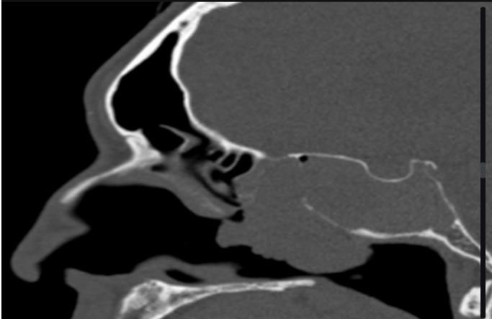
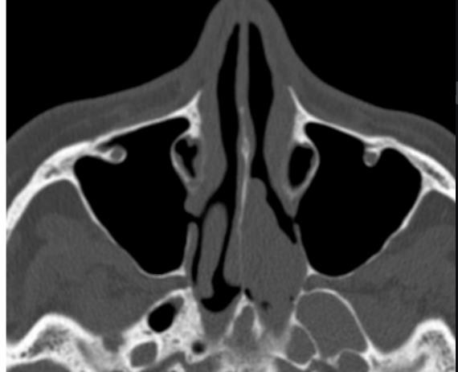
Figure 1: Sagittal (a) and axial (b) CT images of the nasosinuses showing homogeneous hypodense filling of the sphenoid sinus extending to the cavum and the nasal cavity
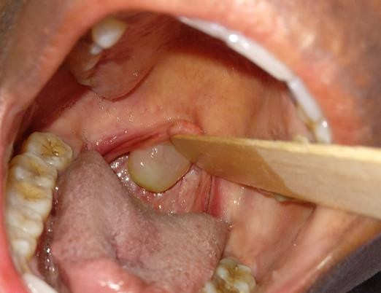
Figure 2: Clinical photo - The sphenochoanal polyp. Clinical photo showing the large sphenochoanal polyp hanging from the posterior choana in the oropharynx.

DISCUSSION
Sphenoid polyps are a rare clinical entity and much less common than antrochoanal polyps [2]. According to the literature, they mainly occur in adolescents and young adults (54.5% between the ages of 10 and 30 according to Piquet et al) [5], although several observations reported in the literature find older patients between the ages of 50 and 70. There is no gender predominance. The sphenochoanal polyp must be distinguished from meningoencephalocele (presented as a defect in the base of the skull allowing communication between the brain and the nasal cavity), nasopharyngeal fibroma (nasal obstruction and recurrent unilateral epistaxis), and inverted papilloma (unilateral tumour with enlargement of the osteomeatal complex in older patients) [1]. However, its main differential diagnosis remains the antrochoanal polyp, as they share the same clinical and histopathological features.
The clinical symptoms of sphenoid polyps are almost identical to those of antral polyps, but there are differences in the results of endoscopic examination and nasal sinus CT scans. Nasal obstruction is the main symptom in patients with sphenoid polyps, and it can be unilateral or bilateral. Rhinorrhoea, headaches and sometimes snoring may also occur [4]. Due to their
deep location, these polyps may escape anterior rhinoscopy, hence the importance of nasal endoscopy, which is essential and mandatory, not only to confirm the diagnosis, but also to visualise the extent of the polyp. However, sinus CT is the gold standard examination [6]. The combined use of diagnostic nasal endoscopy and imaging techniques is recommended for an accurate diagnosis of isolated sphenoid sinus lesions [3]. The treatment of spheno-choanal polyps is exclusively surgical, mainly by endoscopic endonasal approach. This approach offers excellent visualization of the affected sinuses and is associated with a low recurrence rate compared to simple polypectomy. Other advantages of this technique include minimal blood loss, less pain, rapid recovery, and shorter operating time [7].

CONCLUSION
Sphenochoanal polyp is a rare cause of nasal obstruction whose precise etiopathogenesis remains unknown. This rare condition requires endoscopic examination, computed tomography and/or sinus MRI for a complete assessment. The reference treatment remains endoscopic surgery allowing a complete removal of the polyp thus decreasing the risk of
recurrence and the incidence of possible complications.

Consent
As per international standards or university standards, patient(s) written consent has been collected and preserved by the author(s).

Disclaimer (Artificial intelligence)
Option 1:
Author(s) hereby declare that NO generative AI technologies such as Large Language Models (ChatGPT, COPILOT, etc.) and text-to-image generators have been used during the writing or editing of this manuscript.
Option 2:
Author(s) hereby declare that generative AI technologies such as Large Language Models, etc. have been used during the writing or editing of manuscripts. This explanation will include the name, version, model, and source of the generative AI technology and as well as all input prompts provided to the generative AI technology
Details of the AI usage are given below:
1.
2.
3.

References
- Tosun F, Yetiser S, Akcam T, Ozkaptan Y. Sphenochoanal polyp: endoscopic surgery. Int J Pediatr Otorhinolaryngol. 2001;58(1):87–90. [PubMed] [Google Scholar]
- Dadas B, Yilmaz O, Vural C, Calis AB, Turgut S. Choanal polyp of sphenoidal origin. Eur Arch Otorhinolaryngol. 2000;257(7):379–381. [PubMed] [Google Scholar]
- DS Sethi. Isolated sphenoid lesions: diagnosis and management. Otolaryngol Head Neck Surg. 1999 May;120(5):730–736. [PubMed] [Google Scholar]
- Ozbay M, Yorgancilar E, Kinis V. A rare cause of nasal obstruction: Sphenochoanal polyp. J Clin Exp Invest. 2012;3:435–437. [Google Scholar]
- Piquet J Chevallier D, Leger G, Iwuquette Leconte-Houcke M. Microchirurgie endonasale du polype antro-choanal. Acta Otorhinolaryngologie Belg. 1992;46: 267-271. PubMed| Google Scholar
- Weissman JL, Tabor EK, Curtin HD. Sphénochoanal Polyps: Evalualion wilh CT and MR Imaging. Radiology. Jan 1991;178(1). PubMed| Google Scholar.
- Crampette L, Mondain M, Rombaux P. Sphenochoanal polyp in children. Diagnosis and Treatment. Rhinology. 1995;33(1): 43-45. PubMed| Google Scholar
- Amber Kesarwani, Darwin Kaushal, Rahul Kumar Singh, Amit Goya. Sphenochoanal Polyp: A Rare Entity with Review of Literature. J Otolaryngol ENT Res. 2017;8(4): 00251. PubMed| Google Scholar
- Bist SS, M Bisht, Kumar R, Varshney S. Sphenochoanal polyp: an endoscopic view. Ear Nose Throat J. January 2007; 86(1): 19-20. PubMed| Google Scholar

