A Case Report on Porcelain Gall Bladder

ABSTRACT:
Porcelain gallbladder (PGB) originally refers to the bluish discoloration and brittle consistency of the gallbladder wall, though the terms is now broadly applied to all the forms of gallbladder calcification. Extensive calcium deposition within the gallbladder wall imparts a fragile, brittle texture and a characteristic porcelain- like appearance. Also referred to as calcified gallbladder or calcifying cholecystitis. Despite their clinical relevance, the precise etiology and pathogenesis of gallbladder wall calcifications remain poorly understood. Current evidence suggests they result from a chronic inflammatory process, although definitive mechanisms are yet to be elucidated. primary objective of this case study is to present a classic presentation of porcelain gallbladder in a 56- year-old female patient, detailing her clinical course, evaluation parameters considered and treatment approaches achieved to manage the condition.
Keywords: Porcelain gallbladder, gallbladder wall, gallbladder calcification, chronic inflammation

Introduction:
Calcification of gall bladder, often referred to as Porcelain Gallbladder (PGB), have garnered significant attention due to their perceived association with gallbladder carcinoma. PGB is classified into two subtypes on the extent of calcification: complete intramural calcification and selective mucosal calcification, the latter of which has been linked to an increased risk of gallbladder carcinoma.[1] These calcifications often occur alongside gallstones and are frequently asymptomatic, representing incidental findings on radiographic imaging. The main purpose of this case study is to present a classic presentation of porcelain gallbladder is about its clinical course diagnostic evaluation, and the treatment approach implemented[2]. The two recognized types of calcification are: (1) Complete intramural calcification, where the entire gallbladder wall is uniformly calcified; and (2) Selective mucosal calcification, where calcification is limited to the mucosal layer. The latter type has been reported to carry a higher risk of gallbladder carcinoma.

Case presentation
Patient Information, Clinical Findings, Timeline
A 56 years old female patient was admitted in the hospital with the chief complaints of occasional abdominal pain for 10 years. She is a known case of Breast Cancer (drugs used were not reported by patient). She denies of other co-morbidities like Hypertension, Diabetes Mellitus. Investigating her family history reveals that her aunty (paternal) has Breast Cancer. Her personal history stated that the Appetite, Bowel & Bladder are Normal, Regular, but her Sleep was Decreased due to Abdominal Pain.
Diagnostic Assessment:
The patient is in a conscious and coherent in state, with normal blood pressure with afebrile condition temperature. All her laboratory findings like Haematology, Biochemistry were found normal. The Plain CT scan of Abdomen presents the following Impression.
Radiological Findings:
Figure 1. Representative CT image demonstrating curvilinear calcification along the gallbladder wall, characteristic of porcelain gallbladder (illustrative only).
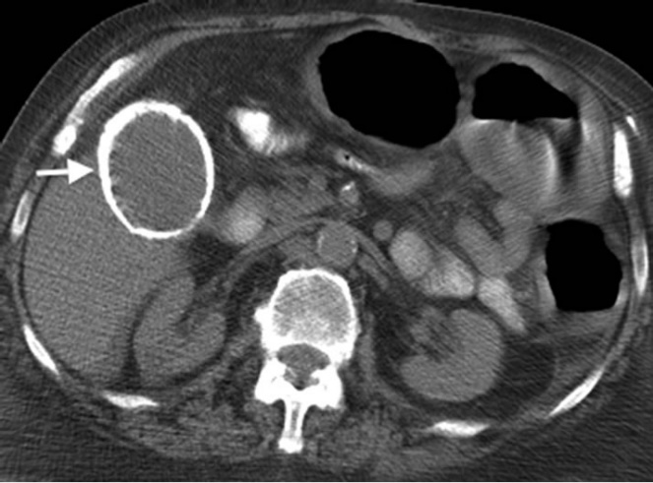
- Adenomyomatosis changes in fundus of Gall bladder.
- Small cysts in segment V at at right lobe of Liver.
- No para-aortic Lymphadenopathy.
- Schmorl’s node impression superior end plate of D 12 Vertebra.
Histopathological Findings:
Microscopic examination revealed diffuse hyalinization of the gallbladder wall, mucosal atrophy with focal epithelial denudation, patchy calcification, and chronic inflammatory infiltrate predominantly composed of lymphocytes and plasma cells. These findings are consistent with chronic cholecystitis and porcelain gallbladder morphology.

Discussion:
Gall bladder calcification is known as porcelain gall bladder (PGB). The term originally refers to the blue discoloration and brittle consistency of the gall bladder wall, calcium deposits invade gall bladder, the gall bladder wall become fragile, brittle and bluish, which results in a porcelain appearance. The degree of calcification in the gallbladder wall varies, ranging from small focal plaques localized within the mucosal layer and glandular spaces to extensive full- thickness calcification. In severe cases, the muscularis layer is replaced by calcified fibrosis, often accompanied by sloughing of the overlying mucosa. This spectrum of histopathological changes reflects the chronicity and severity of the inflammatory process[3].
Institution based studies report the prevalence of porcelain gallbladder in 0.1% to 0.2% of patients with gallbladder disease, although its true prevalence remains uncertain due to limited large- scale population- based data[4].
Porcelain gallbladder developed gallbladder carcinoma. However, more recent studies report significantly lower rates of malignancy, raising questions about the accuracy of earlier findings and the potential overestimation of this association. From a clinical perspective, the potential link between gallbladder wall calcifications and carcinoma is crucial, particularly in guiding decisions regarding prophylactic cholecystectomy[5].
Pathology:
The exact pathogenesis of porcelain gall bladder is still unclear, but it is thought to be the final result of chronic inflammation resulting in hemorrhage, scarring and hyalinization of the gall bladder wall. 3. The main etiopathology is thought to be chronic wall irritation of gall bladder caused by gall stones and cystic duct obstruction with bile stagnation, which produces mucosal calcium carbonate precipitation.[6,7,8]
Treatment:
Patients with non malignant porcelain gall bladder treated with cholecystectomy have good prognosis.
In addition to conventional laparoscopic cholecystectomy, single- incision laparoscopic cholecystectomy also being reported to be used. Whereas the pharmacological management involves the drugs to help in managing the symptoms, so given as Symptomatic therapy. 6

Treatment given in Case Study:
Patient under went for Laparoscopic Cholecystectomy (Frozen Sec).
Laparoscopic Cholecystectomy: It is a surgical removal of gall bladder usually done by inserting a tiny video camera and special tools through several small incisions to see inside abdomen.
S. No | Trade Name | Generic Name | R.O. A | Dose | Frequency
1. | Inj. AUGMENTIN | Amoxycillin + Clavulanic Acid | IV | 1.2 gm | BID  1-0-1
2. | Inj. METROGYL | Metronidazole | IV | 100 ml | TID  1-1-1
3. | Inj. JUSTIN | Diclofenac | IV | 75 mg | BID  1-0-1
4. | Inj. PAN | Pantoprazole | IV | 40 mg | OD  1-0-0
Table 1: Post OP orders

Table 2: Discharge Summary
S. No | Trade Name | Generic Name | R.O. A | Dose | Frequency
1. | T. AUGMENTIN | Amoxycillin + Clavulanic Acid | P/O | 625 mg | BD  1-0-1
2. | T. METROGYL | Metronidazole | P/O | 400 mg | BD  1-0-1
3. | Cap. VELOZ- D | Domperidone + Rabeprazole | P/O | 40 + 30 mg | OD  1-0-0
4. | T. CHYMORAL- AP | Aceclofenac + Paracetamol + Trypsin, Chymotrypsin | P/O | 1 Tab  (100 mg + 325 mg+ 50000 AU) | BD  1-0-1
5. | T. ONCOVIT PLUS | Multivitamins+ Minerals | P/O | 1 Tab | OD  0-1-0

Conclusion:
Porcelain Gallbladder, a rare condition often associated with chronic gallbladder inflammation and an increased risk of gallbladder carcinoma, underscores the importance of timely diagnosis and surgical intervention. This case highlights the successful management of a female patient through laparoscopic cholecystectomy, reaffirming its role as a safe and effective treatment modality. Early detection and proactive surgical management remain crucial in reducing potential complications and improving patient outcomes.
Ethical approval and Consent: Obtained approval from the Manipal hospital ethical committee. We also obtained informed consent from the patient which we have attached with this case report for the journal’s reference.
Disclaimer (Artificial intelligence):
Author(s) hereby declare that NO generative AI technologies such as Large Language Models (ChatGPT, manuscript.
References:
1. Stephen AE, Berger DL. Carcinoma in the porcelain gallbladder: a relationship revisited. Surgery. 2024;129(6):699-703.
2. Schnelldorfer T. Porcelain gallbladder: a benign process or concern for malignancy?. J Gastrointest Surg. 2023;17(6):1161-1168.
3. Khan ZS, Livingston EH, Huerta S. Reassessing the need for prophylactic surgery in patients with porcelain gallbladder: case series and systematic review of the literature. Arch Surg. 2011;146(11):1143-1147.
4. Ashur H, Siegal B, Oland Y, Adam YG. Calcified Gallbladder: (Porcelain Gallbladder). Isr J Med Sci. 1978;14(6):560-562.
5. Park JY, Park BK, Ko JS, Bang S, Song SY, Chung JB. Bile acid analysis in biliary tract cancer. Hepatogastroenterology. 2007;54(79):956-960.
6. European Association for the Study of the Liver (EASL). EASL Clinical Practice Guidelines on the prevention, diagnosis and treatment of gallstones. J Hepatol. 2016;65(1):146-181.
7. Smith J, et al. Contemporary management of porcelain gallbladder and risk of gallbladder cancer. Ann Hepatobiliary Pancreat Surg. 2021;25(2):200-207.
8. Doe K, et al. Imaging characteristics and diagnostic challenges in porcelain gallbladder: a 2023 update. Clin Radiol. 2023;78(5):389-396.

