Between trauma and infection: diagnostic and therapeutic approach to progressive orbital cellulitis

Abstract: Orbital cellulitis is a rare but potentially serious condition with diverse etiologies, requiring prompt diagnosis and management to avoid severe complications such as blindness or meningitis. We report the case of a 75-year-old female patient admitted with a clinical presentation of left orbital cellulitis occurring two days after an ocular trauma. The unusual context of onset posed a diagnostic and therapeutic dilemma for the practitioner. We discuss our approach to this situation, as well as the importance of close clinical monitoring and appropriate management in case of failure of initial medical treatment

Keywords: case report, Orbital cellulitis, Sinusitis, Surgical decompression

Introduction
Orbital cellulitis is an infection of the orbital tissues, located behind the orbital septum. This infection can be caused by local trauma(less common) or the spread of adjacent sinus infections. It is a rare but serious infection due to the risk of major complications such as blindness and death. Therefore, it is crucial to recognize the symptoms and treat this infection appropriately. Additionally, it is essential to differentiate orbital cellulitis from preseptal (periorbital) cellulitis, as the management and prognosis differ.
Through this clinical case, we report our clinical and therapeutic approach to a case of orbital cellulitis, where both traumatic and sinus-related etiologies were considered.

Case Report
A 75-year-old female patient with a history of hypertension (on treatment), left amblyopia, and neurological follow-up for instability over the past year. Previous brain imaging was unremarkable except for left anterior ethmoidal sinusitis.
She presented as an emergency with left red and painful eye, occurring two days after a traumatic fall with left ocular impact, but no associated rhinological symptoms (no rhinorrhea, postnasal drip, rhinitis, nasal obstruction, or sinus pain) (Images 1).
The Clinical Examination found that the patient was confused and febrile (37°C), with left eye swelling, edematous and inflamed conjunctiva. Visual acuity appeared preserved, but ocular motility was reduced in all directions. Rhinological examination with endoscopy revealed a free nasal cavity, but the left middle meatus was edematous and contained pus (which was sampled). Neurological examination showed no other abnormalities.
A sinus CT scan (Images 2) demonstrated was performed and shows a Left fronto-ethmoido-maxillary sinusitis with complete opacification of the left ethmoid cells, Hyperdense spontaneous filling of the ipsilateral maxillary and frontal sinuses; Left eyelid soft tissue infiltration without a clearly defined abscess, consistent with Chandler grade 1 preseptal cellulitis.
Blood tests was performed , Inflammatory markers (pre-antibiotics) showed elevated CRP and leukocytosis. Lumbar puncture was sterile. And Bacteriological analysis of the pus from the middle meatus identified a sensitive Staphylococcus species.
Given the pre-existing sinusitis on imaging and the post-traumatic onset (left ocular impact), both traumatic and sinus-related origins of the cellulitis were considered.
The patient was hospitalized and started on empirical broad-spectrum antibiotics (ciprofloxacin, metronidazole, and an aminoglycoside for 3 days), along with nasal treatment (nasal irrigation and xylocaine-naphazoline packing).
In Clinical Course at 48 Hours the symptoms worsened: Increased chemosis, proptosis, and restricted eye movement. Persistent local inflammation (though CRP decreased). We Repeat CT that revealed Chandler stage II orbital cellulitis with grade 2 proptosis (Image 3).
Given the progression, surgical management was indicated, consisting of External orbital decompression. And an Endoscopic sinus drainage via Left middle meatal antrostomy and Frontal sinus drainage (Draf II procedure), resecting the frontal sinus floor up to the lamina papyracea and middle turbinate.Samples were sent for pathology and bacteriology.
Postoperatively, antibiotics and extensive nasal irrigation were continued. The patient's condition improved significantly, with Reduction in eyelid and conjunctival inflammation and Restoration of ocular motility (Image 4).
Discussion
Orbital cellulitis is a rare but serious infection affecting orbital tissues, associated with a significant risk of blindness, meningitis and death. Consequently, practitioners must be aware of the diagnosis and management of this condition.
Orbital cellulitis can affect all age groups. Children are more commonly affected mainly between ages 7-12 and 60-70 for adults[1].While gender distribution is usually equal [32,58,176], males are more frequently affected in other studies (66.7%–70.6%), possibly due to work-related trauma in these regions. [2,3].
Sinusogenic spread accounts for 1.5 and 5.6% of orbital infections, with ethmoid sinus involvement being most common in children, whereas adults more frequently exhibit frontal sinus origin. [4,5]. The primary cause in children is ethmoid sinusitis, facilitated by anatomical factors such as the thin lamina papyracea and valveless venous drainage. In adults, The most common etiological factors include, dental infections, and dental procedures, as well as orbital trauma, foreign bodies, or implants. Immunocompromised states—such as diabetes mellitus, HIV, or long-term immunosuppression—increase susceptibility and must be carefully evaluated [6,2] Other potential sources include dacryocystitis, ophthalmic surgery, peribulbar anesthesia, and hematogenous spread from bacteremia [7]. Seasonal variations have also been noted, with higher incidence in winter and early spring, correlating with peak rhinosinusitis activity [8]. A thorough clinical history and risk factor assessment are essential for accurate diagnosis and management.
The causative organisms of orbital cellulitis (OC) have evolved significantly since the introduction of the Haemophilus influenzae type B (HIB) vaccine, which previously accounted for most pediatric cases with frequent bacteremia [9] In the post-vaccine era, HIB causes only 3.5% of infections , with gram-positive cocci now predominating—particularly Staphylococcus aureus (including methicillin-resistant strains, MRSA) and Streptococcus species [10-11]. Gram-negative and anaerobic bacteria are also implicated, especially in dental-origin infections or older children, where narrowed sinus ostia favor anaerobic growth. Fungal pathogens (e.g., Mucor, Aspergillus) are rare but life-threatening in immunocompromised hosts[12]
Identifying pathogens remains challenging due to contaminating normal flora, prior antibiotic use, and polymicrobial involvement [13]. Blood cultures are often negative [14], whereas abscess aspirates and sinus samples yield the most reliable cultures [15]. While invasive sampling is diagnostically superior, it is not routinely recommended [16].
Orbital cellulitis typically manifests with painful eyelid edema (95.9%), erythema (77.7%), and conjunctival chemosis, often accompanied by proptosis and ophthalmoplegia [11]. Key distinguishing features from preseptal cellulitis include pain with eye movements, restricted ocular motility, diplopia, decreased visual acuity, relative afferent pupillary defect (RAPD), and fever (70.9% in children) [17]. Severe cases may present with elevated intraocular pressure (IOP) or orbital compartment syndrome (OCS), warranting emergency intervention [2] Associated sinusitis (86–98%) frequently underlies the infection, while advanced disease can progress to subperiosteal/orbital abscess, cavernous sinus thrombosis (CST) (with cranial nerve palsies and bilateral symptoms), or intracranial complications (meningitis, abscess). Systemic signs (fever, headache, nausea) and vision loss (11%) may occur due to optic neuropathy, vascular occlusion, or exposure keratopathy. Immunocompromised patients are at risk for fulminant fungal infections with subtle early signs [18].
Orbital cellulitis is primarily a clinical diagnosis, but the condition is confirmed based on imaging. CT scan is the first-line imaging modality for orbital cellulitis, particularly in cases with proptosis, ophthalmoplegia, or vision loss [2]. It accurately visualizes orbital structures (extraocular muscles, optic nerve, sinuses) and detects complications such as subperiosteal/orbital abscesses (rim-enhancing fluid collections), foreign bodies, and sinusitis [19,20]. Contrast-enhanced CT helps differentiate abscesses (rim enhancement) from inflammatory edema and monitors treatment response. However, early abscesses may be missed, necessitating repeat imaging if clinical suspicion persists [19].
MRI surpasses CT in soft-tissue resolution, especially for intracranial extension (cavernous sinus thrombosis, meningitis) and fungal infections (e.g., Mucor) [21]. Fat-saturated T2 and diffusion-weighted sequences excel in detecting abscesses (T2 hyperintensity, diffusion restriction) and distinguishing cellulitis from mimics like orbital inflammatory syndrome [19,21]. MRI avoids radiation but is limited by availability and longer acquisition times [21].
Ultrasonography has a restricted role, primarily screening for anterior abscesses, but lacks sensitivity compared to CT/MRI [2,19].
Ophthalmological clinical signs and imaging (sinus CT scan) allow classification of cellulitis into 5 Chandler stages (22):
- Stage I corresponds to preseptal cellulitis (the eyeball is normal)
- Stages II-V or true orbital cellulitis, clinically marked by chemosis, proptosis and reduced ocular motility, sometimes with decreased visual acuity
(Stage II: orbital cellulitis, Stage III: subperiosteal abscess, Stage IV: intraorbital abscess, Stage V: cavernous sinus thrombosis)
Laboratory workup include Inflammatory markers such as erythrocyte sedimentation rate (ESR) and C-reactive protein (CRP) maybe elevated in both preseptal and orbital cellulitis [23]. Leukocyto sis may be present, with a sensitivity of 19–33% in orbital cellulitis [23,24]. Blood cultures should be obtained, but their yield may be as low as 3% [24]
Optimal management requires obtaining pus cultures from abscesses, wounds, or sinuses using sterile swabs/aspirates, with PRAS media for anaerobic preservation when possible. Gram stain provides immediate guidance for empiric therapy, while cultures with susceptibility testing (automated/conventional) identify pathogens and resistance patterns. Blood cultures should be drawn for suspected sepsis, though their yield decreases after antibiotic initiation [6,13]. This comprehensive approach enables targeted antibiotic therapy, particularly crucial for anaerobic infections from dental/sinus sources. While abscess cultures offer the highest diagnostic value, repeat sampling may be needed in treatment-refractory cases to optimize antimicrobial coverage and improve outcomes.
Hospital admission is mandatory for all patients with orbital cellulitis, particularly when presenting with proptosis, ophthalmoplegia, visual impairment, or neurological symptoms. Initial empiric therapy should combine a third-generation cephalosporin (ceftriaxone) with an aminoglycoside (amikacin) to cover both Gram-positive and Gram-negative organisms, with adjustments based on culture results from sinus/abscess specimens [2,25]. Intravenous antibiotics are typically administered for 1-2 weeks, followed by oral therapy to complete a 3-4 week total course, guided by clinical response [26]. Patients require twice-daily monitoring of visual acuity, ocular motility, and neurological status, with hourly assessments if complications are suspected [86]. Concurrent management of predisposing conditions is essential [2]. While most cases respond to medical therapy alone, surgical intervention may be necessary for abscess drainage or refractory infections [27].
The use of steroids in patients with orbital cellulitis remains controversial. Steroids may reduce the tissue damage and toxic effects of inflammatory mediators. If one chooses to use steroids, they must be administered only after visible clinical improvement starts with IV antibiotics and if the underlying metabolic abnormality permits. Steroids must be avoided in immunocompromised, uncontrolled diabetics and in cases of fungal orbital cellulitis for obvious reasons. [1]
Surgical management becomes imperative in orbital cellulitis when medical therapy fails or when vision-threatening or intracranial complications arise. The primary indications for surgery include: large orbital or subperiosteal abscesses (>1-1.5 cm), abscesses located at the orbital apex or superior orbit, vision loss or pupillary changes, proptosis exceeding 5 mm, and intracranial extension [13].
The surgical approach is tailored to the abscess location. Endoscopic transnasal drainage has become the preferred method for medial abscesses, offering excellent visualization while avoiding visible scarring [28]. For superolateral abscesses, traditional external approaches (e.g., Lynch incision) may be necessary despite cosmetic concerns. Foreign bodies, whether organic or iatrogenic, must be completely removed to prevent persistent infection, with concurrent debridement of necrotic tissue.
In cases with intracranial complications (brain abscess, cavernous sinus thrombosis), emergent multidisciplinary surgery is crucial, typically involving combined craniotomy, orbital decompression, and sinus surgery [29]. Concurrent sinusitis or dental infections should be addressed simultaneously to eliminate the infection source [30]. Postoperatively, patients require close monitoring with serial imaging and visual assessments to detect potential complications or recurrence [2]. The decision for surgery must balance risks and benefits, considering factors like patient age (children >10 years have higher complication rates [31]), abscess size/location, and response to initial therapy. A multidisciplinary team involving ophthalmology, ENT, and neurosurgery optimizes outcomes in complex cases [13].

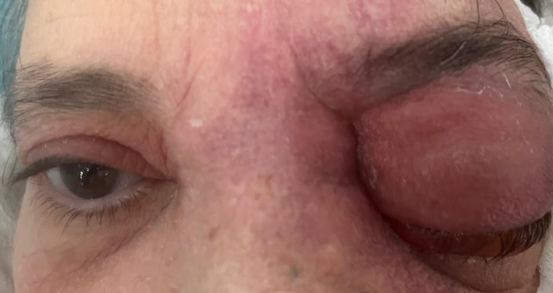
Figure 1 : left orbital cellulitis with chemosis
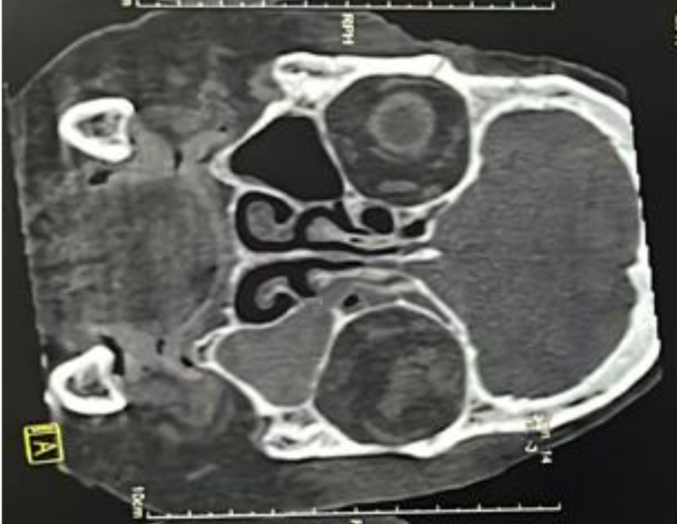
Figure 2: Coronal sinus CT scan: Left fronto-ethmoido-maxillary opacification with infiltration of the left orbital cellulofatty tissue.
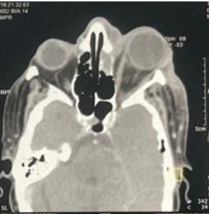
Figure 3 : Axial CT scan revealing grade II Chandler's cellulitis with grade II exophthalmos.

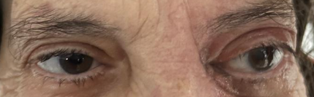
Figure 4: Postoperative day 30, showing a normal-appearing eyeball

Conclusion
Orbital cellulitis is primarily a clinical diagnosis, but the condition is confirmed based on imaging. CT scan is the first-line imaging modality for orbital cellulitis, particularly in cases with proptosis, ophthalmoplegia, or vision loss. The use of steroids in patients with orbital cellulitis remains controversial. Steroids may reduce the tissue damage and toxic effects of inflammatory mediators. Surgical management becomes imperative in orbital cellulitis when medical therapy fails or when vision-threatening or intracranial complications arise.
Consent
As per international standards or university standards, patient(s) written consent has been collected and preserved by the author(s).

Disclaimer (Artificial intelligence)
Author(s) hereby declare that NO generative AI technologies such as Large Language Models (ChatGPT, manuscript.

Reference:
1. Yadalla D, Jayagayathri R, Padmanaban K, Ramasamy R, Rammohan R, Nisar SP, et al. Bacterial orbital cellulitis – A review. Indian J Ophthalmol 2023;71:2687-93.
2. Chaudhry IA, Al-Rashed W, Arat YO. The hot orbit: orbital cellulitis. Middle East Afr J Ophthalmol. 2012;19(1):34e42
3. Friling R, Garty BZ, Kornreich L, et al. Medical and surgical management of orbital cellulitis in children. Folia Med (Plovdiv). 2014;56(4):253e8
4. Al-Madani MV, Khatatbeh AE, Rawashdeh RZ, Al-Khtoum NF, Shawagfeh NR. The prevalence of orbital complications among children and adults with acute rhinosinusitis. Braz J Otorhinolaryngol. 2013;79(6):716–9. https://doi.org/10. 5935/1808-8694.20130131.
5. Radovani P, Vasili D, Xhelili M, Dervishi J. Orbital complications of sinusitis. Balk Med J. 2013;30(2):151–4. https://doi.org/10.5152/balkanmedj.2013.8005.)
6. Murphy C, Livingstone I, Foot B, Murgatroyd H, MacEwen CJ. Orbital cellulitis in Scotland: Current incidence, etiology, management, and outcomes. Br J Ophthalmol 2014;98:1575-8.
7. Jessica Pelletier, Alex Koyfman, Brit Long, High risk and low prevalence diseases: Orbital cellulitis, The American Journal of Emergency Medicine, Volume 68, 2023, Pages 1-9,ISSN 0735 6757,https://doi.org/10.1016/j.ajem.2023.02.024
8. Le TD, Liu ES, Adatia FA, Buncic JR, Blaser S. The effect of adding orbital computed tomography findings to the Chandler criteria for classifying pediatricorbital cellulitis in predicting which patients will require surgical intervention. J AAPOS. 2014;18(3):271e7).
9. Ambati B. Periorbital and orbital cellulitis before and after the advent of Haemoph ilus influenzae type B vaccination. Ophthalmology. 2000;107(8):1450–3. https:// doi.org/10.1016/S0161-6420(00)00178-0.
10. Smith TF, O’Day D, Wright PF. Clinical implications of preseptal (periorbital) cellu litis in childhood. Pediatrics. 1978;62(6):1006–9
11. Anosike BI, Ganapathy V, Nakamura MM. Epidemiology and management of orbital cellulitis in children. J Pediatr Infect Dis Soc. 2022;11(5):214–20. https://doi.org/10. 1093/jpids/piac006.]. MRSA represents 5–6.5% of total OC cases and up to 73% of Staphylococcus infections
12. Sagiv O, Thakar SD, Kandl TJ, Kontoyiannis DP, Debnam JM, Esmaeli B. Clinical course of preseptal and orbital cellulitis in 50 immunocompromised patients with cancer. Ophthalmology. 2018;125(2):318–20. https://doi.org/10.1016/j. ophtha.2017.10.006.].
13. Lee S, Yen MT. Management of preseptal and orbital cellulitis. Saudi J Ophthalmol. 2011;25(1):21e9
14. Ozkurt FE, Ozkurt ZG, Gul A, et al. Management of orbital complications of sinusitis. Arq Bras Oftalmol. 2014;77(5):293e6
15. Pandian DG, Babu RK, Chaitra A, et al. Nine years’ review on preseptal and orbital cellulitis and emergence of community-acquired methicillin-resistant Staphylococus aureus in a tertiary hospital in India. Indian J Ophthalmol. 2011;59(6):431e5
16. McKinley SH, Yen MT, Miller AM, Yen KG. Microbiology of pediatric orbital cellulitis. Am J Ophthalmol. 2007;144(4):497e501
17. Santos JC, Pinto S, Ferreira S, Maia C, Alves S, da Silva V. Pediatric preseptal and or bital cellulitis: a 10-year experience. Int J Pediatr Otorhinolaryngol. 2019;120:82–8.
18. El Mograbi A, Ritter A, Najjar E, Soudry E. Orbital complications of rhinosinusitis in the adult population: Analysis of cases presenting to a tertiary medical center over 13 years. Ann Otol Rhinol Laryngol 2019;128:563-8
19. Dankbaar JW, van BemmelAJ, Pameijer FA. Imaging findings of the orbital and intracranial complications of acute bacterial rhinosinusitis. Insights Imaging. 2015;6(5):509e18
20. Rudloe TF, Harper MB, Prabhu SP, et al. Acute periorbital infections: who needs emergent imaging? Pediatrics. 2010;125(4):e719e26
21. Kapur R, Sepahdari AR, Mafee MF, et al. MR imaging of orbital inflammatory syndrome, orbital cellulitis, and orbital lymphoid lesions: the role of diffusion-weighted imaging. AJNR Am J Neuroradiol. 2009;30(1):64e70
22. Chandler JR, Langenbrunner DJ, Stevens ER. The pathogene sis of orbital complications in acute sinusitis. Laryngoscope 1970;80:1414—28.
23. Liu IT, Kao SC, Wang AG, Tsai CC, Liang CK, Hsu WM. Preseptal and orbital cellulitis: a 10-year review of hospitalized patients. J Chin Med Assoc. 2006;69(9):415–22. https://doi.org/10.1016/S1726-4901(09)70284-9.
24. Fanella S, Singer A,Embree J. Presentation and management of pediatric orbital cellulitis. Can J Infect Dis Med Microbiol. 2011;22(3):97–100. https://doi.org/10.1155/ 2011/626809.
25. Kim BY, Bae JH. Role of systemic corticosteroids in orbital cellulitis: A meta-analysis and literature review. Braz J Otorhinolaryngol 2022;88:257-62.
26. Kornelsen E, Mahant S, Parkin P, Ren LY, Reginald YA, Shah SS, et al. Corticosteroids for periorbital and orbital cellulitis.Cochrane Database Syst Rev 2021;4:CD013535.
27. Kloek CE, Rubin PA. Role of inflammation in orbital cellulitis. Int Ophthalmol Clin. 2006 ;46(2 ): 57e68
28. Meara DJ. Sinonasal disease and orbital cellulitis in children. Oral Maxillofacial Surg Clin N Am. 2012;24(3):487e96
29. Reynolds DJ, Kodsi SR, Rubin SE, Rodgers IR. Intracranial infection associated with preseptal and orbital cellulitis in the pediatric patient. J AAPOS. 2003;7(6):413e7
30. Slavsky A, Fraga J, Gonza´lez Frea G, et al. Ethmoidal fracture. Differential diagnosis of orbital cellulites in pediatrics. Clinical case. [Article in Spanish]. Arch Argent Pediatr. 2010;108(5):e5e8.
31. Greenberg MF, Pollard ZF. Nonsurgical management of subperiosteal abscess of the orbit. Ophthalmology. 2001;108(7):1167e9

