Assessing the Impacts of Temperature and Precipitation Dynamics on Climate Variability Across Northeast Nigeria

ABSTRACT
Several studies have highlighted the vulnerability of the climatic and weather dynamics globally. This study investigates climate variability impacts and the relationship between temperature and precipitation in diverse locales, emphasizing their effects on local environments and ecosystems. We analyze climatic data across Northeast Nigeria, which include Bauchi (10.31°N, 9.84°E), Damaturu (11.75°N, 11.96°E), Gombe (10.29°N, 11.17°E), Jalingo (8.89°N, 11.36°E), Maiduguri (11.85°N, 13.16°E), and Yola (9.21°N, 12.48°E). Exploring mean yearly temperature (ºC) and precipitation (mm) data for forty-six (46) years from 1979 to 2024 retrieved from meteoblue database. The highest values observed were 29.40°C in 2005 and 2024 in Jalingo (8.89°N, 11.36°E) and 1502.60 mm in 1981 in Bauchi (10.31°N, 9.84°E). The methodology comprises of descriptive statistics, correlation matrices, trend graphs, box plots, and visualizing relationships utilizing heatmaps. Using linear regression, we obtained an average R² of 0.34 for all the locations. Jalingo was found to have the highest mean temperature of 28.51°C. Bauchi depicts the highest precipitation of 1092.56 mm. This indicates that the locations have warmer climatic condition, while fluctuations in mean precipitation signify varied hydrological systems. Results of this study indicate important developments in climatic variables and their possible effects on ecosystems and agriculture, rising unpredictability in precipitation patterns and temperature extremes. The findings highlight the necessity for adaptive strategies to alleviate the dangers of flooding and resource depletion. Through the integration of these measures, communities within these locations in northeast Nigeria can enhance their preparedness and adaptability to the challenges presented by evolving environmental conditions.
Keywords: Climatic change, temperature variation, precipitation pattern, environmental impacts

1. INTRODUCTION
Complex patterns across many places and seasons are revealed by research on the relationship between temperature and precipitation (Kunkel et al., 2020; Boers et al., 2019). Both the annual mean temperature (AMT) and annual total precipitation (ATP) series exhibit long-term persistence, with AMT typically exhibiting greater Hurst exponents than ATP (Zhong & Guo, 2025). Global ecosystems and society are seriously threatened by climate change, which is defined by long-term changes in temperature and precipitation patterns (Malhi et al., 2020; Subramanian et al., 2023; Zhang et al., 2022). Rising sea levels, changed weather patterns, and an increase in the frequency of extreme occurrences are only a few of the consequences of these changes, which are mostly the result of human-caused greenhouse gas emissions (Trenberth, 2018 and Hamza et al., 2020). Evapotranspiration is acknowledged as the fundamental characteristic that represents climatic changes and is an essential part of the hydrological and meteorological cycles (Punia et al., 2025). The Intergovernmental Panel on Climate Change (IPCC) emphasizes that there is no question about how human activity affects the climate system and that immediate action is required to reduce emissions and prepare for the effects that are now being felt. Ignoring these issues will make vulnerabilities worse, especially in areas that rely heavily on natural resources (Vardy et al., 2017; Minx et al., 2017; Lahn, 2021; and Jebeile, 2022).
Certain geographical areas and groups are at disproportionate danger due to the unequal distribution of climate change's consequences (Abi Deivanayagam et al., 2023). Because of their historical marginalization and intimate relationships to the environment, indigenous peoples and local communities who frequently depend on nature for their livelihoods are especially at risk (Oldekop et al., 2020). Two most important climatic parameters are temperature and precipitation. Because of their dependence, it is difficult to simulate temperature and rainfall at the same time, and variations in these are strongly revealing of climate change (Rana et al., 2017). Climate sensitive diseases can become more common, agricultural techniques can be disrupted, and water supplies can be threatened by changes in temperature and precipitation patterns (Semenza et al., 2022 and George, 2025). Furthermore, Jha et al. (2024), Charak et al. (2024), and Singh & Pandey (2024) reported that severe weather conditions like heat waves, droughts, and floods have the potential to destroy infrastructure, uproot communities, and cause large financial losses. Singh and Rawat (2025) reported that the climate of Haryana demonstrates significant regional fluctuation, influenced by its many geographical features, including the Shivalik Hills, the Yamuna River, and the Thar Desert. These interrelated issues show how urgently localized research is needed to guide successful adaptation and mitigation plans. Reducing climate vulnerabilities and increasing resilience require adaptation and mitigation measures (Joakim, 2021 and Abbass et al., 2022). By reducing greenhouse gas emissions or sequestering carbon, mitigation measures seek to lessen the severity of climate change (Filonchyk et al., 2024; Aldy & Halem, 2024). Important steps in this regard include encouraging sustainable land management techniques, increasing energy efficiency, and switching to renewable energy sources. Conversely, adaptation techniques aim to reduce exposure to climate risks and increase adaptive ability in order to adapt to the effects of climate change (Antwi-Agyei et al., 2021; Jamshidi et al., 2019). This could entail enhancing early warning systems, creating drought-resistant crops, and putting flood control measures into action (Ochien’g, 2024). Achieving long-term sustainability and safeguarding vulnerable populations requires combining mitigation and adaptation strategies (Fuldauer et al., 2022; Tenzing, 2020). Henry et al., (2023) reported that meteorological data on observed climatic patterns matched community perceptions of temperature and rainfall trends.
Seddon et al. (2020) and Seddon et al. (2021) reported that developing focused and efficient solutions requires an understanding of the unique effects of climate change on local settings and Important elements in this process include analyzing trends in temperature and precipitation, identifying ecosystems that are at risk, and evaluating the possible effects on agriculture and water resources. For majority of models, regions, and time periods, precipitation variability rises at least as much as mean precipitation and less than moisture and extreme precipitation (Pendergrass et al., 2017). The intricate interactions between climatic factors and environmental impacts can be better understood by using descriptive statistics, correlation analyses, trend graphs, and box plots. Additionally, it is essential to interact with local people and take into account their expertise in order to guarantee that adaptation and mitigation plans are socially and culturally fair.
The goal of this study is to present a thorough analysis of how climate change affects temperature and precipitation patterns in the six states of Northeast Nigeria by calculating the descriptive statistics, such as mean, median, standard deviation, and range, for temperature and precipitation at each location, analyze the correlations between temperature and precipitation across all locations using a heatmap, visualize trends in mean yearly temperature and precipitation over time for each location, including fitted regression lines with R-squared, RMSE, and MAE values to identify significant variations in temperature and precipitation between locations and also examine the possible effects of these changes on local environments, such as flooding, ecosystems, agriculture, and water resources, for policy recommendation adaptation and mitigation policies.

2. METHODOLOGY
2.1 Study area
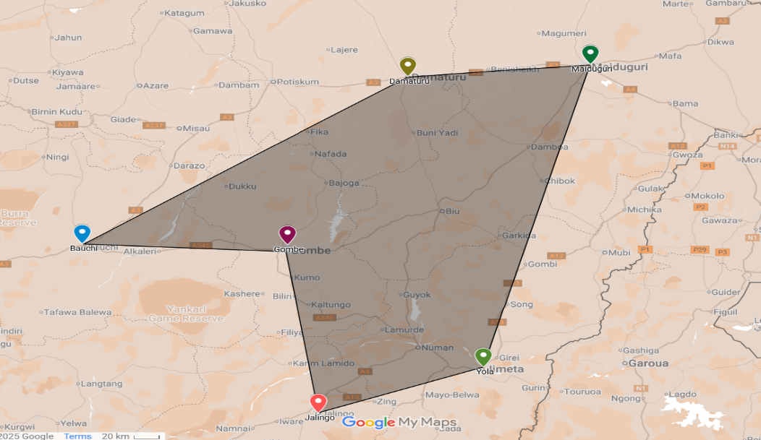
Fig. 1. Map of Northeastern Nigeria states showing the study area
Recent studies highlight the vulnerability of the six northeastern states of Nigeria, Bauchi (10.31°N, 9.84°E), Damaturu (11.75°N, 11.96°E), Gombe (10.29°N, 11.17°E), Jalingo (8.89°N, 11.36°E), Maiduguri (11.85°N, 13.16°E), and Yola (9.21°N, 12.48°E), as shown in Fig. 1, to climate change, particularly in relation to temperature and precipitation patterns. According to Toromade et al. (2024), increasing temperatures and erratic rainfall patterns have exacerbated flooding events in these regions, impacting agricultural activities and threatening food security. Erondu (2025) argues that climate change has intensified the occurrence and severity of extreme weather events, leading to significant socio-economic impacts, including displacement and the loss of livelihoods.
2.2 Data collection
High-resolution simulated and historical climate data for six regions was obtained from Meteoblue, a commercial weather and climate data source (Benson et al., 2021). Meteoblue's History API provides HTTP queries for on-demand data access. Meteoblue was chosen for this study for its free, low-cost academic access and substantial coverage, including 40 years of mean yearly data (Paparrizos et al., 2020). Andrei-Laurențiu et al. (2023), Olatona et al. (2024), and Iraqi et al. (2021) reported some accuracy of Meteoblue data and suitability for scientific research. Meteoblue data has been used to study water temperature modelling and climate change's impact (Junqueira, 2023). Meteoblue's user-friendliness and huge meteorological database make it useful for climate and environmental studies, even though it exaggerates wind speed and air temperature. Mean yearly data of temperature and precipitation of 46 years (1979 to 2024) from the Meteoblue database website were retrieved under history and climate (meteoblue, 2025) to examine how climate change affects the six states using the capital for each state in Northeast Nigeria, which are Bauchi (10.31°N, 9.84°E), Damaturu (11.75°N, 11.96°E), Gombe (10.29°N, 11.17°E), Jalingo (8.89°N, 11.36°E), Maiduguri (11.85°N, 13.16°E), and Yola (9.21°N, 12.48°E). The mean, median, standard deviation, and range were determined for each location's temperature and precipitation data to summarize central patterns and variability. For clarity, a heatmap was used to depict a correlation matrix of temperature and precipitation. Line plots were generated using average annual temperature and precipitation data to evaluate patterns. To assess model performance, we evaluated R-squared, RMSE, and MAE values and used fitted regression lines to quantify trends. Box plots were utilized to show the distribution of these variables among sites.

3. RESULTS AND DISCUSSION
3.1 Descriptive Statistics
The summary table of descriptive statistics for each location offers significant insights into the distribution of temperature and precipitation data across the 46-year span. Table 1 shows the mean values denoting the average temperature and precipitation amounts, underscoring notable disparities among the six locations. Locations with elevated mean temperatures, such as 28.51°C in Jalingo, followed by Yola with 28.38913043°C and Maiduguri with 27.72°C, indicate locations with warmer climatic conditions, whilst fluctuations in mean precipitation signify diverse hydrological systems with the highest mean precipitation of 1092.556522 mm from Bauchi, 620.8956522 mm from Yola, and 579.71 mm from Jalingo. There is no significant difference in mean temperature and precipitation from all six locations, denoting that they all have warmer climate conditions and diverse hydrological systems that could influence flooding and other environmental impacts within the region of Northeast Nigeria. This is in line with the most recent report from the Intergovernmental Panel on Climate Change (IPCC, 2024), which said it was almost certain that the amount of heat in the oceans had grown since the 1970s and that it was most likely due to human activities. The datasets used here show that the world ocean's heat content rose at a rate of 0.6 ± 0.1 W m⁻² (6.8 ZJ per year) over the whole ocean from 1971 to 2024.
Table 1. Descriptive statistics of temperature and precipitation of the six locations
 | Mean Temp/Precip | Median Temp/Precip | Standard Deviation Temp/Precip | Range Temp/Precip | Pearson Correlation
BMT | 24.84347826 | 24.9 | 0.481964579 | 2.4 | 0.716034738
DMT | 27.2173913 | 27.25 | 0.413819256 | 1.9 | 0.753603676
GMT | 27.41521739 | 27.5 | 0.443705303 | 2.1 | 0.842936341
JMT | 28.50652174 | 28.45 | 0.473944288 | 1.8 | 0.756632794
MMT | 27.72391304 | 27.8 | 0.366475576 | 1.5 | 0.681053613
YMT | 28.38913043 | 28.45 | 0.469149709 | 1.9
BMP | 1092.556522 | 1052.45 | 169.8224035 | 675.3 | 0.487222263
DMP | 458.2978261 | 450.2 | 98.22432486 | 444 | 0.708421276
GMP | 441.526087 | 429.25 | 109.4760236 | 504.9 | 0.664096955
JMP | 579.7130435 | 558.65 | 119.1392549 | 501.9 | 0.58800079
MMP | 471.3978261 | 463.85 | 104.916014 | 453.2 | 0.653712014
YMP | 620.8956522 | 596.2 | 117.9433347 | 474.5
*pearson correlation relationship. Bauchi mean temperature/precipitation (BMT/BMP), Damaturu mean temperature/precipitation (DMT/DMP), Gombe mean temperature/precipitation (GMT/GMP), Jalingo mean temperature/precipitation (JMT/JMP), Maiduguri mean temperature/precipitation (MMT/MMP), Yola mean temperature/precipitation (YMT/YMP),
The standard deviation and range clarify the variability and distribution of the data across sites. Bauchi depicts a standard deviation temperature of 0.48°C, indicating a high significant variability in temperature, and 169.82 mm in precipitation, denoting unstable climatic conditions. The range, defined as the disparity between the maximum and minimum values, offers further insight into the extremes encountered at each location, with Bauchi having a temperature range of 2.40 and 675 for precipitation. Collectively, these statistics provide a thorough comprehension of climatic patterns, which point towards decision-making processes related to climate resilience and adaptation strategies. The Pearson correlation coefficient between temperature and precipitation was found to be 0.84 for GMT and JMT and 0.71 for DMP and DMP, indicating a strong positive relationship. The strong correlation indicates that as temperature increases, precipitation tends to increase as well, warranting further investigation into the climatic impacts on local ecosystems in this region.
3.2 Correlation Heatmap
Fig. 2 explores the heatmap derived from the correlation matrix, which depicts the associations between temperature and precipitation across the six locations. The correlations demonstrate significant patterns, with specific places showing substantial positive correlations between mean temperature and precipitation levels, indicating that when temperatures climb, precipitation also tends to rise. Locations such as BMT and DMT exhibited elevated correlation coefficients, indicating that climatic conditions in these regions are affected by analogous atmospheric causes. In contrast, several locations exhibited weaker or even negative correlations, underscoring the heterogeneity in climatic responses and suggesting that local geographical and environmental factors substantially affect these locations.
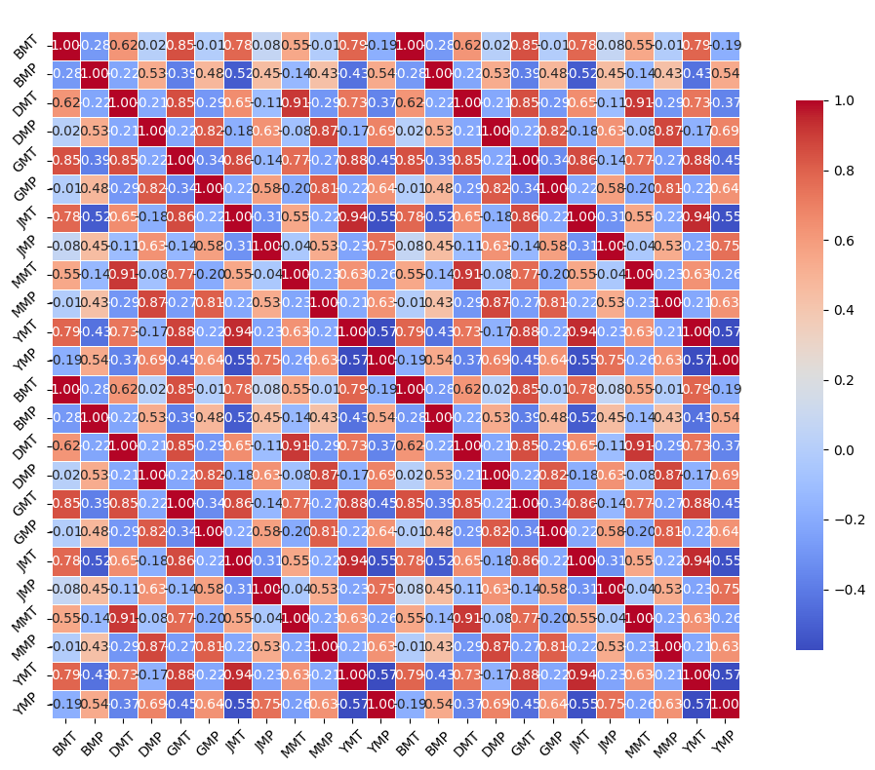
Fig. 2. Heatmap correlation and relationships between temperature and precipitation
Comprehending these relationships is essential for climate modelling and resource management. The robust associations identified in particular areas may guide agricultural methods, water resource management, and climate adaptation measures. The heterogeneity in correlations highlights the necessity for localized studies. Regions with weak correlations, such as YMP and MMP may necessitate distinct solutions to mitigate climate consequences, indicating that a uniform strategy may prove ineffective. These insights can assist policymakers and stakeholders in making informed decisions based on the distinct climatic interactions inherent to each region.
3.3 Trend Linearity
The trend graphs for average annual temperature and precipitation across the six locations exhibit clear patterns across the measured years. Linear regression was utilized for the analysis using the equation,
Y = βo + β₁ X + ϵ (1)
Where Y denotes the dependent variable, β₀ and β₁ are the intercept and slope, and X and ϵ are the independent variable and error term. The relationship between the dependable and the independent value is linear. The degree to which the independent factors account for the variability in the dependent variable is shown by the R-squared value. A positive correlation is represented by a number near 1, meaning that a greater R-squared value denotes a better fit. Fig. 3 depicts each graphic feature with fitted regression lines that depict the underlying trends of values depicting BMT with an R² of 0.29, DMT with an R² of 0.04, GMT with an R² of 0.18, followed by JMT with an R² of 0.34, MMT with an R² of 0.01, and YMT with an R² of 0.34 evaluated from equation 1. This denotes that JMT and YMT having the same value of 0.34 indicates a low but more robust correlation between time and the corresponding environmental characteristics. The RMSE of BMT, DMT, and GMT is 0.40, and MAE is 0.30, denoting the average prediction errors and illustrating the dependability of the regressions. These measurements facilitate our comprehension of the degree to which temperature and precipitation values diverge from the anticipated trends.
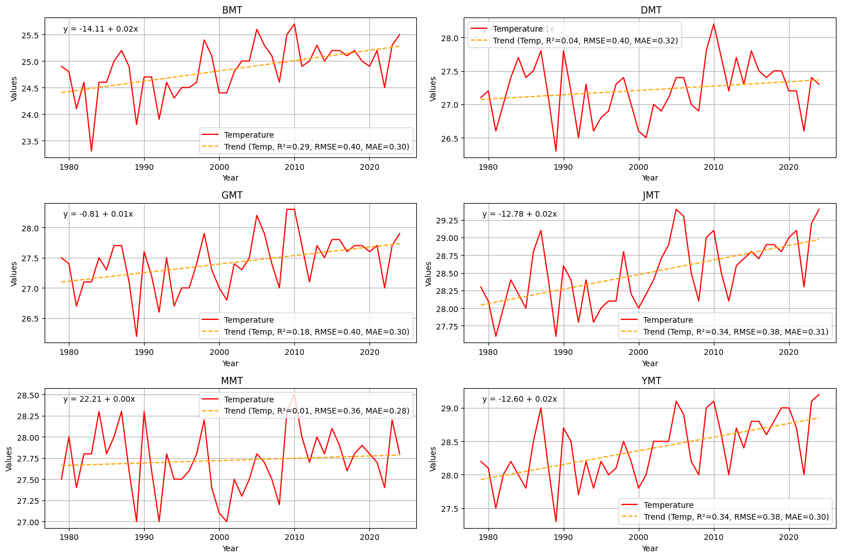
Fig. 3. Mean yearly temperature for each location, including fitted regression lines of trends
The visualizations underscore notable trends in climate data, with certain locations demonstrating pronounced temperature rises over time, but precipitation patterns reveal greater variability, with lower trend values for all six locations having an R² of 0.14. The fitted regression lines indicate that in all the regions, temperature trends are getting progressively alarming, potentially signaling broader climate change effects. Moreover, areas exhibiting reduced RMSE and MAE values demonstrate more steady patterns, indicating that the models employed in those regions are more dependable. The analysis emphasizes the necessity of both monitoring trends and quantifying their significance from these statistical metrics, which facilitates the development of effective climate adaptation and mitigation policies.
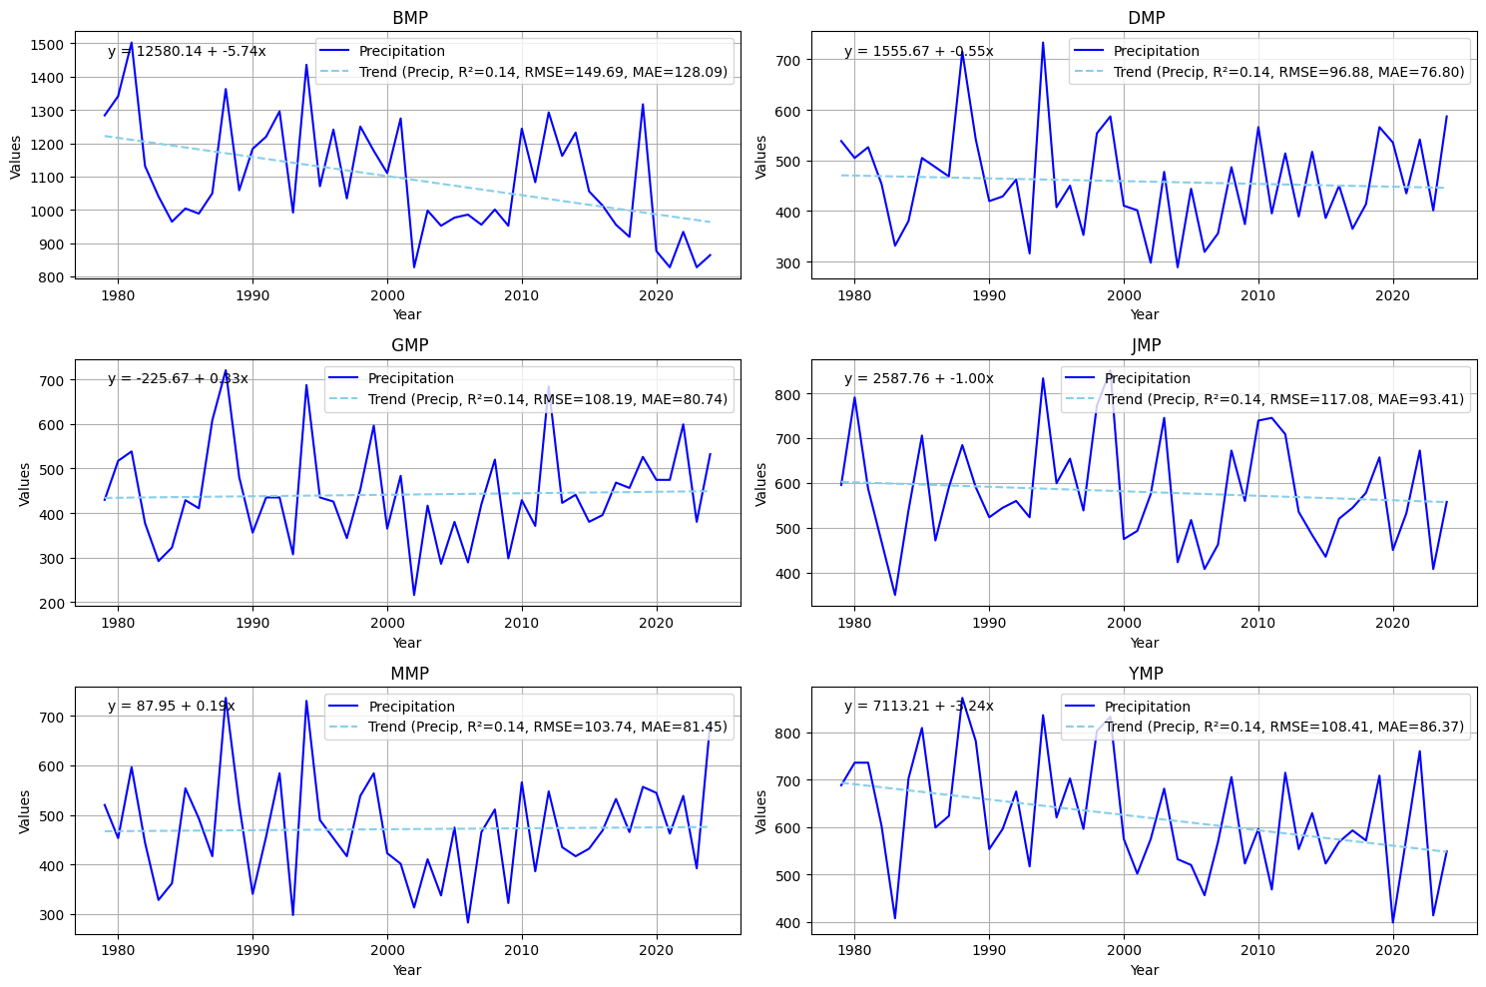
Fig. 4. Mean yearly precipitation for each location, including fitted regression lines of trends
The box plots in Fig. 4 clearly depict the distribution of temperature and precipitation across the six locations, highlighting different patterns in climatic variability. The graphs illustrate a distinct range of means and medians for temperature, with certain areas displaying broader interquartile ranges, such as JMT and YMT, signifying increased variability in temperature. Certain regions exhibit elevated median temperatures, indicating localized warming patterns. The precipitation box plots reveal considerable disparities among sites, with BMP exhibiting regularly elevated precipitation amounts, whereas other locations stay comparatively arid. The existence of outliers in both graphs underscores significant weather occurrences that could affect these locations, necessitating additional study.
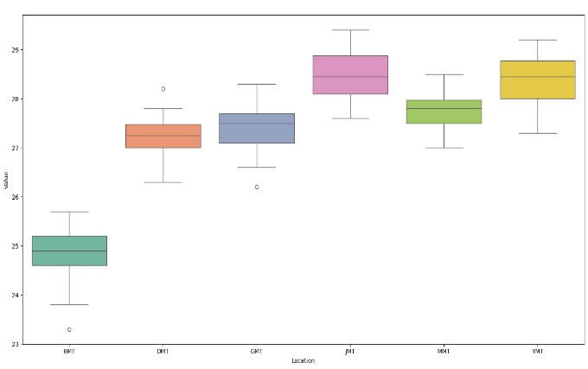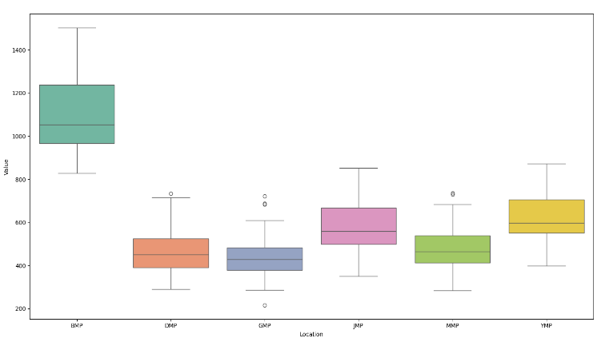
Fig. 5. Boxplot of distribution of temperature and precipitation across each location
These visualizations in Fig. 5 offer significant insights into the climatic conditions of each locale, facilitating the comprehension of the interplay between temperature and precipitation across various habitats. The observed fluctuations may impact agriculture, water resource management, and ecosystem vitality. Moreover, these insights can assist local authorities in formulating focused measures to tackle the specific climate difficulties encountered by each region.
3.4 Consequences for the local ecosystem
The study of local environmental consequences indicated substantial issues related to flooding patterns and their possible effects on ecosystems, agriculture, and water resources. Elevated precipitation and altered temperature patterns may result in more frequent and severe flooding events, as shown in Figs. 6a and 6b, where BMT, GMT, and YMT depict a positive trend better than DMT and MMT unlike BMP, DMP, GMP, JMP, MMT, and YMP with negative trends, disrupting local ecosystems and jeopardizing biodiversity. Agricultural output may diminish due to soil erosion and crop loss, while water resources may become strained as runoff escalates, resulting in potential pollution of freshwater supplies. These alterations require a reassessment of existing land use practices and water management systems to guarantee sustainability and resilience against climate impacts.
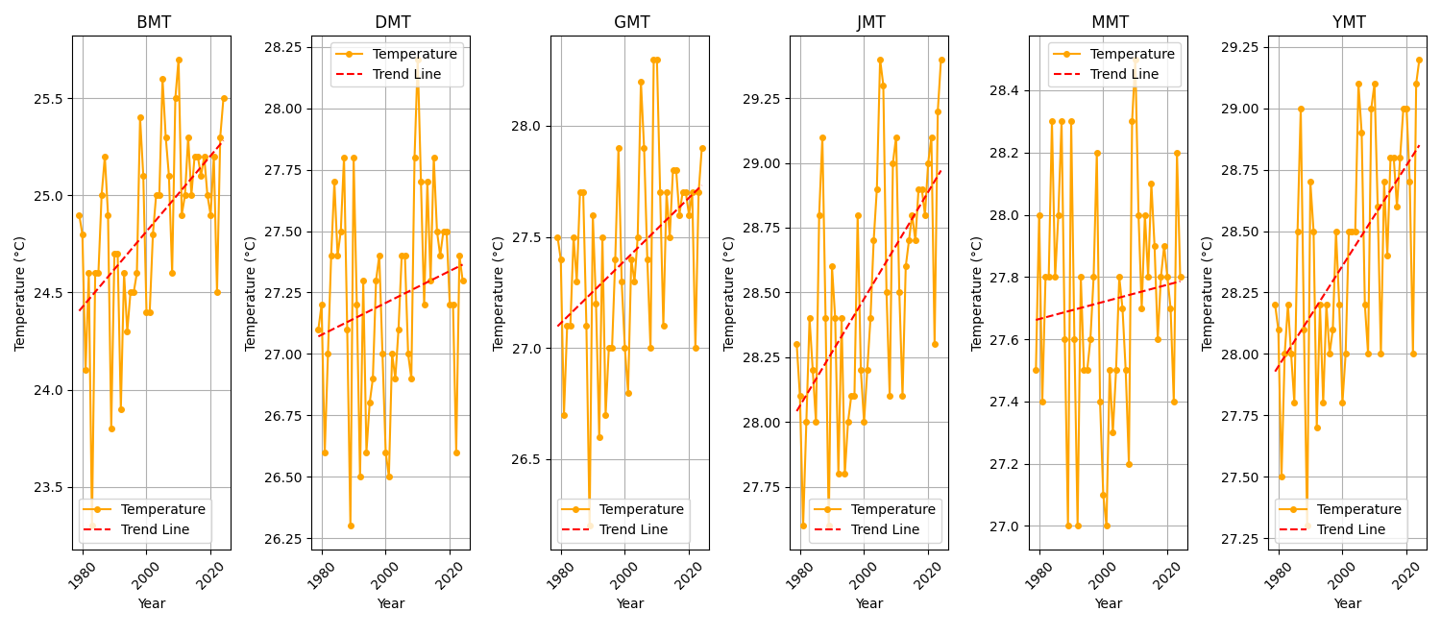
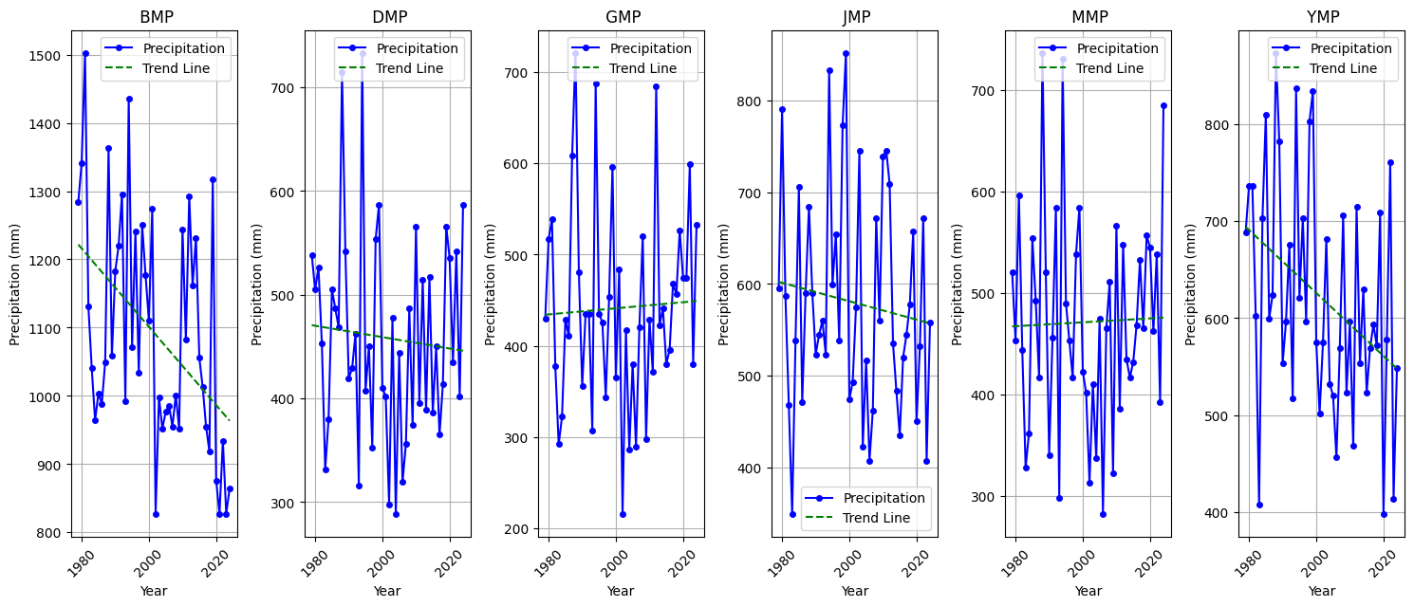
Figs. 6a , 6b: Line graphs of trends of temperature and precipitation for each location

4. CONCLUSION
This study utilizes data from the Meteoblue database of forty-six (46) years, from 1979 to 2024, for mean yearly temperature and precipitation for six locations in the northeastern part of Nigeria from the climate change section, focusing on the capital of each state to obtain central data, which are Bauchi (10.31°N, 9.84°E), Damaturu (11.75°N, 11.96°E), Gombe (10.29°N, 11.17°E), Jalingo (8.89°N, 11.36°E), Maiduguri (11.85°N, 13.16°E), and Yola (9.21°N, 12.48°E). The highest mean temperature and precipitation were observed at 29.4°C in 2005 and 2024 in Jalingo (8.89°N, 11.36°E) and 1502.6 mm in 1981 in Bauchi (10.31°N, 9.84°E). Our findings reveal a significant correlation between both temperature and precipitation trends and climate dynamics in those locations influencing flooding and impacting agriculture production, water resource management, and ecosystem vitality. With an average R² of 0.34 for all the locations, with a mean temperature of 28.51°C in Jalingo and a high precipitation of 1092.56 mm in Bauchi. This indicates warmer climatic conditions, while fluctuations in mean precipitation signify varied hydrological systems. These findings emphasize the necessity of more studies on monitoring and analysis of meteorological data to improve our comprehension of environmental dynamics. The correlation matrix heatmap elucidates the links between temperature and precipitation across diverse locales. The identified associations underscore the necessity of localized climatic studies, as they can guide successful resource management methods and adaptation to climate change effects. Findings from this study provide a basis for subsequent study and policy formulation to tackle the issues presented by climate change in these areas.
Comprehending the ramifications of climate change on local ecosystems is crucial for formulating effective adaptation and mitigation policies. By mitigating flooding risks and their impacts on ecosystems, agriculture, and water supplies, communities can bolster their resilience and sustainability amid persistent environmental changes. Executing specific policy proposals will be essential in promoting a proactive strategy to address these difficulties.
4.1 Recommendation
Given these findings, implementing green infrastructure, including wetlands and vegetated swales, can effectively manage rainwater and mitigate flooding concerns. Furthermore, advocating for sustainable agriculture techniques that improve soil health and resilience will be essential for ensuring food security. Policymakers ought to allocate resources towards community education and engagement activities to enhance knowledge of climate consequences and promote proactive measures among residents. Through the integration of these measures, communities within these locations in northeast Nigeria can enhance their preparedness and adaptability to the challenges presented by evolving environmental conditions.

5. COMPETING INTERESTS DISCLAIMER:
Authors have declared that they have no known competing financial interests OR non-financial interests OR personal relationships that could have appeared to influence the work reported in this paper.
6. DISCLAIMER (Artificial intelligence)
Author(s) hereby declare that NO generative AI technologies such as Large Language Models (ChatGPT, COPILOT, etc.) and text-to-image generators have been used during the writing or editing of this manuscript.

7. REFERENCES
Abbass, K., Qasim, M. Z., Song, H., Murshed, M., Mahmood, H., & Younis, I. (2022). A review of the global climate change impacts, adaptation, and sustainable mitigation measures. Environmental science and pollution research, 29(28), 42539-42559.
Abi Deivanayagam, T., English, S., Hickel, J., Bonifacio, J., Guinto, R. R., Hill, K. X., ... & Devakumar, D. (2023). Envisioning environmental equity: climate change, health, and racial justice. The Lancet, 402(10395), 64-78.
Aldy, J. E., & Halem, Z. M. (2024). The evolving role of greenhouse gas emission offsets in combating climate change. Review of Environmental Economics and Policy, 18(2), 212-233.
Andrei-Laurențiu, P. O. P. E. S. C. U., & Ioana, N. E. N. C. I. U. (2023). Climate Change Trends And Early Adaptation Strategies: Potential Impacts And Solutions For Bucharest Municipality. Sciences, 4(3), 32-39.
Antwi-Agyei, P., & Stringer, L. C. (2021). Improving the effectiveness of agricultural extension services in supporting farmers to adapt to climate change: Insights from northeastern Ghana. Climate Risk Management, 32, 100304.
Benson, A., Hoffmann, D. L., Daura, J., Sanz, M., Rodrigues, F., Souto, P., & Zilhão, J. (2021). A speleothem record from Portugal reveals phases of increased winter precipitation in western Iberia during the Holocene. The Holocene, 31(8), 1339-1350.
Boers, N., Goswami, B., Rheinwalt, A., Bookhagen, B., Hoskins, B., & Kurths, J. (2019). Complex networks reveal global pattern of extreme-rainfall teleconnections. Nature, 566(7744), 373-377.
Charak, A., Ravi, K., & Verma, A. (2024). Review of various climate change exacerbated natural hazards in India and consequential socioeconomic vulnerabilities. IDRiM Journal, 13(2), 142-177.
Erondu, C. I. (2025). AN EVALUATION OF SOCIO-ECONOMIC IMPLICATIONS OF CLIMATE-INDUCED DISPLACEMENT IN NIGERIA. Open Journal of Social Science and Humanities (ISSN: 2734-2077), 6(1), 1-15.
Filonchyk, M., Peterson, M. P., Zhang, L., Hurynovich, V., & He, Y. (2024). Greenhouse gases emissions and global climate change: Examining the influence of CO2, CH4, and N2O. Science of The Total Environment, 935, 173359.
Fuldauer, L. I., Thacker, S., Haggis, R. A., Fuso-Nerini, F., Nicholls, R. J., & Hall, J. W. (2022). Targeting climate adaptation to safeguard and advance the Sustainable Development Goals. Nature communications, 13(1), 3579.
George, M. (2025). Effects of changes in temperature and precipitation as climate factors that influence the spread of climate-related diseases: A systematic review. African Geographical Review, 44(4), 412-425.
Hamza, Y. G., Ameta, S. K., Tukur, A., & Usman, A. (2020). Overview on evidence and reality of climate change. IOSR J Environ Sci Toxicol Food Technol, 14(7), 17-26.
Henry, J. N., & Koske, J. B. (2023). Perception of Adaptation Strategies to Climate Variability in Machakos County, Kenya. Asian J. Geo. Res, 6(4), 58-79.
https://www.meteoblue.com/en/weather/week/jalingo_nigeria_2336589. 2025
Iraqi, A. A., & AbdAlla, A. M. (2021). Analysis of long-term climatic changes at Hodeidah-Yemen during the period between 1984 and 2019.
Jamshidi, O., Asadi, A., Kalantari, K., Azadi, H., & Scheffran, J. (2019). Vulnerability to climate change of smallholder farmers in the Hamadan province, Iran. Climate Risk Management, 23, 146-159.
Jebeile, J. (2022). Values and objectivity in the intergovernmental panel on climate change. In Questioning Experts and Expertise (pp. 148-163). Routledge.
Jha, M. K., & Dev, M. (2024). Impacts of climate change. In Smart internet of things for environment and healthcare (pp. 139-159). Cham: Springer Nature Switzerland.
Joakim, E. P., Mortsch, L., & Oulahen, G. (2021). Using vulnerability and resilience concepts to advance climate change adaptation. In Environmental hazards and resilience (pp. 13-31). Routledge.
Junqueira, P. (2023). Climate Change and the Wine Quality in Bordeaux Region (Doctoral dissertation, Kedge Business School).
Kunkel, K. E., Karl, T. R., Squires, M. F., Yin, X., Stegall, S. T., & Easterling, D. R. (2020). Precipitation extremes: Trends and relationships with average precipitation and precipitable water in the contiguous United States. Journal of Applied Meteorology and Climatology, 59(1), 125-142.
Lahn, B. (2021). Changing climate change: The carbon budget and the modifying-work of the IPCC. Social studies of Science, 51(1), 3-27.
Malhi, Y., Franklin, J., Seddon, N., Solan, M., Turner, M. G., Field, C. B., & Knowlton, N. (2020). Climate change and ecosystems: threats, opportunities and solutions. Philosophical transactions of the Royal Society B, 375(1794), 20190104.
Minx, J. C., Callaghan, M., Lamb, W. F., Garard, J., & Edenhofer, O. (2017). Learning about climate change solutions in the IPCC and beyond. Environmental Science & Policy, 77, 252-259.
Ochien’g, P. O. (2024). Assessment of Drought Early Warning Systems for Resilience Building in Isiolo County, Kenya (Doctoral dissertation, University of Nairobi).
Olatona, G. I., & Oyedokun, S. M. (2024). Analysing the Impact of Solar and Ultraviolet Radiations on Human Health and Agriculture: a Case Study of Nigerian and the Us Cities.
Oldekop, J. A., Rasmussen, L. V., Agrawal, A., Bebbington, A. J., Meyfroidt, P., Bengston, D. N., ... & Wilson, S. J. (2020). Forest-linked livelihoods in a globalized world. Nature Plants, 6(12), 1400-1407.
Paparrizos, S., Smolenaars, W., Gbangou, T., Slobbe, E. V., & Ludwig, F. (2020). Verification of weather and seasonal forecast information concerning the peri-urban farmers’ needs in the lower ganges delta in bangladesh. Atmosphere, 11(10), 1041.
Pendergrass, A. G., Knutti, R., Lehner, F., Deser, C., & Sanderson, B. M. (2017). Precipitation variability increases in a warmer climate Sci. Rep, 7, 17966.
Punia, R., Choudhary, K., & Kumar, P. (2025). Impact of Climate Change on Potential Evapotranspiration in Bawal and Karnal Districts of Haryana, India: A Spatio-temporal Analysis. International Journal of Environment and Climate Change, 15(8), 54-67.
Rana, A., Moradkhani, H., & Qin, Y. (2017). Understanding the joint behavior of temperature and precipitation for climate change impact studies. Theoretical and Applied Climatology, 129(1), 321-339.
Seddon, N., Chausson, A., Berry, P., Girardin, C. A., Smith, A., & Turner, B. (2020). Understanding the value and limits of nature-based solutions to climate change and other global challenges. Philosophical Transactions of the Royal Society B, 375(1794), 20190120.
Seddon, N., Smith, A., Smith, P., Key, I., Chausson, A., Girardin, C., ... & Turner, B. (2021). Getting the message right on nature‐based solutions to climate change. Global change biology, 27(8), 1518-1546.
Semenza, J. C., Rocklöv, J., & Ebi, K. L. (2022). Climate change and cascading risks from infectious disease. Infectious diseases and therapy, 11(4), 1371-1390.
Singh, G., & Pandey, A. (2024). Climate change induced disasters and highly vulnerable infrastructure in Uttarakhand, India: current status and way forward towards resilience and long-term sustainability. Sustainable and Resilient Infrastructure, 9(2), 145-167.
Singh, K., & Rawat, S. (2025). Assessment of Temperature and Precipitation Variability and its Spatial Distribution Over Haryana, India. International Journal of Environment and Climate Change, 15(8), 240-248.
Solecki, W., Roberts, D., & Seto, K. C. (2024). Strategies to improve the impact of the IPCC Special Report on Climate Change and Cities. Nature Climate Change, 14(7), 685-691.
Subramanian, A., Nagarajan, A. M., Vinod, S., Chakraborty, S., Sivagami, K., Theodore, T., ... & Mangesh, V. L. (2023). Long-term impacts of climate change on coastal and transitional eco-systems in India: an overview of its current status, future projections, solutions, and policies. RSC advances, 13(18), 12204-12228.
Tenzing, J. D. (2020). Integrating social protection and climate change adaptation: A review. Wiley Interdisciplinary Reviews: Climate Change, 11(2), e626.
Toromade, A. S., Soyombo, D. A., Kupa, E., & Ijomah, T. I. (2024). Reviewing the impact of climate change on global food security: Challenges and solutions. International journal of applied research in social sciences, 6(7), 1403-1416.
Trenberth, K. E. (2018). Climate change caused by human activities is happening and it already has major consequences. Journal of energy & natural resources law, 36(4), 463-481.
Vardy, M., Oppenheimer, M., Dubash, N. K., O'Reilly, J., & Jamieson, D. (2017). The intergovernmental panel on climate change: challenges and opportunities. Annual Review of Environment and Resources, 42(1), 55-75.
Zhang, P., Peng, C., Zhang, J., Zhang, J., Chen, J., & Zhao, H. (2022). Long-term harmful algal blooms and nutrients patterns affected by climate change and anthropogenic pressures in the zhanjiang bay, China. Frontiers in Marine Science, 9, 849819.
Zhang, X., Zhong, J., Zhang, X., Zhang, D., Miao, C., Wang, D., & Guo, L. (2025). China can achieve carbon neutrality in line with the Paris Agreement’s 2 C target: navigating global emissions scenarios, warming levels, and extreme event projections. Engineering, 44, 207-214.

